User Testing for Web Accessibility Project Report

Prepared for the McMaster Accessibility Council and McMaster Media Production Services
August 7, 2018

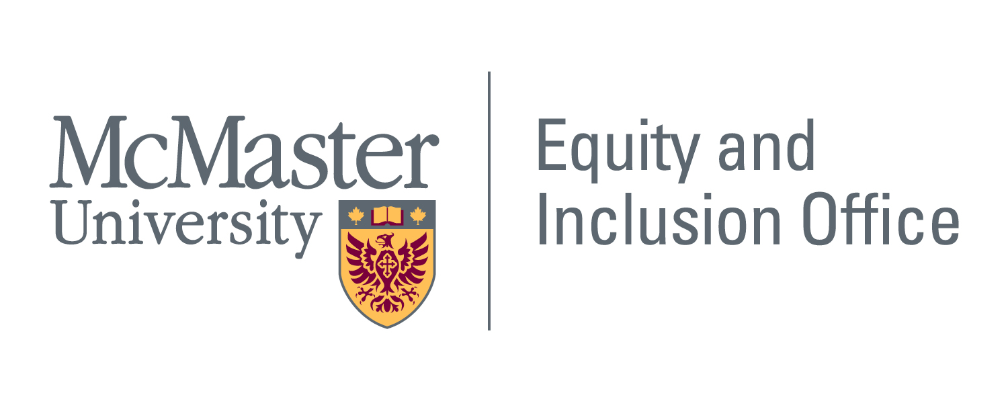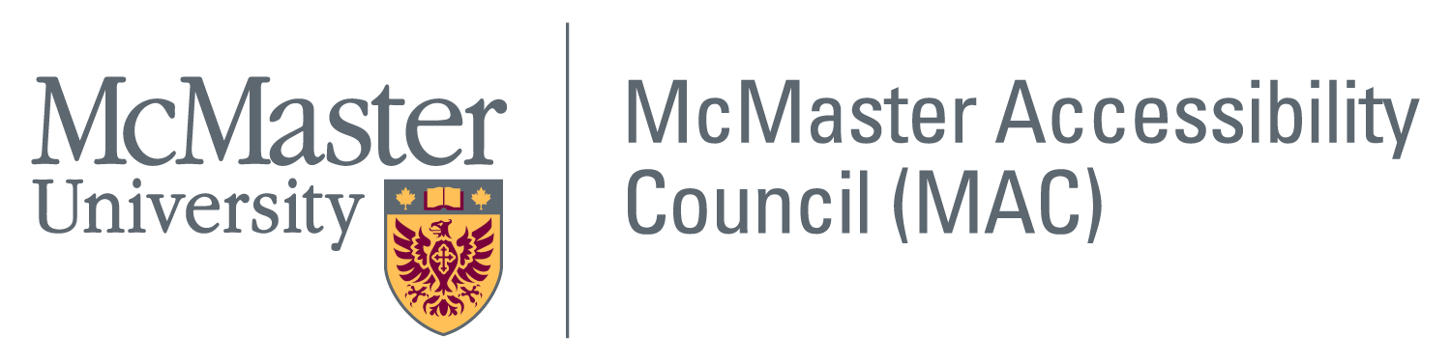

Executive Summary

As website AODA compliance deadlines draw closer within Ontario, universities are working to develop university-wide website accessibility strategies to enhance the inclusion of students, staff and students with disabilities, many of whom are excluded from online spaces when they encounter accessibility barriers to navigating and interacting with completely or partially inaccessible websites.
Through discussions with the Chair and Web Accessibility Strategist (WAS) of the McMaster Accessibility Council (MAC) and the Equity and Inclusion Office’s (EIO) Accessibility Projects Coordinator/Facilitator, the need for conducting user testing for accessibility was identified. While there has been much effort to move website accessibility forward at the University, including the hiring of the Web Accessibility Strategist and the striking of a Web Accessibility Advisory Group, it was recognized that in order to demonstrate AODA / WCAG 2.0 AA compliance, McMaster websites had to be tested for accessibility. While some web users may enter online spaces in ways that are deemed (and designed for) as being “typical” or “normal”, this is indeed not the experience of all users, and in particular, users with disabilities. When websites are not tested for technical functionality, ease of navigability, logical order and clarity of content, users who enter online spaces in different ways are excluded from online participation. Within a university context, this is particularly relevant when course content, assessments, services, and communication are being accessed almost exclusively online.
After identifying this need, the MAC Chair, EIO staff, and the WAS applied to the MacPherson Student Scholar Program and received funding for a short-term research project, the User Testing for Web Accessibility Project (UTWAP). Four students with fluency in assistive technology (AT), website development, and/or data management were recruited and hired to learn about user testing for accessibility to test McMaster’s Accessibility Hub. The Accessibility Hub houses accessibility-related information, resources, and contacts and describes the steps that McMaster University is taking to meet AODA compliance, and is therefore situated to be the exemplar accessible website at McMaster.
Central goals to the UTWAP have included:
- Testing for and identifying inaccessible areas of the Accessibility Hub website
- Communicating these findings to Media Production Services to assist in the re-build of the Accessibility Hub website
- Promoting and advocating for accessibility / disability-inclusion broadly at McMaster University
The students, guided by staff and faculty partners, conceptualized a collaborative, partner-driven project that would position and prioritize disabled users of AT as experts for functional user testing of the Accessibility Hub. The McMaster faculty and staff partners on the Project provided student partners with guidance and expertise in accessibility and web accessibility/development, designing project processes and outcomes, and meeting project timelines and goals.
The student team was tasked with building and then testing “test cases” using assistive technologies/software (keyboard navigation, Chrome Vox, Dragon Naturally Speaking, screen readers, and Colour Oracle) to see whether or not the technology would interact with the website. If students could navigate the function with the assistive technology (e.g. click on the “zoom in/out” button and have the page zoom in), the test case passed. If not it failed. Test cases were typically built to have approximately 3-4 logical steps, for example:
- Visit “accessibility.mcmaster.ca”
- Navigate mouse to zoom in/out button
- Click on zoom in/zoom out button
- The page enlarges/minimizes
Once the student had performed the test, they would input data into a data input form regarding:
- Which AT they would be using
- Which function they would be testing
- The environment for testing (home, computer lab, etc.)
- Disability-type (optional to fill-in)
- Date/time stamp for tests conducted

From the 33 original test cases and 32 replicated test cases that were built and tested, 54 cases failed to demonstrate successful interaction of navigating the Hub with the aforementioned assistive technologies. The number of failed cases is reflective of a high-level accessibility audit that was completed on the Hub website prior to test case building, given the short time period in which to complete the entire project (one academic semester) and in order to highlight and prioritize problematic areas of the site to remedy immediately. A section of Observations has been captured at the end of this Report, which includes suggestions for improving the accessibility of/additions of:

- Icons, images, videos and banners
- Search functionality
- Required fields in forms
- Visible focus
- Internal and external links
- Colour contrast
- Navigation bar/main navigation tabs
- Navigating important/essential information
- Inclusion of compliance claim on the Hub’s landing page

Implementing the recommendations from this Report is one of many steps necessary to creating accessible online spaces at McMaster University. We would like to emphasize that there are many other versions of testing for accessibility, types of test cases that can be built, and communities of peoples with disabilities who can be included in user testing processes beyond those that are captured in the Report below. We would also like to assert that while the voices of students and staff with disabilities have been highlighted as experts in designing this Project, the process and allies/partners have been essential to realizing the outcomes of this Project. McMaster University is working proactively to achieve full AODA web compliance by January 1, 2021, a goal that will be met more quickly and successfully by continuing to work with those who face repeated barriers to accessibility within the University environment, namely, students, staff and faculty with disabilities.

Please do not hesitate to reach out to our team should you have any questions, concerns, or comments at access@mcmaster.ca.

Table of Contents
Executive Summary 1
Preamble 5
Introduction 6
Background 6
McMaster’s Accessibility Hub Website 7
Special Thanks and Consideration to 8
Methods 9
Team Recruitment and Building 9
Team Expertise 10
Background Research 10
Using a Functional Test Case Approach to Testing 11
Conducting Testing 12
Limitations 13
Recruitment 13
Testing 14
Observations and Recommendations 14
Data: Test Cases Built, Replicated and Tested 27
Conclusion 28
Test Case: Sample Format 30
References 32

Preamble

On January 1, 2012, McMaster set out a compliance schedule to reach WCAG 2.0 AA compliance by 2021 under the Accessibility for Ontarians with Disabilities Act, 2005 (AODA) “Information and Communication Standard”. However, the McMaster website, along with many other university websites, remain inaccessible or only partially accessible by AODA standards.
The User Testing for Website Accessibility Project team conducted localized functional testing on the McMaster Accessibility Hub with the goals of raising awareness about, and facilitating immediate and short term steps to address website accessibility, by demonstrating opportunities to make features of the McMaster Accessibility Hub website more accessible, as an example.
McMaster University is taking thoughtful and proactive measures to ensure that it meets the AODA compliance schedule. A Web Accessibility Specialist position was created and a Web Accessibility Advisory Group has been struck. The Specialist, the Advisory Group and various stakeholders will work together in the development and implementation of a broad Web Accessibility Strategy that will work to remediate any existing systemic accessibility barriers. For example, The Accessibility Advisory Group will focus on accessibility-related issues which may result from the existence of several decentralized website development units on and off the main campus and how this decentralization may impact the institution’s ability to move web accessibility forward in a uniform and cohesive way.
Designing for accessibility to meet the needs of members of the disability communities is rooted in the recognition that community members are key knowledge holders and experts. There have been many voices advocating for the need to include students, staff, and faculty with disabilities in upgrading all areas of the University to meet both AODA compliance and the spirit of accessibility and disability inclusion. It is important for McMaster University to rely on the knowledge and lived experiences of disabled persons and communities in order to create equitable and accessible social, physical, and online environments and to collectively realize the University's goal of building an inclusive community.

Introduction

Background

This Report was prepared at the request of the McMaster Accessibility Council (MAC) Chair, Anne Pottier, and McMaster Media Production Services in order to share a summary of results and recommendations from the User Testing for Web Accessibility Student Partner Project with various web development units on campus. The Project took place from January to May 2018. In the Fall of 2017, staff from McMaster University’s Equity and Inclusion Office (EIO), the MAC Chair and the Web Accessibility Specialist (WAS) discussed strategies for addressing the gap in website development services on-campus as part of McMaster’s ongoing Web Accessibility Strategy. All McMaster websites are expected to be WCAG 2.0 AA compliant by 2021 in order to meet the timeline set forth under the Information and Communications Standard within Accessibility for Ontarians with Disabilities, 2005 (AODA) legislation. This requirement necessitated user testing for technical accessibility during all stages of website development (Interactive Accessibility, 2015). Additionally, and similar to built/physical environments, websites are often designed with non-disabled users in mind, making it essential that accessible web development and user testing take place regularly, to ensure the inclusion of disabled users in online spaces. According to Interactive Accessibility (2015), user testing not only improves the experience for individuals who use assistive technology (AT), but for all users. It assures that websites are truly technically accessible and that users with disabilities can complete all functions on a website with few to no barrier-related issues.

However, given the current decentralized nature of website development at McMaster University, barriers continue to exist in trying to create and implement accessible approaches to website design and development uniformly across units. These barriers include being able to carry out consistent and regular user testing on all McMaster websites. Therefore, the User Testing for Web Accessibility Project (UTWAP) aims to contribute recommendations to be integrated into McMaster’s Web Accessibility Strategy, specifically in the areas of:

- Promotion of user testing across all website development units; and,
- Creation of accessible website development templates that can be used and shared across units, and which are designed from the beginning with WCAG 2.0 AA standards, AT interactions, and a variety of website users in mind.

McMaster’s Accessibility Hub Website

The Accessibility Hub (AH) contains information, contacts and links to tools and resources that help McMaster University meet AODA compliance and adhere to the spirit of accessibility. Given the content and purpose of the site, ensuring WCAG compliance during the 2017 website upgrade is essential. The AODA compliance schedule for WCAG 2.0 AA standards (O. Reg. 191/11: Integrated Accessibility Standards) is as follows:

1. By January 1, 2014, new Internet websites and web content on those sites must conform to WCAG 2.0 Level A.
2. By January 1, 2021, all Internet websites and web content must conform to WCAG 2.0 Level AA, other than,
i. Success criteria 1.2.4 Captions (Live), and
ii. Success criteria 1.2.5 Audio Descriptions (Pre-recorded). O. Reg. 191/11, s. 14 (4).
As McMaster's “one-stop-shop” for all things accessibility-related, the Accessibility Hub must set the accessibility standard for all other website development activities on campus. With this in mind, the User Testing for Web Accessibility Project carried out user testing on the re-launched Accessibility Hub to evaluate specifically:
- The overall performance of the website’s various functions, including: navigation buttons, internal and external links, zoom function, drop-down menus/ “accordion”-style text, pop-up boxes, navigation, access to essential information, headers, footers and more.
- The interaction of these various functions with a range of assistive technology (AT) commonly used by peoples with different disabilities to access online spaces, including: speech-to-text, read-aloud, screen readers, colour filters, and keyboard-only navigation technologies.

Please note that it was outside of the scope of this Project to carry out user testing on user experience, content usefulness and clarity, as well as overall website navigation and clarity. Some of this work, however, is currently being taken up through MacPherson Institute-led research for instructors and TAs on the benefits of accessing accessibility-related resources.
The below results and recommendations from the UTWAP, while limited to technical website functionality, will contribute to supporting an accessible website development strategy that adopts a proactive, accessibility-design approach. Such an approach will minimize the need for reactive “fixes” to eliminate accessibility barriers created during the design-phases of website development.

Special Thanks and Consideration to

- MacPherson Student Partners (Akshay Aggarwal, Sarah Williams-Habibi, Ryan Joslin,
- Vipushi Sivanesanathan) involved in researching, testing for and writing this Report
- Kate Brown, Accessibility Projects Coordinator, Equity and Inclusion Office
- Alise de Bie, Accessibility Projects Facilitator, Equity and Inclusion Office
- Clark Cipryk, Web Accessibility Specialist, McMaster Accessibility Council
- MacPherson Student Partners Program

The User Testing for Accessibility Project team would like to sincerely thank those who provided financial support and feedback throughout the Project process. It is our hope, and one of the main goals of the Project, that the Report’s recommendations will be considered by website development units on-campus and that they will contribute to the overall development of McMaster’s Web Accessibility Strategy in useful, practical and implementable ways.

If you have questions, concerns, or feedback regarding the content, layout, or accessibility of this Report, please contact Kate Brown, Accessibility Project Coordinator, Equity and Inclusion Office at: access@mcmaster.ca.

Methods

Team Recruitment and Building

The UTWAP proposal was accepted by the McMaster Paul R. MacPherson Teaching and Learning Institute Student Partners Program and four student partners were recruited. The students, guided by staff and faculty partners, conceptualized a collaborative, partner-driven project that would position and prioritize disabled users of AT as experts for functional user testing of the Accessibility Hub. The McMaster faculty and staff partners on the Project provided student partners with guidance and expertise in accessibility and web accessibility/development, designing project processes and outcomes, and meeting project timelines and goals.

Currently, all McMaster instructors and TAs are required to take AODA and Human Rights Code Training and AODA Accessible Education Training (Forward with Flexibility: A Teaching and Learning Resource on Accessibility), both of which are housed on the Accessibility Hub and both of which must be accessible to all McMaster community members. Additionally, instructional staff at McMaster are increasingly being directed to the Accessibility Hub to access tools to support accessible education practices, including assistance with alternative formats, closed captioning, educational technologies, and more that pertain to and support them in their roles as instructors. For these reasons and because the Student Partners Program premises itself upon principles of equity in student/faculty/staff partnerships, it was a clear choice to situate the User Testing for Accessible Websites Project within this program.

Students with disabilities and/or experience using AT, and/or web development/user testing experience were recruited to work with the Web Accessibility Specialist and team members from the Equity and Inclusion Office to meet the overall goals and objectives of the Project. Paid positions were advertised through MacPherson, EIO, McMaster Student Accessibility Services and accessibility/disability-related channels and listservs to reach out to a large population of disabled students. Four students were hired: two with AT expertise, one with experience in observation/data input, and one with user testing and website development expertise. In total, 5 out of the 7-member team of staff and students identified with disability experience.

Team Expertise

The team’s combined expertise in AT included:
- Dragon NaturallySpeaking (speech to text)
- Head Mouse (fine neck motor navigation mouse)
- Keyboard navigation
- ChromeVox (read aloud function)

To test for colour contrast, we used Colour Oracle (a colour blindness filter application). Time constraints prevented the recruitment of a screen reader user to the Project; however, the Web Accessibility Specialist possessed a high level of practice, familiarity and expertise using screen readers.

Background Research

The team began by reviewing web accessibility literature and tutorials including:

- Lynda.com
- WCAG 2.0 AA standards and web accessibility compliance within the O. Reg. 191/11: Integrated Standards Regulation (Information and Communications Standard), and
- McMaster’s Accessibility Hub.

The research and design coordinator and website development expert, Akshay Aggarwal, also created a resource section on the OneNote Project Management Platform to guide the other partners’ understanding of:

- Various tools for testing website accessibility
- Functional test case building (samples and instructions)
- Functional test case testing (background information, samples and instructions)

Student partners were also asked to develop personal/team learning goals encompassing what they wished to get out of the Project and their initial motivations for joining the Project. These goals are summarized below and include:

- Learning more about accessibility/programs that promote accessibility at the university
- Improving access for students with undiagnosed disabilities
- Improving access for students with learning disabilities
- Understanding how student/staff/faculty partnerships function
- Learning more about equity and inclusion work
- How to properly build/conduct tests cases
- Understanding how different AT work
- Discovering if improving accessibility for one AT (e.g. Dragon) will improve access for other users with different disabilities
- Learning more about data input/transcription
- Carrying out literature reviews for background information

By gaining a better sense of what motivated student partners to apply for the Project, team members were able to better discuss and brainstorm how to delegate tasks. The team also quickly learned to respect each other’s needs and accommodations around school, work, and disability, improving overall team communication, collaboration and morale.

Using a Functional Test Case Approach to Testing

Several motivating factors led the team to choose a Functional Test Case approach (N.A., 2018) for the UTWAP. The central goal of UTWAP was to test the interaction between several different types of AT and individual software functionalities on the Accessibility Hub, according to the WCAG 2.0 AA guidelines, which provide web developers with a comprehensive checklist of what functionalities a website must have to become web content accessible. These international guidelines provide web and content developers with a list of “success criteria”, as well as techniques to meet success criteria, to support the development of accessible websites.

To envision building test cases, the team needed to create conditions in which a (new) user/"tester" could come to the site and determine whether they were able to access a function (e.g. drop-down menu, a navigation button, a zoom-in/-out button, etc.) within 3-4 logical steps. An example of this might look like:

- A user of Dragon Professional 15 (speech recognition software) visits the Accessibility Hub and needs to zoom in on the text of the homepage.
- First step: Tell Dragon “go to/visit accessibility.mcmaster.ca” (expected result: the page will navigate to the Accessibility Hub)
- Second step: Tell Dragon to “click on zoom in” (expected result: the page will zoom in)

The function will either work and the page will zoom in (PASS) or the AT will not interface properly with the function and the page will not zoom in (FAIL).

If a user is unable to access a function, with or without AT, the “step” in the test case will at this point have failed. Imagining how many functions are needed to develop a comprehensive website, one can begin to see how quickly a website can become nonfunctional and inaccessible (and how much frustration this may cause for the user).

To streamline the process of building test cases, the web development expert initially completed a high-level accessibility audit of the Accessibility Hub. In doing so, they were able to narrow down:
- Which functions on the Accessibility Hub would be highest priority to build test cases for (i.e. which functions presented as being most problematic/in need of remediation after the initial accessibility-audit)
- Which functions on the Accessibility Hub are most likely to be used on other McMaster websites (i.e. which website functions best suit the needs of the McMaster community)

Using Microsoft Teams and One Note for the team’s project management suite, a comprehensive data input form was designed that could be accessed and replicated by all team members through the Teams app. This input form allowed partners to specify the platforms and operating systems they would be accessing (laptop, mobile, tablet; Windows or Mac), as well as:

- Which AT they would be using
- Which function they would be testing
- The environment for testing (home, computer lab, etc.)
- Disability-type (optional to fill-in)
- Date/time stamp for tests conducted.

Additionally, the input form included the various “steps” a user would need to take in order to successfully access a function using their AT and at which step the test case “failed” (i.e. the point during the process when the user was not able to access the function). Please see Appendix A for a sample of the data input form.

Conducting Testing

Weekly check-ins and team meeting were held from January-April 2018, to support team learning, answer questions, brainstorm and organize various testing sessions once the methodology had been learned. Initially, the web development expert designed several of the test cases to instruct other team members on how to create test cases independently. Team members were taught:
- How to replicate a test case, so that we could observe several different ATs across several platforms interfacing with the same functions (e.g. using Dragon, Chrome Vox and keyboard navigation to test the zoom function on PC and Mac).

- How to build their own test cases for functions that they learned to recognize as being potentially problematic for their AT (e.g. anticipating that while Chrome Vox or a screen reader would read aloud the text in the “body” of the page, it may not work for the far right-hand side of the page, where many external links were posted).

Team members chose whether they wanted an observer present to observe, record and input their data results, or if they preferred to observe and input the data on their own. Given that testing did not require observation of human “reaction” per se, it was possible for team members to conduct, observe, and record data on their own.
As well, team members decided which environments would work best to carry out testing on test cases built for their specific AT (e.g. home, library, private room at the university, etc.). A difference in environment wasn’t viewed as a factor that might alter test results (unlike, for example, a difference in platform, AT version, or operating system). In the future and if our testing goes beyond a functional test case approach to, for example, a user experience approach, environmental conditions, as well as the need for an official “observer”, will need to be considered.

Limitations

Recruitment

Given the short turnaround time to advertise to potential partners, we only received a total of 6 applicants for this Project. The primary audience for recruitment was students with disabilities who also use AT and there may have been barriers to applying for these positions that were not fully addressed during the recruitment process. These barriers may have included:
- Fear/stigma around “outing” oneself as a disabled person (potential to better advertise positions as being within “safe” environment/spaces).
- Lack of connection to various disability-related services/listservs (did not receive information).
- Difficulty with the application process itself (e.g. electronic inaccessibility, needing support in applying for positions, etc.).
- Lack of confidence/experience drawing on one’s experiences of disability in the context of employment.
- Lack of familiarity with the MacPherson Institute or Equity and Inclusion Office (lack of trust).
- Financial complications of formal paid employment due to Ontario Student Assistance Program (OSAP) or Ontario Disability Support Program (ODSP).
- MacPherson’s application process is unusual in its format and applicants may not have had the information they needed to apply (e.g. formal job description, tasks, contact person for asking questions, application process unclear, confidentiality (where one’s information goes and who decides successful candidates).
- Due to project specifications, the pool of applicants would have been quite limited to begin with.

Given the supervisors' various connections to communities of disabled students on-campus, an in-person approach where candidates are invited to compete for the job posting - in addition to posting the job publicly - may have yielded a broader group of students with disabilities and AT users. This approach may have helped mitigate some of the potential barriers listed above.

Testing
Academic semester-based time restrictions should be considered as a limitation to the testing, as the number of test cases we were able to build and test were limited to a period of approximately 6-7 weeks, taking place after team members were oriented to basic literature and approaches. Team members’ availability and course work priorities also produced restrictions. Additionally, it would have been ideal to have been able to recruit 1-2 more AT users with fluency in different AT. This would have bolstered the number of test cases the team was able to replicate (e.g. testing one function against 5 different AT vs. 3 or 4), as well as viewing the website from different disability perspectives (e.g. viewing the website from Dragon vs. screen reader vs. Chrome Vox perspectives).

Observations and Recommendations

This section will provide the reader with a summary of observations made by the team members who conducted test case testing. Screen shots of the Accessibility Hub have been included with highlighted areas to clarify which observations took place and where updates to the website are recommended. There is an additional section at the end that includes data for the number of original test cases built and tested, test cases replicated and tested, as well as how many test cases passed/failed.
For additional information, or to view the test case data in full, please contact Kate Brown, Accessibility Project Coordinator, Equity and Inclusion Office at access@mcmaster.ca.
- All images, icons, banners and videos on the page should have appropriate alternative text.
This will support and create more contextual meaning for users of certain AT, including screen readers or read aloud software. The team used both Chrome Vox read aloud and NVDA and JAWS screen readers for the accessibility audit and testing purposes. Below are the results:
- For the zoom in and zoom out button on every page of the Accessibility Hub, Chrome Vox reads aloud + (“plus”) and – (“minus”) when the user navigates either using the keyboard, screen reader or mouse.

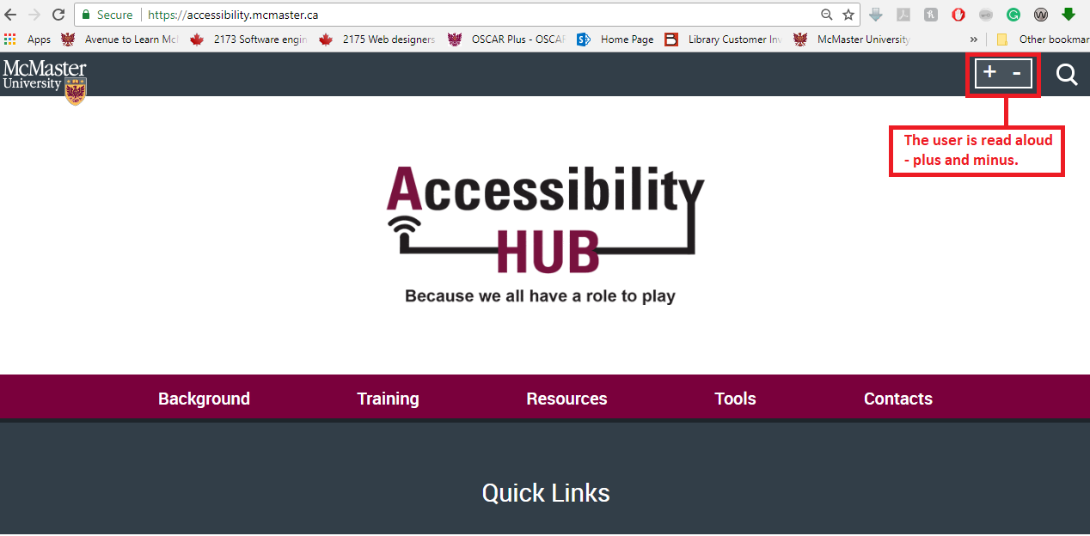
Conclusion: The user who is not able to visually recognize the icons will have to interpret the meaning of plus or minus because it is not explicitly named “zoom in” and “zoom out”.
Resolution: The function should read, “zoom in” and “zoom out”.

- The search functionality should be easy to use for all users, and particularly, users with various disabilities.
The search functionality of the Accessibility Hub is an integral part of the website. A good search functionality provides users a quick and easy way to find what they are looking for, making the overall experience positive.
- The search functionality should be the first option after the option of skip to navigation bar and main content (refer the screenshot below).
- The search box (vs. a search icon) should be present on the page so that the user is able to type their search item directly into the box. By creating a search box, one step is reduced for users, who would otherwise need to click on a search icon and then enter the search term. For non-disabled users, this extra step may not be hugely inconvenient, however, for users of AT, the elimination of this one extra step makes a significant difference in the amount of effort required to search the site.
- When a person uses Chrome Vox to click on or navigate with the search icon, the icon reads aloud, “search internal link”. This language is both unclear and inaccurate, as it may give the user the impression that the search icon is an internal link. Instead, it should read “search function” or something similar to this effect.

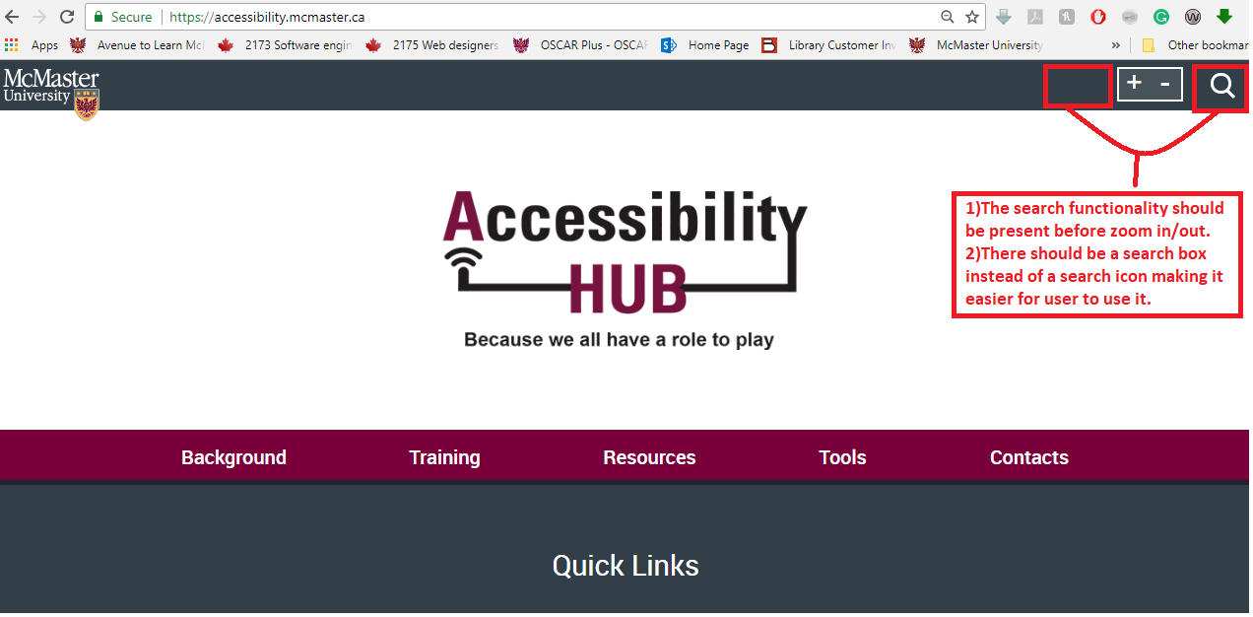
Resolutions:
- The search functionality should be the first option after the option of skip to navigation bar and main content
- The search icon should be a search box
- The search box should read aloud “search function” or “search box”

- All the required fields in a form should have a clear demarcation.
It is recommended that the Accessibility Hub and all McMaster websites should have a clear visual indication to make sure the user is aware that any given form on the site is a required field (e.g. a message under the field that reads “this field is required”). This will prevent the user from having to wait for an error message to return from the back-end servers if a form is incorrectly submitted due to a lack of demarcation. This change will improve user experience for all the users and reduces one step for users of specific AT who will otherwise fail to input a required field.
- The first observation is on the Contacts page, where the form at the bottom of the page has required fields that are not clearly demarcated.
- The second observation is that the “subject” form field should be made mandatory because the user can submit the form with only email ID rendering the functionality useless to the administrative team.
- The third observation is that a screen reader/read aloud software should read aloud appropriate text to the user while they are filling the form providing contextual information for every form field in the form.

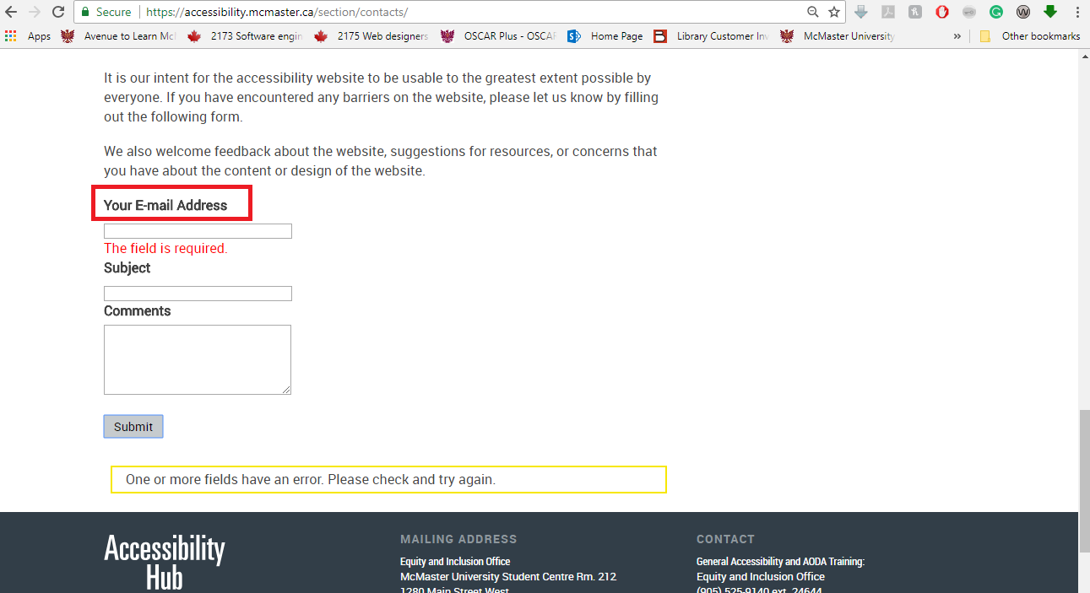
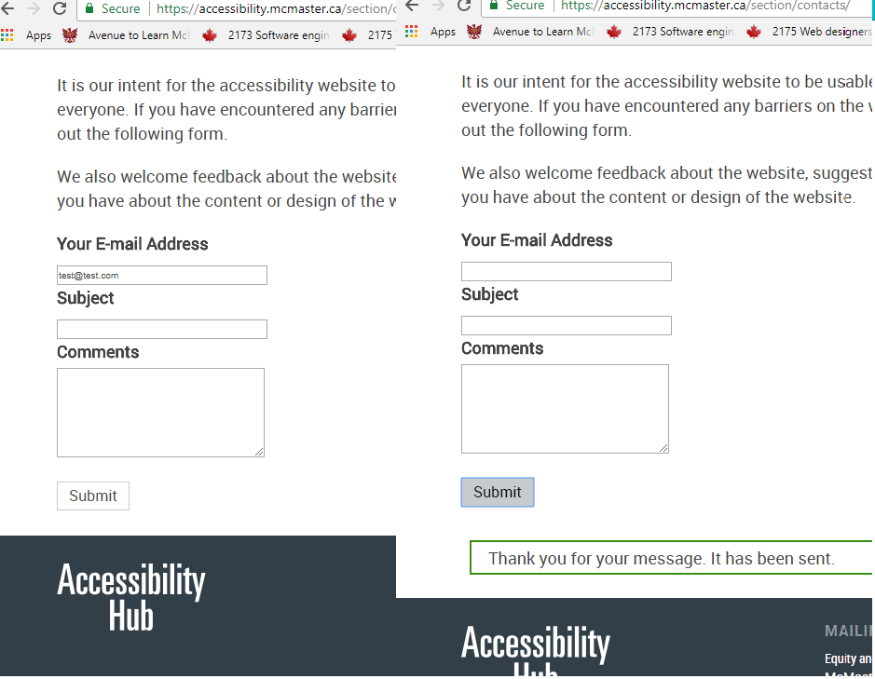
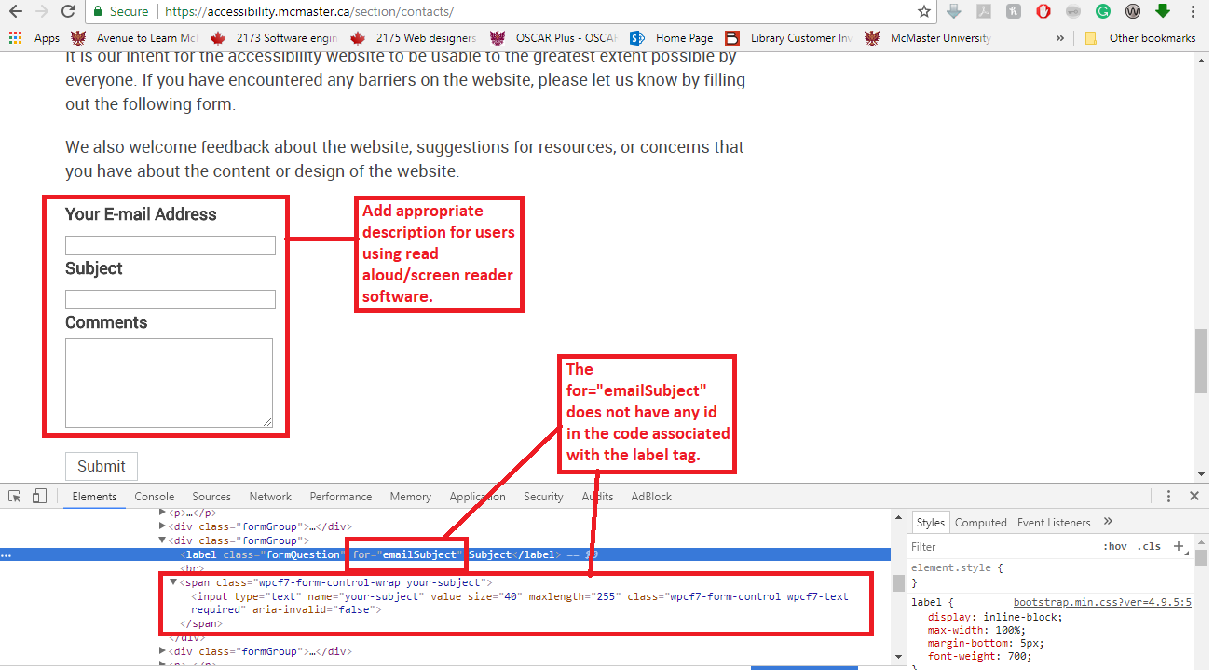
Resolutions:
- Add a clear demarcation for all the required fields.
- Add validation to make “Subject” form field mandatory.
- Add meaningful description to the entire form field.

- Every part of the page that can be accessed should have a visible focus.
This recommendation is for users of a range of AT, including read aloud, screen readers, keyboard navigation and Dragon Naturally Speaking (speech to text software). A visible focus helps users identify the current area they are navigating and helps them to decide to navigate forward or backward. A visible focus would give the user a clear idea of the current position of the cursor, making it easier and possible for all users to navigate the website.
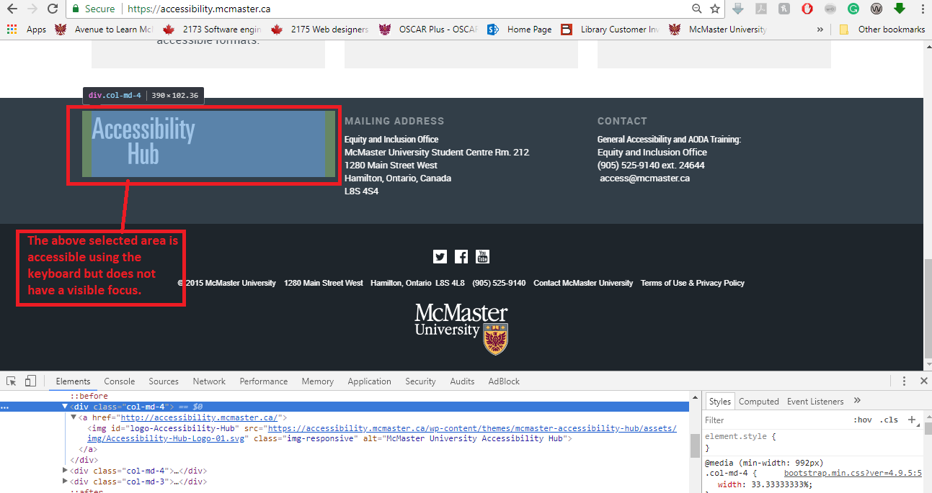
Resolution:
- Add visible focus to every section accessible using keyboard.

- All the external and internal links should have a description.
This recommendation is for users using read aloud or screen reader software, including Chrome Vox, which was used for testing this scenario.
- When navigating to any internal and external link, Chrome Vox only reads aloud “external link” or “internal link”, failing to provide any useful or meaningful information to the user, and rendering its functionality irrelevant.
- It was observed that when clicking on external links, the new page opens in the same tab, defeating the purpose of the external link. The link should be opened in a new tab.
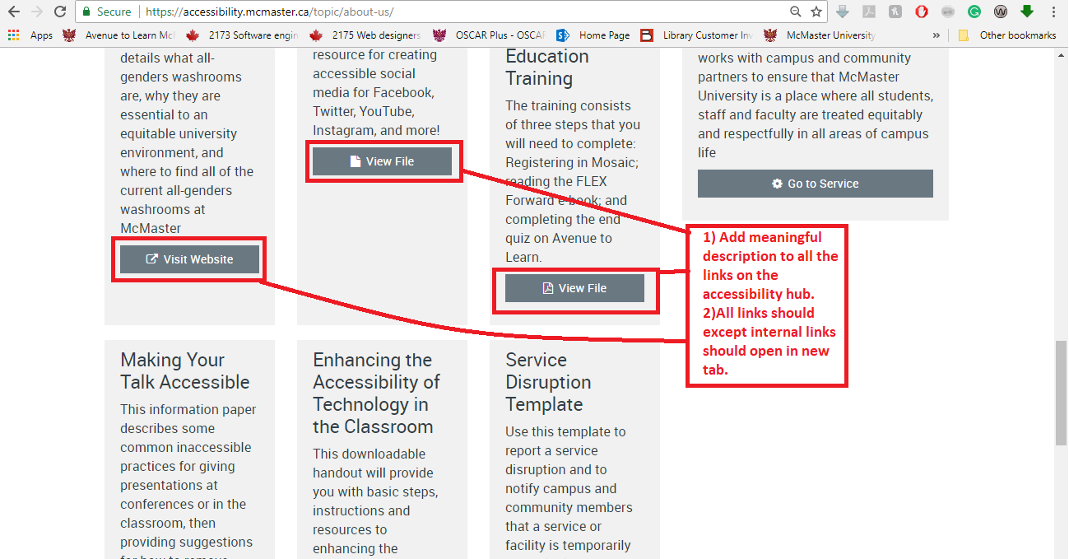

Resolutions:
- Add meaningful description to internal and external links to make navigation for users of certain AT possible.
- Have all external links open in new tabs.

- The colour contrast ratios should be compliant with WCAG 2.0 AA/ AODA standards (4.5:1 colour contrast for normal/small text and 3:1 for large text).
This recommendation is primarily for users with low vision/colour blindness, which can make distinguishing between the background colour and the actual content of the page difficult.
- Using https://webaim.org/resources/contrastchecker/ and Wave Checker to assess colour contrast ratios in the footer, the contrast failed to meet the 4.5:1 contrast ratio.
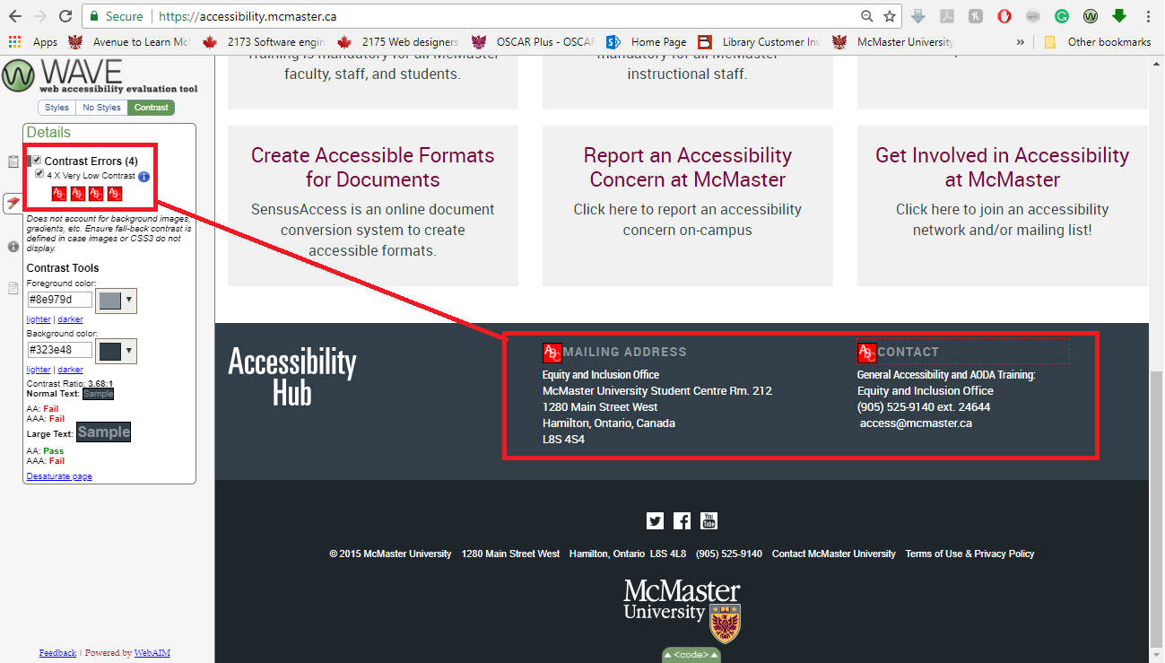

Resolution:
- Strengthen colour contrast in the footer (e.g. don’t put light grey on slightly darker gray, but perhaps white on dark grey) to meet a 4.5:1 ratio.

- The navigation bar should display the option selected in the main navigation bar.
This recommendation is for all users, as the above shouldn’t be confusing or unclear to any user.
- When the user clicks on one of the main navigation options and then clicks on the one of the sub-menu navigation options, the selection from the main navigation option is removed, making it difficult for the user to comprehend their current position in the Accessibility Hub.
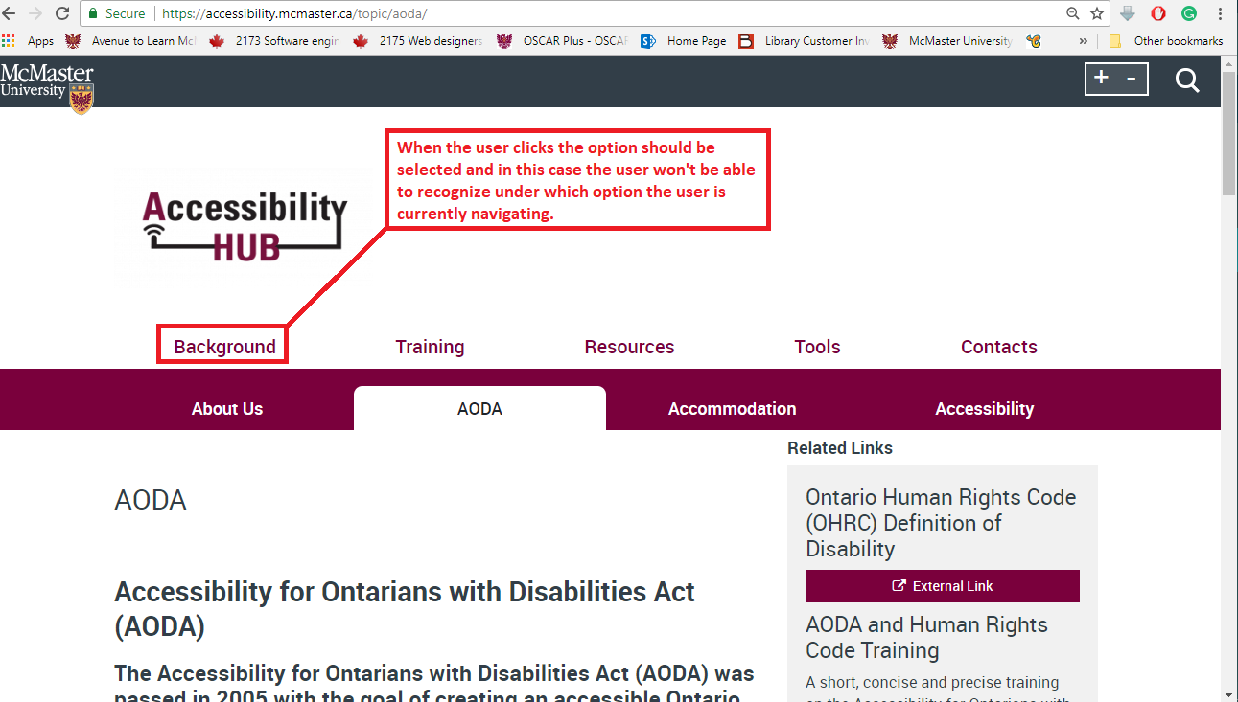
Resolution:
- Add highlighting for selected option in the main navigation bar.

- The user should have options of “skip to navigation bar” and “skip to right panel” in the header of the page.
This recommendation is primarily to remove barriers that would prevent total keyboard navigation of the website.
- When the user starts navigating from the top of the page using the keyboard, they should have an option to directly skip to the navigation bar or right panel (wherever a right panel is present) in the header section of the page.

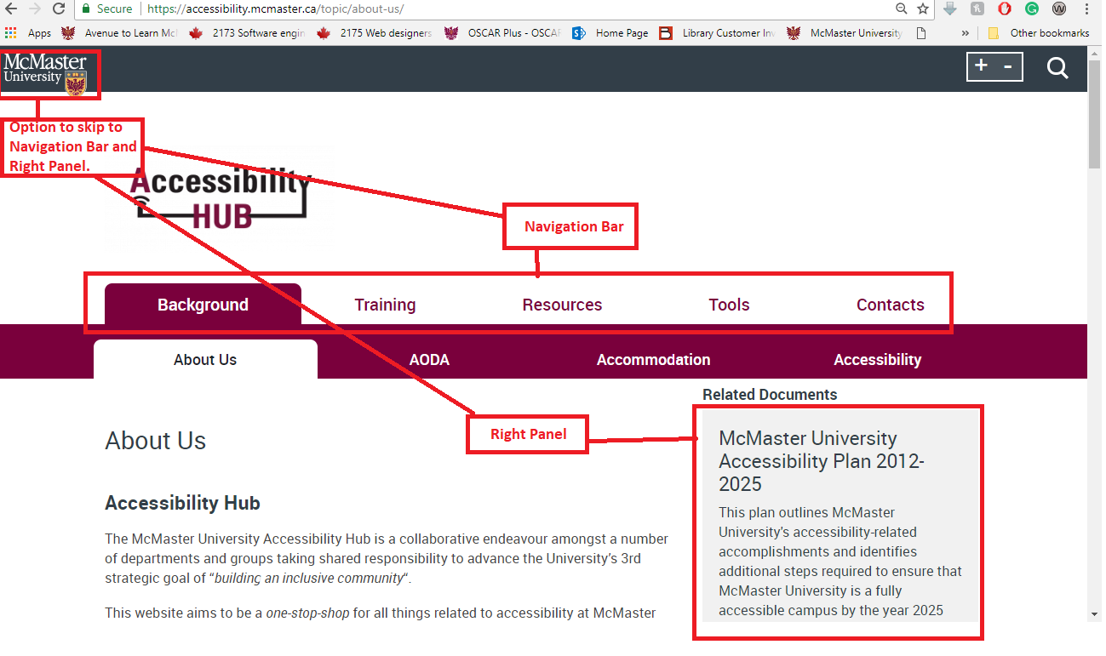

Resolution:

- Add an option of skip to navigation and skip to right panel in the header of the page.

- All important/essential information on the page should be accessible through navigation software (e.g. read-aloud, speech command, screen reader and keyboard software)
- The first observation is that when navigating the site using only the keyboard after the navigation bar, all headings in the main content area were bypassed (i.e. not registered as being there by the keyboard).
- The second observation is that all information in the main content area is not keyboard accessible (i.e. the keyboard would skip the information, instead jumping only to embedded links).
- The third observation is that all content, including headers, in the right panel is inaccessible.
- The fourth observation is that in the footer, the mailing address and the name of the contact office is not accessible to assistive technologies.
- Our fifth observation is that all the modals on the website (e.g. pop-up boxes of text, accordion text, and tiles of text containing information and embedded links) are not accessible to the user; even after adding an aria-label, these modals did not open after pressing Enter or space bar.
- The sixth observation is that the content within the modals is also not accessible.
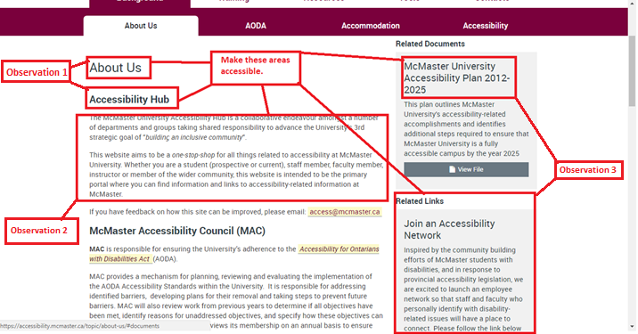

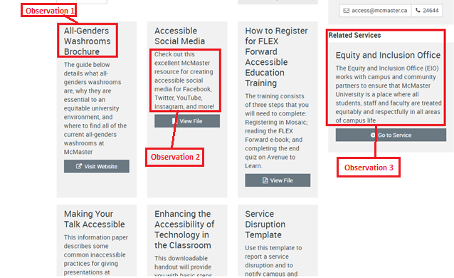
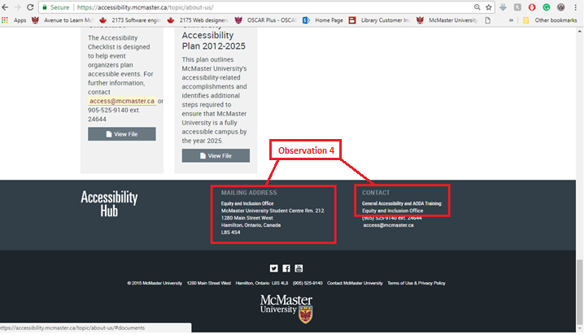
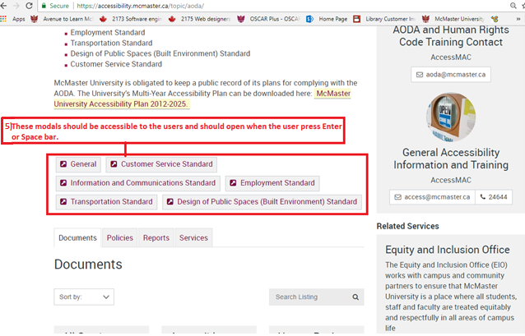
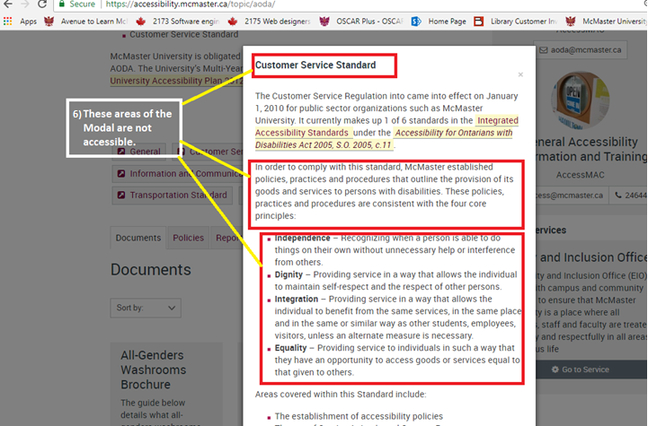

Resolution:
- Make all of the important parts of the page accessible by either using standard HTML tags or adding an aria-label to the current HTML tags.

- All icons, images or buttons on the page should be visible to the user.
  - It was observed that the banner on the home page does not have visible scroll (left or right) options. However, when the keyboard is used to navigate the banner, there is a visible focus for scrolling the banners.

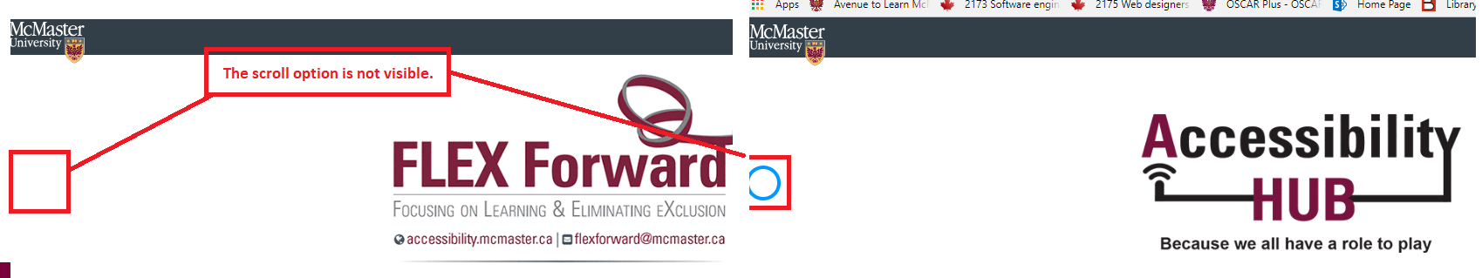

Resolution:
- Change or update all of the images, icons or buttons on the page to make it visible to the user.

- If the website is accessibility compliant, then the compliance claim should be present on the Accessibility Hub.
This recommendation is to include a compliance report on the Accessibility Hub, including any exceptions to WCAG 2.0 AA or AAA conformance standards (so that users are aware when they enter the site). This plain language report should provide information to the user about the accessibility of the website, including all assistive technologies the website supports and any features that may not be accessible to users using assistive technology. In addition to meeting our compliance responsibilities and ensuring fair access to information for all users, major search engines, such as Google, will promote and showcase accessible websites above inaccessible websites, placing them higher in general and specific search results.

Data: Test Cases Built, Replicated and Tested
Captured in the table below, the number of original test cases built totaled 33 and the number of test cases replicated for screen reader, read aloud, voice command, colour blind filter and keyboard navigation technology (across Mac and PC platforms) totaled 32.
Out of the 65 test cases conducted in total (original + replicated), 11 text cases passed and 54 failed. The reader should keep in mind that as a result of the initial high-level accessibility audit conducted prior to test case building, the user testing team anticipated which areas of the site would not meet WCAG 2.0 AA compliance requirements before building test cases. Test cases were therefore built and replicated specifically to highlight the areas of the site that required updating. This was done as a time saving measure and to ensure that priority areas of the site would be identified.

Table 1: Accessibility Hub Test Cases Built and Replicated; Pass or Fail
 | Types of AT | Original | Replicated | Pass | Fail | Total
Tester 1 | -Keyboard navigation -Chrome Vox read-aloud | 23 | 0 | 0 | 23 | 23
Tester 2 | -Chrome Vox read-aloud  -Colour Oracle | 2 | 17 | 0 | 19 | 19
Tester 3 | -Screen reader (observer/data input) | 0 | 8 | 2 | 6 | 8
Tester 4 | -Dragon Professional v. 15 | 8 | 7 | 9 | 6 | 15
Total |  | 33 | 32 | 11 | 54 | 65

Conclusion

McMaster University is committed to taking proactive measures to move accessibility forward and to meet internal and external compliance timelines set forth by the AODA. It will continue to take steps toward enhancing the inclusion of McMaster students, staff and faculty with disabilities. Accessibility is an ongoing process, whether applied to principles of website development, designing spaces, communication and employment practices, or building accessible and inclusive communities. This process is creative, dynamic, rooted in problem solving, engagement and re-engagement and is rarely ever “done”. It is one of the University’s goals to enhance website accessibility in order to meet WCAG 2.0 AA guidelines by January 1, 2021, in accordance with the AODA Communication Standard; however, McMaster will need to continue engaging with principles of accessibility and user experience to go beyond AODA expectations and truly make McMaster websites as accessible as possible to a broad and diverse audience. To do this, we must continue consulting and working with peoples with disabilities, many of whom are experts in naming which aspects of a site may be inaccessible (technically, navigation / logical order of information, accessibility of content, etc.), as a result of meeting repeated barriers to accessing online spaces on a continual basis.
The Accessibility Hub was used as a case study for this Report, focused upon primarily to become an exemplar accessible site at McMaster, but from which broad and specific takeaways can be gleaned and applied across all website development at the University. Collaboration across website development units, the McMaster Accessibility Council, the Equity and Inclusion Office, and in consultation with communities of peoples with disabilities is key to creating equitable and accessible social, physical, and online environments and to collectively realizing the University's goal of building an inclusive community.

Appendix A

Test Case: Sample Format

Title (short summary of the Test Case) – Platform (Mobile, Desktop, Tablet, Laptop) - Operating System Used (Mac\Windows) - Testing Software Used (Wave, OracleColor, Dragon, Chrome Vox, Head Mouse Extreme, No AT)

Description
Small Summary of Test Case

Test Case Id | Unique Id of Test Case eg. AA001 , SWH001,
Test Case Author | (Name of the Person Writing the Test Case)
Test Case Version | Version 1.0\2.0
Test Case Updated By | (Name of the Person Updating the Test Case)
Platform | Mobile\Desktop\Tablet\Laptop
Operating System | Windows\Mac
Environment | Testing Lab\ External Environment (home, student center)
Testing Software Used | Wave\OracleColor\Dragon\Chrome Vox
Test Case Executed By | Tester executing the Test case
Test Case Execution Date & Time | Date and time of Execution of Test Case
Tester with Disability | Yes\No
Type of Disability | (Mention the type of Disability of Tester)
Testing Environment | Production\ QA\ Pre-Production \ Development
Tester Type | Self\ Observer

Test Steps | Expected Results | Actual Observation | Status
Step 1 |  |  | Pass\Fail
Step 2 |  |  | Pass\Fail
Step 3 |  |  | Pass\Fail
Step 4 |  |  | Pass\Fail

Screenshots For Reference
(Attach screenshots of the above steps and highlight areas on the screenshots of the steps that have failed. Always include screenshots that would be useful to the end to draft the recommendations).
Step 1 :

Step 2: (Fail)

Test Case Status | Pass\Fail
Test Case Step Failed | (Mention the Steps that have Failed)  Step 2
Defect Impact | High\ Medium \ Low
Defect Priority | P0\P1\P3\P4

References

Accessibility for Ontarians with Disabilities (2005, c. 11). Retrieved from
https://www.ontario.ca/laws/statute/05a11

Jaeger, P. T. (2014). Internet justice: Reconceptualizing the legal rights of persons with disabilities to
promote equal access in the age of rapid technological change. Review of Disability Studies, 9(1).
Retrieved from http://www.rds.hawaii.edu/ojs/index.php/journal/article/view/71

McLaughlin, M. J., & Nolet, V. (2004). What every principal needs to know about special education.
Corwin, Thousand Oaks, CA.

WEbAIM. (2018). Accessibility and SEO. Retrieved from
https://webaim.org/blog/web-accessibility-and-seo/

Web content accessibility guidelines: WCAG 2.0. (2008, December 11). Retrieved from
https://www.w3.org/TR/WCAG20/

What is functional testing: A complete guide with its types and examples. (2018, June 7). Retrieved
from https://www.softwaretestinghelp.com/guide-to-functional-testing/

McLaughin and Nolet (2004, p. 98), define assistive technology (AT) as “any tool, device, or piece of equipment that can increase or improve the ability of a [person] with a disability to perform functions of daily living.” In the context of website accessibility, assistive technologies are a range of softwares and tools to ensure that there are multiple ways of engaging with websites, with the understanding that there is no one best or normal way to access online content. Some examples of assistive technologies include: screen reading programs, (JAWS or Window-Eyes); text-to-speech programs, (Chrome Vox); speech-to-text programs (or command speech programs), (Dragon); screen magnifiers; specialized mice (Mouse Grid or Head Mouse), and many more (Jaeger, 2014).
Please note that both “disabled persons/people” and “people/persons with disabilities” will be used interchangeably within this report to acknowledge individual’s preferred language of disability self-identification.
For example, a dotted or highlighted line around each section of the site that is able to be accessed with a mouse, keyboard or voice command.
See WEbAIM. (2018). Accessibility and SEO. Retrieved from https://webaim.org/blog/web-accessibility-and-seo/ for an in-depth discussion on how web accessibility and search engine optimization align.
Please contact Kate Brown, Accessibility Projects Coordinator, in the EIO to view or obtain copies of the entire dataset for the UTAWP at: access@mcmaster.ca.

