ASSESSING THREATS FACING SNAPPING TURTLES IN AN URBANIZED MARSH

Using SPATIAL approaches to examine threats facing common snapping turtles (Chelydra serpentina) in the urbanized Cootes Paradise Marsh, Lake Ontario

By

MORGAN L. PICZAK, Hons. B.Sc.

A Thesis Submitted to the School of Graduate Studies in Partial Fulfilment of the Requirements for Degree Master of Science.

McMaster University

© Copyright by Morgan. L. Piczak, September 2018

Master of Science (2018) McMaster University
Department of Biology Hamilton, Ontario, Canada
TITLE: Using spatial approaches to examine threats facing common snapping turtles (Chelydra serpentina) in the urbanized Cootes Paradise Marsh, Lake Ontario.
AUTHOR: Morgan L. Piczak, Hons. B. Sc. (McMaster University)
SUPERVISOR: Professor Patricia Chow-Fraser
NUMBER OF PAGES: cxxviii, 128

LAY ABSTRACT
Common snapping turtles (Chelydra serpentina) exhibit “slow” life history traits which make them particularly vulnerable to human activities, such as urbanization. In this thesis, I used demographic and road mortality information to provide evidence that the population of snapping turtles living in the degraded Cootes Paradise Marsh ecosystem has substantially declined over the past three decades. I also assessed current availability of nesting and overwintering habitat that are both essential for maintaining a viable population of snapping turtles. My results highlight the devastating effects road mortality can impart on long-lived freshwater reptiles, and cautions against further modification or destruction of their critical habitat.

GENERAL ABSTRACT
In Ontario, the common snapping turtle, Chelydra serpentina, is listed as Special Concern and is at risk of decline. These long-lived organisms are particularly susceptible to anthropogenic threats owing to delayed sexual maturity, low recruitment and reliance on low adult mortality. Threats facing this species include road mortality and habitat loss and/or destruction. These threats are anecdotally evident within Cootes Paradise Marsh, a highly urbanized river-mouth coastal marsh located in a heavily urbanized region at the western end of Lake Ontario. Straddling Dundas and Hamilton, the wetland is bisected by Cootes Drive, a four-lane highway (maximum speed 80 km/h) that has resulted in fatal collisions with wildlife. We re-analyzed data from previous capture-mark-recapture studies and determined that the snapping turtle population has declined by almost 90% from 1985 to 2002. Using road mortality survey data collected by citizen science group Dundas Turtle Watch, we determined that some of this decline can be attributed to road mortality. Through radio tracking, we also found that the population remains at risk to road mortalities because their home ranges overlap surrounding roads. Besides the direct negative effect of mortality, roads impart broader and additional unintended consequences by hindering turtles’ access to critical nesting and overwintering habitat. We acquired digital orthophotos to assess changes in availability of nesting habitat, which is crucial for recruitment and population maintenance. Potential nesting habitat decreased by almost 50% between 1934 and 2010. Through nest surveys conducted in 2017, we determined that there is currently disproportionate use of artificial gravel mounds for nesting. For overwintering purposes, snapping turtles appear to be using a wide range of habitat types within the upland terrestrial matrix of the wetland ecosystem. We also confirmed that sites used for overwintering did not cool below inhibiting temperatures between early December and end of March. This study illustrates the toll that road mortality can have on urbanized herpetofauna populations and highlights the importance of ensuring that recovery plans focus on restoring both the quantity and quality of nesting and overwintering habitats.

ACKNOWLEDGEMENTS
First, I would like to thank my advisor, Dr. Patricia Chow-Fraser for your continued support, patience, contagious spirit and for always having an open door. Your passion for ecology has been inspiring and I am grateful for all that I have learned from you. I would also like to thank my supervisory committee member, Dr. Jon Stone. Thanks for all your constructive feedback and for having the greatest lab website.
Special thanks to Chantel Markle, for passing on your love for turtles (even the ones that bite!), amazing field skills, advice and constant support over the past two years!
Thank you Alana Tedeschi, for making my time here so Unforgettable (featuring French Montana) and spending too many Fridays at Che (the limit does not exist???). Here’s to many more Bud Light king cans shared together at cottages, bars, concerts, new countries or wherever really, cheers Luna! Thanks to Nick Luymes for proving that scientists can be intelligent, have sweet moves and be dank. Just because my degree here is over, doesn’t mean that I won’t be sharing more memes with you two in the future.
Thanks so much to the whole PCF lab for the encouragement, helping me in the field (even though Cootes isn’t as glamorous as Georgian Bay) and for the support. I know my time at McMaster would not have been nearly as enjoyable without you guys! Thanks Dan Weller, Prabha Rupasinghe, James Marcaccio, Steve Savoie, Lindsey Boyd, Stuart Campbell, Tim Law and Jordan DeBoer. Jacqueline Garnett, despite being fall prone, you made the best field assistant I could have ever hoped for!!! Even when #1or #2 went missing, you were always up for the challenge and flooded waders never bothered you (too much!).
Thanks so much to my all field volunteers, specifically Samantha Sinclair and Peter Morley. Also Leigh Licursi, the MBA-turned-scientist! Dylan Melmer, thanks for helping me with stats whenever I showed up at your house or called you on FaceTime.
Shane de Solla and Christine Bishop, I am appreciative of your advice, support and guidance throughout my whole journey!
I am grateful for the support of the Hamilton Conservation Authority, specifically Lesley McDonnell, Lisa Jennings and Colin Oaks. Thanks to the Royal Botanical Gardens and Sarah Richer for your support and constant enthusiasm. David Galbraith thank you for helping set the stage for snapping turtle research in Cootes Paradise and for your encouragement throughout my degree. Dundas Turtle Watch, all their passionate volunteers, Joanna Chapman and JoAnne Haynes, thank you.
Thanks so much to my family! Dad, thanks for all the rides, dropping your own work to read anything I sent you and for helping me live in an “and” world. Mom, sorry I turned your brand new RAV-4 into a field-mobile and turtle ambulance (the turtles probably didn’t look appreciative, but I know they were). Thanks to you I was able to help save 4 turtles!!! Shout out to Paige, ESKITIT. Finally, thanks to Winston for your unrelenting love, you are missed dearly.
Chris, thank you for your continuous encouragement, support and for helping me in the field. I now know that the lady turtles love you as much as I do.
TABLE OF CONTENTS
LAY ABSTRACT iii
GENERAL ABSTRACT iv
ACKNOWLEDGEMENTS vi
LIST OF FIGURES xi
LIST OF TABLES xiv
LIST OF ALL ABREVIATIONS AND SYMBOLS xvi
DECLARATION OF ACADEMIC ACHIEVMENT xviii
Chapter 1: General Introduction 1
Freshwater Turtles 1
Focal Species 2
Study Site 3
Threats and Trade-offs 4
Thesis Objectives 6
Literature Cited 8
Chapter 2: Impact of a highly urbanized landscape on a population of common snapping turtles (Chelydra serpentina) in western Lake Ontario 13
Abstract 14
METHODS 17
Site description 17
Field Methods 18
Statistical Analysis 19
Road Mortality and Population Census Data 20
RESULTS 24
DISCUSSION 28
Recommended Management Actions 32
ACKNOWLEDGEMENTS 34
LITERATURE CITED 35
Tables and Figures 41
Chapter 3: Assessment of critical habitat for common snapping turtles (Chelydra serpentina) in an urbanized coastal wetland. 48
Abstract 49
Introduction 50
Methods 54
Site description 54
Nesting Habitat 55
Overwintering Habitat 57
Results 59
Nesting Habitat 59
Overwintering Habitat 61
Discussion 62
Acknowledgements 68
Literature Cited 69
Table and Figures 78
Chapter 4: General Conclusion 90
Summary 90
Recommendations for management 91
Future Avenues for Research 93
Literature Cited 96
Appendix: First ranavirus case and associated mortality in a common snapping turtle (Chelydra serpentina). 98
Abstract 99
Introduction 100
Materials and Methods 102
Study Site 102
Background 103
Histopathology and Bacteriology 104
Molecular 104
Results 105
Gross Findings 105
Histopathology Findings 105
Bacteriology Findings 107
PCR Findings 107
Discussion 107
Acknowledgments 113
Literature Cited 114
Figures 123

LIST OF FIGURES
Figure 2.1 Location of Cootes Paradise Marsh within the Laurentian Great Lakes (inset). Sampling locations in western Cootes Paradise Marsh are surrounded by highly urbanized areas. WP = West Pond, DC = Desjardins Canal, BC= Borer’s Creek, SC = Spencer’s Creek, P1 = Pond 1, P2 = Pond 2. Cootes Drive is the four-lane highway directly bisecting the wetland. 43
Figure 2.2 (a) Estimated snapping turtle population size with Poisson confidence intervals in the western portion of Cootes Paradise Marsh from 1985 to 2002. The open circle shows the total number of snapping turtles encountered in 2017 (t). (b) Annual estimation of the lower (M_{l}) (white circles) and upper (M_{u}) (grey circles) adult mortalities from 1985 to 2016 (Eq. 3 and Eq. 4), as well as the annual estimation of mortalities using current road mortality rates (M_{c}) (Eq. 7) (black circles). 44
Figure 2.3 Results from incremental area analysis demonstrate an asymptotic shape, indicating a sufficient number of relocations from each turtle had been acquired to conduct home range analyses. 45
Figure 2.4 Minimum convex polygon (MCP) of population range (estimated by the 100% MCP) and core range (estimated by 50% MCP) for the snapping turtle population in western Cootes Paradise Marsh. Both the population and core range estimates are shown to overlap with surrounding roads (Cootes Drive, King Street East and Olympic Drive). 46
Figure 2.5 Linear regression of number of adult snapping turtles found on the road versus number of surveys completed by Dundas Turtle Watch annually (r² = 0.59, p = 0.02). 47
Figure 3.1 Location of sampling locations in Cootes Paradise Marsh and surrounding upland habitat. Cootes Paradise Marsh open water, WP = West Pond, DC = Desjardins Canal, BC = Borer’s Creek, SC = Spencer’s Creek, HCA 1 = Hamilton Conservation Authority 1, HCA 2 = Hamilton Conservation Authority Pond 2. Inset shows the location of CPM within the Laurentian Great Lakes. 84
Figure 3.2 Diagram of breakpoint analysis (a) completed on water temperatures. Onset date was identified as the first breaking point and overwintering (OW) duration is the total length of times between breaking points one and two. Variation in air temperature (b) from October 27th 2017 to March 30th 2018 in CPM. 85
Figure 3.3 Change in area of potential nesting habitat in CPM presented as (a) absolute amount of habitat types (ha) and (b) relative amount of habitat types (%). 86
Figure 3.4 Change in Lake Ontario mean annual water level (above sea level), arrow shows year of Lake Ontario water level regulation implementation (1963) and open circles show years of interest. 87
Figure 3.5 Results of a change detection analysis showing changes in the amount of potential nesting habitat in CPM between1934 and 2010. 88
Figure 3.6 Location of temperature loggers in wetland habitat during October 2016 to March 2017, October 2017 to March 2018 and location of tagged snapping turtles between October 2017 to March 2018. 89
Figure A1.1 The Laurentian Great Lakes are located in Canada (A) and Cootes Paradise Marsh is located in the extreme western end of Lake Ontario (B). Within Cootes Paradise Marsh, a snapping turtle infected with ranavirus was found in West Pond (C). 123
Figure A1.2 (A) Severe palpebral and rostral swelling and (B) epidermal ulceration on the lateral neck, both symptoms are consistent with those of a ranavirus infection. 124
Figure A1.3 A photomicrograph of necrotic and edematous conjunctiva from a snapping turtle with a ranaviral infection. Hematoxylin and eosin stain. 125
Figure A1.4 A photomicrograph of a palpebral blood vessel with fibrinoid necrosis characterized by hyalinized hypereosinophilic matrix segmentally effacing the wall and karyorrhectic debris. Hematoxylin and eosin stain. 126
Figure A1.5 A photomicrograph of the spleen of a snapping turtle with a ranavirus infection has been entirely effaced by necrosis, fibrin and hemorrhage. Hematoxylin and eosin stain. 127
Figure A1.6 An electromicrograph of the icosahedral iridovirus particle from the liver of a snapping turtle. 128

LIST OF TABLES
Table 2.1 Findings from Dundas Turtle Watch road mortality surveys conducted on Cootes Drive, Olympic Drive and King Street East. We used the lowest number of observed dead adult turtles (m) from 2009 to estimate the lowest (M_{l}) and highest number of encountered adult turtles (s) from 2012 to estimate the upper (M_{u}) adult road mortalities from 1984 to 2002. 41
Table 2.2 Basic descriptions of tagged turtles with corresponding movement information during 2017. Size of home range (HR) and core range (CR) was estimated by Minimum Convex Polygon. See Fig. 1 for locations of site codes where turtles were first tagged. 42
Table 3.1 Dates of orthophotos used in this study to map potential nesting habitat for snapping turtles in CPM. Resolution refers to size of pixel. 78
Table 3.2 Potential nesting habitat types in CPM based on manually classified orthophotos using the Ecological Land Classification for Southern Ontario. 79
Table 3.3 Overwintering habitat types based on the Ecological Land Classification for Southern Ontario, which based on literature are considered to be overwintering habitat for snapping turtles. 80
Table 3.4 Results from the change detection analysis including a matrix of change in habitat types from 1934 to 2010 including each type of habitat lost or gained. 81
Table 3.5 Proportion of potential nesting habitat surveyed versus nesting observations. 82
Table 3.6 Comparison of water temperatures during the winters of 2016/2017 and 2017/2018, for sites where tagged turtles had been present during the winter (Confirmed = Y), and where they had not (Confirmed = N). A representative plot of temperatures for each site type is shown, along with the mean date of onset of low temperatures, mean overwintering duration, mean water temperature during the period of low temperatures, and the mean number of days in which temperatures were below 0.6 °C (mean days below). 83

LIST OF ALL ABREVIATIONS AND SYMBOLS
BC Borer’s Creek
BLAST Basic Local Alignment Search Tool
BP Base pairs
CPM Cootes Paradise Marsh
°C Degrees Celsius
DC Desjardins Canal
DO Dissolved oxygen
DTW Dundas Turtle Watch
FV3 Frog virus 3
GIS Geographic information system
GPS Global positioning unit
HCA Hamilton Conservation Authority
m Total number of observed adult snapping turtle deaths in a single year
MSB Martius scarlet clue
MCP Minimum convex polygon
M_{l} Lower estimation of total adult snapping turtle mortalities
M_{u} Upper estimation of total adult snapping turtle mortalities
M_{c} Estimation of total adult snapping turtle mortalities using the current mortality rate
OW Overwintering
p Snapping turtle population estimate from 2002
PCR Polymerase chain reaction
RBG Royal Botanical Gardens
r_{u} Upper mortality rate
r_{l} Lower mortality Rate
r_{c} Mortality rate that would have occurred for the 2002 population estimate to decline to the total number of snapping turtles we encountered in 2017
s Total number of adult snapping turtles observed during a single year
SC Spencer’s Creek
SCL Straight carapace length
SWOOP Southwestern Ontario Orthophotography Project
t total number of snapping turtles captured in 2017
WP West Pond
WSCA Wildlife scientific collectors’ authorization
y Years

DECLARATION OF ACADEMIC ACHIEVMENT
This thesis is formatted as a “sandwich thesis” which consists of four chapters and an appendix. Chapter 1 is a general introduction to the thesis. Chapters 2 and 3 are manuscripts that have been submitted for publication to peer reviewed scientific journals. Chapter 4 consists of a general conclusion. The appendix is also a manuscript that is being prepared for submission.
For the second chapter Chantel Markle and I planned the radio tracking data collection, which I subsequently executed. Road mortality data were collected by the citizen science group, Dundas Turtle Watch, and capture-mark-recapture data were collected by David Galbraith and Shane de Solla. I performed analyses on all data with Dr. Patricia Chow-Fraser. I completed all writing with supervision from Dr. Patricia Chow-Fraser, while Chantel Markle provided comments and edits.
For the third chapter I collected all nesting, overwintering and water temperature data and then completed all analyses and writing under the guidance of my advisor, Dr. Patricia Chow-Fraser.
The Appendix is additional work that I completed during my tenure. I encountered the sick turtle during routine surveys and transported it to Hobbitstee Wildlife Refuge; subsequent to its death, Christina McKenzie completed the histopathology under the supervision of Claire Jardine. Heindrich Snyman (British Columbia Ministry of Agriculture) performed the PCR analyses to confirm ranavirus infection. Christina and I wrote the manuscript and were provided with feedback and comments from all authors.

Chapter 1: General Introduction

Freshwater Turtles
On a global scale, reptile populations are declining at an alarming rate (Gibbons et al., 2000) and turtles are among the most endangered taxonomic groups in the world (IUCN, 2013; Marchand and Litvaitis, 2003). Some of the main threats facing herpetofauna include introduced invasive species, diseases, environmental pollution, unsustainable use, global climate change, habitat loss and degradation (Gibbons et al., 2000). For freshwater turtles, loss and degradation of critical habitat resulting from human encroachment and development has become the most insidious threat to their persistence in an ever-urbanizing world (COSEWIC, 2008).
Ontario’s eight species of native freshwater turtles are all listed “at risk” (COSEWIC, 2018). In Ontario, the common snapping turtle, Chelydra serpentina, is identified as Special Concern and is at risk of decline due anthropogenic threats and their life history strategies (Congdon et al., 1994; COSEWIC, 2008). These prehistoric and long-lived organisms have a “bet hedging” life history that includes reliance on low adult mortality, delayed sexual maturity and low annual recruitment (Congdon et al., 1994). These life history strategies make common snapping turtles extremely vulnerable to anthropogenic threats where even small increases in adult mortality can result in observable population declines (Brooks et al., 1990; Congdon et al., 1994; Midwood et al., 2015; Zimmer-Shaffer et al., 2014). A high adult survivorship is required to maintain populations (Baxter-Gilbert et al., 2015, Haxton, 2000); however, all life stages should be considered when attempting to conserve a population (Marchand and Litvaitis, 2003). Therefore, to preserve a population and minimize risk of extirpation, it is essential to achieve adequate recruitment, reduce number of adult mortalities and maintain habitat conditions (Brooks et al., 1991). Since these animals are so long lived (upwards of 100 years; COSEWIC, 2008), it is often difficult in short-term studies to determine effects of anthropogenic threats that usually take many decades to be manifested (Dekker, 2015).

Focal Species
Common snapping turtles are Canada’s largest freshwater turtle and are an important vector between aquatic and terrestrial ecosystems (COSEWIC, 2008). This species is highly recognizable due to its unique morphological features including olive colour, large body, slightly rounded carapace, powerful hooked upper jaw, strong limbs with webbed feet and long tail with three rows of tubercles (Pritchard, 1979). Adult male snapping turtles are larger than females and the species exhibit sexual dimorphism (White and Murphy, 1973). Common snapping turtles range from the United States up to southern Canada and east of the Rocky Mountains (Dekker, 2015). General habitat includes a variety of permanent bodies of freshwater with soft mud bottoms, specifically marshes, ponds, lakes and reservoirs (Pritchard, 1979). Threats to snapping turtles include mortality from fishing, persecution, nest depredation, illegal harvesting, environmental contaminants/pollution, invasive species (common reed, Phragmites australis and red-eared slider, Trachemys scripta elegans), habitat alteration/destruction and road mortality (COSEWIC, 2008). Legal harvesting has also been a threat to common snapping turtles; until recently, the daily limit was 2 adults but beginning in April 2017, Ontario placed a permanent ban on hunting this species (Fish and Wildlife Conservation Act, 1997). Additionally, First Nation’s people are still permitted to hunt common snapping turtles. The hunting of common snapping turtles within Ontario may have contributed to population decline.
Common snapping turtles are of ecological, cultural and scientific significance. Ecologically speaking, their eggs provide important nutrition to meso-predators (including raccoons (Procyon lotor), red foxes (Vulpes fulva), coyotes (Canis latrans), striped skunks (Mephitis mephitis) and Virginia opossums (Didelphis virginiana)) (Urbanek et al. 2016) while these species are raising their young, which is an important time in life history. Additionally, hatchlings are a food source to many vertebrate species in lentic and terrestrial ecosystems (COSEWIC, 2008), and this provides an ecological connection between these functionally disparate habitats (Crump et al., 2016). Snapping turtles, which can live longer than humans, are familiar to many Canadians, who often have stories and personal connections to the species (COSEWIC, 2008). They are also of great cultural significance to the First Nation peoples of Canada. Finally, this species holds particular scientific interest due to their anoxia adaptions (Ultsch, 2006) and how they occupy a wide range of aquatic habitat (Paterson et al., 2012).

Study Site
Cootes Paradise Marsh (CPM) is a 250 ha highly urbanized river mouth coastal marsh situated in the extreme western end of Lake Ontario (Chow-Fraser, 1998). It is surrounded by Hamilton to the south, Dundas to the west and Waterdown to the northeast, and land within its watershed has been subjected to urban and agricultural development (Thomasen and Chow-Fraser, 2012). Once a lush emergent marsh, CPM has become degraded by high water turbidity and dominated by non-native fish and plant species (Lougheed et al., 2004). West Pond, positioned in the western portion of CPM, historically supported a very dense population of common snapping turtles (Galbraith et al., 1988). Cootes Drive is a four-lane highway/arterial (maximum speed of 80 km/h) road that bisects the western portion of CPM, connecting Hamilton and Dundas. Anecdotal evidence suggests that the high-volume-high-speed highway and other surrounding roads (Olympic Drive and King Street East), have fragmented critical habitat for turtles and have forced them to access other habitat by crossing roads and becoming vulnerable to road mortality. Additionally, adjacent lands around the marsh have been subjected to anthropogenic modifications over the past century, which may have altered their critical habitat (specifically nesting and overwintering habitat).

Threats and Trade-offs
The life cycle of freshwater turtles makes them particularly vulnerable to road mortality as they need to cross roads to forage, disperse from natal sites, locate basking sites, migrate between seasonal habitats, seek out mates and identify nesting sites (Ashley et al., 2007; Aresco, 2005a; Gibbs and Shriver, 2002). Their slow movements increase their time spent on roads and place them at risk of desiccation while crossing (Andrews et al., 2008). Direct effects of roads are primarily injuries from collision and road mortality, as well as death via associated construction processes such as burying or blasting (Andrews et al., 2008). The ‘zone of impact’ of a road can extend up to 2 km beyond the edge of the shoulder (Aresco, 2005b) and can result in habitat loss/degradation, barriers to movement/gene flow (Aresco, 2005a), pollution, noise, light and increased transmission of invasive species (Andrews et al., 2008). Females are at particular risk of road mortality due to their terrestrial migrations and are often attracted to road sides to nest (DeCatanzaro and Chow-Fraser, 2010). Due to their “slow” life history traits, common snapping turtles are particularly susceptible to the effects of road mortality, which is capable of substantially decreasing populations (Haxton, 2000).
Critical habitat is used for overwintering, migration, feeding, rearing and reproduction, which are all essential life history functions (Government of Canada, 2009). Identifying critical habitat and determining the spatial distribution of a population are key steps when forming mitigation and management strategies (Markle, 2017). In urban areas, such as CPM, it is also important to understand the effect that anthropogenic threats may have on critical habitat. For snapping turtles, nesting habitat supports recruitment, while overwintering habitat is crucial for survival; ultimately, both contribute to population persistence.
Selecting a suitable nest site is one of the last investments female turtles make during the reproductive process (Pappas et al., 2013) and oviposition site can have important phenological implications for hatchlings, including survival, development and growth (Kolbe and Janzen, 2002). Suitable nesting habitat for snapping turtles includes open areas with exposed sun, relatively loose substrate and sparse vegetation to ease digging (Thompson et al., 2017). Although turtles are able to exploit modified environments due to increased open canopies and soft substrate (Marchand and Litvaitis, 2003), often there is decreased reproductive success and increased nest depredation (Thompson et al., 2017).
Viable overwintering habitat can mean the difference between life and death to individual snapping turtles (Paterson et al., 2012). During the winter, snapping turtles are at risk of dying via freezing, being eaten by meso-predators, or succumbing to lactic acidosis from low dissolved oxygen (DO) levels (Brown and Brooks, 1994). Snapping turtles confront a trade-off when selecting overwintering sites: sites within the water column normally have higher DO, but are colder, while sites in the mud have lower DO, but are warmer (Brown and Brooks, 1994). Selecting sites that attend to these competing needs are crucial to snapping turtle survival and population maintenance.

Thesis Objectives
In this study, we examine threats facing common snapping turtles in the urbanized CPM. To form effective mitigation and conservation plans, it is essential to identify threats at the appropriate temporal and spatial scales. In Chapter 2, we investigated how road mortality on surrounding roads, including Cootes Drive, Olympic Drive and King Street East, has affected the population and may be used to explain the population decline over the past three decades. In Chapter 3, we assessed changes in availability of critical habitat (nesting and overwintering habitat) for the snapping turtles in CPM. The overall goal of this study is to provide a current status of the population, identify threats that may have contributed to the overall decline in the West Pond population, and inform the development of recovery strategies for this at-risk population by assessing current availability of critical habitat for nesting and overwintering.

Literature Cited
Andrews, K. M., Gibbons, J. W., Jochimsen, D. M. and Mitchell, J. (2008). Ecological effects of roads on amphibians and reptiles: a literature review. Herpetological Conservation 3:121–143.
Aresco, M. J. (2005a). The effect of sex-specific terrestrial movements and roads on the sex ratio of freshwater turtles. Biological Conservation 123:37–44.
Aresco, M. J. (2005b). Mitigation measures to reduce highway mortality of turtles and other herpetofauna at a north Florida lake. Journal of Wildlife Management 69:549–560.
Ashley, E. P., A. Kosloski, and S. A. Petrie. (2007). Incidence of intentional vehicle–reptile collisions. Human Dimensions of Wildlife 12:137–143.
Baxter-Gilbert, J. H., Riley, J. L., Lesbarrères, D. and Litzgus, J. D. (2015). Mitigating reptile road mortality: fence failures compromise ecopassage effectiveness. PLoS ONE 10:e0120537.
Brooks, R. J., Brown, G. P. and Galbraith, D. A. (1991). Effects of a sudden increase in natural mortality of adults on a population of the common snapping turtle (Chelydra serpentina). Canadian Journal of Zoology 69:1314-1320.
Brown, G. P. and Brooks, R. J. (1994). Characteristics of and fidelity to hibernacula in a northern population of snapping turtles Chelydra serpentina. Copeia 1994:222-226.
Chow-Fraser, P. (1998). A conceptual ecological model to aid restoration of Cootes Paradise Marsh, a degraded coastal wetland of Lake Ontario, Canada. Wetland Ecology and Management 6:43–57.
Committee on the Status of Endangered Wildlife in Canada [COSEWIC]. 2018. Canadian Turtles in Trouble. Available from: https://www.newswire.ca/news-releases/canadian-turtles-in-trouble-681525251.html
Committee on the Status of Endangered Wildlife in Canada [COSEWIC]. 2008. COSEWIC assessment and update status report on the snapping turtle Chelydra serpentina in Canada. Committee on the Status of Endangered Wildlife in Canada, Ottawa, Canada.
Congdon, J. D., Dunham, A. E. and van Loben Sels, R. C. (1994). Demographics of Common Snapping Turtles (Chelydra Serpentina): Implications for Conservation and Management of Long-Lived Organisms. American Zoologist 34 (3):397-408.
Crump, P.S., Robertson, S.J. AND Rommel-Crump, R.E. (2016). High incidence of road-killed freshwater turtles at a lake in east Texas, USA. Herpetological Conservation and Biology 11(1):181-187.
DeCatanzaro, R. and Chow-Fraser, P. (2010). Relationship of road density and marsh condition to turtle assemblage characteristics in the Laurentian Great Lakes. Journal of Great Lakes Research 36:357-365.
Dekker, C. D. (2015). Population and status assessment of the snapping turtle Chelydra serpentina in North Dakota. Masters of Science Thesis, University of Idaho.
Fish and Wildlife Conservation Act. (1997). Ontario Regulation 670/98. Open Seasons.
Galbraith, D. A., Bishop, C. A., Brooks, R. J., Simser, W. L. and Lampman, K. P. (1988). Factors affecting the density of populations of common snapping turtles (Chelydra serpentina). Canadian Journal of Zoology 66:1233-1240.
Gibbs, J. P. and Shriver, W. G. (2002). Estimating the effects of road mortality on turtle population. Conservation Biology 16(6):1647-1652.
Gibbons, J. W., Scott, D. E., Ryan, T. J. et al. (2000). The Global Decline of Reptiles, Déjà Vu Amphibians. BioScience 50(8):653-666.
Government of Canada. (2009). Species at risk public registry. Available from http://www.sararegistry.gc.ca/sar/index/default_e.cfm
Haxton, T. (2000). Road mortality of snapping turtles, Chelydra serpentina, in Central Ontario during their nesting period. Canadian Field-Naturalist 114(1):106-110.
IUCN. (2013). International Union for Conservation of Nature. Available from http://www.iucn.org/
Loughleed, V. L., Theysmeyer, R., Smith, T. and Chow-Fraser, P. (2004). Carp exclusion, food-web interactions, and the restoration of Cootes Paradise Marsh. Journal of Great Lakes Research 30(1):44-57.
Kolbe, J. J. and Janzen, F. J. (2002). Impact of nest-site selection on next success and nest temperature in natural and disturbed habitats. Ecology 83(1):269-281.
Marchand, M. N. and Litvaitis, J. A. (2003). Effects of landscape composition, habitat features, and nest distribution on predation rates of simulated turtle nests. Biological Conservation 117:243-251.
Markle, C. E. (2017). Landscape-level conservation of freshwater turtles. Doctor of Philosophy Thesis, McMaster University.
Midwood, J. D., Cairns, N. A., Stoot, L. J., Cooke, S. J. and Blouin-Demers, G. (2014). Bycatch mortality can cause extirpation in four freshwater turtles. Aquatic Conservation: Marine and Freshwater Ecosystems 25:71-80
Pappas, M.J., J.D. Congdon, B.J. Brecke, and S. Freedberg. (2013). Orientation of freshwater hatchling Blanding's (Emydoiea blandingii) and Snapping Turtles (Chelydra serpentina) dispersing from experimental nests in agricultural fields. Herpetological Conservation and Biology 8:385‒399.
Paterson, J. E., Steinberg, B. D. and Litzgus, J. D. (2012). Generally specialized or especially general? Habitat selection by Snapping Turtles (Chelydra serpentina) in central Ontario. Canadian Journal of Zoology 90:139-149.
Pritchard, P. C. H. (1979). Encyclopedia of turtles. T.F.H. Publications, Neptune, New Jersey.
Thomasen, S. and Chow-Fraser, P. (2012). Detecting changes in ecosystem quality following long-term restoration efforts in Cootes Paradise Marsh. Ecological Indicators 13:82-92.
Thompson, M. M., Coe, B. H., Congdon, J. D., Stauffer, D. F. and Hopkins, W. A. (2017). Nesting ecology and habitat use of Chelydra serpentina in an area modified by agricultural and industrial activity. Herpetological Conservation and Biology 12:292-306.
Ultsch, GR (2006) The ecology of overwintering among turtles: where turtles overwinter and its consequences. Biological Review 81:339-367.
White, J.B., and G.G. Murphy. (1973). The reproductive cycle and sexual dimorphism of the common Snapping Turtle, Chelydra serpentina serpentina. Herpetologica 29:240-246.
Zimmer-Shaffer, S.A., Briggler, J.T. and Millspaugh, J.J. (2014). Modeling the effects of commercial harvest on population growth of river turtles. Chelonian Conservation and Biology 13(2):227-236.

Chapter 2: Impact of a highly urbanized landscape on a population of common snapping turtles (Chelydra serpentina) in western Lake Ontario

*Morgan L. Piczak, Chantel E. Markle and Patricia Chow-Fraser

McMaster University
Department of Biology
1280 Main Street West, Hamilton, ON
L8S 4K1

*Corresponding author, piczam1@mcmaster.ca, 905-525-9140 EXT 27461

Keywords: road mortality; home range; population census; Cootes Paradise Marsh
Presented in manuscript format and has been submitted to Chelonian Conservation and Biology.

Abstract. —
Cootes Drive is a 2.5 km four-lane highway connecting the town of Dundas to the City of Hamilton that bisects wetland habitat used for nesting and overwintering by common snapping turtles (Chelydra serpentina). We hypothesized that turtle mortality from collision with vehicles on Cootes Drive has caused a decline in the population as turtles attempt to access habitat on both sides of the road. Capture-mark-recapture studies confirmed a dramatic decline in the turtle population from 791 individuals in 1985 to 112 individuals in 2002. Concurrently, human population in Dundas has grown by 25% and traffic volume on Cootes Drive is relatively high (the 2016 volume was 17,000+ cars •d⁻¹). Using 2009-2016 road mortality data obtained from citizen-science group Dundas Turtle Watch, we derived a current adult mortality rate of 3.3%; applying this rate, we estimated that a total of 527 adult snapping turtles may have died due to vehicular collisions since 1985. Based on radio tracked data (6 males and 4 females) and analyses, majority of the tagged turtles crossed the road at least once, with a mean of 3 road crossings per turtle. At the individual level, 7 of the 10 tracked turtles had home ranges that overlapped with Cootes Drive, while both the population and core range overlapped with the road. Our findings support the hypothesis that road mortality has contributed to the dramatic decline in the snapping turtle population in recent decades. As a step towards recovery, exclusion fencing must be installed for an extended distance along both sides of Cootes Drive to prevent turtles from crossing the road and promote use of existing aquatic culverts.

INTRODUCTION
The extensive and dense road network that currently exists in southwestern Ontario means that virtually all wildlife species exist within 1.5 km of a road (Gunson 2010). Road networks pose a threat to biodiversity (Beaudry et al. 2012; Clevenger et al. 2003; Findlay and Houlahan 1997) and particularly to herpetofauna (Andrews et al. 2008; Gibbs and Shriver 2002) by causing point source mortalities (Baxter-Gilbert et al. 2015). For instance, freshwater turtles are attracted to roads for nesting and thermoregulation (Garrah 2012), and often have large home ranges that may require individuals to cross roads to access habitats for mating or overwintering (Ashley et al. 2007; Langen et al. 2009). Since turtles move slowly, they spend more time on roads than do fast-moving fauna and are therefore more vulnerable to road mortality (Dodd et al. 1989; Garrah 2012). Additionally, freshwater turtles’ life cycle makes them particularly vulnerable to road mortality as they need to cross roads to forage, disperse from natal sites, locate basking sites, migrate between seasonal habitats, seek out mates and find nesting sites (Ashley et al. 2007; Aresco 2005a; Gibbs and Shriver 2002). A road’s so-called ‘zone of impact’ can extend up to 2 km beyond the edge (Aresco 2005b) and can result in negative effects such as habitat loss and fragmentation, reduced gene flow (Aresco 2005a; Crawford et al. 2014; Findlay and Houlanhan 1997), noise and light pollution, as well as increased transmission of invasive species (Andrews et al. 2008). Road mortality may act as a threat on such a large spatial scale that entire populations may experience unsustainable increases in mortality and subsequent decreases in reproductive output (Beaudry et al. 2010). Therefore, it is essential to determine the scale of a threat in order to advance appropriate and effective mitigation strategies.
Life history traits such as delayed maturity and low reproductive rate, and behaviours including high site fidelity (to nesting and overwintering sites), make the negative impacts of roads extremely difficult to overcome for the snapping turtle (Chelydra serpentina; COSEWIC 2008). Snapping turtles exhibit bet-hedging life history traits that rely on low adult mortality to sustain populations (Baxter-Gilbert et al. 2015; Haxton 2000). Given the rate that cities have sprawled, and agricultural lands have developed over the past half a century, the associated growth of road networks would likely have destroyed and fragmented critical habitat for these populations and resulted in high road mortality (DeCatanzaro and Chow-Fraser 2010).
We investigate the influence of road mortality on a large population of snapping turtles in Cootes Paradise Marsh, residing on the western edge of Lake Ontario (Galbraith et al. 1988). Although the sub-population located in West Pond has been well studied since the mid-1980s, the primary foci of past studies have been on effects of persistent toxic substances on the health and associated effects on reproductive capacity of snapping turtles (Bishop et al. 1998; de Solla et al. 1998; de Solla et al. 2008). The focus of our study, however, will be on the risk to snapping turtles posed by increased traffic volume on surrounding roads and Cootes Drive, a four-lane highway, that directly bisects the marsh. We hypothesize that traffic on Cootes Drive and adjoining roads has led to high road mortality rates that may explain the overall decline in the snapping turtle population in West Pond over recent decades. We will use capture-mark-recapture studies conducted to obtain population estimates of snapping turtles in Cootes Paradise Marsh and road mortality surveys to estimate adult road mortality between 1985 and 2016. Finally, we will use radio tracking data from 10 adult snapping turtles to estimate their home ranges and examine interactions with surrounding roads. The overall goal of this study is to provide a current status of the population, identify threats that may have contributed to the overall decline in the West Pond population and to inform the development of recovery strategies for this at-risk population.

METHODS
Site description. —
Our study took place in Cootes Paradise Marsh (CPM), a 250-ha anthropogenically degraded river mouth coastal marsh in the extreme western end of Lake Ontario (Chow Fraser et al. 1998; Chow-Fraser 2005). Although CPM is situated in a highly urbanized landscape, the marsh is provincially significant owing to its high aquatic and terrestrial biodiversity (Chow-Fraser 1998; Loughleed et al. 2004), including some at-risk species of marsh birds (i.e. Least bittern, Ixobrychus exilis, Smith and Chow-Fraser, unpub. data) and reptiles. The population of common snapping turtles has been studied in CPM since the mid 1980s, primarily in West Pond (WP; Fig. 1; Galbraith et al. 1988). Our study focuses on the western part of CPM, which includes West Pond, Spencer’s Creek, Borer’s Creek, and two ponds located on land owned and managed by the Hamilton Conservation Authority (P1 and P2; Figure 2.1). The marsh complex is completely surrounded by urban lands including the towns of Dundas, Flamborough, Ancaster and the City of Hamilton. Cootes Drive is a four-lane highway (posted limit of 80 km/h) constructed in 1936 that bisects the wetland complex at the western end and is a main artery from Hamilton to Dundas with high traffic volume (> 17,000 vehicles per day in 2016; City of Hamilton Traffic Department 2018; Figure 2.1).
Some management actions have been implemented to mitigate the road mortality along Cootes Drive. At the end of 2017, a small portion on the eastern side of the road (just over 300 m) was completely fenced with chain link (i.e., on both sides of the road), while 700 m west of Spencer’s Creek Bridge was partially fenced with Animex (fencing only on the south side of Cootes Drive; Figure 2.1). Approximately 2000 m of Cootes Drive, Olympic Drive, and King Street East remain completely unfenced. There are currently two concrete aquatic culverts below Cootes Drive that could serve as eco-passages for turtles, one under the Spencer’s Creek Bridge and the other at the western terminus of the Animex fencing, which could connect marsh habitat on either side of Cootes Drive (see Figure 2.1).

Field Methods. —
We opportunistically caught 10 adult common snapping turtles (6 males, 4 females) by hand in April 2017. We collected biometric data and determined the sex of the turtle with the length ratio of the bottom two plastron scutes compared to the pre-cloacal length (Petokas 1979). We fitted each turtle with a radio transmitter (10 g; Lotek Wireless, Newmarket, ON, Canada) using epoxy putty and ensured that 1) the total weight of the transmitter and epoxy putty did not exceed 5% of the turtle’s total body weight and 2) that the attachments were coloured black to provide camouflage. Immediately after tagging, we released each snapping turtle at their initial capture site. Throughout the 2017 and 2018 season, we used a 3-element Yagi antenna (Wildlife Materials International, Murphysboro, IL, USA) and a Lotek Biotracker Receiver (Lotek Wireless, Newmarket, ON, Canada) to relocate tagged turtles. Radio tracking was conducted from April to September 2017 and from April to June in 2018 to ensure that each individual was located at least once per week. Each time a turtle was re-located, we recorded the GPS location and type of habitat occupied by each turtle.

Statistical Analysis. —
We conducted an incremental area analysis to determine data sufficiency prior to calculating home range area for each radio tracked individual. The home range (based on 100% Minimum Convex Polygon (MCP)) of 3 locations was first calculated and then re-calculated for each subsequent location added. The home ranges were plotted against the number of locations until an asymptotic slope could be visually confirmed. According to Jaeger and Cobb (2012), at least 30 points are required to reach this asymptote to indicate a sufficient number of relocations has been achieved. To determine the population range, we included locations of all untagged snapping turtles that we encountered during our surveys, including those of adults and juveniles.
We estimated home ranges at the individual and population level using an extension of R 3.3.2 (version 5.0, R Core Team, 2018) called Reproducible Home Range (Signer and Balkenhol 2015) in ArcGIS 10.5 (ESRI, Redlands, CA, USA). Estimations of individual home ranges did not include nesting migrations of the tagged female turtles. MCPs were calculated at the 50% (core range) and 100% (home range) level for individuals and the population. We also calculated population and core range for behavioural seasons in 2017: pre-nesting (April 1–June 12), nesting (June 13–July 4) and post-nesting (July 5–September 20). Pre-nesting season was defined as the period when we started radio tracking to the time when the first nest site is identified during nesting surveys. The nesting season was delineated by the period when the first and last nests were found during surveys. Post-nesting season began after the last day of the nesting season and until the first day of the overwintering period (determined from a graph of thermal data from December 2017 to March 2018 (see Chapter 3)).
We used the intersect tool in ArcGIS 10.5 to calculate the amount (ha) of overlap between individual and population ranges with Cootes Drive, King Street East, and Olympic Drive. Based on chronology of data points, we determined the number of “presumed road crossings” which we defined as an instance when a turtle was found on one side of the road and then on the opposite side when radio tracked. We refer to this as a presumed road crossing because we do not have locational data showing that the turtle had actually travelled over the road or under the road via culverts.

Road Mortality and Population Census Data. —
Dundas Turtle Watch (DTW) is a long standing and well recognized citizen-science program that monitors wildlife road mortality on Cootes Drive and surrounding roads. This program has been operational since 2009 and volunteers walk a designated route to survey Cootes Drive, Olympic Drive, and King Street East (Figure 2.1). In addition to recording any deceased wildlife on the road, volunteers assist animals across the road if they happen to find them crossing, thereby averting road mortalities. In 2009 and 2010, the survey route was completed biweekly from June to September, but by 2011, they were completed at least weekly through the summer. Inconsistency in the program’s survey effort during the earlier years likely resulted in an underestimation of road mortality occurrences. We performed a linear regression analysis to examine the relationship between survey effort and total adult snapping turtles found on roads.
We also assembled census data to determine how snapping turtle population size has changed over recent decades. The data were from previous capture-mark-recapture studies that had been conducted in West Pond during 1985 (Galbraith et al. 1988), 1994, 1995, 2002, 2006, 2007, and 2008 (de Solla, unpublished data). In brief, hoop nets were baited with sardines for 14 consecutive days in June and July, during which seven days were used for capture and marking and seven days for recapture. Snapping turtles were either notched or marked with metal tags. We also conducted our own capture-mark-recapture studies in 2017 using the same methods. We used data from these recapture studies and the Lincoln-Petersen method (Lincoln, 1930) to estimate population size. The upper and lower 95% Poisson confidence intervals were calculated for all population estimates.
The Lincoln-Petersen method assumes that a) the population is closed (no immigration or emigration, no births or deaths), b) all animals are equally likely to be captured, c) use of nets and marking the turtles do not affect their catchability, d) that nets are set randomly throughout the study area, e) markings on turtles are not lost and f) all markings are recorded correctly (Krebs, 1989). While most of these six assumptions were likely met during each of the capture mark recapture studies, we are aware that first assumption may have been violated since some turtles may have emigrated into West Pond during these survey periods to access nesting habitat (Galbraith et al. 1988).
Using road mortality survey data (2009–2016; Table 2.1) provided by DTW, we estimated an upper (r_{u}) and lower (r_{l}) mortality rate to approximate the number of adult snapping turtles that could have died from road mortality between 1985 to 2002 (M). To determine the lower estimate of total deaths (M_{l}), we used the lowest number of observed adult deaths across all survey years (m). For the upper estimate (M_{u}), we summed the highest number of total observed turtles (dead and alive) encountered on the road during a single survey years (s) (Table 2.1). This included averted mortalities because without volunteer intervention, these turtles likely would have died while crossing four lanes (Aresco 2005b). The lower (r_{l}) annual mortality rate was derived by dividing the lower number of observed deaths (m) by the snapping turtle population from 2002 (p) (Eq. 1). Then the upper (r_{u}) annual mortality rate was derived by dividing the number of observed turtles (s) by the snapping turtle population from 2002 (p) (Eq. 2). We applied both lower and upper annual mortality rates to the population in 1985 (P_{y}) and each subsequent year (P_{y+1}) to estimate the lower and upper estimate of the historic population from 1985 to 2002. In the equations below, y is the year.
Eq. 1 Historic annual population (lower estimate): P_{y+1} = P_{y} $-$ $[(m)/p$] * P_{y}]
P_{y+1} = P_{y}$-$ [r_{l} * P_{y}]
Eq. 2 Historic annual population (upper estimate): P_{y+1} = P_{y}$-$ $[(s)/p$] * P_{y}]
P_{y+1} = P_{y} $–$ [r_{u} * P_{y}]
To determine a lower (M_{l}) and upper (M_{u}) estimate for the adult road mortalities we applied the annual mortality rates (r_{l} and r_{u}) to each year (1985-2017) to derive corresponding estimates of population size (Eq. 1 and Eq. 2) and then summed all mortalities to estimate a lower (M_{l}) and upper (M_{u}) total number of adult road mortalities (Eq. 3 and Eq. 4).
Eq. 3 M_{l} = Σ r_{l} * P_{y}
Eq. 4 M_{u} = Σ r_{u} * P_{y}
There were some assumptions associated with the estimation of the lower (M_{l}) and upper (M_{u}) adult road mortalities. First, we assumed that traffic volume and mean speed on the surveyed roads has not changed over time. Secondly, we also assumed constant rates of adult road mortality throughout the study period. When determining the upper estimate (M_{u}), we had to assume that all turtles that had been brought safely across the road by DTW volunteers would have died trying to cross it. We also assumed that the same individual had not been saved more than once. We do not know the extent to which these assumptions were violated, but they would have inflated mortality estimates.
We also determined the current mean mortality rate (r_{c}) that would have occurred in order for the 2002 population estimate (p) to decline to the total number of snapping turtles that we encountered (t) in 2017 (Eq. 5), expressed on a per annum basis (y; 2017 minus 2002).
Eq. 5 r_{c} = (p–t)/y
From there, we applied the current mortality rate (r_{c}) to the 1985 population (P_{y}) and each subsequent year (P_{y+1}) to arrive at an alternate approximation of the turtle population from 1985 to 2017.
Eq. 6 Historic annual population using current mortality rate: P_{y+1} = P_{y} $–$ [r_{c}* P_{y}]
We applied the current mortality rates (r_{c}) to each year (1985-2017) to derive corresponding estimates of population size (Eq. 6) and then summed all mortalities to estimate a total number of adult road mortalities (M_{c}) (Eq. 7). This calculation estimated the adult road mortalities based on current mortality rates.
Eq. 7 M_{c} = Σ r_{c} * P_{y}

RESULTS
The western end of CPM is located close to the town boundary of Dundas and the marsh is rimmed by several busy roads, including Cootes Drive (see Figure 2.1), which in 2016 had a mean daily traffic volume of >17,000 vehicles (City of Hamilton Traffic Department 2018). The population in Dundas has grown steadily over the past three decades, increasing by 25% from 20,000 to 25,000 between 1980 and 2010. Over this same period, the estimated snapping turtle population in western CPM declined by almost 90%, from 791 individuals in 1985 to only 112 in 2002 (Figure 2.2a). We could not include the 2006, 2007 or 2008 capture-mark-recapture data by de Solla (unpublished data) or our data from 2017 because the number of marked recaptures was insufficient (only one marked recapture in 2006 and none in 2007, 2008 or 2017). According to Krebs (1989), an insufficient number of marked recaptures results in an unreliable population estimate when using the Lincoln-Peterson method. Although we were unable to obtain a population estimate in 2017, we encountered 65 individual snapping turtles in western CPM during that year.
The 10 snapping turtles we tracked during 2017 and 2018 included 4 females and 6 males. We collected a minimum of 30 relocations per turtle (mean of 34.5 relocations; Table 2.2). Based on the asymptotic shape of curves in the incremental area analysis (Figure 2.3), we were satisfied that we had adequately re-located all tagged individuals during the study period to estimate a valid home range for each. At the population level, we had 411 locations from the tracking program, and 101 locations that were from encounters with additional untagged turtles during 2017 and 2018. Using this information, we calculated a population range of 288.8 ha and a core range of 22.8 ha (Figure 2.4). Both population and core ranges overlapped with surrounding roads including Cootes Drive, Olympic Drive, and King Street East.
Excluding migrations during the nesting season, the mean female ranges (core range and home range of 1.0 and 15.3 ha, respectively) were smaller than those of the males (core range and home range of 12.4 and 49.9 ha, respectively; Table 2.2). When males and females are pooled, three individual core ranges overlapped with surrounding roads; one individual’s core range overlapped with Olympic Drive, while those of two others overlapped with Cootes Drive. By comparison, seven individual home ranges overlapped with surrounding roads (i.e., home range of five males and two females overlapped with Olympic Drive, Cootes Drive and King Street East). Majority of the home ranges overlapped portions of surrounding roads that were either unfenced or only partially fenced. The mean number of presumed road crossings was 3 per turtle; during the 2017 and 2018 seasons, 8 turtles crossed at least one road (Table 2.1). A greater number of males (n = 5) crossed roads than did females (n = 2), and the total number of presumed crossings was also higher for males (mean = 3.8 ± 3.4 SE) than for females (mean = 1.8 ± 2.3 SE).
In general, majority of snapping turtles that had been caught in the southern Hamilton Conservation Area ponds (Ponds 1 and 2) moved north towards CPM after capture; by comparison, all turtles originating from West Pond remained there and did not cross Cootes Drive during the active season. Nevertheless, two males that had been caught in WP moved throughout the Desjardins Canal during the study and their home range overlapped extensively with Olympic Drive; based on this, we surmise that they might have crossed the roads on numerous occasions.
Throughout the pre-nesting, nesting, and post-nesting behavioural seasons, the population and core range overlapped with different portions of surrounding roads. Overlap between population core range and roads was highest during the nesting season (1.8 ha) compared to the pre- and post-nesting seasons (1.2 and 0.7 ha, respectively). Throughout all behavioural seasons, the population core ranges overlapped directly with the portion of Cootes Drive that is currently unfenced or only partially fenced (Figure 2.1). Similarly, the majority of the population and all individual turtle home ranges overlapped with roads where there was no fencing or just partial fencing (see Figure 2.1).
Between 2009 and 2016 inclusive (7 years), the lowest number of observed dead adults was 1 (m). The highest number of observed turtles encountered on the road including dead (m) and live adults was 12 in 2012 (s). The lower annual mortality rate (r_{l}) was calculated to be 0.9%, which was obtained by dividing the lowest number of observed dead adults (1) by the capture-mark-recapture data that estimated the population size in 2002 (112; p). The upper annual mortality rate (r_{u}) was estimated to be 10.0%, which was obtained by dividing the highest number of total adult deaths observed on the road (s) by the 2002 population size (112; p).
Next, we applied the upper and lower annual mortality rates (r_{l} and r_{u}) to the 1985 census (P_{y} = 791) to estimate a range of mortalities and did this to all subsequent census data. Using this approach, we estimated that at least 220 (M_{l}) and at most 773 (M_{u}) adult snapping turtles may have died due to vehicular collisions between 1985 and 2017 (Figure 2.2b). There was a significant negative relationship between mortality and survey effort (r² = 0.59, p = 0.02; Figure 2.5). Assuming no other immigration or emigration, the current annual mortality rate (r_{c}) would have been 3.3% for a population of 112 snapping turtles in 2002 to decline to the 65 (t) individuals we encountered in 2017. Applying the current mortality rate (r_{c}) (3.3%), we estimated that a total of 527 adult snapping turtles may have died due to vehicular collisions.

DISCUSSION
The snapping turtle population in western Cootes Paradise Marsh (CPM) had once been one of the densest populations in Ontario (66 ind•ha⁻¹ in the mid 1980s; Galbraith et al. 1988) with an estimated population of 791 in 1985. By the early 2000s, the population had declined by almost 90% to 112. If in subsequent years, the population had continued to decline beyond 100, then according to the assumptions of the Lincoln-Petersen method, the capture-mark-recapture data would not have yielded data to calculate a reliable estimate of the West Pond sub-population (Krebs, 1989). The unacceptably low number of recaptured turtles in 2006, 2007, 2008 and 2017 supports this contention. The negative correlation of the linear regression also supports a population decline because even though survey effort increased throughout time, the number of turtles encountered continued to decline. Despite this decline, this population is still likely one of the largest in urban centers within Lake Ontario.
Though we were unable to reliably estimate the population due to insufficient number of captures, we conducted exhaustive surveys on a weekly basis during the summer of 2017 and found 65 individual common snapping turtles in western CPM. Assuming no other immigration or emigration, the 2002 turtle population (112) would have declined annually by 3.3% to reach a population of 65 turtles by 2017. This mortality rate is low compared to the estimated upper mortality rate of 10.0% (r_{u}), but is higher than the estimated lower mortality rate of 0.9% (r_{l}). Since there is a significant negative relationship between mortality and survey effort (r² = 0.59, p = 0.02; Figure 2.5), upper mortality rates (i.e. 10.0%) derived from the DTW surveys were likely overestimates in the earlier years, since volunteers did not monitor as frequently then as they did after 2014. Previous studies examining harvest on snapping turtles determined that mortality rates higher than 2.3% would result in a population decline (Zimmer-Shaffer et al. 2014). There is high likelihood that the actual mortality rates in western CPM exceeded this threshold, even though we estimated rates as low as 0.9%. Therefore, we attribute the large decline in the turtle population to on-going road mortality on Cootes Drive and Olympic Drive following the period of urban expansion in the town of Dundas in the 1990s.
Despite the relatively small human population of 25,000, the traffic volume on Cootes Drive exceeds 17,000 vehicles per day (City of Hamilton, 2018). This traffic volume does not include the number of cars on adjacent roads (i.e. Olympic Drive and King Street East). Most other studies that have examined road mortality of turtle populations reported substantially lower traffic volumes, ranging from a few thousand cars per day (Ashley and Robinson 1996; Crump et al. 2016; Garrah et al. 2015; Glista et al. 2008) to almost 14,000 cars per day (Langen et al. 2009). The only study reporting higher traffic volumes than ours (> 21,500 vehicles per day; Aresco 2005b) occurred in Lake Jackson, Florida, where only 2% of the turtles crossing a four-lane highway made it across without getting hit by a vehicle (Aresco 2005b). Therefore, it is not surprising that the snapping turtles on Cootes Drive faced certain death when they tried to access habitat on opposite sides of Cootes Drive, especially since 2.7% of drivers have been found to intentionally hit turtles in southern Ontario (Ashley et al. 2007).
We do not have direct evidence of turtles crossing Cootes Drive because we did not have any GPS-enabled tracking devices, and the chance of observing them crossing the road is very low because of their dwindling numbers. We must therefore infer from radio tracked movement data that turtles crossed over or under a road, when we find them on opposite sides of the road over a relatively short period (at most one week). During 2017 and 2018, seven of the ten tagged snapping turtles crossed roads surrounding CPM, and did so at least once during the active season. It is clear that radio tagged turtles used habitat on both sides of Cootes Drive. This is consistent with other studies in which turtle populations used both sides of a road sandwiched by wetland habitats (i.e.., Aresco 2005b; Baxter-Gilbert et al. 2015; Haxton 2000). In fact, in a Georgian Bay population, only 27% (6 of 22) of tagged turtles had home ranges that overlapped with surrounding roads (Baxter Gilbert et al. 2015), and this is substantially lower than seven out of ten of tagged turtles in this study. Additionally, a previous study conducted in CPM in 1995 also reported that the home range of female snapping turtle overlapped with Cootes Drive (Pettit et al. 2015), thereby indicating our population had been at risk for multiple decades.
We determined that the mean home range size of the snapping turtles in CPM was 36.0 ha, which is substantially larger than those reported in most other studies, in which home ranges of snapping turtles ranged between 0.65 and 11.3 ha (i.e. Brown 1992; Obbard and Brooks 1981; Pettit et al. 1995). The exception is the mean home range of 47.9 ha for a population in Algonquin Provincial Park (Paterson et al. 2012). The relatively large home range sizes for snapping turtles in CPM is potentially due to the highly degraded wetland that is surrounded by urban areas. The degraded habitat might be the reason that snapping turtles must venture long distances to acquire resources, and we recommend that a proper study be initiated to examine the relationship between habitat quality and home range size for common snapping turtles.
There is well documented evidence that even a small increase in natural adult mortality could decrease population size dramatically (Aresco 2005b; Brooks et al. 1991; Congdon et al. 1994; Midwood et al. 2015; Zimmer-Shaffer et al. 2014). Midwood et al. (2015) found that loss of a single adult female snapping turtle per year could decrease the population to zero within just 200 years. Furthermore, Congdon et al. (1994), found that an increase in snapping turtle mortality by 0.1 adult per year could halve a population in just 20 years. We estimate that at the peak, the number of adult turtles dying from road mortality could have ranged between 8 and 80 annually from 1985 to 2017. It is very difficult for snapping turtle populations to compensate for the loss of adults via anthropogenic stress and these situations can put populations in danger of extirpation (Cunnington and Brooks 1995).
We estimated that a substantial number of adult snapping turtles could have died on surrounding roads in recent decades; however, due to variation in survey frequency across years, we likely overestimated adult mortality rates in earlier years. We must balance this bias against other circumstances that may lead to underestimates. For instance, our estimates do not account for eventual mortalities of animals that manage to crawl off the road after colliding with cars (Dodd et al 1989). Scavengers and road maintenance (i.e. mowing) can also reduce the number of carcasses encountered during surveys and lead to an underestimation of mortality (Crump et al. 2016).
Besides road mortality, the snapping turtle population could have been reduced by a number of other threats including persistent toxic substances present in CPM, which can result in decreased hatching success, increased deformities (de Solla et al. 1998) and abnormal development in snapping turtle hatchlings (Bishop et al. 1998). Additionally, prior to April 2017, Ontario permitted the legal hunting of up to two adult snapping turtles per day (Fish and Wildlife Conservation Act 1997). Other potential threats pertaining to CPM include persecution by people, high nest depredation by meso-predators that are common in urbanized areas, water-quality pollution (from the sewage treatment facility at the western end of the Desjardins Canal), loss and fragmentation of critical habitat, effects of invasive plant species, as well as infection/disease (COSEWIC, 2008). Therefore, besides road mortality, many of these other threats and/or combinations of threats could have contributed to the substantial decline in turtle population over the past three decades.
Future studies should examine the effect of other potential threats on this severe snapping turtle population decline in the western portion of CPM. Since snapping turtles do not respond to density dependent threats with an increase in recruitment or immigration, they often have a very slow recovery following population declines (Brooks et al. 1991). Moreover, loss of adults not only lowers overall population size, it also decreases recruitment and reproductive output. For example, adult diamondback terrapin survival exerted the highest influence on population growth and minimizing adult road mortality was deemed to be one of the most important components in recovery plans (Crawford et al. 2014).

Recommended Management Actions
The population of snapping turtles in western CPM is at high risk of being killed or injured by cars along unfenced and partially fenced roads because of the large overlap between individual and population ranges with adjacent roads, including Cootes Drive, with a relatively high daily traffic volume. To reduce further road mortality along this road, it is imperative that complete exclusion fencing (on both sides of the road) be installed in areas within the population range. Markle et al. (2017) has shown that only complete fencing mitigated against collisions with cars, and that partial fencing actually increased turtle abundance on roads by 6% compared to no fencing (Markle et al. 2017). Since the integrity of exclusion fencing is extremely important (Markle et al, 2017; Baxter-Gilbert et al. 2015), we do not recommend using silt fencing or geotextile plastic because of their relative fragility and vulnerability to damage (ultraviolet damage, holes and rips) (Aresco 2005b; Baxter-Gilbert et al. 2015; Markle et al. 2017). Although durable fencing material/design has high upfront costs, they are known to be more effective and longer lasting than the fragile brands/options of fencing currently employed. Should fence integrity be compromised and allow turtles to access the road, they may become entrapped by the fencing, and become exposed to additional risk (Markle et al. 2017; Wilson and Topham 2009). Additionally, where fences end abruptly, turtles are able to access the road at the terminus of the fencing and therefore fencing should be angled and curved back into surrounding habitat to deny individuals the ability to circumvent the structure (Aresco 2005b; Markle et al. 2017).
Wildlife exclusion fencing should be combined with installation of eco-passages (culverts) to ensure that gene flow is maintained between snapping turtles that find themselves on either side of the road (Andrews et al. 2008). Fortunately, there are two existing aquatic culverts below Cootes Drive that connect CPM with the HCA ponds. Given the current situation, turtles are offered little incentive to use culverts when it is more convenient for them to simply wander across cross the road in the unfenced segments. Appropriately angled fencing towards the culvert openings should allow turtles and other wildlife to safely cross Cootes Drive using these structures.

ACKNOWLEDGEMENTS
We would like to thank the students of the Chow-Fraser lab and in particular, Jacqueline Garnett, who assisted in data collection. Assistance from Hamilton Conservation Authority specifically Lisa Jennings, Colin Oaks and Lesley McDowall, and from Royal Botanical Gardens, particularly Sarah Richer, are much appreciated. We would also like to thank Dundas Turtle Watch (DTW) and their devoted volunteers for completing road mortality surveys. In particular, we thank Joanna Chapman for initiating DTW and keeping it going continuously since 2009. Thank you to Christine Bishop for providing initial information and assisting in planning of this study. David Galbraith and Shane de Solla conducted capture-mark-recapture studies and kindly shared their data. We carried out all field work under approved animal use protocols from McMaster University (no. 17-01-05) and site-specific permits (Hamilton Conservation Authority land access, Wildlife Scientific Collector’s Authorization no. 1084392 and Royal Botanical Gardens no. 2016-07).

LITERATURE CITED
Andrews, K.M., Gibbons J.W., Jochimsen, D.M. and Mitchell, J. 2008. Ecological effects of roads on amphibians and reptiles: a literature review. Herpetological Conservation 3:121–143.
Aresco, M.J. 2005a. The effect of sex-specific terrestrial movements and roads on the sex ratio of freshwater turtles. Biological Conservation 123:37–44.
Aresco, M.J. 2005b. Mitigation measures to reduce highway mortality of turtles and other herpetofauna at a north Florida lake. Journal of Wildlife Management 69:549–560.
Ashley, E.P., Kosloski, A. and Petrie, S.A. 2007. Incidence of intentional vehicle–reptile collisions. Human Dimensions of Wildlife 12:137–143.
Ashley, E.P. and Robinson, J.T. 1996. Road mortality of amphibians, reptiles and other wildlife on the Long Point Causeway, Lake Erie, Ontario. Canadian Field Naturalist 110:403–412.
Baxter-Gilbert, J.H., Riley, J.L., Lesbarrères, D. and Litzgus, J.D. 2015. Mitigating reptile road mortality: fence failures compromise ecopassage effectiveness. PLoS ONE 10:e0120537.
Beaudry, F.B., Demaynadier, P.G. and Hunter, M. L. JR. 2012. Identifying hot moments in road-mortality risk for freshwater turtles. Journal of Wildlife Management 74(1):52-159.
Bishop, C.A., Ng, P., Petitt, K.E., Kennedy, S.W., Stegeman, J.J., Norstrom, R.J. and R.J. Brooks. 1998. Environmental contamination and developmental abnormalities in eggs and hatchlings of the common Snapping Turtle (Chelydra serpentina serpentina) from the Great Lakes-St. Lawrence River basin (1989-91). Environmental Pollution 101: 143-156.
Brooks, R.J., Brown, G.P. and Galbraith, D.A. 1991. Effects of a sudden increase in natural mortality of adults on a population of the common snapping turtle (Chelydra serpentina). Canadian Journal of Zoology 69: 1314-1320.
Brown, G.P. 1992. Thermal and Spatial Ecology of a Northern Population of Snapping Turtles Chelydra serpentina. MSc Thesis, University of Guelph, Guelph, ON.
Chow-Fraser, P. 1998. A conceptual ecological model to aid restoration of Cootes Paradise Marsh, a degraded coastal wetland of Lake Ontario, Canada. Wetland Ecology and Management 6:43–57.
Chow-Fraser, P. 2005. Ecosystem response to changes in water level of Lake Ontario marshes: lessons from the restoration of Cootes Paradise Marsh. Hydrobiologica 539: 189-204.
Chow-Fraser, P., Lougheed V.L., Le Thiec, V., Crosbie, B., Simser L. and Lord, J. 1998. Long-term response of the biotic community to fluctuating water levels and changes in water quality in Cootes Paradise Marsh, a degraded coastal wetland of Lake Ontario. Wetlands Ecology and Management 6:19–42.
City of Hamilton Traffic Department. 2018. The Traffic Count Database System.
Clevenger, A.P., Chruszcz, B. and Gunson, K.E. 2003. Spatial patterns and factors influencing small vertebrate fauna road-kill aggregations. Biological Conservation 109(2003):15–26.
Committee on the Status of Endangered Wildlife in Canada. 2008. COSEWIC assessment and update status report on the snapping turtle Chelydra serpentina in Canada. Committee on the Status of Endangered Wildlife in Canada, Ottawa, Canada, 47 pp.
Congdon, J.D., Dunham, A.E. and van Loben Sels, R.C. 1994. Demographics of Common Snapping Turtles (Chelydra Serpentina): Implications for Conservation and Management of Long-Lived Organisms. American Zoologist 34(3):397-408.
Crawford, B.A., Maerz, J.C., Nibbelink, N.P., Buhlmann, K.A. and Norton, T. M. 2014. Estimating the consequences of multiple threats and management strategies for semi-aquatic turtles. Journal of Applied Ecology 2014(51):359–366.
Crump, P.S., Robertson, S.J. and Rommel-Crump, R.E. 2016. High incidence of road-killed freshwater turtles at a lake in east Texas, USA. Herpetological Conservation and Biology 11(1):181-187.
Cunnington, D.C. and Brooks, R.J. 1995. Bet hedging theory and eigenelasticity: a comparison of the life histories of loggerhead sea turtles (Careffa careffa) and snapping turtles (Chelydra serpentina). Canadian Journal of Zoology 74:291-296.
DeCatanzaro, R. and Chow-Fraser, P. 2010. Relationship of road density and marsh condition to turtle assemblage characteristics in the Laurentian Great Lakes. Journal of Great Lakes Research 36:357-365.
de Solla, S.R., Bishop, C.A., Van Der Kraak, G. and Brooks, R.J. 1998. Impact of organochlorine contamination on levels of sex hormones and external morphology of common Snapping Turtles (Chelydra serpentina serpentina) in Ontario, Canada. Environmental Health Perspectives 106(5):253-260.
de Solla S.R, Fernie, K.J. and Ashpole, S. 2008. Snapping Turtles Chelydra serpentina as bioindicators in Canadian Areas of Concern in the Great Lakes Basin. II. Changes in hatching success and hatchling deformities in relation to persistent organic pollutants. Environmental Pollution 153:529-536
Dodd, C.K. Jr., Enge, K.M., and Stuart, J.N. 1989. Reptiles on highways in north-central Alabama, USA. Journal of Herpetology. 23:197–200.
Findlay, C.S. and Houlahan, J. 1997. Anthropogenic correlates of species richness in Southeastern Ontario Wetlands. Conservation Biology 11(1):1000-1009.
Fish and Wildlife Conservation Act. 1997. Ontario Regulation 670/98. Open Seasons.
Galbraith, D.A., Bishop, C.A., Brooks, R J., Simser, W.L. and Lampman, K.P. 1988. Factors affecting the density of populations of common snapping turtles (Chelydra serpentina). Canadian Journal of Zoology 66:1233-1240.
Garrah, E. 2012. Wildlife road mortality on the 1000 islands parkway in South Eastern Ontario: peak times, hot spots, and mitigation using drainage culverts. MES Thesis, Queen’s University, Kingston, ON.
Gibbs, J.P. and Shriver, W.G. 2002. Estimating the effects of road mortality on turtle population. Conservation Biology 16(6):1647-1652.
Glista, D.J., DeVault, T.L. and DeWoody, A.J. 2008. Vertebrate road mortality predominantly impacts amphibians. Herpetological Conservation and Biology 3(1):77-87.
Gunson, K.E. 2010. Green infrastructure design for municipal roads. Municipal World 120:9–10.
Haxton, T. 2000. Road mortality of snapping turtles, Chelydra serpentina, in Central Ontario during their nesting period. Canadian Field-Naturalist 114(1):106-110.
Jaeger, C. P. and Cobb, V. A. (2012). Comparative Spatial Ecologies of Female Painted Turtles (Chrysemys picta) and Red-Eared Sliders (Trachemys scripta) at Reelfoot Lake, Tennessee. Chelonian Conservation and Biology 11(1):59–67.
Krebs, C.J. 1989. Ecological methodology. Harper and Row, New York, NY.
Langen, T.A., Ogden, K.M. and Schwarting, L.L. 2009. Predicting hot spots of herpetofauna road mortality along highway networks. Journal of Wildlife Management 73(1):104-114.
Lincoln, F.C. 1930. Calculating waterfowl abundance on the basis of banding returns U.S. Department of Agriculture Circular No. 118.
Loughleed, V.L., Theysmeyer, R., Smith, T. and Chow-Fraser, P. 2004. Carp exclusion, food-web interactions, and the restoration of Cootes Paradise Marsh. Journal of Great Lakes Research 30(1):44-57.
Markle, C.E., Gillingwater, S.D., Levick, R. and Chow-Fraser, P. 2017. The true cost of partial fencing: Evaluating strategies to reduce reptile road mortality. Wildlife Society Bulletin 41(2):342–350.
Midwood, J.D., Cairns, N.A., Stoot, L.J., Cooke, S.J. and Blouin-Demers, G. 2014. Bycatch mortality can cause extirpation in four freshwater turtles. Aquatic Conservation: Marine and Freshwater Ecosystems 25:71-80.
Ontario Ministry of Natural Resources and Forestry. 2013. Reptile and amphibian exclusion fencing: best practices. First edition. Species at Risk Branch Technical Note. Ontario Ministry of Natural Resources and Forestry, Peterborough, Ontario, Canada.
Obbard, M.E. and Brooks, R.J. 1981. A Radio-Telemetry and Mark Recapture Study of Activity in the Common Snapping Turtle, Chelydra serpentina. Copeia, 1981:630-637.
Paterson, J.E., Steinberg, B.D. and Litzgus, J.D. 2012. Generally specialized or especially general? Habitat selection by Snapping Turtles (Chelydra serpentina) in central Ontario. Canadian Journal of Zoology 90:139-149.
Petokas, P.J. 1979. The turtles of Cranberry Creek Marsh: population and morphological parameters. MS Thesis, State University of New York, Syracuse, NY.
Pettit, K.E., Bishop, C.A. and Brooks, R.J. 1995. Home range and movements of the Common Snapping Turtle, Chelydra serpentina serpentina, in a coastal wetland of Hamilton Harbour, Lake Ontario, Canada. Canadian Field-Naturalist 109:192-200.
Signer, J. and Balkenhol, N. 2015. Reproducible home ranges (rhr): A new, user-friendly R package for analyses of wildlife telemetry data. Wildlife Society Bulletin 39(2):358-363
Wilson, J.S. and Topham, S. 2009. The negative effects of barrier fencing on the desert tortoise (Gopherus agassizii) and non-target species: Is there room for improvement? Contemporary Herpetology 3:1–4.
Zimmer-Shaffer, S.A., Briggler, J.T. and Millspaugh, J.J. 2014. Modeling the effects of commercial harvest on population growth of river turtles. Chelonian Conservation and Biology 13(2):227-236.

Tables and Figures
Table 2.1 Findings from Dundas Turtle Watch road mortality surveys conducted on Cootes Drive, Olympic Drive and King Street East. We used the lowest number of observed dead adult turtles (m) from 2009 to estimate the lowest (M_{l}) and highest number of encountered adult turtles (s) from 2012 to estimate the upper (M_{u}) adult road mortalities from 1984 to 2002.
Year | Number of surveys | Number of dead adult turtles (m) | Number of saved adult turtles | Total encountered adult turtles (s)
2009 | 17 | 1 | 7 | 8
2010 | 18 | 2 | 9 | 11
2011 | 42 | 3 | 8 | 11
2012 | 24 | 0 | 12 | 12
2013 | 44 | 3 | 7 | 10
2014 | 73 | 0 | 1 | 1
2015 | 71 | 2 | 3 | 5
2016 | 66 | 3 | 4 | 7

Table 2.2 Basic descriptions of tagged turtles with corresponding movement information during 2017. Size of home range (HR) and core range (CR) was estimated by Minimum Convex Polygon. See Fig. 1 for locations of site codes where turtles were first tagged.
Turtle ID | Sex | Site code | SCL (cm) | Number of  relocations | Number of presumed road crossings | CR (ha) | HR (ha)
1 | M | P1 | 34.5 | 33 | 8 | 48.5* | 156.9*
2 | M | P2 | 37.4 | 30 | 8 | 22.4* | 115.0*
3 | M | WP | 40.3 | 34 | 2 | 1.0 | 9.9*
4 | M | WP | 37.3 | 41 | 0 | 0.6 | 4.2
5 | M | WP | 36.8 | 39 | 5 | 2.0* | 10.1*
7 | M | P1 | 35.9 | 38 | 1 | 0.1 | 9.2*
9 | F | P2 | 29.9 | 31 | 5 | 0.8 | 25.1*
11 | F | P1 | 28.3 | 34 | 1 | 2.0 | 20.4*
12 | F | P2 | 28.3 | 35 | 0 | 0.1 | 0.9
13 | F | WP | 29.9 | 30 | 0 | 1.3 | 14.6
Mean Total |  |  |  | 35 | 3 | 7.8 | 36.6
Mean Female |  |  |  |  |  | 1.0 | 15.3
Mean Male |  |  |  |  |  | 12.4 | 50.9

* indicate that individuals’ home range overlapped with a road.

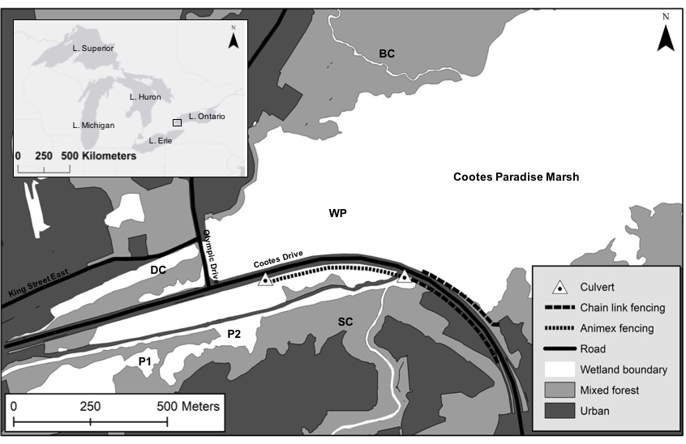
Figure 2.1 Location of Cootes Paradise Marsh within the Laurentian Great Lakes (inset). Sampling locations in western Cootes Paradise Marsh are surrounded by highly urbanized areas. WP = West Pond, DC = Desjardins Canal, BC= Borer’s Creek, SC = Spencer’s Creek, P1 = Pond 1, P2 = Pond 2. Cootes Drive is the four-lane highway directly bisecting the wetland.

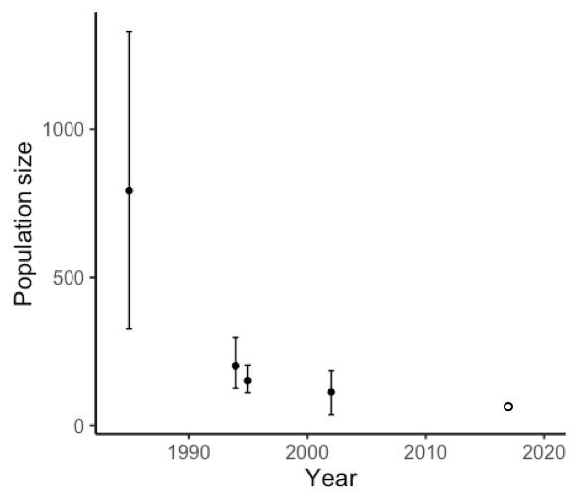
a
b
Figure 2.2 (a) Estimated snapping turtle population size with Poisson confidence intervals in the western portion of Cootes Paradise Marsh from 1985 to 2002. The open circle shows the total number of snapping turtles encountered in 2017 (t). (b) Annual estimation of the lower (M_{l}) (white circles) and upper (M_{u}) (grey circles) adult mortalities from 1985 to 2016 (Eq. 3 and Eq. 4), as well as the annual estimation of mortalities using current road mortality rates (M_{c}) (Eq. 7) (black circles).
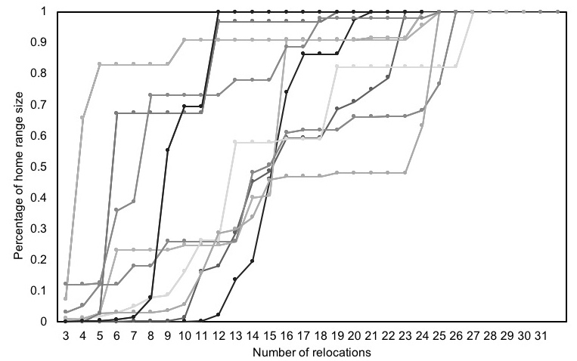
Figure 2.3 Results from incremental area analysis demonstrate an asymptotic shape, indicating a sufficient number of relocations from each turtle had been acquired to conduct home range analyses.

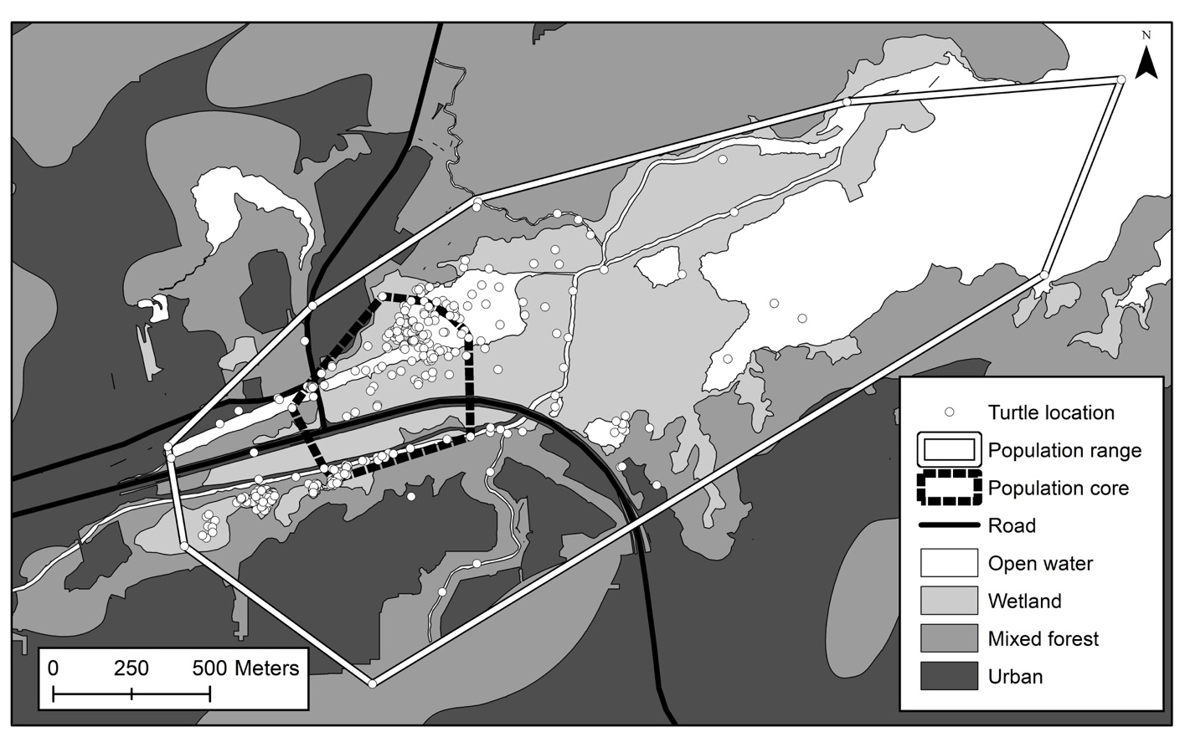
Figure 2.4 Minimum convex polygon (MCP) of population range (estimated by the 100% MCP) and core range (estimated by 50% MCP) for the snapping turtle population in western Cootes Paradise Marsh. Both the population and core range estimates are shown to overlap with surrounding roads (Cootes Drive, King Street East and Olympic Drive).

Figure 2.5 Linear regression of number of adult snapping turtles found on the road versus number of surveys completed by Dundas Turtle Watch annually (r² = 0.59, p = 0.02).

Chapter 3: Assessment of critical habitat for common snapping turtles (Chelydra serpentina) in an urbanized coastal wetland.

*Morgan L. Piczak and Patricia Chow-Fraser

McMaster University
Department of Biology
1280 Main Street West, Hamilton, ON
L8S 4K1

*Corresponding author: morganpiczak@gmail.com
Keywords: snapping turtle; Chelydra serpentina; urban impacts; critical habitat; overwintering; nesting

Presented in manuscript format and has been submitted to the Journal of Urban Ecology.

Abstract
Critical habitats such as nesting areas and overwintering sites are specific areas used by organisms to carry out important life functions. In many urbanized centers, critical habitats of at-risk species have often become degraded and/or fragmented because of human activities. Such is the case for the population of common snapping turtles (Chelydra serpentina) in Cootes Paradise Marsh, a highly urbanized ecosystem located at the western tip of Lake Ontario. In addition to these threats, mortality from collisions with cars on a four-lane highway at the western end of the marsh has greatly reduced wildlife populations. Here, we examine long-term changes in critical habitat distribution that has accompanied urbanization of Cootes Paradise Marsh from 1934 to 2010. We delineated potential nesting habitat for snapping turtles in 7 digitized aerial photos, using literature information and 2017 nesting surveys as guides. Between 1934 and 2010, total area of potential nesting habitat decreased by almost 50%. Nesting surveys confirmed that snapping turtles were disproportionately using artificial nesting mounds and this suggests that availability of natural nesting habitat is limited. We also radio tracked 11 snapping turtles to identify use of overwintering habitat. Temperature loggers monitored in-situ water temperatures at each turtle’s location and other unconfirmed habitats. The snapping turtle population overwintered in a wide range of upland terrestrial habitats, and although we found consistent water temperatures across confirmed and unconfirmed sites, confirmed sites provided slightly earlier onset, longer protection from freezing temperatures, and experienced shorter durations when temperatures dropped below freezing.

Introduction
Critical habitat can be defined as habitat that is essential for an organism to carry out necessary life functions such as reproduction/mating, overwintering, migration, feeding or rearing (Government of Canada 2009). To effectively manage and conserve wildlife populations, particularly those living in an urban center, managers must know the species’ home range and location of critical habitat (Markle and Chow-Fraser 2017). Where freshwater turtles are concerned, in addition to identifying critical habitat, it is also important to identify anthropogenic threats that may be contributing to habitat alteration, destruction or fragmentation.
Common snapping turtles (Chelydra serpentina) are long-lived organisms whose life-history strategies include delayed sexual maturity, reliance on low adult mortality, and low recruitment, traits that leave populations at risk to alteration of critical habitat, a primary adverse effect of urbanization (Congdon et al. 1994; COSEWIC 2008). For common snapping turtles, critical habitat includes nesting and overwintering habitat, both of which are important for maintaining population viability (COSEWIC 2008). The reproductive rate of snapping turtles is extremely low; less than 0.1% of eggs of snapping turtles hatch and survive to sexual maturity, even in an undisturbed setting such as Ontario’s Algonquin Provincial Park (COSEWIC 2008). Therefore, presence of suitable nesting habitat is essential for supporting recruitment and preserving populations. The oviposition site is important to nesting success and can have important phenological implications for hatchlings including survival, development and growth rates (Kolbe and Janzen 2002). In urban, modified, and/or polluted environments which have a host of anthropogenic impacts, reproductive success and recruitment can be even lower and seriously impair population stability (Thompson et al. 2017).
Suitable nesting habitat is characterized by well-drained soil, minimal vegetative cover and open canopy for sun exposure (Dekker 2015; Thompson et al. 2017). In natural settings, nesting sites can include abandoned beaver lodges, muskrat houses, sandy or rocky shorelines (Obbard and Brooks 1980). In many altered and urbanized landscapes that lack suitable nesting sites, snapping turtles may be attracted to use suboptimal or unsafe sites such as shoulders of roads (Haxton 2000) or agricultural fields (Pappas et al. 2013). Such areas are ecological sinks associated with low survivorship of eggs and hatchlings (Mui et al. 2015). Specifically, on roads sides, survival factors can include high road mortality, soil compaction and anthropogenic pollution (Paterson et al. 2012). In agricultural fields, nests could be flooded via irrigation and/or damaged or destroyed during the tilling process, both also resulting in decreased nest success (Thompson et al. 2017). In highly urbanized settings, proactive identification of nesting habitat and measures to steer turtles away from dangerous habitats such installation of artificial nesting mounds are common strategies in conservation programs (Grosse et al. 2015; TRCA 2018).
At northern latitudes, selection of appropriate overwintering sites is very important to the point of being predictive of life or death for individual snapping turtles. Snapping turtle survival during harsh winter conditions is reliant on individuals selecting sites that a) provide protection from freezing water temperatures, b) afford concealment from predation and c) deliver access to dissolved oxygen (DO) (Brown and Brooks 1994). Snapping turtles spend nearly half the year at overwintering sites (Strain et al. 2012) and it is critical that these areas possess these three conditions necessary to increase winter survival probabilities. Prolonged exposure to sub-zero temperatures can result in turtles freezing to death, given that the freezing temperature of body fluids in turtles is -0.6 ℃ (Costanzo et al. 2006). Ideally, overwintering sites will have water temperatures sufficiently cool to support a reduction in metabolic costs (Markle and Chow-Fraser 2017; Paterson et al. 2012), but not so cold as to result in freezing. During overwintering, turtles may also be subjected to anoxic conditions and must use anaerobic respiration; however, this leads to lactic acid accumulation (Meeks and Ultsch 1990; Reese et al. 2002). Overwintering sites must therefore provide sufficient DO to minimize risk of death via acidosis.
As discussed above, freshwater turtles are confronted with a trade-off between death by acidosis or by freezing. If they select sites with muddy substrate, they could avoid freezing but may encounter low DO levels that can result in acidosis (Brown and Brooks 1994; Paterson et al. 2012; Reese et al. 2002). Sites that are above the sediment surface could have higher DO levels but may freeze during the winter (Brown and Brooks 1994). Finally, to the extent that snapping turtles reduce their metabolic activity, they are increasingly vulnerable to mammalian depredation by a variety of predators including mink (Neovison vison), otters (Lontra canadensis) and black bears (Ursus americanus) (Ultsch 2006). Because of all these dimensions, snapping turtles can overwinter in a wide range of shallow aquatic sites; identifying the physical characteristics (especially depth & ambient water temperature) that are most important for overwintering habitats can assist conservation agencies in developing recovery plans for this at-risk species.
Cootes Paradise Marsh (CPM) is an urbanized river mouth coastal marsh located in the extreme western end of Lake Ontario (Chow-Fraser 1998). This marsh has been subjected to a range of anthropogenic stressors including urban and agricultural development, invasive species (common carp, Cyprinus carpio and common reed, Phragmites australis), external and internal loading and regulation of water levels (1963) (International Joint Commission 1961) that have resulted in loss of emergent and submergent vegetation (Chow-Fraser 2005; Loughleed et al. 2004; Thomasen and Chow-Fraser 2012). Additionally, road mortality associated with Cootes Drive, a four-lane highway that bisects the wetland, is hypothesized to have dramatically decreased snapping turtle population size over in recent decades and created unsafe nesting sites along roadsides. Taken together, these represent direct or indirect threats to the viability of the remaining population of snapping turtles in CPM.
Preserving a population of snapping turtles requires sufficient recruitment through viable nesting habitat and high adult survival, which partially depends on suitable overwintering habitat (Dekker 2015). To promote recruitment and winter survival and therefore minimize risk of population extirpation, it is essential to identify and protect critical habitat in such urbanized and often anthropogenically degraded settings. The goal of this study is to assess and identify long-term changes in available nesting and overwintering habitats for the sub-population of snapping turtles located at the western end of CPM. We will examine changes in the amount of potential nesting habitat over 7 decades that included data before and after the establishment of Cootes Drive in 1936. We will also use information on current nesting and overwintering habitat to determine important characteristics of these critical habitats. By identifying and mapping critical habitat, we will inform management and conservation agencies on strategies to conserve the remaining snapping turtle population in CPM.

Methods

Site description
Cootes Paradise Marsh (CPM) is a provincially significant, 250-ha river mouth coastal wetland located in the extreme western end of Lake Ontario (Fig. 1). While highly productive and supportive of biodiversity, CPM has been subjected to long-term negative impacts of agricultural and urban development associated with the towns of Dundas, Flamborough, and Ancaster and the City of Hamilton that border the wetland complex (Chow-Fraser 1998). Previously mentioned anthropogenic impacts have included degradation and loss of habitat, nutrient and sediment enrichment, regulation of Lake Ontario water levels beginning in 1963 (International Joint Commission 1961), and invasion of non-native species. Water-level regulation led to die-back of the native cattail (Typha latifolia) and paved the way for invasion of reed manna grass (Glyceria maxima) and the invasive haplotype of common reed (Phragmites australis) (Wei and Chow-Fraser 2006). Sediment and nutrient enrichment from wastewater effluent led to water-quality degradation, loss of submergent vegetation and concomitant dominance by the non-native common carp (Cyprinus carpio) (Chow-Fraser et al. 1998).
Of all the ecosystem stressors on CPM, however, the construction of Cootes Drive in 1936 likely had the most severe consequences for the turtle populations. This is a busy four-lane arterial road/highway connecting Hamilton to the town of Dundas, which bisects the western portion of CPM into West Pond to the northwest and two ponds on Hamilton Conservation Authority (HCA) land to the southeast (see Fig 3.1). With a posted speed limit of 80 km/h, traffic on this road since the 1980s has been responsible for a relatively high mortality of freshwater turtles and other wildlife that once inhabited the marsh ecosystem (Piczak et al. 2018).

Nesting Habitat
We obtained available historic air photos of CPM complex to study how potential suitable nesting habitat has changed over the past century. Photos taken in 1934, 1959, 1972, 1978, 1999, 2002 and 2010 were first imported into ArcGIS 10.5 (ESRI, Redlands, California, USA; see Table 3.1). To delineate the outer boundary of the habitat mapping, we digitized the shoreline of CPM using the 2010 imagery and applied a 500 m buffer to ensure we captured maximum distance a female snapping turtle would travel on land to a nesting site (Congdon et al. 1987; Paterson et al. 2012). We applied this footprint to all photos across years to ensure we had the same spatial extent with which to conduct a change detection analysis. Within the 500-m shoreline buffer, habitats were manually digitized at a map scale of 1:1500. Since there is no available information of what had been used as nesting habitat in CPM, we had to create a ruleset to delineate and classify potentially suitable nesting habitats based on published descriptions of nesting habitat for snapping turtles, which includes open areas with loose soil and minimal vegetation (Dekker 2015; Steyermark et al. 2008). To ensure this protocol could be applied to all photos, we used the 1934 and 2010 images to guide the ruleset creation. Furthermore, we modified habitat ecosites from the Ecological Land Classification for Southern Ontario system (Table 3.2). We then used ArcGIS 10.5 to delineate different habitat classes and calculated the total area of all habitat types for each year. Finally, we conducted a change detection analysis of the 1934 and 2010 images to determine the type of habitat lost, gained or left unchanged.

All field work was conducted respectful of approved McMaster University animal use protocols (No. 17-01-05) and site-specific permits (Hamilton Conservation Authority land access, Wildlife Scientific Collector’s Authorization No. 1084392 and Royal Botanical Gardens No. 2016-07). Nesting surveys were conducted during the day by walking a designated route from May 23rd to July 7th 2017. We created transects along the roadside and surveyed both sides of the transect; in larger fields that were logistically unfeasible to survey completely, we applied a regular grid pattern (~ 2 m) to conduct nest surveys. We noted the GPS of each location, date and time of the survey and any evidence of nesting activity (i.e. presence of a nesting mound, female turtle, eggs or egg shells). Data about the macrohabitat such as percentage vegetation cover and weather conditions were also recorded. Potential nesting habitat type of the surveyed area was classified according to modifications from the Ecological Land Classification for Southern Ontario, which included 5 classes: anthropogenically maintained fields, natural fields, gravel, shoreline and agricultural fields (Table 3.2). We calculated the percentage of nesting observations of each habitat type and compared it to the percentage of habitat types within the survey area.

Overwintering Habitat
We opportunistically captured snapping turtles soon after they emerged from overwintering during April 2017, notched them (Cagle 1939) and outfitted them with radio transmitters (Lotek Wireless, Newmarket, ON, Canada, 10 g) using an Ontario Ministry of Natural Resources and Forestry (OMNRF) approved epoxy putty. We ensured that the total weight of the transmitter and epoxy putty did not exceed 5% of the turtle’s total body weight to avoid disruption of behaviors and movements. The epoxy putty and transmitter were camouflaged with black marker. Once the epoxy was hardened to the touch, the radio transmitter was checked to ensure proper functioning and then the turtle was released at the capture site. Turtles were tracked on five occasions throughout the 2017/18 winter period (October 18th, November 14th, December 4th, January 15th and March 14th). When each turtle was relocated, we recorded the GPS location, the habitat type and corresponding meteorological information. All relocations were mapped in ArcGIS 10.5. We determined habitat use by calculating the percentage of overwintering relocations recorded on each habitat type (Ecological Land Classification for Southern Ontario system) (Table 3.3).
To identify trends in overwintering water temperatures, we installed temperature loggers (HOBO Onset, Bourne, MA, USA) at 12 sites to monitor water temperature at potential overwintering sites. Loggers were arbitrarily placed within each major habitat type and set to record the water temperature every 4 hours. We mounted the loggers to bamboo sticks or metal rebar poles approximately 7 cm above the substrate to approximate the location of an overwintering turtle (Edge et al. 2009). Finally, air temperature data were gathered from the McMaster University Weather Station, located within 1500 m of the study site.
The boundaries of the pre-overwintering, overwintering and post-overwintering periods were statistically determined with a break point analysis in R 3.3.2 (version 5.0) (R Core Team 2018). We examined differences in onset date, overwintering duration and calculated mean water temperatures during the overwintering period for all sites. An earlier onset date would provide earlier protection from fluctuating air temperatures and could increase changes to survival. Overwintering duration is the period between the first and second breaking point identified in the breakpoint analysis, where water temperatures remain low and stable throughout the winter and the slope is flatter (Fig 3.2a). We also determined the number of days spent below -0.6 ℃, the freezing temperature of turtle body fluids (Costanzo et al. 2006). We compared differences in water temperatures between confirmed and unconfirmed sites using Mann-Whitney t test (α = 0.05 for all statistical tests).

Results

Nesting Habitat
Between 1934 and 2010, the total amount of potential nesting habitat in Cootes Paradise Marsh (CPM) decreased steadily from 270 to 140 ha, a drop of nearly 50% (Fig 3.3a). Some of this decline may be attributed to higher marsh water levels as a result of Lake Ontario regulations that reduced the amount of shoreline, wet meadow and emergent marshes after the early 1960s (Fig 3.4). These water-level regulations would have had the greatest effect on near-shore habitat, including the shoreline, which did experience a decline from 2 ha to 0.6 ha.
Over this time period, the relative amount of anthropogenically maintained fields has also increased from 40 to 80% of available habitat (Fig 3.3b), though this is not due to an increase in the absolute amount of maintained fields, but because of an overall decline in amount of potential nesting habitats. Natural habitats including shoreline remained relatively low at approximately 1% (2-0.4 ha) across the full study period. Agricultural landscape that once dominated the region at over 40% of available habitat (95 ha) has declined to less than 5% (3 ha) by 2010. Finally, the relative amount of natural fields and gravel have remained stable.

Change detection analyses showed a uniform and widespread change in distribution of potential nesting habitat in CPM from 1934 to 2010 (Fig 3.5; Table 3.4). Over this period, about 95 ha of the nesting habitat remained unchanged, while 176 ha had been lost and only 48 ha had been gained. Though the habitat loss was quite evenly distributed throughout the landscape, some areas experienced a larger decline than others. For example, greater habitat loss was associated with the urbanization of Dundas to the west and Westdale Village (Hamilton) to the southeast. Additionally, agricultural lands that once existed to the north of the marsh had been renaturalized to mixed wood forests in recent decades, and the increased shading from vegetation likely make it no longer usable as nesting habitat. Overall, 27 ha of agricultural land have been converted to anthropogenically maintained fields, 5 ha to natural fields, and 59 ha have been lost. Additionally, 46 ha of natural fields and 68 ha of anthropogenically maintained fields have been lost. The most widespread increase was in anthropogenically maintained fields (35 ha), followed by natural fields (10 ha), with > three ha in all other classes.

The most prevalent potential nesting habitat type within our nesting survey route was anthropogenically maintained fields (87%) (Table 3.5), while gravel was the next most available habitat type (11%), followed by natural fields (5%), shoreline (0.7%) and artificial mounds (0.3%). Almost 50% of the 84 nesting observations made between May 23rd to July 4th (n = 41) occurred on artificial nesting mounds. Use on gravel accounted for >35% while those on shoreline habitat and anthropogenically maintained fields accounted for <10%. We consistently found more nests (n = 71) on anthropogenically modified areas (including artificial nesting mounds and gravel shoulders of roads) than on naturally occurring nesting habitats. The large number of nesting observations combined with the relatively small area of nesting mounds resulted in a high density of nesting observations.

Overwintering Habitat
In general, movement activity decreased for all tagged snapping turtles after late September, as they migrated to overwintering locations. Three of the individuals (ID #1, 2, and 5) chose overwintering sites located on opposite sides of Olympic Drive or Cootes Drive (see Fig 3.1) than where they had been found during the active season, and we infer from this that they crossed the road at least once. They overwintered in a wide range of upland terrestrial habitat including creeks (n = 1), flooded cattails (n = 1), flooded grass (n = 2), flooded forest (n = 3) and water’s edge (n = 4) (Fig 3.6). Tagged turtles used near-shore habitats rather than open-water areas, such as the middle of ponds or creeks. The maximum depth of overwintering sites (combined mud and water) was < 1 m (mean of 0.57 m). Most of the turtles (n = 8/11) overwintered in areas associated with wood structures such as roots or fallen logs. Those that did not overwinter in wood structures were found in dense emergent vegetation including grasses and cattail stands.
All habitat types were used by both sexes, except that females did not use flooded grass, while males did not use flooded cattails (but they were in close proximity). There were two pairs (two males in one and one of each sex in the other) that overwintered together, with < ten m between individuals. We detected very little monthly movement during the winter, with only ID #13 moving 30 m downstream in Borer’s Creek and ID #1 moving three m in March. All tagged snapping turtles survived the winter. Activity increased from mid-March onward as turtles started to move throughout the wetland complex.

We analyzed the thermal data according to confirmed sites (where tagged turtles overwintered) and unconfirmed sites (where no known turtle had overwintered) (Fig 3.6). Despite fluctuating and cold air temperatures (Fig 3.2b), both confirmed and unconfirmed sites provided a mean water temperature during the overwintering period of 0.4°C (P = >0.51). Despite this similarity, we noted four differences in other thermal parameters. First, the onset date for the overwintering period occurred earlier for the confirmed than unconfirmed sites (December 13th vs December 16th) (Table 6). Secondly, duration of the overwintering period was longer by almost one full week for the confirmed vs unconfirmed sites (103.7 days vs 97.5 days, respectively). Thirdly, the number of days below -0.6°C (the freezing point of turtle body fluids) (Constanzo et al. 2006) was 3.3 for confirmed and 5.0 days for the unconfirmed sites. Finally, confirmed sites provided more stable water temperatures compared to unconfirmed sites, as indicated by the larger fluctuations and range in water temperatures for the latter.

Discussion
Common snapping turtle populations, particularly those in urban environments, face many threats, including reduced quantity and quality of critical overwintering and nesting habitat. Populations of snapping turtles that occur at the northern periphery of their home range may be at greater risk of being extirpated because of environmental change (Lesbarréres et al. 2014). It is imperative that we conserve and protect such isolated populations because recolonization in altered environments is difficult (Marchand and Litvaitis 2003).
Based on digital orthophotos, we determined that the amount of potential nesting habitat in Cootes Paradise Marsh (CPM) has declined by almost half between 1934 and 2010. Turtles are disproportionately using artificial gravel mounds for nesting rather than naturally occurring habitats, which are limited. Both sexes overwintered in a wide range of upland habitat types. The thermal characteristics that distinguish between confirmed and unconfirmed overwintering sites include an earlier onset of the overwintering duration (hence a longer overwintering period), a narrower range in temperatures and lower fluctuations around a mean of 0.4 °C, and a fewer number of days below the critical freezing temperature of -0.6 °C. Therefore, confirmed sites provided a longer, more stable thermal environment that protected snapping turtles from freezing during the winter.
Consistent with other studies that examined changes in wetland habitat in southern Ontario (Markle et al. 2018; Wilcox et al. 2008), we found long-term changes in habitat composition in this highly urbanized ecosystem, changes that may have drastically reduced the availability of potential nesting habitat for the once abundant snapping turtle population in CPM. One of the main changes in potential nesting habitat is related to conversion of agricultural fields to anthropogenically maintained fields (i.e. lawns), which now represent almost 80% of available potential nesting habitat. Presence of grass can alter the temperature and moisture content of the substrate, rendering the habitat less suitable for successful egg incubation and hatchling emergence (Bobyn and Brooks 1993; Kolbe and Janzen 2002). Additionally, activities associated with anthropogenically maintained fields, such as mowing (Thompson et al. 2017) and pesticide use (de Solla et al. 2011) could also result in decreased nest success. Even though agricultural fields currently represent a small portion of available potential nesting habitat, they are attractive to female snapping turtles (Thompson et al. 2017); however, these are also suboptimal habitats because incubation temperatures are lower (Freedberg et al. 2011) and hatchlings can become spatially disoriented when they emerge (Pappas et al. 2013; Congdon et al. 2015).
The almost 50% decline in potential suitable nesting habitat from 1934 to 2010 could have led to reduced recruitment and a subsequent decrease in population size. The change detection showed that higher loss of potential nesting habitat occurred near Dundas and Westdale, two urbanized areas, which are commonly associated with meso-predators (Riley and Litzgus 2014; Thompson et al. 2017; Urbanek et al. 2016) including raccoons, skunks and foxes. High nest depredation can lower recruitment, which can eventually lead to aging populations and population decline (Browne and Hecnar 2007; Markle et al. 2018). Additionally, Thompsen et al. (2017) noted that reproductive success of snapping turtles is lowered in polluted and/or modified environments.
The disproportionate use of artificial mounds in this study may indicate that there is a shortage of suitable nesting habitat in the ecosystem (Loncke and Obbard 1977). On the one hand, studies have found that nesting in artificial mounds can lead to increased hatching and nest success compared with roadsides (Paterson et al. 2013). On the other hand, high densities of nests can facilitate increased nest depredation (Dekker 2015), which for snapping turtle nests in natural ecosystems can be as high as 100% (Lincke et al. 1989; Marchand and Litvaitis 2003). Therefore, it is important to have a sufficient number of artificial mounds installed to facilitate nest success, in order to minimize risk of depredation from meso-predators in such an urbanized environment.
Published studies found snapping turtles overwintering in a wide range of aquatic habitats, including shallow streams/creeks (Brown and Brooks 1994; Ultsch and Lee 1983), edge of the water body or stream (Obbard and Brooks 1981), muddy bottoms of marshes, ponds and lakes (Fitch 1956; Obbard and Brooks 1981), muskrat houses (Cahn 1937; Carr 1952; Ernst and Barbour 1972) and even beaver structures (Strain et al. 2012). Our tagged snapping turtles used flooded grass, flooded cattails, waters edge, creeks and flooded forest. All tagged snapping turtles survived the winter, suggesting that these sites are suitable and therefore important to population persistence.
We also found that tagged snapping turtles used shallow sites (<one m in maximum depth) that were associated with woody structures such as fallen logs or roots (Meeks and Ultsch 1990; Pettit et al. 2005; Ultsch 2006). Woody structures may help to conceal them from predators and therefore enhance survivorship. Removal of such structures (even if they are in protected areas such as conservation areas or parks) could leave turtles vulnerable to mammalian predation and contribute to population decline. Future studies could examine additional specific physical characteristics of overwintering sites, including various types of concealment, depth of water/mud or amount of ice coverage. Such information would be beneficial for management of habitats undergoing change related to global climate change or for creation/restoration of overwintering sites for introduced individuals.
Based on our observations, protecting the upland matrix of CPM will ensure that suitable overwintering habitat will be available for the population of snapping turtles. Others (i.e. Buhlmann and Gibbons 2001; Pettit et al. 2005) have also suggested that protecting the upland matrix was crucial to promoting winter survival of snapping turtles and ultimately population persistence. Two groups of snapping turtles overwintered together, perhaps because of limited suitable sites or possible because this behavior ensured they would find mates as soon as they emerged in spring (Markle and Chow-Fraser 2017).
Both confirmed and unconfirmed overwintering sites shared the same mean water temperature (0.4 °C), which is colder than that determined for a population of snapping turtles in Algonquin Provincial Park (1.0-1.7 °C; Brown and Brooks 1994). Paterson et al. (2012) found the mean body temperature of snapping turtles in Algonquin Park was 1.29 °C, while the mean water temperature was 2.59 °C. Turtles must select sites with water temperatures that keep them from freezing, but that also sufficiently cool to lower their metabolism and thus conserve energy (Edge et al. 2009, Markle and Chow-Fraser 2017). In our study, they appear to be using sites that provide slightly colder mean water temperatures than in previous studies. These colder recorded temperatures could be an indication that the snapping turtles of CPM are seeking out lower water temperatures as a means of slowing their metabolism, which may reflect real differences between the urbanized population in this study and the more rural population in Algonquin Provincial Park. Alternatively, this could be because we did not deploy the temperature loggers as deep in the substrate as was done in the Algonquin Park study. Future studies should adopt Paterson et al.’s (2012) method of attaching temperature loggers to turtle carapaces to examine the direct water temperatures experienced by the turtles.
All of the tagged snapping turtles overwintered in varying depths of mud, with a layer of water on top of the substrate. It is possible that snapping turtles in our study made use of the mud for thermal purposes but were also physically close to water to acquire the DO. Site selection and thermal suitability likely contributed to the survival of all 11 tagged snapping turtles through the winter. Suitable overwintering sites contribute to adult survival, which is crucial to population maintenance since snapping turtle populations do not have density dependent responses (Brooks et al. 1991; Congdon et al. 1994) and are unable to compensate for chronic loss of breeding adults (Areso and Gunzberger 2007).
Effective management of at-risk species requires a thorough understanding of threats at all life stages from egg to adult (Marchand and Litvaitis 2003). Almost all previous information on snapping turtles are for populations living in relatively undisturbed habitats. This is the first study of a highly urbanized population in Canada, that has experienced a dramatic loss in amount of critical habitat by almost 50% in previous decades, which is well within the life time of such long-lived turtles. This loss of potential nesting habitat could be reducing recruitment and ultimately contributing to population decline. Our survey of nesting activities suggests that there is currently a lack of suitable nesting sites within CPM, and that additional artificial nest sites should be installed as soon as possible, to decrease nest density and depredation rates. There is no indication that availability of overwintering sites is limited, but we recommend that the upland matrix surrounding the western end of CPM be protected from further alterations.

Acknowledgements
Thank you to the students of the Chow-Fraser lab and to Jacqueline Garnett for assisting with data collection. Thanks to Dylan Melmer for his insight and help with analysis. We also like to thank the Hamilton Conservation Authority and Royal Botanical Gardens. This project was funded by the Natural Sciences and Engineering Research Council of Canada.

Conflict of interest statement. None declared.

Literature Cited
Bobyn, ML and Brooks, RJ (1993) Incubation conditions as potential factors limiting the northern distribution of snapping turtle, Chelydra serpentina. Canadian Journal of Zoology 72:28-37.
Brooks, RJ, Brown, GP and Galbraith, DA (1991) Effects of a sudden increase in natural mortality of adults on a population of the common snapping turtle (Chelydra serpentina). Canadian Journal of Zoology 69:1314-1320.
Brown, GP and Brooks, RJ (1994) Characteristics of and fidelity to hibernacula in a northern population of snapping turtles Chelydra serpentina. Copeia 1994:222-226.
Browne, C and Hecnar, SJ (2007) Species loss and shifting population structure of freshwater turtles despite habitat protection. Biological Conservation 138:421–429.
Buhlmann, KA and Gibbons, JW (2001) Terrestrial habitat use by aquatic turtles from a seasonally fluctuating wetland: implications for wetland conservation boundaries. Internal Journal of Turtle and Tortoise Research 4(1):115-127.
Cagle, FR (1939) A system of marking turtles for future identification. Copeia 1939:170–173.
Cahn, AR (1937) The Turtles of Illinois. Illinois Biological Monographs 16:9–218.
Carr, AF (1952) Handbook of Turtles – The Turtles of the United States, Canada, and Baja California. Comstock Division of Cornell University Press, Ithaca, New York.
City of Hamilton, Information Technology Services, GIS Services. Digital orthoimagery of the City of Hamilton. Spring 2002. Accessed as a web map tile service.
Committee on the Status of Endangered Wildlife in Canada [COSEWIC] (2008) COSEWIC assessment and update status report on the snapping turtle Chelydra serpentina in Canada. Committee on the Status of Endangered Wildlife in Canada, Ottawa, Canada.
Chow-Fraser, P (1998) A conceptual ecological model to aid restoration of Cootes Paradise Marsh, a degraded coastal wetland of Lake Ontario, Canada. Wetlands Ecology and Management 6:43-57.
Chow-Fraser, P, Lougheed, VL, Le Thiec, V, Crosbie, B, Simser, L and Lord, J (1998) Long-term response of the biotic community to fluctuating water levels and changes in water quality in Cootes Paradise Marsh, a degraded coastal wetland of Lake Ontario. Wetlands Ecology and Management 6:19–42.
Chow-Fraser, P (2005) Ecosystem response to changes in water level of Lake Ontario marshes: lessons from the restoration of Cootes Paradise Marsh. Hydrobiologia 539:189-204.
Congdon, JD, Breitenbach, GL, van Loben Sels, RC and Tinkle, DW (1987) Reproduction and nesting ecology of snapping turtles (Chelydra serpentina) in Southeastern Michigan. Herptologica 43(1):39-54.
Congdon, JD, Dunham, AE and van Loben Sels, RC (1994) Demographics of Common Snapping Turtles (Chelydra serpentina): Implications for Conservation and Management of Long-Lived Organisms. American Zoologist 34(3):397-408.
Congdon, JD, Pappas, MJ, Krenz, JD, Brecke, BJ and Schlenner, M (2015) Compass orientation during dispersal of freshwater hatchling Snapping Turtles (Chelydra serpentina) and Blanding's Turtles (Emydoidea blandingii). Ethology 121:538‒547.
Costanzo, JP, Baker, PJ and Lee, Jr, RE (2006) Physiological responses to freezing in hatchlings of freeze-tolerant and intolerant turtles. Journal of Comparative Physiology 177:697–707.
Dekker, CD (2015) Population and status assessment of the snapping turtle Chelydra serpentina in North Dakota. Dissertation, University of Idaho.
de Solla, SR, Martin, PA and Mikoda, P (2011) Toxicity of pesticide and fertilizer mixtures simulating corn production to eggs of snapping turtles (Chelydra serpentina). Science of the Total Environment 409(20):4306-4311.
Edge, CB, Steinberg, BD, Brooks, RJ and Litzgus, JD (2009) Temperature and site selection by Blanding's Turtles (Emydoidea blandingii) during hibernation near the species' northern range limit. Canadian Journal of Zoology 87:825–834.
Ernst, CH and Barbour, RW (1994) Turtles of the United States and Canada. Smithsonian Institution Press, Washington, D.C.
Fitch, HS (1956) Temperature responses in free-living amphibians and reptiles of northeastern Kansas. University of Kansas Publications of the Museum of Natural History 8:417–476.
Freedberg, S, Lee, C and Pappas, M (2011) Agricultural practices alter sex ratios in a reptile with environmental sex determination. Biological Conservation 144:1159‒1166.
Government of Canada 2009 Species at risk public registry. Available from http://www.sararegistry.gc.ca/sar/index/default_e.cfm
Grosse, AM, Crawford, BA, Maerz, JC, Buhlmann, KA, Norton, T, Kaylor, M and Tuberville, TD (2015) Effects of vegetation structure and artificial nesting habitats on hatchling sex determination and nest survival of diamondback terrapins. Journal of Fish and Wildlife Management 6(1):19-28.
Haxton, T (2000) Road mortality of snapping turtles, Chelydra serpentina, in Central Ontario during their nesting period. Canadian Field-Naturalist 114(1):106-110.
International Joint Commission (1961) Water Levels of Lake Ontario: Report to the Government of Canada and the Government of the United States.
Kolbe, JJ and Janzen, FJ (2002) Impact of nest-site selection on next success and nest temperature in natural and disturbed habitats. Ecology 83(1):269-281.
Lesbarréres, D, Ashpole, SL, Bishop, CA, Blouin-Demers, G, Brooks, RJ, Echaubard, P, Govindarajulu, P et al. (2014) Conservation of herpetofauna in northern landscapes: threats and challenges. Biological Conservation 170:48-55.
Linck, MH, DePari, JA, Butler, BO and Graham, TE (1989) Nesting behavior of the turtle, Emydoidea blandingi, in Massachusetts. Journal of Herpetology 23(4):442–444.
Lockwood Survey Corporation ltd. [Hamilton Area, 1972] : [C5383-72-Photo 16]. Scale [1:12,000 approximately]. C5383-72. [Place of publication unknown]: [Publisher unknown], 1972.
Loncke, DJ and Obbard, ME (1977) Tag success, dimensions, clutch size and nesting site fidelity for the snapping turtle, Chelydra serpentina, (Reptilia, testudines, chelydridae) in Algonquin Park, Ontario, Canada. Journal of Herpetology 11(2):243-244.
Loughleed, VL, Theysmeyer, R, Smith, T and Chow-Fraser, P (2004) Carp exclusion, food-web interactions, and the restoration of Cootes Paradise Marsh. Journal of Great Lakes Research 30(1):44-57.
Marchand, MN and Litvaitis, JA (2003) Effects of landscape composition, habitat features, and nest distribution on predation rates of simulated turtle nests. Biological Conservation 117:243-251.
Markle, CE and Chow-Fraser, P (2017) Thermal characteristics of overwintering habitats for the Blanding’s turtle (Emydoidea blandingii) across three study areas in Ontario, Canada. Herpetological Conservation and Biology 12:241-251.
Markle, CE, Chow-Fraser, GE and Chow-Fraser, P (2018) Long-term habitat changes in a protected area: Implications for herpetofauna habitat management and restoration. PLoS One 13(2):e0192134.
Meeks, RL and Ultsch, GR (1990). Overwintering behavior of snapping turtles. Copeia 3:880-884.
Mui, AB, Edge, CB, Paterson, JE, Caverhill, B, Johnson, B, Litzgus, JD and He, Y (2015) Nesting sites in agricultural landscapes may reduce the reproductive success of populations of Blanding’s Turtles (Emydoidea blandingii). Canadian Journal of Zoology 94:61-67.
National Air Photo Library. [Greater Hamilton Area, from Caledonia to Vineland, 1934-11-03] : [A4871-Photo 10]. Scale [1:20,000]. A4871. [Place of publication unknown]: [Publisher unknown], 1934.
North West Geomatics Canada Inc. [West Hamilton, 1999] : [GTA004-Photo 56]. Scale 1:20,000. GTA004. [Place of publication unknown]: [Publisher unknown], 1999.
Obbard, ME and Brooks, RJ (1980) Nesting migrations in the common snapping turtle (Chelydra serpentina). Herptologica 36:158-162.
Obbard, ME and Brooks, RJ (1981) Fate of overwintered clutches of the common snapping turtle (Chelydra serpentina) in Algonquin Park, Ontario. The Canadian Field-Naturalist 95(3):350-352.
Ontario Ministry of Natural Resources. [Regional Municipality of Hamilton-Wentworth and Surrounding Area, 1978] : [4319-63-Photo 224]. Scale [1:10,000]. 4319-63. [Place of publication unknown]: [Publisher unknown], 1978.
Pappas, MJ, Congdon, JD, Brecke, BJ and Freedberg, S (2013) Orientation of freshwater hatchling Blanding's (Emydoiea blandingii) and Snapping Turtles (Chelydra serpentina) dispersing from experimental nests in agricultural fields. Herpetological Conservation and Biology 8:385‒399.
Paterson, JE, Steinberg, BD and Litzgus, JD (2012) Generally specialized or especially general? Habitat selection by Snapping Turtles (Chelydra serpentina) in central Ontario. Canadian Journal of Zoology 90:139-149.
Paterson, JE, Steinberg, BD and Litzgus, JD (2013) Not just any old pile of dirt: evaluating the use of artificial nesting mounds as conservation tools for freshwater turtles. Oryx 47(4):607-615.
Pettit, KE, Bishop, CA and Brooks, RJ (1995) Home range and movements of the Common Snapping Turtle, Chelydra serpentina serpentina, in a coastal wetland of Hamilton Harbour, Lake Ontario, Canada. Canadian Field-Naturalist 109:192-200.
Piczak, M, Markle, CE and Chow-Fraser, P (2018) Impact of a highly urbanized landscape on a population of common snapping turtles (Chelydra serpentina) in western Lake Ontario. Submitted to Chelonian Conservation and Biology.
Reese, SA, Jackson, DC and Ultsch, GR (2002) The physiology of overwintering in a turtle that occupies multiple habitats, the common snapping turtle (Chelydra serpentina). Physiological and Biochemical Zoology 75(5):432-438.
Riley, JL and Litzgus, JD (2014) Cues used by predators to detect freshwater turtle nests may persist late into incubation. Canadian Field-Naturalist 128(2):179-188.
Spartan Air Services Ltd. [Golden Horseshoe Area, 1959-11-09] : [A16883-Photo 16]. Scale [1:30,000 approximately]. A16883. [Ottawa, Ont.]: [Spartan Air Services Ltd.], 1959-1962.
Steyermark, AC, Finkler, MS, Brooks, RJ and Gibbons, JW (2008) Biology of the snapping turtle. the Johns Hopkins University Press, Baltimore, Maryland.
Strain, GF, Anderson, JT, Michael, ED and Turk, PJ (2012) Hibernacula use and hibernation phenology in the common snapping turtle (Chelydra serpentina) in Canaan Valley, West Virginia. Journal of Herpetology 46(2):269-274.
SWOOP 2015: Lidar [computer file]. Land Information Ontario, Ontario Ministry of Natural Resources and Forestry, [2015].
Thomasen, S and Chow-Fraser, P (2012) Detecting changes in ecosystem quality following long-term restoration efforts in Cootes Paradise Marsh. Ecological Indicators 13:82-92.
Thompson, MM, Coe, BH, Congdon, JD, Stauffer, DF and Hopkins, WA (2017) Nesting ecology and habitat use of Chelydra serpentina in an area modified by agricultural and industrial activity. Herpetological Conservation and Biology 12:292-306.
Toronto and Region Conservation Authority [TRCA]. (2018). Reptiles and amphibians of Tommy Thompson Park. Available from: https://tommythompsonpark.ca/park-species/herpetofauna/
Ultsch, GR and Lee, D (1983) Radiotelemetric observations of wintering snapping turtles (Chelydra serpentina) in Rhode Island. Journal of the Alabama Academy of Sciences 54:200–206.
Ultsch, GR (2006) The ecology of overwintering among turtles: where turtles overwinter and its consequences. Biological Review 81:339-367.

Urbanek, RE, Glowacki, GA and Nielsen, CK (2016) Effect of raccoon (Procyon lotor) reduction on Blanding’s turtle (Emydoidea blandingii) nest success. The Journal of North American Herpetology 1:39-44.
Wei, A and Chow-Fraser, P (2006) Synergistic impact of water level fluctuation and invasion of Glyceria on Typha in a freshwater marsh of Lake Ontario. Aquatic Botany 84:63-69.
Wilcox, DA, Kowalski, KP, Hoare, HL, Carlson, ML and Morgan, HN (2008) Cattail invasion of sedge/grass meadows in Lake Ontario: photointerpretation analysis of sixteen wetlands over five decades. Journal of Great Lakes Research 34:301–323.

Table and Figures
Table 3.1 Dates of orthophotos used in this study to map potential nesting habitat for snapping turtles in CPM. Resolution refers to size of pixel.
Year | Type | Spectral type | Resolution (cm) | Season | Source
1934 | Orthophoto | B&W | 260 | Leaf on | National Air Photo Library (Canada), 1934.
1959 | Orthophoto | B&W | 125 | Leaf off | Spartan Air Services Ltd, 1959.
1972 | Orthophoto | B&W | 55 | Leaf on | Lockwood Survey Corporation ltd., 1972.
1978 | Orthophoto | B&W | 50 | Leaf on | Ontario. Ministry of Natural Resources, 1978.
1999 | Orthophoto | True colour | 12.5 | Leaf on | North West Geomatics Canada Inc. 1999.
2002 | Orthophoto | True colour | 20 | Leaf off | City of Hamilton, 2002.
2010 | Orthophoto | True colour | 20 | Leaf off | Southwestern Ontario Orthophotography Project (SWOOP)
Table 3.2 Potential nesting habitat types in CPM based on manually classified orthophotos using the Ecological Land Classification for Southern Ontario.
Habitat | Description
Anthropogenically maintained field | Areas with grass for human use including lawns, sports fields
Natural field | Open, natural, terrestrial area with minimal tree cover
Gravel | Areas with gravel, minimal vegetation
Shoreline | Land adjacent to body of water, with minimal vegetation
Agriculture | Active or retired agricultural fields

Table 3.3 Overwintering habitat types based on the Ecological Land Classification for Southern Ontario, which based on literature are considered to be overwintering habitat for snapping turtles.
Habitat | Description
Flooded forest | Deciduous or coniferous trees, with standing water present
Waters edge | Habitat adjacent to a body of water, can include fallen logs and/or trees
Creek | Streams or creeks that flow throughout the year
Flooded cattails | Homogenous growth of dense cattail stands in marsh
Flooded grass | Homogenous growth of dense grass stands in marsh

Table 3.4 Results from the change detection analysis including a matrix of change in habitat types from 1934 to 2010 including each type of habitat lost or gained.
Habitat types (ha) |  | 1934
 |  | Anthropogenically maintained field | Gravel | Agriculture | Natural field | Shoreline | Gained
2010 | Anthropogenically maintained field | 39.84 | 0.33 | 27.44 | 6.41 | 0.02 | 34.81
 | Gravel | 0.43 | 0.44 | 0.45 | 0.85 | 0.11 | 2.33
 | Agriculture | 0.00 | 0.00 | 3.32 | 0.00 | 0.00 | 0.03
 | Natural field | 4.91 | 0.00 | 5.03 | 5.03 | 0.03 | 10.26
 | Shoreline | 0.01 | 0.00 | 0.00 | 0.02 | 0.26 | 0.29
 | Lost | 67.85 | 1.43 | 59.35 | 45.90 | 1.78

Table 3.5 Proportion of potential nesting habitat surveyed versus nesting observations.
Habitat Type | Survey area proportion (%) | Nesting observations (%)
Natural field | 1.0 |  | 0.1
Anthropogenically maintained field | 87.0 |  | 8.3
Shoreline | 0.7 |  | 7.1
Artificial mound | 0.3 |  | 48.8
Gravel | 11.0 |  | 35.7

Table 3.6 Comparison of water temperatures during the winters of 2016/2017 and 2017/2018, for sites where tagged turtles had been present during the winter (Confirmed = Y), and where they had not (Confirmed = N). A representative plot of temperatures for each site type is shown, along with the mean date of onset of low temperatures, mean overwintering duration, mean water temperature during the period of low temperatures, and the mean number of days in which temperatures were below 0.6 °C (mean days below).
Confirmed | Representative water  temperature graph | Mean  onset date | Mean OW duration | Mean temp (°C) | Mean days below
Y | 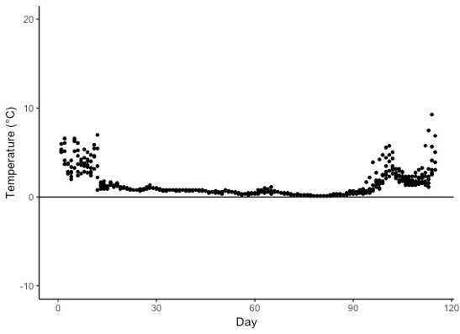 | Dec 13th | 103.7 | 0.44 | 3.3
N | 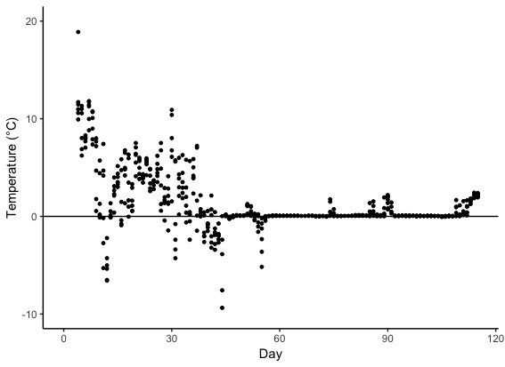 | Dec 16th | 97.5 | 0.44 | 5.0
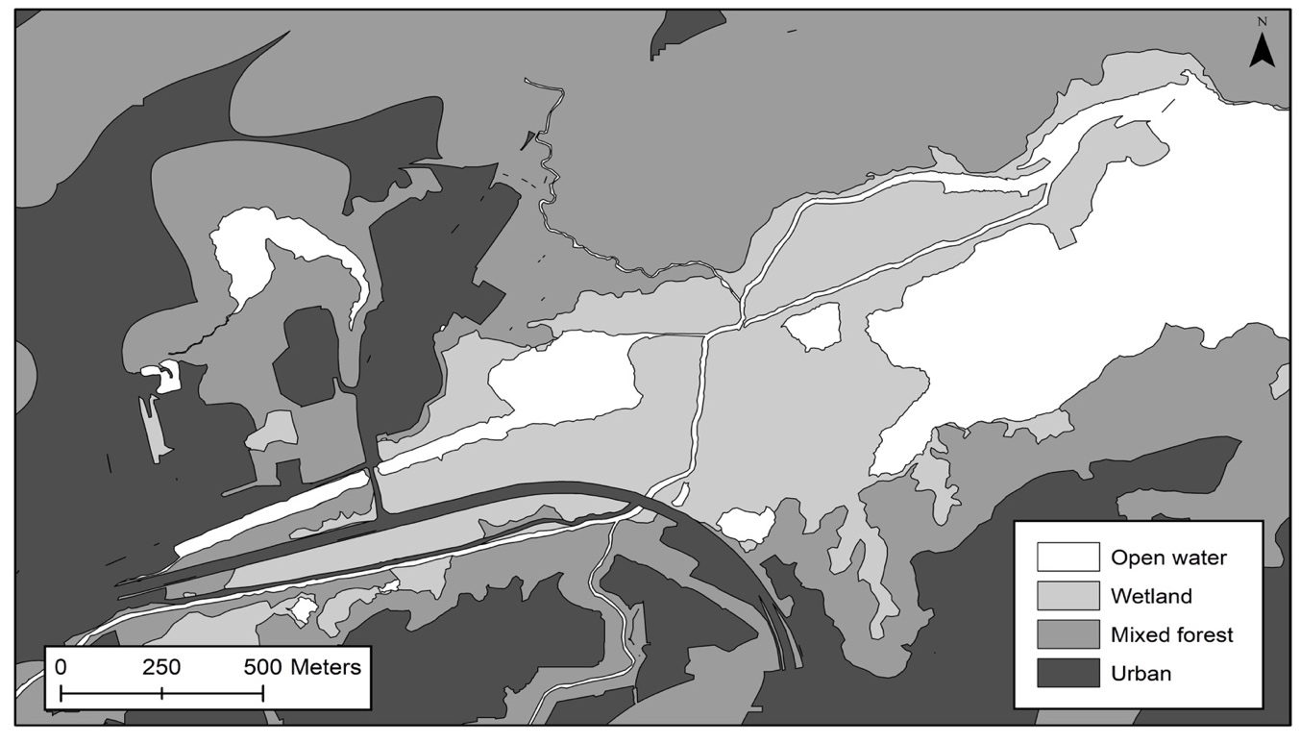
SC
HCA 1
HCA 2
DC
BC
WP
L. Ontario
L. Huron
L. Michigan
L. Erie
Cootes Paradise Marsh
L. Superior
Figure 3.1 Location of sampling locations in Cootes Paradise Marsh and surrounding upland habitat. Cootes Paradise Marsh open water, WP = West Pond, DC = Desjardins Canal, BC = Borer’s Creek, SC = Spencer’s Creek, HCA 1 = Hamilton Conservation Authority 1, HCA 2 = Hamilton Conservation Authority Pond 2. Inset shows the location of CPM within the Laurentian Great Lakes.

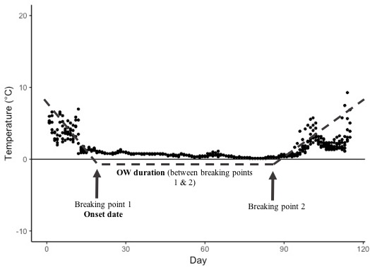
b
a
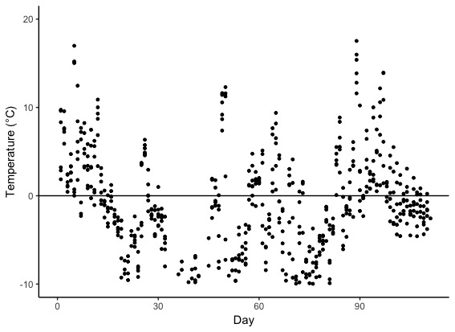
Figure 3.2 Diagram of breakpoint analysis (a) completed on water temperatures. Onset date was identified as the first breaking point and overwintering (OW) duration is the total length of times between breaking points one and two. Variation in air temperature (b) from October 27th 2017 to March 30th 2018 in CPM.

a
b
Figure 3.3 Change in area of potential nesting habitat in CPM presented as (a) absolute amount of habitat types (ha) and (b) relative amount of habitat types (%).
2002
1999
1978
1972
1959
1934
2010
Figure 3.4 Change in Lake Ontario mean annual water level (above sea level), arrow shows year of Lake Ontario water level regulation implementation (1963) and open circles show years of interest.

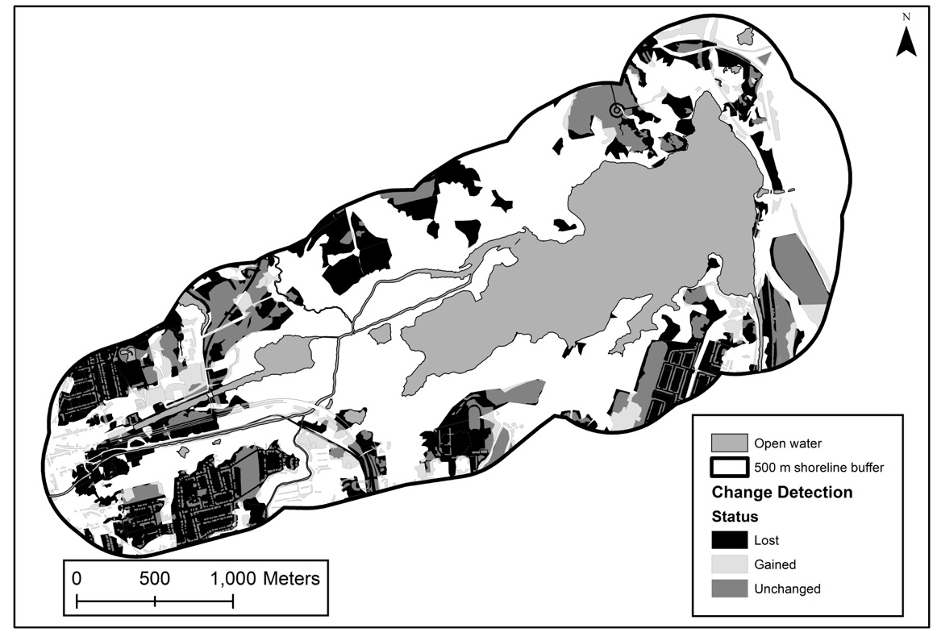
Figure 3.5 Results of a change detection analysis showing changes in the amount of potential nesting habitat in CPM between1934 and 2010.

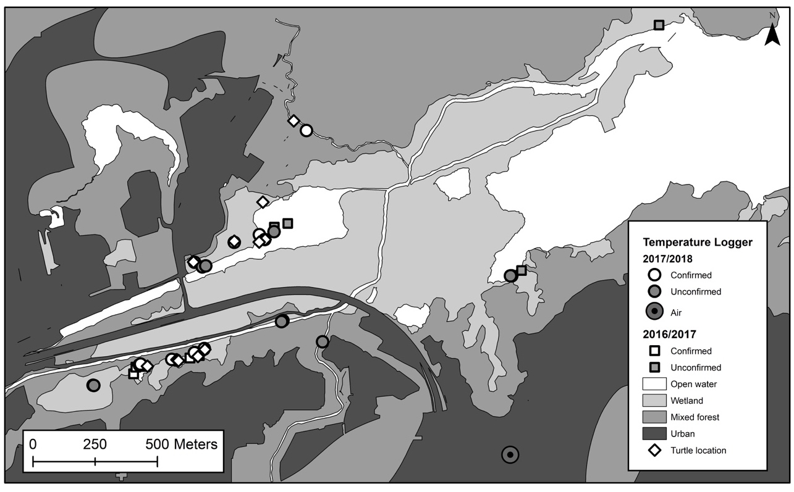
Figure 3.6 Location of temperature loggers in wetland habitat during October 2016 to March 2017, October 2017 to March 2018 and location of tagged snapping turtles between October 2017 to March 2018.

Chapter 4: General Conclusion

Summary
Effective management and mitigation strategies require a thorough understanding of an organism’s spatial needs within a landscape, along with threats that may be acting across all life stages. Although road mortality is an anthropogenic threat that imparts deleterious impacts on many herpetofauna species, it is particularly harmful to long-lived species that have delayed sexual maturity such as the snapping turtle. We have provided strong evidence, which includes empirically derived mortality data as well as measured home ranges of ten tagged individuals, that the decline in the snapping turtle population of western CPM by over 90% since 1985 is likely the result of collisions with vehicles on Cootes and Olympic Drives. Despite the drastic population decline, this population of snapping turtles is likely one of the largest urban populations in Lake Ontario. Another contributing factor to the decline may be reduced availability of potential nesting habitat, which has declined by almost half since 1934, and is possibly limiting. Although the amount and type of overwintering habitat do not appear to be limiting for this dwindling population, turtles appear to choose sites based on the rate and duration at which water temperatures drop below freezing, and there is no easy way for us to distinguish between used and unused overwintering habitats based solely on appearance. Hence, non-discriminant alterations of wetland habitat through urban development will continue to threaten the persistence. It is difficult to think of worse threats, but we found it this year, when we obtained confirmation that one of the common snapping turtles in CPM died of a ranavirus infection. This was the first reported morbidity and mortality of a reptile dying of ranavirus in Canada.

Recommendations for Management of CPM
Our findings have revealed important considerations for the management of freshwater turtles and in particular, common snapping turtles. Here we will provide recommendations to advance mitigation strategies to conserve these imperiled taxa.
- We recommend installation of complete wildlife exclusion fencing on Cootes Drive, Olympic Drive and King Street East to minimize road mortality occurrences. It would be preferable to use a material that is durable (such as Animex fencing) and to ensure that the termini curve into the habitat to minimize circumvention. We also recommend that stakeholders form a maintenance program to ensure perpetual fencing integrity.
- Through our radio tracking program, we determined a wide variation in overwintering microhabitats used by snapping turtles. To promote individual survival through winter months, we recommend that the surrounding upland matrix associated with wetlands be protected from alteration.
- We determined disproportionate use of artificial mounds for nesting. Previous studies have determined that these mounds are effective in producing successful nests (Paterson et al., 2013); however, where insufficient artificial mounds exist in conjunction with limited natural habitat, such high nest densities can increase depredation rates (Marchand and Litvaitis, 2003). In urban areas, such as CPM, mesopredators including racoons, skunks and foxes likely exist in unnaturally high abundance. Therefore, the combination of high density nesting sites and increased abundances of meso-predator populations could result in unsustainably high nest depredation rates. We recommend installation of additional artificial nesting mounds to decrease nest density in efforts to reduce nest depredation rates.
- To examine long term changes in habitat, we recommend the use of imagery that spans at least multiple decades. Using imagery that spanned nearly a century permitted us to examine the vast change in habitats associated with urban and agricultural development within Hamilton, Ontario.
- Since freshwater turtles, including the common snapping turtles, are extremely long-lived organisms, longitudinal studies are challenging; however, having access to multi decade capture-mark-recapture data enabled us to detect population trends. Therefore, we recommend that long-term monitoring programs of populations be implemented and maintained going forward. Such long-term protocols are invaluable for developing long-term recovery plans.
- Frog virus 3, is an emerging disease that can be transmitted across ectothermic classes and have been associated with mass mortalities in other species and populations (Gray et al., 2009). Currently, the prevalence of ranavirus within the common snapping turtle population as well as the community is unknown. To prevent further transmission, the extent of ranavirus within this fragile urban ecosystem, both geographically and taxonomically, should be determined as soon as possible.

Future Avenues for Research
Throughout our own research process, various new questions and potential areas of research arose. There is much work to be done regarding the conservation of freshwater turtles; here we provide future avenues for research.
- We discovered the first occurrence and associated mortality of ranavirus (Frog virus 3, FV3) in any common snapping turtle (see Appendix). Although the source of the infection is unknown, this virus can be transmitted across ectothermic classes (Gray et al., 2009), including potential host species that share their environment with snapping turtles. The prevalence of FV3 within the snapping turtle population and the greater CPM community is unknown. These viruses have been associated with mass mortalities in the past in other species (Chinchar et al., 2009; Miller et al., 2011; Teacher et al., 2010; Une et al. 2009); therefore, studies should be initiated to study the incidence of ranavirus within the snapping turtle population as well as cross-species transmission within the community. Such studies could collect tissues samples via cloacal swabs, tail/toe clippings or tissues samples (liver or kidney) from all known host species within CPM.
- The impacts of climate change on herpetofauna and population resiliency are largely unknown. Future fluctuations in intensity, duration and timing of weather patterns could result in significant changes to aquatic habitats and wetlands. Therefore, future research should examine the effect of global climate change on habitat and potential implications for common snapping turtles throughout their life cycle.
- Overwintering for snapping turtles is hypothesized to be substantially impacted by global climate change in the future. Examining additional physical characteristics (dissolved oxygen levels, water/mud depths, ice coverage and various types of concealment such as logs) within successful overwintering sites would permit a deeper understanding of overwintering site requirements.
- Relative to previous studies, the individual home range sizes of the common snapping turtles in our study were much larger. Determinants of home range size should be investigated, perhaps to determine the relationship between home range size and habitat degradation.
- Previous studies of the turtle population in Hamilton Harbour examined the effects of contaminants in adults that may be associated with surrounding industry; however, there have been no studies investigating the effects of wastewater effluent associated with the Dundas Wastewater Treatment Plant (WWTP). Future research could be directed to understanding the effect of the WWTP effluent (i.e. pharmaceuticals in the effluent) on all snapping turtle age classes.
- There are currently two aquatic culverts in place on Cootes Drive which could decrease the effects of habitat fragmentation and increase gene flow for snapping turtles and other species. However, these culverts were installed for hydrological reasons, and may not be in suitable in terms of width, length, and construction material for wildlife crossings. Therefore, more studies should assess current use and examine how culvert type, size and design may influence how wildlife use these as eco-passages. These types of studies could be executed with the use of PIT tagging systems, GPS tags, intensive radio-tracking or a Before-After-Control-Impact study examining wildlife exclusion fencing effectiveness.
- Future studies should examine population structure of freshwater turtles and snapping turtles within CPM to determine if it is an aging population with a skewed sex ratio towards males. For example, given that populations appear to be suffering from decreased recruitment, there will be fewer juveniles and in time, the declining birth rate will lead to extirpation. Additionally, when populations are subjected to road mortality, often sex ratios can become skewed towards a male bias because females are being struck while seeking nest sites.

Literature Cited
Chinchar, V. G., Hyatt, A., Miyazaki, T. and Williams, T. (2009). Family Iridoviridae: poor viral relations no longer. Current Topics in Microbiology and Immunology 328:123–170.
Galbraith, D. A., Bishop, C. A., Brooks, R. J., Simser, W. L. and Lampman, K. P. (1988). Factors affecting the density of populations of common snapping turtles (Chelydra serpentina). Canadian Journal of Zoology 66:1233-1240.
Garrah, E. (2012). Wildlife road mortality on the 1000 islands parkway in South Eastern Ontario: peak times, hot spots, and mitigation using drainage culverts. Masters of Environmental Science Thesis, Queen’s University.
Gray, M. J., D. Miller, and J. T. Hoverman. (2009). Ecology and pathology of amphibian ranaviruses. Diseases of Aquatic Organisms 87(3):243–266.
Haxton, T. (2000). Road mortality of snapping turtles, Chelydra serpentina, in Central Ontario during their nesting period. Canadian Field-Naturalist 114(1):106-110.
Marchand, M. N. and Litvaitis, J. A. (2003). Effects of landscape composition, habitat features, and nest distribution on predation rates of simulated turtle nests. Biological Conservation 117:243-251.
Markle, C.E., Gillingwater, S.D., Levick, R., and Chow-Fraser, P. (2017). The true cost of partial fencing: Evaluating strategies to reduce reptile road mortality. Wildlife Society Bulletin 41(2):342–350.
Miller, D. L., Gray, M. J. and Storfer, A. (2011). Ecopathology of ranaviruses infecting amphibians. Viruses 3:2351–2373.
Paterson, J. E., Steinberg, B. D. and Litzgus, J. D. (2012). Generally specialized or especially general? Habitat selection by Snapping Turtles (Chelydra serpentina) in central Ontario. Canadian Journal of Zoology 90:139-149.
Paterson, J. E., Steinberg, B. D. and Litzgus, J. D. (2013). Not just any old pile of dirt: evaluating the use of artificial nesting mounds as conservation tools for freshwater turtles. Oryx 47(4):607-615.
Teacher, A. G. F., Cunningham, A. A. and Garner, T. W. J. (2010). Assessing the long-term impacts of Ranavirus infection on wild common frog populations. Animal Conservation 13:514–522.
Une, Y., Sakuma, A., Matsueda H et al. (2009). Ranavirus outbreak in North American bullfrogs (Rana catesbeiana), Japan. Emerging Infectious Diseases 15:1146–1147.

Appendix: First ranavirus case and associated mortality in a common snapping turtle (Chelydra serpentina).

By

Morgan L. Piczak¹**, Christina M. McKenzie^{2}**, Heindrich N. Snyman³, Patricia Chow-Fraser¹ and Claire M. Jardine²

¹Department of Biology, McMaster University, 1280 Main Street West, Hamilton, ON, L8S 4K1
²Canadian Wildlife Health Cooperative – Ontario/Nunavut, Pathobiology, University of Guelph, 50 Stone Road East, Guelph, ON, N1G 2W1
³Animal Health Centre - British Columbia Ministry of Agriculture 1767 Angus Campbell Road Abbotsford, BC, V3G 2M3
Department of Pathobiology, Ontario Veterinary College, University of Guelph, 50 Stone Road East, Guelph, ON, N1G 2W1

**Both authors contributed equally

Keywords: snapping turtle; Chelydra serpentina; reptile; ranavirus; Cootes Paradise Marsh; Canada; mortality; Frog virus 3
Presented in manuscript format and will be submitted to Herpetological Review.

Abstract
One adult male snapping turtle was captured from the highly urbanized Cootes Paradise Marsh, Lake Ontario, Canada in summer 2017 with marked palpebral edema and skin ulcerations. The turtle died at a treatment facility and was submitted for post mortem investigation. Gross lesions included ulcerative conjunctivitis, necrotizing stomatitis, and splenomegaly. Microscopically this corresponded to fibrinonecrotizing vasculitis and severe fibrinous splenic necrosis. Quantitative polymerase chain reaction analyses of DNA collected from the liver tested positive for ranavirus Frog virus 3. This is the first report of morbidity and mortality of any common snapping turtle with a ranavirus infection, and the first reported case of ranavirus infection in a reptile in Canada. In Ontario, only amphibian species have been documented as being infected with ranavirus, and though the source of this infection is unknown, snapping turtles coexist in lentic environments with these prospective ranavirus hosts. Ranavirus has the potential to impart negative impacts on this already declining population of snapping turtles and whole communities since it is transferable across species. This report has furthered our understanding of host range and geographic distribution of ranaviruses; however, to minimize the risk of further spread or an outbreak, it is essential to implement a monitoring program to determine the prevalence of ranavirus within this fragile, urban ecosystem.

Introduction
On a global scale, herpetofauna are in peril as populations face decline, extirpation and extinction (Gibbons et al., 2000). Anthropogenic factors such as habitat fragmentation, degradation and loss may be contributing to these phenomena (Marchand and Litvaitis, 2004); however, the spread of infectious diseases, including ranaviruses may also have a negative effect (Monsen-Collar et al., 2013). These viruses belong to the family Iridoviridae and genus ranavirus and have been documented on six continents and in 175 species of ectothermic vertebrates (Duffus et al., 2015). One species of the genus ranavirus, Frog virus 3 (FV3) has infected mostly amphibians, although the number of species affected is growing (Winzeler et al., 2015). Due to lack of reporting and asymptomatic or cryptic hosts, the known geographic range and host variety of ranaviruses is likely underestimated (Duffus et al., 2015).
Previous studies have determined that ranaviruses are capable of transferring between ectothermic vertebrate classes and can act as asymptomatic reservoirs (Allender, 2012; Brenes et al., 2014a; Brenes et al., 2014b) For low density or geographically isolated species, ranavirus may represent a substantial threat as it could contribute to population decline or extirpation (Lesbarrères et al., 2012; Teacher et al., 2010;). Specifically, there have been ranavirus infections reported in wild box turtles (Terrapene sp) within North America that have resulted in mortalities (Allender et al., 2006; De Voe et al. 2014; Johnson et al., 2008; Kimble et al., 2014). It has been suggested that mortalities associated with ranavirus could be detrimental to box turtle populations, particularly if the individuals lost are female (Farnsworth and Seigal, 2013). Furthermore, during a high prevalence of ranavirus within a wild population of eastern box turtles (Terrepene Carolina Carolina) 21% individuals died (Belzer and Seibert 2011; Johnson et al. 2008). Evidence suggests that in chelonians, ranaviruses result in an acute and rapidly lethal infection (Johnson et al., 2007) and symptoms include skin lesions, organ and tissue swelling and death via organ failure typically within three weeks (Monsen-Collar, 2013).
Ranaviruses are capable of infecting both captive and wild animals and can be transmitted across fish, amphibians and reptiles (Gray et al., 2009; Winzeler et al., 2015). Ranavirus can be transmitted via a number of routes including through the environment (water) (Brenes et al., 2014a), consumption of an infected host, or through direct contact with an infected individual (Pearmen et al., 2004). Within the USA, there have been recordings of ranavirus infections in amphibians (Davidson and Chambers, 2011; Hamed et al., 2013), fish (Grant et al., 2005; Southard et al., 2009; USFWS, 2011) and reptiles (Goodman et al., 2013; Johnson et al., 2008). In Canada, across 9 of the 13 provinces and territories (AB, BC, PEI, SK, MB, ON, NU, NWT, QC), reports of ranavirus infections have been limited to amphibians (families Ambystomatidae, Hylidae, Ranidae and Salamandridae) (Duffus et al., 2008; Whitfield et al., 2013). In North America, all ranavirus cases infecting reptiles have occurred within the USA (none in Canada) and have affected various sauropsids, including turtles, specifically within families Emydidae (Goodman et al., 2013) and Testudinidae (Johnson et al., 2008).
To our knowledge, this is the first reported case of ranavirus-induced mortality in a reptile in Canada and the first report of ranavirus infection in a common snapping turtle (Chelydra serpentina). Snapping turtles are long-lived organisms whose life history is characterized by delayed sexual maturity, low recruitment and reliance on low adult mortality (COSEWIC, 2008). Due to this “bet hedging” life history, this species is extremely susceptible to stochastic environmental stressors, particularly if the stressor is acting on a large spatial scale, such as habitat alteration (Congdon et al., 1994). For these reasons, snapping turtle populations could experience serious deleterious impacts should a high prevalence of ranavirus occur. In the western end of Cootes Paradise Marsh (CPM), a highly degraded coastal wetland at the extreme western end of Lake Ontario, Canada (Chow-Fraser et al., 1998; Chow-Fraser, 2005), a population of snapping turtles has been declining since the mid 1980s (see Chapter 2). There have been reports of amphibians infected with ranavirus in Ontario (Duffus et al., 2015), and often times these species coexist with snapping turtles in lentic environments such as CPM. Although prevalence and mortality rate of ranavirus infection in snapping turtles within CPM is currently unknown, we suspect that there is a large potential for ranavirus to have a deleterious effect on the population. This report will contribute further understanding of the geographic range and variety of host species that have been infected by the ranavirus.

Materials and Methods

Study Site
Cootes Paradise Marsh (CPM) is a 250 ha anthropogenically degraded coastal wetland located in the western end of Lake Ontario, Canada that has suffered habitat loss and impaired water quality (Chow-Fraser et al., 1998; Chow-Fraser, 2005; Figure 1). West Pond is located at the western end of the marsh and its only source of water (other than rain water) is a wastewater outfall discharging treated effluent from the Dundas Wastewater Treatment Plant. This pond is dominated by few vegetative species including white water lilies, cattails, an invasive haplotype of common reed (Phragmites australis) and reed manna grass (Glyceria grandis) (Wei and Chow-Fraser, 2006). The marsh and surrounding creeks (Ancaster, Spencer’s and Borer’s Creek) are inhabited by documented ranavirus host species in other locations within Ontario and North America including amphibian species specifically spring peeper (Pseudacris crucifer), green frog (Lithobates clamitans), northern leopard frog (Lithobates pipiens), American bullfrog (Lithobates catesbeianus), American toad (Anaxyrus americanus), eastern newt (Notophthalmus viridescens), eastern red-backed salamander (Plethodon cinereus; Piczak, unpublished data), fish species such as largemouth bass (Micropterus salmoides), gizzard shad (Dorosoma cepedianum) and black crappie (Pomoxis nigromaculatus; Loughleed et al., 2004) and turtle species including the invasive red eared slider (Trachemys scripta elegans) and midland painted turtles (Chrysemys picta). In Ontario, ranavirus has been documented in amphibian species that can share water with snapping turtles, specifically: spring peeper, green frog, northern leopard frog and eastern newt (Duffus et al., 2015).

Background
All field work in this report was carried out under approved animal use protocols from McMaster University (no. 17-01-05) and site-specific permits (WSCA no. 1084392 and RBG no. 2016-07). During a regular radio tracking survey in West Pond on June 14th 2017 (Figure 1), we found a large male snapping turtle with lesions and severe swelling on the face, neck and eyes (Figure 2), which we later determined to be symptoms of ranavirus. We brought the turtle to a wildlife veterinary clinic (Hobbitstee Wildlife Refuge, Jarvis Ontario), where it was treated with an antibiotic, Ceftazadime. The turtle died shortly after arrival to the refuge and was submitted to the Canadian Wildlife Health Cooperative – Ontario Regional Centre for diagnostic evaluation.

Histopathology and Bacteriology
A post-mortem examination was performed and various tissues (skin, stomach, heart, spleen, kidney, lung, liver, testis, thyroid, intestine and skeletal muscle) were prepared routinely for histologic examination and stained with hematoxylin and eosin. Additional stains included Masson’s Trichrome and Martius Scarlet Blue (MSB) Trichrome on select tissues. Swabs of the oral lesions were taken for bacterial culture.

Molecular
We extracted DNA from the swabs of liver tissue and used a conventional polymerase chain reaction (PCR) with the following primers: FV3-MCP-1-F (5'-GCA GGC CGC CCC AGT CCA-3') FV3-MCP-2-R (5'-GGG CGG TGG TGT ACC CAG AGT TGT-3'). These primers target the major capsid protein gene with an amplicon size of 482 base pairs (bp). We then sequenced a 440 bp fragment and used the Basic Local Alignment Search Tool (BLAST) to match gene sequences from the GenBank.

Results

Gross Findings
Necropsy revealed marked bilateral palpebral swelling that effectively occluded vision, with associated conjunctival ulceration and yellow-tan crusting. A 1.5 cm diameter soft tissue swelling was present at the right oral commissure. There was a focal 1.5 cm x 1 cm area of ulcerative necrosis in the dorsal soft palate, just caudal to the bill and there was a rim of necrotic tissue lining the inner aspect of the upper beak. The oral cavity contained a small amount of red-tinged purulent fluid. The spleen was enlarged to approximately 5 cm x 3 cm and the liver was diffusely pale yellow-brown. Lungs were diffusely moderately congested. The turtle had moderate amounts of subcutaneous and perivisceral fat, although the stomach and intestinal tract were empty, with only a few hard fecal pellets present in the rectum.

Histopathology Findings
There was multifocal full thickness necrosis of the conjunctival epithelium with fibrin, edema and aggregates of poorly preserved leukocytes expanding the underlying connective tissues (Figure 3). Fibrinoid change was apparent in many blood vessels within the underlying connective tissue and was accompanied by moderate numbers of leukocytes within the wall and in the perivascular connective tissue (Figure 4). Superficially, there were colonies of coccoid bacteria within the necrotic tissue.
The spleen was severely affected by fibrinonecrotizing vasculitis with fibrin, necrosis, hemorrhage and a mixed population of leukocytes effacing over 95% of the architecture (Figure 5). There was diffuse lymphoid depletion and no appreciable remaining follicular structures. Fibrinoid change was present in the vast majority of blood vessels, characterized by amorphous eosinophilic material segmentally expanding the walls, along with frequent granulocytic cells (Figure 5). These blood vessels were surrounded by concentric, fibrillar, hypereosinophilic areas in which there was loss of differential staining and scattered karyorrhectic debris (fibrin and coagulation necrosis) accompanied by variable numbers of poorly preserved monocytes and granulocytes. Numerous embolized trematode eggs measuring 100-150 μm in length were found within the spleen.
There was evidence of vascular fibrinoid change in the liver, kidney and lungs, but not to the extent observed in the spleen or conjunctiva, with no necrosis or inflammation of the adjacent tissues.
Using electromicroscopy, iridovirus particles were visualized in the liver, displaying their characteristic icosahedral shape (Figure 6). In the liver, all hepatocytes had variable cytoplasmic vacuolation, consistent with glycogen and or lipid, and there were aggregates of melanomacrophages, considered to be within normal limits (Allender et al., 2013). Hepatic sinusoids were mildly enlarged, but no thrombi were noted.
Within the kidney there was extensive tubular epithelial necrosis with sloughing of cells into the lumen. Glomeruli frequently contained markedly segmentally thickened capillary loops. Embolized trematode eggs, similar to those noted in the spleen, were embedded in the mucosa of the stomach and sometimes associated with adjacent necrosis and heterophilic inflammation. Lungs were markedly congested. Testes were inactive.

Bacteriology Findings
Swabs of the oral lesions produced moderate growth (3+) of Acinetobacter calcoaceticus, Providencia rettgeri, Aeromonas veronii, Aeromonas eucrenophila, Klebsiella oxytoca, Citrobacter braakii, and Pseudomonas rhodesia. No Mycoplasma spp. was isolated from the mouth swab. Some of these bacteria are known to be primary pathogens in turtles, but in this case, they are interpreted as bacterial overgrowth given the distribution of cocci visible histologically.

PCR Findings
A sample of frozen liver tested positive for Frog virus 3 via PCR. The same sample tested negative for herpesvirus. The BLAST search showed 100% match with Lacerta moticola ranavirus and FV3 major capsid protein gene sequences in the GenBank.

Discussion
We have documented the first case of ranavirus and associated mortality of any reptile species in Canada, as well as, the first case of mortality of a common snapping turtle. Ranaviruses are emerging pathogens with expanding geographic ranges and host species (Duffus et al., 2015). These viruses, particularly Frog virus 3, have been known to cause mass mortality events and can impart substantial negative effects on populations (Chinchar et al., 2009; Miller et al., 2011; Teacher et al., 2010; Une et al. 2009). The snapping turtle displayed severe clinical symptoms of a ranavirus infection including bilateral palpebral swelling and soft tissue swelling. All clinical, histological and molecular results were consistent with a FV3 infection. Finally, PCR results confirm the diagnosis of a ranavirus infection and mortality. The gross and microscopic findings in this case are consistent with previous reports of FV3 infection in turtles and are severe enough to have been the cause of mortality. In chelonians, FV3 infection presents clinically with ocular and nasal discharge, respiratory distress, palpebral edema, anorexia and lethargy (De Voe et al. 2004; Johnson et al., 2007).
Gross lesions included fibrinonecrotic oral ulceration, conjunctivitis, cellulitis, splenomegaly and subcutaneous edema
(Allender et al. 2013; De Voe et al. 2004; Heldstab, 1982; Johnson et al. 2007; Johnson et al. 2008; Marschang et al. 2014;). Microscopic lesions often involve systemic fibrinonecrotizing vasculitis characterized by hyalinized vessel walls (De Voe et al. 2004; Johnson et al., 2007). This can be especially prominent in the spleen, leading to effacement of splenic architecture by hemorrhage and fibrin and depletion of lymphoid follicles (Allender et al. 2013; Johnson et al., 2007). It has been hypothesized that the severe damage to splenic ellipsoids observed with chelonian FV3 infections could be result of their filtering function leading to antigen trapping and a subsequent immune response (Johnson et al., 2007). Other common microscopic lesions include fibrin thrombi, necrotizing hepatitis and ulceration with fibrinonecrotic plaques of mucous membranes (Adamovicz et al. 2018; Allender et al. 2013; De Voe et al. 2004; Johnson et al., 2007; Marschang et al. 2014). The damage to mucous membranes, most notably the oral mucosa and conjunctiva, could be the result of viral replication in epithelial cells or secondary to thrombus formation and ensuing infarction (Johnson et al., 2007).
Large, basophilic, intracytoplasmic inclusion bodies are often visible in epithelial cells in amphibian and fish iridovirus infections but, in chelonians, viral inclusion bodies are unpredictable and their presence varies based on the species (Allender et al. 2013; Johnson et al. 2008; Marschang et al. 2014) . In this case, inclusion bodies were not observed microscopically. However, the characteristic icosahedral viral particles of iridoviruses were visualized using EM of the liver
(Heldstab,1982; Johnson et al., 2007).
The major differential diagnosis for the observed stomatitis and conjunctivitis is a herpesviral infection, which was ruled out via PCR of liver tissue (Divers and Mader 2005) Systemic fibrinoid vasculaitis can also be caused by herpesvirus, as well as bacterial septicemia, rickettsial disease and systemic fungal infections – of which there was no microscopic evidence (De Voe et al. 2004).
The population of snapping turtles in CPM has been declining since the mid 1980s (Galbraith et al., 1988), likely due to high occurrence of road mortality (see Chapter 2). Although road mortality historically accounted for majority of the decline in the CPM population, other threats, including disease, may be more prevalent in the future. Because of their life history traits, adult survivorship is crucial to maintaining populations, and even a small increase in adult mortality can threaten the entire population (Aresco, 2005; Baxter-Gilbert et al., 2015; Brooks et al., 1990; Midwood et al., 2015; Zimmer-Shaffer et al., 2014). Congdon et al. (1994), found that an increase in snapping turtle mortality by 0.1 adults per year could halve a population in just 20 years. This one individual has already contributed to population decline by individual loss, but also through loss of potential reproductive output.
The occurrence of ranavirus in CPM is consistent with the hypothesis that the spread of this disease can be facilitated by severe environmental degradation (Reeve et al., 2013). Natural and anthropogenic stressors are hypothesized to suppress immune function and therefore make individuals more susceptible to disease and infections (Dunner et al., 2015), like ranaviruses. Previous studies have found increased cases of ranavirus associated with industry, human housing (St-Amour et al., 2008) and impaired water quality (Greer and Collins, 2008). Unfortunately, CPM is subjected to many of these stressors (Mudroch and Capobianco, 1979; Thomasen and Chow-Fraser, 2012), and may have contributed to the contraction of this virus.
Within Canada, only amphibians have been documented to be infected with ranavirus. In Ontario the spring peeper, green frog, northern leopard frog and eastern newt have been reported (Duffus et al., 2015). The source of the pathogen has not been identified in this case; however, in CPM, snapping turtles share water with all of the previously mentioned species and interclass transmission could have occurred through water (Brenes et al., 2014a; Brenes et al., 2015b; Duffus et al., 2015), sediment (Gray et al., 2009), direct contact or ingestion of infected individuals (Belzer and Seibert 2011; Brunner et al., 2007; Gray et al., 2009; Kimble et al. 2014). One study orally inoculated wood frogs (Rana sylvatica) and determined that liver, feces and skin tested positive for FV3 and therefore each substance could be a potential source of infection (Forzán et al., 2017). Most reports of ranavirus interclass transmission have occurred between amphibian and fish species (Bang-Jensen et al. 2009; Gobbo et al. 2010; Picco et al. 2010). In Japan, FV3 resulted in mass mortalities of the introduced American bullfrog tadpoles and ranavirus was also detected in the livers of fish (Gnathopogon sp) that were present in the pond (Une et al., 2009), therefore suggesting interclass transmission, potentially via water. Brenes et al. (2014b) determined that FV3 (isolated from American bullfrog, eastern box turtle, Terrapene carolina carolina, and pallid sturgeon, Scaphirhynchus albus) could be transmitted via water across fish (channel catfish, Ictalurus punctatus and western mosquitofish Gambusia affinis) and aquatic turtle (Florida softshell turtle, Apalone ferox and Mississippi map turtles, Graptemys pseudogeographica kohni) species and resulted in subclinical infections and low occurrences of mortality. Dunner et al. (2015) stated that while transmission between individual turtles within the same population is unlikely to occur due to low densities, transmission through other classes within the same environment could increase prevalence and result in die-offs.
There have been outbreaks in other turtle species in the USA including box turtles (Terrapene sp) (Duffus et al., 2015) and the number of cases and species is rising (Winzeler et al., 2015). Box turtles are mainly terrestrial, but move between temporary ponds, which could increase their exposure to other infected amphibians (Belzer and Seibert 2011). Conversely, snapping turtles are primarily aquatic (COSEWIC, 2008) and it is possible that this could substantially increase their exposure since they spend the majority of their time in water, which can be shared by potential ranavirus host species. Specifically, Brenes et al., (2014) determined that FV3 can be transmitted through water across ectothermic vertebrate classes including amphibians (Cope’s gray treefrog, Hyla chrysoscelis larvae) and turtles (red-eared slider). Snapping turtles may also be exposed to ranavirus infected individuals via their feeding habits, which can include scavenging for carrion (Ernst et al., 1994; Harding, 1997) that could be infected with ranavirus. Additionally, snapping turtles can be asymptomatic and act as reservoirs for ranavirus, which could ultimately result in transmission it to other species, mainly amphibians (Brenes, et al., 2014a, Brenes et al., 2014b). A previous study determined that mosquitos could be a possible vector as ranavirus infected mosquitos were found at the same site as infected Eastern box turtles (Kimble et al., 2014). It is suggested that in low density turtle populations, where contact between infected individuals may be infrequent, mosquitos could play a role in facilitating virus spread (Kimble et al., 2014).
In general, the prevalence of ranavirus is unknown due to underreporting (Daszak et al., 1999), insufficient long-term studies, lack of awareness, and infrequent disease monitoring in biological studies (Duffus et al., 2015). We accidentally encountered this infected individual while carrying out routine surveys. There may be other infected individuals in the marsh that have escaped detection and without a dedicated investigation, we will not know the extent of spread throughout the population. To prevent an outbreak and minimize risk of extirpation, managers of CPM should determine the prevalence of ranavirus. If possible, the study should have an expanded scope to identify the source of this infection, and any other vertebrates that may serve as a host for ranavirus in CPM.

Acknowledgments
We thank Jacqueline Garnett for assisting in the capture and transportation of the snapping turtle. Also, thanks to Chantal Theijn and Hobbitstee Wildlife Refuge for treating the turtle and completing initial medical and physical examinations. Thanks to Douglas Campbell at the Canadian Wildlife Heath Cooperative for assistance in interpreting gross and microscopic lesions.

Literature Cited

Adamovicz, L., Allender, M. C., Archer, G., Rzadkowska, M., Boers, K., Phillips, C., Driskell, E., Kinsel, M. J., and Chu, C. (2018). “Investigation of Multiple Mortality Events in Eastern Box Turtles (Terrapene Carolina Carolina). PLoS One 13 (4): e0195617–20.
Allender, M .C., Fry, M. M., Irizarry, A. R. et al. (2006). Intracytoplasmic inclusions in circulating leukocytes from an eastern box turtle (Terrapene carolina carolina) with iridoviral infection. Journal of Wildlife Diseases 42:677–684.
Allender, M. C. (2012). Characterizing the epidemiology of ranavirus in North American chelonians: diagnosis, surveillance, pathogensis and treatment. Doctoral Thesis. University of Illinois. 219 pp.
Allender, M. C., Mitchell, M. A., Torres, T., Sekowska, J. and Driskell, E .A. (2013). Pathogenicity of Frog Virus 3-Like Virus in Red- Eared Slider Turtles (Trachemys Scripta Elegans) at Two Environmental Temperatures. Journal of Comparative Pathology 149(2-3):356–67.
Aresco, M. J. (2005). The effect of sex-specific terrestrial movements and roads on the sex ratio of freshwater turtles. Biological Conservation 123:37–44.
Bang-Jensen, B., Ersboll, A. K, and Ariel, E. (2009). Susceptibility of pike Esox luciusto a panel of ranavirus isolates. Diseases of Aquatic Organisms 83:169– 179
Baxter-Gilbert, J. H., Riley, J. L., Lesbarrères, D., and Litzgus, J. D. (2015). Mitigating reptile road mortality: fence failures compromise ecopassage effectiveness. PLoS ONE 10:e0120537.
Belzer, W. R. and Seibert, S. (2011). A natural history of Ranavirus in an eastern box turtle population. Turtle Tortoise Newsletter 15:18–25.
Brenes, R., Gray, M. J., Waltzek, T. B., Wilkes, R. P. and Miller, D. L. (2014a). Transmission of ranavirus between ectothermic vertebrate hosts. PLoS ONE 9(3): e92476.
Brenes, R., Miller, D. L., Waltzek, T. B., Wilkes, R. P., Tucker, J. L., Chaney, J. C., Hardman, R. H. et al. (2014b). Susceptibility of fish and turtles to three ranaviruses isolated from different ectothermic vertebrate classes. Journal of Aquatic Animal Health 26:118-126.
Brooks, R. J., Brown, G. P. and Galbraith, D. A. (1991). Effects of a sudden increase in natural mortality of adults on a population of the common snapping turtle (Chelydra serpentina). Canadian Journal of Zoology 69:1314-1320.
Brunner, J.L., Schock, D.M. and Collins, J.P. (2007). Transmission Dynamics of the Amphibian Ranavirus Ambystoma tigrinum Virus. Diseases of Aquatic Organisms 77:87–95.
Chinchar, V. G., Hyatt, A., Miyazaki, T. and Williams, T. (2009) Family Iridoviridae: poor viral relations no longer. Current Topics in Microbiology and Immunology 328:123–170
Chow-Fraser, P. (2005). Ecosystem response to changes in water level of Lake Ontario marshes: lessons from the restoration of Cootes Paradise Marsh. Hydrobiologica 539:189-204.
Chow-Fraser, P., Lougheed, V. L., Le Thiec, V., Crosbie, B., Simser, L. and J. Lord. (1998). Long-term response of the biotic community to fluctuating water levels and changes in water quality in Cootes Paradise Marsh, a degraded coastal wetland of Lake Ontario. Wetlands Ecology and Management 6: 19–42.
Committee on the Status of Endangered Wildlife in Canada [COSEWIC]. (2008). COSEWIC assessment and update status report on the snapping turtle Chelydra serpentina in Canada. Committee on the Status of Endangered Wildlife in Canada, Ottawa, Canada.
Congdon, J. D., Dunham, A. E. and van Loben Sels, R. C. (1994). Demographics of Common Snapping Turtles (Chelydra Serpentina): Implications for Conservation and Management of Long-Lived Organisms. American Zoologist, Vol. 34, No. 3: 397-408.
Daszak, P., Berger, L., Cunningham, A. A. et al. (1999). Emerging infectious diseases and amphibian population declines. Emerging Infectious Diseases 6:735–748
Davidson, S. R. A. and Chambers, D. L. (2011). Ranavirus prevalence in amphibian populations of Wise County, Virginia, USA. Herpetological Review 42:214–215.
De Voe, R., Geissler, K., Elmore, S., Rotstein, D., Lewbart, G. and Guy, J. 2004. Ranavirus-Associated Morbidity and Mortality in a Group of Captive Eastern Box Turtles (Terrapene Carolina Carolina). Journal of Zoo and Wildlife Medicine 35(4):34–43.
Divers, S. J. and Douglas R. M. (2005). Reptile Medicine and Surgery-E-Book. Elsevier Health Sciences.
Duffus, A. L. J., Pauli, B. D., Wozney K., Brunettie, C. R. and Berril, M. (2008). Frog virus 3-like infections in aquatic amphibian communities. Journal of Wildlife Diseases 44:109–120.
Duffus, A. L. J., Waltzek, T. B., Stöhr, A. C, Allender, M. C., Gotesman, M., Whittington, R. J., Hick, P., Hines, M. K. and Marschang R. E. (2015). Distribution and Host Range of Ranaviruses. In: Gray M., Chinchar V. Ranaviruses. Springer, Cham.
Dunner, J. L., Storfer, A., Gray, M. J. and Hoverman, J. T. (2015). Ranavirus ecology and evolution: from epidemiology to extinction. In: Gray M., Chinchar V. Ranaviruses. Springer, Cham.
Ernst, C.H., R.W. Barbour, and J.E. Lovich. (1994). Turtles of the United States and Canada. Smithsonian Institution Press, Washington D.C.
Farnsworth, S. D. and Seigel, R. A. (2013). Responses, movements, and survival of relocated box turtles during construction of the intercounty connector highway in Maryland. Transportation Research Record Journal of the Transportation Research Board 2362:1–8.
Forzán, M. J., Jones, K. M., Ariel, E., Whittington, R. K., Wood, J., Frederick Markham, R. J. and Daoust, P.Y. (2017). Pathogenesis of Frog Virus 3 ( Ranavirus, Iridoviridae) Infection in Wood Frogs ( Rana sylvatica). Veterinary Pathology 54(3):531-548
Galbraith, D. A., Bishop, C. A., Brooks, R. J., Simser, W. L. and Lampman, K. P. (1988). Factors affecting the density of populations of common snapping turtles (Chelydra serpentina). Canadian Journal of Zoology 66:1233-1240.
Gibbons, J.W., Scott, D. E., Ryan, T. J. et al. (2000). The global decline of reptiles, déjà vu amphibians. Bioscience 50:653−666.
Gobbo, F., E. Cappellozza, M. R. Pastore, and G. Bovo. (2010). Susceptibility of Black Bullhead Ameiurus melas to a panel of ranavirus isolates. Diseases of Aquatic Organisms 90:167–174.
Goodman, R. M., Miller, D. L. and Ararso, Y. T. (2013) Prevalence of ranavirus in Virginia turtles as detected by tail-clip sampling versus oral-cloacal swabbing. Northeastern Naturalist 20:325–332
Grant, E. C., Inendino, K. R., Love, W. J., Philipp, D. P. and Goldberg, T. L. (2005). Effects of practices related to catch-and-release angling on mortality and viral transmission in juvenile largemouth bass infected with largemouth bass virus. Journal of Aquatic Animal Health 17:315–322
Gray, M. J., D. l. Miller, and J. T. Hoverman. (2009). Ecology and pathology of amphibian ranaviruses. Diseases of Aquatic Organisms 87(3):243–266.
Hamed, M. K., Gray, M. J. and Miller, D. L. (2013). First report of ranavirus in plethodontidae salamanders from the Mount Rogers National Recreation Area, Virginia, USA. Herpetological Review 44:455–457.
Harding, J.H. (1997). Amphibians and Reptiles of the Great Lakes Region. The University of Michigan Press, Ann Arbor, Michigan.
Haxton, T. (2000). Road mortality of snapping turtles, Chelydra serpentina, in Central Ontario during their nesting period. Canadian Field-Naturalist 114(1):106-110.
Heldstab, A. and Bestetti, G., (1982). Spontaneous Viral Hepatitis in a Spur-Tailed Mediterranean Land Tortoise (Testudo Hermanni). The Journal of Zoo Animal Medicine 13(3):113.
Johnson, A. J., Pessier, A. P. and Jacobson, E. R. (2007). Experimental transmission of a Ranavirus in western ornate box turtles (Terrapene ornata ornata) and red-eared sliders (Trachemys scripta elegans). Veterinary Pathology 44:285–297.
Johnson, A. J., Pessier, A. P., Wellehan, J. F. X. et al. (2008). Ranavirus infection of free-ranging and captive box turtles and tortoises in the United States. Journal of Wildlife Diseases 44:851–863.
Kimble, S. J., Karna, A. K., Johnson, A. J. et al. (2014). Mosquitoes as a potential vector of ranavirus trans- mission in terrestrial turtles. EcoHealth 12(2):334-338.
Lesbarrères, A., Balseiro, A., Brunner, J., Chincar, V. G., Duffus, A., Kerby, J., Miller, D. L., Robert, J., Schock, D. M., Waltzek, T. and Gray, M. J. (2012). Ranavirus: past, present and future. Biology Letters 8: 481-483.
Loughleed, V. L., Theysmeyer, R., Smith, T. and Chow-Fraser, P. (2004). Carp exclusion, food-web interactions, and the restoration of Cootes Paradise Marsh. Journal of Great Lakes Research 30(1):44-57.
Marschang, R E, Becher, P., Posthaus, H., et al. 2014. Isolation and Characterization of an Iridovirus From Hermann’s Tortoises (Testudo Hermanni). Archives of Virology 144(10): 1909–22.
Marchand, M. M. and Litvaitis, J. A. (2004). Effects of habitat features and landscape composition on the population structure of a common aquatic turtle in a region undergoing rapid development. Conservation Biology 18(3):758-767.
Midwood, J. D., Cairns, N. A., Stoot, L. J., Cooke, S. J. and Blouin-Demers, G. (2014). Bycatch mortality can cause extirpation in four freshwater turtles. Aquatic Conservation: Marine and Freshwater Ecosystems 25:71-80.
Miller, D. L., Gray, M. J. and Storfer, A. (2011). Ecopathology of ranaviruses infecting amphibians. Viruses 3:2351–2373.
Monsen-Collar, K., Hazard, L. and Dolcemascolo, P. (2013). A Ranavirus-related Mortality Event and the First Report of Ranavirus in New Jersey. Herpetological Review 44(2):263-265.
Mudroch, A. and Capobianco, J. A. (1979). Effects of treated effluent on a natural marsh. Journal (Water Pollution Control Federation) 51:2243-2256.
Pearman, P. B., Garner, T. W. J., Straub, M., and Greber, U. F. (2004) Response of the Italian agile frog (Rana latastei) to a Ranavirus, frog virus 3: a model for viral emergence in naïve populations. Journal of Wildlife Diseases 40:660–669
Picco, A. M., Karam, A. P. and J. P. Collins. (2010). Pathogen host switching in commercial trade with management recommendations. Ecohealth 7:252–256.
Reeve, B. C., Crespi, E. J., Whipps, C. M. and Brunner, J. L. (2013) Natural stressors and ranavirus susceptibility in larval wood frogs (Rana sylvatica). Ecohealth 10:190–200
Southard, G. M., Fries, L. T. and Terre, D. R. (2009). Largemouth bass virus in Texas: distribution and management issues. Journal of Aquatic Animal Health 21:36–42
St Amour, V., Wong, W. M., Garner, T. W. J et al, (2008) Anthropogenic influence on prevalence of 2 amphibian pathogens. Emerging Infectious Diseases 12:1175–1176
Teacher, A. G. F., Cunningham, A. A. and Garner, T. W. J. (2010) Assessing the long-term impacts of Ranavirus infection on wild common frog populations. Animal Conservation 13:514–522.
Thomasen, S. and Chow-Fraser, P. (2012). Detecting changes in ecosystem quality following long-term restoration efforts in Cootes Paradise marsh. Ecological Indicators 13:82-92.
Une, Y., Sakuma, A., Matsueda, .H et al (2009) Ranavirus outbreak in North American bullfrogs (Rana catesbeiana), Japan. Emerging Infectious Diseases 15:1146–1147.
USFWS, (2011). National wild fish health survey database. USFWS, Washington, DC. www.fws.gov/wildfishsurvey/database/nwfhs. Accessed 26 March 2018.
Whitfield, S. M., Geerdes, E., Chacon, I., Ballestro Rodriguez, E., Jimenez, R. R., Donnelly, M. A. and Kerby, J. L. (2013). Infection and co-infection by the amphibian chytrid fungus and ranavirus in wild Costa Rican frogs. Diseases of Aquatic Organisms 104:173–178
Wei, A, and Chow-Fraser, P. (2006). Synergistic impact of water level fluctuation and invasion of Glyceria on Typha in a freshwater marsh of Lake Ontario. Aquatic Botany: 84:63-69.
Winzeler, M. E., Hamilton, M. T., Tuberville, T. D. and Lance, S. L. (2015). First case of ranavirus and associated morbidity and mortality in an eastern mud turtle Kinosternon subrubrum in South Carolina. Diseases of Aquatic Organisms. 114: 77-81.
Zimmer-Shaffer, S. A., Briggler, J. T. and Millspaugh J.J. (2014). Modeling the effects of commercial harvest on population growth of river turtles. Chelonian Conservation and Biology 13(2):227-236.

Figures
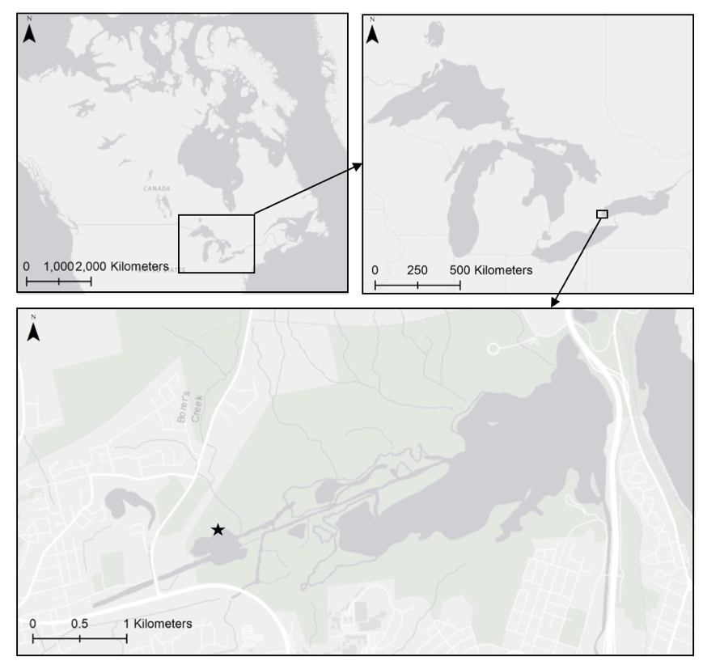
C
B
A
Figure A1.0.1 The Laurentian Great Lakes are located in Canada (A) and Cootes Paradise Marsh is located in the extreme western end of Lake Ontario (B). Within Cootes Paradise Marsh, a snapping turtle infected with ranavirus was found in West Pond (C).

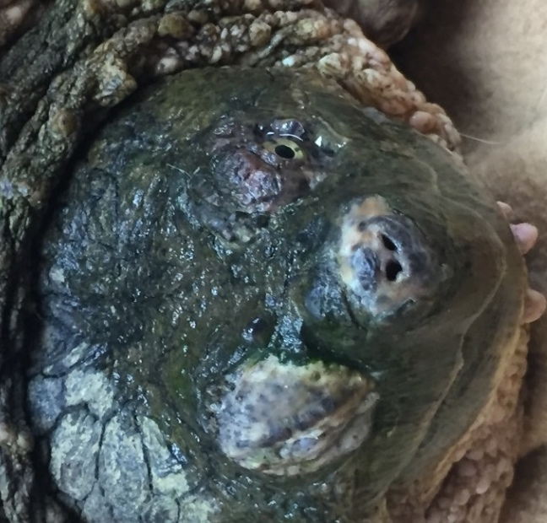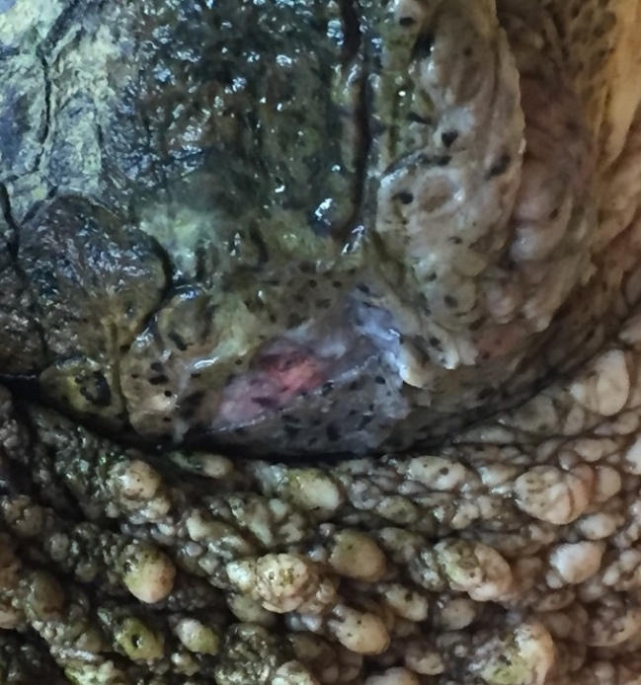
B
A
Figure A1.2 (A) Severe palpebral and rostral swelling and (B) epidermal ulceration on the lateral neck, both symptoms are consistent with those of a ranavirus infection.

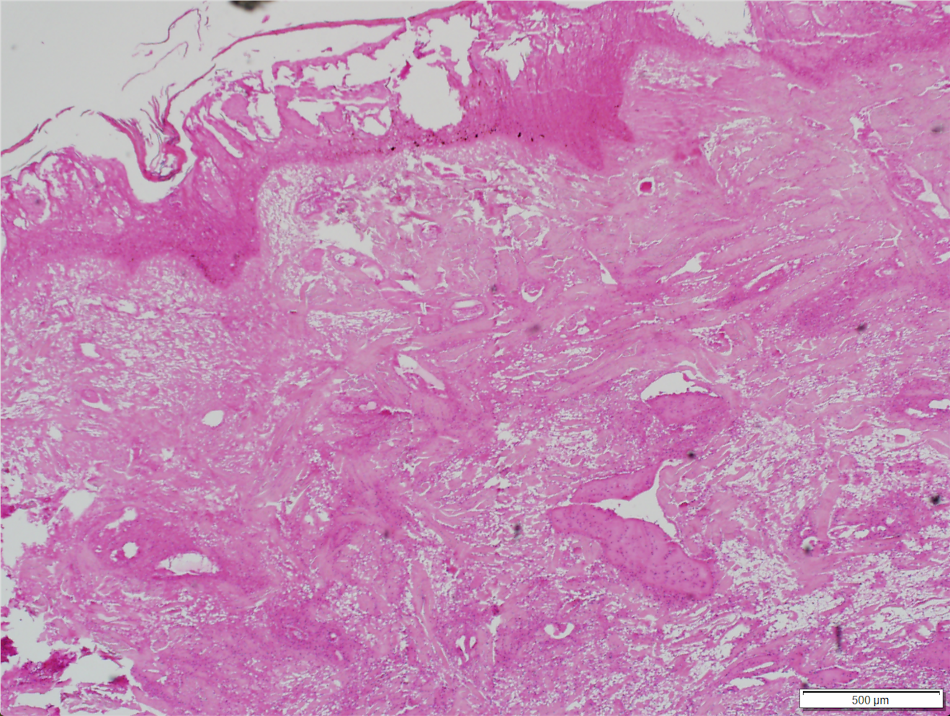
Figure A1.3 A photomicrograph of necrotic and edematous conjunctiva from a snapping turtle with a ranaviral infection. Hematoxylin and eosin stain.
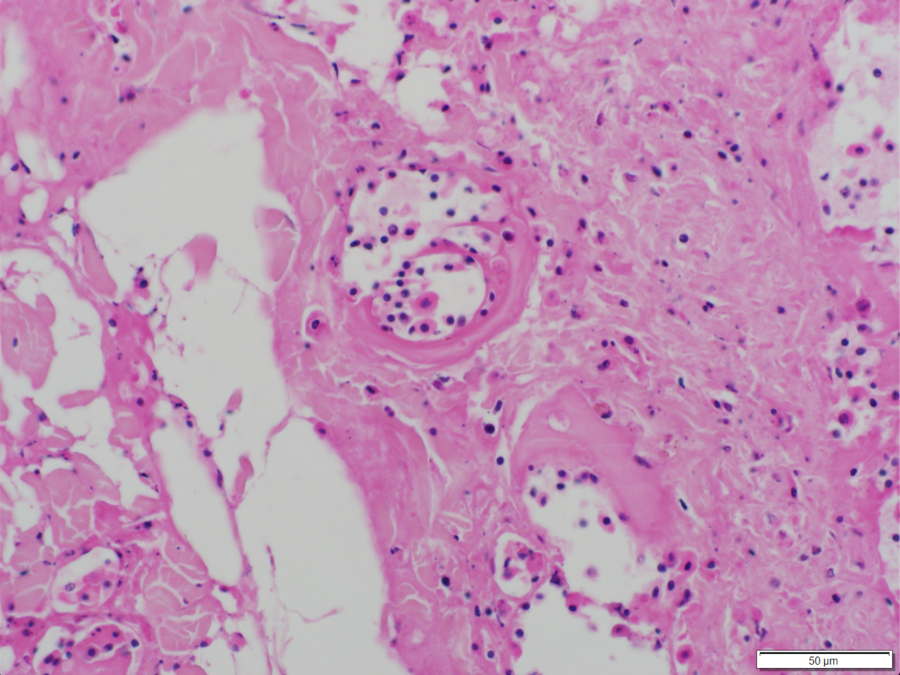
Figure A1.4 A photomicrograph of a palpebral blood vessel with fibrinoid necrosis characterized by hyalinized hypereosinophilic matrix segmentally effacing the wall and karyorrhectic debris. Hematoxylin and eosin stain.

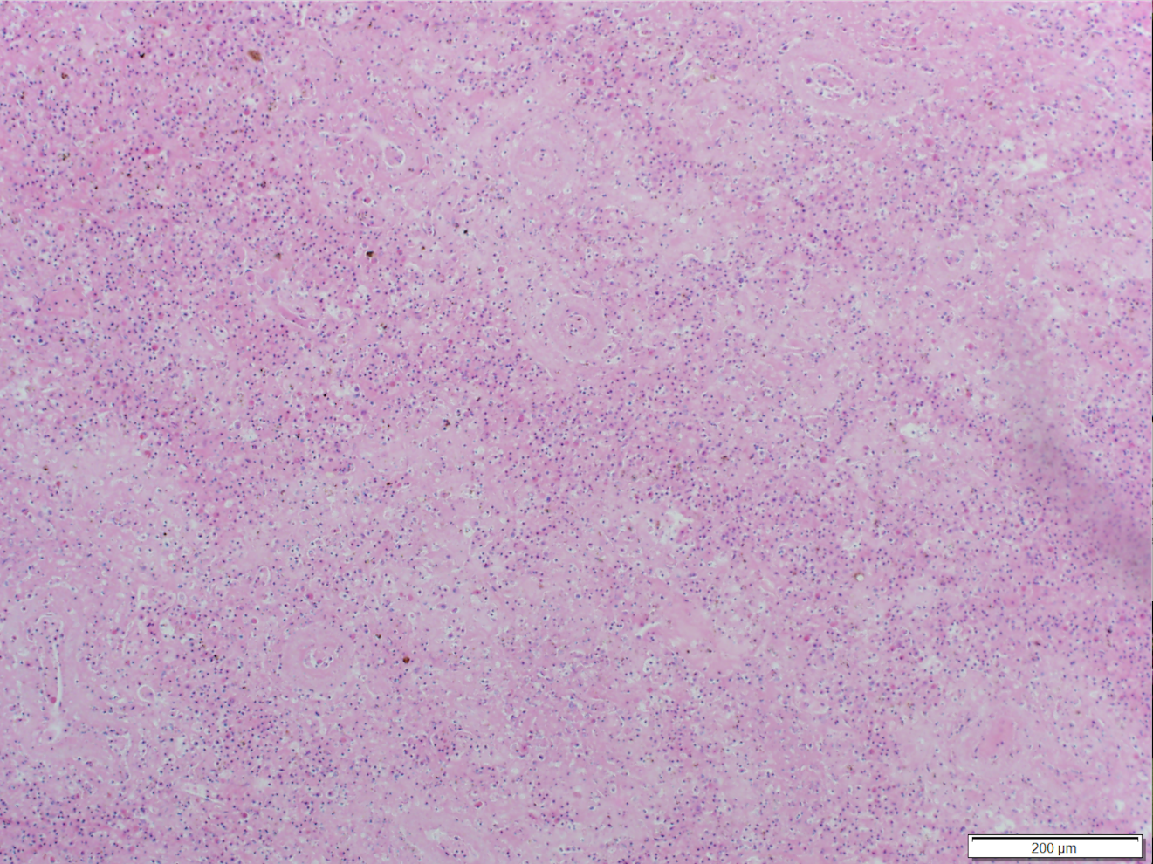
Figure A1.5 A photomicrograph of the spleen of a snapping turtle with a ranavirus infection has been entirely effaced by necrosis, fibrin and hemorrhage. Hematoxylin and eosin stain.
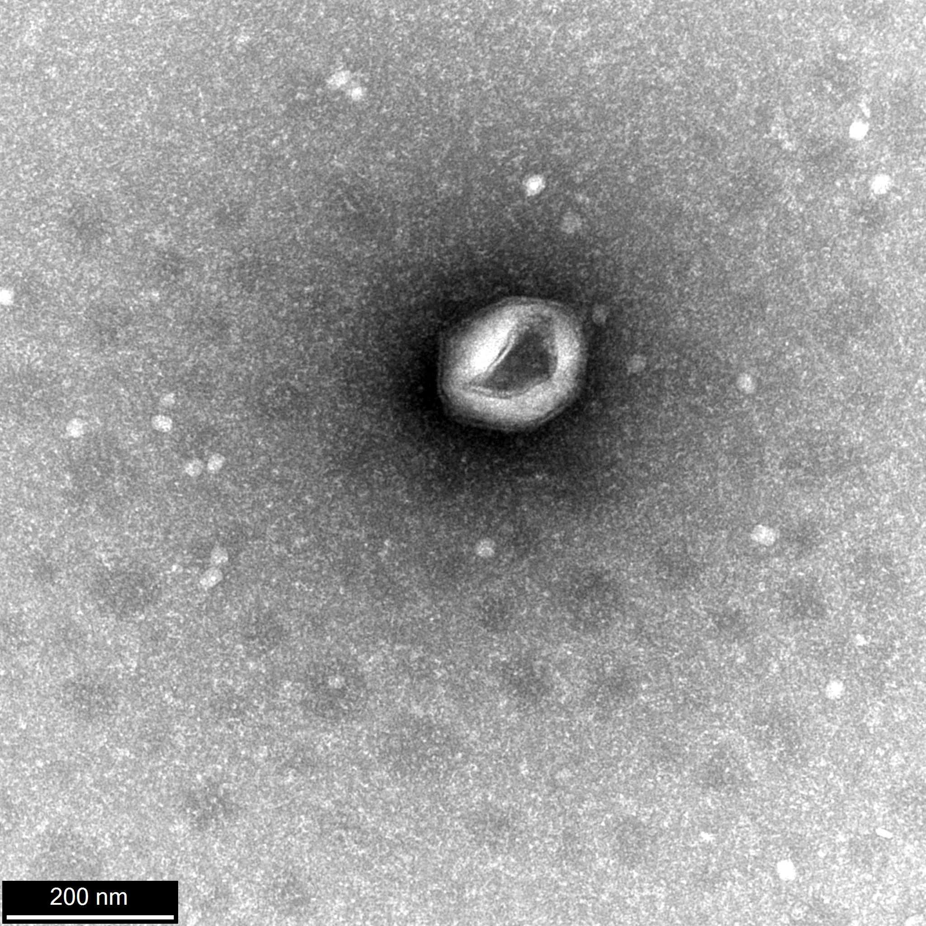
Figure A1.6 An electromicrograph of the icosahedral iridovirus particle from the liver of a snapping turtle.

