CHARACTERIZATION OF NAPHTHENIC ACID FRACTION COMPOUNDS IN AN OIL SANDS PIT LAKE USING ULTRA-HIGH RESOLUTION MASS SPECTROMETRY WITH ELECTROSPRAY IONIZATION

CHARACTERIZATION OF NAPHTHENIC ACID FRACTION COMPOUNDS IN AN OIL SANDS PIT LAKE USING ULTRA-HIGH RESOLUTION MASS SPECTROMETRY WITH ELECTROSPRAY IONIZATION

By: Jacob Luke Anthony Bothen, Hon. B.Sc.

A Thesis submitted to the School of Graduate Studies in the Partial Fulfillment of the Requirements for the Degree of Master of Science

McMaster University
© Copyright by Jacob Luke Anthony Bothen, 2023

Master of Science (2023) McMaster University, Hamilton, Ontario

School of Earth, Environment, & Society

TITLE: Characterization of Naphthenic Acid Fraction Compounds in an Oil Sands Pit Lake using Ultra-High Resolution Mass Spectrometry with Electrospray ionization.
AUTHOR: Jacob Luke Anthony Bothen, Hons. B.Sc. (Trent University)

SUPERVISOR: Professor Gregory F. Slater

NUMBER OF PAGES: xi, 133 pages.

Abstract
Extraction and production of viscous petroleum or bitumen in Alberta, Canada has rapidly developed in the last 30 years, and in 2022 the average daily production was nearly 4 million barrels/day. As a result of the increased global demand of crude oil and technical improvements in the extraction process of surface mining and in situ technologies, this daily output of crude oil is expected to increase further. Surface mining operations are required to invest and implement long-term reclamation strategies in order to properly reduce/manage the large volumes of oil sands process-affected water (OSPW) and tailings and convert the surrounding mining area into an environment similar to its initial state. Commissioned in late 2012 within Syncrude’s Mildred Lake mining site is Base Mine Lake (BML), the first full-scale demonstration of Water Capped Tailings Technology. This aquatic reclamation environment serves as the first of many oil sands pit lakes proposed in the surrounding region, therefore, it is crucial that a comprehensive assembly of scientific pursuits are incorporated into the monitoring and research programs of BML. The presence of petroleum-associated organic compounds, such as Hydrocarbons and Naphthenic acid Fraction compounds (NAFC), remains a top priority for evaluating how BML meets surface water guidelines, but also plays a larger role in the scientific understanding of how biogeochemical and physical processes can impact the environmental fate and transport of these organic compounds in future oil sand pit lakes.
This master’s dissertation is focused on the use of ultra-high resolution mass spectrometry to determine the molecular profile of NAFCs extracted from BML in 2019. In this thesis, electrospray ionization Fourier transform ion cyclotron resonance mass spectrometry (ESI-FT ICR MS) was used to investigate: i) how particular experimental variables impact the qualitative measurements of oil sand NAFCs, and ii) the spatial variability of NAFCs within the BML water cap and FFT with the aim of providing novel insights to key biogeochemical processes and potential transport mechanisms for continued NAFC inputs in the water column.

DEDICATION

I would like to dedicate this dissertation in the memory of Dr. Jill Crossman who suddenly passed away in September 2021. Jill, I will forever remember the memories that we shared during the car rides blasting Avril Lavine or out on Lake Simcoe during one of our many sampling expenditures throughout the summer of 2016. It deeply saddens me that someone as hardworking, intelligent, and compassionate as yourself in the field of Environmental Science left this world so soon. Thank you for giving me the opportunity to assist in your amazing research, and for inspiring me to follow my dreams of working in Environmental Chemistry.

ACKNOWLEDGEMENTS

First and foremost, I would like to give my sincere gratitude to Dr. Greg Slater for his knowledge and continued support during my time completing my masters. It wasn’t easy completing research during the height of the Covid pandemic, but Dr. Slater made sure to keep those of us in the lab group engaged with the virtual lab meetings or the occasional zoom movie night. I am truly grateful for your guidance related to writing and formulating research talking points, as well as providing a welcoming lab environment during my transition to graduate studies at McMaster.

Secondly, I would like to give a special thanks to Dr. Naomi Stock for without whom this research would not be possible. I really appreciated the amount of commitment you’ve given to this research endeavour since the fall of 2019 and the valuable experience you shared with me related to lab methods or operating the SolariX XR were invaluable. Your constructive criticism and questions related to my research helped me to realize the necessity of narrowing down my research goals/scope and prioritizing the key research themes.

Next are my graduate colleagues at Mac and Trent. My research warriors are those that whom I kept in close contact during the wearying days of the pandemic. Huge thanks to Rebecca Hale, Sian Ford, Johnny Periera, and Han Bao!!I know for a fact that things would have been a hell of a lot tougher if it wasn’t for your guy’s support and friendship during my tenure at McMaster. Sincere thanks to Justin Spak, Patricia Wilson, Tyler Roy, and Elmira Nazari from Trent University for your hospitality and friendship you showed me during my times in Peterborough.

I would also like to give acknowledgements to the Professor’s at Trent University who gave me the wisdom and compassion to dive into the field of Environmental Chemistry. Thank you to Dr. Jean-Francios Koprivnjak, Dr. Dirk Wallschlaeger, Dr. Huy Dang, Dr. Doug Evans, Dr. Peter Dillon, and Dr. Chris Metcalfe for providing me with such sophisticated courses on Enviro Chem and for allowing me to be a part of your research experiences.

Lastly, I have saved the largest and most important thanks to my family (Wendy, Anthony, and Sarah) and partner Vanessa. I will always be thankful for all of your support and motivation through this journey and for believing in me every step of the way.

PREFACE
This dissertation consists of two research chapters that are prepared to be submitted to peer-reviewed scientific journals (Chapters Two and Three). Chapters Two and Three were in collaboration with Dr. Naomi Stock of Trent University’s Water Quality Centre. All chapters were written by Jacob Luke Anthony Bothen with editorial comments by Dr. Greg F. Slater and Dr. Naomi L. Stock.

TABLE OF CONTENTS
Abstract…………………………………………………………………………………………...iv
Dedication…………………………………………………………………………………………v
Acknowledgment…………………………………………………………………........................vi
Preface…………………………………………………………………………………………...vii
Table of contents…………………………………………………………………………….….viii
List of figures…………………………………………………………………………………......ix
List of tables……………………………………………………………………………………..xii
Chapter One: Introduction…………………………………………………………………………1
Chapter Two: Molecular characterization of Naphthenic Acid Fraction Compounds by ESI(+/-) FT-ICR-MS: Impact of Solvent choice and Ionization mode…………………………………….23
Supporting Information…………………………………………………………………..61
Chapter Three: Investigation of Naphthenic Acid Fraction Compounds in Base Mine Lake by ESI(+/-) FT-ICR MS: Significance towards understanding the Environmental Fate and Sources of bitumen-derived organics in End pit lakes……………………………………………………….72
Supporting Information………………………………………………………………....119
Chapter Four: Conclusions and future research outlooks……………………………………….124

List of Figures
Chapter One:
Figure 1. Oil Sand Deposits in Alberta, Canada. (https://cosia.ca/blog/oil-sands-101-whats-different-about-albertas-oil-sands)
Figure 2. Generalized design for bitumen extraction during surface mining of Alberta Oil sands. (Masliyah et al. 2004)
Figure 3. Examples of Naphthenic Acid Fraction compounds that may contain aromatic structures, nitrogen and sulfur atoms, and methylated features (Taken from Celsie et al. 2016).
Figure 4. Schematic portraying the processes of producing a mass spectrum from FT ICR MS analysis (Taken from Marshall and Hendrickson 2008).
Chapter Two
Figure 1. A) Mass Spectra of 4 solvent systems for BML P1 9m in ESI(-) and B) in ESI(+).
Figure 2. NAFC Class Distribution for BML P1 9m ESI(-).
Figure 3. NAFC heteroatom class distribution for BML P1 9m analyzed in ESI (+) FT ICR MS.
Figure 4. Comparison of the effect of solvents for the Carbon number Vs. DBE distribution for 6 most abundant NAFC classes from ESI (-) analysis of BML P1 9m. Bubble sizes are representative of the relative abundances of individual species.
Figure 5. C# Vs. DBE plots for O⁺, SO⁺, and NO⁺ detected in the ESI (+) FT ICR MS measurements of BML P1 0.5m.
Figure 6. Comparison of van Krevelen plots between ESI (-) and (+). Note the x-axis is the O/C ratio and the y-axis is the H/C Ratio.
Figure 7. Comparison of the O₂ compounds detected from ESI+ resulting in the presence of +H and +Na molecular ions versus the -H ions detected in ESI-.
Figure S1. Raw chemical data of MeOH BML P1 9m ESI (+) FT-ICR MS as a result of SmartFormula function when exported via Van Krevelen plot using Bruker Data Analysis 5.0.
Figure S2. A) Mass Spectra of 4 solvent systems for BML P1 0.5m in ESI(-) and B) in ESI(+).
Figure S3. Heteroatom Class Distribution for BML P1 0.5m ESI(-).
Figure S4. NAFC heteroatom class distribution for BML P1 0.5m analyzed in ESI (+) FT ICR MS.
Figure S5. Comparison of the effect of solvents for the Carbon number Vs. DBE distribution for 6 most abundant NAFC classes from ESI (-) analysis of BML P1 0.5m. Bubble sizes are representative of the relative abundances of individual species.
Figure S6. C# Vs. DBE plots for O⁺, SO⁺, and NO⁺ detected in the ESI (+) FT ICR MS measurements of BML P1 9m. Note: RA stands for Relative Abundance (%).
Figure S7. Comparison of the Van Krevelen plots generated for each solvent system from the ESI (-) and (+) analysis of BML P1 0.5m.
Figure S8. Sodiated compounds detected by ESI(+) FT ICR MS for BML P1 0.5m.
Figure S9. Sodiated compounds detected by ESI(+) FT ICR MS for BML P1 9m
Chapter Three
Figure 1. Satellite image of Alberta, Canada and zoomed-in image of BML accompanied with a cross-sectional figure displaying samples utilized in this study (red diamonds).
Figure 2. ESI (-) FT ICR MS data from the analysis of BML water cap and FFT, BCR, and 1ppm Sigma Aldrich standard. BML water cap and FFT samples from Platform 1 and 2 were pooled together to generate an average and standard deviation (shown in error bars). A) Number of assigned formulas for the types of categorized heteroatom classes, and B) Relative abundance data for the individual heteroatom classes.
Figure 3. ESI (+) FT ICR MS data from the analysis of BML water cap and FFT, BCR, and 1ppm Sigma Aldrich standard. BML water cap and FFT samples were pooled together from Platform 1 and 2 to generate an average and standard deviation (shown in error bars). A) Number of assigned formulas for the types of categorized heteroatom classes, and B) Relative abundance data for the individual heteroatom classes.
Figure 4. Carbon Number versus Double Bond Equivalence plot of hydrocarbons and oxygen-containing NAFCs detected in ESI (-) from the water cap and FFT samples at P1, the 2016 BCR water sample, and Sigma Aldrich NA standard.
Figure 5. Carbon Number versus DBE plot for HC and oxygenated compounds detected in the ESI (+) measurements of the water cap and FFT samples at P1 from BML.
Figure 6. Van Krevelen Diagrams of the ESI (-) analysis of BML samples from P1 (Water cap and FFT). The red boxes represent an area of interest for the absence or presence of NAFCs. The arrows and letters in the P1 Shallow Water cap plot represent important biogeochemical reactions as identified from Kim et al. (2003) and are as followed: A) Methylation, demethylation or alkyl chain elongation, B) Hydrogenation or dehydrogenation, C) Hydration or condensation, and D) Oxidation or reduction.
Figure 7. A) PCA plot generated from the relative abundance data of the ESI (-) analysis of the BML water cap and FFT samples from Platform 1 and 2 and the 2016 BCR, and B) Heatmap correlation plot of all the NAFC features.
Figure 8A. Broadband mass spectra of BML P2 9m water sample analyzed in ESI (-) and a zoomed in 0.20 m/z mass window at 283 m/z displaying several identified NAFCs, and B the same mass spectra and mass window of BML P2 9m as analyzed in ESI (+).
Figure S1. Number of Assigned Chemical Formulas for the various heteroatom classes detected in ESI (-)
Figure S2. Number of Assigned Chemical Formulas for the various heteroatom classes detected in ESI (+)
Figure S3. Relative abundance results for the major sodiated compounds detected in ESI (+).
Figure S4. Van Krevelen diagrams of the ESI (-) measurements from water cap and FFT samples collected from Platform 2.
Figure S5. A) PCA plot for ESI (+) relative abundance data, and B) Correlation Heatmap of NAFC features analyzed by ESI (+).

Chapter Four
Figure 5. Generalized scheme of the Environmental Fate and Transport of NAFCs and PH in BML.

Figure 6. Histograms of the ppm error values assigned to the chemical formulas identified in ESI (+) & (-)

List of Tables

Chapter One
Table 1. Monitoring projects that are directed towards the short- and long-term objectives of BML (Syncrude 2022).

Chapter Two
Table 1. List of number of assigned formulas and mass accuracies of the 4 solvent mixtures in both positive and negative mode.
Table S1. Relative abundance data for the major NAFCs classes during the ESI (-) FT-ICR MS analysis of BML P1 9m. ND = Not Detected
Table S2. Relative abundance data for the major NAFCs classes during the ESI (-) FT-ICR MS analysis of BML P1 0.5m. ND = Not Detected
Table S3. Relative abundance data for the protonated and sodiated NAFCs measured in ESI (+) FT ICR MS analysis of all four solvents across both BML water samples.
Table S4. List of chemicals identified in the blanks that were removed from the ESI (-) and (+) data sets.

Chapter Three
Table 1. List of all samples used, and total number of peaks detected by ESI (+) & (-) with the calculate root mean squared error.

Chapter One: Introduction
  - Introduction to Bitumen Production in Alberta, Canada
1.1.1 Overview of Alberta Oil Sands
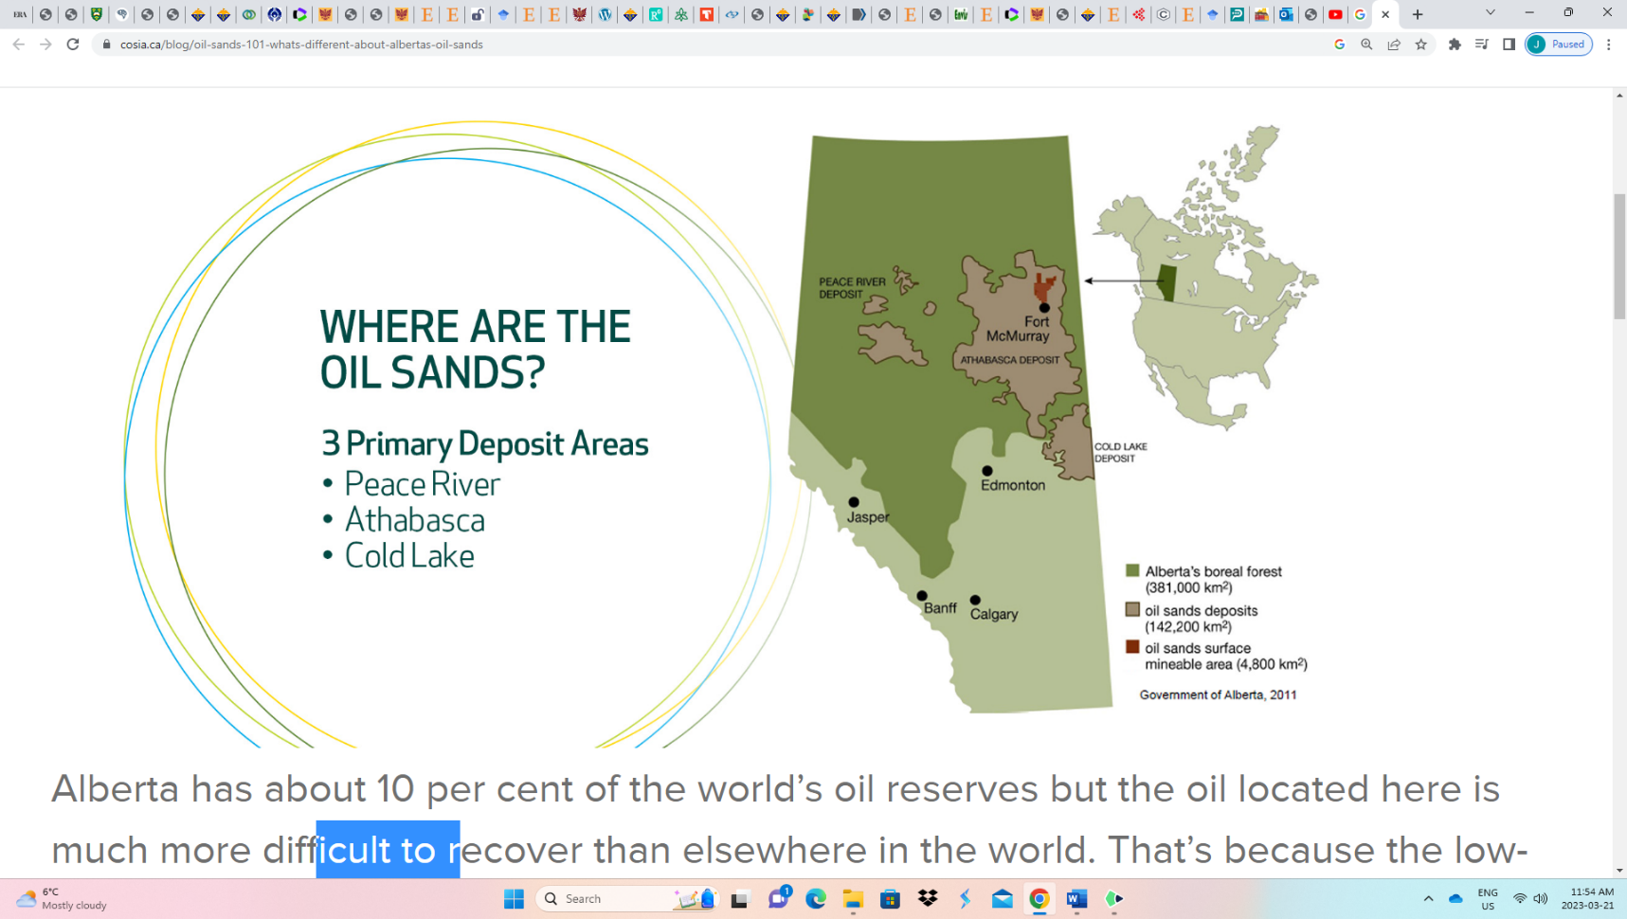
The depletion of conventional or “sweet” petroleum reserves has led to a rapid shift in the exploration, extraction, and processing of heavily biodegraded petroleum or bitumen, in order to meet current global energy demands. Oil sands deposits in Alberta, Canada contain one of the world’s largest petroleum reserves with estimates of 300+ billon barrels of raw bitumen (Masliyah et al. 2004), and approximately 180-300 billion barrels that are recoverable under current technologies (Rosa et al. 2016). The three regions in Alberta where Oil Sands production occurs are Athabasca, Cold Lake, and Peace River (Figure 1), and daily petroleum production has steadily increased from 540,000 barrels/day in 2002 to 3.79 million barrels/day in 2022 (CER, 2023). Surface mining and Steam-assisted gravity drainage (SAGD) are the primary extraction methods for shallow (0-75m deep) and deep (75-200m) oil sands deposits, respectively. Both methods account for roughly half of the daily bitumen output, however, it is estimated that around 80% of total deposits in Alberta will require SAGD (de Klerk et al. 2013; Yang et al. 2022).

Oil sands are comprised primarily of sand and clay particles that are coalesced with varying quantities of water and bitumen. A high-quality oil sand ore has a high bitumen content (~15-20%) and a low water content (>1%), whereas a low-quality oil sand ore has a high-water content (~5-10%) and a low bitumen content (>5%). Large oil sand deposits occur in regions once containing large ancient water bodies, where marine/aquatic organisms accumulated in sediments and underwent catagenesis to produce hydrocarbons over millions of years. However, due to presence/formation of orogenic belts, the buried hydrocarbon deposits were displaced and slowly migrated towards the surface, which exposed the pristine petroleum deposit to varying reservoir temperatures and eventually established an oil-water interface (Huang et al. 2020). These conditions provided various hydrocarbon-degrading microorganisms to flourish and further accelerated the in-situ biodegradation of the petroleum, which produced the viscous, high molecular weight bitumen that is currently found (Larter et al. 2003; Gieg 2018). The complexity of the physical/chemical properties and molecular composition of bitumen from the Alberta Oil Sands (AOS) have fascinated petroleum geochemists for many decades. It is now well established that the high viscosity and high boiling points of bitumen are directly connected to its enrichment of heavy polycyclic aromatic hydrocarbons (PAH), S-,N-, and O-containing compounds, and heavy metals relative to conventional crude oils which are mostly comprised of low molecular weight hydrocarbons (Gieg 2018; Huang et al. 2020).
Figure 1. Oil Sand Deposits in Alberta, Canada. (https://cosia.ca/blog/oil-sands-101-whats-different-about-albertas-oil-sands)
    - Brief outline of Surface Mining of Oil Sands
The immense size and unconventional nature of AOS deposits present a technological and economic challenge to achieve optimal petroleum recovery and refining. Currently, bitumen extraction is carried out via two major processes: surface mining of shallow deposits and steam assisted gravity drainage (SAGD) of deeper deposits. Surface mining has been an established industry in Alberta for more than one hundred years (Masliyah et al. 2004), whereas SAGD is a more recent extraction process for bitumen and is rapidly expanding across Alberta. Reviews on the concept and modelling of SAGD are discussed in detail elsewhere (Butler 1985, 2008; Gates et al. 2007; Rui et al. 2018), and the mechanisms/operations used for surface mining of oil sands and subsequent reclamation strategies will be the focus in this dissertation.
Figure 2 displays the generalized structure of the extraction of bitumen from surface mining of oil sands put forth by Masliyah et al. (2004). Large trucks and excavators remove the oil sands in open pit mines and transported to the extraction plant. Once transported to the extraction plant the mined materials are placed into industrial sized crushers break down the oil sands ore in manageable sizes, which are then treated with a hot caustic aqueous solution and organic solvents to produce a slurry. The warm water and constant agitation allow the solids and bitumen to separate, and the organic solvents and aeration (gas bubbles) cause the bitumen’s density to decrease and float to the surface as a bitumen froth. This froth is processed further to purify the recovered bitumen by removing the leftover water and solids and is sent to petroleum upgraders and refineries around the world. During this extraction process the unwanted by-products (i.e., water and solids) are constantly being sent to tailings ponds for waste management. Tailings ponds allow for additional bitumen to be recovered, storage and consolidation of solids, and recycling of process-affect water into the extraction process.
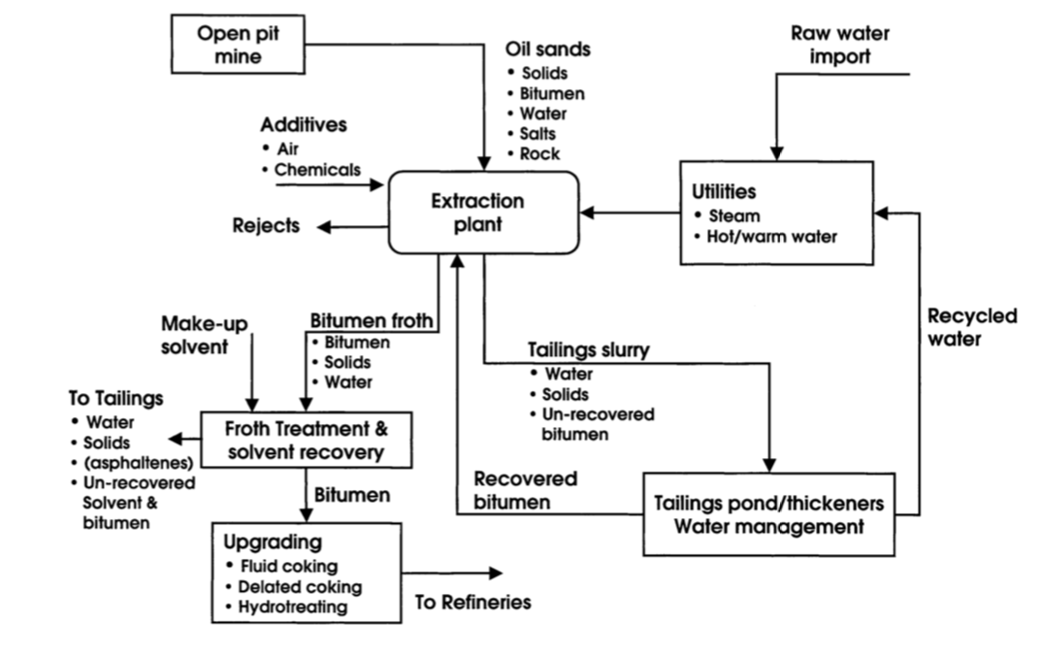
Figure 2. Generalized design for bitumen extraction during surface mining of Alberta Oil sands. (Masliyah et al. 2004)
However, because of the rapid growth of bitumen production from surface mining, so to have the concerns on the environmental consequences of bitumen production to the surrounding environment (Giesly et al. 2010; Schindler et al. 2010; Kurek et al. 2013; Wasiuta et al. 2019; Zhou et al. 2021). A myriad of environmental stresses such as loss of boreal forest (Rosa et al. 2016), high consumption rate of freshwater (Allen 2008), and accumulation of tailings and process affected water in tailings ponds in an estimated total area of 270 km² (Government of Alberta 2023). To address the issue of responsible mining of Alberta oil sands, the Government of Alberta generated a “Tailings Management Framework for the Mineable Athabasca Oil Sands” in 2015 to regulate oil sands operators and properly secure that future mine closure strategies had responsible goals towards environmental protection and sustainability (Syncrude 2022).
    - Description of Base Mine Lake and Reclamation Objectives
Reclamation of the disturbed areas and produced tailings have led to several emerging strategies to ensure a safe transition to the end stages of surface mining locations. End Pit Lakes (EPL) are being considered as an effective reclamation strategy that will use decommissioned mine pits to store large volumes of tailings and process affected water (CAPP 2021). Located within the south-east region of the Mildred Lake Mining site (Syncrude Energy Inc.), Base Mine Lake (BML) is the first large-scale demonstration of Water Capping Tailings Technology (WCTT). The surface area of the water layer is approximately 800 hectares (8 km²), and the total volume of the fluid fine tailings (FFT) and overlying water cap is roughly 240 Mm³ (2.4x10²³ L) (Syncrude 2022). The short-term goals associated with verifying the performance of WCTT are associated with FFT settlement over time and prevention of intrinsic mixing mechanisms to resuspend fines, and the water column should not be acutely toxic to biota and pass the appropriate provincial and federal water quality guidelines reclamation certification (Syncrude 2022). To achieve reclamation certification the long-term goals of BML must include indicators that the water column passes the provincial and federal chronic toxicity guidelines to protect aquatic life (Syncrude 2022). Integrated in the BML monitoring is a multidisciplinary and multi-university research program that focuses on supporting the science-driven research objectives for assessing the demonstration of WCTT. Shown in Table 1 are the various physical, chemical, and biological research objectives being conducted in BML.
Table 1. Monitoring projects that are directed towards the short- and long-term objectives of BML (Syncrude 2022).
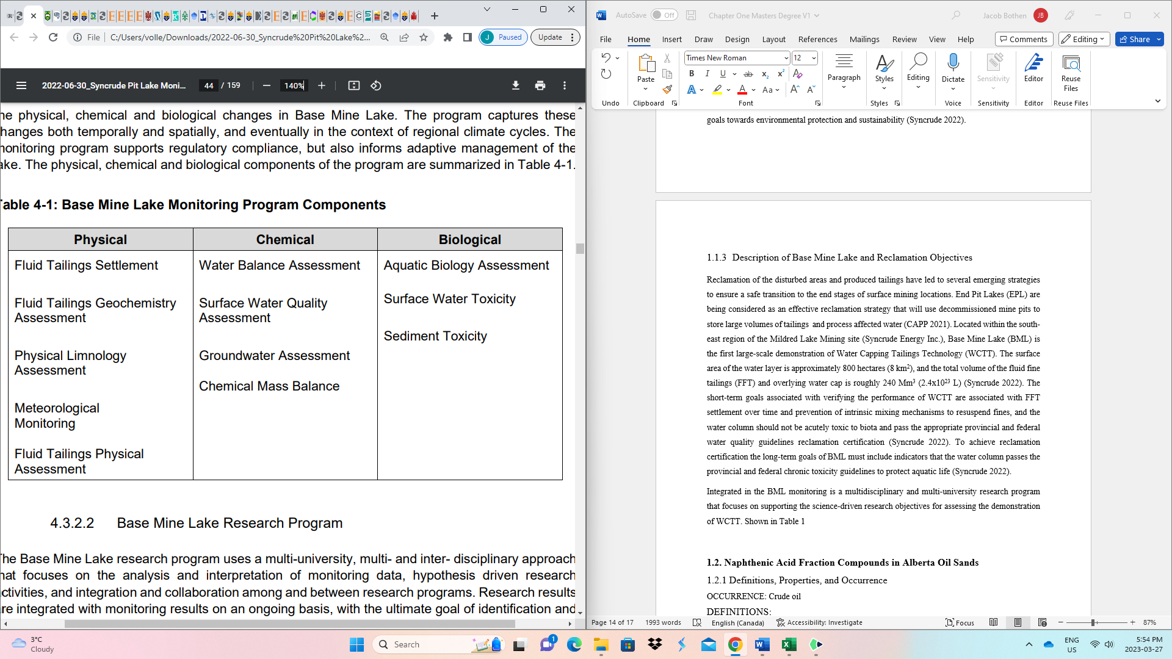
End pit lakes are commonly utilized in North America for the reclamation of mining metal ores and coal and have very distinct biogeochemical properties from natural lakes in that they are acidic, and the microbial activity is dominated by sulfate-reducing bacteria (Castro & Moore 2000). BML can be viewed as a unique EPL demonstration in that the water column is slightly basic (pH ~ 8) and that the initial substrates (i.e., FFT and OSPW) are rich in organic components that are associated with petroleum. Thus, the biogeochemistry that takes place in BML is predominantly associated with the cycling of carbon sources but as a result of the diverging redox zones present in BML, there are differences in the metabolic pathways and terminal electron acceptors. In the oxic water column methanotrophic bacterial communities consume dissolved oxygen (DO) to oxidize methane (CH₄) that is generated and transported out of the FFT (Slater et al. 2021; Albakistani et al. 2022), whereas methanogenic metabolic pathways like fermentation or carbon dioxide reduction prevail in the anoxic FFT by consuming residual organic solvent and bitumen (Siddique et al. 2006, 2011; Slater et al. 2021). Sulfur and Nitrogen biogeochemical cycles are also present in BML and have also been found to impact the oxygen consumption rates in the BML water column (Risacher et al. 2018; Mori et al. 2019; Yan et al. 2022).
To demonstrate that the water cap is fulfilling surface water quality guidelines and toxicity criteria, several chemical constituents are monitored on an annual and seasonal basis. The inorganic chemicals that consistently exceeding guidelines are chloride, sulphide, total ammonia, and boron, whereas F2 hydrocarbons (C10-C16) are the organic constituents that exceed the surface water quality guidelines. Acute toxicity of BML surface water has not occurred since 2014, but residual chronic toxicity is observed and may be attributed to an additional type of organic constituent commonly found within oil sands-process affected waters, called Naphthenic Acid Fraction compounds (NAFC) (White and Liber 2020).
1.2. Naphthenic Acid Fraction Compounds in Alberta Oil Sands
1.2.1 Definitions, Properties, and Occurrence
During the formation of crude oil that takes place over geological timescales, the chemical composition of the parent oil can be altered by thermal, physical, and biogeochemical processes (Hunt 1995, Gieg 2018). As previously mentioned in section 1.1.1, micro-organisms are present in the oil reservoir and are likely situated at the oil-water transition zone, where labile hydrocarbons diffuse towards this interface and allowing microorganisms to facilitate biodegradation (Huang et al. 2020). As a result of extensive in-situ biodegradation of the Alberta oil sands, the lighter and more saturated hydrocarbons were preferentially removed, and caused the most recalcitrant hydrocarbons structures, such a poly-aromatic ring structures, degradation by-products, such as carboxylic acids, to build up over time (Huang et al. 2020). When heavily biodegraded oils, such as the Alberta oil sands, are explored for economic recovery, the Total Acid Number (TAN) of an oil is an important geochemical property for petroleum geochemists as it assists in evaluating the degree of subsurface oil biodegradation and the economic consequences associated with refining an oil with a high TAN (Hunt 1996; Laredo et al. 2004). The high TAN values of an oil typically signify that there is a high concentration of a complex mixture of organic acids, traditionally referred to as Naphthenic Acids (NA).
With the general empirical formula of C_{n}H_{2n+Z}O₂ (where n is the number of carbons and Z is a negative even integer symbolizing the degree of unsaturation), NAs were represented as alkylated-substituted acyclic and cycloaliphatic carboxylic acids (Headley and McMartin 2004; Clemente and Fedorak 2005). However, with the emergence of advanced analytical techniques in recent decades, it was uncovered that other polar chemical species containing nitrogen and/or sulfur heteroatoms, poly-oxygenated functional groups and aromatic structure can also be identified in NA extracts (Headley et al. 2013). Thus, the term Naphthenic Acid Fraction Compounds (NAFC) is now commonly used to describe this broader group of polar organics and displayed in Figure 3 are potential chemical structures affiliated within the generic formula of C_{n}H_{2n+Z}O_{x}S_{s}N_{n} (Headley et al. 2013; Celsie et al. 2016; Vander Meulen et al. 2021).
NAFCs are non-volatile compounds that behave like a surfactant, meaning they have both a hydrophilic and a hydrophobic component of the molecule (Headley and McMartin 2004). NAFCs are present in elevated concentrations in OSPW due to a combination of factors. First, oil sands are enriched in NAFCs and when mining operators utilize warm caustic solution during bitumen extraction it helps to increase the solubility of NAFCs and allow for subsequent partitioning/removal from bitumen into OSPW. Secondly, the increased recycling of OSPW and inherently stable chemical structures of oil sands NAFC allows for their accumulation over time. In BML, NAFCs are present due to the initial OSPW used to fill part of the water cap, released into the water cap as porewater advection/diffusion when the FFT naturally settles, and potentially diffusing out of residual bitumen into porewater.
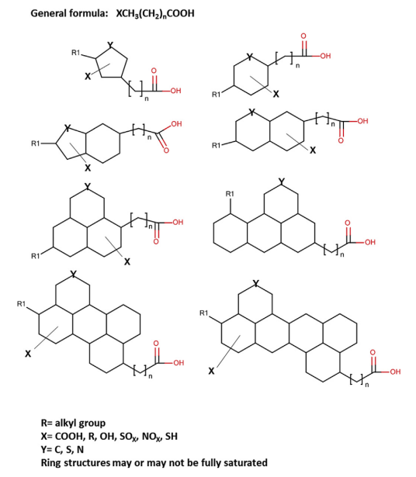
Figure 3. Examples of Naphthenic Acid Fraction compounds that may contain aromatic structures, nitrogen and sulfur atoms, and methylated features (Taken from Celsie et al. 2016).
    - Toxicity & Environmental Fate in the Aquatic Environment
The major concern associated with the increased stockpile of tailings and OSPW are directly related to the known toxic properties these materials have to numerous aquatic biotas, which was later determined to be caused by the increased concentrations of NAs (Headley and McMartin 2004; Clemente and Fedorak 2005; Marentette et al. 2015a,b; Bartlett et al. 2017; Bauer et al. 2017, 2019; White and Liber 2020). The most probable mode of acute toxicity of NAs is narcosis, which is likely a result of the surfactant-like properties of NAs (Frank et al. 2008; Brown and Ulrich 2015). Chronic toxicity induced by NAFCs is becoming an important measure to determine, especially in the context as additional EPLs are planned for future development. Several recent studies have demonstrated that sub-lethal exposure of NAFCs to wood frogs (Rana sylvatica) yielded chronic effects on their subsequent reproductive successes (Elvidge et al. 2023; Robinson et al. 2023). A challenge moving forward for toxicity assays in dealing with the molecular complexity of NAFCs in and being able to precisely establish which chemical families or individual compounds may be resulting in the observed toxic effects.
In the context of oil sands reclamation and environmental protection in the case of tailings pond seepage/collapse, it is important to understand what the key processes are in controlling the environmental fate and transport of NAFCs in aquatic and terrestrial environments. Since oil sand NAFCs are water soluble and chemically stable, there is a possible concern that if NAFCs are released and mixed with either surface water or groundwaters, it is possible that they can be transported swiftly away from the point source. Long-range transport of NAFC would therefore have the potential to impact mammal and human populations that rely on wells or surface waters for drinking water. Biodegradation (Scott et al. 2005; Han et al. 2008, 2009; Lengger et al. 2013; El-Waraky 2021) and photo-oxidation (McMartin et al. 2004; Headley et al. 2009; Mishra et al. 2010; Leshuk et al. 2016a,b, 2018; de Oliveira Livera et al. 2018) are the two NAFC transformation/removal processes that have been proposed in the literature. Photodegradation in EPLs were only recently considered to be an important NAFC removal process (Challis et al. 2020), whereas greater focus has focused on biodegradation as the major degradation pathway. Depending on the redox environment, biodegradation can either follow an aerobic or an anaerobic metabolic pathway. Aerobic biodegradation typically occurs at much faster rates than anaerobic biodegradation (Widdel and Rabus 2001), therefore, if NAFCs are introduced/placed in an oxygen-rich aquatic environment their residence time will be lower than in an anoxic environment. The establishment of microbial communities capable of facilitating aerobic biodegradation is crucial for the removal and eventual mineralization of residual NAFCs in BML. However, an unwanted consequence of anaerobic biodegradation occurring in the FFT is that microbes are degrading residual hydrocarbons and bitumen to produce newly formed NAFCs (Quagraine et al. 2005); which can be transported into the overlying water column. To monitor and accurately identify the initial chemical composition of NAFCs, as well as the resulting degradation metabolites, there is an increasing need to perform robust analytical analysis to measure/monitor these super-complex organic mixtures.
1.3 Fourier Transform Ion Cyclotron Resonance Mass Spectrometry (FT-ICR-MS) and Electrospray Ionization (ESI)
    - Overview of Theory and Principles of FT ICR MS
Fourier transform ion cyclotron resonance mass spectrometry is regarded as a very powerful analytical tool for the molecular analysis of complex organic mixtures, such as raw/weathered petroleum, NAFCs, and natural organic matter. Created by Comisarow and Marshall in 1974, FT-ICR MS has been at the centre of many scientific discoveries over the last 50 years, and when paired with various ionization techniques, it is possible to detect various polar and non-polar molecules that are not easily detected with chromatographic measurements (McKenna et al. 2013).
Marshall et al. (1998) provides a robust explanation to the physics and mathematic principles used to design FT-ICR MS instruments. Displayed in Figure 4 is a simplified schematic outlining the different processes that take place in order to produce a mass spectrum with FT ICR MS instruments. In Figure 4a) and Equation (1), the movement of ions in a spatially uniform and static magnetic field, B, rotate in a confined space at a cyclotron frequency, v_{c} (Hz or rad/sec), that is parallel to the magnetic field and inversely proportional to the mass to charge ratio (m/z).
Equation (1) $v_{c}=\frac{zB}{m}$
When the magnetic field strength is increased to the order of several Tesla’s (T), the mass accuracy, dynamic range, and length of analysis are improved (Cho et al. 2015). The cyclic motion of the confined ions is detected by measuring the image current of the ions passing the detection plates, which are characteristic of geometric waveforms that oscillate periodically and thus the frequency can be determined and is entirely unique to the ions mass to charge ratio. Figure 4b) displays the subsequent time-domain image current signal generated from ions passing through electrodes, from which Fourier Transform data reduction is applied to convert the current signals into a frequency (Figure 4c). Finally, the ion cyclotron frequencies are converted into a mass spectrum using a calibrated frequency-to-m/z conversion factor (Figure 4d).
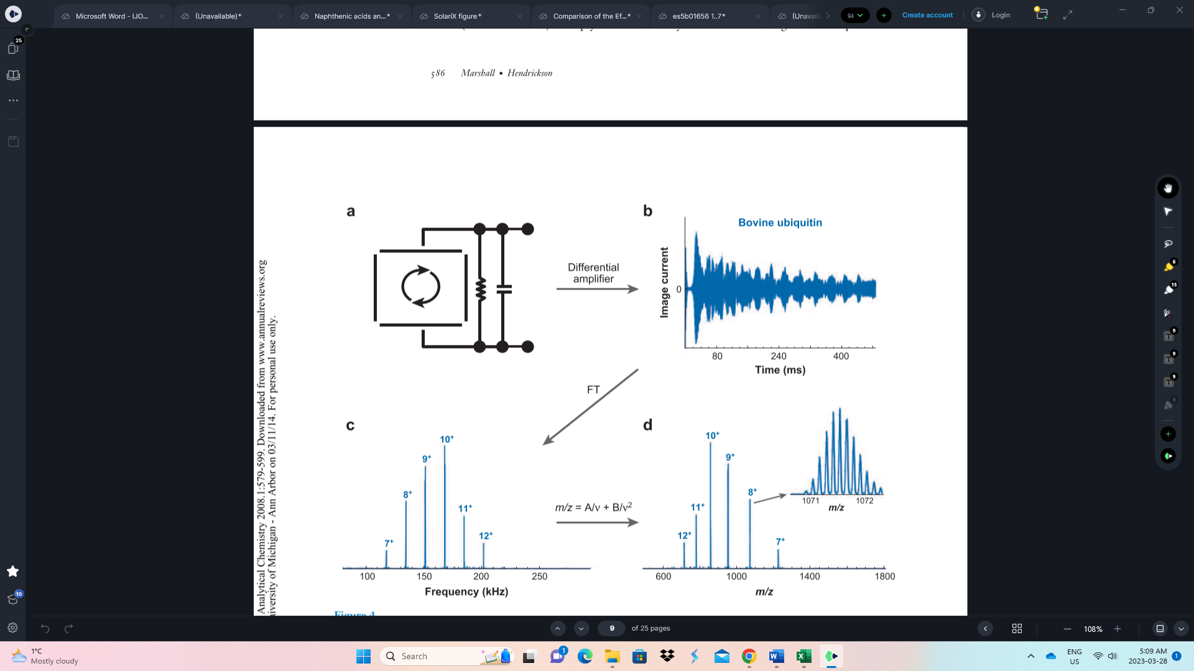
Figure 4. Schematic portraying the processes of producing a mass spectrum from FT ICR MS analysis (Taken from Marshall and Hendrickson 2008).
1.3.2 Electrospray Ionization (ESI)
To achieve optimal results utilizing FT ICR MS instrumentation, a critical step is in the formation of charged ions generated from some method of analyte ionization. Electrospray ionization (ESI) is one of the most utilized ionization methods used for MS analysis of polar, low molecular weight analytes (Prabhu et al. 2023), and when paired with the FT ICR MS instruments, it is possible to resolve small mass differences between isobaric compounds (i.e., C₃ vs. SH₄ or O₂ vs. S, etc.) (Reemtsma 2009). Prabhu et al. (2023) provides an extensive scientific primer for the set up, mechanism, and outlook of ESI. In summary, the liquid sample is introduced to the ESI capillary and exposed to a high voltage that produces macro sized charged droplets in the Taylor cone. The use of s nebulizer and drying gases cause solvent evaporation which reduces the droplet size and generates gas-phase ions that can be introduced into the mass analyzer. Depending on the analyte of interest, utilizing the correct ionization modes (I.e., positive- and negative-ion) is important step to consider if the analytes ionize as a positively or negatively charged ions, respectively. Several other parameters can pose as a limitation to the suitability of ESI, such as sample pH, matrix effect, and presence of non-volatile salts and molecular adducts (Prabhu et al. 2023) and should be considered prior and during analysis when attempting to perform ESI-FT ICR MS analysis of polar analytes likes NAFCs.
1.4 Research Objectives and Thesis Outline
As part of the extensive monitoring and research initiatives conducted in affiliation of BML, the overall objective of this dissertation was to perform FT ICR MS measurements in positive and negative ESI to provide novel molecular characterization of NAFCs within samples collected from BML. To my knowledge, the ESI-FT-ICR MS results presented within the dissertation are the first to be conducted on BML. Ultrahigh resolution mass spectrometry with ESI is advantageous for characterizing NAFCs in that it offers the best possible analytical window to detect polar, heteroatom containing compounds, and can give chemical information about the composition of NAFCs in BML that chromatographic analysis cannot. Furthermore, ESI-FT ICR MS had demonstrated that it is the most ideal technique for monitoring the key environmental weathering processes (i.e., biodegradation and photo-oxidation) of organics affiliated with petroleum, which is significant towards understanding the environmental fate of NAFCs in large-scale the reclamation efforts such as BML.
The second chapter of this thesis present an investigation of how certain analytical variables, like solvent composition and ionization mode, impacted the detection and analysis of NAFCs extracted from BML water cap samples. Four unique solvent mixtures were tested to find which mixture was suitable to be used to reconstitute the acidic liquid-liquid extracts of shallow and deep-water cap samples, with subsequent analysis in positive and negative ESI-FT ICR MS.
The third chapter of this thesis characterizes the spatial trends of NAFCs within the FFT and water cap samples collected at Platform’s 1 & 2 in BML. The objective of this study was to identify molecular markers for the presence of key transformation processes and demonstrate that some NAFC classes can be used to monitor the on-set of continued sources in the BML system.
1.5 References
Masliyah, J., Zhou, Z., Xu, Z., Czarnecki, J., & Hamza, H. (2004). Understanding water-based bitumen extraction from Athabasca oil sands. In Canadian Journal of Chemical Engineering (Vol. 82, Issue 4). https://doi.org/10.1002/cjce.5450820403

Rosa, L., Davis, K. F., Rulli, M. C., & D’Odorico, P. (2017). Environmental consequences of oil production from oil sands. Earth’s Future, 5(2). https://doi.org/10.1002/2016EF000484

Canadian Energy Regulator. Provincial and Territorial Energy Profiles-Alberta Energy Production. Accessed through: https://www.cer-rec.gc.ca/en/data-analysis/energy-markets/provincial-territorial-energy-profiles/provincial-territorial-energy-profiles-alberta.html

de Klerk, A., Gray, M. R., & Zerpa, N. (2013). Unconventional Oil and Gas. Oilsands. In Future Energy: Improved, Sustainable and Clean Options for our Planet. https://doi.org/10.1016/B978-0-08-099424-6.00005-3

Yang, C., Kuang, W., Zhang, G., Mortazavi, S., Doiron, A., Volchek, K., & Lambert, P. (2022). Characterization of residual organic matter in oil sands steam assisted gravity drainage produced water treated by ceramic nanofiltration membranes. Journal of Petroleum Science and Engineering, 208. https://doi.org/10.1016/j.petrol.2021.109408

Huang, H., Silva, R. C., Radović, J. R., & Larter, S. R. (2020). Environmental and Economic Implications of the Biogeochemistry of Oil Sands Bitumen. In Hydrocarbons, Oils and Lipids: Diversity, Origin, Chemistry and Fate. https://doi.org/10.1007/978-3-319-90569-3_19

Larter, S., Wilhelms, A., Head, I., Koopmans, M., Aplin, A., di Primio, R., Zwach, C., Erdmann, M., & Telnaes, N. (2003). The controls on the composition of biodegraded oils in the deep subsurface - Part 1: Biodegradation rates in petroleum reservoirs. Organic Geochemistry, 34(4). https://doi.org/10.1016/S0146-6380(02)00240-1

Gieg, L. M. (2018). Microbial Communities in Oil Shales, Biodegraded and Heavy Oil Reservoirs, and Bitumen Deposits. In Microbial Communities Utilizing Hydrocarbons and Lipids: Members, Metagenomics and Ecophysiology. https://doi.org/10.1007/978-3-319-60063-5_4-1

Butler, R. M. (1985). NEW APPROACH TO THE MODELLING OF STEAM-ASSISTED GRAVITY DRAINAGE. Journal of Canadian Petroleum Technology, 24(3). https://doi.org/10.2118/85-03-01

Butler, R. M. (2008). Steam-assisted gravity drainage: Concept, development, performance and future. SPE Reprint Series, 61. https://doi.org/10.2118/94-02-05

Gates, I. D., Kenny, J., Hernandez-Hdez, I. L., & Bunio, G. L. (2007). Steam-injection strategy and energetics of steam-assisted gravity drainage. SPE Reservoir Evaluation and Engineering, 10(1). https://doi.org/10.2118/97742-pa

Rui, Z., Wang, X., Zhang, Z., Lu, J., Chen, G., Zhou, X., & Patil, S. (2018). A realistic and integrated model for evaluating oil sands development with Steam Assisted Gravity Drainage technology in Canada. Applied Energy, 213. https://doi.org/10.1016/j.apenergy.2018.01.015

Giesy, J. P., Anderson, J. C., & Wiseman, S. B. (2010). Alberta oil sands development. Proceedings of the National Academy of Sciences, 107(3), 951-952.

Schindler, D. (2010). Tar sands need solid science. In Nature (Vol. 468, Issue 7323). https://doi.org/10.1038/468499a

Kurek, J., Kirk, J. L., Muir, D. C. G., Wang, X., Evans, M. S., & Smol, J. P. (2013). Legacy of a half century of Athabasca oil sands development recorded by lake ecosystems. Proceedings of the National Academy of Sciences of the United States of America, 110(5). https://doi.org/10.1073/pnas.1217675110

Wasiuta, V., Kirk, J. L., Chambers, P. A., Alexander, A. C., Wyatt, F. R., Rooney, R. C., & Cooke, C. A. (2019). Accumulating Mercury and Methylmercury Burdens in Watersheds Impacted by Oil Sands Pollution. Environmental Science and Technology, 53(21). https://doi.org/10.1021/acs.est.9b02373
Zhou, J. Z. (2021). Role of mineral flotation technology in improving bitumen extraction from mined Athabasca oil sands III. Next generation of water-based oil sands extraction. Canadian Journal of Chemical Engineering, 99(3). https://doi.org/10.1002/cjce.23874
Allen, E. W. (2008). Process water treatment in Canada’s oil sands industry: I. Target pollutants and treatment objectives. Journal of Environmental Engineering and Science, 7(2). https://doi.org/10.1139/S07-038

Government of Alberta. Total Area of the oil sands tailings ponds over time. 2023. Accessed on :https://osip.alberta.ca/library/dataset/details/542
Syncrude Ltd. 2022 Pit lake monitoring and research report EPEA Approval No. 26-03 (as amended). https://era.library.ualberta.ca/items/0994fedb-74d0-4397-a6ad-932f78bee1ee
Canada’s oil and natural gas producers (CAPP). 2021. An Introduction to oil sands pit lakes. https://www.capp.ca/wp-content/uploads/2021/05/An-Introduction-to-Oil-Sands-Pit-Lakes-392128.pdf

Castro, J. M., & Moore, J. N. (2000). Pit lakes: Their characteristics and the potential for their remediation. Environmental Geology, 39(11). https://doi.org/10.1007/s002549900100
Slater, G. F., Goad, C. A., Lindsay, M. B. J., Mumford, K. G., Nelson, T. E. C., Brady, A. L., Jessen, G. L., & Warren, L. A. (2021). Isotopic and chemical assessment of the dynamics of methane sources and microbial cycling during early development of an oil sands pit lake. Microorganisms, 9(12). https://doi.org/10.3390/microorganisms9122509

Albakistani, E. A., Nwosu, F. C., Furgason, C., Haupt, E. S., Smirnova, A. v., Verbeke, T. J., Lee, E. S., Kim, J. J., Chan, A., Ruhl, I. A., Sheremet, A., Rudderham, S. B., Lindsay, M. B. J., & Dunfield, P. F. (2022). Seasonal Dynamics of Methanotrophic Bacteria in a Boreal Oil Sands End Pit Lake. Applied and Environmental Microbiology, 88(3). https://doi.org/10.1128/aem.01455-21

Siddique, T., Fedorak, P. M., & Foght, J. M. (2006). Biodegradation of short-chain n-alkanes in oil sands tailings under methanogenic conditions. Environmental Science and Technology, 40(17). https://doi.org/10.1021/es060993m

Siddique, T., Penner, T., Semple, K., & Foght, J. M. (2011). Anaerobic biodegradation of longer-chain n-alkanes coupled to methane production in oil sands tailings. Environmental Science and Technology, 45(13). https://doi.org/10.1021/es200649t
Risacher, F. F., Morris, P. K., Arriaga, D., Goad, C., Nelson, T. C., Slater, G. F., & Warren, L. A. (2018). The interplay of methane and ammonia as key oxygen consuming constituents in early stage development of Base Mine Lake, the first demonstration oil sands pit lake. Applied Geochemistry, 93. https://doi.org/10.1016/j.apgeochem.2018.03.013

Mori, J. F., Chen, L. X., Jessen, G. L., Rudderham, S. B., McBeth, J. M., Lindsay, M. B. J., Slater, G. F., Banfield, J. F., & Warren, L. A. (2019). Putative mixotrophic nitrifying-denitrifying gammaproteobacteria implicated in nitrogen cycling within the ammonia/oxygen transition zone of an oil sands pit lake. Frontiers in Microbiology, 10(OCT). https://doi.org/10.3389/fmicb.2019.02435

Yan, Y., Nelson, T. E. C., Twible, L., Whaley-Martin, K., Jarolimek, C. V., King, J. J., ... & Warren, L. A. (2022). Sulfur mass balance and speciation in the water cap during early-stage development in the first pilot pit lake in the Alberta Oil Sands. Environmental Chemistry, 19(4), 236-253.

White, K. B., & Liber, K. (2020). Chronic Toxicity of Surface Water from a Canadian Oil Sands End Pit Lake to the Freshwater Invertebrates Chironomus dilutus and Ceriodaphnia dubia. Archives of Environmental Contamination and Toxicology, 78(3). https://doi.org/10.1007/s00244-020-00720-3

Hunt, J. M. (1995). Petroleum geochemistry and geology (textbook). Petroleum Geochemistry and Geology (Textbook).(2 nd Ed.), WH Freeman Company.

Laredo, G. C., López, C. R., Álvarez, R. E., & Cano, J. L. (2004). Naphthenic acids, total acid number and sulfur content profile characterization in Isthmus and Maya crude oils. Fuel, 83(11–12). https://doi.org/10.1016/j.fuel.2004.02.004

Headley, J. v., & McMartin, D. W. (2004). A review of the occurrence and fate of naphthenic acids in aquatic environments. In Journal of Environmental Science and Health - Part A Toxic/Hazardous Substances and Environmental Engineering (Vol. 39, Issue 8). https://doi.org/10.1081/ESE-120039370

Clemente, J. S., & Fedorak, P. M. (2005). A review of the occurrence, analyses, toxicity, and biodegradation of naphthenic acids. In Chemosphere (Vol. 60, Issue 5). https://doi.org/10.1016/j.chemosphere.2005.02.065

Headley, J. v., Peru, K. M., Fahlman, B., Colodey, A., & McMartin, D. W. (2013). Selective solvent extraction and characterization of the acid extractable fraction of Athabasca oils sands process waters by Orbitrap mass spectrometry. International Journal of Mass Spectrometry, 345–347. https://doi.org/10.1016/j.ijms.2012.08.023

Celsie, A., Parnis, J. M., & Mackay, D. (2016). Impact of temperature, pH, and salinity changes on the physico-chemical properties of model naphthenic acids. Chemosphere, 146. https://doi.org/10.1016/j.chemosphere.2015.11.122

vander Meulen, I. J., Klemish, J. L., Peru, K. M., Chen, D. D. Y., Pyle, G. G., & Headley, J. v. (2021). Molecular profiles of naphthenic acid fraction compounds from mine lease wetlands in the Athabasca Oil Sands Region. Chemosphere, 272. https://doi.org/10.1016/j.chemosphere.2021.129892

Marentette, J. R., Frank, R. A., Bartlett, A. J., Gillis, P. L., Hewitt, L. M., Peru, K. M., Headley, J. v., Brunswick, P., Shang, D., & Parrott, J. L. (2015). Toxicity of naphthenic acid fraction components extracted from fresh and aged oil sands process-affected waters, and commercial naphthenic acid mixtures, to fathead minnow (Pimephales promelas) embryos. Aquatic Toxicology, 164. https://doi.org/10.1016/j.aquatox.2015.04.024

Marentette, J. R., Frank, R. A., Hewitt, L. M., Gillis, P. L., Bartlett, A. J., Brunswick, P., ... & Parrott, J. L. (2015). Sensitivity of walleye (Sander vitreus) and fathead minnow (Pimephales promelas) early-life stages to naphthenic acid fraction components extracted from fresh oil sands process-affected waters. Environmental pollution, 207, 59-67.

Bartlett, A. J., Frank, R. A., Gillis, P. L., Parrott, J. L., Marentette, J. R., Brown, L. R., Hooey, T., Vanderveen, R., McInnis, R., Brunswick, P., Shang, D., Headley, J. v., Peru, K. M., & Hewitt, L. M. (2017). Toxicity of naphthenic acids to invertebrates: Extracts from oil sands process-affected water versus commercial mixtures. Environmental Pollution, 227. https://doi.org/10.1016/j.envpol.2017.04.056

Bauer, A. E., Hewitt, L. M., Parrott, J. L., Bartlett, A. J., Gillis, P. L., Deeth, L. E., Rudy, M. D., Vanderveen, R., Brown, L., Campbell, S. D., Rodrigues, M. R., Farwell, A. J., Dixon, D. G., & Frank, R. A. (2019). The toxicity of organic fractions from aged oil sands process-affected water to aquatic species. Science of the Total Environment, 669. https://doi.org/10.1016/j.scitotenv.2019.03.107

Bauer, A. E., Frank, R. A., Headley, J. v., Peru, K. M., Farwell, A. J., & Dixon, D. G. (2017). Toxicity of oil sands acid-extractable organic fractions to freshwater fish: Pimephales promelas (fathead minnow) and Oryzias latipes (Japanesemedaka). Chemosphere, 171. https://doi.org/10.1016/j.chemosphere.2016.12.059

Frank, R. A., Kavanagh, R., Kent Burnison, B., Arsenault, G., Headley, J. v., Peru, K. M., van der Kraak, G., & Solomon, K. R. (2008). Toxicity assessment of collected fractions from an extracted naphthenic acid mixture. Chemosphere, 72(9). https://doi.org/10.1016/j.chemosphere.2008.04.078
Brown, L. D., & Ulrich, A. C. (2015). Oil sands naphthenic acids: A review of properties, measurement, and treatment. In Chemosphere (Vol. 127). https://doi.org/10.1016/j.chemosphere.2015.02.003

Elvidge, C. K., Robinson, C. E., Caza, R. A., Hewitt, L. M., Frank, R. A., & Orihel, D. M. (2023). Chemical communication in wood frog (Rana sylvatica) tadpoles is influenced by early-life exposure to naphthenic acid fraction compounds. Aquatic Toxicology, 257, 106435.

Robinson, C. E., Elvidge, C. K., Frank, R. A., Headley, J. V., Hewitt, L. M., Little, A. G., ... & Orihel, D. M. (2023). Naphthenic acid fraction compounds reduce the reproductive success of wood frogs (Rana sylvatica) by affecting offspring viability. Environmental Pollution, 316, 120455.
Scott, A. C., MacKinnon, M. D., & Fedorak, P. M. (2005). Naphthenic acids in athabasca oil sands tailings waters are less biodegradable than commercial naphthenic acids. Environmental Science and Technology, 39(21). https://doi.org/10.1021/es051003k
Han, X., Scott, A. C., Fedorak, P. M., Bataineh, M., & Martin, J. W. (2008). Influence of molecular structure on the biodegradability of naphthenic acids. Environmental Science and Technology, 42(4). https://doi.org/10.1021/es702220c
Han, X., MacKinnon, M. D., & Martin, J. W. (2009). Estimating the in situ biodegradation of naphthenic acids in oil sands process waters by HPLC/HRMS. Chemosphere, 76(1). https://doi.org/10.1016/j.chemosphere.2009.02.026
Lengger, S. K., Scarlett, A. G., West, C. E., & Rowland, S. J. (2013). Diamondoid diacids (“O4” species) in oil sands process-affected water. Rapid Communications in Mass Spectrometry, 27(23). https://doi.org/10.1002/rcm.6729
El-Waraky, M. Assessment of the sources and biodegradation potential of hydrocarbons and naphthenic acids in an oil sands end pit lake. PhD Dissertation, McMaster University. 2021.

McMartin, D. W., Headley, J. v., Friesen, D. A., Peru, K. M., & Gillies, J. A. (2004). Photolysis of naphthenic acids in natural surface water. Journal of Environmental Science and Health - Part A Toxic/Hazardous Substances and Environmental Engineering, 39(6). https://doi.org/10.1081/ESE-120037839

Headley, J. v., Du, J. L., Peru, K. M., & McMartin, D. W. (2009). Electrospray ionization mass spectrometry of the photodegradation of naphthenic acids mixtures irradiated with titanium dioxide. Journal of Environmental Science and Health - Part A Toxic/Hazardous Substances and Environmental Engineering, 44(6). https://doi.org/10.1080/10934520902784625

Mishra, S., Meda, V., Dalai, A. K., McMartin, D. W., Headley, J. v., & Peru, K. M. (2010). Photocatalysis of Naphthenic Acids in Water. Journal of Water Resource and Protection, 02(07). https://doi.org/10.4236/jwarp.2010.27074

Leshuk, T., de Oliveira Livera, D., Peru, K. M., Headley, J. v., Vijayaraghavan, S., Wong, T., & Gu, F. (2016). Photocatalytic degradation kinetics of naphthenic acids in oil sands process-affected water: Multifactorial determination of significant factors. Chemosphere, 165. https://doi.org/10.1016/j.chemosphere.2016.08.115

Leshuk, T., Wong, T., Linley, S., Peru, K. M., Headley, J. v., & Gu, F. (2016). Solar photocatalytic degradation of naphthenic acids in oil sands process-affected water. Chemosphere, 144. https://doi.org/10.1016/j.chemosphere.2015.10.073

Leshuk, T., Krishnakumar, H., Livera, D. de O., & Gu, F. (2018). Floating photocatalysts for passive solar degradation of naphthenic acids in oil sands process-affected water. Water (Switzerland), 10(2). https://doi.org/10.3390/w10020202

de Oliveira Livera, D., Leshuk, T., Peru, K. M., Headley, J. v., & Gu, F. (2018). Structure-reactivity relationship of naphthenic acids in the photocatalytic degradation process. Chemosphere, 200. https://doi.org/10.1016/j.chemosphere.2018.02.049

Challis, J. K., Parajas, A., Anderson, J. C., Asiedu, E., Martin, J. W., Wong, C. S., & Ross, M. S. (2020). Photodegradation of bitumen-derived organics in oil sands process-affected water. Environmental Science: Processes and Impacts, 22(5). https://doi.org/10.1039/d0em00005a
Widdel, F., & Rabus, R. (2001). Anaerobic biodegradation of saturated and aromatic hydrocarbons. In Current Opinion in Biotechnology (Vol. 12, Issue 3). https://doi.org/10.1016/S0958-1669(00)00209-3

Quagraine, E. K., Headley, J. v., & Peterson, H. G. (2005). Is biodegradation of bitumen a source of recalcitrant naphthenic acid mixtures in oil sands tailing pond waters? Journal of Environmental Science and Health - Part A Toxic/Hazardous Substances and Environmental Engineering, 40(3). https://doi.org/10.1081/ESE-200046637

McKenna, A. M., Nelson, R. K., Reddy, C. M., Savory, J. J., Kaiser, N. K., Fitzsimmons, J. E., Marshall, A. G., & Rodgers, R. P. (2013). Expansion of the analytical window for oil spill characterization by ultrahigh resolution mass spectrometry: Beyond gas chromatography. Environmental Science and Technology, 47(13). https://doi.org/10.1021/es305284t

Marshall, A. G., Hendrickson, C. L., & Jackson, G. S. (1998). Fourier transform ion cyclotron resonance mass spectrometry: A primer. Mass Spectrometry Reviews, 17(1). https://doi.org/10.1002/(SICI)1098-2787(1998)17:1<1::AID-MAS1>3.0.CO;2-K
Marshall, A. G., & Hendrickson, C. L. (2008). High-resolution mass spectrometers. In Annual Review of Analytical Chemistry (Vol. 1, Issue 1). https://doi.org/10.1146/annurev.anchem.1.031207.112945
Cho, Y., Ahmed, A., Islam, A., & Kim, S. (2015). Developments in FT-ICR ms instrumentation, ionization techniques, and data interpretation methods for petroleomics. Mass Spectrometry Reviews, 34(2). https://doi.org/10.1002/mas.21438
Reemtsma, T. (2009). Determination of molecular formulas of natural organic matter molecules by (ultra-) high-resolution mass spectrometry. Status and needs. In Journal of Chromatography A (Vol. 1216, Issue 18). https://doi.org/10.1016/j.chroma.2009.02.033
Prabhu, G. R. D., Williams, E. R., Wilm, M., & Urban, P. L. (2023). Mass spectrometry using electrospray ionization. Nature Reviews Methods Primers, 3(1), 23. https://doi.org/10.1038/s43586-023-00203-4

Chapter 2
MOLECULAR CHARACTERIZATION OF NAPHTHENIC ACID FRACTION COMPOUNDS BY ESI(+/-) FT-ICR-MS: IMPACT OF SOLVENT CHOICE & IONIZATION MODE.

Manuscript in preparation for submission to Analytical Chemistry or Rapid Communications of Mass Spectrometry or International Journal of Environmental Analytical Chemistry

Bothen, J.L.A¹, Stock, N. L², Slater G.F¹
¹School of Earth, Environment, and Society, McMaster University, Hamilton, Ontario, Canada
² Water Quality Centre, Trent University, Peterborough, Ontario, Canada

ABSTRACT.
Naphthenic Acid Fraction Compounds (NAFCs) are a complex mixture of water-soluble polar organics that exist in raw petroleum. Growing attention related to the toxicity and persistence of NAFCs in the environment has led to an expansion of analytical methodologies and techniques. Bitumen from the Oil Sands in Alberta, Canada, is a heavily biodegraded petroleum that contains above average quantities of NAFCs which are known to accumulate in process waters during the caustic hot water extraction. The use of ultrahigh-resolution mass spectrometry (UHRMS) has provided new molecular insights on the chemical fingerprint of NAFCs in Oil sand Process water (OSPW) in relation to natural freshwater, and the environmental fate and transformation of NAFCs in lab experiments and constructed wetlands. However, the NAFC results obtained from UHRMS can be significantly influenced by numerous factors during the analysis including the type of instrumentation, sample extraction method used, and ionization mode. In this study we examined the variability in detection of NAFC induced by differing the solvent reconstitution mixtures of an acidic liquid-liquid extraction (LLE) of water from an oil sands Pit Lake utilizing (+/-) Electrospray Ionization-Fourier-Transform-Ion-Cyclotron-Resonance Mass Spectrometry (ESI-FT-ICR-MS) analysis. We highlight the key changes in the observed NAFCs composition when differing the combination of solvents, as well as in the detection of chemical species when analyzed in both positive- and negative-mode ESI. These influences were particularly evident for the Sulfur-containing NAFCs in that more chemical species were observed in the solvent combinations containing Toluene (I.e., 3:1 MeOH:Tol & 3:2 MeOH:Tol) and within the positive-mode ESI data, suggesting these compounds are more accessible when using non-polar solvents and likely contain basic functional groups. Overall, the 3:1 MeOH:Toluene solvent mixture was determined as the best choice amongst the solvent systems we studied for NAFC extraction via LLE and subsequent analysis in ESI (+/-) FT ICR MS.

Introduction.
The application of Mass Spectrometry (MS) within the discipline of Environmental Science has contributed significant scientific progress towards the understanding of complex environmental processes and environmental pollution (Richardson, 2001, Hernández et al. 2012). With respect to crude oil and/or petroleum, MS has been a powerful analytical tool capable of providing important chemical information related to the distribution and concentration of various petroleum hydrocarbons in reservoirs and environmental matrices (Borisov et al. 2019), as well as being able to identify the transformation/weathering products that occur when released into various environments (Wang and Fingus, 1995; Tarr et al. 2016; Heshka et al. 2022). The development and application of Fourier transform Ion cyclotron resonance mass spectrometry (FT-ICR-MS) in the past several decades has greatly expanded the ability to identify a wide range of organic compounds in various matrices. As coined by Marshall and Rodgers (2004,2008), the field of “Petroleomics” utilizes high resolution mass spectrometry techniques (primarily FT-ICR-MS) to characterize various hydrocarbon and heteroatom-containing components of raw and weathered petroleum. Heteroatom-containing compounds are closely associated with the asphaltene fraction within petroleum and are important to monitor as there are serious implications on the economic value and processing of petroleum due to fouling of catalysts (Niyonsaba et al. 2019) and corrosion of refining equipment (Rowland et al. 2014), as well as to the potential toxicity to aquatic life due to their higher aqueous solubilities and therefore bioavailability as compared to petroleum hydrocarbons within aquatic environments (Griffiths et al. 2014; Liu and Kujawinski 2015). As highlighted for its ability to detect and measure heteroatoms previously unidentified by conventional gas chromatography mass spectrometry (GC-MS) analysis of petroleum (McKenna et al. 2013), FT-ICR-MS provides qualitative data using the ultra-high resolving power and mass accuracy to assign discrete assignment to various acidic and basic C_{c}H_{h}O_{o}S_{s}N_{n} compounds (Hughey et al. 2002; Marshall and Rodgers 2004, 2008). It is well known that unconventional petroleum deposits will continue to supply our growing energy needs in the future (Gordon 2012; Nduagu and Gates 2015), however, since these deposits contain heavily degraded petroleum with higher quantities of heteroatom components (de Klerk et al. 2013; Chew 2014), there is a growing need for additional petroleomic research to understand the environmental impacts of unconventional petroleum extraction and production.
The Alberta Oil Sand Region (AOSR) contains one of the largest known heavy crude oil or bitumen reserves in the world, and petroleum production from the AOSR has steadily risen to approximately 2-3 million barrels day⁻¹ of marketable petroleum in 2021 (AER 2022). Oil sand deposits contain a high molecular mass, viscous mixture of hydrocarbons that are closely consolidated with sand, clay particles, and water (Larter and Head 2014). Approximately 253.0 10³ m³/day of AOSR bitumen is recovered by surface mining and in situ productions now account for 264.6 10³ m³/day (AER 2022). While the latter is a more recent type of extraction and does not produce tailings, the economical surface mining operations have been established for approximately 50 years and has resulted in the accumulation of large volumes of tailings and process waters within mining sites across the AOSR. The bitumen found in the AOSR is classified as a heavily degraded petroleum reservoir due to a high degree of in situ biodegradation (Clemente and Fedorak, 2005; Hubert et al. 2012; Larter and Head 2014; Huang et al. 2020). The extent of biodegradation resulted in elevated concentrations of organic acids referred to as Naphthenic Acids (NAs), as well as other heteroatom-containing compounds in the bitumen in comparison to other conventional petroleum reservoirs (Barrow et al. 2009; de Klreck et al. 2013; Rowland et al. 2014; Brown and Ulrich 2015). The toxicity of oil sands process water (OSPW) is closely associated with NAs (Jones et al. 2011; Bauer et al. 2019), which become solubilized and concentrated into the aqueous phase during caustic hot water addition used in surface mining operations (Rogers et al. 2002; Giesy et al. 2010; Scott et al. 2020). Therefore, over the last decades there has been a significant amount of research completed on the chemical speciation of organics within OSPW and their fate within the aquatic environment.
NAs have traditionally been defined as acyclic and alicyclic carboxylic acids with a general formula of C_{n}H_{2n+z}O₂ (where n = carbon number, and Z is a negative even integer representing the degree of unsaturation) (Headley and McMartin 2004; Clemente and Fedorak 2005), but with the utilizing of FT ICR MS in Petroleomics and application of comprehensive two dimensional gas chromatography MS, it was uncovered that various poly-oxygenated NAs, aromatic NAs, and Sulfur- and Nitrogen-containing NAs are present in OSPW (Barrow et al. 2010; Headley et al. 2011; Barrow et al. 2015; Headley et al. 2016; Huang et al. 2018), raw petroleum (Hughey et al. 2002; Stanford et al. 2007; Marshall and Rodgers 2008; Smith et al. 2008; Mapolelo et al. 2011), and petroleum-affected environmental samples ( Aeppli et al. 2012; Bowman et al. 2014, 2018, 2020; Vander Muelen et al. 2021; Wise et al. 2022). To include these additional chemical classes with the classical definition of NAs, the terms Naphthenic Acid Fraction Compounds (NAFCs), and Oil sand tailings water acid-extractable organics (OSTWAEO) have been proposed in the literature from studies related to the Alberta Oil sands, and the term Water Soluble Organics (WSO) has been used for describing the presence of polar organics as a result of oil spills (Grewer et al. 2010; Headley et al. 2011; Brown and Ulrich 2015; Headley et al. 2015; Liu and Kujawinski 2015). For the purpose of this study, the term NAFC will be used as it encompasses the many classes of organics collected from an acidified water sample. An important issue that has been addressed in recent years is that the petroleum-derived acid extractable organics (AEO) from either oil spills or process waters impart a unique chemical fingerprint, which is inherently dependent on the composition of the parent oil and weathering processes incurred. However, other organic compounds that may be within this complex mixture but would not be classified as WSO or NAFCs (i.e., biological compounds like saturated fatty acids, fulvic acids, and humic acids) can interfere or supress the ability to identify and monitor the important petroleum-related components.
To assess the NAFC composition within complex environmental mixtures like OSPW and reclamation landscapes, the use of offline laboratory methodologies has shown to be a necessary step to isolate NAFCs into concentrated extracts which thereby removes the dissolved salts and metals and transfers the organic compounds of interest into a solvent medium that is suitable for ionization and mass spectrometry analysis. Methods such as Liquid-Liquid Extraction (LLE) and Solid Phase Extraction (SPE) of acidified water samples have been the dominant methods used for petroleum WSO and oil sands NAFCs (Liu and Kujawinski 2015; Barros et al. 2022). McKenna et al. (2021) conducted ESI (-) FT ICR MS measurements of simulated petroleum affected biodegradation and photo-oxidation microcosms with subsequent extraction of WSO with SPE and LLE. The authors highlighted that the LLE method was a more suitable method for isolating non-polar WSO associated with weathered petroleum components, whereas SPE was found to be more effective in isolating highly polar species that resemble dissolved organic matter in the water column. This key conclusion by McKenna et al. (2021) demonstrates that the non-polar characteristics of organics derived from petroleum makes LLE an effective and simple method for capturing a wide breadth of organics.
Additional analytical variables shown to influence the detection of Petroleum WSO and NAFCs are the choice of solvent for reconstitution and ionization mode. Headley et al. (2007) assessed the impact of solvent choice by preparing various solvent systems using different combinations of MeOH, ACN, H₂O, DCM, 1-Octanol for an oil sands naphthenic acid extract that was analyzed by ESI(-) FT ICR MS. The study found that the solubilities of classical naphthenic acids did not vary within the polar solvent systems and that the non-polar solvent combinations generated unstable nano spray conditions and possessed enriched signals of higher molecular weight naphthenic acids. Interestingly, the use of Toluene and MeOH as solvent mediums are commonly utilized in petroleomic studies, but to our knowledge only one study investigating oil sands NAFCs have used these solvents as their solvent systems (Grewer et al. 2010), whereas many other oil sands NAFC studies reported using 1:1 H₂O:ACN (e.g., Barrow et al. 2015; Heska et al. 2022; Vander Meulen et al. 2022). Additionally, recent investigations are expanding their window of detection for NAFC by use of positive ionization modes, but to date no studies have examined the molecular variability of various solvent systems in positive modes. Therefore, the objectives of this study are to provide a robust investigation of NAFCs using additional solvent systems from that of Headley et al. (2007) and utilize positive and negative mode ESI FT ICR MS for comprehensive coverage of AEO from BML surface waters.
Experimental or Methods.
Extraction of NAFCs
Water samples were collected at a depth of 0.5m and 9m below the Air-Water Interface from platform 1 in Base Mine Lake (BML), which is an Oil Sand End pit lake (EPL) located within Syncrude’s Mildred Lake mining site. Descriptions of the necessity and strategy for oil sands EPLs can be found elsewhere (Syncrude 2022), and numerous studies investigating the physical limnology and biogeochemical progression of BML can be found elsewhere (Dompierre et al. 2016; Dompierre et al. 2017; Risacher et al. 2018; Tedford et al. 2019; Arriaga et al. 2019; Bowman et al. 2020; El-Waraky 2021; Slater et al. 2021). A 6.2L Van Dorn water sampler was used to collect the samples during late July of 2019, in accordance with protocols determined by Risacher et al. (2018). Previous research has shown that BML exhibits thermal stratification in the summer (Lawrence et al. 2015), thus the two water samples represent the epilimnion and hypolimnion. The water samples were placed in pre-cleaned 1L Nalgene bottles and stored at -20ºC, prior to shipment to the Environmental Organic Geochemistry Lab at McMaster University. The extraction protocol utilized in this study has slight modifications from previous analysis of NAFCs from BML (Bowman et al. 2020). Briefly, each sample was thawed and divided into 4 aliquots of 100mL, then filtered through a 0.45μm polyether sulfone filter paper (Merck Millipore Ltd, Ireland). A concentrated solution of HCl (Caledon Lab Chemicals, Canada) was added dropwise to reduce the solution pH to 2 and the samples were placed into 250mL separatory funnels to complete LLE. Samples were extracted with 4 x 25mL washes of dichloromethane after carefully allowing the emulsion layer to settle after 3-5 minutes, from which the organic phases were collected into 100mL glass jars. All glassware used in this study underwent a rigorous cleaning routine involving multiple rinses with organic solvents and combusted in a furnace at 400°C for 24 hours. The organic extracts were blown to dryness with a gentle stream of N₂ in a sand bath and reconstituted in 5mL with the following solvent mixtures: 100% MeOH, 1:1 MeOH: ACN, 3:1 MeOH:Toluene, and 3:2 MeOH:Toluene. After vertexing the stock solvent solutions for 2-3 minutes, 2x0.5mL aliquots of each solvent stock solution were further diluted to 10mL with their respective solvent system. Working solutions were generated to reduce ion suppression due to high analyte concentration (Ruddy et al. 2018), and to complete Electrospray ionization in both negative and positive modes. Process blanks containing Milli Q water were prepared using the extraction protocol mentioned above and a blank was generated for each solvent system investigated.
ESI (+/-) FT-ICR-MS Analysis
All samples were analyzed with a 7T Fourier Transform Ion Cyclotron Resonance Mass Spectrometer (SolariX XR, Bruker, Billerica, MA, USA) at Trent University’s Water Quality Centre in Peterborough, Ontario. Measurements were completed in both positive and negative modes by direct infusion with a 250 µL Hamilton syringe into the Apollo II ion funnel electrospray source (Bruker, Billerica, MA, USA). Samples were introduced at a flow rate of 180µL/hour and exposed to an ESI spray voltage of ± 4.5kV and end plate offset of -1kV. Prior to analysis, 40 µL of concentrated Formic acid and Ammonium Acetate solutions were added to the positive and negative sample vials to improve ionization due to the lack of a protic solvent. The instrument was externally calibrated with a 0.45mg/L solution of NaTFA in both ionization modes to 8 Mega word processing, and a mass accuracy of <1 ppm was achieved between m/z =100-350 and <2 ppm for m/z= 400-800. The mass resolutions of 450,000, 310,000, and 200,000 were observed at 250 m/z, 400 m/z, and 600 m/z, respectively. All mass spectra were acquired in broadband mode with a m/z window of 55 to 800, and a total of 150 and 75 scans were accumulated for samples and process blanks, respectively. For achieving an optimal total ion count (TIC) of 1x10⁹ ions for accurate and consistent measurements, the ion accumulation time within the linear hexapole ranged from 0.005 to 0.01 (s) for NAFC samples in ESI positive and negative and 0.5(s) for blanks. Additional parameters utilized throughout this study are as follows: Dry gas temperature of 200℃ and flow rate of 4.0L/min; Nitrogen as the nebulizer gas with a pressure of 1.00 bar. After a sample was analyzed, an in-house cleaning method was established in order reduce sample carry over and contamination that would impact the proceeding measurements. The routine used was as follows: (1) the syringe was 10x cleaned with the respective solvent, (2) the tubing and capillary for the ESI were flushed with 150 µL of 1:1 Iso-propyl alcohol: Milli Q water and 150 µL of the previous solvent system used, (3) the acquisition of a process blank of the previous solvent, and (4) the syringe was primed for the next solvent system using 5 rinses.
Data Processing & Data Visualization
Following the ESI (+/-) FT-ICR-MS measurements, the mass spectra were uploaded into Data Analysis (Bruker Daltonics v 5.0) for processing and assignment of elemental formulae. A signal to noise (S/N) ratio of 6 or greater was selected for generating the working mass list to be used for the SmartFormula™ molecular assignment function. The parameters for running SmartFormula™ in ESI(-) were as follows: Number of formulae per m/z = 1; Charge = -1; ppm error threshold = ±2 ppm; Only Molecular ions of [M -H]⁻ to be considered; # of Carbon’s 0-100; # of Hydrogen’s 0-200; # of Oxygen’s 0-20; # of Nitrogen’s 0-3; # of Sulfur’s 0-3. For the ESI(+) data, a charge of +1 was used and the molecular ions of [M+H]⁺ and [M+Na]⁺ were considered, and all other parameters stayed the same as ESI (-). It was observed that numerous peaks were undetected by SmartFormula™ but were within the above-mentioned criteria, therefore, we found that manual selection of chemical formula using the same criteria was necessary for a complete and accurate interpretation of the data. A total of 50 hours was needed to complete a full scan of manually checking the thousands of peaks within the entire ESI (+) & (-) data sets. Following the accurate molecular assignment, the chemical data was exported to excel as a comma separated values (CSV) document using the “Export Data for Van Krevelen Plot” function. Additional treatment of the chemical data from the “Export Data for Van Krevelen Plot” function can be found within the materials and methods section of the Supporting Information.
Results and Discussion
In order to determine the effect of differing the reconstitution solvent after N₂ blowdown it was important that other conditions used throughout the study, such as NAFC extraction protocol and FT-ICR-MS operational parameters, were kept consistent. The ESI (+/-) FT-ICR-MS analysis of acidic LLE of two BML water cap samples (P1 0.5m & 9m depths) yielded significant variations in results between four solvent reconstitution systems compared here (MeOH, 1:1 MeOH:ACN, 3:1 MeOH:Tol, and 3:2 MeOH:Tol). Overall, results showed that heteroatom containing compounds (O, S, N species) represented the bulk of compounds identified and that the solvent reconstitution systems produced variable results related to the number of peaks assigned and relative abundances for NAFCs in both ESI (+) & (-). In order to further assess the discrete molecular variations between solvents and positive/negative ESI, we investigated the data using approaches routinely found in investigations of oil sands NAFC and petroleum WSO to help identify discrete differences or similarities at the molecular level when these analytical variables were altered.
Mass Spectral differences between solvents and ionization polarity
The broadband mass spectra of BML P1 9m from ESI (-) & (+) analyses are presented in Figure 1, and the mass spectra of BML P1 0.5m are shown in Figure S2. Overall, the greatest response (i.e., signal intensity) was observed for 3:1 MeOH: Toluene in ESI(-) mode, followed by MeOH and 1:1 MeOH:ACN in ESI (-), then 3:2 MeOH:Tol and MeOH in ESI (+). Both 3:1 MeOH:Tol and MeOH displayed a gaussian-shaped distribution of ions between 200-300 m/z in ESI (-) & 200-400 m/z in ESI (+) for both BML samples. In contrast, mass spectra of 1:1 MeOH:ACN and 3:2 MeOH:Toluene did not have any observable patterns across both ionization modes and depths, and instead possessed several large amplitude peaks spaced variably across the mass window. 3:1 MeOH:Tol also performed the best in both ESI (+) & (-) modes in terms of formulas assigned, with between 2272-3805 formulas and total summed peak intensities between 3.86x10¹⁰ – 2.28x10¹¹ (Table 1). MeOH also preformed well, though it detected somewhat fewer assigned formulas between both ionization modes (926 – 3830) and had a lower overall intensity range of 1.98x10¹⁰ – 6.16x10¹⁰. The other two solvent system (1:1 MeOH:ACN & 3:2 MeOH:Tol) displayed higher variability in the number of formula assignments and had greater differences in performance between ionization modes. This relationship for the 1:1 MeOH:ACN and 3:2 MeOH:Tol solvent systems to prefer a single ionization mode will be discussed in the forthcoming sections.
Summarized in Table 1 are the number of assigned elemental formula’s, the mass accuracies calculated by mean absolute error (MAE), and the total intensities of the assigned formulae for the solvent systems used in this study. These results demonstrate that for both positive and negative ionization modes a general pattern of increasing number of assigned formulae corresponded to a higher total intensity and a greater overall mass accuracy. For instance, ESI (-) 3:2 MeOH:Toluene produced the lowest number of assigned formula’s (I.e., 730 & 840) but had the most accurate results (average ppm errors of 0.39 and 0.499), whereas in ESI (+) it produced 1970 and 4049 assigned formulas with average mass errors of 0.831 and 0.904, respectively. It is well known that ESI-FT-ICR-MS reproducibility is prone to several factors, including solvents utilized during sample introduction (He et al. 2020) and sufficient resolving power to identify the myriad of organic isobaric components within a given sample. In this study, the 3:1 MeOH:Tol and MeOH solvent mixtures produced accurate and abundant chemical data and were more likely to have higher signal intensity under the operating parameters than the other solvent systems (I.e., 1:1 MeOH:ACN and 3:2 MeOH:Toluene). The proceeding sections aim to provide a detailed comparison on how the solvent system and ionization mode impacted the molecular characterization of the two BML water samples analyzed.
Solvent impact on the NAFC composition in ESI (-) and (+)
NAFC Composition detected in ESI (-).
Prior to the use of ultra high-resolution mass spectrometry, the “classical naphthenic acids” or O₂ compounds were analyzed by methods such as FT-IR, gas chromatography mass spectrometry, and low-resolution mass spectrometry, which frequently found that this group of organic acids represented the majority of polar organics in OSPW (Martin et al. 2008; Grewer et al. 2010). However, as illustrated in Figure 2 and S3, the O₂ compound class represents just one of many classes of heteroatom-containing chemical species collected from acidified water samples from various industrial or natural locations when detected by ESI (-) FT-ICR-MS, which is in close agreement with previous studies (Grewer et al. 2010; Headley et al. 2011; Barrow et al. 2016).
The most dominant classes of heteroatom containing compounds detected in ESI (-) mode were the O_{x}⁻ and O_{x}S_{y}⁻ species (where x=1-9 and y=1-3) for both BML water samples and across all solvents (Figure 2 and S3). Similar chemical distributions were observed for the O₁₋₉ and S₁O₁₋₅ species between the tested solvent systems in ESI (-) and we speculate that within the water samples examined, these are the dominant heteroatom-containing organics extracted by the acidic liquid-liquid method used in this study. The minor differences in the number of compounds detected is reliant on the solubility of compounds within each solvent system (Headley et al. 2007) and the individual compounds ability to ionize as a result of charge competition (Enke 1997; Alharbi et al. 2019). The classes of O₂⁻, O₃⁻, and O₄⁻ exhibited the highest number of assigned formulae for heteroatoms in ESI (-) (Figure 2 and S3), ranging between 100 to >200 individual compounds per class. All solvent systems detected a wide range of Sulfur-containing NAFCs (c.f Figure 2 and S3), but we found that the 3:1 MeOH:Toluene solvent system exhibited an increased number of Sulfur-containing species, especially the O_{x}S₂ and O_{x}S compounds, in both water samples which signals this solvent system may be more advantageous for the detection of Sulfur-containing heteroatoms in ESI (-) mode.
While there were variations between number of compounds/classes detected, there were even greater variations in the relative abundances of the compounds detected between solvent systems. Overall, each solvent system displayed more than 50% of its relative abundance with the O₂⁻, O₃⁻, and O₄⁻ chemical classes (Table S1 and S2), which coincides with the fact that these chemical species displayed the highest number of assigned formulas. The water samples reconstituted with 3:1 MeOH:Toluene exhibited a comparable NAFC relative abundance distribution to each other but were vastly different from the NAFC relative abundances to the MeOH, 1:1 MeOH:ACN, and 3:2 MeOH:Toluene solvent mixtures which had most of the relative abundance associated with O₂⁻ and O₄⁻. For example, the BML P1 0.5m (9m water sample in brackets) reconstituted in 3:1 MeOH:Toluene had relative abundances values of 3.71% (2.85%), 11.44% (8.51%), 39.67% (33.84%), 9.76% (8.24%) and 3.53% (4.49%) for O₂⁻, O₃⁻, O₄⁻, O₅⁻, O₆⁻, whereas these same samples reconstituted in MeOH had values of 45.32% (25.36), 8.05% (17.23%), 10.89% (29.48%), 3.04% (4.73%), and 2.30% (1.62%), respectively. Furthermore, while commentary on BML water column profiles is outside the scope of this study, we observed that the samples reconstituted with MeOH, 1:1 MeOH:ACN, and 3:2 MeOH:Toluene did not display consistent # of assigned formulas and relative abundances across some important NAFC classes. This was particularly notable for the Sulfur containing NAFCs, like the O₃S⁻ class. Using 1:1 MeOH:ACN as an example, it that went from 25 observed formulas and a relative abundance of 17.95% in the 0.5m water sample to 115 assigned formulas and a relative abundance of 4.4% observed for the 9m water sample. On the other hand, the analysis carried out using the 3:1 MeOH:Toluene solvent system assigned 175 and 95 chemical formulas with total relative abundances of 8.12% and 3.16% for the O₃S⁻ class in the 0.5m and 9m water sample, respectively. Thus, leading to the determination that even when fewer chemical formulas are assigned in 3:1 MeOH:Toluene across different samples, the relationship towards the relative abundance values are not severely impacted. These comparisons display that while variability in measuring the NAFC classes did occur, the 3:1 MeOH:Toluene solvent mixture outperformed the other 3 solvent systems by providing a uniform relationship between the number of assigned chemical formulas and relative abundance.
The acidic N_{x}O_{x} species were detected in all solvent systems by ESI (-) but represented a small portion of the total assigned formulas in ESI (-) mode (see Figure 2 and S3) and contributed to minor portions (<2%) to total relative abundances of each solvent system (Table S1 & S2). This coincides with the fact that that oxygen and sulfur heteroatoms likely containing acidic functional groups, like carboxylic acids, which are preferentially ionized by ESI (-) and thereby suppress the detection of the weakly acidic nitrogen-containing compounds (Hughey et al. 2002). It is also entirely possible that N-containing NAFCs are present in significantly lower concentrations in the water samples used in this study.
NAFC composition detected in ESI(+)
FT- ICR MS analysis carried out in ESI (+) mode resulted in a more complex mass spectra due to the simultaneous presence of [M+H]⁺ and [M+Na]⁺ molecular ions, and a total of 103 molecular classes containing various combinations of O, S, and N spanning both ion types. Similar to the NAFC results in ESI (-) mode above, the NAFC classes containing oxygen and sulfur were the most prevalent heteroatom containing compounds detected in ESI (+) (Figure 3 and S4), however, the most assigned/abundant classes across all solvents in ESI (+) exhibited a general shift towards lower oxygenated compounds in comparison to the ESI (-) results (i.e., O_{x}⁺ and O_{x}S_{y}⁺ where x= 1-4 and y=1-2).
Overall, all solvent systems displayed a general trend in that the relative abundances of pronated O₁₋₆⁺ and O₁₋₅S₁⁺ species were low and did not exceed 5% relative abundance, whereas the sodium adducts for O₁₋₆⁺ and O₁₋₅S₁⁺ species exhibited higher relative abundances that ranged up to 15%; the distribution, abundances, and occurrence of sodium adducts generated by ESI (+) are discussed in later sections. MeOH and 3:2 MeOH:Toluene solvent mixtures consistently generated the highest measured relative abundances and # of assigned formulas for [O₁+H]⁺ to [O₅+H]⁺, while 3:1 MeOH:Toluene expressed more variability for these sets of compounds between water samples. The 1:1 MeOH:ACN solvent mixture had minimal detection of these sets of compounds thus leading to very small relative abundances, with exception to [O₄+H]⁺. In the 0.5m (and 9m) water samples, 3:1 MeOH:Toluene measured relative abundance values of 3.93% (2.78%), 3.32% (3.41%), 5.03% (3.14%), 1.68% (4.51%), and 0.76% (4.56%) for [O₁S₁+H]⁺, [O₂S₁+H]⁺, [O₃S₁+H]⁺, [O₄S₁+H]⁺, and [O₅S₁+H]⁺, respectively, which were found to be the largest abundance displayed among all solvent systems. These findings further corroborate with the ESI (-) results in that the 3:1 MeOH:Toluene solvent mixture provides a suitable solvent matrix for an improved effectiveness for detecting O_{x}S compounds.
In contrast to the ESI (-) results, the results in positive mode showed elevated assignments and abundances of N_{x}O_{x} compounds which is in agreement with past results (Purcell et al. 2007). The class of N₁O₁⁺, N₁O₂⁺, N₁O₃⁺, and N₁O₄⁺ were the most detected nitrogen classes (Figure 3 and S4). Abundances of N₁O₁⁺ ranged between 0.1% to 1.3% which were the highest of all N_{x}O_{x}⁺ compounds. Additionally, these series of N and O compounds were poorly analyzed when the combination of ESI (+) and 1:1 MeOH:ACN were used. The solvent mixture of 3:1 MeOH:Toluene displayed greater variability related to assignment and abundances of N_{x}O_{x}⁺ compounds between water samples than MeOH and 3:2 MeOH:Toluene.
Hydrocarbon compounds (HC= C_{c}H_{h}, S_{x}-HC= C_{c}H_{h}S_{s} and N_{x}-HC = C_{c}H_{h}N_{n}) were detected throughout all solvent mixtures and displayed elevated relative abundances and # of detected formulas in ESI (+) in comparison to ESI (-). The S₁-HC class possessed the largest relative abundance values in ESI (+), which were relatively similar between MeOH, 3:1 MeOH:Toluene, and 3:2 MeOH:Toluene (Table S3). HC species displayed lower abundances than the S₁-HC class and were more variably measured/abundant between solvents, but MeOH and 3:2 MeOH:Toluene were the two solvent mixtures that displayed improved detection and abundances. The remaining HC classes (S₂, N, N₂, and N₃) all contained low to very low relative abundance values (<0.5%) and were sparsely detected (i.e., <50 detected compounds).

Carbon Number Vs. Double Bond Equivalence (DBE) plots of several key NAFC classes.
Based on the elemental formulas generated for each heteroatom class it is possible to calculate the degree of unsaturation using double bond equivalence (DBE), and when plotted versus carbon number, these plots can provide important information related to the distributions of various chemical structures from compounds that exist within a particular heteroatom class. Therefore, from the ESI (-) analysis the plots containing the Carbon number (C#) and DBE of O₂⁻, O₃⁻, O₄⁻, O₂S⁻, O₃S⁻, and O₄S⁻ are given for BML P1 9m in Figure 4 and Figure S5 for BML P1 0.5m. These plots demonstrated that the 3:1 MeOH:Toluene solvent mixture displayed distribution of NAFCs that was similar between the two water samples. It was found that similar homologous compounds were detected and that the relative abundances for the naphthenic acid and poly-oxygenated naphthenic acid compounds (O₂, O₃, O₄) and oxygenated sulfur compounds (O₂S, O₃S, and O₄S) were primarily located between DBE = 1 up to DBE = 10 and Carbon numbers 10 to 20. The C# versus DBE plots of MeOH and 1:1 MeOH:ACN in Figure 4 contain a comparable composition to 3:1 MeOH:Toluene for the highlighted NAFCs, however, figure S5 demonstrates that MeOH and 1:1 MeOH:ACN had considerably less detection of Oxy-sulfur compounds and an increase in the number of and abundance of classical NAs and Oxy-NAs compounds possessing DBE’s = 1 & 2. With respect to previous studies of NAFCs in the AOSR, researchers have demonstrated that the NAFCs associated with OSPW inputs are enriched with compounds containing elevated DBE’s and have greater resistances to biodegradation than commercial NA mixtures (Scott et al. 2005; Grewer et al. 2010). Therefore, it is important to determine which solvent reconstitution system can consistently measuring/detect the OSPW-derived NAFCs, such as NAs and Poly-NAs possessing DBE’s =3 & 4 (Z-Number = -4 and -6, respectively) and Sulfur-NAFCs (Grewer et al. 2010; Headley et al. 2011), which have been identified as potential markers of an OSPW chemical profile. It is evident from Figure 4 and S5, the analysis of the BML water samples using the 3:1 MeOH:Toluene solvent system was the most effective in the detection of classical NAs, oxygenated NAs, and Sulfur-NAs that possess a chemical signature that is comparable to OSPW. The MeOH and MeOH:ACN solvent mixtures were variable in their extent to detect an OSPW chemical signature as it was clouded by the presence of saturated fatty acids that are associated with non-anthropogenic NAFC sources (Ross et al. 2012). These compounds were observed in figure 4 for the 3:1 MeOH: Tol systems but not to the same extent as the other three solvent system. The identity of these compounds likely corresponds to saturated and mono-unsaturated fatty acids (Grewer et al. 2010; Ross et al. 2012) and are known to interfere with investigating bitumen-derived NAFC profiles in environmental samples (Sun et al. 2017; Frank et al. 2016). The 3:2 MeOH: Tol solvent mixture displayed a clear discrepancy in both the distributions and abundances of NAFCs compared to the other 3 solvent systems, leading to the determination that 3:2 MeOH: Tol was not effective for NAFC analysis/detection in the ESI (-) mode.
Upon estimating the octanol-water partitioning coefficient of dissolved organics (D_{OW}) in OSPW as measured by HPLC-Orbitrap MS in both positive and negative ESI, Zhang et al. (2015) observed that the polar neutral and basic compounds uniquely observed in ESI (+), specifically the NAFC classes of O₁⁺, NO⁺, and SO⁺, displayed the largest D_{OW} and bioconcentration factor (BCF) values. Therefore, we set out to identify and understand how altering the solvent mixture impacted the measurement of these compounds in the ESI (+) mode. Depicted in Figure 7 and Figure S6 are the C# Vs. DBE plots for the O₁⁺, NO⁺, and SO⁺ classes for all solvents used in the shallow and deep BML water samples, respectively. Overall, the detection of the three basic species was highly variable across the solvents and water samples. The 1:1 MeOH:ACN solvent system produced the poorest detection of the three species, which is consistent with the previous discussion that this solvent system was not suitable for ESI(+) analysis. The 3:1 MeOH:Toluene displayed a weakened detection of O⁺ and NO⁺ species but was found to have the best coverage for the basic SO⁺ compounds in both water samples. The OS⁺ species displayed the highest relative abundances and total # of formula’s assigned across all solvent systems in ESI (+), with the major grouping of compounds found between DBE = 10 to 15 and C# = 20 to 30 which likely corresponds to the oxygenation of polyaromatic hydrocarbons (PAH) containing a sulfur functional group like thiophenic hydrocarbons. Additional OS⁺ between DBE = 1-10 and C# = 10-20 were detected to a limited extent and likely coincide with oxygenation sulfidic hydrocarbons (Wise et al. 2022). Overall, the ESI (+) results using the 3:2 MeOH:Toluene system displayed consistent measurements of O⁺, NO⁺, and SO⁺ species, which concurs agreeably with the fact that these compounds have the highest recorded D_{OW} values, and that this solvent mixture is the most non-polar solvent system used in this study. Therefore, we suggest future studies aiming to investigate these sets of non-polar compounds make use of the 3:2 MeOH:Toluene solvent reconstitution system. However, as demonstrated in the section evaluating solvents in ESI (-), this solvent mixture was the least ideal and thus would not make it a strong candidate for studies measuring NAFCs in both ionization modes.
Understanding the effect of ionization mode on NAFC results.
Visualization of the differences in NAFC composition between ionization mode
While ESI(-) is the most common way to analyze the acidic components of Oil sands NAFCs (Kovalchik et al. 2017), more studies are including the use of ESI (+) for characterization of basic petroleum compounds and NAFCs within OSPW from tailing ponds and constructed wetlands (Pereira et al. 2013; Barrow et al. 2015, 2016; Zhang et al. 2015, 2016; Sun et al. 2017; Alharbi et al. 2019; Challis et al. 2020). Positive ionization allows for detecting and monitoring different functional groups like ketones, aldehydes, sulfonyls, pyridines which can not be ionized through negative ionization (Wise et al. 2022). Thus, a gap in the literature was present relating to characterizing and understanding the effects of solvent choice in the ESI (+) analyses of oil sands NAFCs. Shown in Figure 5 and S7 are the van Krevelen plots of the positive and negative ionization data sets for the deep and shallow BML water samples, respectively. The van Krevelen diagram has become a useful tool for FT-ICR-MS studies to visualize the molecular formulas based on their H/C and O/C atomic ratios, which can aid in the organization of major chemical classes present and elucidate important biogeochemical reactions (Kim et al. 2003; Sleighter and Hatcher 2007). While discussions on the biochemical cycling of NAFCs in BML using van Krevelen diagrams are reserved for a future communication, the purpose of using them in this study was to help identify molecular differences in the NAFC composition measured from both negative and positive ESI between the solvent mixtures investigated.
In general, the majority of compounds identified by each solvent system were found between H/C ratios of 0.5 to 2 and O/C ratios of 0 to 0.5 and is an outcome of to the fact that there were similar compositions in the heteroatom distribution discussed in the previous sections. Interestingly, all van Krevelen diagrams contained chemical species with O/C = 0 which is likely due to the presence of hydrocarbons and S- and N-containing hydrocarbons (as shown in Figure 2, 3, and Figure S3, S4) and that these compounds were more pronounced in the ESI (+) measurements. The existence of these organic compounds in the BML water cap is likely a result of BML being an oil sands reclamation pit lake and contains oil sands process affected materials (i.e., OSPW and tailings). We suspect that these hydrocarbons partitioned into the non-polar DCM fraction when completing the liquid-liquid extraction and were preferentially ionized when analysed in ESI (+) mode rather than ESI (-). While it is generally understood that ESI is not a suitable analysis of non-polar hydrocarbons/heteroatoms and that Atmospheric Pressure Photoionization (APPI) is the more applicable technique for these sets of compounds (Walters et al. 2015; Barrow et al. 2015, 2016), these results demonstrate that the combination of LLE and positive ionization it may make it possible to measure some non-polar compounds, such as hydrocarbons and heteroatom-containing hydrocarbons, from oil sands impacted water samples via ESI-FT ICR MS.
It is also clear from the van Krevelen diagrams that not all the solvents used in this study were well suited for both positive and negative mode electrospray ionization measurements. For example, the ESI (-) van Krevelen plot for 1:1 MeOH:ACN in Figure 5 measured 2787 individual compounds spanning across a series of different chemical classes and transformations, but the ESI (+) results of that same sample measured approximately half as many compounds as ESI (-) and the distinct patterns relating to the series of chemicals was absent (Figure 5). The contrary can be said about the 3:2 MeOH: Toluene solvent system, which detected the smallest detection of various NAFCs for both water samples in ESI (-) but displayed a greatly improved measurement of NAFCs in ESI (+), especially non-polar compounds with O/C ratios between 0-0.2 (Figure 5). Figures 6 and S7 demonstrate that the MeOH and 3:1 MeOH:Toluene solvent systems detected a consistent # of NAFCs and when ionization mode differed as did their chemical profiles. However, when comparing the heteroatom class distribution between the four solvents in ESI (+), figures 3 and S4 shows that MeOH and 3:1 MeOH:Toluene were highly variable for detecting most protonated species (i.e., [M+H]⁺) between water depths: with exception for the S₁ and O_{x}S compounds.
Presence of Sodiated species in ESI(+) analysis.
During the formation of quasi-molecular ions in the positive electrospray process, it has been established that both protonated and sodiated adducts can exist for oxygenated species within the mass spectra of complex organic mixtures acquired during ESI-MS analysis (Rostad and Leenheer 2004; Koch et al. 2005; Sleighter and Hatcher 2007; Banerjee and Mazumdar 2012; Chanthamontri et al. 2014). We observed that sodiated compounds were found within all samples measured in ESI(+) and that the order of increasing number of assigned sodiated compounds for solvent mixtures was as followed: 1:1 MeOH:ACN MeOH 3:1 MeOH:Toluene 3:2 MeOH:Toluene (Figure S8 and S9). This pattern also coincided with an increasing order of the relative abundance attributed to sodiated compounds detected in ESI (+) (Table S3). The majority of sodiated species detected were affiliated with the O_{x} and O_{x}S₁ classes and comparable distributions in # of assigned formulas for sodiated species were observed between samples. The O₂ and O₄ sodiated classes displayed most of the highest relative abundances and # of detected compounds but were still variable between solvent systems and water samples. To understand if there are differences/similarities between the identify of these molecular ions another approach is required. Thus, shown in figure 7 is the compositional distribution of O₂ species that were either assigned with protonated/sodiated ions in positive mode and compared to the O₂ deprotonated ions detected in negative mode to distinguish analogous compounds. Overall, these results display there are similarities in the molecular composition of O₂ compounds detected between the ESI (+) and (-), however, these results are not entirely conclusive in that the presence of both adducts for the same molecular formula is representative for structural isomers.
The decision to include sodiated molecular formulas in this study was due to the observation that these molecular adducts were abundant in a high volume and abundance within each water sample and solvent system in ESI (+) mode. The origin of these compounds is unknown, but we attempt to provide a plausible explanation for their presence in the measured mass spectra. First, sodium could be present on the glassware used and be unknowingly introduced sodium ions into the ESI interface where it could compete with protons during the adduct formation. Thus, for future considerations a more rigorous cleaning protocol should be used to decontaminant glassware of salts and possibly increase the concentration of additives, like formic acid, to assist in increased proton adduct formation. A second possibility could be a consequence of using sodium trifluoro-acetate (NaTFA) as the external calibrant during the beginning of the experiments which could have introduced sodium ions into the ESI source and vacuum chambers, however, this is the least likely scenario as proper cleaning protocols were utilized after every sample to properly flush the capillary tube with solvents and run a blank. Lastly, it could be possible that these compounds are sodium naphthenates that were ionized with the addition of a proton during the electrospray ionization source and not naphthenic acids that become ionized with a Na ion. It is well known in the field of Proteomics that there is strong pairing of Na to carboxylate functional groups (Banerjee and Mazumdar 2012), and when you take into consideration that Na concentrations of the BML water are slightly above that of freshwater (Syncrude 2022), the existence of both naphthenic acids and sodium naphthenates in the BML water column is probable. Of course, if only ESI (-) mode was used in this study we would not have detected these types of compounds as they would also be found as singly charged anions like their acid counterparts. Therefore, we suggest that future studies aiming to investigate oil sands NAFCs using positive mode ESI should consider including sodiated adducts in their data processing/treatment as it could represent a large bulk of detected compounds which span across important heteroatom classes. Additionally, further follow up analysis is required to understand if the observed sodiated compounds have any chemical relationships to the deprotonated compounds in ESI(-) or alternatively if there are any similarities or differences to the protonated compounds (i.e., are all sodiated compounds present as protonated species and vice versa).
Conclusion
In conclusion, this study demonstrates the overall susceptibility of NAFC analysis to various analytical parameters, such as how the type of solvent mixture and the ionization polarity impacted the detection of NAFC from acidified water samples collected from an oil sands pit lake. We compared a solvent recombination system highlighted by Headley et al. (2007) and with the combinations of MeOH and Toluene which are frequently found within petroleomic studies. Oxygenated NAFCs (I.e., O_{x}, O_{x}S₁, & O_{x}S₂) were the dominant chemical species within both ionization modes in terms of relative abundances and number of assigned formulas, however, we also detected non-polar hydrocarbons and S- and N-containing hydrocarbons which were more prevalent and displayed higher relative abundances in the comparatively non-polar solvent mixtures (I.e., 3:1 and 3:2 MeOH:Toluene) and in ESI (+). Interestingly, the analyses of the 9m water samples across the four solvent systems in ESI (-) & (+) typically contained more assigned chemical formula’s than the 0.5m water samples (See Table 1). The comparison of depth profiles has important implications for discussing the sources of NAFCs into the BML water column from the underlying FFT, as postulated from previous studies on BML (Bowman et al. 2020; El-Waraky 2021). However, the focus of this study was to understand and identify the impact of varying the solvent reconstitution post LLE, but discussions of the sources and fates of NAFCs in BML will be examined in future communications where additional water samples from other sampling platforms and the inclusion of FFT samples will be used to better represent the BML system.
Depiction of the NAFC data through commonly utilized plots found in petroleomic and oil sands studies, we determined that the 3:1 MeOH: Toluene solvent mixture was the most suitable solvent for reconstituting extracts from LLE and subsequent analysis by ESI(+/-) FT ICR MS because it produced consistent mass spectral results that allowed for accurate assignment and resolution of various NAFCs between both negative and positive ESI.
Acknowledgment
We would like to acknowledge the financial support from NSERC Canada and Syncrude Canada to whom we are extremely grateful funding this project. The authors would like to thank Jennie Kirby, Dr. Mohamed El-Waraky, and PhD Candidate Han Bao within the Environmental Organic Geochemistry Group at McMaster University for their valuable support in discussions pertaining to BML and experimental recommendations for NAFC analysis, as well as Hayla Evans at the Trent University Water Quality Centre for her administrative assistance. We would also like to that Jonathan Spence for his assistance in the writing/editing of the Python script helped save many hours of data processing.
TABLES

ESI (-) Samples | # Of Formula’s Assigned | Mass Accuracy  (MAE) | Total Intensity of Assigned Formulae | ESI (+) Samples | # Of Formula’s Assigned | Overall Mass Accuracy (MAE) | Total Intensity of Assigned Formulae
9m MeOH | 2339 | 0.591 | 1.22 x10¹¹ | 9m MeOH | 3830 | 0.810 | 7.04 x10¹⁰
0.5m MeOH | 926 | 0.294 | 1.64 x10¹⁰ | 0.5m MeOH | 2109 | 0.522 | 2.47 x10¹⁰
9m 1:1 MeOH:ACN | 2787 | 0.810 | 6.16 x10¹⁰ | 9m 1:1 MeOH:ACN | 1455 | 0.610 | 1.98 x10¹⁰
0.5m 1:1 MeOH:ACN | 1596 | 1.047 | 2.98x10¹⁰ | 0.5m 1:1 MeOH:ACN | 960 | 0.612 | 2.39 x10¹⁰
9m 3:1 MeOH:Toluene | 3385 | 1.189 | 2.28 x10¹¹ | 9m 3:1 MeOH:Toluene | 2703 | 0.325 | 3.86 x10¹⁰
0.5m 3:1 MeOH:Toluene | 2272 | 0.635 | 7.13 x10¹⁰ | 0.5m 3:1 MeOH:Toluene | 3805 | 0.725 | 6.98 x10¹⁰
9m 3:2 MeOH:Toluene | 840 | 0.300 | 3.84 x10¹⁰ | 9m 3:2 MeOH:Toluene | 1970 | 0.742 | 3.96 x10¹⁰
0.5m 3:2 MeOH:Toluene | 730 | 0.216 | 2.56 x10¹⁰ | 0.5m 3:2 MeOH:Toluene | 4049 | 0.808 | 6.89 x10¹⁰

FIGURES
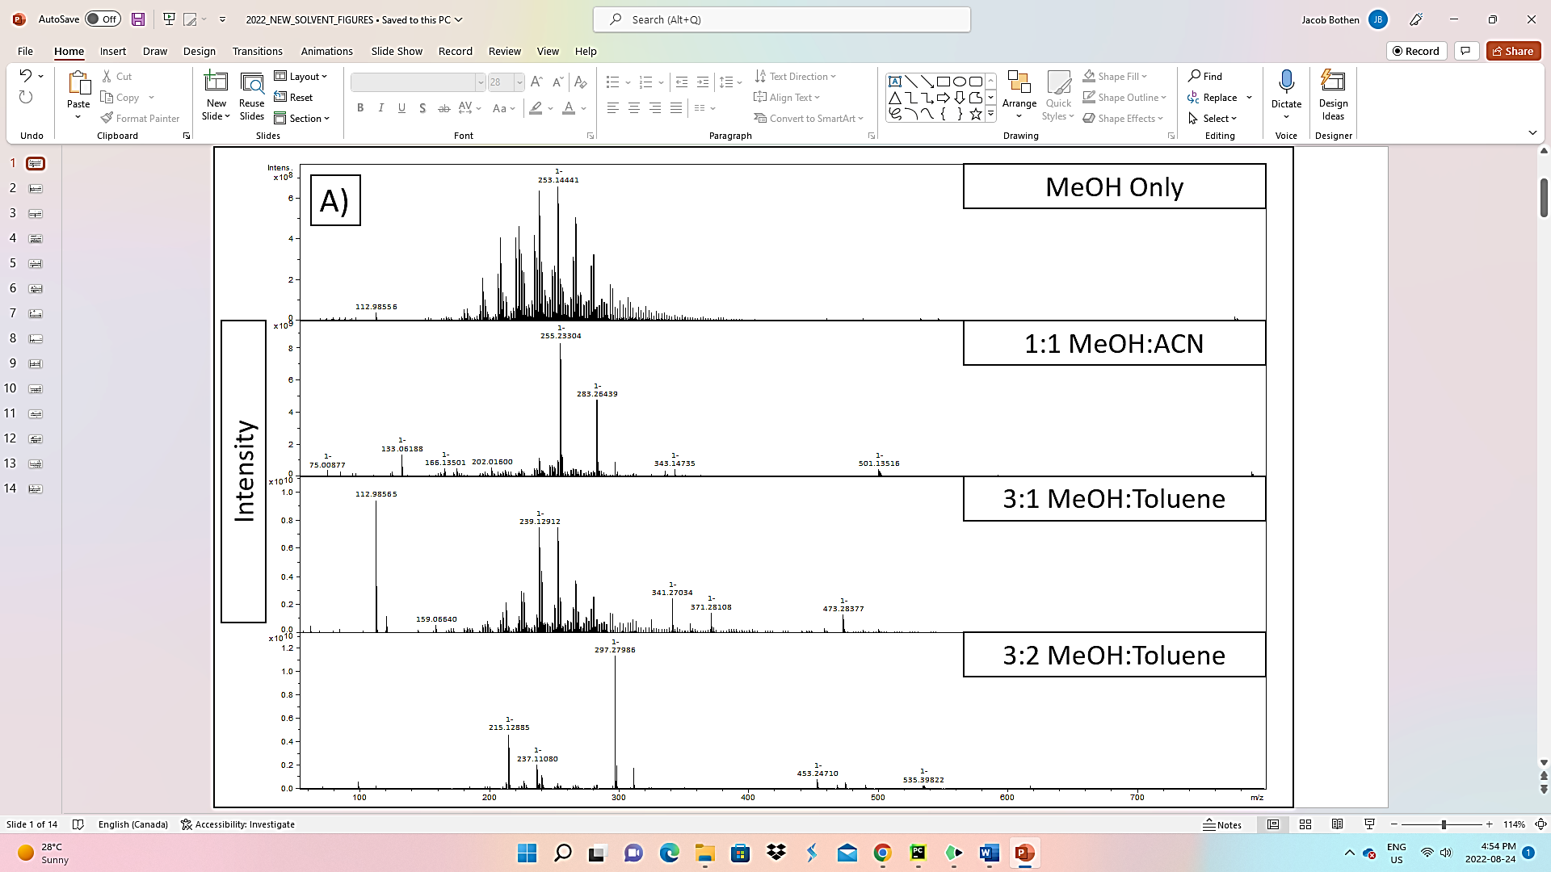
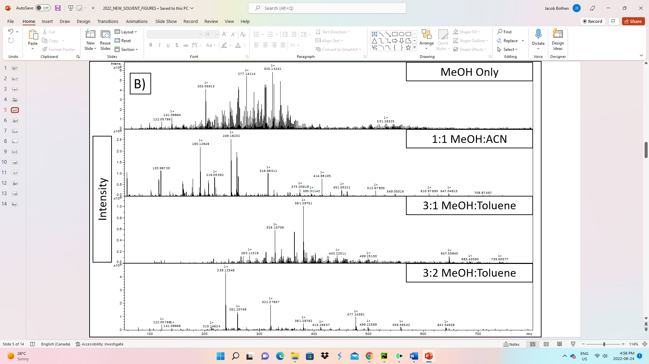
Figure 1. A) Mass Spectra of 4 solvent systems for BML P1 9m in ESI(-) and B) in ESI(+).
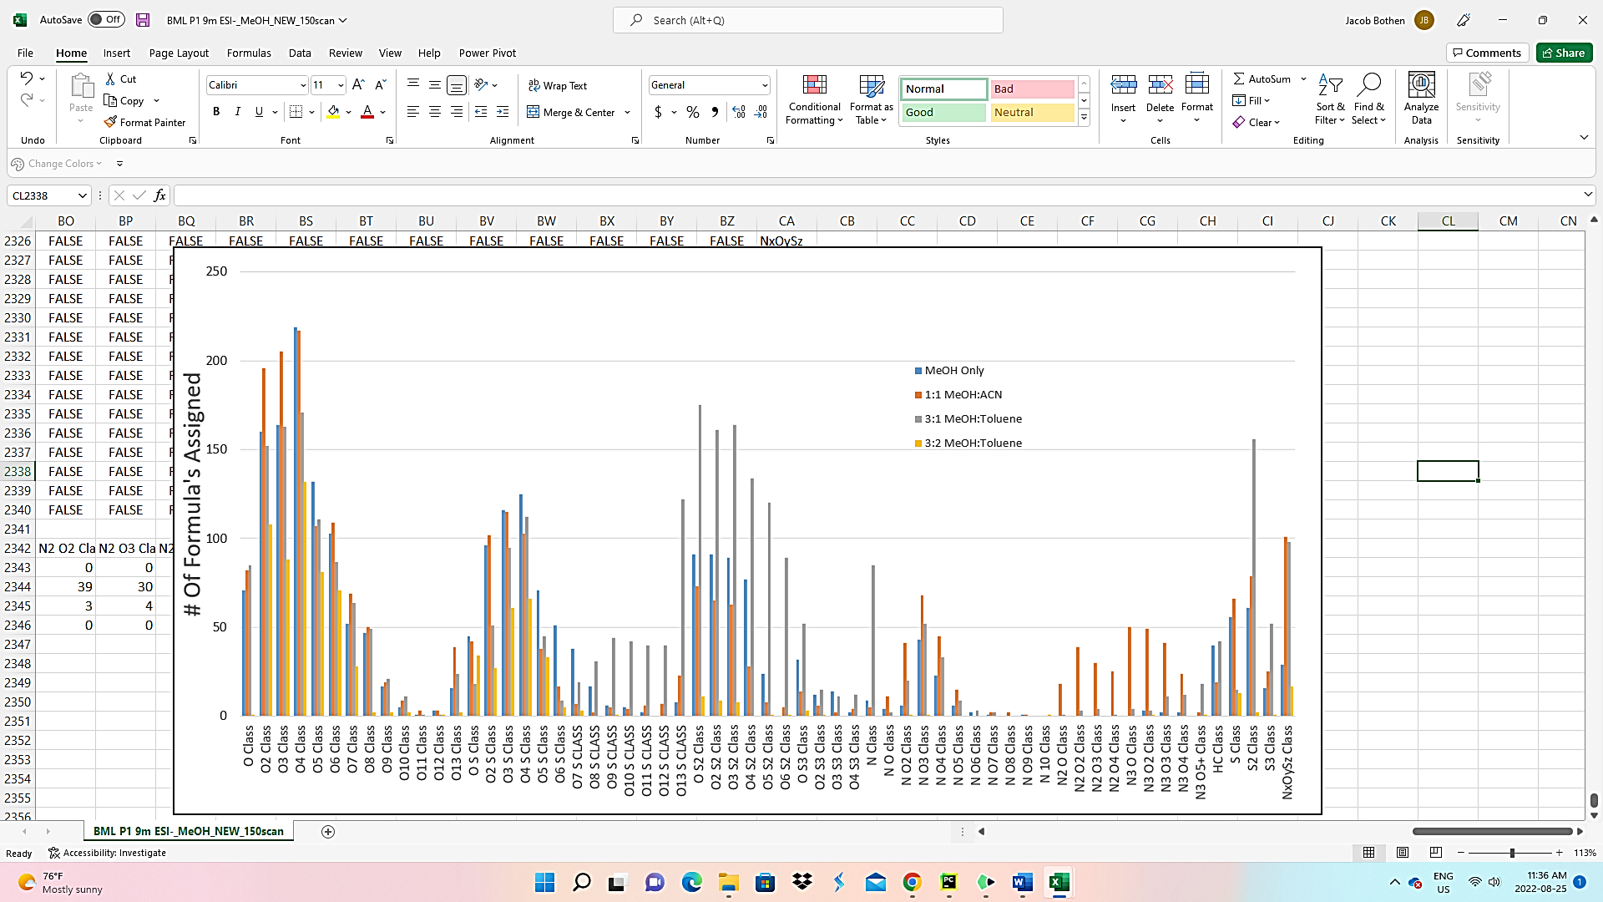
Figure 2. NAFC Class Distribution for BML P1 9m ESI(-).
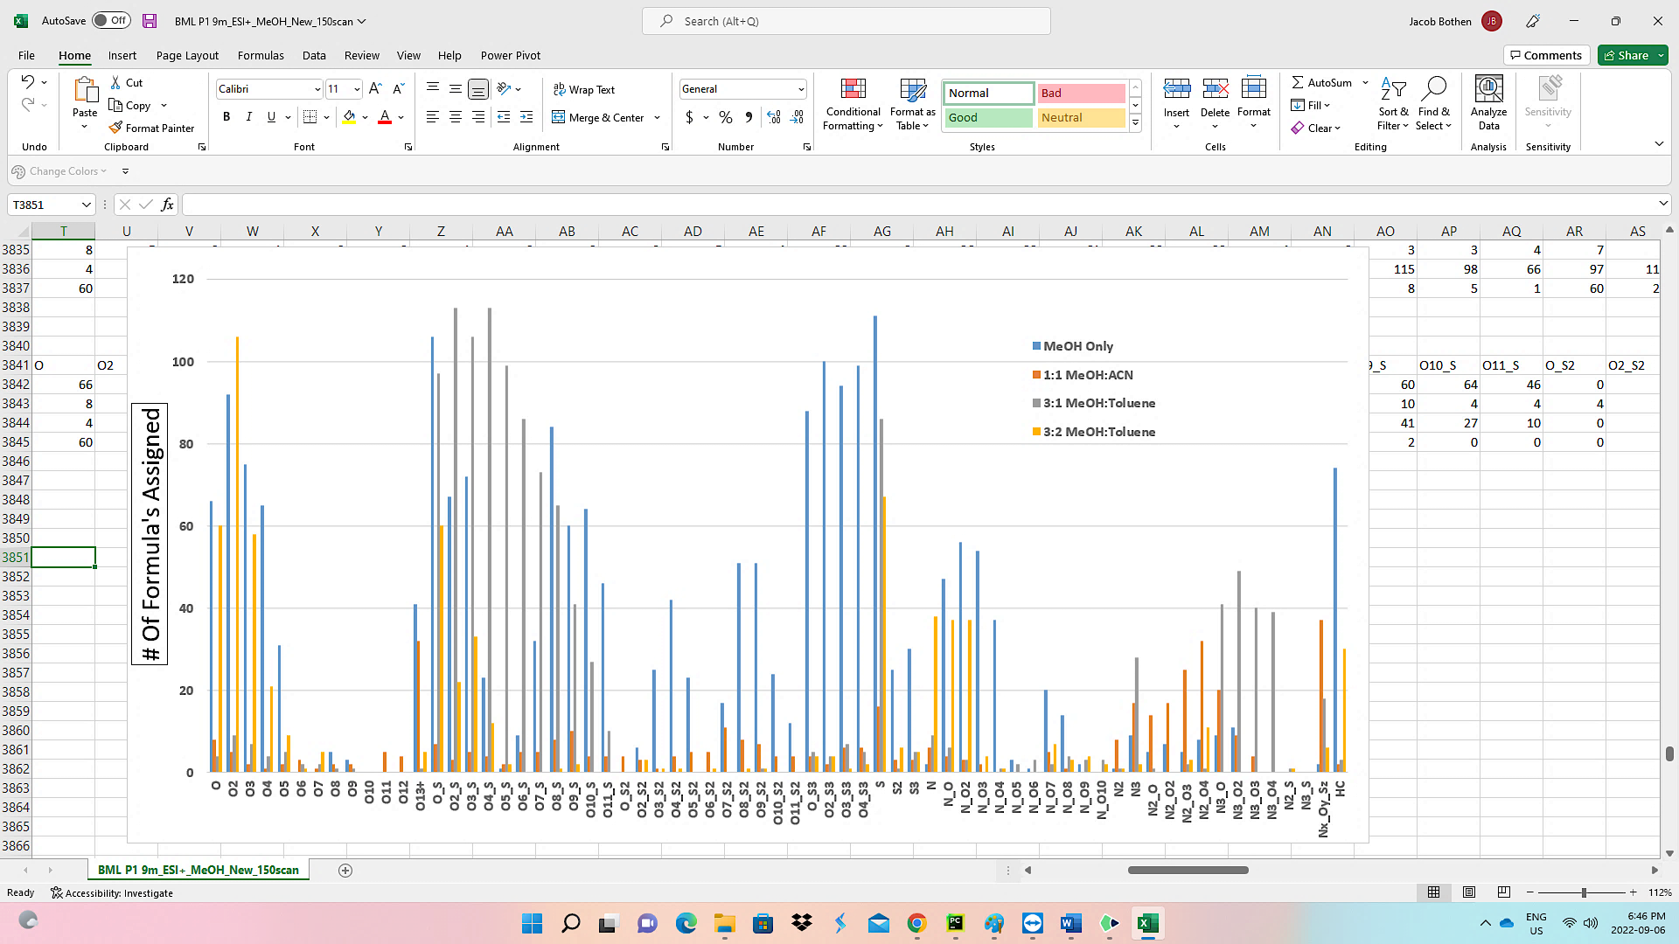
Figure 3. NAFC heteroatom class distribution for BML P1 9m analyzed in ESI (+) FT ICR MS.
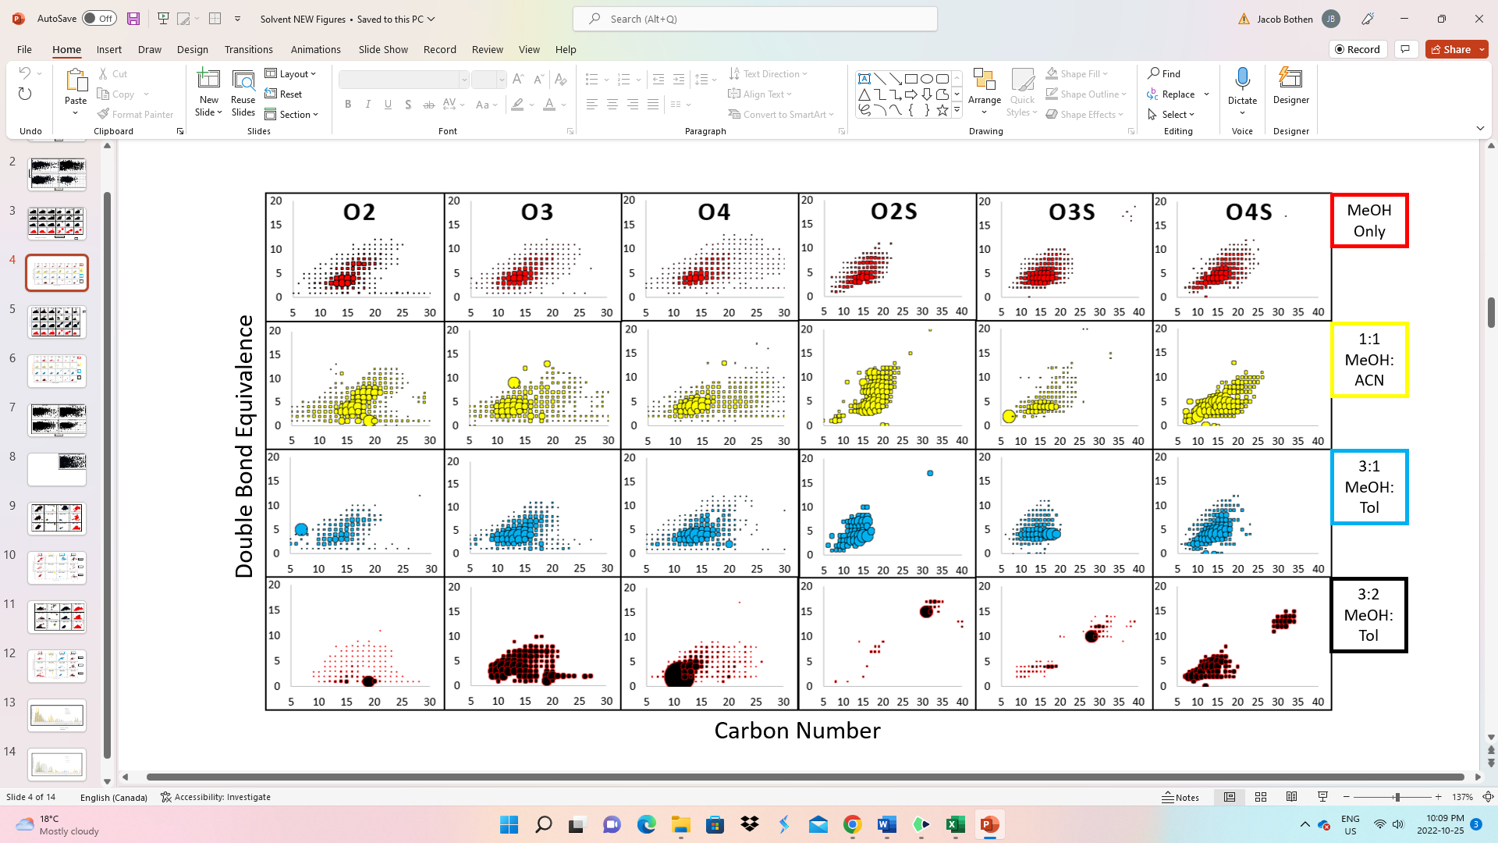
Figure 4. Comparison of the effect of solvents for the Carbon number Vs. DBE distribution for 6 most abundant NAFC classes from ESI (-) analysis of BML P1 9m. Bubble sizes are representative of the relative abundances of individual species.
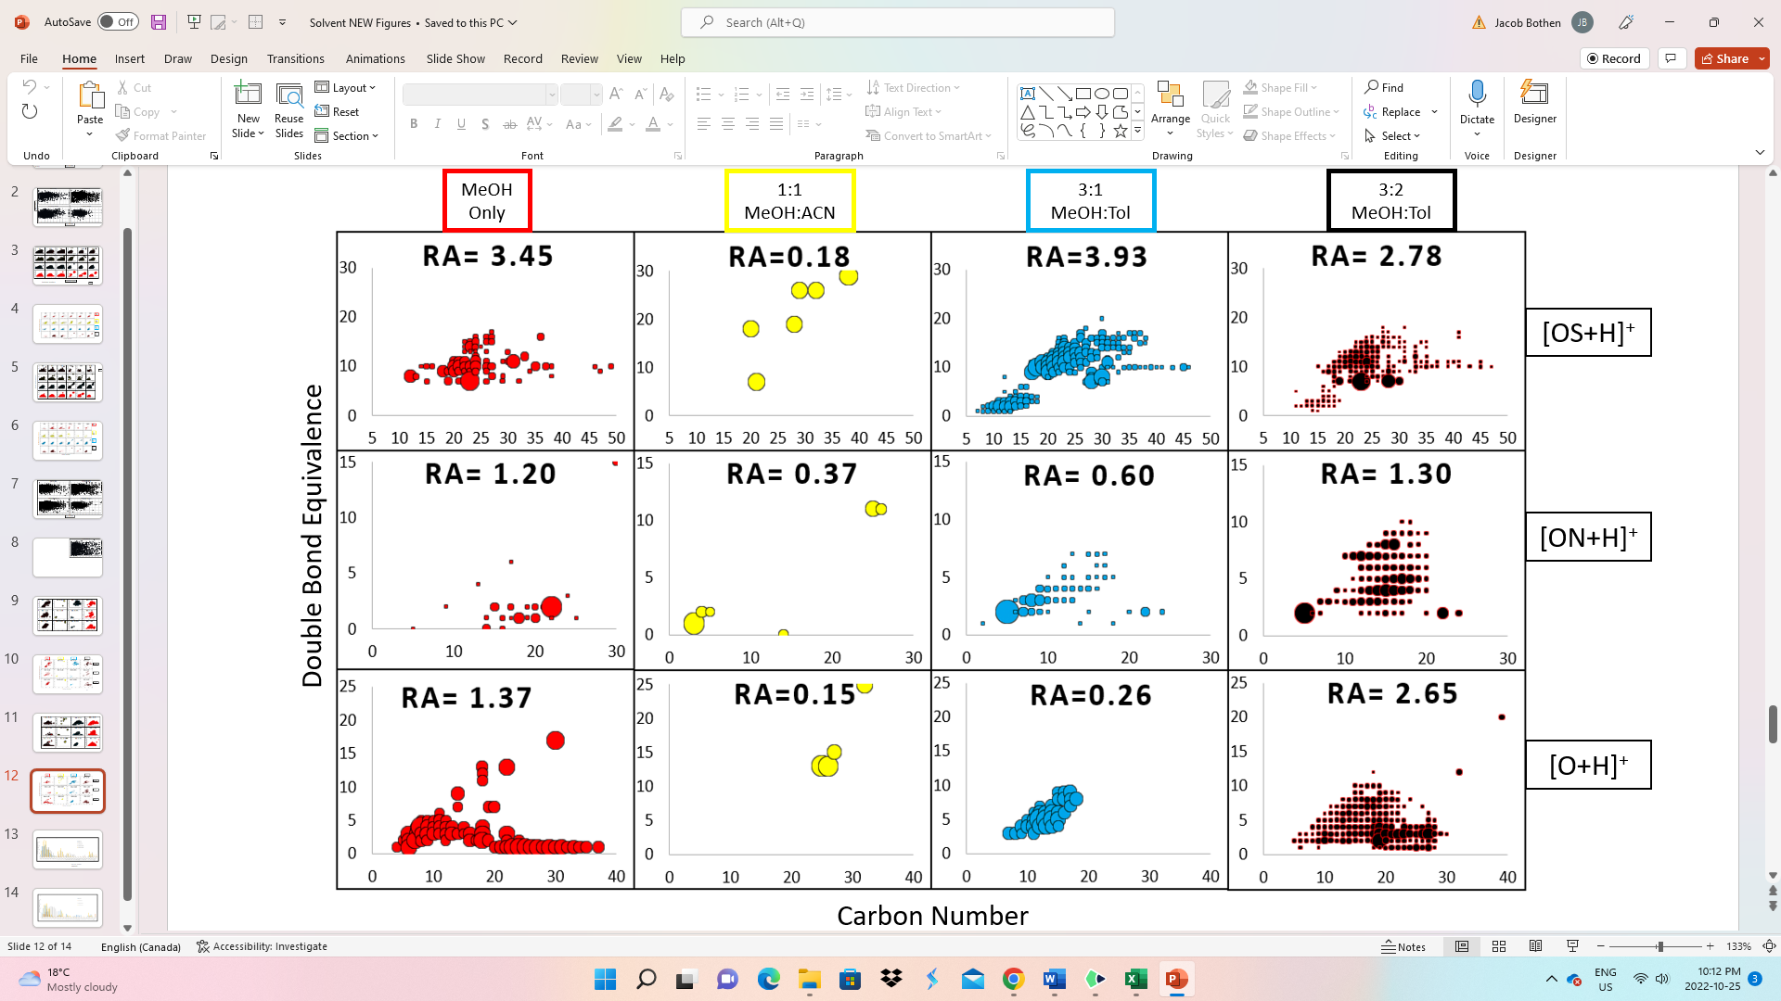
Figure 5. C# Vs. DBE plots for O⁺, SO⁺, and NO⁺ detected in the ESI (+) FT ICR MS measurements of BML P1 0.5m.

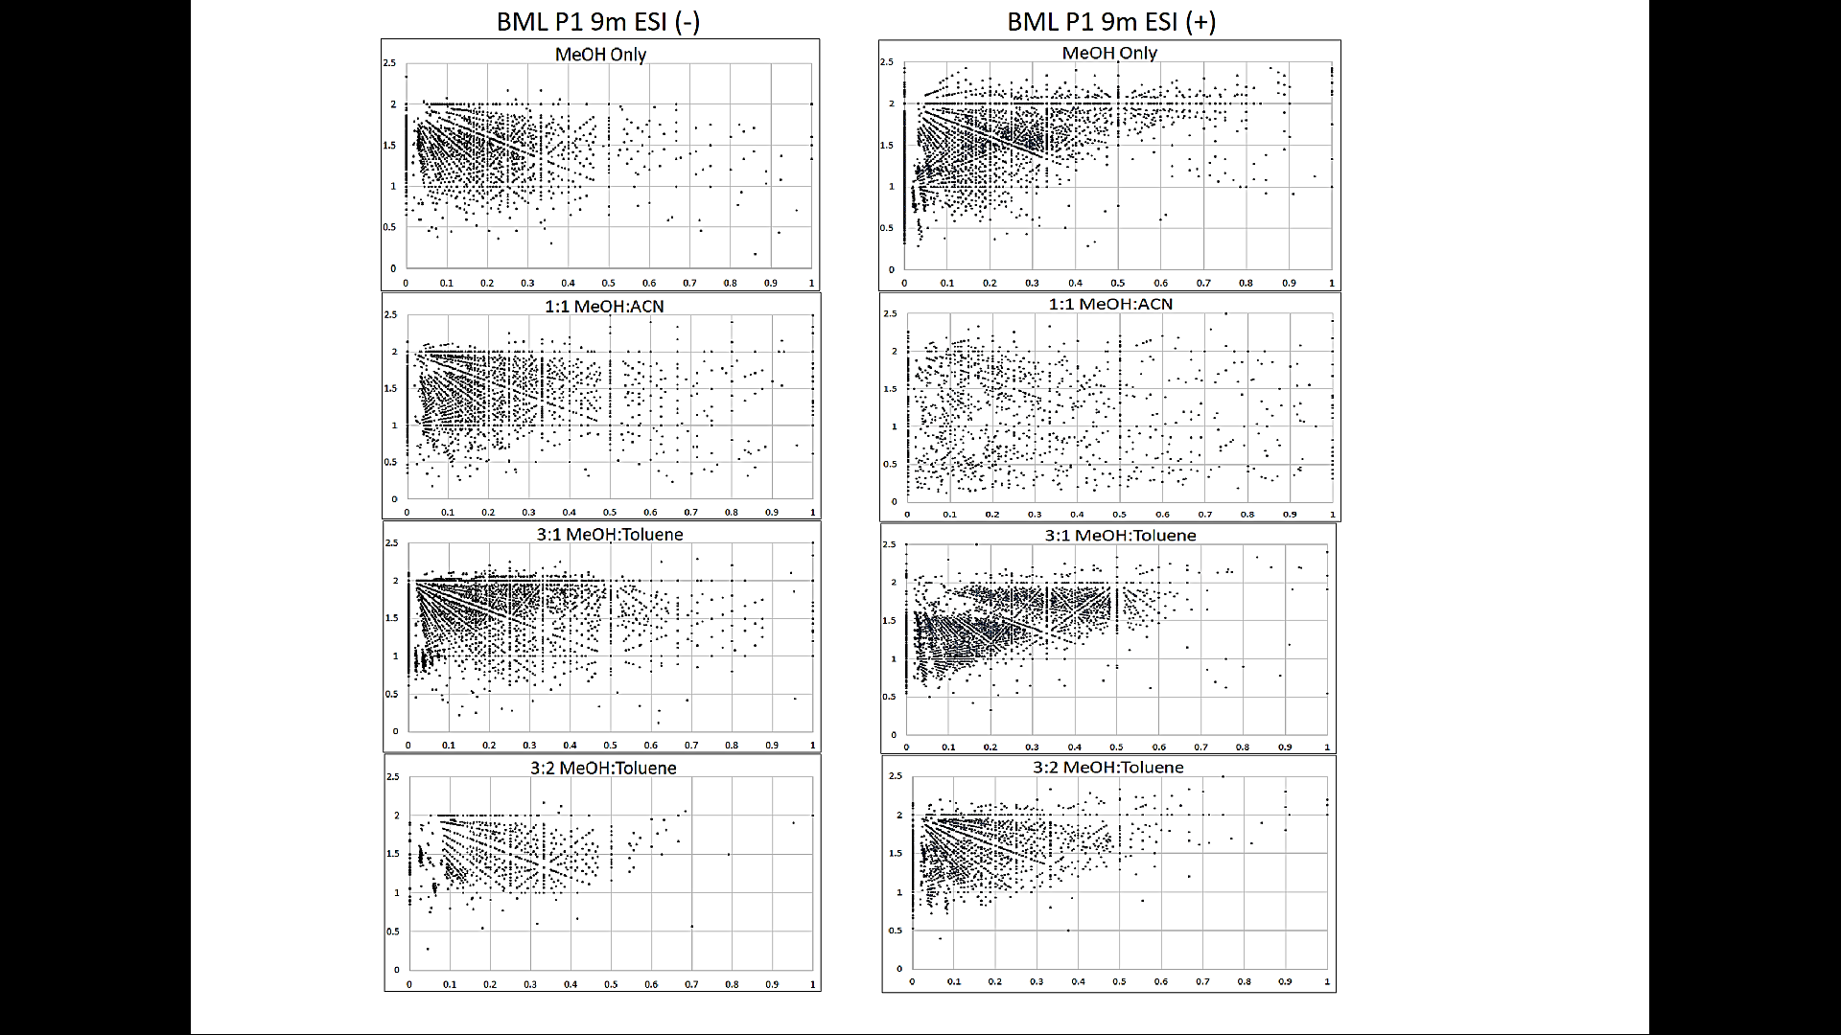
Figure 6. Comparison of van Krevelen plots between ESI (-) and (+). Note the x-axis is the O/C ratio and the y-axis is the H/C Ratio.
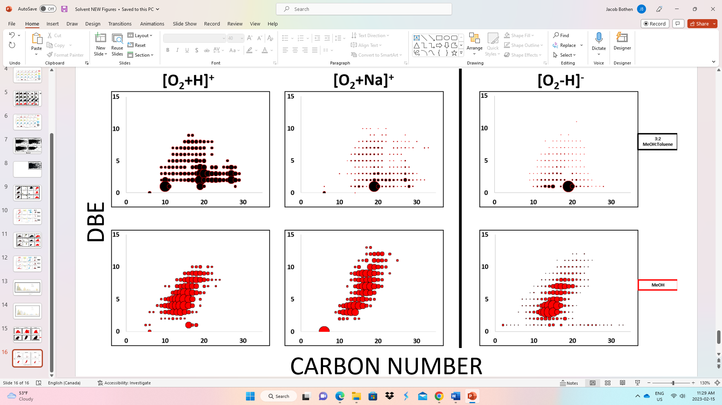
Figure 7. Comparison of the O₂ compounds detected from ESI+ resulting in the presence of +H and +Na molecular ions versus the -H ions detected in ESI-.
References
Richardson, S.D. Mass Spectrometry in Environmental Sciences. Chemical Reviews, 2001, 101(2), 211-254. https://doi.org/10.1021/cr990090u
Hernández, F., Sancho, J. v., Ibáñez, M., Abad, E., Portolés, T., & Mattioli, L. (2012). Current use of high-resolution mass spectrometry in the environmental sciences. In Analytical and Bioanalytical Chemistry (Vol. 403, Issue 5). https://doi.org/10.1007/s00216-012-5844-7
Borisov, R.S; Kulikova, L.N.; Zaikin, V.G. Mass Spectrometry in Petroleum Chemistry (Petroleomics). Petroleum Chemistry, 2019, 59, 1055-1076. https://doi.org/10.1134/S0965544119100025
Wang Z.; Fingus, M. Differentiation of the source of spilled oil and monitoring of the oil weathering process using gas chromatography-mass spectrometry. Journal of Chromatography A, 1995, 712(2), 321-343. https://doi.org/10.1016/0021-9673(95)00546-Y
Tarr, M.A.; Zito, P.; Overton, E.B.; Olson, G.M.; Adhikari, P.L.; Reddy, C.M. Weathering of Oil spilled in the Marine Environment. Oceanography, 2016, 29(3), 126-135. https://www.jstor.org/stable/24862715
Heshka, N.E.; Peru, K.M.; Xin, Q.; Dettman, H.D.; Headley, J.V. High Resolution Orbitrap Mass Spectrometry analysis of oxidized hydrocarbons found in freshwater following a simulated spill of crude oil. Chemosphere, 2022, 292, 133415. https://doi.org/10.1016/j.chemosphere.2021.133415
Marshall, A.G; Rodgers, R.P. Petroleomics: The next grand challenge for chemical analysis. Accounts of Chemical Research, 2004, 37(1), 53-59. https://doi.org/10.1021/ar020177t
Marshall, A.G; Rodgers, R.P. Petroleomics: Chemistry of the underworld. Proceedings of the National Academy Sciences, 2008, 105(47) 18090-18095. https://doi.org/10.1073/pnas.0805069105
Niyonsaba, E.; Manheim, J.M.; Yerabolu, R.; Kenttämaa, H.I. Recent Advances in Petroleum analysis by Mass Spectrometry. Analytical Chemistry, 2019, 91(1), 156-177. https://doi.org/10.1021/acs.analchem.8b05258
Rowland, S.M.; Robbins, W.K.; Corilo, Y.E.; Marshall, A.G.; Rodgers, R.P. Solid-phase extraction fractionation to extend the characterization of naphthenic acids in crude oil by electrospray ionization Fourier transform ion cyclotron resonance mass spectrometry. Energy & Fuels, 2014, 28(8), 5043-5048. https://doi.org/10.1021/ef5015023
Griffiths, M.T.; Da Campo, R.; O’Connor, P.B.; Barrow, M.P. Throwing light on Petroleum: Simulated exposure of crude oil to sunlight and characterization using atmospheric pressure photoionization Fourier transform ion cyclotron resonance mass spectrometry. Analytical Chemistry, 2014, 86(1), 527-534. https://doi.org/10.1021/ac4025335
Liu, Y; Kujawinski, E.B. Chemical composition and potential environmental impacts of water-soluble polar crude oil components inferred from ESI FT-ICR MS. PLoS ONE, 2015, 10(9), 1-18. https://doi.org/10.1371/journal.pone.0136376
McKenna, A.M.; Nelson, R.K.; Reddy, C.M.; Savory, J.J.; Kaiser, N.K.; Fitzsimmons, J.E.; Marshall, A.G.; Rodgers, R.P. Expansion of the Analytical Window for oil spill characterization by ultrahigh resolution Mass spectrometry: Beyond gas chromatography. Environmental Science & Technology, 2013, 47(13), 7530-7539. https://doi.org/10.1021/es305284t
Hughey, C.A.; Rodgers, R.P.; Marshall, A.G.; Qian, K.; Robbins, W.K. Identification of acidic NSO compounds in crude oils of different geochemical origins by negative ion electrospray Fourier transform ion cyclotron resonance mass spectrometry. Organic Geochemistry, 2002, 33, 743-759.
Gordon, D. Understanding Unconventional Oil. Carnegie Endowment, 2012. Available at: https://carnegieendowment.org/files/unconventional_oil.pdf (Accessed June 6, 2022).
Nduagu, E. I., & Gates, I. D. (2015). Unconventional Heavy Oil Growth and Global Greenhouse Gas Emissions. Environmental Science and Technology, 49(14). https://doi.org/10.1021/acs.est.5b01913
de Klerk, A.; Gray, M.R.; Zerpa, N. Unconventional Oil and Gas: Oilsands. In Future Energy, 2nd ed.; Letcher, T.M., Ed.; Elsevier: Amsterdam, Netherlands, 2014; Chapter 5, pp 95-116.
Chew, K.J. The future of Oil: Unconventional fossil fuels. Philosophical Transactions of the Royal Society A, 2014, 372, 1-34. https://doi.org/10.1098/rsta.2012.0324
Alberta Energy Regulator (May 2022). Crude Bitumen Production. Accessed on June 6, 2022 from: https://www.aer.ca/providing-information/data-and-reports/statistical-reports/st98/crude-bitumen/production
Larter, S.R.; Head, I.M. Oil Sands and Heavy Oil: Origin and Exploitation. Elements, 2014, 10(4), 277-283. https://doi.org/10.2113/gselements.10.4.277
Clemente, J. S., & Fedorak, P. M. (2005). A review of the occurrence, analyses, toxicity, and biodegradation of naphthenic acids. In Chemosphere (Vol. 60, Issue 5). https://doi.org/10.1016/j.chemosphere.2005.02.065
Hubert, C. R. J., Oldenburg, T. B. P., Fustic, M., Gray, N. D., Larter, S. R., Penn, K., Rowan, A. K., Seshadri, R., Sherry, A., Swainsbury, R., Voordouw, G., Voordouw, J. K., & Head, I. M. (2012). Massive dominance of Epsilonproteobacteria in formation waters from a Canadian oil sands reservoir containing severely biodegraded oil. Environmental Microbiology, 14(2). https://doi.org/10.1111/j.1462-2920.2011.02521.x
Huang, H., Silva, R. C., Radović, J. R., & Larter, S. R. (2020). Environmental and Economic Implications of the Biogeochemistry of Oil Sands Bitumen. In Hydrocarbons, Oils and Lipids: Diversity, Origin, Chemistry and Fate. https://doi.org/10.1007/978-3-319-90569-3_19
Barrow, M. P., Headley, J. v., Peru, K. M., & Derrick, P. J. (2009). Data visualization for the characterization of naphthenic acids within petroleum samples. Energy and Fuels, 23(5). https://doi.org/10.1021/ef800985z
Brown, L. D., & Ulrich, A. C. (2015). Oil sands naphthenic acids: A review of properties, measurement, and treatment. In Chemosphere (Vol. 127). https://doi.org/10.1016/j.chemosphere.2015.02.003
Jones, D.; Scarlett, A.G.; West, C.E.; Rowland, S.J. Toxicity of individual Naphthenic acids to Vibrio fischeri. Environmental Science and Technology, 2011, 45(22), 9776-9782.
Bauer, A. E., Hewitt, L. M., Parrott, J. L., Bartlett, A. J., Gillis, P. L., Deeth, L. E., Rudy, M. D., Vanderveen, R., Brown, L., Campbell, S. D., Rodrigues, M. R., Farwell, A. J., Dixon, D. G., & Frank, R. A. (2019). The toxicity of organic fractions from aged oil sands process-affected water to aquatic species. Science of the Total Environment, 669. https://doi.org/10.1016/j.scitotenv.2019.03.107
Rogers, V. v., Liber, K., & MacKinnon, M. D. (2002). Isolation and characterization of naphthenic acids from athabasca oil sands tailings pond water. Chemosphere, 48(5). https://doi.org/10.1016/S0045-6535(02)00133-9
J.P. Giesy, J.C. Anderson, S.B. Wiseman. Alberta oil sands development. PNAS, 107 (3) (2010), pp. 951-952
Scott, A. C., Zubot, W., Davis, C. W., & Brogly, J. (2020). Bioaccumulation potential of naphthenic acids and other ionizable dissolved organics in oil sands process water (OSPW) – A review. In Science of the Total Environment (Vol. 712). https://doi.org/10.1016/j.scitotenv.2019.134558
Headley, J.V; McMartin, D.W. A review of the occurrence and fate of Naphthenic acids in Aquatic environments. Journal of Environmental Science and Health, Part A, 2004, 39(8), 1989-2010.
Barrow, M. P., Witt, M., Headley, J. v., & Peru, K. M. (2010). Athabasca oil sands process water: Characterization by atmospheric pressure photoionization and electrospray ionization Fourier transform ion cyclotron resonance mass spectrometry. Analytical Chemistry, 82(9). https://doi.org/10.1021/ac100103y
Headley, J. v., Barrow, M. P., Peru, K. M., Fahlman, B., Frank, R. A., Bickerton, G., McMaster, M. E., Parrott, J., & Hewitt, L. M. (2011). Preliminary fingerprinting of Athabasca oil sands polar organics in environmental samples using electrospray ionization Fourier transform ion cyclotron resonance mass spectrometry. Rapid Communications in Mass Spectrometry, 25(13). https://doi.org/10.1002/rcm.5062
Barrow, M. P., Peru, K. M., Fahlman, B., Hewitt, L. M., Frank, R. A., & Headley, J. v. (2015). Beyond Naphthenic Acids: Environmental Screening of Water from Natural Sources and the Athabasca Oil Sands Industry Using Atmospheric Pressure Photoionization Fourier Transform Ion Cyclotron Resonance Mass Spectrometry. Journal of the American Society for Mass Spectrometry, 26(9). https://doi.org/10.1007/s13361-015-1188-9
Headley, J. v., Peru, K. M., & Barrow, M. P. (2016). Advances in mass spectrometric characterization of naphthenic acids fraction compounds in oil sands environmental samples and crude oil - A review. In Mass Spectrometry Reviews (Vol. 35, Issue 2). https://doi.org/10.1002/mas.21472
Huang, R., Chen, Y., Meshref, M. N. A., Chelme-Ayala, P., Dong, S., Ibrahim, M. D., Wang, C., Klamerth, N., Hughes, S. A., Headley, J. v., Peru, K. M., Brown, C., Mahaffey, A., & Gamal El-Din, M. (2018). Characterization and determination of naphthenic acids species in oil sands process-affected water and groundwater from oil sands development area of Alberta, Canada. Water Research, 128. https://doi.org/10.1016/j.watres.2017.10.003
Stanford, L. A., Kim, S., Klein, G. C., Smith, D. F., Rodgers, R. P., & Marshall, A. G. (2007). Identification of water-soluble heavy crude oil organic-acids, bases, and neutrals by electrospray ionization and field desorption ionization fourier transform ion cyclotron resonance mass spectrometry. Environmental Science and Technology, 41(8). https://doi.org/10.1021/es0624063
Smith, D. F., Rahimi, P., Teclemariam, A., Rodgers, R. P., & Marshall, A. G. (2008). Characterization of athabasca bitumen heavy vacuum gas oil distillation cuts by negative/positive electrospray ionization and automated liquid injection field desorption ionization Fourier transform ion cyclotron resonance mass spectrometry. Energy and Fuels, 22(5). https://doi.org/10.1021/ef8000357
Mapolelo, M. M., Rodgers, R. P., Blakney, G. T., Yen, A. T., Asomaning, S., & Marshall, A. G. (2011). Characterization of naphthenic acids in crude oils and naphthenates by electrospray ionization FT-ICR mass spectrometry. International Journal of Mass Spectrometry, 300(2–3). https://doi.org/10.1016/j.ijms.2010.06.005
Aeppli, C., Carmichael, C. A., Nelson, R. K., Lemkau, K. L., Graham, W. M., Redmond, M. C., Valentine, D. L., & Reddy, C. M. (2012). Oil weathering after the Deepwater Horizon disaster led to the formation of oxygenated residues. Environmental Science and Technology, 46(16). https://doi.org/10.1021/es3015138
Bowman, D. T., Slater, G. F., Warren, L. A., & McCarry, B. E. (2014). Identification of individual thiophene-, indane-, tetralin-, cyclohexane-, and adamantane-type carboxylic acids in composite tailings pore water from Alberta oil sands. Rapid Communications in Mass Spectrometry, 28(19). https://doi.org/10.1002/rcm.6996
Bowman, D. T., Jobst, K. J., Ortiz, X., Reiner, E. J., Warren, L. A., McCarry, B. E., & Slater, G. F. (2018). Improved coverage of naphthenic acid fraction compounds by comprehensive two-dimensional gas chromatography coupled with high resolution mass spectrometry. Journal of Chromatography A, 1536. https://doi.org/10.1016/j.chroma.2017.07.017
Bowman, D. T., Warren, L. A., & Slater, G. F. (2020). Isomer-specific monitoring of naphthenic acids at an oil sands pit lake by comprehensive two-dimensional gas chromatography–mass spectrometry. Science of the Total Environment, 746. https://doi.org/10.1016/j.scitotenv.2020.140985
vander Meulen, I. J., Klemish, J. L., Peru, K. M., Chen, D. D. Y., Pyle, G. G., & Headley, J. v. (2021). Molecular profiles of naphthenic acid fraction compounds from mine lease wetlands in the Athabasca Oil Sands Region. Chemosphere, 272. https://doi.org/10.1016/j.chemosphere.2021.129892
Wise, S. A., Rodgers, R. P., Reddy, C. M., Nelson, R. K., Kujawinski, E. B., Wade, T. L., Campiglia, A. D., & Liu, Z. (2022). Advances in Chemical Analysis of Oil Spills Since the Deepwater Horizon Disaster. In Critical Reviews in Analytical Chemistry. https://doi.org/10.1080/10408347.2022.2039093
Grewer. D.M.; Young, R.F.; Whittal, R.M.; Fedorak, P.M. Naphthenic acids and other acid-extractables in water samples from Alberta: What is being measured? Science of the Total Environment, 2010, 408, 5997-6010.
Barros, E. v., Filgueiras, P. R., Lacerda, V., Rodgers, R. P., & Romão, W. (2022). Characterization of naphthenic acids in crude oil samples – A literature review. In Fuel (Vol. 319). https://doi.org/10.1016/j.fuel.2022.123775

McKenna, A. M., Chen, H., Weisbrod, C. R., & Blakney, G. T. (2021). Molecular comparison of solid-phase extraction and liquid/liquid extraction of water-soluble petroleum compounds produced through photodegradation and biodegradation by ft-icr mass spectrometry. Analytical Chemistry, 93(10). https://doi.org/10.1021/acs.analchem.0c05230
Headley, J. v., Peru, K. M., Barrow, M. P., & Derrick, P. J. (2007). Characterization of naphthenic acids from athabasca oil sands using electrospray ionization: The significant influence of solvents. Analytical Chemistry, 79(16). https://doi.org/10.1021/ac070905w
vander Meulen, I. J., Schock, D. M., Parrott, J. L., Simair, M. C., Mundy, L. J., Ajaero, C., Pauli, B. D., Peru, K. M., McMartin, D. W., & Headley, J. v. (2022). Transformation of bitumen-derived naphthenic acid fraction compounds across surface waters of wetlands in the Athabasca Oil Sands region. Science of the Total Environment, 806. https://doi.org/10.1016/j.scitotenv.2021.150619

Syncrude Ltd. 2022 Pit lake monitoring and research report EPEA Approval No. 26-03 (as amended). https://era.library.ualberta.ca/items/0994fedb-74d0-4397-a6ad-932f78bee1ee

Dompierre, K. A., Lindsay, M. B. J., Cruz-Hernández, P., & Halferdahl, G. M. (2016). Initial geochemical characteristics of fluid fine tailings in an oil sands end pit lake. Science of the Total Environment, 556. https://doi.org/10.1016/j.scitotenv.2016.03.002

Dompierre, K. A., Barbour, S. L., North, R. L., Carey, S. K., & Lindsay, M. B. J. (2017). Chemical mass transport between fluid fine tailings and the overlying water cover of an oil sands end pit lake. Water Resources Research, 53(6). https://doi.org/10.1002/2016WR020112

Risacher, F. F., Morris, P. K., Arriaga, D., Goad, C., Nelson, T. C., Slater, G. F., & Warren, L. A. (2018). The interplay of methane and ammonia as key oxygen consuming constituents in early stage development of Base Mine Lake, the first demonstration oil sands pit lake. Applied Geochemistry, 93. https://doi.org/10.1016/j.apgeochem.2018.03.013

Tedford, E., Halferdahl, G., Pieters, R., & Lawrence, G. A. (2019). Temporal variations in turbidity in an oil sands pit lake. Environmental Fluid Mechanics, 19(2). https://doi.org/10.1007/s10652-018-9632-6

Arriaga, D., Nelson, T. C., Risacher, F. F., Morris, P. K., Goad, C., Slater, G. F., & Warren, L. A. (2019). The co-importance of physical mixing and biogeochemical consumption in controlling water cap oxygen levels in Base Mine Lake. Applied Geochemistry, 111. https://doi.org/10.1016/j.apgeochem.2019.104442

Bowman, D. T., Warren, L. A., & Slater, G. F. (2020). Isomer-specific monitoring of naphthenic acids at an oil sands pit lake by comprehensive two-dimensional gas chromatography–mass spectrometry. Science of the Total Environment, 746. https://doi.org/10.1016/j.scitotenv.2020.140985
El-Waraky, M. Assessment of the sources and biodegradation potential of hydrocarbons and naphthenic acids in an oil sands end pit lake. PhD Dissertation, McMaster University. 2021.
Slater, G. F., Goad, C. A., Lindsay, M. B. J., Mumford, K. G., Nelson, T. E. C., Brady, A. L., Jessen, G. L., & Warren, L. A. (2021). Isotopic and chemical assessment of the dynamics of methane sources and microbial cycling during early development of an oil sands pit lake. Microorganisms, 9(12). https://doi.org/10.3390/microorganisms9122509

Lawrence, G. A., Tedford, E. W., & Pieters, R. (2015). Suspended solids in an end pit lake: Potential mixing mechanisms. Canadian Journal of Civil Engineering, 43(3). https://doi.org/10.1139/cjce-2015-0381

Ruddy, B. M., Hendrickson, C. L., Rodgers, R. P., & Marshall, A. G. (2018). Positive Ion Electrospray Ionization Suppression in Petroleum and Complex Mixtures. Energy and Fuels, 32(3). https://doi.org/10.1021/acs.energyfuels.7b03204
He, C.; Zhang, Y.; Li, Y.; Zhuo, X.; Li, Y.; Zhang, C.; Shi, Q. In-house standard method for molecular characterization of dissolved organic matter by FT-ICR Mass spectrometry. ACS Omega, 2020, 5(20), 11730-11736.

Martin, J. W., Han, X., Peru, K. M., & Headley, J. v. (2008). Comparison of high- and low-resolution electrospray ionization mass spectrometry for the analysis of naphthenic acid mixtures in oil sands process water. Rapid Communications in Mass Spectrometry, 22(12). https://doi.org/10.1002/rcm.3570

Enke, C. G. (1997). A Predictive Model for Matrix and Analyte Effects in Electrospray Ionization of Singly-Charged Ionic Analytes. Analytical Chemistry, 69(23). https://doi.org/10.1021/ac970095w

Alharbi, H.A.; Morandi, G.D.; Jones, P.D.; Wiseman, S.B.; Giesy, J.P. Comparison of the effects of extraction techniques on mass spectrometry profiles of dissolved organic compounds in oil sands process-affected water. Energy and Fuels, 2019, 33, 7001-7008.
Purcell, J. M., Rodgers, R. P., Hendrickson, C. L., & Marshall, A. G. (2007). Speciation of Nitrogen Containing Aromatics by Atmospheric Pressure Photoionization or Electrospray Ionization Fourier Transform Ion Cyclotron Resonance Mass Spectrometry. Journal of the American Society for Mass Spectrometry, 18(7). https://doi.org/10.1016/j.jasms.2007.03.030

Scott, A. C., MacKinnon, M. D., & Fedorak, P. M. (2005). Naphthenic acids in athabasca oil sands tailings waters are less biodegradable than commercial naphthenic acids. Environmental Science and Technology, 39(21). https://doi.org/10.1021/es051003k

Ross, M. S., Pereira, A. D. S., Fennell, J., Davies, M., Johnson, J., Sliva, L., & Martin, J. W. (2012). Quantitative and qualitative analysis of naphthenic acids in natural waters surrounding the canadian oil sands industry. Environmental Science and Technology, 46(23). https://doi.org/10.1021/es303432u

Sun, C., Shotyk, W., Cuss, C. W., Donner, M. W., Fennell, J., Javed, M., Noernberg, T., Poesch, M., Pelletier, R., Sinnatamby, N., Siddique, T., & Martin, J. W. (2017). Characterization of Naphthenic Acids and Other Dissolved Organics in Natural Water from the Athabasca Oil Sands Region, Canada. Environmental Science and Technology, 51(17). https://doi.org/10.1021/acs.est.7b02082

Frank, R.A.; Milestone, C.B.; Rowland, S.J.; Headley, J.V.; Kavanagh, R.J.; Lengger, S.K.; Scarlett, A.G.; West, C.E.; Peru, K.M.; Hewitt, L.M. Assessing spatial and temporal variability of acid-extractable organics in oil sands process-affected waters. Chemosphere, 2016, 160, 303-313.
Zhang, K., Pereira, A. S., & Martin, J. W. (2015). Estimates of Octanol-Water Partitioning for Thousands of Dissolved Organic Species in Oil Sands Process-Affected Water. Environmental Science and Technology, 49(14). https://doi.org/10.1021/acs.est.5b01656
Zhang, K., Wiseman, S., Giesy, J. P., & Martin, J. W. (2016). Bioconcentration of Dissolved Organic Compounds from Oil Sands Process-Affected Water by Medaka (Oryzias latipes): Importance of Partitioning to Phospholipids. Environmental Science and Technology, 50(12). https://doi.org/10.1021/acs.est.6b01354
Kovalchik, K.A.; Maclennan, M.S.; Peru, K.M.; Headley, J.V.; Chen, D.D.Y. Standard method design considerations for semi-quantification of total naphthenic acids in oil sands process affected water by mass spectrometry: A review. Front. Chem. Sci. Eng., 2017, 11(3), 497-507.
Pereira, A. S., Islam, M. S., Gamal El-Din, M., & Martin, J. W. (2013). Ozonation degrades all detectable organic compound classes in oil sands process-affected water; An application of high-performance liquid chromatography/obitrap mass spectrometry. Rapid Communications in Mass Spectrometry, 27(21). https://doi.org/10.1002/rcm.6688

Challis, J. K., Parajas, A., Anderson, J. C., Asiedu, E., Martin, J. W., Wong, C. S., & Ross, M. S. (2020). Photodegradation of bitumen-derived organics in oil sands process-affected water. Environmental Science: Processes and Impacts, 22(5). https://doi.org/10.1039/d0em00005a
Kim, S.; Kramer, R.W.; Hatcher. Graphical method for analysis of ultrahigh resolution broadband mass spectra of natural organic matter, the Van Krevelen diagram. Analytical Chemistry, 2003, 75, 5336-5344
Sleighter, R.L.; Hatcher, P.G. The application of electrospray ionization coupled to ultrahigh resolution mass spectrometry for the molecular characterization of natural organic matter. Journal of Mass Spectrometry, 2007, 42, 559-574.

Walters, C. C., Wang, F. C., Qian, K., Wu, C., Mennito, A. S., & Wei, Z. (2015). Petroleum alteration by thermochemical sulfate reduction - A comprehensive molecular study of aromatic hydrocarbons and polar compounds. Geochimica et Cosmochimica Acta, 153. https://doi.org/10.1016/j.gca.2014.11.021
Rostad, C. E., & Leenheer, J. A. (2004). Factors that affect molecular weight distribution of Suwannee river fulvic acid as determined by electrospray ionization/mass spectrometry. Analytica Chimica Acta, 523(2). https://doi.org/10.1016/j.aca.2004.06.065

Koch, B. P., Witt, M., Engbrodt, R., Dittmar, T., & Kattner, G. (2005). Molecular formulae of marine and terrigenous dissolved organic matter detected by electrospray ionization Fourier transform ion cyclotron resonance mass spectrometry. Geochimica et Cosmochimica Acta, 69(13). https://doi.org/10.1016/j.gca.2005.02.027

Sleighter, R. L., & Hatcher, P. G. (2007). The application of electrospray ionization coupled to ultrahigh resolution mass spectrometry for the molecular characterization of natural organic matter. In Journal of Mass Spectrometry (Vol. 42, Issue 5). https://doi.org/10.1002/jms.1221

Banerjee, S., & Mazumdar, S. (2012). Electrospray Ionization Mass Spectrometry: A Technique to Access the Information beyond the Molecular Weight of the Analyte. International Journal of Analytical Chemistry, 2012. https://doi.org/10.1155/2012/282574

Chanthamontri, C. K., Stopford, A. P., Snowdon, R. W., Oldenburg, T. B. P., & Larter, S. R. (2014). On-line desalting of crude oil in the source region of a fourier transform ion cyclotron resonance mass spectrometer. Journal of the American Society for Mass Spectrometry, 25(8). https://doi.org/10.1007/s13361-014-0906-z

SUPPORTING INFORMATION
Materials and Methods
After each mass spectra were assigned the chemical formulas within the chosen parameters, the information was exported to excel in the format shown in Figure S1. The total ion intensities displayed in Table 1 were determined by summing the “Observed_Intens” of the assigned formulas, and the RMSE was calculated using the “err_ppm” data. Since the data set contained chemical formulas with a -1 or +1 charge symbolizing deprotonation or protonation, it was beneficial to add a new column called “H_Neutral” and determine the # of H’s within the neutral molecules. When Na was present as an adduct for the chemical formulas in ESI (+) data, the H# was not adjusted. The next important steps for processing the data were to assign various properties useful for the different plots shown in the results. The O/C ratios and H/C ratios (using the H_Neutral #) were calculated by dividing their respective elemental columns, and DBE and Z number were determined using Equation 1 and 2, respectively. A total of 61 and 124 heteroatom classes were allocated to the ESI (-) and (+), respectively, using various adaptations of Equation 3; which assigned each formula in the various classes by combination of “IF” and “AND” functions. The Mean Absolute Error (MAE) value displayed in Table 1 was calculated using Equation 5 and the ppm errors generated by the SmartFormula software as shown in figure S1.
Eq. 1. $DBE=C\#- \frac{H\#}{2}+ \frac{N\#}{2}+1$
Eq. 2. $Z Number=\left(-2\right)\left(DBE\right)+N\#+2$
Eq. 3 ([O₃+H]⁺ example using Figure S1 cells) = IF((AND($K2=3, $L=0, $J=0, $I2=0)), “O3”)
Eq 4. $Relative Abundance=(\frac{Observed Intensity }{Sum of Observed Intensities})×(100)$
Eq 5. Mean Absolute Error = Sumproduct(ABS(E2:E32))/count(E2:E32) (example from figure S1)
Additional data filtering procedures were conducted on each chemical mass list which included removing formulas shown in Table S4 corresponding to chemicals routinely found within the within the blanks of ESI(-) & (+) mass spectra’s, chemical formulas possessing DBE’s <0 and Z Number’s >3, and formulas with high molecular weight compounds possessing low C and H values and high O, S, and N values. A downside for not using commercially available mass finder softer wares, such as Composer or Petro-Org, is that isotopologues (mainly ¹³C, and occasionally ³⁴S) of each mass was not searched and could have led to SmartFormula assigning formulas that do not make sense from a chemical standpoint. The final processing step in excel was determining the Relative abundance values of individual formulas as shown equation 4. A custom Python® script was written to further organize the heteroatom class into individualized spreadsheets and to perform the calculations of the total relative abundances of all the classes across ESI (-) and (+) samples.

Supporting Figures
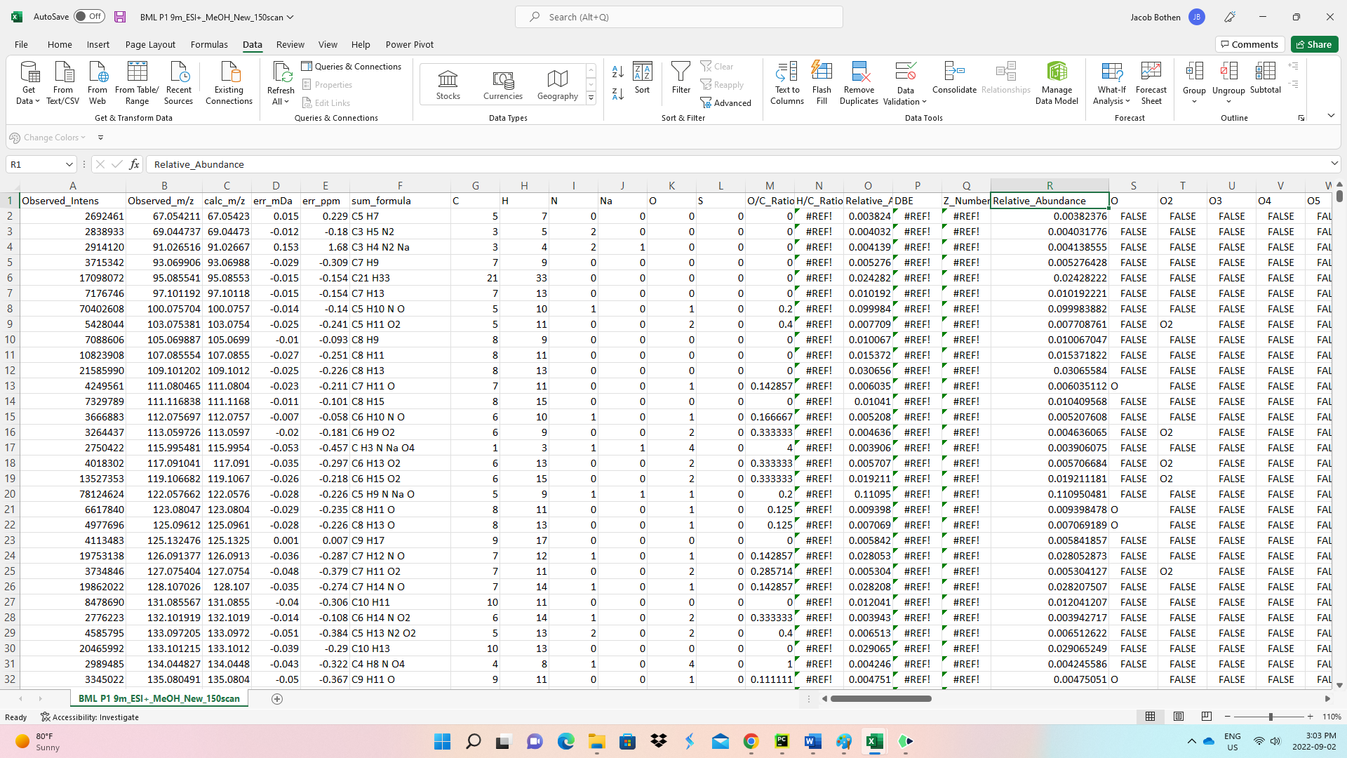
Figure S1. Raw chemical data of MeOH BML P1 9m ESI (+) FT-ICR MS as a result of SmartFormula function when exported via Van Krevelen plot using Bruker Data Analysis 5.0.

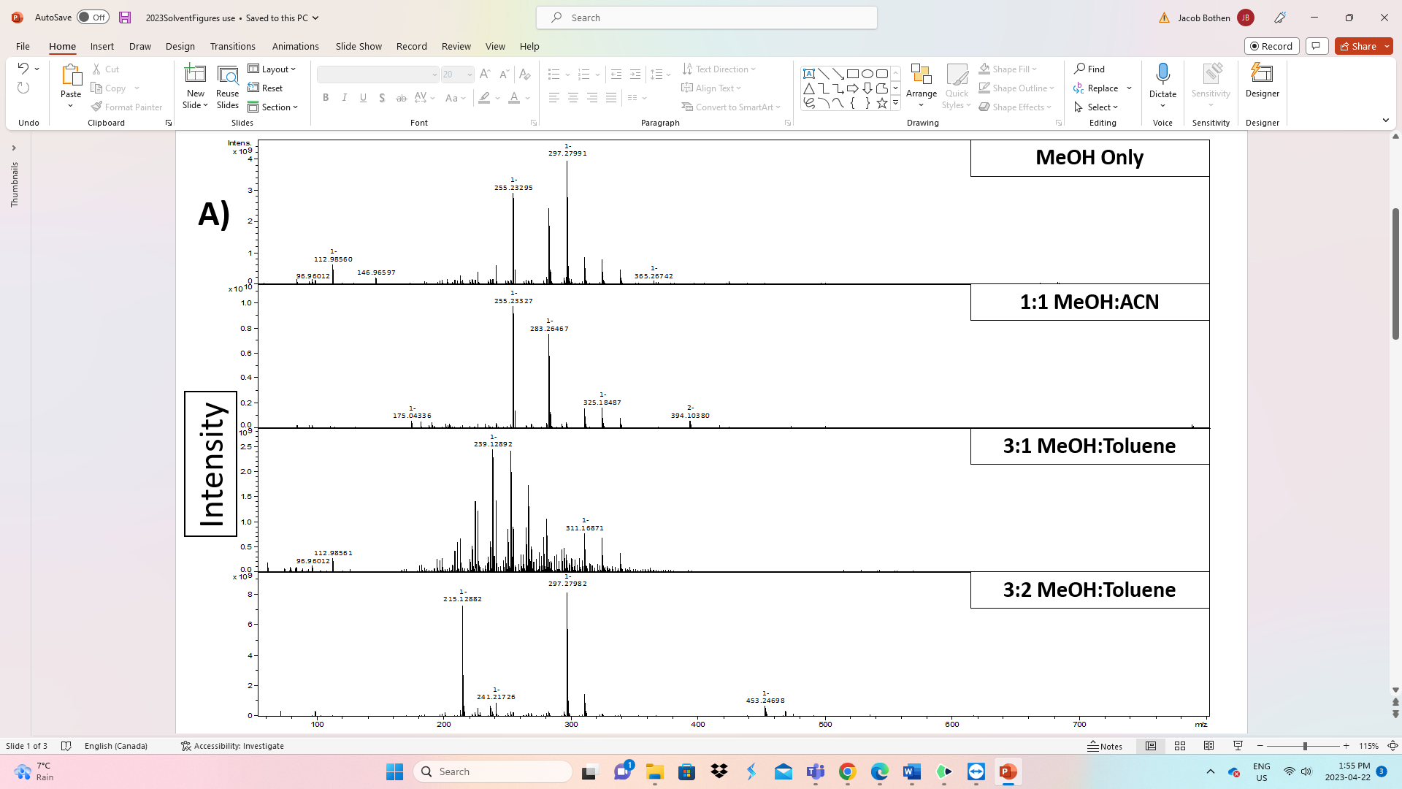
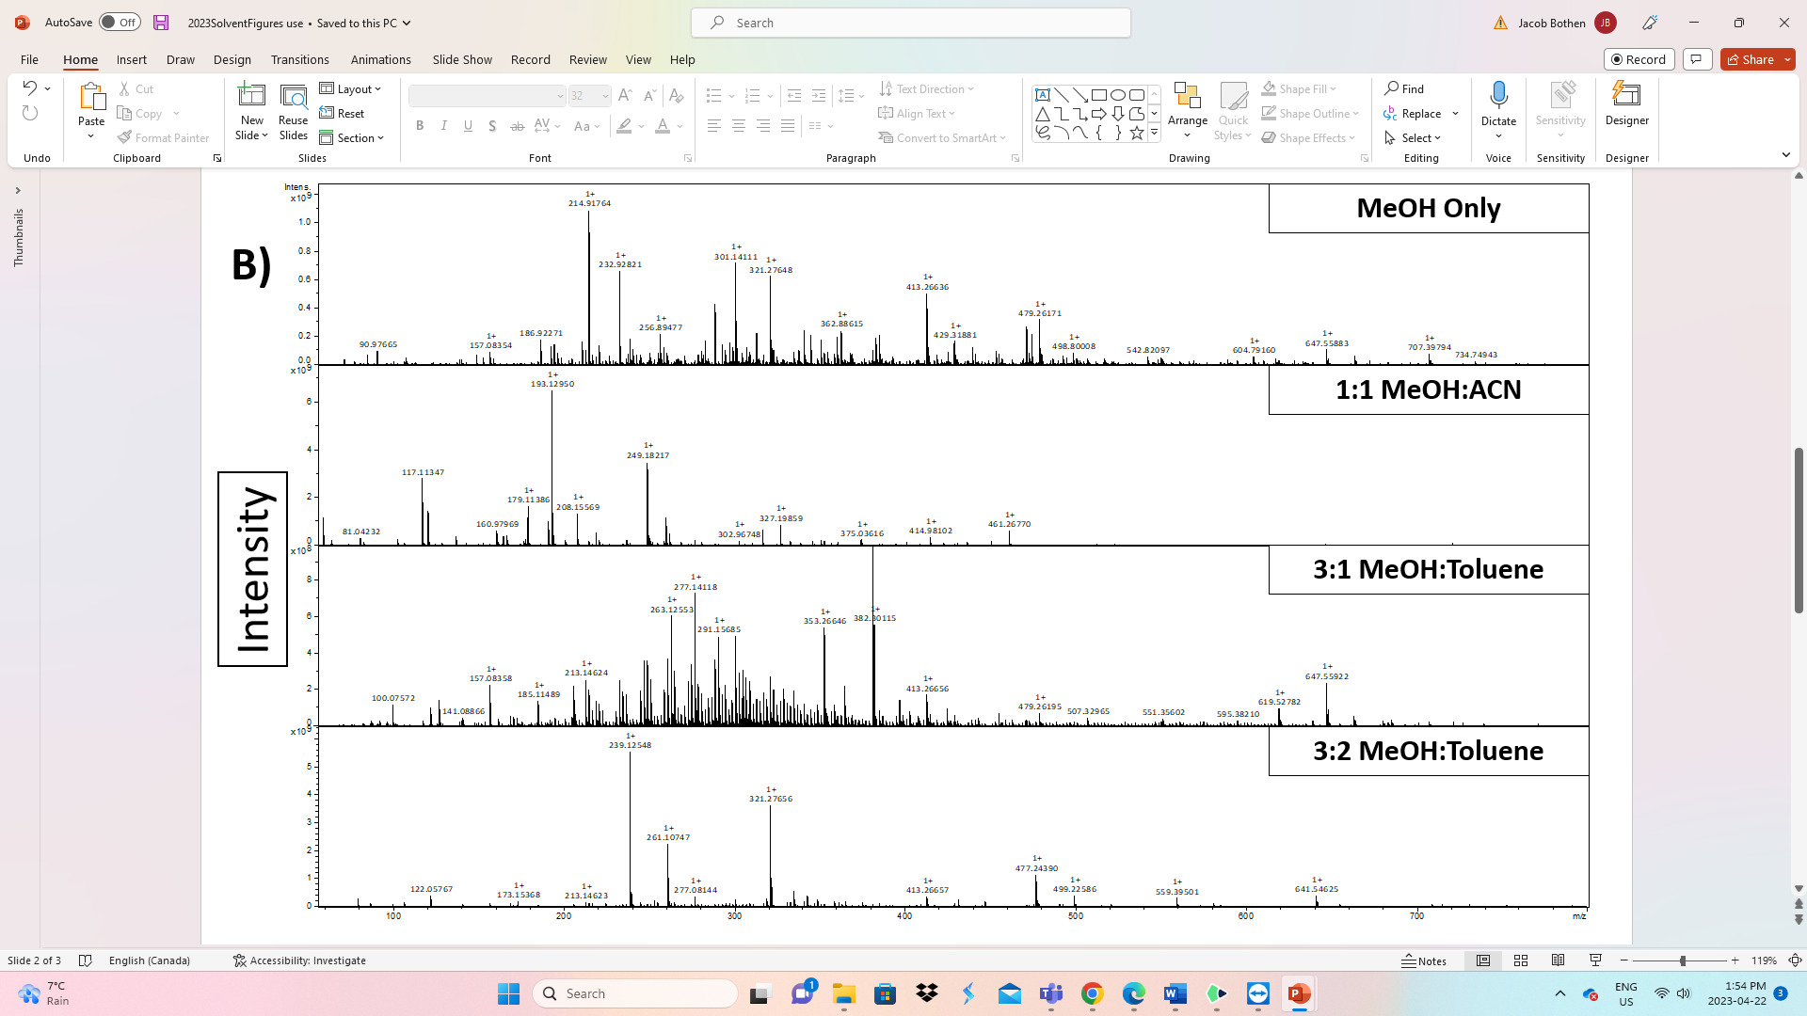
Figure S2. A) Mass Spectra of 4 solvent systems for BML P1 0.5m in ESI(-) and B) in ESI(+).

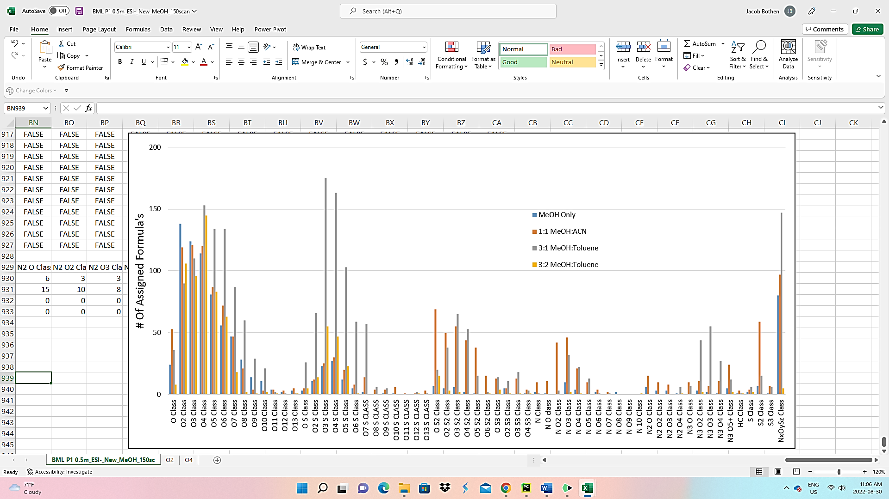
Figure S3. Heteroatom Class Distribution for BML P1 0.5m ESI(-).
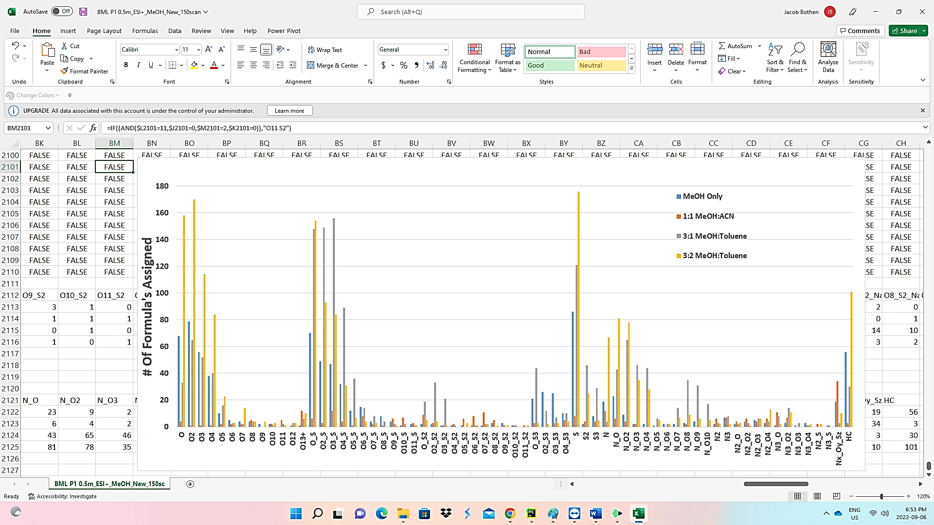
Figure S4. NAFC heteroatom class distribution for BML P1 0.5m analyzed in ESI (+) FT ICR MS.
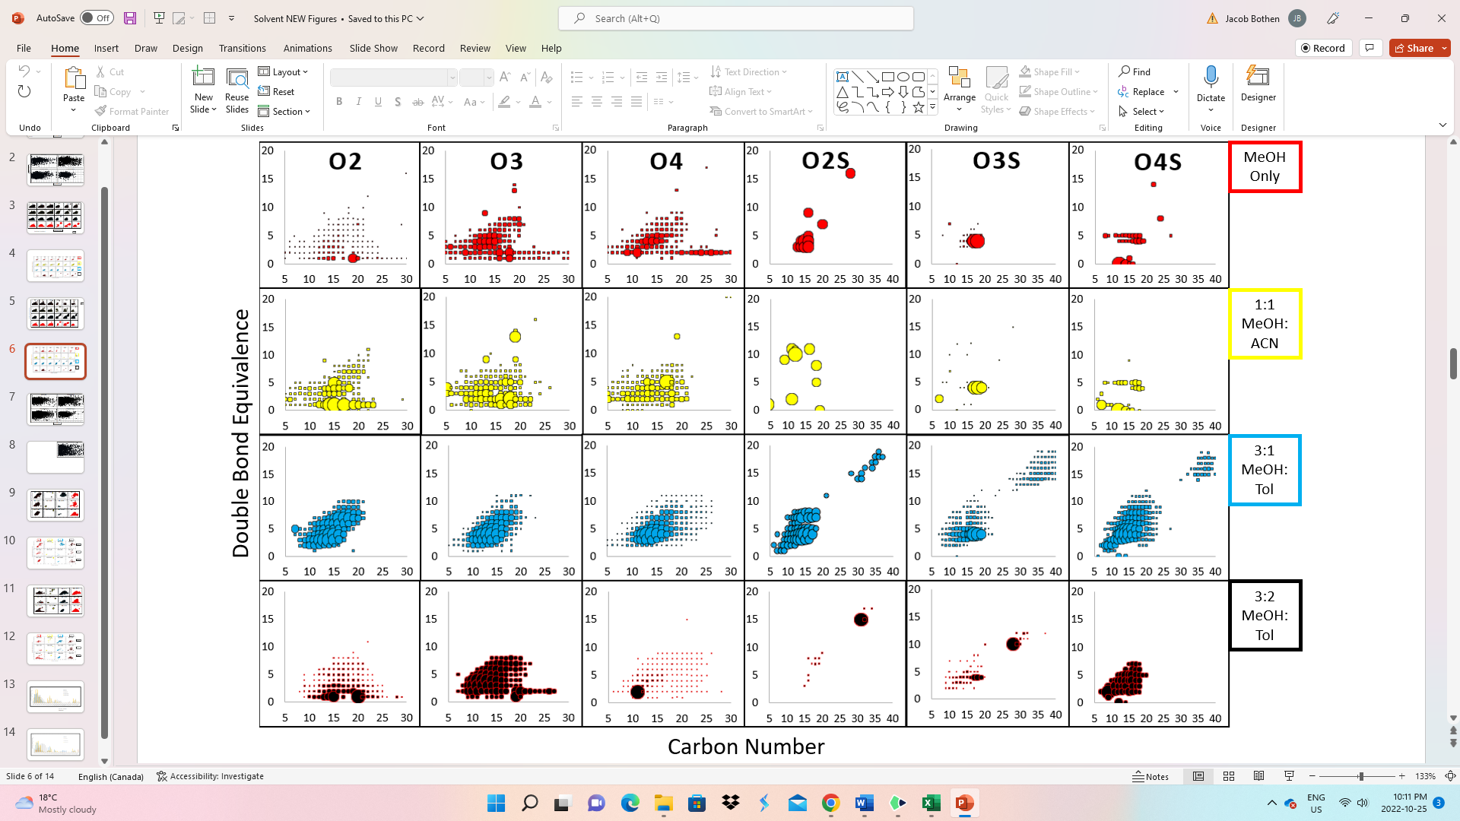
Figure S5. Comparison of the effect of solvents for the Carbon number Vs. DBE distribution for 6 most abundant NAFC classes from ESI (-) analysis of BML P1 0.5m. Bubble sizes are representative of the relative abundances of individual species.
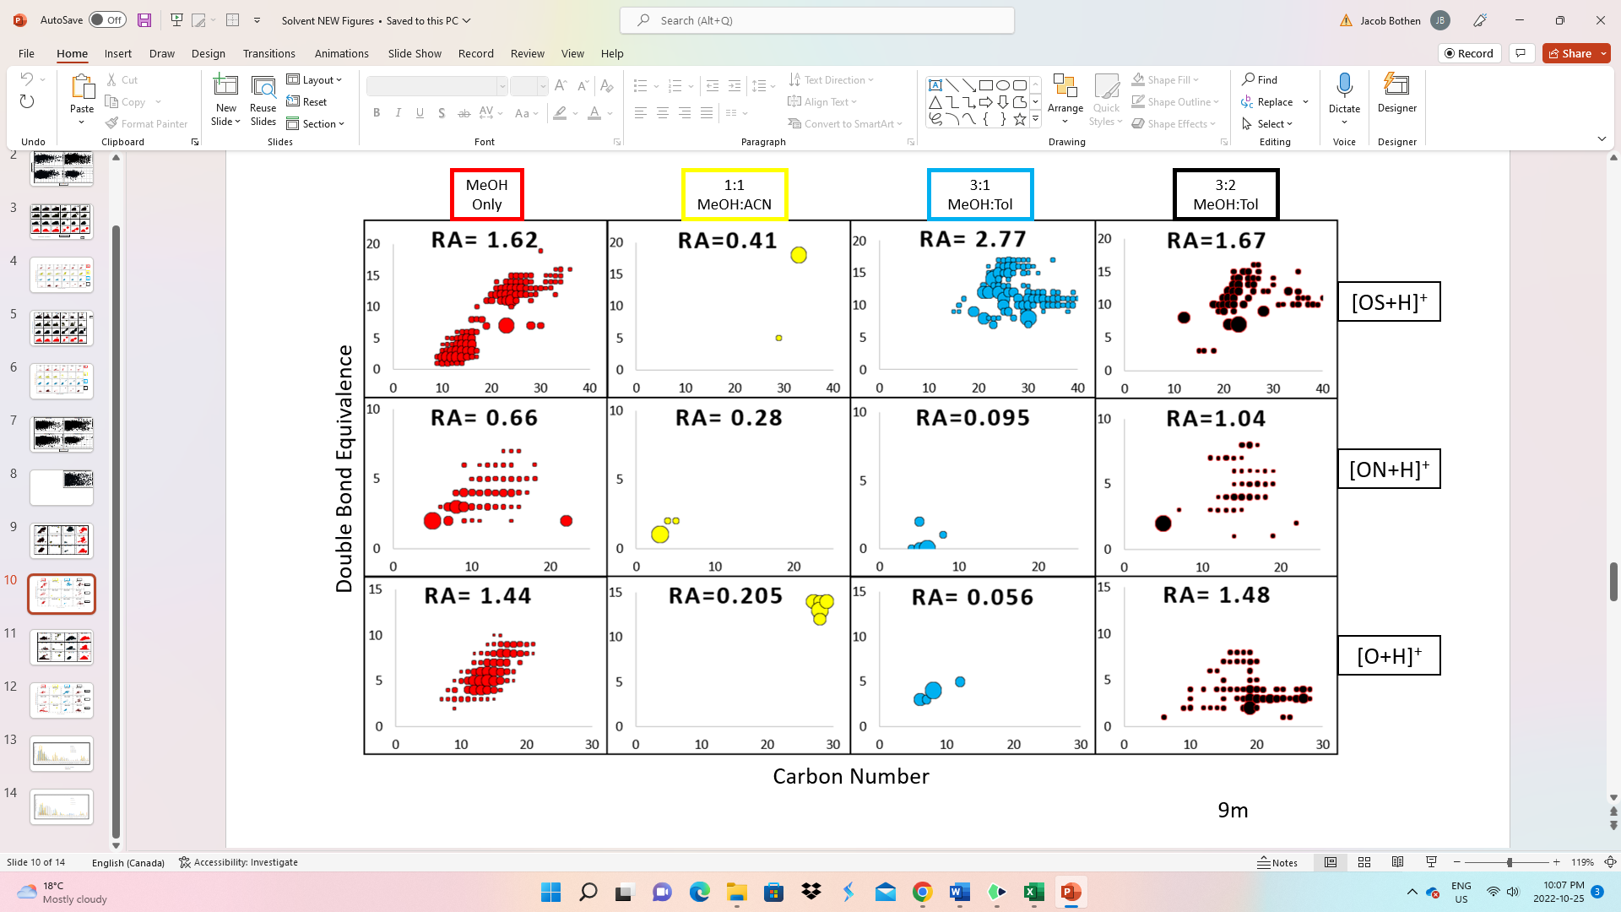
Figure S6. C# Vs. DBE plots for O⁺, SO⁺, and NO⁺ detected in the ESI (+) FT ICR MS measurements of BML P1 9m. Note: RA stands for Relative Abundance (%).

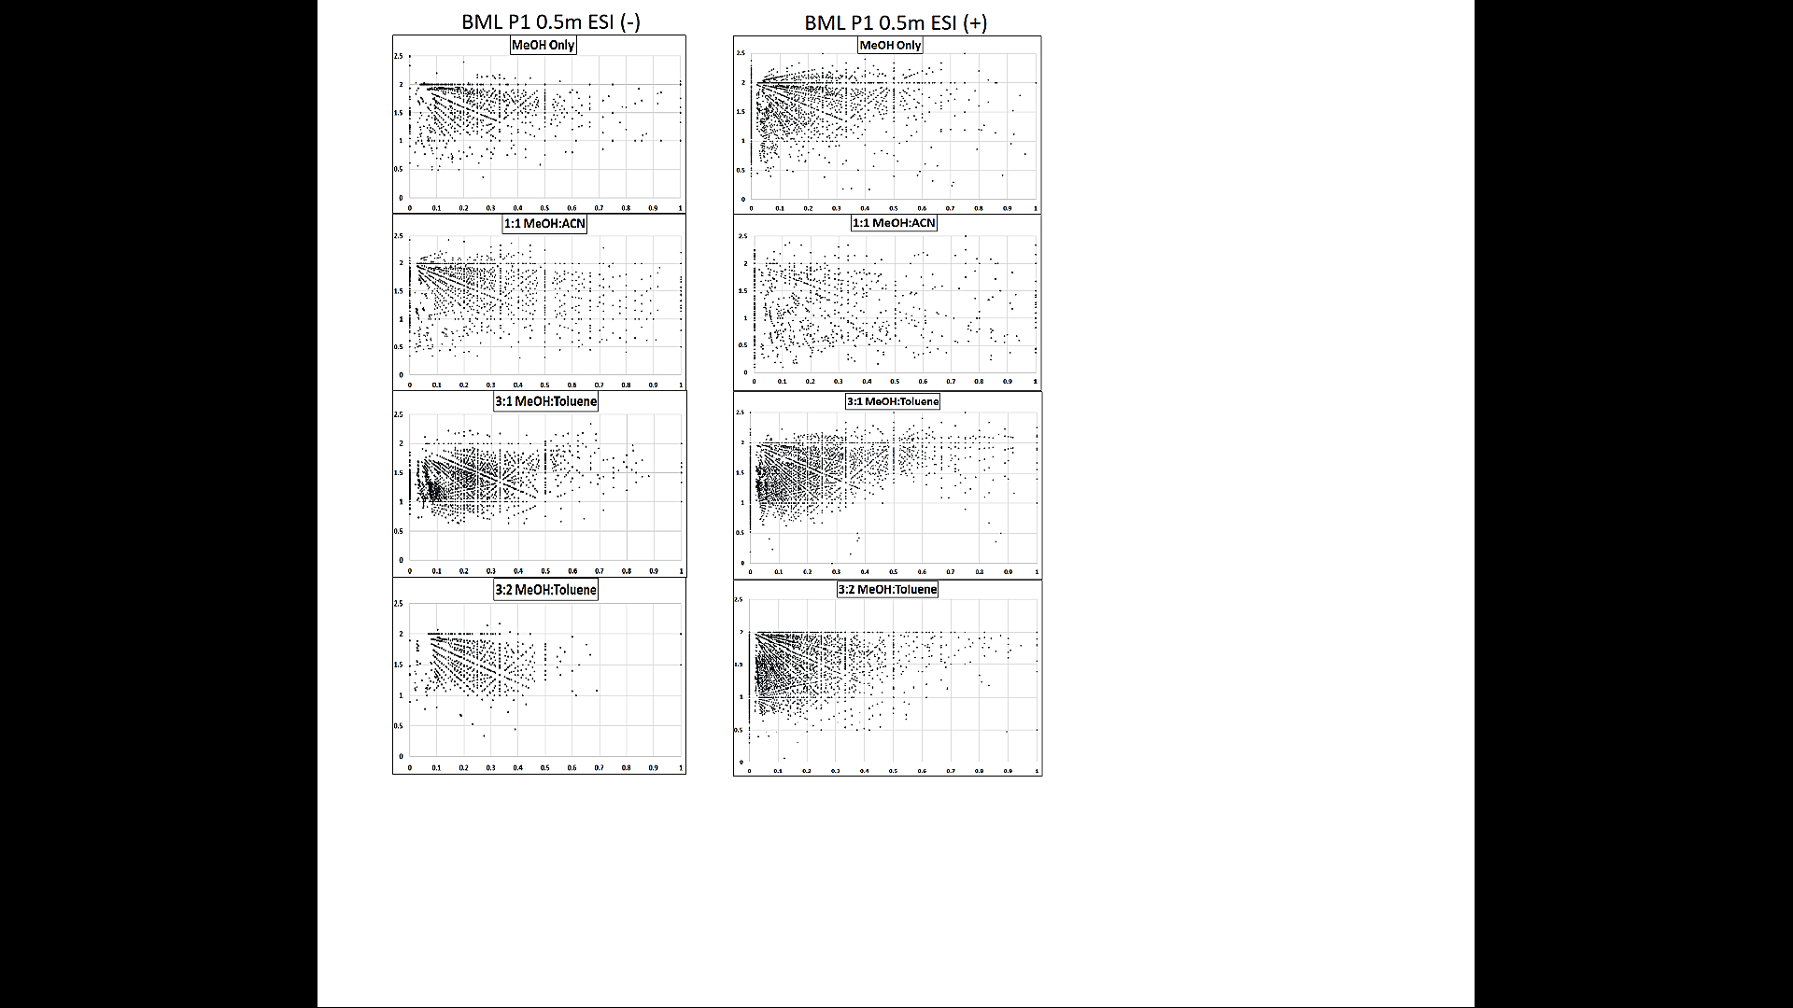
Figure S7. Comparison of the Van Krevelen plots generated for each solvent system from the ESI (-) and (+) analysis of BML P1 0.5m.
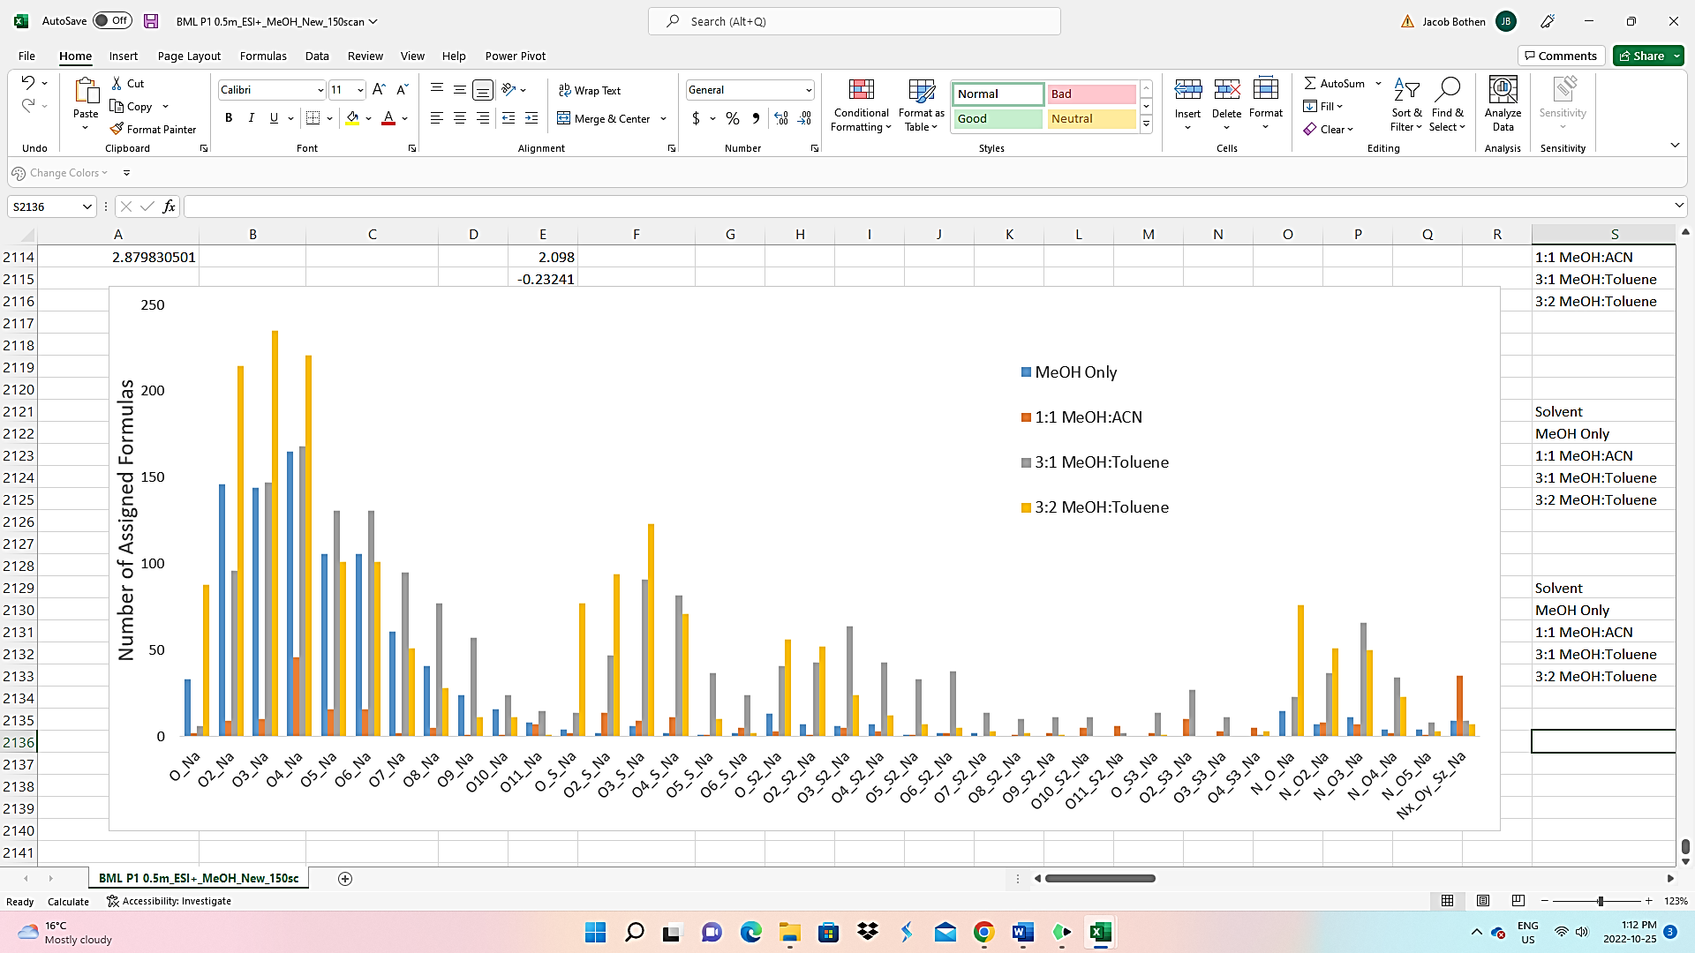
Figure S8. Sodiated compounds detected by ESI(+) FT ICR MS for BML P1 0.5m.
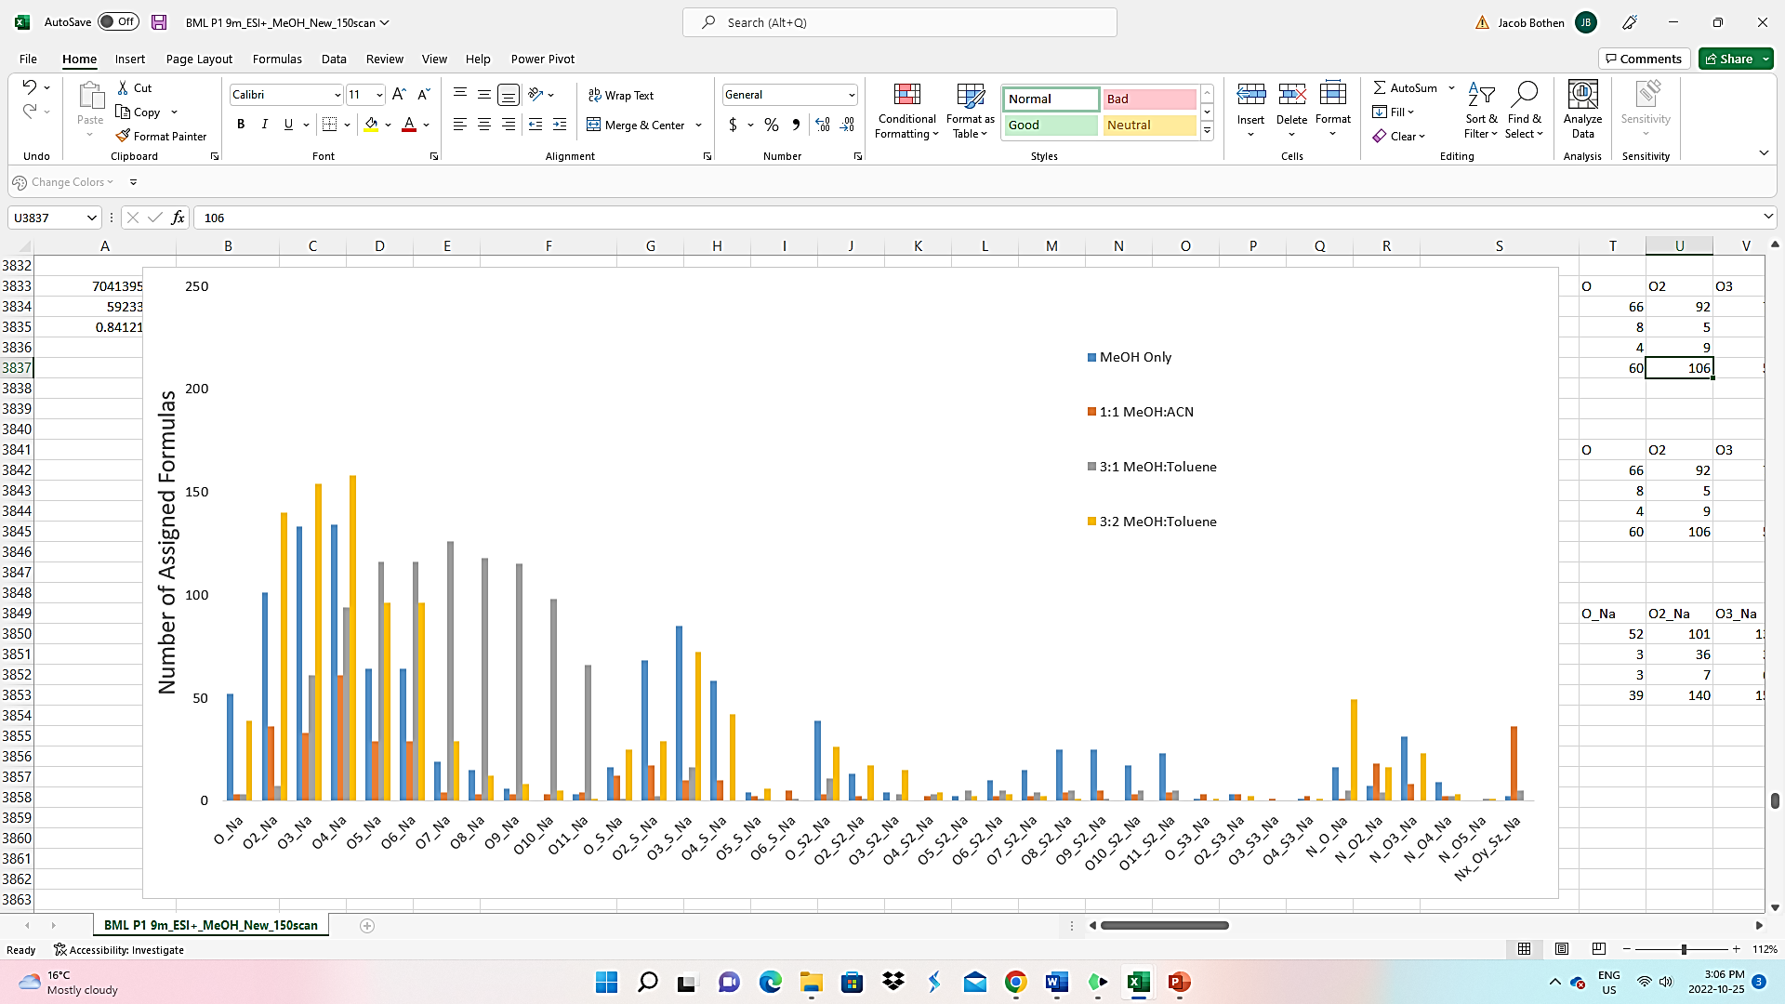
Figure S9. Sodiated compounds detected by ESI(+) FT ICR MS for BML P1 9m.
Supporting Tables
Table S1. Relative abundance data for the major NAFCs classes during the ESI (-) FT-ICR MS analysis of BML P1 9m. ND = Not Detected
NAFC Class | MeOH | 1:1 MeOH:ACN | 3:1 MeOH:Toluene | 3:2 MeOH:Toluene
O1 | 0.9725 | 1.184 | 0.463 | 0.008
O2 | 25.36 | 21.56 | 2.85 | 53.82
O3 | 17.23 | 11.07 | 8.51 | 3.05
O4 | 29.48 | 20.69 | 33.84 | 23.96
O5 | 4.73 | 5.31 | 8.24 | 3.37
O6 | 1.62 | 3.08 | 4.49 | 1.35
O7 | 0.373 | 1.11 | 2.999 | 0.308
O8 | 0.34 | 0.542 | 1.983 | 0.02
OS | 0.37 | 0.997 | 0.08 | 2.09
O2S | 3.04 | 3.14 | 0.39 | 1.06
O3S | 4.67 | 4.4 | 3.16 | 4.71
O4S | 3.73 | 2.44 | 3.84 | 1.72
O5S | 1.07 | 0.72 | 0.72 | 0.52
O6S | 0.257 | 0.22 | 0.204 | 0.045
O7S | 0.194 | 0.07 | 0.07 | 0.042
OS2 | 1.08 | 1.02 | 3.63 | 0.24
O2S2 | 0.82 | 0.94 | 2.56 | 0.13
O3S2 | 0.62 | 0.66 | 2.44 | 0.19
O4S2 | 0.4 | 0.25 | 2.27 | ND
NO | 0.01 | 0.26 | 0.005 | ND
NO2 | 0.01 | 0.26 | 0.05 | 0.01
NO3 | 0.42 | 1.63 | 0.22 | 0.01
NO4 | 0.11 | 0.55 | 0.14 | ND
HC | 0.26 | 0.18 | 0.27 | ND
S | 0.45 | 1.08 | 0.09 | 0.36
S2 | 0.77 | 1.2 | 4.28 | 0.02
NOS | 0.17 | 2.46 | 1.57 | 1.21
Other | 1.4435 | 12.98 | 10.64 | 1.852
Sum of RA% | 100 | 100 | 100 | 100

Table S2. Relative abundance data for the major NAFCs classes during the ESI (-) FT-ICR MS analysis of BML P1 0.5m. ND = Not Detected
NAFC Class | MeOH | 1:1 MeOH:ACN | 3:1 MeOH:Toluene | 3:2 MeOH:Toluene
O1 | 1.66 | 2.107 | 0.37 | 0.115
O2 | 45.32 | 15.02 | 3.71 | 30.85
O3 | 8.05 | 9.135 | 11.44 | 5.88
O4 | 10.89 | 10.195 | 39.67 | 43.57
O5 | 3.04 | 4.855 | 9.76 | 4.12
O6 | 2.30 | 4.82 | 3.53 | 1.61
O7 | 2.02 | 2.996 | 1.39 | 0.29
O8 | 0.854 | 0.637 | 0.75 | 0.031
OS | 0.07 | 0.16 | 0.164 | 0.76
O2S | 0.28 | 0.326 | 0.95 | 1.66
O3S | 13.39 | 17.95 | 8.12 | 6.13
O4S | 1.97 | 3.42 | 6.09 | 1.68
O5S | 0.33 | 0.77 | 2.31 | 0.514
O6S | 0.143 | 0.443 | 0.536 | 0.03
O7S | 0.05 | 0.374 | 0.596 | ND
OS2 | 0.16 | 3.02 | 0.6 | 0.4
O2S2 | 0.23 | 1.925 | 0.59 | 0.166
O3S2 | 0.456 | 1.85 | 0.66 | 0.30
O4S2 | 0.04 | 1.516 | 0.5 | ND
NO | 0.017 | 0.18 | 0.01 | ND
NO2 | ND | 0.77 | 0.01 | 0.03
NO3 | 0.78 | 2.33 | 0.29 | 0.03
NO4 | 0.1 | 0.35 | 0.15 | 0.02
HC | 0.02 | 0.08 | 0.005 | 0.01
S | 0.04 | 0.11 | 0.05 | 0.15
S2 | 0.37 | 2.21 | 0.74 | ND
NOS | 2.98 | 2.205 | 1.44 | 0.25
Other | 4.45 | 10.25 | 5.57 | 1.87
Sum of RA% | 100 | 100 | 100 | 100

Table S3. Relative abundance data for the protonated and sodiated NAFCs measured in ESI (+) FT ICR MS analysis of all four solvents across both BML water samples.
NAFC Class | 1:1 MeOH:ACN 0.5m P1 Water Cap | 1:1 MeOH:ACN P1 9m Water Cap | MeOH Only P1 0.5m Water cap | MeOH Only P1 9m Water cap | 3:1 MeOH:Tol P1 0.5m Water cap | 3:1 MeOH:Tol P1 9m Water cap | 3:2 MeOH:Tol P1 0.5m Water cap | 3:2 MeOH:Tol P1 9m Water cap
O1 | 0.1507 | 0.205 | 1.371 | 1.444 | 0.262 | 0.0565 | 2.653 | 1.485
O2 | 0.05 | 0.149 | 3.014 | 4.2 | 0.924 | 0.1 | 5.215 | 4.106
O3 | 0.035 | 0.11 | 1.716 | 4.103 | 0.983 | 0.08 | 2.424 | 1.308
O4 | 2.626 | 1.076 | 1.22 | 1.685 | 0.566 | 0.0474 | 1.144 | 0.487
O5 | 0.098 | 0.059 | 0.401 | 0.357 | 0.16 | 0.044 | 0.21 | 0.172
O6 | 0.536 | 0.574 | 0.18 | ND | 0.023 | 0.019 | 0.0185 | 0.017
O7 | 0.072 | 0.03 | 0.1 | ND | 0.022 | 0.027 | 0.17 | 0.095
O8 | 1.264 | 0.193 | 0.1 | 0.067 | 0.03 | 0.008 | 0.0456 | ND
S1O1 | 0.172 | 0.406 | 0.345 | 1.62 | 3.927 | 2.774 | 2.78 | 1.673
S1O2 | 0.1 | 0.106 | 2.167 | 1.207 | 3.322 | 3.4065 | 1.17 | 0.76
S1O3 | 4.18 | 1.63 | 3.04 | 3.463 | 5.026 | 3.141 | 1.75 | 1.2
S1O4 | 0.34 | 0.12 | 1.176 | 0.3 | 1.68 | 4.507 | 0.34 | 0.33
S1O5 | 0.025 | 0.06 | 0.38 | 0.005 | 0.756 | 4.56 | 0.1173 | 0.08
S1O6 | 0.468 | 0.532 | 1.126 | 0.08 | 0.263 | 3.52 | 0.091 | ND
S1O7 | 0.58 | 0.392 | 0.135 | 0.56 | 0.1 | 2.457 | 0.033 | ND
S2O1 | 0.944 | 0.4242 | 0.13 | ND | 0.19 | ND | 0.05 | ND
S2O2 | 0.212 | 0.066 | 0.032 | 0.051 | 0.54 | ND | 0.083 | 0.14
S2O3 | 0.173 | 0.018 | 0.015 | 0.64 | 0.212 | ND | 0.01 | 0.014
S2O4 | 0.061 | 0.177 | 0.0256 | 0.745 | 0.004 | ND | ND | 0.022
S | 1.845 | 0.837 | 5.266 | 2.826 | 5.72 | 2.312 | 5.022 | 2.831
S2 | 0.213 | 0.133 | 0.101 | 0.245 | 0.776 | 0.01 | 0.214 | 0.102
N | 1.65 | 0.22 | 1.1 | 0.02 | 0.0165 | 0.105 | 0.89 | 1.007
N1O1 | 0.371 | 0.283 | 1.201 | 0.664 | 0.602 | 0.095 | 1.303 | 1.04
N1O2 | 0.1776 | 0.1345 | 0.24 | 0.789 | 0.883 | 0.0257 | 0.981 | 0.811
N1O3 | 0.094 | 0.044 | 0.038 | 0.87 | 0.59 | ND | 0.28 | 0.057
N1O4 | ND | ND | 0.044 | 0.471 | 0.4826 | 0.01 | 0.2265 | 0.05
N1O5 | ND | ND | 0.0235 | 0.015 | 0.0414 | 0.02 | 0.03 | ND
N1O6 | ND | ND | 0.034 | 0.008 | 0.001 | 0.03 | 0.014 | ND
N1O7 | ND | 0.158 | 0.026 | 0.228 | 0.106 | 0.042 | 0.05 | 0.137
N1O8 | 0.066 | ND | 0.078 | 0.16 | 0.413 | 0.05 | 0.11 | 0.09
N1O9 | ND | ND | 0.15 | 0.03 | 0.481 | 0.0375 | 0.05 | 0.12
N2 | 0.42 | 0.645 | 0.037 | ND | 0.01 | 0.008 | 0.015 | 0.017
N3 | 0.417 | 1.83 | 0.304 | 0.047 | 0.07 | 0.764 | 0.016 | 0.08
N3O1 | 0.685 | 0.9316 | 0.022 | 0.074 | 0.056 | 1.212 | 0.03 | ND
N3O2 | 0.28 | 0.333 | 0.176 | 0.172 | 0.214 | 1.45 | 0.1065 | ND
N3O3 | ND | 0.186 | 0.016 | ND | 0.024 | 1.1485 | ND | ND
NOS | 5.51 | 5.445 | 1.67 | 0.67 | 0.6507 | 0.997 | 0.066 | 0.115
NOS+Na | 6.265 | 5.28 | 1.23 | 0.15 | 0.9 | 1.12 | 0.07 | ND
HC | 0.136 | 0.042 | 1.31 | 1.67 | 0.197 | 0.023 | 1.366 | 0.54
O1+Na | 0.059 | 0.087 | 1.553 | 0.623 | 0.12 | 0.061 | 1.566 | 1.2
O2+Na | 15.411 | 15.406 | 8.9 | 3.29 | 1.974 | 0.095 | 15.38 | 15.24
O3+Na | 1.4 | 1.413 | 8.42 | 7.695 | 10.682 | 1.23 | 8.183 | 8.8
O4+Na | 2.956 | 4.47 | 15.973 | 9.308 | 14.581 | 2.763 | 17.418 | 22.27
O5+Na | 0.625 | 1.12 | 6.964 | 2.11 | 6.3 | 6.92 | 2.93 | 4.9
O6+Na | 0.173 | 0.69 | 5.66 | 0.51 | 3.583 | 7.954 | 1.27 | 2.08
O7+Na | 0.072 | 0.127 | 2.414 | 0.19 | 2.607 | 9.73 | 0.56 | 0.84
O8+Na | 0.225 | 0.155 | 2.746 | 0.26 | 2.351 | 8.2 | 0.274 | 0.3
OS+Na | 0.0785 | 0.483 | 0.13 | 0.18 | 0.1704 | 0.01 | 1.48 | 1.245
O2S+Na | 0.7 | 0.766 | 0.26 | 1.21 | 0.823 | 0.022 | 1.4 | 1.02
O3S+Na | 0.3226 | 0.335 | 0.132 | 2.73 | 6.302 | 0.2765 | 4.87 | 3.17
O4S+Na | 0.622 | 0.65 | 0.03 | 1.15 | 2.69 | ND | 1.252 | 1.27
O5S+Na | 0.1 | 0.082 | 0.07 | 0.04 | 0.68 | 0.01 | 0.08 | 0.1
O6S+Na | 0.456 | 0.266 | 0.11 | ND | 0.253 | 0.01 | 0.02 | ND
NO+Na | ND | 0.04 | 1.29 | 0.34 | 0.563 | 0.066 | 2.21 | 1.04
NO2+Na | 1.185 | 1.064 | 0.49 | 0.192 | 0.709 | 0.092 | 0.684 | 0.437
NO3+Na | 0.669 | 0.262 | 0.507 | 0.3 | 1.041 | ND | 0.547 | 0.438
NO4+Na | 0.053 | 0.044 | 0.211 | 0.091 | 0.373 | 0.011 | 0.18 | 0.074
Other | 44.68 | 49.71 | 14.4 | 40.145 | 12.97 | 28.342 | 10.55 | 16.69
Sum of [NAFC+Na]⁺ | 31.4 | 32.7 | 57.1 | 30.4 | 56.7 | 38.6 | 60.4 | 64.4
Sum of RA% | 100 | 100 | 100 | 100 | 100 | 100 | 100 | 100

Table S4. List of chemicals identified in the blanks that were removed from the ESI (-) and (+) data sets.
Positive Mode | Chemical Formula | Observed m/z value
 | [C₂₁H₄₂O₄Na]⁺ | 381.29734
 | [C₁₉H₃₈O₄Na]⁺ | 353.26607
 | [C₂₄H₃₈O₃Na]⁺ | 397.27126
 | [C₂₁H₄₃O₄]⁺ | 359.31543
 | [C₄₃H₇₃S]⁺ | 647.55840
 | [C₄₃H₇₁S]⁺ | 619.52710
Negative Mode | [C₁₈H₃₅O₂]⁻ | 283.26462
 | [C₁₆H₃₁O₂]⁻ | 255.23330
 | [C₁₅H₂₉O₂]⁻ | 241.21739
 | [C₂₀H₃₉O₂]⁻ | 311.29567
 | [C₂₂H₄₃O₂]⁻ | 339.32703
 | [C₁₈H₂₉O₃S]⁻ | 325.18435
 | [C₂₄H₄₃O₂]⁻ | 367.35838
 | [C₂₅H₄₉O₂]⁻ | 381.37406
 | [C₂₂H₄₃O₆]⁻ | 403.30662
 | [C₄₀H₇₇O₇]⁻ | 669.56801

Chapter 3
INVESTIGATION OF NAPHTHENIC ACID FRACTION COMPOUNDS IN BASE MINE LAKE BY ESI(+/-) FT-ICR MS: SIGNIFICANCE TOWARDS UNDERSTANDING THE BIOGEOCHEMICAL CYCLING OF BITUMEN-DERIVED ORGANICS IN END PIT LAKES

Manuscript in preparation for submission to Environmental Science & Technology or Science of the Total Environment or Organic Geochemistry

Bothen, J.L.A¹, Stock, N. L², Slater G.F¹
¹School of Earth, Environment, and Society, McMaster University, Hamilton, Ontario, Canada
² Water Quality Centre, Trent University, Peterborough, Ontario, Canada
Abstract.
Oil Sand pit lakes (OSPL) are proposed as a practicable reclamation strategy for decommissioned mine pits and the long-term storage of fluid fine tailings (FFT) in the Alberta Oil Sand Region. In 2012, Base Mine Lake (BML) was commissioned as the first large-scale demonstration of OSPLs within Syncrude’s Mildred Lake mining site. Recent monitoring reports indicate the BML water column meets the regulatory criteria for water quality for nearly all parameters. However, understanding the ongoing sources and biogeochemical cycling of organic components within the system, particularly Petroleum Hydrocarbons (PH) and Naphthenic Acid Fraction compounds (NAFC), is important for demonstrating the ongoing effectiveness of the BML system as it develops. In this study, we utilized Electrospray ionization Fourier Transform Ion Cyclotron Resonance Mass Spectrometry (ESI (+/-) FT ICR MS) to characterize the molecular distribution of NAFC, and to a lesser extent, PH, within the Acid extractable organics (AEO) of water column and FFT porewaters of the BML system. Measurements in ESI (+) & (-) resulted in detection of an extensive array of NAFC species containing O, S, and N, as well as Hydrocarbons; with a greater number of heteroatom species detected in ESI (+) mode. The distribution of AEO within BML was dominated by alkylated cyclic and aromatic oxygenated compounds (i.e., O1-O6) and a higher abundance of S-containing compounds, which was distinct in chemical profile from the freshwater sampled from the nearby Beaver Creek Reservoir. The observation of large, aromatic O₁₋₄⁺ species found in shallow depths of the water cap indicated that photo-oxidation of bitumen or hydrocarbons was occurring near the air-water interface. Through chemometric analysis it was identified that hydrocarbons and lower oxygenated oxy-sulfur compounds had a strong correlation to FFT porewater samples, which indicated that continued porewater advection or diffusion during FFT consolidation can be an ongoing source of these organics. We suspect that the observed elevated abundances of O₃, O₄ and O₅ species compared to O₂ in the water cap as compared to the FFT is evidence of aerobic biodegradation in the oxic water column. These findings are compelling evidence that over 10 years of development, the indigenous microbiota in the water column of BML can accommodate the necessary aerobic degradation pathways to oxidize persistent NAFCs. We propose that future ESI-FT ICR MS studies should continue to investigate the long-term temporal analysis of NAFCs alongside the dynamic microbial composition in BML, in addition with controlled laboratory experiments (i.e., ebullition and photo-oxidation) to provide a comprehensive portrayal of the environmental fate of PHs and NAFCs during the early stages of OSPLs.
INTRODUCTION
A significant fraction of the global recoverable petroleum reserve is located in Alberta, Canada which contains a viscous and heavily degraded petroleum called bitumen that is closely consolidated with sands, clays, and water, cumulatively referred to as oil sands (Larter and Head 2014, Huang et al. 2020). In 2021, approximately 3.25x10⁶ barrels day⁻¹ of bitumen were produced (1 barrel of oil = approx. 159 L), from which surface mining of oil sands accounted for nearly half of the total bitumen production (AER 2022). The extraction methodology currently used in surface mining operations has evolved into a more modern and technical adaptation of the Clark hot water extraction (Masliyah et al. 2004, Zhou et al. 2020). The existence of significant volumes of oil sands process affected water (OSPW) and tailings that contain organic contaminants that can be toxic to aquatic and terrestrial organisms, has led to the need to develop reclamation strategies in response to regulatory and environmental responsibility requirements (Allen 2008; Giesly et al. 2010). Water capping tailings technology (WCTT) developed by Syncrude Ltd is one such reclamation strategy that involves placing large volumes of FFT into decommissioned mine pits and covering with a considerable water cap (composed of OSPW and freshwater) that is deeper than a conventional tailings pond. These engineered aquatic landscapes would ultimately be referred to as End Pit lakes (EPLs) or Oil sands Pit Lakes (OSPLs) and are expected to be an important factor for the success of oil sand mine closure developments in the future (CAPP 2021).
In 2012, Base Mine Lake was commissioned as the regions first large-scale demonstration of EPLs within the AOSR. The key outcomes in demonstrating the viability of WCTT are closely tied to the short- and long-term regulatory requirements set by Federal and Provincial environmental agencies (CEMA 2012; Syncrude 2022). Physical sequestration of FFT below the water cap and suppression of internal mixing processes are important physical processes monitored throughout BML (Dompierre et al. 2016, 2017; Lawrence et al. 2015; Tedford et al. 2019; Hurley et al. 2020; Zhao et al. 2021; Francis et al. 2022). Water quality is a key long-term monitoring priority of the research programs investigating BML, as it encompasses several chemical and biological indicators that help to identify/understand how this reclamation landscape can fulfill environmental regulatory requirements and transition into a functioning aquatic ecosystem (Syncrude 2022). Petroleum hydrocarbons (PH) and naphthenic acids (NA) are the organic components of primary interest with respect to water quality within BML. PH’s are a complex mixture of compounds consisting of only C and H hydrocarbons that can be divided into four major structural groups; alkanes, cycloalkanes, alkenes, and aromatics (Kuppusamy et al. 2020), and have been a long-standing priority pollutant associated with oil and gas developments (Logeshwaran et al. 2018). The sources of PHs within tailings, and by extension to the BML system, include the organic solvents used during extraction (either Naphtha or Paraffinic solvents depending on the company) and/or the residual raw bitumen. NAs are naturally present in petroleum because of maturation processes in the reservoir like in situ biodegradation (Whitby 2010) and have general chemical properties representative of surfactants (Headley and McMartin 2004; Clemente and Fedorak 2005; Celsie et al. 2016; Barros et al. 2022). NAs also exist in higher concentrations than PH’s in OSPW due to increased water solubility at operational conditions and prolonged persistence within process waters and tailings during the water-based extraction of oil sands (Giesey et al. 2010). Research on NA’s has greatly expanded in recent decades as it represents the principal toxicants in OSPW to terrestrial and aquatic organisms (Bauer et al. 2017, 2019; White and Liber 2020; Robinson et al. 2023). It is expected that NA’s, and to a lesser degree PH’s, will be present within the BML water column as either derived from the OSPW originally used to contribute to filling the lakes water level or released from FFT porewater into the water column from advective/diffusive fluxes from natural consolidation of FFT (Dompierre et al. 2017) or porewater mixing from conduits formed as a consequence of gas ebullition (Zhao et al. 2021). Previous work in BML has determined that dissolved methane, and by association other dissolved species (i.e. H₂S, CO₂, and NH₃), are generated through distinctive microbial activities and transported from the FFT into the hypolimnion of BML via porewater advection during FFT consolidation, molecular diffusion, and associated with methane ebullition (Risacher et al. 2018; Arriaga et al. 2019; Slater et al. 2021; Jessen et al. 2022). Despite evidence of these potential ongoing mechanisms of input, it has been found that relative abundance fingerprints of NA were consistent spatially and temporally over a year (Bowman et al. 2020), and that this stable NA profile continues over multiple years and exhibits distinct metabolic pathways (El-Waraky 2021).
Thus far, research into cycling and chemical profile of NA’s in BML have been undertaken by comprehensive two-dimensional gas chromatography Time of flight mass spectrometry (GC x GC/TOF-MS) which has allowed for the structural interpretation of several individual NA’s (Bowman et al. 2018; 2020, El-Waraky 2021). However, the limitations of chromatographic measurements on complex organic mixtures, like NA’s, make the use of additional analytical techniques a necessary step forward for better understanding the identity and biogeochemical cycling of bitumen-derived organics in BML, since various chemical species are simply not amenable to the gas chromatographic measurements (Stanford et al. 2007; McKenna et al. 2013; Robson et al. 2017). A common issue encountered by chromatographic analysis of petroleum impacted samples is the presence of an unresolved complex mixture (UCM), which contains a mix of hydrocarbons and their biodegradation metabolites (Booth et al. 2007; West et al. 2014; Farrington and Quinn 2015; Aitken et al. 2018). While it has been shown that GC x GC/TOF-MS provides greatly improved resolution for lower molecular weight (C# between 5-35) non-polar organics and can distinguish structural isomers (Wardlaw et al. 2011), it is still quite limited in its capacity to measure/detect the less volatile organics, which are usually larger (>35 Carbons), and more polar compounds (McKenna et al. 2013). Therefore, to discern if NAs found within the original OSPW in BML have persisted/degraded or has continually been generated from microbial degradation of hydrocarbons in BML, researchers are presented with a unique challenge from an analytical perspective, which is nonetheless crucial to overcome for assessing the biogeochemical progression of BML.
In the last two decades the application of high resolution mass spectrometers, such as Fourier transform ion cyclotron resonance mass spectrometry (FT-ICR MS) and more recently Orbitrap-mass spectrometry, have demonstrated to be the leading analytical technique for qualitative characterization of the complex mixture of polar compounds associated with asphaltenes in raw Bitumen, OSPW, and water soluble organics produced from environmental weathering processes of petroleum in marine environments (Marshall and Rodgers 2004, 2008; Barrow et al. 2015, 2016; Liu and Kujawinski 2015; Oldenburg et al. 2017; Benigni et al. 2017). Consequently, the definition of NA’s was expanded in recent years and is more commonly referred to as Naphthenic acid Fraction Compounds (NAFCs) to include the many mono- and poly-oxygenated species and assortment of mixed oxygen-/sulfur-/nitrogen- containing compounds (i.e., S_{x}O_{x} and N_{x}O_{x}). The ultra-high mass resolution of FT ICR (ex. 350,000 for 7T and >2 million for 21T at m/z 400; Smith et al. 2018) and sub parts per million and parts per billion mass accuracies enable confident assignment and resolution of thousands of elemental formulae containing various combinations of heteroatoms (C_{c}H_{h}O_{o}S_{s}N_{n}) and hydrogen deficiencies (I.e., Double Bond Equivalence (DBE)) within a single mass spectrum. FT-ICR MS does have the ability to perform targeted analysis of a specific group of organic contaminants (Young et al. 2022), this technique has principally been used as a non-targeted technique due to its ability to measure multiple chemical compounds and classes simultaneously. Additionally, the use of negative and positive ionization modes with FT-ICR-MS affords for detection of acidic and basic compounds, respectively, and has shown to provide useful insights on the weathering of petroleum via identification of the key degradation pathways of petroleum components in aquatic environments (Niles et al. 2019; Wise et al. 2022). Data visualization is a typical challenge for FT-ICR-MS studies of complex organic mixtures like NAFCs found in OSPW (Barrow et al. 2009), and in general the plots containing Carbon number Vs. DBE, Van Krevelen, and Relative abundances of heteroatom classes are commonly used in studies investigating the formation of oxidized species from oil spills or molecular fingerprint of OSPW. Previous studies have also shown that commercially available Naphthenic acid standard mixtures are not an appropriate benchmark for Oil sands NAFC studies due to their stark difference in chemical profile (Grewer et al. 2010), their elevated toxicity and distinguishable mechanistic toxic effects to aquatic organisms (Marentette et al. 2015; Gutierrez-Villagomez et al. 2019), and higher susceptibility to biodegradation in relation to NAFCs present in OSPW (Fedorak et al. 2005). Furthermore, with the rapid expansion of chemometric statistical analysis and its coupled application towards environmental forensics/chemistry has allowed researchers the ability to discern important features and trends within the expansive and complex chemical information generated by ultra-high-resolution mass spectrometry. For instance, Principal component analysis (PCA) using the relative abundance data from ESI(-) FT-ICR-MS data of oil sands Acid Extracted Organics sourced from natural and industrial water samples discovered that classical NA and oxygenated NAs with hydrogen deficiencies of -4 to -12 (DBE 3 to 7) and Oxy-sulfur compounds are convincing chemical markers associated with the chemical profiles of oil sands process waters in relation to fresh water samples (Grewer et al. 2010; Headley et al. 2011).
The goal of this study was to use ESI (+/-) FT ICR MS to assess the identity and biogeochemical cycling of NAFC and PH within BML water cap and FFT in order to understand ongoing biotic or abiotic removal processes, which will thereby help inform key management decisions and the designs of future OSPL in the region.
MATERIALS AND METHODS
Study Area and Sampling Locations.
Located 35km north of Fort McMurray, Alberta within Syncrude’s Mildred Lake mining site is Base Mine Lake, the first large-scale demonstration of water capping tailings technology (WCTT) as a wet reclamation strategy (Figure 1). Deposition of FFT into the decommissioned Base Mine began in 1992 from which FFT was hydraulically pumped from nearby tailings ponds into the SW and NE corners. Addition of FFT halted in 2012 when a depth of 45m was reached which equates to approximately 186 Mm³ of FFT (Bowman et al. 2020; White and Liber 2020). The water cap was quickly added after FFT deposition stopped and was composed of 50% OSPW and 50% freshwater from the nearby Beaver Creek Reservoir (BCR). The initial water depth was 5-7m, but as the FFT naturally consolidated and additional freshwater from BCR was inputted, the water depth has increased to around 10-12m across the lake (Brandon 2016; Tedford et al. 2019; Syncrude 2022). The addition of Alum in 2016 was part of an adaptive strategy that significantly reduced the turbidity of the water column (Syncrude 2022); however, the lake still experiences turbidity events from biannual turnover and isolated events related to various mechanisms that resuspends particulates (Tedford et al. 2019; Zhao et al. 2021).
The use of long-term monitoring stations (Platforms 1-3) set up across the lake to track important geochemical data have been useful for spatial and temporal studies on BML (Dompierre et al. 2016; Dompierre et al. 2017; Risacher et al. 2018; Tedford et al. 2019; Arriaga et al. 2019; Bowman et al. 2020; El-Waraky 2021). The FFT-Water interface (FWI) is a key area of interest for a majority of BML studies as it is regarded as an active area for the chemical and physical exchange of inorganic and organic chemical constituents (Dompierre et al. 2016, 2017; Bowman et al. 2020, El-Waraky 2021; Francis et al. 2022), and represents a distinct biogeochemical zone where aerobic and anaerobic microbial communities may survive and co-exist (Risacher et al. 2018; Arriaga et al. 2019). A total of four water samples and four FFT were taken from Platform 1 and 2 (Figure 1) during the summer and fall of 2019 using routine protocols (Arriaga et al. 2018; Dompierre et al. 2016). Water samples were collected on May 29th and July 30th and represent the epilimnion (0.5m below Air-water interface) and hypolimnion (9m below air-water interface) sections of the water column. FFT samples were collected during two sampling expeditions (September 30th and October 10th) and were chosen to represent FFT at shallow and deep intervals below the FWI at Platform 1 and 2. A shallow water sample (1m depth) taken in 2016 from the nearby Beaver Creek Reservoir (BCR) shown in figure 1 and a Sigma-Aldrich Naphthenic Acid technical mixture (Oakville, ON, Canada) provided by the Trent University Water Quality Centre were also included in this studies sample set to provide a comparison on the chemical composition of NAFCs within a known freshwater system and a commercial standard, respectively.
Extraction of Naphthenic Acids Fraction Compounds.
Methanol (MeOH) and toluene (HPLC grade, 98%) were purchased from Sigma Aldrich and dichloromethane (DCM) was acquired from Caledon Laboratories (Georgetown, Ontario, Canada). All glassware used during the NAFC extraction process underwent a strict cleaning protocol that involved several solvent rinses with methanol, hexane, and DCM after experimental use and combustion in a furnace at 450 ℃ for 24 hours. The extraction of NAFC from BML water cap, FFT samples and BCR water sample were completed using a modified acidic liquid/liquid extraction (ALLE) similar to that described in Bowman et al. (2020). Water and FFT samples were removed from the storage freezers 24 hours prior to extraction and placed into the fume hoods to thaw overnight. 100 mL of water was taken from each water cap sample, whereas 50g of FFT were accurately weighed on a scale and centrifuged at 3100 rpm for 90 minutes from which the supernatant was removed and resulted in approximately 20-25mL of porewater. All water samples were filtered through a 0.45μm filter paper to remove residual particulates and bitumen (present only in FFT samples), followed by acidification to pH<2 by dropwise addition of a concentrated HCl solution. Using 250 mL separatory funnels the acidic water samples were washed 4 times with 25mL of DCM and the organic phase was collected in 100mL amber jars after the emulsion layer dissipated. Four Process blanks (Milli-Q water) and a 2016 BCR water with a final volume of 125mL underwent NAFC extraction and followed the protocol above with an adjustment of using 4x40mL washes with DCM. The organic extracts were blown to dryness with a gentle stream of N₂ in a sand bath set at 40℃ and the dried extracts were reconstituted in 10mL of a 3:1 MeOH:Toluene solution and vortexed for 2-3 minutes. From this stock solution, two aliquots of 0.5mL were further diluted in an additional 10mL of 3:1 MeOH:Toluene in order to lower the concentration and reduce the effect of ion suppression (Ruddy et al. 2018), as well as to make two working solutions for subsequent analysis in positive and negative modes. Lastly, a 1ppm working solution containing the Sigma Aldrich Naphthenic acid technical mixture was made by dilution in MeOH for ESI (+/-) FT ICR MS analysis.
ESI (+/-) FT-ICR-MS Analysis.
The acid extractable organics were analyzed by a Fourier transform – ion cyclotron resonance mass spectrometer (FT-ICR-MS) equipped with a 7T magnet and Apollo II ion funnel electrospray source (SolariX XR, Bruker, Billerica, MA, USA) within Trent University’s Water Quality Centre in Peterborough, Canada. The instrument was externally calibrated with a 0.1mg/L solution of Sodium trifluoroacetate (NaTFA) in both positive and negative mode by sequential acquisition of data point sizes of 1Megaword to 8Megaword processing. The final mass accuracy of < 1ppm were achieved between 100-400 m/z and <2ppm between 450-800 m/z. The mass resolutions of 450,000, 310,000, and 200,000 were observed in all measured mass spectra at 250 m/z, 400 m/z, and 600 m/z, respectively. After direct infusion with a 250 μL Hamilton syringe, a total of 250 scans were acquired for samples and 100 scans were acquired for process blanks. Additional operating parameters that were utilized in this study are described in the previous chapter of this thesis (Bothen et al. No Date). Prior to the FT ICR MS analysis, 40 µL of a concentrated aqueous solution of Formic acid was added to the BML working solutions designated for analysis in positive ESI and 40 µL of concentrated aqueous solution of Ammonium acetate was added to the second working solution for analysis in negative ESI. The addition of these chemical additives to the solutions prior to ESI FT ICR MS experiments has shown to increase ionization capability of various heteroatom classes which thereby reduces ion suppression (Ruddy et al. 2018).
Data Processing and Chemometric Analysis.
Data processing of mass spectral results in positive and negative ionization modes were performed on the Data Analysis software (Bruker Daltonics, Billerica, MA, USA) and followed the methods for formula assignment and data treatment described in the previous chapter (Bothen et al. No Date). Each mass spectra generated thousands of chemical formulas that were divided into their respective NAFC classes (i.e., C_{c}H_{h}O₂ would be assigned the O₂ class, C_{c}H_{h}O₃S would be the O₃S class, C_{c}H_{h} would be the HC class, etc.) and were assigned a relative abundance value by dividing each chemical formulas intensity by the summed intensity of all compounds assigned. The following excel files of each sample analyzed in negative and positive mode contained all the relevant chemical information (i.e., C#, O/C ratio, H/C ratio, DBE, Relative abundance, etc.) and were run through a custom written Python script to assist in compiling the relative abundances of each NAFC class into an individualized .csv file. Principal component analysis (PCA) and correlation heatmaps were generated from the “Statistical Analysis [one factor]” generic format in MetaboAnalyst (Version 5.0) online platform. BML and BCR relative abundance data from the negative and positive data sets were used and normalized via log transformation, as it is known that data pre-treatment can reduce data variability and improve the ability of clustering analysis (van den Berg et al. 2006). A draw-back for log transformation is that it cannot deal with a value of zero (van den Berg et al. 2006), therefore, for any samples that had NAFC classes with no detected compounds and thus had no measured relative abundance value, a generic value of 0.0001 was assigned.
Results
NAFC profiles from ESI (+/-) FT ICR MS Analysis
ESI (-) Analysis
The total number of chemical formulas assigned to the NAFC classes outlined in the previous chapters for the BML water cap and FFT, BCR and Sigma Aldrich analysis in ESI (-) are listed in Table 1. Also displayed are with the mean absolute error of the calculated ppm error values. Figure 2 displays the relative abundances of individual NAFC classes detected above 0.1% and the number of assigned chemical formulas for analogous NAFC groups (i.e., O₂ and O₃ would fall under O_{x}, and O₂S and O₃S are O_{x}S₁, and etc.). The relative abundances and number of formulas for the major chemical families for both the BML water cap (n=4) and FFT samples (n=4) were averaged, and the standard deviation was calculated and expressed as the error bars in Figure 2. Additionally included in Figure 2 are the NAFC results of the 2016 BCR water sample and 1ppm Sigma Aldrich naphthenic acid technical mixture to enable comparison of the BML NAFC results to the chemical profile to a freshwater sample and a NA technical mixture, respectively.
The largest number of observed compounds for every sample fell within the O_{x}⁻ category, which included compounds with a single oxygen atom up to twenty oxygen atoms (O₁-O₂₀). The BCR water sampled was found to contain the most O_{x}⁻ species (1291), followed by the averaged FFT samples (935 ±83) which overlapped with the Water cap samples (868±126), and finally the Sigma Aldrich NA std detected only 266 unique O_{x} species (Figure 2A). The most prevalent classes of compounds within O_{x} were the O₄⁻> O₃⁻> O₂⁻ species, which likely possess the carboxylic acid functional group. The abundance of O₄⁻ compounds was higher in the BML water cap samples (37.83% ±1.33%) than the FFT samples (31.48% ± 3.83%), which were both considerably greater than the BCR water sample (14.76%) and Sigma Aldrich NA mixture (8.6%). The hydroxylated carboxylic acids (O₃⁻) abundances were generally greater than the mono-carboxylic acids (O₂⁻ species) in BML and BCR, except for the Sigma Aldrich NA technical mixture where 86.11% and 0.88% of the total relative abundance was attributed to O₂⁻ and O₃⁻, respectively. O₃⁻ species abundances were also larger in the BML water cap (19.43% ± 2.45%) than the FFT (14.85% ± 2.56%), while O₂⁻ abundances were slightly higher but with higher variably in the FFT (11.74% ±4.34%) than the water cap (8.38% ±1.43%). The higher oxygenated compounds (i.e., O₅₋₁₂⁻) were present in water cap and FFT samples at roughly 8-9% of the total relative abundance, but within BCR these higher oxygenated compounds were detected in greater numbers of individual compounds and displayed a considerably higher total relative abundance (~30%).
The O_{x}S₁⁻ category was the second most often observed species and displayed comprised of 15-20% of the total relative abundance. O_{x}S₁⁻compounds were found more commonly in BML FFT samples 817 (±29) and water cap samples at 648 (±86) than in BCR (271) and were almost completely absent in Sigma Aldrich NA technical mixture at 23 total compounds (Figure 2A). 70% of the O_{x}S₁⁻ compounds were made up by theO₁S⁻ to O₅S⁻ classes within the BML water cap, FFT and BCR water samples. O₃S⁻ was greater in the water cap (5.83% ± 0.46%) than FFT samples (4.45%±0.45%), whereas O₄S⁻ displayed elevated abundances in the FFT samples (6.89%± 1.07%) than the water cap (5.56%±0.41%). The O₃S⁻ and O₄S⁻ classes were considerably lower in the BCR samples at 2.75% and 1%, as well as the Sigma Aldrich technical mixtures with 0.231% and 0.01%, respectively. Overall, the O_{x}S⁻ compounds containing greater than 5 oxygens did not exhibit abundances greater than 0.35%.
The remaining oxygenated heteroatom classes (I.e., O_{x}S₂⁻ , N_{x}O_{x}⁻ , and NOS⁻) and non-oxygenated classes (I.e., hydrocarbons and S-/N-containing hydrocarbons) comprised a smaller portion of the total assigned compounds (i.e., ~41%) and relative abundances (~10%) than the previous NAFC’s. The O_{x}S₂⁻ species were detected in low quantities (>5% of all compounds towards the total relative abundance) in the BML water samples. As expected, based on the results of chapter 2, the oxygenated nitrogen species (N_{x}O_{x}⁻) were the least frequently detected class of compounds across all samples analyzed in ESI (-), and the compounds labelled as NO₃ was the only class that measured relative abundances above 0.2%. Hydrocarbons and Sulfur/Nitrogen containing hydrocarbons were detected in all samples within a range of relative abundances (0.1%-2.2%). In general, BML FFT samples possessed a greater number of hydrocarbon-like compounds (317±42) than water cap samples (227±47), which were both considerably elevated to BCR (166) and Sigma Aldrich (29).

ESI (+) Analysis
Analysis of the AEOs in the positive ionization mode resulted in a greater number of identified chemical classes and more accurate chemical assignments than the negative mode (Table 1). As was observed in chapter 2, the heteroatom distribution and abundances of oxygenated compounds detected in ESI (+) differed greatly from the ESI (-) analysis. A total of 104 unique heteroatom classes were determined from the ESI (+) measurements, which represented molecular ions as both protonated ([+H]⁺) and sodiated ([+Na]⁺) ions. The presence of sodiated compounds contributed to greater number of chemical classes used in ESI (+) analysis than the measurements in ESI (-). Figure 3 summarizes the number of formulas per chemical class and relative abundances of the major NAFCs of all samples in the same format in the previous section.
Oxygenated compounds (both [O_{x}+H]⁺ and [O_{x}+Na]⁺) represented a slim majority of species detected in ESI (+), with water cap samples displaying a slightly higher number of detected [O_{x}+H]⁺ compounds and abundances than FFT samples. As discussed in chapter 2, the [O_{x}+Na]⁺ compounds can also be present in the ESI (+) measurements and we observed that similarities in the number of assigned compounds between the water cap (752 ±93) and FFT (681 ±99) but the overall abundances of sodiated compounds were greater in the FFT (Figure S3). Collectively, the FFT samples displayed a greater variance in the abundances of [O₁-O₅+H]⁺ compounds as seen by the size of the error bars in Figure 3. In the water cap samples the compounds of [O₁+H]⁺, [O₂+H]⁺, and [O₃+H]⁺ accounted for 2.465% ±0.38%, 5.15%±0.54%, 6.84%±0.60%, respectively, and were greater than the abundances in FFT samples (i.e., 1.33%±0.86%, 3.55%±1.67%, and 5.22±2.85%). While the Sigma Aldrich NA std reported fewer oxygenated compounds in relation to the BML samples (i.e., Sigma Aldrich = 457 versus water cap = 1500 ±201 for both types of ions), it exhibited the largest abundances for the [O₁-O₄+H]⁺ and [O₂+Na]⁺ compounds (Figure 3B and S3). The BCR water sample had the lowest number of detected O_{x}+H species, however, its distribution of O_{x}+Na compounds was consistent with what was observed in ESI (-) in that it contained an elevated number and abundance of higher oxygenated species (O₄-O₈) in comparison to the BML samples.
The oxygenated sulfur compounds (O_{x}S₁+H, O_{x}S₁+Na, O_{x}S₂+H, O_{x}S₂+Na, O_{x}S₃+H, O_{x}S₃+Na) were present primarily in the BML water cap and FFT samples and seemingly absent in BCR and Sigma Aldrich, which was also consistent with the ESI (-) results. The O_{x}S₁ compounds (both +H and +Na ion classes) represented the bulk of the oxy-sulfur NAFCs in ESI (+), with the greatest number of individual compounds and abundances attributed to the O₁S₁ – O₄S₁ classes (Figure 3B and Figure S2). Only the relative abundances for [O₁S₁+H]⁺ and [O₂S₁+H]⁺ were comparable between the BML water cap and FFT samples (Figure 3B). BML water cap samples contained more individual protonated compounds and abundances of the O₃S₁ – O₇S₁ classes than the FFT (Figure S2). The [O₃S₁+H]⁺ class from water cap samples displayed the largest abundance of all O_{x}S₁⁺ compounds (both +H and +Na ion classes) at 10.21%±1.39%. The BCR water sample also displayed a large abundance of the [O₃S₁+H]⁺ class with 6.42%, however, upon closer investigation it was found that only 7 [O₃S₁+H]⁺ compounds were detected in BCR and that 5.4% of the 6.42% (or 84%) of this classes’ abundance was attributed to a single compound ([C₄₈H₈₂O₃S+H]⁺). This is a significantly different tendency than what was observed in the BML samples in that the [O₃S₁+H]⁺ species, and O_{x}S₁⁺ in general, had their abundances distributed evenly across many individual compounds.
The remaining heteroatom classes that were present in lower abundances included the protonated N_{x}O_{x}, HC, S- & N-HC, and NOS compounds, as well as their sodiated varieties (except for HC compounds). Among these classes, it was observed that the protonated N_{x}O_{x}⁺ species in the water cap and FFT samples exhibited the highest number of compounds and abundances. The water cap was found to have a greater number of oxygenated nitrogen compounds than the FFT (Figure 3A). The protonated N₁O₁ – N₁O₆ species in the BML water cap samples displayed the greatest relative abundances of N_{x}O_{x} compounds with values of 1.9%, 1.53%, 3.1%, 4.21%, 1.62%, and 0.41%, respectively. In total these six classes accounted for 12.77% of the total averaged water cap relative abundances. In comparison, these six N_{x}O_{x} classes in the BML FFT samples on average totalled 8.13% and displayed greater abundances for the lower oxygenated compounds (I.e., N₁O₁). The remaining N_{x}O_{x} species (Figure S2) were sporadically identified across all samples and constitute a very small portion (<1%) of the total relative abundance of the ESI (+) data. The hydrocarbon-type compounds were detected in all samples and were found to contain greater abundances compared to the ESI (-) results. The S₁-HC class exhibited on average more detected compounds in the BML water cap samples than FFT (141±12 vs. 103±53, respectively), but overall contained higher abundances in the FFT than water cap (5.56%±1.46% vs. 2.92%±0.14%, respectively). The HC class was also observed in all BML water cap and FFT samples and the Sigma Aldrich standard, with the exception of the 2016 BCR water sample. HC represented the second most prevalent class within the hydrocarbon-type species. At a relative abundance of 2.61%, the HC class from the Sigma Aldrich NA standard was about double of the averaged BML water cap and FFT samples (1.44% and 0.975%, respectively), however, both the water cap and FFT samples contained on average more detected HC compounds than Sigma Aldrich (Figure S2).
Discussion
We aim to demonstrate that ESI(+/-) FT ICR MS measurements provided an effective and supplementary analytical window to characterize NAFCs (and HC’s) residing in the BML water column and FFT porewaters. The following sections will attempt to conjecture that the observed molecular fingerprint of AEO’s in BML is governed by environmentally relevant transformation mechanisms, as well as establishing that spatial variability of NAFCs profiles exist between the water cap and FFT in BML, and more generally to freshwater sample (BCR) and a NA technical mixture (Sigma Aldrich).
Key Transformation processes affecting the environmental fate of NAFCs and PHs in BML
Biodegradation
In this current work, we observed that oxidized NAFCs (i.e., O₃, O₃S, O₄, and O₄S) were the dominant chemical species in BML water cap and FFT samples in comparison to classical NAs (i.e., O₂) and lower oxygenated Sulfur-containing NAFCs. These results strongly suggest that indigenous micro-organisms in BML water column have been facilitating the in-situ biodegradation of the initial and/or residual bitumen-derived organics, like classical naphthenic acids (O₂) and PHs, since the commissioning of this aquatic reclamation strategy in 2012. Han et al. (2009) demonstrated that an adequate indication of biodegradation of NAFCs in experimental reclamation ponds was attributed to a greater sum response of mono- and di-oxidized NAs (i.e., O₃ and O₄) relative to classical NAs. In calculating the ratios of oxidized NAFCs to parent NAs using the relative abundances of (O₃+O₄)/O₂ between the water cap and FFT in Figure 2, we discovered that oxidized NAFCs are nearly twice as abundant in the water cap than the FFT (6.82 vs. 3.95, respectively). This difference is presumably correlated to the enhanced capabilities of aerobic metabolic pathways, completed by populations of methanotrophic bacteria (Albakistani et al. 2022) in the water cap than the anaerobic degradation sequences facilitated by methanogenic bacteria present in the FFT (El-Waraky 2021; Slater et al. 2021). These findings closely align with the proposed outcome of a deeper water cap in OSPL’s in which it will be substantially more saturated with dissolved oxygen than a tailings pond, and thus have a greater magnitude to inhabit aerobic biodegradation.
Figures 4 and 5 display the carbon number versus double bond equivalence (DBE) for HCs and NAFCs measured from the water cap and FFT samples at P1 in ESI (-) and (+), respectively. These plots assist in visualizing the analogous series of NAFCs that differ in size (i.e., increase or decrease in C#) and degree of ring coupling and/or double bonding. In all the BML samples there is a distinct cluster of compounds containing similar C# and DBE ranges which begins in the HC class and persists with four or five oxygens within the molecular structure (see circles in Figure 4). These compounds are located between C#’s 10-20 and DBE’s 3-12, with the DBE series of 3 to 8 (Z number = -6 to -14) exhibiting the highest abundances. This indicates that the oxidized NAFCs found in the water cap and FFT of BML contain highly cyclic and aromatic chemical structures, which tend to be more persistent and slowly biodegraded (Scott et al. 2005; Han et al. 2008). Furthermore, highlighted in the green boxes in Figure 5, the O₃⁺ and O₄⁺ species in the shallow and deep-water cap possessed a strong arrangement of compounds with 10-15 carbon atoms and DBE’s = 3-10. The abundance of these compounds appears to decrease within the shallow FFT, and it is almost completely missing in the deep FFT. These two observations combined strongly suggest evidence of aerobic biodegradation pathways, such that several iterations of oxidation of the various molecular structures can occur. The FFT on the other hand, appears to display a strong signature of hydrocarbons inputs and preference to anaerobic biodegradation due to the lack of freely DO, and thus must find other chemotrophic anaerobic mechanisms, like fermentation or succinate reactions, to produce energy and produce oxidized NAFC. Although confirming that biodegradation has been established since the creation of BML would require a temporal investigation of NAFCs, we conjecture that the presence and high abundances of oxidized NAFCs is evidence of biodegradation since previous studies have concluded that the NAFC profile of OSPW from active tailings ponds is dominated by classical NAs and SO₁/SO₂, and desolate in oxidized NAFCs (Han et al. 2009; Grewer et al. 2010; Headley et al. 2011; Frank et al. 2016; Milestone et al. 2021).
Lastly, another approach to better elucidate key differences in the microbial pathways for NAFC and PH degradation is the use of the van Krevelen diagrams. For the complex FT ICR MS measurements and characterization of dissolved polar organics van Krevelen diagrams has been widely utilized and serves as an important visualization for the grouping of various chemical families and biogeochemical reactions (Kim et al. 2003; Sleighter and Hatcher 2007). While the van Krevelen diagrams are generally applied during investigation on the molecular characterization of natural organic matter (Sleighter & Hatcher 2008, Herzsprung et al. 2017), it can also serve as functional tool to NAFC studies that aim to characterize NAFC transformations in engineered aquatic environments (Vander Meulen et al. 2022). Shown in Figures 7 and 8 are the van Krevelen diagrams of the BML P1 water cap and FFT samples analyzed in ESI (-) and (+), respectively. Some general trends within the BML are the lack of compounds between O/C = 0.5-1.0 and concentration of molecular compounds located between O/C = 0-0.5 and H/C = 0.5-2. The reactions of (A) Methylation, demethylation, or alkyl chain elongation, (B) hydrogenation or dehydrogenation, (C) hydration or condensation, and (D) oxidation or reduction proposed by Kim et al. (2003) are labelled in Figure 5. It is evident that some reactions occur more frequently than others which has direct implications on the metabolism of various chemical features of NAFCs. For instance, trends/data indicative of oxidation/reduction reactions are observed in both the ESI (+) and (-) vK diagrams but only appear as a single horizontal line spanning across O/C ratios = 0-0.8 and at H/C ratios of 2 and 1, whereas methylation/demethylation and hydration/condensation reactions can be found more frequently and spread across a larger range of H/C and O/C ratios. Several demethylation reactions (downward slope of line A) from H/C = 2 appears to produce a vast quantity of oxygenated compounds, which signals that a dominant source of organic compounds that microbes are likely preferentially degrading has less aromaticity and more methylated features. Interestingly, upon closer inspection of the ESI(-) data sets, we discovered that the most abundant compounds were [C₁₃H₁₉O₄]⁻, [C₁₄H₂₁O₄]⁻, and [C₁₅H₂₃O₄]⁻. These O₄⁻ species likely correspond to biodegradation products reported by Lengger et al. (2013) which are adamantane structures that contain two carboxylated methyl side chains, as well as an additional methyl group on the adamantane backbone. Alkylated cyclic and aromatic hydrocarbons are very common in bitumen from the Alberta oil sands (Huang et al. 2020), and previous targeted analysis of oil sands NAs using GC x GC/TOF-MS demonstrated that adamantane and di-adamantane carboxylic acids are commonly measured in OSPW (Rowland et al. 2011a,b; Bowman et al. 2014). The ring-like cage of adamantane-type hydrocarbons are strongly recalcitrant to biodegradation, but alkyl side chains are easily attacked and converted to oxygenated metabolites (Wardlaw et al. 2011). Lastly, we observed evidence of several hydration reactions occurring at H/C =1 that were only found within the four FFT samples, as shown by the increased number of compounds found in the red boxes in Figure 7 and S4. Aromatic hydrocarbons, like polycyclic aromatic hydrocarbons (PAHs), exist in elevated concentrations in the FFT but are below detection limits within the water cap (Syncrude 2022), thus these results infer that the detection of aromatic metabolites, possibly from alkylated PAHs, is a result of anaerobic biodegradation.
Photo-Oxidation
The series of studies that utilized ESI-FT ICR MS to understand the fate of oil released from the DWH spill it determined that photodegradation played a major role in the environmental fate of petroleum-derived organics during marine oil spills (Ray et al. 2014; Tarr et al. 2016; Aeppli 2022; Wise et al. 2022). Additionally, several studies have investigated the applicability of photocatalysis as a remediation method for wastewater contaminated with naphthenic acids (McMartin et al. 2004; Headley et al. 2009; Mishra et al. 2010; Leshuk et al. 2016a,b, 2018; de Oliveira Livera et al. 2018). However, it was only recently proposed by Challis et al. (2020) through a series of controlled photolysis experiments that photodegradation may be an important mechanism for the removal of bitumen-derived organics (I.e., PHs and NAFCs) in oil sand pit lakes. The red circles in Figure 5 identify a series of large (C# >30) and aromatic (DBE>10) compounds present as highly abundant O₁⁺ compounds and persist as higher oxygenated compounds (O₂₋₄⁺) in minor amounts. Within the deeper water cap samples (9m from AWI) and both the shallow and deep FFT samples, the existence of the above-mentioned compounds was either completely absent or sparsely detected with no indication of continuous oxidation.
We hypothesize that the presence of these large and aromatic oxygenated NAFCs, and subsequent absence in the hypolimnion and FFT, is a result of photodegradation from polycyclic aromatic hydrocarbons found within bitumen sheens that occur on the surface waters of BML. We suspect that there are multiple factors at play that may explain the occurrence of these compounds in the 2019 BML surface water samples. First is the fact that there has been a stark reduction in the turbidity of BML from the large-scale addition of Alum (Jessen et al. 2020). In reducing turbidity, light penetration increases and allows for generation of the reactive hydroxyl radicals. The second factor is the existence of bitumen sheens that have been observed in certain areas on the surface of BML (Hurley et al. 2020; Syncrude 2022). Ebullition resulting from methanogenesis in the FFT (Slater et al. 2021; Francis et al. 2022) has been proposed as a mechanism for transporting bitumen (present as large matts on top of the FFT) through the water column and spreading across the surface waters and shores of BML (Syncrude 2022). Interestingly, these large and aromatic species were not detected as HC⁺, which may be a limitation of the source used in this study (i.e., ESI) since it is known to have lower ionization efficiencies for strongly nonpolar compounds (Barrow et al. 2010, 2015); which warrants future investigations to use alternative direct infusion sources (i.e. atmospheric pressure photoionization) to properly investigate the photodegradation of large, hydrophobic organics in BML. An additional speculation of the presence of the above-mentioned compounds could be as a result of forming molecular dimers during analysis. While NAFC dimers have been shown to exist during ESI(-) FT ICR MS analysis and can be negated with longer ion accumulation residence times (Da Campo et al. 2009), the noncovalent interaction of NAFCs has not been examined using ESI (+) FT ICR MS. Furthermore, since all samples were analyzed under the same conditions and parameters the formation of molecular dimers should be present throughout all the BML samples, however, as seen in Figure 5 this is not the case.
While these results are still preliminary and may require further experimental analysis to follow up on the bitumen transport mechanism and subsequent photo-transformation, we demonstrate that future BML and oil sands pit lake research should consider photodegradation as a key mechanism for the environmental fate of organics.
Spatial Variability of NAFC Profiles and Assessment of on-going NAFC inputs to BML
Comparison of NAFC distribution within Carbon Number and DBE plots
The BCR water sample and Sigma Aldrich technical mixture data are also shown in Figure 4 to demonstrate that BML has a contrasting chemical profile of NAFCs. It was important to include these two samples in this study to have a representative framework of NAFCs detected within: A) natural surface water sample located in the AOSR and B) a commercially available NA mixture that has been used for toxicity assays (Gutierrez-Villagomez et al. 2019; Raez-Villanueva et al. 2019). Highlighted within the red boxes and higher oxygenated compounds (O₆₋₉⁻) in Figure 4, we observed that the BCR water sample possesses a greater number of O₂₋₄⁻ species containing DBE = 1 & 2 and a greater abundance of higher oxygenated compounds in comparison to the BML water cap and FFT samples. The identity of the DBE = 1 & 2 compounds likely corresponds to saturated and mono-unsaturated fatty acids that are commonly encountered in natural freshwater systems (Grewer et al. 2010; Sun et al. 2017), whereas the O₆₋₉⁻ species are most likely derived from the highly polar compounds of dissolved organic matter (DOM). Interestingly, the shallow water cap sample in Figure 4 does appear to have some resemblances of the O₆₋₉⁻ compounds identified in BCR whereas the deep-water cap and FFT samples do not have a similar distribution, which may warrant further physical and biogeochemical investigations into how the BCR freshwater inputs into BML are mixing when the water column is stratified.
Furthermore, NAFCs found within the black circles in Figure 4 were detected in the BCR sample, however, the distribution of abundances was different to that of the BML water cap and FFT samples. These findings indicate that a NAFCs profile like that found in BML are present in BCR but potentially derived from different inputs. Sun et al. (2017) concluded that high concentrations of NAs can be found in freshwater samples located adjacent to mining activity and North of oil sands industrial activity, and that differentiation of the processes of natural erosion/ infiltration of surface waters to the underlying bitumen or seepage of OSPW can not be distinguished. Consequently, Sigma Aldrich NA standard contains a vastly different chemical composition to the BML and BCR systems. This is clearly demonstrated in Figure 4 in which the NA standards profile largely contains saturated O₂⁻ species (I.e., DBE = 1 & 2), and very minor contributions/detection of the O₃⁻ and O₄⁻ species and/or larger compounds that possess more aromaticity (I.e., DBE > 4). These results are in close agreement with Grewer et al. (2010) and further coincide with the fact that commercial NA standards are not applicable for environmental forensic studies that aim to source appropriate NAFCs from the oil sands industries (Vander Meulen et al. 2022).
When examined in the C# vs DBE plots in Figure 4, the compositional distribution of NAs and oxidized NAFCs in the water cap and FFT of BML are comparable to NAFCs from OSPW in tailings ponds, as reported in previous studies (Han et al. 2009; Grewer et al. 2010; Headley et al. 2011). Overall, the C# vs. DBE plots of NAFCs within BML samples (water cap and FFT) displayed minimal variation in the series of compounds detected and were very different from BCR and the technical mixture. Ultimately, Figure 4 demonstrates that the chemical profile of AEO in BML remains strongly influenced by its initial materials (I.e., OSPW and tailings). On closer inspection of Figure 4, there are several large (C#>25) and cyclic (DBE>3) O₄⁻ species present in the shallow and deep FFT samples (green squares in figure 4). These compounds could be the succinate intermediates recently discovered in the FFT as a result of anaerobic biodegradation pathways (El-Waraky 2021). Surprisingly, a few of these compounds are seldomly present in the deep-water cap, yet it is well known that the succinate metabolic pathway solely takes place in anaerobic environments (Gieg & Suflilta 2002; Meckenstock et al. 2004; Rabus 2005). Therefore, we theorize that the presence of these proposed succinate intermediates in the deep water column (i.e., hypolimnion) could be a consequence of two likely scenario’s: 1) The proposed succinate metabolites are continuing to be produced via anaerobic degradation of PHs in the FFT and are transported into the hypolimnion as the FFT continues to naturally consolidate and release the porewater into the water column, and 2) the hypolimnion becomes anoxic during the summer stratification (Arriaga et al. 2019) and may allow anaerobic micro-organisms to establish themselves and ultimately facilitate biodegradation through succinate metabolic pathways.
Comparison of NAFC Relative Abundances
Several studies in recent years have utilized chemometric statistical analysis for separating and identifying NAFC profiles of AEOs within environmentally relevant oil sands samples, as measured by advanced mass spectrometric techniques (Grewer et al. 2010; Headley et al. 2011; Barrow et al. 2015; Bowman et al. 2020; Hewitt et al. 2020; El-Waraky 2021). In this study, we applied two chemometric statistical tests, Principal Component Analysis (PCA) and Heatmap Correlation Plot (HCP), to the heteroatom relative abundances from the ESI (-) and (+) measurements. The Sigma Aldrich technical mixture ESI (-) and ESI (+) data were excluded from the chemometric analysis as the previous sections demonstrated that the Sigma Aldrich NA standard was evidently contrasting to the environmental samples of BML and BCR. PC1 (73.4%) accounts for the most variation in the PCA plot in figure 9A which can be seen as separation of the BML and BCR samples, whereas PC2 (14%) comprehends to a distinction between the water cap and FFT samples in BML. To understand the strength in the relationships between the features (i.e., NAFCs) and samples that may be driving the separations within the PCA plot, shown in figure 9B are the correlations heatmaps. From the heatmap, the classes of O₁⁻, S₁⁻, O₁S₁⁻, O₂S₁⁻, and HC⁻ are seen to display a stronger relationship with the BML FFT samples, which indicates that the porewaters within the FFT could be a continual source of these compounds in the BML system. Additionally, we observed a general trend that BML samples (water cap and FFT) possess a close relationship with Sulfur-Oxygen species and the BCR water sample is adjoined to highly oxygenated compounds that are more prevalent in natural organic matter (I.e., O₇-O₁₂⁻). These two factors are likely responsible for the large separation observed in PC1 (Figure 9A). The ESI (+) chemometric results shown in Figure S5 appear to display similar trends to the ESI (-) results. For example, the BML water cap and FFT sample are distinctly separated and the FFT samples show a greater degree of variation (I.e., not clumped together). The NAFC features within Figure S5B display that hydrocarbon-like compounds (I.e., S₁ and N₁ hydrocarbons) and sodiated compounds were closely tied to FFT samples, which supports the on-going theory that FFT porewater is a major source of salts, PHs, and NAFCs into the BML water column (Dompierre et al. 2016, 2017, Bowman et al. 2020; El-Waraky 2021).
The impact of ionization mode on the NAFC analysis
The analysis of AEO from BML and BCR was found to greatly impact the overall appearance of the broadband mass spectra and subsequent chemical profiles of NAFCs. Displayed in Figures 8A and 8B are the mass spectra of the BML P2 9m water sample that was analyzed in negative and positive ionization FT ICR MS, respectively. There are clear differences in the appearances between the two broadband mass spectra, which includes the broader m/z range of the gaussian shape distribution in the ESI (+) spectra and the elevated ion intensities in the ESI (-) spectra. Highlighted in the boxes within Figures 8 is a magnified mass window for 283 m/z that displays the accurate assignment (ppm error > ±1) of numerous chemical formulas and heteroatom classes and sufficient mass resolution to reveal the presence of isobaric compounds (I.e., C₄ vs. SH₄ mass split). Also shown within the 283 m/z mass window are additional differences in the types of ions present within each ionization polarity. For instance, the ESI (-) measurements contain only singularly charged anions as a result of deprotonation within the ESI source, whereas the ESI (+) measurements generated singularly charged cations via the formation of protonated or sodiated adducts in the ESI source. The presence of both protonated and sodiated chemical formulas made the interpretation of the ESI (+) mass spectral data more complex and is most likely the reason behind the large difference in assigned chemical formulas between the ESI (-) and (+) data shown in Table 1. The formation of sodiated adducts has been well documented in studies investigation the molecular composition of DOM via ESI (+) FT ICR MS (Kim et al. 2003; Sleighter et al. 2007, 2008), however, to our knowledge this is the first time sodiated adducts have been identified and characterized for NAFCs.
Furthermore, disparities in the relative abundance results were identified between the same heteroatom classes when analyzed in ESI (-) and (+). The classes O₁, O₁S₁, N₁O_{x} (where x<1<6), S₁-HC, and HC were observed to have elevated relative abundances in the positive ionization polarity and signals the importance of measuring NAFCs via both ionization polarities to evaluate a broad coverage of chemical families between samples. For instance, a recent study by Zhang et al. (2015) utilized HPLC-Orbitrap operated in both ESI (+) and (-) modes to uncover the estimated bioaccumulation potential of various NAFCs found within OSPW. Their results found that the classes most likely to have a higher bioaccumulation factor are the oxygenated species O₁, N₁O₁, and O₁S₁ found within the positive mode. Since BML was created using tailings and OSPW from the Mildred Lake mining site, the observation that the O₁⁺, S₁O₁⁺, and N₁O₁⁺ classes were elevated in the BML samples than BCR or the NA standard coincides with the results from Zhang et al. (2015), and thus warrants future studies to monitor and study the bioaccumulation potential of these classes within the BML ecosystem.
Within the ESI (+/-) results, it was clear that the hydrocarbon classes, specifically S₁-HC and HC, were present. These compounds generally displayed elevated abundances in the FFT porewater samples than the rest of the samples (Figure 3), which is likely related to the presence of residual bitumen or residual hydrocarbon diluent located in the FFT. While ESI is generally considered as a “soft ionization” technique (Kujawinski et al. 2002), it is possible that the presence of these hydrocarbon compounds within nearly all analysis (not observed in Sigma Aldrich ESI(-) and ESI(+) analysis of BCR) could be a consequence of in situ fragmentation generated from the high voltage used within ionization source. Further assessment of this phenomena is required to uncover the presence of these hydrocarbon compounds within these ESI-FT ICR MS measurements.
Hydrocarbons (i.e., linear alkanes, cyclo-alkanes, and mono/poly aromatics) and sulfur containing hydrocarbon compounds (i.e., benzothiophenes and di-benzothiophenes) are traditionally analyzed by Gas chromatographic techniques (Wang & Fingas 1997; Shi & Wu 2021), but recent studies have shown that ESI (+) and APPI (+) coupled to FT ICR MS analysis are more suitable for detecting nonpolar compounds under certain operating conditions (Ruddy et al. 2014; Guricza and Schrader 2015). Therefore, we suggest that future studies aim to compare the hydrocarbon fingerprints within BML as detected by ESI (+)- or APPI(+)- FT ICR MS with coordinated GC X GC/TOF-MS to provide a thorough understanding on their molecular identity and potential for further biogeochemical cycling.
Conclusion
The ESI (+/-) FT ICR MS analysis of AEO from the first large scale OSPL water column and FFT porewaters revealed novel chemical insights into the environmental fate processes and sources of NAFCs and PHs. We presented supplementary evidence to previous BML studies in that aerobic degradation is occurring in the water column due to the increased presence/abundances of poly-oxygenated NAFC metabolites in comparison to classical naphthenic acids (O₂) commonly encountered in tailings ponds. The existence of large, aromatic O₁₋₄⁺ species found only in the shallow water cap of BML suggests that photodegradation of hydrocarbons or bitumen may be occurring at the AWI, and requires further analysis to evaluate the significance that photo-oxidation may serve as a form of sequestration for NAFCs and PHs during the subsequent livelihood of BML and for planned OSPLs. Chemometric analysis of the ESI (+) & (-) data sets revealed that in general BML (water cap and FFT) has a contrasting NAFC profile than the nearby BCR. Differences in the NAFC profile between the water cap and FFT are attributed to O₁⁻, O₂⁻, SO⁻, SO₂⁻, N₁⁺, and S₁⁺. We conclude that ESI-FT ICR MS was a powerful analytical tool to identify and understanding the complex biogeochemical cycling occurring in BML, and that future studies should continue to use this technique for a temporal analysis of BMLs water cap and FFT and lab demonstrations that are focused on environmental fate/transport processes relevant to BML (i.e., mixing and transport caused ebullition and photo-degradation).

Figures
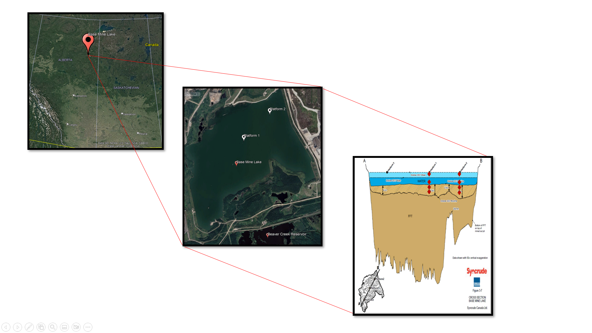
Figure 1. Satellite image of Alberta, Canada and zoomed-in image of BML accompanied with a cross-sectional figure displaying samples utilized in this study (red diamonds).
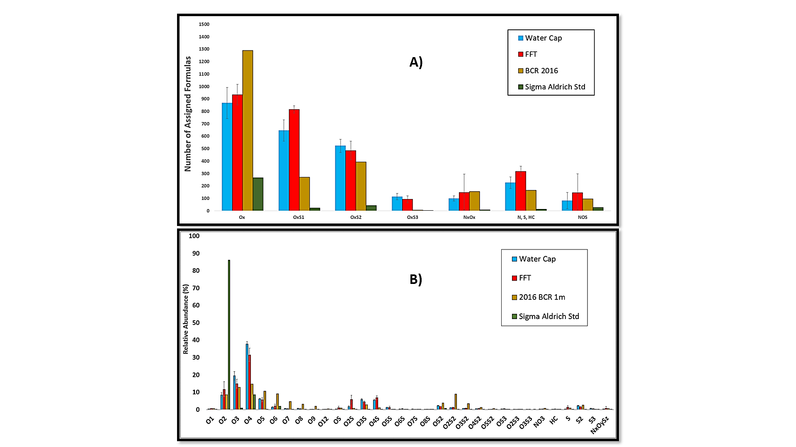
Figure 2. ESI (-) FT ICR MS data from the analysis of BML water cap and FFT, BCR, and 1ppm Sigma Aldrich standard. BML water cap and FFT samples from Platform 1 and 2 were pooled together to generate an average and standard deviation (shown in error bars). A) Number of assigned formulas for the types of categorized heteroatom classes, and B) Relative abundance data for the individual heteroatom classes.
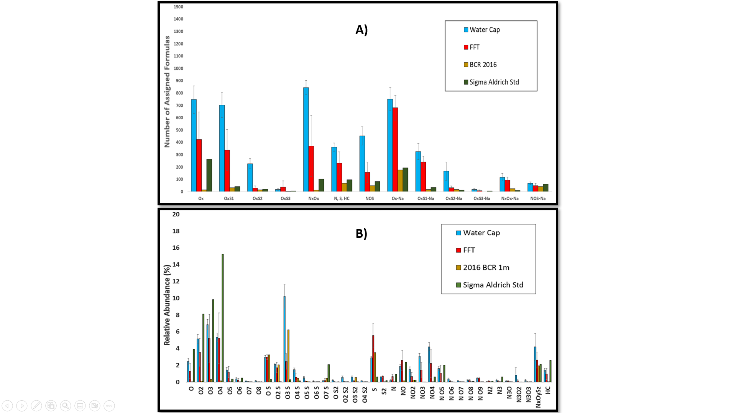
Figure 3. ESI (+) FT ICR MS data from the analysis of BML water cap and FFT, BCR, and 1ppm Sigma Aldrich standard. BML water cap and FFT samples were pooled together from Platform 1 and 2 to generate an average and standard deviation (shown in error bars). A) Number of assigned formulas for the types of categorized heteroatom classes, and B) Relative abundance data for the individual heteroatom classes.


Figure 4. Carbon Number versus Double Bond Equivalence plot of hydrocarbons and oxygen-containing NAFCs detected in ESI (-) from the water cap and FFT samples at P1, the 2016 BCR water sample, and Sigma Aldrich NA standard.
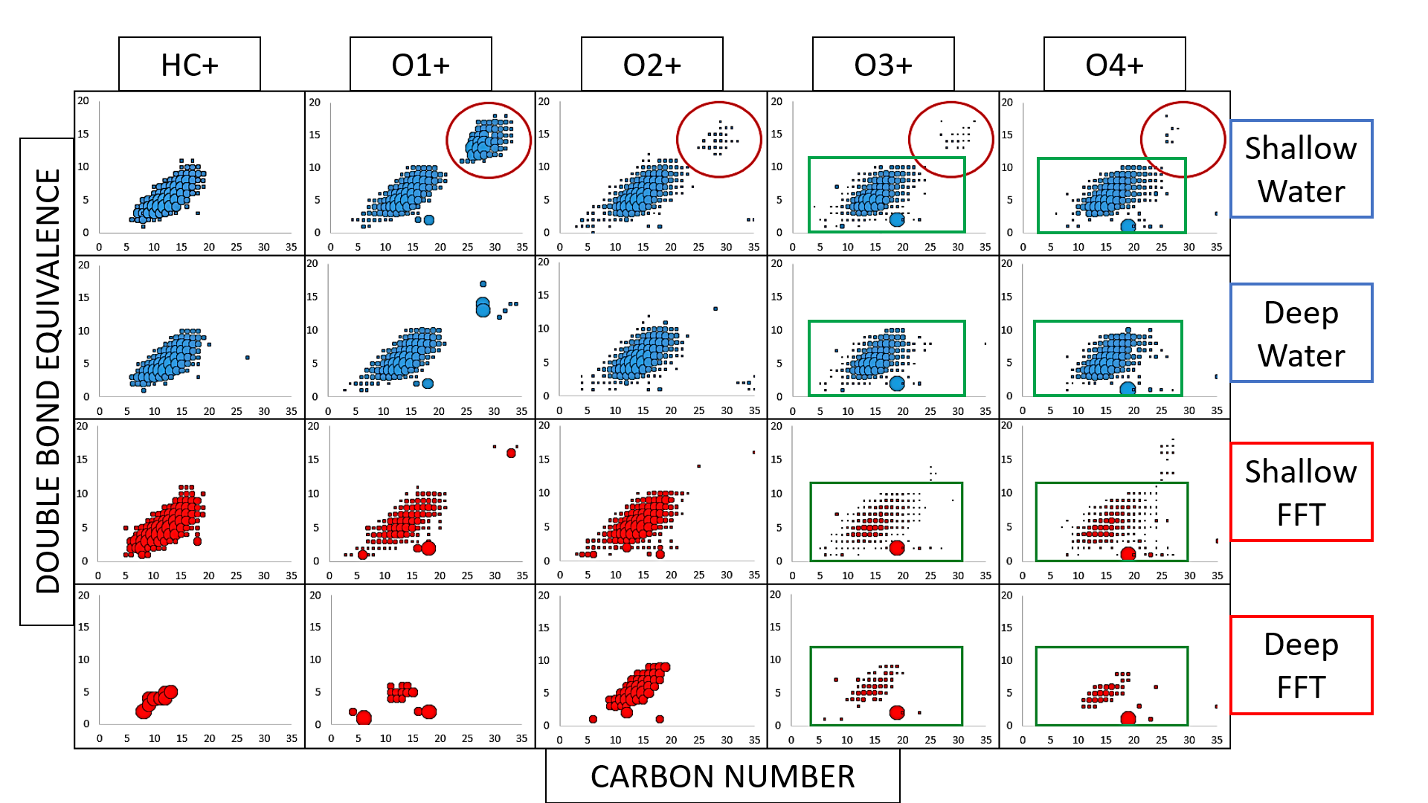
Figure 5. Carbon Number versus DBE plot for HC and oxygenated compounds detected in the ESI (+) measurements of the water cap and FFT samples at P1 from BML.

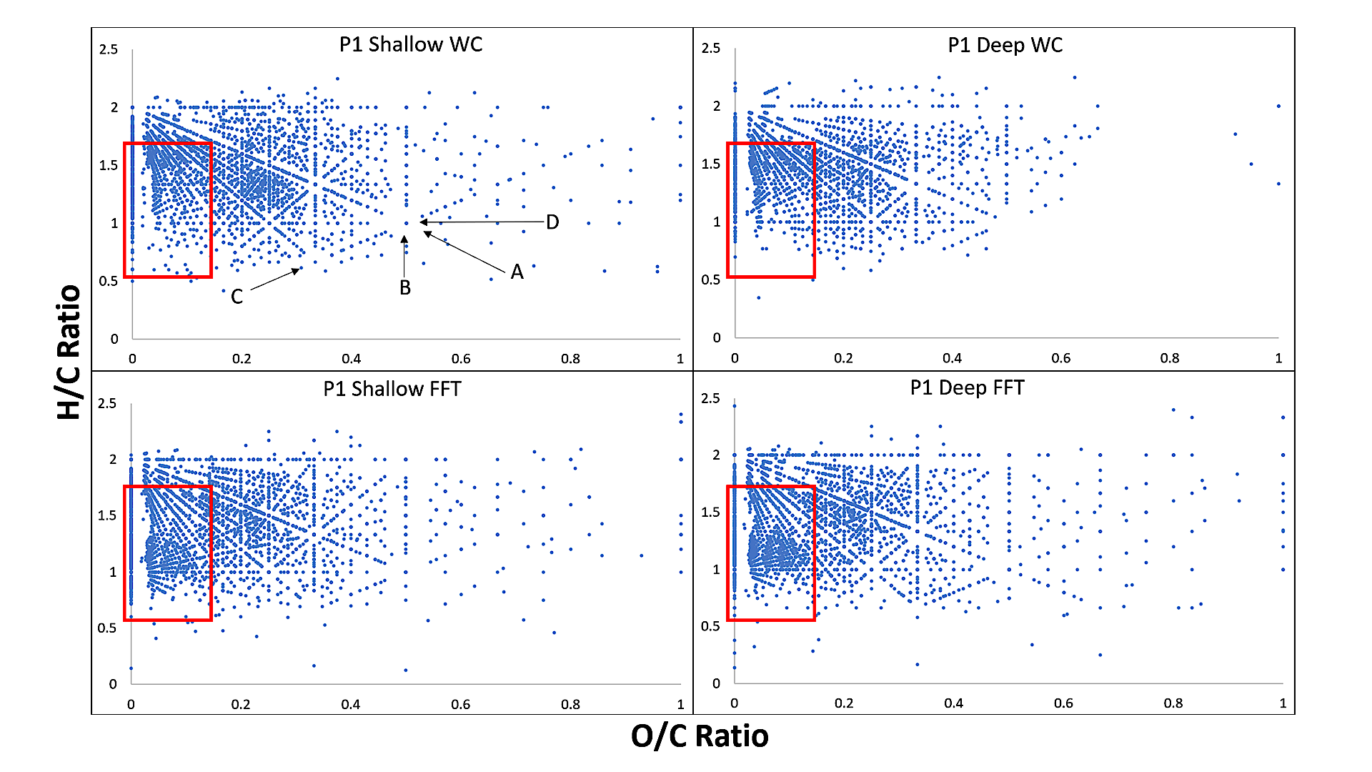
Figure 6. Van Krevelen Diagrams of the ESI (-) analysis of BML samples from P1 (Water cap and FFT). The red boxes represent an area of interest for the absence or presence of NAFCs. The arrows and letters in the P1 Shallow Water cap plot represent important biogeochemical reactions as identified from Kim et al. (2003) and are as followed: A) Methylation, demethylation or alkyl chain elongation, B) Hydrogenation or dehydrogenation, C) Hydration or condensation, and D) Oxidation or reduction.

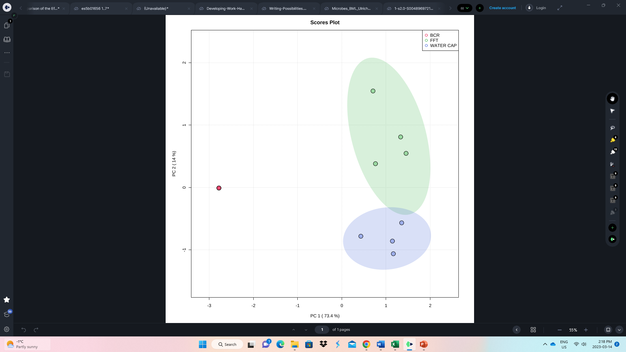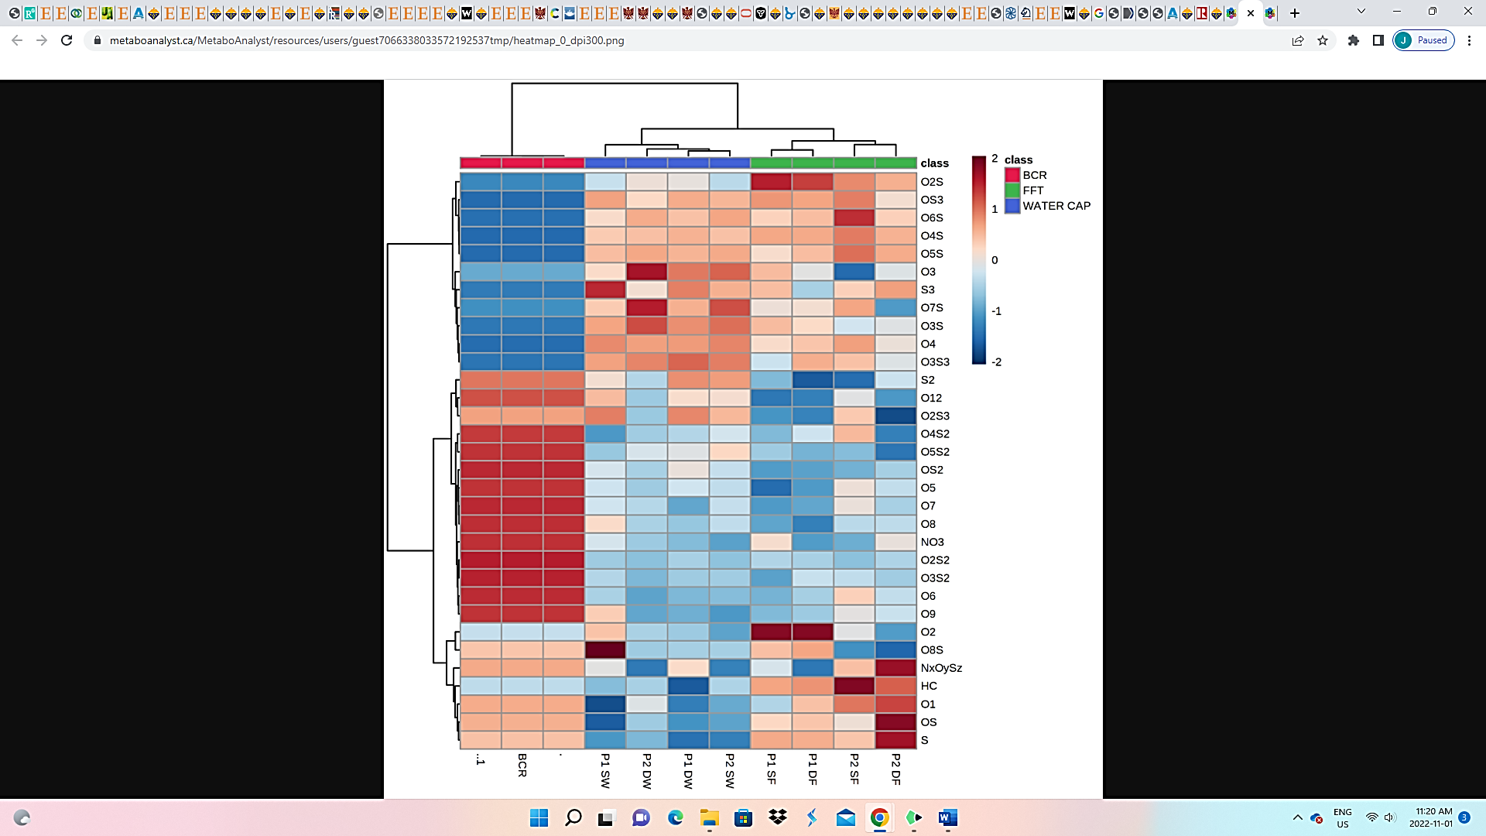
A)
B)
Figure 7. A) PCA plot generated from the relative abundance data of the ESI (-) analysis of the BML water cap and FFT samples from Platform 1 and 2 and the 2016 BCR, and B) Heatmap correlation plot of all the NAFC features.
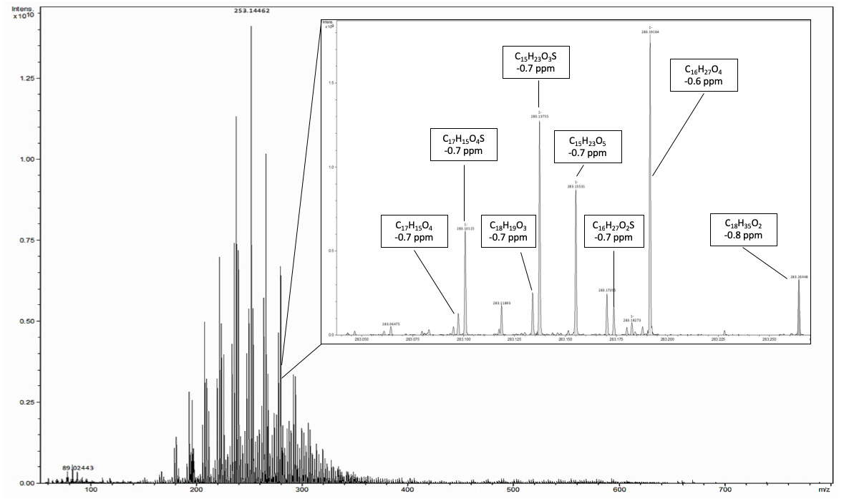
A)
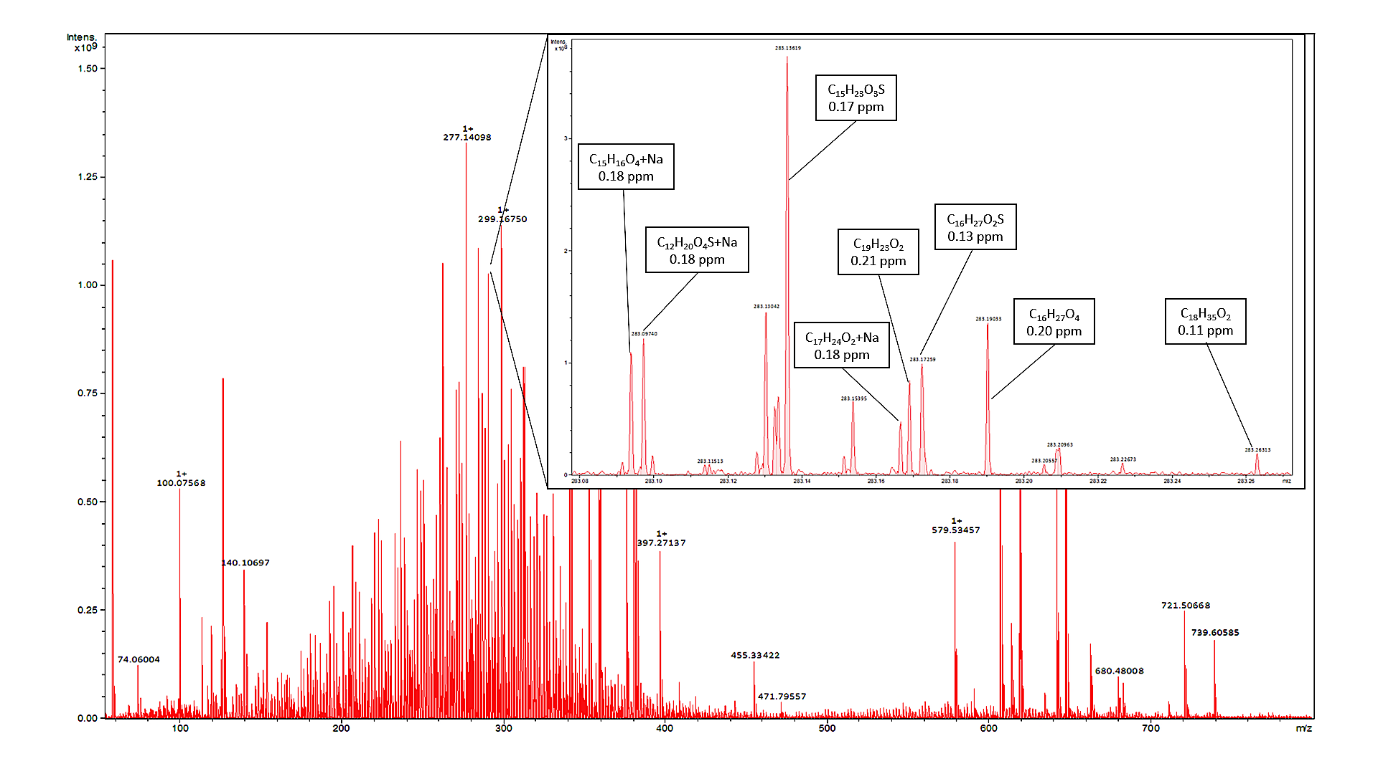
B)
Figure 8A. Broadband mass spectra of BML P2 9m water sample analyzed in ESI (-) and a zoomed in 0.20 m/z mass window at 283 m/z displaying several identified NAFCs, and B the same mass spectra and mass window of BML P2 9m as analyzed in ESI (+).

Tables
Table 1. List of all samples used, and total number of peaks detected by ESI (+) & (-) with the calculate root mean squared error.
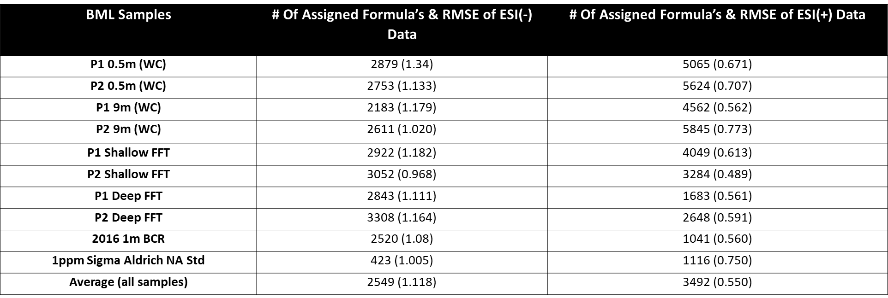
References (in order of appearance)
Larter, S. R., & Head, I. M. (2014). Erratum: Oil sands and heavy oil: Origin and exploitation (Elements (2014) 10 (277-284)). In Elements (Vol. 10, Issue 5).

Huang, H., Silva, R. C., Radović, J. R., & Larter, S. R. (2020). Environmental and Economic Implications of the Biogeochemistry of Oil Sands Bitumen. In Hydrocarbons, Oils and Lipids: Diversity, Origin, Chemistry and Fate. https://doi.org/10.1007/978-3-319-90569-3_19
Masliyah, J., Zhou, Z., Xu, Z., Czarnecki, J., & Hamza, H. (2004). Understanding water-based bitumen extraction from athabasca oil sands. In Canadian Journal of Chemical Engineering (Vol. 82, Issue 4). https://doi.org/10.1002/cjce.5450820403
Zhou, J. Z. (2021). Role of mineral flotation technology in improving bitumen extraction from mined Athabasca oil sands III. Next generation of water-based oil sands extraction. Canadian Journal of Chemical Engineering, 99(3). https://doi.org/10.1002/cjce.23874

Allen, E. W. (2008). Process water treatment in Canada’s oil sands industry: I. Target pollutants and treatment objectives. Journal of Environmental Engineering and Science, 7(2). https://doi.org/10.1139/S07-038
Giesy, J. P., Anderson, J. C., & Wiseman, S. B. (2010). Alberta oil sands development. Proceedings of the National Academy of Sciences, 107(3), 951-952.

Dompierre, K. A., Lindsay, M. B. J., Cruz-Hernández, P., & Halferdahl, G. M. (2016). Initial geochemical characteristics of fluid fine tailings in an oil sands end pit lake. Science of the Total Environment, 556. https://doi.org/10.1016/j.scitotenv.2016.03.002
Dompierre, K. A., Barbour, S. L., North, R. L., Carey, S. K., & Lindsay, M. B. J. (2017). Chemical mass transport between fluid fine tailings and the overlying water cover of an oil sands end pit lake. Water Resources Research, 53(6). https://doi.org/10.1002/2016WR020112
Lawrence, G. A., Tedford, E. W., & Pieters, R. (2015). Suspended solids in an end pit lake: Potential mixing mechanisms. Canadian Journal of Civil Engineering, 43(3). https://doi.org/10.1139/cjce-2015-0381
Tedford, E., Halferdahl, G., Pieters, R., & Lawrence, G. A. (2019). Temporal variations in turbidity in an oil sands pit lake. Environmental Fluid Mechanics, 19(2). https://doi.org/10.1007/s10652-018-9632-6
Hurley, D., Lawrence, G., & Tedford, E. (2020). Effects of Hydrocarbons on Wind Waves in a Mine Pit Lake. Mine Water and the Environment, 39(3). https://doi.org/10.1007/s10230-020-00686-7
Zhao, K., Tedford, E. W., Zare, M., & Lawrence, G. A. (2021). Impact of atmospheric pressure variations on methane ebullition and lake turbidity during ice-cover. In Limnology And Oceanography Letters (Vol. 6, Issue 5). https://doi.org/10.1002/lol2.10201
Francis, D. J., Barbour, S. L., & Lindsay, M. B. J. (2022). Ebullition enhances chemical mass transport across the tailings-water interface of oil sands pit lakes. Journal of Contaminant Hydrology, 245. https://doi.org/10.1016/j.jconhyd.2021.103938
Kuppusamy, S., Maddela, N. R., Megharaj, M., & Venkateswarlu, K. (2020). An Overview of Total Petroleum Hydrocarbons. In Total Petroleum Hydrocarbons. https://doi.org/10.1007/978-3-030-24035-6_1
Logeshwaran, P., Megharaj, M., Chadalavada, S., Bowman, M., & Naidu, R. (2018). Petroleum hydrocarbons (PH) in groundwater aquifers: An overview of environmental fate, toxicity, microbial degradation and risk-based remediation approaches. In Environmental Technology and Innovation (Vol. 10). https://doi.org/10.1016/j.eti.2018.02.001
Whitby, C. (2010). Microbial Naphthenic Acid Degradation. In Advances in Applied Microbiology (Vol. 70). https://doi.org/10.1016/S0065-2164(10)70003-4
Headley, J. v., & McMartin, D. W. (2004). A review of the occurrence and fate of naphthenic acids in aquatic environments. In Journal of Environmental Science and Health - Part A Toxic/Hazardous Substances and Environmental Engineering (Vol. 39, Issue 8). https://doi.org/10.1081/ESE-120039370
Clemente, J. S., & Fedorak, P. M. (2005). A review of the occurrence, analyses, toxicity, and biodegradation of naphthenic acids. In Chemosphere (Vol. 60, Issue 5). https://doi.org/10.1016/j.chemosphere.2005.02.065

Celsie, A., Parnis, J. M., & Mackay, D. (2016). Impact of temperature, pH, and salinity changes on the physico-chemical properties of model naphthenic acids. Chemosphere, 146. https://doi.org/10.1016/j.chemosphere.2015.11.122

Barros, E. v., Filgueiras, P. R., Lacerda, V., Rodgers, R. P., & Romão, W. (2022). Characterization of naphthenic acids in crude oil samples – A literature review. In Fuel (Vol. 319). https://doi.org/10.1016/j.fuel.2022.123775
Bauer, A. E., Frank, R. A., Headley, J. v., Peru, K. M., Farwell, A. J., & Dixon, D. G. (2017). Toxicity of oil sands acid-extractable organic fractions to freshwater fish: Pimephales promelas (fathead minnow) and Oryzias latipes (Japanese medaka). Chemosphere, 171. https://doi.org/10.1016/j.chemosphere.2016.12.059
Bauer, A. E., Hewitt, L. M., Parrott, J. L., Bartlett, A. J., Gillis, P. L., Deeth, L. E., Rudy, M. D., Vanderveen, R., Brown, L., Campbell, S. D., Rodrigues, M. R., Farwell, A. J., Dixon, D. G., & Frank, R. A. (2019). The toxicity of organic fractions from aged oil sands process-affected water to aquatic species. Science of the Total Environment, 669. https://doi.org/10.1016/j.scitotenv.2019.03.107
White, K. B., & Liber, K. (2020). Chronic Toxicity of Surface Water from a Canadian Oil Sands End Pit Lake to the Freshwater Invertebrates Chironomus dilutus and Ceriodaphnia dubia. Archives of Environmental Contamination and Toxicology, 78(3). https://doi.org/10.1007/s00244-020-00720-3
Robinson, C. E., Elvidge, C. K., Frank, R. A., Headley, J. V., Hewitt, L. M., Little, A. G., ... & Orihel, D. M. (2023). Naphthenic acid fraction compounds reduce the reproductive success of wood frogs (Rana sylvatica) by affecting offspring viability. Environmental Pollution, 316, 120455.
Risacher, F. F., Morris, P. K., Arriaga, D., Goad, C., Nelson, T. C., Slater, G. F., & Warren, L. A. (2018). The interplay of methane and ammonia as key oxygen consuming constituents in early stage development of Base Mine Lake, the first demonstration oil sands pit lake. Applied Geochemistry, 93. https://doi.org/10.1016/j.apgeochem.2018.03.013
Arriaga, D., Nelson, T. C., Risacher, F. F., Morris, P. K., Goad, C., Slater, G. F., & Warren, L. A. (2019). The co-importance of physical mixing and biogeochemical consumption in controlling water cap oxygen levels in Base Mine Lake. Applied Geochemistry, 111. https://doi.org/10.1016/j.apgeochem.2019.104442

Slater, G. F., Goad, C. A., Lindsay, M. B. J., Mumford, K. G., Nelson, T. E. C., Brady, A. L., Jessen, G. L., & Warren, L. A. (2021). Isotopic and chemical assessment of the dynamics of methane sources and microbial cycling during early development of an oil sands pit lake. Microorganisms, 9(12). https://doi.org/10.3390/microorganisms9122509

Jessen, G. L., Chen, L. X., Mori, J. F., Nelson, T. E. C., Slater, G. F., Lindsay, M. B. J., Banfield, J. F., & Warren, L. A. (2022). Alum Addition Triggers Hypoxia in an Engineered Pit Lake. Microorganisms, 10(3). https://doi.org/10.3390/microorganisms10030510

Bowman, D. T., Warren, L. A., & Slater, G. F. (2020). Isomer-specific monitoring of naphthenic acids at an oil sands pit lake by comprehensive two-dimensional gas chromatography–mass spectrometry. Science of the Total Environment, 746. https://doi.org/10.1016/j.scitotenv.2020.140985

Bowman, D. T., Jobst, K. J., Ortiz, X., Reiner, E. J., Warren, L. A., McCarry, B. E., & Slater, G. F. (2018). Improved coverage of naphthenic acid fraction compounds by comprehensive two-dimensional gas chromatography coupled with high resolution mass spectrometry. Journal of Chromatography A, 1536. https://doi.org/10.1016/j.chroma.2017.07.017
El-Waraky, M. Assessment of the sources and biodegradation potential of hydrocarbons and naphthenic acids in an oil sands end pit lake. PhD Dissertation, McMaster University. 2021. Pg 127.

Stanford, L. A., Kim, S., Klein, G. C., Smith, D. F., Rodgers, R. P., & Marshall, A. G. (2007). Identification of water-soluble heavy crude oil organic-acids, bases, and neutrals by electrospray ionization and field desorption ionization fourier transform ion cyclotron resonance mass spectrometry. Environmental Science and Technology, 41(8). https://doi.org/10.1021/es0624063
McKenna, A. M., Nelson, R. K., Reddy, C. M., Savory, J. J., Kaiser, N. K., Fitzsimmons, J. E., Marshall, A. G., & Rodgers, R. P. (2013). Expansion of the analytical window for oil spill characterization by ultrahigh resolution mass spectrometry: Beyond gas chromatography. Environmental Science and Technology, 47(13). https://doi.org/10.1021/es305284t

Robson, W. J., Sutton, P. A., McCormack, P., Chilcott, N. P., & Rowland, S. J. (2017). Class Type Separation of the Polar and Apolar Components of Petroleum. Analytical Chemistry, 89(5). https://doi.org/10.1021/acs.analchem.6b04202

Booth, A. M., Sutton, P. A., Lewis, C. A., Lewis, A. C., Scarlett, A., Chau, W., Widdows, J., & Rowland, S. J. (2007). Unresolved complex mixtures of aromatic hydrocarbons: Thousands of overlooked persistent, bioaccumulative, and toxic contaminants in mussels. Environmental Science and Technology, 41(2). https://doi.org/10.1021/es0615829

West, C. E., Pureveen, J., Scarlett, A. G., Lengger, S. K., Wilde, M. J., Korndorffer, F., Tegelaar, E. W., & Rowland, S. J. (2014). Can two-dimensional gas chromatography/mass spectrometric identification of bicyclic aromatic acids in petroleum fractions help to reveal further details of aromatic hydrocarbon biotransformation pathways? Rapid Communications in Mass Spectrometry, 28(9). https://doi.org/10.1002/rcm.6876

Farrington, J. W., & Quinn, J. G. (2015). “Unresolved Complex Mixture” (UCM): A brief history of the term and moving beyond it. Marine Pollution Bulletin, 96(1–2). https://doi.org/10.1016/j.marpolbul.2015.04.039

Aitken, C. M., Head, I. M., Jones, D. M., Rowland, S. J., Scarlett, A. G., & West, C. E. (2018). Comprehensive two-dimensional gas chromatography-mass spectrometry of complex mixtures of anaerobic bacterial metabolites of petroleum hydrocarbons. Journal of Chromatography A, 1536. https://doi.org/10.1016/j.chroma.2017.06.027

Wardlaw, G. D., Nelson, R. K., Reddy, C. M., & Valentine, D. L. (2011). Biodegradation preference for isomers of alkylated naphthalenes and benzothiophenes in marine sediment contaminated with crude oil. Organic Geochemistry, 42(6). https://doi.org/10.1016/j.orggeochem.2011.03.029

Marshall, A. G., & Rodgers, R. P. (2004). Petroleomics: The Next Grand Challenge for Chemical Analysis. Accounts of Chemical Research, 37(1). https://doi.org/10.1021/ar020177t

Marshall, A. G., & Rodgers, R. P. (2008). Petroleomics: Chemistry of the underworld. Proceedings of the National Academy of Sciences of the United States of America, 105(47). https://doi.org/10.1073/pnas.0805069105

Smith, D. F., Rahimi, P., Teclemariam, A., Rodgers, R. P., & Marshall, A. G. (2008). Characterization of Athabasca bitumen heavy vacuum gas oil distillation cuts by negative/positive electrospray ionization and automated liquid injection field desorption ionization Fourier transform ion cyclotron resonance mass spectrometry. Energy and Fuels, 22(5). https://doi.org/10.1021/ef8000357

Barrow, M. P., Peru, K. M., Fahlman, B., Hewitt, L. M., Frank, R. A., & Headley, J. v. (2015). Beyond Naphthenic Acids: Environmental Screening of Water from Natural Sources and the Athabasca Oil Sands Industry Using Atmospheric Pressure Photoionization Fourier Transform Ion Cyclotron Resonance Mass Spectrometry. Journal of the American Society for Mass Spectrometry, 26(9). https://doi.org/10.1007/s13361-015-1188-9

Barrow, M. P., Peru, K. M., McMartin, D. W., & Headley, J. v. (2016). Effects of Extraction pH on the Fourier Transform Ion Cyclotron Resonance Mass Spectrometry Profiles of Athabasca Oil Sands Process Water. Energy and Fuels, 30(5). https://doi.org/10.1021/acs.energyfuels.5b02086

Liu, Y., & Kujawinski, E. B. (2015). Chemical composition and potential environmental impacts of water-soluble polar crude oil components inferred from esi FT-ICR MS. PLoS ONE, 10(9). https://doi.org/10.1371/journal.pone.0136376

Oldenburg, T. B. P., Jones, M., Huang, H., Bennett, B., Shafiee, N. S., Head, I., & Larter, S. R. (2017). The controls on the composition of biodegraded oils in the deep subsurface – Part 4. Destruction and production of high molecular weight non-hydrocarbon species and destruction of aromatic hydrocarbons during progressive in-reservoir biodegradation. Organic Geochemistry, 114. https://doi.org/10.1016/j.orggeochem.2017.09.003

Benigni, P., Sandoval, K., Thompson, C. J., Ridgeway, M. E., Park, M. A., Gardinali, P., & Fernandez-Lima, F. (2017). Analysis of Photoirradiated Water Accommodated Fractions of Crude Oils Using Tandem TIMS and FT-ICR MS. Environmental Science and Technology, 51(11). https://doi.org/10.1021/acs.est.7b00508

Smith, D. F., Podgorski, D. C., Rodgers, R. P., Blakney, G. T., & Hendrickson, C. L. (2018). 21 Tesla FT-ICR Mass Spectrometer for Ultrahigh-Resolution Analysis of Complex Organic Mixtures. Analytical Chemistry, 90(3). https://doi.org/10.1021/acs.analchem.7b04159

Young, R. B., Pica, N. E., Sharifan, H., Chen, H., Roth, H. K., Blakney, G. T., Borch, T., Higgins, C. P., Kornuc, J. J., McKenna, A. M., & Blotevogel, J. (2022). PFAS Analysis with Ultrahigh Resolution 21T FT-ICR MS: Suspect and Nontargeted Screening with Unrivaled Mass Resolving Power and Accuracy. Environmental Science and Technology, 56(4). https://doi.org/10.1021/acs.est.1c08143

Niles, S. F., Chacón-Patiño, M. L., Chen, H., McKenna, A. M., Blakney, G. T., Rodgers, R. P., & Marshall, A. G. (2019). Molecular-Level Characterization of Oil-Soluble Ketone/Aldehyde Photo-Oxidation Products by Fourier Transform Ion Cyclotron Resonance Mass Spectrometry Reveals Similarity between Microcosm and Field Samples. Environmental Science and Technology, 53(12). https://doi.org/10.1021/acs.est.9b00908

Wise, S. A., Rodgers, R. P., Reddy, C. M., Nelson, R. K., Kujawinski, E. B., Wade, T. L., Campiglia, A. D., & Liu, Z. (2022). Advances in Chemical Analysis of Oil Spills Since the Deepwater Horizon Disaster. In Critical Reviews in Analytical Chemistry. https://doi.org/10.1080/10408347.2022.2039093

Barrow, M. P., Headley, J. v., Peru, K. M., & Derrick, P. J. (2009). Data visualization for the characterization of naphthenic acids within petroleum samples. Energy and Fuels, 23(5). https://doi.org/10.1021/ef800985z

Grewer, D. M., Young, R. F., Whittal, R. M., & Fedorak, P. M. (2010). Naphthenic acids and other acid-extractables in water samples from Alberta: What is being measured? Science of the Total Environment, 408(23). https://doi.org/10.1016/j.scitotenv.2010.08.013

Marentette, J. R., Frank, R. A., Bartlett, A. J., Gillis, P. L., Hewitt, L. M., Peru, K. M., Headley, J. v., Brunswick, P., Shang, D., & Parrott, J. L. (2015). Toxicity of naphthenic acid fraction components extracted from fresh and aged oil sands process-affected waters, and commercial naphthenic acid mixtures, to fathead minnow (Pimephales promelas) embryos. Aquatic Toxicology, 164. https://doi.org/10.1016/j.aquatox.2015.04.024

Gutierrez-Villagomez, J. M., Peru, K. M., Edington, C., Headley, J. v., Pauli, B. D., & Trudeau, V. L. (2019). Naphthenic Acid Mixtures and Acid-Extractable Organics from Oil Sands Process-Affected Water Impair Embryonic Development of Silurana (Xenopus) tropicalis. Environmental Science and Technology. https://doi.org/10.1021/acs.est.8b04461

Headley, J. v., Barrow, M. P., Peru, K. M., Fahlman, B., Frank, R. A., Bickerton, G., McMaster, M. E., Parrott, J., & Hewitt, L. M. (2011). Preliminary fingerprinting of Athabasca oil sands polar organics in environmental samples using electrospray ionization Fourier transform ion cyclotron resonance mass spectrometry. Rapid Communications in Mass Spectrometry, 25(13). https://doi.org/10.1002/rcm.5062

Brandon, J. T. 2016. Turbidity mitigation in an oil sands end pit lake through pH reduction and freshwater addition. M.Sc. Thesis, Department of Civil and Environmental Engineering,
University of Alberta. 135 pp.

Ruddy, B. M., Hendrickson, C. L., Rodgers, R. P., & Marshall, A. G. (2018). Positive Ion Electrospray Ionization Suppression in Petroleum and Complex Mixtures. Energy and Fuels, 32(3). https://doi.org/10.1021/acs.energyfuels.7b03204

van den Berg, R. A., Hoefsloot, H. C. J., Westerhuis, J. A., Smilde, A. K., & van der Werf, M. J. (2006). Centering, scaling, and transformations: Improving the biological information content of metabolomics data. BMC Genomics, 7. https://doi.org/10.1186/1471-2164-7-142

Han, X., MacKinnon, M. D., & Martin, J. W. (2009). Estimating the in situ biodegradation of naphthenic acids in oil sands process waters by HPLC/HRMS. Chemosphere, 76(1). https://doi.org/10.1016/j.chemosphere.2009.02.026

Frank, R. A., Milestone, C. B., Rowland, S. J., Headley, J. v., Kavanagh, R. J., Lengger, S. K., Scarlett, A. G., West, C. E., Peru, K. M., & Hewitt, L. M. (2016). Assessing spatial and temporal variability of acid-extractable organics in oil sands process-affected waters. Chemosphere, 160. https://doi.org/10.1016/j.chemosphere.2016.06.093

Milestone, C. B., Sun, C., Martin, J. W., Bickerton, G., Roy, J. W., Frank, R. A., & Hewitt, L. M. (2021). Non-target profiling of bitumen-influenced waters for the identification of tracers unique to oil sands processed-affected water (OSPW) in the Athabasca watershed of Alberta, Canada. Rapid Communications in Mass Spectrometry, 35(3). https://doi.org/10.1002/rcm.8984

Kim, S., Kramer, R. W., & Hatcher, P. G. (2003). Graphical Method for Analysis of Ultrahigh-Resolution Broadband Mass Spectra of Natural Organic Matter, the Van Krevelen Diagram. Analytical Chemistry, 75(20). https://doi.org/10.1021/ac034415p

Sleighter, R. L., & Hatcher, P. G. (2007). The application of electrospray ionization coupled to ultrahigh resolution mass spectrometry for the molecular characterization of natural organic matter. In Journal of Mass Spectrometry (Vol. 42, Issue 5). https://doi.org/10.1002/jms.1221

Sleighter, R. L., & Hatcher, P. G. (2008). Molecular characterization of dissolved organic matter (DOM) along a river to ocean transect of the lower Chesapeake Bay by ultrahigh resolution electrospray ionization Fourier transform ion cyclotron resonance mass spectrometry. Marine Chemistry, 110(3–4). https://doi.org/10.1016/j.marchem.2008.04.008

Herzsprung, P., Osterloh, K., von Tümpling, W., Harir, M., Hertkorn, N., Schmitt-Kopplin, P., Meissner, R., Bernsdorf, S., & Friese, K. (2017). Differences in DOM of rewetted and natural peatlands – Results from high-field FT-ICR-MS and bulk optical parameters. Science of the Total Environment, 586. https://doi.org/10.1016/j.scitotenv.2017.02.054

vander Meulen, I. J., Schock, D. M., Parrott, J. L., Simair, M. C., Mundy, L. J., Ajaero, C., Pauli, B. D., Peru, K. M., McMartin, D. W., & Headley, J. v. (2022). Transformation of bitumen-derived naphthenic acid fraction compounds across surface waters of wetlands in the Athabasca Oil Sands region. Science of the Total Environment, 806. https://doi.org/10.1016/j.scitotenv.2021.150619

Lengger, S. K., Scarlett, A. G., West, C. E., & Rowland, S. J. (2013). Diamondoid diacids (“O4” species) in oil sands process-affected water. Rapid Communications in Mass Spectrometry, 27(23). https://doi.org/10.1002/rcm.6729

Rowland, S. J., West, C. E., Scarlett, A. G., & Jones, D. (2011). Identification of individual acids in a commercial sample of naphthenic acids from petroleum by two-dimensional comprehensive gas chromatography/mass spectrometry. Rapid Communications in Mass Spectrometry, 25(12). https://doi.org/10.1002/rcm.5040

Rowland, S. J., Scarlett, A. G., Jones, D., West, C. E., & Frank, R. A. (2011). Diamonds in the rough: Identification of individual naphthenic acids in oil sands process water. Environmental Science and Technology, 45(7). https://doi.org/10.1021/es103721b

Bowman, D. T., Slater, G. F., Warren, L. A., & McCarry, B. E. (2014). Identification of individual thiophene-, indane-, tetralin-, cyclohexane-, and adamantane-type carboxylic acids in composite tailings pore water from Alberta oil sands. Rapid Communications in Mass Spectrometry, 28(19). https://doi.org/10.1002/rcm.6996

Ray, P. Z., Chen, H., Podgorski, D. C., McKenna, A. M., & Tarr, M. A. (2014). Sunlight creates oxygenated species in water-soluble fractions of Deepwater horizon oil. Journal of Hazardous Materials, 280. https://doi.org/10.1016/j.jhazmat.2014.08.059

Tarr, M. A., Zito, P., Overton, E. B., Olson, G. M., Adhikari, P. L., & Reddy, C. M. (2016). Weathering of oil spilled in the marine environment. Oceanography, 29(3). https://doi.org/10.5670/oceanog.2016.77

Aeppli, C. (2022). Recent advance in understanding photooxidation of hydrocarbons after oil spills. In Current Opinion in Chemical Engineering (Vol. 36). https://doi.org/10.1016/j.coche.2021.100763

McMartin, D. W., Headley, J. v., Friesen, D. A., Peru, K. M., & Gillies, J. A. (2004). Photolysis of naphthenic acids in natural surface water. Journal of Environmental Science and Health - Part A Toxic/Hazardous Substances and Environmental Engineering, 39(6). https://doi.org/10.1081/ESE-120037839

Headley, J. v., Du, J. L., Peru, K. M., & McMartin, D. W. (2009). Electrospray ionization mass spectrometry of the photodegradation of naphthenic acids mixtures irradiated with titanium dioxide. Journal of Environmental Science and Health - Part A Toxic/Hazardous Substances and Environmental Engineering, 44(6). https://doi.org/10.1080/10934520902784625

Mishra, S., Meda, V., Dalai, A. K., McMartin, D. W., Headley, J. v., & Peru, K. M. (2010). Photocatalysis of Naphthenic Acids in Water. Journal of Water Resource and Protection, 02(07). https://doi.org/10.4236/jwarp.2010.27074

Leshuk, T., de Oliveira Livera, D., Peru, K. M., Headley, J. v., Vijayaraghavan, S., Wong, T., & Gu, F. (2016). Photocatalytic degradation kinetics of naphthenic acids in oil sands process-affected water: Multifactorial determination of significant factors. Chemosphere, 165. https://doi.org/10.1016/j.chemosphere.2016.08.115

Leshuk, T., Wong, T., Linley, S., Peru, K. M., Headley, J. v., & Gu, F. (2016). Solar photocatalytic degradation of naphthenic acids in oil sands process-affected water. Chemosphere, 144. https://doi.org/10.1016/j.chemosphere.2015.10.073

Leshuk, T., Krishnakumar, H., Livera, D. de O., & Gu, F. (2018). Floating photocatalysts for passive solar degradation of naphthenic acids in oil sands process-affected water. Water (Switzerland), 10(2). https://doi.org/10.3390/w10020202

de Oliveira Livera, D., Leshuk, T., Peru, K. M., Headley, J. v., & Gu, F. (2018). Structure-reactivity relationship of naphthenic acids in the photocatalytic degradation process. Chemosphere, 200. https://doi.org/10.1016/j.chemosphere.2018.02.049

Challis, J. K., Parajas, A., Anderson, J. C., Asiedu, E., Martin, J. W., Wong, C. S., & Ross, M. S. (2020). Photodegradation of bitumen-derived organics in oil sands process-affected water. Environmental Science: Processes and Impacts, 22(5). https://doi.org/10.1039/d0em00005a

Barrow, M. P. (2010). Petroleomics: Study of the old and the new. In Biofuels (Vol. 1, Issue 5). https://doi.org/10.4155/bfs.10.55

Raez-Villanueva, S., Jamshed, L., Ratnayake, G., Cheng, L., Thomas, P. J., & Holloway, A. C. (2019). Adverse effects of naphthenic acids on reproductive health: A focus on placental trophoblast cells. Reproductive Toxicology, 90. https://doi.org/10.1016/j.reprotox.2019.09.002

Sun, C., Shotyk, W., Cuss, C. W., Donner, M. W., Fennell, J., Javed, M., Noernberg, T., Poesch, M., Pelletier, R., Sinnatamby, N., Siddique, T., & Martin, J. W. (2017). Characterization of Naphthenic Acids and Other Dissolved Organics in Natural Water from the Athabasca Oil Sands Region, Canada. Environmental Science and Technology, 51(17). https://doi.org/10.1021/acs.est.7b02082

Gieg, L. M., & Suflita, J. M. (2002). Detection of anaerobic metabolites of saturated and aromatic hydrocarbons in petroleum-contaminated aquifers. Environmental Science and Technology, 36(17). https://doi.org/10.1021/es0205333

Meckenstock, R. U., Safinowski, M., & Griebler, C. (2004). Anaerobic degradation of polycyclic aromatic hydrocarbons. FEMS Microbiology Ecology, 49(1). https://doi.org/10.1016/j.femsec.2004.02.019

Rabus, R. (2014). Biodegradation of Hydrocarbons Under Anoxic Conditions. In Petroleum Microbiology. https://doi.org/10.1128/9781555817589.ch14

Hewitt, L. M., Roy, J. W., Rowland, S. J., Bickerton, G., Desilva, A., Headley, J. v., Milestone, C. B., Scarlett, A. G., Brown, S., Spencer, C., West, C. E., Peru, K. M., Grapentine, L., Ahad, J. M. E., Pakdel, H., & Frank, R. A. (2020). Advances in Distinguishing Groundwater Influenced by Oil Sands Process-Affected Water (OSPW) from Natural Bitumen-Influenced Groundwaters. Environmental Science and Technology, 54(3). https://doi.org/10.1021/acs.est.9b05040

Zhang, K., Pereira, A. S., & Martin, J. W. (2015). Estimates of Octanol-Water Partitioning for Thousands of Dissolved Organic Species in Oil Sands Process-Affected Water. Environmental Science and Technology, 49(14). https://doi.org/10.1021/acs.est.5b01656

Kujawinski, E. B., Freitas, M. A., Zang, X., Hatcher, P. G., Green-Church, K. B., & Jones, R. B. (2002). The application of electrospray ionization mass spectrometry (ESI MS) to the structural characterization of natural organic matter. Organic geochemistry, 33(3), 171-180. https://doi.org/10.1016/S0146-6380(01)00149-8

Wang, Z. and Fingas, M. (1997) Developments in the Analysis of Petroleum Hydrocarbons in Oils, Petroleum Products and Oil-Spilled-Related Environmental Samples by Gas Chromatography. Journal of Chromatography A, 774, 51-78.
https://doi.org/10.1016/S0021-9673(97)00270-7
Shi, Q., & Wu, J. (2021). Review on sulfur compounds in petroleum and its products: state-of-the-art and perspectives. Energy & Fuels, 35(18), 14445-14461. https://doi.org/10.1021/acs.energyfuels.1c02229

Ruddy, B. M., Huettel, M., Kostka, J. E., Lobodin, V. v., Bythell, B. J., McKenna, A. M., Aeppli, C., Reddy, C. M., Nelson, R. K., Marshall, A. G., & Rodgers, R. P. (2014). Targeted petroleomics: Analytical investigation of macondo well oil oxidation products from pensacola beach. Energy and Fuels, 28(6). https://doi.org/10.1021/ef500427n

Molnárné Guricza, L., & Schrader, W. (2015). Electrospray ionization for determination of non-polar polyaromatic hydrocarbons and polyaromatic heterocycles in heavy crude oil asphaltenes. Journal of Mass Spectrometry, 50(3). https://doi.org/10.1002/jms.3561

Supporting Information

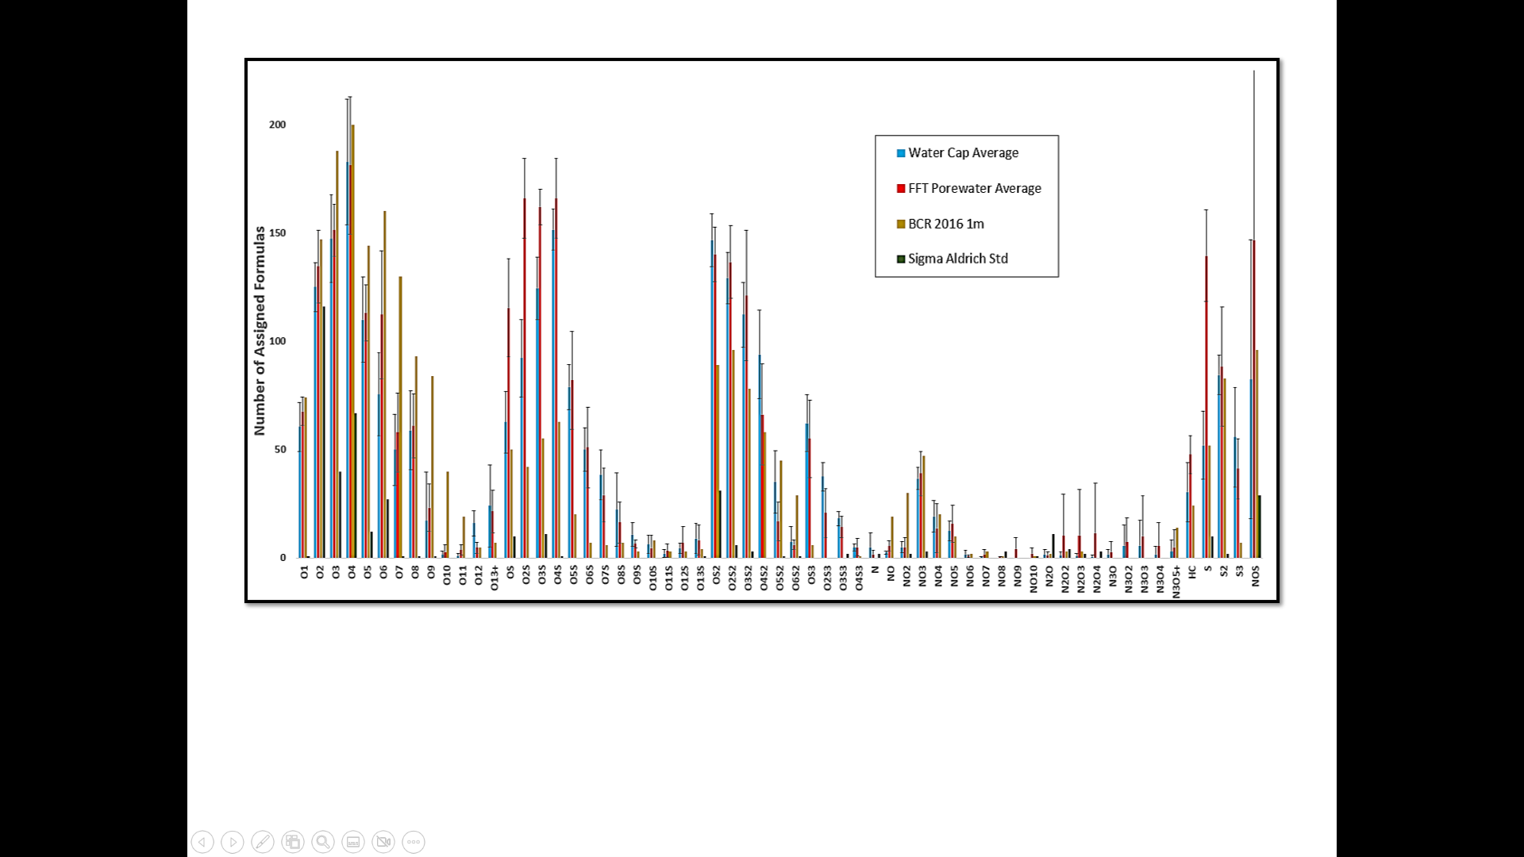
Figure S1. Number of Assigned Chemical Formulas for the various heteroatom classes detected in ESI (-)
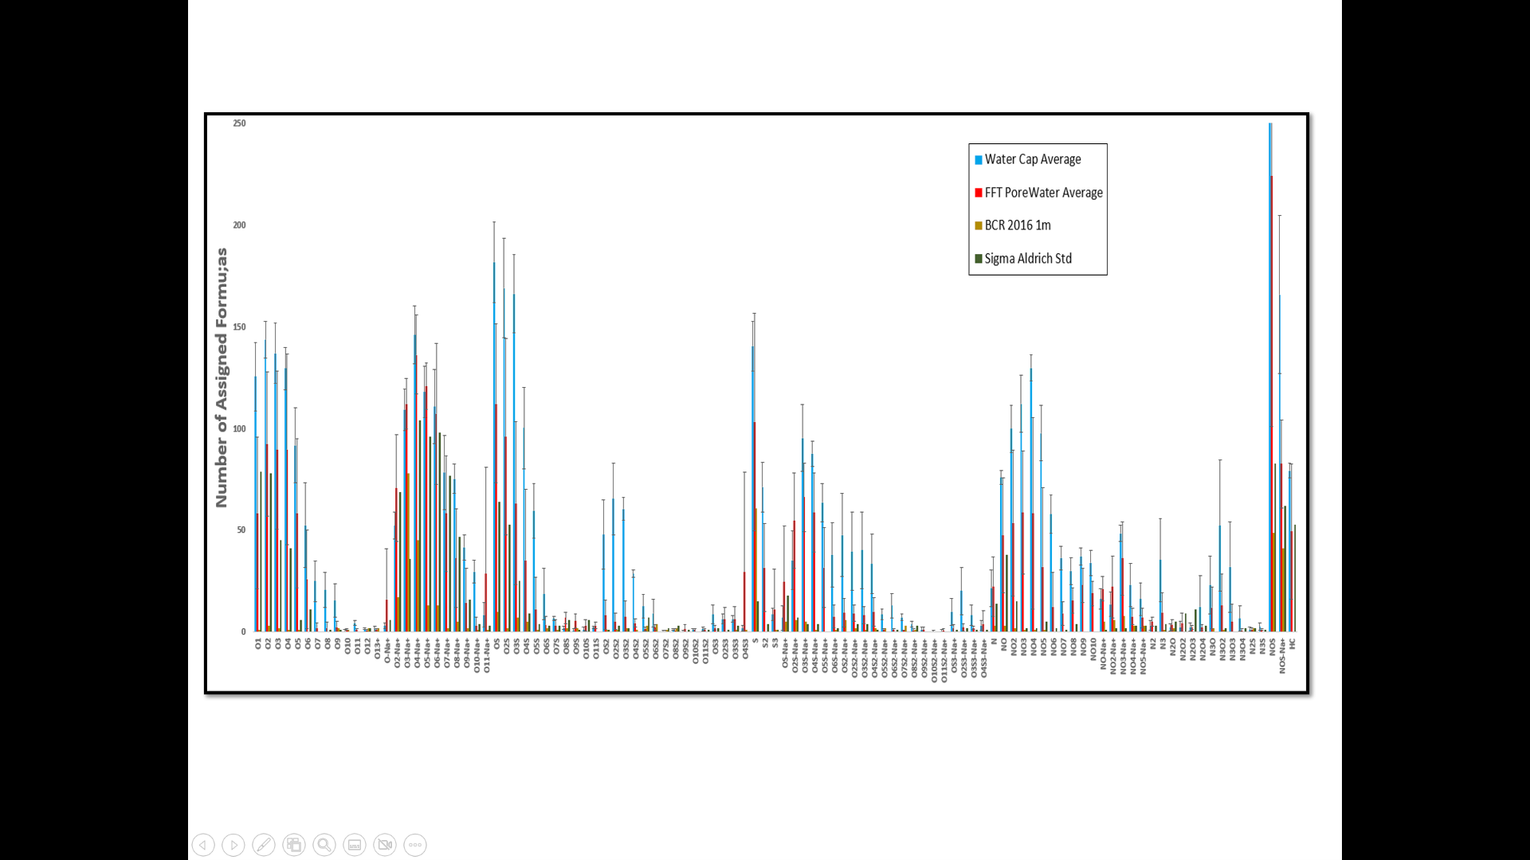
Figure S2. Number of Assigned Chemical Formulas for the various heteroatom classes detected in ESI (+)

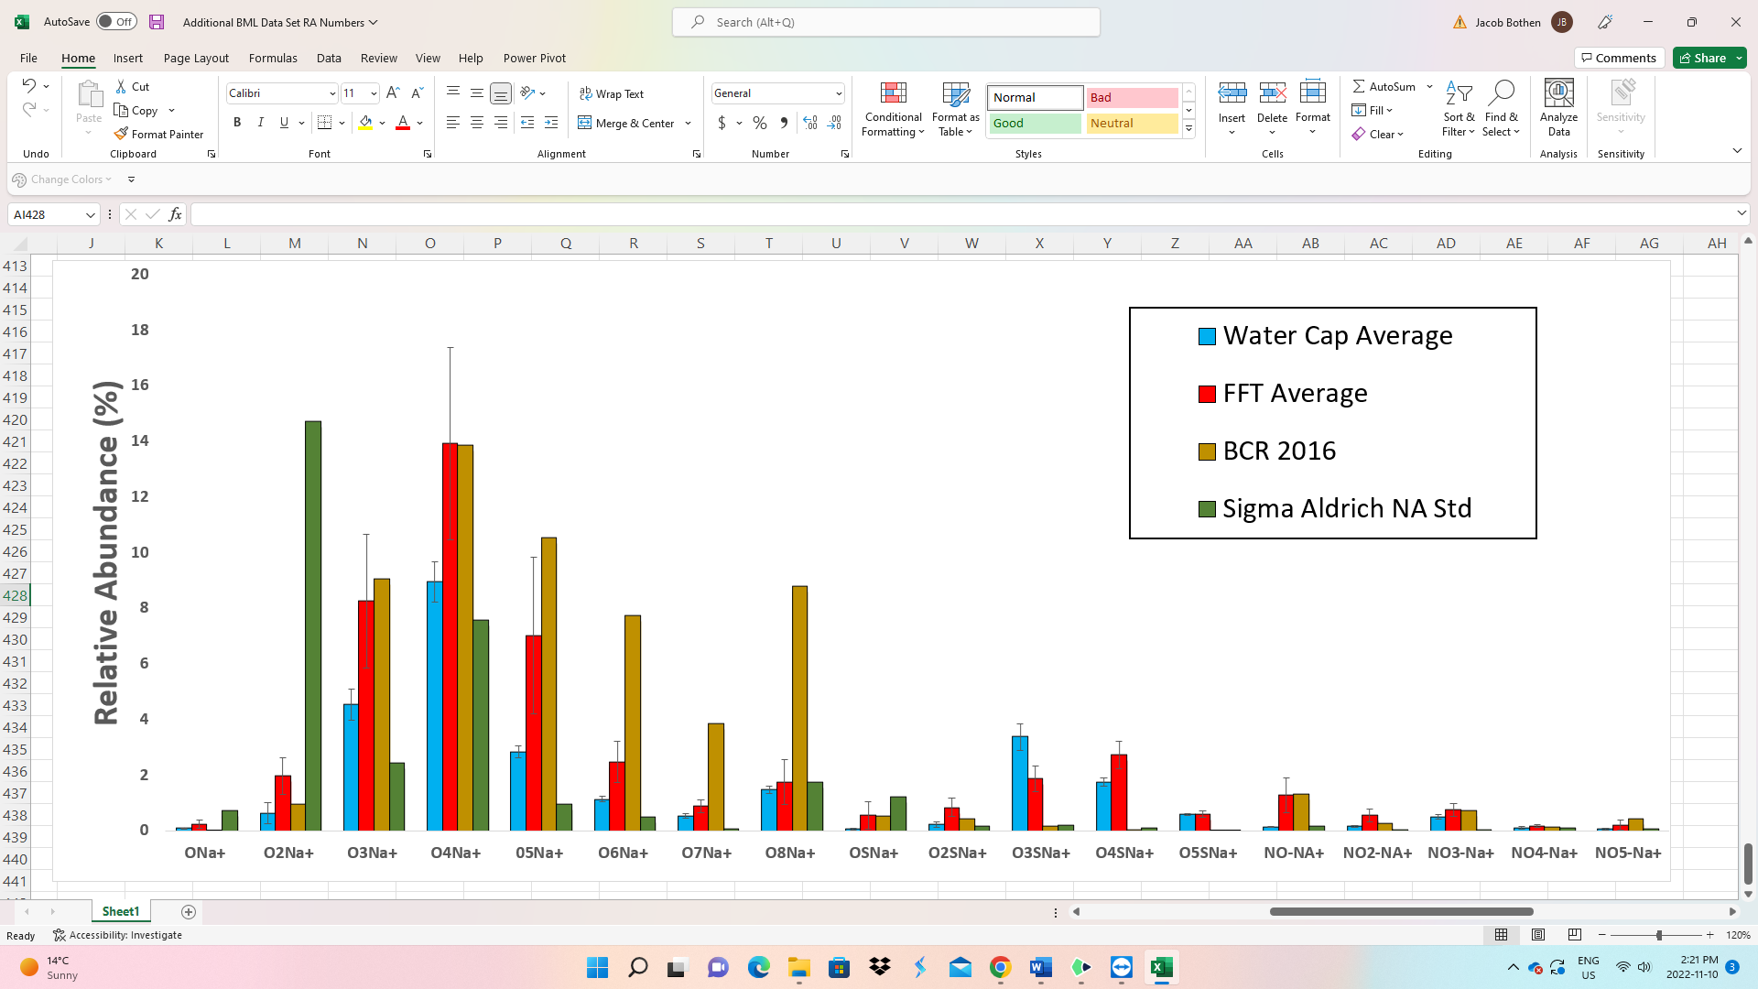
Figure S3. Relative abundance results for the major sodiated compounds detected in ESI (+).
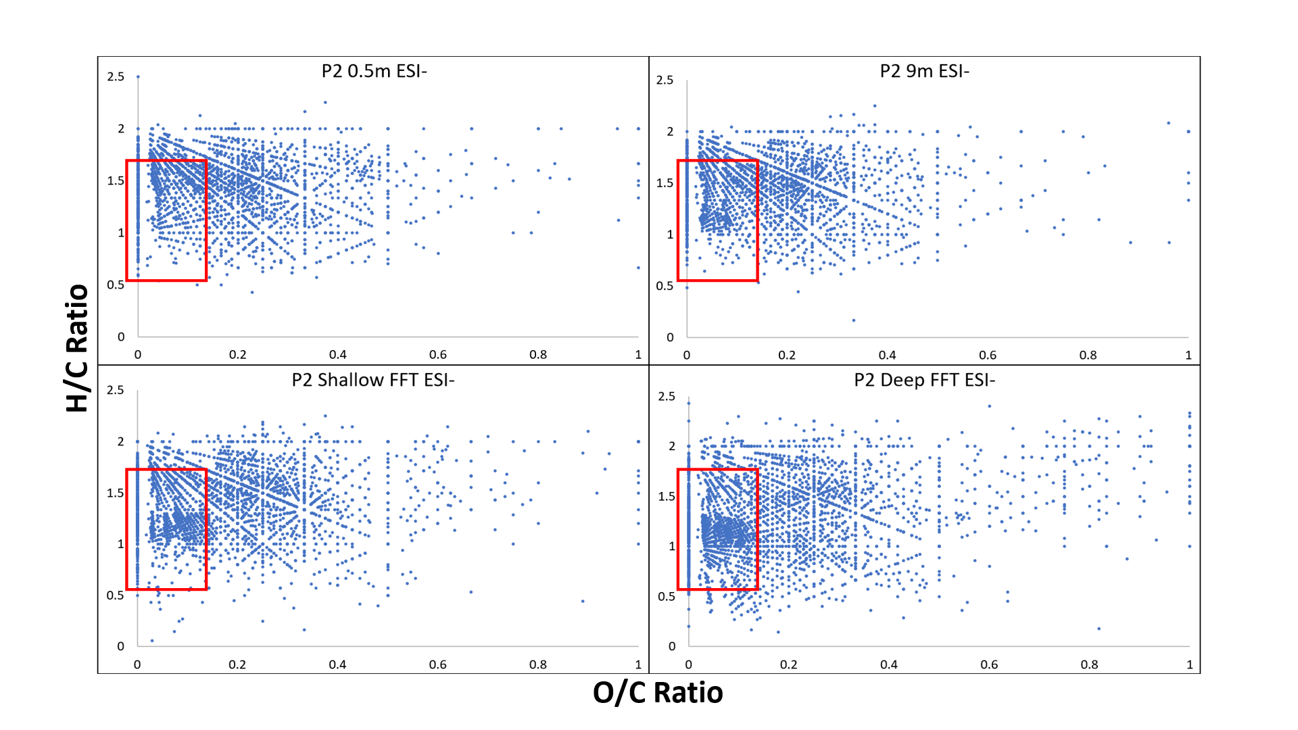
Figure S4. Van Krevelen diagrams of the ESI (-) measurements from water cap and FFT samples collected from Platform 2.
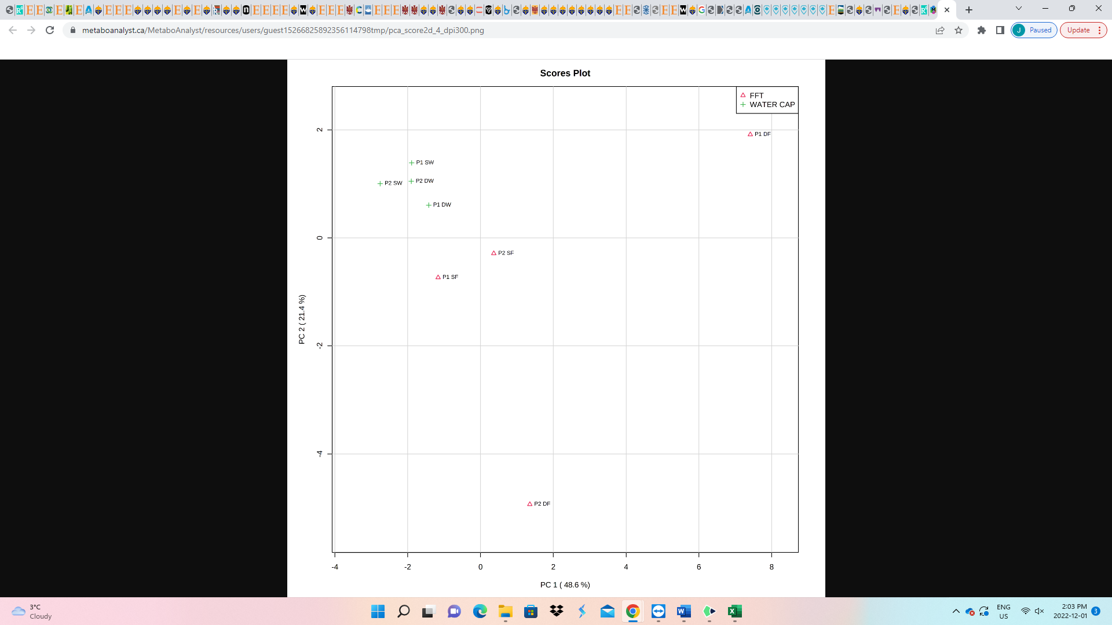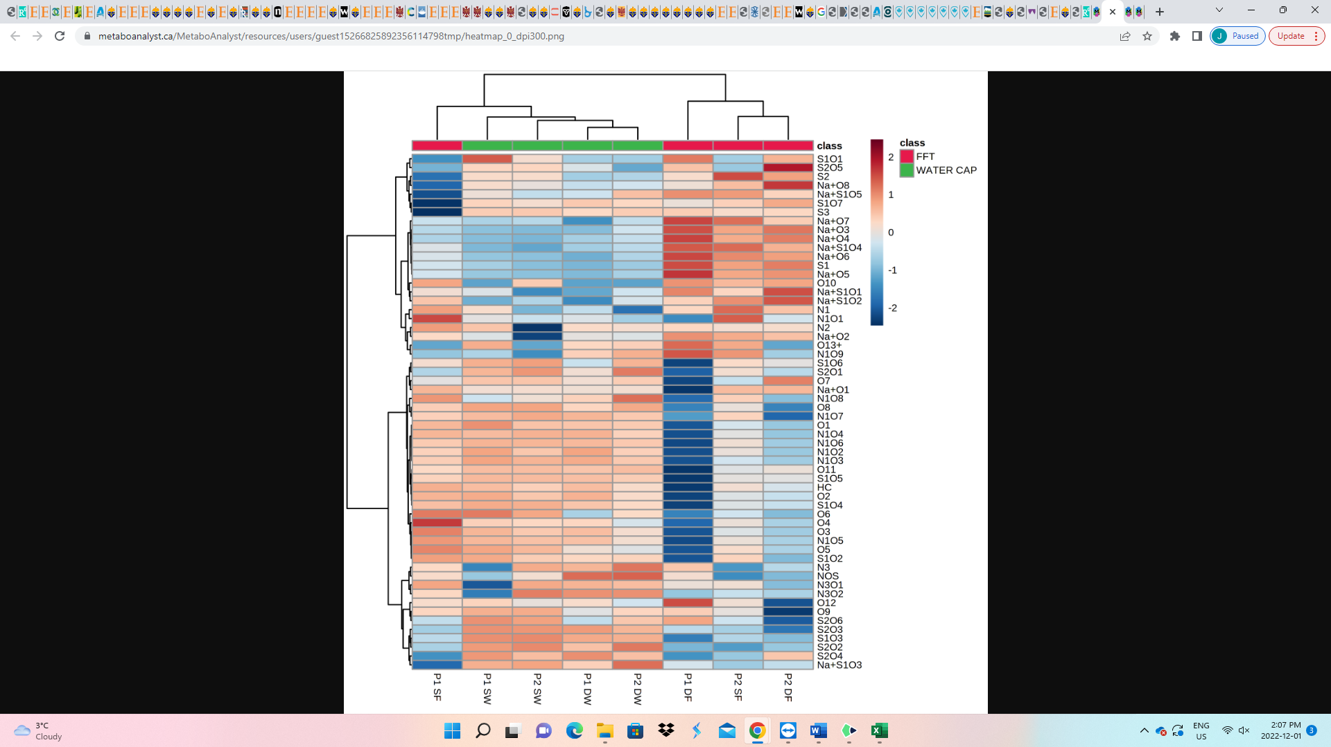
A)
B)
Figure S5. A) PCA plot for ESI (+) relative abundance data, and B) Correlation Heatmap of NAFC features analyzed by ESI (+).

Chapter Four: Conclusions and Future Research
4.1 Brief Summary of Research
The research contained within this dissertation focuses on two main topics: 1) analytical measurements of NAFCs, and 2) assessing NAFC sources and biogeochemical cycling in Base Mine Lake, the first large-scale Oil sands pit lake in the Athabasca Oil sands region. This dissertation centered around the utilization of ESI (+/-) FT ICR MS to characterize how certain analytical parameters may impact the detection of NAFCs from Oil sands impacted water samples and to understand the likely sources/biogeochemical processes that are associated with observed NAFC profiles that are present/absent across the BML system. This research attempts to add meaningful results to the culmination of analytical environmental chemistry research on characterizing the super complex mixture of organics present in oil sands affected materials, and how important environmental fate and transport mechanisms will impact their existence in BML as this aquatic landscape progresses into a functioning ecosystem.
4.2 Chapter Two:
Under geological timescales there are several factors that can alter the composition of raw petroleum whilst in the reservoir and these factors are carefully taken into account during the exploration and production of petroleum deposits. One such factor that petroleum geochemists closely watch is the extent of in situ biodegradation. We now understand that indigenous microorganisms in the subsurface have adapted to utilize hydrocarbons and non-hydrocarbons within the oil as a source of energy, which ultimately changes the physical and chemical properties of the parent oil. Depending on the degree of biodegradation, the altered oil can experience a depletion of saturated and cyclic hydrocarbons and a build-up of aromatic hydrocarbons and metabolic by-products that contain heteroatom (O, S, and N), which may be responsible for serious repercussions for the processing and refinement farther down the production sequence. Naphthenic acids Fraction Compounds (NAFC) are a diverse group of organics found in petroleum that contain varying amounts of O, S, and N atoms, and are a key group of chemicals that are closely monitored as part of the total acid number (TAN) of raw crude oils to indicate oil maturity and potential for corrosion problems (Barrow et al. 2003).
In the last two decades a large amount of scientific work has undergone the challenge of providing better analytical tools to understand the chemical composition of NA in crude oil and environmentally weathered oil (Barros et al. 2022). More specifically, upon the expansion of petroleum production from the oil sands deposits in Alberta, Canada; which represents a significant fraction of the global petroleum stockpile and contains a heavily biodegraded form of petroleum called bitumen (Huang et al. 2020), environmental concerns related to elevated NAs concentrations and subsequent toxic properties within oil sands process water (OSPW) and tailings generated from surface mining operations has initiated several monitoring programs. As lead by Dr. John Headley and many other scientists, countless studies have been published in recent years that focus on the analytical techniques/methods development better aimed at understanding to chemical composition of NAs within OSPW and other environmental matrices.
In chapter two, the objective of the study was to examine how differing the reconstitution solvents and ionization polarity influenced the high-resolution mass spectrometry analysis of acid extractable organics from water samples taken from an oil sands pit lake. This study expands upon two details within the article published by Headley et al. (2007) examining the impact of solvent systems in the analysis of NAFCs from OSPW, in which we included MeOH and Toluene solvent systems that are routinely used in petroleomic studies and that our measurements were accomplished in both positive and negative electrospray ionization Fourier transform ion cyclotron resonance mass spectrometry (ESI-FT ICR MS). The comparison between solvent systems and ionization polarity were evaluated by several indexes, which included the comparison of mass spectral performance indicators (I.e., total ion signal, mass accuracy, and mass distribution) and commonly found plots within NAFC studies (I.e., Carbon # Vs. DBE, Heteroatom relative abundance distribution, etc.). The 3:1 MeOH: Toluene solvent mixture was tentatively confirmed as the most suitable solvent system as it generated consistent and accurate results in both positive and negative ionization modes, as well as demonstrating it was capable of detection of a broad array of heteroatom classes, which were highlighted for its ability to measure Sulfur-containing NAFCs.
The results in this study reaffirmed previous conclusions from the analysis of NAFCs by high-resolution MS found that classical naphthenic acids (I.e., O₂) are one of the many classes observed within AEO and that the detection and assignment of Sulfur-containing NAFC requires mass spectrometers that have sufficient mass resolving power. A limitation of this study was the lack of duplicate or triplicate water samples used. Including duplicates or triplicates would provide more conclusive statistical results that would better determine which solvent reconstitution system was most optimal given the study’s analytical conditions. Additionally, several recent NAFC studies report the use of the 1:1 ACN: H₂O solvent system for reconstitution (Vander Meulen et al. 2021; ‘Heshka et al. 2022), thus including this solvent would have been a direct comparison of a commonly used solvent matrix to those used in this study.
4.3 Chapter Three:
Reclamation is an integral component within the mine closure strategies for surface mining operations in the Athabasca oil sands region (AOSR). The development of Water capped tailings technology (WCTT) began as lab demonstrations over three decades ago in the research labs of Syncrude Ltd. and has transformed into the first large scale demonstration in the AOSR with the creation of Base Mine Lake (BML). The scale of BML makes it a more dynamic and complex engineered aquatic environment than lab demonstrations, and with the assistance of internal research programs and numerous institutional research groups, various physical and biogeochemical processes in the lake are closely monitored and serve a key role in identifying and understanding potential challenges for future proposed pit lakes in the region. Factors such a turbidity, salt concentrations, oxygen consuming constituents (OCC), and residual organic contaminants have been the center of numerous BML studies and are also closely linked with meeting and maintaining regulatory criteria (Dompierre et al. 2016, 2017; Risacher et al. 2018; Arriaga et al. 2019; Tedford et al. 2019; Bowman et al. 2020; Slater et al. 2020, Jenssen et al. 2020; El-Waraky 2021; Syncrude 2022).
In chapter three, electrospray ionization Fourier transform ion cyclotron resonance mass spectrometry (ESI- FT ICR MS) was utilized for the first time to provide cutting edge insights on the molecular characterization of NAFCs within the acid extractable organics fraction of surface water and FFT porewater samples collected from 2 monitoring platforms in BML, as well as the nearby freshwater stream of beaver creek reservoir (BCR) and a commercially available naphthenic acid technical mixture. The objective of this research chapter was to advance several previously identified trends related to the cycling and sources of bitumen-derived organics (i.e., PHs and NAFCs) within the BML system. ESI (+/-)-FT ICR MS was advantageous for the analysis of NAFCs in relation to previous studies (Bowman et al. 2020; El-Waraky 2021) as it could precisely identify and detect numerous polar, heteroatom-containing chemical species that are important chemical markers for the presence of key transformation processes (i.e., biodegradation).
Shown in Figure 1 is a schematic outlining the major findings from this research chapter. The results in this study further demonstrated that the two distinctive biogeochemical redox zones in BML (i.e., the oxic (aerobic) water column and the anoxic (anaerobic) underlying FFT) and the different starting materials that make up these zones (i.e., OSPW in water cap and tailings in FFT) strongly contributed to the distinct NAFC profiles we observed. The aerobic biodegradation pathways are established in the water column of BML because of greater abundances of oxidized NAFCs (i.e., O₃^{-/+} and O₄^{-/+}) compared to classical NAs (i.e., O₂^{-/+}) that were measured in the underlying FFT. This study was the first to provide evidence that photodegradation of hydrocarbons or bitumen may be occurring on the surface waters of BML. Through the utilization of Carbon Number Vs. DBE plots, Van Krevelen diagrams, and chemometric analyses, NAFCs observed in BML contain alkylated-cyclic and -aromatic chemical structures and larger abundances of Sulfur-containing NAFCs than the freshwater sample from BCR. Additionally, hydrocarbon compounds (i.e., S₁, N₁, and HC) were detected in both the water cap and FFT samples signalling that BML continues to have a chemical profile dominated by bitumen-derived organics. However, the FFT samples routinely detected an increased number and relative abundances of these non-polar compounds compared to the water cap which suggests that these compounds are originating from the residual bitumen and residual organic solvents (Naphtha) found within the FFT. As a result of porewater advection from natural consolidation of FFT porewater in the water column, in combination with other transport/mixing mechanisms (i.e., diffusion and ebullition), the FFT acting as a source of non-polar compounds may be persistent issue in BML that needs further investigating within the adaptive management practices of end pit lakes.
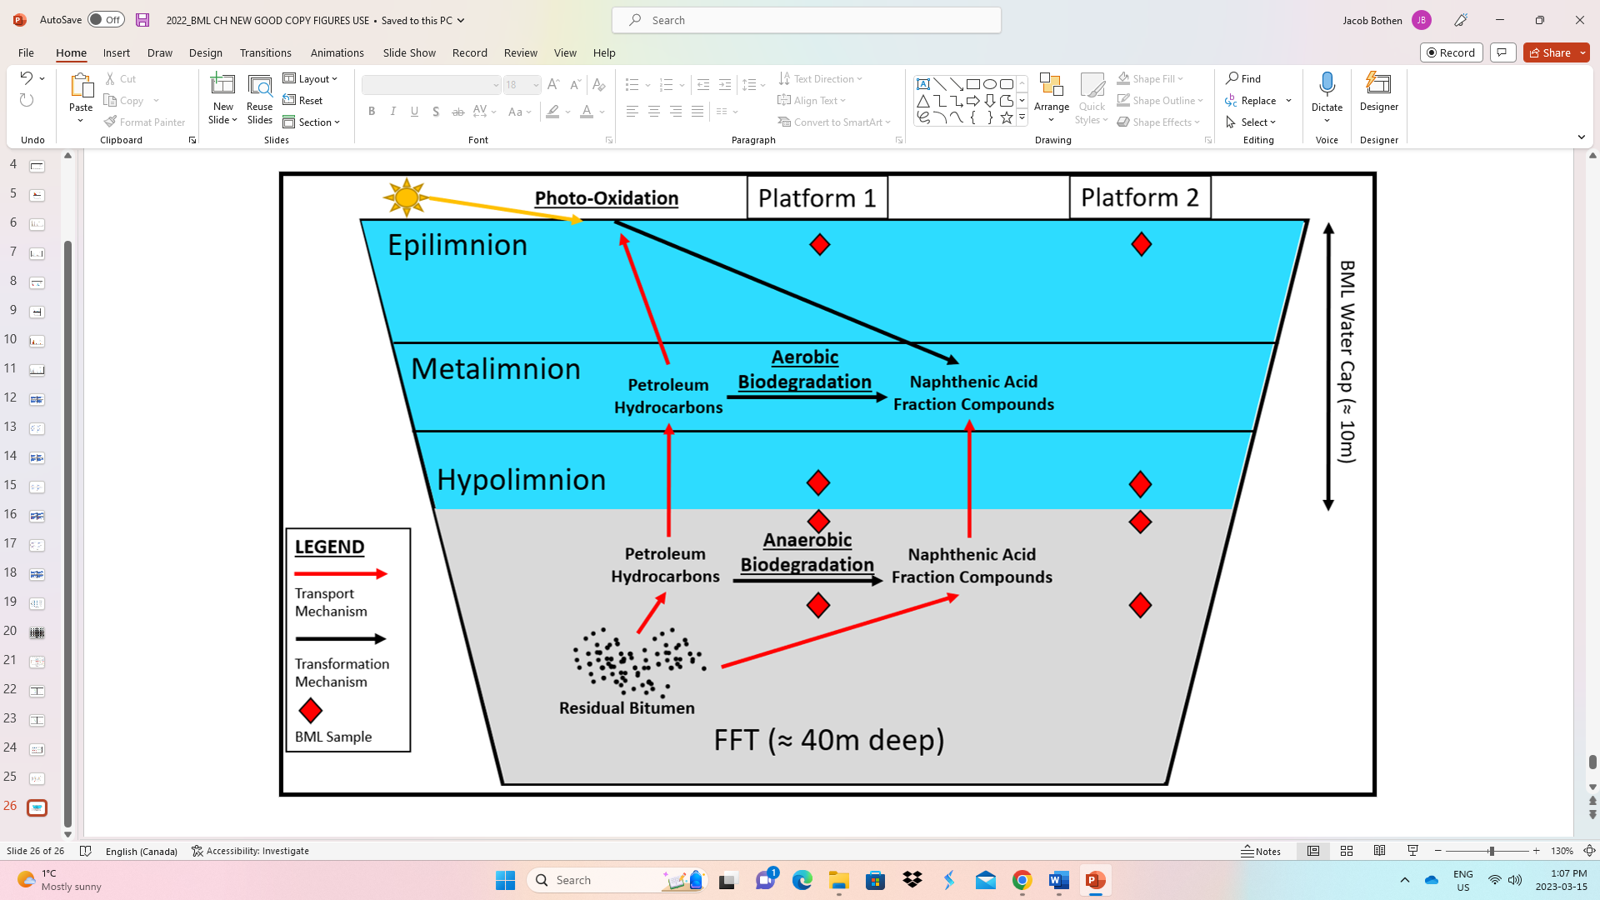
Figure 1. Generalized scheme of the Environmental Fate and Transport of NAFCs and PH in BML.
4.4 Study Limitations and Future Research Considerations:
Limitations
While conducting this research I realized there were several limitations in this dissertation that were attributed to the analytical methods and technique used.
Firstly, ESI-FT ICR MS analysis is highlighted for its ability to provide an extensive compositional framework for more polar and less volatile species in a given sample, but since the mode of sample introduction was direct infusion and not paired with chromatographic separation techniques, it cannot provide information related to the numerous chemical isomers for the compounds identified within the mass spectra. In addition, many of the volatile and low molecular weight organics potentially present in BML would not be measured by ESI-FT ICR MS and are more suitable for gas chromatographic mass spectrometry analysis. Understandably, these factors are part of the greater limitations to the analysis of complex organic mixtures in that there is no one single analytical technique that can measure all chemical species present in a way that is optimal for both qualitative and quantitative.
While optimizing the FT ICR MS used in this thesis, I observed that the mass resolution was ideal for the closest of isobaric compounds (~400,000 at 400 m/z), however, the mass accuracies were more variable between negative and positive mode (c.f. Figure 2) and were slightly larger than reported values from other studies (Headley et al. 2007; Headley et al. 2011; Barrow et al. 2015; Headley et al. 2016). This observation is likely a consequence of several factors. The first and most likely culprit is that the sample concentration may be too high and caused there to be too many ions within the ICR cell resulting in increased ion collisions during their cyclotron frequency. The second factor is that only an external calibration method prior to running the samples was used. To achieve more accurate results in future analysis, the inclusion of a set of internal standard compounds that will not likely be found in the samples (i.e., isotopically enriched compounds like deuterated compounds) should be added to take advantage of the lock mass calibration system within the operating system of the SolariX XR. In addition, the processing and formula assignment of the large quantity of mass spectral data within chapters two and three were completed using a combination of the SmartFormula function in Data Analysis and Excel/Python, which took many hours to complete. The use of commercially available processing software’s like Composer or Petro-Org would decrease the amount of time for sample processing and assist in rapidly visualizing the data in commonly used plots (i.e., DBE vs. C#, relative abundances, etc.).
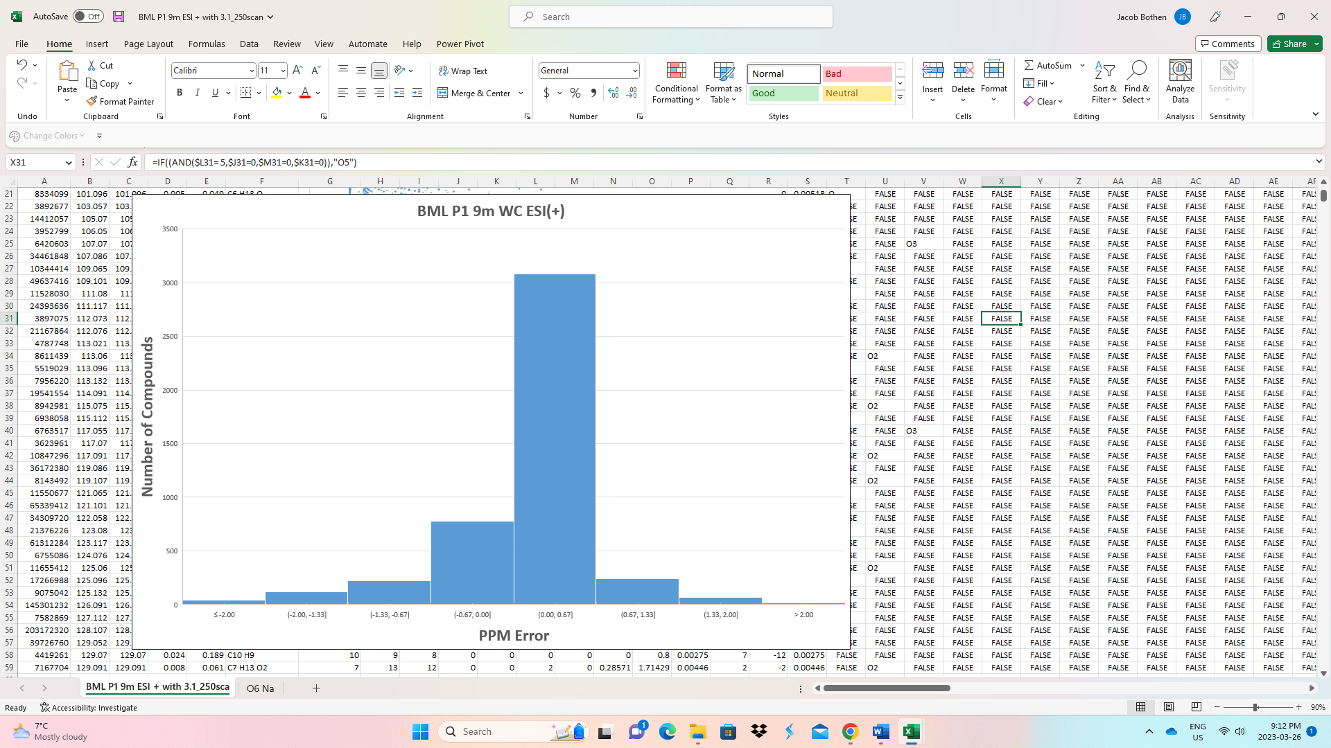
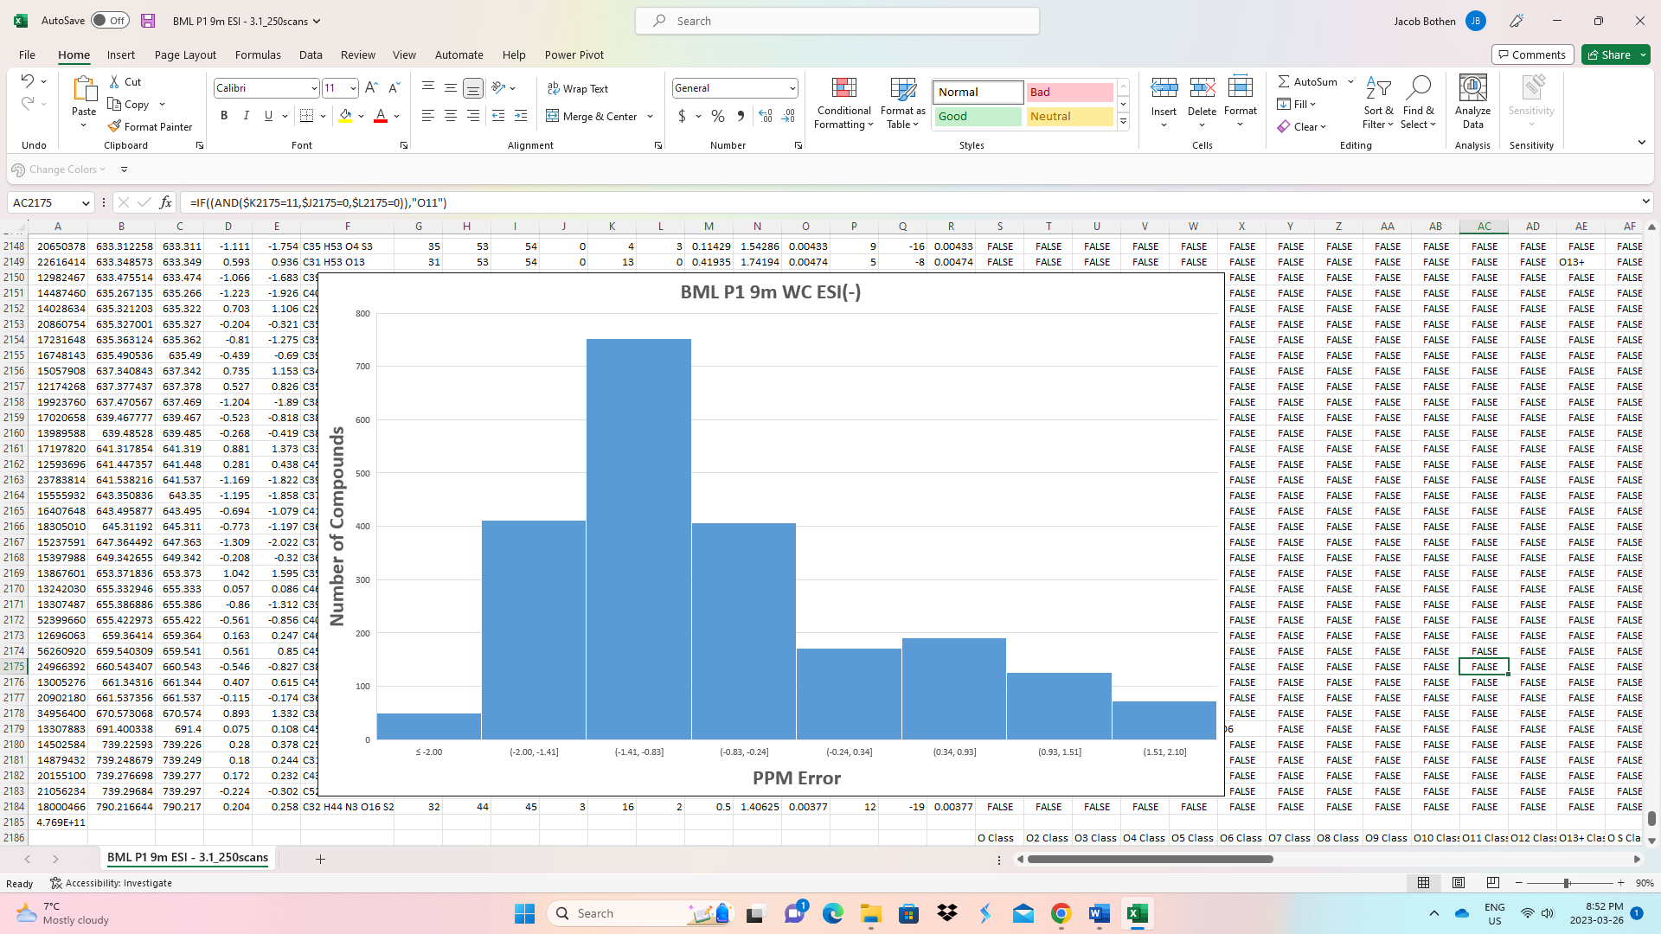
Figure 2. Histograms of the ppm error values assigned to the chemical formulas identified in ESI (+) & (-)
Future Research Considerations
Considering that BML is the first large scale oil sands pit lake, the research conducted over its lifetime will be valuable for other oil sands operators when additional pit lakes are being planned and ultimately commissioned in the surrounding region. The samples utilized in this dissertation were taken from platform 1 and 2 in BML in the summer of 2019, and represented a spatial analysis of NAFCs. To further evaluate the extent of the biogeochemical processes and the key transport mechanisms will have on the long-term environmental fate of NAFCs, a larger temporal analysis of BML water cap and FFT samples are strongly suggested. This may include water cap and FFT samples collected during the first year of BML (2013), prior and post whole-lake alum addition (2015-2017), and a decade after BML was commissioned (2022). The inclusion of other water samples to this future study, such as fresh OSPW from a tailings pond or additional samples from BCR or the Athabasca River, may also demonstrate how the BML chemical profile is dynamically changing. Finally, the residual bitumen present in the FFT may also be another potential type of sample to include in future analysis, as its measurements may give novel molecular insights to the polar NAFCs that could potentially leach from the bitumen into the porewater and subsequently released into the water cap.
On-going laboratory experiments utilizing samples collected from BML should focus on the key transformation and transportation mechanisms highlighted in Chapter Three. These include microcosms containing either FFT or water cap samples, which can be used to examine biodegradation of hydrocarbons or NAFCs, as well as gas ebullition experiments to understand the mechanism of hydrocarbon/bitumen transport potentially occurring in BML. It may be of interest to conceptualize or quantify the organics that partition into the gas phase of bubbles or onto the bubble surfaces. It is known in the literature that surfactants, such as NAFCs, play an important role in the formation and stabilization of gas bubbles while moving through a water column (Liefer and Patro 2002), as well as lowering the interfacial tension between crude oil and water (Anderson et al. 2016). Understanding these discrete bubble properties and mechanisms from BML samples may serve a greater role in helping to identify solutions to help mitigate bitumen transport from gas ebullition.
Lastly, I suggest that in order to provide the most comprehensive analytical results of non-polar and polar organics in BML, a future study should consider combining the use of two-dimensional gas chromatography mass spectrometry (GCxGC-MS) and ESI-FT ICR MS of BML water cap and FFT samples. Tarr et al. (2016) concluded that the combination of these two analytical techniques after the Deepwater Horizon oil spill were extremely advantageous for tracking the environmental weathering of petroleum constituents. GCxGC-MS analysis can provide accurate measurements of low molecular weight and volatile organics, such as hydrocarbons from the residual naphtha in the FFT which are suspected to be the drivers of methanogenesis (Slater et al. 2021) or hydrocarbons contained within the bitumen sheens located at the air-water interface of the BML surface waters.
4.5 References.
Barrow, M. P., McDonnell, L. A., Feng, X., Walker, J., & Derrick, P. J. (2003). Determination of the nature of naphthenic acids present in crude oils using nanospray Fourier transform ion cyclotron resonance mass spectrometry: The continued battle against corrosion. Analytical Chemistry, 75(4). https://doi.org/10.1021/ac020388b

Barros, E. v., Filgueiras, P. R., Lacerda, V., Rodgers, R. P., & Romão, W. (2022). Characterization of naphthenic acids in crude oil samples – A literature review. In Fuel (Vol. 319). https://doi.org/10.1016/j.fuel.2022.123775

Huang, H., Silva, R. C., Radović, J. R., & Larter, S. R. (2020). Environmental and Economic Implications of the Biogeochemistry of Oil Sands Bitumen. In Hydrocarbons, Oils and Lipids: Diversity, Origin, Chemistry and Fate. https://doi.org/10.1007/978-3-319-90569-3_19

Headley, J. v., Peru, K. M., Barrow, M. P., & Derrick, P. J. (2007). Characterization of naphthenic acids from athabasca oil sands using electrospray ionization: The significant influence of solvents. Analytical Chemistry, 79(16). https://doi.org/10.1021/ac070905w

vander Meulen, I. J., Klemish, J. L., Peru, K. M., Chen, D. D. Y., Pyle, G. G., & Headley, J. v. (2021). Molecular profiles of naphthenic acid fraction compounds from mine lease wetlands in the Athabasca Oil Sands Region. Chemosphere, 272. https://doi.org/10.1016/j.chemosphere.2021.129892

Heshka, N. E., Peru, K. M., Xin, Q., Dettman, H. D., & Headley, J. v. (2022). High resolution Orbitrap mass spectrometry analysis of oxidized hydrocarbons found in freshwater following a simulated spill of crude oil. Chemosphere, 292. https://doi.org/10.1016/j.chemosphere.2021.133415

Dompierre, K. A., Lindsay, M. B. J., Cruz-Hernández, P., & Halferdahl, G. M. (2016). Initial geochemical characteristics of fluid fine tailings in an oil sands end pit lake. Science of the Total Environment, 556. https://doi.org/10.1016/j.scitotenv.2016.03.002

Dompierre, K. A., Barbour, S. L., North, R. L., Carey, S. K., & Lindsay, M. B. J. (2017). Chemical mass transport between fluid fine tailings and the overlying water cover of an oil sands end pit lake. Water Resources Research, 53(6). https://doi.org/10.1002/2016WR020112

Risacher, F. F., Morris, P. K., Arriaga, D., Goad, C., Nelson, T. C., Slater, G. F., & Warren, L. A. (2018). The interplay of methane and ammonia as key oxygen consuming constituents in early stage development of Base Mine Lake, the first demonstration oil sands pit lake. Applied Geochemistry, 93. https://doi.org/10.1016/j.apgeochem.2018.03.013

Arriaga, D., Nelson, T. C., Risacher, F. F., Morris, P. K., Goad, C., Slater, G. F., & Warren, L. A. (2019). The co-importance of physical mixing and biogeochemical consumption in controlling water cap oxygen levels in Base Mine Lake. Applied Geochemistry, 111. https://doi.org/10.1016/j.apgeochem.2019.104442

Tedford, E., Halferdahl, G., Pieters, R., & Lawrence, G. A. (2019). Temporal variations in turbidity in an oil sands pit lake. Environmental Fluid Mechanics, 19(2). https://doi.org/10.1007/s10652-018-9632-6

Bowman, D. T., Warren, L. A., & Slater, G. F. (2020). Isomer-specific monitoring of naphthenic acids at an oil sands pit lake by comprehensive two-dimensional gas chromatography–mass spectrometry. Science of the Total Environment, 746. https://doi.org/10.1016/j.scitotenv.2020.140985

Slater, G. F., Goad, C. A., Lindsay, M. B. J., Mumford, K. G., Nelson, T. E. C., Brady, A. L., Jessen, G. L., & Warren, L. A. (2021). Isotopic and chemical assessment of the dynamics of methane sources and microbial cycling during early development of an oil sands pit lake. Microorganisms, 9(12). https://doi.org/10.3390/microorganisms9122509

Jessen, G. L., Chen, L. X., Mori, J. F., Nelson, T. E. C., Slater, G. F., Lindsay, M. B. J., Banfield, J. F., & Warren, L. A. (2022). Alum Addition Triggers Hypoxia in an Engineered Pit Lake. Microorganisms, 10(3). https://doi.org/10.3390/microorganisms10030510

Headley, J. v., Barrow, M. P., Peru, K. M., Fahlman, B., Frank, R. A., Bickerton, G., McMaster, M. E., Parrott, J., & Hewitt, L. M. (2011). Preliminary fingerprinting of Athabasca oil sands polar organics in environmental samples using electrospray ionization Fourier transform ion cyclotron resonance mass spectrometry. Rapid Communications in Mass Spectrometry, 25(13). https://doi.org/10.1002/rcm.5062

Barrow, M. P., Peru, K. M., Fahlman, B., Hewitt, L. M., Frank, R. A., & Headley, J. v. (2015). Beyond Naphthenic Acids: Environmental Screening of Water from Natural Sources and the Athabasca Oil Sands Industry Using Atmospheric Pressure Photoionization Fourier Transform Ion Cyclotron Resonance Mass Spectrometry. Journal of the American Society for Mass Spectrometry, 26(9). https://doi.org/10.1007/s13361-015-1188-9

Headley, J. v., Peru, K. M., & Barrow, M. P. (2016). Advances in mass spectrometric characterization of naphthenic acids fraction compounds in oil sands environmental samples and crude oil - A review. In Mass Spectrometry Reviews (Vol. 35, Issue 2). https://doi.org/10.1002/mas.21472

Leifer, I., & Patro, R. K. (2002). The bubble mechanism for methane transport from the shallow sea bed to the surface: A review and sensitivity study. Continental Shelf Research, 22(16). https://doi.org/10.1016/S0278-4343(02)00065-1

Andersen, S. I., Chandra, M. S., Chen, J., Zeng, B. Y., Zou, F., Mapolelo, M., Abdallah, W., & Buiting, J. J. (2016). Detection and Impact of Carboxylic Acids at the Crude Oil-Water Interface. Energy and Fuels, 30(6). https://doi.org/10.1021/acs.energyfuels.5b02930

Tarr, M. A., Zito, P., Overton, E. B., Olson, G. M., Adhikari, P. L., & Reddy, C. M. (2016). Weathering of oil spilled in the marine environment. Oceanography, 29(3). https://doi.org/10.5670/oceanog.2016.77

