IDENTIFYING AND CHARACTERIZING NOVEL ANTITHROMBIN-INHIBITING RNA APTAMERS

IDENTIFYING AND CHARACTERIZING NOVEL ANTITHROMBIN-INHIBITING RNA APTAMERS

By MOSTAFA AMR HAMADA, B.Sc.

A Thesis
Submitted to the School of Graduate Studies
in Partial Fulfillment of the Requirements for the Degree
Master of Science

McMaster University
© Copyright by Mostafa Amr Hamada, 2022
MASTER OF SCIENCE (2022) McMaster University (Medical Sciences) Hamilton, Ontario

TITLE: Identifying and Characterizing Novel Antithrombin-Inhibiting RNA Aptamers
AUTHOR: Mostafa A. Hamada. B.Sc. (McMaster University)
SUPERVISOR: Dr. William P. Sheffield
COMMITTEE MEMBERS: Dr. Yingfu Li, Dr. Patricia Liaw, Dr. Colin Kretz
NUMBER OF PAGES: xii, 156

ABSTRACT
Antithrombin (AT) is a plasma serine protease inhibitor that regulates thrombin and other activated clotting factors in the intrinsic and common pathways of coagulation. As the most abundant coagulation pathway inhibitor, AT serves to maintain balance in the coagulation system by inducing an anticoagulant effect. The importance of AT is evident in cases where deficiencies of AT lead to increased risk of venous thromboembolic disease. Since an AT antagonist would be considered a procoagulant, inactivating AT could provide a novel approach to restoring hemostasis in patients with inherited or acquired bleeding disorders.
In vitro selection is a powerful tool used to screen large combinatorial oligonucleotide libraries against a target molecule or protein. By employing this technique in combination with high-throughput screening, we identified novel RNA aptamer candidates capable of binding AT with high affinity and inhibiting AT’s inactivation of its main target protease, thrombin.
Kinetic characterization of the most abundant aptamer candidates showed a reduction in AT-mediated thrombin inhibition of 50-60%. The most inhibitory aptamer, R6_15, mediated a decrease of AT’s second-order rate constant from 2.37 ± 0.06 x 10⁴ to 1.57 ± 0.02 x 10⁴ M⁻¹ s⁻¹ (mean ± SD) The interaction between the aptamers and AT was also measured in human plasma. In a clotting assay, aptamer R6_15 accelerated clotting time by approximately 7 seconds (from 44.3 ± 0.8 to 37.3 ± 0.7 seconds). This difference in clotting time was the greatest noticed among all the other aptamer candidates. By measuring the change in AT’s fluorescence intensity, we were able to determine the aptamers’ binding capacity. The binding affinities (k_{d}) of aptamers R6_15 and R6_19 were 65.3 ± 8.7 and 67.5 ± 14.5 nM, respectively. Truncation of R6_15 on either its 5’ or 3’ end did not increase its inhibitory activity or binding affinity towards AT. By pairing the selection data with dynamic molecular modelling, the interface of aptamer R6_15 to AT was predicted to be at the site of heparin binding, specifically at residue K114. Although these computer-generated results are not conclusive, they provide a testable hypothesis for future experimentation.
Ultimately, this work provides evidence that the application of in vitro evolution has yielded a novel anti-serpin aptamer. With some modifications, the selection protocol employed in this study could be revisited to identify tighter binders and more potent inhibitors of AT. Either aptamer R6_15 or a future higher affinity AT-binding aptamer could be tested for its efficacy in reducing bleeding in vivo using mouse models of acquired hemophilia or traumatic bleeding.

ACKNOWLEDGEMENTS
It is only appropriate to start this section with many thanks to my research supervisor and mentor Dr. William Sheffield. His passion for science and impressive intellect about all things blood and serpins truly resonated with me for the duration of my lab career (which is almost half a decade), starting as a mere 3rd year undergraduate research student in 3H31. Regardless of how many tangents our one-on-one meetings took, I always valued our time together and the light-hearted conversations that took place over Zoom or in the office with the view of the “glass castle”. I would also like to thank my supervisory committee members Dr. Colin Kretz, Dr. Patricia Liaw, and Dr. Yingfu Li for their commitment to the advancement of my project and their invaluable advice.
It would have been difficult (possibly impossible) to conduct any experiment without the guidance and persistence of Varsha. However, I would never have enjoyed my time in the lab (or breakroom) without the fun conversations with Louise and Antje, who always made me feel welcomed from the first day. To my fellow students, Tyler, Ghofran, and Sangavi: words cannot describe the amount of fun, engaging, and extensive chats that we had. Whether we were talking about TikTok’s, memes, Marvel, or video games, your endless support and motivation is something I will carry forward in my career. To my ‘Day 1’ brothers; Fadel, Abdul, Afif, Uzair, and Haseab: thank you for always being up for late-night coffee chats or your endless support and motivation.
A final thanks to my parents, Amr and Lina, who were always by my side and helped me through a lot of difficult times, even though I am pretty sure they still do not understand what my Master’s is about. I hope this thesis helps them understand…or not.
TABLE OF CONTENTS
Title Page…………………………………………………………………………………...i
Descriptive Note………………………………………………………………......……….ii
Lay Abstract……………………………………………………………...….……………iii
Abstract………………………………………………………………………..………… iv
Acknowledgements……………………………………………………………………… vi
Table of Contents……………………………………...…………………...…………… vii
List of Figures……………………………………………………………...….…………..x
List of Tables……………………………………………………………...….…………..xii
List of Symbols and Abbreviations………………………………….…...….…………..xiii

1 Introduction 1
1.1 Coagulation 1
1.1.1 The Coagulation Cascade 1
1.1.2 Haemostasis 2
1.2 Thrombin 6
1.3 Serpins 6
1.3.1 Mechanism of Function 7
1.3.2 Antithrombin’s Role in Coagulation 8
1.3.2.1 Antithrombin-Heparin Interaction 9
1.3.3 Antithrombin Deficiency 10
1.4 Nucleic Acid Inhibitors in Coagulation 11
1.4.1 Short-Interfering RNAs 11
1.4.2 Aptamers 13
1.4.2.1 Anticoagulant Aptamers 14
1.4.2.2 Procoagulant Aptamers 14
1.5 Selecting for Novel RNA Aptamer by Applying In-Vitro Selection Protocols 15
1.5.1 Applying High-Throughput Screening 16
1.6 Rationale for Study 19
1.7 Hypotheses 19
1.8 Project Outline 19

2 Materials 21
2.1 Source of Chemicals and Reagents 21
2.2 Oligonucleotides 21
2.3 Computer Software 24
3 Methods 25
3.1 Combinatorial RNA Library 25
3.2 In Vitro Selection Protocol 25
3.2.1 Systematic Evolution of Ligands by EXponential enrichment (SELEX) 25
3.2.2 Purifying RNA Sequences 26
3.2.3 Confirmation of Sequence Regeneration after Selection Rounds 27
3.2.4 High-Throughput Screening 27
3.2.5 Synthesizing Aptamer Sequences 31
3.3 Kinetic Characterization of AT Inhibition of Thrombin 31
3.3.1 Thrombin Activity Assay 32
3.3.2 Aptamer Inhibition of AT in Kinetics Assay 32
3.3.3 Aptamer Inhibition of AT-Heparin Complex in Kinetics Assay 33
3.3.4 Measuring Residual Thrombin Activity 34
3.4 Clotting Time Assay 34
3.4.1 Normal aPTT Assay 35
3.4.2 Modified aPTT Assay 35
3.4.3 Diluted aPTT Assay 35
3.5 Binding Characterization using Plate Binding Assay 36
3.6 Binding Characterization using AT Intrinsic Fluorescence 37
3.7 Truncation of R6_15 Aptamer 39
3.8 Consensus Sequence Analysis 42
3.9 Molecular Modeling of AT Interactions with Aptamers 42
4 Results 44
4.1 Biopanning the Combinatorial RNA Library with AT 44
4.1.1 HT Sequencing Results 44
4.2 AT Inhibition of Thrombin 52
4.3 Kinetic Characterization of Aptamer Candidates as Inhibitors of AT in Thrombin-mediated Amidolysis 55
4.3.1 Round 6 and 10 RNA Pools Significantly Increase Rate of Thrombin-mediated Amidolysis, compared to the Initial Round 0 55
4.3.2 Comparing the Effects of Aptamer Candidates on AT’s Rate of Thrombin Inhibition 58
4.3.3 Effects of Heparin on the Aptamer Candidates Kinetic Characterization. 61
4.4 Inhibition of AT by Aptamer Candidates in Pooled Human Plasma 66
4.4.1 Measuring Clotting Time in Standard aPTT Assay 66
4.4.2 Measuring Clotting Time in Modified aPTT Assay 66
4.4.3 Measuring Clotting Time in Dilute aPTT Assay 72
4.5 Characterization of Immobilized Aptamer Binding Affinity to AT using a Plate Binding Assay 75
4.6 Effects of Aptamers R6_10, R6_15, and R6_19 on the Intrinsic Fluorescence of AT as a measure of Binding Affinity 82
4.7 Effects of Truncated R6_15 Variants on AT Inhibition in Human Plasma 98
4.8 Binding Characterization of Truncated R6_15 Variants to AT using Intrinsic Fluorescence 105
4.9 RNA Sequence Analysis of the Most Active Aptamers 111
5 Discussion 116
5.1 The In Vitro Selection Protocol and its Limitations 116
5.1.1 Ranking of the Most Abundant Sequences 119
5.2 Determining the Most Improved Aptamers based on Kinetic Characteristics 121
5.3 Examining the Most Improved Aptamers based on Binding Characteristics 123
5.4 Determining the Most Improved Aptamers based on Clotting Time Assay 125
5.5 Predicting the Optimal Regions on Aptamer for AT Inhibition 127
5.5.1 Sequence Alignment 129
5.5.2 Secondary Structure Analysis 129
5.6 Modelling Aptamer-AT Interactions 133
6 Conclusions and Future Directions 139
7 Appendix 142
8 References 146

LIST OF FIGURES
Figure 1. The current model of the coagulation cascade 5
Figure 2. A diagram of SELEX in vitro selection process 18
Figure 3. Magnetic bead-antithrombin complex 30
Figure 4. Graphical illustration of sequences of the truncated R6_15 variants 41
Figure 5. Output of high-throughput screening Rounds 2-10 46
Figure 6. Enrichment graph of the aptamer candidates 51
Figure 7. Kinetic parameters of AT inhibition of thrombin with and without heparin 54
Figure 8. Thrombin activity assay demonstrate a significant increase in chromogenic substrate cleavage 57
Figure 9. Screening test for the aptamers capable of decelerating AT’s inhibition of thrombin 60
Figure 10. Heparin-catalyzed kinetic parameters 63
Figure 11. Effects of aptamer candidates in normal and modified aPTT assays 69
Figure 12. Effects of aptamer candidates on pooled AT-deficient human plasma in a dilute aPTT assay 74
Figure 13. Binding characterization of the top aptamer candidates to AT using the plate-based binding assay 79
Figure 14. Standard curve of AT using the plate-based binding assay 81
Figure 15. Example of the fluorescence emission spectra of AT before and after the addition of 10 U/mL standard heparin 85
Figure 16. Example of the fluorescence emission spectra of AT before and after the addition of aptamers 87
Figure 17. Characterization of the AT standard curve in fluorescence assay 89
Figure 18. Change in fluorescence intensity of AT due to increasing concentrations of aptamer 94
Figure 19. Binding affinity parameters of standard heparin to the AT-aptamer complexes 100
Figure 20. Effects of R6_15 truncated variants on clotting time of pooled human plasma 102
Figure 21. Examples of R6_15 variants’ effects on the change of fluorescence of AT 107
Figure 22. The most frequently occurring ribonucleic acid bases in a multiple sequence alignment 115
Figure 23. Illustration of the predicted binding regions on the R6_15 primary sequence 132
Figure 24. Computer-generated image of the predicted AT-R6_15 complex 138

Figure S1. Example of gel electrophoresis following rounds 7 and 8 of in vitro selection 144
Figure S2. Graphical illustrations of the structures of aptamer R6_15 and its truncated variants, as predicted by Mfold 145
Figure S3. Binding characterization of a combined titration of the top aptamer candidates (R6_15 and R6_19) to AT using the plate-based binding assay 146

LIST OF TABLES
Table 1. List of oligonucleotides used during this project 23
Table 2. Frequencies of sequences after high-throughput screening of Rounds 2-10 49
Table 3. Comparison of second order of thrombin inhibition by AT 65
Table 4. Absolute clotting times of pooled human plasma upon treatment with aptamers 71

Table 5. Comparison of AT binding to immobilized aptamer sequences 77
Table 6. Effects of aptamers on AT’s intrinsic fluorescent intensity 91
Table 7. Binding characteristics of the most likely aptamers to target AT 97
Table 8. Measurement of clotting time of aptamer R6_15 variants in the modified aPTT assay 104
Table 9. Binding affinities of R6_15 truncated variants 110
Table 10. Results of the BLAST global alignment by pairing two aptamer sequences at a time 113

Table S1. Overview of the selection protocol as the rounds progress 143

LIST OF SYMBOLS AND ABBREVIATIONS
°C | degrees Celsius
3’ | 3’ primer region variant
5’ | 5’ primer region variant
ANOVA | analysis of variance
APC | activated protein C
Apt | aptamer
aPTT | activated partial thromboplastin time
AT | antithrombin
bp | base pair
BSA | bovine serum albumin
C-terminal | carboxyl-terminal
DNA | deoxyribonucleic acid
dsDNA | double-stranded DNA
E | enzyme
E₀ | initial enzyme activity
E_{t} | enzyme activity at time, t
eIF4e | eukaryotic translation initiation factor 4E
F | Factor
F₀ | initial intrinsic fluorescence intensity
F_{n} | intrinsic fluorescence intensity at ligand concentration, n
FELIAP | Factor ELeven Inhibitory APtamer
FVa | activated Factor Va
FVIIIa | activated Factor VIIIa
FIXa | activated Factor IXa
FXa | activated Factor Xa
FXIa | activated Factor XIa
Glu | glutamic acid
GnRH | gonadotropin-releasing hormone
HEPES | 4-(2-hydroxyethyl)-1-piperazineethanesulfonic acid
HNE | human neutrophil elastase
HRP | horse radish peroxidase
HT | high throughput
HTS | high throughput screening
IC₅₀ | half maximal inhibitory concentration
IDT | Integrated DNA Technologies
IgG | immunoglobulin G
IVT | in-vitro transcription
K | lysine
k₂ | second-order rate constant
k_{d} | equilibrium dissociation constant
kDa | kilodaltons
Kg | kilogram
k_{obs} | uncalibrated observed rate constant
LMWH | low molecular weight heparin
Ln | natural logarithm
LocARNA | local alignment for RNA
Lys | lysine
M | molar
Mean V | average reaction velocity
MEME | Multiple Em for Motif Elicitation
mg | milligram
min | minutes
mL | milliliter
mM | millimolar
MOBIX | Molecular Biology and Biotechnology Institute, McMaster University
mRNA | messenger ribonucleic acid
n | nano
NaCl | sodium chloride
NaHCO₃ | sodium bicarbonate
NEG | negative control
Neg. Con. | negative control aptamer
ng | nanograms
NGS | Next-Generation Sequencing
nm | nanometer
nM | nanomolar
NMR | nuclear magnetic resonance
NP | no primer region variant
nt | nucleotides
N-terminal | amino-terminal
OD | Optical density
p | pico
P₀ | initial protease activity
PAGE | polyacrylamide gel electrophoresis
PBS | phosphate buffer saline
PCR | polymerase chain reaction
pd | plasma derived
PDB | Protein Data Bank
pM | picomolar
P_{t} | protease activity at time, t
R | selection round
R₀ | initial round
RCL | reactive center loop
RNA | ribonucleic acid
RNAi | ribonucleic acid interference
RT | room temperature
RT-PCR | reverse-transcription polymerase chain reaction
s | second
S-2238 | H-D-Phenylalanyl-L-pipecolyl-L-arginine-p-nitroaniline
SB | selection buffer
SD | standard deviation
SDS | sodium dodecyl sulphate
SELEX | Systematic Evolution of Ligands by EXponential enrichment
SEM | standard error of mean
serpin | serine protease inhibitors
SH | standard heparin
siRNA | short-interference ribonucleic acid
SPR | surface plasmon resonance
SWB | stringent wash buffer
TBS | tris-buffered saline
TF | tissue factor
TFPI | tissue factor pathway inhibitor
TMB | 3,3’,5,5’-tetramethylbenzidine
U | unit of activity
UFH | unfractionated heparin
VB | veronal buffer
WB | wash buffer
X-ray | Energetic High-Frequency Electromagnetic Radiation
α | alpha
β | beta
ΔG | change in free energy
μL | microliter
μM | micromolar

Declaration of Academic Achievement
All work presented in this thesis was completed independently by me, with the exception of generating the randomized DNA library, which was done by Dr. David ‘Kojo’ Donkor. This work was presented in preliminary form at the Earl W. Davie Symposium on October 15, 2020, and 10th Annual Norman Bethune Symposium on April 6, 2021, both in Vancouver, BC, Canada. This work was later showcased at the 2021 McMaster Graduate Students Plenary and the McMaster Centre for Transfusion Research on March 15, 2022, in Hamilton, ON, Canada.
All requirements prior to defense of this Master’s thesis have been met. I have completed two graduate level courses, MS 732 and 733: Vascular Diseases and Haemostasis I and II. I have achieved course grades of A+ and A, respectively. I was a teaching assistant for HTH SCI 1LL3: Biochemistry in Nursing for the Winter 2022 semester.

INTRODUCTION

Coagulation

The Coagulation Cascade
In response to tissue damage, a series of tightly regulated plasma proteases and cofactors act to minimize blood loss by generating an insoluble fibrin clot (1). The activation of these key factors ultimately leads to the formation of coagulation protease thrombin (2). Among the most important roles of thrombin are the cleavage of fibrinogen into fibrin and activation of platelets, forming two major components of a blood clot (3). The coagulation cascade can be divided into two distinct, yet connected, pathways: the intrinsic and extrinsic pathways, which are illustrated in Figure 1. However, a more thorough theory behind blood hemostasis emphasizes localization of coagulation on the surface of platelets (4).
In the intrinsic pathway, contact between serine protease factor XII (FXII) and negative charged surfaces marks the initiation of the intrinsic pathway response (5). This results in the limited conformational activation of FXII (FXIIa). Subsequently, FXIIa activates prekallikrein to kallikrein, which amplifies the intrinsic pathway by further activating additional FXII and prekallikrein (6). The cascade continues as FXIIa activates FXI, and FXIa proceeds to activate FIX (7). FX is then activated by a complex of FIXa and its cofactor FVIIIa. The resulting FXa plays a key role in the generation of more thrombin, combining with cofactor FVa to form the prothrombinase complex (2). In addition to activating fibrinogen, thrombin further amplifies the cascade by activating cofactors FV and FVIII, and serine protease FXI (7). Therefore, it is evident that the intrinsic pathway plays an integral role in the amplification of thrombin generation and ultimately fibrin production.
Tissue damage initiates the activity of the extrinsic pathway. Upon damage to the endothelial layer of cells, tissue factor (TF) which is a subendothelial transmembrane protein, comes in contact with the circulation (7). When TF becomes exposed, it binds small amounts of circulating preformed FVIIa, and this TF-FVIIa complex proteolytically cleaves FX, yielding FXa, which binds to activated platelets (8). The FXa protease, along with its cofactor FVa (prothrombinase) cleaves the zymogen FII (prothrombin), generating thousands of FIIa (thrombin) molecules from just one molecule of FXa (9). As previously mentioned, thrombin then concludes the coagulation cascade by converting fibrinogen into fibrin. This conversion generates fibrin monomers which aggregate and form mesh-like structure that stabilize the blood clot, along with all its components (10).

Haemostasis
In the vascular system, haemostasis operates as a balance between the clot formation and degradation forces. This balance is maintained by proteolytic activation of zymogens and direct inactivation of coagulation proteases (Figure 1). Injury to the vessel wall initiates coagulation, by exposing tissue factor (TF) and allowing for it complex with Factor VIIa. Coagulation can also be triggered by negatively charged biomolecules such as polyphosphate or cell-free DNA. Nucleic acids circulating in the plasma may originate primary from apoptotic cells (4). Current models suggest that coagulation is further amplified on the surface of activated platelets (7). Under normal conditions, the coagulation system is tightly regulated by several direct protease inhibitors. This delicate balance can be disturbed when the activity of procoagulant proteases increases, or when the naturally occurring inhibitors of coagulation decrease in activity and/or concentration (11). Modulating the haemostatic balance mainly depends upon the inhibitor activities of antithrombin (AT), activated protein C (APC), and tissue factor pathway inhibitor (TFPI). The specific anticoagulant roles of APC and AT are discussed in more detail in Sections 1.2 and 1.3.2, respectively. TFPI inhibits the TF-FVIIa complex in the presence of FXa, serving to limit extrinsic pathway-driven coagulation unless the procoagulant stimulus is strong enough to overcome TFPI modulation (12).
Since this balance between excessive clotting and bleeding is delicate, deficiencies in either of the procoagulants or anticoagulants could lead to serious pathologies (13). Deficiencies of natural anticoagulants, like AT, APC, and TFPI, are associated with an increased risk of venous thrombosis (14-16). Indeed, Factor V Leiden, which is a variant form of Factor V resistant to proteolytic attack by APC, is the most common hereditary risk factor for venous thrombosis in the Caucasian population (15).

Figure 1. The current model of the coagulation cascade. A schematic illustrating the inhibitory effect of antithrombin (AT) on the intrinsic extrinsic, and common pathways of the coagulation system. The bolded dotted line indicates the increased specificity of antithrombin towards thrombin and FXa. This figure also shows the inhibitory effects of a potential RNA aptamer towards AT. Not shown in this figure is the requirement for Ca²⁺ by vitamin K-dependent factors. The extrinsic pathway section of the cascade highlights the physiological initiation of coagulation, where blood comes into contact with exposed tissue factor on sub-endothelial cells. In the cell-based model, coagulation progresses via the prothrombinase and Xase complexes on the surface of activated platelets (4).
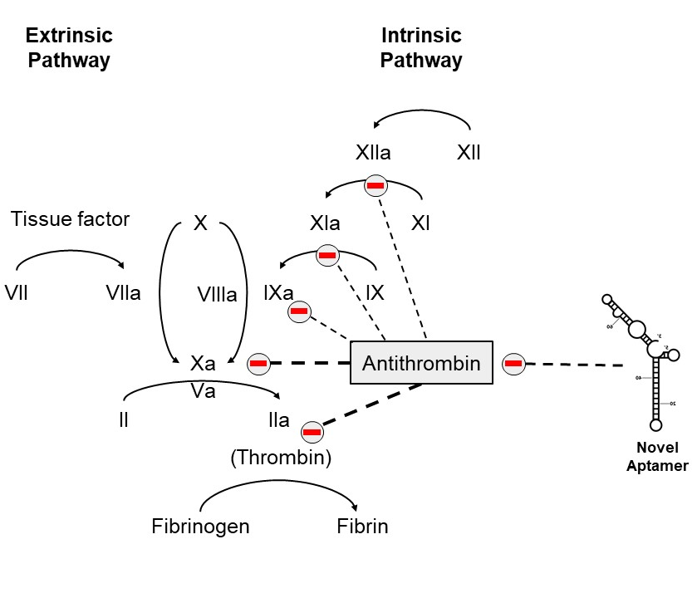

Thrombin
Thrombin catalyzes the conversion of fibrinogen to fibrin (17). The deposition of fibrin yields a meshwork that envelops platelets and other coagulation proteins to seal the site of vascular injury, especially when the fibrin is cross-linked by FXIIIa, a transglutaminase that is activated from FXIII by thrombin (18). In doing so, the blood clot is stabilized, and further bleeding is prevented. Additionally, the initial thrombin produced by the coagulation cascade re-enters the process and engages in a positive feedback loop (19). This loop involves the activation of FV and FVIII by thrombin, two cofactors which actively produce more thrombin and FXa through their involvement in the prothrombinase and tenase complexes. These two later factors are involved in a more sustained production of thrombin, than the starting thrombin generated by the coagulation cascade. Conversely, thrombin also has anticoagulant properties. For instance, the thrombin-thrombomodulin complex cleaves protein C, which yields APC (20). In the coagulation cascade, APC proteolytically inactivates activated cofactors FVa and FVIIIa, leading to a slower clotting process (20).

Serpins
The serine protease inhibitor (serpin) superfamily is comprised of thousands of proteins spanning many types of organisms, all with a common tertiary structure (21). Serpins, whether inhibitory or not, are major regulators in a variety of biological processes including blood coagulation, fibrinolysis, inflammation, chaperoning, and cell migration. Serpins also play vital roles in the regulation of serine protease cascades, like the coagulation cascade, by limiting the amount of active protease present (22). Serpins maintain a highly conserved core structure, comprised of three β-sheets and eight to nine α-helices (23). This conserved structure is necessary for proper function. Another characteristic of serpins is the reactive centre loop (RCL), which is an approximately 25 residue hypervariable surface loop, which is important in not only initial binding by target proteases, but also in their subsequent capture in a covalent inhibitory complex (24).

Mechanism of Function
As the target protease approaches the RCL of the serpin, it forms a non-covalent “encounter” complex, which resembles that formed in the interactions between the protease and its cognate substrates (25). Like the initial stages of a hydrolysis reaction, the active site of the protease then cleaves a specific P1-P1’ residues bond on the RCL (26). However, the reaction is not completed, because of the rapid release of energy stored in the serpin fold, which leaves the serpin-protease complex covalently attached in an denaturation-resistant, acyl-enzyme intermediate (27). The acyl-enzyme bond is formed between the hydroxyl group of the protease’s active site serine and the carbonyl carbon of the P1 residue on the serpin’s RCL. Subsequently, the serpin undergoes a conformational change as a result of this P1-P1’ cleavage, causing the RCL to insert into the core of the serpin as a central β-sheet (26). This “stressed-to-relaxed” change displaces the attached protease to the opposite pole of the serpin, greatly distorting its tertiary structure (26). Therefore, in this mechanism, both the inhibitor and its target are incapacitated, which allows for serpins to be regulators of tightly controlled pathways.

Antithrombin’s Role in Coagulation
AT, the serpin of interest in this study, is a 58 kDa glycoprotein produced by the liver. It functions as a coagulation regulator by inactivating key coagulation cascade proteases: primarily thrombin, FXa, and less efficiently, FIXa, FXIa, and other activated serine proteases (28-31). As an inhibitor, AT alone is responsible for 80% of thrombin’s inhibition (32).
Synthesis of AT starts in the liver as an immature preprotein molecule made up of 464 amino acids. Following proteolytic cleavage of a 32 amino acid signal sequence at the amino terminus, the mature AT protein is released and follows the secretory pathway into the bloodstream. Under normal conditions, AT’s plasma concentration is relatively high at 140 mg/L, or approximately 1.5 µM, making it the most abundant coagulation pathway inhibitor in plasma (33, 34). Three disulfide bonds exist in the mature AT protein, and four consensus sites for N-linked glycosylation, allowing for a potential of four glycosylation sites (35). Mature AT is further sub-divided into α-AT or β-AT isoforms, where α-AT has all four Asn-X-Thr/Ser sites occupied by N-linked glycans (36). α-AT is the more dominant isoform of AT, making up 90% of the protein’s plasma concentration. β-AT has only 3/4 occupied glycosylation sites, lacking modification of Asn135, which results in it having a higher affinity for heparin and heparin-like molecules than α-AT, due to lesser obstruction of the heparin binding site than in the fully glycosylated isoform (37).

Antithrombin-Heparin Interaction
Heparin is a naturally occurring glycosaminoglycan (38). Unfractionated heparin (UFH) is extracted from pig intestinal mucosa or bovine lungs and manufactured into standard heparin for clinical use. UFH chains range in size from 5000–30,000 Daltons, with an average weight of 15,000 Daltons. Low-molecular weight heparins (LMWH), which are typically enzymatic digestion products of UFH, consist of molecular chains of shorter length than UFH, with an average weight of 4.5 kDa (38). Both UH and LMWH contain a unique pentasaccharide sequence consisting of negatively-charged sulfate groups, which allow for high affinity interactions with AT’s heparin-binding domain (39). AT naturally inhibits thrombin via the classic serpin-protease mechanism (Section 1.3.1), albeit at a slow rate (7-11 x 10³ M⁻¹ s⁻¹) (40). The binding of heparin to AT maximally accelerates the reaction rate with thrombin by about 3000-fold, to 2-5 x 10⁷ M⁻¹ s⁻¹ (40). This increase is primarily due to the role of heparin in forming a ternary complex between AT, thrombin, and heparin (41). Heparin provides a template to which both AT and thrombin bind, and greatly increase their chances of productive interaction. This template affect roughly accounts for 1000-fold increase in the rate of reaction (42). Additionally, heparin causes a conformational change in AT, accounting for approximately 3 times increase in the reaction rate (43). The change in AT structure due to heparin is evident in the protrusion of the RCL (44). Thrombin is then more likely to proteolytically attack the loop. Similar increases in rates of FXa, FIXa, and FXIa inhibition by AT in the presence of heparins have been identified, although none are faster than thrombin (45). The importance of the template mechanism or the conformational change mechanism in AT’s inhibition of different proteases varies; thrombin inhibition is primarily catalyzed via the template mechanism, whereas for FXa and FIXa, conformational change is more important (46). This property is reflected in the size limitation for thrombin inhibition; heparin chains must be at least 18 saccharide units long to increase AT’s rate of thrombin inhibition maximally (47).
The site of heparin binding on AT has been the subject of many studies. X-ray structures of native AT compared to heparin-bound AT show conformational changes to the RCL (48). Mutation studies which target the critical Tyr253 residue demonstrate loss of AT reactivity with FXa and FIXa, suggesting that this exosite plays a critical role in the favourable changes to AT structure induced by heparin binding (49). Another study focused on generating a K114M AT mutant, which showed loss of anticoagulant activity compared to the native AT in the presence of heparin (50). Co-crystallization of the pentasaccharide core of heparin with AT has revealed that pentasaccharide binding tilts and elongates helix D and forms a new helix (P) between the C and D helices of AT. Pentasaccharide binding is achieved by direct hydrogen bonding between its sulfates and carboxylates to R129 and K125 in the D helix, R46 and R47 in the A helix, K114 and E113 in the P helix, and to K11 and R13 in the amino terminal region (51).

Antithrombin Deficiency
As described in Section 1.1.2, deficiencies in natural anticoagulants are often associated with an increased risk of venous thrombosis. AT is one of the natural occurring anticoagulant proteins which play a major role in modulating the coagulation process (52). Although complete AT deficiency is incompatible with life (as shown through mouse knockout studies), type I autosomal dominant individuals carrying this mutation experience 40-60% normal AT activity, which can explain the increased risk of venous thrombosis (53). On the other hand, patients suffering from severe bleeding disorders like hemophilia or trauma patients at risk of excessive bleeding often exhibit sub-optimal coagulation. In targeting AT we join other researchers who have asked or are asking the question, “By removing the “stops” on an already weakened coagulation system, can hemostasis be restored and clotting beneficially promoted?” Others have approached this question by developing means to inhibit APC or TFPI, and in this project we have investigated the down-regulation of AT; multiple targets must sometimes be investigated to translate basic research into therapeutic agent development.

Nucleic Acid Inhibitors in Coagulation
For a long period of time, nucleic acids have just been thought of as compounds used only for the storage and transfer of inherited cellular genetic information. As time and technology progressed, researchers developed a new theory to capture the diverse functions of nucleic acids (54, 55). This “RNA world theory” states that nucleic acids can indeed perform many regulatory functions and bind various molecules (56, 57). Unlocking this unique multifunctionality of oligonucleotides has led to the discovery of many candidates for diagnostic and therapeutic purposes (58, 59).

Short-Interfering RNAs
Gene silencing systems at the RNA level in eukaryotic cells have been shown to regulate gene expression and defend cells against viral genetic elements (60-63). This method of suppression at the transcriptional and translational level was given the term ‘RNA silencing’. A component of RNA silencing is a short-stranded oligonucleotide known as short interfering RNA (siRNA) (64). Due to the complementary nature of the siRNA to the target mRNA, it is able to guide an RNA-induced silencing complex (RISC), which is capable of degrading the mRNA strand (65). In coagulation, RNA interference (RNAi) technology has been exploited in several ways. Researchers from the Biotechnology Centre of Oslo have described an siRNA fragment that resulted in a 10-fold depletion in TF mRNA and a 5-10-fold reduction of TF protein (66). Such anticoagulant therapeutic is of potentially great importance in abnormal or excessive blood clotting disorders as TF is the most potent initiator of blood coagulation (67). Furthermore, in 2015, Sehgal et al showed the use of therapeutic RNAi to target AT mRNA and decrease circulating levels of AT (68). In their model of hemophilia A mice, the researchers noted a dose-dependent decrease in antithrombin levels when injected with the therapeutic RNAi, ALN-AT3. This form of treatment promoted hemostasis in mouse models of hemophilia and led to improved thrombin generation. This product, termed fitusiran (Sanofi), is now undergoing phase III trials after successful phase I and II trials demonstrated dose-dependent AT depletion and sustained thrombin generation (69). The speed of siRNA and RNAi therapies are affected by the time required to initially lower mRNA and then protein levels of the target. Compared to aptamers targeting a plasma protein directly after intravenous injection, siRNA and RNAi molecules must first enter cells and access their mRNA targets before eliciting an effect (70). In our proposed approach in this project, however, an RNA aptamer would be capable of inhibiting the circulating AT protein much more rapidly since an intravenous injection of anti-AT aptamer would directly bind the protein as it circulates in the blood. For instance, Gonadotropin-releasing hormone (GnRH)-binding aptamers were found to be capable of diminishing the activity of GnRH by 80% within the first 1.5 hours of administration (71). Currently in literature, there exists no therapeutic agent capable of inhibiting the mature AT protein.

Aptamers
Aptamers are single-stranded nucleic molecules that can bind to target proteins with high specificity and affinity (72, 73). The term ‘aptamer’ is derived from the Greek word aptus; “to fit”. Aptamers are used to bind to proteins which do not naturally interact with nucleic acids. Targets can be small molecules like adenosine monophosphate (AMP) or larger proteins like enzymes, transcription factors, growth factors, and coagulation proteins (73-81). Certain advantages make aptamers a more attractive alternative to antibodies or other organic drugs that directly target proteins.
In terms of therapeutic purposes, aptamers can be applied in the same way as monoclonal antibodies. Yet, conventional methods of aptamer in vitro selection do not require live organisms, which are an integral part of producing monoclonal antibodies (82). Since the process of developing antibodies requires biological organisms, scaling-up and issues with potential contamination can make developing antibodies less appealing (83). On the contrary, aptamers can be easily mass-produced, are less prone to contamination, and are non-immunogenic. Although antibodies can theoretically be chemically modified, this process is difficult and may affect antibody function (84, 85). The chemistry of the oligonucleotides can be readily modified to extended their half-life in vivo by adding chemical stability, without impacting aptamer binding affinity to its target (86). The majority of clinically-relevant aptamers function as antagonists and thus, interfere with protein-protein binding (87). However, some aptamers have been identified to have agonist-like behaviour (88). This illustrates the flexibility of aptamers to be either inhibitors or promoters of protein activity and function.

Anticoagulant Aptamers
Several DNA and RNA aptamers capable of binding coagulation factors have been previously identified in literature. For instance, R9D-14t, a 58-nt RNA aptamer, was able to prevent thrombin from binding fibrinogen, FVa, and other protein substrates (89). Another notable example is an anti-FXIa aptamer developed by the Sullinger group with high binding affinity of k_{d} = 84.9 nM (90, 91). Like the anti-TF siRNA mentioned above, both these aptamers are excellent therapeutic candidates for treating thrombosis and other related clotting disorders.

Procoagulant Aptamers
Bleeding can be a life-threatening clinical problem, whether it arises from acquired or genetic causes (92). Severe bleeding can be found in trauma, for instance in patients injured in automobile accidents or from gunshot wounds and blast injuries (93). In patients suffering from hemophilia, severe bleeding can also occur, although chronic bleeding into joints is a more common sequela requiring medical management (94). Currently, medical intervention for trauma-induced bleeding includes blood product transfusion, while hemophilia is controlled via prophylactic infusions of recombinant FVIII or FIX or by emerging biosimilar products (95, 96). To address unmet clinical needs in both areas, researchers have begun to explore novel ways of enhancing coagulation to respond to excessive bleeding (97). One approach is to develop a nucleic acid-based polymer, called an aptamer, which folds into a conformation ideal for binding and inhibiting a target protein.
In literature, some aptamers have been developed to target natural anticoagulants, which promotes blood clotting. These aptamers are used for procoagulant purposes, which is in the same direction as our study. Müller and colleagues were able to identify a 52-nt DNA aptamer termed HS02-52G, which binds the exosite of human APC with very high affinity (98). Like AT, APC regulates the coagulation cascade, but it is not an inhibitor, but rather a protease which inactivates FVa and FVIIIa. HS02-52G demonstrates reduced aPTT clotting time, reflecting its procoagulant effect (98). Additionally, researchers have discovered ARC19499, an RNA aptamer which targets TFPI with a K_{d} of 2.8 nM and an IC₅₀ of 17.9 nM (99). TFPI is an inhibitor of tissue factor, a protein which activates factor VIIa and factor Xa in the extrinsic pathway. Therefore, by inhibiting TFPI, the aptamer removes a regulatory control of coagulation and enhances blood clotting.

Selecting for Novel RNA Aptamer by Applying In-Vitro Selection Protocols
An emerging strategy to identify novel oligonucleotide inhibitors, or aptamers, of proteins is through Systematic Evolution of Ligands by EXponential enrichment (SELEX), which was first proposed by Ellington et al., and Tuerk et al. in 1990 (100-102). Nowadays, this process is often regarded as the most conventional method for aptamer engineering (103, 104). The starting point of SELEX is a relatively large combinatorial library, composed of nucleic acid sequences. Through multiple iterative rounds of positive, in vitro selection against the target protein with increasing stringency, the RNA pool is progressively rendered more selective for binding its target (105). Hypothetically, over many iterative rounds of selection, the pool of sequences will be more enriched and selective towards its protein target.

Applying High-Throughput Screening
In this study, we employed the powerful high throughput screening (HTS) or deep sequencing technique to help identify a novel RNA aptamer from the millions of sequences. Integrating HTS into the SELEX protocol can facilitating the discovery of consensus bases and primary sequence motifs (106). Identifying a consensus region can help with future truncation experiments and studies to determine aptamer binding-sites, which can aid in the design of an optimal agent (107).
Figure 2. A diagram of SELEX in vitro selection. Schematic representation of the aptamer sequence library screening protocol. The starting DNA library was used to generate the RNA sequences, which were subsequently introduced to antithrombin (positive selection round). The weaker sequences were eluted by high-salt concentration wash buffers, whereas the stronger sequences were collected and amplified to generate the new round’s pool of aptamers or were identified by high throughput sequencing.

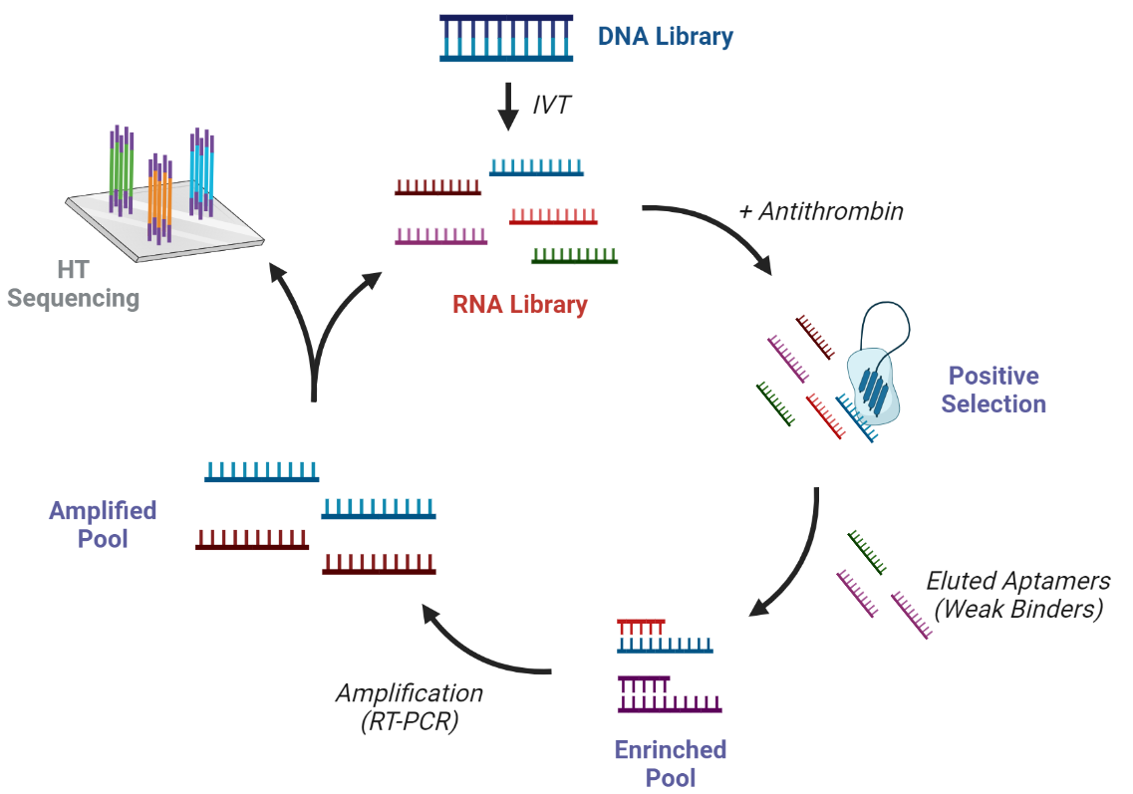

Rationale for Study
Patients suffering from AT deficiencies have been found to exhibit thrombotic complications such as venous thrombosis (53), showing that downregulating AT upregulates coagulation. By modulating activity of circulating human plasma AT via an RNA aptamer, we pose the question of whether decreased AT activity would enhance and restore coagulation in the context of excessive bleeding. Knockdown of AT activity in patients with chronic bleeding disorders or in patients with acquired bleeding tendencies (e.g. trauma) could help restore hemostasis by accelerating the formation of blood clots. As described previously, the in vitro evolution process, otherwise known as SELEX, has been extensively utilized to identify nucleic acid inhibitors of coagulation proteins. We employed this protocol to discover a novel, modified RNA aptamer capable of binding AT with high affinity and decreasing AT’s anticoagulant activity.

Hypotheses
There exists, within the sequence and conformational space defined by an RNA aptamer library with a variable region defined by 40 contiguous random ribonucleotides, at least one RNA aptamer that will bind to AT with high affinity and block protease inhibition. Further, RNA aptamers binding to AT with high affinity will interfere with AT’s biological function and act as procoagulant agents in purified and plasma systems.

Project Outline
Objectives that I aimed to complete by the end of my thesis research were to:
i. Biopan the randomized RNA library against human plasma AT for 10 rounds of selection using the SELEX protocol;
ii. Test for aptamer pool’s inhibition of AT by measuring thrombin activity in a chromogenic assay;
iii. Identify RNA aptamer candidates through the use of in silico techniques;
iv. Synthesize top 10 most abundant aptamers identified by high-throughput screening, top 10 by in silico bioinformatic modelling, and a negative control.
v. Test for candidates’ inhibition of AT by measuring thrombin activity in a chromogenic assay;
vi. Test for candidates’ inhibition of AT by measuring clotting time in an aPTT assay;
vii. Test for candidates’ binding to AT through plate-based binding assay, gel-shift assay, or intrinsic fluorescence studies;
viii. Identify at least one RNA aptamer that binds and neutralizes AT activity.

MATERIALS

2.1 Source of Chemicals and Reagents
Chemicals and biological reagents were purchased from the following suppliers: New England Biolabs (Pickering, ON) Phusion DNA polymerase; Thermo Fisher Scientific (Burlington, ON) Coomassie Plus Protein Assay Reagent, TMB developing solution, NanoDrop Spectrophotometer, SuperScript One-Step RT-PCR System, Pierce™ Streptavidin Magnetic Beads, Pierce™ Streptavidin Coated High Capacity Plates, Standard Heparin Sodium; Qiagen (Carlsbad, CA) QIAquick PCR purification kit, QIAprep Spin Miniprep kit, QIAquick Gel Extraction kit, HotStarTaw Plus Master Mix; Varian Medical Systems (Ottawa, ON) Cary Eclipse Fluorescence Spectrophotometer; Tecan (Toronto, ON) Infinite ® 200 PRO; Integrated DNA Technologies (Hamilton, ON) DNA oligonucleotides; MOBIX (Hamilton, ON) DNA oligonucleotides and primers; Gibco (Grand Island, NY) Tween 80; BDH (Toronto, ON) β-mercaptoethanol, Triton X-100; Bio-Rad (Mississauga, ON) nitrocellulose paper; Lucigen (Toronto, ON) Durascribe T7 Transcription Kit; Cedarlane Labs (Burlington, ON) Sivelestat; Affinity Biologicals (Hamilton, ON) anti-antithrombin IgG, biotinylated anti-antithrombin IgG; Sigma-Aldrich (Oakville, ON) Antithrombin III from human plasma, Biotin, Thrombin from human plasma; Diapharma (Illinois, USA) Chromogenix S-2238;

2.2 Oligonucleotides
The following table lists and describes the oligonucleotides used in this project. All sequences were synthesized at the McMaster Institute for Molecular Biology and Biotechnology (MOBIX) at McMaster University (Hamilton, ON).
Table 1. List of oligonucleotides used during this project. This table is divided into two sections; the first details the primers, whereas the second lists the sequences of tested aptamer candidates.

Primer Name | Description | DNA Sequence (5’ – 3’) | Size (bp)
FWD | Forward primer for reverting RNA to DNA, via RT-PCR | TGCGCTCTAGAGTCGAAT | 18
REV | Reverse primer for reverting RNA to DNA, via RT-PCR | GTATACCTGCAGCTGAGG | 18
T7-REV | Reverse primer for reverting RNA to DNA, via RT-PCR | TAATACGACTCACTATAGGTATACCTGCAGCTGAGG | 38
P5-503 | Forward deep sequencing primer 1 | AATGATACGGCGACCACCGAGATCTACACTATCCTCTACACTCTTTCCCTACACGACGCTCTTCCGATCTNNNNGTATACCTGCAGCTGAGG | 92
P5-504 | Forward deep sequencing primer 2 | AATGATACGGCGACCACCGAGATCTACACAGAGTAGAACACTCTTTCCCTACACGACGCTCTTCCGATCTNNNNGTATACCTGCAGCTGAGG | 92
P7-707 | Reverse deep sequencing primer 1 | CAAGCAGAAGACGGCATACGAGATGTAGAGAGGTGACTGGAGTTCAGACGTGTGCTCTTCCGATCTTGCGCT CTAGAGTCGAAT | 84
P7-708 | Reverse deep sequencing primer 2 | CAAGCAGAAGACGGCATACGAGATCCTCTCTGGTGACTGGAGTTCAGACGTGTGCTCTTCCGATCTTGCGCT CTAGAGTCGAAT | 84
BIO-PRMR | Primer for immobilizing aptamer on binding plate | BIOTIN - GTATACCTGCAGCTGAGG | 18

Aptamer ID | RNA Sequence (5’ – 3’) | Size (bp)
R6_10 | GGGUAUACCUGCAGCUGAGGUAAUGGCUGUGUGCCUUUAUUCAUGCCUGCAUGUGACGCGAUUCGACUCUAGAGCGCA | 76
R6_15 | GUAUACCUGCAGCUGAGGCACUACAUUGUUUCGGUUGCACACGCCAACAGAGCACGAAAUUCGACUCUAGAGCGCA | 76
R6_19 | GGGUAUACCUGCAGCUGAGGUGUGCGAAUGCCUUUUUAACGCACGC  GCAUAGUUGUUACAAUUCGACUCUAGAGCGCA | 76
NEG | GUAUACCUGCAGCUGAGGGCAAGGGGUGCGGUUAGUUCCGAGAUAG  UUUGGGUUCCUAAUUCGACUCUAGAGCGCA | 76
NP_R6_15 | GCACUACAUUGUUUCGGUUGCACACGCCAACAGAGCACGAA | 40
5P_R6_15 | GUAUACCUGCAGCUGAGGCACUACAUUGUUUCGGUUGCACACGCCAACAGAGCACGAA | 58
3P_R6_15 | GCACUACAUUGUUUCGGUUGCACACGCCAACAGAGCACGAAAUUCGA  CUCUAGAGCGCA | 58

2.3 Computer Software
Modelled structures were manipulated and imaged with PyMOL 2.5 (https://pymol.org/) (The PyMOL Molecular Graphics System, Schrodinger, New York NY). Prism 9 was used to generate graphs, plots, and figures (GraphPad Software, San Diego CA).

3 METHODS

3.1 Combinatorial RNA Library
Used previously in Donkor et al (108), the primer-free ssDNA library was composed of the following sequence: 5′-TGCGCTCTAGAGTCGAAT-N₄₀-CCTCAGCTGCAGGTATAC-3′, where N₄₀ represents a 40 nucleotide randomized region which is flanked by the 18 nucleotide primer-binding regions. This DNA library was used to generate the starting RNA library via an in vitro transcription (IVT) reaction:
5′-UGCGCUCUAGAGUCGAAU-N₄₀-CCUCAGCUGCAGGUAUAC-3′. For additional details regarding the buffer and experimental conditions, see Section 3.2.5 The sequence of the initial RNA library was as follows:

3.2 In Vitro Selection Protocol
In this study, solution-based, magnetic bead SELEX was employed as described in Tuerk and Gold (102), however with some modifications. Figure 2 represents a schematic of the biopanning protocol employed. Throughout the entire selection process, the 500 uL final solution volume was in a 1.5 mL Eppendorf tube.

3.2.1 Systematic Evolution of Ligands by EXponential enrichment (SELEX)
All reactions took place at room temperature. Prior to the incubation period, streptavidin-coated magnetic beads (New England BioLabs) were pre-washed with selection buffer. All wash steps were conducted by adding wash buffer (WB: 20 mM Tris-HCl, 150 mM NaCl, 5 mM KCl, 1mM MgCl₂, 1 mM CaCl₂, 0.005% Tween-20) into the Eppendorf tube and incubating on Barnstead Thermolyne Labquake end-over-end rotator. Following the 5 min wash spin, the buffer was extracted from the tube, using a magnet to help concentrate the beads to the side. Next, the pre-washed magnetic beads were incubated with 2 µg biotinylated anti-human AT polyclonal antibody (Affinity Biologicals) for 30 min in selection buffer (SB: 137 mM NaCl, 2.7 mM KCl, 10 mM Na₂HPO₄, 1.8 mM KH₂PO₄, pH 7.4). The beads were then washed three times using wash buffer to remove unbound antibody. Next, the bead-antibody complex was incubated with 2X molar excess human AT for 30 min. Similarly, the beads were washed three times using wash buffer to pull away unbound antithrombin. For the first round of selection, 1000 pmole of R₀ RNA was diluted and heated in SB, then cooled on ice. The RNA was incubated with the bead-antibody-AT complex for 2 hours on the rotator. As the selection proceeds to later rounds, the amount of RNA that was incubated and incubation times were decreased (Table S1). Following the incubation, the beads were washed with Stringent WB (SWB: 20 mM Tris-HCl, 4 M NaCl, 5 mM KCl, 1mM MgCl₂, 1 mM CaCl₂, 0.005% Tween-20) three times consecutively, removing any low affinity aptamers. The stringency and quantity of the wash steps will intensify as the selection protocol proceeds. Bound aptamers were separated and eluted from bead-antibody-AT complex using phenol: chloroform: isoamyl alcohol (25:24:1) and HEPES buffer, respectively. The extracted RNA sequences were precipitated using 70% ethanol in a 50 uL final volume.

3.2.2 Purifying RNA Sequences
Following the termination of the transcription reaction, 2 µL of sodium acetate and 50 µL of ethanol was added to the collected 20 µL sample. The mixture was incubated on ice for 15-30 minutes. The sample was collected by centrifugation at 10,000 x g speed for 20 minutes at 4°C. Following the removal of the supernatant with a pipette, the pellet was rinsed gently with 70% ethanol. The pellet was then suspended in 20 µL of nuclease-free water and stored at -20°C. When the sequences were required for experimentations, the aptamers were refolded by heating at 95°C for 5 minutes, followed by 15 minutes on ice (108).

3.2.3 Confirmation of Sequence Regeneration after Selection Rounds
The precipitated pool of sequences following a round of selection was reverse-transcribed and amplified, producing the dsDNA sequences. The enriched RNA sequences were in vitro transcribed to re-generate the pool for subsequent rounds. This specific RNA transcription reaction introduces chemically modified 2’F-uracil triphosphate (UTP) and 2’F-cytosine triphosphate (CTP) nucleotides, which stabilizes the RNA strand and makes the molecule less susceptible to nuclease degradation. To confirm the success of the reverse-transcription and transcription reactions, 1 µL samples from each reaction product were visualized on 7.5% urea-denaturing polyacrylamide gel electrophoresis. The gels were visualized by staining with Coomassie Brilliant Blue. A sample gel from the 8th round of selection is shown below (Figure S1).

3.2.4 High-Throughput Screening
RNA samples obtained after selection rounds 2-10 were prepared for high-throughput (or deep) sequencing to thoroughly analyze the selected aptamer pools for enrichment and abundance of sequences. The selected RNA samples were reverse transcribed to dsDNA, using the One-Step RT-PCR (reverse transcription polymerase chain reaction) Kit (Thermo Fisher Scientific, Burlington ON). Two unique forward and reverse primers that are used specifically for deep sequencing. The RT-PCR products were sequences using an Illumina Miseq DNA sequencer at the Farncombe Metagenomics Facility, McMaster University (Hamilton, ON). The confirmation of proper sequence was conducted by Farncombe. The coverage of the samples was 1% (i.e. the outputted number of sequence reads comprised 1% of the total number of sequences in the original sample). The raw FASTQ sequences were sorted and pre-processed using the Galaxy server workflows, developed by William Thiel (109). The data was outputted in FASTA and TABULAR formats for visualization and analysis on Google Spreadsheets.

Figure 3. Magnetic bead-antithrombin complex. Illustration of the magnetic bead-streptavidin-biotinylated antibody-human antithrombin complex that was employed during the in-vitro selection process. The numbers at the bottom of the figure represent the order of addition into solution.

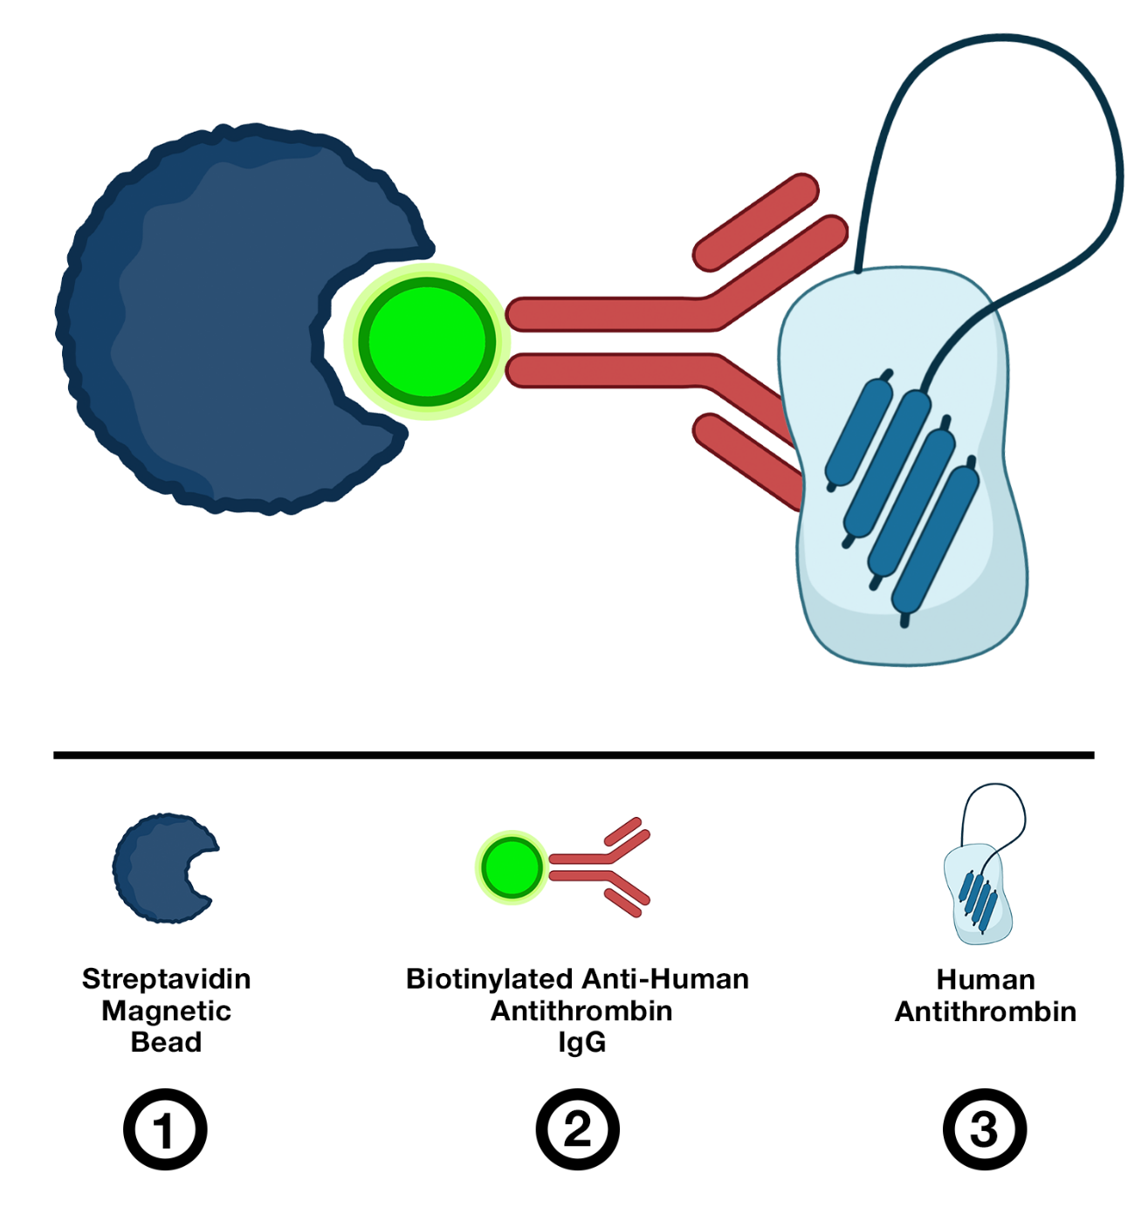

3.2.5 Synthesizing Aptamer Sequences
The RNA aptamers included chemically-modified 2’ position on the sugar residues of uracil and cytosine nucleotides. Particularly, the 2’-hydroxyl (OH) group was substituted for a fluorine (F). Such modified RNA sequence has been shown to have many benefits over natural DNA/RNA sequences, in terms of affinity and stability (110). Their sequences had to be synthesized using the in vitro transcription (IVT) kit (Lucigen, Toronto ON). In this study, 1 µg of template DNA (which contains the T7 transcription promoter region) was used in a total volume of 20 µL reaction. The IVT reaction was optimized specifically for this sequence length and guanine-to-cytosine (G:C) ratio to reduce the amount of template strand and maximize yield. It was found that a 6 hour incubation at 37°C, followed by a 15 minute DNase reaction was optimal for the generation of the aptamers.

3.3 Kinetic Characterization of AT Inhibition of Thrombin
All chromogenic assays conducted in this study were performed on a 96-well flat bottom microtiter plate, at 37°C in PPNE kinetic buffer (20 mM sodium phosphate, 100 mM NaCl, 0.1 mM EDTA, 0.1% polyethylene glycol (PEG) 8000, pH 7.4). The absorbance was measured and recorded via the BioTek® ELx808 (BioTek Instruments, East Falmouth, MA). The assays were used as a method of recording the second rate reaction constant, under pseudo first-order conditions. For this project chromogenic assays were used to analyze the inhibitory activities of enriched pool and RNA aptamer candidates towards AT, by measuring the impact of AT’s rate of inhibition of thrombin.

3.3.1 Thrombin Activity Assay
In this assay, 200 nM of selected RNA aptamer pools were incubated with 200 nM AT for 15 min at 37°C. Reactions between RNA pool and AT in this assay occurred at 1:1 RNA:AT ratio. Following the incubation, 10 nM thrombin was added to the solution. The ratio of serpin: thrombin was consistently maintained at 20:1. Immediately after, 100 µM S-2238 chromogenic assay was added to each well using a multichannel pipettor. The kinetic read lasted for 5 minutes, measuring absorbance at 405 nm.

3.3.2 Aptamer Inhibition of AT in Kinetics Assay
The kinetic parameters of the AT-thrombin inhibition reaction were also determined in the presence of RNA aptamer sequences. In this experiment, 2000 nM aptamer and 200 nM AT were incubated for 20 minutes at 37°C in a final volume of 10 µL. Similar to the previous assay setup, a final concentration of 10 nM thrombin were introduced, which increased the reaction volume to 20 µL. Thrombin was added to the aptamer-AT solution at 1-minute time points, for a total of 10 minutes. An excess amount of chromogenic substrate, S-2238 (100 µM), was added to all wells immediately following the last thrombin titration. A 5-minute kinetic read was initiated to measure the absorbance of substrate amidolysis.
Serpin-protease kinetics can be determined by graphing the natural logarithm of initial divided by final protease activity, versus time, as shown in Equation A. In this assay, the protease activity is correlated to the measurement of absorbance from S-2238 cleavage.
Equation A $ln⁡(\frac{P_{o}}{P_{t}})={(k}_{obs}) t$
Where, $P_{o}$ is the initial protease activity at time = 0 (unitless)
$P_{t}$ is the protease activity at time, t (unitless)
$k_{obs}$ is the slope of the best-fitting trendline (s⁻¹)
$t$ is time (s)
After calculating the trendline using linear regression (GraphPad Prism 9.0) and deriving its slope, Equation B below was utilized to determine the second-order rate of AT inhibition of thrombin, for each specific aptamer condition.
Equation B ${ k}_{2}=\frac{k_{obs}}{{\left[AT\right]}_{f}}$
Where,
${ k}_{2}$ is the second-order rate constant (M⁻¹ s⁻¹)
${\left[AT\right]}_{f}$represents the final concentration of AT (serpin) in the reaction volume (M)

3.3.3 Aptamer Inhibition of AT-Heparin Complex in Kinetics Assay
This assay was performed to observe the effect of heparin on aptamer’s potential inhibition of AT in the chromogenic assay. All reaction conditions from the previous assay without the heparin were replicated in this experiment. The only exception being the addition of 0.2 U/mL standard heparin to the final reaction volume of 30 µL. Heparin was introduced to AT at the same time as the aptamer. Additionally, 10 µL of 100 µM S-2238 was added to the AT-aptamer-heparin well. This step was necessary to slow down the reaction rate, as heparin rapidly accelerates the rate of thrombin inhibition by AT (40). Therefore, all four components were incubated at 37°C for 20 minutes in a 20 µL solution (111).
In Equation C, the calculated second-order rate of inhibition (k₂) takes into account the effects of the chromogenic substrate in decelerating AT-heparin-thrombin kinetics (112).

Equation C $k_{2}\left(M^{-1} s^{-1}\right)=\frac{k_{obs} }{{\left[AT\right]}_{final}}× \left(1+ \frac{{\left[S-2238\right]}_{f}}{K_{M}}\right)$
Where,
${\left[S-2238\right]}_{f}$ is the final concentration of chromogenic substrate (M)
$K_{M}$ is the Michaelis-Menten constant of the chromogenic substrate (M)

3.3.4 Measuring Residual Thrombin Activity
Cleavage of chromogenic substrate S-2238 was used to record residual thrombin activity in the presence of AT, with and without aptamer. The RNA aptamer and AT were mixed at a 10:1 ratio (100:10 nM final concentration), at 37°C for 20 min. This aptamer-AT complex was then introduced to thrombin (10 nM) at 1 minute intervals between 0 and 10 minutes. Residual thrombin activity was then determined by addition of chromogenic substrate and measurement of the rate of amidolysis. The ratio of final to initial thrombin activity was calculated and graphed against time (x-axis).

3.4 Clotting Time Assay
The activated partial thromboplastin time (aPTT) assay is a plasma clotting assay that is clinically used to test for abnormalities in the intrinsic pathway (113). For all conditions, the STart® 4 Hemostasis Analyzer (Diagnostica Stago) was used. All solutions were diluted in 1X veronal buffer (10 mM sodium barbital, pH 7.4). Essentially, faster clotting (less clotting time) correlates to increased coagulation activity, presumably because AT is inhibited by the aptamer. Therefore, faster clotting indicates increased aptamer activity.

3.4.1 Normal aPTT Assay
In the normal aPTT, the RNA aptamer (5 µM) was added to 50 µL pooled human plasma for 30 minutes at 37°C. Then, 50 µL C.K. Prest® reagent was introduced to the plasma and allowed to incubate for 180 seconds. This was followed by the addition of CaCl₂ to a final concentration of 5 mM to initiate clotting time recording. Control conditions of this reaction were buffer only and aptamer only.

3.4.2 Modified aPTT Assay
In subsequent experiments, the aPTT assay was modified by using AT-deficient human plasma. The same amounts of plasma, reagent, and CaCl₂ were used, and in the same order as the previous normal aPTT assay. By adding back lower concentration of AT (500 nM versus 1.5 µM), it became more feasible to generate and use lower concentrations of aptamer. AT delayed clotting time by 5 seconds on average. In the ‘Buffer only’ control, the baseline clotting time was 35 seconds, whereas adding the 500 nM AT increased it to 40 seconds. This resulted in a 5-second ‘clotting window’ in which aptamers could be tested for any procoagulant effect.

3.4.3 Diluted aPTT Assay
To demonstrate a clearer effect of aptamer on clotting, the C.K. Prest® aPTT reagent was diluted 1/15 to slow down plasma clotting, as originally described by de Matt (114) and later used in Hamada et al (115). By diluting the C.K. Prest® aPTT reagent, the ‘clotting window’ was increased to 20 seconds (65 sec. with buffer vs 85 sec. with AT). This allowed for a greater opportunity for aptamers to demonstrate their specific inhibition of AT and show an effect on the clotting time.

3.5 Binding Characterization using Plate Binding Assay
The plate binding assay was previously described in Guo et al. (116), wherein the researchers characterized an eukaryotic translation initiation factor 4E (eIF4e) DNA aptamer using a similar technique. In our study, the 76-bp RNA aptamer (100 nM) was incubated with the biotinylated DNA primer (100 nM) at 70°C for 10 minutes. The plates were coated with coating buffer (10 mM Na₂HPO₄, pH 7.4) overnight at 4°C. The biotinylated primer (IDT) was designed to hybridize to the 5’ end of the aptamer. The hybridized aptamer-biotinylated primer was aliquoted into the streptavidin-coated wells. Following an incubation at room temperature (RT) for 30 minutes while rocking, the wells were washed three times with wash buffer (0.01% Tween-20) for 5 minutes per wash. Subsequently, AT (10 nM) was incubated onto the aptamer-bound wells for 30 minutes at RT while rocking. The wells were again washed three times. Finally, HRP-conjugated anti-AT immunoglobulin G (IgG) (1/10,000 dilution) was added to detect aptamer-bound AT in the wells. All reactants were diluted in selection buffer (137 mM NaCl, 2.7 mM KCl, 10 mM Na₂HPO₄, 1.8 mM KH₂PO₄, pH 7.4). After a 1-hour incubation at RT, the wells were washed five times. The TMB developing solution was then added and absorbance at 405 nm was obtained using a spectrophotometer. Essentially, the higher reaction velocities (colour production) indicated the presence of more AT relative to the controls. Therefore, larger mean velocity values were correlated with higher binding of aptamer to AT.

3.6 Binding Characterization using AT Intrinsic Fluorescence
This assay was used to detect changes in AT’s fluorescence intensity due to adding an inhibitory aptamer or heparin, or aptamer and heparin together. There are six accessible tryptophan groups on the AT molecule. Upon excitation at 280nm, the produced emission spectrum peaks at 341 nm (117). The binding affinity constant was derived from observing the decrease in peak intensity versus the concentration of aptamer in solution. AT’s fluorescent intensity measurements were taken on a Cray Eclipse Fluorescence Spectrophotometer (Agilent, Santa Clara CA), using a thermostatic cell holder and a quartz cuvette. All reactions took place at RT. All solutions were diluted using a fluorescence binding buffer (50 mM Tris, 150 mM NaCl, and 0.1% PEG 8000, pH 8.3). Intrinsic protein fluorescence was observed between 300-400nm emission wavelengths, where the peak was expected at around 340nm. The light was excited at a wavelength of 280nm. The excitation slit width remained constant at 2 mm. Fluorescent readings were taken at 1 minute following incubation of aptamer-AT or AT-heparin. The concentration of AT was kept constant at 200 nM, whereas the concentrations of aptamer and heparin were varied from 0-500nM, and 0-10U/mL respectively.
Equation D $\% Decrease=\frac{F_{i} -F_{f}}{F_{i}}×100$
Where,
$F_{i}$ is the initial (no aptamer) fluorescence intensity of AT at 340 nm (unitless)
$F_{f}$ is the final (aptamer added) fluorescence intensity of AT at 340 nm (unitless)
Equation D above was used to determine the decrease of AT intensity upon adding the aptamer. The peak values of the AT emission spectra before and after addition of aptamer were compared and statistically analyzed. The diminishing of AT’s peak fluorescence intensities was presumed to be due to the effects of aptamer binding to the surface of AT.
Additionally, there was another application to the change in AT fluorescent emission spectra due to aptamer binding. By titrating an increasing amount of aptamer to a constant concentration of AT, we observed that the AT fluorescence peak intensity decreased. Therefore, by titrating 20 nM aptamer samples until the final aptamer concentration of 500 or 1000 nM, a binding curve can be derived by graphing the peak intensity values versus the amount of aptamer added. The goal was to determine the k_{d} of the inhibitor, in this case the RNA aptamer. Using the “Inhibitor vs response” 4-parameters curve model on Prism 9.0, a trendline was calculated which fits the data points on the graph. It was also preferable to have plenty of data points so that the variable slope model was more accurate. Additionally, the non-linear regression model was fitted to a Hill Slope of -1.0, which was maintained throughout all different conditions and experiments. All fluorescence binding affinity curves were modelled on the following dose-response curve equation:
Equation E $y=F_{T}+\frac{F_{B} -F_{T}}{1+{(\frac{kd}{x})}^{H}}$
Where,
$F_{T}$ represents the top plateau of fluorescence intensity (unitless)
$F_{B}$ represents the bottom plateau of fluorescence intensity (unitless)
$k_{d}$ is the binding affinity constant (nM)
$H$ is Hill Slope constant, which is always at -1.0

3.7 Truncation of R6_15 Aptamer
Given the noticeable procoagulant effect of R6_15 in the clotting time assay as well as the kinetics and fluorescence experiments, this aptamer was selected for additional testing. The aptamer is comprised of three different regions; two 18-bp primer binding regions for amplification, and a 40-bp variable region. Three different variations of the aptamer R6_15 were generated, which are highlighted in depth in Figure 4. The NP R6_15 variant lacks both primer-binding regions of the sequence. The 5P and 3P R6_15 do not have either the 5’ and 3’ primer-binding regions, respectively. All three new DNA oligonucleotides were ordered and sequenced by MOBIX. They were then subject to an asymmetrical PCR reaction to incorporate the T7 promotor region to the 5’ end of the DNA strand. The T7-DNA was used as the template strand for the IVT reaction to generate the final RNA aptamer, which contains the modified ribonucleotide bases. This RNA aptamer was then purified and store at -20°C.

Figure 4. Graphical illustration of sequences of the truncated R6_15 variants.

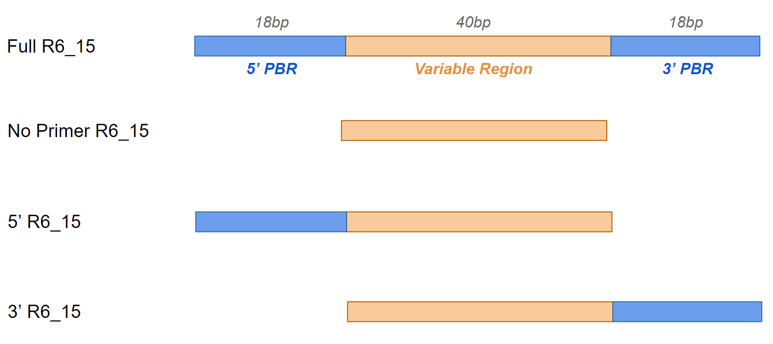

3.8 Consensus Sequence Analysis
RNA sequences were aligned, and motifs were discovered with MEME (Multiple Em for Motif Elicitation) Suite 5.4.1 (118) (Bailey and Noble, Menlo Park CA).

3.9 Molecular Modeling of AT Interactions with Aptamers
Protein crystal structures were downloaded from The Protein Data Bank (PBD) (https://pdb101.rcsb.org/). The following file were extracted from the database:
1E03: Human Plasma AT-Pentasaccharide
1E05: Human Plasma AT
1TB6: AT-Heparin-Thrombin
2B4X: AT Duplex
3KCG: AT-Pentasaccharide-FIXa
After the most promising aptamer candidates were determined, their RNA sequences were identified and converted to their respective 2D ‘dot’ structure using RNA Fold (119) (http://rna/RNAfold.cgi). To generate the 3D model of each RNA sequence, the primary sequence and previously obtained 2D structure were inputted into RNA Composer (120, 121) (http://rnacomposer.pl/). This workflow provided a pymol-compatible three-dimensional structure that is capable of being docked and modelled to the AT and AT-heparin crystal structures. Primarily, the AT structure used for modelling AT-aptamer interactions was 1E03. However, 1E03, 1TB6, and 3KCG were used to model AT-aptamer-heparin interactions. For these three aforementioned structures, only the AT and heparin sections of the .pdb file were utilized for ClusPro docking. The non-relevant portions of the molecules (e.g. thrombin and FIXa) were deleted. The pentasaccharide and heparin molecules were extracted from 1E03 and 1TB6, respectively, to be used for AT-aptamer-heparin modelling.
The predicted 3D RNA molecule and crystal structure of human AT were modelled using HDOCK (122-125) (http://hdock.phys.hust.edu.cn/). Through energy-minimizing clustering, the lowest energy ranked model of RNA-AT for each aptamer was chosen. The generated models were refined using HADDOCK 2.2 (126) (Utrecht, The Netherlands) (https://wenmr.science.uu.nl/haddock2.4/).

4 RESULTS

4.1 Biopanning the Combinatorial RNA Library with AT
The initial goal of this project was to select for an aptamer sequence from a large combinatorial library of 76-nucleotide (nt) long, modified RNA sequences, capable of binding and inhibiting AT. Given that the RNA sequences contain a 40-nt long variable region, flanked by 18-nt constant primer-binding regions for replication purposes, this large library is theoretically made up of 4⁴⁰ unique RNA potential aptamers.

4.1.1 HT Sequencing Results
In this project, the collected RNA sequences from the 2nd, 3rd, 5th, and 6th rounds were initially deep sequenced using high-throughput screening (HTS). The number of rounds sequenced at a time was limited by the availability of deep sequencing primers. A maximum of four different combinations of two forward and two reverse primers could be produced. Over these initial four rounds, the number of different sequences present in each round screen decreased by about 10,000 each round (Figure 5). The next batch of rounds to be deep sequenced was composed of samples from the 7th, 8th, 9th, and 10th round screens. The number of unique reads appeared to decrease progressively over these four rounds. Total unique sequence reads in Rounds 2, 3, 5, and 6 were 174591, 158437, 137286, and 132124, respectively.

Figure 5. Output of high-throughput screening following Rounds 2-10. The number of unique reads obtained after Round 2 (R2) through Round 10 (R10) of biopanning of the RNA aptamer library is shown.

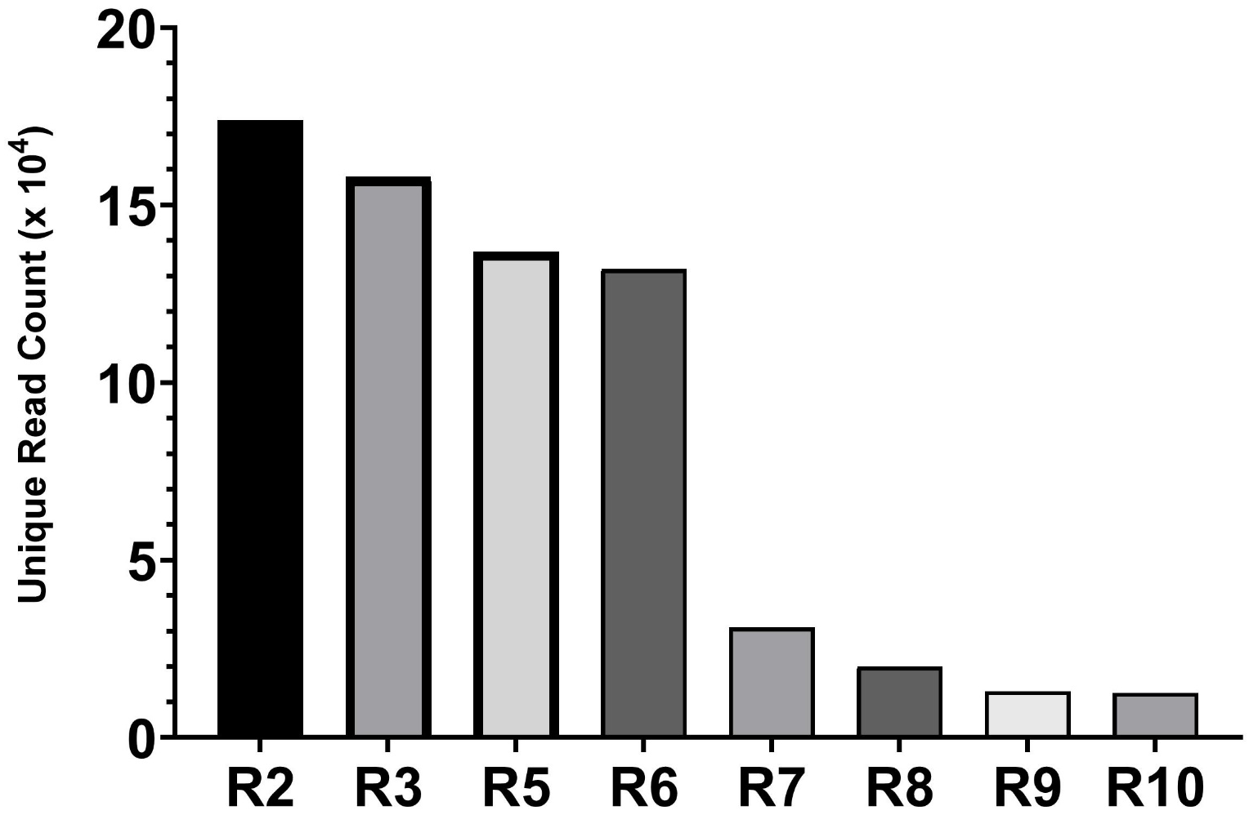

To compare rounds to each other, these sequence abundances were normalized by using ‘Frequency (%)’ instead of number of sequences in a round pool. This was achieved by dividing the number of sequence reads detected from HTS by the total number of reads in the round. In Table 2, the 25 most abundant sequences by round 9 are listed. Aptamer R6_1, R6_5, R6_8, and R6_15 were the most abundant sequences after nine rounds of selection. The frequency of these aptamers ranged from 5-7% each in the last round. The following set of aptamer sequences seem to occupy the 3-0.5% range. Examples of these aptamers are R6_2, R6_10, and R6_19. The progression of a few candidates’ frequency over the selection process is graphed on Figure 6. R6_1 and R6_5 consistently ranked either 1st or 2nd in terms of enrichment, whereas R6_15 experienced a delayed escalation to the number 3 spot. Note the relatively unchanged frequency of aptamer R6_20 over all ten rounds of in-vitro selection. For this reason, it was chosen to be the negative control aptamer for subsequent experiments.
Table 2. Frequencies of sequences after high-throughput screening of Rounds 2-10. The frequency of selected aptamer sequences after Round 2 (R2) through Round 10 (R10) of biopanning of the RNA aptamer library is shown. Aptamers were named after R6, hence the format if R6_X, where X is the unique number identifier.

Aptamer  Candidate ID | Frequency (%)
 | R2 | R3 | R5 | R6 | R7 | R8 | R9
R6_1 | 0 | 0 | 1.31 | 3.28 | 3.50 | 0.75 | 6.01
R6_2 | 0 | 0 | 1.65 | 2.58 | 3.50 | 1.50 | 3.76
R6_3 | 0 | 0 | 0.96 | 2.37 | 0.58 | 6.02 | 1.50
R6_4 | 0 | 0 | 0.96 | 1.89 | 1.17 | 0.75 | 2.25
R6_5 | 0 | 0 | 0.14 | 1.89 | 4.67 | 3.01 | 7.51
R6_6 | 0 | 0 | 0.76 | 1.75 | 0.58 | 1.50 | 0.75
R6_7 | 0 | 0 | 0.28 | 1.40 | 0.58 | 1.50 | 0.75
R6_8 | 0 | 0 | 0.55 | 1.40 | 2.34 | 3.76 | 5.26
R6_9 | 0 | 0 | 0.14 | 1.40 | 0.58 | 2.25 | 0.75
R6_10 | 0 | 0 | 0.41 | 1.40 | 0 | 0.75 | 2.25
R6_11 | 0 | 0 | 0.07 | 1.40 | 2.92 | 0.75 | 4.50
R6_12 | 0 | 0 | 0.83 | 0.84 | 0.58 | 1.50 | 1.50
R6_13 | 0 | 0 | 0.34 | 0.83 | 0.58 | 1.50 | 0.75
R6_14 | 0 | 0 | 0.21 | 0.84 | 1.17 | 0 | 0.75
R6_15 | 0 | 0 | 0.07 | 0.84 | 1.17 | 3.76 | 5.26
R6_16 | 0 | 0 | 0.41 | 0.77 | 0 | 3.01 | 0.75
R6_17 | 0 | 0 | 0.14 | 0.77 | 0 | 1.53 | 0.75
R6_18 | 0 | 0 | 0.48 | 0.77 | 1.68 | 1.50 | 0.75
R6_19 | 0 | 0 | 0.34 | 0.70 | 2.34 | 0 | 3.76
R6_20 | 0 | 0 | 0.76 | 0.70 | 0.58 | 0.75 | 0.75
R6_26 | 0 | 0 | 0.14 | 0.63 | 0.58 | 1.50 | 3.76
R6_28 | 0 | 0 | 0.14 | 0.63 | 1.17 | 0.75 | 1.50
R6_38 | 0 | 0 | 0.48 | 0.56 | 1.17 | 0.75 | 1.50
R6_45 | 0 | 0 | 0.14 | 0.49 | 2.34 | 1.50 | 1.50
R6_69 | 0 | 0 | 0.07 | 0.42 | 0.58 | 0.75 | 0.75
R6_75 | 0 | 0 | 0.07 | 0.42 | 1.17 | 1.50 | 0.75
Total Reads | 173367 | 161834 | 145192 | 143937 | 17122 | 13307 | 12868

Figure 6. Enrichment graph of the aptamer candidates. The frequency of sequence prevalence (y-axis) in each round of biopanning, as represented on the x-axis.

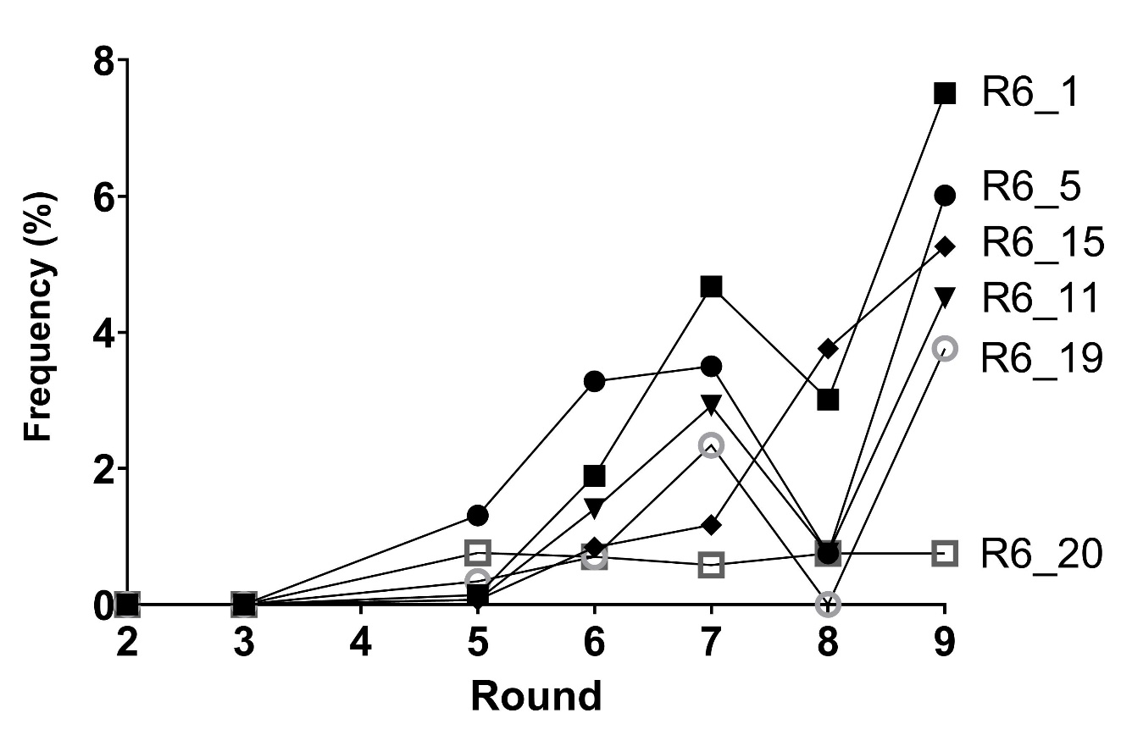

4.2 AT Inhibition of Thrombin
The addition of heparin accelerates the antithrombin inhibition reaction of thrombin, as explained in the Introduction section of this thesis. Preliminary results from the initial stages of this project were consistent with the literature (41, 44, 127). Heparin was found to accelerate AT’s k₂ for thrombin inhibition from 4.0 ± 0.1 x 10³ M⁻¹ s⁻¹ to 1.1 ± 0.5 x 10⁷ M⁻¹ s⁻¹, an increase of four orders of magnitude (Figure 7). Data shown in Panel A was used to derive k₂ values in Panel B. The slope of the trendline of the heparin condition was determined to be approximately 0.12, whereas the non-heparin inhibition reaction’s trendline resulted in a flatter slope of 0.015.
Figure 7. Kinetic parameters of AT inhibition of thrombin with and without heparin. (A) The natural logarithm of the ratio of the initial thrombin activity (P₀) to the residual activity at time t (P_{t}) vs. the time in seconds (x-axis). Graphed lines are the lines of best fit determined by linear regression. Individual data points which are the mean ± SD of three determinations. (B) Increase in rate of inhibition of thrombin by AT in the condition with 0.5 U/mL standard heparin, compared to without heparin.

A
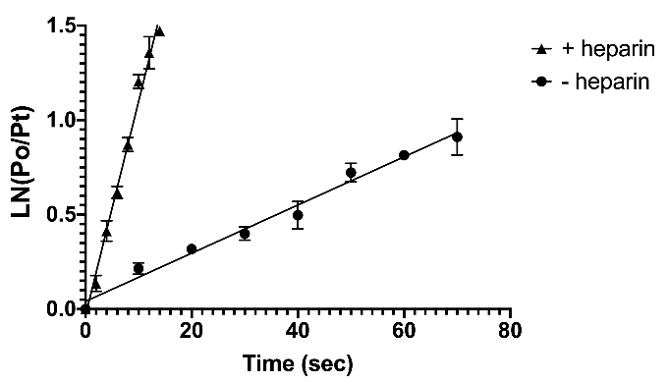
B
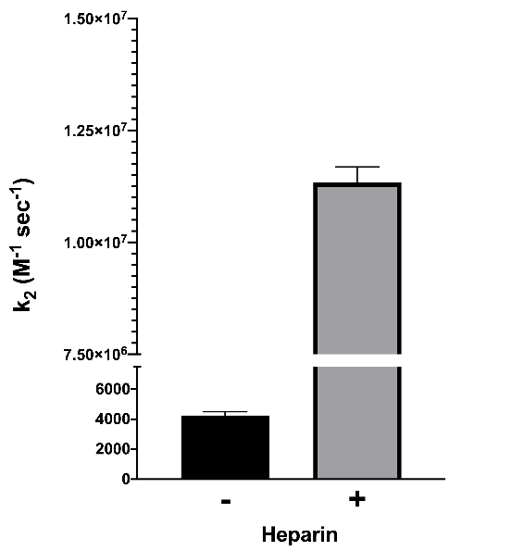

4.3 Kinetic Characterization of Aptamer Candidates as Inhibitors of AT in Thrombin-mediated Amidolysis
In this project, the primary way of measuring aptamer inhibition of AT activity was through determining thrombin’s cleavage of its chromogenic substrate, S-2238. Initially, this kinetics assay was used to test for any anti-AT activity following ten rounds of biopanning. The assay was further refined to derive a k₂ for AT’s inhibition of thrombin, in the presence of specific aptamer sequences. The change in k₂ provided a standard way to assess the relative inhibitory activity of each aptamer candidate.

4.3.1 Round 6 and 10 RNA Pools Significantly Increase Rate of Thrombin-mediated Amidolysis, compared to the Initial Round 0
Prior to determining which aptamer sequences needed to be synthesized for further analysis, the RNA pools from rounds 0, 6 and 10 were tested for AT inhibition. In this version of the thrombin-mediated chromogenic assay, a single-time point was recorded, The increase in the reaction velocity indicated more active thrombin, which correlated with a less active AT. Therefore, the inhibitory effect of the round screen pool was directly correlated with an increase in mean velocity. As seen in Figure 8, the round 10 aptamer pool did not differ statistically from the control reaction, which was a thrombin-only reaction, indicating that AT activity in the assay had been neutralized. Round 10’s aptamer pool also showed a significant increase in thrombin activity compared to the Round 0 and Round 6 pools, by p-values of 0.001 and 0.003 respectively (One-way ANOVA analysis).

Figure 8. Thrombin activity assay demonstrate a significant increase in chromogenic substrate cleavage (mean V) from the initial pool to the more enriched pools (Rounds 6 and 10). The round 0 pool was representative of the non-selected population of RNA sequences before starting the selection protocol. Data in this figure represents the mean of three determinations. Vertical error bars denote the standard deviation. Horizontal lines that link different conditions represent statistical significance using one-way ANOVA, with Tukey-Kramer multiple comparisons post-test. Symbols above the horizontal bar indicate statistically significant differences from the thrombin only control: **p < 0.01. “ns” not significant.

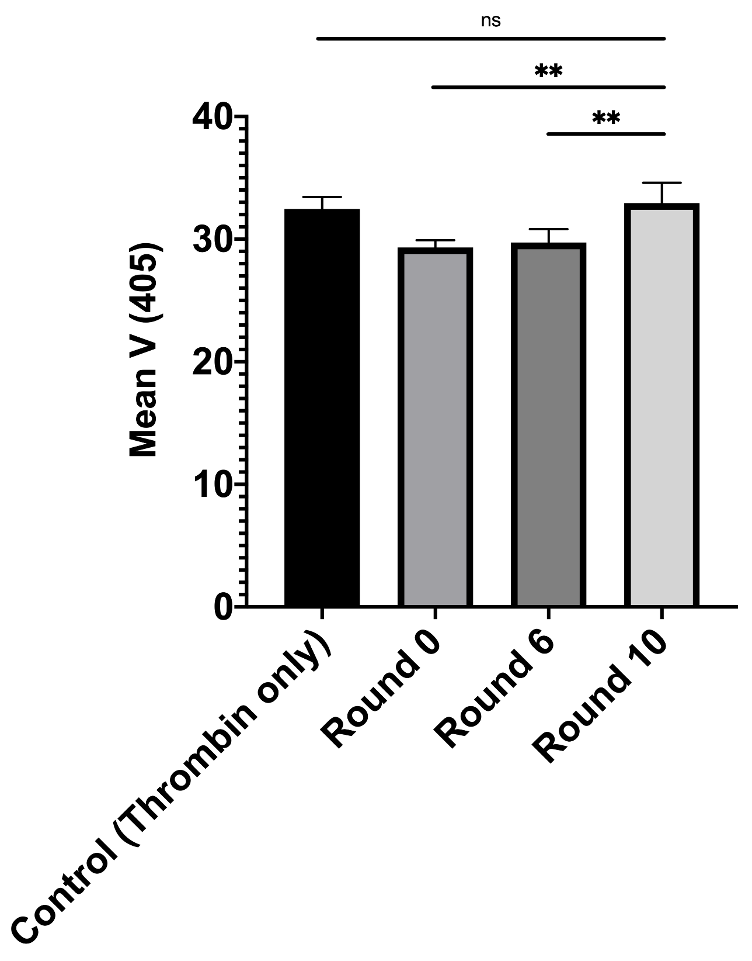

4.3.2 Comparing the Effects of Aptamer Candidates on AT’s Rate of Thrombin Inhibition
The comparison of the rate of thrombin inhibition by AT in presence of the aptamer candidates demonstrated that all aptamers appear to have decreased the rate constant of inhibition, compared to the ‘AT + Thrombin’ (no aptamer) control. However, some aptamers decreased the reaction rate more notably than others. For instance, aptamers R6_15, 19, 45, and 69 were associated with the lowest inhibition rate constants, approximately 60% of the no aptamer control (Figure 9A). Figure 9B compares the residual thrombin activity of aptamers R6_1 and R6_15 to that of the negative control aptamer. R6_1 and R6_15 appeared to increase thrombin activity compared to the negative control. For instance, at every time point (except the initial t=0), thrombin activity in presence of the negative control was lower than the two aptamer candidates.

Figure 9. Screening test for the aptamers capable of decelerating AT’s inhibition of thrombin. (A) Kinetic parameters of the 19 most abundant aptamers from round 9 are shown above, compared to AT-Thrombin (No Aptamer) reaction (dotted line) and negative control aptamer. (B) Comparisons of the residual thrombin activity as a percentage of initial activity after incubation with AT and aptamers R6_15, R6_1, or the negative control aptamer. Data points represent the mean ± SD, using three determinations for graph A and five determinations for graph B. Lines of best fit determined by non-linear regression are shown.

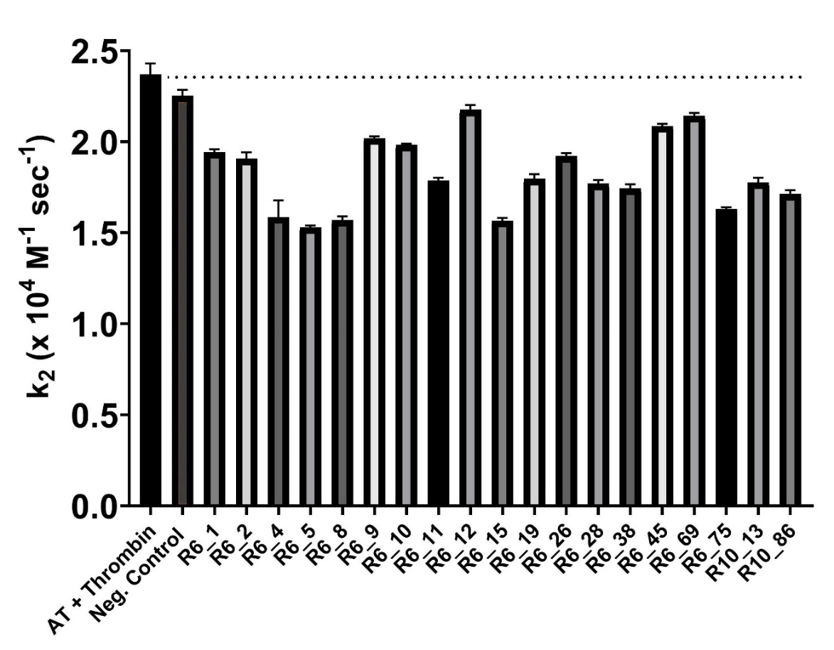
A

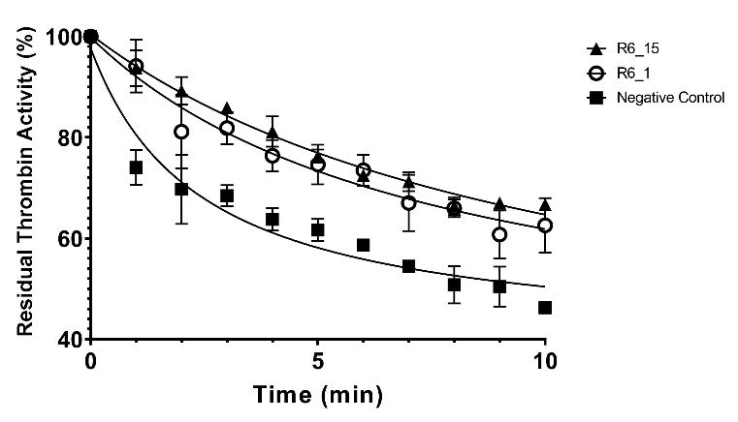
B

4.3.3 Effects of Heparin on the Aptamer Candidates’ Kinetic Characterization
The aptamers (R6_10, R6_15, and R6_19) found to be most active in the inhibition o AT in the absence of heparin were next tested for their effect on the rate of heparin-catalyzed AT inhibition of thrombin. The same control reaction, “No-Aptamer”, as the previous non-heparin kinetic characterization was used. Additionally, the negative control aptamer (R6_20) was also tested in this assay. Based on data presented in Figure 10A, the aptamer R6_15 had the lowest slope, indicating a slower inhibition reaction compared to the no aptamer control and the negative aptamer control. Similarly, in Figure 10B, the aptamer R6_15 significantly decreased the rate of inhibition by about 60%, and R6_10 significantly lowered the rate by 40%, compared to the no aptamer control. On the other hand, aptamer R6_19 did not significantly alter the rate of inhibition from the two assay controls. Lastly, Panel C shows the effect of R6_15 on prolonging the time which thrombin is actively cleaving the chromogenic substrate, compared to the lower thrombin activity in the negative control and R6_19 conditions.
In the discontinuous kinetics assay without heparin, R6_10, R6_15, and R6_19 were among the aptamer candidates with the greatest decrease in k₂ (Table 3A). All those aptamers showed a significant decrease in k₂ (p < 0.0001). The negative control aptamer was associated with a small (5%), but significant, decline in k₂ in the absence of heparin. However, in the kinetic assay with heparin present (Table 3B), neither the negative control aptamer nor R6_19 displayed a significant decrease in k₂. Similar to the heparin-absent experiment, R6_10 and R6_15 were still associated with a significant decline in k₂, compared to the no aptamer control.
Figure 10. Heparin-catalyzed kinetic parameters. (A) The natural logarithm of the ratio of the initial thrombin activity (P₀) to the residual activity at time t (P_{t}) vs. the time in seconds (x-axis). Lines of best fit were determined by linear regression. Individual data points are the mean ± SD of five determinations. (B) Representation of the three most active aptamers compared to AT-Thrombin (No Aptamer control) and negative control aptamer, in an AT inhibition of thrombin reaction which includes heparin. Graphs bars represent the thrombin mean reaction velocities of five different determinations. The SD is shown in the error bars. Horizontal capped lines that link different conditions represent statistical significance using one-way ANOVA, with Tukey-Kramer multiple comparisons post-test. Symbols above the horizontal bar indicate statistically significant differences from Buffer or AT only reactions: *p < 0.05; **p < 0.01; ***p < 0.001; ****p < 0.0001. “ns” not significant. (C) Comparisons of the residual thrombin activity as a percentage of initial activity after incubation of AT, heparin, as well as aptamers R6_15, R6_19, or the negative control aptamer. The points represent the mean ± SD, using five determinations. The lines are representative of the line of best fit as determined by non-linear regression.

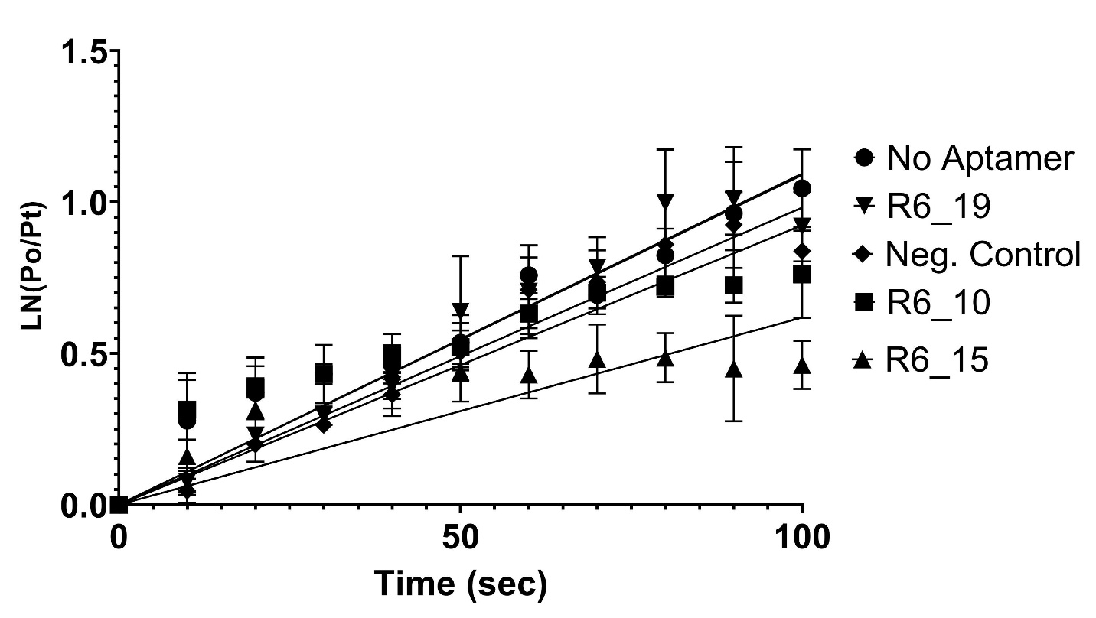
A

B | C
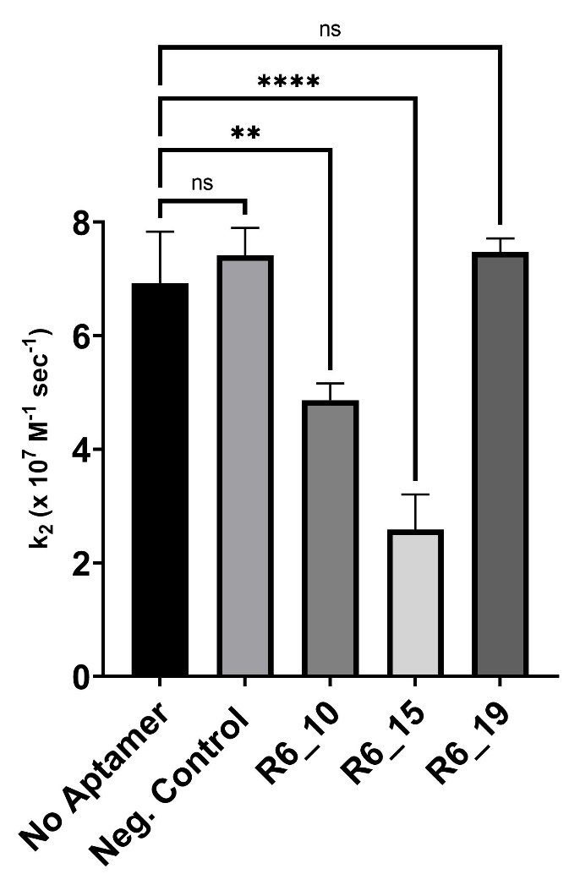 | 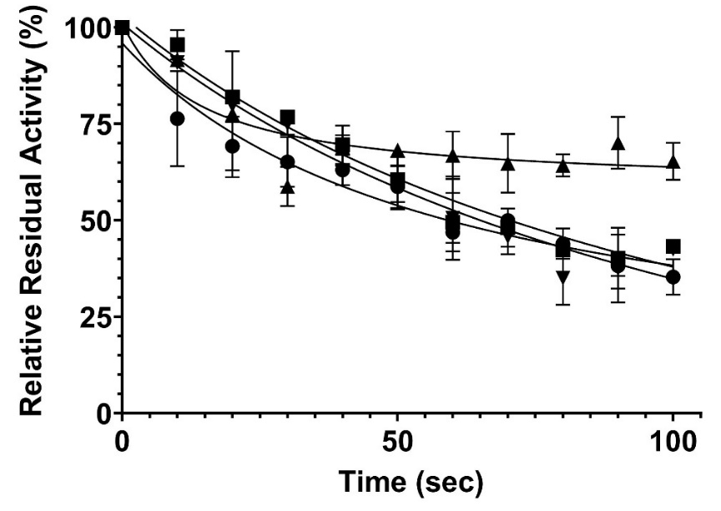
Table 3. Comparison of second order of thrombin inhibition by AT. This table reports the effects of aptamers on the rate of the (A) non-heparin and (B) heparin-catalyzed reactions. Values are the mean ± SD of five determinations. ‘NEG’ denotes the negative control aptamer. Statistical significance of the aptamers’ effects was compared to the no-aptamer control (No Apt.) and was calculated using the one-way ANOVA, with Tukey-Kramer multiple comparisons post-test. *p < 0.05; **p < 0.01; ***p < 0.001; ****p < 0.0001. “ns” not significant.

Aptamer | k₂ AT (x 10⁴ M⁻¹ s⁻¹) | P-value
No Apt. | 2.37 ± 0.06 | -
R6_10 | 1.98 ± 0.01 | **** <0.0001
R6_15 | 1.57 ± 0.02 | **** <0.0001
R6_19 | 1.80 ± 0.03 | **** <0.0001
NEG | 2.25 ± 0.03 | ** 0.006
A

B

Aptamer | k₂ AT-Heparin (x 10⁷ M⁻¹ s⁻¹) | P-value
No Apt. | 6.92 ± 0.91 | -
R6_10 | 4.87 ± 0.29 | ** 0.004
R6_15 | 2.59 ± 0.62 | **** <0.0001
R6_19 | 7.48 ± 0.23 | ns
NEG | 7.42 ± 0.48 | ns

4.4 Inhibition of AT by Aptamer Candidates in Pooled Human Plasma
As explained thoroughly in the Methods section, three variations of the aPPT clotting time assay were designed and utilized. These assays identified some aptamer candidates which accelerated the time to clotting when added to pooled human plasma. This acceleration in clotting has been represented in the form of a graph, in which the change in clotting time (from the baseline: buffer or AT) was measured and recorded.

4.4.1 Measuring Clotting Time in Standard aPTT Assay
In the standard aPTT assay, about half of the tested 20 aptamers appeared to accelerate clotting, as observed in Figure 11A where ten aptamers caused change in clotting time to fall below the dotted line (buffer baseline). The other nine aptamers, along with the negative control aptamer, slowed down plasma clotting. In other words, in these conditions, the clotting time increased compared to buffer (above dotted line).

4.4.2 Measuring Clotting Time in Modified aPTT Assay
In this variation of the clotting assay, AT-deficient plasma was used, instead of the normal pooled human plasma, and AT was added to a defined concentration of 500 nM with or without aptamers. There were negative changes in average clotting time for 13 aptamer conditions, which included aptamers R6_9, R6_10, R6_15, and R6_19 (Figure 11B). These 13 aptamers caused a decrease in clotting time from the baseline (500 nM AT), consistent with a reduction in AT activity and a corresponding acceleration in coagulation function. The rest of the aptamers exhibited a positive change in average clotting time, or prolongation of plasma clotting. These candidates produced clotting times greater than the baseline (dotted line), suggestive either of increased AT activity or an increase in the activity of one or more clotting factors in plasma.
In the Table 4 below, the mean clotting data of some aptamer conditions are summarized for both the standard and modified clotting assays. Out of the 19 synthesized candidates, six aptamers significantly decreased clotting time of pooled human plasma. For example, the addition of aptamer R6_15 to human plasma accelerated clotting by 1.8 seconds from the buffer only baseline (Table 4A). In the modified aPTT assay, some aptamers like R6_9, R6_10, and R6_15 produced a significant effect on the AT-deficient plasma clotting time (Table 4B).
Figure 11. Effects of aptamer candidates in standard and modified aPTT assays.
Clotting assay data is shown as a change in clotting time, in seconds, from the baseline (dotted line). (A) This panel shows the change in clotting time, from buffer only, when the normal human plasma was treated with the aptamer candidates. (B) Aptamer candidates change clotting times in modified (AT-deficient plasma) aPTT assay. The mean clotting times, of three determinations, are denoted by the horizontal bar among the dots. Each black dot represents an individual clotting time point. The horizontal dotted line represents the baseline (buffer or AT).

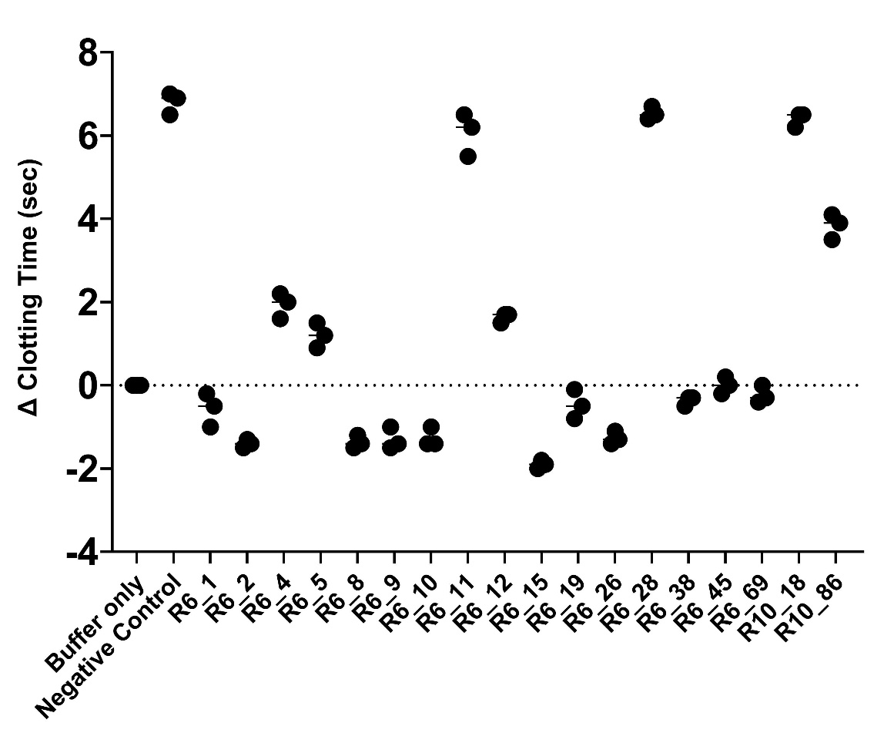
A

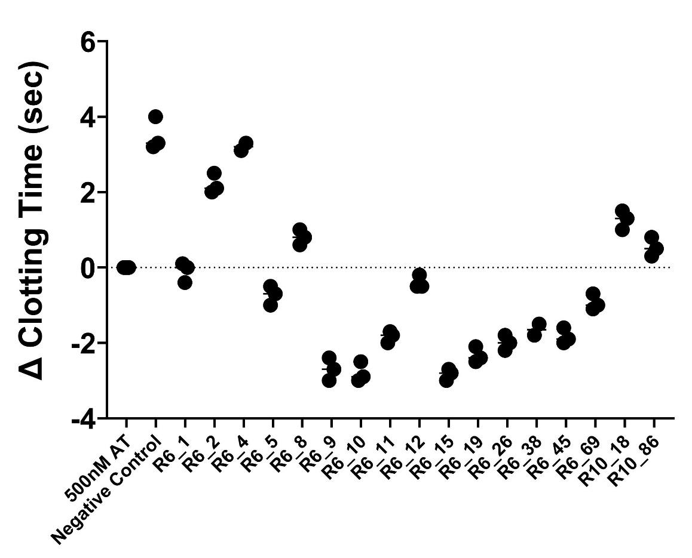
B

Table 4. Absolute clotting times of pooled human plasma upon treatment with aptamers. Shown are only the aptamers which accelerated the clotting of plasma in a (A) normal aPTT assay and (B) modified aPTT assay. Average clotting time was calculated using three determinations. Statistical significance was achieved using One-way ANOVA, with Tukey-Kramer multiple comparisons post-test. P-values identify significant differences from the buffer or AT only conditions: **p < 0.01; ****p < 0.0001. ‘ns’ not significant.

Aptamer | Average Clotting Time ± SD (sec) | P-value
Buffer | 30.4 ± 0.3 | -
R6_1 | 29.9 ± 0.3 | ns
R6_2 | 29.1± 0.1 | **** <0.0001
R6_8 | 29.1 ± 0.2 | **** <0.0001
R6_9 | 29.2 ± 0.3 | **** <0.0001
R6_10 | 29.2 ± 0.2 | **** <0.0001
R6_15 | 28.6 ± 0.1 | **** <0.0001
R6_19 | 30.0 ± 0.4 | ns
R6_26 | 29.2 ± 0.2 | **** <0.0001
R6_38 | 30.1 ± 0.1 | ns
R6_45 | 30.5 ± 0.2 | ns
R6_69 | 30.3 ± 0.2 | ns
B
A
Aptamer | Average Clotting Time ± SD (sec) | P-value
AT only | 40.0 ± 0.2 | -
R6_1 | 39.9 ± 0.3 | ns
R6_5 | 39.3 ± 0.3 | ns
R6_9 | 37.3 ± 0.3 | **** <0.0001
R6_10 | 37.2 ± 0.3 | **** <0.0001
R6_11 | 38.2 ± 0.2 | **** <0.0001
R6_12 | 39.6 ± 0.2 | ns
R6_15 | 37.2 ± 0.2 | **** <0.0001
R6_19 | 37.7 ± 0.2 | **** <0.0001
R6_26 | 38.0 ± 0.2 | ** 0.0064
R6_38 | 38.2 ± 0.2 | ** 0.0033
R6_45 | 38.1 ± 0.2 | ** 0.0051
R6_69 | 39.1 ± 0.3 | ns

4.4.3 Measuring Clotting Time in Dilute aPTT Assay
The same aptamers from previous aPTT experiments were also tested for any potential inhibitory effects on AT in a dilute plasma clotting assay. In this modified assay, the clotting activator was diluted, slowing down the time to lot, and potentially allowing more granular distinctions of aptamer effects. Shown in Figure 12 below are the effects of some of these aptamer candidates on the recorded clotting times. Compared to the control (500 nM AT), all the tested aptamers resulted in a significant acceleration of plasma clotting, as represented by the negative change in clotting time. Most notable are the experimental conditions in which aptamers R6_10, R6_15, and R6_19 were tested. In these instances, these aptamers quickened the dilute plasma clotting by 13 seconds on average, compared to the baseline (horizontal dashed line). It is also worth noting that the negative control aptamer along with aptamers R6_1-9 had lesser influence on the clotting times (average of 5-7 seconds) than the more active sequences. Additionally, the aptamers on the right hand side of the figure produced intermediate effects, in between that of the most active aptamers (e.g. R6_15) and the first aptamers (e.g. R6_1).

Figure 12. Effects of aptamer candidates on pooled AT-deficient human plasma in a dilute aPTT assay. Clotting assay data is shown as a change in clotting time, in seconds, from the baseline (dotted line). The figures displays the effects aptamer candidates have on plasma clotting time in a dilute aPTT assay. The mean clotting times are denoted by the horizontal bar among the dots. Each black dot reveals an individual clotting time point. The horizontal dotted line represents the clotting time baseline (500 nM AT). Horizontal lines that link different conditions represent statistical significance using one-way ANOVA, with Tukey-Kramer multiple comparisons post-test. Symbols above the horizontal bar indicate statistically significant differences from the thrombin only control: ***p < 0.001; ****p < 0.0001.

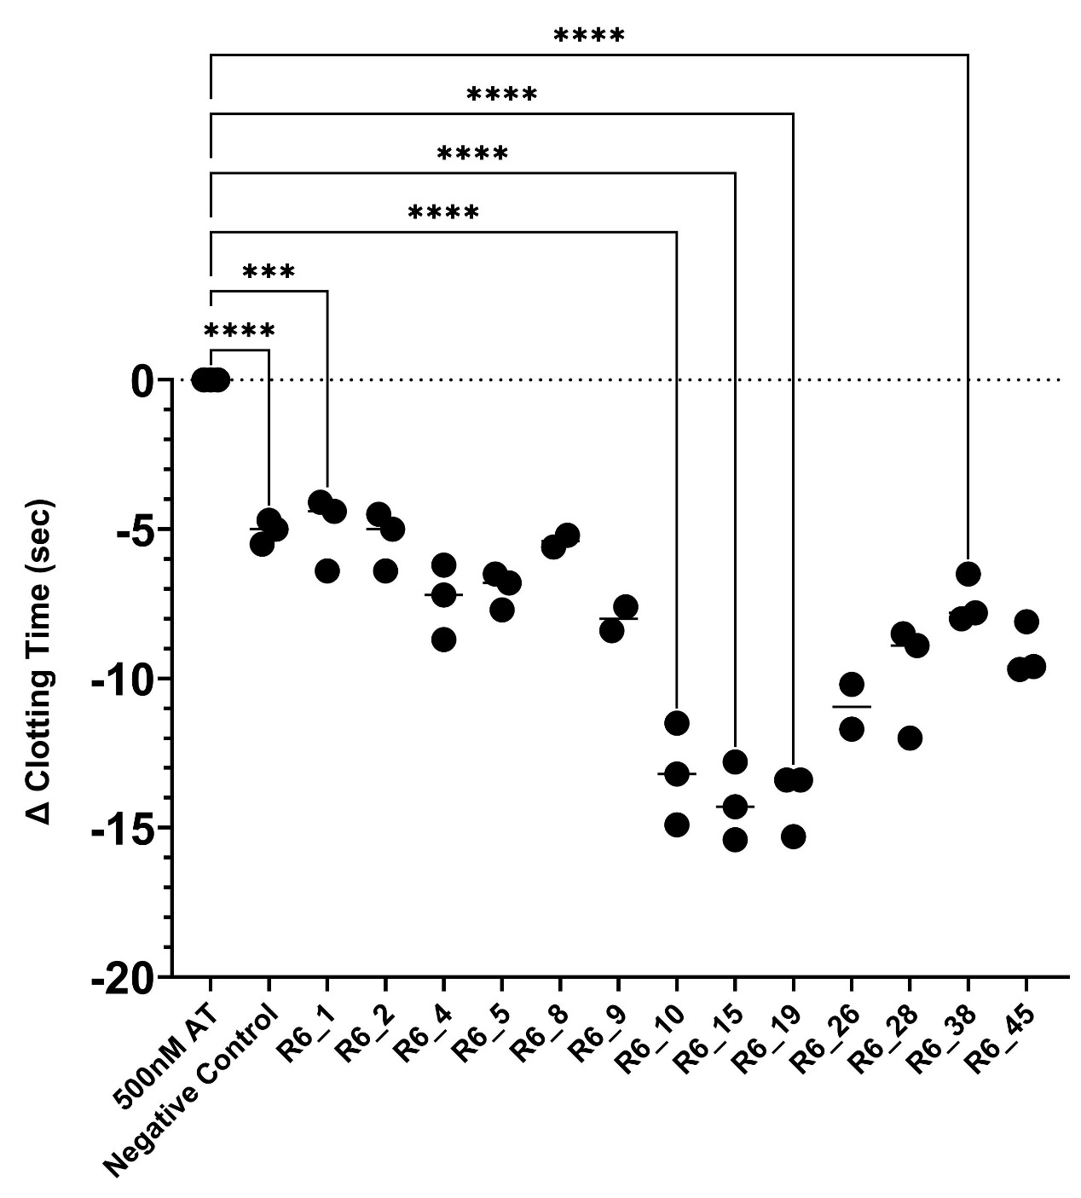

4.5 Characterization of Immobilized Aptamer Binding Affinity to AT using a Plate Binding Assay
In this assay, reaction velocities of the colour production by horse radish peroxidase (HRP)-linked anti-AT IgG after substrate addition were measured. Increased reaction velocities (mean V) indicated more immunoreactive AT in the wells, and therefore more bound AT. The assay baseline was a “no aptamer” condition, in which no aptamer was added to the wells. This value was subtracted from all the other data points. In this experiment, aptamers with the most improved AT binding were R6_10, R6_19, and R6_15 in that order. Based on the mean velocities in Table 5, the negative control aptamer (0.153) captured almost half of the amount of AT as the top binding aptamers (0.354). This assay was also used to show increase in AT bound to immobilized RNA sequences from rounds 0-6.
In Figure 13 below, aptamers (R6_10, R6_15, and R6_19) were tested for their binding to AT over a range of concentrations (0.01-10000 nM). The binding capacity of R6_10 to AT peaked at around 100 nM of aptamer, whereas R6_15 and R6_19 continued to increase. At the 10 µM aptamer mark, all three aptamers were equivalent to each other in terms of HRP-conjugated IgG activity, which correlates to binding of AT. The negative control aptamer did not cause an increase in mean velocity until about 100 nM. This aptamer consistently produced lower reaction velocities than the most active aptamers. The percentage of AT still bound to aptamers R6_10, R6_15, and R6_19 after all the washes was determined to be 10%, 8%, and 9% respectively.

Table 5. Comparison of AT binding to immobilized aptamer sequences. The measurement of binding is the reaction velocity of HRP-mediated colour production.

Aptamer Candidate | Mean V ± SD
R6_1 | 0.232 ± 0.002
R6_2 | 0.253 ± 0.012
R6_3 | 0.258 ± 0.043
R6_4 | 0.267 ± 0.008
R6_5 | 0.291 ± 0.005
R6_6 | 0.284 ± 0.021
R6_7 | 0.299 ± 0.010
R6_8 | 0.311 ± 0.011
R6_9 | 0.288 ± 0.037
R6_10 | 0.404 ± 0.011
R6_11 | 0.274 ± 0.005
R6_15 | 0.325 ± 0.023
R6_19 | 0.354 ± 0.019
R6_26 | 0.267 ± 0.031
R6_28 | 0.288 ± 0.014
Negative Control | 0.153 ± 0.014
Round 0 | 0.185 ± 0.013
Round 1 | 0.201 ± 0.022
Round 2 | 0.193 ± 0.007
Round 3 | 0.189 ± 0.015
Round 6 | 0.255 ± 0.029

Figure 13. Binding characterization of the top aptamer candidates to AT using the plate-based binding assay. Each point represents the mean colorimetric production (± SD) of HRP-conjugated anti-AT IgG. Higher mean velocities are correlated to the increased presence of bound AT, which was captured by the immobilized aptamer. Each data point is the average of three different determinations. The x-axis is graphed on a logarithmic scale. The error bars represent the SD.

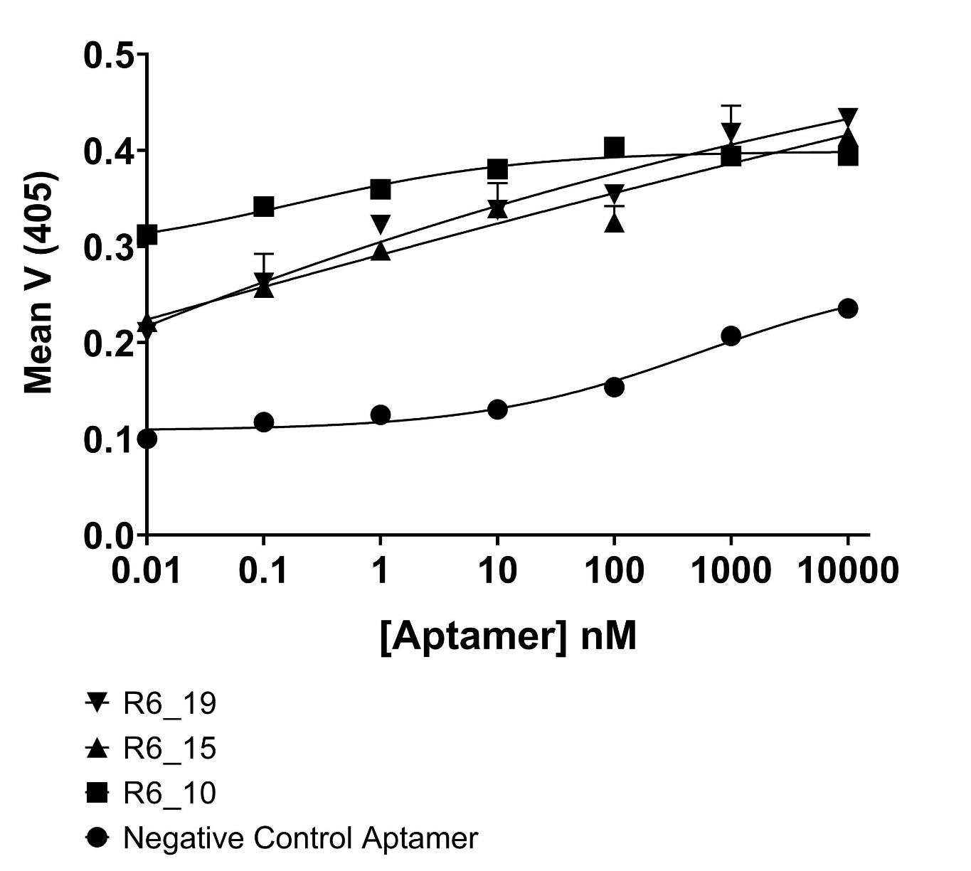

Figure 14. Standard curve of AT using the plate-based binding assay. Each point represents the mean colorimetric production (± SD) of HRP-conjugated anti-AT IgG. Higher mean velocities are correlated to the increased present of bound AT, which are captured by the immobilized aptamer. The data point is the average of three different determinations. The x-axis is graphed on a logarithmic scale. The error bars represent the SD.

A
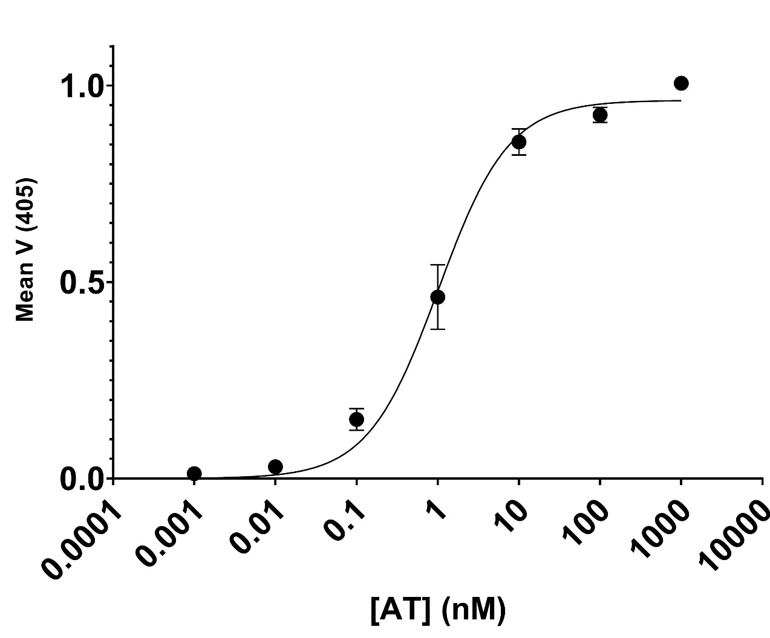
 | Mean V (± SD) | Percentage AT Bound (%)
R6_10 | 0.404 ± 0.011 | 10
R6_15 | 0.325 ± 0.023 | 8
R6_19 | 0.354 ± 0.019 | 9
NEG. | 0.153 ± 0.014 | <1

B

4.6 Effects of Aptamers R6_10, R6_15, and R6_19 on the Intrinsic Fluorescence of AT as a measure of Binding Affinity
Molecules binding to AT have been shown to affect the intensity of AT’s intrinsic fluorescence emissions. As shown in Figure 15 below, AT alone (in buffer) demonstrated an intrinsic fluorescence peaking at approximately 450-500 intensity units. However, the addition of standard heparin, a molecule which binds tightly to AT, raised the peak of AT by about 200-250 units to a final value of 700 (⬥). Heparin by itself did not yield any fluorescence signal.
Conversely, combining aptamer shown to reduce AT inhibition in clotting assays which AT decrease the protein’s intrinsic fluorescence, as evidenced by a flattening of the fluorescence emission curve. This phenomenon can be observed in Figure 16. In other words, the peak intensity value of AT decreased by about 40-50% in the presence of plasma clotting-active aptamers. In contrast, the negative control aptamer resulted in a negligible difference from the AT only peak (■). As seen in Panels A-C, the new AT peak (▼) following aptamer addition peaked at 300 for the R6_10 condition or 280 for the R6_15 and R6_19 conditions. This reduction in AT fluorescence intensity was significant for all three aptamers, as shown in Table 6. The introduction of heparin to the aptamer-AT complex had varied effects on the AT fluorescence intensity, as represented by the ⬥ symbol, in the presence of different aptamers. For R6_10, the average fluorescence intensity of AT at the peak increased by about 50 units from the R6_10-AT complex fluorescence curve. However, heparin fully restored the original AT fluorescence peak value of 450-500 units after adding heparin to the R6_15-AT and R6_19-AT complexes. The negative control aptamer-AT complex (Figure 17D) shared the same curve as the AT only (Figure 15) fluorescence spectrum.
Statistical analysis identified that the effects of aptamers R6_10, R6_15, and R6_19 on AT’s fluorescence intensity were significant, whether or not heparin was present (Table 6). The top binding aptamers were able to decrease the intrinsic fluorescence of AT, based on Figure 16’s standard curve, by between 36-41% in the heparin-less condition. On the other hand, the negative control aptamer resulted in non-significant effect on AT’s fluorescence curve. By adding heparin to aptamer-AT solution, R6_10 was able to decrease AT percentage by another 17%, whereas R6_15 effect remained relatively negligible and R6_19 caused an overall increase in AT intensity from 41% decrease to about 34% decrease.
Another use of AT fluorescence assay was to determine binding affinity constants of aptamers to AT. By titrating increasing concentrations of aptamer, a binding curve was generated, which facilitated the process of calculating the binding dissociation constant (k_{d}) (Figure 17). Aptamer R6_15 was revealed as the tightest binder to AT, with a binding dissociation constant of 65.3 nM. Aptamer R6_19 and R6_20 both bound AT with affinity of 67.5 and 204 nM, respectively. The negative control aptamer was also tested for its binding to AT, which resulted in a very high k_{d} of 1789 nM. The aptamers were all compared to the negative control for any statistical significance. The p-values are shown in Table 6. All aptamers were statistically different from the negative control aptamer.
Figure 15. Example of the fluorescence emission spectra of AT before and after the addition of 10 U/mL standard heparin. Each data point on the graph represents the mean of five determinations as measured by the fluorometer. Not visible are the error bars which represent the SD.
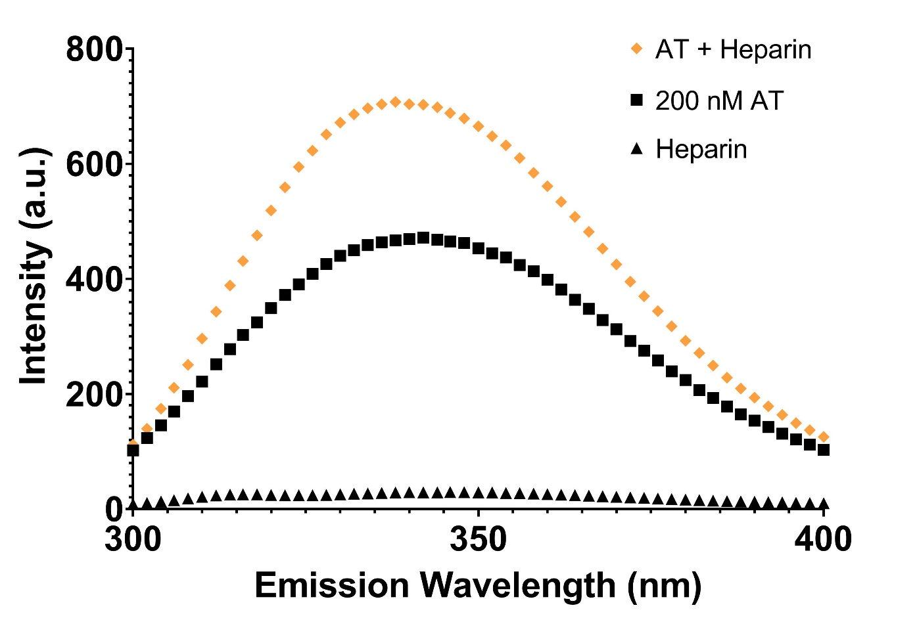

Figure 16. Example of the fluorescence emission spectra of AT before and after the addition of aptamers. Panels A-D show the effect of aptamer R6_10, R6_15, R6_19, and negative control aptamer on AT’s fluorescence intensity, respectively. Each data point on the graph represents the mean of five determinations as measured by the fluorometer. Not visible are the error bars which represent the SD.

A R6_10 | B R6_15
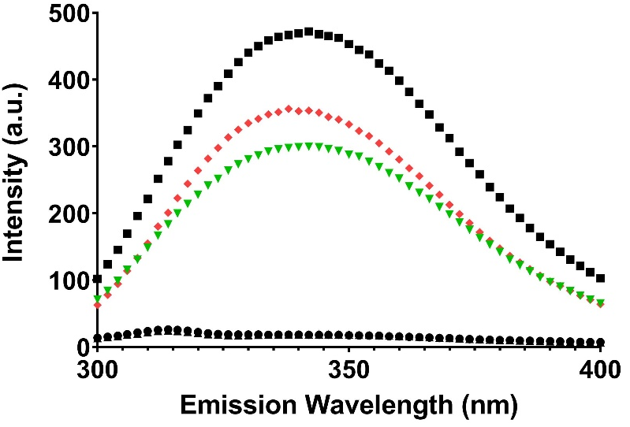 | 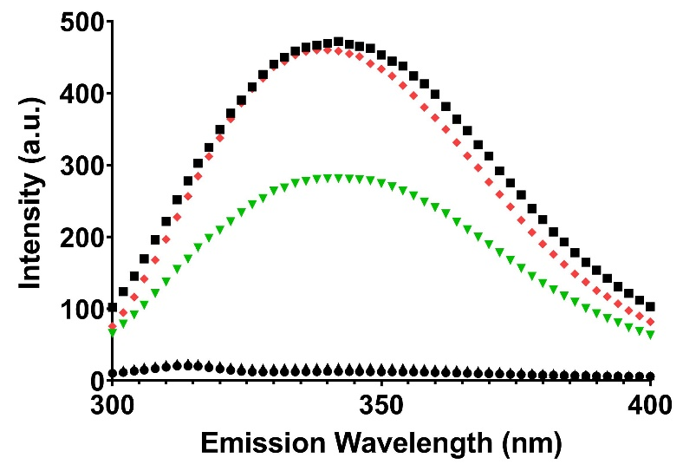
C R6_19 | D NEG.
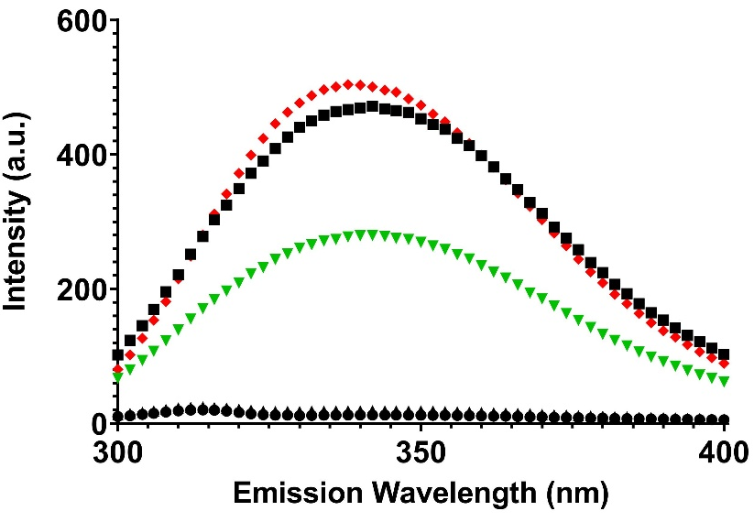 | 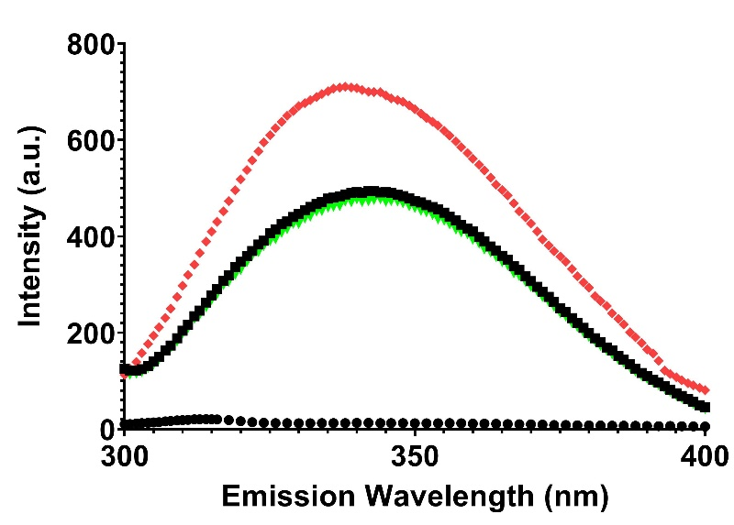

Figure 17. Characterization of the AT standard curve in fluorescence assay. This standard was created using increasing concentrations of AT and continuously measuring the fluorescence emission intensity. Slope of the linear trendline was determined to be 2.633, which was subsequently used for calculation of was used for extrapolating the percentage decrease of AT. The means ± SD of three determinations are shown in each point. The error bars are smaller than the size of the symbols.

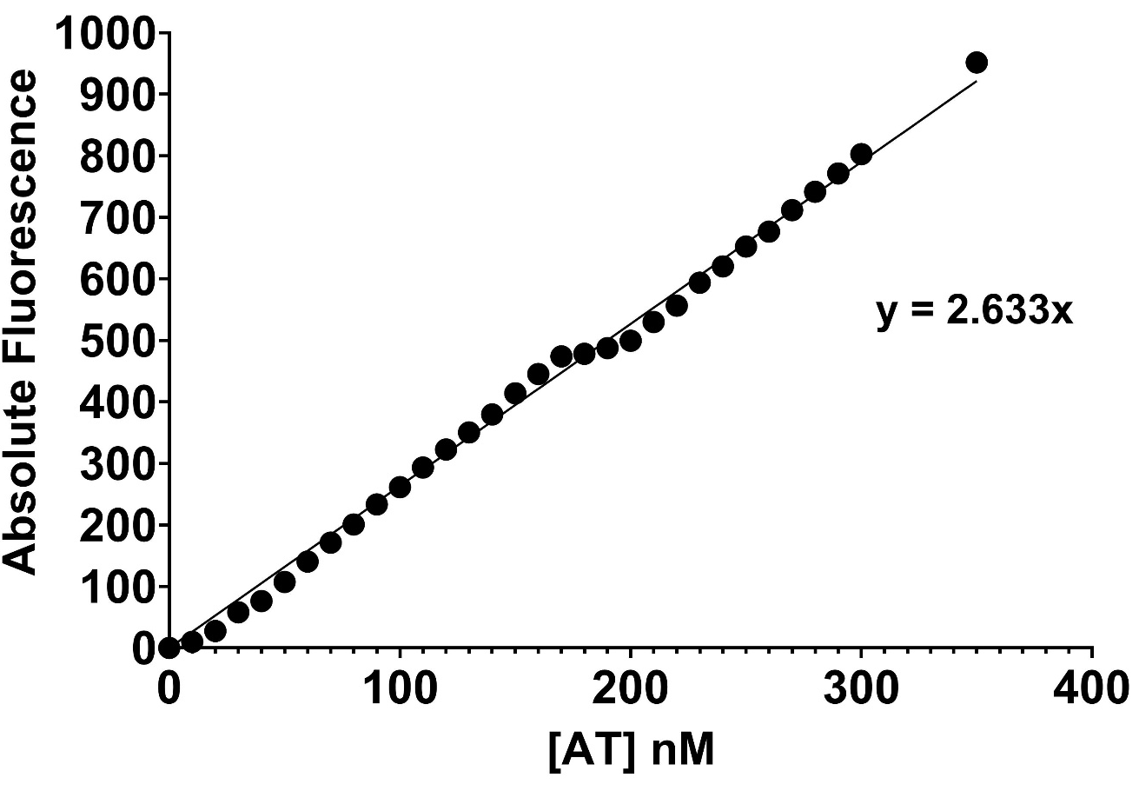

Table 6. Effects of aptamers on AT’s intrinsic fluorescent intensity. Panel A displays the decrease in AT fluorescence, whereas Panel B shows the effect on heparin-bound AT’s fluorescence. The means ± SD of five determinations are listed in each cell. Statistical significance compared to AT only fluorescence was determined by one-way ANOVA Multiple Comparisons test. “Mean F” average peak fluorescence intensity. “ns” not significant.

 | Mean F (± SD) | % Decrease | P-value
AT | 471.9 ± 1.2 | - | -
R6_10 | 300.8 ± 1.4 | 36.58 | **** <0.0001
R6_15 | 281.3 ± 1.1 | 40.52 | **** <0.0001
R6_19 | 279.3 ± 1.3 | 40.97 | **** <0.0001
NEG. | 472.7 ± 2.9 | -0.76 | ns
A

 | Mean F (± SD) | % Decrease | P-value
AT | 767.7 ± 1.4 | - | -
R6_10 | 356.3 ± 0.6 | 53.6 | **** <0.0001
R6_15 | 460.1 ± 2.4 | 40.0 | **** <0.0001
R6_19 | 504.1 ± 3.0 | 34.3 | **** <0.0001
NEG. | 712.6 ± 3.0 | 7.2 | **** <0.0001
B

The following experiment consisted of measuring the effect of aptamers R6_15 and the negative control on the binding of AT in the presence of increasing concentrations of heparin. As illustrated in Figure 19A below, the increasing amount of heparin in the “no R6_15” condition (●) was associated with a fluorescence plateau at around the 100 ΔF mark. However, when 1 μM of R6_15 was added, the titrated heparin produced a peak change in fluorescence of about 26.1 a.u. (□). This equates to a 73.9% decrease in ΔF by adding 10-fold molar excess of R6_15 to AT. On the other hand, 1 μM of negative control aptamer decreased the maximum fluorescence plateau by only 28% (Figure 19B). Aptamer R6_15 was more effective at decreasing heparin binding affinity to AT than the negative control aptamer.

Figure 18. Change in fluorescence intensity of AT due to increasing concentrations of aptamer. The means ± SD of five determinations are shown in each point.

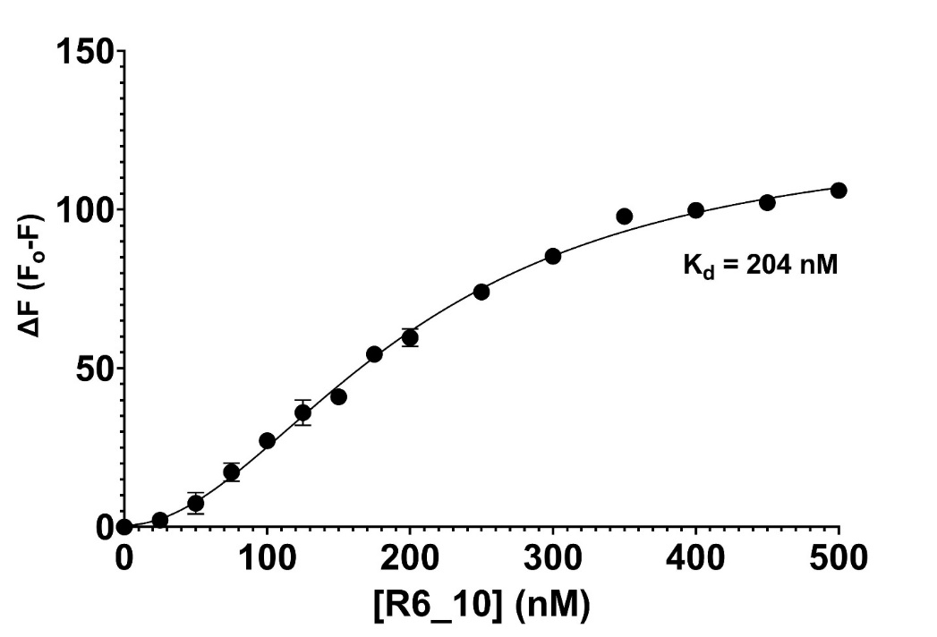
A

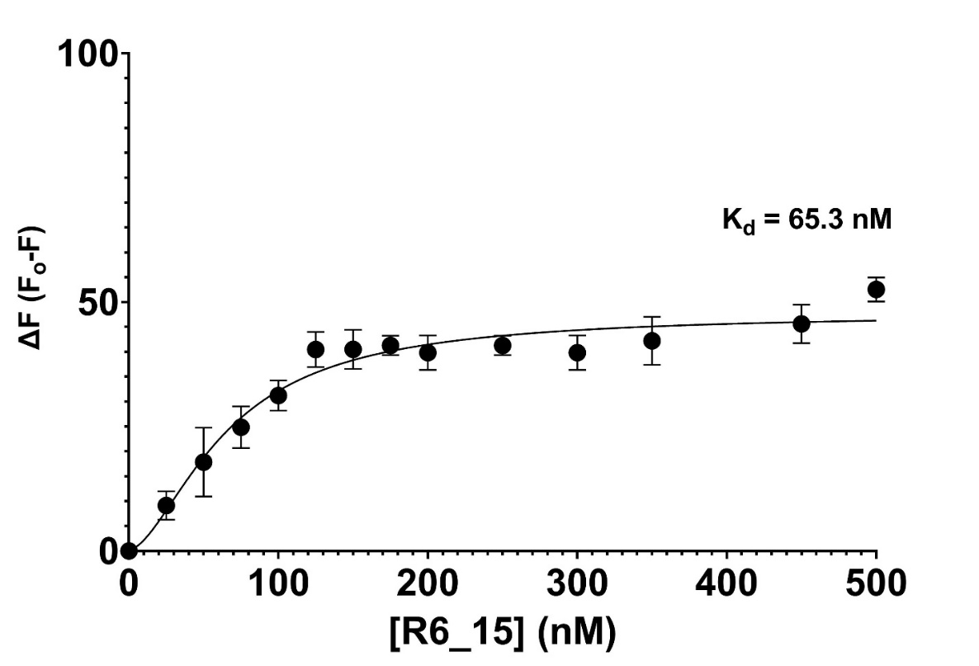
B

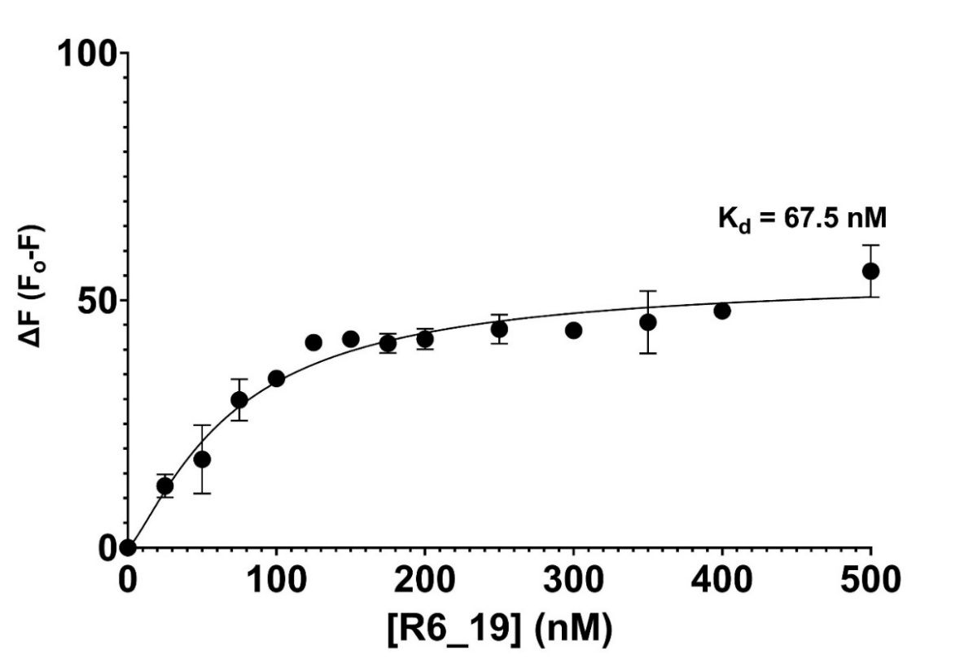
C

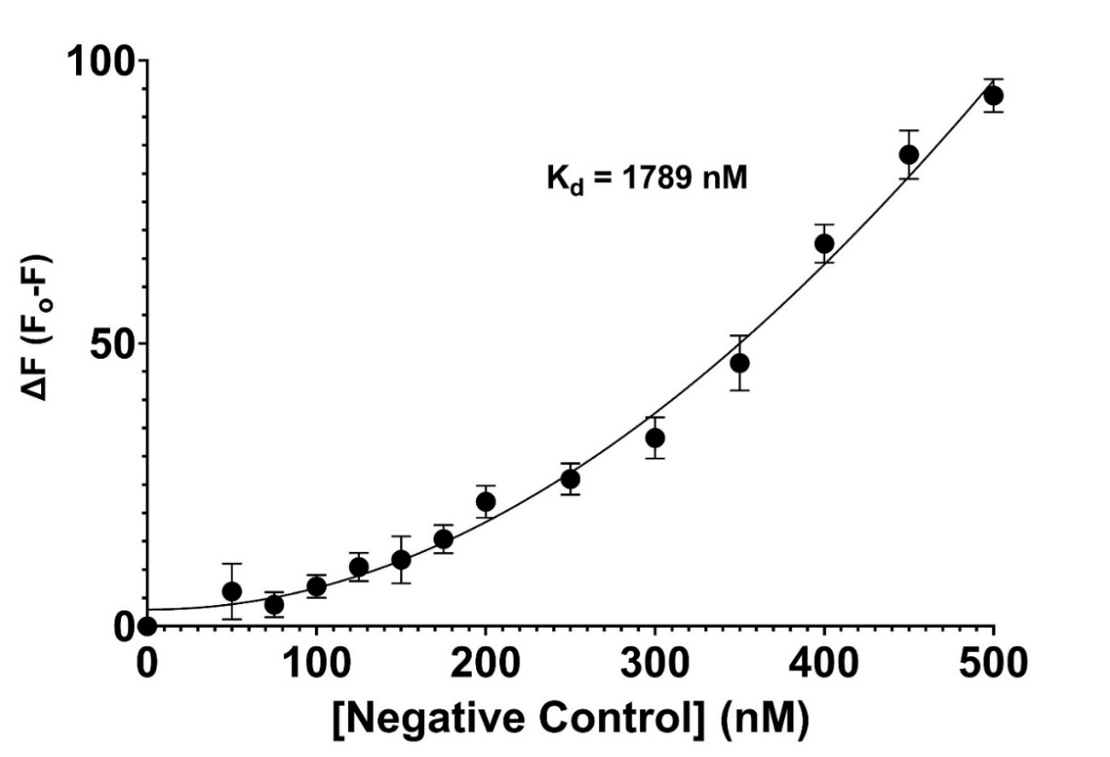
D

Table 7. Binding characteristics of the most likely aptamers to target AT. The binding affinity values (k_{d}) show were derived from the above plots and averaged from five determinations. Statistical significance was achieved using one-way ANOVA, with Tukey-Kramer multiple comparisons post-test. P-values show identify the significant differences from the negative control aptamer (NEG.) condition: **p < 0.01.

 | k_{d} ± SD (nM) | P-value
R6_10 | 204.3 ± 6.8 | ** 0.0041
R6_15 | 65.3 ± 8.7 | ** 0.0026
R6_19 | 67.5 ± 14.5 | ** 0.0028
NEG. | 1789 ± 53 | -

4.7 Effects of Truncated R6_15 Variants on AT Inhibition in Human Plasma
As demonstrated in Figure 19, the full-length R6_15 aptamer remained the sequence with the quickest clotting time in all three different types of aPTT assays. None of the variants resulted in a significantly less time to clot than full-length R6_15. In the normal and dilute aPTT assays, the differences between the full-length and all variants were significant (p-value < 0.0001) (Figure 20A,C). However, in the modified clotting assay, there was no significant difference between the full-length and 3P R6_15 variant (p-value = 0.053) (Table 8). Compared to the AT baseline, the full-length, 5P and 3P R6_15 truncated variants significantly decreased clotting time (Figure 19B). Only the no primer-binding regions R6_15 variant (NP R6_15) did not cause a significant decrease in clotting time (Table 8).
Figure 19. Binding affinity parameters of standard heparin to the AT-aptamer complexes. (A) This panel demonstrates the decrease in binding affinity of heparin in response to increasing concentrations of R6_15 relative to AT. Panel B shows the results of the same experiment, however while adding heparin into the reaction. The means ± SD of five determinations are shown in each point.

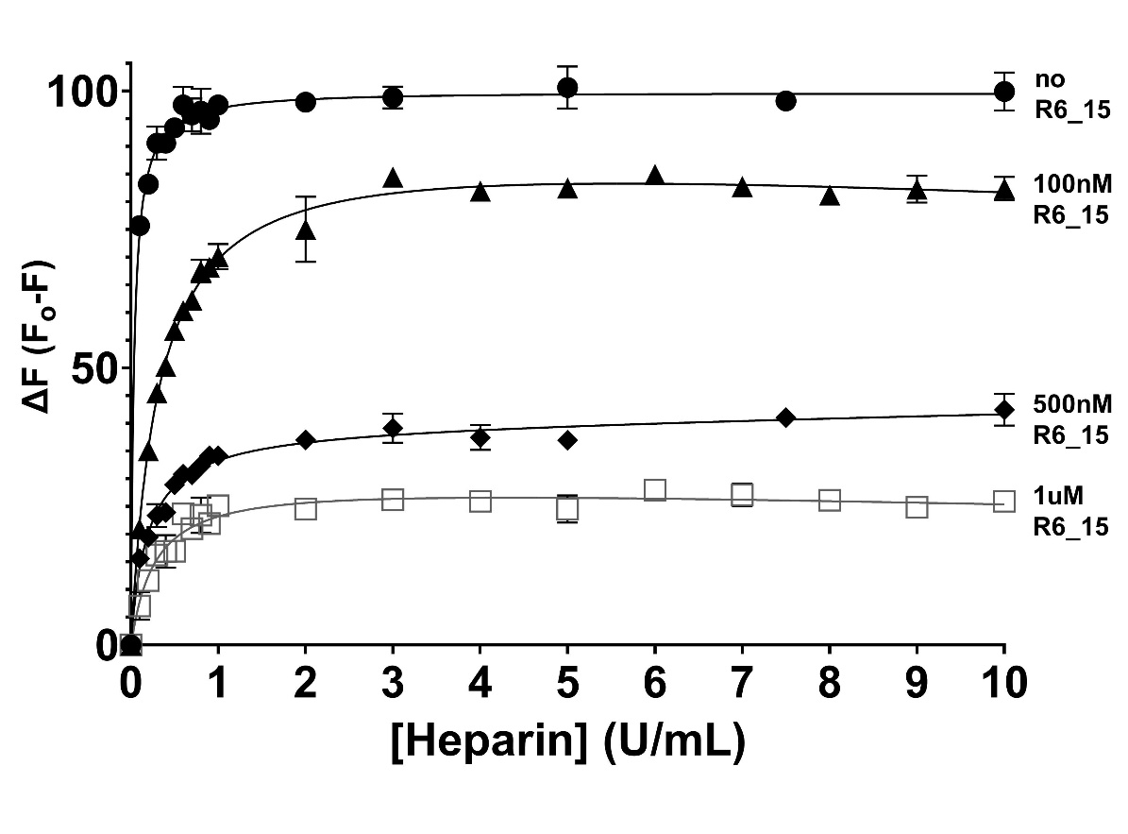
A

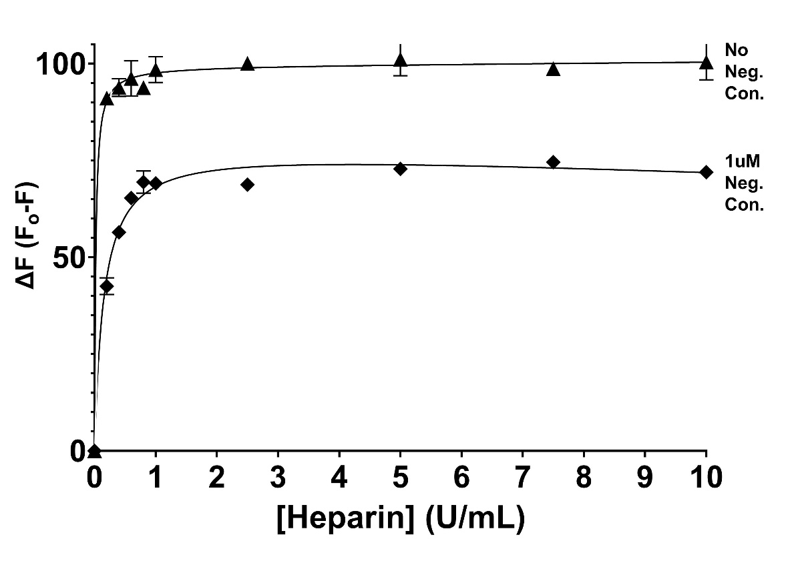
B

Figure 20. Effects of R6_15 truncated variants on clotting time of pooled human plasma. Panel A shows the effect of truncated variants on plasma in a standard aPTT assay, whereas clotting time for the modified and dilute aPTT assays are displayed on panels B and C, respectively. Clotting assay data is shown as a change in clotting time, in seconds, from the baseline (dotted line). Each black dot represents an individual clotting time point. Horizontal capped lines that link different conditions represent statistical significance using one-way ANOVA, with Tukey-Kramer multiple comparisons post-test. Symbols above the horizontal bar indicate statistically significant differences from Buffer or AT only reactions: **p < 0.01; ***p < 0.001; ****p < 0.0001. “ns” not significant.

A  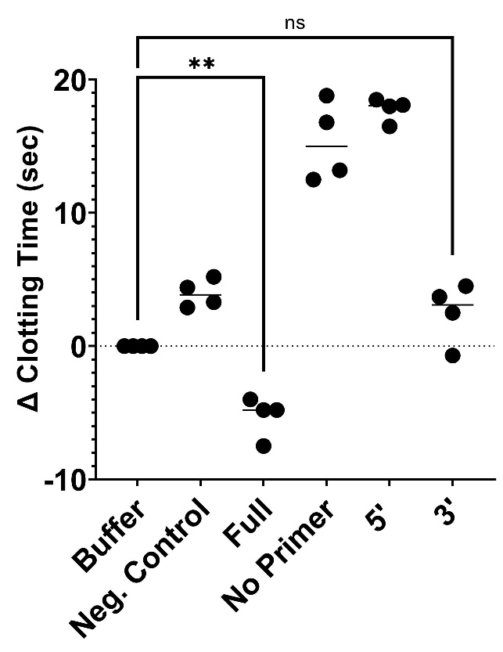 | B  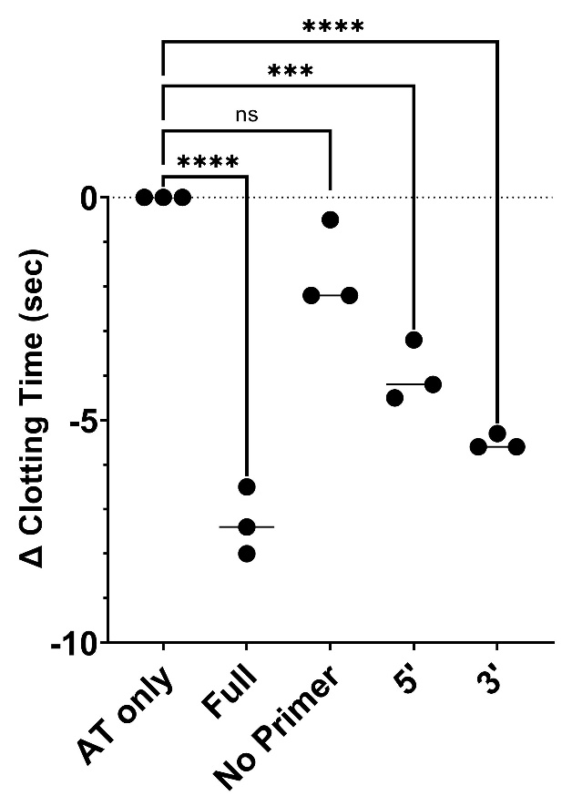
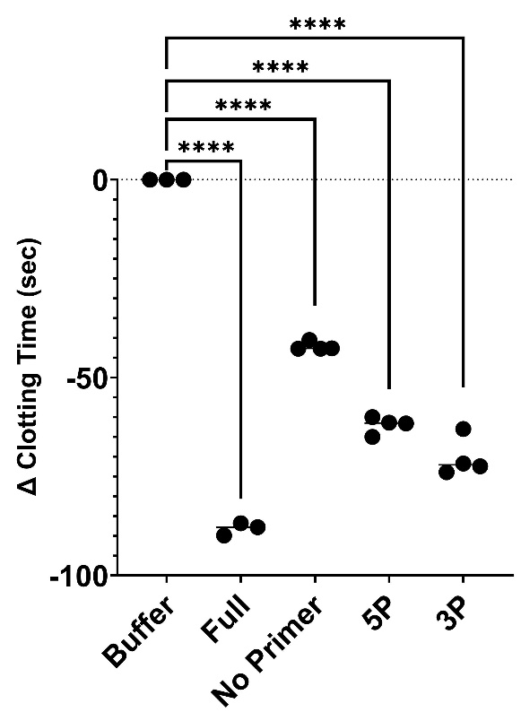
C

Table 8. Measurement of clotting time of aptamer R6_15 variants in the modified aPTT assay. Clotting times represented in the second column are averaged from three determinations. Statistical significance was probed using one-way ANOVA, with multiple comparisons post-test.

Aptamer | Average Clotting Time ± SD (sec) | P-value (from AT) | P-value (from Full)
AT | 44.3 ± 0.8 | - | -
Full R6_15 | 37.3 ± 0.7 | **** <0.0001 | -
NP_R6_15 | 42.7 ± 1.1 | ns | **** <0.0001
5P_R6_15 | 40.6 ± 0.7 | *** 0.001 | * 0.025
3P_R6_15 | 39.1 ± 0.2 | **** <0.0001 | ns

4.8 Binding Characterization of Truncated R6_15 Variants to AT using Intrinsic Fluorescence
The same R6_15 variants from the aPTT assays were also tested using the fluorescence binding assay under the same conditions explained in the Methods section. The variants’ k_{d} values do not decrease from the full-length value of 60.23 nM (Table 9). As shown in Figure 21B below, the aptamer variant with the no primer binding region (‘NP R6_15’) does not appear to even bind specifically to AT since the 4-parameter equation cannot derive a binding affinity constant. However, like the aPTT assays, adding back the 5’ and 3’ primer binding regions shows a reversion of binding affinity back to the level of the full-length R6_15 aptamer. The binding affinity of 5P R6_15 was statistically different from the full-length aptamer. On the other hand, 3P and full R6_15 did not statistically differ in terms of their k_{d} values. These results complement the clotting time data since the addition of the 3’ primer binding region shows better binding to AT, than with the addition of the 5’ region only, or by taking away both regions.

Figure 21. Examples of R6_15 variants’ effects on the change of fluorescence of AT. Panels A-D represent the full-length, no primer-binding region, 5’ primer-binding region, and 3’ primer-binding region R6_15 variants, respectively. The means ± SD of five determinations are shown in each point. The derived binding affinity constants (k_{d}) determinations are shown in each graph.

A

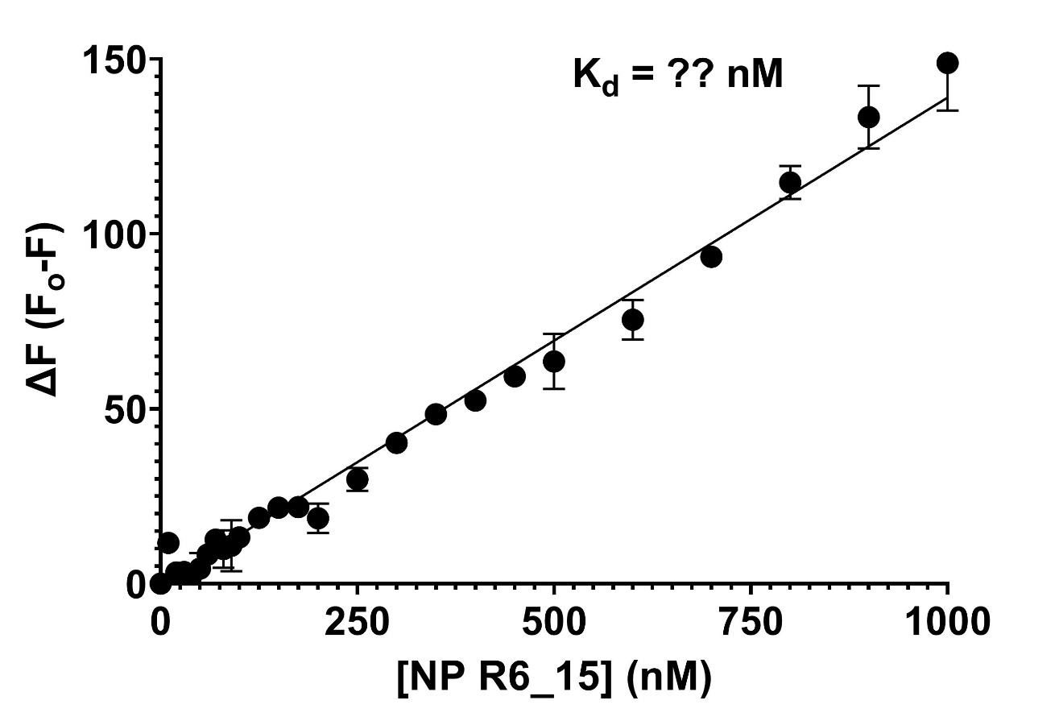
B

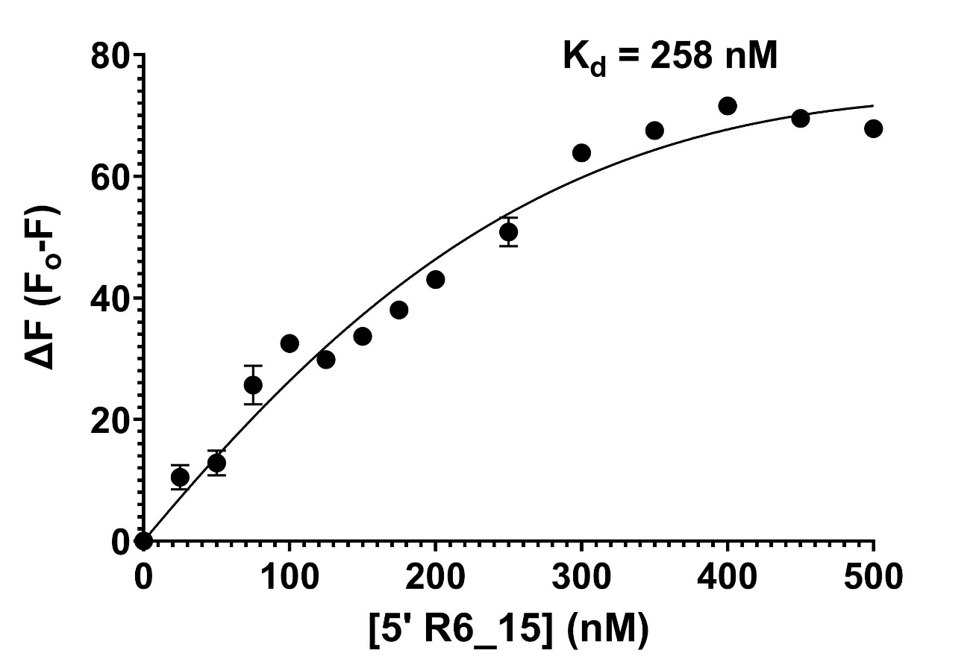
C

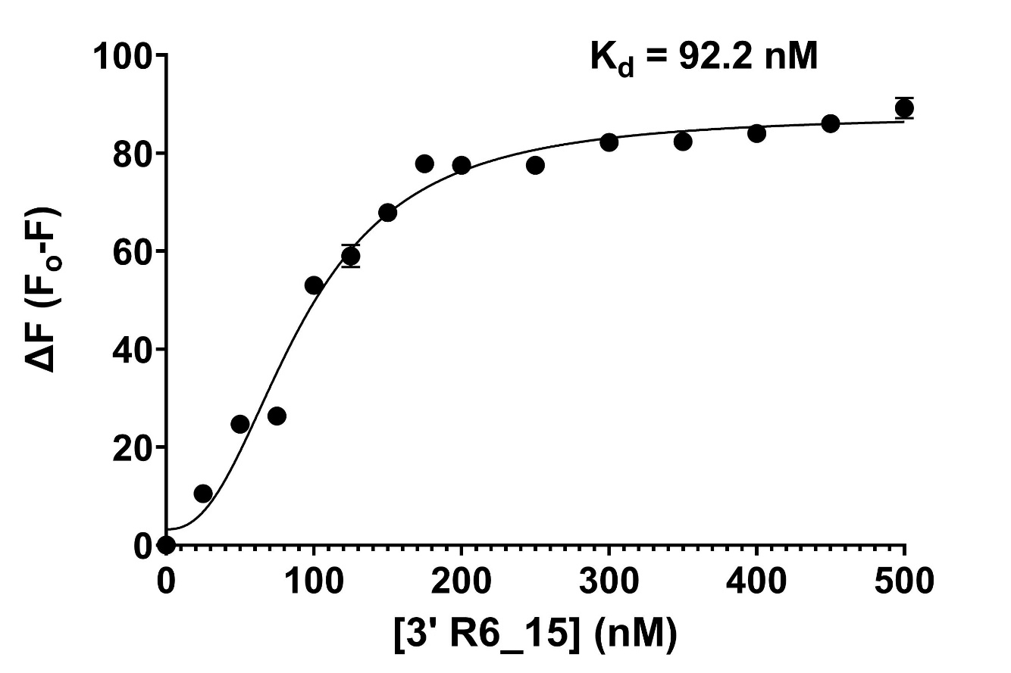
D

Table 9. Binding affinities of R6_15 truncated variants. The average binding affinities were averaged from three determinations. Statistical significance was probed using one-way ANOVA, with Tukey-Kramer multiple comparisons post-test. “ND” not detected. “ns” not significant.

 | k_{d} ± SD (nM) | P-value
Full R6_15 | 65.3 ± 8.7 | -
NP R6_15 | ND | ND
5P R6_15 | 258 ± 28 | **** <0.0001
3P R6_15 | 92.2 ± 2.6 | ns

4.9 RNA Sequence Analysis of the Most Active Aptamers
A trend in the variable region of the aptamers with improved AT binding was observed. By aligning the variable regions of the top four aptamer candidates (based on plate binding assay), it is evident that the guanine at position 6, uracil at position 17, and adenine at position 31 are highly conserved among all the top candidates. However, there was no strong consensus sequence found at the exact positions of the variable region. Instead, we chose to further investigate potential binding motifs by comparing only two aptamers at a time. As highlighted in Table 10 below, the Basic Local Alignment Search Tool (BLAST) identified exact overlaps. It could be possible that these exact motifs are responsible for binding to different sites on AT.
Additionally, by aligning these same aptamers using the MEME server, an optimal consensus sequence was found near the middle of the variable region (Figure 22). It is evident that the uracil position conserved among all sequences, including the non-selected control. Across all the 3 most active sequences, uracil (positions 17, 23) and guanine (position 18) are conserved (Figure 22). Additionally, cytosine (position 19), uracil (positions 25,26), and adenine (position 31) appear frequently. When compared to the negative control aptamer, only the uracil at position 19 is common whereas none of the other bases are present.

Table 10. Results of the BLAST global alignment by pairing two aptamer sequences at a time.

APTamer | Aptamer Variable Region | Motif
POSITION | 20 25 30 35 40 45 50 55 | -
R6_10 | UAAUGGCUGUGUGCCUUUAUUCAUGCCUGCAUGUGACGCG | UGCCUUU
R6_19 | UGUGCGAAUGCCUUUUUAACGCACGCGCAUAGUUGUUACA
R6_10 | UAAUGGCUGUGUGCCUUUAUUCAUGCCUGCAUGUGACGCG | UAUUCA
R6_15 | GUGCAGGGUAUACACGUGUCCGUAUUCACCAGGACUUCGA
R6_15 | GUGCAGGGUAUACACGUGUCCGUAUUCACCAGGACUUCGA | GUGC
R6_19 | UGUGCGAAUGCCUUUUUAACGCACGCGCAUAGUUGUUACA

Figure 22. The most frequently occurring ribonucleic acid bases in a multiple sequence alignment. Panel A shows a figure of the consensus sequence of the aptamer candidates that bind AT most avidly. Panel B represents the comparisons between the sequences of these top binding aptamers, as well as in relation to the negative control aptamer.

Aptamer | Aptamer Variable Region
R6_10 | GCGGACUACU | UGCUAAUAUUUAGCA | UACCGUAGUA
R6_15 | GGUAUACACG | UGUCCGUUUUCACCA | GGACUUCGAG
R6_19 | AAUGGCUGUG | UGCCUUUAUUCAUGC | CUGCAUGUGA
CONTROL | UGAUUAUAUC | UCCAUUGUACUCUCG | CAGUCGUUUC
A

B

5 DISCUSSION
The overarching goal of this project was to discover a novel RNA aptamer capable of targeting and inhibiting human plasma AT. To accomplish this goal, we chose to biopan a large RNA combinatorial library against AT, a member of the serpin family of proteins. Previous studies have indicated that the knockdown of AT activity via an siRNA inhibitor rebalances hemostasis in patients suffering from hemophilia A and B (128). Rebalancing hemostasis in favour of clotting could also be of benefit in trauma. Given that inhibiting AT has been shown to restore hemostasis, we sought to achieve a similar outcome by using aptamer technology to target AT. As of now, limited studies explore the inhibition of AT as therapeutic option. Additionally, there are no methods previously described in literature concerning biopanning a large combinatorial nucleic acid library against AT. While rebalancing coagulation via inhibition of APC (98) or inhibition of TFPI (99) have been investigated, there is limited information regarding inhibition of AT in the literature. In this project, direct inhibition of AT by RNA aptamers was investigated.

5.1 The In Vitro Selection Protocol and its Limitations
In this study, aptamer candidates were identified and generated through an in vitro selection process known as SELEX (100, 101). Recent advancements in the field, such as high throughput or deep sequencing, have facilitated the identification, processing, and visualization of the SELEX output. Combining HTS with SELEX (HT-SELEX) provides a deeper understanding of the sequence selection process. By characterizing these sequences, or aptamer candidates, following a set number of selection rounds, researchers have been able to probe an entire in vitro evolution process more thoroughly. Additionally, HT-SELEX offers an improved identification of the most active sequences in the enriched libraries.
As described in the Introduction section of this thesis, SELEX is often referred to as a “black box”. There are many variables that can alter the outcome of a SELEX experiment, such as number of cycles, target concentration, buffer conditions, incubation temperature and oligonucleotide library composition (129). Since the majority of target proteins in SELEX do not naturally bind nucleic acids, deducing an oligonucleotide sequence or a certain motif cannot be achieved without using in vitro selection. Hence the importance of proper design of the SELEX protocol, as it greatly contributes to the success of the aptamer candidates.
In this study, we employed the same starting randomized oligonucleotide library that was previously used in the lab to identify a novel anti-FXIa aptamer (108). This original DNA library was converted into modified RNA sequences, which are chemically modified at the 2’ position of the sugar molecules. Based on previous studies, these chemical additions result in a nuclease-resistant conformation, which increases the aptamer half-life, and may show superior affinity to targets (130, 131). Indeed, it has been demonstrated that target binding of weaker aptamers can be improved by up to 100-fold by incorporating these chemical modifications (132).
After ten iterative rounds of selection, the final enriched library was hypothesized to contain at least a few aptamer candidates capable of binding AT with high affinity and specificity. This section of the thesis explores these candidates thoroughly by analyzing their effects on multiple experiments, which measure AT’s structure and activity, and relating them to other aptamers in published studies.
We employed similar selection conditions which have been previously explored in well-known aptamer discovery studies that used SELEX (100, 101, 103). However, in our study, starting from Round 6, the stringency of the selection protocol was intensified as summarized in Table S1. For instance, the salt concentration in the wash buffer was greatly increased, whereas the incubation times and the amount of target AT were decreased. These steps were applied under the assumption that they would pressure the system to select for the strongest binding sequences to AT. However, it is possible that these relatively harsh conditions resulted in the lack of a single or few sequences dominating the enriched pool by the end of selection. In a study by Kim et al., the researchers aimed to discovered a novel single-stranded DNA (ssDNA) aptamer against the influenza virus H5N1 (133). The authors increased the concentrations of salt in buffers and decreased incubation time to 15 minutes, which were the same conditions used in our study. The researchers concluded that great deviations in buffer conditions can lead to failure of target binding (134). Increasing stringency of wash buffer (too much salt) may have an effect on aptamer structure formation and binding behavior to its target. In another paper, Siddiqui and Yuan demonstrated that the binding affinity of their DNA aptamer to its target was significantly decreased as the ionic strength of buffer increased (135). By applying this theory to our protocol, this may be the reason as to why some of the most enriched aptamer candidates in Round 10 lost binding capacity to AT.
In this SELEX protocol, the AT protein was immobilized on magnetic streptavidin beads via a biotinylated anti-AT IgG (See Figure 3 for a detailed illustration). This orientation could present a possible limitation. Immobilizing AT may have resulted in a change of its conformation and limited some sequences from binding to it in its native form. Additionally, the biotinylated polyclonal antibody could have bound to AT epitopes that may have been good sites for inhibitory aptamer binding. In both scenarios, inhibitory sequences could have been eliminated from selection as they were not able to bind AT.

5.1.1 Ranking of the Most Abundant Sequences
After the 10th selection round, the first step was to identify specific sequences which inhibit and/or bind AT in vitro by deep sequencing. As previously mentioned in the Results section, the 20 most abundant sequences determined from HTS analysis were tested in AT-thrombin kinetics assay, as well as plate-based and fluorescence binding assays. Following these experiments, a few select aptamers were identified as potential strong binders to AT. These aptamers, which were named R6_10, R6_15, and R6_19, were observed to have significantly disrupted AT’s inhibition of thrombin and altered AT’s intrinsic fluorescence, compared to the no-aptamer condition and negative control aptamer.
The two most frequent sequences by the final round of selection (R6_1 and R6_5) did not perform as well as R6_15 in either the kinetics or binding assays. These sequences appeared to be the most abundant candidates in the selected pool, yet they did not specifically bind AT as well as the other aptamers. This outcome could have arisen due to unintended PCR bias during the regeneration of the RNA pools, between selection rounds (136). It is possible that certain nucleotides were favored in the PCR or IVT reaction. A study concerning such bias in SELEX pool regeneration has identified adenine bases to be more frequently excluded during IVT reactions, than other nucleotides (137). Ideally, the number of PCR cycles should be kept at the minimum to reduce unintended PCR bias (136). In this project, PCR conditions were constant, with the number of cycles being 20 consistently throughout the SELEX protocol. By analyzing the HTS results, the fourth most abundant sequence terms of frequency appeared to be the most inhibitory aptamer and tightest binder to AT.
Even though there was a drop-off in the abundance of the top aptamer candidates in Rounds 8 and 10, the sequencing data still presented compelling data which made us proceed with kinetically characterizing the specific sequences. As observed in Table 3, the frequencies of the most abundant sequences were greatly decreased in Round 8 and later increased back in Round 9. This drop-off occurred again in Round 10 (not shown). By inspecting the selection protocol (Table S1), some explanations can be provided. Round 8 marked the decrease in incubation times from 30 to 15 minutes and reducing the amount of RNA pool by half for the first time. This provided less opportunities for the sequences to interact and bind AT. In Round 10, the concentration of AT used was decreased by 10-fold, from 4 to 0.4 μg. In this case, a reduced amount of target protein led to more competition between sequences, which may have affected the binding of these sequences to AT. These drastic changes in the selection process could have contributed to the drop-off in sequence frequencies as demonstrated by HTS analysis.
In this study, the negative control aptamer was chosen for primarily three reasons. Firstly, it was the same size as the other most abundant 20 sequences. Secondly, the negative control aptamer was from the same library. And lastly, it did not increase in abundance over the ten rounds of selection. This observation indicates that this negative control sequence was not enriched. However, a more appropriate negative control aptamer could have been employed in this study. To make the negative control aptamer, the primary sequence of the most inhibitory aptamer candidate R6_15’s variable region could have been scrambled. That way, the negative control would have the same nucleotide composition as R6_15 but in a randomly shuffled sequence.

5.2 Determining the Most Improved Aptamers based on Kinetic Characteristics
In the kinetic assay, the rate of inhibition of thrombin by AT was observed and recorded. To determine the effect of aptamers on the rate of AT’s inhibition of thrombin, the second-order rate constants were derived and compared to every other condition (no-aptamer condition, negative control aptamer, or other aptamer conditions). The first experiment which was conducted showed that the total RNA populations after Round 6 and 10 showed significantly increased thrombin activity than the Round 0 population (Figure 7). This observation provided us with the confidence that there exists in the enriched pools at least one sequence which interrupted AT’s inhibition of thrombin. This was indicative that the selection process was possibly successful and generated specific sequences with high binding capacity to AT.
In separate study, researchers tested the effect of human peptidylarginine deiminase 4 (PADI4) on AT inactivation (138). Similar to our kinetic experiments, they found that increasing the amount of the inhibitor PADI4 resulted in an increase of residual thrombin activity. Their findings were consistent with our results since the inhibitory aptamers (e.g., R6_15) appeared to have prompted the activity of thrombin to increase, compared to the no-aptamer (AT-thrombin only) and negative control conditions (Figure 8B). Therefore, we were able to correlate this increase in thrombin residual activity with AT inhibition, similar to what Chang et al concluded (138).
Later kinetic experiments focused on the effects of specific RNA sequences that were individually synthesized and purified. By determining the k₂’s of each AT-thrombin inhibition reaction, in presence of a specific aptamer candidate, we were able to compare the effect these sequences have on AT’s rate of inhibition. In the Results section, Figure 8A summarizes these findings and this figure identifies aptamers R6_4, 5, 8 and 15 as the ones with the most negative effect on k₂. Furthermore, the same experiment was conducted with the only difference being incorporating standard heparin. This condition was tested because of a working hypothesis that some aptamer sequences may be binding to AT at the same region as heparin. As shown in Figure 9B and Table 3, it appeared that heparin competed with R6_19 for AT binding. In the R6_19 condition without heparin, there was a significant decrease in AT’s second-order rate of inhibition of thrombin compared to the baseline, indicating the possibility that R6_19 actively interrupted the AT-thrombin interaction. However, when adding heparin, that same rate was no longer significant, potentially meaning that the aptamer R6_19 does not inhibit AT as well when heparin is present. On the other hand, aptamers R6_10 and 15 both significantly decreased AT’s rate of inhibition regardless of whether heparin was present or not. This finding explains not only the strength of these aptamers’ binding to AT, but also the location of this aptamer-AT interface. It could possibly be that heparin was not able to compete with these aptamers for AT binding, or that these aptamers bound at a different site from heparin. The finding that AT binds to heparin with a K_{D} of 72 ± 19 nM (139) supports the latter possibility.

5.3 Examining the Most Improved Aptamers based on Binding Characteristics
In this study, we used two different experiments to measure the aptamers’ binding capacity to AT. The first was the plate-based binding assay, which provided a singular value of AT binding, rather than a binding affinity constant. The second experiment was designed to derive a k_{d}, which was obtained by measuring the change in intrinsic fluorescence of AT. As previously described in the Methods sections, the plate binding assay was used to immobilize the aptamer to a streptavidin-coated plate and the amount of AT captured was measured through an anti-AT HRP-conjugated IgG. Although this assay was not appropriate for calculating a binding constant, it was valuable to compare the amount of AT captured by each aptamer candidate and gave initial information. It was shown that conditions with aptamers R6_8, 10, 15, and 19 produced the greatest mean velocities, or heightened HRP activity, after adding the substrate (Table 5). This increased HRP activity was indicative of elevated amounts of anti-AT IgG, which correlates to more AT captured by the immobilized aptamer. In other words, these aptamers captured the most amount of AT protein compared to the other candidates and the negative control. However, the differences in mean velocities between these aptamer conditions and other candidates were not great (mean velocity values were about 30% within each other). Therefore, this assay did not provide conclusive evidence that a single or few aptamers were superior to the others at capturing AT. The reason as to why this may be the case is found in the experimental approach. To immobilize the aptamer, an oligonucleotide sequence that is complementary to the 5’ primer-binding region, with a biotin tag, was hybridized to the aptamer. In a study by Siddiqui and Yuan, researchers showed that adding a 5’-biotin tag to the aptamer showed decreased binding capacity to their target (135). This impact on binding may be due to disruptions in the secondary structure or proper folding of the aptamer, causing the aptamer to lose specificity to the target. In our study, the 5’-biotinylated primer may have altered the aptamer shape and its ability to capture AT as well as it would in biotin-free solution.
The second approach to quantify aptamer-AT binding involved deriving a binding affinity constants. In this assay, we measured the change in intrinsic fluorescence of AT and generated binding curves based on the amount of aptamer added. The aptamer R6_15 displayed the best binding capacity to AT in lower-mid nanomolar range, with a k_{d} of 65.3 ± 8.7 nM (Figure 18B). As shown in Table 7, aptamer R6_19 retained similar binding affinity to R6_15, however, R6_10 had more than a 3-fold decrease in affinity to AT. The negative control aptamer’s binding to AT was undetectable (k_{d} > 1 μM). Although the aptamer R6_15 demonstrated high binding affinity towards AT, the question remains as to whether its affinity could have been improved under different conditions (133). For instance, the buffer used during the selection process was different from the fluorescence assay buffer in terms of pH and salt concentrations (see Methods section for buffer components). Studies have shown that variations in pH and amount of salt could impact binding of oligonucleotides to their intended target (140-142). The affinity of aptamers to AT in the fluorescence assay could have been impacted by the difference in selection and binding buffers. Furthermore, lower incubation temperature may have an adverse effect on the k_{d} of an aptamer (143). The selection process and k_{d} determinations were conducted at room temperature. It is possible that binding experiments at 37°C may show higher affinity (144).
In the literature, there exist two RNA aptamers which have comparable binding affinity constants to R6_15. Pathogenic influenza virus H5N1-binding aptamer (HBA) binding constant derived from quenched fluorescence demonstrated a k_{d} of 70.05 nM (133). Another example is an anti-human neutrophil elastase (HNE) RNA chemically modified aptamer, termed 2fHNE-1, which presented an affinity constant of 78 nM (145). This aptamer is prominent since it was generated by using similar SELEX conditions as our aptamers. For example, the incubation times with the target protein HNE and 2’ sugar carbon modifications on the RNA structure were both akin to our study conditions. However, during the selection process, the researchers used almost double concentration of NaCl as we used in the selection buffer.

5.4 Determining the Most Improved Aptamers based on Clotting Time Assay
Plasma clotting assays have been previously used in literature to assess aptamers’ inhibitory activity towards a certain target protein. Similar to this project, other studies sought to test SELEX-derived aptamers against two other natural anticoagulants, APC and TFPI in human plasma assays. In an abstract published by Wagner et al, an unnamed anti-APC RNA aptamer discovered by Archemix Corporation decreased clotting times in normal plasma-based assay (146). In another paper, TFPI antagonist aptamer BAX499 improved fibrin clot formation in normal human and hemophilia A plasma. The aptamer also showed decreased clotting time and accelerated propagation of clotting compared to controls (147). Based on these results, the authors concluded that the enhanced clotting was primarily due to the inactivation of TFPI. This paper demonstrates that assessing anticoagulant inhibition by aptamers is possible, and that provided us with more confidence when interpreting the results of these experiments for our study.
Almost half of the tested sequences appeared to accelerate clotting, potentially indicating that the activity of AT in normal human plasma was diminished or that there was a direct effect on coagulation factors (Figure 10). Potentially, this inactivation of AT led to less inhibition of its target coagulation factors, which are mainly thrombin and FXa (148). These factors were then able to continue their role in coagulation cascade and accelerate the clotting process.
The rest of the aptamers in the normal human plasma, along with the negative control, appeared to slow clotting down. This observation may be due to the aptamers non-specifically targeting other coagulation enzymes or cofactors. Since the RNA aptamers are highly negatively-charged molecules, they could potentially interact and bind with positively-charged regions of plasma proteins and interrupt the clotting process.
In the modified clotting assay, similar proportions of the aptamer candidates were able to speed up the clotting process. These were mostly the same sequences that were previously identified using the normal clotting assay. However, aptamers like R6_19 and R6_38 significantly accelerated clotting times in the modified assay (Table 7). As previously described, the dilute clotting assay greatly reduced the rate of plasma clotting for all conditions. All the aptamers showed significant effects in this modified assay. This type of assay allowed for the most active aptamer candidates to demonstrate greater effectiveness at accelerating clotting than in another non-dilute assay type, by altering the signal-to-noise ratio. As observed in Figure 11, conditions with aptamers R6_10, R6_15, and R6_19 produced the fastest clotting times. Therefore, we can infer that these aptamers led to the greatest reduction in plasma AT activity out of all the other candidates.

5.5 Predicting the Optimal Regions on Aptamer for AT Inhibition
Truncation experiments were used to pinpoint which region of the R6_15 aptamer was responsible for binding and inhibiting AT. As previously described, three new truncated variants were generated (Figure 4). One variant represented only the 40 nt variable region of the aptamer, whereas the other two variants incorporated either the 5’ primer-binding region along with the variable region or the 3’ primer-binding region and the variable region. In a plasma clotting assay, none of the truncated variants resulted in a significantly less time to clot than full-length R6_15. It is evident that truncating portions of the aptamer did not result in an enhanced procoagulant effect in plasma. It was only in a modified clotting assay (using AT-deficient human plasma) that there was no significant difference between clotting times of plasma under full-length and 3P R6_15 variant conditions (Table 8). However, the 5P and 3P R6_15 truncated variants significantly decreased clotting time compared to the AT baseline (Figure 20B). This observation indicates that these variants maintain some inhibitory and binding affinity to AT which were later quantified in the binding assay. The variable region variant (NP R6_15 variant) did not show any effect on the plasma clotting time in the modified assay. Only the no primer-binding regions R6_15 variant (NP R6_15) did not cause a significant decrease in clotting time (Table 8). An example of a full-length aptamer having higher binding affinity to its target than the truncated version is the previously mentioned HBA aptamer (133). Researchers found that none of the truncated structures worked as well independently as the full-length aptamer. Furthermore, by consulting the literature, it is evident that these primer-binding (fixed) regions are important for proper aptamer binding to target as these fixed regions can often influence the selection process (149). The bias can be due to the effect of these regions on the folding and function of aptamers (150). Therefore, removing these sequences likely results in loss of specificity of the target, like what was observed in our study.
On the other hand, researchers have shown that truncating the primer-binding sites resulted in better target binding in some cases (76, 151, 152). The authors concluded that shortening the aptamer sequence allowed for folding of simpler structure that had equal or better binding affinity to its target. These observations diverge from our results. It appears that the 3’ primer-binding site is important to the structure and function of the R6_15 aptamer. The variants with the truncated 3’ region, NP_R6_15 and 5P_R6_15, resulted in weaker binding capacities and longer clotting times. Furthermore, there were no statistically significant differences between the full-length aptamer and its 3P variant in both the modified clotting time assay and intrinsic fluorescence binding assay. This observation could possibly indicate that the 3’ primer binding region is integral for proper aptamer folding and AT surface recognition.

5.5.1 Sequence Alignment
As observed in the alignment of the primary sequences of the top three most avid AT-binding aptamers, there was no clear consensus found in the variable regions. However, near the middle of variable region (positions 17-28), some bases appeared to be conserved. Most notable was the uracil-rich region, which was predicted to have closer binding to AT. The significance of the uracil bases is discussed in-depth in later sections. Yet, as evident by the truncation experiments on aptamer R6_15, this region does not bind and inhibit AT independently. The flanking fixed regions play an integral role in the function of this aptamer. Additionally, the negative control’s sequence does not appear to align to any of the top sequences listed above, increasing the probability that some of the identified motifs are necessary for AT inhibition.

5.5.2 Secondary Structure Analysis
In this study, the Mfold server was used to predict aptamer RNA secondary structure (153). These structures for aptamer R6_15 and its truncated variants are shown in Figure S2. Notable structural motifs of R6_15 are the stem-loops on either side of the molecule. Researchers performed experiments to test the importance of these terminal structural motifs on target binding (154). Yang et al. found that aptamers with stem-loop structures on both sides had lower K_{D} values than the sequences in the library with hairpin structures. The only R6_15 variant with two stem-loop structures was the 3P_R6_15. This truncated variant demonstrated equal capacity as the full-length aptamer to bind and inhibit AT in the fluorescence and plasma clotting assays, respectively. The most inhibitory aptamer identified by our screening, along with its most active variants, conformed with the conclusions of Yang et al. Like our own findings, the authors deduced that trimming the constant primer-binding regions showed a strong decrease in affinity to their target protein AMACR, a cancer marker. This observation shows the impact of the fixed regions on aptamer binding to its target.
Figure 23. Illustration of the predicted binding regions on the R6_15 primary sequence. The darker shades of green indicate closer interactions with the surface of AT, as predicted by the molecular dynamic’s simulation. The red asterisk (*) represents the region of the aptamer with the closest interface distance to AT.

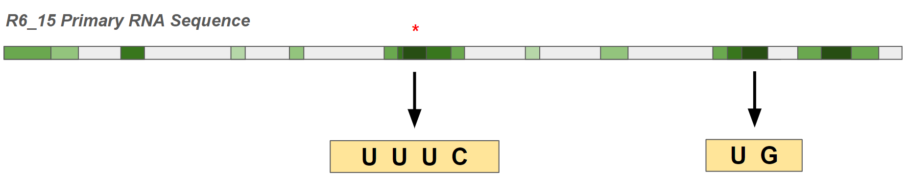

5.6 Modelling Aptamer-AT Interactions
In this study, there was no plan to co-crystalize any aptamer-AT complex. Although a crystal structure would have provided extensive knowledge of specific AT-aptamer interactions, it was not feasible to conduct in the duration of this master’s project. Moreover, there are no existing crystal structures of any AT-nucleic acid complex in the PDB which we can be used to infer aptamer interactions with AT. However, by using predictive computer modelling along with an existing thrombin-aptamer crystal structure (PDB ID: 3DD2), conceptualizing how an inhibitory RNA aptamer could bind AT became clearer.
We used RNA-target protein modelling like what was used previously by two independent research groups, who employed the HDOCK web-based software to predict binding interfaces. The HDOCK web server was consistently ranked as one of the top predictor algorithms in CAPRI sessions (155, 156). This software also maintains 75% success rate when predicting RNA-protein models (157). Firstly, Amar et al were able to construct a complex of the virulence-associated protein B and C (VapBC) associated with a generated transfer RNA (tRNA) molecule. They found that the tRNA molecule binds multiple arginine residues on the surface of VapBC and were subsequently able to validate the importance of a specific arginine residue (Arg94) via mutagenesis studies (158). In another study, researchers identified binding regions of the protein N-Myc Downstream Regulated 1 (NDRG1) to a long non-coding RNA (lncRNA) molecule. The predicted complex and binding fragments were verified by in vitro experiments (159).
In this project, the predicted AT-R6_15 model was generated by flexible computational docking. Such docking methods cannot be certain to reliably predict the structure of the complex, since the RNA molecule undergoes large conformational changes upon binding (160). However, a previous study successfully confirmed a simulated model of palytoxin (PTX) and an ssDNA aptamer (P-18S2) binding, using flexible molecular dynamics (161). Akin to our study’s experimental design, the aptamer three-dimensional (3D) structure was generated using the ‘RNA Composer’ software (Methods 3.9). The simulated binding sites of P-18S2 to PTX were firmly proved to be the actual binding sites by using real-time optical analytical techniques to obtain the binding affinity constant. This study demonstrates that in silico nucleic acid 3D structure determination and flexible molecular docking can be used to accurately predict aptamer-target interactions. A graphical illustration of the predicted AT-R6_15 complex is shown below in Figure 24A.
The only crystal structure available of a non-nucleic acid binding protein with an aptamer is of a thrombin-aptamer complex. We used information provided in the structure’s accompanying paper to understand some of our own findings from the predicted AT-R6_15 complex. Long et al presented the first thrombin-RNA aptamer crystallized complex (162). In this structure, researchers demonstrated that the aptamer Toggle-25t interacted with the arginine and lysine residues of thrombin’s exosite-2, a heparin-binding site. It was concluded that the aptamer interacted directly with the residues with which heparin normally interfaces. However, the nature of these interactions was different from what is observed with heparin. The authors hypothesized that the RNA aptamer has a higher degree of shape complementarity because of the ability for the aptamer to fold in a way that fits the surface of the native protein. Additionally, the aptamer-thrombin interface has more extensive van der Waals contacts and π-π stacking interactions with the arginine and lysine residues than heparin, which may be the reason why the aptamer binds thrombin with a K_{d} that is 4 orders of magnitude less than heparin (162). These findings can be extrapolated to our modelled AT-R6_15 structure. A portion of the R6_15 aptamer was predicted to interface with AT within the site of heparin binding, specifically lysine residue 114 (K114) (Introduction 1.3.2.1). Furthermore, AT’s K114 was involved in forming ionic interactions as well as potential hydrogen bonding with the phosphate backbone of the RNA aptamer (Figure 24B). Mutation studies on AT’s surface residues have demonstrated the importance of Lys114 to the binding of heparin to AT (50). The mutated K114M AT blocked heparin’s ability of conformationally activating AT. Aptamer-AT interactions at that specific residue (K114) could be locking the AT in its native state where the RCL is still partially inserted into β sheet A and is not in a suitable configuration for proteolytic attack by thrombin.
By analyzing the thrombin-Toggle-25t interface, adenine bases were determined to be preferred in the RNA binding motif; however according to the authors, a reason for that is not readily apparent. Another study which explored 41 different RNA-protein crystalized complexes concluded that adenine, uracil, and cytosine bases more easily stack with arginine and lysine residues on the surface of proteins (163). This finding is relevant to the modelled AT-R6_15 complex as the predicted binding regions of aptamer R6_15 have a high frequency of uracil bases (Figure 23). Coincidently, this uracil-rich region is present in the consensus sequence of the top three most active anti-AT aptamer candidates (Figure 22). By exploring the literature, we found that our predicted model aligns with what other researchers previously concluded about protein-RNA interactions using co-crystalized structures. Ultimately, docking techniques cannot fully predict actual AT-aptamer interactions since mathematical models cannot consider all the experimental factors that play a role. However, as we have shown, combining predicted models with relevant crystallization findings from other studies can provide reliable information concerning how the two molecules possibly interact.

Figure 24. Computer-generated image of the predicted AT-R6_15 complex. Panel A illustrates the docking of aptamer R6_15 (green molecule) to the right side of the AT protein. Sections of the aptamer with relatively closer distances to AT surface are highlighted in red. Panel B is a close-up representation of the Lys114 and its interactions with the bases of aptamer R6_15.

A
Helix A
Helix D

B

6 CONCLUSIONS AND FUTURE DIRECTIONS
By the end of this project, we demonstrated that sequences derived from the in vitro selection process were successful binders and inhibitors of AT. This study further examined the effects of the most inhibitory aptamers on AT through various experiments. These experiments tested AT’s ability to inhibit thrombin in the presence of these inhibitory aptamer candidates. Also, the binding capacity of the aptamer sequences to AT was measured and compared. Ultimately, aptamer R6_15 was found to be the most avid binder and inhibitor of AT.
This study was the first in which an oligonucleotide library was probed against the protein AT. Although this project presented novel inhibitors of the natural anticoagulant AT, additional developments to our protocol may yield even stronger binders and more potent inhibitors. By reprobing the oligonucleotide library under less stringent selection conditions over ten rounds, new sequences may emerge and dominate the enriched pool.
Modelling data suggests that the aptamer R6_15 binds AT near or exactly at the heparin-binding site. Additional studies may be required to assess the validity of the dynamic modelling results. Such experiments may involve direct AT mutagenesis at the site of predicted binding (e.g., Lys114) and comparing binding constants to that of the native AT. Furthermore, future studies could explore where else the aptamers could bind. Based on the nature of the serpin-protease inhibition mechanism, it may seem as though the most inhibitory aptamer should bind the RCL, or at least interfere with the insertion of the RCL into the core of AT. A possible experiment could be incorporating thrombin-AT complexes into SELEX as a negative selection round. That way, researchers would be confident that any sequences identified from the thrombin-AT round could not easily bind at the RCL. Another study could revisit the selection protocol and incorporate heparin into the SELEX solution. In this potential experiment, the system would be pressured to select for aptamer candidates that do not bind at AT’s heparin-binding site. Therefore, by the end of the selection process, the identified sequences would likely bind other regions of AT, including the RCL. This protocol could potentially result in more inhibitory aptamers that specifically target the RCL or the mechanism of RCL insertion.
Beyond this project, assessing the inhibitory activity of the aptamers in vivo could uncover their potential as therapeutics. Since the most inhibitory and tightest binding aptamer is R6_15, it could be tested for its efficacy in reducing bleeding in monkey and/or mouse models of acquired hemophilia or traumatic bleeding. AT is among the most abundant proteins circulating in plasma with a concentration of approximately 150 mg/L or 2.4 µM (164). To insure maximum possible inhibition of AT by the aptamer, about a 10-fold molar excess of aptamer would have to be delivered. R6_15 can be easily mass produced with minimal risk of contamination since it is a chemically well-defined molecule that does not require biological systems to generate.
In a previous study, it was shown that an anti-AT siRNA therapeutic (fitusiran) reduced AT activity by 70% (120). By testing our aptamer R6_15 in human plasma, we showed that the activity of AT decreases by approximately 40-50%. Similar values were observed in the discontinuous kinetics assay, as well as the intrinsic fluorescence assay. Knowing that in vitro results may not be consistent with the outcomes of in vivo experiments, it may be worthwhile to test the aptamer R6_15 in vivo. Based on this project’s results, R6_15 may not exceed the AT inhibition threshold set by fitusiran. Nevertheless, this experiment will provide conclusive data on whether reprobing the library under different conditions is necessary. A revised SELEX protocol would address the functional limitations experienced in this study by lessening the selective pressures and introducing heparin or thrombin in the selection process. Now that this project established the success of in vitro selection protocol in discovering a novel RNA aptamer that is inhibitory towards AT, expanding on this knowledge could help identify a stronger inhibitor of AT.

7 APPENDIX
 | Round Number
 | 1 | 2 | 3 | 4 | 5 | 6
Positive Incubation Time | 120 min |  |  | n/a | 60 min | 30 min
RNA Incubated | 4 nmole | 1 nmole |  |  | 500 pmole
Wash [NaCl] | 150 mM |  |  |  |  | 4 M

Table S1. Overview of the selection protocol as the rounds progress. Note the increasing wash stringency and decrease in incubation time. The final two rounds (11 and 12) were not completed.

 | Round Number
 | 7 | 8 | 9 | 10 | 11 | 12
Positive Incubation Time | 30 min | 15 min |  | 10 min |  | 5 min
RNA Incubated | 500 pmole | 250 pmole |  |  | 100 pmole
Wash [NaCl] | 4 M
Wash Repetitions | 3 times | 5 times
Competing RNA | n/a |  | 2X
Antithrombin | 4 μg |  |  | 0.4 μg

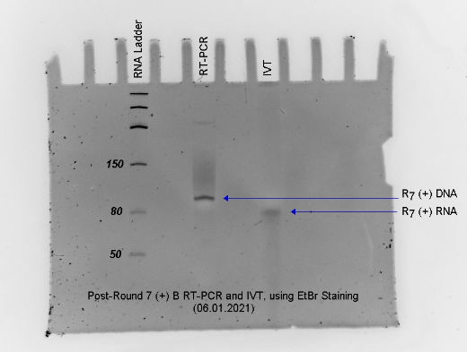
A

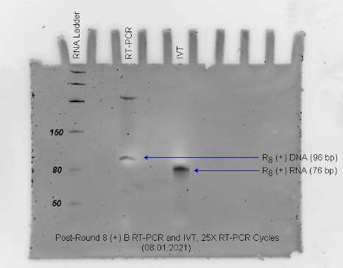
B

Figure S1. Example of gel electrophoresis following rounds 7 (A) and 8 (B) of in vitro selection. The blue arrows indicate oligonucleotide bands of interest. The DNA strand generated after selection by RT-PCR is 96 base pairs (bp) in size, whereas the RNA strand is 76 bp long (in the IVT lane). The top band in the RT-PCR lane is a non-specific product of the reaction.

A | B
C | D

Figure S2. Graphical illustrations of the structures of aptamer R6_15 and its truncated variants, as predicted by Mfold. Panel A represents the full-length aptamer R6_15. Truncated variant NP (no primer-binding sites) is shown in Panel B. The variants with the 5’ and 3’ primer-binding sites (5P and 3P) are shown in Panels C and D, respectively.
Figure S3. Binding characterization of a combined titration of the top aptamer candidates (R6_15 and R6_19) to AT using the plate-based binding assay. Each point represents the mean colorimetric production (± SD) of HRP-conjugated anti-AT IgG. Higher mean velocities are correlated to the increased presence of bound AT, which was captured by the immobilized aptamer. Each data point is the average of three different determinations. The x-axis is graphed on a logarithmic scale. The error bars represent the SD.

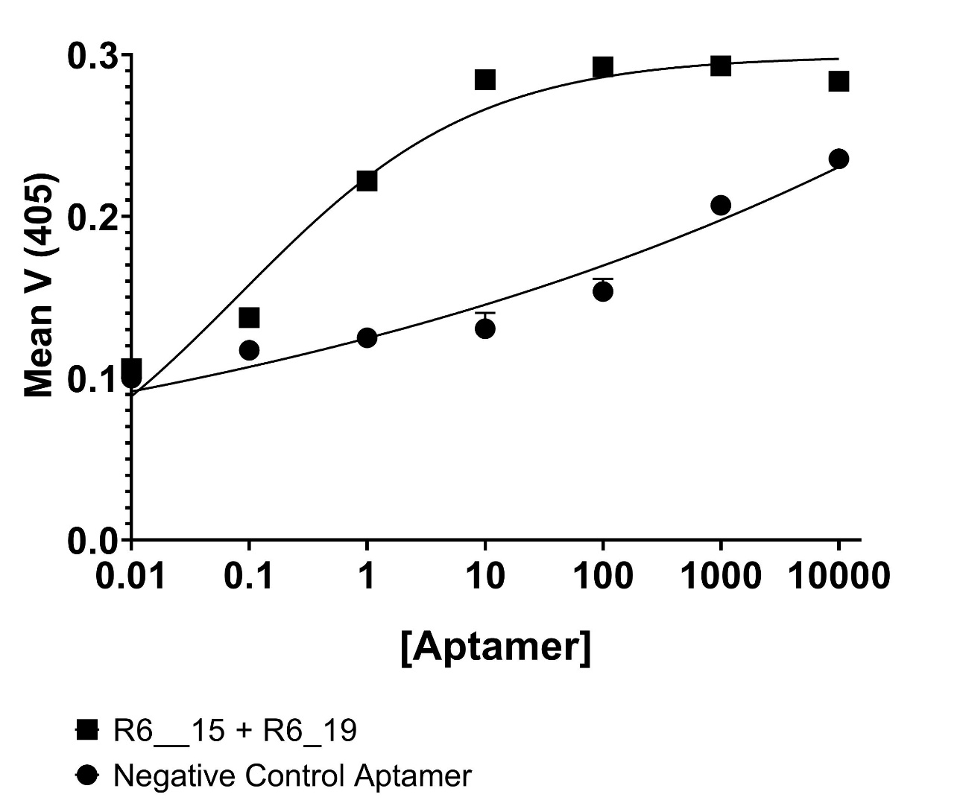

8 REFERENCES
1. Davidson CJ, Hirt RP, Lal K, Snell P, Elgar G, Tuddenham EG, et al. Molecular evolution of the vertebrate blood coagulation network. Thromb Haemost. 2003;89(3):420-8.
2. Davie EW, Kulman JD. An overview of the structure and function of thrombin. Semin Thromb Hemost. 2006;32 Suppl 1:3-15.
3. Ansell J. Factor Xa or thrombin: is factor Xa a better target? J Thromb Haemost. 2007;5 Suppl 1:60-4.
4. Hoffman M, Monroe DM, 3rd. A cell-based model of hemostasis. Thromb Haemost. 2001;85(6):958-65.
5. Krem MM, Di Cera E. Evolution of enzyme cascades from embryonic development to blood coagulation. Trends Biochem Sci. 2002;27(2):67-74.
6. Hamad OA, Bäck J, Nilsson PH, Nilsson B, Ekdahl KN. Platelets, complement, and contact activation: partners in inflammation and thrombosis. Adv Exp Med Biol. 2012;946:185-205.
7. Borissoff JI, Spronk HM, Heeneman S, ten Cate H. Is thrombin a key player in the 'coagulation-atherogenesis' maze? Cardiovasc Res. 2009;82(3):392-403.
8. Yamamoto M, Nakagaki T, Kisiel W. Tissue factor-dependent autoactivation of human blood coagulation factor VII. J Biol Chem. 1992;267(27):19089-94.
9. Autin L, Steen M, Dahlbäck B, Villoutreix BO. Proposed structural models of the prothrombinase (FXa-FVa) complex. Proteins. 2006;63(3):440-50.
10. Monroe DM, Hoffman M, Roberts HR. Platelets and thrombin generation. Arterioscler Thromb Vasc Biol. 2002;22(9):1381-9.
11. Previtali E, Bucciarelli P, Passamonti SM, Martinelli I. Risk factors for venous and arterial thrombosis. Blood Transfus. 2011;9(2):120-38.
12. Mast AE. Tissue Factor Pathway Inhibitor. Arteriosclerosis, Thrombosis, and Vascular Biology. 2016;36(1):9-14.
13. Lipe B, Ornstein DL. Deficiencies of Natural Anticoagulants, Protein C, Protein S, and Antithrombin. Circulation. 2011;124(14):e365-e8.
14. Heestermans M, Salloum-Asfar S, Streef T, Laghmani EH, Salvatori D, Luken BM, et al. Mouse venous thrombosis upon silencing of anticoagulants depends on tissue factor and platelets, not FXII or neutrophils. Blood. 2019;133(19):2090-9.
15. Beresford CH. Antithrombin III deficiency. Blood Reviews. 1988;2(4):239-50.
16. Maclean PS, Tait RC. Hereditary and Acquired Antithrombin Deficiency. Drugs. 2007;67(10):1429-40.
17. Mosesson MW. Fibrinogen and fibrin structure and functions. J Thromb Haemost. 2005;3(8):1894-904.
18. Siebenlist KR, Meh DA, Mosesson MW. Protransglutaminase (factor XIII) mediated crosslinking of fibrinogen and fibrin. Thromb Haemost. 2001;86(5):1221-8.
19. Mann KG, Brummel K, Butenas S. What is all that thrombin for? J Thromb Haemost. 2003;1(7):1504-14.
20. Bode W. Structure and interaction modes of thrombin. Blood Cells Mol Dis. 2006;36(2):122-30.
21. Law RHP, Zhang Q, McGowan S, Buckle AM, Silverman GA, Wong W, et al. An overview of the serpin superfamily. Genome Biology. 2006;7(5):216.
22. Schechter I, Berger A. On the size of the active site in proteases. I. Papain. Biochem Biophys Res Commun. 1967;27(2):157-62.
23. Chang W, Wardell M, Lomas D, Carrell R. Probing serpin reactive-loop conformations by proteolytic cleavage. Biochemical Journal. 1996;314(2):647-53.
24. Stratikos E, Gettins PGW. Formation of the covalent serpin-proteinase complex involves translocation of the proteinase by more than 70 &#xc5; and full insertion of the reactive center loop into &#x3b2;-sheet A. Proceedings of the National Academy of Sciences. 1999;96(9):4808-13.
25. Stratikos E, Gettins PGW. Mapping the Serpin-Proteinase Complex Using Single Cysteine Variants of α1-Proteinase Inhibitor Pittsburgh*. Journal of Biological Chemistry. 1998;273(25):15582-9.
26. Hood DB, Huntington JA, Gettins PG. Alpha 1-proteinase inhibitor variant T345R. Influence of P14 residue on substrate and inhibitory pathways. Biochemistry. 1994;33(28):8538-47.
27. Abildgaard U. Inhibition of the Thrombin-Fibrinogen Reaction by Heparin in the Absence of Cofactor. Scandinavian Journal of Haematology. 1968;5(6):432-9.
28. Kurachi K, Fujikawa K, Schmer G, Davie EW. Inhibition of bovine factor IXa and factor Xabeta by antithrombin III. Biochemistry. 1976;15(2):373-7.
29. Damus PS, Hicks M, Rosenberg RD. Anticoagulant action of heparin. Nature. 1973;246(5432):355-7.
30. Bae J, Desai UR, Pervin A, Caldwell EE, Weiler JM, Linhardt RJ. Interaction of heparin with synthetic antithrombin III peptide analogues. Biochem J. 1994;301 ( Pt 1)(Pt 1):121-9.
31. Kurachi K, Fujikawa K, Schmer G, Davie EW. Inhibition of bovine factor IXa and factor Xa.beta. by antithrombin III. Biochemistry. 1976;15(2):373-7.
32. Damus PS, Hicks M, Rosenberg RD. Anticoagulant Action of Heparin. Nature. 1973;246(5432):355-7.
33. Conard J, Brosstad F, Lie Larsen M, Samama M, Abildgaard U. Molar antithrombin concentration in normal human plasma. Haemostasis. 1983;13(6):363-8.
34. Sas G, Pepper DS, Cash JD. Investigations on Antithrombin III in Normal Plasma and Serum. British Journal of Haematology. 1975;30(3):265-72.
35. Rosenberg RD, Damus PS. The purification and mechanism of action of human antithrombin-heparin cofactor. J Biol Chem. 1973;248(18):6490-505.
36. Hirsh J, Warkentin TE, Shaughnessy SG, Anand SS, Halperin JL, Raschke R, et al. Heparin and low-molecular-weight heparin: mechanisms of action, pharmacokinetics, dosing, monitoring, efficacy, and safety. Chest. 2001;119(1 Suppl):64s-94s.
37. Linhardt RJ, Gunay NS. Production and chemical processing of low molecular weight heparins. Semin Thromb Hemost. 1999;25 Suppl 3:5-16.
38. Holmer E, Kurachi K, Söderström G. The molecular-weight dependence of the rate-enhancing effect of heparin on the inhibition of thrombin, factor Xa, factor IXa, factor XIa, factor XIIa and kallikrein by antithrombin. Biochem J. 1981;193(2):395-400.
39. Björk I, Olson ST. Antithrombin. A bloody important serpin. Adv Exp Med Biol. 1997;425:17-33.
40. Olson ST, Björk I, Sheffer R, Craig PA, Shore JD, Choay J. Role of the antithrombin-binding pentasaccharide in heparin acceleration of antithrombin-proteinase reactions. Resolution of the antithrombin conformational change contribution to heparin rate enhancement. J Biol Chem. 1992;267(18):12528-38.
41. Huntington JA, Read RJ, Carrell RW. Structure of a serpin-protease complex shows inhibition by deformation. Nature. 2000;407(6806):923-6.
42. O'Keeffe D, Olson ST, Gasiunas N, Gallagher J, Baglin TP, Huntington JA. The Heparin Binding Properties of Heparin Cofactor II Suggest an Antithrombin-like Activation Mechanism*. Journal of Biological Chemistry. 2004;279(48):50267-73.
43. Langdown J, Belzar KJ, Savory WJ, Baglin TP, Huntington JA. The critical role of hinge-region expulsion in the induced-fit heparin binding mechanism of antithrombin. Journal of molecular biology. 2009;386(5):1278-89.
44. Langdown J, Johnson DJ, Baglin TP, Huntington JA. Allosteric activation of antithrombin critically depends upon hinge region extension. J Biol Chem. 2004;279(45):47288-97.
45. Jordan RE, Oosta GM, Gardner WT, Rosenberg RD. The kinetics of hemostatic enzyme-antithrombin interactions in the presence of low molecular weight heparin. J Biol Chem. 1980;255(21):10081-90.
46. Whisstock JC, Pike RN, Jin L, Skinner R, Pei XY, Carrell RW, et al. Conformational changes in serpins: II. The mechanism of activation of antithrombin by heparin. J Mol Biol. 2000;301(5):1287-305.
47. Schreuder HA, de Boer B, Dijkema R, Mulders J, Theunissen HJ, Grootenhuis PD, et al. The intact and cleaved human antithrombin III complex as a model for serpin-proteinase interactions. Nat Struct Biol. 1994;1(1):48-54.
48. Izaguirre G, Aguila S, Qi L, Swanson R, Roth R, Rezaie AR, et al. Conformational activation of antithrombin by heparin involves an altered exosite interaction with protease. The Journal of biological chemistry. 2014;289(49):34049-64.
49. Izaguirre G, Olson ST. Residues Tyr253 and Glu255 in strand 3 of beta-sheet C of antithrombin are key determinants of an exosite made accessible by heparin activation to promote rapid inhibition of factors Xa and IXa. J Biol Chem. 2006;281(19):13424-32.
50. Zhang W, Swanson R, Izaguirre G, Xiong Y, Lau LF, Olson ST. The heparin-binding site of antithrombin is crucial for antiangiogenic activity. Blood. 2005;106(5):1621-8.
51. Jin L, Abrahams JP, Skinner R, Petitou M, Pike RN, Carrell RW. The anticoagulant activation of antithrombin by&#x2009;heparin. Proceedings of the National Academy of Sciences. 1997;94(26):14683-8.
52. High KA. Antithrombin III, protein C, and protein S. Naturally occurring anticoagulant proteins. Arch Pathol Lab Med. 1988;112(1):28-36.
53. Khan S, Dickerman JD. Hereditary thrombophilia. Thrombosis Journal. 2006;4(1):15.
54. Gilbert W. Origin of life: The RNA world. Nature. 1986;319(6055):618-.
55. Gold L, Janjic N, Jarvis T, Schneider D, Walker JJ, Wilcox SK, et al. Aptamers and the RNA world, past and present. Cold Spring Harb Perspect Biol. 2012;4(3).
56. Song KM, Lee S, Ban C. Aptamers and their biological applications. Sensors (Basel). 2012;12(1):612-31.
57. Burnett JC, Rossi JJ. RNA-based therapeutics: current progress and future prospects. Chem Biol. 2012;19(1):60-71.
58. Cibiel A, Pestourie C, Ducongé F. In vivo uses of aptamers selected against cell surface biomarkers for therapy and molecular imaging. Biochimie. 2012;94(7):1595-606.
59. Yang L, Zhang X, Ye M, Jiang J, Yang R, Fu T, et al. Aptamer-conjugated nanomaterials and their applications. Adv Drug Deliv Rev. 2011;63(14-15):1361-70.
60. Ketting RF, Haverkamp TH, van Luenen HG, Plasterk RH. Mut-7 of C. elegans, required for transposon silencing and RNA interference, is a homolog of Werner syndrome helicase and RNaseD. Cell. 1999;99(2):133-41.
61. Grishok A, Pasquinelli AE, Conte D, Li N, Parrish S, Ha I, et al. Genes and mechanisms related to RNA interference regulate expression of the small temporal RNAs that control C. elegans developmental timing. Cell. 2001;106(1):23-34.
62. Hutvágner G, McLachlan J, Pasquinelli AE, Bálint E, Tuschl T, Zamore PD. A cellular function for the RNA-interference enzyme Dicer in the maturation of the let-7 small temporal RNA. Science. 2001;293(5531):834-8.
63. Ketting RF, Fischer SE, Bernstein E, Sijen T, Hannon GJ, Plasterk RH. Dicer functions in RNA interference and in synthesis of small RNA involved in developmental timing in C. elegans. Genes Dev. 2001;15(20):2654-9.
64. Hamilton AJ, Baulcombe DC. A species of small antisense RNA in posttranscriptional gene silencing in plants. Science. 1999;286(5441):950-2.
65. Hammond SM, Bernstein E, Beach D, Hannon GJ. An RNA-directed nuclease mediates post-transcriptional gene silencing in Drosophila cells. Nature. 2000;404(6775):293-6.
66. Holen T, Amarzguioui M, Wiiger MT, Babaie E, Prydz H. Positional effects of short interfering RNAs targeting the human coagulation trigger Tissue Factor. Nucleic acids research. 2002;30(8):1757-66.
67. Camerer E, Kolstø AB, Prydz H. Cell biology of tissue factor, the principal initiator of blood coagulation. Thromb Res. 1996;81(1):1-41.
68. Sehgal A, Barros S, Ivanciu L, Cooley B, Qin J, Racie T, et al. An RNAi therapeutic targeting antithrombin to rebalance the coagulation system and promote hemostasis in hemophilia. Nat Med. 2015;21(5):492-7.
69. Pipe S, Ragni MV, Négrier C, Yu Q, Bajwa N, Caminis J, et al. Fitusiran, an RNAi Therapeutic Targeting Antithrombin to Restore Hemostatic Balance in Patients with Hemophilia a or B with or without Inhibitors: Management of Acute Bleeding Events. Blood. 2019;134:1138.
70. Wang J, Lu Z, Wientjes MG, Au JLS. Delivery of siRNA Therapeutics: Barriers and Carriers. The AAPS Journal. 2010;12(4):492-503.
71. Leva S, Lichte A, Burmeister J, Muhn P, Jahnke B, Fesser D, et al. GnRH binding RNA and DNA Spiegelmers: a novel approach toward GnRH antagonism. Chem Biol. 2002;9(3):351-9.
72. Lakhin AV, Tarantul VZ, Gening LV. Aptamers: problems, solutions and prospects. Acta Naturae. 2013;5(4):34-43.
73. Nimjee SM, Rusconi CP, Sullenger BA. Aptamers: an emerging class of therapeutics. Annu Rev Med. 2005;56:555-83.
74. Rusconi CP, Scardino E, Layzer J, Pitoc GA, Ortel TL, Monroe D, et al. RNA aptamers as reversible antagonists of coagulation factor IXa. Nature. 2002;419(6902):90-4.
75. Kubik MF, Stephens AW, Schneider D, Marlar RA, Tasset D. High-affinity RNA ligands to human alpha-thrombin. Nucleic Acids Res. 1994;22(13):2619-26.
76. Bock LC, Griffin LC, Latham JA, Vermaas EH, Toole JJ. Selection of single-stranded DNA molecules that bind and inhibit human thrombin. Nature. 1992;355(6360):564-6.
77. Ishizaki J, Nevins JR, Sullenger BA. Inhibition of cell proliferation by an RNA ligand that selectively blocks E2F function. Nat Med. 1996;2(12):1386-9.
78. Ruckman J, Green LS, Beeson J, Waugh S, Gillette WL, Henninger DD, et al. 2'-Fluoropyrimidine RNA-based aptamers to the 165-amino acid form of vascular endothelial growth factor (VEGF165). Inhibition of receptor binding and VEGF-induced vascular permeability through interactions requiring the exon 7-encoded domain. J Biol Chem. 1998;273(32):20556-67.
79. Kumar PK, Machida K, Urvil PT, Kakiuchi N, Vishnuvardhan D, Shimotohno K, et al. Isolation of RNA aptamers specific to the NS3 protein of hepatitis C virus from a pool of completely random RNA. Virology. 1997;237(2):270-82.
80. Sullenger BA, Gallardo HF, Ungers GE, Gilboa E. Overexpression of TAR sequences renders cells resistant to human immunodeficiency virus replication. Cell. 1990;63(3):601-8.
81. Hermann T, Patel DJ. Adaptive recognition by nucleic acid aptamers. Science. 2000;287(5454):820-5.
82. Nissim A, Chernajovsky Y. Historical development of monoclonal antibody therapeutics. Therapeutic Antibodies. 2008:3-18.
83. Keefe AD, Pai S, Ellington A. Aptamers as therapeutics. Nat Rev Drug Discov. 2010;9(7):537-50.
84. Sharifi J, Khawli LA, Hornick JL, Epstein AL. Improving monoclonal antibody pharmacokinetics via chemical modification. Q J Nucl Med. 1998;42(4):242-9.
85. Constantinou A, Chen C, Deonarain MP. Modulating the pharmacokinetics of therapeutic antibodies. Biotechnol Lett. 2010;32(5):609-22.
86. Burmeister PE, Wang C, Killough JR, Lewis SD, Horwitz LR, Ferguson A, et al. 2'-Deoxy purine, 2'-O-methyl pyrimidine (dRmY) aptamers as candidate therapeutics. Oligonucleotides. 2006;16(4):337-51.
87. Keefe AD, Pai S, Ellington A. Aptamers as therapeutics. Nature Reviews Drug Discovery. 2010;9(7):537-50.
88. Chen CH, Chernis GA, Hoang VQ, Landgraf R. Inhibition of heregulin signaling by an aptamer that preferentially binds to the oligomeric form of human epidermal growth factor receptor-3. Proc Natl Acad Sci U S A. 2003;100(16):9226-31.
89. Bompani K, Monroe D, Church F, Sullenger B. A high affinity, antidote-controllable prothrombin and thrombin-binding RNA aptamer inhibits thrombin generation and thrombin activity. Journal of Thrombosis and Haemostasis. 2012;10(5):870-80.
90. Nimjee SM, Sullenger BA. Therapeutic Aptamers: Evolving to Find their Clinical Niche. Curr Med Chem. 2020;27(25):4181-93.
91. Woodruff RS, Ivanov I, Verhamme IM, Sun MF, Gailani D, Sullenger BA. Generation and characterization of aptamers targeting factor XIa. Thromb Res. 2017;156:134-41.
92. Kruse-Jarres R, Kempton CL, Baudo F, Collins PW, Knoebl P, Leissinger CA, et al. Acquired hemophilia A: Updated review of evidence and treatment guidance. Am J Hematol. 2017;92(7):695-705.
93. Holcomb JB, McMullin NR, Pearse L, Caruso J, Wade CE, Oetjen-Gerdes L, et al. Causes of death in U.S. Special Operations Forces in the global war on terrorism: 2001-2004. Ann Surg. 2007;245(6):986-91.
94. Peyvandi F, Garagiola I, Young G. The past and future of haemophilia: diagnosis, treatments, and its complications. Lancet. 2016;388(10040):187-97.
95. Berntorp E, Astermark J, Björkman S, Blanchette VS, Fischer K, Giangrande PL, et al. Consensus perspectives on prophylactic therapy for haemophilia: summary statement. Haemophilia. 2003;9 Suppl 1:1-4.
96. Aledort LM, Haschmeyer RH, Pettersson H. A longitudinal study of orthopaedic outcomes for severe factor-VIII-deficient haemophiliacs. The Orthopaedic Outcome Study Group. J Intern Med. 1994;236(4):391-9.
97. Kizilocak H, Young G. Diagnosis and treatment of hemophilia. Clin Adv Hematol Oncol. 2019;17(6):344-51.
98. Müller J, Isermann B, Dücker C, Salehi M, Meyer M, Friedrich M, et al. An Exosite-Specific ssDNA Aptamer Inhibits the Anticoagulant Functions of Activated Protein C and Enhances Inhibition by Protein C Inhibitor. Chemistry & Biology. 2009;16(4):442-51.
99. Waters EK, Genga RM, Schwartz MC, Nelson JA, Schaub RG, Olson KA, et al. Aptamer ARC19499 mediates a procoagulant hemostatic effect by inhibiting tissue factor pathway inhibitor. Blood. 2011;117(20):5514-22.
100. Ellington AD, Szostak JW. In vitro selection of RNA molecules that bind specific ligands. Nature. 1990;346(6287):818-22.
101. Tuerk C, Gold L. Systematic evolution of ligands by exponential enrichment: RNA ligands to bacteriophage T4 DNA polymerase. Science. 1990;249(4968):505-10.
102. Tuerk C, Gold L. Systematic Evolution of Ligands by Exponential Enrichment: RNA Ligands to Bacteriophage T4 DNA Polymerase. Science. 1990;249(4968):505-10.
103. Shamah SM, Healy JM, Cload ST. Complex Target SELEX. Accounts of Chemical Research. 2008;41(1):130-8.
104. Marimuthu C, Tang TH, Tominaga J, Tan SC, Gopinath SC. Single-stranded DNA (ssDNA) production in DNA aptamer generation. Analyst. 2012;137(6):1307-15.
105. Komarova N, Kuznetsov A. Inside the Black Box: What Makes SELEX Better? Molecules. 2019;24(19):3598.
106. Nguyen Quang N, Perret G, Ducongé F. Applications of High-Throughput Sequencing for In Vitro Selection and Characterization of Aptamers. Pharmaceuticals (Basel). 2016;9(4):76.
107. Takahashi M, Wu X, Ho M, Chomchan P, Rossi JJ, Burnett JC, et al. High throughput sequencing analysis of RNA libraries reveals the influences of initial library and PCR methods on SELEX efficiency. Sci Rep. 2016;6:33697-.
108. Donkor DA, Bhakta V, Eltringham-Smith LJ, Stafford AR, Weitz JI, Sheffield WP. Selection and characterization of a DNA aptamer inhibiting coagulation factor XIa. Sci Rep. 2017;7(1):2102.
109. Thiel WH. Galaxy Workflows for Web-based Bioinformatics Analysis of Aptamer High-throughput Sequencing Data. Mol Ther Nucleic Acids. 2016;5(8):e345.
110. Lapa SA, Chudinov AV, Timofeev EN. The Toolbox for Modified Aptamers. Mol Biotechnol. 2016;58(2):79-92.
111. Holmer E, Lindahl U, Bäckström G, Thunberg L, Sandberg H, Söderström G, et al. Anticoagulant activities and effects on platelets of a heparin fragment with high affinity for antithrombin. Thrombosis Research. 1980;18(6):861-9.
112. Horvath AJ, Lu BG, Pike RN, Bottomley SP. Methods to measure the kinetics of protease inhibition by serpins. Methods Enzymol. 2011;501:223-35.
113. Bates SM, Weitz JI. Coagulation Assays. Circulation. 2005;112(4):e53-e60.
114. de Maat S, Sanrattana W, Mailer RK, Parr NMJ, Hessing M, Koetsier RM, et al. Design and characterization of α1-antitrypsin variants for treatment of contact system–driven thromboinflammation. Blood. 2019;134(19):1658-69.
115. Hamada M, Bhakta V, Andres SN, Sheffield WP. Stepwise Reversion of Multiply Mutated Recombinant Antitrypsin Reveals a Selective Inhibitor of Coagulation Factor XIa as Active as the M358R Variant. Front Cardiovasc Med. 2021;8:647405.
116. Guo WM, Kong KW, Brown CJ, Quah ST, Yeo HL, Hoon S, et al. Identification and Characterization of an eIF4e DNA Aptamer That Inhibits Proliferation With High Throughput Sequencing. Mol Ther Nucleic Acids. 2014;3(12):e217.
117. Einarsson R, Andersson L-O. Binding of heparin to human antithrombin III as studied by measurements of tryptophan fluorescence. Biochimica et Biophysica Acta (BBA) - Protein Structure. 1977;490(1):104-11.
118. Bailey TL, Johnson J, Grant CE, Noble WS. The MEME Suite. Nucleic Acids Research. 2015;43(W1):W39-W49.
119. Gruber AR, Lorenz R, Bernhart SH, Neuböck R, Hofacker IL. The Vienna RNA websuite. Nucleic Acids Res. 2008;36(Web Server issue):W70-4.
120. Popenda M, Szachniuk M, Antczak M, Purzycka KJ, Lukasiak P, Bartol N, et al. Automated 3D structure composition for large RNAs. Nucleic Acids Research. 2012;40(14):e112-e.
121. Antczak M, Popenda M, Zok T, Sarzynska J, Ratajczak T, Tomczyk K, et al. New functionality of RNAComposer: an application to shape the axis of miR160 precursor structure. Acta Biochim Pol. 2016;63(4):737-44.
122. Desta IT, Porter KA, Xia B, Kozakov D, Vajda S. Performance and Its Limits in Rigid Body Protein-Protein Docking. Structure. 2020;28(9):1071-81.e3.
123. Vajda S, Yueh C, Beglov D, Bohnuud T, Mottarella SE, Xia B, et al. New additions to the ClusPro server motivated by CAPRI. Proteins. 2017;85(3):435-44.
124. Kozakov D, Hall DR, Xia B, Porter KA, Padhorny D, Yueh C, et al. The ClusPro web server for protein–protein docking. Nature Protocols. 2017;12(2):255-78.
125. Kozakov D, Beglov D, Bohnuud T, Mottarella SE, Xia B, Hall DR, et al. How good is automated protein docking? Proteins. 2013;81(12):2159-66.
126. Dominguez C, Boelens R, Bonvin AMJJ. HADDOCK: A Protein−Protein Docking Approach Based on Biochemical or Biophysical Information. Journal of the American Chemical Society. 2003;125(7):1731-7.
127. Tsiang M, Jain AK, Gibbs CS. Functional requirements for inhibition of thrombin by antithrombin III in the presence and absence of heparin. J Biol Chem. 1997;272(18):12024-9.
128. Pasi KJ, Lissitchkov T, Mamonov V, Mant T, Timofeeva M, Bagot C, et al. Targeting of antithrombin in hemophilia A or B with investigational siRNA therapeutic fitusiran-Results of the phase 1 inhibitor cohort. Journal of thrombosis and haemostasis : JTH. 2021;19(6):1436-46.
129. Takahashi M, Wu X, Ho M, Chomchan P, Rossi JJ, Burnett JC, et al. High throughput sequencing analysis of RNA libraries reveals the influences of initial library and PCR methods on SELEX efficiency. Sci Rep. 2016;6(1):33697.
130. Pieken WA, Olsen DB, Benseler F, Aurup H, Eckstein F. Kinetic characterization of ribonuclease-resistant 2'-modified hammerhead ribozymes. Science. 1991;253(5017):314-7.
131. Gold L, Ayers D, Bertino J, Bock C, Bock A, Brody EN, et al. Aptamer-based multiplexed proteomic technology for biomarker discovery. PLoS One. 2010;5(12):e15004-e.
132. Davies DR, Gelinas AD, Zhang C, Rohloff JC, Carter JD, O'Connell D, et al. Unique motifs and hydrophobic interactions shape the binding of modified DNA ligands to protein targets. Proc Natl Acad Sci U S A. 2012;109(49):19971-6.
133. Kim S-H, Choi J-W, Kim A-R, Lee S-C, Yoon M-Y. Development of ssDNA Aptamers for Diagnosis and Inhibition of the Highly Pathogenic Avian Influenza Virus Subtype H5N1. Biomolecules. 2020;10(8):1116.
134. Komarova N, Kuznetsov A. Inside the Black Box: What Makes SELEX Better? Molecules. 2019;24(19).
135. Siddiqui S, Yuan J. Binding Characteristics Study of DNA based Aptamers for E. coli O157:H7. Molecules. 2021;26(1).
136. Tsuji S, Hirabayashi N, Kato S, Akitomi J, Egashira H, Tanaka T, et al. Effective isolation of RNA aptamer through suppression of PCR bias. Biochem Biophys Res Commun. 2009;386(1):223-6.
137. Thiel WH, Bair T, Wyatt Thiel K, Dassie JP, Rockey WM, Howell CA, et al. Nucleotide bias observed with a short SELEX RNA aptamer library. Nucleic Acid Ther. 2011;21(4):253-63.
138. Chang X, Yamada R, Sawada T, Suzuki A, Kochi Y, Yamamoto K. The inhibition of antithrombin by peptidylarginine deiminase 4 may contribute to pathogenesis of rheumatoid arthritis. Rheumatology. 2004;44(3):293-8.
139. Olson ST, Srinivasan KR, Björk I, Shore JD. Binding of high affinity heparin to antithrombin III. Stopped flow kinetic studies of the binding interaction. J Biol Chem. 1981;256(21):11073-9.
140. Gotrik MR, Feagin TA, Csordas AT, Nakamoto MA, Soh HT. Advancements in Aptamer Discovery Technologies. Accounts of Chemical Research. 2016;49(9):1903-10.
141. Tan SY, Acquah C, Sidhu A, Ongkudon CM, Yon LS, Danquah MK. SELEX Modifications and Bioanalytical Techniques for Aptamer–Target Binding Characterization. Critical Reviews in Analytical Chemistry. 2016;46(6):521-37.
142. Kohlberger M, Gadermaier G. SELEX: Critical factors and optimization strategies for successful aptamer selection. Biotechnol Appl Biochem. 2021.
143. Nakatsuka N, Cao HH, Deshayes S, Melkonian AL, Kasko AM, Weiss PS, et al. Aptamer Recognition of Multiplexed Small-Molecule-Functionalized Substrates. ACS Appl Mater Interfaces. 2018;10(28):23490-500.
144. McKeague M, De Girolamo A, Valenzano S, Pascale M, Ruscito A, Velu R, et al. Comprehensive analytical comparison of strategies used for small molecule aptamer evaluation. Anal Chem. 2015;87(17):8608-12.
145. Thirunavukarasu D, Chen T, Liu Z, Hongdilokkul N, Romesberg FE. Selection of 2′-Fluoro-Modified Aptamers with Optimized Properties. Journal of the American Chemical Society. 2017;139(8):2892-5.
146. Wagner PGM, Schwartz MC, McGinness KE, Genga RM, Kurz JC, Waters EK, et al. Discovery and Characterization of An Anti-APC Aptamer for Use In Hemophilia. Blood. 2010;116(21):2222-.
147. Parunov LA, Fadeeva OA, Balandina AN, Soshstivoa NP, Koptya KG, Kumskova MA, et al. Improvement of spatial fibrin formation by the anti-TFPI aptamer BAX499: changing clot size by targeting extrinsic pathway initiation. Journal of Thrombosis and Haemostasis. 2011;9(9):1825-34.
148. Björk I, Olson ST. Antithrombin. In: Church FC, Cunningham DD, Ginsburg D, Hoffman M, Stone SR, Tollefsen DM, editors. Chemistry and Biology of Serpins. Boston, MA: Springer US; 1997. p. 17-33.
149. Ouellet E, Lagally ET, Cheung KC, Haynes CA. A simple method for eliminating fixed-region interference of aptamer binding during SELEX. Biotechnology and Bioengineering. 2014;111(11):2265-79.
150. Sampson T. Aptamers and SELEX: the technology. World Patent Information. 2003;25(2):123-9.
151. Hesselberth JR, Miller D, Robertus J, Ellington AD. In vitro selection of RNA molecules that inhibit the activity of ricin A-chain. J Biol Chem. 2000;275(7):4937-42.
152. Berezhnoy A, Stewart CA, McNamara JO, 2nd, Thiel W, Giangrande P, Trinchieri G, et al. Isolation and optimization of murine IL-10 receptor blocking oligonucleotide aptamers using high-throughput sequencing. Mol Ther. 2012;20(6):1242-50.
153. Zuker M. Mfold web server for nucleic acid folding and hybridization prediction. Nucleic acids research. 2003;31(13):3406-15.
154. Yang D-K, Chou C-F, Chen L-C. Selection of aptamers for AMACR detection from DNA libraries with different primers. RSC Advances. 2018;8(34):19067-74.
155. Yan Y, Zhang D, Zhou P, Li B, Huang S-Y. HDOCK: a web server for protein–protein and protein–DNA/RNA docking based on a hybrid strategy. Nucleic Acids Research. 2017;45(W1):W365-W73.
156. Huang SY, Zou X. MDockPP: A hierarchical approach for protein-protein docking and its application to CAPRI rounds 15-19. Proteins. 2010;78(15):3096-103.
157. Lensink MF, Velankar S, Wodak SJ. Modeling protein-protein and protein-peptide complexes: CAPRI 6th edition. Proteins. 2017;85(3):359-77.
158. Deep A, Tiwari P, Agarwal S, Kaundal S, Kidwai S, Singh R, et al. Structural, functional and biological insights into the role of Mycobacterium tuberculosis VapBC11 toxin-antitoxin system: targeting a tRNase to tackle mycobacterial adaptation. Nucleic acids research. 2018;46(21):11639-55.
159. Yeh C-C, Luo J-L, Nhut Phan N, Cheng Y-C, Chow L-P, Tsai M-H, et al. Different effects of long noncoding RNA NDRG1-OT1 fragments on NDRG1 transcription in breast cancer cells under hypoxia. RNA Biol. 2018;15(12):1487-98.
160. Nithin C, Ghosh P, Bujnicki JM. Bioinformatics Tools and Benchmarks for Computational Docking and 3D Structure Prediction of RNA-Protein Complexes. Genes (Basel). 2018;9(9).
161. Hu B, Zhou R, Li Z, Ouyang S, Li Z, Hu W, et al. Study of the binding mechanism of aptamer to palytoxin by docking and molecular simulation. Sci Rep. 2019;9(1):15494-.
162. Long SB, Long MB, White RR, Sullenger BA. Crystal structure of an RNA aptamer bound to thrombin. Rna. 2008;14(12):2504-12.
163. Morozova N, Allers J, Myers J, Shamoo Y. Protein-RNA interactions: exploring binding patterns with a three-dimensional superposition analysis of high resolution structures. Bioinformatics. 2006;22(22):2746-52.
164. Marciniak E, Gockerman JP. Heparin-induced decrease in circulating antithrombin-III. Lancet. 1977;2(8038):581-4.

