IMPROVING SURGICAL REFERRALS FOR NEONATES IN LLMICs

EXPLORING BARRIERS AND FACILITATORS TO SURGICAL REFERRALS FOR NEONATES WITH CONGENITAL ANOMALIES

By NATASHA O. ROSS, B.A.

A Thesis Submitted to the School of Graduate Studies in Partial Fulfilment of the Requirements for the Degree Master of Science

McMaster University
January 2022

Master of Science, 2022
Global Health
McMaster University
Hamilton, Ontario

Exploring Barriers and Facilitators to Surgical Referrals for Neonates with Congenital Anomalies

Natasha Oluwashade Ross, B.A.

Supervised by Dr. Brian Cameron

Number of Pages: 34

Lay Abstract

Congenital anomalies (CA) have been identified as a significant contributor to the global burden of disease, accounting for 25.3-38.8 million disability-adjusted life-years worldwide. Many CA have been classified as surgically treatable however, approximately 295,000 neonates die annually due to these conditions. As 94% of CA occur in low- and low- middle-income countries (LLMICs), this study aims to elucidate any barriers and facilitators that may influence accessing surgical treatment. A systematic review has been selected to synthesize the literature regarding what is known about accessing surgery for neonates with CA in LLMICs.

Abstract

Advancements in medicine have resulted in decreased neonatal mortality and morbidity associated with congenital anomalies (CA). Unfortunately, the advantages of these developments have been confined to high-income countries (HICs), demonstrated by the comparatively high incidence of congenital anomalies in low and low-middle-income countries (LLMICs). Evidence suggests that neonates in LLMICs encounter considerably more barriers to care than those in HICs due to a malfunctioning referral system and poorly implemented health policies that hinder the timely provision of care. As many CA are now accepted as surgically treatable, the purpose of this study was to understand what inhibits the success of a neonate from obtaining surgery in LLMICs and how that could be improved. Seven databases were searched in this systematic review to identify articles on neonates with surgically treatable CA. A total of 370 studies were identified for screening; 16 were included in the final analysis. Studies were screened and selected individually by two researchers based on the research question, and all disagreements were resolved jointly. Studies were reviewed for factors affecting the delivery of surgical treatment and were then coded as a barrier or a facilitator. Barriers to care were identified in every study, and suggested facilitators were offered by the authors, but these facilitators were not tested in the studies. This study contributes to the literature by providing additional detail on what is known about the surgical referral system in LLMICs. The study findings will inform policymakers and local governments of the realities faced by neonates and their caregivers while navigating through the surgical referral system and establish the need for alternate policy implementation strategies.

Acknowledgements

Throughout this thesis project, I have received immense support and guidance.

I would first like to thank my supervisor, Dr. Brian Cameron, whose expertise guided me in cultivating the foundations of this research.

I would also like to thank my supervisory committee member, Dr. Elizabeth Alvarez, whose meaningful feedback permitted me to continuously refine this work. Your guidance was invaluable in formulating the methodology and analysis for this project.

I would like to acknowledge and thank Laura Banfield, McMaster Health Sciences Librarian, for her immense support and guidance in formulating my search strategy.

I would like to thank my colleague, Michal Leckie, for acting as a secondary reviewer and contributing to the deliverables of this research.

In addition, I would like to thank my grandfather Dr. Sunday Afolabi and my uncle, Dr. Paul Afolabi, for their valuable practical and research insight and the endless support and encouragement they have provided me with.

I want to thank my mother, Caroline Ross, who has provided my every need during the acquisition of not only this master’s degree but all of my schooling. Thank you for putting me in a position where my education can be my top priority.

Finally, I would like to thank my grandmother, Brenda Afolabi, for her wise counsel and empathetic ear. You have shown me the value of cultivating perseverance and diligence with a positive spirit, and for that I am grateful.

Table of Contents

INTRODUCTION…………………….………………………………………page 1
BACKGROUND AND NEED………………………..………………………page 2
METHODOLOGY
Study Design……………………………………………………………….….page 4
Data Collection…………………………………………………………….….page 4
Data Analysis………………………………………………………………….page 7
RESULTS……………………………………………………………………..page 11
Search Results…………………………………………………………………page 11
DISCUSSION
Key Findings…………………………………………………………………..page 15
Implications for Policy and Practice…………………………………………..page 17
Implications for Research……………………………………………………..page 19
Strengths and Limitations……………………………………………………..page 19
Conclusion ………………………………………………………..…………..page 20
REFERENCES…………………………………………………...……..…….page 21

APPENDICES
Appendix A: PRISMA Checklist ………………….……………..….……...……..page 25
Appendix B: DCP3 ideal surgery capacity table …..……………..………………..page 28
Appendix C: A database search strategy ……………..………………..…..……....page 29
Appendix D: Data Management tools ………………….…………..………...…....page 30
Appendix E: Data Extraction Sheet ……………..……………………...……...…..page 32
Appendix F: Study Characteristics ………...…………………………………..…..page 34

Lists of Figures and Tables

Fig.1: Ecological Model of Health Behaviour…………………………………..page 9
Fig. 2: Key Features of Health Arrangements Model …………….…………….page 10
Fig. 3: PRISMA Flow Chart…………………………………………………….page 11
Fig. 4: Study Characteristics…………………………………………………….page 12
Fig. 5: Barriers to Surgical Referrals……………………………………………page 14
Fig. 6: Facilitators to Surgical Referrals…………………….…………………..page 15

List of all Abbreviations

Abbreviations
BoD – Burden of disease
GBD – Global burden of disease
GICS – Global Initiative for Children’s Surgery
HIC – High-income countries
LLMIC – Low and low-middle income countries
SDG – Sustainable development goals
SDH – Social determinants of health
UN – United Nations
WHO – World Health Organization

Declaration of Academic Achievement

I, Natasha O. Ross, declare this thesis to be my own work. I am the sole author of this document. No part of this work has been published or submitted for publication or a higher degree at another institution.

My colleague, Michal Leckie, has contributed to this body of work by acting as a secondary reviewer during the data collection and extraction process.

My supervisor, Dr. Brian Cameron, and supervisory committee member, Dr. Elizabeth Alvarez, have provided guidance, feedback, and support throughout the duration of this project.

To the best of my knowledge, the content of this body of work does not infringe on anyone’s copyright.

Introduction
Global health can be defined as “an area for study, research, and practice that places a priority on improving health and achieving health equity for all people worldwide” [1]. The growth of global health in the past decade has resulted in improved health outcomes for numerous populations, especially in the global north. The prioritization of global health has been, in part, due to governing bodies acknowledging the necessity of health for not only individuals, but the prosperity of entire nations as well. Markedly, the United Nation’s introduction of the Sustainable development goals (SDGs) ushered in new public health and research initiatives in various areas, specifically, infectious diseases and maternal and child health [1]. Advancements in global health continue to have advantages at both micro and meso levels, thus giving cause for further investment.
Sometimes referred to as the “neglected stepchild” of global health, global surgery has been overlooked for the vast set of conditions it can alleviate, resulting from a host of reasons, the greatest being a lack of public awareness and support [2]. Without the adequate public support that comes in forms such as funding, research, and awareness, those individuals requiring surgical treatment in resource-poor areas have been left to fend for themselves. The inability of individuals and families in regions of the global south to ascertain and fund the surgical care needed has resulted in an immense health burden that requires immediate attention [8]. Unfortunately, within global surgery, further inequalities exist within surgical specialties. The resource barriers faced by those working within global surgery in conjunction with the vulnerability and lack of agency experienced by the pediatric population have led to a significant burden of morbidity and mortality [3].
The pediatric morbidity and mortality realized in resource-poor regions are partly attributed to congenital anomalies. As congenital anomalies account for approximately 25.3-38.8 million disability-adjusted life-years worldwide, with 94% of them occurring in low-and middle-income countries, the need for attention and effort to reconcile this disparity is indisputable [3]. The gross accumulation of congenital anomalies is attributed to higher birth rates (therefore increasing the likelihood of children being born with these conditions) and significantly poorer infrastructure and resources (meaning less readily available facilities and doctors). The astounding difference in survival rates between high-income countries (HICs) and low and low-middle-income countries (LLMICs) demonstrates that these congenital anomalies no longer need to be regarded as the deadly conditions they once were [2]. Solutions and treatments have been established for these conditions in HICs, so it is imperative to understand what hinders them from being viable in LLMICs. Understanding the nuances that prevent the delivery of this critical care will give insight and direction for new solutions and/or adaptations that can be made for solutions that have already been established in HICs.

Background and Need
The World Health Organization (WHO) announced the SDG target for child mortality that aims to reduce the number of preventable deaths of newborns and children under the age of 5, as well as reduction of the current global neonatal mortality to a rate as low as 12 deaths per 1000 live births by 2030 [4]. Additionally, WHO has identified congenital anomalies as one of the main contributors to the global burden of disease (GBD) [4]. Congenital anomalies, also referred to as birth defects, congenital defects, and congenital malformations can be defined as, “structural or functional anomalies that occur during intrauterine life” [5]. Many congenital anomalies have been classified as surgically treatable, however, despite this, globally, approximately 295,000 neonates die annually due to these birth defects [5]. Although advancements have been made in this field, they have typically been confined to HICs leading WHO to acknowledge that congenital anomalies disproportionately affect LLMICs [5, 6]. This is further exemplified by the burden of disease (BoD) for congenital anomalies remaining almost double in Africa compared to North America [7]. Furthermore, social determinants of health (SDH) such as “sociocultural, economic, and structural factors that limit the accessibility and quality of pediatric surgery” have also been associated with the high rates of congenital anomalies in LLMICs [3]. For this reason, the need to advance the delivery of neonatal surgical care in developing countries to lower the BoD of congenital anomalies and lower rates of neonatal morbidity and mortality has been identified [3].
As many congenital anomalies are deemed to be surgically treatable in HICs, this study aims to respond to the gap in the literature by synthesizing what is known about the referral process in obtaining surgical treatment for congenital anomalies. In the 2019 report to advance global children’s surgery, the Global Initiative for Children’s Surgery (GICS) highlighted the need to prioritize triage and referrals in global pediatric surgery [8]. Furthermore, studies have attributed the high BoD for congenital anomalies to delays in the referral process (i.e., delay seeking care and obtaining a referral) [9, 10]. The findings from these studies have illuminated the need to develop and refine systems of surgical referrals and consider the role of patient-related factors in this decision-making process. This systematic review seeks to answer the question: What are the barriers and facilitators in the surgical referral process encountered by neonates with surgically treatable congenital anomalies in LLMICs?

Methodology
Study Design
Due to the scope of the topic, a systematic review design was selected to account for the current state of surgical referrals for neonates with congenital malformations in LLMICs. A systematic review was best suited for this study’s qualitative research question as preliminary searches demonstrated that there was a considerable body of evidence available to analyze without further primary research [11]. Additionally, the systematic review design allowed for exhaustive and comprehensive searching on the research question that contributes to a meaningful synthesis of what is known regarding referrals for neonates with congenital anomalies. Ultimately, the design is fit for closing the identified research gap so that further advancements may be made.

Data Collection
Data for this study was collected through Ovid databases using McMaster University’s online library forum. Databases included were AMED, Embase, Emcare, MEDLINE, CINAHL, and PubMed. A separate search was conducted for grey literature through Global Index Medicus. The search was conducted with the support of a health sciences librarian to assist in optimizing search results. The search was conducted without language restrictions and restricted to studies published between 2000 and 2020. This time frame was selected to avoid the inclusion of studies published in years prior that may have reported barriers to neonatal surgical care that no longer persist due to advancements in the field.
A standard search strategy was utilized beginning with PubMed and then adjusted accordingly to suit the mechanisms of each database to yield the most relevant results. Keywords including “neonates”, “referral”, and “congenital anomalies” were included. To retrieve studies with data on surgically treatable congenital anomalies, categorical terms such as “congenital heart defects”, “gastrointestinal defects”, “neural tube defects”, and “urogenital defects” were included to avoid studies published on congenital anomalies in neonates that are not surgically treatable. Studies were included if they discussed the referral of neonates (defined as infants within 0-28 days of life) with surgically treatable congenital anomalies and if they published findings from countries classified as LLMICs by the World Bank [6]. No language restrictions were placed on the search, however, studies not published in English, French, Spanish, Portuguese, or Arabic were excluded for review due to the inability of reviewers to translate them. There were no restrictions regarding patient gender and race. Studies were excluded if they did not. discuss the referral process relating to the treatment of neonates and if they were published before 2000.
All results yielded from the search were downloaded into Zotero, a reference management software, and then uploaded to Covidence, a systematic review management platform, for the title and abstract screening, full-text screening, data extraction and quality assessment. The quality of studies was determined using the Critical Appraisal Skills Programme (CASP) checklists. Each study’s design, methodology, results, and application of findings were evaluated by both reviewers using a relevant checklist. Once references were imported to Covidence, duplicates were removed before commencing title and abstract screening. The title and abstract screening were completed by a primary and secondary reviewer. All conflicts were then addressed jointly by the primary and secondary reviewer with a third team member available to resolve disagreements if needed. Studies that were found to meet the inclusion criteria were moved to the full-text screening where reviewers again independently reviewed each article, selecting ‘yes,’ ‘no,’ or ‘maybe’ as their decision. Again, conflicts were resolved together by the reviewers. Reviewers sought to extract barriers and/or facilitators that influenced access to neonatal surgical care. Information presented in studies as hindering a patient from accessing referred surgical treatment is considered a barrier. Information presented as enabling or positively influencing the decision to proceed with a surgical referral has been classified as a facilitator. Once a barrier and/or facilitator was identified, reviewers placed them into high-level categories in the data extraction form. Barriers and facilitators have been coded deductively following the two frameworks described below in Data Analysis [12].
An additional manual search was conducted by searching the reference lists of articles included for data extraction. No additional studies relating to the research question were found through this manual search.

Data Analysis
Two frameworks, the ecological model of health behaviour and the implementing health systems framework, have been selected to guide the categorization of barriers and facilitators and subsequent data analysis. These models have been chosen because the divisions within them are conducive to LLMIC settings and can account for the wide variety of reasons an individual may experience disruptions in receiving health care.
The ecological model has been selected to classify barriers and facilitators encountered by healthcare recipients, whereas tenets of the implementing health systems model are used for those met by healthcare providers. The use of two models is in an effort to distinguish barriers and facilitators faced by different decision-makers in the referral process. Although the healthcare recipient (or in this case, the primary caretaker) is acknowledged to be a primary decision-maker in whether to proceed with a course of treatment, there are some barriers that will be met by healthcare providers that will hinder a surgical referral regardless of whether or not the healthcare recipient is compliant [13].
The ecological model of health behaviour is a conceptual framework that addresses health as being affected by multiple levels of influence [14]. This conceptual framework is comprehensive in its provision of feasible solutions because it actively seeks to incorporate and consider the various influences on health behaviours [15]. By utilizing this model, this study was equipped to identify the most common barriers for individuals seeking surgical referrals in LLMICs. Because this study focused on revealing the facilitators and barriers that encourage or inhibit the success of a surgical referral for a neonatal patient with a congenital anomaly, this framework was well suited to identify the primary sources.
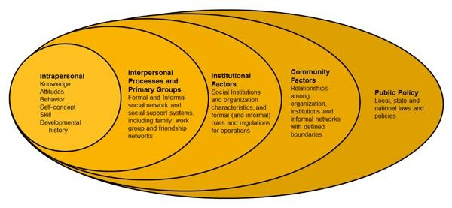
The ecological model of health behaviour acknowledges that health can be affected by factors that can be organized under five main categories: intrapersonal, interpersonal, organizational, community, and public policy [15]. Firstly, intrapersonal influences can be biological and/or psychological elements that affect an individual [15]. Interventions that consider intrapersonal factors often incorporate techniques that teach individuals how to mitigate the effects of social pressures (i.e., peer pressure resistance) [14]. Secondly, interpersonal factors can be social and/or cultural [15]. Interventions that consider interpersonal factors often seek to equip individuals with the tools to change interpersonal relationships “which serve to encourage, support and maintain undesirable behaviours” [14]. Thirdly, institutional, or organizational factors may be rules and regulations that result in behavioural change [14]. Interventions that seek to mitigate organizational factors ensure that program implementation is supported by the staff’s organization to ensure its success [14]. Community factors typically refer to the linkage of interpersonal and institutional factors on a macro-level – interventions that consider community factors will acknowledge the variation in subgroups (i.e., sub-cultural norms) and align them with the intervention design [14]. Finally, factors resulting from public policy (i.e., lack of service funding) are considered to structurally inform the intervention and encourage public advocacy and policy analysis [14].
Fig. 1: Ecological Model of Health Behaviour [14].

The health systems arrangements model, adapted from WHO’s building blocks of health systems, is better suited to organize barriers and facilitators met by healthcare providers that occur due to issues in a nation’s health system arrangement [16]. This framework acknowledges that health interventions are only successful when, “health workers are supported by the other interrelated elements of health systems” [17]. When a health system is unable to support these professionals, barriers are more likely to be encountered in the form of physician shortages, limited diagnostic tools and other forms of resource limitations [16]. These resource shortages are examples of barriers first met by healthcare providers that consequently inhibit the referral process.
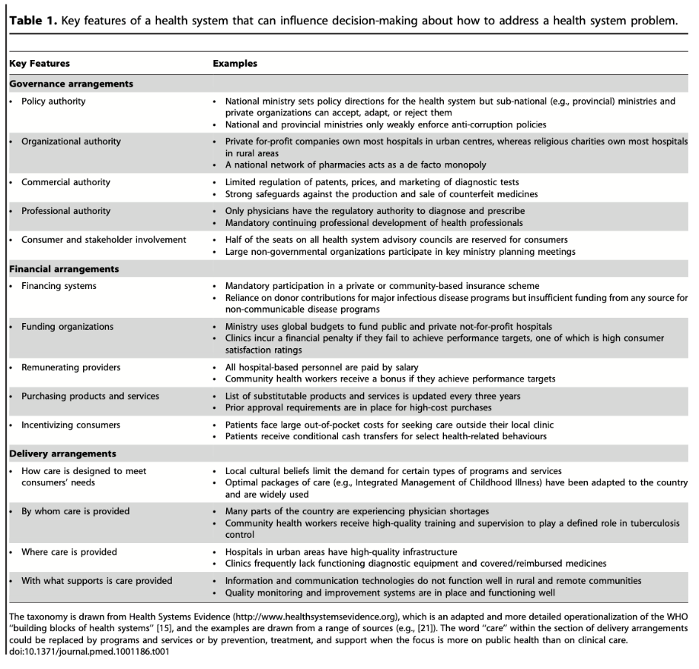
The tenets used from this model will be the “key features” identified in influencing the decision-making regarding health system problems. These three key features are governance, financial and delivery arrangements. Governance arrangements can be understood to be those that influence policy and policymaking, particularly policies that affect the provision of health services [17]. Financial arrangements are those that fund the health system, such as an allocated budget for physician salaries [17]. Finally, delivery arrangements are concerned with who is providing the care, where it is provided, and the tools utilized to deliver the service [17]. As this framework is primarily centered around the health care provider’s ability to deliver care, this framework will be incorporated under the “institutional factors” of the ecological model of health for data analysis.
Fig. 2: Key features of Health Arrangements Model [17].
Results
Search Results
The initial search of barriers and facilitators for surgical referral of neonates with congenital anomalies yielded a total of 370 publications. 12 duplicate articles were removed, leaving a remainder of 358 studies. After the title and abstract screening, 321 studies were deemed irrelevant, leaving 37 publications that met the inclusion criteria for full-text review. Following the full-text review, a total of 16 articles were included for data extraction (Fig. 3).
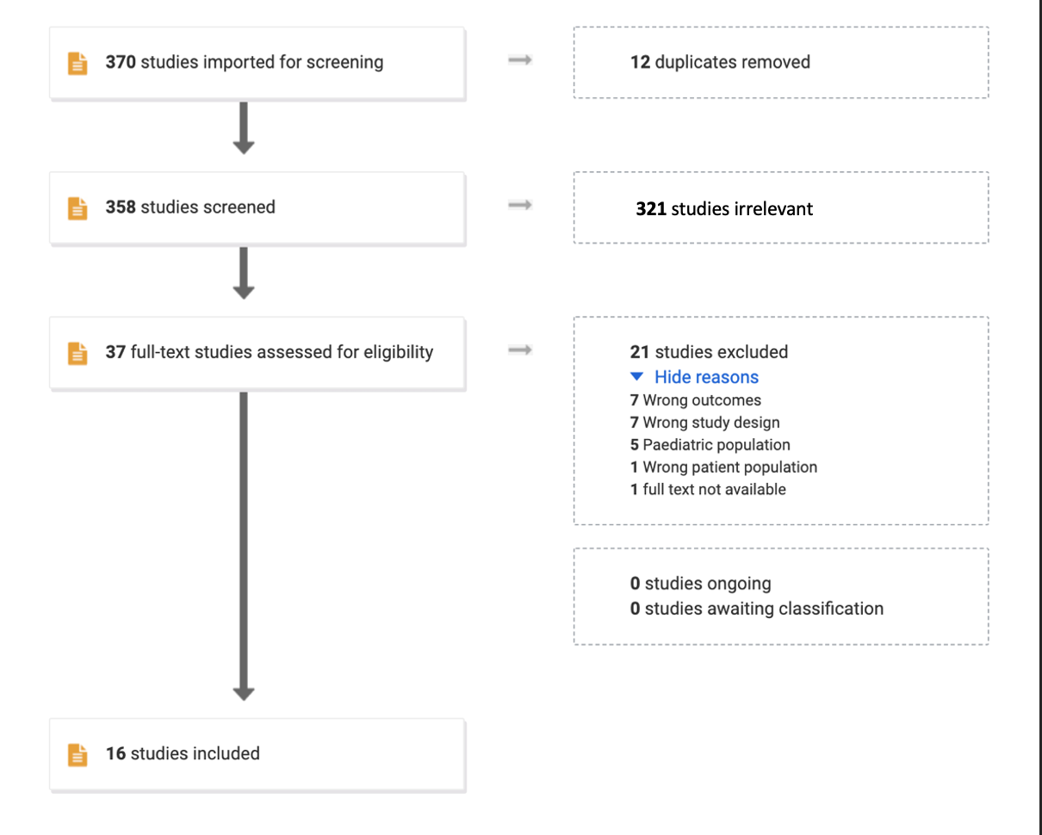
Fig. 3: PRISMA Flow Chart
Date | Study | Publication type | Country | World Bank Classification | Subject |  | Referral System Delay
2001 | Ameh et al. | retrospective cohort analysis | Nigeria | Lower-Middle | Emergency neonatal surgery in Nigeria |  | Delay in accessing primary care, delay in obtaining referral for care at tertiary facility.
2008 | Pandey et al. | prospective cohort study | India | Lower-Middle | Management of congenital diaphragmatic hernia in a developing country. |  | Delay in accessing primary care.
2009 | Aggarwal et al. | retrospective cohort analysis | India | Lower-Middle | Exploring referrals for neonatal surgery in West Bengal. |  | Delay in obtaining referral for care at tertiary facility.
2010 | Poenaru et al. | case report | - | - | Management of colorectal disease in low-resource settings. |  | Difficulty accessing/affording tertiary care.
2013 | Lawal et al. | cross sectional study | Nigeria | Lower-Middle | Mothers' awareness of anorectal malformations. |  | Delay in accessing primary care, delay in obtaining referral for tertiary care.
2015 | Malhotra & Thapar | retrospective cohort analysis | India | Lower-Middle | Outcome of congenital anomalies in tertiary health centers. |  | Delay in accessing primary care, delay in obtaining referral for care at tertiary facility.
2015 | Sitkin et al. | commentary | - | - | Management of congenital anomalies in low-and middle-income countries. |  | Delay in accessing primary care, delay in obtaining referral for tertiary care.
2016 | Ekenze et al. | systematic review | Multi-country | Low & Lower-Middle | Management of neonatal surgery. |  | Delay in accessing primary and tertiary care.
2016 | Wesonga et al. | prospective cohort study | Uganda | Low | Management of gastroschisis in Uganda. |  | Delay in accessing primary care, delay in obtaining referral during antenatal period.
2017 | Cairo et al. | retrospective cohort analysis | Uganda | Low | Emergency neonatal surgery for intestinal atresia in Uganda. |  | Delay in obtaining referral during antenatal period.
2017 | Ekenze et al. | retrospective cohort analysis | Nigeria | Lower-Middle | Outcomes of interdisciplinary team management for neonatal surgery. |  | Delay in accessing primary care, delay in obtaining referral for tertiary care.
2018 | Pilkington et al. | cohort study | Uganda | Low | Quantifying delays and barriers to access experienced by caregivers. |  | Delay in accessing primary care, difficulty accessing/ affording tertiary care.
2018 | Wright et al. | commentary | - | - |  | Challenges of managing infants with GS in low-resource settings and potential solutions. | Delay in accessing primary care, delay in obtaining referral during antenatal period.
2019 | Cheung et al. | prospective cohort study | Uganda | Low |  | Benefits of prospective clinical database for pediatric surgery. | Delay in accessing primary care, delay in obtaining referral for tertiary care.
2019 | Yousef et al. | retrospective chart review and scoping review | Multi-country | Low |  | Quantifying surgical delays for congenital anomalies in African countries. | Delay in accessing primary care, delay in obtaining referral for tertiary care, delay in receiving tertiary care.
2020 | Shalaby et al. | prospective cohort study | Egypt | Lower-Middle |  | Outcome of declined neonatal referrals in Egypt. | Delay in obtaining referral for tertiary care.

Fig. 4: Study Characteristics
Of the 16 studies included, four (25 %) were published between 2000-2010 and 12 (75 %) were published between 2010 - 2020 (see fig. 4 and appx. F). Overall, five (31.3 %) were retrospective cohort studies [18, 19, 20, 23, 25], five (31.3%) prospective cohort studies [21, 26, 27, 29, 31], two (12.5 %) commentaries [30, 32], one (6.3 %) systematic review [22], one (6.3 %) case report [28], one (6.3 %) cross-sectional study [24], and one (6.3 %) retrospective chart review and scoping review [32] (see fig. 4). The sources of the publications were Uganda (n = 4; 25 %), Nigeria (n = 3; 18.8 %), India (n = 3; 18.8 %), Ethiopia (n = 1; 6.3 %), and Egypt (n = 1; 6.3 %). Eight (50 %) of the publications were from countries classified by the World Bank as lower-middle income and 6 (37.5 %) from those categorized as low income (see fig. 4 and appx F).
Barriers to care were identified in all 16 studies, however, no facilitators were evaluated in influencing surgical referrals in any of the articles (see fig. 5, and fig. 6). A total of 18 barriers to care were identified in the 16 studies. Of the barriers identified, one (5.5 %) was attributed to intrapersonal factors, 13 (72.2 %) were institutional factors, two (11.1 %) were community factors, and two (11.1 %) were attributed to public policy. Institutional factors were the most significant barrier and were elucidated further by the health systems arrangement model. Of the 13 institutional barriers, four (30.7 %) were due to governance arrangements, five (38.5 %) were attributed to delivery arrangements, and four (30.7 %) due to financial arrangements.
Although no facilitators were evaluated in the included studies, suggested facilitators were listed by authors as ways to combat the associated barriers to surgical referrals. A total of 35 possible facilitators were suggested. Of the facilitators suggested, 18 (51%) were categorized as institutional factors, one (3%) was classified as a community factor, and 16 (46%) were related to public policy factors. No facilitators relating to intrapersonal or interpersonal factors were found. Of the 18 institutional factors found, seven (38.8%) were related to governance arrangements, 11 (61.1%) were related to delivery arrangements, and one (5.5%) was related to financial arrangements.
Dimension and Barriers | References
Health care recipients
Intrapersonal  Delayed presentation due to guardian’s lack of awareness of the congenital anomaly | [22], [23], [24], [27], [3]
Institutional Factors  Health Care Delivery Arrangements  Governance Arrangements  Poor communication between hospitals and health care providers  Improper implementation of health policies  Improper registry of congenital anomalies  Lack of exposure to the specialty in training  Delivery Arrangements  Poor interaction between sub-specialties  Lack of trained personnel  Transported long distances without adequate resuscitation  Inaccessible health care centers  Lack of awareness of diagnostic procedures  Financial Arrangements  Inability to pay for care due to poverty  Lack of funding and planning for tertiary health care centers  Lack of proper infrastructure  Lack of incentives from the government for health care providers | [29]  [18]  [18]  [18]  [19], [22]  [22], [23], [24], [32]  [19]  [22], [25], [26], [31], [32]  [18], [20], [3]  [25], [27], [28], [3]  [18]  [18]  [18]
Community Factors  Prominence of home deliveries  Cultural beliefs | [26], [30]  [3]
Public Policy  Untimely access to care  Poor infrastructure | [18], [21], [26], [30]  [21], [22], [26], [30]

Fig. 5: Barriers to Surgical Referrals for Neonates with Congenital Anomalies.
Dimension and Facilitators | References
Health care recipients
Intrapersonal  None found | -
Institutional Factors  Health Care System Arrangements  Governance Arrangements  Introduction of screening protocols  Standard institutional protocol for treatment of given congenital anomaly  Routine well-baby examination at birth  Expediting children through referral and definitive management when life-threatening conditions necessitate  Optimize all health care interactions to identify children who require referral for surgical care  Development of clear guidelines for acceptable wait times  Delivery Arrangements  Dedicated pediatric operating rooms  Increased anesthetic personnel  Increase in pediatric specialists  Advancements in surgical technique  Timely access to surgical services  Availability of intensive care facilities and personnel  Widespread use of parenteral nutrition  Coordinated antenatal care to improve early referral  Improved service delivery  Widespread use of prenatal ultrasonography  Use of descriptive tools to cite reasons for no referral  Financial Arrangements  Improved facilities | [20]  [30]  [22]  [27]  [27]  [27]  [21]  [19] [23]  [20] [21] [32]  [20]  [20][27]  [20] [23]  [20]  [20] [22]  [21]  [25] [30]  [29]  [19]
interpersonal factors  None found | -
Community Factors  Community engagement and education regarding congenital anomalies | [31]
Public Policy  Creation of new tertiary facilities  Creation of a national database for congenital anomalies  Improved diagnostic and resuscitation facilities in primary and secondary centers to improve early referral  Increased exposure to pediatric surgery during medical training  Education initiatives for health care providers to improve detection and diagnosis  Education initiatives for parents  Development of educational materials such as a visual portfolio of congenital anomalies  Building pediatric surgical capacity by conducting research to guide health system development  Implementation of prospective databases  Development of affordable modes of medical transport systems  Regionalization of care in in individual countries to concentrate funding, care, research, and training  Improved international collaboration that offers opportunity for training focused on the local needs of trainee institutions  Empower health care providers who administer vaccines to evaluate, diagnose and appropriately refer children with congenital anomalies  Incorporation of pre-natal scans in national guidelines and protocols  Improved national standards for training and service delivery for antenatal care  Creation of pre-hospital management protocol for primary and secondary level facilities | [18]  [29]  [26] [31]  [18]  [19] [20] [21] [22] [26] [31]  [19] [24]  [27]  [21] [3]  [21]  [19] [22] [26] [28] [31]  [22]  [23]  [27]  [31]  [31]  [31]
Fig 6: Suggested Facilitators to Surgical Referrals for Neonates with Congenital Anomalies.

The most common barriers found in the studies were delayed presentation due to guardian’s lack of awareness of the neonates’ congenital anomaly and inaccessible health care centers (both barriers cited in five of the included studies) (see fig. 6). Lack of trained personnel, inability to pay for care due to poverty, untimely access to care, and poor infrastructure were the next most common barriers (each identified in four studies) (see fig. 6). ,The most common facilitators identified were education initiatives for health care providers to improve detection and diagnosis of congenital anomalies in neonates (cited in six studies) and development of affordable modes of transport (cited in five studies) (see fig. 6).

Discussion
Key Findings
This study identified the barriers and facilitators that influence attaining surgical referrals for neonates with congenital anomalies in LLMICs. To the best of our knowledge, this is the first study that has sought to elucidate both barriers and facilitators to surgical referrals for this demographic. Barriers that prevented or caused a delay to surgical referral were identified in every study. However, facilitators were not evaluated in any of the studies. Rather the facilitators included in studies were stated as recommendations by the authors as ways to improve or circumvent the present barriers.
These findings reveal that most barriers and facilitators are related to institutional and health system factors. This is expected as the countries from which these findings were extracted from are classified as low or low-middle income by the World Bank, thus expectedly facing constraints on resources. Although interpersonal and community factors may play a role in initially seeking care, the bulk of the issue remains in making the health care system permeable to those seeking care.
The findings from this study are in alignment with relevant literature. A 2021 study exploring how caregivers of children with congenital heart defects (CHD) navigate the healthcare system in Ethiopia found that “[m]ajor care-seeking delays were related to inefficient and complex health care system, largely due to delayed CHD diagnosis, financial hardships, and a lack of hospitals that can perform operations” [33]. These three factors (delayed diagnosis, financial hardships, and lack of hospitals that can perform operations) were among the most cited barriers in this present study. Furthermore, the Ethiopian study found that delayed diagnosis resulted from a lack of parental awareness of the congenital anomaly and misdiagnosis by health care providers, both of which were also identified among the most common barriers found in this study, thus further demonstrating the reliability of this study’s results.
The issue of resource availability is reiterated in the study conducted by Yousef and colleagues. In this 2019 multinational African study, it was determined that although material and human resources are a vital factor in an individual’s progress through the health care system, it is the large population size in conjunction with the shortage of health care providers that greatly contributes to the burdensome surgical backlog. Additionally, Yousef and colleagues found that currently there is little data on the exact incidence of index cases of congenital surgical anomalies in LLMICs supporting the call for national and prospective databases found as facilitators in our included studies [32]
Another frequently cited barrier was the ability of health care professionals to detect and diagnose the congenital anomaly upon presentation. As a result, educational initiatives directed at health care providers are the most common facilitator identified. Pilkington and colleagues illuminate this further through the findings presented in their study [27]. In this study conducted in Mbarara, Uganda, all mothers had at least one prenatal interaction with a health care provider or facility; however, only 27% of birth anomalies were first identified by a health care provider [27]. This demonstrates that widespread use of prenatal diagnostic techniques must be accompanied by educational initiatives for health care professionals in order to improve prenatal diagnosis. These results highlight how the problems that hinder neonatal surgical referrals are often intertwined.

Implications for Policy and Practice
The matter of improving surgical referrals for neonates with congenital anomalies is, unfortunately, a part of a much greater “wicked” problem. “Wicked” problems are defined by policymakers by their “complex, numerous and sometimes undefined causes which are often globalized” [34]. In this instance, the difficulty in attaining surgical referrals is a result of persisting poverty, poor governance, and malfunctioning healthcare systems. This makes the task of creating and implementing solutions additionally arduous for policymakers. Because this problem is intrinsically ill-defined, policymakers may find it advantageous to simultaneously implement solutions from both top-down and bottom-up approaches.
Strategies utilizing a top-down approach would advance policy reforms and resource allocation. For example, facilitators identified in this study, such as ‘WHO mandated protocols for screening and wait times’ and ‘the implementation of national congenital anomaly databases,’ reveal the need for standardized practice that must be regulated by a governing body. Additionally, the call to increase exposure to the pediatric specialty in medical training curriculum is one that would be far more successful if mandated by a governing body rather than individual institutions. Utilizing a top-down approach for this facilitator could result in improving the quality and consistency of health care provider knowledge.
Solutions employing a bottom-up approach would be those targeted at the individual and community level. Identified barriers to attaining a surgical referral in a timely manner at the individual and community level were the prominence of domiciliary births and pejorative cultural beliefs (i.e., viewing the anomaly as supernatural or evil) [3]. Therefore, advancing a corresponding facilitator such as community engagement and education would see more success if important stakeholders such as mothers, traditional birth attendants, and community leaders were included in the development of the initiative prior to its implementation.

Implications for Research
This study revealed a large sum of barriers and facilitators that have been categorized as institutional and public policy factors. Although few barriers and facilitators were cited as intrapersonal, interpersonal, and community factors, there is not enough evidence to conclude or assess the extent of the influence of cultural beliefs. Future research wishing to improve neonatal surgical referrals and patient satisfaction with healthcare system interactions may find it advantageous to survey the beliefs and opinions of guardians of children with congenital anomalies to ascertain the present role of culture. Additionally, because all facilitators identified in the included studies were suggested by authors, further efforts achieved through implementation science and policy and systems approaches will assist in evaluating if these suggested facilitators are feasible.

Strengths and Limitations
This study has several strengths, the greatest being that it specifically sought to reveal factors that influenced surgical referrals in neonates. Many of the studies included in this systematic review outlined delays to surgical care in general, but it is the particular analysis of the referral system in this study that presents novel findings that can lead to improvements in access to surgeries. Furthermore, the studies included are a good representation of African LLMICs. This review does not focus on one single region but instead includes an array of African countries and India. The commonality of these barriers and facilitators throughout these varying countries and cultures confirms that these issues are inherent to the low and low-middle income countries represented in this study, thus requiring adapted or innovative solutions. This study also has three main limitations. The first limitation is that the search strategy utilized congenital anomaly categories instead of specific conditions. This means that relevant studies may have been missed if they did not include terms like ‘congenital anomaly’ or an appropriate sub-category such as, ‘gastrointestinal defects’ or ‘cardiac defects’. The second and third limitations are the small subset of articles included and that many of the studies included presented findings from a single institution, both of which may impact the generalizability of the results.

Conclusion
This study presents novel and consolidated findings pertaining to the barriers and facilitators that influence the ability of a neonate to advance through the referral system and obtain surgical care for surgically treatable congenital anomalies. This research has identified barriers and suggested facilitators to surgical referrals in LLMICs. Undoubtedly, LLMICs have starkly different circumstances than HICs (such as greater population size, constricted resource availability, and limited human capital in the workforce) that cause resistance and added difficulty in making change. However, through identifying barriers and suggesting facilitators that could counteract them, there is a path forward for testing solutions to existing problems.

References
[1] Beaglehole R, Bonita R. What is global health? Glob. Health Action [Internet]. 2010 Apr [cited 2021 Nov 1]. 3. Available from: DOI: 10.3402/gha.v3i0.5142.
[2] Farmer PE, Kim JY. Surgery and Global Health: A View from Beyond the OR. World J. Surg [Internet] 2008 Apr [cited 2021 Nov 1]. 32(4): 533–536. Available from: DOI: 10.1007/s00268-008-9525-9.
[3] Sitkin N A, Ozgediz D, Donkor P, Farmer DL. Congenital Anomalies in Low- and Middle-Income Countries: The Unborn Child of Global Surgery. World J. Surg. [Internet]. 2015 [cited 2021 Nov 1]. 39: 36–40. Available from: DOI: 10.1007/s00268-014-2714-9.
[4] World Health Organization [Internet]. Sustainable Development Goals (SDGs). [cited 2020 Dec. 12]. Available from: https://www.who.int/health-topics/sustainable-development-goals#tab=tab_2
[5] World Health Organization. Newborns: improving survival and well-being. 2020, September 19 [cited 2020 Dec. 12]. Available from: https://www.who.int/news-room/fact-sheets/detail/newborns-reducingmortality#:~:text=Sub%2DSaharan%20Africa%20had%20the,deaths%20per%201%2C000%20live%20births.
[6] The World Bank. How does the World Bank classify countries? [Internet]. [cited April 2021] Available from https://datahelpdesk.worldbank.org/knowledgebase/articles/378834-how-does-the-world-bank-classify-countries
[7] Poenaru, D, Pemberton J, Frankfurter C, and Cameron BH, Quantifying the Disability from Congenital Anomalies Averted Through Pediatric Surgery: A Cross-Sectional Comparison of a Pediatric Surgical Unit in Kenya and Canada. World J Surg [Internet]. 2015 [cited 2021 Nov 1]. 39(9):2198-206, DOI: 10.1007/s00268-015-3103-8.
[8] Wright N, Jensen G, St-Louis E, Grabski D, Yousef Y, Kaseje N, et al. Global Initiative for Children’s Surgery: A Model of Global Collaboration to Advance the Surgical Care of Children. World J Surg. [Internet]. 2019 Jun [cited Dec 13, 2020]. 43(6):1416–25. Available from https://doi.org/10.1007/s00268-018-04887-8
[9] Ekpemo SC, Eleweke N, Okoronkwo N, Assumpta C. Challenges and Outcomes of Neonatal Surgery at the Abia State University Teaching Hospital Aba Nigeria. American
Journal of Biomedical and Life Sciences [Internet]. 2018 [cited 2021 Nov 1] 6(4): 69-72. Available from: doi: 10.11648/j.ajbls.20180604.11
[10] Akande TM. Referral system in Nigeria: Study of a tertiary health facility. Annals of African Medicine [Internet]. 2004 [cited 2021 Nov 1]. 3(3),130-133. Available from http://hdl.handle.net/1807/4098
[11] Alagha E. Guides: Systematic Reviews: Should I do a systematic review? [Internet]. [cited 2021 Nov 22]. Available from: https://guides.dml.georgetown.edu/systematicreviews/requirements
[12] Vaismoradi M, Turunen H, Bondas T. Content analysis and thematic analysis: Implications for conducting a qualitative descriptive study. Nursing & Health Sciences [Internet]. 2004 [cited 2021 Nov 1] 15(3), 398–405. https://doi.org/10.1111/nhs.12048
[13] Martinez AM, Khu DTK, Boo NY, Neou L, Saysanasongkham B, Partridge JC. Barriers to neonatal care in developing countries: Parents’ and providers’ perceptions. Journal of Paediatrics and Child Health [Internet]. 2012 [cited 2021 Nov 1]. 48(9), 852–858. Available from: https://doi.org/10.1111/j.1440-1754.2012.02544.x
[14] McLeroy KR, Steckler A, Bibeau D. The social ecology of health promotion interventions. Health Education Quarterly [Internet], 1988 [cited 2020 Dec. 19]. 15(4):351-377. Available from: http://tamhsc.academia.edu/KennethMcLeroy/Papers/81901/An_Ecological_Perspective_on_Health_Promotion_Programs.
[15] Sallis JF, Owen N, Fisher EB. Ecological models of health behaviour. In: Health behaviour and health education: Theory, research, and practice, 4th ed. San Francisco, CA, US: Jossey-Bass. 2008 [ cited 2020 Dec. 3] Available from Available from: https://psycnet.apa.org/record/2008-17146-020
[16] Lavis JN, Røttingen J A, Bosch-Capblanch X, Atun R, El-Jardali F, Gilson L, Lewin S, Oliver S, Ongolo-Zogo P, Haines A. Guidance for Evidence-Informed Policies about Health Systems: Linking Guidance Development to Policy Development. PLOS Medicine [Internet]. 2012 [cited 2021 Nov 1]. 9(3). Available from: https://doi.org/10.1371/journal.pmed.1001186
[17] Alvarez E, Lavis J. Implementing health systems guidance: A workbook to support the contextualization of recommendations at the national or subnational level. McMaster Health Forum [Internet]. 2016 April [cited 2021 May 3]. Available from: https://www.mcmasterforum.org/docs/default-source/resources/12_guidance-contextualization-workbook.pdf?sfvrsn=601b55d5_9
[18] Agarwal AK, Das S, Das S, Ghosh D, Agarwal A. Scenario of neonatal surgery in West Bengal with reference to cases of anorectal malformation. Indian J Pediatr [Internet]. 2009 May; Available from: http://imsear.searo.who.int/handle/123456789/142198
[19] Ameh EA, Dogo PM, Nmadu PT. Emergency neonatal surgery in a developing country. Pediatr Surg Int. 2001.17(5–6):448–51.
[20] Cairo S, Kakembo N, Kisa P, Muzira A, Cheung M, Healy J, et al. Disparity in access and outcomes for emergency neonatal surgery: intestinal atresia in Kampala, Uganda. Pediatr Surg Int. 2017;33(8):907–15.
[21] Cheung M, Kakembo N, Rizgar N, Grabski D, Ullrich S, Muzira A, et al. Epidemiology and mortality of pediatric surgical conditions: insights from a tertiary center in Uganda. Pediatr Surg Int. 2019;35(11):1279–89.
[22] Ekenze SO, Ajuzieogu OV, Nwomeh BC. Challenges of management and outcome of neonatal surgery in Africa: a systematic review. Pediatr Surg Int. 2016;32(3):291–9.
[23] Ekenze SO, Ajuzieogu OV, Nwomeh BC. Neonatal surgery in Africa: a systematic review and meta-analysis of challenges of management and outcome. Lancet. 2015;385 Suppl 2(2985213r, l0s, 0053266): S35.
[24] Lawal TA, Fatiregun AA, Yusuf OB. Mothers’ awareness of anorectal malformations: a pointer to delayed diagnosis in a developing country. Eur J Pediatr Surg. 2013;23(6):480–5.
[25] Malhotra P, Thapar K. Pattern of major congenital anomalies and their outcome. 2015 1] Beaglehole R, Bonita R. What is global health? Glob. Health Action [Internet]. 2010 Apr [cited 2021 Nov 1]. 3. Available from: DOI: 10.3402/gha.v3i0.5142.
[26] Pandey A, Tandon RK, Kureel SN, Wakhlu A, Rawat J. Evaluation of congenital diaphragmatic hernia in a tertiary health center of a developing country: management and survival. Hernia. 2008;12(2):189–92.
[27] Pilkington M, Situma M, Winthrop A, Poenaru D. Quantifying delays and self-identified barriers to timely access to pediatric surgery at Mbarara Regional Referral Hospital, Uganda. Journal of Pediatric Surgery. 2018 May;53(5):1073–9.
[28] Poenaru D, Borgstein E, Numanoglu A, Azzie G. Caring for children with colorectal disease in the context of limited resources. Semin Pediatr Surg. 2010;19(2):118–27.
[29] Shalaby A, Ragab M, Bahaaeldin K. Outcome of declined neonatal surgical referrals at Cairo University Specialized Pediatric Hospital. Journal of Pediatric Surgery. 2020 Mar;55(3):518–22.
[30] Wesonga AS, Fitzgerald TN, Kabuye R, Kirunda S, Langer M, Kakembo N, et al. Gastroschisis in Uganda: Opportunities for improved survival. J Pediatr Surg. 2016;51(11):1772–7.
[31] Wright NJ, Sekabira J, Ade-Ajayi N. Care of infants with gastroschisis in low-resource settings. Semin Pediatr Surg. 2018;27(5):321–6.
[32] Yousef Y, Lee A, Ayele F, Poenaru D. Delayed access to care and unmet burden of pediatric surgical disease in resource-constrained African countries. Journal of Pediatric Surgery. 2019 Apr;54(4):845–53.
[33] Choi S, Shin H, Heo J, Gedlu E, Nega B, Moges T, et al. How do caregivers of children with congenital heart diseases access and navigate the healthcare system in Ethiopia? BMC Health Serv Res. 2021;21(1):110.
[34] Walls HL. Wicked problems and a ‘wicked’ solution. Globalization and Health. 2018 Apr 13;14(1):34.
[35] Moher D, Liberati A, Tetzlaff, J, Altman, DG and Group, TP. Preferred Reporting Items for Systematic Reviews and Meta-Analyses: The PRISMA Statement. PLOS [Internet]. 2009 July [cited Nov 21, 2021]; 6(7). Available from DOI: 10.1371/journal.pmed.1000097.
[36] Mock CN, Donkor P, Gawande A, Jamison DT, Kruk ME, and Debas HT. Essential Surgery: Key Messages of This Volume in Essential Surgery: Disease Control Priorities, Third Edition. The International Bank for Reconstruction and Development / The World Bank [Internet]. 2015 Jan. [cited Nov. 06, 2021] Available from http://www.ncbi.nlm.nih.gov/books/NBK333511/
[37] McMaster Health Sciences Library. [Internet] Covidence; 2021 Available from https://library.mcmaster.ca/databases/covidence (cited Dec. 12 2021).

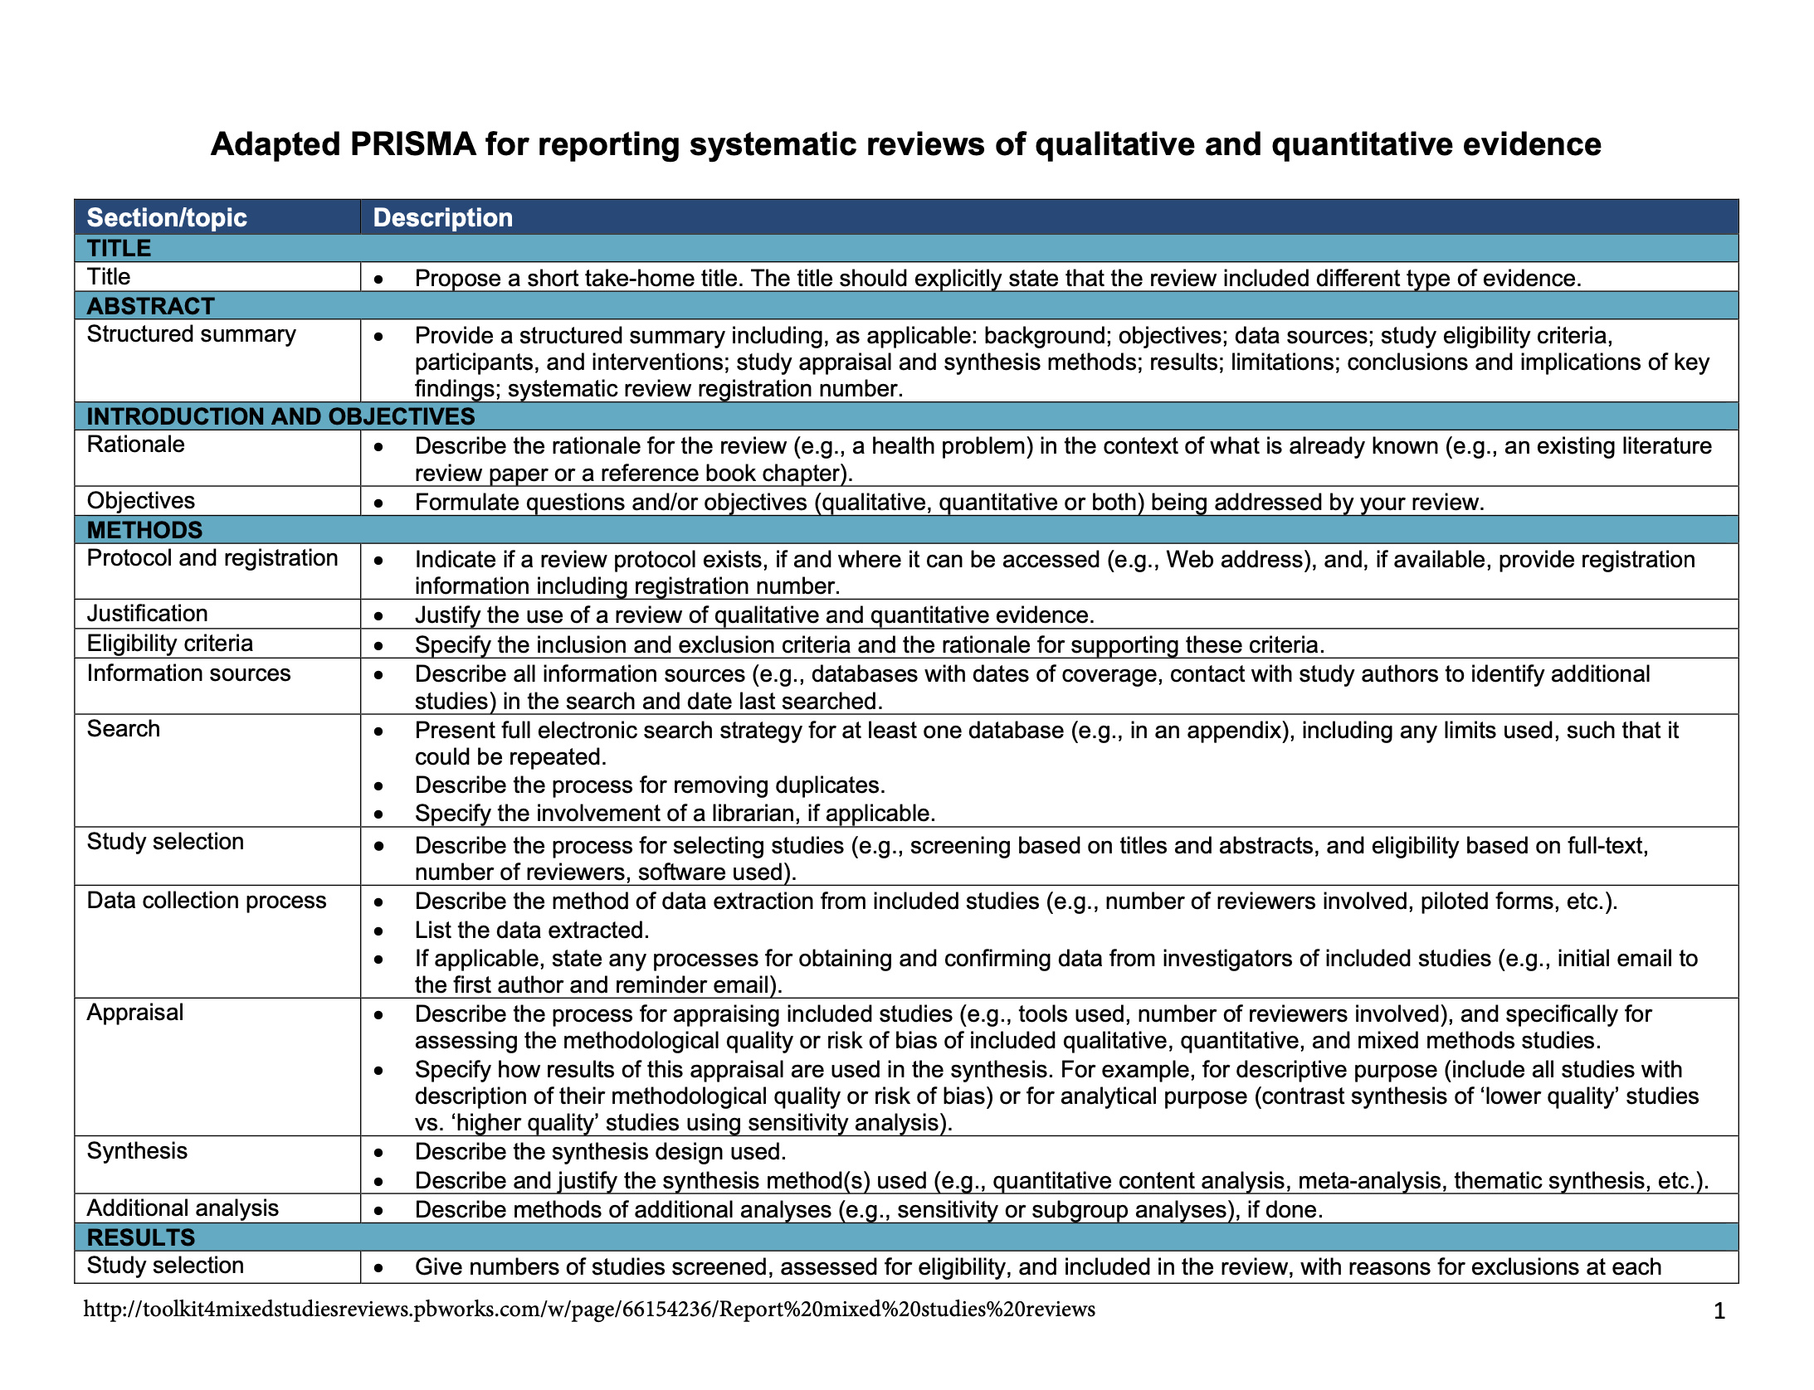
Appendix A: PRISMA Checklist [35]

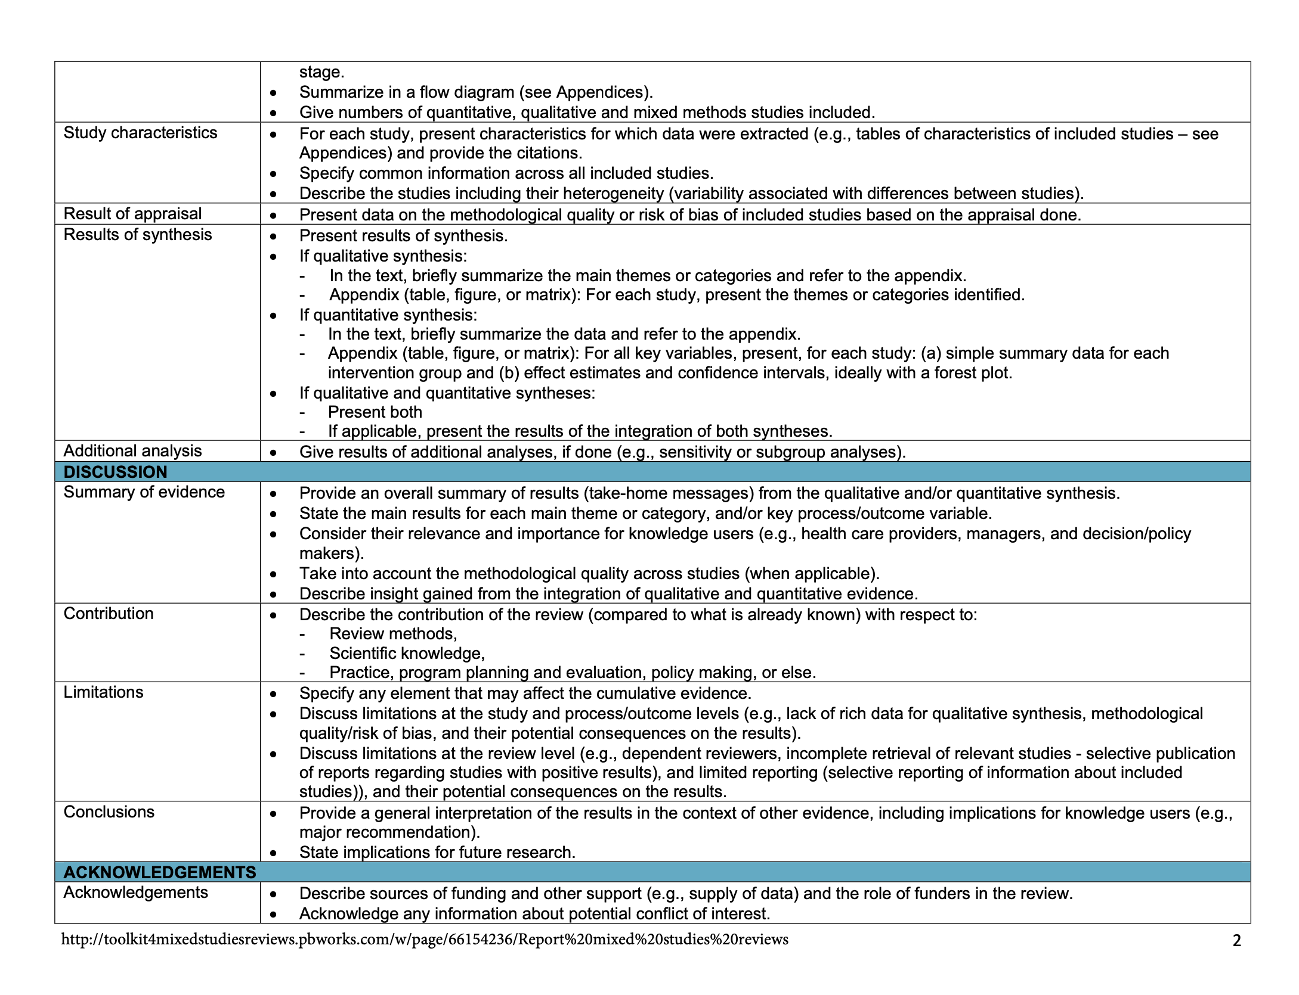

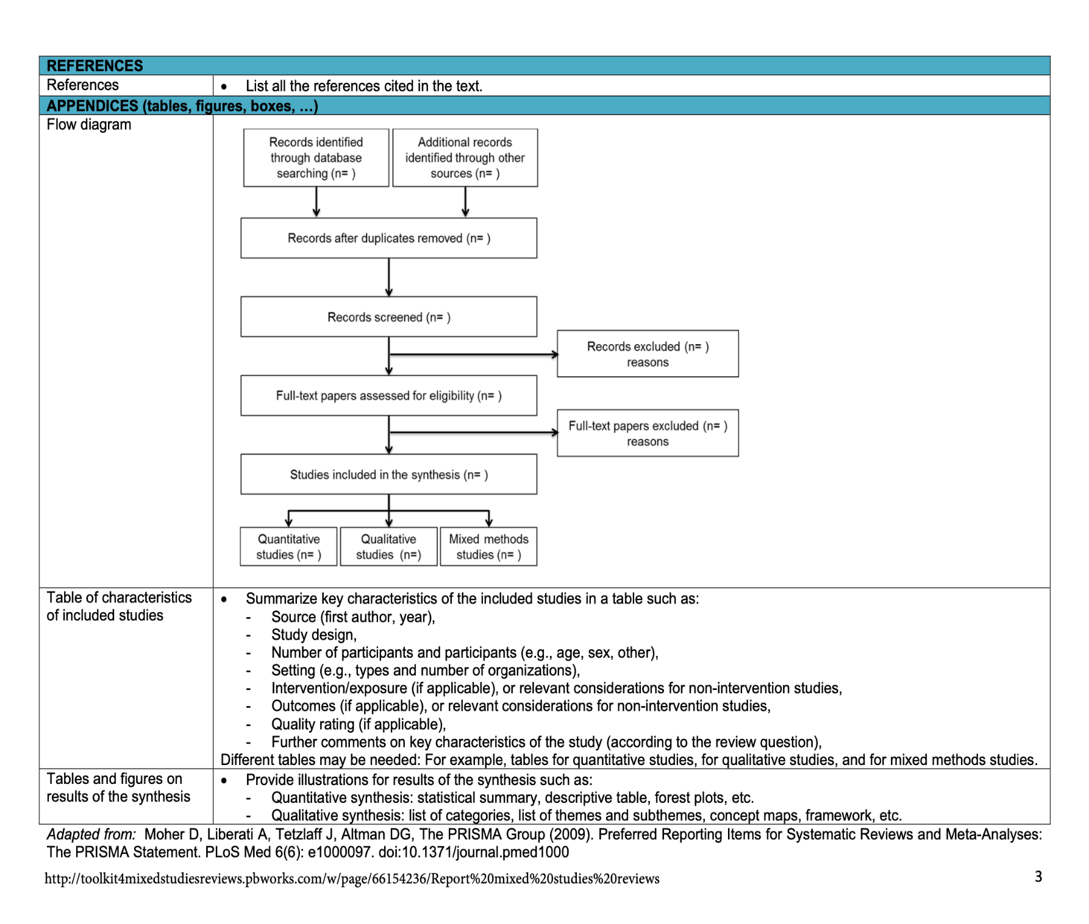

Appendix B: DCP3 ideal surgical capacity table [36]

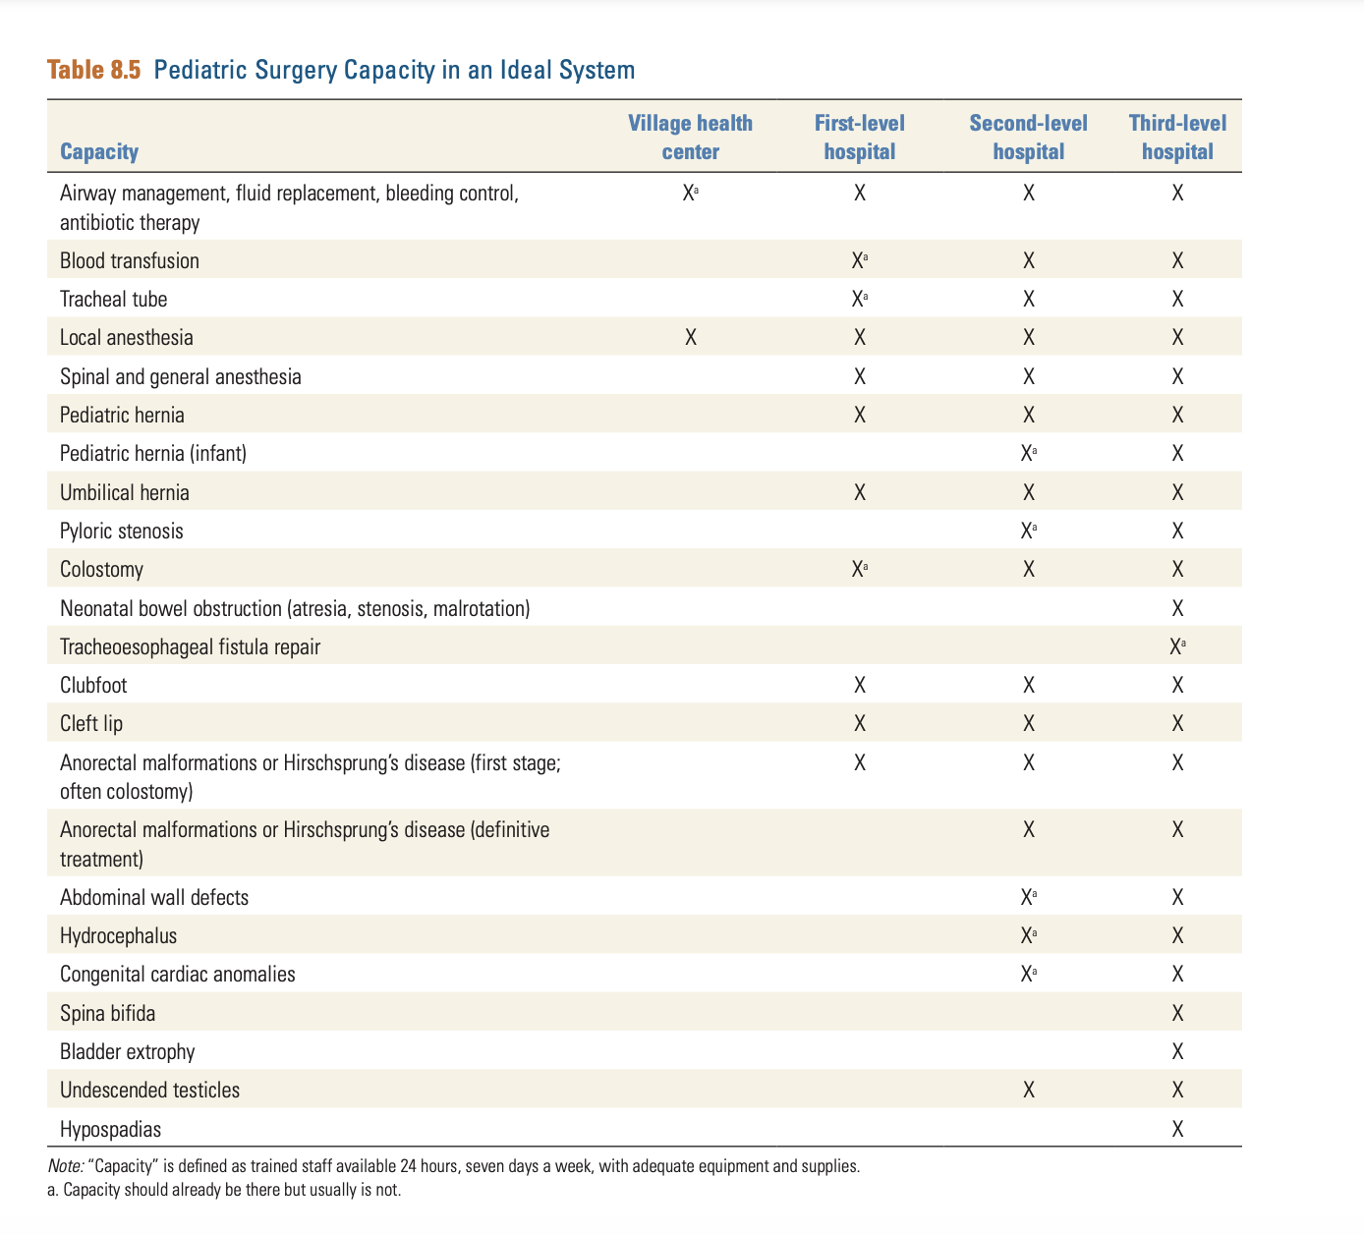

Appendix C: A database search strategy
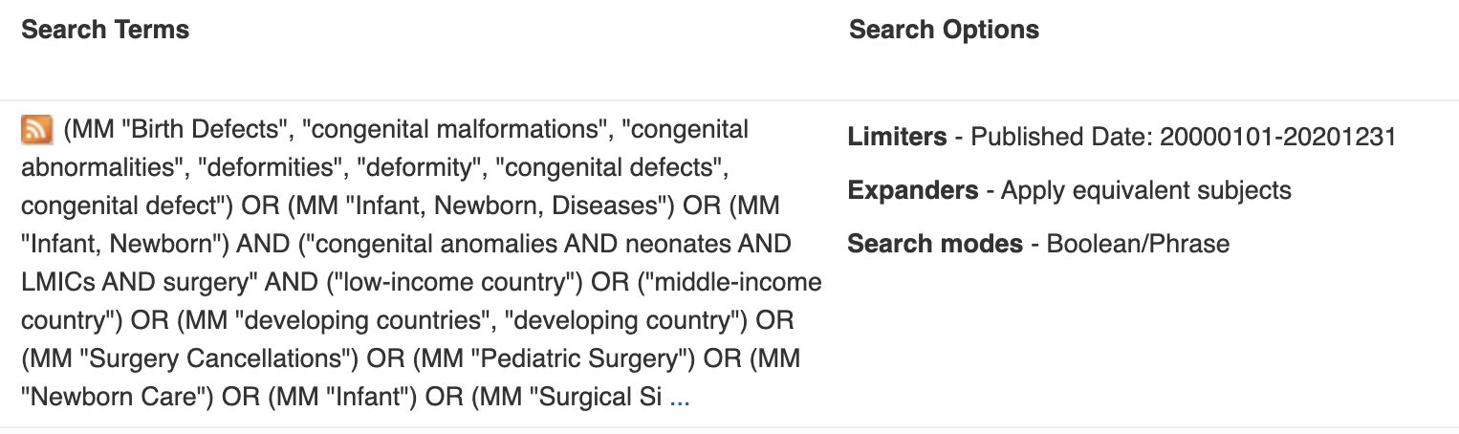

Appendix D: Data Management Tools

Covidence:
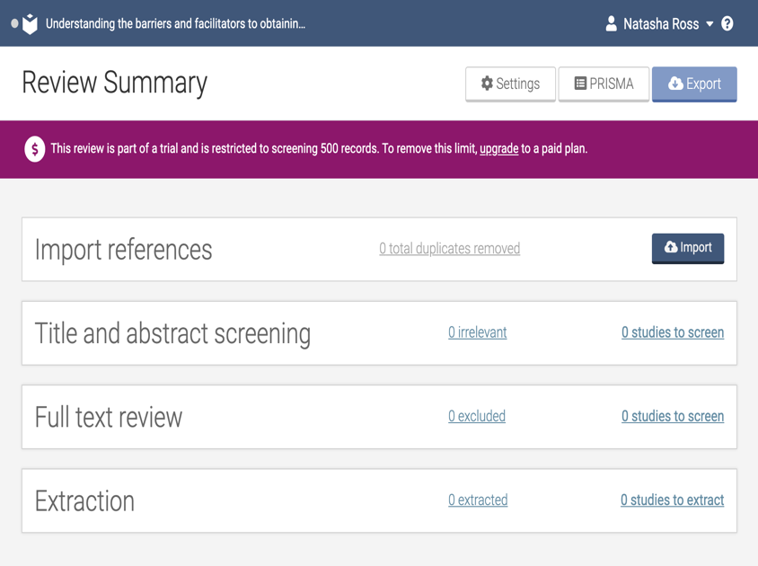
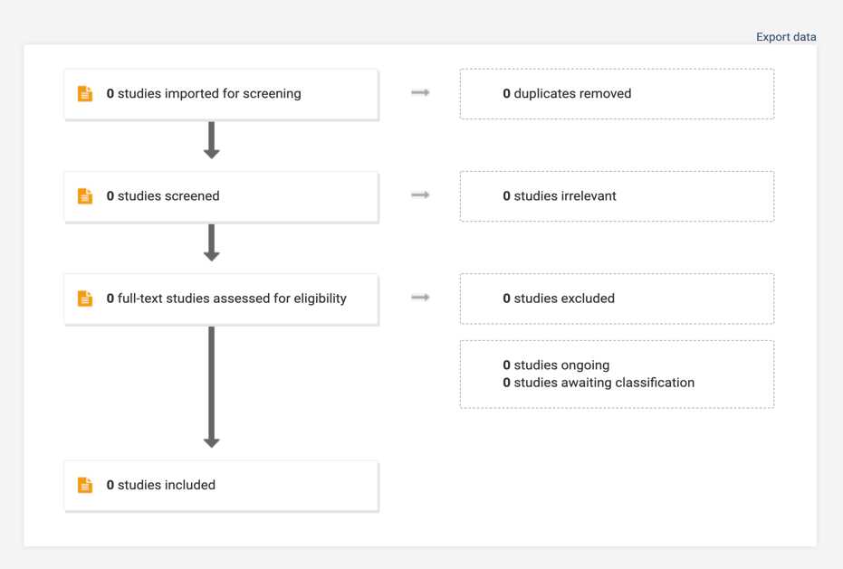

“Covidence is a web-based software platform that streamlines the production of systematic reviews. It supports citation screening, full text review, risk of bias assessment, and more. McMaster now provides unlimited access to university affiliates” [37].


  - Zotero:
Zotero is a web-based reference management tool that creates and organizes references in one convenient library (McMaster Libraries, 2020).

Appendix E: Data Extraction Sheet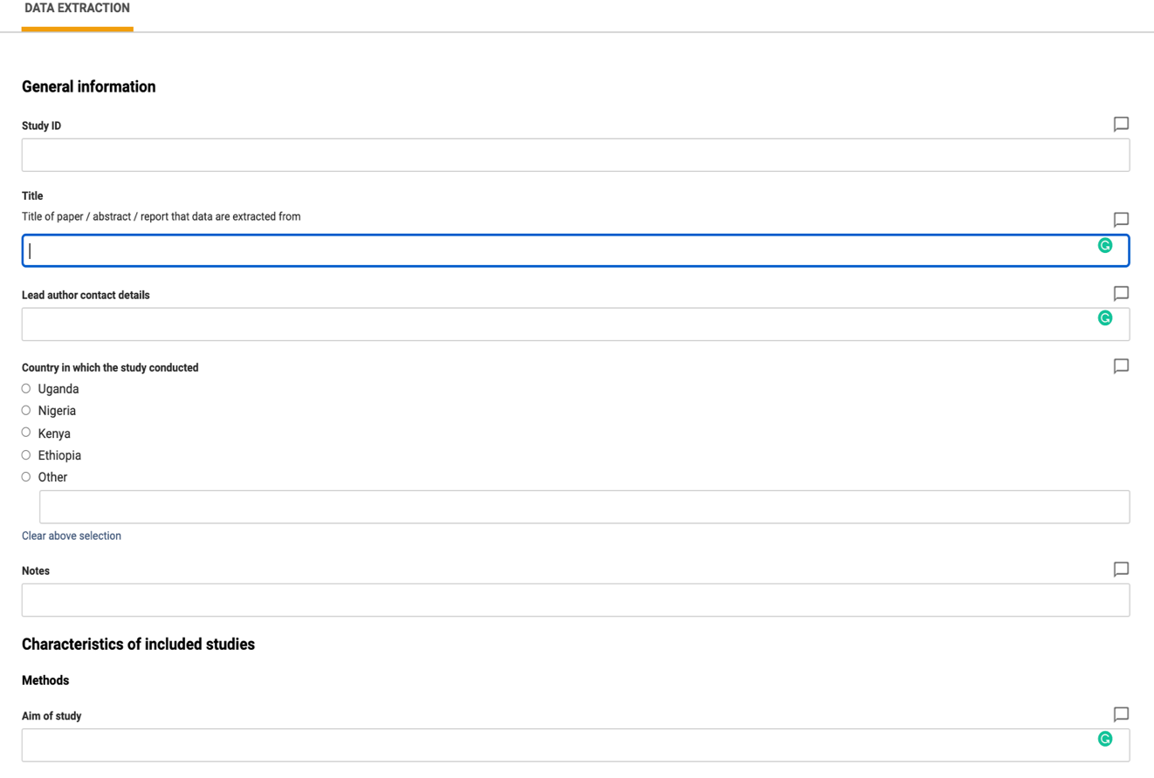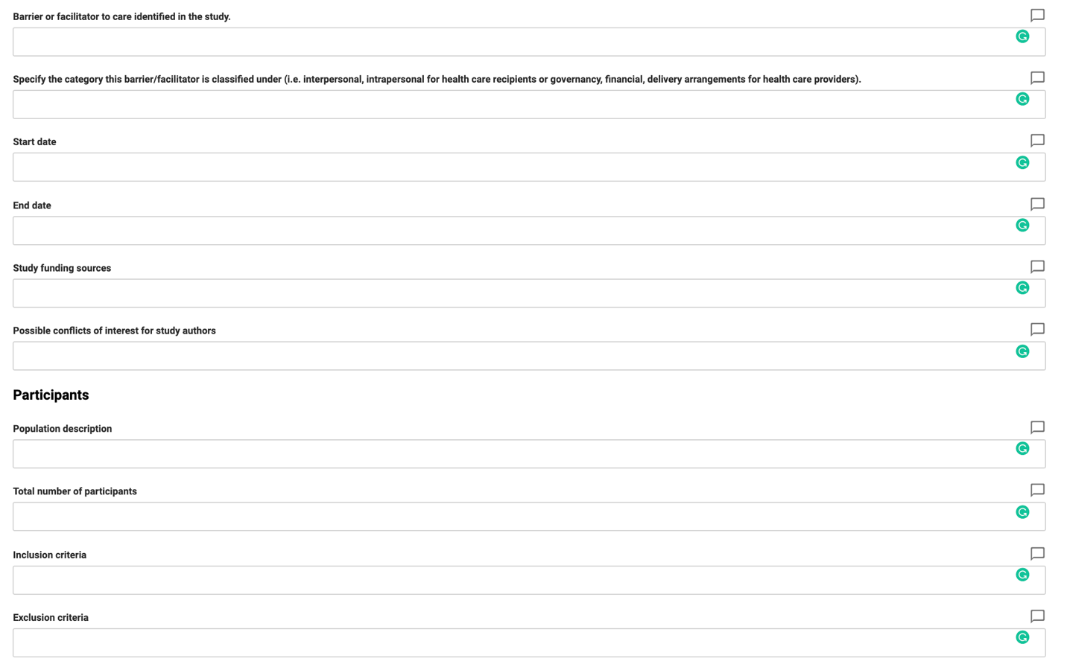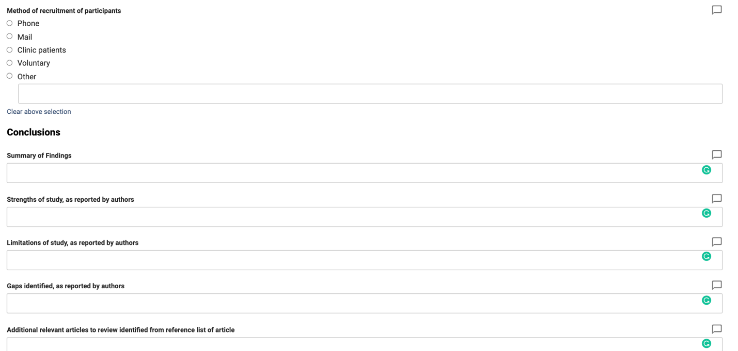

Appendix F: Study Characteristics

