FACTORS AFFECTING THE MORPHOLOGY AND COMPOSITION OF MOF CRYSTALS

FACTORS AFFECTING THE MORPHOLOGY AND COMPOSITION OF MOF CRYSTALS

By
ILINKA MIRKOVIC, MSc Chemical Engineering
A Thesis Submitted to the School of Graduate Studies in Partial Fulfillment of the Requirements for the Degree
Master of Applied Science

McMaster University
September 2020.

MASTER OF APPLIED SCIENCE (2020) McMaster University

(Chemical Engineering) Hamilton, Ontario

TITLE: FACTORS AFFECTING THE MORPHOLOGY AND
COMPOSITION OF MOF CRYSTALS

AUTHOR: Ilinka Mirkovic
MSc. Chemical Engineering
(University of Belgrade)

SUPERVIOR Dr Shiping Zhu
Dr Carlos Filipe

Table of Contents
Acknowledgements 4
List of figures 5
List of figures in supporting information 7
List of Tables 8
List of tables in supporting information 8
List of Abbreviations 8
Chapter 1: Introduction 10
Research topic: Metal-Organic Frameworks (MOFs) 10
Research Objectives 12
Thesis Organization 13
References 15
Chapter 2: Research background and Literature review 20
Direct growth of MOF crystals on the substrates 20
Direct growth of MOFs on the cellulose-based substrates 22
Bimetallic metal-organic frameworks 25
Bimetallic Zeolitic-Imidazolate Frameworks (ZIFs) 28
References 31
Chapter 3: Crystal growth of MOF-5 around cellulose-based fibres 39
having a necklace morphology 39
Abstract 39
Introduction 40
Experimental Section 42
Results and Discussion 45
Conclusion 56
Acknowledgments 57
References 57
Supporting Information 64
Chapter 4: Characterization and properties of Cu_{x}ZIF-8 zeolitic imidazolate framework 68
Abstract 68
Introduction 69
Experimental Section 72
Characterizations of prepared ZIF-8 and Cu/Zn-ZIF 73
Results and discussion 74
Conclusion 83
References 84
Supporting Information 90
Chapter 5: Major conclusions and recommendations for the future work 92
Suggested future work 93

Acknowledgements

First of all, I want express my gratitude to my supervisor Dr. Shiping Zhu for accepting me as one of his students. Although the outcome of my studies is not what I expected when I started, I am grateful to have been part of his group. I am especially grateful for his understanding when it comes to some health problem that I faced during my studies. I owe the same gratitude to my co supervisor Dr. Carlos Filipe. It’s amazing how much understanding and patience he has always had with me.
I would also like to thank my supervisory committee members, Dr. Igor Zhitomirsky and Dr. Li Xi for their valuable time in evaluating my research work. Thanks to three amazing ladies Ms. Kristina Trollip, Ms. Michelle Whalen and Ms. Linda Ellis for helping me and for making our department more beautiful. Thanks to all the members of Chemical Engineering department and all the undergraduate and graduate students that I had a chance to meet and work with. Thanks to Ms. Victoria Jarvis, Ms. Marcia Reid and people from other departments who helped with my research.
I would also like to add that it was a great experience to work in PolyMac Zhu group and that I enjoyed the time spent with current and former members. Special thanks to all of them for making hard time that I went through easier.

List of figures

Figure 2-1. FESEM image of anionic cellulose after in situ synthesis of MOF 199. The inset shows EDX spectra indicating the presence of Cu.
Figure 2-2. A) Preparing cellulose paper @MOF-5 composite materials with precipitated calcium carbonate (PCC) fillers. B) Growth of different MOFs on the surface of the cellulose substrate.
Figure 2-3. Two possible synthesis ways of bimetallic MOFs A) One-step synthesis and B) Post-synthetic modifications.
Figure 2-4. Illustration of the structural evolution in core-shell MOFs.
Figure 2-5. Crystal structures of ZIF-67, ZIF-8 and ZIF-90 having SOD topology. Yellow ball represents space in the cage.
Figure 2-6. A) Schematic illustration of the crystal structure of bimetallic ZIF and B) Gradually color change of the final product.
Figure 2-7. A) Schematic representation of Cu-doped ZIF-8 with random incorporation of the second metal and B) TEM images of ZIF-8 crystals doped with 1% and 25% of Cu. Adapted from 50.
Figure 3-1. Schematic representation illustrating the steps involved in the MOF-5@Substrate preparation, taking cotton bulbs as an example. (A) Pristine cotton bulb, (B) treatment with DA solution, (C) modified cotton bulb (grey color represents a color change of the substrate upon treatment with DA), (D) treatment with MOF-5 mother solution, and (E) cotton bulb with MOF-5 crystals.
Figure 3-2. SEM images of MOF-5@Substrate (temperature of the crystal growth was 65°C). (A) MOF-5 crystals on the pristine paper (no DA), (B) MOF-5 crystals on the paper modified with DA, and (C) MOF-5 growing around cotton fibres (D) “necklace” morphology (scale bar 100 µm).
Figure 3-3. SEM images of MOF-5@Cotton structures obtained at 105°C. (A) Unmodified cotton bulbs, (B) bulbs treated with 2 mg/mL DA solution, (C) substrates modified with 5 mg/mL DA solution and (D) “necklace” morphology (scale bar 100 µm).
Figure 3-4. FTIR spectra of pristine cotton, cotton modified in DA solution and
MOF-5@Cotton structure obtained at 105°C
Figure 3-5. XRD patterns of MOF-5 crystals and MOF-5 crystals grown on modified and unmodified cotton bulbs at 105°C.
Figure 3-6. N₂ sorption isotherms for MOF-5 and MOF-5@Cotton samples at 77K. The solid symbols represent adsorption while open symbols represent desorption.
Figure 3-7. (A) Exposing MOF-5@Cotton structure to a constant air flow in order to determine the stability of fabricated structures, (B) Stability of MOF-5@Cotton structures as a function of DA solution concentration
Figure 3-8. TGA thermogram of representative MOF-5@Cotton sample.
Figure 4-1. Schematic representation illustrating the steps in synthesis of crystals (A) Synthesis of ZIF-8 in the water, (B) Synthesis of Cu_{x}ZIF-8 and representation of random incorporation of Cu into the framework (C) visual color change observed with addition of Cu (II)
Figure 4-2. (A) SEM images of prepared samples, (B) EDS spectrum of prepared samples and (C) elemental composition obtained from EDS analysis
(Scale bar 5 µm)
Figure 4-3. (A) TEM of prepared samples and (B) powder XRD spectra of prepared samples (Scale bar 800 nm)

List of figures in supporting information

Figure S3-1. Digital photographs of (A) MOF-5 crystals formed in the solution, (B) MOF-5 crystals attached on pure cotton and DA treated cotton and (C) cotton bulbs before and after dopamine treatment
Figure S3-2. Digital photographs and SEM images of the cellulose-based substrates with MOF-5 crystals. A) MOF-5@Paper, B) MOF-5@Cotton. Scale bar 100µm
Figure S3-3. X-ray diffraction patterns of the MOF-5@Cotton structure when the temperature was 65°C. (A) DA modified substrate (B) Unmodified substrate
Figure S3-4. N₂ sorption isotherms for MOF-5 and MOF-5@Cotton samples at 77K for low pressure
Figure S4-1. SEM image of Cu₅₀/ZIF-8 showing truncated rhombic dodecahedral structure of crystals
Figure S4-2. TEM images of ZIF-8, Cu₂₅/ZIF-8, and Cu₅₀/ZIF-8 samples (Scale bar 200 nm)

List of Tables

Table 2-1. Successfully synthesised bimetallic MOFs and their applications
Table 4-1. Names of prepares samples and amounts of starting materials used through synthesis

List of tables in supporting information

Table S3-1. Results obtained by stability test of the modified and unmodified cotton substrates treated with MOF-5 mother solution

List of Abbreviations

BTC Benzene-1,3,5-tricarboxylate
DA Dopamine
DEF Diethilformamide
DOPA 3,4-dihydroxy-l-phenylalanine
DI Deionized
DMF Dimethylformamide
EDS Energy-dispersive X-ray spectroscopy
HKUST Hong Kong University of Science and Technology
HmIm 2-methylimidazole
MIL Material Institute de Lavoisier
MOF Metal Organic Frameworks
PDA Polydopamine
RDB Remazol black B
SAM Self-assembled monolayers
SEM Scanning Electron Microscopy
SOD Sodalite
TEM Transmission Electron Microscopy
TGA Thermogravimetric analysis
TRIS Tris (hydroxymethyl) aminomethane
XRD X‐ray diffraction
ZIF Zeolitic Imidazolate Frameworks

Chapter 1: Introduction

Research topic: Metal-Organic Frameworks (MOFs)

Porous materials have become a subject of great scientific interest in recent decades due to their broad range of applications, and their ability to interact with atoms, ions, and molecules both on the surface and throughout the bulk of a material. ¹ Among porous materials, zeolites and activated carbons have been the most intensively researched. However, in last two decades, a new class of porous materials known as metal-organic frameworks (MOFs) has drawn great attention from researchers.
Metal-organic frameworks (MOFs), also known as coordination polymers, ^{2,3} are porous crystalline materials that were first synthesized in 1999; since that time, these materials have attracted significant interest due to their attractive properties. ^{4,5}
This class of porous materials generally consists of crystalline compounds that are built from metal ions or metal ion clusters, which act as connectors and organic linkers. The synthesis of an MOF is dependent on the chemical structures and properties of all of its constituent components, with a huge range of network topologies (i.e., one-, two-, and three- dimensional topologies) having been developed since the first MOFs were reported. ^{4,6} In addition, the ability to change ligands allows a variety of organic linkers with different functional groups to be introduced to the network. Furthermore, pore size, pore shape, functionality, and network topology can all be tuned, thus allowing the properties of an MOF to be adjusted to suit a particular application. Most reported MOFs were synthesised via solvothermal and hydrothermal methods using organic solvent or water as a medium and high temperatures. ^{7–10} To avoid the longer reaction times usually required for these methods, researchers have developed new methods, such as microwave/ultrasound-assisted process, which allow MOFs to be synthesized in only a few minutes. ^{11,12} Aside from the above-noted methods, other commonly used methods include electrochemical methods, mechanochemical methods, and synthesis under solvent-free conditions, among others. ^{13–15}
Although researchers have become interested in MOFs due to the huge number of different MOFs that can be synthesized using relatively simple preparation methods, the root of interest in MOFs is due to their unique properties. Unlike other porous materials such as activated carbons and zeolites, MOFs offer thermal and chemical stability, ordered structure with various reactive sites, tunable pore properties, ultra-low densities, and large internal surface areas of up to 7000 m²g⁻¹. ^{16,17} As a result of these properties, MOFs have emerged as an interesting class of materials with various applications. One of the most commonly researched MOF applications is for the storage of gases (methane and hydrogen). In particular, MOFs are well-suited for hydrogen storage due to their high surface areas and low densities. ^{18–20} Similarly, MOFs have also been examined as good candidates for hydrogen storage due to their high surface areas and pore volumes. ^{21–24} Furthermore, adjustable pore sizes and controllable surface properties, along with high surface areas, make MOFs ideal candidates for gas separation applications. ^{25–27} Some of the other most commonly investigated MOF applications include their use as drug delivery systems, ^{28,29} as chemical sensors, ^{30,31} for catalysis, ^{22,30–32} and for air purification. ³³
Even though MOFs possess unique properties, the study of their potential is often limited due to the form in which they are produced, which is most often a powder. To overcome this problem, researchers have attempted to fabricate MOFs as membranes, as well as attempted to deposit them onto cost-effective polymeric substrates or ceramics, to name a few notable formats. ^{22,34–36} One attractive approach that has been garnering more attention is the fabrication of composites using MOFs and cellulose based materials. ^{37–39}
The manipulation of the size and shape of the crystals is important because it can help determine the physical properties of the final material and enable specific applications. Given the recent surge in interest on attaching MOFs to various surfaces, we examine potential approaches to controlling the morphology of MOF-assemblies (Chapter 3). In addition, we grew MOF crystals using natural substrates, and attempted to manipulate their shape by altering some of the initial parameters. Furthermore, since it is always desirable to discover new MOFs, we modified well-known MOFs by introducing another metal into the framework to examine how doing so affects the morphology of the parent MOF (Chapter 4).

Research Objectives

Research on MOFs can be divided into five main categories: design, preparation, modification, processing, and applications. The focus of this thesis is the “design” of MOF crystals, and the use of various modifications to control of their morphology.
The overall objectives of this thesis are as follows:
- To control the morphology of MOF-assemblies. To achieve this goal, MOFs were grown using well-known MOFs and natural polymeric supports, while modifying the initial substrates and some of the synthesis parameters.
- Preparing new MOFs by modifying well-known MOFs (ZIF-8) and their characterizations. Here, the effect of introducing new metal into the framework of the crystals was examined.

Thesis Organization

This thesis follows “sandwich” format, consisting of one article that has been published in a peer-reviewed journal (Chapter 3), and one manuscript that is currently in preparation for publication (Chapter 4). These two chapters are “sandwiched” between the Literature Review (Chapter 2) and the Conclusion (Chapter 5).

Chapter 1: Introduction. This chapter introduces the research background on metal-organic frameworks, as well as their properties, methods of synthesis, applications, and known problems. In addition to this theoretical background, Chapter 1 also presents on overview of the thesis and its structure.

Chapter 2: Research background and Literature review. This chapter is divided into two parts. The first part provides a general background on controlling the morphology of MOF assemblies and using supports for the growth of well-known MOFs. It is also known that the structure of an MOF is closely related to the starting synthesis components, and that changing only one parameter can lead to the preparation of new MOFs. Based on this fact, in the second part we focused on introducing an additional metal into the system and reviewing the bimetallic MOFs that have been synthesized to date. The special interest of this thesis is zeolitic-imidazole frameworks and their derivates.

Chapter 3: Crystal growth of MOF-5 around cellulose-based fibres having a necklace morphology. This chapter details the growth of MOFs, specifically the growth of MOF-5 on a cellulose-based substrated using modification agents. Our work shows how, aside from the dopamine that was used modify the cellulose substrate, the structure of the substrate plays an important role in MOF growth. In addition, we were able to form a stable “necklace” morphology and attach it to MOF-5 crystals as a substrate, which is important for future applications. This chapter was published as an article on ACS Omega, 2019, 4, 1, 169-175(doi:10.1021/acsomega.8b02442.)

Chapter 4: Characterization and properties of Cu_{x}ZIF-8 zeolitic imidazolate framework. This chapter presents the synthesis of a bimetallic zeolitic-imidazolate framework (ZIF) in aqueous solution. ZIF-8 is one of the most well-known zinc-based MOFs, and there has been increasing interest among researchers to modify it by introducing another metal into its framework. In this chapter, we focus on the influence of Cu (II) when it is incorporated into the ZIF-8 framework. As we show, the sodalyte structure characteristic to ZIF-8 was preserved after adding another metal up to 50 mass % of the new metal, which was a great improvement compared to the 25 mass % reported in the literature. This manuscript is currently in preparation for publication.

Chapter 5: Conclusions. The final chapter presents the main conclusions and contributions of this research, along with suggestions for future work in this field.

References

1. Davis ME. pure silicaで有機物を吸着 for Emerging Applications. Nature. 2002;417(June):813-821.
2. Kitagawa S, Kitaura R, Noro SI. Functional porous coordination polymers. Angew Chemie - Int Ed. 2004;43(18):2334-2375. doi:10.1002/anie.200300610
3. Uemura K, Matsuda R, Kitagawa S. Flexible microporous coordination polymers. J Solid State Chem. 2005;178(8 SPEC. ISS.):2420-2429. doi:10.1016/j.jssc.2005.05.036
4. Design and synthesis of an exceptionally stable and highly. 1999;402(November):276-279.
5. Yaghi OM, O’Keeffe M, Ockwig NW, Chae HK, Eddaoudi M, Kim J. Reticular synthesis and the design of new materials. Nature. 2003;423(6941):705-714. doi:10.1038/nature01650
6. Chui SSY, Lo SMF, Charmant JPH, Orpen AG, Williams ID. A chemically functionalizable nanoporous material [Cu3(TMA)2 (H2O)3](n). Science (80- ). 1999;283(5405):1148-1150. doi:10.1126/science.283.5405.1148
7. Lin W, Wang Z, Ma L. A novel octupolar metal-organic NLO material based on a chiral 2D coordination network [14]. J Am Chem Soc. 1999;121(48):11249-11250. doi:10.1021/ja9928327
8. Yaghi OM, Li H. Hydrothermal Synthesis of a Metal-Organic Framework Containing Large Rectangular Channels. J Am Chem Soc. 1995;117(41):10401-10402. doi:10.1021/ja00146a033
9. Stock N, Biswas S. Synthesis of metal-organic frameworks (MOFs): Routes to various MOF topologies, morphologies, and composites. Chem Rev. 2012;112(2):933-969. doi:10.1021/cr200304e
10. Dybtsev DN, Nuzhdin AL, Chun H, et al. A Homochiral Metal–Organic Material with Permanent Porosity, Enantioselective Sorption Properties, and Catalytic Activity. Angew Chemie. 2006;118(6):930-934. doi:10.1002/ange.200503023
11. Ni Z, Masel RI. Rapid production of metal-organic frameworks via microwave-assisted solvothermal synthesis. J Am Chem Soc. 2006;128(38):12394-12395. doi:10.1021/ja0635231
12. Chalati T, Horcajada P, Gref R, Couvreur P, Serre C. Optimisation of the synthesis of MOF nanoparticles made of flexible porous iron fumarate MIL-88A. J Mater Chem. 2011;21(7):2220-2227. doi:10.1039/c0jm03563g
13. Gangu KK, Maddila S, Mukkamala SB, Jonnalagadda SB. A review on contemporary Metal-Organic Framework materials. Inorganica Chim Acta. 2016;446:61-74. doi:10.1016/j.ica.2016.02.062
14. Lee YR, Kim J, Ahn WS. Synthesis of metal-organic frameworks: A mini review. Korean J Chem Eng. 2013;30(9):1667-1680. doi:10.1007/s11814-013-0140-6
15. Safaei M, Foroughi MM, Ebrahimpoor N, Jahani S, Omidi A, Khatami M. A review on metal-organic frameworks: Synthesis and applications. TrAC - Trends Anal Chem. 2019;118:401-425. doi:10.1016/j.trac.2019.06.007
16. Furukawa H, Ko N, Go YB, et al. Ultrahigh porosity in metal-organic frameworks. Science (80- ). 2010;329(5990):424-428. doi:10.1126/science.1192160
17. Hirscher M. Hydrogen storage by cryoadsorption in ultrahigh-porosity metal-organic frameworks. Angew Chemie - Int Ed. 2011;50(3):581-582. doi:10.1002/anie.201006913
18. Rosi NL, Eckert J, Eddaoudi M, et al. Hydrogen storage in microporous metal-organic frameworks. Science (80- ). 2003;300(5622):1127-1129. doi:10.1126/science.1083440
19. Murray LJ, Dinc M, Long JR. Hydrogen storage in metal-organic frameworks. Chem Soc Rev. 2009;38(5):1294-1314. doi:10.1039/b802256a
20. Suh MP, Park HJ, Prasad TK, Lim DW. Hydrogen storage in metal-organic frameworks. Chem Rev. 2012;112(2):782-835. doi:10.1021/cr200274s
21. Ma S, Sun D, Simmons JM, Collier CD, Yuan D, Zhou HC. Metal-organic framework from an anthracene derivative containing nanoscopic cages exhibiting high methane uptake. J Am Chem Soc. 2008;130(3):1012-1016. doi:10.1021/ja0771639
22. Gomez IJ, Arnaiz B, Cacioppo M, Arcudi F, Prato M. Nitrogen-doped Carbon Nanodots for bioimaging and delivery of paclitaxel. J Mater Chem B. 2018;6(35). doi:10.1039/x0xx00000x
23. Senkovska I, Kaskel S. High pressure methane adsorption in the metal-organic frameworks Cu3(btc)2, Zn2(bdc)2dabco, and Cr3F(H2O)2O(bdc)3. Microporous Mesoporous Mater. 2008;112(1-3):108-115. doi:10.1016/j.micromeso.2007.09.016
24. Peng Y, Krungleviciute V, Eryazici I, Hupp JT, Farha OK, Yildirim T. Methane storage in metal-organic frameworks: Current records, surprise findings, and challenges. J Am Chem Soc. 2013;135(32):11887-11894. doi:10.1021/ja4045289
25. Tanh Jeazet HB, Staudt C, Janiak C. Metal-organic frameworks in mixed-matrix membranes for gas separation. Dalt Trans. 2012;41(46):14003-14027. doi:10.1039/c2dt31550e
26. Lin RB, Xiang S, Xing H, Zhou W, Chen B. Exploration of porous metal–organic frameworks for gas separation and purification. Coord Chem Rev. 2019;378:87-103. doi:10.1016/j.ccr.2017.09.027
27. Li JR, Ma Y, McCarthy MC, et al. Carbon dioxide capture-related gas adsorption and separation in metal-organic frameworks. Coord Chem Rev. 2011;255(15-16):1791-1823. doi:10.1016/j.ccr.2011.02.012
28. Horcajada P, Chalati T, Serre C, et al. Porous metal-organic-framework nanoscale carriers as a potential platform for drug deliveryand imaging. Nat Mater. 2010;9(2):172-178. doi:10.1038/nmat2608
29. Li S, Wang K, Shi Y, et al. Novel Biological Functions of ZIF-NP as a Delivery Vehicle: High Pulmonary Accumulation, Favorable Biocompatibility, and Improved Therapeutic Outcome. Adv Funct Mater. 2016;26(16):2715-2727. doi:10.1002/adfm.201504998
30. Mondloch JE, Katz MJ, Isley WC, et al. Destruction of chemical warfare agents using metal-organic frameworks. Nat Mater. 2015;14(5):512-516. doi:10.1038/nmat4238
31. Metzger ED, Brozek CK, Comito RJ, Dinca M. Selective dimerization of ethylene to 1-butene with a porous catalyst. ACS Cent Sci. 2016;2(3):148-153. doi:10.1021/acscentsci.6b00012
32. Farrusseng D, Aguado S, Pinel C. Metal-organic frameworks: Opportunities for catalysis. Angew Chemie - Int Ed. 2009;48(41):7502-7513. doi:10.1002/anie.200806063
33. Chen Y, Zhang S, Cao S, et al. Roll-to-Roll Production of Metal-Organic Framework Coatings for Particulate Matter Removal. Adv Mater. 2017;29(15):4-9. doi:10.1002/adma.201606221
34. Zhu H, Zhu S. A versatile and facile surface modification route based on polydopamine for the growth of MOF films on different substrates. Can J Chem Eng. 2015;93(1):63-67. doi:10.1002/cjce.22115
35. Bux H, Chmelik C, Van Baten JM, Krishna R, Caro J. Novel MOF-membrane for molecular sieving predicted by IR-diffusion studies and molecular modeling. Adv Mater. 2010;22(42):4741-4743. doi:10.1002/adma.201002066
36. Liu D, Ma X, Xi H, Lin YS. Gas transport properties and propylene/propane separation characteristics of ZIF-8 membranes. J Memb Sci. 2014;451:85-93. doi:10.1016/j.memsci.2013.09.029
37. da Silva Pinto M, Sierra-Avila CA, Hinestroza JP. In situ synthesis of a Cu-BTC metal-organic framework (MOF 199) onto cellulosic fibrous substrates: Cotton. Cellulose. 2012;19(5):1771-1779. doi:10.1007/s10570-012-9752-y
38. Rodríguez HS, Hinestroza JP, Ochoa-Puentes C, Sierra CA, Soto CY. Antibacterial activity against Escherichia coli of Cu-BTC (MOF-199) metal-organic framework immobilized onto cellulosic fibers. J Appl Polym Sci. 2014;131(19):1-5. doi:10.1002/app.40815
39. Zhu H, Yang X, Cranston ED, Zhu S. Flexible and Porous Nanocellulose Aerogels with High Loadings of Metal–Organic-Framework Particles for Separations Applications. Adv Mater. 2016;28(35):7652-7657. doi:10.1002/adma.201601351

Chapter 2: Research background and Literature review

Controlling MOF morphology and crystal quality is a broad field of research that cannot be covered fully within the scope of this thesis. As such, we focus on the literature related to two approaches to creating MOFs. In the first part of this chapter, we review approaches that groove various MOFs onto substrates in order to obtain different morphologies, with an emphasis on growing MOFs from the substrate. The second part of this chapter focuses on approaches that attempt to control morphology by changing the MOF’s compositional parameters—in this case, by adding a second metal to the framework.

Direct growth of MOF crystals on the substrates

To date, various substrates have been used for growing MOF crystals, including alumina, silica, nylon, or thin films. The most common strategies used to grow crystals on these substrates are as follows:¹
- Direct growth: This approach entails the immersion of the substrate in the metal salt and organic linker solutions. Typically, this method is assisted by heating, which triggers the nucleation process and causes heterogeneous nucleation to take place.
- Layer-by-layer growth: In this approach, the substrates are immersed in a solution consisting of metal salt and organic ligand multiple times. The substrates are usually rinsed with solvent between immersions, which facilitates the production of homogenous films.
- Secondary growth of seeded growth: This method involves coating the substrate with a seed layer and then immersing it in a solution of MOF. This method is similar to the direct method, but it provides better surface coverage.
- Chemical solution deposition: In this simple method, the desired substrate is spin- or dip-coated with a stable dispersion of crystals. This method is advantageous because it allows for the thickness of the layer to be easily controlled.

The literature contains numerous studies demonstrating the direct growth of MOF thin films and crystals on thin surfaces, beads, and fibres. Prior research has successfully used the direct growth method to produce thin films on functionalized substrates, ^{2–4} or in combination with a layer-by-layer technique to obtain better substrate coverage.^{5,6} However, findings have shown that pre-modifying the substrate will yield better results when using the direct growth approach, as it enhances the growth of a variety of MOFs on the surface, including MOF-5, HKUST-1, and ZIF.^{7–9} Other studies have explored the use of self-assembled monolayers (SAM) as surface modification agents for the direct growth of MOF crystals, with findings revealing the important role played by the functional SAM groups in the growth process. ^{10–14}

Direct growth of MOFs on the cellulose-based substrates

The nature and structure of the selected substrate also plays an important role in the direct growth of MOFs. As the most abundant polymer in nature, which also happens to be renewable, cellulose-based fibres have been employed in the food and textile industries for a number of applications, including as coatings and in optical and pharmaceutical films. ¹⁵
The first study to document the chemical attachment and growth of MOFs on the surface of cellulose fibres found that MOF 199 growth can be easily synthesized on carboxymethylated fibres (Figure 2-1).¹⁶ Additionally, subsequent works have discovered that this system has antibacterial properties against E. coli, and that the MOF 199 crystals, and not its components, were solely responsible for these properties.^{17,18}

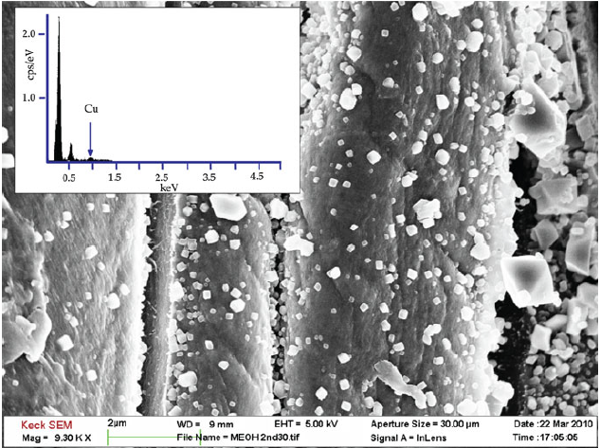
Figure 2-1. FESEM image of anionic cellulose after in situ synthesis of MOF 199. The inset shows EDX spectra indicating the presence of Cu. Adapted from 16.

Researchers have also investigated MOF growth using cellulose-modified papers as a substrate and gas adsorption. ^{19,20} Since hydrogen bonding between fibers occurs due to the abundance of hydroxyl groups in the cellulose papers, it is generally necessary to use modification agents to interrupt this process. As these works showed, the dense structure of the paper facilitated the attachment of MOF crystals to its surface (Figure 2-2).

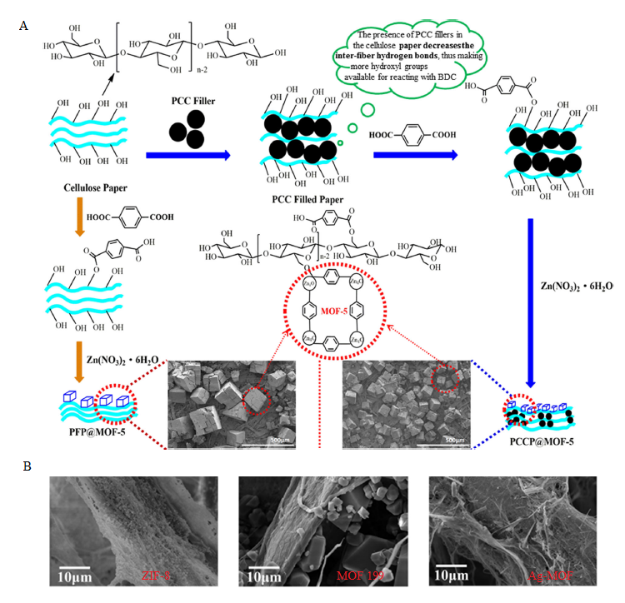

Figure 2-2. A) Preparing cellulose paper @MOF-5 composite materials with precipitated calcium carbonate (PCC) fillers. Reprinted from 19. B) Growth of different MOFs on the surface of the cellulose substrate. Adapted from 20.

Although substrate modifications can enhance nucleation and crystal growth of crystals, the structure of the substrate plays important role. Because of the dense structure of the paper MOF crystals can grow only on the surface of the substrate. When it comes to fibres, MOFs can be chemically attached for the surface; however, our work in Chapter 3 shows that it is possible to obtain unique structures wherein crystals are grown around the fibres,²¹ and that this morphology can be affected by changing some of the synthesis parameters.

Bimetallic metal-organic frameworks

Although MOFs have been recognized as promising materials for many applications, researchers continue to search for ways to enhance their properties and modify well-known parent MOFs. One promising approach to this end is the incorporation of a second metal ion into the node of the framework to yield bimetallic MOFs.
Introducing a second metal into the framework can produce rich adsorptive sites and high porosity, but bimetallic MOFs pose a number of challenges as well, including: fragile frameworks; potentially having similar properties to monometallic MOF; and topologies that are difficult to predict. ²²
Generally, all previously synthesized bimetallic MOFs can be divided into two categories: ²³

- Solid solution bimetallic MOFs: This category refers to MOFs wherein metals are well-dispersed through crystal framework though not distributed completely homogeneously, as this is not possible. The two most common ways of synthesizing these bimetallic MOFs are: a) direct or one-step synthesis, and b) via post-synthetic modifications. These methods are illustrated in Figure 2-3.
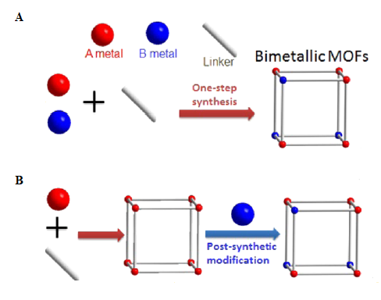

Figure 2-3. Two possible approaches for synthesizing bimetallic MOFs A) One-step synthesis and B) Post-synthetic modification. Adapted from 22.

- Core-shell bimetallic MOFs: These MOFs possess both a core and a shell with a metal centre ²⁴ (Figure 2-4). Some well-established methods of preparing this type of MOF include seed-induced growth, post synthetic exchange, and one-pot synthesis.

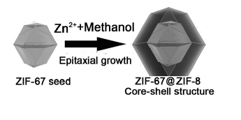
Figure 2-4. Illustration of the structural evolution in core-shell MOFs. Adapted from 24.

As noted above, it is simply not possible to review the whole body of MOF research in this thesis; therefore, we will strictly examine solution bimetallic MOFs obtained via one-step synthesis, wherein two metal salts are dissolved together and mixed with a solution of the organic ligand. This synthesis method faces two key challenges: the incorporation of the metal is usually random, and the formation of the other phase must be avoided. Despite these challenges, this method has been used to synthesize numerous bimetallic MOFs, sometimes through the addition of a second metal precursor. These MOFs and their potential applications are presented in Table 2-1.

Table 2-1. Successfully synthesised bimetallic MOFs and their applications.

Bimetallic MOF | Second metal added | Potential application
Co/MOF-5 ²⁵ | Co²⁺ doping into MOF-5 | Gas adsorption
Zn/CuBTC ²⁶ | Zn²⁺ doping into HKUST -1 | Adsorption of dibenzothiphene
Co/MOF-74 ²⁷ | Co²⁺ doping into MOF-74 | Hydrogen adsorption
Cu/ZIF-67 ²⁸ | Cu²⁺ doping into ZIF-67 | Degradation of organic dye
Cu/ZIF-8 ²⁹ | Cu²⁺ doping into ZIF-8 | Catalysis
Mg/MIL-101 ³⁰ | Mg²⁺ doping into MIL-101(Cr) | CO₂ adsorption
Ce/UiO-66 ³¹ | Ce doping into UiO-66 | Catalysis

Bimetallic Zeolitic-Imidazolate Frameworks (ZIFs)

One of the most researched subclasses of MOFs are known as Zeolitic-Imidazolate Framewoks (ZIFs), which are frameworks wherein tetrahedral divalent metal ions, usually Zn cations, are linked to imidazole ligands via coordination bonds.^{32,33} A number of ZIFs with zeolite-like saodalite (SOD) topologies have been synthesized, with three of the best-known representatives shown in Figure 2-5. ³⁴

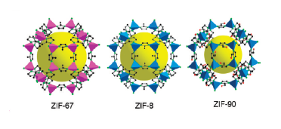
Figure 2-5. Crystal structures of ZIF-67, ZIF-8, and ZIF-90—all of which have an SOD topology. The yellow ball represents space in the cage. Adapted from 34.

As with all types of MOFs, this subclass is interesting because of its unique properties—in this case, permanent porosity and unexpected thermal and chemical stability. ^{35–37}
Since all of these properties are controlled by the morphology of the ZIF particles, it is important to investigate methods of shaping ZIF crystals in a controlled manner. The number of synthetic conditions can be changed in order to control the growth of the ZIF particles that influence the MOF’s kinetic and thermodynamic factors. ^{26,38,39} One of the most widely used approaches for controlling the growth of the particles relies on changing the initial concentrations and/or ratios of these components. ⁴⁰
Zinc (II) cations can be substituted with the divalent cations, Co (II) or Cu (II), without altering the MOF’s topology. ZIF-67 is produced when tetrahedral divalent cobalt Cu (II) cations are connected via coordination bonds to an imidazole ligand; in contrast, ZIF-8 is produced when Zn (II) cations are used. We examined works that used only one metal or both metals (Cu and Zn) while changing the doping percentage, as well as works exploring various applications such as CO₂ and H₂ uptake, dye adsorption, catalysis. ^{41–49}
All of these works are based on the same principle: varying Co content. The synthesis starts with only one metal solution (usually with Zn); gradually, the amount of the first metal solution is decreased, and the amount of the second metal solution is increased—in this case, Co. The resulting framework will depend on the amount of both metals presented. (Figure 2-6A)
Visually, this process can be followed by observing the changes in color to the powder as a result of the reaction. As can be seen, incorporating Co into the ZIF framework causes the powder to gradually change from white to violet (Figure 2-6B).

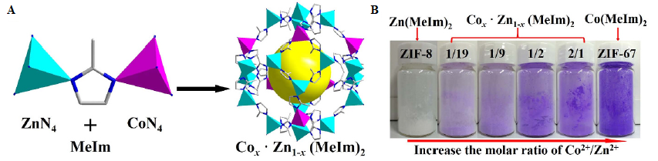

Figure 2-6. A) Schematic illustration of the crystal structure of bimetallic ZIF; and B) Gradual color change of the final product. Adapted from 46.

Compared to the parent ZIF-8, the resulting cobalt-substituted ZIF-8 had higher porosity, 40% more surface area, and 30% more pore volume. Furthermore, the cobalt-substituted ZIF-8 had higher CO₂ and H₂ uptakes, which is an inherent feature of Co-doped frameworks.⁴¹ The particles with and without Co also had well-defined truncated rhombic dodecahedral morphology; however, the nucleation rate was slowed down, which resulted in bigger nanoparticles. ^{44,45}
Aside from metal atoms such as Zn²⁺ and Co²⁺, it may be possible to use Cu²⁺ to connect four imidazolate ligands in order to form a neutral network in a ZIF tetrahedral unit. However, the literature contains very few studies that have used Cu to this end, or that have used a lower doping percentage of Cu compared to Co for catalysis.^{50,51} This bimetallic framework is relatively easy to synthesize, as it can be done at room temperature using methanol as a solvent (Figure 2-7A); however, the incorporation of the second metal in the framework is random and cannot be controlled. The crystal structure of Cu-doped ZIF was confirmed, but the addition of the second metal slowed down the kinetics. Increasing the amount of Cu in the system served to increase the size of the crystals, thus confirming the formation of less nuclei (Figure 2-7B). To date, the highest reported Cu-doping percentage has been 25%, with complete collapse of the framework occurring at 50 % of Cu. ⁵⁰
Finally, the incorporation of iron into the ZIF-8 framework in order to enhance its photocatalytic activity was tested via the degradation of Remazol black B (RDB). ⁵²
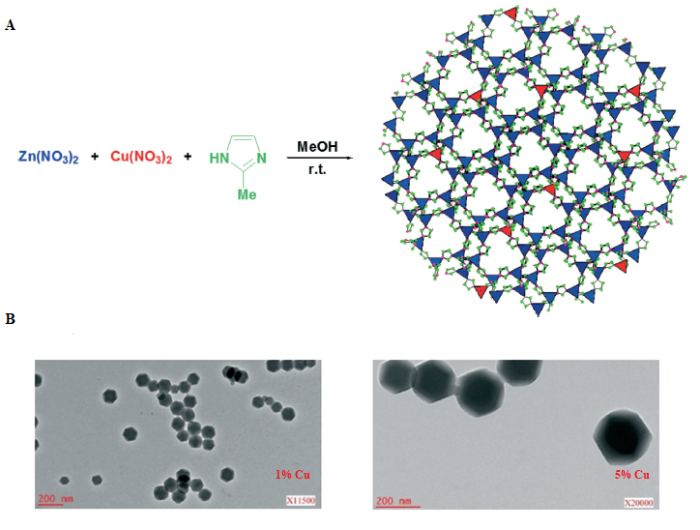
Figure 2-7. A) Schematic representation of Cu-doped ZIF-8 with random incorporation of a second metal; and B) TEM images of ZIF-8 crystals doped with 1% and 25% of Cu. Adapted from 50.

References

1. Stock N, Biswas S. Synthesis of metal-organic frameworks (MOFs): Routes to various MOF topologies, morphologies, and composites. Chem Rev. 2012;112(2):933-969. doi:10.1021/cr200304e
2. Ma J, Li J, Guo R, et al. Direct growth of flake-like metal-organic framework on textile carbon cloth as high-performance supercapacitor electrode. J Power Sources. 2019;428(February):124-130. doi:10.1016/j.jpowsour.2019.04.101
3. Arnold M, Kortunov P, Jones DJ, Nedellec Y, Kärger J, Caro J. Oriented crystallisation on supports and anisotropic mass transport of the metal-organic framework manganese formate. Eur J Inorg Chem. 2007;(1):60-64. doi:10.1002/ejic.200600698
4. Bux H, Liang F, Li Y, Cravillon J, Wiebcke M, Caro J. Zeolitic imidazolate framework membrane with molecular sieving properties by microwave-assisted solvothermal synthesis. J Am Chem Soc. 2009;131(44):16000-16001. doi:10.1021/ja907359t
5. Lu G, Hupp JT. Metal-organic frameworks as sensors: A ZIF-8 based fabry-pérot device as a selective sensor for chemical vapors and gases. J Am Chem Soc. 2010;132(23):7832-7833. doi:10.1021/ja101415b
6. Tu M, Wannapaiboon S, Khaletskaya K, Fischer RA. Engineering Zeolitic-Imidazolate Framework (ZIF) Thin Film Devices for Selective Detection of Volatile Organic Compounds. Adv Funct Mater. 2015;25(28):4470-4479. doi:10.1002/adfm.201500760
7. Falcaro P, Hill AJ, Nairn KM, et al. A new method to position and functionalize metal-organic framework crystals. Nat Commun. 2011;2(1). doi:10.1038/ncomms1234
8. Guo H, Zhu G, Hewitt IJ, Qiu S. Twin copper source" growth of metal-organic framework membrane: Cu3(BTC)2 with high permeability and selectivity for recycling H2. J Am Chem Soc. 2009;131(5):1646-1647. doi:10.1021/ja8074874
9. McCarthy MC, Varela-Guerrero V, Barnett G V., Jeong HK. Synthesis of zeolitic imidazolate framework films and membranes with controlled microstructures. Langmuir. 2010;26(18):14636-14641. doi:10.1021/la102409e
10. Hermes S, Schröder F, Chelmowski R, Wöll C, Fischer RA. Selective nucleation and growth of metal-organic open framework thin films on patterned COOH/CF3-terminated self-assembled monolayers on Au(111). J Am Chem Soc. 2005;127(40):13744-13745. doi:10.1021/ja053523l
11. Hermes S, Zacher D, Baunemann A, Wöll C, Fischer RA. Selective growth and MOCVD loading of small single crystals of MOF-5 at alumina and silica surfaces modified with organic self-assembled monolayers. Chem Mater. 2007;19(9):2168-2173. doi:10.1021/cm062854
12. Biemmi E, Scherb C, Bein T. Oriented growth of the metal organic framework Cu3(BTC) 2(H2O)3·xH2O tunable with functionalized self-assembled monolayers. J Am Chem Soc. 2007;129(26):8054-8055. doi:10.1021/ja0701208
13. Scherb C, Schödel A, Bein T. Directing the Structure of Metal–Organic Frameworks by Oriented Surface Growth on an Organic Monolayer. Angew Chemie. 2008;120(31):5861-5863. doi:10.1002/ange.200704034
14. Schoedel A, Scherb C, Bein T. Oriented Nanoscale Films of Metal-Organic Frameworks By Room-Temperature Gel-Layer Synthesis. Angew Chemie. 2010;122(40):7383-7386. doi:10.1002/ange.201001684
15. Kim J, Yun S, Lee SK. Cellulose smart material: Possibility and challenges. J Intell Mater Syst Struct. 2008;19(3):417-422. doi:10.1177/1045389X07083140
16. da Silva Pinto M, Sierra-Avila CA, Hinestroza JP. In situ synthesis of a Cu-BTC metal-organic framework (MOF 199) onto cellulosic fibrous substrates: Cotton. Cellulose. 2012;19(5):1771-1779. doi:10.1007/s10570-012-9752-y
17. Rodríguez HS, Hinestroza JP, Ochoa-Puentes C, Sierra CA, Soto CY. Antibacterial activity against Escherichia coli of Cu-BTC (MOF-199) metal-organic framework immobilized onto cellulosic fibers. J Appl Polym Sci. 2014;131(19):1-5. doi:10.1002/app.40815
18. Wang C, Qian X, An X. In situ green preparation and antibacterial activity of copper-based metal–organic frameworks/cellulose fibers (HKUST-1/CF) composite. Cellulose. 2015;22(6):3789-3797. doi:10.1007/s10570-015-0754-4
19. Yang Q, Zhang M, Song S, Yang B. Surface modification of PCC filled cellulose paper by MOF-5 (Zn3(BDC)2) metal–organic frameworks for use as soft gas adsorption composite materials. Cellulose. 2017;24(7):3051-3060. doi:10.1007/s10570-017-1331-9
20. Ma S, Zhang M, Nie J, Yang B, Song S, Lu P. Multifunctional cellulose-based air filters with high loadings of metal–organic frameworks prepared by in situ growth method for gas adsorption and antibacterial applications. Cellulose. 2018;25(10):5999-6010. doi:10.1007/s10570-018-1982-1
21. Mirkovic I, Lei L, Ljubic D, Zhu S. Crystal Growth of Metal-Organic Framework-5 around Cellulose-Based Fibers Having a Necklace Morphology. ACS Omega. 2019;4(1):169-175. doi:10.1021/acsomega.8b02332
22. Yang X, Xu Q. Bimetallic Metal-Organic Frameworks for Gas Storage and Separation. Cryst Growth Des. 2017;17(4):1450-1455. doi:10.1021/acs.cgd.7b00166
23. Chen L, Wang HF, Li C, Xu Q. Bimetallic metal-organic frameworks and their derivatives. Chem Sci. 2020;11(21):5369-5403. doi:10.1039/d0sc01432j
24. Yang J, Zhang F, Lu H, et al. Hollow Zn/Co ZIF Particles Derived from Core-Shell ZIF-67@ZIF-8 as Selective Catalyst for the Semi-Hydrogenation of Acetylene. Angew Chemie. 2015;127(37):11039-11043. doi:10.1002/ange.201504242
25. Botas JA, Calleja G, Sánchez-Sánchez M, Orcajo MG. Cobalt doping of the MOF-5 framework and its effect on gas-adsorption properties. Langmuir. 2010;26(8):5300-5303. doi:10.1021/la100423a
26. Z-scheme F, Yb N, O AS, Er Y. 美国科学院学报 Materials Chemistry A 材料化学 a. Published online 2017. doi:10.1039/c7ta07529d
27. Botas JA, Calleja G, Sánchez-Sánchez M, Orcajo MG. Effect of Zn/Co ratio in MOF-74 type materials containing exposed metal sites on their hydrogen adsorption behaviour and on their band gap energy. Int J Hydrogen Energy. 2011;36(17):10834-10844. doi:10.1016/j.ijhydene.2011.05.187
28. Yang H, He XW, Wang F, Kang Y, Zhang J. Doping copper into ZIF-67 for enhancing gas uptake capacity and visible-light-driven photocatalytic degradation of organic dye. J Mater Chem. 2012;22(41):21849-21851. doi:10.1039/c2jm35602c
29. Paquin F, Rivnay J, Salleo A, Stingelin N, Silva C. Multi-phase semicrystalline microstructures drive exciton dissociation in neat plastic semiconductors. J Mater Chem C. 2015;3:10715-10722. doi:10.1039/b000000x
30. Zhou Z, Mei L, Ma C, et al. A novel bimetallic MIL-101(Cr, Mg) with high CO2 adsorption capacity and CO2/N2 selectivity. Chem Eng Sci. 2016;147:109-117. doi:10.1016/j.ces.2016.03.035
31. Gomez IJ, Arnaiz B, Cacioppo M, Arcudi F, Prato M. Nitrogen-doped Carbon Nanodots for bioimaging and delivery of paclitaxel. J Mater Chem B. 2018;6(35). doi:10.1039/x0xx00000x
32. Huang XC, Lin YY, Zhang JP, Chen XM. Ligand-directed strategy for zeolite-type metal-organic frameworks: Zinc(II) imidazolates with unusual zeolitic topologies. Angew Chemie - Int Ed. 2006;45(10):1557-1559. doi:10.1002/anie.200503778
33. Park KS, Ni Z, Côté AP, et al. Exceptional chemical and thermal stability of zeolitic imidazolate frameworks. Proc Natl Acad Sci U S A. 2006;103(27):10186-10191. doi:10.1073/pnas.0602439103
34. Phan A, Doonan CJ, Uribe-Romo FJ, Knobler CB, Okeeffe M, Yaghi OM. Synthesis, structure, and carbon dioxide capture properties of zeolitic imidazolate frameworks. Acc Chem Res. 2010;43(1):58-67. doi:10.1021/ar900116g
35. Gómez-Álvarez P, Hamad S, Haranczyk M, Ruiz-Salvador AR, Calero S. Comparing gas separation performance between all known zeolites and their zeolitic imidazolate framework counterparts. Dalt Trans. 2016;45(1):216-225. doi:10.1039/c5dt04012d
36. Wang S, Yao W, Lin J, Ding Z, Wang X. Cobalt Imidazolate Metal-Organic Frameworks Photosplit CO 2 under Mild Reaction Conditions . Angew Chemie. 2014;126(4):1052-1056. doi:10.1002/ange.201309426
37. Chen R, Yao J, Gu Q, et al. A two-dimensional zeolitic imidazolate framework with a cushion-shaped cavity for CO2 adsorption. Chem Commun. 2013;49(82):9500-9502. doi:10.1039/c3cc44342f
38. Venna SR, Jasinski JB, Carreon MA. Structural evolution of zeolitic imidazolate framework-8. J Am Chem Soc. 2010;132(51):18030-18033. doi:10.1021/ja109268m
39. Tsai CW, Langner EHG. The effect of synthesis temperature on the particle size of nano-ZIF-8. Microporous Mesoporous Mater. 2016;221:8-13. doi:10.1016/j.micromeso.2015.08.041
40. Cravillon J, Münzer S, Lohmeier SJ, Feldhoff A, Huber K, Wiebcke M. Rapid room-temperature synthesis and characterization of nanocrystals of a prototypical zeolitic imidazolate framework. Chem Mater. 2009;21(8):1410-1412. doi:10.1021/cm900166h
41. Kaur G, Rai RK, Tyagi D, et al. Room-temperature synthesis of bimetallic Co-Zn based zeolitic imidazolate frameworks in water for enhanced CO2 and H2 uptakes. J Mater Chem A. 2016;4(39):14932-14938. doi:10.1039/c6ta04342a
42. Butova V V., Polyakov VA, Budnyk AP, et al. Zn/Co ZIF family: MW synthesis, characterization and stability upon halogen sorption. Polyhedron. 2018;154:457-464. doi:10.1016/j.poly.2018.08.006
43. Butova V V., Bulanova EA, Polyakov VA, et al. The effect of cobalt content in Zn/Co-ZIF-8 on iodine capping properties. Inorganica Chim Acta. 2019;492(April):18-22. doi:10.1016/j.ica.2019.04.011
44. Zareba JK, Nyk M, Samoć M. Co/ZIF-8 Heterometallic Nanoparticles: Control of Nanocrystal Size and Properties by a Mixed-Metal Approach. Cryst Growth Des. 2016;16(11):6419-6425. doi:10.1021/acs.cgd.6b01090
45. Saliba D, Ammar M, Rammal M, Al-Ghoul M, Hmadeh M. Crystal Growth of ZIF-8, ZIF-67, and Their Mixed-Metal Derivatives. J Am Chem Soc. 2018;140(5):1812-1823. doi:10.1021/jacs.7b11589
46. Tang J, Salunkhe RR, Zhang H, et al. Bimetallic metal-organic frameworks for controlled catalytic graphitization of nanoporous carbons. Sci Rep. 2016;6(April):3-4. doi:10.1038/srep30295
47. Zhou K, Mousavi B, Luo Z, Phatanasri S, Chaemchuen S, Verpoort F. Characterization and properties of Zn/Co zeolitic imidazolate frameworks vs. ZIF-8 and ZIF-67. J Mater Chem A. 2017;5(3):952-957. doi:10.1039/C6TA07860E
48. Li Y, Zhou K, He M, Yao J. Synthesis of ZIF-8 and ZIF-67 using mixed-base and their dye adsorption. Microporous Mesoporous Mater. 2016;234:287-292. doi:10.1016/j.micromeso.2016.07.039
49. Nandigama SK, Bheeram VR, Mukkamala SB. Rapid synthesis of mono/bimetallic (Zn/Co/Zn–Co) zeolitic imidazolate frameworks at room temperature and evolution of their CO 2 uptake capacity. Environ Chem Lett. 2019;17(1):447-454. doi:10.1007/s10311-018-0775-y
50. Schejn A, Aboulaich A, Balan L, et al. Cu2+-doped zeolitic imidazolate frameworks (ZIF-8): Efficient and stable catalysts for cycloadditions and condensation reactions. Catal Sci Technol. 2015;5(3):1829-1839. doi:10.1039/c4cy01505c
51. Nagarjun N, Dhakshinamoorthy A. A Cu-Doped ZIF-8 metal organic framework as a heterogeneous solid catalyst for aerobic oxidation of benzylic hydrocarbons. New J Chem. 2019;43(47):18702-18712. doi:10.1039/c9nj03698a
52. Thanh MT, Thien TV, Du PD, Hung NP, Khieu DQ. Iron doped zeolitic imidazolate framework (Fe-ZIF-8): synthesis and photocatalytic degradation of RDB dye in Fe-ZIF-8. J Porous Mater. 2018;25(3):857-869. doi:10.1007/s10934-017-0498-7

Chapter 3: Crystal growth of MOF-5 around cellulose-based fibres

having a necklace morphology
This chapter was published on ACS Omega, 2019, 4, 1, 169-175
(doi:10.1021/acsomega.8b02442.)

Abstract

Herein, MOF-5 crystals were grown on cellulose-based substrates including paper and cotton. Dopamine was used as a surface modification agent to improve the compatibility between MOF-5 crystals and the used substrates. The formed polydopamine film promoted the growth of MOF-5 crystals, which were bonded to the substrates. Besides dopamine, the structure of the substrate also played a major role in the crystal growth. In the case of paper, which had a structure with fibres closely packed to each other, MOF-5 crystals grew only on the surface of fibres (one side) and could easily fall off. Unlike paper, the cotton bulb had a looser structure and MOF-5 crystals grew around the fibres, forming a stable "necklace" morphology. The effects of dopamine modification on the crystal growth and the formation of "necklace" morphology were investigated using SEM analysis. The crystalline structure of MOF-5 was confirmed using XRD. To determine how firmly crystals were attached to the cotton fibres, the substrates were exposed to a constant and strong air flow. It was found that the dopamine-modified cotton increased the strength of MOF-5 crystal attached to fibres. This work demonstrates the firm attachment of MOF-5 crystals for the substrate which is important for the further application.

Introduction

Metal-organic frameworks (MOF) are a class of crystalline porous materials made by linking metal ions and organic ligands. Because of their well-defined structure and functionality, these porous materials have received a great research attention over the recent years.^{1–3} Their large and accessible surface area up to 7000 m² g⁻¹ is one of the most important characteristics.⁴ Tunable pore properties, various active sites, as well as thermal stability offer MOF materials potential applications for gas storage and separation,^{5,6} catalysis,^{7,8} and drug delivery systems.⁹ Applying MOF for filtration of toxic gases^{10,11} and for air purification has become a hot research topic because of the increasing global air pollution.^{12,13} Despite all the properties that MOFs possess, these materials are usually obtained as powders, and this form limits their applications. To overcome this, many methods to process MOF crystals into various structures were reported, i.e. MOF thin-films ¹⁴ and membranes.¹⁵ Recently it became more popular to grow MOF crystals of the surface of different fibres made by electrospinning process.^{16–19} Supporting MOF crystals onto commercially available, cost-effective and eco-friendly substrates provides an effective approach to expand their potential applications. One of the best candidates is cellulose-based substrates.
Cellulose is one of the widely used, renewable and natural polymers. Cellulose fibres, whiskers or cellulose nanocrystals have a broad range of applications in filtration, textile industry, biomedicine, and as reinforcing filler in adhesives.^{20,21,22} Good mechanical properties, low cost, abundance, good processability and easy recycling ensure their use in the fabrication of various composite materials. However, due to cellulose polar and hydrophilic nature, cellulose compatibility with nonpolar and hydrophobic materials is limited.²³ To improve adhesive properties of cellulose-based substrates and ensure the growth of MOF crystals, the surface must be modified.²⁴
Dopamine (DA) has been used as a surface modification agent for various substrates, and it is inspired by the chemistry of proteins in marine mussels.^{25–27} The ability of mussels to attract foreign objects is originated from proteins, which are rich in catechol groups from 3,4-dihydroxy-l-phenylalanine (DOPA) and lysine (amine) groups.^{28,29} The same functional groups can be found in small molecule dopamines which can polymerize under mild conditions and can be applied to almost all kinds of surfaces via amine and catechol functional groups.³⁰ Although the mechanism of DA self-polymerization into polydopamine (PDA) is complex and is yet to be understood,³¹ an effective surface modification can be achieved by simple treatment of substrates with buffered DA solution at ambient temperature. On the surface of treated substrates, a thin polymer film is formed and its thickness is a function of immersion time. Our group has reported the use of DA for surface modification of various substrates and the growth of MOF-5 thin films on PDA as a nucleation center.³² PDA coated onto the surface of substrates significantly promoted the growth of MOF-5 crystals, facilitating the attachment of MOF crystal seeds to the substrate surface. Except for the adhesive ability to attach MOF-5 crystals, catechol groups on polymerized DA can bind with metal ions and form a metal-catecholate coordination complex.^{28,33,34} This simple fabrication of MOF-5 films was accomplished by simply immersing substrates into a MOF-5 mother solution.
In this work, we report a facile method to grow MOF-5 crystals around cellulose-based fibres. The growth of MOF crystals on cellulose fibres by various methods have been reported in the literature. Deposition of HKUST-1 crystals on pulp fibres was reported through in situ synthesis of MOF in the presence of pulp fibres.³⁵ Different degrees of surface coverage were obtained depending on the chemical composition of fibres. Reynolds et al.³⁶ reported immobilization of CuBTC crystals on cotton substrates via functionalization of the cotton surface with carboxylate linkers and immersing the modified substrate in a MOF mother solution. It was demonstrated that the modification played a vital role in the coverage of the substrate surface. Hinestroza et al.³⁷ presented chemical attachment of MOF-199 onto cotton fibres. All these works showed that MOF crystals grow on the surface of cellulose-based substrates. However, to the best of our knowledge, there has been no report on a “necklace” morphology, that is, the growth of crystal around cotton fibres. MOF-5 crystals were firmly attached to the fibre, while the large surface of the crystals remains free.

Experimental Section

Materials: Zinc nitrate hexahydrate (Zn (NO₃)₂·6H₂O, 98 %), terephthalic acid (98%), dopamine hydrochloride, tris(hydroxymethyl) aminomethane (99.8 %) and dopamine hydrochloride were purchased from Sigma-Aldrich. N,N-dimethylformamide (DMF, 99.8 %) was purchased from Caledon, CA. All chemicals were used without further purification. Deionized water was used throughout all the experiments.
Two different substrates were used in the experiments: paper strips and cotton bulbs. The paper was coffee filter paper (GK ConnaisseurTM 03-2644637 from Dollarama in CA). Commercially available cotton balls made for medical uses were used.
Substrate modification: Paper was cut into rectangular strips, and cotton was washed with acetone and dried at room temperature. Dopamine (DA) solution was made by dissolving dopamine hydrochloride in 200 mL tris (hydroxymethyl) aminomethane (Tris) aqueous solution (10 mM). The amounts of dopamine dissolved in 200mL of Tris were 400 mg and 1000 mg. The substrates were immersed in the two dopamine solutions having different concentration and left at room temperature for 24 h. The modified paper and cotton were washed with deionized water and ethanol three times to remove residual dopamine and dried in a vacuum oven at 65ºC for 24 h. To compare how MOF-5 crystals were attached to substrates without PDA, pristine paper and cotton were used. The paper strips and cotton bulbs were only washed with acetone and dried at room temperature.
Preparation of MOF-5 mother solution: MOF-5 mother solution was prepared as follows. First, 4.239 g of Zn (NO₃)₂·6H₂O and 0.9072 g terephthalic acid were dissolved in 135 mL of DMF. Transparent mother solution was then heated to 65ºC and kept for 48h. After temperature was raised to 105ºC, the mother solution was left for additional 72 hours at this temperature. Mother solution stayed transparent where generated MOF crystals were settled at the bottom of the beaker (Figure S3-1A, Supporting Information). MOF-5 crystals were cooled down to room temperature, washed with DMF and dried in vacuo at 65ºC
Preparation of MOF@Paper structures: The modified paper was immersed in the MOF-5 mother solution and remained for three days at 65ºC. After that, the sample was rinsed with DMF and dried in vacuo at 65ºC.
Preparation of MOF@Cotton structures: The modified cotton was immersed in MOF-5 mother solution and kept in the mother solution for three days. In one set of experiments, the temperature was 65ºC, while in the other it was increased to 105 ºC and left for 72 hours. Prepared MOF crystals were attached for the cotton bulb (Figure S3-1B, Supporting Information) and mother solution stayed transparent. All samples were washed with DMF and dried in vacuo at 65ºC.
Characterization: JEOL JSM 7000 Scanning Electronic Microscopy (SEM) was used to characterize morphologies of the obtained structures. FTIR characterization was done on Thermal NICOLET 6700. Samples were scanned for 64 times and spectra were obtained with wavelengths from 4000 cm⁻¹ to 500 cm⁻¹. Gas sorption date were collected using Quantachrome Instrument (v 5.2) at 77 K measuring nitrogen adsorption. Samples were previously degassed for 24h at 393 K. TGA was performed using Mettler TGA/DSC 3+ Thermogravimetric Analyzer. Thermograms were recorded at a heating rate of 10ºC/min between 37 and 600ºC in a flow of argon at 20 mL/min. X‐ray diffraction (XRD) of MOF@Substrate structures was carried out on Bruker D8 Advance Powder Diffractometer with a scan speed of 1° min⁻¹, a step size of 0.01°, and a 2θ range of 2–45°.
Stability test: To investigate the stability of MOF@Cotton structures, the structures were exposed to a constant airflow at 18L/min, three times for twenty seconds until a constant mass was reached (Supporting Information, Table S3-1). The present of the saved mass was calculated using the following equation:

$P=\frac{m_{1}(MOF@Cotton)}{m(MOF@Cotton)}*100, \%$ (1)
where m (MOF@Cotton) was the mass of structures before air blow, m₁ (MOF@Cotton) was the mass of structures after exposure to air flow 3x20 s.

Results and Discussion

Two commercially available cellulose-based substrates, namely, paper strips (paper) and cotton bulks (cotton), were treated with DA to modify the surface of the substrates and to ensure adhesion of the MOF-5 crystals. MOF-5, as one of the most studied MOFs, was chosen for the crystal growth onto the substrates due to its thermal stability and large and accessible surface area.^{38,39} This isoreticular MOF (IRMOF) is inexpensive and easy to synthesize in various ways.^{38,40,41} The structure of modified cellulose substrates has a significant effect on the attachment of MOF-5 crystals nurtured from a mother solution to the fibres. It was found that MOF-5 crystals could grow only on the paper surface (one side of the paper substrate) and were easy to fall detached, while in the case of cotton, stable crystalline structures around individual fibres were formed. Apart from the substrate structure, the influences of DA solution concentration and MOF-5 nurture temperature on the crystal growth and morphology were studied. The morphology of MOF-5@Substrate structures was investigated using Scanning Electron Microscopy (SEM), and the crystal structure of MOF-5 was confirmed by X-ray diffraction (XRD). Quantitative measurements were performed to determine how firmly MOF-5 crystals were attached to the cellulose-based fibres.
The fabrication of MOF-5@Substrate structures is schematically represented in Figure 3-1. For simplicity, the schematic displays fabrication steps using the cotton bulbs (Figure 3-1A) and the same procedure was applied to the paper strips. The first step was a substrate modification by DA hydrochloride solutions of two different concentrations (Figure 3-1B). The DA solutions were prepared by dissolving DA hydrochloride in 200 mL tris (hydroxymethyl) aminomethane (Tris) aqueous solution (10 mM). The prepared concentrations of DA in Tris were 2 mg/mL and 5 mg/mL. Cotton bulbs were treated with DA solution for 24 h at room temperature. Upon treatment, the modified bulbs were dried in vacuo at 65ºC for 24h (Figure 3-1C). For control experiments, non-modified substrates were used after being rinsed with acetone and dried at room temperature. An obvious difference in observation of the substrates, treated with and without DA, was the change of their color from white to dark gray (Figure S3-1C, Supporting Information). This change in color indicated that polydopamine (PDA) was formed and coated the cellulose-based substrates.⁴²

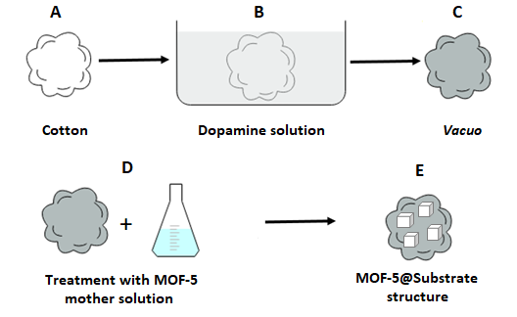
Figure 3-1. Schematic representation illustrating the steps involved in the MOF-5@Substrate preparation, taking cotton bulbs as an example. (A) Pristine cotton bulb, (B) treatment with DA solution, (C) modified cotton bulb (grey color represents a color change of the substrate upon treatment with DA), (D) treatment with MOF-5 mother solution, and (E) cotton bulb with MOF-5 crystals.

In the next step, we prepared MOF-5 mother solution through a straightforward method, using the recipe reported by Fisher at al.⁴³ Zinc nitrate hexahydrate and terephthalic acid were dissolved in dimethylformamide (DMF). The final step was the growth of MOF-5 crystals onto paper and cotton substrates (Figure S3-2A, S2B respectively). The substrates were immersed in MOF-5 mother solutions and kept for three days, at 65ºC (Figure 3-1D). To investigate the temperature effect on the crystal growth, another set of substrates was kept in MOF-5 mother solution at 105ºC. In both cases, the prepared samples were rinsed with DMF and dried in vacuo at 65ºC for 24 h, after which MOF-5 crystals could be observed on the substrates by the naked eyes (Figure 3-1E).
The effect of DA solution concentration on MOF-5 crystal growth and their binding to the substrate were investigated. The results showed that the pristine paper substrate (no DA) treated with MOF-5 mother solution (Figure 3-2A), was almost free of MOF-5 crystals, i.e. very few crystals were formed on the paper surface. On the other hand, the DA-modified paper substrate was densely covered with MOF-5 crystals of more than 100 µm in size, as it can be seen by the SEM image in Figure 3-2B. The modification with DA and consequently formed PDA clearly improved compatibility of the paper substrates with MOF-5, which promoted the crystal growth. The hydrophilic character of cellulose was reduced by reaction between hydroxyl groups on the surface and catechol groups of DA. The formed PDA layer on the surface of substrates also became a nucleation site of MOF-5 crystals. Although DA contributed to the greater coverage of the paper surfaces, it was difficult, if not impossible, to grow MOF-5 crystals around fibres of the cellulose paper, due to space limitation effects. The paper substrate had a dense structure where fibres were close to each other and crystals could not grow within the fibres. Consequently, MOF-5 crystals could easily fall off the paper substrates, regardless of the modification with DA. In contrast, the experiments performed with the cotton bulbs gave a very different morphology. The loose fibrous structure of the cotton bulbs proved to be a better choice for the nucleation and growth of MOF-5 crystals.

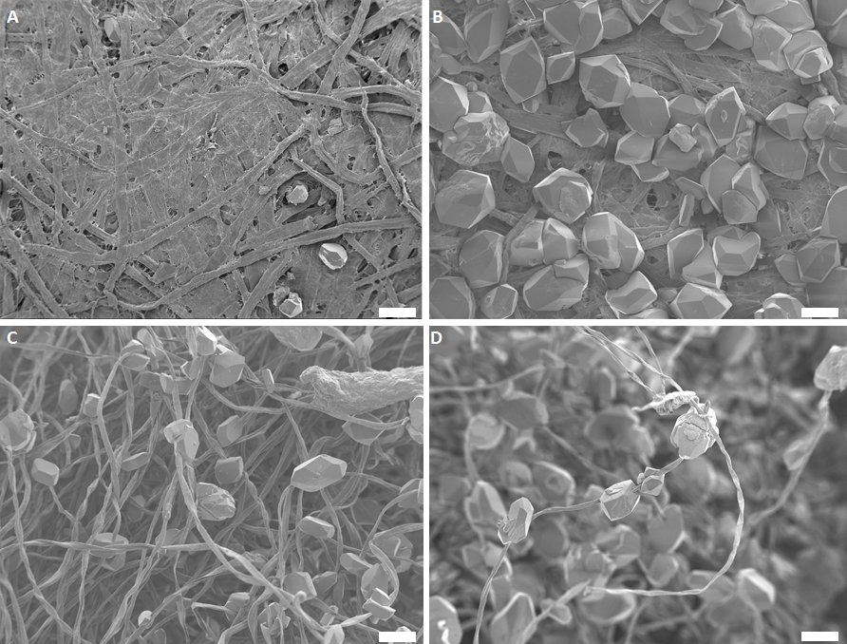
Figure 3-2. SEM images of MOF-5@Substrate (temperature of the crystal growth was 65°C). (A) MOF-5 crystals on the pristine paper (no DA), (B) MOF-5 crystals on the paper modified with DA, and (C) MOF-5 growing around cotton fibres (D) “necklace” morphology (scale bar 100 µm).

Unlike the crystals that grew only on fibres at the paper surface, the crystals grown on fibres of the cotton bulb (inside-out of the bulb) wrapped the fibres, forming a unique morphology with the crystals firmly attached to the fibres (Figure 3-2C). To the best of our knowledge, there has been no work reported on growing MOF crystals around cotton fibres. The MOF-5 crystals were stringed by the cotton fibres as a MOF-5 “necklace” (Figure 3-2D). In both cases, the truncated cubic shape of the crystals was formed at 65°C. This MOF-5 was made of dicarboxylic linkers and metal ions that together created a three-dimensional cubic unit cell. In general, the crystal shape is related to its internal structure,⁴⁴ it is a reflection of the unit cell shape, and thus the shape of MOF-5 crystals was expected to be cubic. All the crystals formed had the same truncated cubic shape.
To examine how temperature affects the crystal shape, another set of experiments were performed, in which the substrates were kept in the mother solution for three days at 105ºC. As a substrate in this set of MOF-5 growth, only cotton bulbs were used because it was proven that the crystals could be firmly attached to the fibres. The crystal shape could be controlled by changing the synthesis conditions.⁴⁵ In this case, an increase of temperature led to a change of MOF-5 crystal shape. It is evident in Figure 3-3 that the resulting MOF-5 crystals have the expected cubic shape. SEM analysis proved once again the importance of substrate modification with DA solution. The unmodified cotton bulbs (Figure 3-3A) were much less covered with MOF-5 crystals than the DA-modified substrates (Figure 3-3B, C, and D). The formed PDA film on the surface of fibres provided more nucleation sites for MOF-5 crystals, due to interactions of catechol groups of DA with metal ions of MOF-5. A better coverage of substrates with MOF-5 crystals was achieved. Moreover, as a result of having more nucleation sites on the surface of the fibres, smaller crystals were formed with a size of less than 100 µm. MOF-5 crystals on the DA-modified fibers were found to be more uniform in size than those grown on the unmodified cotton fibers, which had a size larger than 100µm. Once again, the “necklace” morphology was confirmed with the crystals wrapping cotton fibres, as it can be clearly seen from Figure 3-3D, with the red arrows pointing out to the fibres penetrating through the crystals.

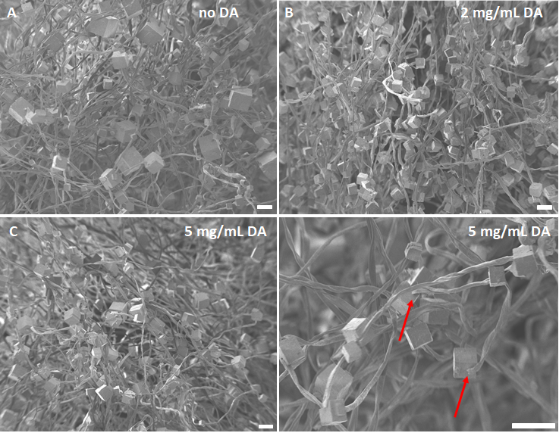
Figure 3-3. SEM images of MOF-5@Cotton structures obtained at 105°C. (A) Unmodified cotton bulbs, (B) bulbs treated with 2 mg/mL DA solution, (C) substrates modified with 5 mg/mL DA solution and (D) “necklace” morphology (scale bar 100 µm).

ATR-FTIR spectra of pristine cotton, cotton modified with PDA and MOF-5@Cotton substrates are shown in Figure 3-4. Polydopamine and cellulose in their structure have similar spectra and bands observed between 3300 cm⁻¹-3400 cm⁻¹ can be assigned to not only -OH group stretching modes but also to -NH from polydopamine. The presence of the quinine group that exists in polydopamine can be confirmed with the peak at 1720 cm⁻¹ that appears in the case of DA modified cotton with and without MOF-5 crystals. Furthermore, spectrum for the DA modified cotton shows broad and weak signal around 1600 cm⁻¹ and it is assigned to -C=C stretching modes. ^{46,47} However, in the case when MOF-5 grows around the fibres the presence of strong peaks around 1390 cm⁻¹ and 1600 cm⁻¹ are assigned to the existence of organic linker which is in the case of MOF-5 terephthalic acid. ⁴⁸

Figure 3-4. FTIR spectra of pristine cotton, cotton modified in DA solution and
MOF-5@Cotton structure obtained at 105°C

XRD was used to confirm the crystal structure of pristine MOF-5 crystals and MOF-5 crystals grown on the DA-modified and unmodified cotton at 105°C. Unlike XRD patterns of MOF-5 truncated cubic crystals grown at 65°C (Figure S3-3), Figure 3-5 shows a typical diffractogram of MOF-5 crystals as previously reported by Yaghi et al.³⁸ All the characteristic peaks were identified confirming the cubic shape of MOF-5 crystals observed in SEM analyses in Figure 3-5, as well as its crystallinity due to sharp diffraction peaks. Furthermore, the modification of cotton bulbs with DA did not affect the crystal structure of MOF-5, which could be observed by contrasting XRD patterns in Figures 3-5.

Figure 3-5. XRD patterns of MOF-5 crystals and MOF-5 crystals grown on modified and unmodified cotton bulbs at 105°C.

The pore properties of both MOF-5 and MOF-5@Cotton samples were analyzed using nitrogen physisorption at 77K. Figure 3-6 shows adsorption and desorption isotherms of the pristine MOF-5 and MOF-5@Cotton. The measurements showed Type I isotherm for both samples with a characteristic sharp increase for low relative pressure (Figure S3-4, Supporting Information). Even though the N₂ adsorption slightly decreased, in the case of MOF-5@Cotton sample kept high porosity. Specific area when structures are synthesized in this way is 658.04 m²/g for MOF-5 crystals, while for MOF-5@Cotton structure is 611.71 m²/g
Figure 3-6. N₂ sorption isotherms for MOF-5 and MOF-5@Cotton samples at 77K. The solid symbols represent adsorption while open symbols represent desorption.

MOF crystals have been studied for various environmental applications.^{49,50} Combined with cellulose fibres those structures would have certain advantages because of their green nature and low-cost. However, there must be a strong attachment of MOF crystals on the substrate. In this work, we demonstrated that it is possible to bind MOF-5 crystals and cellulose fibres. However, how strong MOF-5 crystals were attached to cellulose fibres could be questioned. We quantitatively determined their strength by exposing MOF-5@Cotton samples to a constant air blow, 18L/min, three times for twenty seconds, or until a constant mass was reached (Figure 3-7A). The mass of MOF-5@Cotton structure was measured before and after the air blow. The percentage of MOF-5 crystals remaining attached to the fibres was calculated using the equation given in the experimental part.

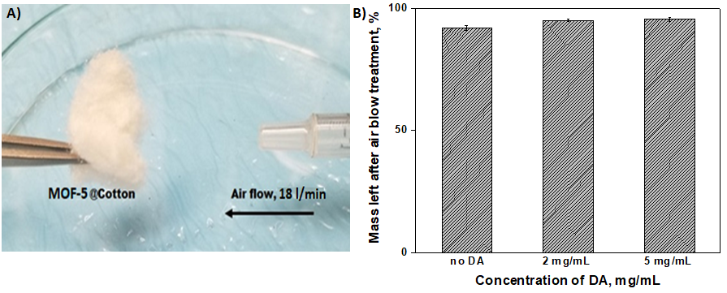
Figure 3-7. (A) Exposing MOF-5@Cotton structure to a constant air flow in order to determine the stability of fabricated structures, (B) Stability of MOF-5@Cotton structures as a function of DA solution concentration

The fabricated MOF-5@Cotton structure proved to be quite resistant to the air blow effect and the “necklace” morphology increased the stability of the MOF crystals stringed on the fibres. Figure 3-7B compares the results for cotton substrates modified and unmodified with two different DA concentrations. The percentage of MOF-5 crystals remaining attached to the unmodified cotton substrates was 91.9% ± 1.1%. For the substrate treated with 2 mg/mL of DA solution, this number was 94.8% ± 0.6%, while for 5 mg/mL, it was 96% ± 1.1%, which clearly indicated that DA improved the attachment of MOF-5 to the cotton fibres.
The TGA curves of cotton, MOF-5 and MOF-5@Cotton structures are shown in Figure 3-8. Major weight loss in the case of pure cotton occurred between 180 and 430ºC due to decomposition of cellulose as main component of cotton. Thermogram for pristine MOF-5 reveals its typical degradation mechanism with two weight losses. The first weight loss (5.51%) occurs because of solvent evaporation, while degradation of metal-organic framework starts around 400ºC. Finally, for MOF-5@Cotton sample the first weigh loss can be attributed not only to the evaporation of solvent (DMF) which was used for synthesis of MOF-5 but also to the evaporation of adsorbed moisture in cotton fibres. Every additional weight loss before 430ºC is attributed to the degradation of cotton fibres and this is consistent with results for pure cotton. Decomposition of framework caused the final weight loss and it started after 430 ºC.^{51–53} Amount of char that was formed during thermal degradation was used to quantitatively determine amount of MOF-5 incorporated. The char yield of pure cellulose at 600ºC was 11.3% while in the case of MOF-5@Cotton structures number increased to 35.7% and we can say that this structures have 24.4% MOF-5 by mass.

Figure 3-8. TGA thermogram of representative MOF-5@Cotton sample.

Conclusion

In summary, a facile method to attach MOF-5 crystals to cellulose-based fibres and to fabricate stable morphologies is demonstrated. Paper and cotton fibres have been used in the experiments. In both substrates, dopamine was used as a surface modification agent, which promoted the growth of crystals. The surface was modified by simply immersing substrates in a dopamine solution. An important difference between the two substrates was in the way of crystals growth. Because of the dense structure of the paper, MOF-5 crystals could grow only on the surface of the substrate. In contrast, in the case of cotton substrates, the crystals grew throughout the whole body of a cotton bulb and were firmly attached to the fibres. MOF-5 crystals could grow around the surface of individual cellulose fibres, generating a stable “necklace” morphology. In this way, MOF-5 crystals were firmly attached to the fibres, which is desired in many applications. Apart from the structure of the used substrates, surface modification of the substrates with DA played a major role in the crystal growth. No matter what kind of substrate was used, all the experiments showed that after DA modification, more crystals grew on the surface. The obtained MOF-5@Cotton structure showed excellent stability when they were exposed to air blow as an external influence, due to the strong attachment of the crystals and fibres.

Acknowledgments

The authors sincerely acknowledge the Natural Science and Engineering Research Council (NSERC) (RGPIN-2015-05841) of Canada for supporting this research through Discovery Grant Program.

References

1. Furukawa, H., Cordova, K. E., O’Keeffe, M. & Yaghi, O. M. The Chemistry and Applications of Metal-Organic Frameworks. Science 9, 1230444 (2010).
2. Li, H., Eddaoudi, M., O’Keeffe, M. & Yaghi, O. M. Design and synthesis of an exceptionally stable and highly porous metal-organic framework. Nature 402, 276–279 (1999).
3. Yaghi, O. M. & Li, H. Hydrothermal Synthesis of a Metal-Organic Framework Containing Large Rectangular Channels. J. Am. Chem. Soc. 117, 10401–10402 (1995).
4. Senkovska, I. & Kaskel, S. Ultrahigh porosity in mesoporous MOFs: promises and limitations. Chem. Commun. 50, 7089 (2014).
5. Millward, A. R. & Yaghi, O. M. Metal Organic Frameworks with Exceptionally High Capacity for Storage of Carbon Dioxide at Room Temperature. J. Am. Chem. Soc. 127, 17998–17999 (2005).
6. Wang, X., Xie, L., Huang, K.-W. & Lai, Z. A rationally designed amino-borane complex in a metal organic framework: a novel reusable hydrogen storage and size-selective reduction material. Chem. Commun. 51, 7610–7613 (2015).
7. Mondloch, J. E., Katz, M.J., Isley, W.C., Ghosh, P., Liao, P., Bury, W., Wagner, G.W., Hall, M.G., DeCoste, J.B., Peterson, G.W., Snurr, R.Q., Cramer, C.J., Hupp, J.T. & Karha, O.K. Destruction of chemical warfare agents using metal–organic frameworks. Nat. Mater. 14, 512–516 (2015).
8. Katz, M.J., Moon, S.Y., Mondloch, J.E., Beyzavi, M.H., Stephenson, C.J., Hupp J.T. & Farha O.K. Exploiting parameter space in MOFs: a 20-fold enhancement of phosphate-ester hydrolysis with UiO-66-NH ₂. Chem. Sci. 6, 2286–2291 (2015).
9. Horcajada, P., Chalati, T., Serre, C., Gillet, B., Sebrie, C., Baati, T., Eubank, J.F., Heurtaux, D., Clayette, P., Kreuz, C., Chang, J.S., Hwang,Y.K., Marsaud, V., Bories, P.N., Cynober, L., Gil, S., Férey, G., Couvreur, P. & Gref, R. Porous metal-organic-framework nanoscale carriers as a potential platform for drug delivery and imaging. Nat. Mater. 9, 172–178 (2010).
10. Barea, E., Montoro, C. & Navarro, J. A. R. Toxic gas removal – metal–organic frameworks for the capture and degradation of toxic gases and vapours. Chem. Soc. Rev. 43, 5419–5430 (2014).
11. Decoste, J. B. & Peterson, G. W. Metal-organic frameworks for air purification of toxic chemicals. Chem. Rev. 114, 5695–5727 (2014).
12. Zhang, Y., Yuan, S., Feng, X., Li, H., Zhou, J. & Wang, B. Preparation of Nano fibrous Metal − Organic Framework Filters for Efficient Air Pollution Control, J. Am. Chem. Soc. 138, 18, 5785-5788 (2016).
13. Chen, Y., Zhang, S., Cao, S., Li, S., Chen, F., Yuan, S., Xu, C., Zhou, J., Feng, X., Ma, X. & Wang, B. Roll-to-Roll Production of Metal-Organic Framework Coatings for Particulate Matter Removal. Adv. Mater. 29, 4–9 (2017).
14. Zhu, H., Yang, X., Cranston, E. D. & Zhu, S. Flexible and Porous Nanocellulose Aerogels with High Loadings of Metal-Organic-Framework Particles for Separations Applications. Adv. Mater. 28, 7652–7657 (2016).
15. Liu, D., Ma, X., Xi, H. & Lin, Y. S. Gas transport properties and propylene/propane separation characteristics of ZIF-8 membranes. J. Memb. Sci. 451, 85–93 (2014).
16. Lee, D. T., Zhao, J., Peterson, G. W. & Parsons, G. N. Catalytic ‘mOF-Cloth’ Formed via Directed Supramolecular Assembly of UiO-66-NH2Crystals on Atomic Layer Deposition-Coated Textiles for Rapid Degradation of Chemical Warfare Agent Simulants. Chem. Mater. 29, 4894–4903 (2017).
17. Lu, A. X., Ploskonka, A. M., Tovar, T. M., Peterson, G. W. & Decoste, J. B. Direct Surface Growth of UIO-66-NH2on Polyacrylonitrile Nanofibers for Efficient Toxic Chemical Removal. Ind. Eng. Chem. Res. 56, 14502–14506 (2017).
18. Lu, A. X., McEntee M., Browe M.A., Hall M.G., DeCoste J.B & Peterson G.W. MOFabric: Electrospun Nanofiber Mats from PVDF/UiO-66-NH2for Chemical Protection and Decontamination. ACS Appl. Mater. Interfaces 9, 13632–13636 (2017).
19. Zhao, J., Lee D.T., Yaga R.W., Hall M.G, Barton H.F, Woodward I.R., Oldham C.J., Walls H.J., Peterson G.W. & Parsons G.N. Ultra-Fast Degradation of Chemical Warfare Agents Using MOF–Nanofiber Kebabs. Angew. Chemie - Int. Ed. 55, 13224–13228 (2016).
20. Kim, J., Yun, S. & Ounaies, Z. Discovery of cellulose as a smart material. Macromolecules 39, 4202–4206 (2006).
21. Potulski, D. C., De Muniz, G. I. B., Klock, U. & De Andrade, A. S. Influência da incorporação de celulose microfibrilada nas propriedades de resistência mecânicas do papel. Sci. For. Sci. 40, 345–351 (2014).
22. Kumar, V. & Kumari, M. Processing and characterization of natural cellulose fibers / thermoset polymer composites. Carbohydr. Polym. 109, 102–117 (2014).
23. Gu, Y. & Huang, J. Fabrication of natural cellulose substance derived hierarchical polymeric materials †. 3764–3770 (2009). doi:10.1039/b900450p
24. Abdelmouleh, M., Boufi, S., Salah, A., Belgacem, M. N. & Gandini, A. Interaction of Silane Coupling Agents with Cellulose. 3203–3208 (2002).
25. Wei, Q. et al. Improving the blood compatibility of material surfaces via biomolecule-immobilized mussel-inspired coatings. J. Biomed. Mater. Res. - Part A 96 A, 38–45 (2011).
26. Yang, S. H., Kang, S.M., Lee, K-B., Chung, T.D., Lee, H. & Choi, I.S. Mussel-inspired encapsulation and functionalization of individual yeast cells. J. Am. Chem. Soc. 133, 2795–2797 (2011).
27. Ku, S. H., Lee, J. S. & Park, C. B. Spatial control of cell adhesion and patterning through mussel-inspired surface modification by polydopamine. Langmuir 26, 15104–15108 (2010).

28. Yu, M., Hwang, J., & Deming, T.J. Role of l-3,4-Dihydroxyphenylalanine in Mussel

Adhesive Proteins J. Am. Chem. Soc. 121, 24, 5825-5826
29. Ding, Y. H., Floren, M. & Tan, W. Mussel-inspired polydopamine for bio-surface functionalization. Biosurface and Biotribology 2, 121–136 (2016).
30. Lee, H., Dellatore, S. M., Miller, W. M. & Messersmith, P. B. a m Hl tm Mussel-Inspired for Multifunctional Surface. Science (80-. ). 318, 426–430 (2007).
31. Dreyer, D. R., Miller, D. J., Freeman, B. D., Paul, D. R. & Bielawski, C. W. Elucidating the structure of poly(dopamine). Langmuir 28, 6428–6435 (2012).
32. Zhu, H. & Zhu, S. A versatile and facile surface modification route based on polydopamine for the growth of MOF films on different substrates. Can. J. Chem. Eng. 93, 63–67 (2015).
33. Xu, Z. Mechanics of metal-catecholate complexes: The roles of coordination state and metal types. Sci. Rep. 3, 7–9 (2013).
34. Zhou, M., Li, J., Zhang, M., Wang, H., Lan, Y., Wu, Y., Li, F. & Li, G. A polydopamine layer as the nucleation center of MOF deposition on ‘inert’ polymer surfaces to fabricate hierarchically structured porous films. Chem. Commun. 51, 2706–2709 (2015).
35. Küsgens, P., Siegle, S. & Kaskel, S. Crystal Growth of the Metal-Organic Framework Cu ₃ (BTC) ₂ on the Surface of Pulp Fibers. Adv. Eng. Mater. 11, 93–95 (2009).
36. Neufeld, M. J., Harding, J. L. & Reynolds, M. M. Immobilization of Metal-Organic Framework Copper(II) Benzene-1,3,5-tricarboxylate (CuBTC) onto Cotton Fabric as a Nitric Oxide Release Catalyst. ACS Appl. Mater. Interfaces 7, 26742–26750 (2015).
37. da Silva Pinto, M., Sierra-Avila, C. A. & Hinestroza, J. P. In situ synthesis of a Cu-BTC metal-organic framework (MOF 199) onto cellulosic fibrous substrates: Cotton. Cellulose 19, 1771–1779 (2012).
38. Li, H., Eddaoudi, M., O’Keeffe, M. & Yaghi, O. M. Design and synthesis of an exceptionally stable and highly porous metal-organic framework. 402, 276–279 (1999).
39. Bloch, E. D. et al. Hydrogen Storage in Microporous Metal-Organic Frameworks. Science (80-. ). 335, 1606–1610 (2012).
40. Son, W.-J., Kim, J., Kim, J. & Ahn, W.-S. Sonochemical synthesis of MOF-5. Chem. Commun. 6336 (2008).
41. Tranchemontagne, D. J., Hunt, J. R. & Yaghi, O. M. Room temperature synthesis of metal-organic frameworks: MOF-5, MOF-74, MOF-177, MOF-199, and IRMOF-0. Tetrahedron 64, 8553–8557 (2008).
42. Ye, C., Wu, Y. & Wang, Z. Modification of cellulose paper with polydopamine as a thin film microextraction phase for detection of nitrophenols in oil samples. RSC Adv. 6, 9066–9071 (2016).
43. Hermes, S., Zacher, D., Baunemann, A., Wöll, C. & Fischer, R. A. Selective growth and MOCVD loading of small single crystals of MOF-5 at alumina and silica surfaces modified with organic self-assembled monolayers. Chem. Mater. 19, 2168–2173 (2007).
44. Dhanaraj, G., Byrappa, K., Prasad, V. & Dudley, M. Crystal Growth Techniques and Characterization: An Overview. Springer Handb. Cryst. Growth 3–16 (2010).
45. Seoane, B., Castellanos, S., Dikhtiarenko, A., Kapteijn, F. & Gascon, J. Multi-scale crystal engineering of metal organic frameworks. Coord. Chem. Rev. (2015).
46. Chung, C., Lee, M. & Choe, E. K. Characterization of cotton fabric scouring by FT-IR ATR spectroscopy. Carbohydr. Polym. 58, 417–420 (2004).
47. Zangmeister, R. A., Morris, T. A. & Tarlov, M. J. Characterization of polydopamine thin films deposited at short times by autoxidation of dopamine. Langmuir 29, 8619–8628 (2013).
48. Song, J., Zhang, B., Jiang, T., Yang, G. & Han, B. Synthesis of cyclic carbonates and dimethyl carbonate using CO2as a building block catalyzed by MOF-5/KI and MOF-5/KI/K2CO3. Front. Chem. China 6, 21–30 (2011).
49. Torad, N. L., Hu M., Ishihara S., Sukegawa H., Belik A.A., Imura M., Ariga K., Sakka Y. & Yamauchi Y. Direct synthesis of MOF-derived nanoporous carbon with magnetic Co nanoparticles toward efficient water treatment. Small 10, 2096–2107 (2014).
50. Cao, S. W. & Zhu, Y. J. Hierarchically nanostructured α-Fe2O3 hollow spheres: Preparation, growth mechanism, photocatalytic property, and application in water treatment. J. Phys. Chem. C 112, 6253–6257 (2008).
51. Hafizovic, J. et al. The inconsistency in adsorption properties and powder XRD data of MOF-5 is rationalized by framework interpenetration and the presence of organic and inorganic species in the nanocavities. J. Am. Chem. Soc. 129, 3612–3620 (2007).
52. Abidi, N. Hequet, E., Thermogravimetric analysis of cotton fibers: Relationships with maturity and fineness. Appl. Polym. Sci. 103, 3476–3482 (2007).
53. Perez, E. V., Balkus, K. J., Ferraris, J. P. & Musselman, I. H. Mixed-matrix membranes containing MOF-5 for gas separations. J. Memb. Sci. 328, 165–173 (2009).

Supporting Information

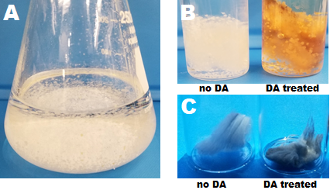
Figure S3-1. Digital photographs of (A) MOF-5 crystals formed in the solution, (B) MOF-5 crystals attached on pure cotton and DA treated cotton and (C) cotton bulbs before and after dopamine treatment.
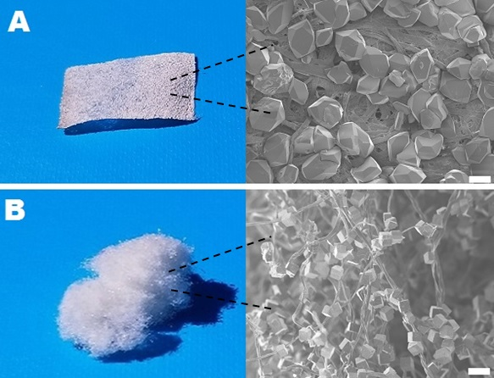
Figure S3-2. Digital photographs and SEM images of the cellulose-based substrates with MOF-5 crystals. A) MOF-5@Paper, B) MOF-5@Cotton. Scale bar 100µm.

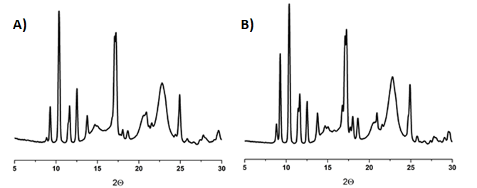
Figure S3-3. X-ray diffraction patterns of the MOF-5@Cotton structure when the temperature was 65°C. (A) DA modified substrate (B) Unmodified substrate
Figure S3-4. N₂ sorption isotherms for MOF-5 and MOF-5@Cotton samples at 77K for low pressure.

Table S3-1. Results obtained by stability test of the modified and unmodified cotton substrates treated with MOF-5 mother solution

Concentration of DA solution | m(Cotton+MOF-5), g | m₁(Cotton+MOF-5), g | MOF-5 left, %
 | 0.1151 | 0.1058 | 91.92
No DA | 0.0993 | 0.0902 | 90.84
 | 0.1278 | 0.1188 | 92.96
 | 0.0816 | 0.077 | 94.36
2 mg/mL | 0.0984 | 0.0933 | 94.82
 | 0.0612 | 0.0584 | 95.42
 | 0.1135 | 0.1073 | 94.54
5 mg/mL | 0.1085 | 0.1042 | 96.04
 | 0.0954 | 0.0916 | 96.02

Chapter 4: Characterization and properties of Cu_{x}ZIF-8 zeolitic imidazolate framework

Abstract

We report here as a synthesis of bimetallic zeolitic imidazolate framework Cu_{x}ZIF-8 in aqueous solution. The crystals were prepared by mixing 2-methylimidazole (HmIm) and Zn acetate or mixture of Zn acetate and Cu acetate in deionized water at room temperature. We focused on the influence of the addition of Cu (II) and its incorporation into framework. Scanning electron microscopy and transmission electron microscopy showed that both ZIF-8, Cu₂₅ZIF-8 and Cu₅₀ZIF-8 particles were truncated rhombic dodecahedron and rhombic dodecahedron shaped which is a typical shape of ZIF-8 particles. EDS analysis gave a confirmation that Cu (II) is incorporated in the framework. Moreover, X-ray diffraction showed characteristic patterns for ZIF-8 and they were also present in Cu₂₅ZIF-8 and Cu₅₀ZIF-8 samples which indicated that sodalite type structure was preserved even with a high loading of Cu. This was a great improvement considering that so far collapse of the framework was reported at the lower amounts of Cu (II).

Introduction

Porous crystalline hybrid materials named metal-organic frameworks (MOFs) have been widely studied due to some of their exceptional properties such as high porosity, high surface area, low density, and tunable structures. The crystal structure of MOFs is constructed between metal ions or clusters (nodes) coordinated to the organic linker. The possibility of combining nodes and organic molecules is various and based on that up until today many subclasses of MOFs have been synthesized. ^{1–5}
One of the most investigated and promising sub-classes of MOFs are so-called Zeolitic imidazolate frameworks (ZIF). Besides the high surface area and porosity that are the main properties of all MOFs this sub-class shows unexpected higher thermal stability. Sodalite-type topology found in ZIF-8 as one of the most studied representatives is similar to zeolites and this crystal share property of both MOFs and zeolites which broads field of their potential application. ⁶⁻¹⁶ Divalent zinc cation in the tetrahedral unit is linked through N atom with deprotonated imidazole ligands to form a neutral framework with cages around 11.6 Å in diameter and six narrow pores (3.4 Å) that make cages accessible. ^{17–19} These materials can be synthesized through different synthesis routes such as solvothermal synthesis, ultrasound method, microwave method, sonochemical and so on. ^{20–24} One of the most common ways of controlling the growth of ZIFs is through variation of metal salts, ligand and solvent amounts. ^{25–27} Deprotonation of ligand plays an important role in this process and it is also dependent on the solvent used throughout the synthesis. The main solvents used for ZIF-8 synthesis are methanol, N,N-diethilformamide, dimethylformamide, and water. The first ZIF-8 reported was made in the diethilformamide (DEF) using a solvothermal growth with high thermal stability and large surface area. ²³ However, DEF is not easy to remove because the solvent stays trapped inside the pore spaces. An organic molecule is trapped inside of the cage and it has to be removed by solvent exchange. To overcome this problem DEF was successfully replaced with methanol or some other solvent which can be removed easily because of smaller kinetic diameter. ^{28,29} Because of all environmental problems that organic solvents can cause the goal is to replace them with water whenever that is possible. Furthermore, organic solvents are more expensive. Not only that water as a solvent has no risk when it is used in the experiments but also molecules of water are smaller than SOD cage. Various groups have succeeded so far in the synthesis of ZIF-8 crystals in aqueous systems with different properties of obtained crystals. ^{26,27,30,31} Since all aforementioned properties of ZIF, it is important to investigate how the growth of ZIFs can be controlled and if there is any method that can broaden their application field.
Today there is an increasing interest in the modification of ZIF-8 crystals and preparing mixed-metal ZIFs which could enhance the activity of parent ZIF-8. Zn(II) cations in parent ZIF-8 can be substituted by Cu (II) or Co (II) and its topology remains the same. The most common way to obtain substitution is post synthetic treatment of prepared ZIFs while one step synthesis stays more challenging until today. This method implies that all components are added at the same time to the reaction mixture, which means that the salts of both metals are dissolved simultaneously in a certain amount of solvent and then mixed with the ligand solution.
Numerous works have shown that substitution of Zn (II) with Co (II) cations is possible ether completely or up to certain percentage depending on the synthesis procedure. ^{32–34} If Zn (II) are substituted completely and Co (II) is linked with imidazole ligands formed framework is named ZIF-67. Substitution and incorporation of other metals in the zeolitic framework to obtain heterometalic framework seems to be more complicated.
The literature contains only a few reports of synthesis heterometallic ZIFs when the other metal is copper and when synthesis is done in one step. Heterogeneous catalyst Cu/ZIF-8 for cycloaddition and condensation reactions was reported and prepared in the methanol solution, with metal ions from zinc nitrate hexahydrate and copper nitrate trihydrate and 2-methilimidazole as ligand. The highest doping percentage of Cu(II) was 25% Cu relative to Zn and material preserved its properties with a small decrease in specific surface area and pore volume. However, at the higher doping percentage, the framework collapsed. ³⁵ It was also reported that Cu/ZIF-8 can improve catalytic activity for aerobic oxidation of benzylic hydrocarbons but the doping percentage for this purpose was kept low (no higher than 2.8% Cu). ³⁶ Other than methanol as solvent only ethanol was used as medium for synthesis and not with the high percentage of Cu (II). ³⁷ However, there have no been reports on a higher doping percentage of Cu (II) or nor with water as medium for synthesis.
Following the results found in the literature, the main focus of this work was to achieve a higher incorporation degree of Cu (II) into the framework and to examine how a high degree of incorporation can be achieved without collapsing framework. With an increasing interest in replacing organic solvents with water, all of our experiments were conducted in deionized water as a solvent. Herein we report straight forward a synthesis of Cu_{x}ZIF-8 using water as a solvent for the first time, 2-methyl imidazole as ligand and acetate of zinc or/and copper as metal salts. Source of metal ions can also affect the formation of the crystal and unlike the previous and aforementioned works that use metal nitrates in their hydrate state here we have prepared frameworks with zinc acetate and copper (II) acetate. ^{26,38} Acetate ions except that are inhibiting the formation of hydroxide by-products are also controlling heterogeneous nucleation. Properties of Cu/ZIF-8 were characterized and compared to pure ZIF-8 that was also prepared. To the best of our knowledge, this is the first report of bimetallic Cu/ZIF-8 prepared in the water system with a framework stable up to 50 mass %.

Experimental Section

Materials: Zinc acetate, ZnAc (Zn(CH₃COO)₂, 99.99%), copper (II) acetate, CuAc (Cu(CH₃COO)_{2,} 98%₎ and 2-methilimidazole, HmIm (CH₃C₃H₂N₂H, 99%) were purchased in Sigma-Aldrich. All chemicals were used without further purification. Deionized water was used throughout all the experiments.
Preparation of ZIF-8: The solution of zinc was prepared by dissolving 0.540 g of ZnAc, in 10 ml of DI water and the ligand solution was prepared by dissolving 12.3 g of HmIm in 90 ml of DI water. Two solutions were mixed and stirred vigorously in the first 10 minutes. In the next step, the solution was left on the orbital agitator for one hour after what ZIF-8 was separated from the solution by centrifugation. Sample named ZIF-8 was washed with DI water 3 times, with methanol 3 times and dried at 80°C under vacuum for 24h.
Preparation of Cu_{x}ZIF-8: For the preparation of Cu_{x}ZIF-8, the amount of ZnAc and CuAc in the water solution was varied. The synthesis protocol of Cu₂₅ZIF-8 from Table 4-1 which contains names of all samples, will be provided as an example. To 10 ml of DI water 0.135 g of CuAc was added first and when it was dissolved 0.405 g of ZN was added to the solution which was then stirred vigorously. Because molar masses of CuAc and ZnAc are close enough the summary mass was kept at 0.540 g throughout all experiments. Ligand solution for all the samples was prepared the same way. After adding ligand solution and vigorously mixing the mixture was left at the orbital agitator for one hour. All the samples were centrifuged, washed the same way as ZIF-8.
Table 4-1. Names of prepares samples and amounts of starting materials used through synthesis

Sample | Name | m(ZnAc) | m(CuAc ) | M(HmIm) | V(H₂O, DI), ml
1 | ZIF-8 | 0.540 | 0.000 | 12.3 | 10 + 90
2 | Cu₂₅ZIF-8 | 0.405 | 0.135 | 12.3 | 10 + 90
3 | Cu₅₀ZIF-8 | 0.270 | 0.270 | 12.3 | 10 + 90
4 | Cu₇₅ZIF-8 | 0.135 | 0.405 | 12.3 | 10 + 90
5 | Cu₁₀₀ZIF-8 | 0.000 | 0.540 | 12.3 | 10 + 90

Characterizations of prepared ZIF-8 and Cu/Zn-ZIF

JEOL JSM 7000 Scanning Electronic Microscopy (SEM) coupled with Energy-dispersive X-ray spectroscopy (EDS) to examine surface morphologies and elemental composition of products. Transmission electron microscopy was studied using JEOL JEM 1200 TEMSCAN operating at 80kV Transmission Electron Microscopy (TEM) and images were taken by placing a drop of sample in water onto a carbon grid. X‐ray diffraction (XRD) of pure ZIF-8 and Cu_{x}ZIF-8 were collected from Bruker D8 Advance Powder Diffractometer with a scan speed of 1° min⁻¹, a step size of 0.01°, and a 2θ range of 2–45°

Results and discussion

Zinc based zeolitic framework ZIF-8 and bimetallic Cu_{x}ZIF-8 were synthesised in the water as medium. So far various methods have been developed for synthesis of ZIF-8 crystals and different solvents have been used. ^{23,39,40} Using organic solvents for synthesis however can cause environmental problems and problems while working with them because of their toxicity and sometimes flammability. Furthermore, when it comes to ZIFs solvents can stay trapped inside of the pores because organic molecule can be larger than SOD cage. ²⁷ Water has been used widely used in last years as a solvent for synthesis of ZIF-8. ^{26,27,30,32,38,41} In addition to solvents the choice of metal ion source also plays a major role in the synthesis of ZIF-8. Synthesis of ZIF-8 using various zinc sources was done in water as medium for comparison and it was found that zinc acetate is the best precursor for ZIF-8 synthesis and obtained particles had the best quality with rhombic dodecahedron morphology. ²⁶
However, no reports of bimetallic ZIF-8 with a ZnAc as ion source have been found. In this work, we used water as a solvent to synthesis ZIF-8 in the first place and as a source of metal ions, ZnAc was used. The most common source of metal ions in ZIF-8 synthesis is Zinc nitrate hexahydrate (ZnNi) which compared to ZnAc shows faster nucleation rate, but poorer quality of crystals under the same synthesis conditions. Secondly, bimetallic Cu_{x}ZIF-8 was synthesized as well in water and except ZnAc as a source of metal ion CuAc was used as a source of other metal. The amounts of each ion source (ZnAc and CuAc) were adjusted from sample to sample as it was described in the experimental part. Crystals prepared are denoted as ZIF-8 and Cu_{x}ZIF-8 where X is the percentage of CuAc Washed in water and methanol and dried samples were further characterized. It was found that a high degree of other metal incorporation can be achieved under described conditions. Morphology of particles was investigated using SEM and TEM, while crystal structure was confirmed by XRD.
The synthesis of ZIF-8 and CuxZIF-8 as schematically represented in Fig. 1. Water solution of ZnAc was prepared and water solution of HmIm was added by vigorously mixing with magnetic stir for 10 minutes to obtain ZIF-8 mother solution. Than the ZIF-8 mother solution was left at orbital agitator for 60 minutes and slowly shaken all the time. Mother solution of Cu_{x}ZIF-8 was prepared by mixing water solution of ZnAc and CuAc with water solution of HmIm (Fig. 1B) in the same way as ZIF-8. The amounts of ZnAc were gradually decreased and at the same time, the amount of CuAc was increased to examine what is the percentage of other metal that can be introduced into the framework and when the framework is going to collapse. All prepared mother solutions were shaken at orbital agitator for one hour at room temperature, centrifuged and washed with water and methanol, and dried at 80°C under vacuum for 24h.
Increasing the copper content leads to a gradual change in the color (Fig. 1C) of the dried samples from white for ZIF-8 to brown for Cu₁₀₀ZIF-8 sample. Intensity of the samples color is related to the content od Cu (II). Loading of Cu (II) not only affects the color of the final product but also the kinetics of the reaction. The presence of more than one metal cation slows down the kinetics. When the synthesis is done only with a solution of one metal ion (ZnAc, ZIF-8 is a product or CuAc, Cu₁₀₀ZIF-8 is a product) milky solution forms faster compered to synthesis when both metal ion sources are present. The addition of other metal into the solution slows down the reaction and not even after 10 minutes of vigorously stirring the solution is milky. The solution left on the orbital agitator starts to change the color and becomes milky gradually with time.
Solutions becoming less dense can be an indication that number of nuclei formed is decreasing. Diameter of the particles gradually increases by addition of copper salt which confirms that we have less nuclei formed. ³⁵ This was also confirmed by Scanning Electron Microscopy (SEM) and Transmission Electron Microscopy (TEM) (Figure 4-2 and Figure 4-3).

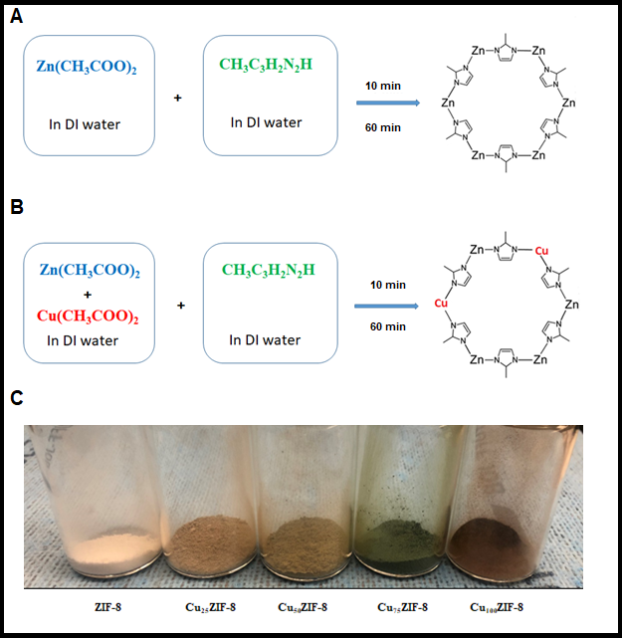
Figure 4-1. Schematic representation illustrating the steps in synthesis of crystals (A) Synthesis of ZIF-8 in the water, (B) Synthesis of Cu_{x}ZIF-8 and representation of random incorporation of Cu into the framework (C) visual color change observed with addition of Cu (II)

SEM images were taken for ZIF-8 and Cu_{x}ZIF-8 samples (Figure 4-2A). SEM images for ZIF-8, Cu₂₅ZIF-8 and Cu₅₀ZIF-8 showed a lot of small particles with size increasing as Cu (II) loading % increased. Moreover, sample Cu₅₀ZIF-8 shows larger crystals compared to ZIF-8 with well defined facets, sharp corners and sharp edges (Supporting information, Figure S4-1). Increasing crystal size with addition of Cu (II) confirms once again that number of nuclei formed is less than in pure ZIF-8 and that the frameworks continue to grow through addition of Zn (II), Cu (II) and imidazolate species. What was interesting here is that rhombic dodecahedron exposing 12 {110} faces characteristic for ZIF-8 was formed in one hour and shape was preserved even with high Cu loading. These results led to conclusion that framework didn’t collapse and that ZIF-8 structure was preserved even with such a high loading of Cu (II). Compared with a result reported in the literature where researchers obtained 25 % loading of Cu (II) this was a significant improvement.
However, when the amount of Cu further increased two things were observed. Firstly, the shape of particles changed to poorly resolved rounded shape for Cu₇₅ZIF-8 while in the case of Cu₁₀₀ZIF-8 SEM image reviled only aggregates and chunks not really particles. Secondly, the diameter of rounded particles for the sample Cu₇₅ZIF-8 is significantly bigger. This was the first indication that copper affected the morphology. SEM coupled with energy-dispersive X-ray spectroscopy (EDS) gave us results about the quantity of copper in the final product. Figure 4-2B and 2C shows the EDS spectrum and elemental analysis respectively. We observed change in morphology with SEM and at the same time change in the composition of the final product. The presence of zinc and copper was confirmed. Sample Cu₂₅ZIF-8 shows higher weight % of copper which was expected because in the starting mixture more Zn (II) is present compared to Cu (II). Similar Cu₇₅ZIF-8 shows a higher weight % of Cu (II) again due to the composition of the starting mixture. Even though the same amounts of zinc salt and copper salts were used for the synthesis, sample Cu₅₀ZIF-8 shows that the weight % of zinc is 2.61 times higher than copper. This fact shows that metal nodes in the framework are still mainly made of zinc and higher affinity of imidazole ligand towards zinc ions.
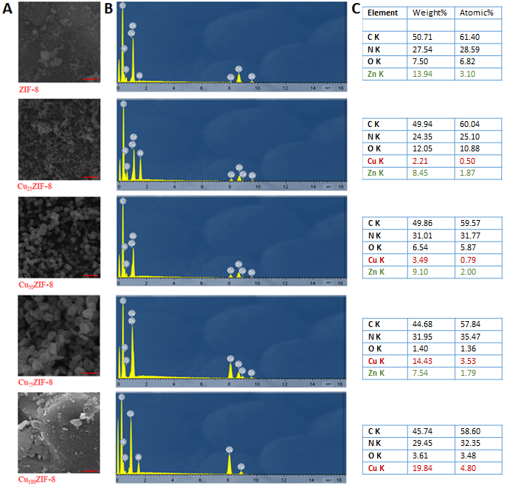
Figure 4-2. (A) SEM images of prepared samples, (B) EDS spectrum of prepared samples and (C) elemental composition obtained from EDS analysis
(Scale bar 5 µm)

Better insight into particle shape was provided with Transmission Electron Morphology (TEM). Typical shapes of ZIF-8 are rhombic dodecahedron or truncated rhombic dodecahedron usually depending on the time of synthesis and longer synthesis time give a better defined shapes of particles. ^{18,22,42} TEM images (Figure 4-3A) show well defined shapes for samples ZIF-8, Cu₂₅ZIF-8 and Cu₅₀ZIF-8 which were not observed at the higher Cu loading and these results are in agreement with SEM analysis. However, between these three samples there is a slight difference in the shape and the addition of Cu (II) makes edges much sharper. (Supporting information, Figure S4-3). There is a change of crystal shape from truncated rhombic dodecahedron (ZIF-8) to rhombic dodecahedron even though the time of the synthesis is the same for every sample (Cu₅₀ZIF-8) which indicates that pure ZIF-8 would need longer time of the synthesis to form rhombic dodecahedron crystal and that evolution of crystal is slower compared to Cu₅₀ZIF-8.
X‐ray diffraction (XRD) patterns of all prepared samples are presented in Figure 4-3B. The first conclusion from this analysis was that there is a difference between first three samples (ZIF-8, Cu₂₅ZIF-8 and Cu₅₀ZIF-8) compared to last two samples (Cu₇₅ZIF-8 and Cu₁₀₀ZIF-8) and that is in an accordance with previous SEM and TEM results. Crystallinity of ZIF-8, Cu₂₅ZIF-8 and Cu₅₀ZIF-8 was maintained and all characteristic peaks reported for ZIF-8 synthesised in water can be observed as well in patterns of Cu₂₅ZIF-8 and Cu_{50.} ZIF-8. ²⁷ No peak that would indicate the presence of new phase was found which is no case in the presence of other metal ions. ^{43,44} In these samples presence of Cu (II) didn’t cause collapse of the framework and peaks indicated the formation of body-centered crystal lattice symmetry reported before. Explanation may be given due to similar ionic size of Cu (II) (0.71 Å) and Zn (II) (0.74 Å). ^{35,36,45} This analysis showed that ZIF-8 with high loading of Cu (II) can be synthesised this way and that somewhere between Cu₅₀ZIF-8 and Cu₇₅ZIF-8 there is a critical point where framework collapses because of insufficient amount of Zn (II) which are based on the results required for framework to exist.
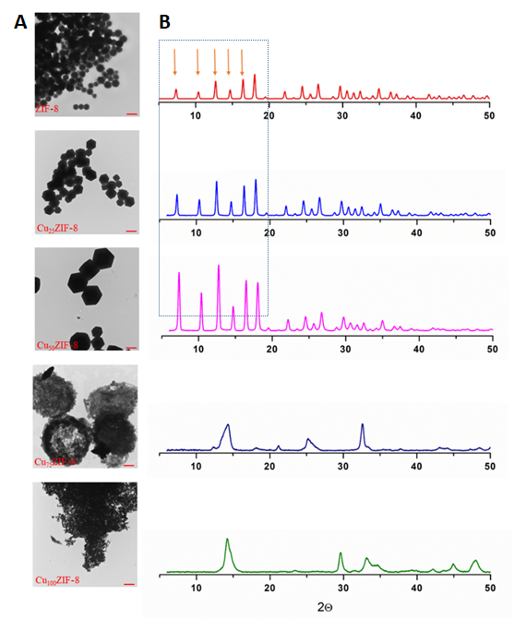
Figure 4-3. (A) TEM of prepared samples and (B) powder XRD spectra of prepared samples
(Scale bar 800 nm)

Conclusion

In summary, a facile method of synthesis Cu (II) doped ZIF-8 at room temperature, in water as the solvent for a short time was presented. ZIF-8 crystals can be doped with Cu (II) ions up to 50 % without the collapse of the framework. This was a great improvement considering that all the results found so far gave 25 mass % as maximum doping percentage. What was interesting is that Zn (II) ions have a greater affinity towards HmIm ions and that formation of the frameworks strongly depends on the presence of Zn (II) ions. This was proved by the EDS. At 75 mass % of Cu (II) in the reaction mixture, the framework is collapsed as XRD has proved even though EDS shows the presence of Zn (II) in the product. The critical point when the framework collapses is somewhere between 50 and 75 mass % Cu (II) which should be investigated further. Both SEM and TEM showed that formed particles have truncated rhombic dodecahedron shape (ZIF-8) and rhombic dodecahedron shape (Cu₂₅ ZIF-8and Cu₅₀ZIF-8) with shape and edges better defined for the samples doped with Cu (II). Particles have a significantly bigger size when they are Cu (II) doped compared to ZIF-8. However, in the case of samples Cu₇₅ ZIF-8 and Cu₁₀₀ZIF-8 we can see that shape is lost which indicates that the framework was not formed and these results are in accordance with the results from other analyses obtained.

References

1. Britt D, Tranchemontagne D, Yaghi OM. Metal-organic frameworks with high capacity and selectivity for harmful gases. Proc Natl Acad Sci U S A. 2008;105(33):11623-11627. doi:10.1073/pnas.0804900105
2. Fang Z, Bueken B, De Vos DE, Fischer RA. Defect-Engineered Metal-Organic Frameworks. Angew Chemie - Int Ed. 2015;54(25):7234-7254. doi:10.1002/anie.201411540
3. Férey G. Hybrid porous solids: Past, present, future. Chem Soc Rev. 2008;37(1):191-214. doi:10.1039/b618320b
4. Furukawa H, Cordova KE, O’Keeffe M, Yaghi OM. The chemistry and applications of metal-organic frameworks. Science (80- ). 2013;341(6149). doi:10.1126/science.1230444
5. Hidalgo T, Serre C, Horcajada P. Nanostructured metal – organic frameworks and their bio-related applications. 2016;307:342-360.
6. Chen B, Liang C, Yang J, et al. A microporous metal-organic framework for gas-chromatographic separation of alkanes. Angew Chemie - Int Ed. 2006;45(9):1390-1393. doi:10.1002/anie.200502844
7. Lee J, Farha OK, Roberts J, Scheidt KA, Nguyen ST, Hupp JT. Metal-organic framework materials as catalysts. Chem Soc Rev. 2009;38(5):1450-1459. doi:10.1039/b807080f
8. Morris RE, Wheatley PS. Gas storage in nanoporous materials. Angew Chemie - Int Ed. 2008;47(27):4966-4981. doi:10.1002/anie.200703934
9. Lu G, Hupp JT. Metal-organic frameworks as sensors: A ZIF-8 based fabry-pérot device as a selective sensor for chemical vapors and gases. J Am Chem Soc. 2010;132(23):7832-7833. doi:10.1021/ja101415b
10. Harbuzaru B V., Corma A, Rey F, et al. A miniaturized linear ph sensor based on a highly photoluminescent self-assembled Europium(III) metal-organic framework. Angew Chemie - Int Ed. 2009;48(35):6476-6479. doi:10.1002/anie.200902045
11. Li Y, Liang F, Bux H, Yang W, Caro J. Zeolitic imidazolate framework ZIF-7 based molecular sieve membrane for hydrogen separation. J Memb Sci. 2010;354(1-2):48-54. doi:10.1016/j.memsci.2010.02.074
12. Liu Y, Hu E, Khan EA, Lai Z. Synthesis and characterization of ZIF-69 membranes and separation for CO2/CO mixture. J Memb Sci. 2010;353(1-2):36-40. doi:10.1016/j.memsci.2010.02.023
13. Jiang HL, Liu B, Akita T, Haruta M, Sakurai H, Xu Q. Au@ZIF-8: CO oxidation over gold nanoparticles deposited to metal-organic framework. J Am Chem Soc. 2009;131(32):11302-11303. doi:10.1021/ja9047653
14. Farha OK, Yazaydin AÖ, Eryazici I, et al. De novo synthesis of a metal-organic framework material featuring ultrahigh surface area and gas storage capacities. Nat Chem. 2010;2(11):944-948. doi:10.1038/nchem.834
15. Murray LJ, Dinc M, Long JR. Hydrogen storage in metal-organic frameworks. Chem Soc Rev. 2009;38(5):1294-1314. doi:10.1039/b802256a
16. Tran UPN, Le KKA, Phan NTS. Expanding applications of metal-organic frameworks: Zeolite imidazolate framework zif-8 as an efficient heterogeneous catalyst for the knoevenagel reaction. ACS Catal. 2011;1(2):120-127. doi:10.1021/cs1000625
17. Banerjee R. High-Throughput Synthesis of Zeolitic. ReVision. 2008;939(February):939-944. doi:10.1126/science.1152516
18. Schejn A, Balan L, Falk V, Aranda L, Medjahdi G, Schneider R. Controlling ZIF-8 nano- and microcrystal formation and reactivity through zinc salt variations. CrystEngComm. 2014;16(21):4493-4500. doi:10.1039/c3ce42485e
19. Zhou K, Mousavi B, Luo Z, Phatanasri S, Chaemchuen S, Verpoort F. Characterization and properties of Zn/Co zeolitic imidazolate frameworks vs. ZIF-8 and ZIF-67. J Mater Chem A. 2017;5(3):952-957. doi:10.1039/C6TA07860E
20. Seoane B, Zamaro JM, Tellez C, Coronas J. Sonocrystallization of zeolitic imidazolate frameworks (ZIF-7, ZIF-8, ZIF-11 and ZIF-20). CrystEngComm. 2012;14(9):3103-3107. doi:10.1039/c2ce06382d
21. Bux H, Liang F, Li Y, Cravillon J, Wiebcke M, Caro J. Zeolitic imidazolate framework membrane with molecular sieving properties by microwave-assisted solvothermal synthesis. J Am Chem Soc. 2009;131(44):16000-16001. doi:10.1021/ja907359t
22. Cravillon J, Schröder CA, Bux H, Rothkirch A, Caro J, Wiebcke M. Formate modulated solvothermal synthesis of ZIF-8 investigated using time-resolved in situ X-ray diffraction and scanning electron microscopy. CrystEngComm. 2012;14(2):492-498. doi:10.1039/c1ce06002c
23. Park KS, Ni Z, Côté AP, et al. Exceptional chemical and thermal stability of zeolitic imidazolate frameworks. Proc Natl Acad Sci U S A. 2006;103(27):10186-10191. doi:10.1073/pnas.0602439103
24. Lee YR, Jang MS, Cho HY, Kwon HJ, Kim S, Ahn WS. ZIF-8: A comparison of synthesis methods. Chem Eng J. 2015;271:276-280. doi:10.1016/j.cej.2015.02.094
25. Yao J, He M, Wang H. Strategies for controlling crystal structure and reducing usage of organic ligand and solvents in the synthesis of zeolitic imidazolate frameworks. CrystEngComm. 2015;17(27):4970-4976. doi:10.1039/c5ce00663e
26. Jian M, Liu B, Liu R, Qu J, Wang H, Zhang X. Water-based synthesis of zeolitic imidazolate framework-8 with high morphology level at room temperature. RSC Adv. 2015;5(60):48433-48441. doi:10.1039/c5ra04033g
27. Kida K, Okita M, Fujita K, Tanaka S, Miyake Y. Formation of high crystalline ZIF-8 in an aqueous solution. CrystEngComm. 2013;15(9):1794-1801. doi:10.1039/c2ce26847g
28. Cravillon J, Nayuk R, Springer S, Feldhoff A, Huber K, Wiebcke M. Controlling zeolitic imidazolate framework nano- and microcrystal formation: Insight into crystal growth by time-resolved in situ static light scattering. Chem Mater. 2011;23(8):2130-2141. doi:10.1021/cm103571y
29. Bustamante EL, Fernández JL, Zamaro JM. Influence of the solvent in the synthesis of zeolitic imidazolate framework-8 (ZIF-8) nanocrystals at room temperature. J Colloid Interface Sci. 2014;424:37-43. doi:10.1016/j.jcis.2014.03.014
30. Tanaka S, Kida K, Okita M, Ito Y, Miyake Y. Size-Controlled synthesis of zeolitic imidazolate framework-8 (ZIF-8) crystals in an aqueous system at room temperature. Chem Lett. 2012;41(10):1337-1339. doi:10.1246/cl.2012.1337
31. Pan Y, Liu Y, Zeng G, Zhao L, Lai Z. Rapid synthesis of zeolitic imidazolate framework-8 (ZIF-8) nanocrystals in an aqueous system. Chem Commun. 2011;47(7):2071-2073. doi:10.1039/c0cc05002d
32. Nandigama SK, Bheeram VR, Mukkamala SB. Rapid synthesis of mono/bimetallic (Zn/Co/Zn–Co) zeolitic imidazolate frameworks at room temperature and evolution of their CO 2 uptake capacity. Environ Chem Lett. 2019;17(1):447-454. doi:10.1007/s10311-018-0775-y
33. Saliba D, Ammar M, Rammal M, Al-Ghoul M, Hmadeh M. Crystal Growth of ZIF-8, ZIF-67, and Their Mixed-Metal Derivatives. J Am Chem Soc. 2018;140(5):1812-1823. doi:10.1021/jacs.7b11589
34. Zareba JK, Nyk M, Samoć M. Co/ZIF-8 Heterometallic Nanoparticles: Control of Nanocrystal Size and Properties by a Mixed-Metal Approach. Cryst Growth Des. 2016;16(11):6419-6425. doi:10.1021/acs.cgd.6b01090
35. Schejn A, Aboulaich A, Balan L, et al. Cu2+-doped zeolitic imidazolate frameworks (ZIF-8): Efficient and stable catalysts for cycloadditions and condensation reactions. Catal Sci Technol. 2015;5(3):1829-1839. doi:10.1039/c4cy01505c
36. Nagarjun N, Dhakshinamoorthy A. A Cu-Doped ZIF-8 metal organic framework as a heterogeneous solid catalyst for aerobic oxidation of benzylic hydrocarbons. New J Chem. 2019;43(47):18702-18712. doi:10.1039/c9nj03698a
37. Hou J, Hao J, Wang Y, Liu J. Synthesis of CuII/ZIF-8 Metal-organic Framework Catalyst and Its Application in the Aerobic Oxidation of Alcohols. Chem Res Chinese Univ. 2019;35(5):860-865. doi:10.1007/s40242-019-9133-2
38. Tanaka S, Shimada T, Fujita K, et al. Seeding-free aqueous synthesis of zeolitic imidazolate framework-8 membranes: How to trigger preferential heterogeneous nucleation and membrane growth in aqueous rapid reaction solution. J Memb Sci. 2014;472:29-38. doi:10.1016/j.memsci.2014.08.038
39. Lee YR, Kim J, Ahn WS. Synthesis of metal-organic frameworks: A mini review. Korean J Chem Eng. 2013;30(9):1667-1680. doi:10.1007/s11814-013-0140-6
40. Huang XC, Lin YY, Zhang JP, Chen XM. Ligand-directed strategy for zeolite-type metal-organic frameworks: Zinc(II) imidazolates with unusual zeolitic topologies. Angew Chemie - Int Ed. 2006;45(10):1557-1559. doi:10.1002/anie.200503778
41. Kida K, Fujita K, Shimada T, Tanaka S, Miyake Y. Layer-by-layer aqueous rapid synthesis of ZIF-8 films on a reactive surface. Dalt Trans. 2013;42(31):11128-11135. doi:10.1039/c3dt51135a
42. Pan Y, Heryadi D, Zhou F, et al. Tuning the crystal morphology and size of zeolitic imidazolate framework-8 in aqueous solution by surfactants. CrystEngComm. 2011;13(23):6937-6940. doi:10.1039/c1ce05780d
43. Paquin F, Rivnay J, Salleo A, Stingelin N, Silva C. Multi-phase semicrystalline microstructures drive exciton dissociation in neat plastic semiconductors. J Mater Chem C. 2015;3:10715-10722. doi:10.1039/b000000x
44. Li R, Ren X, Feng X, Li X, Hu C, Wang B. A highly stable metal- and nitrogen-doped nanocomposite derived from Zn/Ni-ZIF-8 capable of CO2 capture and separation. Chem Commun. 2014;50(52):6894-6897. doi:10.1039/c4cc01087f
45. Zhang L, Hu YH. Strong effects of higher-valent cations on the structure of the zeolitic Zn(2-methylimidazole)2 framework (ZIF-8). J Phys Chem C. 2011;115(16):7967-7971. doi:10.1021/jp200699n

Supporting Information

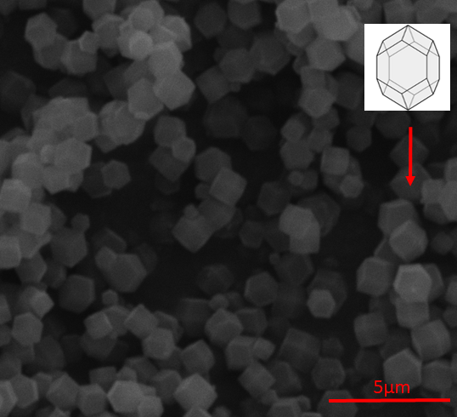
Figure S4-1. SEM image of Cu₅₀/ZIF-8 showing truncated rhombic dodecahedral structure of crystals.

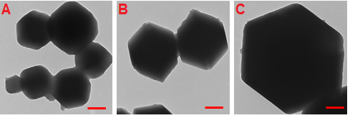
Figure S4-2. TEM images of ZIF-8, Cu₂₅/ZIF-8, and Cu₅₀/ZIF-8 samples (Scale bar 200 nm).

Chapter 5: Major conclusions and recommendations for the future work

This thesis examined changes in the morphology of MOF crystals and two potential methods of controlling it.
The research in Chapter 3 examined growing MOFs from the cellulose substrates and changes in crystals morphology. This research yielded 3 major conclusions:

- Paper and cotton fibres were used as supports for the attachment of MOF-5 crystals, and stable morphologies were fabricated. When dopamine was used as a surface modification agent, the MOF-5 crystals showed better attachment and coverage of the substrate, as well as improved growth. The hydrophilic character of the cellulose was reduced, which allowed it to form a PDA layer on the substrate surfaces. These substrate surfaces then became nucleation sites for the MOF-5 crystals.
- The substrate structure plays an important role in how crystals grow. Paper with a dense structure is not the best substrate for growing crystals, as crystals will only grow on the surface. A cotton bulb with a “loose” structure was found to be a better substrate because the crystals grew throughout it. MOF-5 crystals firmly attached to the individual cellulose fibres, forming a stable “necklace” morphology, which is desired in many applications.
- Since the crystal shape is a reflection of the unit cell shape, we expected the MOF-5 crystals to be cubic in shape. Our results showed that the crystals had a truncated cubic shape at lower temperatures, and a more fully cubic shape at higher temperatures. This provides further evidence of the importance of external parameters in controlling morphology.

The research in Chapter 4 introduced another metal in order to prepare bimetallic MOFs. The major conclusions of this research are as follows:

- The synthesis of bimetallic ZIF-8 doped with Cu (II) cations is relatively easily to achieve, as it can be done quickly at room temperature using water as a solvent. This finding is especially interesting because all prior syntheses of this MOF were performed using organic solvents.
- It is possible to prepare a bimetallic ZIF-8 framework of up to 50 mass % of Cu without the collapse of the framework. This was a great improvement, as the best prior results have only been able to achieve a maximum doping percentage of 25 mass %. The presence of both metals in the samples was also confirmed via EDS analysis. The critical point at which the framework collapses is somewhere between 50 mass % and 75 mass % of Cu.
- Particles doped with Cu were rhombic dodecahedral in shape, with better-defined edges compared to pure ZIF-8. The Cu (II) spiked particles were also significantly larger compared to the pure ZIF-8 particles.
- Particles collapsed at 75 mass % of Cu, which indicates that a framework was not formed.

Suggested future work

The primary focus of this thesis was how the morphology of the MOF crystals can be affected and changed. The studies and findings presented in this work provide fruitful ground for future research efforts in this area. In particular, this research provides 3 key avenues for future research:
- Firstly, with respect to MOF attachment to the substrate, future work could focus on attaching ZIF to cellulose-based substrates, as some of our laboratory experiments in this area yielded promising results. In particular, we found that ZIFs can be easily attached to cellulose substrates without previous modification.
- Secondly, future work could explore using the combination method to attach MOFs to the substrates, and to synthesize bimetallic MOFs. This idea was also partially examined in the present research, as stable MOF-cellulose paper structures were tested for the adsorption of Cu (II) cations. Our results showed that it is possible to remove significant amounts of copper from a water solution; however, the underlying mechanism in this process was cation exchange, which meant that the water solution was rich in Zn (II) cations. This fact can be used for the synthesis of bimetallic ZIFs through the adsorption of other cations from water solutions.
- Finally, future research might further examine the bimetallic CuZIF-8 described in Chapter 4. In particular, it would be useful to identify the critical point at which the ZIF-8 framework collapses when doped with Cu (II) cations. This ZIF has yet to be reported in the literature, and it would be necessary to finish experiments relating to surface area, porosity, and chemical and thermal stability. Future work should also focus on evaluating prepared ZIFs in different applications.

