SUTURELESS AORTIC VALVE REPLACEMENT

USE, PERCEPTIONS AND EVIDENCE OF SUTURELESS AORTIC VALVE REPLACEMENT

By AHMAD MAKHDOUM, MD

A Thesis Submitted to the School of Graduate Studies in Partial Fulfilment of the Requirement for the Degree Master of Science in Health Research Methodology

McMaster University © Copyright by Ahmad Makhdoum, June 2019

McMaster University, Master of Science, 2019, Hamilton, Ontario (Health Research Methodology)

TITLE: Use, Perceptions and the Evidence of Sutureless Aortic Valve Replacement.

AUTHOR: Ahmad Makhdoum, MD (McMaster University).
SUPERVISOR: Professor Richard P Whitlock, MD, PHD.

Lay Abstract

Aortic valve stenosis (AS) is considered the most common valvular heart disease, which caused by narrowing of the aortic valve. Aortic valve replacement (AVR) is the only acceptable treatment to relieve the stenosis. Several strategies are available including conventional surgical aortic valve replacement (SAVR), transcatheter aortic valve replacement (TAVR), and sutureless aortic valve replacement (SuAVR). SAVR is an invasive procedure and denied in a considerable number of patients with aortic stenosis due to aging and presence of multiple diseases leading to higher risk of complications. TAVR is less invasive option and showed excellent results when compared to SAVR. However, it was associated with complications. SuAVR has developed to overcome some of the drawbacks of SAVR and TAVR. SuAVR is associated with short operation time and less complications compared to SAVR and TAVR. This thesis summarizes the safety, perceptions and evidence surrounding the use of SuAVR.

Abstract

Aortic Stenosis (AS) is the most common valvular heart disease. Aortic valve replacement (AVR) is the only acceptable treatment for AS. Several replacement methods are available to treat AS including conventional surgical aortic valve replacement (SAVR), transcatheter aortic valve replacement (TAVR), and Sutureless aortic valve replacement (SuAVR). SAVR showed excellent long-term results. However, it is an invasive procedure and is denied in substantial number of patients. TAVR showed excellent results and outcomes when compared to SAVR. However, it is associated with increased rate of paravalvular leaks that may impact long term outcomes. SuAVR has developed to overcome the drawbacks of SAVR and TAVR. SuAVR is associated with favorable short and midterm outcomes when compared to SAVR and TAVR. In this thesis, we summarize the safety, the evidence and the perceptions of using SuAVR in Canada. In Chapter1, we evaluated the use of SuAVR Perceval bioprosthesis in retrospective single center study of 415 patients with AS. SuAVR showed excellent immediate post-operative and hemodynamics outcomes. In chapter 2, we sought to establish perceptions and patterns to SuAVR use among Canadian cardiac surgeons. Sixty-Six Canadian cardiac Surgeons responded to the survey. Surgeons reported influential factors, barriers to use SuAVR, and their interest in a trial comparing SuAVR versus TAVR. Surgeons were likely to use SuAVR in high risk patients with hostile aortic root, small aortic annulus and in patients undergoing concomitant procedures whereas cost was the main limiting factor to use SuAVR in Canada. Majority of surgeons reported their interest in participating in a trial comparing SuAVR with TAVR. In chapter 3, we systematically reviewed and meta-analyzed the international evidence of using SuAVR versus SAVR and TAVR. SuAVR showed favorable or comparable results to SAVR and TAVR. However, long term and randomized data are needed to confirm these results.

Acknowledgments

I would like to express my sincere appreciation for my thesis supervisors: Dr. Richard Whitlock, Dr. Andre Lamy, Dr. Waleed Alhazzani, and Dr. Bobby Yanagawa. I also would to extend my thanks and gratitude to Dr. Emilie Belley-Cote, who provided guidance and mentorship throughout this process. Moreover, I would like to express my thanks to several colleagues for their great contributions in my thesis:
- Dr. Kevin Teoh (cardiac surgeon, Southlake Regional Health Sciences Center, Newmarket, Ontario, Canada).
- Alex Koziarz (medical student, University of Toronto, Ontario, Canada).
- Dr. Ali Alsagheir (cardiac surgery resident, McMaster University, Ontario, Canada).
- Dr. Saurabh Gupta (cardiac surgery resident, McMaster University, Ontario, Canada).
- Arjun Pandy (Undergraduate student, McMaster University, Ontario, Canada).
- Seleman Reza (Undergraduate student, McMaster University, Ontario, Canada).
- Arjan Dhoot (medical student, University of Toronto, Ontario, Canada).
- Kevin Um (medical student, McMaster University, Ontario, Canada).

Table of Contents
Lay Abstract iv
Abstract v
Acknowledgments vi
List of Figures and Tables x
List of Abbreviations: xii
Declaration of Academic Achievements: xiii
Introduction 0
Chapter 1: 2
Sutureless Aortic Valve Replacement with Perceval S bioprosthesis, Single Centre Experience. 2
Abstract 4
Introduction 4
Methods/Results 4
Conclusion 5
Introduction 6
Patients and Methods 7
Patients 7
Technology 7
Operative technique 7
Statistical analysis 8
Results 8
Baseline characteristics 8
Intraoperative details 9
Discussion 12
Limitations 15
Conclusion 15
Chapter 2: 16
A Survey of Cardiac Surgeons to evaluate the use of Sutureless Aortic Valve Replacement in Canada 16
Abstract 18
Background 18
Objective 18
Methods/Result 18
Introduction 20
Materials and Methods 21
Survey Development 21
Participant Identification 21
Survey Administration 21
Statistical Analyses 22
Results 22
Respondent Characteristics 22
Valve choice practice 22
Influential Factors to Implant SuAVR 22
Clinical Factors. 22
Anatomic Factors. 22
Procedural Related Factors 23
Barriers to adopt SuAVR 26
Future Research Directions 26
Discussion 28
Barriers to Implant SuAVR 30
Future Research Directions 32
Strength and Limitations 33
Conclusion 33
Chapter 3: 38
Outcomes of Sutureless Aortic Valve Replacement versus Conventional Aortic Valve Replacement and Trans- catheter Aortic Valve Replacement, Systematic Review and Meta-analysis. 38
Abstract 41
Background 41
Methods/Results 41
Conclusion 42
Introduction 43
Methods 44
Literature search 45
Measures of treatment effect/ Data analysis 46
Assessment of heterogeneity 46
Subgroup analysis/Sensitivity analysis 46
Assessment of the certainty of the evidence 47
Results 47
Search Results 47
Mortality 49
SuAVR versus SAVR. 49
SuAVR versus TAVR 51
Stroke 53
SuAVR versus SAVR. 53
SuAVR versus TAVR. 54
Permanent pacemaker implantation (PPI) 54
SuAVR versus SAVR. 55
SuAVR versus TAVR. 56
Acute Kidney Injury 57
SuAVR versus SAVR. 57
SuAVR versus TAVR. 58
Post-operative Aortic Valve Mean Gradient 58
SuAVR versus SAVR 58
SuAVR versus TAVR. 59
Paravalvular Leak 60
SuAVR versus SAVR 60
SuAVR versus TAVR. 61
Aortic Cross Clamp Time 62
SuAVR versus SAVR 62
Cardiopulmonary bypass time (CPB) 64
Discussion 65
Strength and Limitations 68
Conclusion 68
Table of Included Studies 69
Table of Results 74
Appendix 1: 77
Search strategy 77
Appendix 2: Risk of Bias Assessment 80
Appendix 3: Funnel Plots for Meta-Analysis 84
Appendix 4: GRADE Assessment. 88
References 91

List of Figures and Tables
- Chapter 1:
- Table 1. Preoperative demographics and clinical characteristics.
- Table 2. Intraoperative details.
- Table 3. Procedural outcomes.
- Table 4. Preoperative and pre-discharge echocardiographic results.
- Chapter 2:
  - Table 1. Factors Influencing the Use of SuAVR in Canada.
  - Table 2. Perceived Influential Barriers to Use SuAVR in Canada.
  - Table 3. Rating of Proposed Primary Outcomes for a Trial Comparing SuAVR vs. TAVR.
  - Figure 1. Influential factors to use SuAVR.
  - Figure 2. Rating of Proposed Primary Outcomes of a Trial Comparing SuAVR vs. TAVR as Critical, Important, or Not Important.
  - Appendix: Survey questions.
- Chapter 3:
  - Figure 1. A PRISMA schematic of search strategy. PRISMA: Preferred Reporting Items for Systematic Reviews and Meta-Analyses.
  - Figure 2A. Adjusted studies (SuAVR versus SAVR), 30-day and 2 years mortality.
  - Figure 2B. Unadjusted studies (SuAVR versus SAVR)- 30-day mortality.
  - Figure 3C. Adjusted studies (SuAVR versus TAVR)-stroke.
  - Figure 4A. Adjusted studies (SuAVR versus SAVR), permanent pacemaker implantation.
  - Figure 4B. Unadjusted studies (SuAVR versus SAVR), permanent pacemaker implantation.
  - Figure 4C. Adjusted studies (SuAVR versus TAVR), permanent pacemaker implantation.
  - Figure 4D. Unadjusted studies (SuAVR versus TAVR), permanent pacemaker implantation.
  - Figure 5A. Adjusted studies (SuAVR versus SAVR), acute kidney injury.
  - Figure 5B. Unadjusted studies (SuAVR versus SAVR), acute kidney injury.
  - Figure 5C. Adjusted studies (SuAVR versus TAVR), acute kidney injury.
  - Figure 6A. Adjusted studies (SuAVR versus SAVR), post-operative mean gradient.
  - Figure 6B. Unadjusted studies (SuAVR versus SAVR). Post-operative mean gradient.
  - Figure 6C. Adjusted studies (SuAVR versus TAVR), post-operative mean gradient.
  - Figure 6D. Unadjusted studies (SuAVR versus TAVR), post-operative mean gradient.
  - Figure 7A. Adjusted studies (SuAVR versus SAVR), paravalvular leak.
  - Figure 7B. Unadjusted studies (SuAVR versus SAVR), paravalvular leak.
  - Figure 7C. Adjusted studies (SuAVR versus TAVR), paravalvular leak.
  - Figure 7D. Unadjusted studies (SuAVR versus TAVR), paravalvualr leak.
  - Figure 8A. Adjusted studies (SuAVR versus SAVR), aortic cross clamp time.
  - Figure 8B. Unadjusted studies (SuAVR versus SAVR), aortic cross clamp time.
  - Figure 9A. Adjusted studies (SuAVR versus SAVR), cardiopulmonary bypass time
  - Figure 9B. Unadjusted studies (SuAVR versus SAVR), cardiopulmonary bypass time
  - Table of included studies
    - Table 1A: List of included studies (SuAVR vs. SAVR) – Adjusted.
    - Table 2A: List of included studies (SuAVR vs. SAVR) – Unadjusted.
    - Table 1B: List of Included Studies (SuAVR vs. TAVR) – Adjusted.
    - Table 2B: List of Included Studies (SuAVR vs. TAVR) – Unadjusted.
  - Table of results
- Table 3A: Adjusted studies (SuAVR versus SAVR).
- Table 3B: Unadjusted studies (SuAVR versus SAVR).
- Table 4A: Adjusted studies (SuAVR versus TAVR).
- Table 4B: Unadjusted studies (SuAVR versus TAVR).
  - Appendix 1: Search strategy
  - Appendix 2: Risk of Bias Assessment
    - Table 1A: Risk of Bias of SuAVR vs. Conventional AVR (SAVR) in Adjusted Observational Studies:
    - Table 2A: Risk of Bias of SuAVR vs. TAVR Adjusted Observational Studies:
    - Table 2B: Risk of Bias of SuAVR vs. TAVR Unadjusted Observational Studies:
    - Table 1B: Risk of Bias of SuAVR vs. SAVR Unadjusted Observational Studies:
  - Appendix 3: Funnel Plots of Effect Size versus Standard Error in Observational Studies
- Funnel plot for the mortality outcome for SuAVR and SAVR.
- Funnel plot for the aortic cross clamp time outcome for SuAVR and SAVR.
- Funnel plot for the cardiopulmonary bypass outcome of SuAVR versus SAVR.
- Funnel plot of stroke outcome of SUAVR versus SAVR.
- Funnel plot of acute kidney injury outcome of SuAVR versus SAVR.
- Funnel plot of permanent pacemaker implantation of SuAVR versus SAVR.
- Funnel plot of post-operative mean gradient of SuAVR versus SAVR.
  - Appendix 4: GRADE Assessment.
    - A. GRADE Assessment for observational data (SuAVR vs. SAVR).
    - B. GRADE Assessment of observational data (SuAVR vs. TAVR).

List of Abbreviations:
- SAVR = Conventional Aortic Valve Replacement.
- SuAVR = Sutureless Aortic Valve Replacement.
- TAVR = Transcatheter Aortic Valve Replacement.
- STS = Society of Thoracic Surgeons.
- ACX = Aortic Cross Clamp.
- CPB = Cardiopulmonary Bypass.
- PVL = Paravalvular Leak.
- PPI = Permanent Pacemaker Implantation.
- AKI = Acute Kidney Injury.
- POMG = Post-Operative Mean Gradient.
- LOS = Length of Stay.
- MIS = Minimally invasive surgery or approach.
- MI-SuAVR = Minimally Invasive Sutureless Aortic Valve Replacement.
- Atm = Atomsphere.
- SD = Standard Deviation.
- IQR = Interquartile Range.
- OR = Odds Ratio.
- RR = Risk Ratio.

Declaration of Academic Achievements:
This master thesis was not financially funded by any organization or institute. I have prepared, analyzed and wrote all the chapters. Several participants have significantly contributed in this thesis. The participants are:
- Alex Koziarz.
Contribution:
- systematic review and meta-analysis data collection, extraction and grading the quality of evidence.
- Dr. Ali Alsagheir
Contribution:
- systematic review and meta-analysis data collection, extraction and grading the quality of evidence.
- Dr. Saurabh Gupta.
Contribution:
- systematic review and meta-analysis data collection, extraction and grading the quality of evidence.
- Arjun Pandy.
Contribution:
- Systematic review and meta-analysis data collection and extraction.
- Single center retrospective study data collection.

- Seleman Reza.
Contribution:
- Systematic review and meta-analysis data collection and extraction.
- Single center retrospective study data collection.
- Arjan Dhoot.
Contribution:
- Single center retrospective study data collection.
- Kevin Um.
Contribution:
- Systematic review and meta-analysis data collection and extraction.

Introduction

Aortic stenosis (AS) is the most common valvular disorder. The incidence of AS escalates as the age increases, with life expectancy reduced in symptomatic patients(Carabello and Paulus). The incidence of AS escalates as the age increases, with life expectancy reduced in symptomatic patients(Nkomo et al.). Once symptoms develop, AS carries a high mortality of 50% within 2 years if left untreated(Joint Task Force on the Management of Valvular Heart Disease of the European Society of Cardiology (ESC) et al.). To relieve the stenosis, aortic valve replacement is the only acceptable and effective treatment for AS. Conventional aortic valve replacement (SAVR) through a median sternotomy has long been the standard of care for severe aortic stenosis with documented improvement in survival(J. M. Brown et al.). Despite the survival benefit observed with SAVR, almost 30% of AS patients remain unsuitable and denied surgery due to advanced age, comorbidities and left ventricular dysfunction(Varadarajan et al.). These factors have led to the introduction of several less invasive treatment methods, namely transcatheter aortic valve replacement (TAVR) and sutureless aortic valve replacement (SuAVR). TAVR has emerged as an acceptable alternative to SAVR in high risk patients (defined as The Society of Thoracic Surgeons ]STS[ score > 8%) and inoperable patients(Smith et al.). More recently, the use of TAVR has expanded to include patients with intermediate (STS= 4-8%) and low risk (STS <4%) patients with non-inferior results compared to SAVR(Leon, Smith, Mack, Makkar, Svensson, Kodali, Thourani, Tuzcu, Miller, Herrmann, Doshi, Cohen, Pichard, Kapadia, Dewey, Babaliaros, Szeto, Williams, Kereiakes, Zajarias, Greason, Whisenant, Hodson, Moses, Trento, D. L. Brown, Fearon, Pibarot, Hahn, Jaber, Anderson, Alu, and Webb; Reardon et al.; Popma et al.). Despite the advantages associated with TAVR, it has been associated with increased rates of paravalvular leaks (PVL) and vascular complications when compared to SAVR(Leon, Smith, Mack, Makkar, Svensson, Kodali, Thourani, Tuzcu, Miller, Herrmann, Doshi, Cohen, Pichard, Kapadia, Dewey, Babaliaros, Szeto, Williams, Kereiakes, Zajarias, Greason, Whisenant, Hodson, Moses, Trento, D. L. Brown, Fearon, Pibarot, Hahn, Jaber, Anderson, Alu, and Webb; Popma et al.). To fill the gaps SAVR and TAVR, sutureless aortic valve replacement (SuAVR) bioprosthesis has developed to help overcome the drawbacks of SAVR and TAVR. The use of SuAVR allows shorter operating time, complete excision of the native valve and favorable hemodynamics given the sutureless valve design permitting a faster implantation time and larger effective orifice area. Multiple reports showed reduced aortic cross time (ACX), shorter cardiopulmonary bypass time (CPB) when compared to SAVR(Powell et al.; Meco, Montisci, et al.). SuAVR also facilitates use of minimally invasive surgery by further reducing ACX, CPB times and possible blood transfusion requirements(Gilmanov et al.). When compared to TAVR, studies suggest better outcomes in 30-day mortality and PVL with SuAVR. (Takagi and Umemoto; Powell et al.). These results are compelling to consider SuAVR as an alternative to SAVR and TAVR. However, there no current published randomized trials confirming the relative effectiveness of SuAVR in comparison to SAVR or TAVR. In this thesis, we aimed to evaluate and summarize the safety, perceptions, and current evidence supporting the evidence of SuAVR.

Chapter 1:

Sutureless Aortic Valve Replacement with Perceval S bioprosthesis, Single Centre Experience.

Sutureless Aortic Valve Replacement with Perceval bioprosthesis, Single Centre Experience.

Ahmad Makhdoum^{1,2}, Alex Koziarz², Arjun Pandey¹, Seleman Reza¹, Ali Alsagheir, Arjan Dhoot², Emilie Belley-Cote¹, Kevin Teoh³, Waleed Alhazzani^{1,4}, Andre Lamy¹, Bobby Yanagawa², Richard Whitlock^{1,5}

- Population Research Health Institute, McMaster University, Hamilton, Canada.
- Division of Cardiac Surgery, St. Michael’s Hospital, University of Toronto, Toronto, Canada.
- Southlake Regional Health Sciences Centre, Newmarket, Ontario, Canada.
- Division of Critical Care, Department of Medicine, McMaster University, Hamilton, Ontario, Canada.
- Division of Cardiac Surgery, Department of Surgery, McMaster University, Hamilton, Ontario, Canada.

Corresponding Author:
Richard P Whitlock, MD, PhD
David Braley Cardiac, Vascular and Stroke Research Institute
Room 1C1-5B, 237 Barton Street East,
Hamilton Ontario L8L 2X2
Phone: 905 527 4322 ext. 40306
Email: Richard.Whitlock@phri.ca

Key words: Aortic stenosis, Sutureless aortic valve replacement, Perceval

Financial Support: We conducted this study without financial support. Dr. Whitlock is supported by a mid-career award from the Heart and Stroke Foundation of Canada.

Conflict of Interests: None.

Abstract

Introduction
Sutureless aortic valve replacement (SuAVR) has emerged as a potential alternative to conventional aortic valve replacement (SAVR) and transcatheter aortic valve replacement (TAVR). The purpose of this study is to evaluate and report the immediate outcomes of SuAVR using the Perceval device.

Methods/Results
Between December 2012 and March 2018, 415 patients underwent aortic valve replacement using the Perceval bioprosthesis at Southlake Regional Health Sciences Centre were reviewed retrospectively. The mean age of the patients was 77±8 years and 61% of patients were male. The mean left ventricular ejection fraction was 57±9%. The mean STS score was 9.2±2.7%. The mean preoperative aortic valve mean gradient and aortic valve area were 44±15 mmHg and 0.8±0.2 cm² respectively. There were no intraoperative deaths. Isolated AVR was performed in 196 patients (47%) and concomitant procedures were done in 219 patients (53%). Median duration of cross clamp (ACX) and cardiopulmonary bypass (CPB) for isolated procedures were 49 minutes (interquartile range (IQR):37-61) and 66 minutes (IQR: 50-84) respectively, whereas for concomitant procedures, the ACX and CPB times were 86 minutes (IQR: 69-103) and 103 minutes (IQR: 83-125). In-hospital mortality was 3% (12/415). The median hospital length of stay was 7 days (IQR: 5-9). Five patients had postoperative stroke (1.2%). The rate of permanent pacemaker implantation was 12% (50/415). Hemodynamic performance improved significantly on discharge when compared to baseline with a mean aortic valve mean gradient of 13±5 mmHg (p=<0.001). There were no cases with more than trivial paravalvular leaks reported.

Conclusion
SuAVR is associated with excellent post-operative hemodynamic and clinical outcomes. SuAVR is safe and effective alternative to SAVR and TAVR in high risk patients.

Introduction
Aortic valve stenosis (AS) is the most common valvular heart disease in developed countries(Carabello and Paulus). Aortic valve replacement (AVR) is the gold standard treatment for severe or symptomatic aortic stenosis. However, the risk of mortality and morbidity associated with AVR increases with age and comorbidities which lead to denying surgery in substantial number of patients with severe AS (Olsson et al.). Recently, transcatheter aortic valve replacement (TAVR) has emerged as a less invasive treatment for high, intermediate, and low risk patients with non-inferior results compared to SAVR(Leon, Smith, Mack, Miller, et al.; Leon, Smith, Mack, Makkar, Svensson, Kodali, Thourani, Tuzcu, Miller, Herrmann, Doshi, Cohen, Pichard, Kapadia, Dewey, Babaliaros, Szeto, Williams, Kereiakes, Zajarias, Greason, Whisenant, Hodson, Moses, Trento, D. L. Brown, Fearon, Pibarot, Hahn, Jaber, Anderson, Alu, and Webb; Popma et al.). However, TAVR has been associated with increased rates of paravalvular leak and risk of leaflet thrombosis when compared to conventional surgical AVR (SAVR)(Leon, Smith, Mack, Makkar, Svensson, Kodali, Thourani, Tuzcu, Miller, Herrmann, Doshi, Cohen, Pichard, Kapadia, Dewey, Babaliaros, Szeto, Williams, Kereiakes, Zajarias, Greason, Whisenant, Hodson, Moses, Trento, D. L. Brown, Fearon, Pibarot, Hahn, Jaber, Anderson, Alu, and Webb). To mitigate the drawbacks of SAVR and TAVR, sutureless aortic valve replacement (SuAVR) has emerged as an alternative strategy to treat patients with aortic stenosis. By avoiding or considerably reducing placement or tying of sutures after native valve excision and decalcification, SuAVR has been shown to reduce operative time and the rate of paravalvular leaks, and facilitates minimally invasive approach (Powell et al.; Takagi and Umemoto). SuAVR is of particular interest in high risk, fragile patients, patients undergoing combined or redo operations. The aim of study was to evaluate the early outcomes of a large single center of patients undergoing SuAVR using the Perceval (LivaNova, Milan, Italy) aortic bioprosthesis.

Patients and Methods

Patients
This is a retrospective study of a single center experience. Between December 2012 and March 2018, 415 patients underwent aortic valve replacement using the Perceval bioprosthesis at Southlake Regional Health Sciences Center in Newmarket, Ontario, Canada. Informed consent was waived and the study was approved by the Research Ethics Board at our center. Selection of patients for Perceval implantation was at the discretion of the surgeon. Five surgeons performed the procedures. We included patients with severe aortic stenosis who underwent SuAVR using Perceval for isolated AVR and concomitant AVR.
Data collection was done using a standardized form that included relevant demographics, surgical, clinical and echocardiographic data. Hemodynamic parameters were assessed preoperatively, intraoperatively, and at discharge using transesophageal and transthoracic echocardiography.

Technology
The Perceval device is a biologic prosthesis composed of bovine pericardium stabilized in a buffered glutaraldehyde solution and assembled on a nitinol stent. This bioprosthesis can be collapsed through a dedicated device and positioned by means of a specific delivery system. The delivery system loaded with the collapsed stent-mounted valve is guided to its correct position by sliding it over the three guiding sutures (4-0 polypropylene), positioned at the nadir level of each resected cusp. Once the delivery system is in position, the prosthesis is deployed, the guiding sutures are removed, and the valve is finally in place. At this point, post-dilation modeling is performed with a dedicated balloon at 4 atmospheres (atm) for 30 seconds.

Operative technique
A standard median sternotomy was performed in 365 patients (88%) and 50 patients (12%) underwent minimally invasive approach using hemisternotomy utilizing a short upper 7 cm skin incision from the sternal notch to the third intercostal space. Hemisternotomy was used only for isolated AVR. All procedures were carried out using aortic cross clamp (ACX) and cardiopulmonary bypass (CPB). With the heart arrested using cold blood cardioplegia, high transverse aortotomy was performed and the aortic valve was inspected. The aortic valve leaflets were excised, the aortic annulus was decalcified and sized. Three positioning sutures of 4-0 prolene were placed across the aortic annulus at the nadir of the sinus. These sutures were then placed through the suture loops of the Perceval device. The valve is then positioned and deployed. The aortotomy was closed with using running 4-0 Prolene suture in 2 layers and the patient was weaned from CPB. Good position and hemodynamics of the bioprosthesis were assessed immediately using intraoperative transesophageal echocardiography.

Statistical analysis
Baseline characteristics were assessed using counts and proportions, medians with interquartile ranges, as well as means with standard deviations. Improvement in transaortic gradients were assessed using paired t-test for continuous variables. Statistical significance was set at a p<0.05. All the statistical analyses were performed using IBM SPSS statistics, Version 25 (SPSS, Chicago, IL).

Results
Baseline characteristics
Table 1 summarized the preoperative and clinical characteristic. Mean age was 77±8 years and 61% of patients were male. The mean left ventricular ejection fraction was 57±9%. The mean preoperative aortic valve mean gradient and aortic valve area were 44±15 mmHg and 0.8±0.2 cm². Sixteen patients (4%) had previous cardiac surgeries (9 had aortic valve replacements and 7 had coronary artery bypass grafts).

Table 1
Preoperative demographics and clinical characteristics
Variable (n=415) | Number (%)/ mean(SD)
Age (year, SD) | 77±8
Male (n, %) | 252 (61)
Left ventricular ejection fraction (mean, SD) | 57±9
AV mean gradient | 44±15
AV peak gradient | 66±23
Aortic valve area | 0.8±0.24
BMI | 29 ± 5.5
Body surface area | 2±0.2
STS score  Intermediate (STS 4-8%).  High (STS > 8%) | 9.8±2.7  101 (24)  314 (76)
NYHA  I-II  III-IV | 366 (88)  59 (14)
Smoking  - Smoker  - Never  - Former | 70 (17)  179 (43)  165 (40)
Diabetes | 126 (30.5)
Hypertension | 316 (76.5)
Myocardial infarction | 98 (23.7)
Atrial fibrillation | 93 (22.5)
Stroke | 42 (10)
Peripheral arterial disease | 37 (9)
Previous cardiac surgery | 16 (4)

Intraoperative details
The details of intraoperative and concomitant procedures are shown in (Table 2). There were no intraoperative deaths and all patients had the Perceval prosthesis implanted successfully. Isolated AVR were performed in 196 patients (47%) and concomitant procedures were done in 219 patients (53%). Median duration of ACX and CPB times for isolated procedure was 49 minutes (interquartile range (IQR): 37 – 61) and 66 minutes (IQR: 50-84) respectively, whereas for concomitant procedures, the ACX and CPB times were 86 minutes (IQR: 69-103) and 103 minutes (IQR: 83-125).

Table 2
Intraoperative details
Variable | Number (%)
Approach  - Full sternotomy.  - Hemi sternotomy | 365 (88)  50 (12)
Prosthesis size (Median, Min-Max)  - Small (21 mm).  - Medium (23 mm).  - Large (25 mm)  - X-large (27 mm) | 25 (21-27)  80 (19)  91 (22)  122 (30)  118 (28)
Concomitant procedure  - None (Isolated AVR)  - CABG  - Multiple valve surgeries | 196 (47)  212 (51)  7 (2)
Aortic cross clamp time (minutes) (Median, Min-max)  - - Isolated AVR  - - Concomitant procedure | 66 (47-89)  49 (37-61)  86 (69-103)
Cardiopulmonary bypass times (minutes) (Median, Min, Max)  - - Isolated AVR  - Concomitant procedure | 84 (65-112)  66 (50-84)  103 (83-125)

Postoperative complications are listed in Table 3. In-hospital mortality was 3% (12/415). Causes of death included respiratory failure (n=7) and multiorgan failure and hemodynamic collapse (n=5). No deaths were related to valve prosthesis dysfunction. The median hospital length of stay was 7 days (IQR: 5-9). Five patients had postoperative stroke (1.2%). Fifty patients (12%) required postoperative implantation of permanent pacemaker. Five patients had postoperative acute kidney injury that required dialysis. Thirty patients (7.7%) had none/trivial paravalvular leaks (PVL) while no cases of mild, moderate or severe PVL were reported. Forty percent of patients had new onset atrial fibrillation, of whom 19% required anticoagulation. The isolated and concomitant procedure patients had similar in-hospital mortality, hospital LOS, stroke, re-exploration for bleeding/tamponade, PVL , and new onset atrial fibrillation. However, patients with concomitant procedure had significantly higher rate of permanent pacemaker implantation and renal failure requiring dialysis when compared to the isolated AVR patients.

Table 3
Procedural outcomes
Variable | Isolated AVR | Concomitant AVR | Total Number(%) | p
In-hospital mortality | 5 | 7 | 12 (3) | 0.460
Hospital length of stay (days) (median, IQR) | 7 (5-11) | 7 (5-9) | 7 (5-9) | 0.381
Renal failure requiring dialysis | 0 | 5 | 5 (1.2) | 0.039
Re-exploration for bleeding/tamponade | 6 | 6 | 12 (3) | 0.533
Stroke | 3 | 2 | 5 (1.2) | 0.833
Permanent Pacemaker Implantation | 16 | 34 | 50 (12) | 0.004
Paravalvular leak  - None/trivial  - Mild  - Moderate  - Severe | 14  0  0  0 | 18  0  0  0 | 32(7.7)  0 (0)  0(0)  0(0) | 0.376
Infective endocarditis | 0 | 0 | 0(0) | NA
New onset atrial fibrillation | 76 | 90 | 166 (40) | 0.310
Valve migration/embolization | 0 | 0 | 0 (0) | NA
Post-operative explantation during the hospital stay | 0 | 0 | 0 (0) | NA

The postoperative hemodynamic parameters are presented in Table 4. Compared to baseline mean and peak aortic trans-valvular gradients, there was a significant improvement in gradients on discharge.

Table 4
Preoperative and pre-discharge echocardiographic results
Variable | Preoperative | Pre-discharge | P
Aortic valve mean gradient | 44±15 | 13±5 | <0.000
Aortic valve peak gradient | 66±23 | 23±8 | <0.000

Discussion
In the present study, we evaluated the immediate outcomes and echocardiographic performance of the Perceval sutureless device. In this experience, we showed that Perceval is safe and feasible procedure associated with excellent post-operative outcomes and hemodynamic performance. We demonstrated a significant improvement in transvalvular mean and peak pressure gradients after SuAVR.
Sutureless aortic valve replacement using Perceval was developed to facilitate surgery in previously inoperable patients or patients at high risk for mortality or morbidity from open heart procedures. In our center, we have used Perceval sutureless device to facilitate minimally invasive approach and to minimize operative time in patients requiring concomitant procedures in whom long periods of ACX and CPB are expected.
Sutureless aortic valve replacement (SuAVR) presents a novel approach for surgical approach and has been designed to allow faster implantation, thus reducing overall operative time including short ACX and CPB time which may have favorable impact on clinical outcomes(Ranucci et al.). This is an advantage for all patients regardless of risk profile. Flameng et al reported the first clinical experience with the Perceval device with excellent early outcomes in 32 high risk patients(Flameng et al.). Larger recent multicenter study of 700 patients by Shresha and colleagues reported low mortality and morbidity rates up to five years follow up with excellent durability of the device(Shrestha, Theodore Fischlein, et al.).
In our experience, we report an in-hospital mortality of 3%. This is likely due to a proportion of these patients had concomitant procedures (49.3%) and have high-risk baseline profile (mean STS =9.8±2.7). However, the in-hospital mortality rate in our cohort does not differ from other series. Hanedan et al reported a similar in-hospital mortality of 3.1% in 65 patients(Hanedan, Mataracı, et al.). Moreover, Mazine et al. reported a similar incidence of 4 % in a multicenter study of 215 patients(Mazine et al.). Nonetheless, the mortality results in our series along with other reports compares favorably with recent conventional AVR reports(Langanay et al.; Du et al.).
Hemodynamic results of the Perceval device in this report show dramatic improvement in both mean and peak aortic pressure gradients. These finding are consistent with previous studies that demonstrated excellent post-operative hemodynamics following SuAVR(Concistrè, Farneti, et al.; Mazine et al.; Shrestha, Theodore Fischlein, et al.). The excellent hemodynamics stems from the design of the prosthesis and the avoidance placing sutures, allowing the implantation of a larger size valve which may translate to a better effective orifice area and hemodynamics.
Our study showed no significant PVL rate (more than trivial). Paravalvular leak (PVL) is a common complication following TAVR which is known to have a negative impact on survival(Leon, Smith,and Webb). Studies showed that even mild degrees of PVL is an independent predictor of mortality(Athappan et al.). SuAVR allows for complete decalcification of the annulus and removal of the native valve; thus, reducing the risk of PVL. Several reports demonstrated reduction in PVL rate with SuAVR when compared to TAVR(Takagi and Umemoto; Powell et al.; Biancari et al.).
Permanent pacemaker implantation (PPI) is an ongoing issue for SuAVR with an incidence between 6 to 17% in several published reports (Flameng et al.; Mazine et al.; Lazkani et al.). SuAVR rely on radial forces for stability which may increase susceptibility to rhythm disturbances secondary to compression of the conduction system. To mitigate the risk of PPI, several reports have introduced technical modifications to SuAVR: 1) Precise positioning of the three guiding sutures by implanting the valve at the nadir of each cusp (Yanagawa et al.; Theodor Fischlein, Gersak, and Pfeiffer); 2) appropriate decalcification of the annulus; 3) release of the three traction sutures applied to the valve commissures to avoid too low deployment of the device in the left ventricular outflow tract(Vogt et al.); and 4) low pressure ballooning of the device at 2 atm as it may provide less compression on the conduction system(Vogt et al.). These reports, however suffer from small sample size and were from single centers. Whether these technical modifications reduce the risk of PPI has yet to be confirmed.
Fifty-three percent of our cohort underwent at least one concomitant procedure; primarily CABG. SuAVR is an appealing strategy and can be the most effective strategy for patients undergoing concomitant procedures and redo operations; mainly due to shorter operative times and these patients usually present a baseline high-risk profile. In a cohort of 243 high risk patients undergoing SuAVR using Perceval with concomitant procedures, Shrestha et al. reported mean CPB and cross-clamp times of 79±32 and 51±23 minutes with low 30-day mortality rate of 2.1%(Shrestha, Folliguet, et al.).
SuAVR may be the ideal valve substitute for minimally invasive surgical approach as it provides shorter operative time as well as excellent or comparable postoperative outcomes when compared to full sternotomy SAVR. In a propensity score matched study of 342 patients (SuAVR=171, SAVR=171), minimally invasive SuAVR (MI-SuaVR) showed a significant reduction in cardiopulmonary bypass (69±20 min vs. 87±20 min; P=<0.001) and aortic cross clamp time (45±15 min vs. 65±15 min; P=<0.001) when compared to full sternotomy SAVR. Additionally, MI-SuAVR showed a significant reduction in blood transfusion when compared to full sternotomy SAVR (1.4±1.7 units vs. 2.4±2.7; P=<0.001)(Dalen et al.).
Despite the increased popularity of SuAVR in the cardiac surgical community, the indications for this procedure are still to be defined. The advantages of this procedure over SAVR and TAVR are mainly from observational, retrospective studies and randomized data is needed. In the authors opinion, SuAVR is an excellent choice to treat severe aortic stenosis in patients more than 75 years of age, redo-operations, patients undergoing concomitant procedure or minimally invasive approach.

Limitations
Our report has some limitations: 1) it represents a single center experience, retrospective design, and lacks a control group, However, our results are similar to other single center publications (Hanedan, Mataracı, et al.; Concistrè, Chiaramonti, et al.; Vogt et al.); 2) patients with trivial PVL require long term follow up to ascertain whether trivial PVL has an impact on long term prognosis, and 3) no economic analysis was performed, and 4) lack of long term data and follow up.

Conclusion

SuAVR using Perceval prosthesis is associated with favorable clinical outcomes, excellent hemodynamic performance, and enhanced applicability of minimally invasive approach. SuAVR is an appealing alternative to conventional AVR and TAVR with several potential advantages including short operative times and reduced rates of PVL. However, randomized and long-term data for clinical outcomes and hemodynamic performance are needed.

Chapter 2:

A Survey of Cardiac Surgeons to evaluate the use of Sutureless Aortic Valve Replacement in Canada

A Survey of Cardiac Surgeons to Evaluate the use of Sutureless Aortic Valve Replacement in Canada

Ahmad Makhdoum^{1,2}, Seleman Reza¹, Emilie Belley-Cote¹, Kevin Teoh³, Waleed Alhazzani^{1,4}, Andre Lamy¹, Bobby Yanagawa², Richard Whitlock^{1,5}

- Population Research Health Institute, McMaster University, Hamilton, Canada.
- Division of Cardiac Surgery, St. Michael’s Hospital, University of Toronto, Toronto, Canada.
- Southlake Regional Health Sciences Centre, Newmarket, Ontario, Canada.
- Division of Critical Care, Department of Medicine, McMaster University, Hamilton, Ontario, Canada.
- Division of Cardiac Surgery, Department of Surgery, McMaster University, Hamilton, Ontario, Canada

Corresponding Author:
Richard P Whitlock, MD, PhD
David Braley Cardiac, Vascular and Stroke Research Institute
Room 1C1-5B, 237 Barton Street East,
Hamilton Ontario L8L 2X2
Phone: 905 527 4322 ext. 40306
Email: Richard.Whitlock@phri.ca

Key words: aortic stenosis, sutureless aortic valve replacement, survey

Acknowledgments: None.

Financial Support: We conducted this study without financial support. Dr. Whitlock is supported by a mid-career award from the Heart and Stroke Foundation of Canada.

Conflict of Interests: None.

Abstract

Background
Sutureless aortic valve replacement (SuAVR) is gaining popularity for the treatment of aortic stenosis. The advantages of SuAVR over conventional AVR include shorter operative time and easier deployment during minimally invasive procedures.

Objective
We sought to establish practice patterns and perceptions regarding SuAVR of cardiac surgeons in Canada.

Methods/Result
A surgeon survey was developed by established content experts, including cardiac surgeons, cardiologists and methodologists. The survey was administered electronically. Five clinicians piloted the survey for clarity and length. The questionnaire examined several domains including respondent characteristics, factors influencing the decision to implant a SuAVR, barriers to SuAVR use, and interest in participating in a trial. We received responses from 66 of 79 surgeons surveyed (84% response rate), representing 18 hospitals across Canada. Every surgeon surveyed had performed at least 1 SuAVR implantation. Respondents were in independent practice for median of 15 (8-20) years. As per surgeons routine practice, 54 % performed SuAVRs, and 32% performed SuAVR and TAVR; 14% did not perform SuAVR. When asked which factors guided the decision to perform SuAVR, 73% indicated “hostile root”, 55% indicated small annular size, 42% chose high STS score, 40% chose older age, 25% selected minimally invasive approach, and 23% selected redo-operation. Factors reported to be against implanting SuAVR were young age (73%), low STS score (40%), and large annular size (30%). Respondents felt that barriers to the use of SuAVR included the cost of the device (33%), the risk of permanent pacemaker (27%) and uncertain durability (12%). The majority of respondents were interested in participating in a randomized controlled trial comparing SuAVR with TAVR (73%).
Conclusion
Surgeons reported being more likely to use a SuAVR in patients with high surgical risk, older age, hostile root, redo-operations, and a small annulus. Cost is the main factor limiting SuAVR use in Canada. The surgical community is interested in trial comparing SuAVR with TAVR. These findings will inform the design of this trial.

Introduction
Aortic stenosis is the most common valvular heart disease in developed countries(Iung; Carabello and Paulus). Surgical aortic valve replacement (AVR) for severe aortic stenosis remains the standard treatment for operable patients(Nishimura et al.). However, the risk of mortality and morbidity associated with AVR increases with age and comorbidities which lead to denying surgery in substantial number of severe AS patients(Iung; Olsson et al.). Recently, transcatheter aortic valve replacement (TAVR) has emerged as a less invasive treatment for high, intermediate, and low risk patients with non-inferior results compared to AVR(Leon, Smith, Mack, Miller, et al.; Leon, Smith, Mack, Makkar, Svensson, Kodali, Thourani, Tuzcu, Miller, Herrmann, Doshi, Cohen, Pichard, Kapadia, Dewey, Babaliaros, Szeto, Williams, Kereiakes, Zajarias, Greason, Whisenant, Hodson, Moses, Trento, D. L. Brown, Fearon, Pibarot, Hahn, Jaber, Anderson, Alu, and Webb; Mack et al.; Popma et al.). However, TAVR has been reported to have higher paravalvular leaks and risk of leaflet thrombosis when compared to conventional AVR (SAVR), the longer term implications of which are unknown(Leon, Smith, Mack, Makkar, Svensson, Kodali, Thourani, Tuzcu, Miller, Herrmann, Doshi, Cohen, Pichard, Kapadia, Dewey, Babaliaros, Szeto, Williams, Kereiakes, Zajarias, Greason, Whisenant, Hodson, Moses, Trento, D. L. Brown, Fearon, Pibarot, Hahn, Jaber, Anderson, Alu, and Webb). Sutureless aortic valves (SuAVR) have shown excellent outcomes when compared to TAVR or conventional aortic valve replacement (SAVR) in several systematic reviews and meta-analyses of adjusted observational studies(Powell et al.; Meco, Miceli, et al.). The mechanism of SuAVR relieves the need for suturing and allows for easier deployment of the valve and thus reducing the overall operative time which may reduce the morbidity with prolonged aortic cross clamp cardiopulmonary bypass time (CPB)(Ranucci et al.). However, the factors that influence surgeons to use SuAVR are not well-described. In this survey, we sought to establish the current practice patterns and perceptions regarding SuAVR amongst Canadian cardiac surgeons.

Materials and Methods

Survey Development
Experts in the field of aortic valve disease and research methodology collaborated in the design of a 37-item questionnaire (Appendix) on surgical practice patterns of SuAVR in Canada. The survey assessed four domains: respondent practice experience, influential factors for or against the use of SuAVR, barriers to the use of SuAVR in Canada and future research directions in SuAVR. Development was conducted in an iterative process with novel interdisciplinary personnel introduced to assess question clarity and validity at each stage. A thorough review of available literature was also conducted to inform questionnaire design. A select group of cardiac surgeons who practice SuAVR piloted the survey to ensure clarity.

Participant Identification
The target population of the survey was Canadian cardiac surgeons with at least one SuAVR implantation. We also specifically targeted academic surgeons because this survey also sought to inform the design of randomized controlled trial comparing SuAVR with TAVR.

Survey Administration
We contacted each potential respondent by email, including the URL hyperlink to an electronic version of the survey (Appendix A) using REDCap (Research Electronic Data Capture) software; a secure web-based tool for data capture (Harris et al.). We gave participants a 2-week period to complete the survey. We sent two follow-up emails at two-week intervals to the non-responders. In the absence of response after these two reminders, we considered the potential participant to have declined participating. We provided no incentive, financial or otherwise.

Statistical Analyses
The unit of analysis was the individual respondent. We used descriptive statistics (means with standard deviation, medians with interquartile ranges, and counts with percentages, where appropriate) to summarize the demographic characteristics of the survey respondents and their practice of SuAVR in Canada.

Results
We surveyed 79 surgeons and obtained responses from 66 (response rate 84%). Responders were from Ontario (n=37), Quebec (n=12), and Alberta (n=11), New Brunswick(n=2) and Newfoundland (n=4).

Respondent Characteristics
Survey respondents had been in practice for a median of 15 years (8-20). These surgeons performed a median of 6 (2-15) of SuAVR and 50 (30-70) of SAVR.

Valve choice practice
When asked about valve implantation practices, 53% (n=35) reported that they routinely perform SuAVR, 33% (n=22) perform both SuAVR and TAVR, 6% (n=4) perform TAVR routinely; and 14% (n=9) do not perform SuAVR routinely.
Influential Factors to Implant SuAVR

Clinical Factors.
Participants were asked about clinical factors that influenced their implantation of SuAVR (Table 1). High STS score and an age above 65 years old (42% and 40%, respectively) followed by poor left ventricular function (22%), and poor lung function (15%).

Anatomic Factors.
Participants were then asked about anatomical factors that influenced their implantation of SuAVR (Table 1). The most commonly reported anatomical factor reported was the “hostile root” (73%) and small annular size (55%) were the most influential factors to implant SuAVR, whereas large annular size (30%) and bicuspid valve pathology (22%) influenced against using SuAVR.

Procedural Related Factors
When asked about procedural factors, 25% of respondents indicated reported that the presence of concomitant procedure and minimally invasive approach influenced them to perform SuAVR, whereas 23% indicated redo-operation.

Table 1
Factors Influencing the implantation of SuAVR in Canada
Influential factor (%, n) | Strong influence in favor | Weak influence in favor | No influence | Weak influence against | Strong influence against
Clinical factors
Age > 65 | 40 % (24) | 35 % (21) | 22 %  (13) | 2%  (1) | 2%  (1)
Age < 65 | 0% (0) | 0% (0) | 8 % (5) | 19  (11) | 73 %  (43)
High STS score | 42 % (25) | 37% (22) | 20 % (12) | 0% (0) | 2% (1)
Intermediate STS score | 10 % (6) | 25% (15) | 50% (30) | 7% (4) | 8% (5)
Low STS score | 2% (1) | 0% (0) | 37% (22) | 22% (13) | 40 % (24)
Chronic Kidney Injury (CKD) | 10% (6) | 22% (13) | 57% (34) | 6% (3) | 7% (4)
Poor lung function | 15% (9) | 38% (23) | 43% (26) | 0% (0) | 3% (2)
Poor LV function | 22% (12) | 30% (18) | 43% (26) | 2% (1) | 3% (2)
Anatomical Factors
Small annular size | 55% (33) | 27% (16) | 15% (9) | 2% (1) | 2% (1)
Large annular size | 2% (1) | 0% (0) | 38% (23) | 30% (18) | 30% (18)
“Hostile root” | 73% (44) | 23% (14) | 2% (1) | 0 % (0) | 2% (1)
Bicuspid aortic valve | 0% (0) | 0% (0) | 45% (27) | 33% (20) | 22% (13)
Procedural factors
Minimally invasive approach (MIS) | 25% (5) | 32% (19) | 40% (24) | 2% (1) | 2% (1)
Concomitant procedure | 25% (15) | 46% (27) | 22% (13) | 3 % (2) | 3% (2)
Redo operation | 23% (14) | 37 % (22) | 32% (19) | 7% (4) | 2% (1)

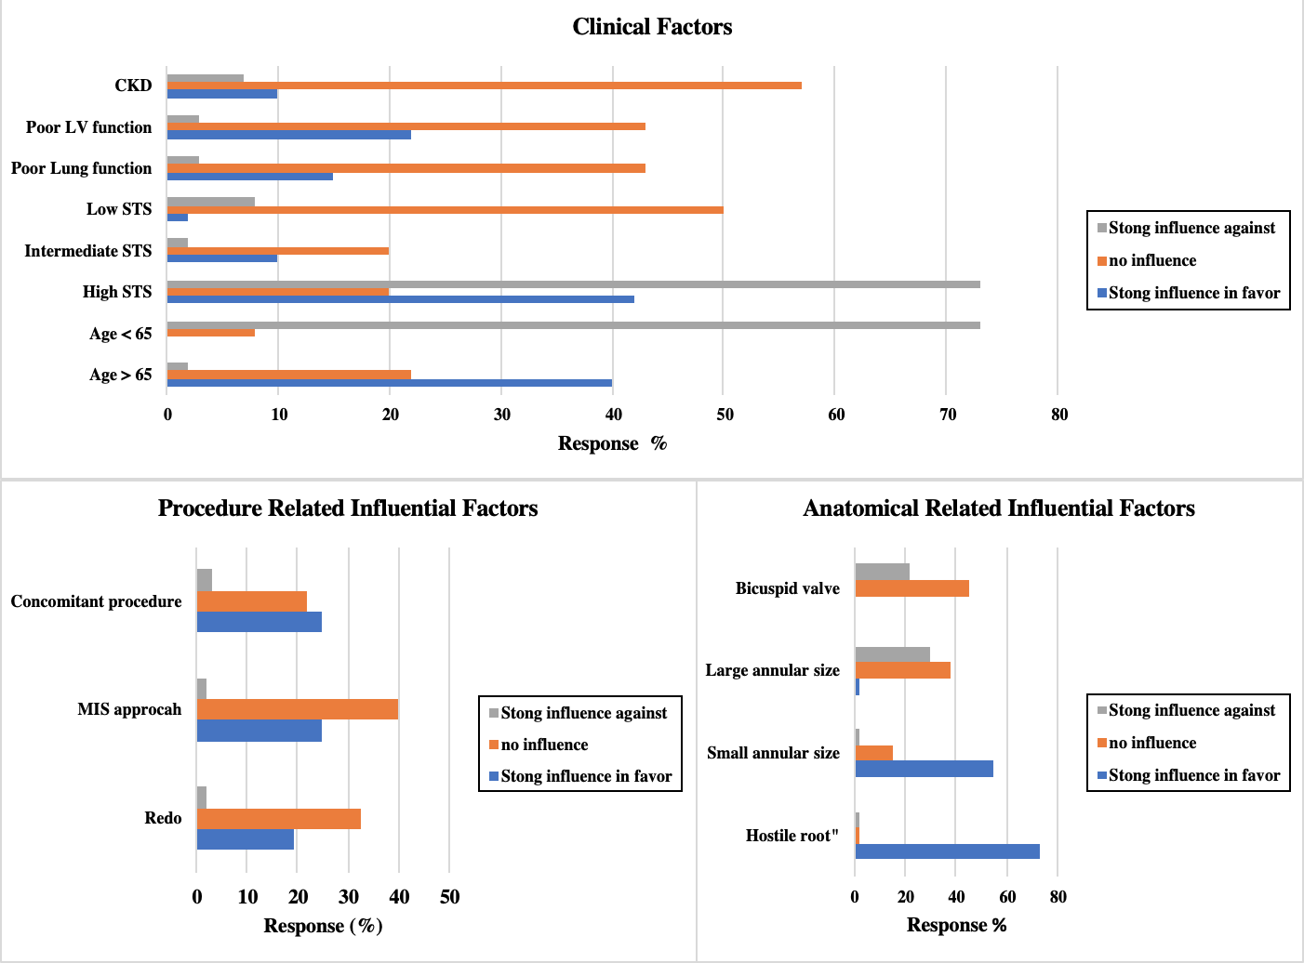
Fig. 1. Influential factors to use SuAVR

Barriers to Routine SuAVR Use:
Table 2 summarized the perceived influential barriers to SuAVR use. Cost, uncertain durability, and permanent pacemaker implantation risk were all reported to be barriers by over 50% of respondents.
Table 2
Perceived Influential Barriers to Use SuAVR in Canada
Barrier (%, n) | Strong influence in favor | Weak influence in favor | No influence | Weak influence against | Strong influence against
Cost | 10% (6) | 8 (5) | 10% (6) | 38% (23) | 33% (20)
Pacemaker Implantation | 3% (2) | 7 (4) | 27% (16) | 37 (22) | 27% (16)
Uncertain durability | 3% (2) | 12% (7) | 15% (9) | 50% (30) | 12% (20)

Future Research Directions
Majority (75%) of the respondents expressed an interest in participating in a trial comparing SuAVR and TAVR. Table 3 and figure 2 summarized the rating for the proposed primary outcomes for a trial comparing SuAVR vs. TAVR. Major Adverse Cardiac and Cerebrovascular Events (MACCE) and structural valve deterioration were all felt to be critical primary outcomes by over 50% of respondents.

Table 3
Rating of Proposed Primary Outcomes for a Trial Comparing SuAVR vs. TAVR
 | Critical | Important | Not important
MACCE | 78% (35) | 22% (10) | 0% (0)
Structural valve deterioration | 76% (34) | 20% (9) | 4% (2)
Permanent Pacemaker Implantation | 44% (20) | 47% (21) | 9% (4)
Quality of Life | 33% (15) | 62% (28) | 4% (2)
Life Threatening Bleeding | 33% (15) | 60% (27) | 7% (3)
Hospital length of stay | 20% (9) | 60% (27) | 20% (9)
Endocarditis | 20% (9) | 47% (21) | 33% (15)
Thrombosis | 18% (8) | 76% (34) | 7% (3)
Major bleeding | 16% (7) | 73% (33) | 11% (5)

Fig. 2. Rating of Proposed Primary Outcomes of a Trial Comparing SuAVR vs. TAVR as Critical, Important, or Not Important

Discussion

Presently, aortic valve replacement includes conventional sutured, transcatheter, and sutureless aortic valve replacement. However, information regarding current practice patterns and perceptions of SuAVR amongst Canadian cardiac surgeons is limited. Our study reports that surgeons are more likely to use SuAVR with patients who are higher surgical risk, older, have hostile root, small annulus, or are undergoing a re-operation. Understanding surgeons’ practice patterns and perceptions is important for the development of future randomized controlled trials.
Among patients with aortic valve disease, conventional sutured aortic valve replacement (SAVR) has demonstrated durability with excellent short- and long-term outcomes. A report published by the Society of Thoracic Surgeons (STS) database of over 100,000 patients from 1026 centers demonstrated a median survival of 13, 9, and 6 years for patients undergoing isolated SAVR aged 65-69, 70-79, and >80 years, respectively (Brennan et al.). However, amongst the oldest patients, which usually present with highest number of comorbidities, the perioperative risk of SAVR is often perceived to outweigh the potential long term benefits (Iung et al.). As such, TAVR has emerged as an alternative to SAVR. TAVR has shown non-inferior results in short- and mid-term outcomes in high, intermediate, and more recently, low risk patients compared to SAVR (Smith et al.; Leon, Smith, Mack, Makkar, Svensson, Kodali, Thourani, Tuzcu, Miller, Herrmann, Doshi, Cohen, Pichard, Kapadia, Dewey, Babaliaros, Szeto, Williams, Kereiakes, Zajarias, Greason, Whisenant, Hodson, Moses, Trento, D. L. Brown, Fearon, Pibarot, Hahn, Jaber, Anderson, Alu, and Webb; Mack et al.). As a consequence of recent data from randomized trials, TAVR has become an accepted alternative to SAVR in high and intermediate risk patients (Nishimura et al.). However, concerns still remain for the use of TAVR with studies suggesting higher risk for paravalvular leak (PVL) and pacemaker implantation, and no long-term studies evaluating long-term durability. The most recent low risk TAVR trials, PARTNER 3 and Evolut Low Risk Trial, showed a higher rate of mild PVL at one year in TAVR arm versus SAVR (PARTNER 3: 29.4% vs. 2.1%, Evolut Low Risk Trial: 33.3% vs. 7.6%). Moreover, the long-term durability of TAVR is also unknown and there is a lack of long term studies or results evaluating the durability of TAVR valves. It is expected that PARTNER 3 and Evolut Low Risk Trials will have a follow up to ten years which will be informative for durability. Regarding permanent pacemaker implantation, TAVR is associated with an increased rate estimated to be at 13% in a pooled analysis by Khatri et al (Khatri et al.).
SuAVR facilitates the use of a minimally invasive approach which may favor post-operative outcomes including shorter hospital length of stay, fewer respiratory complications, and lower incidence of renal failure (Phan et al.). SuAVR also offers excellent echocardiographic hemodynamics, with low transvalvular gradients and reduced risk of patient-prosthesis mismatch when compared to SAVR. Recent randomized controlled trial of 100 patients (SuAVR=50, SAVR=49) by Borger et al showed lower mean gradients in the SuAVR arm (8.5±3.4 vs. 10.3±4.8; P=0.04) and lower rate of patient-prosthesis mismatch (0% vs. 14.3%; P=0.01) (Borger et al.). Moreover, compared to TAVR, SuAVR showed lower rate of any degree of PVL in a pooled analysis of 16,432 patients by Lloyd et al (Lloyd et al.). In their study, SuAVR showed a reduction of mild PVL of 95% when compared to TAVR (OR 0.05, 95%CI, 0.02-0.09). However, whereas SuAVR demonstrates promising short and midterm results, it is associated with higher pacemaker rate and uncertain durability. Some studies (27,28) reported excellent durability and minimal valve deterioration at 5-year follow-up.
Our data highlights that surgeons favor SuAVR use in patients with “hostile roots”, small annular size, high STS score, aged more than 65 years, for ease of minimally invasive access, and redo operation. The design of SuAVR alleviates the need for passing sutures into a calcified annulus, which may decrease the risk of emboli to the cerebral circulation. In addition, sutureless aortic valves have no sewing ring, providing a larger effective orifice which may translate to better hemodynamics. In addition, a larger effective orifice area reduces the risk of patient prosthesis mismatch, which has been associated with poor short- and long-term outcomes (Guo et al.; Blais et al.). SuAVR yields a shorter cardiopulmonary bypass time, aortic cross clamp time, and overall operative time which may result in better outcomes (Ranucci et al.; Santarpino, Pfeiffer, Concistrè, and Theodor Fischlein). This becomes particularly advantageous in redo operations or operations with concomitant procedures. A study by Santaprino et al of 13 patients with redo valve surgery demonstrated a safe and fast and safe procedure as well excellent hemodynamics with mean transvalvular gradient of 10.3 ±1.5 mmhg (Santarpino, Pfeiffer, Concistrè, and Theodor Fischlein). SuAVR is ideal for minimally invasive approach as it requires less manipulation of the aortic root, producing shorter operative time as well as excellent postoperative outcomes when compared to full sternotomy SAVR. In a propensity score matched study of 342 patients (SuAVR=171, SAVR=171), minimally invasive SuAVR (MI-SuaVR) showed a significant reduction in cardiopulmonary bypass (69±20 min vs. 87±20 min; P=<0.001) and aortic cross clamp time (45±15 min vs. 65±15 min; P=<0.001) when compared to full sternotomy SAVR. Additionally, MI-SuAVR showed a significant reduction in blood transfusion when compared to full sternotomy SAVR (1.4±1.7 units vs. 2.4±2.7; P=<0.001)(Dalen et al.).

Barriers to Adopting SuAVR
Cost of the sutureless prostheses is felt to be a significant barrier given that SuAVR requires the similar operative resources as SAVR, and longer hospital and ICU stay compared to TAVR. However, Santarpino et al. showed that SuAVR was associated with lower cost compared to TAVR in a propensity score matched study of 204 patients. These results were mainly driven by the high TAVR device cost (Santarpino et al.). Povero et al. supported these outcomes in their cost-utility analysis by demonstrating SuAVR to be associated lower cost for both in- hospital and long-term costs when accounting for device costs (Povero et al.). In a propensity score matched analysis by Pollari et al. of 164 patients (SuAVR=82, SAVR=82), SuAVR reduced the overall total health care cost by 25%, which was largely driven by shorter intensive care unit and hospital length of stay in favor of SuAVR(Pollari et al.). Despite the favorable cost results for SuAVR, Canadian cardiac surgeons nevertheless found cost to be a barrier for its use. Limited funding for sutureless valves from hospitals may explain this barrier and the correspondingly lower extent of sutureless valve surgical adoption.
Increased risk of permanent pacemaker implantation (PPI) following SuAVR also was a barrier for surgical adoption. SuAVR has been associated with increased risk of PPI with an incidence of 8.5% in a pooled analysis of 30 observational studies (Lazkani et al.). To reduce the risk of PPI, some reports have introduced technical modifications to SuAVR: 1) implanting the valve at the nadir of each cusp (Yanagawa et al.; Theodor Fischlein et al.); 2) ensuring complete annular decalcification; and 3) maintaining coaxiality of the prosthesis with the aortic annulus during device deployment (Theodor Fischlein, Gersak, and Pfeiffer). This may be comparable to some TAVR approaches to reduce pacemaker implantation rate such as the new generation self-expanding transcatheter valve Evolut PRO in which the valve is implanted at a depth between 3-5mm below the native annulus. This technique has demonstrated a PPM rate of 11.8%, which is lower compared to other older TAVR valve generations(Forrest et al.). These reports however suffered from small sample sizes and were from single centers, and accordingly, whether these technical modifications reduce the risk of PPI has not been confirmed.
The long-term durability of sutureless aortic valves remains uncertain, similar to TAVR. Recent published studies with mid-term durability data showed excellent durability and minimal valve deterioration rate. Meuris et al. reported excellent 5 years follow up of SuAVR with no dislodgment or valve deterioration from the SuAVR trial arm including 30 patients (Meuris et al.). Shrestha et al. later supported these results in a large European registry of over 700 patients, demonstrating SuAVR to have neither valve degeneration, thrombosis, nor migration at 5 years follow-up (Shrestha, Theodore Fischlein, et al.). Despite the promising durability results of SuAVR, long term durability is still unknown for this considerably new technology, and as such, Canadian cardiac surgeons recognize it as a barrier for surgical use until future trials report long-term data.

Future Research Directions
Systematic reviews and meta-analyses of adjusted observational studies comparing SuAVR with SAVR and TAVR demonstrated favorable or comparable postoperative outcomes for SuAVR (Powell et al.; Meco, Montisci, et al.; Phan et al.). PERSIST-AVR is an ongoing large randomized controlled trial of 1234 patients with aortic stenosis comparing SuAVR with SAVR with a follow up to five years (www.clinicaltrials.gov Identifier: NCT02673697) (Lorusso et al.). When compared to TAVR, SuAVR showed comparable or superior results to TAVR in terms of paravalvular leak and bleeding complications in meta-analyses of adjusted observational studies (Meco, Montisci, et al.; Lloyd et al.). However, there are no randomized controlled trials comparing SuAVR with TAVR. Given the potential for favorable short- and long-term benefits of SuAVR over TAVR from previous propensity score matched studies, systematic reviews and meta-analyses, a trial comparing these implantation techniques is strongly warranted. This is supported with our surveyed surgeons, the majority of which advocated for conducting a future trial.

Strength and Limitations
This study has several strengths. We surveyed national cardiac surgeons who perform SuAVR procedure as part of their practice, which provided an insight into relative benefits and risks of the procedure from a practical standpoint. The response rate was excellent, considering that we only targeted surgeons with expertise in SuAVR and did not provide any incentives to participate. However, our study is not without limitations. Our results may not represent the opinion of the general cardiac surgery community, as the survey was directed toward all surgeons who perform SuAVR in Canada. Another limitation is that we were not able to define the routine use of SuAVR considering different surgeons have different caseloads and accordingly may have different definitions of routine SuAVR use.

Conclusion
While sutureless aortic valve replacement is gaining popularity in the cardiac surgery community, the evidence for its benefit and use is unclear. Amongst Canadian implanters, the cost of the sutureless devices, the uncertainty regarding long-term durability, and the elevated pacemaker risk are barriers to broader adoption creates a barrier to their adoption. There is interest amongst Canadian cardiac surgeons in a trial comparing SuAVR with TAVR.

Appendix 1: Survey questions
A: Surgeon and Center Data:

- Please enter your study ID:

- Which hospital do you work at?
- Academic.
- Community.
- Which procedures do you perform?
- Sutureless aortic valve replacement (SuVAR)
- Transcatheter aortic valve intervention (TAVR)
- Both.
- Number of years in practice:
- EXACT Number
- Number of conventional aortic valve surgeries that you performed this year:
- EXACT Number
- Number of sutureless aortic valve replacements that you performed this year:
- EXACT Number
- Number of transcatheter aortic valve intervention (TAVR) performed at your institution last year:
- EXACT Number

B: Factors Influencing the Use of SuAVR in Canada:
- Decision to perform sutureless aortic valve replacement is influenced by:
Influential factor | Strong influence in favor | Weak influence in favor | No influence | Weak influence against | Strong influence against
Old age > 65
Young age < 65
High STS score
Intermediate STS score
Low STS score
Small annular size
Large annular size
Hostile root
Concomitant procedure
Poor LV function
Poor lung function
Bicuspid aortic valve
Chronic renal failure
Minimally invasive approach
Redo operation

- Perceived barriers to adopt SuAVR in Canada:
Barrier | Strong influence in favor | Weak influence in favor | No influence | Weak influence against | Strong influence against
Cost
Durability
Pacemaker rate

- Which aortic valve replacement results in most favorable short term outcomes?
- Conventional aortic valve replacement through either full sternotomy or minimally invasive approach.
- Sutureless aortic valve replacement through either full sternotomy or minimally invasive approach.
- TAVR.

- Which aortic valve replacement results in most favorable long term outcomes?
- Conventional aortic valve replacement through either full sternotomy or minimally invasive approach.
- Sutureless aortic valve replacement through either full sternotomy or minimally invasive approach.
- TAVR.
C: Future research directions.
- Would you be interested to participate in a trial comparing sutureless aortic valve replacement versus TAVR?
- Yes.
- No.

- If yes, what should the primary outcome be? (please rate as Critical, Important, Not Important)
1ry outcome | Critical | Important | Not important
MACCE
Hospital length of stay
Permanent pacemaker insertion
Quality of life
Structural valve deterioration
Endocarditis
Thrombosis
Life threatening bleeding
Major bleeding

Chapter 3:

Outcomes of Sutureless Aortic Valve Replacement versus Conventional Aortic Valve Replacement and Trans- catheter Aortic Valve Replacement, Systematic Review and Meta-analysis.

Outcomes of Sutureless Aortic Valve Replacement versus Conventional Aortic Valve Replacement and Trans catheter Aortic Valve Replacement, Systematic Review and Meta-analysis.

Ahmad Makhdoum^{1,2}, Alex Koziarz², Saurabh Gupta^{1,5}, Ali Alsagheir⁵, Arjun Pandey¹, Seleman Reza¹, Kevin Um¹, Emilie Belley-Cote¹, Kevin Teoh³, Waleed Alhazzani^{1,4}, Andre Lamy¹, Bobby Yanagawa², Richard Whitlock^{1,5}

- Population Research Health Institute, McMaster University, Hamilton, Canada.
- Division of Cardiac Surgery, St. Michael’s Hospital, University of Toronto, Toronto, Canada.
- Southlake Regional Health Sciences Centre, Newmarket, Ontario, Canada.
- Division of Critical Care, Department of Medicine, McMaster University, Hamilton, Ontario, Canada.
- Division of Cardiac Surgery, Department of Surgery, McMaster University, Hamilton, Ontario, Canada.

Corresponding Author:
Richard P Whitlock, MD, PhD
David Braley Cardiac, Vascular and Stroke Research Institute
Room 1C1-5B, 237 Barton Street East,
Hamilton Ontario L8L 2X2
Phone: 905 527 4322 ext. 40306
Email: Richard.Whitlock@phri.ca

Key words: Aortic stenosis, Sutureless aortic valve replacement, Perceval

Acknowledgments: None.

Financial Support: We conducted this study without financial support. Dr. Whitlock is supported by a mid-career award from the Heart and Stroke Foundation of Canada.

Conflict of Interests: None.

Abstract

Background
Sutureless aortic valve replacement (SuaVR) is a feasible alternative to conventional aortic replacement (SAVR) and transcatheter aortic valve replacement (TAVR). The aim of this study is to compare the effectiveness of the SuAVR versus SAVR, and SuAVR versus TAVR.

Methods/Results
We searched MEDLINE and EMBASE from inception to August 2018 for observational studies evaluating SuAVR, SAVR, and TAVR in adult patients with aortic stenosis. Independently and in duplicate, we performed screening, full-text assessment, risk of bias evaluation using the CLARITY tool. We pooled data using a random-effects model. We evaluated the quality of evidence using the GRADE framework. Of the references, 51 studies including 8688 participants (SuAVR versus SAVR= 7378; SuAVR versus TAVR= 1310) conducted between 2012 and 2018 were included. Overall, studies were judged to be at unclear risk of bias. Compared to SAVR and TAVR, SuAVR was associated with similar postoperative mean transvalvular gradients (mean difference ]MD[= -1.02; 95% CI, -2.56 to 0.51; p=0.19) and (MD=0.50; 95% CI -0.27 to 1.28, p= 0.20) respectively. Compared to TAVR, SuAVR showed a significant reduction in mortality at 30 days (odds ratio (OR): 0.36; 95% CI, 0.17 to 0.73; P=0.005) and 2 years (OR: 0.39, 95 CI, 0.17 to 0.88; P=0.003). In a subgroup analysis of studies comparing SuAVR versus TAVR in high risk and intermediate risk patients, a reduction in mortality by SuAVR did not reach statistical significance (OR: 0.16; 95% CI, 0.02 to 1.35; p=0.09; I²=0) and (OR= 0.76; 95% CI, 0.32 to 1.82; p=0.54, I²=0%; p-interaction between groups=0.18) respectively. Compared to TAVR, SuAVR showed significant reduction in mild (OR=0.09; 95% CI, 0.03 to 0.26, p=<0.0001) and moderate paravalvular leaks (OR=0.11, 95% CI, 0.02 to 0.61, p=0.01). Compared to SAVR, SuAVR showed a similar reduction in mortality at 30 days (OR: 1.01, 95 % CI, 0.72 to 1.42, P=0.93) and at 2 years (OR: 0.99, 95 % CI, 0.43 to 2.30, P= 0.30). These results were rated low to very quality of evidence using the GRADE framework.

Conclusion
While the use of sutureless aortic valves is increasing with similar short and midterm outcomes compared to TAVR and SAVR, the quality of evidence supporting its utilization is low, even with matched patients. Comparative randomized data with long term follow up is required to elucidate the role of SuAVR.

Introduction
Aortic stenosis (AS) is the most common valvular disorder. The incidence of AS escalates as the age increases, with life expectancy reduced in symptomatic patients(Carabello and Paulus). Symptomatic AS carries high mortality of 50% within 2 years if left untreated(Authors/Task Force Members et al.). Conventional aortic valve replacement (SAVR) through a median sternotomy has long been the standard for severe aortic stenosis with documented improvement in survival(J. M. Brown et al.). However, 30% of patients remain unsuitable for SAVR due to advanced age, comorbidities and left ventricular dysfunction(Varadarajan et al.). Advances in technology have led to less invasive treatment methods, namely transcatheter aortic valve replacement (TAVR) and sutureless aortic valve replacement (SuVAR). TAVR has emerged as an acceptable alternative to SAVR in high risk (STS score >8) or inoperable patients(Nishimura et al.). Recently, transcatheter aortic valve replacement (TAVR) has emerged as a less invasive treatment for high, intermediate, and low risk patients with non-inferior results compared to SAVR(Reardon et al.; Popma et al.). However, TAVR is associated with increased rates of paravalvular leaks and vascular complications when compared to SAVR(Leon, Smith, Mack, Makkar, Svensson, Kodali, Thourani, Tuzcu, Miller, Herrmann, Doshi, Cohen, Pichard, Kapadia, Dewey, Babaliaros, Szeto, Williams, Kereiakes, Zajarias, Greason, Whisenant, Hodson, Moses, Trento, D. L. Brown, Fearon, Pibarot, Hahn, Jaber, Anderson, Alu, and Webb). To fill the gaps between SAVR and TAVR, SuVAR has been developed to help overcome the drawbacks of TAVR and SAVR. SuAVR reduces aortic cross clamp (AXC) and cardiopulmonary bypass time (CPB), and has favorable hemodynamics when compared to SAVR (Powell et al.). SuAVR also facilitates the role of minimally invasive surgery approach by further reducing aortic cross clamp time, cardiopulmonary bypass time and thus operative time. When compared to TAVR, studies suggest better outcomes in 30-day mortality, stroke and post procedural aortic regurgitation with SuAVR(Meco, Miceli, et al.). These results are compelling to consider SuAVR as an alternative to TAVR and SAVR. However, there are no randomized clinical trials to confirm the relative effectiveness of SuAVR versus TAVR. Therefore, we aim to perform systematic review and meta-analysis of observational studies to compare the outcomes between SuAVR versus SAVR and SuAVR versus TAVR.

Methods
This systematic review and meta-analysis protocol is registered with the PROSPERO database (Registration number: CRD42018115738).
We included observational studies comparing sutureless aortic valve replacement (SuAVR) versus conventional aortic valve replacement (SAVR) or TAVR. Non-comparative studies, reviews, case series, case reports, and animal studies were excluded. No language or publication status constraints were placed on the studies. When necessary, we contacted the authors to retrieve any relevant data.
The population of interest included all adult patients (18 years old of age or older) undergoing aortic valve replacement. The intervention of interest was the implantation of sutureless aortic valve replacement (SuAVR). The comparator population included patients undergoing either conventional aortic valve replacement (SAVR) or transcatheter aortic valve replacement (TAVR).
Outcomes included all-cause mortality entailing short (30 days) and midterm (up to two years), stroke, myocardial infarction, acute kidney injury, need for permanent pacemaker implantation, paravalvular leak intensive care unit stay, hospital length of stay, postoperative aortic valve mean gradient, cardiopulmonary bypass time, and cross clamp time.

Literature search
We performed systematic review and meta-analysis in accordance to the standards by the PRISMA guidelines (Preferred Reporting Items for Systematic Reviews and Meta-Analyses)(Moher et al.). The Ovid version of two databases, MEDLINE and EMBASE were searched for articles published between 1946 to August 2018 (Appendix 1). We used several keywords describing the condition, the intervention, and the comparator were used. We extended our search to the references of the selected studies, as well as any previous systematic review of the topic, for all potentially relevant publication. Additionally, we reviewed the conference and meeting proceedings from the American Heart Association (AHA), American Association for Thoracic Surgery (AATS), European Society of Cardiology (ESC), European Association for Cardio-Thoracic Surgery (EACTS), and Society of thoracic Surgeons (STS) for the period 2016-2017. Finally, we contacted expert cardiac surgeons to see if they were aware of any other relevant studies. The search strategy was fully reviewed by librarian with experience conducting searched for systematic reviews.
Six authors independently screened studies and extracted data in duplicate using the Covidence systematic review software (Veritas Health Innovation, Melbourne, Australia). Any differences or disagreements were resolved by discussion and consensus, with a third reviewer involved, if necessary. We contacted the study authors to clarify any ambiguities in study design or potentially missing data not published in the main study.
Two reviewers independently assessed the risk of bias for each included study using the CLARITY tool “Clinical Advances through Research and Information Technology” developed at McMaster University (available at https://distillercer.com/resources/). Studies were assessed for the selection of the intervention and control group, assessment exposure, variable matching, presence or absence of prognostic factors, outcome assessment, and adequacy of follow-up. The risk of bias for each study was categorized as follows: 1) low risk of bias, in which bias is not present, or if present, unlikely to affect the specific outcome; 2) high risk of bias, in which at least one domain assessed is likely to affect the outcome; and 3) unclear risk of bias, in which there is inadequate reported information to properly assess bias or it is unclear how much the risk of bias may affect the outcome.

Measures of treatment effect/ Data analysis
Point estimated were presented as the odds ratio (OR) for dichotomous outcomes and mean difference (MD) or standardized mean difference (SMD) for continuous outcomes, with corresponding 95% confidence intervals (CIs).
We first evaluated the relative clinical and methodological heterogeneity of each study to determine if pooling was appropriate, which included assessing the patient population, intervention, comparator, and outcomes of each study. We pooled the results of the studies using the meta-analysis software Review Manager 5.3 (The Nordic Cochrane Centre, The Cochrane Collaboration, Copenhagen, Denmark). Expecting the studies to display heterogeneity in their design, we used random-effects meta-analysis with the Dersimonian and Laird method to pool relevant study results (DerSimonian and Laird).

Assessment of heterogeneity
The heterogeneity between pooled trials was assessed using the combination of a visual inspection of the graphs along with consideration of the chi-squared test (with statistical significance set at p < 0.10) and the I² statistic (Higgins).

Subgroup analysis/Sensitivity analysis
We defined the following subgroup analysis a priori to explore any possible heterogeneity within the results: high risk versus intermediate risk patients (defined by STS criteria) for the outcome of mortality at final follow-up.

Assessment of the certainty of the evidence
The Grading of Recommendations Assessment, Development and Evaluation (GRADE) approach was used to assess the quality of the evidence for each of the reported outcomes(Guyatt et al.) according to the following criteria: 1) risk of bias; 2) indirectness; 3) inconsistency; 4) imprecision; and 5) publication bias. The final overall quality of the evidence was summarized as very low, low, moderate, or high risk of bias with a “Summary of Findings” table constructed using GRADEpro software (McMaster University, Hamilton, Ontario, Canada) per outcome.

Results

Search Results
A total of 1489 citations for title and abstract screening (Figure 1). Of these, a total of 51 observational studies were included in the final analysis (Tables 1A, 2A, 1B, 2B). Concerning SuAVR versus SAVR, 25 studies were adjusted observational studies (Repossini et al.; D'Onofrio, Rizzoli, et al.; Muneretto et al.; Ensminger et al. ,Nguyen et al.; Wahlers et al.; Belluschi et al., Rubino et al.,Mignosa; Glauber et al., Miceli; Dalen et al.; Forcillo et al.; Andreas et al.; Bruno, Farina, et al.; Pollari et al.; Gilmanov et al.; Rahmanian, Kaya, et al.; Sanchez et al.; Hanedan, Yuruk, et al.; Shalabi et al.; Pfeiffer et al.; Laborde et al.) and 15 unadjusted observational studies (Mujtaba et al.; Konertz et al.; Ferrari et al.; Bening et al.; Ihsan Parlar et al.; Santarpino, Pfeiffer, Concistrè, Grossmann, et al.; König et al.; Vola et al.; Albacker; Ghoneim et al.). Of the adjusted studies , 19 reported mortality, 12 reported aortic cross clamp time (ACX), 10 reported cardiopulmonary bypass time (CPB), 13 reported stroke rate, 14 reported permanent pacemaker implantation (PPI), 8 reported acute kidney injury (AKI), 10 reported post-operative aortic mean gradients, and 6 studies reported paravalvular leak (PVL) rate. Of the unadjusted studies, 10 reported mortality, 11 reported ACX time, 10 reported CPB time, 7 reported stroke rate, 8 reported PPI rate, 6 reported AKI, 5 reported post-operative aortic mean gradient, and 4 reported PVL rate. Concerning SuAVR versus TAVR, 7 studies were adjusted studies (Kamperidis et al.; Bruno, Di Cesare, et al.; Santarpino, Vogt, et al.; Biancari et al.; D'Onofrio, Salizzoni, et al.; Santarpino, Pfeiffer, Jessl, Dell'Aquila, Pollari, et al.; D'Onofrio, Messina, et al.; Repossini et al.) and 4 were unadjusted studies (Dionne et al.; Doss et al.). Of the adjusted studies, 7 reported mortality, 7 reported stroke rate, 6 reported PPI, 6 reported AKI, 4 reported postoperative aortic mean gradients, and 3 reported PVL. Of the unadjusted studies, 2 reported mortality, 1 reported stroke rate, 3 reported PPI, 3 reported post-operative aortic mean gradients, and 3 reported PVL rate.
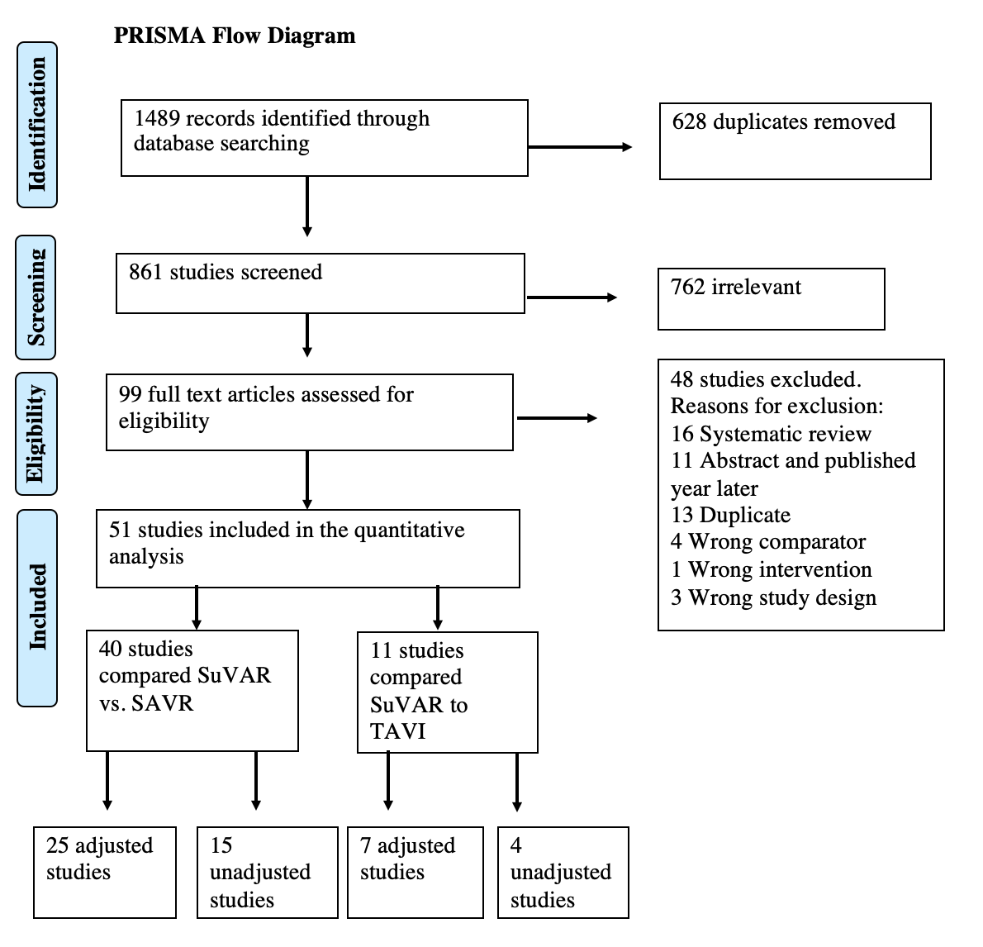
Fig. 1. A PRISMA schematic of search strategy. PRISMA: Preferred Reporting Items for Systematic Reviews and Meta-Analyses.

Mortality

SuAVR versus SAVR.
Adjusted studies: We pooled the date from 19 adjusted observational studies(Andreas et al.; Belluschi et al.; Dalen et al.; D'Onofrio, Rizzoli, et al.; Ensminger et al.; Forcillo et al.; Gilmanov et al.; Glauber, Gilmanov, et al.; Hanedan, Yuruk, et al.; Muneretto et al.; Nguyen et al.; Pollari et al.; Rahmanian, Kaya, et al.; Repossini et al.; Sanchez et al.; Santarpino, Pfeiffer, Concistrè, Grossmann, et al.; Wahlers et al.). These studies included 6156 participants (SuAVR= 2846, SAVR= 3310). The 30-day and 2 years mortality were similar between the two groups (30 days: OR: 1.01; 95% CI, 0.72 to 1.42; p=0.93; I²=0%, very low quality of evidence) and (OR=0.99; 95% CI, 0.43 to 2.30, p=0.98, I²=7%; very low quality of evidence). The quality of evidence was downgraded due to imprecision and serious risk of bias.
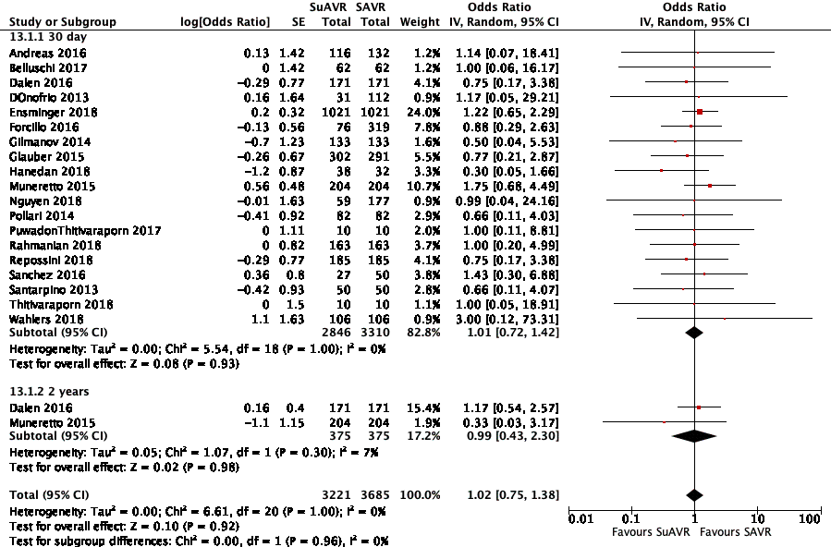
Fig. 2A. Adjusted studies (SuAVR versus SAVR), 30-day and 2 years mortality.

Unadjusted studies: 9 studies reported the mortality outcome (Beckmann et al.; Bening et al.; Ferrari et al.; Ghoneim et al.; Ihsan Parlar et al.; König et al.; Mujtaba et al.; Vola et al.). These studies included 1222 participants (SuAVR= 414, SAVR=808). SuAVR was associated with a similar 30-day mortality when compared to SAVR (RR= 1.14; 95% CI, 0.59 to 2.20, p=0.69, I²=0%)
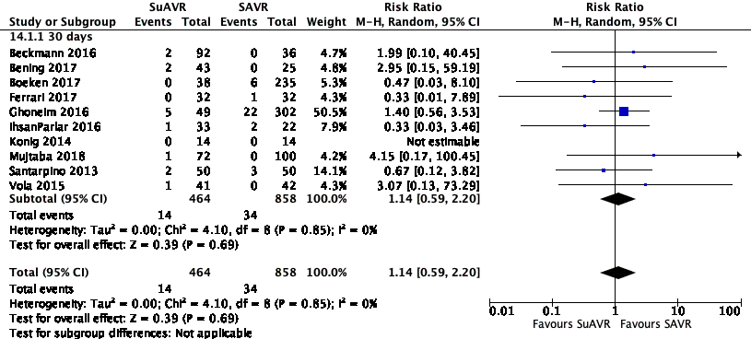
Fig. 2B. Unadjusted studies (SuAVR versus SAVR)- 30-day mortality.
SuAVR versus TAVR
Adjusted studies. Seven studies reported 30-day and 2-year mortality (Biancari et al.; Bruno, Di Cesare, et al.; D'Onofrio, Messina, et al.; Repossini et al.; Santarpino, Pfeiffer, Jessl, Dell'Aquila, Pollari, et al.; Santarpino, Vogt, et al.). These studies included 1086 patients (SuAVR= 543, TAVR=543). SuAVR was associated with a significant reduction in 30 days (OR: 0.36; 95 CI %, 0.17 to 0.73, p=0.005, I²=0%, low quality of evidence) and 2 years mortality (OR:0.39, 95 %CI, 0.17 to 0.88, p=0.02, I²=0%, low quality of evidence) when compared to TAVR. The quality of evidence was downgraded due imprecision. In a subgroup analysis of studies comparing SuAVR versus TAVR in high risk and intermediate risk patients (Figure 2D), SuAVR was associated with similar numerical reduction in high risk and intermediate patients when compared to TAVR, but these did not reach statistical significance (OR: 0.16; 95% CI, 0.02 to 1.35; p=0.09; I²=0) and (OR= 0.76; 95% CI, 0.32 to 1.82; p=0.54, I²=0%; p-interaction between groups=0.18) respectively.
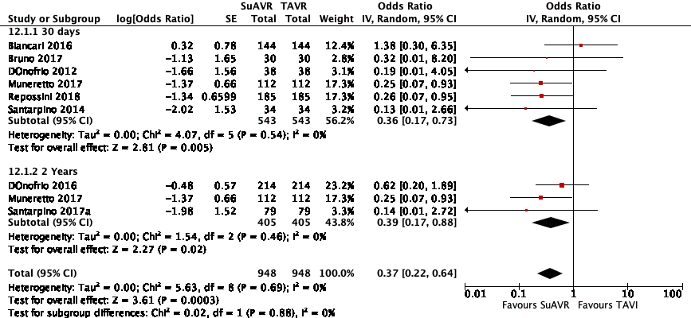
Fig. 2C. Adjusted studies (SuAVR versus TAVR), 30-day and 2-year mortality
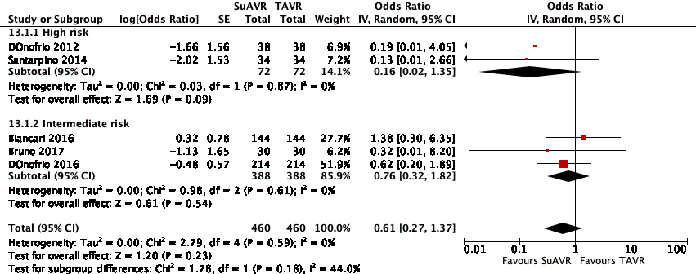
Fig. 2D. Subgroup analysis- high risk versus intermediate (SuAVR versus TAVR), mortality.
Unadjusted studies: Two studies reported 30-day mortality(Doss et al., Grefer et al.) These studies included 224 (SuAVR= 61, TAVR=163). In these studies, SuAVR was not found to be statistically different than TAVR (RR=0.56, 95% CI, 0.18 to 1.69, p=0.30, I²=0%).

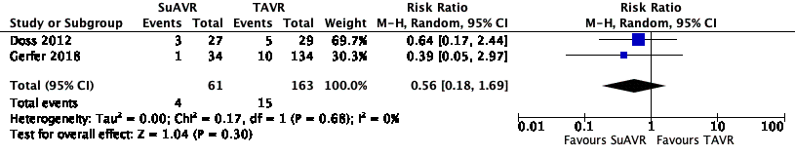
Fig. 2E. Unadjusted studies (SuAVR versus TAVR)-mortality:

Stroke

SuAVR versus SAVR.
Adjusted studies: Thirteen studies reported stroke rate (Andreas et al.; Dalen et al.; Ensminger et al.; Forcillo et al.; Gilmanov et al.; Glauber and Miceli; Nguyen et al.; Pollari et al.; Rahmanian, Kaya, et al.; Repossini et al.; Sanchez et al.; Wahlers et al.) and Thitivaraporn et al. These studies included 5291 participants (SuAVR=2451, SAVR=2840). In these studies, SuAVR was not found to be statistically different than SAVR (OR: 1.20; 95% CI, 0.77 to 1.87, p=0.42, I²=13%, very low quality of evidence). The quality of evidence was downgraded due serious risk of bias and imprecision.
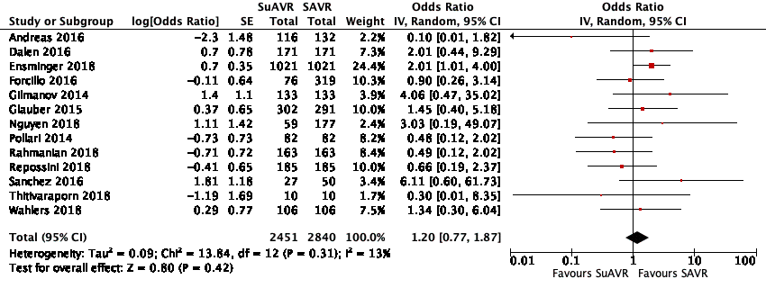
Fig. 3A. Adjusted studies (SuAVR versus SAVR)-Stroke.
Unadjusted studies: Seven studies reported stroke rate(Bening et al.; Ferrari et al.; Ghoneim et al.; Ihsan Parlar et al.; König et al.), Boeken et al. and Villa et al. These studies included 1070 patients (SuAVR=322, SAVR=748). In these studies, SuAVR was not found to be statistically different than SAVR (OR=1.85; 95% CI, 0.69 to 4.99, p=0.22, I²=38%).
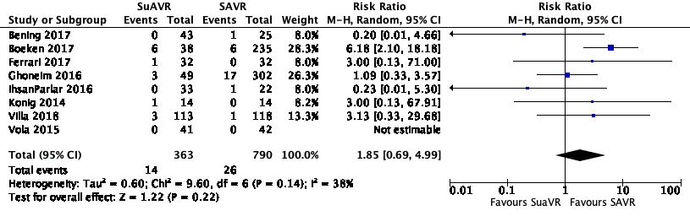
Fig. 3B. Unadjusted studies (SuAVR versus SAVR).
SuAVR versus TAVR.
Adjusted studies: Six studies reported stroke rate(Biancari et al.; Bruno, Di Cesare, et al.; D'Onofrio, Salizzoni, et al.; Kamperidis et al.; Repossini et al.; Santarpino, Pfeiffer, Jessl, Dell'Aquila, Pollari, et al.). These studies included 1300 participants (SuAVR=650, TAVR=650). In these studies, SuAVR was not found to be statistically different than TAVR (OR: 0.77, 95% CI, 0.37 to 1.61, p=0.49, I²=0%, very low quality of evidence). The quality of evidence was downgraded due to risk of bias and imprecision.
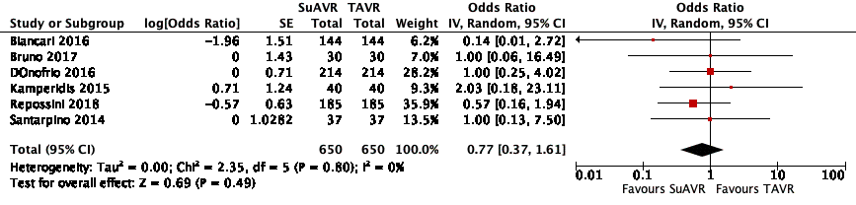
Fig. 3C. Adjusted studies (SuAVR versus TAVR)-stroke.

Unadjusted studies: One study by Gerfer et al. reported stroke rate. This study included 168 patients (SuAVR=34, TAVR=134). In this study, SuAVR was associated with non-significant increase in stroke rate when compared to TAVR (RR: 1.97; 95% CI, 0.18 to 21.10, p=0.57).

Permanent pacemaker implantation (PPI)

SuAVR versus SAVR.
Adjusted studies: Fourteen studies reported PPI rate (Andreas et al.; Dalen et al.; D'Onofrio, Rizzoli, et al.; Ensminger et al.; Forcillo et al.; Gilmanov et al.; Glauber, Moten, et al.; Muneretto et al.; Nguyen et al.; Pollari et al.; Rahmanian, Kaya, et al.; Repossini et al.; Sanchez et al.; Wahlers et al.). These studies included 5822 patients (SuAVR=2676, SAVR=3146). SuAVR was associated with a significant increase in PPI when compared to SAVR (OR=2.45, 95% CI, 1.93 to 3.10, p=<0.0001, I²=0%, very low quality of evidence). The quality of evidence was downgraded due to serious risk of bias and imprecision.
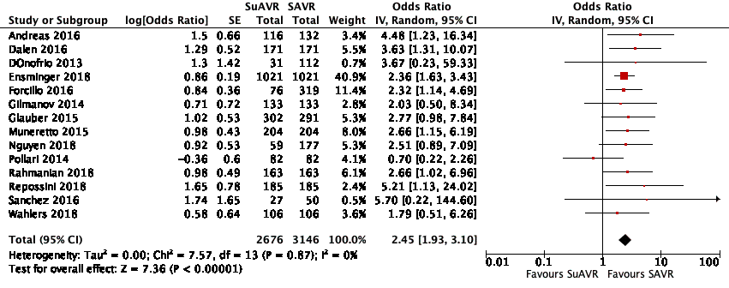
Fig. 4A. Adjusted studies (SuAVR versus SAVR), permanent pacemaker implantation.
Unadjusted studies: Eight studies reported PPI rate (Beckmann et al.; Bening et al.; Ferrari et al.; Ghoneim et al.; Villa et al.; Vola et al.), Boeken et al., and Minami et al. These studies included 1302 participants (SuAVR=460, SAVR=842). In these studies, SuAVR was associated with a significant increase in PPI (RR= 2.48; 95% CI, 1.51 to 4.07; p=0.65, I²=0%).
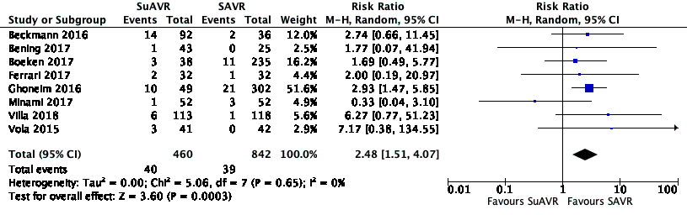
Fig. 4B. Unadjusted studies (SuAVR versus SAVR), permanent pacemaker implantation.

SuAVR versus TAVR.
Adjusted studies. Six studies reported PPI rate (Biancari et al.; Bruno, Di Cesare, et al.; D'Onofrio, Salizzoni, et al.; Muneretto et al.; Repossini et al.; Santarpino, Pfeiffer, Jessl, Dell'Aquila, Pollari, et al.). These studies included 1328 patients (SuAVR= 663, TAVR= 665). In these studies, SuAVR was not found to be statistically different than TAVR (OR:0.63, 95% CI, 0.28 to 1.40, p=0.25, I²=76%, very low quality of evidence). The quality of evidence was downgraded due to serious risk of bias, inconsistency, and imprecision.
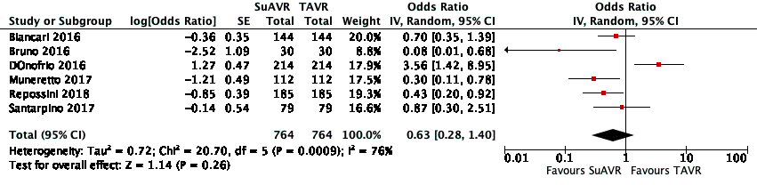
Fig. 4C. Adjusted studies (SuAVR versus TAVR), permanent pacemaker implantation.

Unadjusted studies: Three studies reported on PPI (Gerfer et al., Lacovelli, Doss et al. )reported PPI rate. These studies included 409 participants (SuAVR=108, TAVR=301). In these studies, SuAVR was not found to be statistically different than TAVR (RR=1.51, 95% CI, 0.54 to 4.18, p=0.43, I²=24%).
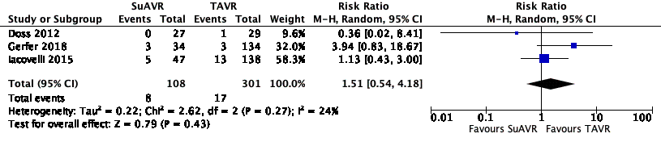
Fig. 4D. Unadjusted studies (SuAVR versus TAVR), permanent pacemaker implantation.

Acute Kidney Injury

SuAVR versus SAVR.
Adjusted studies: Ten studies reported Acute Kidney Injusry (AKI) rate (Belluschi et al.; Forcillo et al.; Glauber and Miceli; MD et al.; Nguyen et al.; Repossini et al.; Wahlers et al.; Gilmanov et al.; Ensminger et al.). These studies included 4988 patients (SuAVR=2319, SAVR=2669). SuAVR did not demonstrate statistical difference than SAVR (OR=0.81, 95% CI, 0.48 to 1.39, p=0.45, I²=70%). The quality of evidence was downgraded due to serious risk of bias, inconsistency, and imprecision.
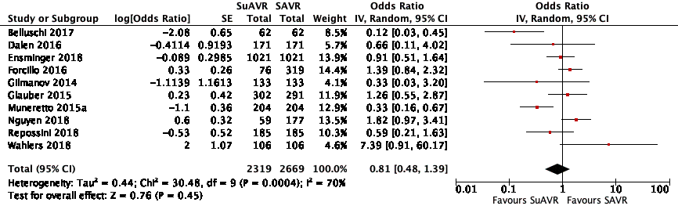
Fig. 5A. Adjusted studies (SuAVR versus SAVR), acute kidney injury.

Unadjusted studies: Six studies including Villa et al. reported AKI (Ferrari et al.; Ghoneim et al.; Ihsan Parlar et al.; Mujtaba et al.; Vola et al.). These studies included 1547 patients (SuAVR=407, SAVR=1140). In these studies, SuAVR was not found to be statistically different than SAVR (OR= 0.89, 95% CI, 0.63 to 1.27, p=0.54, I²=0%).
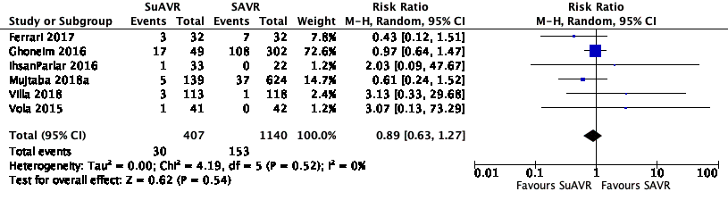
Fig. 5B. Unadjusted studies (SuAVR versus SAVR), acute kidney injury.
SuAVR versus TAVR.
Adjusted studies: Six studies reported AKI rate (Bruno, Di Cesare, et al.; D'Onofrio, Messina, et al.; Kamperidis et al.; MD et al.; Repossini et al.; Santarpino, Pfeiffer, Jessl, Dell'Aquila, Pollari, et al.). These studies included 768 participants (SuAVR=383, TAVR=385). In these studies, SuAVR was associated with significant reduction in AKI when compared to TAVR (0.50; 95% CI, 0.27 to 0.91, p= 0.02, I²=0%, low quality of evidence). The quality of evidence was considered low due to imprecision.
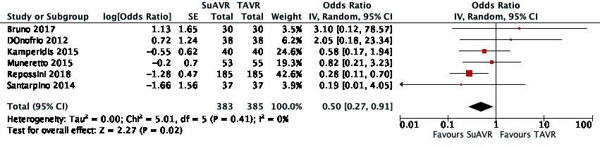
Fig. 5C. Adjusted studies (SuAVR versus TAVR), acute kidney injury.
Unadjusted studies: There were no unadjusted studies reporting this outcome.

Post-operative Aortic Valve Mean Gradient

SuAVR versus SAVR
Adjusted studies: Twelve studies reported Post-operative aortic valve mean gradient (POMG) (Andreas et al.; Belluschi et al.; Bruno, Farina, et al.; D'Onofrio, Rizzoli, et al.; Ensminger et al.; Forcillo et al.; Hanedan, Yuruk, et al.; Nguyen et al.; Rahmanian, Kaya, et al.; Repossini et al.; MD et al.; Shrestha, Maeding, et al.). These studies included 4542 patients (SuAVR=2035, SAVR=2507). In these studies, SuAVR was not found to be statistically different than SAVR (MD= -1.02; 95% CI, -2.56 to 0.51; p=0.19, I²=96%, very low quality of evidence). The quality of evidence was downgraded due to serious risk of bias, inconsistency, and imprecision.
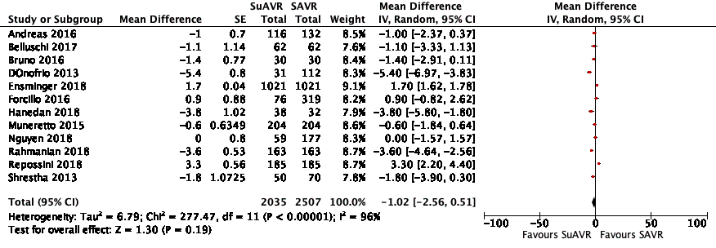
Fig. 6A. Adjusted studies (SuAVR versus SAVR), post-operative mean gradient.
Unadjusted studies: Five studies including Ahmadov et al. and Konig et al. reported POMG (Beckmann et al.; Ghoneim et al.; Vola et al.). These studies included 572 participants (SuAVR=182, SAVR=390). In these studies, SuAVR was not found to be statistically different than SAVR (MD= -1.35; 95% CI, -4.68 to 1.98, p=0.43, I²= 89%).
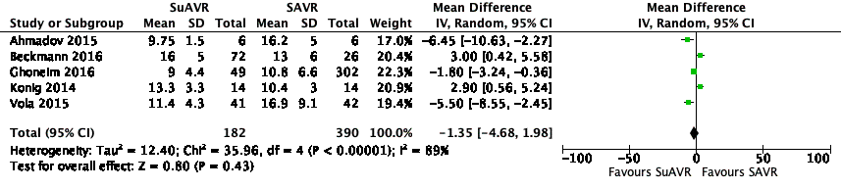
Fig. 6B. Unadjusted studies (SuAVR versus SAVR). Post-operative mean gradient
SuAVR versus TAVR.
Adjusted studies. Four studies reported POMG (Bruno, Di Cesare, et al.; MD et al.; Kamperidis et al.; D'Onofrio, Salizzoni, et al.). These studies included 676 patients (SuAVR= 337, SAVR= 339). In these studies, SuAVR was not found to be statistically different than TAVR (MD=0.50; 95% CI -0.27 to 1.28, p= 0.20, I²=0%, low quality of evidence). The quality of evidence was downgraded due to serious risk of bias.
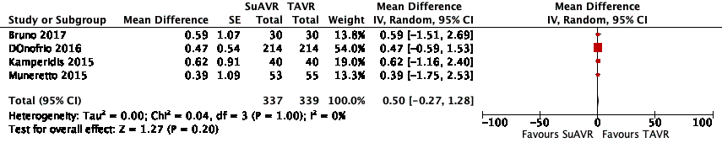
Fig. 6C. Adjusted studies (SuAVR versus TAVR), post-operative mean gradient.
Unadjusted studies.
Three studies reported on POMG (Doss et al., Gerfer et al., Lacovelli et al.). These studies included 409 (SuAVR= 108, TAVR= 301). In these studies, SuAVR was associated with an increase in POMG when compared to TAVR (MD= 2.17, 95% CI= 0.42 to 3.92, p=0.01, I²= 49%).
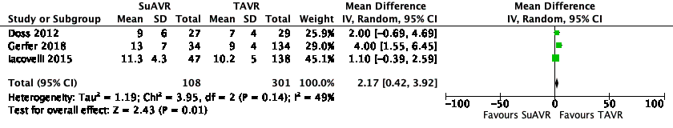
Fig. 6D. Unadjusted studies (SuAVR versus TAVR), post-operative mean gradient.

Paravalvular Leak

SuAVR versus SAVR.
Adjusted studies. Six studies reported Paravalvular leak (PVL) rate as mild or moderate (Andreas et al.; Bruno, Farina, et al.; Dalen et al.; D'Onofrio, Rizzoli, et al.; Ensminger et al.; Nguyen et al.). These studies included 3071 participants (SuAVR= 1428, SAVR=1643). For the included studies, SuAVR did not demonstrate statistical difference than SAVR (mild: OR= 2.70, 95% CI, 0.91 to 8.01, p=0.07, I²=35%; moderate: OR=1.71, 95% CI, 0.42 to 6.95, p=0.46, I²= 26%). The quality of evidence was considered very low due to serious of bias and imprecision.
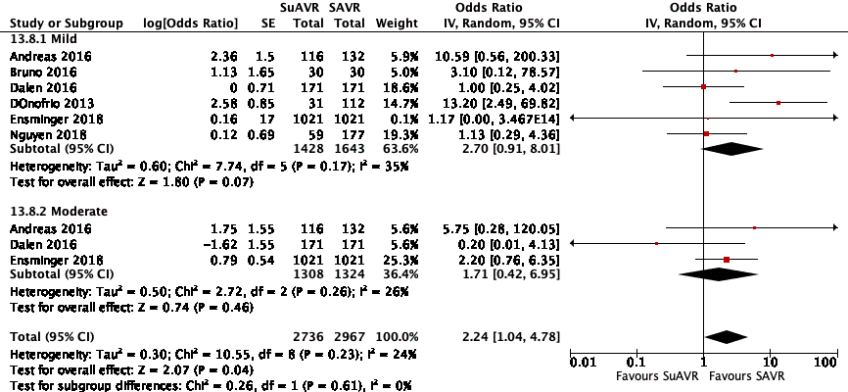
Fig. 7A. Adjusted studies (SuAVR versus SAVR), paravalvular leak.
Unadjusted studies. Four studies including Konig et al. reported mild PVL rate(Albacker; Ghoneim et al.; Vola et al.). These studies included 490 patients (SuAVR=111, SAVR= 380). In the included studies, SuAVR was associated with significant increase in mild PVL risk when compared to SAVR (RR=2.95; 95% CI, 1.50 to 5.79, p=0.002, I²=0%).
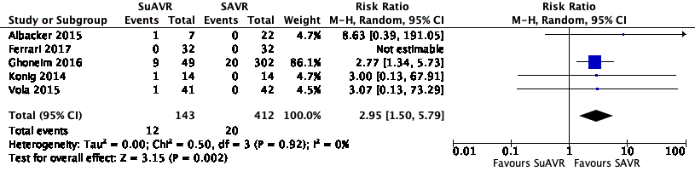
Fig. 7B. Unadjusted studies (SuAVR versus SAVR), paravalvular leak.
SuAVR versus TAVR.
Adjusted studies. Three studies reported PVL rate(Bruno, Di Cesare, et al.; D'Onofrio, Salizzoni, et al.; Santarpino, Vogt, et al.). these studies included 646 participants (SuAVR=323, TAVR=323). In these studies, SuAVR was associated with significant reduction in mild and moderate PVL respectively when compared to TAVR (OR=0.09; 95% CI, 0.03 to 0.26, p=<0.0001, I²=44%) and (OR=0.11, 95% CI, 0.02 to 0.61, p=0.01, I²=0%). The quality of evidence was considered very low due to serious risk of bias and imprecision.
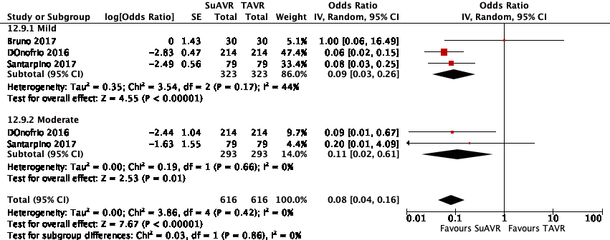
Figure. 7C. Adjusted studies (SuAVR versus TAVR), paravalvular leak.
Unadjusted studies. Two studies reported PVL rate(Doss et al., Gerfer et al.). These studies included 224 patients (SuAVR=61, TAVR=163). In these studies, SuAVR was associated with an overall significant reduction in PVL when compared to TAVR (RR=0.11; 95% CI, 0.03 to 0.45, p=0.002, I²=0%).
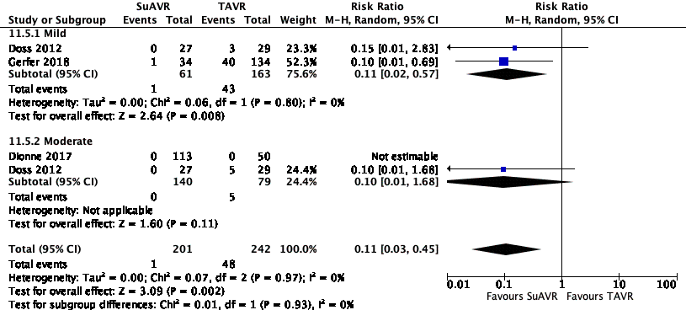
Fig. 7D, Unadjusted studies (SuAVR versus TAVR), paravalvualr leak.

Aortic Cross Clamp Time
SuAVR versus SAVR
Adjusted studies: Thirteen studies reported Aortic cross clamp time (ACX) (Andreas et al.; Belluschi et al.; Bruno, Farina, et al.; Dalen et al.; D'Onofrio, Rizzoli, et al.; Ensminger et al.; Gilmanov et al.; Glauber and Miceli; MD et al.; Pollari et al.; Repossini et al.; Sanchez et al.; Wahlers et al.). These studies included 5019 patients (SuAVR=2470, SAVR=2549). In these studies, SuAVR was associated with significant reduction in AXC when compared to SAVR (MD = -23.02; 95% CI, -33.17 to -12.87; p=<0.0001, I²=100%, very low quality of evidence). The quality of evidence was downgraded due to serious risk of bias.
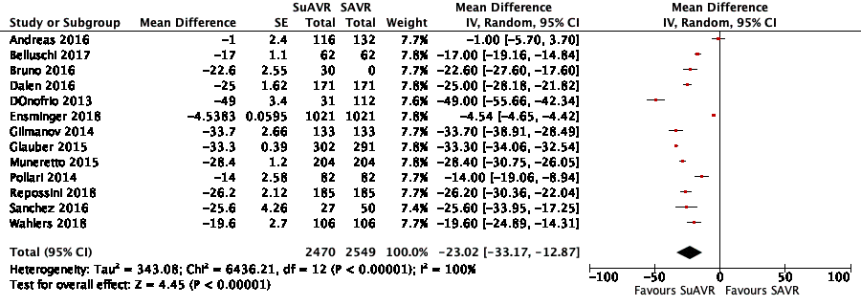
Fig. 8A. Adjusted studies (SuAVR versus SAVR), aortic cross clamp time.
Unadjusted studies: Eleven studies reported AXC time (Albacker; Bening et al.; Ferrari et al.; Ghoneim et al.; Santarpino, Pfeiffer, Concistrè, Grossmann, et al.; Vola et al.). These studies included 877 patients (SuAVR=383, SAVR=494). In these studies, SuAVR was associated with significant reduction in ACX when compared to SAVR (MD= -22.33; 95% CI, -29.25 to -15.41, p= <0.0001, I²=91%).
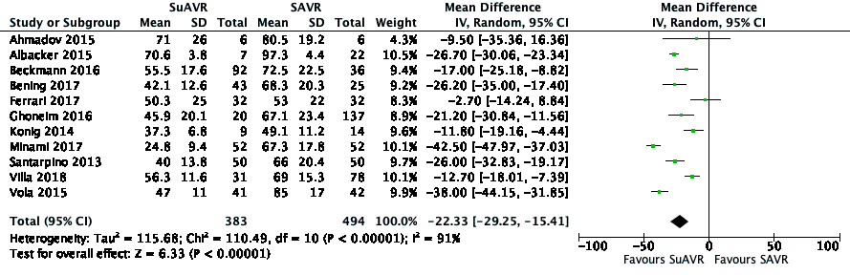
Fig. 8B, Unadjusted studies (SuAVR versus SAVR), aortic cross clamp time.

Cardiopulmonary bypass time (CPB)

SuAVR versus SAVR.
Adjusted studies: Ten studies reported CPB(Andreas et al.; Bruno, Farina, et al.; Dalen et al.; Ensminger et al.; Gilmanov et al.; Glauber and Miceli; MD et al.; Repossini et al.; Sanchez et al.; Wahlers et al.). These studies included 4619 (SuAVR=2295, SAVR=2324). In these studies, SuAVR was associated with significant reduction in CPB time (-19.83; 95% CI, -27.48 to -12.18, p=<0.000, I²= 99%, very low quality of evidence). The quality of evidence was downgraded due to serious risk of bias and inconsistency.
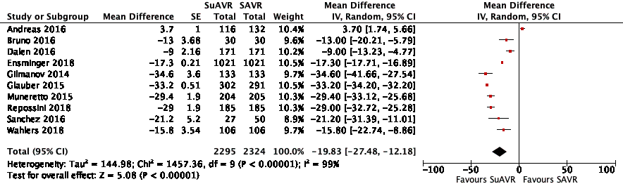
Fig. 9A. Adjusted studies (SuAVR versus SAVR), cardiopulmonary bypass time.
Unadjusted studies. 10 studies reported CPB time(Albacker; Bening et al.; Ferrari et al.; Ghoneim et al.; Santarpino, Pfeiffer, Concistrè, Grossmann, et al.; Vola et al.). These studies included 976 (SuAVR=488, SAVR=488). In these studies, SuAVR was associated with significant reduction in CPB time (MD= -28.15; 95% CI, -35.52 to -20.77, p= <0.000, I²= 85%).
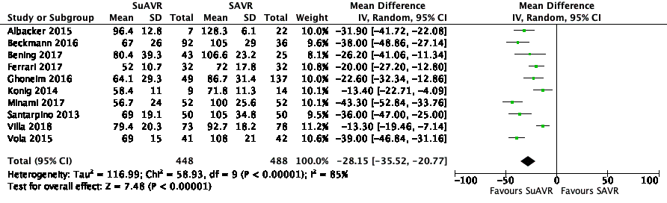
Fig. 9B. Unadjusted studies (SuAVR versus SAVR), cardiopulmonary bypass time.

Discussion

In the present study, we sought to compare the short- and mid-term post-operative outcomes of SuAVR versus SAVR and SuAVR versus TAVR. Our analysis has several important findings. Compared to TAVR, SuAVR was associated with better short- and mid-term mortality and reduced risk of mild and moderate paravalvular leak. However, compared to SAVR, SuAVR showed a similar short- and mid-term mortality benefit, higher risk of permanent pacemaker implantation and paravalvular leaks.
Compared to other meta-analyses, our meta-analysis showed important differences in postoperative outcomes. Whereas the meta-analysis by Lloyd et al. found no difference in mortality of SuAVR when compared to TAVR(Lloyd et al.), our findings demonstrated a reduction in 30-day and 2-year mortality in favor for SuAVR for both propensity-matched and unmatched studies. Also, we observed significant reduction in PVL risk with SuAVR when compared to TAVR. This finding is supported and consistent among other meta-analyses in the literature (Takagi and Umemoto; Shinn et al.; Qureshi et al.), which may support the fact that increased risk for mild PVL following TAVR is an independent risk factor for mortality(Abdel-Wahab et al.). The increased rate of PVL in TAVR was also noted in the most recent low risk trials comparing TAVR to SAVR. In these trials, PARTNER 3 and Evolut, there was a higher rate of mild PVL at one year in TAVR arm versus SAVR (PARTNER 3 Trial: 29.4% vs. 2.1%, Evolut Low Risk Trial: 33.3% vs. 7.6%) (Mack et al.; Popma et al.). The likely explanation behind increased rate of PVL in TAVR may be secondary to non-uniform calcified native valve compression against the aortic wall following TAVR or suboptimal balloon inflation. In SuAVR and SAVR, the ability to decalcify the annulus, remove the valve leaflets and size the valve under direct vision may contribute to the less PVL.
Our results also demonstrated that the risk of permanent pacemaker insertion (PPI) was comparable between SuAVR and TAVR which was also consistent in other meta-analyses(Lloyd et al.; Takagi and Umemoto; Shinn et al.; Qureshi et al.). However, high heterogeneity exists between studies comparing PPI risk. This is likely due to different devices and variable implantation techniques in the TAVR group. For instance, Biancari et al. compared SuAVR to different TAVR devices and implantation techniques including SAPIEN and CoreValve, whereas Bruno et al. only used CoreValve through the transfemoral approach(Biancari et al.; Bruno, Di Cesare, et al.).
Our updated meta-analysis showed that compared to SAVR, SuAVR was associated with a similar mortality benefit and slightly better postoperative hemodynamics. Our meta-analysis stand in distinction by including the largest number of studies and patients. We confirm previous reviews reports conclude that SuAVR may be a safe and alternative option to SAVR(Meco, Montisci, et al.; Lloyd et al.; Powell et al.; Qureshi et al.). We caution that SuAVR showed significant increase in PPI risk when compared to SAVR, and should be confirmed by a randomized trial. To reduce the risk of PPI, some reports have introduced technical modifications to SuAVR: 1) implanting the valve at the nadir of each cusp (Theodor Fischlein, Gersak, and Pfeiffer) (Yanagawa et al.); 2) ensuring complete annular decalcification; and 3) maintaining coaxiality of the prosthesis with the aortic annulus during device deployment(Theodor Fischlein, Gersak, and Pfeiffer). This may be comparable to some TAVR approaches to reduce pacemaker implantation rate such as the new generation self-expanding transcatheter valve Evolut PRO in which the valve is implanted at a depth between 3-5mm below the native annulus. This technique has demonstrated a PPI rate of 11.8%, which is lower compared to other older TAVR valve generations(Forrest et al.).
The use of SuAVR demonstrated shorter aortic cross clamp time (AXC) and cardiopulmonary bypass time (CPB). This was evident in this study and others reports(Powell et al.; Meco, Montisci, et al.). The reduction in both ACX and CPB can be advantageous in several important situations: 1) SuAVR could maximize the use of minimally invasive approach as it would provide overall shorter operative time as well as excellent or comparable postoperative outcomes compared to full sternotomy SAVR. Dalen et al. and Glauber et al. both demonstrated that the use of minimally invasive SuAVR was associated with significant reduction in ACX and CPB compared to full sternotomy SAVR(Dalen et al.; Glauber and Miceli). Additionally, MI-SuAVR showed a significant reduction in blood transfusion when compared to full sternotomy SAVR (1.4 ± 1.7 units vs. 2.4 ± 2.7; P<0.001)(Dalen et al.); 2) redo operations or operations with concomitant procedures. A study by Santarpino et al. of 13 patients with redo valve surgery demonstrated a safe and fast and safe procedure as well excellent hemodynamics with mean transvalvular gradient of 10.3 ± 1.5 mmHg(Santarpino, Pfeiffer, Concistrè, and Theodor Fischlein); and 3) acute kidney injury as several studies have linked the duration of AXC and CPB to postoperative AKI and this may explain relative reduction in AKI in patients undergoing SuAVR compared to SAVR(Rahmanian, Kwiecien, et al.).
This meta-analysis demonstrated improvement in post-operative hemodynamics in SuAVR when compared to SAVR and TAVR. Much like TAVR devices, sutureless valves have no sewing rings which may allow the implantation of larger valve sizes and hence provide a better effective orifice area which can translate to better hemodynamic profile when compared to SAVR. Despite the relative improvement of hemodynamic profile in SuAVR and TAVR compared to SAVR, long term data are warranted to whether improvement in hemodynamics can have long term impact on patients undergoing SuAVR or TAVR.

Strength and Limitations
This systematic review and meta-analysis has several strengths: pre-registration, comprehensive research strategy, and a rigorous evaluation of the quality of evidence. Furthermore, unlike previous meta-analysis on the topic, we divided the observational data as adjusted versus unadjusted instead of combining them in the analysis (Meco, Miceli, et al.; Lloyd et al.). Our systematic review and meta-analysis also has some limitations. First, without included randomized data may introduce bias with respect to differences between compared patient groups. However, the majority of our meta-analyzed studies were matched, which reduces such bias. We also stratified our analyses in terms of match and unmatched study design. Nevertheless, despite the absence of clear biases, we cannot consider these studies equivalent to randomized controlled trials. Second, we were unable to conduct a subgroup analysis of minimally invasive SuAVR versus full sternotomy SAVR and SuAVR versus different TAVR devices. However, meta-analyzing few observational studies with low sample sizes for this comparison may have introduced type II error and data mining.

Conclusion
This systematic review and meta-analysis demonstrates that the use of sutureless aortic valve replacement is safe with similar or superior results compared to SAVR and TAVR. Higher quality randomized data are however needed to further clarify the role of sutureless aortic valve replacement.

Table of Included Studies
Table 1A
List of included studies (SuAVR vs. SAVR) – Adjusted
Study author (year) | Study design | Country of patient enrolment | Operative period | Number of patients | Mean age in years | Mean follow-up
Repossini (2018) | Retrospective | Italy | 2010-2016 | 370 | 76 ± 4 | 2 years
D'Onofrio (2013) | Retrospective | Italy | 2009-2012 | 143 | 73 ± 12 | 30 days
Muneretto (2015) | Retrospective | Italy | 2010-2013 | 110 | 79 | 30 days to 2 years
Ensminger (2018) | Retrospective | Germany | 2011-2015 | 2042 | 75 (range:71-79) | Less than 30 days
Nguyen (2018) | Retrospective | Canada | 2012-2015 | 236 | 70 ± 9 | Less than 30 days
Wahlers (2018) | Retrospective | Germany | 2010-2012 | 212 | 73 ± 8 | 30 days to 1 year
Belluschi (2017) | Retrospective | Italy | 2012-2016 | 124 | 79 (range:75-82) | Less than 30 days
Rubino (2018) | Retrospective | Italy | 2011-2015 | 78 | 72 ± 5 | Less than 30 days
Glauber (2015) | Retrospective | Italy | 2004-2014 | 593 | 74 (range:66-79) | 2 years and 7 months
Dalen (2016) | Retrospective | Multicenter (Belgium, Finland, Germany, Italy, Sweden) | 2007-2014 | 341 | 77 ± 5 | 30 days to 2 years
Forcillo (2016) | Retrospective | Canada | 2011-2015 | 395 | 83 ± 3 | Less than 30 days
Andreas (2016) | Retrospective | Austria | 2010-2014 | 248 | 75 ± 8 | 30 days
Bruno (2016) | Retrospective | Italy | 2012-2015 | 60 | 73 ± 11 | 30 days
Pollari (2014) | Retrospective | Germany | 2010-2013 | 164 | 75 ± 5 | 30 days to 1 year
Gilmanov (2014) | Retrospective | Italy | 2004-2014 | 266 | 73.3 (range:70.1-79.6) | 30 days to 2 years
Gambaro (2017)  “Abstract” | Retrospective | Netherlands | 2014-2017 | 58 | Not reported | Less than 30 days
Thitivaraporn (2017)  “Abstract” | Retrospective | Netherlands | 2013-2016 | 20 | 81.5 | 30 days
Rahmanian (2018) | Retrospective | Germany | 2011-2017 | 327 | 75.8 ± 5.7 | Less than 30 days
Kapralik (2015)  “Abstract” | Retrospective | Canada | 2012-2014 | 90 | 70 ± 7 | Less than 30 days
Santarpino (2013)  “Abstract” | Retrospective | Germany | 2009-2013 | 164 | Not reported | Less than 30 days
Sanchez (2016) | Retrospective | Spain | 2011-2014 | 77 | 76 ± 4 | Less than 30 days
Hanedan (2018) | Retrospective | Turkey | 2009-2016 | 70 | 70.4 ± 10 | 30 days
Shalabi (2016) | Retrospective | Israel | 2011-2014 | 44 | 77 ± 6 | 30 days to 9 months
Pfeiffer (2017) | Retrospective | Germany | 2007-2015 | 453 | 77 ± 5 | Less than 30 days
Laborde (2017) | Retrospective | France | 2010-2012 | 130 | 77.8 ± 7.1 | Less than 30 days

Table 2A
List of included studies (SuAVR vs. SAVR) – Unadjusted
Study author (year) | Study design | Country of patient enrolment | Operative period | Number of patients | Mean age in years | Mean follow- up
Mujtaba (2018) | Retrospective | Ireland | 2011-2016 | 763 | 74 | Less than 30 days
Villa (2018)  “Abstract” | Retrospective | Italy | Not reported | 231 | 80.1 ± 5.5 | Less than 30 days
Konertz (2017) | Retrospective | Germany, South Africa | 2010-2015 | 79 | 71 (range:35-86) | Less than 30 days
Ferrari (2017) | Retrospective | Switzerland | 2014-2015 | 64 | 72.5 ± 6 | 1 year
Bening (2017) | Retrospective | Germany | 2013-2015 | 68 | 75.9 ± 5.7 | 30 days
Ihsan Parlar (2016) | Retrospective | Turkey | 2012-2014 | 55 | 73.6 ± 7.5 | Less than 30 days
Beckmann (2016)  “Abstract” | Retrospective | Germany | 2007-2011 | 128 | 62 (range:37-92) | 2 years to 4 years
Santarpino (2013) | Retrospective | Germany | 2010-2011 | 100 | 77.5 ± 5.3 | 30 days
Konig (2014) | Retrospective | Germany | 2012-2013 | 14 | 74.4 ± 4.4 | 30 days
Vola (2015) | Retrospective | France | 2009-2012 | 83 | 75.7 ± 6.3 | 2 years
Albacker (2015) | Retrospective | Saudi Arabia | 2012-2013 | 29 | 71.5 ± 2.7 | Less than 30 days
Boeken (2017)  “Abstract” | Retrospective | Germany | 2015-2016 | 112 | 73.3 ± 6.9 | Less than 30 days
Stegmeier (2018)  “Abstract” | Retrospective | Germany | Not reported | 87 | Not reported | Not reported
Ahmadov (2015)  “Abstract” | Retrospective | Switzerland | Not reported | 12 | 75 (range:71-78) | Not reported
Ghoneim (2016) | Retrospective | Canada | 2007-2014 | 351 | 78 ± 6 | Less than 30 days

Table 1B
List of Included Studies (SuAVR vs. TAVR) – Adjusted
Study author (year) | Study design | Country of patient enrolment | Operative period | Number of patients | Mean age in years | Mean follow-up
Kamperidis (2015) | Retrospective | Netherlands | 2007-2013 | 80 | 79 ± 4.5 | 1.5 (0.79-2) years
Bruno (2017) | Retrospective | Italy | 2012-2013 | 60 | 79.9 ± 3.9 | 2.4 ± 0.4 years
Santarpino (2017) | Retrospective | Germany | Since 2010 | 158 | 78 ± 5 | 2.2 ± 1.6 years
Biancari (2016) | Retrospective | Multicenter (Belgium, Finland, Germany, Italy, Sweden) | 2007-2014 | 288 | 79.4 ± 5.4 | 30 days
D'Onofrio (2016) | Retrospective | Multicenter (Belgium, Finland, Germany, Italy, Sweden) | 2010-2014 | 412 | 77.4 ± 5.4 | 30 days to 1 year
Santarpino (2014) | Retrospective | Germany | 2010-2012 | 74 | 79.4 ± 5.4 | 1.5 ± 0.8 years
D'Onofrio (2012) | Retrospective | Italy | 2011 | 76 | 80.9 ± 3.9 | 30 days

Table 2B
List of Included Studies (SuAVR vs. TAVR) – Unadjusted
Study author (year) | Study design | Country of patient enrolment | Operative period | Number of patients | Mean age in years | Mean follow-up
Dionne (2017) | Retrospective | Canada | 2010-2015 | 163 | 79.4 ± 5.6 | Less than 30 days
Doss (2012) | Retrospective | Germany | Not reported | 56 | 78 ± 4 | 30 days
Gerfer (2018)  “Abstract” | Retrospective | Germany | 2012-2017 | 168 | Not reported | Less than 30 days
Lacovelli (2015)  “Abstract” | Retrospective | Italy | 2013-2014 | 185 | 82.5 ± 3.9 | 6 months

Table of Results
Table 3A
Adjusted studies (SuAVR versus SAVR)
Outcome |  |  | Studies | Number of participants |  |  | SuAVR | SAVR |  | OR |  | 95%CI |  |  | P | QOE
Dichotomous outcomes
Mortality |  |  | 19 | 6156 |  |  | 2846 | 3310
30 days |  |  |  |  |  |  |  |  |  | 1.01 |  | 0.72-1.42 |  |  | 0.93 | Very low
2 years |  |  |  |  |  |  |  |  |  | 0.99 |  | 0.43-2.30 |  |  | 0.98 | very low
Stroke |  |  | 13 | 5291 |  |  | 2451 | 2840 |  | 1.2 |  | 0.77-1.87 |  |  | 0.42 | very low
Permanent pacemaker implantation |  |  | 14 | 5822 |  |  | 2676 | 3146 |  | 2.45 |  | 1.93-3.10 |  |  | <0.001*** | Very low
Acute kidney Injury |  |  | 10 | 2358 |  |  | 1004 | 1345 |  | 0.89 |  | 0.81-1.39 |  |  | 0.45 | very low
PVL |  |  | 6 | 3071 |  |  | 1428 | 1643 |  |  |  |  |  |  |  | very low
Mild |  |  |  |  |  |  |  |  |  | 2.7 |  | 0.91-8.01 |  |  | 0.07
Moderate |  |  |  |  |  |  |  |  |  | 1.71 |  | 0.42-6.95 |  |  | 0.46
Continuous outcomes
POMG |  |  | 12 | 4524 |  |  | 2035 | 2507 |  | -1.02 |  | -2.56 to 0.51 |  |  | 0.19 | very low
ACX |  |  | 13 | 5019 |  |  | 2470 | 2549 |  | -23 |  | -33.17 to -12.87 |  |  | <0.001*** | very low
CPB |  |  | 10 | 4619 |  |  | 2295 | 2324 |  | -19.8 |  | -27.4 to -12.18 |  |  | <0.001*** | very low
***p<0.001; **p<0.01; *p<0.05

Table 3B
Unadjusted studies (SuAVR versus SAVR)
Outcome | Studies | Number of Participants | SuAVR | SAVR | RR | 95%CI | P
Dichotomous outcome
Mortality | 9 | 1222 | 414 | 808 | 1.25 | 0.61-2.53 | 0.53
Stroke | 7 | 1070 | 322 | 748 | 1.85 | 0.69-4.99 | 0.22
PPI | 8 | 1302 | 460 | 842 | 2.48 | 1.51-4.07 | 0.65
AKI | 6 | 1547 | 407 | 1140 | 0.89 | 0.63-1.27 | 0.54
PVL | 4 | 490 | 111 | 380 | 2.95 | 1.50-5.79 | 0.002**
Continuous outcome
POMG | 5 | 572 | 182 | 390 | -1.35 | -4.68 to 1.98 | 0.43
ACX | 11 | 877 | 383 | 494 | -22.3 | -29.2 to -15.4 | <0.001***
CPB | 11 | 877 | 383 | 494 | -22.3 | -29.25 to -15.41 | <0.001***
***p<0.001; **p<0.01; *p<0.05

Table 4A
Adjusted studies (SuAVR versus TAVR)
Outcome | Studies | Number of Participants | SuAVR | TAVR | OR | 95%CI | P | QOE
Dichotomous outcome
Mortality | 7 | 1086 | 543 | 543 |  |  |  | Low
30 days |  |  |  |  | 0.36 | 0.17-0.73 | 0.005**
2 years |  |  |  |  | 0.39 | 0.17-0.88 | 0.02*
High risk |  |  |  |  | 0.15 | 0.03-0.86 | 0.03*
Intermediate risk |  |  |  |  | 0.55 | 0.27-1.13 | 0.10
Stroke | 6 | 1300 | 650 | 650 | 0.77 | 0.37-1.61 | 0.49 | very low
PPI | 6 | 1328 | 663 | 665 | 0.63 | 0.28-1.40 | 0.25 | very low
AKI | 6 | 768 | 385 | 385 | 0.5 | 0.27-0.91 | 0.02* | very low
PVL | 3 | 646 | 323 | 323 |  |  |  | very low
Mild |  |  |  |  | 0.09 | 0.03-0.26 | <0.001***
Moderate |  |  |  |  | 0.11 | 0.02-0.61 | 0.01*
Continuous outcome
POMG | 5 | 676 | 337 | 339 | 2.58 | 1.79-3.37 | <0.001*** | very low
***p<0.001; **p<0.01; *p<0.05

Table 4B
Unadjusted studies (SuAVR versus TAVR)
Outcome | Studies | Number of Participants | SuAVR | TAVR | RR | 95%CI | P
Dichotomous outcome
Mortality | 2 | 224 | 61 | 163 | 0.56 | 0.18-1.69 | 0.3
Stroke | 1 | 168 | 34 | 134 | 1.97 | 0.18-21.1 | 0.57
PPI | 3 | 409 | 108 | 301 | 1.51 | 0.54-4.18 | 0.43
PVL | 2 | 224 | 61 | 163 | 0.11 | 0.02-0.57 | 0.008**
Continuous outcomes
POMG | 3 | 409 | 108 | 301 | 2.17 | 0.42 to 3.91 | 0.01*
**p<0.01; *p<0.05

Appendix 1:

Search strategy
Database: OVID Medline Epub Ahead of Print, In-Process & Other Non-Indexed Citations, Ovid MEDLINE(R) Daily and Ovid MEDLINE(R) 1946 to Present
Search Strategy:
--------------------------------------------------------------------------------
1 aortic valve.mp. or exp Aortic Valve/ (60746)
2 aortic valve stenosis.mp. (22732)
3 bioprosthesis/ (10524)
4 bioprosthesis.mp. (11398)
5 operatio*.mp. (451661)
6 surgery/ (37251)
7 surgery.mp. (1147332)
8 minimally invasive surgery/ (22280)
9 surgery.fs. (1829003)
10 Sutureless Surgical Procedures/ (63)
11 sutureless.mp. (2386)
12 perceval.mp. (152)
13 rapid deployment valve.mp. (15)
14 1 or 2 (60746)
15 or/3-9 (2630534)
16 11 or 12 or 13 (2418)
17 14 and 15 and 16 (335)
18 Aortic stenosis.m_titl. (6853)
19 lancet.jn. (134662)
20 18 and 19 (24)
21 from 20 keep 3 (1)
22 The Joint Task Force on the Management of Valvular Heart Disease of the European Society of Cardiology.m_titl. (2)
23 from 22 keep 2 (1)
24 (Isolated aortic valve replacement in North America comprising 108,687 patients in 10 years: changes in risks, valve types, and outcomes in the Society).m_titl. (1)
25 Sutureless aortic valve replacement versus transcatheter aortic valve implantation: a meta-analysis of comparative matched studies using propensity score matching.m_titl. (1)
26 The Perceval Sutureless Aortic Valve.m_titl. (7)
27 from 26 keep 4 (1)
28 (International Expert Consensus on Sutureless and Rapid Deployment Valves in Aortic Valve Replacement Using Minimally Invasive Approaches).mp. [mp=title, abstract, original title, name of substance word, subject heading word, keyword heading word, protocol supplementary concept word, rare disease supplementary concept word, unique identifier, synonyms] (1)
29 (Systemic Review and Meta-Analysis of Sutureless Aortic Valve Replacement versus Transcatheter Aortic Valve Implantation).m_titl. (1)
30 17 or 25 or 26 or 28 or 29 (336)
31 25 or 27 or 28 or 29 (4)
32 aortic valve replacement*.mp. (15876)
33 Sutureless Surgical Procedures/ (63)
34 sutureless.mp. (2386)
35 33 or 34 (2386)
36 32 and 35 (283)
37 su-avr.mp. (15)
38 sutureless aortic valve*.mp. (165)
39 36 or 37 or 38 (308)
40 perceval.mp. (152)
41 3F enable bioprosthesis.mp. (9)
42 bioprosthesis valve*.mp. (29)
43 solo valve.mp. (25)
44 intuity.mp. (50)
45 rapid deployment valve.mp. (15)
46 or/40-45 (254)
47 39 or 46 (429)
48 31 or 47 (429)
49 17 or 48 (466)

Database: Embase <1996 to 2018 May 25>
Search Strategy:
--------------------------------------------------------------------------------
1 aortic valve replacement/ (1807)
2 aortic valve replacement*.mp. (19917)
3 1 or 2 (19917)
4 sutureless technique/ (190)
5 sutureless.mp. (2627)
6 4 or 5 (2627)
7 3 and 6 (452)
8 su-avr.mp. (21)
9 sutureless aortic valve*.mp. (261)
10 7 or 8 or 9 (488)
11 perceval.mp. (358)
12 3F enable bioprosthesis.mp. (13)
13 bioprosthesis valve*.mp. (47)
14 solo valve.mp. (36)
15 intuity.mp. (133)
16 or/11-15 (535)
17 10 or 16 (726)
18 aortic valve/ (1360)
19 aortic valve.mp. (52268)
20 aortic valve stenosis/ (1426)
21 aortic valve stenosis.mp. (5833)
22 18 or 19 or 20 or 21 (52268)
23 bioprosthesis.mp. or bioprosthesis/ (8027)
24 operatio*.mp. (473438)
25 surgery/ (384368)
26 minimally invasive surgery/ (34971)
27 surgery.fs. (1507503)
28 23 or 24 or 25 or 26 or 27 (2162618)
29 sutureless technique/ (190)
30 sutureless.mp. (2627)
31 perceval.mp. (358)
32 rapid deployment valve.mp. (34)
33 29 or 30 or 31 or 32 (2727)
34 22 and 28 and 33 (482)
35 17 or 34 (755)

Appendix 2: Risk of Bias Assessment
1A
Risk of Bias of SuAVR vs. Conventional AVR (SAVR) in Adjusted Observational Studies
 | Selection of exposed and non-exposed cohorts from same population? | Confident in the assessment of exposure? | Confident that the outcome of interest was not present at start of study? | Exposed and unexposed groups matched or statistically adjusted for all prognostic variables? | Confident in the assessment of the presence or absence of prognostic factors? | Confident in the assessment of outcome? | Adequate follow up? | Similar co-intervention between the group? | Overall Risk of bias
Repossini 2018 | Definitely Yes | Definitely Yes | Definitely Yes | Definitely Yes | Probably No | Probably Yes | Probably Yes | Probably Yes | Unclear
D'Onofrio 2013 | Definitely Yes | Definitely Yes | Definitely Yes | Definitely Yes | Probably Yes | Probably Yes | Probably Yes | Probably Yes | Unclear
Muneretto 2015 | Definitely Yes | Definitely Yes | Definitely Yes | Definitely Yes | Probably Yes | Definitely Yes | Probably Yes | Probably Yes | Unclear
Ensminger 2018 | Definitely Yes | Definitely Yes | Definitely Yes | Definitely Yes | Probably Yes | Probably Yes | Probably No | Probably Yes | Unclear
Nguyen 2018 | Definitely Yes | Definitely Yes | Definitely Yes | Definitely Yes | Probably Yes | Probably Yes | Probably Yes | Probably Yes | Unclear
Wahlers 2018 | Probably No | Definitely Yes | Definitely Yes | Definitely Yes | Probably Yes | Probably Yes | Probably Yes | Probably Yes | Unclear
Belluschi 2017 | Probably Yes | Definitely Yes | Definitely Yes | Probably Yes | Probably No | Probably Yes | Probably Yes | Probably Yes | Unclear
Rubino 2018 | Definitely Yes | Definitely Yes | Definitely Yes | Definitely Yes | Probably Yes | Probably Yes | Probably Yes | Probably Yes | Unclear
Glauber 2015 | Definitely Yes | Definitely Yes | Definitely Yes | Definitely Yes | Probably Yes | Definitely Yes | Probably Yes | Probably Yes | Unclear
Dalen 2016 | Probably Yes | Definitely Yes | Definitely Yes | Definitely Yes | Probably Yes | Probably Yes | Probably Yes | Probably Yes | Unclear
Forcillo 2016 | Definitely Yes | Definitely Yes | Definitely Yes | Definitely Yes | Probably Yes | Probably Yes | Probably Yes | Probably Yes | Unclear
Andreas 2016 | Definitely Yes | Definitely Yes | Definitely Yes | Probably Yes | Probably Yes | Probably Yes | Probably Yes | Probably Yes | Unclear
Bruno 2016 | Definitely Yes | Definitely Yes | Definitely Yes | Definitely Yes | Probably Yes | Probably Yes | Probably Yes | Probably Yes | Unclear
Pollari 2014 | Definitely Yes | Definitely Yes | Definitely Yes | Definitely Yes | Probably Yes | Probably Yes | Probably Yes | Probably Yes | Unclear
Gilmanov 2014 | Definitely Yes | Definitely Yes | Definitely Yes | Definitely Yes | Probably Yes | Probably Yes | Probably Yes | Probably Yes | Unclear
Gambaro 2017 | Definitely Yes | Definitely Yes | Probably No | Definitely Yes | Probably Yes | Probably No | Probably No | Probably No | Unclear
PuwadonThitivaraporn 2017 | Definitely Yes | Definitely Yes | Definitely Yes | Definitely Yes | Probably Yes | Probably No | Probably No | Probably No | Unclear
Rahmanian 2018 | Definitely Yes | Definitely Yes | Definitely Yes | Definitely Yes | Probably Yes | Probably Yes | Probably Yes | Probably Yes | Unclear
Kapralik 2015 | Definitely Yes | Definitely Yes | Definitely Yes | Probably Yes | Probably Yes | Probably Yes | Probably No | Definitely No | Unclear
Santarpino 2013 | Definitely Yes | Definitely Yes | Definitely Yes | Probably Yes | Probably Yes | Probably Yes | Probably No | Probably Yes | Unclear
Sanchez 2016 | Definitely Yes | Definitely Yes | Definitely Yes | Definitely Yes | Probably Yes | Probably Yes | Probably No | Probably Yes | Unclear
Hanedan 2018 | Definitely Yes | Definitely Yes | Definitely Yes | Probably Yes | Probably Yes | Probably Yes | Probably Yes | Probably Yes | Unclear
Pfeiffer 2017 | Probably Yes | Definitely Yes | Definitely Yes | Probably Yes | Probably Yes | Probably Yes | Probably No | Probably Yes | Unclear
Shalabi 2016 | Definitely Yes | Definitely Yes | Definitely Yes | Definitely Yes | Probably Yes | Probably Yes | Probably Yes | Probably Yes | Unclear
Laborde 2017 | Definitely Yes | Probably Yes | Definitely Yes | Definitely No | Definitely No | Probably No | Probably No | Probably Yes | High risk

1B
Risk of Bias of SuAVR vs. SAVR Unadjusted Observational Studies
 | Selection of exposed and non-exposed cohorts from same population? | Confident in the assessment of exposure? | Confident that the outcome of interest was not present at start of study? | Exposed and unexposed groups matched or statistically adjusted for all prognostic variables? | Confident in the assessment of the presence or absence of prognostic factors? | Confident in the assessment of outcome? | Adequate follow up? | Similar co-intervention between the group? | Overall risk of Bias
Mujtaba 2018 | Definitely Yes | Definitely Yes | Definitely Yes | Definitely No | Definitely No | Probably No | Probably No | Probably Yes | High
Villa 2018 | Definitely Yes | Definitely Yes | Definitely Yes | Definitely No | Definitely No | Probably No | Probably No | Probably Yes | High
Konertz 2017 | Definitely Yes | Definitely Yes | Definitely Yes | Definitely No | Definitely No | Probably No | Probably No | Probably Yes | High
Ferrari 2017 | Definitely Yes | Definitely Yes | Definitely Yes | Definitely No | Definitely No | Probably No | Probably Yes | Probably Yes | High
Bening 2017 | Definitely Yes | Definitely Yes | Definitely Yes | Definitely No | Definitely No | Probably No | Probably No | Probably Yes | High
IhsanParlar 2016 | Definitely Yes | Definitely Yes | Definitely Yes | Definitely No | Definitely No | Probably No | Probably No | Probably Yes | High
Beckmann 2016 | Definitely Yes | Definitely Yes | Definitely Yes | Definitely No | Definitely No | Probably No | Probably Yes | Probably Yes | High
Santarpino 2013 | Definitely Yes | Definitely Yes | Definitely Yes | Definitely No | Definitely No | Probably No | Probably Yes | Probably Yes | High
Vola 2015 | Probably Yes | Definitely Yes | Definitely Yes | Probably No | Definitely No | Probably No | Probably Yes | Probably Yes | High
Albacker 2015 | Definitely Yes | Definitely Yes | Definitely Yes | Definitely No | Definitely No | Definitely No | Probably No | Probably Yes | High
Boeken 2017 | Probably Yes | Definitely Yes | Definitely Yes | Probably No | Definitely No | Probably No | Probably No | Probably Yes | High
Stegmeier 2018 | Definitely Yes | Definitely Yes | Definitely Yes | Probably No | Definitely No | Probably No | Probably No | Probably Yes | High
Ahmadov 2015 | Probably No | Probably No | Probably No | Probably No | Definitely No | Probably No | Probably No | Probably No | High
Ghoneim 2016 | Probably No | Probably No | Probably No | Probably No | Definitely No | Probably No | Probably No | Probably No | High

2A
Risk of Bias of SuAVR vs. TAVR Adjusted Observational Studies

 | Selection of exposed and non-exposed cohorts from same population? | Confident in the assessment of exposure? | Confident that the outcome of interest was not present at start of study? | Exposed and unexposed groups matched or statistically adjusted for all prognostic variables? | Confident in the assessment of the presence or absence of prognostic factors? | Confident in the assessment of outcome? | Adequate follow up? | Similar co-intervention between the group? | Overall risk of bias
Kamperides 2015 | Probably No | Probably Yes | Definitely Yes | Probably Yes | Probably No | Probably Yes | Probably Yes | Probably no | Unclear
Bruno 2017 | Definitely Yes | Definitely Yes | Definitely Yes | Definitely Yes | Probably Yes | Probably Yes | Probably Yes | Probably Yes | Unclear
Santarpino 2017 | Definitely Yes | Definitely Yes | Definitely Yes | Definitely Yes | Probably Yes | Probably Yes | Probably Yes | Probably Yes | Unclear
Biancari 2016 | Probably Yes | Definitely Yes | Definitely Yes | Definitely Yes | Probably Yes | Probably Yes | Probably No | Probably Yes | Unclear
D'Onofrio 2016 | Probably Yes | Definitely Yes | Definitely Yes | Definitely Yes | Probably Yes | Probably Yes | Probably Yes | Probably Yes | Unclear
Santarpino 2014 | Definitely Yes | Definitely Yes | Definitely Yes | Definitely Yes | Probably Yes | Probably Yes | Probably Yes | Probably Yes | Unclear
D'Onofrio 2012 | Probably Yes | Definitely Yes | Definitely Yes | Definitely Yes | Probably Yes | Probably Yes | Probably No | Probably Yes | Unclear

2B
Risk of Bias of SuAVR vs. TAVR Unadjusted Observational Studies
 | Selection of exposed and non-exposed cohorts from same population? | Confident in the assessment of exposure? | Confident that the outcome of interest was not present at start of study? | Exposed and unexposed groups matched or statistically adjusted for all prognostic variables? | Confident in the assessment of the presence or absence of prognostic factors? | Confident in the assessment of outcome? | Adequate follow up? | Similar co-intervention between the group? | Overall risk of bias
Dionne 2017 | Probably Yes | Probably Yes | Definitely Yes | Definitely No | Definitely No | Definitely No | Probably No | Probably No | High
Doss 2012 | Probably Yes | Definitely Yes | Definitely Yes | Definitely No | Definitely No | Definitely No | Probably Yes | Probably Yes | High
Gerfer 2018 | Definitely Yes | Probably No | Definitely Yes | Definitely No | Definitely No | Definitely No | Probably No | Probably No | High
Iacovelli 2015 | Probably Yes | Probably Yes | Definitely Yes | Definitely No | Definitely No | Definitely No | Probably No | Probably No | High

Appendix 3: Funnel Plots for Meta-Analysis
- Funnel plot for the mortality outcome for SuAVR and SAVR. Publication bias was suspected.
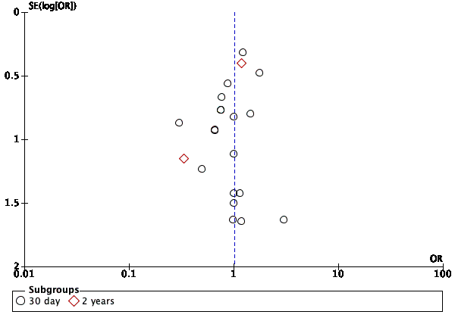

- Funnel plot for the aortic cross clamp time outcome for SuAVR and SAVR. No publication bias was suspected.
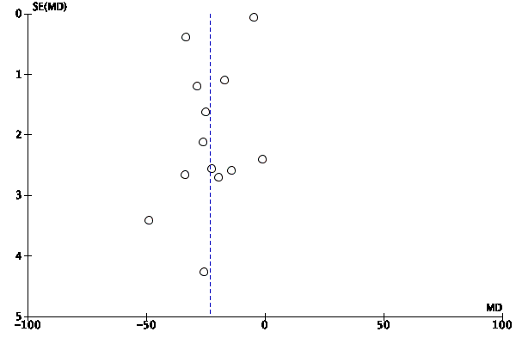
- Funnel plot for the cardiopulmonary bypass outcome of SuAVR versus SAVR. No publication bias was suspected.
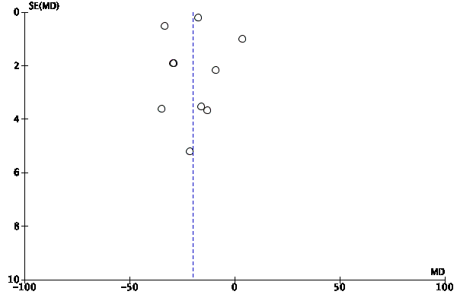

- Funnel plot of stroke outcome of SUAVR versus SAVR: No publication bias was suspected.
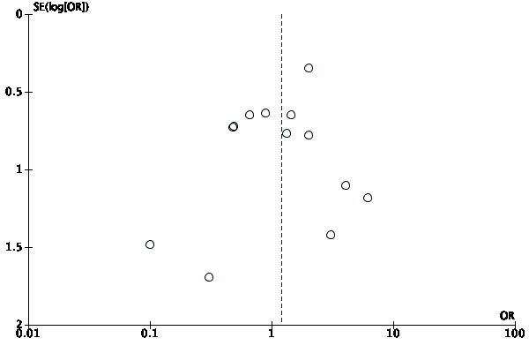
- Funnel plot of acute kidney injury outcome of SuAVR versus SAVR. No publication bias was suspected. 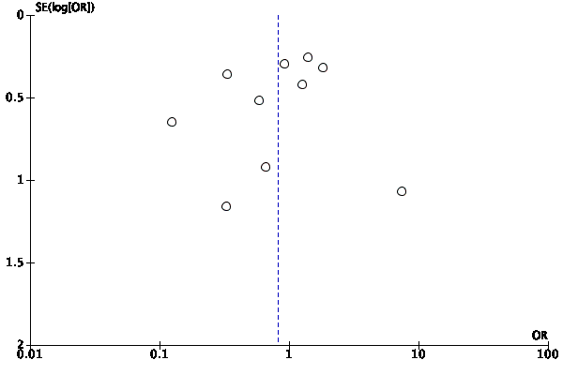

- Funnel plot of permanent pacemaker implantation of SuAVR versus SAVR. No publication bias was suspected.
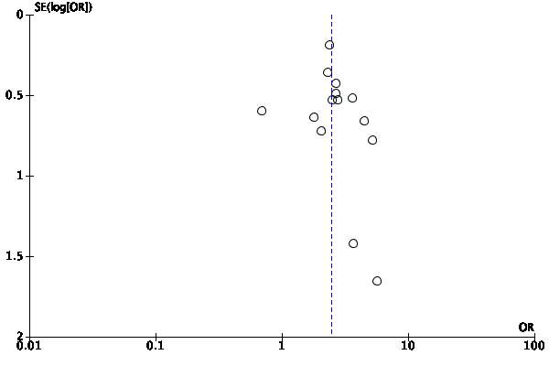
- Funnel plot of post-operative mean gradient of SuAVR versus SAVR. No publication bias was suspected.
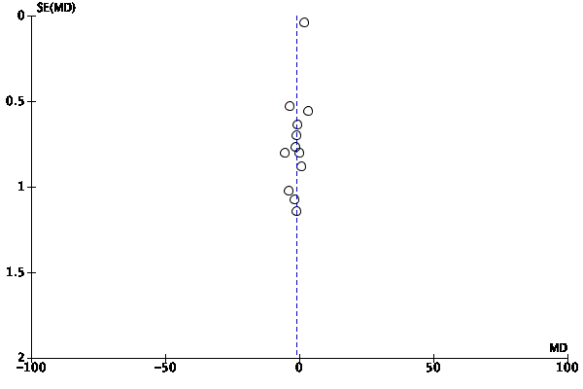

Appendix 4: GRADE Assessment.
- GRADE Assessment for observational data (SuAVR vs. SAVR)
Certainty assessment |  |  |  |  |  |  | № of patients |  | Effect |  | Certainty | Importance
№ of studies | Study design | Risk of bias | Inconsistency | Indirectness | Imprecision | Other considerations | Adjudted OR | placebo | Relative  (95% CI) | Absolute  (95% CI)
Mortality
19 | observational studies | serious ª | not serious | not serious | serious ^{b} | strong association | 70/3221 (2.2%) | 91/3685 (2.5%) | OR 1.01  (0.75 to 1.38) | 0 fewer per 1,000  (from 6 fewer to 9 more) | ⨁◯◯◯  VERY LOW
Stroke
13 | observational studies | serious | not serious | not serious | serious ^{b} | none | 52/2451 (2.1%) | 56/2840 (2.0%) | OR 1.20  (0.77 to 1.87) | 4 more per 1,000  (from 4 fewer to 17 more) | ⨁◯◯◯  VERY LOW
Acute Kidney Injury
8 | observational studies | serious ª | serious ^{c} | not serious | serious ^{b} | none | 95/1004 (9.5%) | 220/1354 (16.2%) | OR 0.89  (0.45 to 1.76) | 15 fewer per 1,000  (from 82 fewer to 92 more) | ⨁◯◯◯  VERY LOW
PPM
14 | observational studies | serious ª | not serious | not serious | serious ^{b} | strong association | 217/2676 (8.1%) | 119/3146 (3.8%) | OR 2.45  (1.93 to 3.10) | 50 more per 1,000  (from 33 more to 71 more) | ⨁◯◯◯  VERY LOW
Myocardial Infarction
7 | observational studies | serious ª | not serious | not serious | serious ^{b} | none | 10/1866 (0.5%) | 15/2070 (0.7%) | OR 0.82  (0.36 to 1.87) | 1 fewer per 1,000  (from 5 fewer to 6 more) | ⨁◯◯◯  VERY LOW
PVL
6 | observational studies | serious ª | not serious | not serious | serious ^{b} | all plausible residual confounding would reduce the demonstrated effect | -/4736 | -/4967 | OR 2.24  (1.04 to 4.78) | 0 fewer per 1,000  (from 0 fewer to 0 fewer) | ⨁◯◯◯  VERY LOW
Aortic valve mean gradient
10 | observational studies | serious ª | serious ^{c} | not serious | serious ^{d} | strong association | 2781 | 3233 | - | MD 1 lower  (2.76 lower to 0.76 higher) | ⨁◯◯◯  VERY LOW
CI: Confidence interval; OR: Odds ratio; SMD: Standardised mean difference; MD: Mean difference

Explanations
a. Unclear risk of bias
b. events< 300
c. High heterogeneity
d. Wide CI

- GRADE Assessment of observational data (SuAVR vs. TAVR)
Certainty assessment |  |  |  |  |  |  | № of patients |  | Effect |  | Certainty | Importance
№ of studies | Study design | Risk of bias | Inconsistency | Indirectness | Imprecision | Other considerations | ADJUSTED OR | placebo | Relative  (95% CI) | Absolute  (95% CI)
Mortality
7 | observational studies | not serious | not serious | not serious | serious ª | strong association | 13/948 (1.4%) | 60/948 (6.3%) | OR 0.37  (0.22 to 0.64) | 39 fewer per 1,000  (from 49 fewer to 22 fewer) | ⨁⨁◯◯  LOW | CRITICAL
Stroke
6 | observational studies | not serious | not serious | not serious | serious ª | none | 13/650 (2.0%) | 18/650 (2.8%) | OR 0.77  (0.37 to 1.61) | 6 fewer per 1,000  (from 17 fewer to 16 more) | ⨁◯◯◯  VERY LOW | CRITICAL
PPM
6 | observational studies | not serious | not serious | not serious | serious ª | none | 60/764 (7.9%) | 85/764 (11.1%) | OR 0.63  (0.28 to 1.40) | 38 fewer per 1,000  (from 77 fewer to 38 more) | ⨁◯◯◯  VERY LOW | IMPORTANT
Mean gradient
4 | observational studies | serious | not serious | not serious | Not serious | none | 337 | 339 | - | SMD 0.5 SD higher  (0.27 lower to 1.28 higher) | ⨁⨁◯◯  LOW
PVL
3 | observational studies | serious | not serious | not serious | Not serious | strong association | 11/616 (1.8%) | 107/616 (17.4%) | OR 0.08  (0.04 to 0.16) | 157 fewer per 1,000  (from 165 fewer to 141 fewer) | ⨁⨁◯◯  LOW | IMPORTANT
Acute Kidney Injury
6 | observational studies | not serious | not serious | not serious | serious ª | strong association | 18/383 (4.7%) | 36/385 (9.4%) | OR 0.50  (0.27 to 0.91) | 44 fewer per 1,000  (from 66 fewer to 8 fewer) | ⨁⨁◯◯  LOW
CI: Confidence interval; OR: Odds ratio; SMD: Standardised mean difference

Explanations
a. Less than 300 events.
b. upper or lower confidence limit crosses the effect size (eg. SMD) of 0.5 in either

References

Abdel-Wahab, Mohamed et al. “Aortic Regurgitation After Transcatheter Aortic Valve Implantation: Incidence and Early Outcome. Results From the German Transcatheter Aortic Valve Interventions Registry..” Heart (British Cardiac Society) 97.11 (2011): 899–906. Web.
Albacker, Turki B. “Thrombocytopenia Associated with Perceval Sutureless Aortic Valve Replacement in Elderly Patients: a Word of Caution..” Heart Surgery Forum 18.3 (2015): E093–7. Web.
Andreas, Martin et al. “Conventional Versus Rapid-Deployment Aortic Valve Replacement: a Single-Centre Comparison Between the Edwards Magna Valve and Its Rapid-Deployment Successor..” Interactive CardioVascular and Thoracic Surgery 22.6 (2016): 799–805. Web.
Athappan, Ganesh et al. “Incidence, Predictors, and Outcomes of Aortic Regurgitation After Transcatheter Aortic Valve Replacement: Meta-Analysis and Systematic Review of Literature..” Journal of the American College of Cardiology 61.15 (2013): 1585–1595. Web.
Authors/Task Force Members et al. “Guidelines on the Management of Valvular Heart Disease (Version 2012): the Joint Task Force on the Management of Valvular Heart Disease of the European Society of Cardiology (ESC) and the European Association for Cardio-Thoracic Surgery (EACTS).” European Heart Journal 33.19 (2012): 2451–2496. Web.
Beckmann, Erik et al. “Aortic Valve Replacement with Sutureless Prosthesis: Better Than Root Enlargement to Avoid Patient-Prosthesis Mismatch?.” Interactive CardioVascular and Thoracic Surgery 22.6 (2016): 744–749. Web.
Belluschi, Igor et al. “Can Perceval Sutureless Valve Reduce the Rate of Patient-Prosthesis Mismatch?†..” European journal of cardio-thoracic surgery : official journal of the European Association for Cardio-thoracic Surgery 51.6 (2017): 1093–1099. Web.
Bening, Constanze et al. “Rapid Deployment Valve System Shortens Operative Times for Aortic Valve Replacement Through Right Anterior Minithoracotomy..” Journal of Cardiothoracic Surgery 12.1 (2017): 27. Web.
Biancari, Fausto et al. “Immediate Outcome After Sutureless Versus Transcatheter Aortic Valve Replacement..” Heart and Vessels 31.3 (2016): 427–433. Web.
Blais, Claudia et al. “Impact of Valve Prosthesis-Patient Mismatch on Short-Term Mortality After Aortic Valve Replacement..” Circulation 108.8 (2003): 983–988. Web.
Borger, Michael A et al. “A Randomized Multicenter Trial of Minimally Invasive Rapid Deployment Versus Conventional Full Sternotomy Aortic Valve Replacement..” The Annals of Thoracic Surgery 99.1 (2015): 17–25. Web.
Brennan, J Matthew et al. “Long-Term Survival After Aortic Valve Replacement Among High-Risk Elderly Patients in the United States: Insights From the Society of Thoracic Surgeons Adult Cardiac Surgery Database, 1991 to 2007..” Circulation 126.13 (2012): 1621–1629. Web.
Brown, James M et al. “Isolated Aortic Valve Replacement in North America Comprising 108,687 Patients in 10 Years: Changes in Risks, Valve Types, and Outcomes in the Society of Thoracic Surgeons National Database..” The Journal of thoracic and cardiovascular surgery 137.1 (2009): 82–90. Web.
Bruno, Piergiorgio, Alessandro Di Cesare, et al. “Rapid-Deployment or Transcatheter Aortic Valves in Intermediate-Risk Patients?.” Asian Cardiovascular and Thoracic Annals 25.4 (2017): 264–270. Web.
Bruno, Piergiorgio, Piero Farina, et al. “Mini-Aortic Surgery with Percutaneous Cannulation and Rapid-Deployment Valve..” Asian Cardiovascular and Thoracic Annals 24.6 (2016): 535–540. Web.
Carabello, Blase A, and Walter J Paulus. “Aortic Stenosis.” The Lancet 373.9667 (2009): 956–966. Web.
Concistrè, Giovanni, Francesca Chiaramonti, et al. “Aortic Valve Replacement with Perceval Bioprosthesis: Single-Center Experience with 617 Implants..” The Annals of Thoracic Surgery 105.1 (2018): 40–46. Web.
Concistrè, Giovanni, Pierandrea Farneti, et al. “Sutureless Aortic Bioprosthesis in Severe Aortic Root Calcification: an Innovative Approach..” Interactive CardioVascular and Thoracic Surgery 14.5 (2012): 670–672. Web.
D'Onofrio, Augusto, Antonio Messina, et al. “Sutureless Aortic Valve Replacement as an Alternative Treatment for Patients Belonging to the ‘Gray Zone’ Between Transcatheter Aortic Valve Implantation and Conventional Surgery: a Propensity-Matched, Multicenter Analysis..” The Journal of thoracic and cardiovascular surgery 144.5 (2012): 1010–1016. Web.
D'Onofrio, Augusto, Giulio Rizzoli, et al. “Conventional Surgery, Sutureless Valves, and Transapical Aortic Valve Replacement: What Is the Best Option for Patients with Aortic Valve Stenosis? a Multicenter, Propensity-Matched Analysis..” The Journal of thoracic and cardiovascular surgery 146.5 (2013): 1065–70– discussion 1070–1. Web.
D'Onofrio, Augusto, Stefano Salizzoni, et al. “The Rise of New Technologies for Aortic Valve Stenosis: a Comparison of Sutureless and Transcatheter Aortic Valve Implantation..” The Journal of thoracic and cardiovascular surgery 152.1 (2016): 99–109.e2. Web.
Dalen, Magnus et al. “Aortic Valve Replacement Through Full Sternotomy with a Stented Bioprosthesis Versus Minimally Invasive Sternotomy with a Sutureless Bioprosthesis..” European journal of cardio-thoracic surgery : official journal of the European Association for Cardio-thoracic Surgery 49.1 (2016): 220–227. Web.
DerSimonian, Rebecca, and Nan Laird. “Meta-Analysis in Clinical Trials*.” (2002): 1–12. Web.
Dionne, Pierre Olivier et al. “Early Hemodynamic Results in Patients with Small Aortic Annulus After Aortic Valve Replacement..” Innovations: Technology and Techniques in Cardiothoracic and Vascular Surgery 12.4 (2017): 254–258. Web.
Doss, Mirko et al. “Sutureless Aortic Valve Replacement: Catheter-Based Transapical Versus Direct Transaortic Implantation..” The Journal of heart valve disease 21.6 (2012): 758–763. Print.
Du, Dongyi Tony et al. “Early Mortality After Aortic Valve Replacement with Mechanical Prosthetic vs Bioprosthetic Valves Among Medicare Beneficiaries: a Population-Based Cohort Study..” JAMA internal medicine 174.11 (2014): 1788–1795. Web.
Ensminger, Stephan et al. “Rapid Deployment Versus Conventional Bioprosthetic Valve Replacement for Aortic Stenosis..” Journal of the American College of Cardiology 71.13 (2018): 1417–1428. Web.
Ferrari, Enrico et al. “Rapid-Deployment Aortic Valve Replacement Versus Standard Bioprosthesis Implantation..” Journal of Cardiac Surgery 32.6 (2017): 322–327. Web.
Fischlein, Theodor, Borut Gersak, and Steffen Pfeiffer. “How to Prevent a Pacemaker Implantation After Sutureless Bioprosthesis..” The Journal of thoracic and cardiovascular surgery 152.2 (2016): 635–636. Web.
Flameng, Willem et al. “Effect of Sutureless Implantation of the Perceval S Aortic Valve Bioprosthesis on Intraoperative and Early Postoperative Outcomes..” The Journal of thoracic and cardiovascular surgery 142.6 (2011): 1453–1457. Web.
Forcillo, Jessica et al. “Perioperative Outcomes with Sutureless Versus Stented Biological Aortic Valves in Elderly Persons..” The Journal of thoracic and cardiovascular surgery 151.6 (2016): 1629–1636. Web.
Forrest, John K et al. “Early Outcomes with the Evolut PRO Repositionable Self-Expanding Transcatheter Aortic Valve with Pericardial Wrap..” JACC: Cardiovascular Interventions 11.2 (2018): 160–168. Web.
Ghoneim, Aly et al. “Management of Small Aortic Annulus in the Era of Sutureless Valves: a Comparative Study Among Different Biological Options..” The Journal of thoracic and cardiovascular surgery 152.4 (2016): 1019–1028. Web.
Gilmanov, Daniyar et al. “Aortic Valve Replacement Through Right Anterior Minithoracotomy: Can Sutureless Technology Improve Clinical Outcomes?.” The Annals of Thoracic Surgery 98.5 (2014): 1585–1592. Web.
Glauber, Mattia, and Antonio Miceli. “Encouraging Durability Results for Sutureless Aortic Valve: the New Gold Standard for Aortic Valve Replacement?.” The Journal of thoracic and cardiovascular surgery 150.1 (2015): 88–90. Web.
Glauber, Mattia, Daniyar Gilmanov, et al. “Right Anterior Minithoracotomy for Aortic Valve Replacement: 10-Year Experience of a Single Center..” The Journal of thoracic and cardiovascular surgery 150.3 (2015): 548–56.e2. Web.
Glauber, Mattia, Simon C Moten, et al. “International Expert Consensus on Sutureless and Rapid Deployment Valves in Aortic Valve Replacement Using Minimally Invasive Approaches..” Vol. 11. 2016. 165–173. Web.
Guo, Lei et al. “Impact of Prosthesis-Patient Mismatch on Short-Term Outcomes After Aortic Valve Replacement: a Retrospective Analysis in East China..” Journal of Cardiothoracic Surgery 12.1 (2017): 42. Web.
Guyatt, Gordon H et al. “GRADE: an Emerging Consensus on Rating Quality of Evidence and Strength of Recommendations..” BMJ (Clinical research ed.) 336.7650 (2008): 924–926. Web.
Hanedan, Muhammet Onur, İlker Mataracı, et al. “Early Outcomes of Sutureless Aortic Valves..” The Korean Journal of Thoracic and Cardiovascular Surgery 49.3 (2016): 165–170. Web.
Hanedan, Muhammet Onur, Mehmet Ali Yuruk, et al. “Sutureless Versus Conventional Aortic Valve Replacement: Outcomes in 70 High-Risk Patients Undergoing Concomitant Cardiac Procedures..” Texas Heart Institute journal 45.1 (2018): 11–16. Web.
Harris, Paul A et al. “Research Electronic Data Capture (REDCap)—a Metadata-Driven Methodology and Workflow Process for Providing Translational Research Informatics Support.” Journal of Biomedical Informatics 42.2 (2009): 377–381. Web.
Higgins, J P T. “Measuring Inconsistency in Meta-Analyses.” BMJ (Clinical research ed.) 327.7414 (2003): 557–560. Web.
Ihsan Parlar, Ali et al. “Immediate Outcomes of Aortic Valve Replacement with Sutureless Versus Stentless Bioprosthesis..” The Journal of heart valve disease 25.1 (2016): 21–27. Print.
Iung, B. “A Prospective Survey of Patients with Valvular Heart Disease in Europe: the Euro Heart Survey on Valvular Heart Disease.” European Heart Journal 24.13 (2003): 1231–1243. Web.
Iung, Bernard et al. “Decision-Making in Elderly Patients with Severe Aortic Stenosis: Why Are So Many Denied Surgery?.” European Heart Journal 26.24 (2005): 2714–2720. Web.
Joint Task Force on the Management of Valvular Heart Disease of the European Society of Cardiology (ESC) et al. “Guidelines on the Management of Valvular Heart Disease (Version 2012)..” European Heart Journal Oct. 2012: 2451–2496. Web.
Kamperidis, Vasileios et al. “Surgical Sutureless and Transcatheter Aortic Valves: Hemodynamic Performance and Clinical Outcomes in Propensity Score-Matched High-Risk Populations with Severe Aortic Stenosis..” JACC: Cardiovascular Interventions 8.5 (2015): 670–677. Web.
Khatri, Prateek J et al. “Adverse Effects Associated with Transcatheter Aortic Valve Implantation: a Meta-Analysis of Contemporary Studies..” Annals of Internal Medicine 158.1 (2013): 35–46. Web.
Konertz, Johanna et al. “Initial Experience with Aortic Valve Replacement via a Minimally Invasive Approach: a Comparison of Stented, Stentless and Sutureless Valves..” Medical science monitor : international medical journal of experimental and clinical research 23 (2017): 1645–1654. Web.
König, Karl Christian et al. “Sutureless Perceval Aortic Valve in Comparison with the Stented Carpentier-Edwards Perimount Aortic Valve..” The Journal of heart valve disease 23.2 (2014): 253–258. Print.
Laborde, Francois et al. “Sutureless Valves Reduce Hospital Costs Compared to Traditional Valves..” The Journal of heart valve disease 26.1 (2017): 1–8. Print.
Langanay, Thierry et al. “Aortic Valve Replacement in the Elderly: the Real Life..” The Annals of Thoracic Surgery 93.1 (2012): 70–7– discussion 77–8. Web.
Lazkani, Mohamad et al. “Permanent Pacemaker Implantation and Paravalvular Leak Rates Following Sutureless Aortic Valve Operations..” Journal of Cardiac Surgery 33.12 (2018): 808–817. Web.
Leon, Martin B, Craig R Smith, Michael J Mack, Raj R Makkar, Lars G Svensson, Susheel K Kodali, Vinod H Thourani, E Murat Tuzcu, D Craig Miller, Howard C Herrmann, Darshan Doshi, David J Cohen, Augusto D Pichard, Samir Kapadia, Todd Dewey, Vasilis Babaliaros, Wilson Y Szeto, Mathew R Williams, Dean Kereiakes, Alan Zajarias, Kevin L Greason, Brian K Whisenant, Robert W Hodson, Jeffrey W Moses, Alfredo Trento, David L Brown, William F Fearon, Philippe Pibarot, Rebecca T Hahn, Wael A Jaber, William N Anderson, Maria C Alu, and John G Webb. “Transcatheter or Surgical Aortic-Valve Replacement in Intermediate-Risk Patients.” New England Journal of Medicine 374.17 (2016): 1609–1620. Web.
Leon, Martin B, Craig R Smith, Michael J Mack, Raj R Makkar, Lars G Svensson, Susheel K Kodali, Vinod H Thourani, E Murat Tuzcu, D Craig Miller, Howard C Herrmann, Darshan Doshi, David J Cohen, Augusto D Pichard, Samir Kapadia, Todd Dewey, Vasilis Babaliaros, Wilson Y Szeto, Mathew R Williams, Dean Kereiakes, Alan Zajarias, Kevin L Greason, Brian K Whisenant, Robert W Hodson, Jeffrey W Moses, Alfredo Trento, David L Brown, William F Fearon, Philippe Pibarot, Rebecca T Hahn, Wael A Jaber, William N Anderson, Maria C Alu, and John G Webb. “Transcatheter or Surgical Aortic-Valve Replacement in Intermediate-Risk Patients.” New England Journal of Medicine 374.17 (2016): 1609–1620. Web.
Leon, Martin B, Craig R Smith, Michael Mack, D Craig Miller, et al. “Transcatheter Aortic-Valve Implantation for Aortic Stenosis in Patients Who Cannot Undergo Surgery.” New England Journal of Medicine 363.17 (2010): 1597–1607. Web.
Lloyd, Declan et al. “Transcatheter, Sutureless and Conventional Aortic-Valve Replacement: a Network Meta-Analysis of 16,432 Patients..” Journal of thoracic disease 11.1 (2019): 188–199. Web.
Lorusso, Roberto et al. “Sutureless Versus Stented Bioprostheses for Aortic Valve Replacement: the Randomized PERSIST-AVR Study Design..” The Thoracic and cardiovascular surgeon EFirst (2018): n. pag. Web.
Mack, Michael J et al. “Transcatheter Aortic-Valve Replacement with a Balloon-Expandable Valve in Low-Risk Patients..” The New England journal of medicine (2019): NEJMoa1814052. Web.
Mazine, Amine et al. “Sutureless Aortic Valve Replacement: a Canadian Multicentre Study..” The Canadian journal of cardiology 31.1 (2015): 63–68. Web.
MD, Claudio Muneretto et al. “A Comparison of Conventional Surgery, Transcatheter Aortic Valve Replacement, and Sutureless Valves in ``Real-World‘’ Patients with Aortic Stenosis and Intermediate- to High-Risk Profile.” Journal of Thoracic and Cardiovascular Surgery 150.6 (2015): 1570–1579. Web.
Meco, Massimo, Andrea Montisci, et al. “Sutureless Perceval Aortic Valve Versus Conventional Stented Bioprostheses: Meta-Analysis of Postoperative and Midterm Results in Isolated Aortic Valve Replacement..” Journal of the American Heart Association 7.4 (2018): 701. Web.
Meco, Massimo, Antonio Miceli, et al. “Sutureless Aortic Valve Replacement Versus Transcatheter Aortic Valve Implantation: a Meta-Analysis of Comparative Matched Studies Using Propensity Score Matching.” Interactive CardioVascular and Thoracic Surgery 26.2 (2017): 202–209. Web.
Meuris, Bart et al. “Five-Year Results of the Pilot Trial of a Sutureless Valve..” The Journal of thoracic and cardiovascular surgery 150.1 (2015): 84–88. Web.
Moher, David et al. “Preferred Reporting Items for Systematic Reviews and Meta-Analyses: the PRISMA Statement.” Nature Methods 6.7 (2009): e1000097. Web.
MSc, Amine Mazine et al. “Sutureless Aortic Valve Replacement: a Canadian Multicentre Study.” Canadian Journal of Cardiology 31.1 (2015): 63–68. Web.
Mujtaba, Syed Saleem et al. “Aortic Valve Replacement with a Conventional Stented Bioprosthesis Versus Sutureless Bioprosthesis: a Study of 763 Patients..” Brazilian journal of cardiovascular surgery 33.2 (2018): 122–128. Web.
Muneretto, Claudio et al. “Treating the Patients in the ‘Grey-Zone’ with Aortic Valve Disease: a Comparison Among Conventional Surgery, Sutureless Valves and Transcatheter Aortic Valve Replacement.” Interactive CardioVascular and Thoracic Surgery 20.1 (2014): 90–95. Web.
Nguyen, Anthony et al. “Early Outcomes with Rapid-Deployment vs Stented Biological Valves: a Propensity-Match Analysis..” Seminars in thoracic and cardiovascular surgery 30.1 (2018): 16–23. Web.
Nishimura, Rick A et al. “2017 AHA/ACC Focused Update of the 2014 AHA/ACC Guideline for the Management of Patients with Valvular Heart Disease: a Report of the American College of Cardiology/American Heart Association Task Force on Clinical Practice Guidelines.” Circulation 135.25 (2017): 1–123. Web.
Nkomo, Vuyisile T et al. “Burden of Valvular Heart Diseases: a Population-Based Study.” The Lancet 368.9540 (2006): 1005–1011. Web.
Olsson, Karin et al. “Patients’ Decision Making About Undergoing Transcatheter Aortic Valve Implantation for Severe Aortic Stenosis.” The Journal of Cardiovascular Nursing 31.6 (2016): 523–528. Web.
Pfeiffer, Steffen et al. “Efficacy of Sutureless Aortic Valves in Minimally Invasive Cardiac Surgery: an Evolution of the Surgical Technique..” The Journal of cardiovascular surgery 58.5 (2017): 731–738. Web.
Phan, Kevin et al. “A Meta-Analysis of Minimally Invasive Versus Conventional Sternotomy for Aortic Valve Replacement..” The Annals of Thoracic Surgery 98.4 (2014): 1499–1511. Web.
Pollari, Francesco et al. “Better Short-Term Outcome by Using Sutureless Valves: a Propensity-Matched Score Analysis..” The Annals of Thoracic Surgery 98.2 (2014): 611–6– discussion 616–7. Web.
Popma, Jeffrey J et al. “Transcatheter Aortic-Valve Replacement with a Self-Expanding Valve in Low-Risk Patients..” The New England journal of medicine (2019): NEJMoa1816885. Web.
Povero, Massimiliano et al. “Cost-Utility of Surgical Sutureless Bioprostheses vs TAVR in Aortic Valve Replacement for Patients at Intermediate and High Surgical Risk..” ClinicoEconomics and outcomes research : CEOR 10 (2018): 733–745. Web.
Powell, Ramsey et al. “The Perceval Sutureless Aortic Valve.” Innovations: Technology and Techniques in Cardiothoracic and Vascular Surgery 12.3 (2017): 155–173. Web.
Qureshi, Saqib H et al. “Meta-Analysis of Sutureless Technology Versus Standard Aortic Valve Replacement and Transcatheter Aortic Valve Replacement..” European journal of cardio-thoracic surgery : official journal of the European Association for Cardio-thoracic Surgery 53.2 (2017): 463–471. Web.
Rahmanian, Parwis B, Grzegorz Kwiecien, et al. “Logistic Risk Model Predicting Postoperative Renal Failure Requiring Dialysis in Cardiac Surgery Patients..” European journal of cardio-thoracic surgery : official journal of the European Association for Cardio-thoracic Surgery 40.3 (2011): 701–707. Web.
Rahmanian, Parwis B, Süreyya Kaya, et al. “Rapid Deployment Aortic Valve Replacement: Excellent Results and Increased Effective Orifice Areas..” The Annals of Thoracic Surgery 105.1 (2018): 24–30. Web.
Ranucci, Marco et al. “Aortic Cross-Clamp Time, New Prostheses, and Outcome in Aortic Valve Replacement..” The Journal of heart valve disease 21.6 (2012): 732–739. Print.
Reardon, Michael J et al. “Surgical or Transcatheter Aortic-Valve Replacement in Intermediate-Risk Patients.” New England Journal of Medicine 376.14 (2017): 1321–1331. Web.
Repossini, Alberto et al. “Stentless Sutureless and Transcatheter Valves: a Comparison of the Hemodynamic Performance of Different Prostheses Concept..” Minerva cardioangiologica 66.2 (2018): 180–190. Web.
Rubino, Antonino S, and Carmelo Mignosa. “Sutureless Valves and the Quality of Perfusion: Towards a Goal Directed Aortic Valve Replacement..” Minerva cardioangiologica 66.2 (2018): 163–169. Web.
Sanchez, Eladio et al. “Thrombocytopenia After Aortic Valve Replacement with Perceval S Sutureless Bioprosthesis..” The Journal of heart valve disease 25.1 (2016): 75–81. Print.
Santarpino, Giuseppe, Ferdinand Vogt, et al. “Sutureless Versus Transfemoral Transcatheter Aortic Valve Implant: a Propensity Score Matching Study..” The Journal of heart valve disease 26.3 (2017): 255–261. Print.
Santarpino, Giuseppe, Steffen Pfeiffer, Giovanni Concistrè, and Theodor Fischlein. “REDO Aortic Valve Replacement: the Sutureless Approach..” The Journal of heart valve disease 22.5 (2013): 615–620. Print.
Santarpino, Giuseppe, Steffen Pfeiffer, Giovanni Concistrè, Irena Grossmann, et al. “The Perceval S Aortic Valve Has the Potential of Shortening Surgical Time: Does It Also Result in Improved Outcome?.” The Annals of Thoracic Surgery 96.1 (2013): 77–81– discussion 81–2. Web.
Santarpino, Giuseppe, Steffen Pfeiffer, Jurgen Jessl, Angelo Dell'Aquila, Ferdinand Vogt, et al. “Clinical Outcome and Cost Analysis of Sutureless Versus Transcatheter Aortic Valve Implantation with Propensity Score Matching Analysis..” The American journal of cardiology 116.11 (2015): 1737–1743. Web.
Santarpino, Giuseppe, Steffen Pfeiffer, Jurgen Jessl, Angelo Maria Dell'Aquila, Francesco Pollari, et al. “Sutureless Replacement Versus Transcatheter Valve Implantation in Aortic Valve Stenosis: a Propensity-Matched Analysis of 2 Strategies in High-Risk Patients..” The Journal of thoracic and cardiovascular surgery 147.2 (2014): 561–567. Web.
Shalabi, Amjad et al. “Sutureless Versus Stented Valve in Aortic Valve Replacement in Patients with Small Annulus..” The Annals of Thoracic Surgery 102.1 (2016): 118–122. Web.
Shinn, Sung Ho et al. “A Systemic Review and Meta-Analysis of Sutureless Aortic Valve Replacement Versus Transcatheter Aortic Valve Implantation..” The Annals of Thoracic Surgery 106.3 (2018): 924–929. Web.
Shrestha, Malakh, Ilona Maeding, et al. “Aortic Valve Replacement in Geriatric Patients with Small Aortic Roots: Are Sutureless Valves the Future?.” Interactive CardioVascular and Thoracic Surgery 17.5 (2013): 778–82– discussion 782. Web.
Shrestha, Malakh, Theodore Fischlein, et al. “European Multicentre Experience with the Sutureless Perceval Valve: Clinical and Haemodynamic Outcomes Up to 5 Years in Over 700 Patients..” European journal of cardio-thoracic surgery : official journal of the European Association for Cardio-thoracic Surgery 49.1 (2016): 234–241. Web.
Shrestha, Malakh, Thierry A Folliguet, et al. “Aortic Valve Replacement and Concomitant Procedures with the Perceval Valve: Results of European Trials..” The Annals of Thoracic Surgery 98.4 (2014): 1294–1300. Web.
Smith, Craig R et al. “Transcatheter Versus Surgical Aortic-Valve Replacement in High-Risk Patients..” The New England journal of medicine 364.23 (2011): 2187–2198. Web.
Takagi, Hisato, and Takuya Umemoto. “Sutureless Aortic Valve Replacement May Improve Early Mortality Compared with Transcatheter Aortic Valve Implantation: a Meta-Analysis of Comparative Studies.” Journal of Cardiology 67.6 (2016): 504–512. Web.
Varadarajan, Padmini et al. “Clinical Profile and Natural History of 453 Nonsurgically Managed Patients with Severe Aortic Stenosis.” The Annals of Thoracic Surgery 82.6 (2006): 2111–2115. Web.
Villa, Emmanuel et al. “Sutureless Aortic Valve Replacement in High Risk Patients Neutralizes Expected Worse Hospital Outcome: a Clinical and Economic Analysis..” Cardiology journal 26.1 (2019): 56–65. Web.
Vogt, Ferdinand et al. “Sutureless Aortic Valve and Pacemaker Rate: From Surgical Tricks to Clinical Outcomes..” The Annals of Thoracic Surgery (2019): n. pag. Web.
Vola, Marco et al. “Sutureless Prostheses and Less Invasive Aortic Valve Replacement: Just an Issue of Clamping Time?.” The Annals of Thoracic Surgery 99.5 (2015): 1518–1523. Web.
Wahlers, Thorsten C W et al. “Outcomes of a Rapid Deployment Aortic Valve Versus Its Conventional Counterpart: a Propensity-Matched Analysis..” Innovations: Technology and Techniques in Cardiothoracic and Vascular Surgery 13.3 (2018): 177–183. Web.
Yanagawa, Bobby et al. “A Simple Modification to Lower Incidence of Heart Block with Sutureless Valve Implantation..” The Journal of thoracic and cardiovascular surgery 152.2 (2016): 630–632. Web.

