Consecutive spray drying to produce coated dry powder vaccines suitable for oral administration
Daniel A. LeClair¹, Emily D. Cranston¹, Brian D. Lichty², Zhou Xing², Michael R. Thompson^{1,*}
¹ Department of Chemical Engineering, McMaster University,
Hamilton, Ontario, Canada L8S 4L7
² McMaster Immunology Research Centre & Department of Pathology and Molecular Medicine, McMaster University, Hamilton, Ontario, Canada L8S 4L7

Submitted to: ACS Biomaterials Science & Engineering
January 2018

* Author to whom correspondence should be addressed.
Email: mthomps@mcmaster.ca
Tel: (905) 525-9140 x 23213

Declarations of interest: none
ABSTRACT
Current global vaccination programs are challenged by costs associated with vaccine cold chain storage and administration. A solid, thermally stable oral dosage form for vaccines would alleviate these costs but is difficult to produce due to general vaccine instability and the complication of bypassing the gastric barrier. We have developed a novel consecutive spray drying method that is suitable for use with biologics and employs Eudragit L100 polymer as the enteric coating. More specifically, in step 1, recombinant replication deficient human type-5 adenovirus and vesicular stomatitis virus were encapsulated by spray drying with sugars from a water solution, and in step 2 the microparticles from step 1 were suspended in ethanol with Eudragit and spray dried again. Up to 25% of the starting material was fully encapsulated within the enteric coating and encapsulation efficiency was largely dependent on spray gas flow rate and the solids concentration in the feed. After step 2, the coated vaccine-sugar particles maintained their thermostability and were slightly larger in size with a rugous surface morphology compared to the particles produced in step 1. The coated particles retained viral vector activity in vitro after 15 minute incubation in 1 M HCl (simulating the stomach environment) and anhydrous ethanol (to dissolve the Eudragit outer shell). The production of dry, orally administered vaccine particles from consecutive spray drying offers the potential to remedy a number of vaccine storage, transportation and administration limitations.

KEYWORDS: spray dry, coating, encapsulation, vaccine, edible, delivery vehicle
Introduction
Two major challenges to global vaccination are cold chain storage and the logistics of vaccine administration.^{1,2} The biological instability of vaccine constituents at even moderate temperatures necessitates the implementation of cold chain storage protocols to retain efficacy, resulting in logistical difficulties.³ Prior work has shown that the thermal stability of biologics can be improved through encapsulation, achievable by drying biologics in an appropriately chosen matrix.^{4–6} However, biological activity still tends to deteriorate over long storage times, particularly under elevated humidity conditions.^{4,7} Furthermore, traditional vaccines are currently administered by intramuscular injection from trained staff to ensure proper efficacy. Unfortunately, such vaccination programs on a global scale are economically infeasible and cultural stigmas surrounding needle injections further complicate administration and population compliance.^{1,8,9}
Alternative methods of vaccine administration, such as inhalation to the lung mucosa or ingestion for intestinal release, seek to alleviate the costs and negative public views as vaccine efficacy can then be accomplished without needle use. Such mucosal routes of vaccine delivery are also immunologically desirable for targeting the pathogens that use mucosal routes for entry. In particular, ingestion is an attractive mucosal route for vaccine delivery due to the ease of administration and lack of discomfort, though the production of an orally administered vaccine is a matter complicated by the gastric barrier.^{10,11} Within this work, a new method was sought for the preparation of an ingestible dry powder vaccine intended to target the aforementioned global vaccination challenges.
Dry powder vaccines are typically produced by spray drying or other industrial methods such as lyophilisation, film drying, and foam drying.^{7,12} In spray drying, liquid solutions of biologically active molecules and dissolved stabilizing excipients, such as sugars, amino acids and polymers, are aerosolized into fine droplets and dried at elevated temperatures.¹³ The otherwise thermally labile biologic experiences minimal activity loss in the spray unit, which is believed to be attributed to short exposure times to the highest of temperatures in the system before being immobilized and benefits from the cooling nature of evaporation as well as insular effects of surrounding water.^{4,14–16} To exhibit thermal stability, the immobilized biologic must prevent aggregation, protein denaturation and chemical instability of the biologic at normal storage temperatures, which is chiefly characterized by the matrix glass transition temperature (T_{g}) of the matrix below which it resembles a solid, stable ‘glass’.¹⁷ To be ingestible, the dry powder must be able to bypass the acidic conditions of the gastric barrier and maintain effective viral activity for delivery to the intestinal tract. Enteric coating, such as Eudragit® L-series polymers are suitable for this purpose.^{10,11}
Although different coating processes for microparticles are documented within the literature, the material options and methods for coating dry powder vaccines are limited by biological sensitivities to solvents and processing conditions that impart significant stresses on the sample.^{18,19} Most processes are far too intensive for use with labile biologics due to activity losses resulting from chemical exposure, high temperatures, UV exposure, etc.²⁰ For example, one state-of-the-art spray drying approach for simultaneous coated encapsulations is using three-fluid or four-fluid nozzles, where two immiscible solutions are combined into sprayed droplets.²¹ For biomedical applications, this spray drying method has been successfully demonstrated for pharmaceutics with concentrated active ingredients in the core surrounded by a shell of chosen excipients.^{21,22} However, this method has limited use for an enteric coating materials since there are difficulties in complete encapsulation (which is necessary to form a protective barrier)^{10,11} and their low solubility in solvents other than those harmful to the included biologic. Each of these pitfalls limits the development of an ingestible, thermally stable vaccine.
Within this study, we have developed a simple yet novel consecutive spray drying method to coat dry powder viral vectors. We elected to focus on adenoviral and vesicular stomatitis viral vectors given their increasing utilization and importance in the development of novel vaccines,²³ though spray drying technology has shown great potential for use with numerous other vaccine candidates.²⁴ The requirements of the chosen method were to produce a complete enteric barrier to wholly protect the encapsulated vaccine/excipient particles from gastric pH, and to show robustness to the solvents necessary to solubilize enteric coating polymers without harming the biologic. To the best of our knowledge, a simple spray drying method for the preparation of enteric-coated microparticles (or oral dosage vaccines) has not been reported previously in the literature. It is thus through this developed spray drying method, which is suitable for use with active biologics, that we propose to address current global vaccination challenges of poor thermal stability and costly administration requirements.

Materials and methods
Chemicals and viral vectors
D-mannitol, D-(+)-trehalose dihydrate and dextran (M_{r} 40000 kDa) were all purchased as USP grade excipients from Sigma-Aldrich (Ontario, Canada). EUDRAGIT® L100, an anionic copolymer of poly(methacylic acid-co-methyl methacrylate) was generously gifted from Evonik Industries (Piscataway, NJ) for the enteric coating and is referred to as “Eudragit” throughout the text. Anhydrous ethanol was purchased from Commercial Alcohols (Ontario, Canada). Fluorescein isothioscyanate (FITC) and Rhodamine B used for fluorescent labelling were purchased from Sigma-Aldrich. A recombinant replication deficient human serotype 5 adenovirus expressing green fluorescent protein (AdHu5GFP) and a vesicular stomatitis virus expressing GFP (VSVGFP) were produced in the vector facility of the McMaster Immunology Research Centre as described previously.^{25,26} For in vitro testing, α-minimum essential medium (α-MEM) was prepared as cell media (in house according to protocol by Life Technologies; Ontario, Canada). Cell media was supplemented with 10% fetal bovine serum and 1% streptomycin/penicillin (Invitrogen; Ontario, Canada).
Consecutive spray drying of enteric-coated vaccine-sugar microparticles
Eudragit-coated vaccine-sugar microparticles were prepared in a two-step process through spray drying with a BÜCHI B-290 Mini Spray Dryer (BÜCHI, Switzerland) equipped with 0.7 mm spray nozzle (Fig. 1). Those steps were:
STEP 1: Dry powder vaccine was spray dried from a 4% (w/v) aqueous solution of sugars and virus (Fig. 1a); two viral vectors expressing a fluorescent protein were tested as a proof of concept for the method and for convenient physical-chemical characterization, namely AdHu5GFP and VSVGFP. A different sugar matrix was chosen for each viral vector based on preliminary trials and in vitro activity testing (data not shown). More specifically, AdHu5GFP was spray dried within a 2:1 (w/w) mannitol/dextran matrix and VSVGFP was spray dried within a trehalose matrix to produce AdHu5GFP-mannitol/dextran and VSVGFP-trehalose particles, respectively. Viral vectors were added at a concentration of 4 x 10⁶ pfu/g relative to the dissolved sugars. The spray dryer operated at an inlet temperature of 120°C, spray gas flow rate of 357 L/h, and liquid feed flow rate of 217.5 mL/h. The powders were collected after drying and immediately used in the next step.
For characterization it was not always necessary to include the viral vector in the spray dried microparticles, which facilitated experiments by avoiding the use of classified biosafety components. It is indicated below which microparticles contained viral vectors (called ‘vaccine-sugar microparticles’) and which ones were sugar-only microparticles. The sugar-only microparticles were sprayed dried following the same procedure outlined above without the addition of viral vectors in the liquid feed.
STEP 2: An enteric coating (Eudragit) was applied on top of the vaccine-sugar (or sugar-only) microparticles. The ‘microparticle cores’ produced in the first step were dispersed in anhydrous ethanol and then Eudragit was added and fully dissolved, leading to a homogenous suspension (Fig 1b). Anhydrous ethanol was chosen as the dispersive medium because the sugars of sprayed microparticle were insoluble whereas Eudragit was of high solubility, and furthermore, because of its safety profile for pharmaceutical processing and human use. Other dispersants such as acetonitrile or acetone could be used instead (from a solubility perspective).
We tested the ability for spray dried vaccine-sugar microparticles to retain their viral activity after direct exposure to ethanol followed by a second spray drying step from ethanol: Supporting Information Figure S1 shows that the activity of AdHu5-mannitol/dextran particles was retained in anhydrous ethanol; however, less desirable mixtures of water and ethanol allowed the particles to swell/partially dissolve and led to significant deactivation of the viral vector.
In the first set of trials, microparticle concentration in ethanol was held constant at 1.3% (w/v) while three Eudragit concentrations were tested, as described in Table 1. The spray dryer operated at an inlet temperature of 200°C and liquid feed flow rate of 217.5 mL/h (Fig 1c). Three spray gas flow rates were tested (Table 1) in these trials. Eudragit-coated vaccine-sugar microparticles were collected after spray drying and immediately characterized and tested for in vitro viral activity. In a second set of trials, the encapsulation efficiency was estimated (see below) and all further samples were coated by spray drying at an Eudragit solids concentration of 1.3% (w/v), sugar/viral microparticle (from step 1) concentration of 1.3% (w/v) and a spray gas flow rate of 357 L/h.
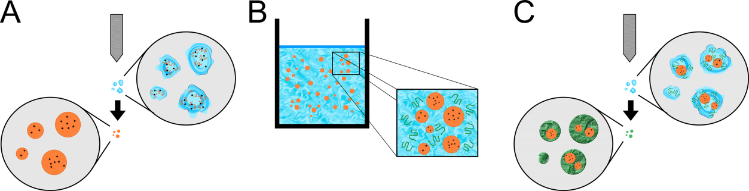
Figure 1. Schematic of the consecutive spray drying process. Spray drying step 1: an aqueous solution of dissolved sugars and viral vectors were spray dried to form vaccine-sugar microparticles (a). Spray drying step 2: the vaccine-sugar microparticles were dispersed in anhydrous ethanol with dissolved Eudragit L100 (b). The ethanol suspension was then spray dried to encapsulate vaccine-sugar microparticles within an Eudragit coating (c). Water and ethanol are depicted in blue, viral vectors are black dots, the sugar matrix is orange and Eudragit in green.
Table 1. Tested process parameters (spray gas flow rate and solids concentration) for the second spray drying step whereby suspended vaccine-sugar microparticles in anhydrous ethanol with dissolved Eudragit were spray dried. Based on this evaluation, all further samples were spray dried at medium spray gas flow rate and high Eudragit concentration (for spray drying step 2).
 | Low | Medium | High
Spray Gas Flow Rate (L/h) | 160 | 357 | 575
Eudragit L100 Solids Concentration (% w/v) | 0.25 | 1.26 | 1.90

Encapsulation efficiency of microparticle coating process
The encapsulation efficiency of the consecutive spray drying process was calculated for batches of Eudragit-coated sugar microparticles produced using the parameters listed in Table 1. Encapsulation efficiency was estimated through a series of steps designed to isolate only the Eudragit-encapsulated microparticles. 100 mg of the coated particles (collected from spray drying step 2) were measured into 1.7 mL Snap Cap microtubes (Diamed; Ontario, Canada) and suspended in 1 mL of 1 M HCl for 5 min to digest poorly coated and uncoated sugar microparticles. Input mass of sugar was determined based off of the measured mass of coated particles and known ratio of sugar/Eudragit spray dried (Table 1, section 2.2). The solution was centrifuged at 8500 rpm in a Microfuge® 18 Centrifuge (R_{max} =82.5 mm; Beckman Coulter; CA, USA) for 1 min, and the HCl and dissolved sugars were removed as the supernatant. Next, the centrifuged solids were resuspended in 1 mL of anhydrous ethanol for 5 min to dissolve the Eudragit coating. Again, the solution was centrifuged at 8500 rpm for 1 min. Ethanol and the dissolved Eudragit were then removed as the supernatant. The remaining sugar microparticles were then dissolved in MilliQ water and transferred to a glass vial for oven stability. The solution was placed in an oven at 140°C overnight to evaporate the water and the dried mass was measured. The remaining dried mass was determined to be the mass of sugar particles encapsulated by Eudragit because sugar particles lacking encapsulation would be dissolved by HCl, and Eudragit shells would be dissolved by ethanol. Encapsulation efficiency was then calculated based off of the measured amount after processing compared to the original input.
Differential scanning calorimetry of coated microparticles (without viral vectors)
Thermograms of the spray dried powders, with and without Eudragit coating, were measured by modulated differential scanning calorimetry (MDSC) with a Q200 Differential Scanning Calorimeter (TA Instruments; DE, USA). 5 – 10 mg of the sample were measured into a hermetically sealed aluminum pan. Pans were equilibrated at 4°C for five minutes. The sample temperature was modulated by ±0.60°C every 40 s and increased at a ramp rate of 3.00°C/min up to a maximum temperature of 200°C. Samples were purged with a nitrogen flow gas at a flow rate of 50 mL/min during the measurement. Thermograms were evaluated for glass transition temperatures (T_{g}, °C) and crystal melting temperatures (T_{m}, °C) using TA Universal Analysis Software (TA Instruments; DE, USA).
Residual Moisture
Approximately 150 mg of spray dried powder was measured into a Mettler Toledo HG63 Moisture Analyzer (Mettler Toledo, Switzerland). The sample was heated linearly to 140°C and held for ten minutes to evaporate all bound water. Residual moisture was then reported by the moisture analyzer as a mass percentage (% w/w).
Size and morphology of coated microparticles (without viral vectors)
Particle size and morphology were investigated using a TESCAN VP scanning electron microscope (SEM) (TESCAN; Czech Republic). Samples were applied to double-sided tape and coated with a 25 nm layer of gold. Micrograph images were collected at a magnification of 1000X and working distance ranging from 22.0 mm to 22.5 mm. The applied electron accelerating voltage was 5.0 kV. All electron microscopy was conducted at pressures less than 5.0 x 10⁻⁴ Pa. Scale bars were added in ImageJ image analysis software (NIH; Bethesda, MD).
Particle sizes were further measured by laser diffraction through use of a Malvern Mastersizer 2000G (Malvern Instruments; United Kingdom) equipped with a He-Ne laser. Powder formulations were dispersed in ethanol or water, and added into the instrument until approximately 10.0% laser obscuration was achieved. Plots of intensity vs. size in the paper are showing averaged distributions based on multiple measured distributions (n = 3).
Fluorescent imaging of coated microparticles (without viral vectors)
For fluorescent imaging, sugar microparticles (without viral vectors) were spray dried with FITC. The labelled sugar microparticles were then suspended in anhydrous ethanol that contained dissolved Rhodamine B and Eudragit and spray dried again. The Eudragit-coated sugar microparticles were mounted on a glass slide and imaged using a Nikon Eclipse LV100N POL epifluorescence microscope (Nikon Instruments; Japan) equipped with emission filters for FITC (530 nm) and Rhodamine (625 nm) dyes. Images were captured using a Retiga 2000R cooled CCD camera (QImaging; BC, Canada) and analyzed with NIS-Elements AR software (Nikon Instruments; Japan). Fluorescent image color channels were later merged in ImageJ software to form a composite image.
In vitro biologic testing of enteric-coated viral microparticles
A549 and Vero cell lines were cultured in T150 flasks with prepared α-MEM. Cells were incubated in a humidified Forma Series II Water Jacketed CO₂ Incubator (Thermo Scientific Corporation; Waltham, MA) at 37.0°C and 5.0% CO₂ and grown to 80-90% confluency. At confluency, A549 and Vero cells were split and plated in 96-well plates for in vitro testing of the AdHu5GFP and VSVGFP vectors, respectively. Three separate conditions were tested in vitro: positive control, negative control, and Eudragit-coated vaccine-sugar microparticles. Positive control samples consisted of uncoated spray dried AdHu5GFP-mannitol/dextran and VSVGFP-trehalose microparticles that were reconstituted in α-MEM. Positive control samples showed the response of the spray dried particles with no processing. The negative control consisted of uncoated spray dried AdHu5GFP-mannitol/dextran and VSVGFP/trehalose microparticles that were incubated in 1 M HCl for 5 min. Negative control samples showed the response of spray dried particles after processing with no coating.
Eudragit-coated vaccine-sugar microparticles were tested after a series of steps designed to test for acid resistance. First, the coated spray dried particles were measured by mass into 1.7 mL Snap Cap microtubes (Diamed; Ontario, Canada). The particles were then suspended in 1 mL of 1 M HCl for 5 min as a simulated gastric fluid. The samples were centrifuged at 8500 rpm for 1 min and the supernatant was discarded. Next, the enteric coating was removed by dissolution in 1 mL of anhydrous ethanol for 5 min before centrifuging at 8500 rpm for 1 min. The supernatant was discarded again and the resulting pellet was dissolved in α-MEM. The culture media and dissolved pellet were then applied to the plated cell monolayer. Positive, negative and Eudragit-coated samples contained approximately 1 x 10⁵ pfu of viral vector per well.
After 24 hours of incubation, viral vector infected wells were imaged for GFP fluorescence by use of a LEICA MZ16 F fluorescence stereo microscope (Meyer Instruments; Houston, TX) with GFP2 filter (480 nm) and processing software OpenLab 4.0.4. Scale bars were added in ImageJ software.

Results and Discussion
Encapsulation efficiency
Coated particles were prepared by consecutive spray drying with the goal of encapsulating vaccine-sugar microparticles within an Eudragit shell that can act as a protective coating suitable for ingestion. The first spray drying step to produce mannitol/dextran and trehalose microparticles (with and without viral vector) was loosely based on the optimized process parameters determined previously¹⁵ and the effect of processing conditions on the encapsulation efficiency in the second spray drying step was investigated here. Specifically, spray gas flow rate and the concentration of Eudragit in the feed solution were adjusted according to Table 1. Encapsulation efficiencies for mannitol/dextran microparticles ranged from 9 ± 2% to 27 ± 3% as shown in Fig. 2. Particle encapsulation increased with increasing spray gas flow rate but levelled off at the high end of the tested flow rates (Fig. 2a). Similarly, encapsulation efficiency increased with increasing Eudragit concentrations in the ethanol feed solution (Fig. 2b) demonstrating that the consecutive spray drying method could effectively be used to coat pre-formed microparticles. A maximum encapsulation efficiency of 25 ± 3% establishes that the majority of the biological is non-encapsulated, and thus a higher dosage would be required for therapeutic applications. This highlights the future need for further encapsulation optimization, however the lower encapsulation efficiency is more acceptable within vaccine application, as this level of non-encapsulated product represents a <1.0 log loss.
For this coating method, faster drying is advantageous to obtain more efficient encapsulation. Evaporation at the drying interface causes an increase in the local concentration of Eudragit surrounding the suspended microparticles within the ethanol droplet.¹⁶ Prolonged drying has the undesirable effect of allowing migration of the insoluble microparticles to the droplet exterior while Eudragit remains homogeneously distributed throughout the droplet.²⁷ Thus, the desire should be to seek operating conditions whereby the drying rate offers less ability for material segregation during solvent evaporation. This is accomplished in part by increased spray gas flow rates that disperse the feed solution into finer droplets, leading to decreased drying times.^{16,28} Furthermore, increasing Eudragit concentration will increase droplet viscosity to slow segregation but also allows for a thicker coating, which increases the chances of complete encapsulation.²⁹ Increasing the Eudragit concentration has the added benefit of causing the onset for precipitation to occur earlier during drying as the critical concentration is reached more quickly.²⁸ As a result, all subsequent coating trials with Eudragit were performed at the highest solids concentration tested (1.9% w/v) with medium spray gas flow rate (357 L/h) since the effect of spray gas flow rate plateaued above this value. Future work may explore the effects of other parameters such as inlet temperature, suspended vaccine-sugar microparticle concentration, ratio of microparticles to Eudragit, liquid feed rate, choice of dispersant, microparticle size, distribution of microparticle size etc. to better optimize efficiency.
Figure 2. Calculated encapsulation efficiency of mannitol/dextran microparticles (without viral vector) in Eudragit enteric coating produced by consecutive spray drying. The effect of spray gas flow rate (L/h) (a) and Eudragit concentration (% w/v) (b) on encapsulation efficiency was measured.

Glass transition temperature of the microparticles
Thermal stability of a dry powder vaccine is dependent upon the immobilizing matrix.⁴ We previously showed that spray dried AdHu5-mannitol/dextran particles had significantly improved thermal stability over long term storage and temperatures as high as 45°C, compared to a liquid vaccine control.⁴ However, mannitol/dextran was found in our preparations for the current study to be less effective with VSV (an enveloped RNA virus different from Ad) in preventing a decline in viral activity compared to trehalose (data not shown). Hence, the demonstration of two kinds of excipients and viral vectors in this study supports the general applicability of this coating method. To quantify thermal stability of dry powder vaccines, one characterization that is beneficial is measurement of the glass transition temperature as it represents the upper threshold by which the matrix sugars can sufficiently immobilize the active biologic in a glassy state over prolonged storage conditions.^{3,7} The T_{g} of uncoated and coated microparticles are summarized in Table 2. The mannitol/dextran particles (without viral vector) exhibited a T_{g} at 137.7°C while the trehalose particles (without viral vector) showed a T_{g} at 49.1°C. The high T_{g} for mannitol/dextran sprayed powder was due to dextran glass formation⁴ whereas the atypically low T_{g} for sprayed trehalose can be attributed to retained moisture leading to plasticization of the sugar matrix (dry trehalose has been reported to exhibit a T_{g} closer to 115°C).^{30,31} T_{g} plasticization by water was demonstrated by the greater amount of water content within spray dried trehalose particles, in comparison to spray dried mannitol/dextran particles (measured at 12.6% w/w for trehalose and 6.3% w/w for mannitol/dextran, Table 2).It is significant that both microparticle types exhibited T_{g} values far above cold chain storage temperatures since it indicates reduced mobility for the AdHu5GFP and VSVGFP vectors in these matrices under typical ambient conditions, even though other factors related to the generated particles will contribute to the thermal stability of the dry powder vaccine ³.
It was essential that the coating method did not impact thermal stability while new barrier properties were given to the vaccine powders. The T_{g} of pure spray dried Eudragit was 152.0°C, which agreed with previous reported values.³² The measured water content for spray dried Eudragit L100 was 3.2% w/w. The coated microparticles exhibited two glass transition temperatures, T_{g}s of 138.3°C and 156.4°C for coated mannitol/dextran particles and T_{g}s of 51.4°C and 157.0°C for the coated trehalose particles. These values were comparable (within experimental sensitivity to the thermal transition) to the separately spray dried particles and Eudragit, respectively. Again, the water content was noticeably greater for coated trehalose particles in comparison to coated mannitol/dextran particles (8.3% w/w versus 5.9% w/w, respectively). Although the water content was high for each case of spray dried trehalose, the spray dry conditions were deliberately chosen based off of prior work for recovering greater activity of the target biological. Based on these findings, the thermal stability of the tested vaccine models was not considered as being affected by the coating method.
Table 2. Measured microparticle glass transition temperature (T_{g}) and crystal melting temperature (T_{m}). Samples tested were spray dried Eudragit, spray dried mannitol/dextran, spray dried trehalose, consecutively spray dried Eudragit-coated mannitol/dextran, and consecutively spray dried Eudragit-coated trehalose.
Sample | T_{g} (°C) | T_{m} (°C) | Water Content (% w/w)
Eudragit L100 | 152.0 | - | 3.2
Mannitol/dextran | 137.7 | 165.0 | 6.3
Trehalose | 49.1 | - | 12.6
Mannitol/dextran + Eudragit L100 | 138.3, 156.4 | 165.8 | 5.9
Trehalose + Eudragit L100 | 51.4, 157.0 | - | 8.3

Morphology and particle size
Mannitol/dextran and trehalose microparticles (without viral vectors) were imaged by SEM before and after the consecutive spray drying coating process for their morphologies, as shown in Fig. 3. Mannitol/dextran particles were smooth, spherical and approximately 10 µm in diameter after the first spray drying step (Fig. 3a.). The Eudragit-coated mannitol/dextran particles differed in both size and morphology (Fig. 3b.). Two new and separate particle populations were observed, which consisted of (i) larger, slightly crumpled particles, and (ii) smaller, highly rugous particles. This bimodal population was not unexpected because the concentration of mannitol/dextran microparticles suspended in the ethanol-Eudragit solution was low, suggesting a low probability that every dispersed droplet contained one or more mannitol/dextran microparticles. The larger particles were considered the population of interest, namely sugar microparticles encapsulated by an Eudragit shell, based on the culmination of supporting evidence from the solubility experiments, Mastersizer measurements and fluorescence microscopy imaging. The crumpled texture was attributed to a partially collapsed shell morphology from the rapid drying conditions applied in the study by selecting high spray gas flow rates, as discussed previously. This morphology is related to an early onset of precipitation and results in hollow particles.¹³ The smaller, rugous particles had a higher probability of being pure Eudragit with no sugar microparticle core. Their wrinkled surface indicates a greater internal void space than those containing sugar microparticles.
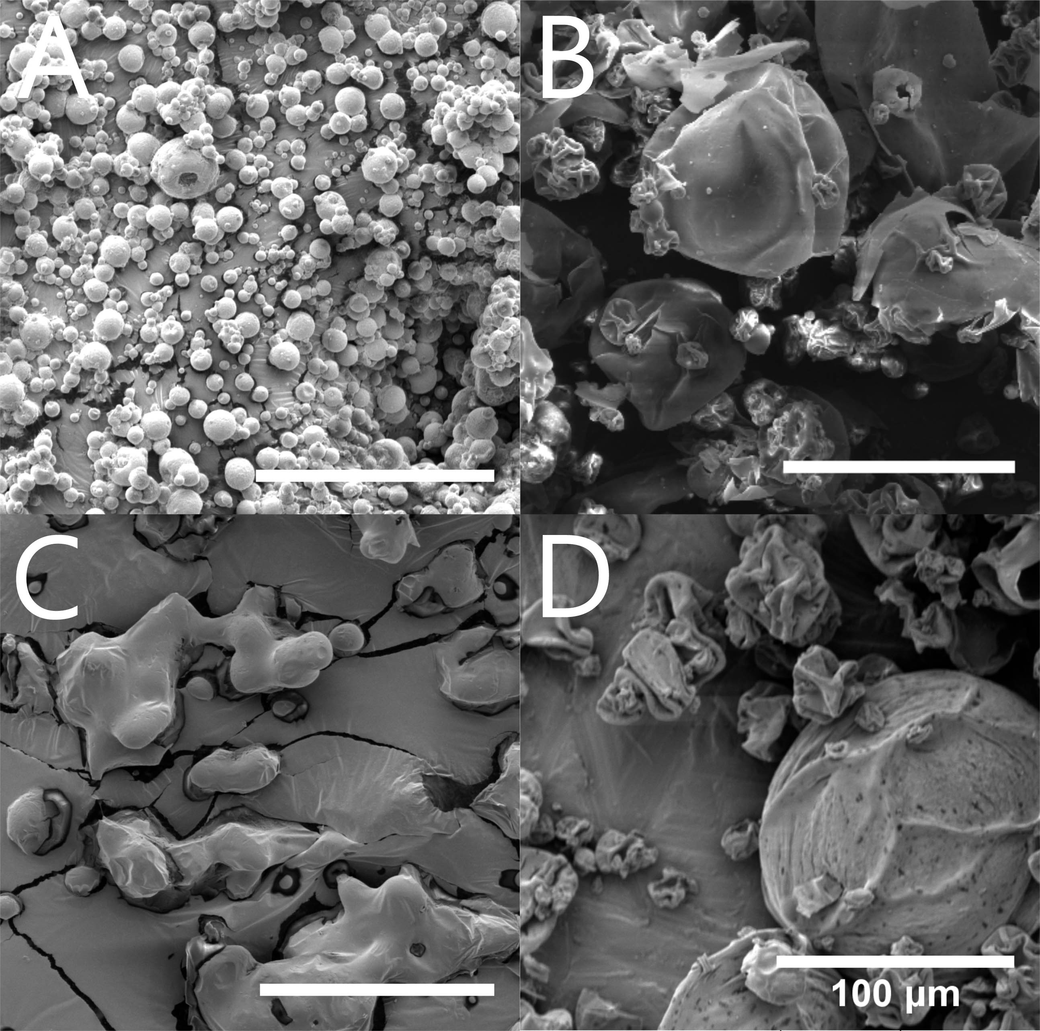
Figure 3. SEM micrographs of sugar microparticles and enteric-coated sugar microparticles. Particle size and morphology is shown to differ between spray dried mannitol/dextran (a) and consecutively spray dried Eudragit-coated mannitol/dextran microparticles (b). Similarly, particle size and morphology changed between spray dried trehalose (c) and consecutively spray dried Eudragit-coated trehalose microparticles (d). All scale bars are 100 μm, samples are coated with 25 nm of gold prior to imaging, and the cracked background is the double sided adhesive tape used to affix the powder samples.

The uncoated trehalose microparticles showed more aggregation than the spray dried mannitol/dextran microparticles (Fig. 3c). The tackiness of the particles due to the low T_{g} of trehalose (Table 2) relative to the air temperature in the collection chamber of the spray dryer (~65ºC) led to more particle aggregation.³³ The plasticized T_{g}, leading to particle aggregation, was a consequential result of the high water content measured for spray dried trehalose particles (Table 2). After consecutive spray drying of trehalose with Eudragit, the same bimodal population seen for mannitol/dextran microparticles was observed (Fig 3d). The larger, slightly crumpled particles were trehalose microparticles coated with Eudragit while the smaller, highly rugose particles were most likely Eudragit with no encapsulated inner sugar core (based on the results of solubility experiments, Mastersizer measurements and fluorescence microscopy imaging).
Particle size distributions were measured for the two steps of the coating process. The spray dried mannitol/dextran microparticles had an average diameter of approximately 10 µm with a normal particle size distribution (Fig. 4a, solid line), which agrees with size of particles seen by SEM (Fig. 3a). The coated mannitol/dextran microparticles exhibited a bimodal particle size distribution, with peaks centred at approximately 25 µm and 175 µm (Fig. 4a, dashed line) attributed to Eudragit particles and Eudragit-coated mannitol/dextran particles, respectively. Once again reflecting the observations made by SEM (Fig. 3b). The smaller particles in this case could not be uncoated mannitol/dextran because the measurement was performed in water, which would dissolve all uncoated sugars. Size analysis of the same coated sample but using ethanol in the Mastersizer (Fig. 4a, dotted line) showed only a monomodal particle size distribution because the polymer had been selectively dissolved away during the analysis.
The same trends were seen for trehalose and the Eudragit-coated trehalose microparticles (Fig. 4b). Spray dried trehalose microparticles (Fig. 4b, solid line) and trehalose microparticles released from the Eudragit coating after dissolution in ethanol (Fig. 4b, dotted line) were slightly larger in size than mannitol/dextran particles, i.e. 20 – 30 µm for the peak of the monomodal distribution, corroborating the size observations in the SEM micrographs (Fig. 3c). Eudragit-coated trehalose microparticles measured for size in water (Fig. 4b, dashed line) demonstrated a bimodal particle size distribution, with peaks centred at approximately 25 µm and 175 µm similar to the mannitol/dextran case, despite the fact that trehalose microparticles started out larger due to aggregation. The peak for the smaller particles closely resembles the same peak for the mannitol/dextrin case further supporting the notion that it corresponds to Eudragit-only particles. The only difference seen in the distributions between the two sugar cases was the higher fraction of coated microparticles with mannitol/dextrin versus trehalose in comparison to the Eudragit-only particles produced.
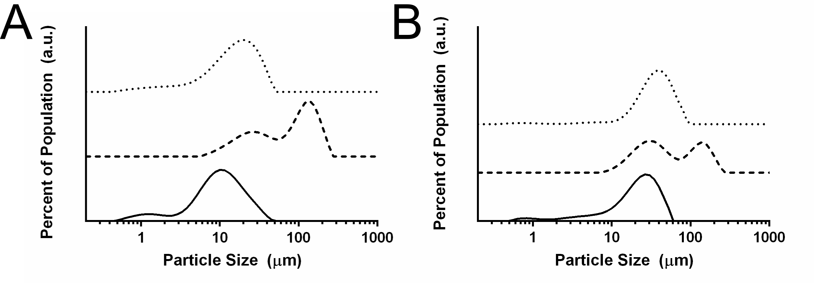
Figure 4. Relative particle size distributions for mannitol/dextran (a) and trehalose (b) microparticles. Size distributions shown correspond to spray dried sugar microparticles in ethanol (–), consecutively spray dried Eudragit-coated sugar microparticles in water (- -) and consecutively spray dried Eudragit-coated sugar microparticles after dissolving the outer coating in ethanol (• •).

Analysis of coating uniformity by fluorescence microscopy
Eudragit polymer and the sugars in the microparticles were labelled for fluorescence microscopy to show that consecutive spray drying resulted in a coating around multiple sugar microparticles (Fig. 5). Eudragit coating appeared red with Rhodamine B by fluorescence microscopy, whereas the mannitol/dextran or trehalose microparticles appeared green with FITC. Imaging revealed large amounts of Eudragit with smaller mannitol/dextran (Fig. 5a) or trehalose-rich (Fig. 5b) regions. The ca. 10 μm sugar microparticles were not centrally located inside the larger (100–300 μm) particles and the Eudragit coating thickness varied considerably around the microparticles. This non-uniformity of the coating is expected from spray drying and is attributed to the diffusion of suspended sugar microparticles within the dispersed ethanol droplets during the drying stage.¹³ Furthermore, the number of sugar microparticles per droplet and their position within each droplet is determined upon dispersion from the spray dryer nozzle.^{34,35} The dispersive event is responsible for the initial distribution of dissolved excipients within the sprayed droplet, meaning some cases will result in an enrichment of sugar microparticles along the interface, while other cases will result in more encapsulated sugar microparticles. The initial distribution of sugar microparticles following dispersion from the spray dryer nozzle is difficult to control, as is the case for all spray drying applications, though effective optimization aims to control the forces following dispersion that affect excipient distribution during drying, such as molecular diffusion and Peclet drying.²⁸ It is primarily this “randomness” that results in the low encapsulation efficiency as any sugar microparticles that remain at the surface of the Eudragit-coated particle clusters at the end of the drying process were inactivated and solubilized during the encapsulation tests. It is possible that the evenness of the Eudragit coating could be improved by adjusting the many spray drying parameters. However, process optimization was not the focus of this study.
Another point to note in the fluorescence microscopy images is that the plane of focus was chosen to see the larger Eudragit-coated sugar particles and not the smaller individualized population of particles on the order of 10 μm. Those small particles could be imaged by fluorescence microscopy; however, they were fully red in all focal planes (data not shown) indicating that they were only composed of Eudragit, which supported the SEM and Mastersizer discussions above.
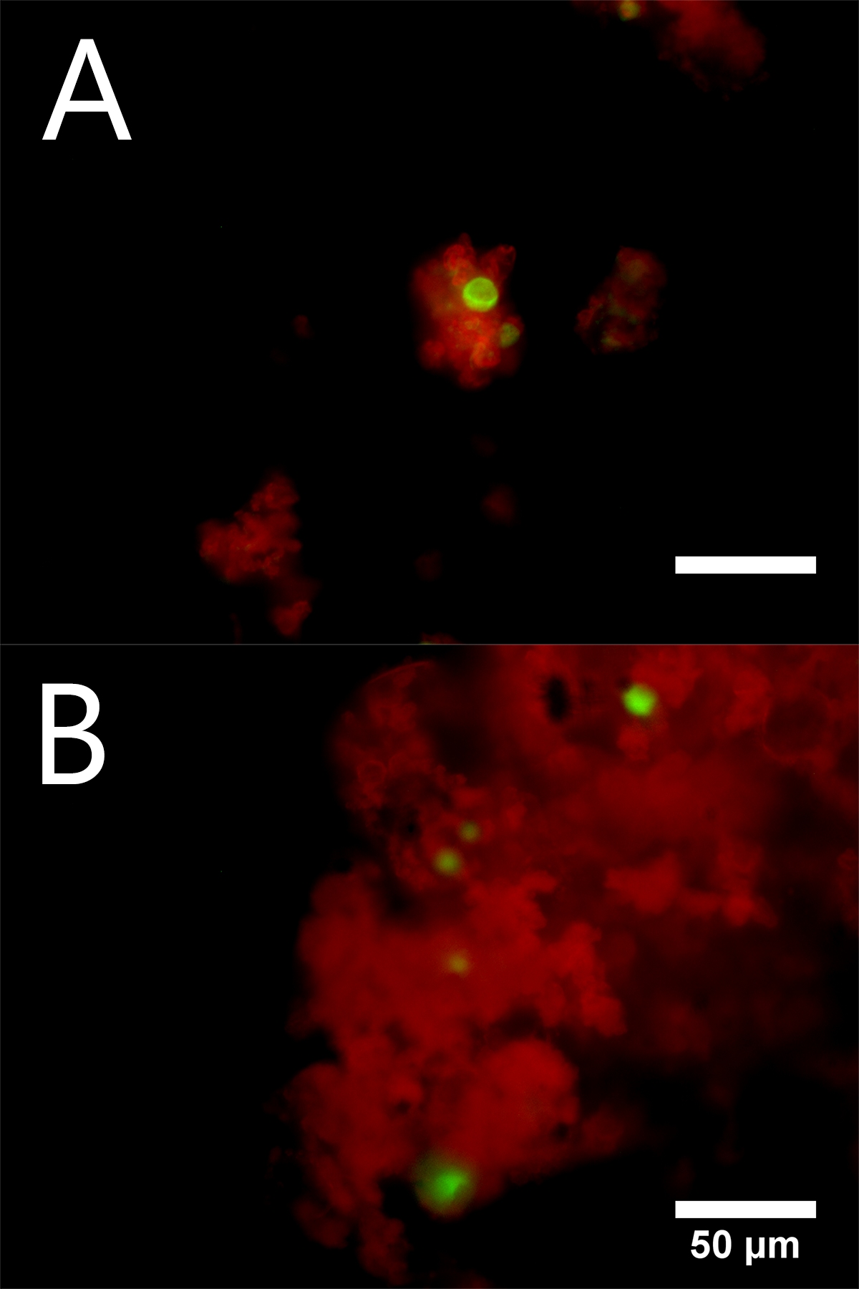
Figure 5. Fluorescence microscopy images of sugar microparticles (green, labelled with FITC) encapsulated within Eudragit (red, labelled with Rhodamine B). Sugar microparticles examined were mannitol/dextran (a) and trehalose (b). Both scale bars are 50 μm.

Viral activity
The effectiveness of the enteric coating was tested by submitting the coated microparticles to gastric pH conditions and comparing in vitro viral activity to positive and negative controls (Fig. 6). Positive controls (i.e., spray dried particles without coating and never being subjected to acidic conditions) showed the transduction of the marker gene-encoded green fluorescent protein (GFP) to A549 cells by reconstituted AdHu5GFP-mannitol/dextran microparticles (Fig. 6a) and to Vero cells by reconstituted VSVGFP-trehalose microparticles (Fig. 6b). Negative controls (i.e., spray dried particles without coating subjected to simulated gastric barrier environment with 1 M HCl for 5 min) demonstrated complete loss of viral vector activity for both AdHu5GFP-mannitol/dextran (Fig. 6c) and VSVGFP-trehalose (Fig. 6d). Importantly, after coating vaccine-sugar microparticles with Eudragit by consecutive spray drying, viral vector activity was maintained throughout both acid and ethanol incubations. This was determined by the observed fluorescence of the transfected cells, for both AdHu5GFP-mannitol/dextran (Fig. 6e) and VSVGFP-trehalose (Fig. 6f) particles.
Strong acids are known to hydrolyze chemical bonds and are clearly detrimental to viral components such as proteins, DNA/RNA and lipids.³⁶ As such, it is the acidic environment of the stomach that greatly prevents efficacy of ingestible viral vector-based vaccines. The consecutive spray dried process tested here allows for viral vector activity to be retained post-acid treatment; in comparison, all uncoated vaccine powders became inactive after HCl incubation. The loss of activity in the uncoated particles agreed with previous work by Rexroad et al. that showed AdHu5 deactivation at pH ≤ 5.³⁷ Furthermore, pH values as low as those tested here (i.e., pH 1) have never been attempted with AdHu5 due to the dissociation of the adenoviral capsid under acidic conditions.^{38,39} Similarly, Zimmer et al. demonstrated the complete loss of VSV viral activity after 15 minutes of incubation in 0.05 M HCl⁴⁰ (which is 20 times lower than the acid concentration tested here). The effectiveness of Eudragit as an enteric coating was shown with these two types of viral vectors and their corresponding sugar matrices demonstrating the flexibility of the method, which can likely be extended to almost any system where the first spray dried microparticles are insoluble yet wettable in the coating soluble solvent used for the second spray drying step. This coating method, and use of Eudragit as an enteric coating, opens up new possibilities for the development of dry, orally administrable powder vaccines based on the proven protection of virus-sugar microparticles in acidic conditions.
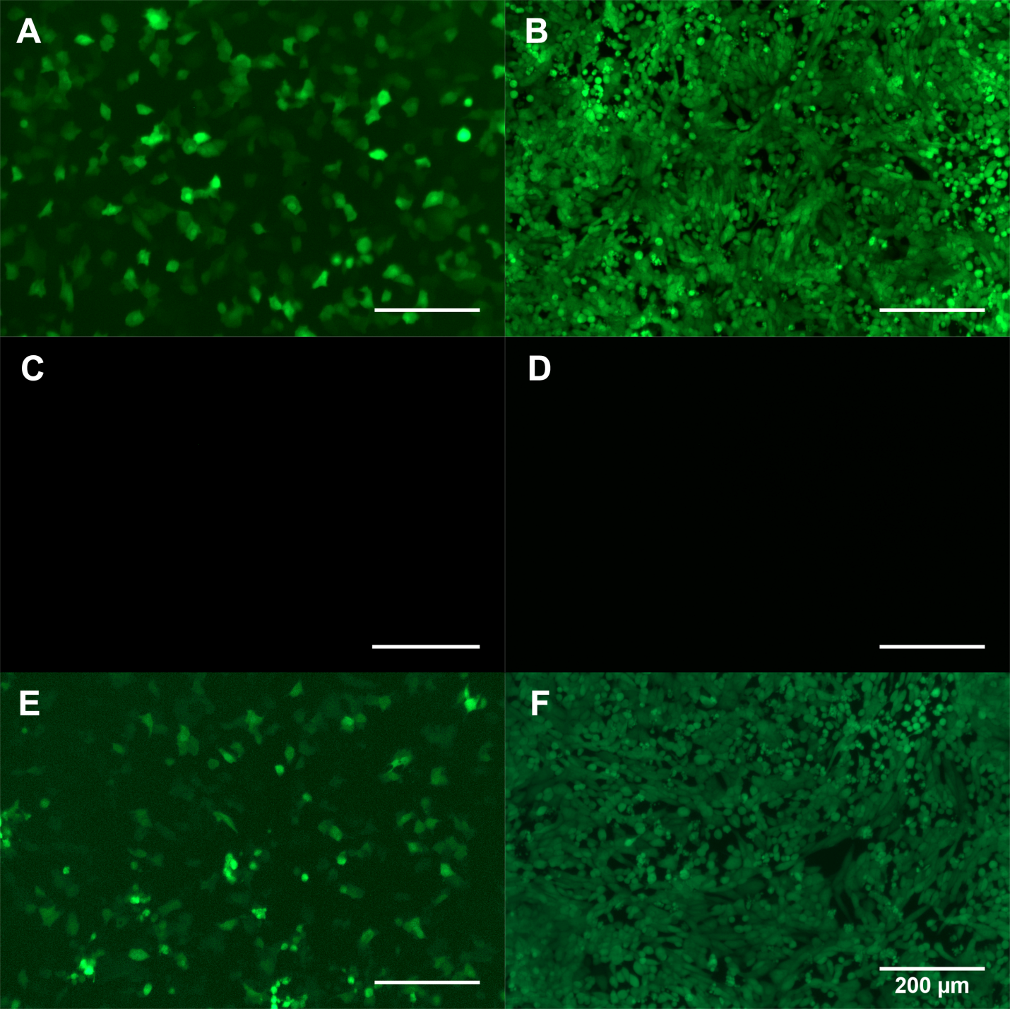
Figure 6. In vitro testing of viral vector activity with A549 (left) and Vero (right) cells using fluorescence microscopy to identify GFP transfected cells. Positive control wells were tested with reconstituted uncoated AdHu5GFP-mannitol/dextran (a) and VSVGFP-trehalose (b) particles produced by spray drying. Negative control wells were tested with reconstituted uncoated AdHu5GFP-mannitol/dextran (c) and VSVGFP-trehalose (d) spray dried particles that were incubated in 1 M HCl for 5 min. Enteric-coated microparticles produced by consecutive spray drying after incubation in both 1 M HCl for 5 min and anhydrous ethanol for 5 min – both Eudragit-coated AdHu5GFP-mannitol/dextran (e) and Eudragit-coated VSVGFP-trehalose (f) retained viral vector activity similar to the positive control. All scale bars are 200 μm.
Conclusions
Consecutive spray drying was used to prepare a thermally stable dry powder vaccine with an enteric coating; two viral vectors in separate excipient matrices were demonstrated. SEM, fluorescence microscopy and particle sizing showed that after coating, the particles were larger and contained multiple vaccine-sugar microparticles in an uneven coating. Smaller Eudragit-only particles were a by-product of the processing method, though future optimization may reduce their numbers. The overall encapsulation efficiency was low but could be improved by adjusting the spray drying process parameters. For example, faster drying and adding more coating material led to better encapsulation. Most importantly, retained viral activity was demonstrated for these coated vaccine powders after incubation in acidic conditions that simulated the gastric barrier. The potential for dried vaccine powders to alleviate cold chain storage needs is already notably promising in the literature and introducing new coating methods such as the consecutive approach opens up the possibility of moving away from injection-based vaccine administration towards a new class of orally administrated vaccines.

Supporting Information
Figure S1: Activity losses (log) of AdHu5GFP after dispersing and spray drying from ethanol.

Acknowledgements
Authors would like to thank Evonik Industries and especially Dr. Asgarzadeh for their donation of Eudragit L100 polymer. Dr. Pelton and Dr. Moran-Mirabal are gratefully acknowledged for the use of their equipment and Xueya Feng and Natasha Kazhdan for their technical assistance. The authors would also like to recognize the assistance of the Electron Microscope Facility in the Health Science Centre at McMaster University. This study is supported by joint fundings from the Canadian Institutes of Health Research (CPG-127775) and Natural Sciences and Engineering Research Council of Canada (FRN#319834).

References
(1) Ford, A. Q.; Touchette, N.; Hall, B. F.; Hwang, A.; Hombach, J. Global Vaccine and Immunization Research Forum: Opportunities and challenges in vaccine discovery, development, and delivery. Vaccine 2016, 34 (13), 1489–1495 DOI: 10.1016/j.vaccine.2015.11.038.
(2) Kristensen, D. D.; Lorenson, T.; Bartholomew, K.; Villadiego, S. Can thermostable vaccines help address cold-chain challenges? Results from stakeholder interviews in six low- and middle-income countries. Vaccine 2016, 34 (7), 899–904 DOI: 10.1016/j.vaccine.2016.01.001.
(3) Brandau, D. T.; Jones, L. S.; Wiethoff, C. M.; Rexroad, J.; Middaugh, C. R. Thermal Stability of Vaccines. J. Pharm. Sci. 2003, 92 (2), 218–231.
(4) LeClair, D. A.; Cranston, E. D.; Xing, Z.; Thompson, M. R. Evaluation of excipients for enhanced thermal stabilization of a human type 5 adenoviral vector through spray drying. Int. J. Pharm. 2016, 506 (1–2), 289–301 DOI: 10.1016/j.ijpharm.2016.04.067.
(5) Ohtake, S.; Martin, R. a; Yee, L.; Chen, D.; Kristensen, D. D.; Lechuga-Ballesteros, D.; Truong-Le, V. Heat-stable measles vaccine produced by spray drying. Vaccine 2010, 28 (5), 1275–1284 DOI: 10.1016/j.vaccine.2009.11.024.
(6) Alcock, R.; Cottingham, M. G.; Rollier, C. S.; Furze, J.; De Costa, S. D.; Hanlon, M.; Spencer, A. J.; Honeycutt, J. D.; Wyllie, D. H.; Gilbert, S. C.; et al. Long-term thermostabilization of live poxviral and adenoviral vaccine vectors at supraphysiological temperatures in carbohydrate glass. Sci. Transl. Med. 2010, 2 (19), 19ra12 DOI: 10.1126/scitranslmed.3000490.
(7) Saluja, V.; Amorij, J. P.; Kapteyn, J. C.; de Boer, a. H.; Frijlink, H. W.; Hinrichs, W. L. J. A comparison between spray drying and spray freeze drying to produce an influenza subunit vaccine powder for inhalation. J. Control. Release 2010, 144 (2), 127–133 DOI: 10.1016/j.jconrel.2010.02.025.
(8) Amorij, J.-P.; Huckriede, A.; Wilschut, J.; Frijlink, H. W.; Hinrichs, W. L. J. Development of stable influenza vaccine powder formulations: challenges and possibilities. Pharm. Res. 2008, 25 (6), 1256–1273 DOI: 10.1007/s11095-008-9559-6.
(9) Zaffran, M.; Vandelaer, J.; Kristensen, D.; Melgaard, B.; Yadav, P.; Antwi-Agyei, K. O.; Lasher, H. The imperative for stronger vaccine supply and logistics systems. Vaccine 2013, 31 (SUPPL2), B73–B80 DOI: 10.1016/j.vaccine.2012.11.036.
(10) Truong-Le, V.; Lovalenti, P. M.; Abdul-Fattah, A. M. Stabilization Challenges and Formulation Strategies Associated with Oral Biologic Drug Delivery Systems. Adv. Drug Deliv. Rev. 2015, 93, 95–108 DOI: 10.1016/j.addr.2015.08.001.
(11) Davitt, C. J. H.; Lavelle, E. C. Delivery strategies to enhance oral vaccination against enteric infections. Adv. Drug Deliv. Rev. 2015, 91, 52–69 DOI: 10.1016/j.addr.2015.03.007.
(12) Langford, A.; Bhatnagar, B.; Walters, R.; Tchessalov, S.; Ohtake, S. Drying technologies for biopharmaceutical applications: Recent developments and future direction. Dry. Technol. 2017, 0 (0), 1–8 DOI: 10.1080/07373937.2017.1355318.
(13) Vehring, R. Pharmaceutical particle engineering via spray drying. Pharm. Res. 2008, 25 (5), 999–1022 DOI: 10.1007/s11095-007-9475-1.
(14) Afkhami, S.; LeClair, D. A.; Haddadi, S.; Lai, R.; Toniolo, S. P.; Ertl, H. C.; Cranston, E. D.; Thompson, M. R.; Xing, Z. Spray dried human and chimpanzee adenoviral-vectored vaccines are thermally stable and immunogenic in vivo. Vaccine 2017 DOI: 10.1016/j.vaccine.2017.04.026.
(15) LeClair, D. A.; Cranston, E. D.; Xing, Z.; Thompson, M. R. Optimization of Spray Drying Conditions for Yield, Particle Size and Biological Activity of Thermally Stable Viral Vectors. Pharm. Res. 2016, 33 (11), 2763–2776 DOI: 10.1007/s11095-016-2003-4.
(16) Seydel, P.; Blömer, J.; Bertling, J. Modeling Particle Formation at Spray Drying Using Population Balances. Dry. Technol. 2006, 24 (2), 137–146 DOI: 10.1080/07373930600558912.
(17) Duddu, S. P.; Dal Monte, P. R. Effect of Glass Transition Temperature on the Stability of Lyophilized Formulations Containing a Chimeric Therapeutic Monoclonal Antibody. Pharm. Res. 1997, 14 (5), 591–595 DOI: 10.1023/A:1012144810067.
(18) Leifels, M.; Jurzik, L.; Wilhelm, M.; Hamza, I. A. Use of ethidium monoazide and propidium monoazide to determine viral infectivity upon inactivation by heat, UV- exposure and chlorine. Int. J. Hyg. Environ. Health 2015, 218 (8), 686–693 DOI: 10.1016/j.ijheh.2015.02.003.
(19) Lou, F.; Neetoo, H.; Chen, H.; Li, J. High Hydrostatic Pressure Processing: A Promising Nonthermal Technology to Inactivate Viruses in High-Risk Foods. Annu. Rev. Food Sci. Technol. 2015, 6 (1), 389–409 DOI: 10.1146/annurev-food-072514-104609.
(20) Bose, S.; Bogner, R. H. Solventless Pharmaceutical Coating Processes: A Review. Pharm. Dev. Technol. 2007, 12 (2), 115–131 DOI: 10.1080/10837450701212479.
(21) Kondo, K.; Niwa, T.; Danjo, K. Preparation of sustained-release coated particles by novel microencapsulation method using three-fluid nozzle spray drying technique. Eur. J. Pharm. Sci. 2014, 51 (1), 11–19 DOI: 10.1016/j.ejps.2013.09.001.
(22) Ohashi, K.; Kabasawa, T.; Ozeki, T.; Okada, H. One-step preparation of rifampicin/poly(lactic-co-glycolic acid) nanoparticle-containing mannitol microspheres using a four-fluid nozzle spray drier for inhalation therapy of tuberculosis. J. Control. Release 2009, 135 (1), 19–24 DOI: 10.1016/j.jconrel.2008.11.027.
(23) Humphreys, I. R.; Sebastian, S. Novel viral vectors in infectious diseases. Immunology 2018, 153 (1), 1–9 DOI: 10.1111/imm.12829.
(24) Kanojia, G.; Have, R. ten; Soema, P. C.; Frijlink, H.; Amorij, J. P.; Kersten, G. Developments in the formulation and delivery of spray dried vaccines. Hum. Vaccines Immunother. 2017, 13 (10), 2364–2378 DOI: 10.1080/21645515.2017.1356952.
(25) Wang, J.; Thorson, L.; Stokes, R. W.; Santosuosso, M.; Huygen, K.; Zganiacz, A.; Hitt, M.; Xing, Z. Single Mucosal, but Not Parenteral, Immunization with Recombinant Adenoviral-Based Vaccine Provides Potent Protection from Pulmonary Tuberculosis. J. Immunol. 2004, 173 (10), 6357–6365 DOI: 10.4049/jimmunol.173.10.6357.
(26) Roediger, E. K.; Kugathasan, K.; Zhang, X. Z.; Lichty, B. D.; Xing, Z. Heterologous boosting of recombinant adenoviral prime immunization with a novel vesicular stomatitis virus-vectored tuberculosis vaccine. Mol. Ther. 2008, 16 (6), 1161–1169 DOI: 10.1038/mt.2008.59.
(27) Porras-Saavedra, J.; Palacios-González, E.; Lartundo-Rojas, L.; Garibay-Febles, V.; Yáñez-Fernández, J.; Hernández-Sánchez, H.; Gutiérrez-López, G.; Alamilla-Beltrán, L. Microstructural properties and distribution of components in microparticles obtained by spray-drying. J. Food Eng. 2015, 152 (May), 105–112 DOI: 10.1016/j.jfoodeng.2014.11.014.
(28) Vehring, R.; Foss, W. R.; Lechuga-Ballesteros, D. Particle formation in spray drying. J. Aerosol Sci. 2007, 38 (7), 728–746 DOI: 10.1016/j.jaerosci.2007.04.005.
(29) Elversson, J.; Millqvist-Fureby, A.; Alderborn, G.; Elofsson, U. Droplet and particle size relationship and shell thickness of inhalable lactose particles during spray drying. J. Pharm. Sci. 2003, 92 (4), 900–910 DOI: 10.1002/jps.10352.
(30) Roos, Y. H. Importance of glass transition and water activity to spray drying and stability of dairy powders. Lait 2002, 82, 475–484 DOI: 10.1051/lait:2002025.
(31) Ding, S.-P.; Fan, J.; Green, J. L.; Lu, Q.; Sanchez, E.; Angell, C. a. Vitrification of trehalose by water loss from its crystalline dihydrate. J. Therm. Anal. 1996, 47 (5), 1391–1405 DOI: 10.1007/BF01992835.
(32) Albano, A.; Phuapradit, W.; Sandhu, H.; Shah, N. Stable Complexes of Poorly Soluble Compounds in Ionic Polymers. 6350786, 2002.
(33) Adhikari, B.; Howes, T.; Lecomte, D.; Bhandari, B. R. A glass transition temperature approach for the prediction of the surface stickiness of a drying droplet during spray drying. Powder Technol. 2005, 149 (2–3), 168–179 DOI: 10.1016/j.powtec.2004.11.007.
(34) Reitz, R. D. Modeling Atomization Processes in High-Pressure Vaporizing Sprays. At. Sprays 1987, 3, 309–337.
(35) Lin, S. P.; Reitz, R. D. Drop and Spray Formation From a Liquid Jet. Annu. Rev. Fluid Mech. 1998, 30 (1), 85–105 DOI: 10.1146/annurev.fluid.30.1.85.
(36) Barkholt, V.; Jensen, A. L. Amino acid analysis: Determination of cystein plus half-cystein in proteins after hydrochloric acid hydrolysis with a disulfide compound as additive. Anal. Biochem. 1989, 177 (338088), 318–322.
(37) Rexroad, J.; Evans, R. K.; Middaugh, C. R. Effect of pH and ionic strength on the physical stability of adenovirus type 5. J. Pharm. Sci. 2006, 95 (2), 237–247 DOI: 10.1002/jps.20496.
(38) Medina-Kauwe, L. K. Endocytosis of adenovirus and adenovirus capsid proteins. Adv. Drug Deliv. Rev. 2003, 55 (11), 1485–1496 DOI: 10.1016/j.addr.2003.07.010.
(39) Meier, O.; Greber, U. F. Adenovirus endocytosis. J. Gene Med. 2004, 6 Suppl 1, S152-63 DOI: 10.1002/jgm.553.
(40) Zimmer, B.; Summermatter, K.; Zimmer, G. Stability and inactivation of vesicular stomatitis virus, a prototype rhabdovirus. Vet. Microbiol. 2013, 162 (1), 78–84 DOI: 10.1016/j.vetmic.2012.08.023.

For Table of Contents Use Only
Consecutive spray drying to produce coated dry powder vaccines suitable for oral administration
Daniel A. LeClair¹, Emily D. Cranston¹, Brian D. Lichty², Zhou Xing², Michael R. Thompson^{1,*}
¹ Department of Chemical Engineering, McMaster University, Hamilton, Ontario, Canada L8S 4L7
² McMaster Immunology Research Centre & Department of Pathology and Molecular Medicine, McMaster University, Hamilton, Ontario, Canada L8S 4L7
*corresponding author
