Cellulose Nanocrystal Aerogels: Processing Techniques and Bone Scaffolding Applications

  - By: Daniel A. Osorio
  - McMaster University, osoriod@mcmaster.ca

A Thesis Submitted to the School of Graduate Studies in Partial Fulfillment of the Requirements for the Degree Master of Applied Science

McMaster University © Copyright by Daniel A. Osorio, August 2017

Master of Applied Science (2017) McMaster University
(Material Science and Engineering) Hamilton, Ontario

Title: Cellulose Nanocrystal Aerogels: Processing Techniques and Bone Scaffolding Applications
Author: Daniel A. Osorio, BASc (University of Waterloo, Waterloo, Ontario, Canada)
Supervisor: Dr. Kathryn Grandfield & Dr. Emily D. Cranston
Number of Pages: xvii, 97

Lay Abstract
Aerogels are light, porous, sponge-like materials that are essentially 99% air by volume. In this work, the aerogels are made from non-toxic plant-based nanoparticles called cellulose nanocrystals (CNCs). This thesis investigates: 1) new ways to control CNC aerogel properties and pore size through different processing methods and 2) the use of CNC aerogels to aid in the repair of damaged bones. High-resolution microscopy and nano-characterization tools show that CNC aerogels have tunable properties, which may extend their possible applications. The internal structure, sponge-like mechanical properties and biocompatibility of CNC aerogels allowed them to be successfully utilized to support bone cells and grow bone-like mineral.

Abstract
This thesis investigates new processing methods and bone tissue engineering applications of cross-linked cellulose nanocrystal (CNC) aerogels. Aerogels are highly porous, low-density materials that have been praised for their high surface area and interconnected pores, but criticized for their brittleness. This prompted a search for new aerogel “building blocks” to produce more flexible materials; CNCs meet this need and chemically cross-linked CNC aerogels have good compressive strength and shape recovery properties in air and liquid environments.
CNCs are high aspect ratio, non-toxic and renewably-sourced nanoparticles. Literature has demonstrated CNC aerogel production using cryo-templating with controlled drying. In this work, we produce aerogels using a new scalable process called pressurized gas expansion (PGX) and compare them to conventional cryo-templated aerogels. PGX aerogels were found to have more expanded fibrillar morphology, a range of mesopore sizes and smaller macropores, in contrast to cryo-templated aerogels that had a sheet-like morphology surrounding larger macropores. Additionally, PGX aerogels had higher specific surface area and porosity, but lower compressive strength due to a lower cross-link density. While neither CNC aerogel type dispersed in water, PGX aerogels partially shrank whereas cryo-templated aerogels did not; this is attributed to their morphological differences. This work shows that new aerogel processing methods can introduce new properties and thus broaden the potential applications of CNC aerogels.
One specific biomedical application was evaluated for CNC aerogels – their use as bone tissue scaffolds. Cryo-templated aerogels comprised of CNCs with different surface chemistries, either sulfate or phosphate groups, were found to have attractive chemical, physical and mechanical properties for bone tissue engineering. This work shows that both types of CNC aerogels can facilitate cell proliferation, favorable differentiation, and can nucleate uniform hydroxyapatite growth. These positive in vitro results and the bimodal pore morphology of CNC aerogels make them promising bone scaffolds for in vivo studies.

Acknowledgements
I would like to give thanks to both of my supervisors Dr. Kathryn Grandfield and Dr. Emily D. Cranston. Without their guidance, patience, and teachings this work could not have been completed. The reflection of this work should not only represent how far I have progressed as both an engineer and a researcher, but also a testament to their leadership and mentorship.
I would like to thank all of my colleagues in both research groups as well. Thank you for taking the time to teach me when I knew nothing, and always giving me a hard time about my results. Without the constant vigilance and discussion we have had over the past two years my skills, as a research would not be as strong as they are now. A special thanks to Bryan E. J. Lee, Stephanie Kedzior, Michael Reid, Dr. Elina Niinivaara, Oriana Vanderfleet, Katelyn Chan, James Tedesco, Iflah Shahid, Heera Marway, Manon Le Gars, and Kelli-Anne Johnson. Also to Xuan (Justin) Yang, who was the first to develop these cross-linked cellulose nanocrystal aerogels; without your contributions and guidance this work could never have been envisioned.
A portion of this work was financially supported by Ceapro Inc. through an NSERC Engage Grant with McMaster University (2016 – 2017). Research direction and technical guidance from Dr. Bernhard Seifried, Paul Moquin, Nicholas Kudeba, and Luis Delgado are greatly acknowledged. Additionally, all management and staff are thanked for their time and support during my two visits to Ceapro Inc. in Edmonton, AB, Canada. I am honoured to have had the opportunity to work with Ceapro Inc. throughout these projects.
Thank you to all professors, technicians, and McMaster facilities that allowed me to use their equipment and provided me training on various techniques. Mainly to professors Dr. R. Pelton, Dr. T. Hoare, Dr. A. Guarné and the technicians Marcia Reid, Andrew Kacheff, Victoria Jarvis, and Dr. Danielle Covelli. Thank you to the following McMaster facilities: the Canadian Center for Electron Microscopy (CCEM), the McMaster Automotive Resource Center (MARC), and McMaster Biointerfaces Institute.
Finally, a special thanks to my family and friends for always supporting me throughout my academic career and always reminding me that my only limitations are the ones I set for myself. A special thank you to the love of my life Nadia Elizabeth Belsito, above everyone else you were there for the hardest of times I’ve ever faced and have helped make me into the person I’ve always wanted to be – Valar Morghulis.

Table of Contents
Lay Abstract iii
Abstract iv
Acknowledgements v
Table of Contents vii
List of Figures xi
List of Tables xiv
List of Acronyms xv
Declaration of Achievement xvii
Chapter 1: Introduction 1
1.1 Cellulose Nanocrystal Aerogels 1
1.2 Research Objectives 2
1.3 Thesis Outline 2
Chapter 2: Literature Review 3
2.1 Cellulose and Types of Nanocellulose 3
2.2 Surface Modification of Cellulose Nanocrystals 5
2.3 Aerogels 8
2.3.1 Production of Aerogels 8
2.4 Cellulose Aerogels 12
2.5 Structure of Bone 13
2.5.1 The Hierarchal Structure of Bone 13
2.5.2 Bone Cells 14
2.5.3 Ossification and Bone Remodeling 15
2.6 Bone Tissue Engineering 17
2.6.1 Bone Formation around Scaffolds 17
2.6.2 Bone Tissue Scaffolds 18
2.6.3 In Vitro Testing of Bone Scaffolds 21

Chapter 3: Morphology of Cross-linked Cellulose Nanocrystal Aerogels: Cryo-templating vs. Pressurized Gas Expansion Processing 23
3.1 Abstract 23
3.2 Introduction 23
3.3 Materials and Methods 27
3.3.1 Materials 27
3.3.2 Preparation of Cellulose Nanocrystals (CNCs) 28
3.3.3 Aldehyde CNC (CHO-CNC) Modification 28
3.3.4 Carboxylic Acid CNC (COOH-CNC) Modification 29
3.3.5 Hydrazide CNC (NH₂NH-CNC) Modification 29
3.3.6 Degree of Functionalization 30
3.3.7 Cryo-templated CPD Aerogel Processing 30
3.3.8 Pressurized Gas Expansion (PGX) Aerogel Processing 31
3.3.9 Dynamic Light Scattering (DLS) 32
3.3.10 Zeta Potential 32
3.3.11 Density Calculation 32
3.3.12 Porosity Calculations 33
3.3.13 Brunauer-Emmett-Teller (BET) Analysis 33
3.3.14 Scanning Electron Microscopy (SEM) Imaging 33
3.3.15 X-Ray Micro Computed Tomography (µCT) 34
3.3.16 X-Ray Diffraction (XRD) 34
3.3.17 X-Ray Photoelectron Spectroscopy (XPS) 35
3.3.18 Compression Testing 35
3.4 Results and Discussion 36
3.4.1 Characterization of Cross-linkable CNCs 36
3.4.2 Macroscopic Comparison of CNC Aerogels 37
3.4.3 Microstructural Analysis and Comparison of CNC Aerogels 38
3.4.4 Comparison of Hydrazone Cross-linking in Aerogels 45
3.4.5 Aerogel Mechanical Properties 46
3.5 Conclusions 47
3.5.1 Acknowledgements 48
Chapter 4: Cellulose Nanocrystals Aerogels as Viable Bone Scaffolds 49
4.1 Abstract 49
4.2 Introduction 49
4.3 Methods and Materials 51
4.3.1 Materials 51
4.3.2 Preparation of Cellulose Nanocrystals 52
4.3.3 Aldehyde CNC (CHO-CNC) Surface Modification 53
4.3.4 Carboxylic Acid CNC (COOH-CNC) Surface Modification 53
4.3.5 Hydrazide CNC (NH₂NH-CNC) Surface Modification 54
4.3.6 CNC Degree of Functionalization 54
4.3.7 Colorimetric Determination of Phosphate Groups on CNCs 55
4.3.8 Aerogel Processing 55
4.3.9 Dynamic Light Scattering (DLS) 56
4.3.10 Zeta Potential 56
4.3.11 Brunauer-Emmett-Teller (BET) Analysis 56
4.3.12 Density Calculation 57
4.3.13 X-Ray Micro Computed Tomography (µCT) 57
4.3.14 Scanning Electron Microscopy (SEM) Imaging 58
4.3.15 X-Ray Diffraction (XRD) Analysis 59
4.3.16 X-Ray Photoelectron Spectroscopy (XPS) Analysis 59
4.3.17 Compression Testing 60
4.3.18 Cell Culture 60
4.3.19 Cell Metabolism 60
4.3.20 Alkaline Phosphatase Activity 61
4.3.21 Statistical Analysis on In Vitro Tests 61
4.3.22 Simulated Body Fluid (SBF) Dip-Test 61
4.4 Results 62
4.4.1 CNC Characterization 62
4.4.2 Aerogel Characterization 63
4.4.3 Aerogel Cell Testing 67
4.4.4 Simulated Body Fluid Testing 68
4.5 Discussion 71
4.6 Conclusion 73
4.6.1 Acknowledgments 74
Chapter 5: Conclusions and Future Works 75
5.1 Conclusion 75
5.2 Future Works 76
References 78

List of Figures
Figure 1: The three chemically distinct parts of cellulose; the non-reducing end, repeating AGUs, and the reducing end.⁵ Figure reproduced from cited reference. 3
Figure 2: Acid hydrolysis preferentially hydrolyzes the disorder regions in natural cellulose to isolate the crystalline regions. These crystalline nanoparticles are known as cellulose nanocrystals and have sulfate half ester surface groups when the hydrolysis is performed using sulfuric acid. 4
Figure 3: Formation of a hydrazone bond between two surface modified CNCs, i.e., an aldehyde CNC and a hydrazide CNC. 8
Figure 4: Schematic of the critical point drying process for aerogel formation; the red circles represent a gel network which may be composed of inorganic, metal, polymer or nanoparticle building blocks. a) Shows the gel network in its original medium of water, water is then exchanged with ethanol to produce b) an alco-gel, followed by submerging the alco-gel in supercritical CO₂ and solvent exchanging to produce c) a supercritical CO₂ –filled gel. d) Returning the gel to ambient conditions allows the CO₂ to sublime and the final dry gel network is obtained which retains its original structure (ideally with minimal collapse). 10
Figure 5: Ternary phase diagram that governs the PGX process; in order to keep a homogenous supercritical fluid, the mixture of water, ethanol, and CO₂ must be above the curved black line. Position 1 shows the start of the procedure with a mixture of water, ethanol and CO_{2.}. Position 2 shows what concentration the system is at after the water has been replaced with CO₂. Position 3 shows where the system is after the ethanol has been replaced with CO₂.⁸⁷ Figure adapted from reference 87. 12
Figure 6: The hierarchal structure of bone. The nanostructure of bone shows the collagen molecule and triple helix structure and the location of HA. The microstructure of bone outlines where collagen and HA occur in a collagen fibril. The microstructure also outlines the structure of the osteon and the Haversian canal. The macrostructure of bone shows the location of spongy bone (trabecular bone) and compact bone.¹²⁰ Figure reproduced from cited figure. 14
Figure 7: The remodelling process broken into four simple steps. Resorption, osteocytes recruit osteoclasts to differentiate, removing bone mineral and matrix to create a cavity. Reversal, mononuclear precursor cells prepare bone surface for new osteoblasts to begin forming bone. Formation, osteoblasts replace resorbed bone and fill the cavity with new bone. Resting, flattened lining cells cover bone surface until the remodelling cycle begins again.¹²⁵ Figure reproduced from cited reference. 17
Figure 8: Comparison of the macroscopic appearance of cryo-templated and PGX CNC aerogels in dry and wet states, the scale bar in (a) is true for all images. (a) Dry cryo-templated aerogel, (b) dry PGX aerogel, (c) cryo-templated aerogel submerged in water, and (d) PGX aerogel submerged in water. The cryo-templated aerogel retained its shape in water, whereas the PGX aerogel shrank; neither aerogel redispersed due to chemical cross-linking. 38
Figure 10: Micro-computed tomography 3D reconstructions with orthogonal slices of (a) cryo-templated aerogels and (b) PGX aerogels. The cryo-templated aerogels have an interconnected macroporous structure and a large distribution of macropores whereas PGX aerogels lack macropores greater than 7 µm (which appears as faded grey areas) and have some aggregated regions (which appear white, one example of an aggregate is highlighted in the purple box). SEM of the (c) purple and (d) green-boxed regions are used to show the microstructure of the white aggregated regions in (b). Aggregates do not have visible macropores but do have mesopores and are more like the dense CNC sheets in cryo-templated aerogels. 41
Figure 11: BET analysis showing the pore size distribution of (a) cryo-templated aerogels and (b) PGX aerogels. Specific surface area values are shown as insets and pore dimensions in nm are annotated above their respective peak, (dV/dD is the derivative of the pore volume taken with respect to the pore diameter). 44
Figure 12: Representative compressive stress-strain curves for cryo-templated and PGX aerogels from 0% to 90% strain. It can be seen that the cryo-templated aerogel is more resistant to compression than the PGX aerogel. 47
Figure 13: SEM micrographs of cross-sections of (a) S-CNC and (b) P-CNC aerogels. Both types of aerogels have similar morphology with cross-linked CNC sheets (or flakes) separated by macropores. Insets at higher magnification show the similar mesoporous structures of the CNC sheets. 64
Figure 14: µCT 3D reconstructions of (a,c) S-CNC and (b,d) P-CNC aerogels. (a-b) Orthogonal slices, and a partial volume rendering showing the interconnected pore structure and macropores ranging from 5 µm and larger. (c,d) The macroporous structure through a 2D xy slice through the center of the aerogels. 65
Figure 16: SEM micrographs of an S-CNC aerogel sheet that is (a) confluent with Saos-2 cells, and (b) at higher magnification shows healthy characteristics such as its oblong shape and extending filopodia. (c) Cell metabolism, and (d) alkaline phosphatase activity results comparing S-CNC and P-CNC aerogels for 1, 3, and 7 days. 68
Figure 17: SEM micrographs at low (left) and high (right) magnification of (a-b) S-CNC and (c-d) P-CNC aerogels after pre-treatment with calcium chloride and SBF submersion for 7 days. Characteristic flake-like HA crystals covered the surface of both types of aerogels, and contained Ca and P (EDX results not shown). 69
Figure 18: XRD spectra for (a) S-CNC and (b) P-CNC aerogels at 0, 7, and 14 days. At 7 days, both types of aerogels show preliminary HA peaks forming. As submersion time in SBF increases to 14 days, peaks become more defined indicating an increase in the HA layer on CNC sheets. Characteristic HA peaks are marked A = 25.9˚ (002), B = 31.8˚ (211), C = 32.9˚ (300), D = 34.0˚ (202), E = 39.8˚ (310), F = 46.7˚ (222), G = 49.5˚ (213), and H = 53.2˚ (004).¹⁹⁴ 70

List of Tables
Table 1: Surface functional group content, particle size, zeta potential, and degree of crystallinity for neat and surface modified CNCs used in the preparation of cross-linked aerogels 36
Table 2: Specific surface area, density, porosity (calculated using Equation 1) and degree of crystallinity of cryo-templated and PGX aerogels. Specific surface area and density values are shown here with their respective standard deviations. 43
Table 3: High-resolution nitrogen XPS analysis of cross-linked CNC aerogels. 46
Table 4: Surface content and apparent particle size for S-CNCs and P-CNCs before and after grafting with aldehyde and hydrazide groups. Zeta potential is only provided for S-CNCs. CHO, COOH-, and NH₂NH-, prefixes pertain to aldehyde, carboxylic acid, and hydrazide surface groups, respectively 62
Table 5: High-resolution nitrogen XPS spectra values for CNC aerogels. 65

List of Acronyms

ADH adipic acid dihydrazide
ALP alkaline phosphatase
AGU anhydrous glucose unit
BC bacterial cellulose
BET Brunauer-Emmett-Teller
CaCl₂ calcium chloride
CHO-CNCs aldehyde modified CNCs
CMC carboxymethyl cellulose
CNCs cellulose nanocrystals
CNF cellulose nanofibrils
COOH-CNCs carboxylic acid modified CNCs
CPD critical point drying
DFT density functional theory
DLS dynamic light scattering
DMSO dimethyl sulfoxide
EDC N’-ethyl-N-(3-(dimethylamino)propyl)-carbodiimide
FD freeze-drying
HA hydroxyapatite
NaIO₄ sodium periodate
NHS N-hydroxysuccinimide
NH₂NH-CNCs hydrazide modified CNCs
OsO₄ osmium tetraoxide
P-CNC phosphoric acid hydrolysed cellulose nanocrystals
PDI polydispersity index
PGX pressurized gas expansion
PLA polylactic acid
RGD arginylglycylaspartic acid
SBF simulated body fluid
S-CNC sulfuric acid hydrolysed cellulose nanocrystals
SEM scanning electron microscopy
TCH thiocarbohydrazide
TEM transmission electron microscopy
TEMPO 2, 2, 6, 6 - (tetramethylpiperidin-1-yl) oxyl
XPS X-ray photoelectron spectroscopy
XRD X-ray diffraction
µCT X-ray micro-computed tomography

Declaration of Achievement

I declare that the research contribution that follows represents original work, completed and written by myself, with editorial assistance from my academic advisors, Dr. Kathryn Grandfield and Dr. Emily D. Cranston.
Chapter 3 was an industrial collaboration with Ceapro Inc. Scientists and technicians at Ceapro, Dr. Bernhard Siefried, Luis Delgado, and Nicolas Kudeba, aided in running the equipment and optimizing sample preparation. All characterization was performed at McMaster University, with the exception of Brunauer-Emmett-Teller analysis, carried out at the University of Waterloo. Technicians that contributed to sample analysis are acknowledged at the end of this chapter.
Chapter 4 was completed in Dr. Kathryn Grandfield’s and Dr. Emily D. Cranston’s laboratory with assistance from students Bryan E. J. Lee (on in vitro cell testing and statistical analysis) and Iflah Shahid (on processing micro-computed tomography images and simulated body fluid submersion tests). All characterization was performed at McMaster University, with the exception of Brunauer-Emmett-Teller analysis, carried out at the University of Waterloo. Technicians that contributed to sample analysis are acknowledged at the end of this chapter.

Introduction

Cellulose Nanocrystal Aerogels
Aerogels are unique materials due to their ultra-low density, high porosity, and high specific surface area.¹ These properties have allowed them to be used in different applications including thermal and acoustic insulation, separations, energy storage and water purification.² Although aerogels have been praised for having unique morphological and optical properties, their brittle nature has limited their potential.³ This has led to the investigation of new aerogel starting materials to make more flexible aerogels that also retain their favourable properties. While many polymers, metals and nanoparticles have been used to produce aerogels in the literature, cellulose nanocrystals (CNCs) also show great promise as strong, high aspect ratio, green and chemically inert building blocks for aerogels.
CNCs are an attractive nanomaterial that have been demonstrated in applications such as composites, gels, coatings, emulsions, and flocculants for use across many sectors including food/cosmetics, construction, biomedical, environmental remediation, specialty chemicals and oil & gas.⁴ CNCs are extracted from renewable resources and have strong mechanical properties, chemically modifiable surfaces, and high specific surface area; they are considered the first non-toxic commercial nanomaterial according to the domestic substances list from Environment Canada.⁵ However, the main disadvantage of the CNC aerogels reported previously is that they disperse when submerged in water since the nanocrystals are held together by weak interactions such as hydrogen bonding and van der Waals force.⁶ The lack of structural integrity in liquids limits the potential applications of CNC aerogels. This drawback has recently been overcome by covalently cross-linking CNCs into porous networked structures, using a number of different chemistries.⁶
With cross-linked CNC aerogels, novel applications can be explored. Tissue engineering is one particular area that can benefit from the unique properties of aerogels. By coupling the non-toxic nature and versatility of CNCs with the strong but flexible nature of CNC aerogels, these new materials have potential to function as improved tissue scaffolds.⁴ Additionally, the CNC aerogels of the past have all had the same morphology from the cryo-templating (with controlled drying) processing methods used.⁶ By developing new aerogel processing techniques, the morphological and mechanical properties and possible applications can be expanded. Furthermore, the exploration of new aerogel processing methods and scale up is fundamental to exploiting the full potential of CNC aerogels.

Research Objectives
This work investigates new properties and applications of cross-linked CNC aerogels: Part 1 aims to understand the morphological and mechanical differences in aerogels produced from different processing techniques and Part 2 evaluates CNC aerogels as bone tissue scaffolds. More specifically, cryo-templated CNC aerogels are compared to pressurised gas expanded (PGX) aerogels and their microstructure, compressive strength, degree of cross-linking and behaviour in aqueous environments are characterized. As bone scaffolds, CNC aerogels with different surface chemistries are studied; interactions between aerogels and osteoblast-like cells (and cell surface proliferation) and the ability of CNC aerogels to facilitate the nucleation of hydroxyapatite (HA) crystals are evaluated.

Thesis Outline
This thesis is segmented into five chapters including this introduction chapter. Chapter 2 is a literature review of pertinent published research related to CNCs, aerogels, cellulose-based aerogels, the structure of bone, bone tissue scaffolds and cellulosic materials used in bone tissue engineering. Chapter 3 compares cryo-templated CNC aerogels to PGX aerogels and Chapter 4 evaluates CNC aerogels as bone tissue scaffolds through in vitro testing. Both Chapter 3 and 4 are written as full manuscripts to be submitted for publication in their current format. Chapter 5 provides a summary of the main conclusions from Chapter 3 and Chapter 4 along with suggestions for future work.

Literature Review

Cellulose and Types of Nanocellulose
Cellulose is a naturally-occurring polymer produced in all plants as well as by some bacteria, animals, fungi and algae.⁷ When plant cells undergo photosynthesis they produce glucose and store it by linking the glucose units together into the long chain polysaccharide known as cellulose.⁷ The cellulose polymer, shown in Figure 1, is linked via ß(1$→$4) glycosidic bonds and consists of three chemically distinct regions: a non-reducing end, repeating anhydrous glucose units (AGUs) and a reducing end.⁵ There are three hydroxyl groups on each AGU.⁵ In nature, the cellulose chains are packed together creating elementary fibrils which assemble into larger structures.⁸ Elementary fibrils contain both ordered regions, referred to as crystalline regions, and disordered regions.⁸ The crystalline regions are made up of tightly-compacted cellulose chains in the cellulose I crystal structure,⁹ which are held together via inter and intra-molecular hydrogen bonds and van der Waals forces. Disordered regions contain the same cellulose chains, but these chains are further apart and more accessible to enzymatic, mechanical and chemical treatments.^{5,8}
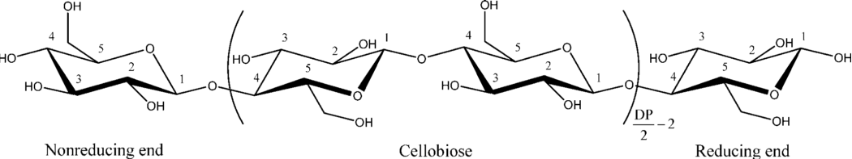
Figure 1: The three chemically distinct parts of cellulose; the non-reducing end, repeating AGUs, and the reducing end.⁵ Figure reproduced from reference 5.
Natural cellulose can be broken down into nano-sized fragments termed nanocellulose. There are three types of nanocellulose that are widely researched: cellulose nanocrystals (CNCs), cellulose nanofibrils (CNFs), and bacterial cellulose (BC).¹⁰ CNCs are obtained by subjecting cellulose to acid hydrolysis or oxidation^{11,12} whereby the disordered regions of the elementary fibril are broken down quickly and the crystalline regions are isolated as individual nanoparticles (Figure 2).⁸ The choice of acid or oxidizing agent used in the production of CNCs affects the surface chemistry and in turn the reactivity, self-assembly behaviour, colloidal stability and rheological properties.⁵ Sulfuric acid hydrolysis is the most studied route to produce CNCs and grafts sulfate half-ester groups onto the CNC surface, as shown in Figure 2. Hydrochloric acid,¹³ phosphoric acid,^{14,15} hydrobromic acid,¹⁶ and various weak acids^{17–19} can also be used to extract CNCs.

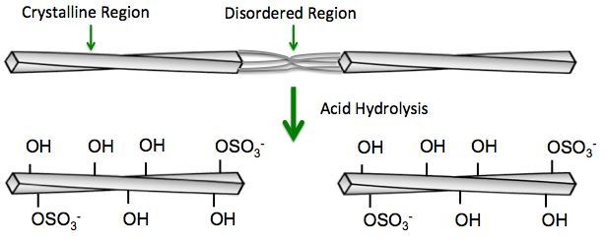
Figure 2: Acid hydrolysis preferentially hydrolyzes the disorder regions in natural cellulose to isolate the crystalline regions. These crystalline nanoparticles are known as cellulose nanocrystals and have sulfate half ester surface groups when the hydrolysis is performed using sulfuric acid.
CNCs are rod-like particles that can be produced from various cellulose sources. In this work, CNCs have been extracted from cotton, which yields nanoparticles with a cross-section of 5 – 10 nm, a length of 100 – 200 nm, and a Young’s modulus of approximately 150 GPa.⁴ CNCs generally have a crystallinity over 80%, measured by X-ray diffraction (XRD),²⁰ solid state nuclear magnetic resonance,²¹ neutron and x-ray fiber diffraction²⁰ and/or Raman spcetroscopy.²² CNCs have been demonstrated to be non-toxic in vitro and in vivo²³ for a range of cell lines and animal models,^{4,24–29} and show no long-lasting environmental risks or effects on wildlife.²⁴ As of this time, Environment Canada considers CNCs the first non-toxic nanomaterial in Canada (from a commercial standpoint),³⁰ however, some gaps in CNC safety knowledge have been identified,³¹ particularly for surface modified CNCs.^{32,33}
The second type of nanocellulose, CNFs, is produced by mechanically disintegrating cellulosic pulp using grinding and high-pressure homogenization processes³⁴ (sometimes combined with oxidation¹² or enzymatic pre-treatments³⁵). The resulting nanomaterial is a long section of the elementary fibril that contains both crystalline and disordered regions. This typically allows CNFs to be a few micrometers in length³⁶ and diameters similar to that of CNCs.³⁷ The crystallinity of CNFs is usually less than CNCs, which is due to the residual disordered regions in CNFs; this imparts CNFs with more flexibility and ability to entangle and as such CNFs can only be handled and processed at very low concentrations as they form a gel around 1 wt%.³⁸
The third type of nanocellulose, BC is obtained through a “bottom up” approach rather than the “top down” approach used to produce CNCs and CNFs. BC is biosynthesized as nanoscale ribbons (that can be collected individually or as fibrous mats) by the bacteria Gluconacetobacter xylinus or the filamentous fungus Trichoderma reesei.^{39–41} BC has a higher crystallinity⁴² than CNCs and is longer (5 µm – 150 µm) with a nanometer-sized cross-section, therefore having a higher aspect ratio than the other two nanocelluloses.^{39–41} BC is used widely in biomedical applications (e.g. stents, wound healing, tissue scaffolds)⁴³,or can be hydrolyzed to produce CNCs.⁴⁴

Surface Modification of Cellulose Nanocrystals
CNCs have many surface hydroxyl groups which are easily modified through well-known carbohydrate chemistries to impart new functionality.⁵ Such reactions can be performed either during hydrolysis or as a post-treatment and include covalent modifications such as polymer grafting or molecule attachment as well as non-covalent surface modifications.⁴⁵ Functionalization aims to improve CNC behaviour, for example, dispersion in polymer composites,⁸ thermal stability,^{15,18} responsive properties,⁴⁶ wettability,⁴⁷ or the ability to act as a template for chemical synthesis.^{48,49} Surface modifications used in this thesis work to impart cross-linking points on the CNC surface are described below.
One of the many CNC surface modifications reported in the literature is the addition of aldehyde groups through a reaction with sodium periodate.⁵⁰ In this reaction, a periodate ion forms a complex with the hydroxyl groups on the C2 and C3, vicinal carbons, of an AGU (see Figure 1 for carbon numbering). After this complex is formed, the carbon-carbon bond between the C2 and C3 is cleaved, leaving two adjacent aldehyde groups.¹¹ Sun et. al. found that the amount of aldehyde groups on a CNC surface can be adjusted by manipulating the pH, temperature, oxidant to cellulose ratio, and time of the reaction; the maximum amount of aldehyde content was found to be 6.95 mmol/g.⁵⁰ In addition, studies have shown that CNCs can be “over-oxidized”, which can potentially change the cellulose structure.^{51,52} Azzam et al. examined the crystallinity of CNCs after prolonged oxidation time through XRD and transmission electron microscopy (TEM).⁵¹ Their results showed that with prolonged oxidation time, CNCs showed progressively less crystalline behaviour before showing a broad “amorphous” peak.⁵¹ They attributed this phenomenon to surface peeling, which resulted in smaller diameter CNCs with cellulose chains dangling from the CNC surface. In an alternate explanation, Larsson et al. saw a similar phenomenon with increasing oxidant concentration, however they claimed that a core-shell of ductile dialcohol cellulose built on the surface of the crystalline cellulose region of CNFs.⁵² Yang et al. reported CNCs treated with sodium periodate formed di- and tricarboxylated cellulose chains that protruded from CNC surfaces, this allowed CNCs to be electrostatically stable.⁵³ Nonetheless, both works of Sun et al and Azzam et al show a decrease in nanocellulose crystallinity with sodium periodate and imply that reactions should be performed carefully to minimize crystallinity loss.^{51,52}
CNCs have also been modified to have carboxylic acid groups on their surface, either added during CNC production or as a post modification reaction. Production methods that hydrolyze CNCs with weak acids such as phosphoric acid,⁵⁴ citric acid,¹⁸ and oxalic acid¹⁷ or produce CNCs by oxidation with ammonium persulfate,¹⁹ will form carboxylic acid groups on CNC surface in ones step. This prevents the grafting of any unwanted anionic groups from stronger acids like sulfuric acid. One example of this is citric acid hydrolysis, in which a citric acid group is grafted onto the C6 of the AGUs. Since citric acid has three available carboxylic acid groups, this allows two carboxylic acid groups to remain on the surface instead of one.¹⁸ Carboxylic acid groups have also been added to CNC surfaces post-acid hydrolysis. This is commonly performed with a (2,2,6,6–tetramethylpiperidin-1-yl) oxyl (TEMPO) oxidation reaction in order to substitute the C6 hydroxyl group for a carboxylic acid group.¹¹
Carboxylic acid groups on CNC surfaces impart anionic surface charge (and thus colloidal stability) and produce the opportunity for further surface modification. For example, the addition of new functional groups (amine,⁵⁵ hydrazide,⁵⁶ fluorescent tags,^{57,58} enzymes,⁵⁹ amino acids⁶⁰) through carbodiimide coupling chemistry has been well studied. Through the use of N’-ethyl-N-(3-(dimethylamino)propyl-carbodiimide (EDC) zero-length linker reactions, amine groups, for example, can be attached to a CNC surface.⁶¹ With the use of N-hydroxysuccinimide (NHS), dihydrazide groups can similarly be grafted to CNCs through the carboxylic acid functionality. The result is a CNC with a free hydrazide group on its surface^{61,62} which in this work is used as a cross-link point to control the assembly of CNC materials.^{60,63,64}
With both hydrazide and aldehyde modified CNCs, it becomes possible to covalently cross-link two individual CNCs through a hydrazone bond.⁶² Hydrazone bonds are formed through hydrazide (or hydrazine) groups and carbonyl (aldehyde or ketone) groups (Figure 3).⁶² The advantage of this type of chemical cross-linking over other types is that hydrazone bonds can form relatively quickly and easily under standard conditions. This is in contrast to other cross-linking chemistries, which either take a long time, or require a catalyst, external stimuli or added chemicals.^{65,66} In addition, hydrazone cross-linking chemistry is less toxic than other cross-linking chemistries,⁵⁶ such as radical cross-linking strategies.⁶⁷ Importantly, hydrazone cross-links have been shown to break down slowly in vitro and in vivo and their by-products are similarly non-toxic.⁵⁶
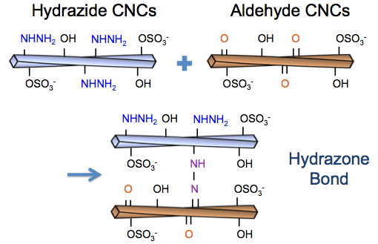
Figure 3: Formation of a hydrazone bond between two surface modified CNCs, i.e., an aldehyde CNC and a hydrazide CNC.

Aerogels
An aerogel is defined as an ultra-low-density material, derived from a gel network by removing the liquid medium and replacing it with a gas.¹ Aerogels are lightweight with porosities over 90%.² One of the most studied and commercially available types of aerogels are silica aerogels,⁶⁸ which are noted for their optical and lightweight properties and have brittle mechanical proeprties.⁶⁹ Silica aerogels also possess thermal insulation and flame resistant properties,⁷⁰ and their high porosity makes them a viable sound insulator, by creating a difficult pathway for sound waves to travel through.^{70,71} Surface modified silica aerogels have also been used as catalysts, separation devices, and gas/energy storage materials.⁶⁸ Other starting materials have been used to produce aerogels including polymers,⁷² carbon nanotubes,^{73,74} graphene,⁷⁵ nanoclays,⁷⁶ and nanocellulose.^{77,78} With the diverse characteristics that aerogels possess, they are an attractive material for a variety of applications.

Production of Aerogels
Aerogels are produced by applying a drying technique to a liquid-based gel, to remove the liquid medium without collapsing the gel network.¹ Critical point drying (CPD) was the first drying technique used by Krister to create an aerogel.⁷⁹ CPD is performed by suspending the gel network, usually in water, into an organic solvent, usually ethanol, until the gel network has become an alco-gel. This process is performed slowly, working from a solvent exchange of 10% ethanol up to 100% ethanol. The alco-gel is then solvent exchanged with supercritical CO₂, since CO₂ is miscible in ethanol. When the ethanol has been fully exchanged with supercritical CO₂, the system is returned to ambient conditions, changing CO₂ into a gas, resulting in the formulation of a dry aerogel.⁸⁰ The CPD process is depicted schematically in Figure 4. CPD is a preferred method for creating aerogels because it prevents the collapse of the gel network by constantly providing a liquid support for the network and phase changing into gas. In many gel networks, if the liquid medium were allowed to evaporate, the gel network would slowly collapse, losing all pore structure in the process.¹
Aerogels can also be produced through freeze-drying.⁸¹ This technique involves freezing a gel network, usually in water, allowing the pores to be kept intact by rigid ice crystals. The gel is then placed in a low temperature controlled high vacuum. The low temperature and low pressure facilitate the phase change from solid state to gas state. This allows the pores to retain their shape as the ice crystals are pumped out by the vacuum, causing an aerogel to form.⁸² Freeze-drying is used fairly readily in pharmaceutical processing and other industrial materials production, however, it is a fairly time consuming drying method.⁸³

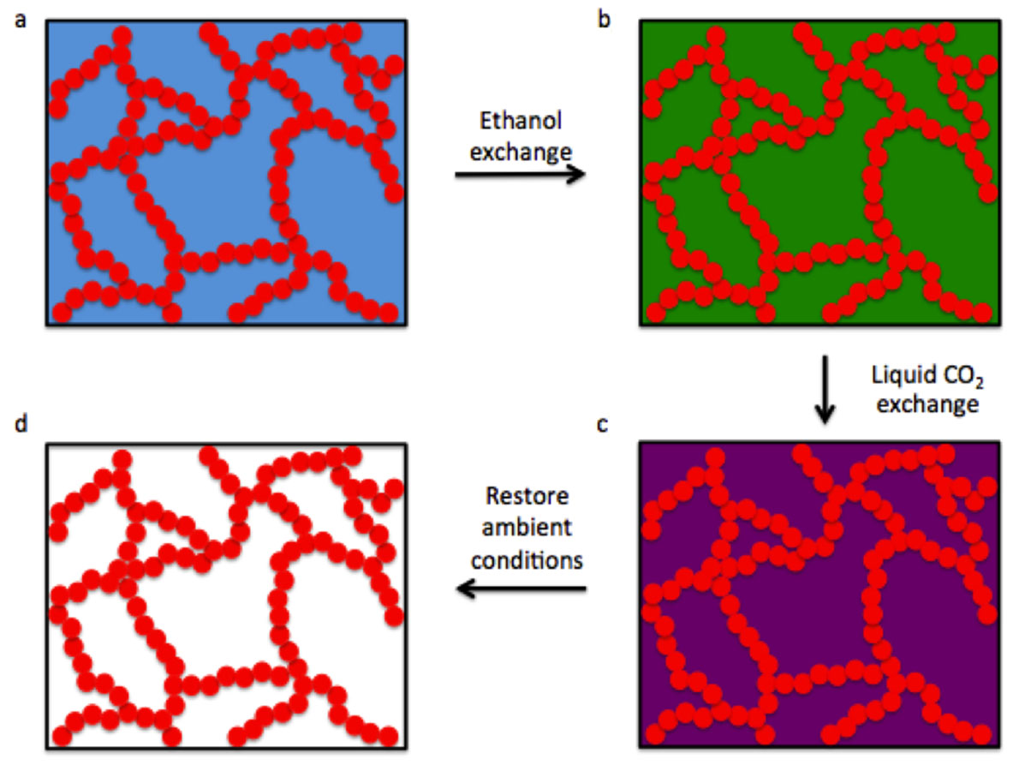
Figure 4: Schematic of the critical point drying process for aerogel formation; the red circles represent a gel network which may be composed of inorganic, metal, polymer or nanoparticle building blocks. a) Shows the gel network in its original medium of water, water is then exchanged with ethanol to produce b) an alco-gel, followed by submerging the alco-gel in supercritical CO₂ and solvent exchanging to produce c) a supercritical CO₂ –filled gel. d) Returning the gel to ambient conditions allows the CO₂ to sublime and the final dry gel network is obtained which retains its original structure (ideally with minimal collapse).
New drying techniques such as spray drying,⁸⁴ spray freeze-drying,⁸⁵ and subcritical drying⁸⁶ have been developed in recent years and may be amenable to aerogel processing, potentially providing unique aerogel morphologies. One such technique called pressurized gas expansion (PGX) has been used to dry polymers and nanoparticles (i.e., solutes) by producing a solution/suspension in water mixed with ethanol and supercritical CO₂, solvent exchanging to supercritical CO₂ fully and then depressurizing the system to remove CO₂.^{87,88} More specifically, the mixture of the solute, water, ethanol and CO₂ must be homogeneous, which is made possible through the pressurized gas expanded ethanol being highly soluble in water. Each fluid is slowly replaced sequentially throughout the process following the ternary phase diagram in Figure 5, passing through compositions labelled 1, 2 and 3, and ensuring the mixture composition always lies above the black curved line. To begin, ethanol and supercritical CO₂ are pumped into the vessel at the same time as the solute solution/suspension is being pumped through a filter, in order to flush water from the system. This leaves the dehydrated solute in ethanol and supercritical CO₂.⁸⁷ The supply of ethanol is then cut off, but supercritical CO₂ continues to be pumped into the vessel, so that finally only solute and supercritical CO₂ remain.⁸⁹ The vessel is then depressurized at ambient conditions, allowing for the supercritical CO₂ to revert to a gas phase and exit the system without affecting the solute network, allowing for an aerogel-like structure to be obtained.^{90,91} While PGX has been used industrially to extract, purify, micronize and dry (bio)polymers intended for cosmeceutical, nutraceutical, and therapeutic products, the materials produced after drying are aerogels that are quite porous and have high specific surface areas.⁸⁷ Although PGX dried materials are rarely used as aerogels (and more often it is considered a drying method which allows materials to be easily redispersed in liquid), we propose that PGX with chemical cross-linking during processing may be an advantageous route to scale-up aerogel production.

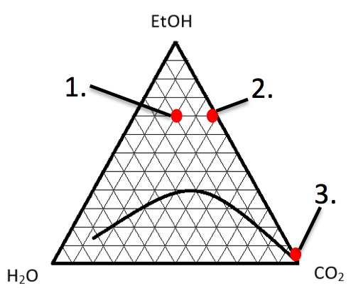
Figure 5: Ternary phase diagram that governs the PGX process; in order to keep a homogenous supercritical fluid, the mixture of water, ethanol, and CO₂ must be above the curved black line. Position 1 shows the start of the procedure with a mixture of water, ethanol and CO_{2.}. Position 2 shows what concentration the system is at after the water has been replaced with CO₂. Position 3 shows where the system is after the ethanol has been replaced with CO₂.⁸⁷ Figure adapted from reference 87.

Cellulose Aerogels
Cellulose is an ideal starting material for aerogels, as it is low cost, versatile, and its nanocellulose derivatives have a high specific surface area.⁴ There have been several types of cellulose-based aerogels reported previously, mostly focusing on CNF-containing aerogels.⁹² Due to the disordered regions, CNFs are more flexible than CNCs, and can entangle with other CNFs in suspension.⁹³ CNF aerogels are commonly produced through either critical point drying a CNF alco-gel, or freeze-drying a CNF cryo-gel,⁶ although alternative drying methods incorporating ambient drying have been developed.^{81,94} In either case, many CNF aerogels are held together by physical cross-linking and hydrogen bonding,⁶ and as such are not very strong and dissociate when introduced into water. Chemical cross-linking can improve CNF aerogel properties,⁶ and has been achieved through the use of post-treatments such as chemical vapour deposition and various CNF coatings.^{95–97} CNF aerogels have been used in applications such as gas filters,⁹⁴ batteries and supercapacitors,⁹⁸ oil adsorbents,⁹⁹ and controlled drug delivery scaffolds.¹⁰⁰
Comparatively, CNC aerogels have not been explored as much as CNF aerogels in the literature. Those reported have followed the standard aerogel synthesis procedures of either being critical point dried from an alco-gel state, or frozen into a cryo-gel and then freeze-dried.^{101,102} However, much like CNF aerogels, CNC aerogels are unstable in aqueous environments and will disperse (in fact, even more so since they cannot “entangle” due to their rigid structure).¹⁰³ Stable CNC aerogels have been produced by chemically cross-linking CNCs.^{62,104–107} The potential of CNC aerogels remains to be fully identified, however, some have been shown to have promising applications as selective absorbents,¹⁰⁵ supercapacitors¹⁰⁸ and insulating materials.³
CNFs and CNCs have also been incorporated as additives in other polymer and silica-based aerogels. In these materials, nanocellulose materials have either been used as material replacements or as mechanical reinforcement agents for supercapacitors,¹⁰⁸¹⁰⁹ wound dressing,¹¹⁰ and water purification applications.^{111,112} These examples show that, alone or as an additive, nanocellulose materials can add further versatility to aerogel materials

Structure of Bone

The Hierarchal Structure of Bone
Bone provides a support structure for the body, facilitates movement, acts as a reservoir of essential ions for biochemical reactions, and is one of the body’s main producers of blood cells.¹¹³ Bones are made of two main components: the organic components, mainly Type 1 collagen, and the inorganic components, mainly HA. The other minor constituents of bone include water, collagenous proteins, non-collagenous proteins, proteoglycans, and other calcium and carbon constituants.^{114,115} Type 1 collagen is an organized unit of three amino acid chains intertwined into a triple helix structure. This complex is mineralized by HA which contributes to the hardness of bone.^{114,116}
Bone can be further categorized by its macrostructure organization as either compact or trabecular bone.¹¹⁷ Compact bone, or cortical bone, is the densest bone tissue which makes up the outer layer of the bone.¹¹⁸ Despite its compact structure, this bone contains pores throughout to allow the flow of blood through a series of blood vessels.^{113,114} Trabecular bone, or spongy bone, is more porous than compact bone and is responsible for bones natural ductility, due to its random, honeycomb organization, it also comprises almost 20% of bone.¹¹⁹ Figure 6 shows the hierarchal structure of bone from the nanostructure to the macrostructure.
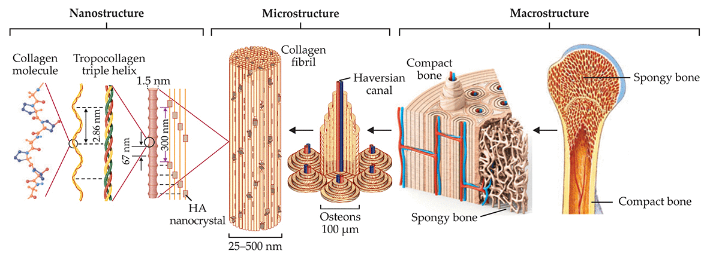
Figure 6: The hierarchal structure of bone. The nanostructure of bone shows the collagen molecule and triple helix structure and the location of HA. The microstructure of bone outlines where collagen and HA occur in a collagen fibril. The microstructure also outlines the structure of the osteon and the Haversian canal. The macrostructure of bone shows the location of spongy bone (trabecular bone) and compact bone.¹²⁰ Figure reproduced from reference 120.

Bone Cells
There are four types of bone cells that contribute to bone formation and remodeling: osteochondral cells, osteoblasts, osteocytes, and osteoclasts.^{121,122} Osteochondral cells, or osteoprogenitor cells, are highly metabolic active cells that are the progenitors of osteoblasts, which reside mostly in the deep layers of the periosteum and the endosteum.^{121,122} Meanwhile, osteoblast cells, bone forming cells, produce both the organic and inorganic components of bone tissue during the bone remodelling process (further reviewed in section 2.5.3).¹²¹ These cells are responsible for secreting the osteoid which serves as the foundation that bone is formed upon.¹²¹ Some osteoblasts will become osteocytes within the bone after their secretion process is completed.¹²¹ Osteocytes are entrapped osteoblasts that remain within the bone matrix.¹²² Osteocytes are responsible for balancing the calcium and phosphorus concentration within bone, and contribute to the remodeling behaviour in response to the local environment.¹²¹ Additionally, osteocytes act as sensors through mechanotransduction (a chemical signaling pathway that senses changes in bone through mechanical loading or microfractures) to signal and recruit osteoclasts and osteoblasts for bone remodelling. Finally, osteoclasts are multinucleated cells that are responsible for resorbing bone to collect calcium and phosphate to be used within the body in biochemical reactions to assist in muscle contractions and metabolic pathways for cell signalling.¹²² Osteoclast cells adhere to a bone’s surface and release hydrolytic enzymes to dissolve organic and inorganic portions of bone and cartilage.¹²¹ This cell is crucial in the remodelling of newly formed bone becoming mature bone.¹²¹ The interplay between these four cells is critical for the bone remodeling process.

Ossification and Bone Remodeling
Bone is formed through a process called ossification which can be classified into two categories: intramembranous ossification and endochondral ossification.^{122,123} Intramembranous ossification is the process of mesenchymal stem cells mediating bone formation without the use of a cartilage mold.¹²³ This process occurs when mesenchymal stem cells cluster together. These stem cells start to form osteochondral cells, which eventually differentiate into osteoblast cells. These cells begin to lay down the osteoid, and commence bone formation. Over time, osteoblasts lay down more collagen fibrils, which are mineralized, creating a disordered layer of bone known as woven bone. Woven bone can become more ordered over time through the bone remodelling process, turning it into lamellar bone.¹²²
Endochondral ossification is the process of mesenchymal stem cells mediating bone formation with the use of a cartilage mould.¹²² The cartilage mould is formed by mesenchymal stem cells differentiating into chondroblasts.¹²⁴ Osteoprogenitor cells lay down around the cartilage mould, forming the periosteum, or outer shell, of the bone.¹²⁴ Osteoblasts begin to infiltrate the center of the cartilage and secrete osteoid, which continues to grow in diameter as osteoblasts lay down more collagen fibrils and a network of blood vessels throughout the developing bone.^{123,124} As the osteoid diameter grows to the appropriate size, chondrocytes begin to develop within the osteoid and produce alkaline phosphatase (ALP).¹²² As the osteoid becomes mineralized, it eventually turns into trabecular bone.¹²⁴ Osteoclasts then break down the center of the bone to create the medullary cavity. The broken down trabecular bone mixes with blood, non-collagenous proteins, and proteoglycans, becoming bone marrow.¹²² Endochondral ossification can be broken down into a primary and secondary ossification. Primary ossification deals with the bulk of the bone being formed, and secondary ossification forms the rounded ends of the bone that connects to joints.¹²² Endochondral ossification is the dominant ossification after fetal development.
However, bone is constantly undergoing a remodelling process in which ordered mature regions of bone are broken down and replaced by woven bone.¹¹⁹ This is phenomenon is particularly relevant for the process of bone healing after trauma or implant placement. Bone remodelling occurs in a cyclic process in four steps.¹²⁵ The first step is resorption, osteocytes signal for osteoclast cells to migrate to a location on bone and remove bone mineral, producing a cavity. After resorption is the reversal stage, where precursor cells prepare the cavity surfaces for bone osteoblast cells. Reversal is followed by formation, where successive waves of osteoblast cells replace resorbed bone and with woven bone. The final step is resting, where the bone is covered with flattened lining cells and the bone location undergoes little cellular activity until the cycle begins again. Woven bone has no order amongst its mineralized collagen, and is weaker than the organized bone tissue in compact and trabecular bone.¹¹⁹ As the remodelling process continues, osteoclasts break down woven bone and osteoblasts lay down more collagen and HA. Bone begins to be remodelled by osteoclasts, osteoblasts and osteocytes to form more organized bone known as lamellar bone.¹¹⁹ This process continues until woven bone is replaced either by compact bone or trabecular bone, depending on which tissue was being remodelled.¹¹⁹ The remodelling process can be seen below in Figure 7.

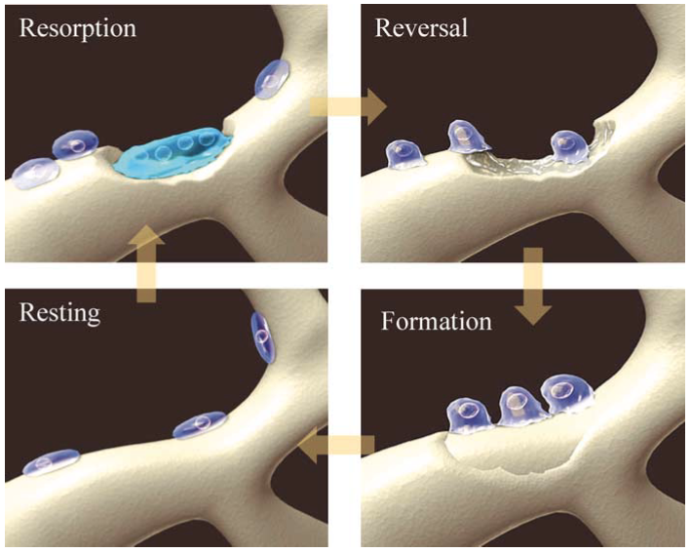
Figure 7: The remodelling process broken into four simple steps. Resorption, osteocytes recruit osteoclasts to differentiate, removing bone mineral and matrix to create a cavity. Reversal, mononuclear precursor cells prepare bone surface for new osteoblasts to begin forming bone. Formation, osteoblasts replace resorbed bone and fill the cavity with new bone. Resting, flattened lining cells cover bone surface until the remodelling cycle begins again.¹²⁵ Figure reproduced from reference 125.

Bone Tissue Engineering

Bone Formation around Scaffolds
Although bone has an effective natural healing process, in the event of a substantial bone disease or trauma, it cannot always heal itself properly. This can impact an individual’s mobility and function, a common symptom of bone defects.¹²⁶ A bone defect is defined as a lack of bone, such as a cavity, in the normal bone structure which may arise from a number of sources.¹²⁷ This can lead to pseudorathrosis, a condition where the body treats the defect as an artificial joint and connects two parts of diseased bone with fibrous tissue which has poor vascularization.¹²⁷ Surgery is often used to remove bone defects and all diseased bone, leaving vacancies within the bone tissue. These vacancies have been traditionally repaired with bone grafts or tissue scaffolds.¹²⁸ In order to create effective tissue scaffolds, bone tissue engineering research has focused on finding materials that promote osteogenesis, osteoinduction, and osteoconduction.¹²⁸ Osteoinduction occurs when a material promotes the recruitment of osteoblasts from within the patient, sometimes through the use of a growth factor or signalling proteins placed within the material.¹²⁸ Osteoconduction occurs when a material provides a suitable environment for woven bone to form, allowing for cell proliferation, HA nucleation, and blood capillary growth.¹²⁸ Osteogenesis is the development and formation of bone and in the presence of a scaffold can occur in two ways: contact and distance osteogenesis. Contact osteogenesis is the process of osteogenic cells forming new bone on the tissue scaffold surface, eventually connecting to surrounding bone. Meanwhile, distance osteogenesis is the process of new bone beginning to form from the walls of the existing cavity, growing towards the tissue scaffold.¹²⁹ These two mechanisms of bone formation around scaffolds often occur simultaneously, culminating in the complete integration of the scaffold material in new bone matrix.

Bone Tissue Scaffolds
Scaffolds designed for bone tissue regeneration have evolved over the years from bone grafts to effectively designed scaffold.¹³⁰ In order to effectively facilitate bone growth, bone scaffolds should have several characteristics. Scaffolds should be highly porous and have a large surface area in order to enable maximum cell and protein adhesion, and cell proliferation.¹³¹ A scaffold also needs pores that are large enough, 100 µm – 200 µm, for cells and proteins to enter, and to allow blood vessel growth.¹³¹ Favourable topography is needed to promote protein adhesion, which, in turn, will promote cell adhesion.¹³² Surface chemistry is crucial for HA nucleation and providing a non-toxic environment for cells to proliferate.¹³¹ Davis et al. have stated that sub-micron features on an implant surface are ideal for effective fibrin retention, which leads to better cell adhesion.¹³³ Scaffolds also need have similar mechanical properties, so that they mimic the intended tissue.¹³² The compressive strength of compact bone ranges between 130 – 205 MPa and trabecular bone ranges between 0.22 and 10.44 MPa.^{134,135} Tissue scaffolds should fit the bone defect completely; any space between the scaffold and the wall of the cavity site can lead to an infection. An ideal bone tissue scaffold should have a combination of these characteristics.¹³² The most common types of bone scaffolds are made of ceramic materials, mainly HA, beta tricalcium phosphate, and bioactive glass due to their osteoconductive properties.¹³⁰

Metal and Ceramic Bone Tissue Scaffolds
Metals are one of the most commonly used materials for bone tissue integration.¹³⁶ This is due to their strong mechanical properties and inertness within the body.¹³⁶ Metals are usually used for bone alignment applications, such as fusion plates.¹³⁷ Metals such as titanium and stainless steel are also used as implants to replace bone tissue, such as a hip replacement or skull plates, due to their resistance to corrosion and high mechanical strength.¹³⁷
Metals can also be used as viable tissue scaffolds.¹³⁶ Iron and magnesium have been shown to slowly degrade within the body through corrosion. Alloys of iron and magnesium can control this corrosion mechanism in order to create a safe rate of degradation to make metal scaffolds possible.¹³⁶ However, these scaffolds are difficult to implant for bone defects. Due to the rigidity of metal, these scaffolds have trouble fitting into the complex structure of bone defects and can have toxic or harmful effects if corrosion is uneven.¹³⁶ Magnesium alloys can also potentially release fatal hydrogen gas bubbles into the blood stream.¹³⁶
Ceramics are the most widely used materials in bone tissue integration. While they are often used as a coating for metal implants to promote osseointegration, ceramics have also been used as a scaffold material.¹³⁸ The most common types of ceramics used for bone tissue applications are HA, beta tricalcium phosphate, bioglass, or other calcium phosphate ceramics.¹³⁹ Many ceramic scaffolds do not degrade quickly, which makes it difficult for the body to replace the scaffold with bone.¹³⁹ Other than scaffolds, ceramics have been incorporated in to bone pastes, which are meant to fill large complex bone vacancies and harden to serve as a bone replacement.¹⁴⁰

Polymer Bone Tissue Scaffolds
Another class of materials used in bone scaffolding is polymeric materials. Polymers can be broken into two categories for bone tissue applications: natural and synthetic. Natural-based polymers like arginylglycylaspartic acid (RGD), chitosan, and alginate are popular choices due to their low toxicity and overall better cell adhesion.¹⁴¹ Natural polymers are not as mechanically strong as synthetic polymers, and it is often harder to control their behaviour in the body.¹⁴¹ Synthetic polymers are simpler to produce on a larger scale due to the ability to control/tune their properties such as polydispersity index (PDI), mechanical properties, and tuneable surface groups.¹⁴¹ Synthetic polymers are often used with other additives, such as HA, to create composites.¹⁴² In addition to the ability to control polymer chain length and surface groups, polymers also have the advantage of being able to form scaffolds in situ; however, these scaffolds often lack appropriate pore size for proper cell penetration and have limited mechanical properties.¹⁴³

Cellulose Bone Scaffolds
Cellulose is an attractive material for tissue scaffolding due to its inherent biocompatibility with human and animal cell lines, its strong mechanical properties, and its ability to be chemically functionalized;⁴ as such, many different types of cellulose tissue scaffolds have been presented in the literature.¹⁴⁴ Carboxymethyl cellulose (CMC) is one of the most common cellulose derivatives incorporated into bone tissue scaffolds.⁴ CMC is often used alongside other polymers, usually cationic polymers like chitosan, in order to develop strong biodegradable scaffolds that can facilitate cell growth.^{145,146} Cellulose microfibers have also been incorporated into cartilage scaffolds.¹⁴⁷ Cellulose microfibers can be phosphorylated to make a more favourable environment for cartilage growth.¹⁴⁷ This is because phosphate groups interact with calcium ions to induce HA growth.¹⁴⁸ Cellulose microfibers can also increase the amount of cell adhesion to the scaffold surface and direct cell growth.^{145,146}
Nanocellulose has also been explored as a material for bone tissue scaffolds. Many papers have shown the use of BC as a viable bone scaffolding material.¹⁴⁸ BC is compatible with various cells such as mesenchymal stem cells and osteoblast cells in both in vitro and in vivo environments.¹⁴⁹ Similar to with cellulose microfibers, the incorporation of phosphate half ester groups on the surface of BC has promoted HA nucleation.¹⁴⁸ With evidence that BC can promote HA nucleation with the assistance of a CaCl₂ pre-treatment, it is likely that CNCs will be able to do the same.
Based on the literature outlined in this section, nanocellulose and CNCs particularly, have been shown to be viable candidates for cell scaffolding, specifically in hybrid/composite materials. One drawback is that on their own, CNC materials are unable to retain their structure in aqueous environments, due to water breaking their hydrogen bonded network (note that the CNCs themselves do not swell or dissolve but the nanoparticles become dispersed when submerged in water).^{5,8} With the potential to covalently cross-link CNCs into stable aerogel networks, it is possible to evaluate CNCs as a viable bone tissue scaffold material. Inherently, chemically cross-linked CNC aerogels have many characteristics that could prove useful for tissue scaffolding.

In Vitro Testing of Bone Scaffolds
In order for bone tissue scaffolds to be effective within the body, they should support both the organic and inorganic portion of bone. Ideally scaffolds would be tested in vivo, in order to see how the scaffold reacts within the body. Due to the expense and ethical issues arising from in vivo testing, in vitro testing is the most appropriate and first alternative evaluation method. For the bone tissue scaffolds evaluated in this work, three types of in vitro tests were conducted: a cell metabolism assay, an ALP assay, and a simulated body fluid (SBF) submersion test. The cell metabolism assay and the ALP assay were performed using a Saos-2 osteosaracoma cell line. Saos-2 osteosaracoma cells are human bone cancer cells that display characteristics of healthy human osteoblasts.¹⁵⁰ These characteristics have lead Saos-2 cells to be used widely in research to evaluate how materials will interact with the body.^{151–153}
The cell metabolism assay is used to quantify metabolism, which is an indicator of vitality of the cells on a scaffold’s surface. This assay is conducted by seeding Saos-2 cells on a scaffold and then allowing them to incubate in cell media for a period of time. After the incubation period has passed, the cells are submerged into an AlamarBlue® solution. The AlamarBlue® solution reacts with living Saos-2 cell metabolic pathways to produce a fluorescent reading when excited with 540 nm light. This measurement can then be used to give a qualitative reading of the cells’ ability to proliferate on the scaffold.¹⁵⁴
The ALP assay is used to evaluate cell differentiation. ALP is an early indicator of osteoblast differentiation, showing that the cells are in an environment where they can express a healthy phenotype. This is measured by adding a cell lysis solution, to break down cells and release their proteins. An aliquot is taken from the lysed cells and is added to a new well plate, where P-nitrophenol phosphate is added. Active ALP will cleave the phosphate group from P-nitrophenol phosphate, allowing it to emit light, which can be measured through an absorbance reading of 405 nm. This reading is then used to quantitatively measure the ALP activity of the cells seeded on the cell scaffold.¹⁵⁴
The SBF submersion test is used to evaluate the ability of the bone tissue scaffold to grow HA. This test consists of creating a buffer solution with similar pH and ion concentration to that of human blood plasma. Kokubo and Takadama have shown that SBF submersion testing can be a valid evaluation of a material’s ability to grow HA in the body.¹⁵⁵ Tas has raised concerns about the SBF process, stating that it is not the exact ion concentration of human blood plasma, and its ability to grow HA on materials that would not grow HA in the body render the technique void of any ability to predict behavior in vivo.¹⁵⁶ Despite these concerns, SBF is still a widely accepted method for evaluating a material’s ability to grow HA.¹⁵⁵

Morphology of Cross-linked Cellulose Nanocrystal Aerogels: Cryo-templating vs. Pressurized Gas Expansion Processing

Abstract
Cellulose nanocrystal (CNC) based aerogels are typically produced through cryo-templating, followed by either critical point drying or freeze-drying. While cryo-templating gives aerogels with a bimodal pore size distribution, better morphological control may be needed for certain applications. This work compares CNC aerogels prepared using a new processing method, called pressurized gas expansion (PGX), to aerogels produced via cryo-templating. In all cases, CNCs were surface modified with orthogonal functional groups to produce covalently cross-linked aerogels which are flexible and do not disperse in water. The aerogels were characterized by scanning electron microscopy, Brunauer-Emmett-Teller analysis, X-ray micro-computed tomography, X-ray diffraction, X-ray photoelectron spectroscopy, and compression testing. PGX aerogels appeared expanded and fibrillar at high magnification, with small mesopores and macropores less than 7 µm, but with large mound-like aggregates. Conversely, cryo-templated aerogels were comprised of dense CNC sheets surrounding macropores of 10 – 950 μm. Overall, PGX aerogels had a lower density, higher porosity, and a higher specific surface area than cryo-templated aerogels; however, they were less stiff due to their morphology and reduced number of chemical cross-links. Scale-up of aerogel processing and understanding of the tunability of such methods may extend the use of CNCs in applications including insulation, separations, flexible supports and biomedical devices.

Introduction
Aerogels are dry ultra-low density materials derived from gel networks by replacing the liquid medium with gas.¹ Aerogels are lightweight with porosities over 99%,¹ and have become popular in a variety of applications, such as acoustic and thermal insulation, energy production/storage, membrane separations, CO₂ capture, and catalyst supports.⁶⁸ Silica aerogels are the most commonly studied aerogels and are readily available commercially. While they have been praised for their insulating abilities and porosity, they have been criticized for their brittle and fragile properties.⁶⁸ To overcome this limitation, alternative aerogel starting materials have been investigated, such as polymers,⁷² carbon nanotubes,^{73,74} graphene,⁷⁵ nanoclays,⁷⁶ and nanocellulose,^{77,78} in order to produce aerogels that are more mechanically robust.
Nanocellulose is a nanoscale derivative of natural cellulose, namely cellulose nanofibrils (CNFs) and cellulose nanocrystals (CNCs); both have been used to produce cellulose-based aerogels as well as composites, emulsions, coatings and packaging.¹⁰ CNFs are isolated primarily through mechanical processes and the ca. 5 nm wide fibrils consist of ordered and disordered cellulose regions, which makes them relatively flexible.¹⁵⁷ As such, CNFs entangle easily at low concentrations which allows them to form highly porous gel networks with good mechanical properties.⁶ On the other hand, CNCs are highly crystalline rod-shaped particles that have diameters of 5 – 10 nm and lengths of 100 – 200 nm (when produced from wood and cotton¹⁵⁸) and therefore have a limited ability to “entangle”. Both CNFs and CNCs are renewably-sourced, non-toxic²³ and easily functionalized through well-known surface chemistry,¹¹ and we employ this latter property to add cross-linking groups to the CNC surface to allow them to covalently form a networked structure providing us with more control over the internal aerogel structure.
CNCs are most commonly extracted by acid hydrolysis or oxidation and have specific surface areas ranging from 200 – 500 m²/g.^{5,19} Their high rigidity and surface area have been exploited in the literature to create CNC aerogels with potential across a broad range of applications such as supercapacitors,¹⁰⁸ selective absorbents,¹⁵⁹ thermal insulators,³ and ion exchange applications.¹⁶⁰ Compared to silica aerogels, CNC aerogels have similar ultra-low density, high porosity, and high specific surface area but with the important advantage of being mechanically strong and flexible.⁶
The first CNC aerogels reported were held together by weak cellulose-cellulose interactions (e.g., hydrogen bonding and van der Waals forces⁶), however, they redispersed in aqueous environments, losing their porous gel structure.¹⁰³ More recently, this has been remedied by covalently binding CNCs together using various cross-linking chemistries.^{105,107,160,161} Our group previously showed that hydrazone bonds could be formed between CNCs that were surface modified with aldehyde and hydrazide groups and the aerogels produced had shape recovery properties, even when submerged in water.⁶² The hydrazone cross-linking is based on bio-orthogonal functional groups that react immediately when in contact, such that external stimuli or additional chemicals are not needed; furthermore, the chemistry is suitable for biomedical applications and the gelation kinetics and cross-link degradation have been well documented.¹⁶²
CNC aerogels with a variety of surface chemistries and functionality have been described in the literature, however, they are all produced using freeze-drying or critical point drying (CPD), which are both cryo-templating methods.⁶ To the best of our knowledge, there have been no reports focused on CNC aerogel processing and as such, this work sets out to compare cryo-templated CNC aerogels and a new industrial scale drying method called pressurized gas expansion (PGX). Cryo-templating is the process of freezing a suspension of CNCs in water to form ice crystals. As ice crystals grow they exclude the CNCs from the water phase, forcing CNCs together into sheet-like structures. In our case, we use aldehyde and hydrazide modified CNCs such that when they come into contact, hydrazone bonds form and the CNCs become chemically cross-linked.⁶² More specifically, when the CNC suspension is frozen, it becomes a cryo-gel, which is submerged into ethanol to solvent exchange the ice-crystals, to become an alco-gel. The alco-gel is then subjected to CPD which is the process of solvent exchanging ethanol for supercritical CO₂.⁶² The supercritical CO₂ is gradually depressurized to ambient conditions to create an aerogel. Similar to CPD, CNC aerogels have also been prepared by freeze-drying^{105,163,164} (and in some cases directional freeze-drying¹⁶⁵) where the cryo-gel is subjected to a low temperature high vacuum, which causes the ice-crystals to sublimate. Both processing methods lead to similar aerogel morphologies with stacked CNC sheets separated by macropores. Mesopores (2 – 50 nm in diameter) can be found between individual CNCs on each sheet.⁶² While both methods give highly porous and reproducible aerogel morphologies, the multiple steps and solvent exchanges required may limit the scale-up of these aerogel production routes.
PGX technology is a potential new technology for aerogel processing.^{88,90,91,166} In our application, PGX consisted in mixing an existing CNC gel network in water with ethanol and supercritical CO₂. The PGX process is used industrially to extract, purify, micronize and dry (bio)polymers/nanoparticles intended for cosmeceutical, nutraceutical, and therapeutic products – this study aimed at exploring PGX-produced aerogels and the potential of a scalable process to produce chemically cross-linked CNC aerogels. Importantly, the PGX process can preserve pre-existing structures from wet state to dried state. This is in contrast to techniques that incorporate freezing such as freeze-drying, where ice crystals will push and condense structures, completely altering pre-existing structures. In the one-step PGX process, polymers/particles (i.e., solutes) are immediately dehydrated. This is due to three separate “mechanisms” occurring during that single step. First, the pressurized gas expanded ethanol offers higher water solubility. Second, the anti-solvent effect of ethanol effectively precipitates the solute out of its original water solution. Finally, the supercritical carbon dioxide stream carries the ethanol and water outside of the precipitation chamber. Once water and ethanol are removed from the system, leaving the gel network suspended in supercritical CO₂, the system is depressurized to ambient pressure, thereby allowing CO₂ to go from the supercritical to the gas phase and exit the system without affecting the polymer/particle network.^{89,90,166} Due to the absence of interfacial tension and by carefully controlling the rate of addition of the solute slurry, ethanol and supercritical carbon dioxide, it is possible to generate unique gel networks that are lightweight and very porous.⁹¹
While the PGX process seems similar to the cryo-templating process regarding solvents, there are some key differences. Namely, the solvent exchange and removal of water happens in a batch-wise manner over long periods of time in the cryo-templating process, whereas in the PGX process the aqueous polymer/particle slurry is continuously pumped into a mixture of ethanol and supercritical CO₂ leading to a single phase regime and instant solvent exchange, thereby causing precipitation and formation of an aerogel-like structure. In the PGX process, gel network formation and gel drying occurs in fractions of seconds using a coaxial nozzle to mix the aqueous slurry with the CO₂ and ethanol under a highly turbulent regime inside a pressurized collection vessel in one step forming highly porous structures over the course of 8 hours. On the other hand, in the cryo-templating method, each solvent is sequentially removed in a diffusion controlled process taking up to 5 days, one after another until it is subjected to the drying process using supercritical CO₂.
This paper compares two chemically cross-linked CNC aerogels – one produced through the PGX process, and the other produced through the cryo-templating process. The aerogels were thoroughly characterized to understand the morphologies attainable through the different processing routes. Specifically, specific surface area, pore size distribution, mechanical properties, chemical cross-link density, crystallinity and microstructure were investigated.

Materials and Methods

Materials
Whatman cotton ashless filter aid was purchased from GE Healthcare Canada (Mississauga, Canada). Sulphuric acid (95% – 98%) and dimethyl sulfoxide were purchased from Caledon Laboratory Chemicals (Georgetown, Canada). Anhydrous ethanol was purchased from Commercial Alcohols (Toronto, Canada). 2,2,6,6 – (tetramethylpiperidin-1-yl)oxyl (TEMPO, 99% purified by sublimation), adipic acid dihydrazide (ADH) ≥98%, N’-ethyl-N-(3-(dimethylamino)propyl)-carbodiimide (EDC, commercial grade), ethylene glycol (99.8%), silver(I) oxide (Ag₂O, ≥99.99% trace metals basis), sodium periodate (NaIO₄, >99.8%), N-hydroxysuccinimide (NHS, 97%), sodium hypochlorite solution (NaClO, 10-15%), sodium bromide (NaBr, Reagent Plus® ≥99%), and thiocarbohydrazide (TCH) 98% were purchased from Sigma-Aldrich (Oakville, Canada). Osmium tetroxide (OsO₄) solution was purchased from Canemco & Marivac (Lakefield, Canada). Hydrochloric acid (HCl, 0.1 M and 1 M) and sodium hydroxide (NaOH, 0.1 M and 1 M) were purchased from LabChem Inc (Zelienople, USA). The water used was purified type I water with a resistivity of 18.2 MΩ·cm (Barnstead NANOpure Diamond system, ThermoScientific, Asheville, USA). No chemicals were modified or further purified before use.

Preparation of Cellulose Nanocrystals (CNCs)
CNCs were prepared through sulfuric acid hydrolysis, as described previously.¹⁵⁸ Briefly, cotton ashless filter aid (40 g) was first blended to a cotton pulp. The pulp was added to 700 mL of 64 wt% sulfuric acid and hydrolyzed for 45 minutes at 45 ˚C under constant mechanical stirring. The cotton-acid slurry was then added to 7 L of 4 ˚C purified water to quench the reaction, and was left for 1 hour to settle. The slurry was then subjected to multiple 10-minute rounds of centrifugation at 5000 rpm. The slurry was centrifuged until a pellet no longer formed. The CNC suspension was then dialysed against purified water using dialysis membranes with a 14 kDa molecular weight cutoff purchased from Sigma-Aldrich. Dialysis water was changed daily for two weeks until the pH of the dialysis water no longer changed (ca. pH 5 – 6). The CNC suspension was then probe sonicated (Sonifier 450, Branson Ultrasonics, Danbury, USA) in an ice bath for three individual rounds (15 minutes total) at an output energy of 60%. The CNC suspension was then passed through Whatman glass filter paper and stored at 4 ˚C. CNCs produced using sulfuric acid hydrolysis have grafted sulfate half ester groups on their surface that impart an anionic surface charge and colloidal stability in water;¹⁵⁸ in this case, CNCs were stored in the acid form, meaning the counterion on the sulfate half ester is a proton.

Aldehyde CNC (CHO-CNC) Modification
To add aldehyde groups onto the CNC surfaces,⁵⁰ 20 g of NaIO₄ was added to a 500 mL 1 wt% suspension of CNCs in a 1 L round bottom flask. The flask was completely covered in aluminum foil to protect the NaIO₄ from light. After the NaIO₄ was dissolved, the pH of the suspension was lowered to 3.5 ± 0.2 with 1 M HCl. The round bottom flask was then covered with a septum and placed in a 45˚C ± 0.1˚C oil bath under constant stirring for 4 hours. The oil bath was also wrapped in aluminum foil to avoid light from interacting with NaIO₄. After 4 hours, the suspension was removed from the oil bath and 10 g of ethylene glycol was added to quench the reaction. The suspension was also exposed to light and air to assist in quenching the reaction. After 10 minutes, the reaction was considered quenched and dialysed for two weeks with daily water changes. CHO-CNCs were stored at 4˚C.

Carboxylic Acid CNC (COOH-CNC) Modification
To add carboxylic acid groups onto the CNC surfaces, a TEMPO oxidation reaction was performed.^{11,12} A 200 mL solution containing 0.148 g of TEMPO and 1.62 g of NaBr was slowly added drop-wise to a 500 mL 1 wt% suspension of CNCs in a 1 L round bottom flask at ambient conditions with stirring. Immediately after, 30 g of 12.5 wt% NaClO was slowly added to the suspension drop-wise. The suspension was allowed to react for 3 hours. The pH of the reaction was closely monitored to remain at 10 ± 0.2 with 1 M NaOH. After 3 hours, 18.2 g of ethanol was added to the suspension to quench the reaction, which was then stirred for another 10 minutes. The suspension was then centrifuged for one round at 10,000 RPM, then dialyzed for two weeks with daily water changes. COOH-CNCs were stored at 4 ˚C.

Hydrazide CNC (NH₂NH-CNC) Modification
The procedure by Yang and Cranston was used to add hydrazide groups onto the CNC surfaces.⁶² Adipic acid dihydrazide (0.6 g) was added to a 200 mL 1 wt% suspension of COOH-CNCs and allowed to dissolve. Both NHS and EDC were suspended in separate 1 mL 1:1 dimethyl sulfoxide:water solutions. The NHS and EDC solutions were then added to the CNC suspension, drop-wise and sequentially. The pH of the suspension was adjusted to 6.8 with NaOH and HCl until there was no more rapid pH change. The CNC suspension was then dialyzed for two weeks with daily water changes. NH₂NH-CNCs were stored at 4˚C.

Degree of Functionalization
Sulfate half-ester,¹⁶⁷ aldehyde,¹⁶⁸ carboxylic acid, and hydrazide content⁶² on CNCs was quantified by conductometric titrations, as reported in the literature. A known mass of CNCs (12 – 15 mg dry) was added to 60 mL of purified water with 0.3 mL of 200 mM NaCl solution to achieve measurable conductivity readings. For titrations involving carboxylic acid content, 0.3 mL of 0.1 M HCl was added to the CNC suspension prior to titrating. This was used to gain a measurable slope for the titration curve as outlined in the literature.¹⁶⁹ Sulfate half-ester content was titrated using 0.250 mL aliquots of 2 mM NaOH. To ensure all sulfate half-ester groups could be titrated (i.e., in acid form, -OSO₃H) all functionalized CNCs were passed through ion exchange resin (Dowex® MarathonTM C hydrogen form, Sigma-Aldrich, Oakville, Canada) before titration as outlined by Beck et al.¹⁶⁷ Aldehyde, carboxylic acid and hydrazide content were titrated using 0.05 mL aliquots of 10 mM NaOH. Since hydrazide groups are grafted to carboxylic acid groups, the carboxylic content remaining on NH₂NH-CNCs was subtracted from the carboxylic content on COOH-CNCs to quantify the number of hydrazide groups on the NH₂NH-CNC surface. Aldehyde content was measured by selectively oxidizing aldehyde groups into carboxylic acid groups with an Ag₂O oxidation reaction¹⁶⁸ by adding 0.193 g of Ag₂O and 0.027 g of NaOH to a 20 mL 0.25 wt% suspension of CHO-CNCs and allowing it to stir overnight. The reaction was then filtered through Whatman glass filter paper. All titrations were performed over a period of approximately 1 hour.

Cryo-templated CPD Aerogel Processing
Cryo-templated CPD aerogels were made by combining 2.5 mL of 2 wt% CHO-CNC suspension, 2.5 mL of 2 wt% NH₂NH-CNC suspension, 0.5 mL of 200 mM NaCl, and 4.5 mL of purified water to create a 1 wt% suspension of CHO-CNC/NH₂NH-CNCs. This suspension was then vortexed for 2 min (level 10 Analog Vortex Mixer, VWR, Mississauga, Canada). Suspensions were then transferred into 15 mm diameter or 8 mm diameter shell vials (depending on the intended characterization). Vials were placed in a -4 ˚C freezer and allowed to freeze overnight to form cryo-gels. The cryo-gels were transferred into anhydrous ethanol in ambient conditions (no collapse of the gel structure was visible which implied that sequential solvent exchanges with increasing ethanol content were unnecessary). Ethanol was changed every day for five days until the cryo-gels were fully infiltrated with ethanol, forming alco-gels. Finally, the alco-gels were transferred into a critical point dryer (Leica EM CPD300, Wien, Austria), where ethanol was solvent exchanged with supercritical CO₂, and gradually depressurized to ambient conditions. All characterization was carried out on cryo-templated aerogels made from the same batch of CHO-CNCs and NH₂NH-CNCs.

Pressurized Gas Expansion (PGX) Aerogel Processing
PGX aerogels were processed at Ceapro Inc. in Edmonton, AB, Canada using their patented technology.¹⁶⁶ The PGX process consists of mixing an aqueous slurry of CNCs, anhydrous ethanol, and supercritical CO₂, all through separate inlet valves, under 100 bars and 40°C that allows removal of water at very low or vanishing interfacial tension during the spraying process.^{90,166} First, CHO-CNCs and NH₂NH-CNCs were suspended in a 9:1 ethanol:water mixture (as opposed to all suspensions described above which were in 100% purified water). 100 mL of a 1 wt% CHO-CNC suspension and 100 mL of a 1 wt% NH₂NH-CNC suspension was mixed together and stirred under high shear mixing with a Silverson L4RT-A (Silverson Machines Inc., East Longmeadow, USA) at 3000 rpm for 3 minutes. The CNC mixture was then pumped into the PGX system under constant stirring. The CNC mixture was fed into the PGX reactor through a coaxial nozzle with a 1/16th inch orifice size. All PGX aerogels were produced using same nozzle parameters. Additional morphological control is anticipated through altering the orifice size of the coaxial nozzle. Once all CNCs had been fed to the reactor, the CNC inlet was closed and anhydrous ethanol and supercritical CO₂ were pumped into the PGX system to further dry the gel. After this additional drying step, the ethanol inlet was closed, which allowed supercritical CO₂ to remove anhydrous ethanol. The supercritical CO₂ and CNCs were then depressurized to ambient pressure to allow the CO₂ to move from the supercritical to the gas phase thereby effectively removing it from the gel. A membrane filter with 5 µm pores was used to trap CNCs into the 5 L collection vessel during PGX processing. The PGX aerogels were dry upon removal in a uniform bulk. The PGX processing method was used to produce five separate batches of highly consistent PGX aerogels; however,all aerogel characterization was carried out on the same PGX batch and errors reported are between measurements on multiple samples from the same batch.

Dynamic Light Scattering (DLS)
DLS was used to determine a relative apparent particle size for CNCs in suspension. The term “apparent” is used in recognition of the fact that CNCs are rod-shaped particles and DLS assumed spherical particles;¹⁷⁰ nonetheless we consider this a valid method to obtain relative sizes of neat and modified CNCs but the values should not be taken as absolute and do not represent either the length or the cross-section of the CNCs. Measurements were made on CNC suspensions diluted to 0.025 wt% with 10 mM NaCl added (to screen the electrostatic double layer) using a Malvern Zetasizer Nano particle analyzer (Malvern Instruments Ltd, Malvern, UK). Particle size readings were obtained over 11 measurements for each of three separate samples with the temperature maintained at 23 ˚C. Standard deviation was calculated from three individual sample measurements.

Zeta Potential
The zeta potential of CNC samples was measured using a ZetaPlus electrophoretic mobility analyzer (Brookhaven Instruments Corp, Holtsville, USA). Samples were prepared by diluting CNC suspensions to 0.25 wt% and adding 10 mM NaCl (to ensure accurate and comparable zeta potential values).¹⁷¹ Zeta potential values were taken from an average of 10 measurements of 15 cycles per sample, all at 23 ˚C. Standard deviation was calculated from three individual sample measurements.

Density Calculation
The aerogel densities were determined by measuring the mass of the aerogel (Analytical Balance, Mettler, readability of 0.0001 g) and dividing it by the measured volume (calculated from dimensions measured with a digital calliper). Diameter and height measurements were calculated as an average of five measurements taken at five different locations on the aerogel. Four aerogels were used to determine the average density of each type of aerogel.

Porosity Calculations
The aerogel porosities were calculated using equation 1 from the literature.⁶²
$P\left(\%\right)= 100*\left(1-\frac{ρ_{Gel}}{ρ_{CNC}}\right)$ [Equation 1]
Where P is the porosity of the aerogel, $ρ_{Gel}$ is the density of the aerogel, and $ρ_{CNC}$ is the density of CNCs which is assumed to be 1.59 g/cm³.¹⁷²

Brunauer-Emmett-Teller (BET) Analysis
Specific surface area and pore size of the CNC aerogels were obtained from N₂ gas adsorption and desorption probing according to BET analysis using a autosorb® iQ (Quantachrome, Boynton Beach, USA) The aerogel samples were first degassed, and then kept under nitrogen gas at 100 ˚C for seven days prior to BET analysis. CNCs are hydrophilic and CNC aerogels have large specific surface areas available to bind water tightly; as such, this extensive drying was necessary to obtain reproducible results to not interfere with the nitrogen gas probing. Furthermore, to show that the drying process had removed all water an additional adsorption/desorption curve was performed for one sample of each aerogel type to ensure that the BET isotherms were nearly identical and that there was no gap between the adsorption and desorption curves at zero relative pressure. The BET analysis was performed at -196 ˚C and specific surface area and pore distributions were calculated using density functional theory. Only isotherms that showed no retention of water were used to acquire specific surface area and pore size distribution.

Scanning Electron Microscopy (SEM) Imaging
Aerogel samples were submerged into liquid nitrogen and fractured to gain an exposed cross-section for SEM analysis. Samples were mounted on a 1” diameter stainless steel stub with nickel paint. Nickel paint was used to coat the sides of the aerogel to create a connection to the sample stage to avoid charge build-up. Aerogels were sputter coated with 5 nm platinum and imaged in a JEOL 7000F SEM (JEOL, Tokyo, Japan) and a Magellan 400 XHR FE-SEM (FEI, Oregon, USA). All aerogel images were taken at a working distance between 4 – 6 mm and at an acceleration voltage of 2 kV.

X-Ray Micro Computed Tomography (µCT)
Aerogel samples were stained with an osmium tetroxide/thiocarbohydrazide staining protocol¹⁷³ in order to increase contrast for µCT analysis. To coat cryo-templated aerogels, the aerogels were submerged into a 1 wt% osmium tetroxide solution for 1 hour. Next, the aerogel was rinsed with purified water until no osmium tetroxide remained. After every rinse, a single drop of 0.5 wt% thiocarbohydrazide (TCH) solution was dropped into the rinsing water. If a black or brown color change occurred, it would indicate remaining osmium tetroxide and an additional rinse would be required. After the aerogel was rinsed, it was submerged into 0.5 wt% TCH solution for 10 minutes. The aerogel was rinsed again using the same method and criteria, but with a drop of 1 wt% osmium tetroxide to test the rinsing water. The aerogel was then submerged into an additional 1 wt% solution of osmium tetroxide for 10 minutes. The aerogel was rinsed with purified water and submerged into anhydrous ethanol, then subjected to CPD. For PGX aerogels, the aerogel was placed in a parafilm-sealed petri dish, with four droplets of 1 wt% osmium tetroxide for 4 hours. The osmium tetroxide solution caused a light chemical vapour deposition of osmium tetroxide on the PGX aerogel surface. Both samples were mounted on a 2.5” diameter brass stub and analyzed with a Skyscan 1172: High Resolution Desk-Top Micro-CT (Bruker, USA). A 40 kV X-ray beam, with no filter, 7 µm pixel size, and a 0.3˚ rotation step/

X-Ray Diffraction (XRD)
The degree of crystallinity of CNC samples was measured by XRD using a Bruker D8 Davinci diffractometer (Bruker, Massachusetts, USA). Samples were prepared by taking CNC aerogels and compressing them to a thin uniform puck. Measurements were taken with a cobalt-sealed tube source emitting a wavelength of 1.79026 Å, at an acceleration voltage of 35 kV, and a probe current of 45 mA with a parallel Gobel Mirror, Vantec 500 area detector, 0.5 mm short collimator covering a 2Θ range of 8˚ - 45˚, and a 0.5 mm slit opening. Silicon wafer blanks were used to subtract background noise from all XRD diffraction patterns. Diffraction patterns were treated with Rietveld refinement as shown in literature.¹⁷¹ The amorphous phase was modeled using a Pseudo-Voigt function with a fixed amorphous peak at 24.1˚ for all CNC samples.

X-Ray Photoelectron Spectroscopy (XPS)
XPS was used to compare the amount of hydrazone cross-linking between PGX and cryo-templated CNC aerogels. Samples for XPS were prepared by compressing aerogels into a thin uniform puck. Samples were measured using a Physical Electronics (PHI) Quantera II spectrometer (Chanhassen, USA) using a Al Κα X-ray source (1486.7 eV) operating at 50 W and 15 kV with a system pressure not allowed to exceed 1.0 x 10⁻⁹ Torr and an operating pressure of 2.0 x 10⁻⁸ Torr. Pass energy of 280 eV was used to collect the survey spectra and a 55 eV was used to collect high-resolution nitrogen spectra. All spectra were collected at a take-off angle of 45˚ and a dual beam charge compensation system was used for the neutralization of all samples. Data was processed using PHI MultiPak Version 9.4.0.7 software. We consider the error in the spectra to be as high as 5%.

Compression Testing
Mechanical stress-strain curves in compression were measured for both PGX and cryo-templated CNC aerogels using a Mach-1 Mechanical Testing System (Biomomentum, Laval, Canada). For cryo-templated aerogels, a 15 mm diameter shell vial was used as a mold. The vial was filled with 1 mL of the mixed CNC suspension and then processed using the cryo-templating method outlined above. PGX aerogel samples were prepared by using a custom stainless steel cylindrical sample cutter to cut samples out of the bulk aerogel at random locations. A razor was used to cut the cylinder to the appropriate height to be approximately the same height as the cryo-templated aerogel samples. All aerogels ranged between 8– 10 mm in diameter and 7– 10 mm in height. All samples were compressed to 90% of their maximum height at a compression speed of 0.1 mm/s in dry ambient conditions.

Results and Discussion

Characterization of Cross-linkable CNCs
In order to fabricate chemically cross-linked CNC aerogels, sulfuric acid hydrolyzed CNCs were first surface modified with orthogonal functional groups, namely aldehyde and hydrazide groups leading to CHO-CNCs and NH₂NH-CNCs, respectively. These modified CNCs form hydrazone bonds immediately when in contact.⁶² All surface modifications employed straightforward water-based chemistries wherein CNCs remain well dispersed, which we believe is necessary to promote uniform functionalization. The reactions were optimized to give a similar density of both aldehyde and hydrazide groups on the CNC surface as shown in Table 1. While it is important to have sufficient cross-link points on the CNCs to facilitate “locking in” of the aerogel network structure, it is likely that due to geometric constraints (and the inflexibility of CNCs) that not all functional groups react. Both PGX and cryo-templated aerogels were produced from the same CHO-CNC and NH₂NH-CNC batches and were characterized extensively prior to use. Table 1 shows the surface group content (measured through conductometric titration), apparent particle size by DLS, zeta potential and degree of crystallinity for all CNCs produced.

Table 1: Surface functional group content, particle size, zeta potential, and degree of crystallinity for neat and surface modified CNCs used in the preparation of cross-linked aerogels
Type of CNC | Sulfate Half-Ester Content (mmol/g) | Aldehyde Content (mmol/g) | Carboxylic Acid Content (mmol/g) | Hydrazide Content  (mmol/g) | Apparent Particle Size  (nm) | Zeta Potential (mV) | Crystallinity  Index (%)
Neat CNC | 0.212 ± 0.002 | - | - | - | 90 ± 1 | -40 ± 3 | 97%
CHO-CNC | 0.122 ± 0.003 | 1.80 ± 0.01 | - | - | 140.1 ± 0.6 | -17.2 ± 0.2 | 89%
COOH-CNC | 0.210 ± 0.002 | - | 1.20 ± 0.03 | - | 90.4 ± 0.6 | -40 ± 5 | 91%
NH₂NH-CNC | 0.211 ± 0.004 | - | 0.60 ± 0.03 | 0.60 ± 0.03 | 98.2 ± 0.8 | -30 ± 3 | 87 %

All modified CNCs remained colloidally stable by eye, despite the decrease in anionic sulfate half ester content after aldehyde functionalization (Table 1). CHO-CNCs had the lowest absolute zeta potential resulting in some aggregation in suspension¹⁷⁴ as evidenced by DLS. TEMPO oxidation revealed no change in the sulfate-half ester group content and COOH-CNCs have a similar zeta potential to the neat CNCs, however carbodiimide coupling to produce NH₂NH-CNCs from COOH-CNCs removes some charge groups leading to a decrease in the absolute zeta potential. COOH-CNCs are slightly larger than neat CNCs, potentially due to some peeling of surface cellulose chains during oxidation.¹⁷⁵ In all cases, CNCs remained anionic and nano-sized.

Macroscopic Comparison of CNC Aerogels
Cryo-templated and PGX aerogels had different macroscopic appearances, as shown in Figure 8. Both aerogels were lightweight and opaque, consistent with previously reported CNC aerogels.⁶ Cryo-templated aerogels were sponge-like, flexible and mechanically robust when compressed by hand (Figure 8a) whereas the PGX aerogels had a fluffier appearance and fragile structure (Figure 8b). In water, both types of aerogels remained intact, however, cryo-templated aerogels maintained their structure (Figure 8c), while PGX aerogels collapsed/shrank (Figure 8d). These physical differences can be attributed to the differences in their microstructure, as discussed further below.
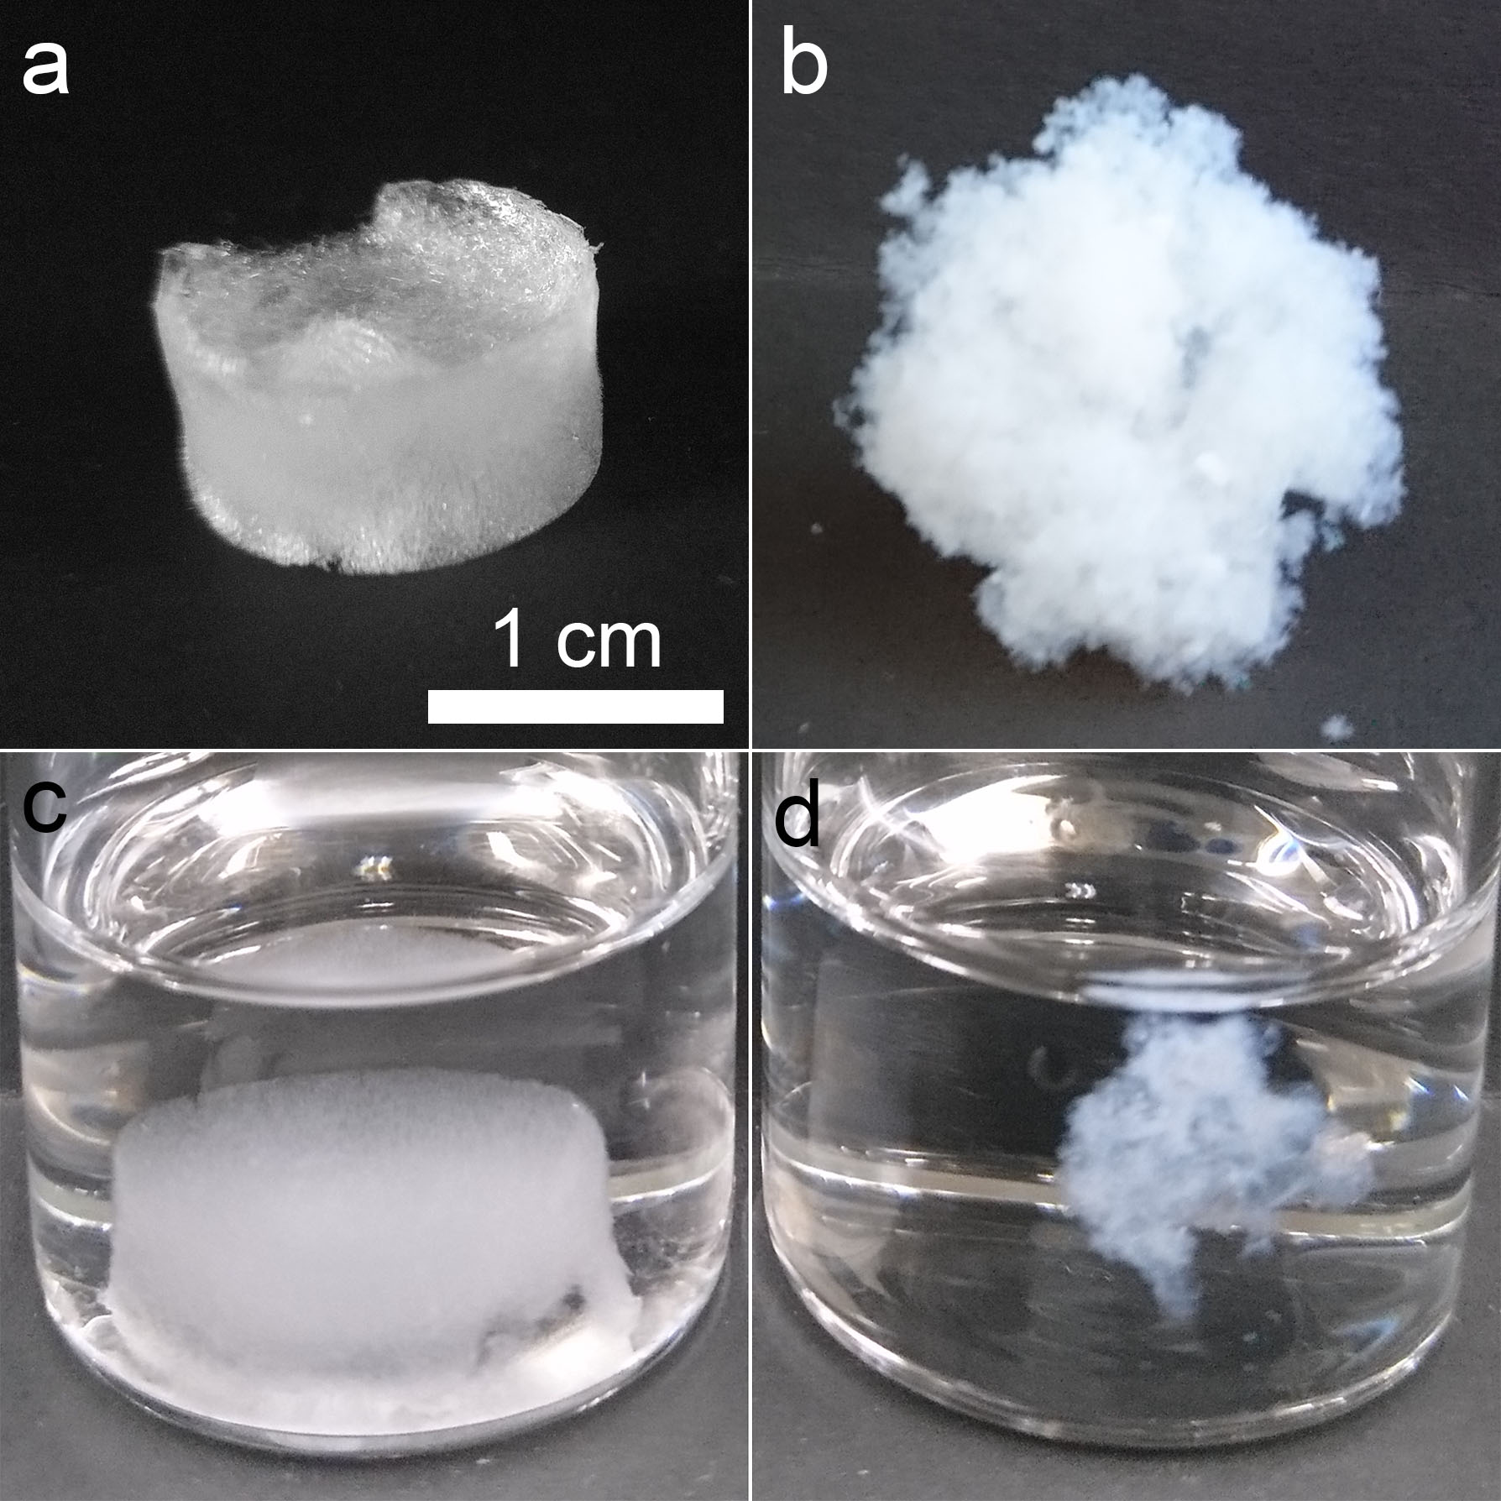
Figure 8: Comparison of the macroscopic appearance of cryo-templated and PGX CNC aerogels in dry and wet states, the scale bar in (a) is true for all images. (a) Dry cryo-templated aerogel, (b) dry PGX aerogel, (c) cryo-templated aerogel submerged in water, and (d) PGX aerogel submerged in water. The cryo-templated aerogel retained its shape in water, whereas the PGX aerogel shrank; neither aerogel redispersed due to chemical cross-linking.

Microstructural Analysis and Comparison of CNC Aerogels
SEM imaging was performed on both types of CNC aerogels to investigate the internal aerogel morphology (Figure 9). Cryo-templated aerogels had a bimodal pore size distribution resulting from the stacking of mesoporous CNC sheets separated by macropores (Figure 9), as reported previously in the literature.⁶² The CNC sheets were random in shape and size due to ice-crystal growth during freezing. Figure 9b and 9c show higher magnification images of a CNC sheet with uniformly distributed and similarly nano-sized mesopores, which result from CNCs cross-linking in a non-parallel manner. Macropore sizes vary widely from ca. 10 to 950 μm. On the other hand, PGX aerogels had a more aggregated mound-like morphology (Figure 9d), likely due to the aggregation induced when CNCs were suspended in the ethanol-water mixture prior to PGX processing. However, the mounds themselves were much more fibrillar and porous compared to the CNC sheets, as shown in Figure 9e. The macropores were much smaller than cryo-templated aerogels at approximately 1 - 4 μm. During PGX processing, CNCs are pumped as a water-ethanol mixture through the nozzle, which exposes it to additional anhydrous ethanol and supercritical carbon dioxide. We infer that when CNCs pass through the nozzle they cross-link together, water is removed, but they are entirely wetted by supercritical CO₂ which keeps them somewhat separated and “expanded” thereby producing the distribution of meso and smaller macropores observed.
We believe that the PGX aerogels have a smaller volume in water because they are less dense and rigid due to the significantly higher proportion of mesopores and their fibrillar nature is more flexible than cryo-templated aerogels. The shrinking of the PGX aerogels in aqueous environments is attributed to a collapse of the PGX aerogel morphology through capillary forces. As water wets the PGX aerogel, the fibrillar morphology is not strong enough to resist forces pulling the fibrils together, causing the overall PGX material to shrink. This contrasts cryo-templated aerogels that can retain their shape in water because the cross-linked CNC sheets are not flexible enough to bend/collapse when wetted.
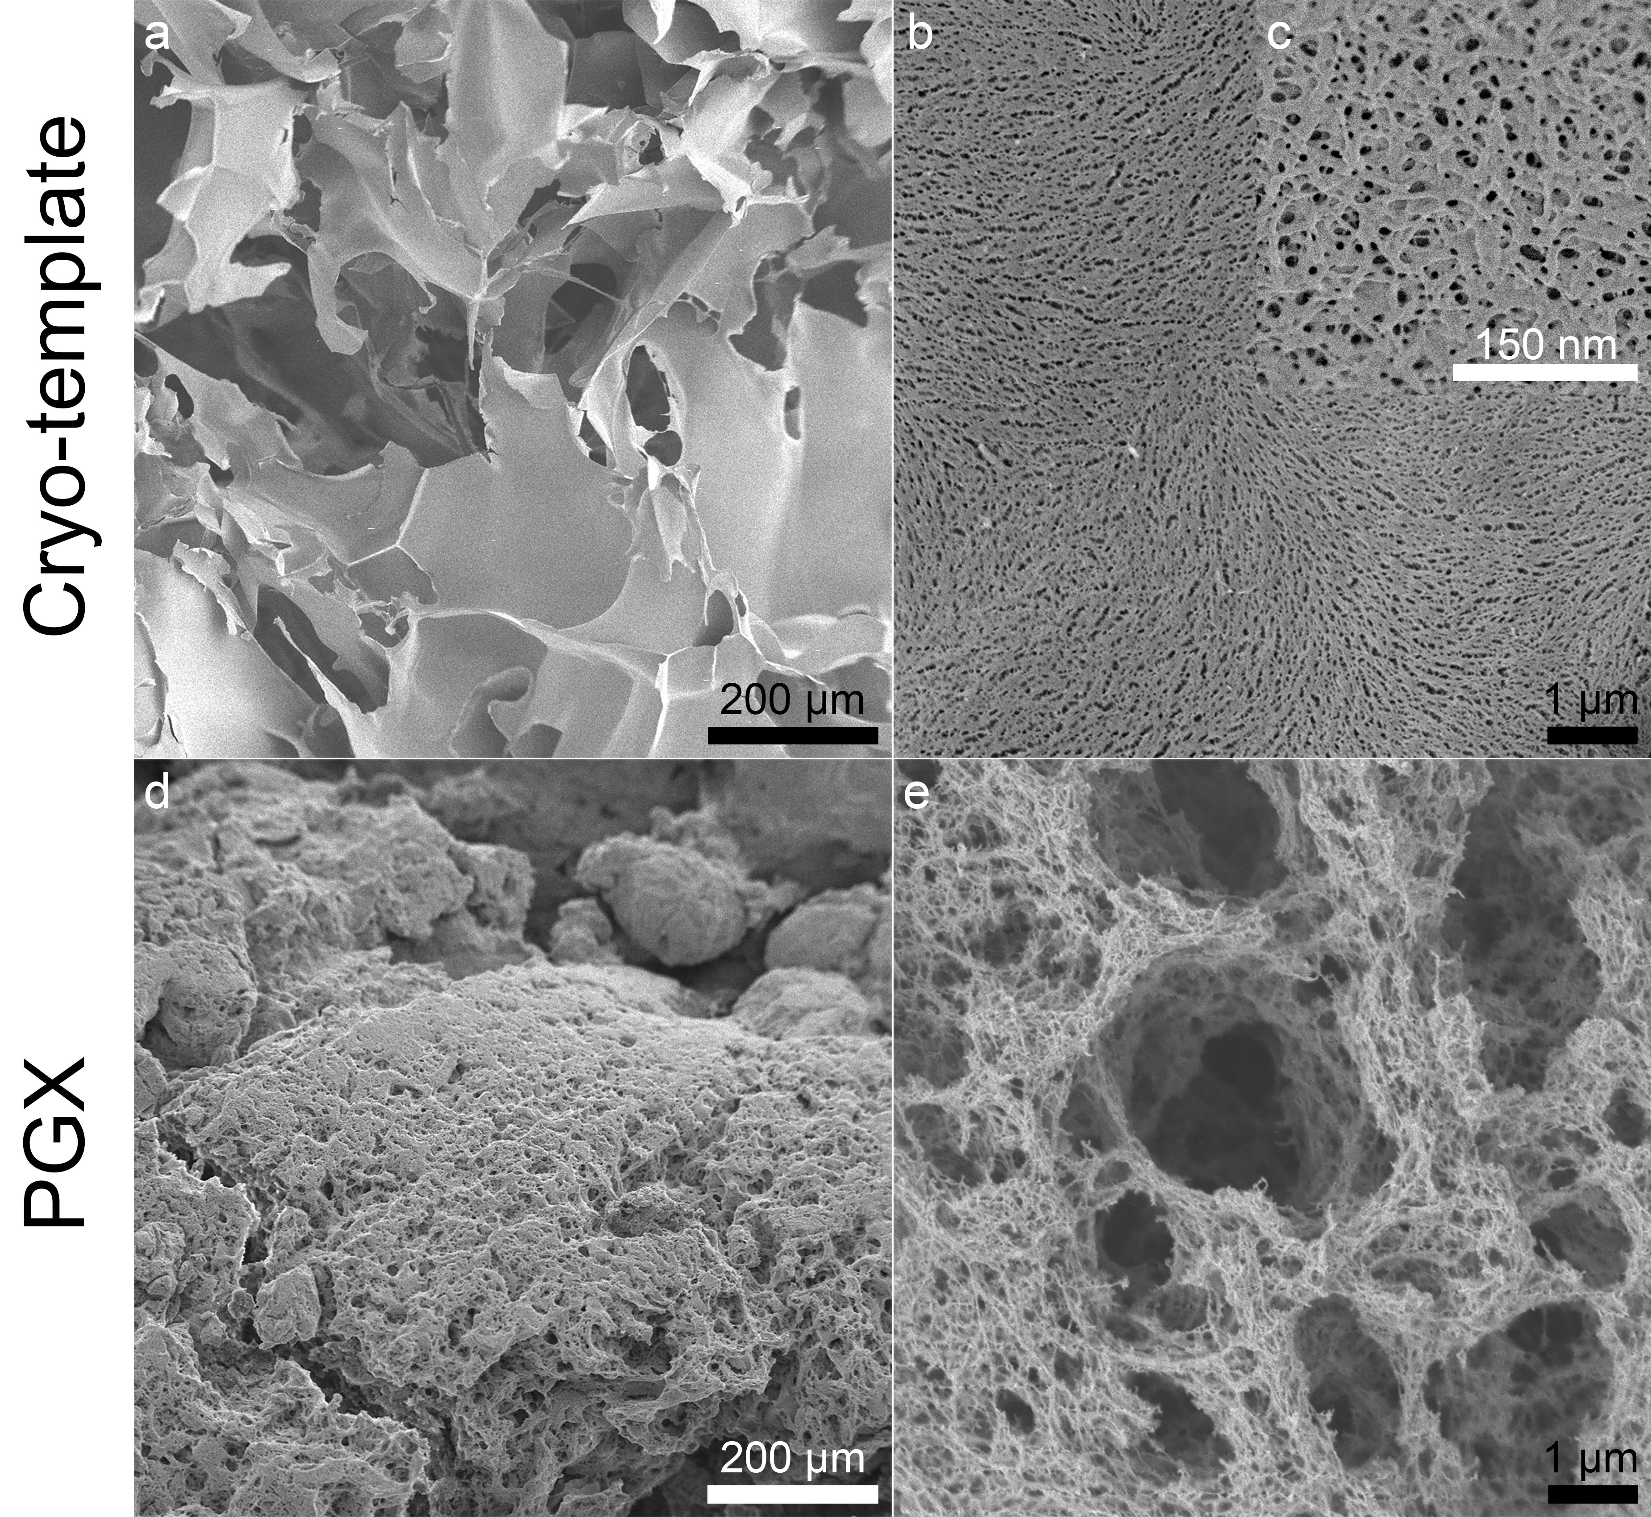
Figure 9: SEM images of the (a-c) cryo-templated and (d-e) PGX aerogels: (a) CNC sheet morphology of cryo-templated aerogels separated by macropores, (b) surface of the CNC sheets, revealing the large distribution of mesopores, (c) a higher magnification of a CNC sheet with well-defined mesopores, (d) the mound-like morphology of the PGX aerogels, and (e) the expanded and fibrillar microstructure of the PGX mounds with a large range of mesopores and small macropores.
Both types of aerogels were also evaluated using X-ray micro-computed tomography; the 3D reconstructions are shown in Figure 10 and complement the SEM images (Figure 9). The macropores of cryo-templated aerogels that separate the CNC sheets are observable in Figure 10, where the white represents the CNC sheets and the black vacancies represent the macropores. Orthogonal slices indicate that the entire pore morphology is interconnected in the cryo-templated aerogel. In contrast, the PGX aerogel has almost no visible macropores, instead a faded grey appearance with denser white regions is seen (Figure 10). The faded appearance is due to a lack of macropores greater than 7 µm (i.e., the resolution limit of μCT with chosen parameters), which agrees with Figure 9d and 9e. This highlights that the two processing methods have given aerogels with completely different pore structures despite both being fairly uniform, albeit in a different way.
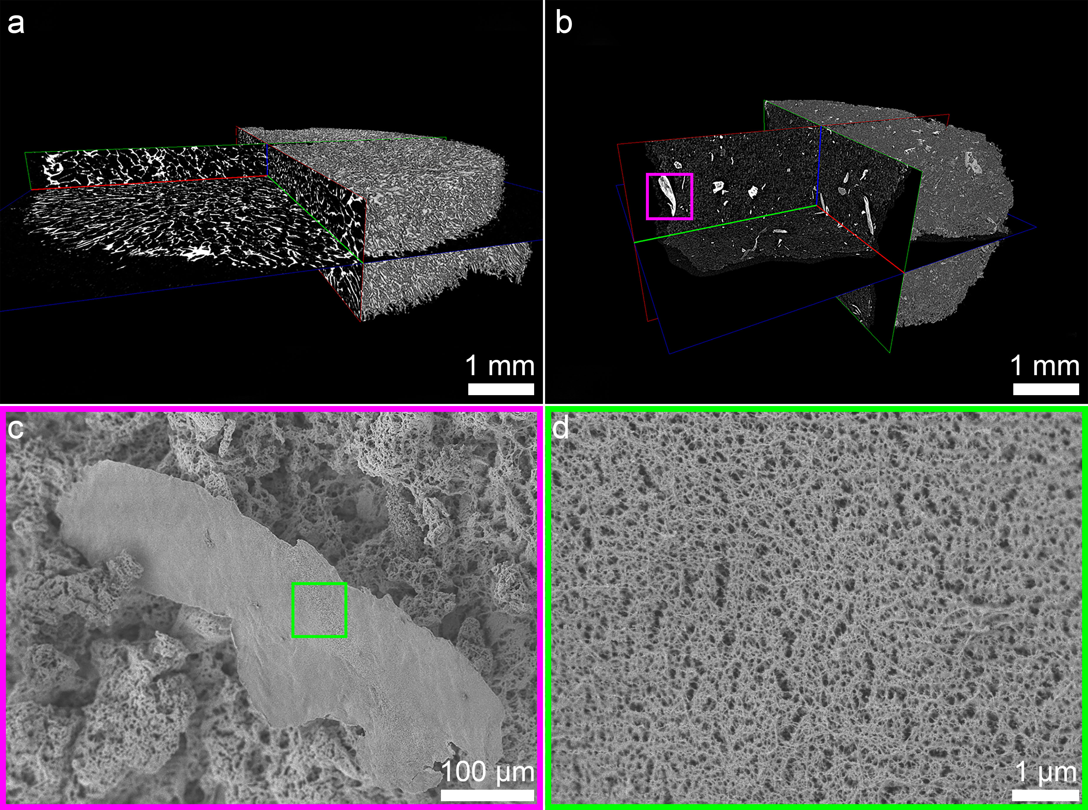
Figure 10: Micro-computed tomography 3D reconstructions with orthogonal slices of (a) cryo-templated aerogels and (b) PGX aerogels. The cryo-templated aerogels have an interconnected macroporous structure and a large distribution of macropores whereas PGX aerogels lack macropores greater than 7 µm (which appears as faded grey areas) and have some aggregated regions (which appear white, one example of an aggregate is highlighted in the purple box). SEM of the (c) purple and (d) green-boxed regions are used to show the microstructure of the white aggregated regions in (b). Aggregates do not have visible macropores but do have mesopores and are more like the dense CNC sheets in cryo-templated aerogels.
The white features in Figure 10 are aggregated regions of CNCs with densities similar to the sheets observed in cryo-templated aerogels. These regions may have been unaffected by the rapid CO₂ expansion during the PGX process potentially due to the supercritical fluid not being able to fully dehydrate, or replace all the water surrounding, the highly cross-linked CNC aggregates. The different microstructure and density of the aggregated regions could influence the uptake of OsO₄, resulting a heavier staining. This could contribute to the change in contrast noted in the µCT. SEM images of these dense regions are shown in Figure 10c which suggests that these aggregates are more condensed than the fluffy mounds surrounding them and do not contain macropores. Figure 10d shows a higher magnification of the aggregated region, which reveals that there are still mesopores present between CNCs, similar to the high magnification images of the sheets in the cryo-templated aerogels. While outside of the scope of this current work, it is likely that the PGX process could be tailored to have more or less of these dense regions in order to control the porosity and mechanical properties of the aerogels.
To quantify the microstructure and morphology of CNC aerogels, density and porosity were determined, BET analysis was performed and XRD was used to ensure that no degradation of the cellulose crystal structure occurred during the aerogel processing. Table 2 presents these values, where cryo-templated aerogels were in line with previously reported work⁶² and PGX aerogels had almost double the specific surface area, half the density, and were therefore slightly more porous. These values agree qualitatively with the SEM and μCT images (Figure 9 and Figure 10). The much higher specific surface area in PGX aerogels is likely due to the rapid expansion of CO₂, where a small mass of CNCs (2 g) expands to fill a 2.5 L volume and a more open pore structure is obtained with more mesopores. It should be noted that both specific surface area values in Table 2 are below the theoretical limit for CNC aerogels. The theoretical limit for CNC aerogels are determined by the specific surface area for the smallest CNCs produced through the sulfuric acid hydrolysis process which was calculated to be as high as ca. 512 m²/g assuming a length of 130 nm, a width of 5 nm, and a density of 1.59 g/cm³.⁶²

Table 2: Specific surface area, density, porosity (calculated using Equation 1) and degree of crystallinity of cryo-templated and PGX aerogels. Specific surface area and density values are shown here with their respective standard deviations.
Type of CNC Aerogel | Specific Surface Area (m²/g) | Density (mg/cm³) | Porosity (%) | Crystallinity Index (%)
Cryo-templated | 190 ± 20 | 10.0 ± 0.8 | 99.3 | 87
PGX | 320 ± 10 | 6 ± 1 | 99.6 | 91

The crystallinity values for both types of aerogels were comparable based on XRD analysis, showing that CNC crystallinity had been maintained post aerogel processing (Table 2). While the best method to measure CNC crystallinity remains debated in the literature¹⁷¹, we believe XRD has the resolution and accuracy to deduce useful relative values. For the PGX process there was some concern that the supercritical conditions could cause the cellulose degree of polymerization to decrease, as shown previously in literature.¹⁷⁶ However, this was not the case and both types of aerogels had crystallinities well within accepted values¹⁷¹ and similar to the starting modified CNCs (Table 1).
In addition to the specific surface area, BET analysis provides further information about the pore size and distribution for pores below 50 nm (Figure 11). Cryo-templated aerogels had two well-defined peaks indicating pore diameters of 3.9 nm and 11.1 nm (Figure 11a), similar to values reported previously.^{62,177} This is further supported by the mesopore sizes observed in Figure 9c (and then the large macropores that tend to be over 10 μm make up the rest of the aerogel porosity and are not measurable by BET). Figure 11a also shows a broad peak from 13 to 36 nm that may be due to the random CNC orientation during the cryo-templating process. As CNCs are excluded from the growing ice crystals and pushed together, rigid aggregates form until they are fully condensed into CNC sheets and depending on the exact orientation of CNCs as they cross-link, a range of pore shapes and sizes is expected.
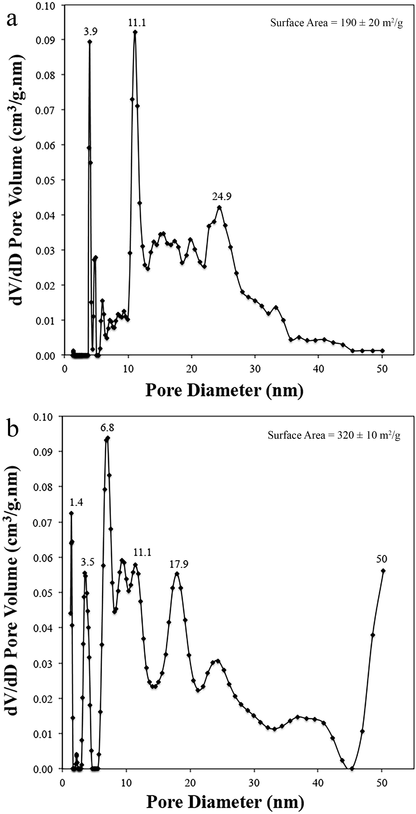
Figure 11: BET analysis showing the pore size distribution of (a) cryo-templated aerogels and (b) PGX aerogels. Specific surface area values are shown as insets and pore dimensions in nm are annotated above their respective peak, (dV/dD is the derivative of the pore volume taken with respect to the pore diameter).
Interestingly, BET analysis of the PGX aerogel also showed some pore sizes that are very similar to the cryo-templated aerogels, namely 3.5 and 11.1 nm (Figure 11b). This may suggest that when CNCs are being pushed together, there are preferred conformations (e.g., an orientation that minimizes electrostatic repulsion). In the PGX aerogels, distinct peaks at 1.4, 6.8 and 17.9 nm were also observed showing that there are more sizes of mesopores present than in cryo-templated aerogels. Finally, the increasing slope between 45 and 50 nm for PGX aerogels further reinforces this, as this shows that pore size is also distributed in the low end of the macropore range, in agreement with Figure 9e. This data indicates that PGX aerogels have a range of pore sizes from mesopores to the lower end of macropores, in contrast to the cryo-templated aerogel’s bimodal pore size distribution.

Comparison of Hydrazone Cross-linking in Aerogels
XPS was used to quantify the number of hydrazone bonds present within both types of aerogels. While XPS can present challenges with cellulose materials that are well known to be susceptible to hydrocarbon contamination,^{171,178} high-resolution nitrogen peak deconvolution can help us better understand the aerogels prepared in this work. Table 3 shows the atomic composition of the different types of nitrogen bonding for cryo-templated and PGX processed aerogels. Specifically, N1 corresponds to amine bonds (N-H₂, bond energy = 400.13 eV) and hydrazine bonds (N-N). N2 corresponds to hydrazone bonds (C=N, bond energy = 401.09 eV). Overall, cryo-templated aerogels have more hydrazone bonds (i.e., are more cross-linked) than PGX aerogels. With more cross-linking the N1 peak decreases a the N2 peak increases, as shown in Table 3.
Enhanced cross-linking in cryo-templated CNC aerogels is likely related to the nature of the production process, which is relatively slow, and forces CNCs together by excluding them from the growing ice front. The force during this process is sufficient to overcome short-range repulsive forces that normally keep CNCs apart; this maximizes the potential for cross-linking. On the other hand, during PGX drying, CNCs are never forced together to this extent – they are colloidally unstable in ethanol because ethanol is a poor dispersant,¹⁷⁹ and this combined with the high shear mixing prior to pumping CNCs into the PGX reactor increases the likelihood of CNCs coming into contact and cross-linking. Although cryo-templated aerogels and PGX aerogels differ in their morphology and cross-link density, they both hold together in water, which was the main goal of producing covalently cross-linked CNC aerogels.

Table 3: High-resolution nitrogen XPS analysis of cross-linked CNC aerogels.
Type of Aerogel | Atomic Composition
 | N1 | N2
Cryo-templated | 55.0 | 45.0
PGX | 75.4 | 24.6

Aerogel Mechanical Properties
Lastly, the compressive strength of CNC aerogels was measured by mechanical compression tests in dry conditions. Cryo-templated aerogels were found to be stiffer than PGX aerogels, as shown in Figure 12. At 90% compression, the cryo-templated aerogels displayed a compressive strength of 94 ± 2 kPa, compared to PGX aerogels, which displayed a compressive strength of 7 ± 2 kPa. This is likely related to the dense CNC sheets within the cryo-templated aerogels as well as the less porous structure and the higher cross-link density. As the aerogel is being compressed, the sheets begin to bend and stack until all space provided by the macropores is gone and this compressed structure offers enhanced strength. Cryo-templated aerogels have also been shown to have good shape recovery properties in both air and water.⁶² Oppositely, PGX aerogels are more easily compressed which is attributed to them having a more open, porous structure with fewer condensed/cross-linked regions to provide reinforcement. The consistency and reproducibility of the PGX process is highlighted by the mechanical properties. As mechanical testing samples were randomly obtained throughout the bulk of the dried PGX aerogel, consistent mechanical properties were observed, showing that the properties and characteristics are uniform throughout the entire PGX aerogel.
The argument that cross-link density affects the compressive behaviour of CNC aerogels (in addition to pore morphology) is supported by previous work in our group where cryo-templated CNC aerogels produced from 1 wt% CNC suspensions (with hydrazone cross-linking) had a compressive stress of only 18 kPa at 90% compression.⁶² This is five times lower than the values seen in this work and the main difference is the density of the surface functionalization on CNCs (i.e., the number of aldehyde and hydrazide groups available for cross-linking). In both works, hydrazide groups are the “limiting” cross-linking group (Table 1) and we have roughly five times more hydrazide groups here than in our previous report.⁶² While it seems difficult to visualize more than a few CNCs cross-linking in a given plane based on their size and rigidity, one possibility is that sheets can stack more easily (or more cross-linking in three dimensions) with more cross-link sites leading to thicker CNC sheets, which would in turn yield an aerogel more resistant to compression.

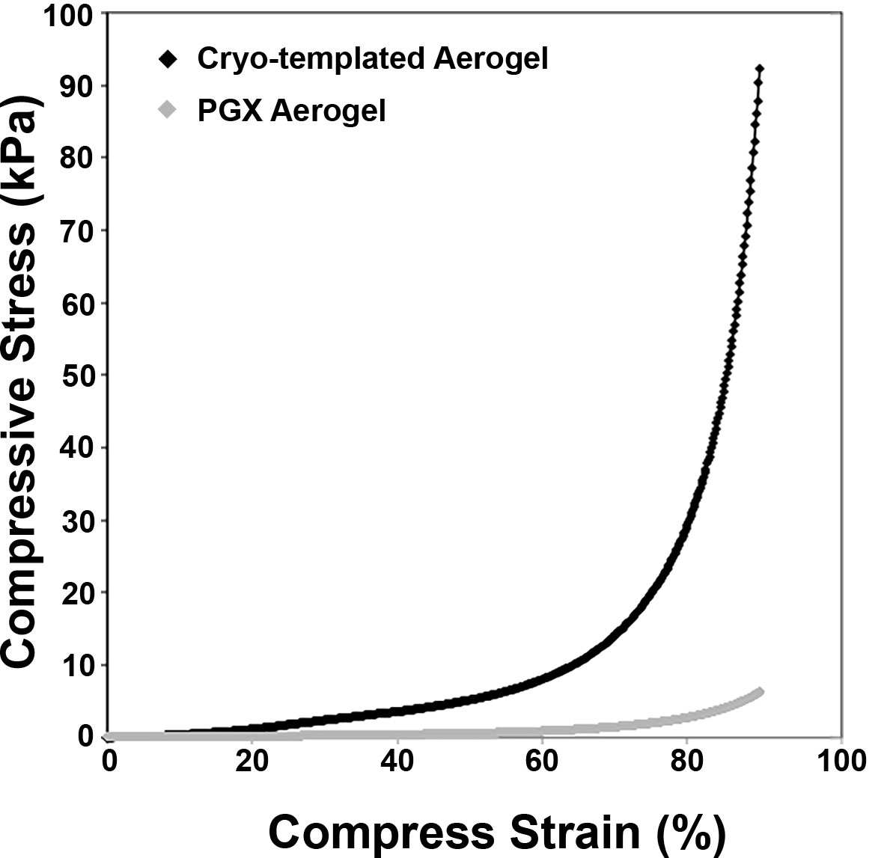
Figure 12: Representative compressive stress-strain curves for cryo-templated and PGX aerogels from 0% to 90% strain. It can be seen that the cryo-templated aerogel is more resistant to compression than the PGX aerogel.

Conclusions
Through this work, we have shown the impact that aerogel processing methods can have on CNC aerogel morphology and performance. Despite both the cryo-templated and PGX process using the same cross-linkable CNCs as the starting material and using water, ethanol, and CO₂ as solvents, two different aerogels were produced. The PGX technology produced a more expanded, fibrillar, and porous CNC aerogel with a greater specific surface area and a wider range of small pore sizes compared to cryo-templated aerogels. PGX aerogels had lower compressive strength and also shrank when submerged in water, whereas cryo-templated aerogels maintained their structure. The pore size distribution for both types of aerogels implied that there are some preferred geometry/spacings when CNCs come together to cross-link and well-defined mesopores are achievable regardless of the processing method. Pore size, the ratio of meso to macropores and crosslink density affected aerogel mechanical properties. With consistent compressive strength, specific surface area, and density measured across multiple samples, it is evident that the PGX process can produce uniform and reproducible CNC aerogels. We believe that the morphology of cross-linked CNC aerogels can be tuned through the processing methods used and that PGX drying is a more industrially feasible route to prepare aerogels that may find application as, insulating, separating/capturing, and scaffolding materials.

Acknowledgements
The authors would like to thank our collaborator Ceapro Inc. for their cooperation, useful discussions, and access to their PGX equipment. We specially thank the work of Nicholas Kudeba and Luis Delgado with the production of PGX samples. We thank Professors T. Hoare, R. Pelton, A. Guarne, the Canadian Center for Electron Microscopy (CCEM), the McMaster Automotive Resource Center (MARC), McMaster Biointerfaces Institute, and the University of Waterloo for shared equipment. Andrew Kacheff, Kelli-Anne Johnson, Iflah Shahid, James Tedesco, Marcia Reid, Victoria Jarvis, Nadia Belsito, Taylor Stimpson and Dr. Danielle Covelli are gratefully acknowledged for training, sample analysis, and expertise. A special thanks to Xuan Yang, for his pioneering work on CNC aerogels and guidance throughout this work.

Cellulose Nanocrystals Aerogels as Viable Bone Scaffolds

Abstract
Chemically cross-linked cellulose nanocrystal (CNC) aerogels possess many properties that could benefit bone tissue scaffolding applications. In this work, CNCs were extracted using either sulfuric acid or phosphoric acid, to produce CNCs with sulfate and phosphate half-ester surface groups, respectively. Cross-linked aerogels fabricated from the two types of CNCs were investigated using scanning electron microscopy, X-ray micro-computed tomography, X-ray photoelectron spectroscopy, Brunauer-Emmett-Teller analysis, and compression testing. Both types of CNC aerogels were evaluated as bone tissue scaffolds via in vitro testing with Saos-2 osteoblast-like cells to quantify cell metabolism and alkaline phosphatase (ALP) activity. All aerogels showed an increase in cell metabolism up to 7 days, and ALP data revealed that both types of CNC aerogels provided a suitable environment for osteoblast differentiation. Additionally, the growth of HA on the aerogels, in simulated body fluid solution, was examined over 14 days and both types of CNC aerogels demonstrated mineral growth after a 0.1 M CaCl₂ pre-treatment. Sulfated CNC aerogels slightly outperformed phosphated CNC aerogels in terms of compressive strength and ability to hold together in liquid environments over long time periods. These results demonstrate that chemically cross-linked CNC aerogels are a promising material for bone tissue scaffolding applications.

Introduction
As the treatment of bone disorders and defects have increased in recent years due to the aging population, there is a growing need for the use of synthetic materials as effective bone tissue scaffolds.¹⁸⁰ Tissue scaffolds are 3D structures meant to facilitate, and in some cases, promote tissue growth.¹⁸¹ Although the characteristics of an ideal bone scaffold are not completely agreed upon, there are some key features that scaffolds should possess. Scaffolds should be highly porous to promote vascularization into the defect area, and pores should be sufficiently large to allow migration of osteogenic cells through the scaffold, an optimum value often considered is a minimum of 100 µm and up to 350 µm in diameter.^{180,182} Other desirable characteristics include tuneable bioresorbability (the ability to degrade at the appropriate rate within the host tissue), non-toxicity in both its bulk and degraded forms, and the presence of favourable surface topography and chemistry to promote protein adhesion and cell differentiation.¹⁸³ Many scaffolds and bone grafts possess these characteristics yet, struggle to conform to the shape of bone defects.¹⁸⁴ This can lead to vacancies between the scaffold and the defect wall, which can in turn lead to incomplete bone healing.¹⁸⁵ This has prompted the investigation of new shape-conforming materials for bone tissue scaffolds.
Cellulose nanocrystals (CNCs) are rod-shaped crystalline nanoparticles that are isolated from natural cellulose through an acid hydrolysis procedure.⁵ CNCs have proven to be an attractive component to several biomedical systems, including drug-delivery,^{25,186} anti-bacterial applications,¹⁸⁷ and tissue engineering.^{188,189} CNCs can also be phosphorylated,¹⁵ which has been shown to promote HA growth on bacterial and nanofiber cellulose-based materials;^{148,190,191} an essential indicator for osteoconduction and bone growth. Moreover, CNCs have been shown to be non-cytotoxic and facilitate cell proliferation in CNC polylactic acid composite scaffolds.¹⁸⁸ Unfortunately, previous scaffold-like materials made solely of CNCs fall apart in aqueous environments, due to CNCs only forming weak cellulose-cellulose bonds (e.g. hydrogen bonding and van der Waals forces) with one another.¹⁰³ This has resulted in CNCs being used as additives (in small quantities) in nanocomposite tissue scaffolds to either improve mechanical properties or cell adhesion.^{188,192}
Our group has demonstrated that the addition of aldehyde and hydrazide functional groups to CNC surfaces allows for the formation of hydrazone bonds when CNCs are brought into contact.⁶² The formation and degradation of hydrazone cross-links has been shown to be suitable for biomedical applications,¹⁶² and allows us to form a chemically cross-linked CNC aerogel which retains its structure in aqueous environments and has shape-recovery properties.⁶² The robust and highly porous nature of hydrazone cross-linked CNC aerogels has led us to apply them as energy storage devices for flexible electronics and as re-usable water purification devices,^{108,159} however, these aerogels have never been investigated as tissue scaffolds.
In order to fully examine the potential of CNC aerogels as bone tissue scaffolds, two types of CNC aerogels were prepared and evaluated. Specifically, the aerogels were produced using CNCs with different surface chemistry; either sulfate half-ester groups (S-CNCs), made through the conventional sulfuric acid hydrolysis procedure,¹⁵⁸ or phosphate half-ester groups (P-CNCs), made through an optimized phosphoric acid hydrolysis procedure.⁵⁴ The effect of phosphorylation on cellulose surfaces in bone applications was evaluated. The morphological and mechanical properties of both types of CNC aerogels were characterized, and they were tested through in vitro cellular assays to determine their potential effectiveness as a bone tissue scaffold.

Methods and Materials

Materials
Whatman cotton ashless filter aid was purchased at GE Healthcare Canada (Mississauga, Canada). 95% -98% sulfuric acid, 85% phosphoric acid and dimethyl sulfoxide (DMSO) were purchased from Caledon Laboratory Chemicals (Georgetown, Canada). Anhydrous ethanol was purchased from Commercial Alcohols (Toronto, Canada). 2,2,6,6 – (tetramethylpiperidin-1-yl)oxyl (TEMPO, 99% purified by sublimation), adipic acid dihydrazide (ADH) ≥ 98%, N’-ethyl-N-(3-(dimethylamino)propyl)-carbodiimide (EDC, commercial grade), ethylene glycol (99.8%), silver(I) oxide (Ag₂O, ≥99.99% trace metals basis), sodium periodate (NaIO₄, >99.8%), N-hydroxysuccinimide (NHS, 97%), sodium hypochlorite solution (NaClO, 10-15%), sodium bromide (NaBr, Reagent Plus® ≥99%), thiocarbohydrazide (TCH) 98%, Trypsin-EDTA (0.25), penicillin/streptomycin, triton X-100, and phosphate-buffered saline were purchased from Sigma-Aldrich (Oakville, Canada). Osmium tetroxide solution was purchased from Canemco & Marivac (Lakefield, Canada). Hydrochloric acid (HCl, 0.1 M and 1 M) and sodium hydroxide (NaOH, 0.1 M and 1 M) were purchased from LabChem Inc (Zelienople, USA). The water used was purified type I water with a resistivity of 18.2 MΩ·cm (Barnstead NANOpure Diamond system, ThermoScientific, Asheville, USA). AlamarBlue®, McCoy’s modified 5A media, and Saos-2 cells (ATCC, Manassas, USA), and fetal bovine serum were purchased from Life Technologies Inc. (Carlsbad, USA). Alkaline phosphatase assay and Abcam buffer was purchased from Abcam (Cambridge, UK). No chemicals were modified or further purified before use.

Preparation of Cellulose Nanocrystals

Sulfuric Acid Hydrolysis
S-CNCs were prepared through a sulfuric acid hydrolysis of cotton ashless filter aid, as described previously.¹⁵⁸ Briefly, 40 g of filter paper were blended into a wet pulp and dried in an oven at 80 ˚C overnight to remove any moisture. The pulp was then added to 700 mL of 64 wt% sulfuric acid at 45 ˚C for 45 minutes under constant stirring. The hydrolysis was then quenched by pouring the acid slurry into 7 L of 4 ˚C purified water and allowed to settle for 1 hour. The quenched slurry was then subjected to multiple 15-minute rounds of centrifugation at 5000 rpm until a pellet could no longer be formed. The centrifuged suspension was then poured into dialysis membranes, with a 14 kDa molecular weight cut-off (Sigma-Aldrich), and dialyzed for 2 weeks with successive water changes until the pH of the dialysis water ranged between 5 and 6. The CNC suspension was sonicated on ice with a probe sonicator (Sonifier 450, Branson Ultrasonics, Danbury, USA) for three 5-minute rounds with 60% output energy. The suspension was then passed through a 1 µm pore size glass microfiber filter (VWR, Mississauga, Canada) and stored at 4 ˚C in the acid form.

Phosphoric Acid Hydrolysis
P-CNCs were prepared through phosphoric acid hydrolysis of cotton ashless filter aid, and optimized to have the highest phosphate content, as described previously.⁵⁴ Briefly, 100 mL of purified water was added to 4 g of blended filter air to create a slurry. The slurry was then placed into an ice bath and had 150 mL of 85% phosphoric acid added drop wise under constant stirring. The acid slurry was then moved into an oil bath at 120 ˚C for 120 minutes under constant stirring. The acid slurry was then centrifuged for one round at 3600 rpm to remove any excess acid. The centrifuged suspension was then dialyzed for two weeks with sequential water changes until the pH of the dialysis ranged between 5 and 6. The CNC suspension was then sonicated on ice for three 5-minute rounds with a probe sonicator with 60% output energy. The suspension was then passed through a 2.5 µm pore size glass microfiber filter, then a 1 µm pore size glass microfiber filter, and stored at 4 ˚C in the acid form.

Aldehyde CNC (CHO-CNC) Surface Modification
Aldehyde groups were grafted to CNC surfaces, as reported previously;⁶² 0.3 g of NaIO₄ was added to a 50 mL 1 wt% suspension of CNCs and allowed to stir under ambient conditions for two hours. The flask was completely surrounded by aluminum foil and covered with a septum to prevent any light or air from interacting with the NaIO₄. After two hours, 0.3 mL of ethylene glycol was added to quench the reaction. The suspension was also exposed to air and light to assist in quenching the reaction. The CNC suspension was then dialyzed for two weeks with sequential water changes until the pH of the dialysis water was between 5 and 6. The CNC suspension was then sonicated on ice with a probe sonicator, passed through a 1 µm pore size glass microfiber filter and stored at 4 ˚C. This procedure was performed on both S-CNCs and P-CNCs.

Carboxylic Acid CNC (COOH-CNC) Surface Modification
Carboxylic acid groups were grafted to CNC surfaces through a TEMPO oxidation reaction,^{11,12} 0.148 g of TEMPO and 1.62 g of NaBr were added to 200 mL of purified water and stirred until dissolved. The TEMPO/NaBr solution was then slowly added drop-wise to a 500 mL solution of 1 wt% CNC suspension. Immediately after, 30 g of 12.5 wt% sodium hypochlorite was slowly added drop-wise, and the suspension was then allowed to react for 3 hours under constant stirring. The pH of the reaction was monitored and kept constant at 10 with 1 M NaOH. To quench the reaction, 18.2 g of anhydrous ethanol was added to the suspension and allowed to stir for an additional 10 min. The suspension was then centrifuged for one round at 10,000 rpm, then dialyzed for two weeks with sequential water changes until the pH of the dialysis water was between 5 and 6. The CNC suspension was then sonicated on ice with a probe sonicator, passed through a 1 µm pore size glass microfiber filter, and stored at 4 ˚C. This procedure was performed on both S-CNCs and P-CNCs.

Hydrazide CNC (NH₂NH-CNC) Surface Modification
Hydrazide groups were grafted to COOH-CNC surfaces, as shown previously,⁶² by adding 0.6 g of ADH to a 200 mL 1 wt% suspension of COOH-CNC until dissolved. 0.0014 g of NHS and 0.06 g of EDC were suspended in separate 1 mL 1:1 water:DMSO solutions. The NHS and the EDC solutions were slowly added drop-wise to the COOH-CNC suspension sequentially. The pH was maintained at 6.8 using 0.1 M HCl and 0.1 M NaOH until the pH no longer changed. The CNC suspension was then dialyzed for two weeks with sequential water changes until the pH of the dialysis water was between 5 and 6. The CNC suspension was then sonicated on ice with a probe sonicator, passed through a 1 µm pore size glass microfiber filter, and stored at 4 ˚C. This procedure was performed on both COOH-S-CNCs and COOH-P-CNCs.

CNC Degree of Functionalization
Surface group content for sulfate half-ester,¹⁶⁷ aldehyde,¹⁶⁸ carboxylic acid, and hydrazide⁶² groups were quantified through conductometric titration. For each titration, 12 – 15 mg of dry CNCs were added to 60 mL of purified water, 0.3 mL of 200 mM NaCl was added before each titration to gain a measurable conductivity reading. For CHO-CNC, COOH-CNC and NH₂NH-CNC titrations, 0.3 mL of 1 M HCl was added to the titration solution prior to titrating to introduce a strong acid slope to properly measure carboxylic acid content.¹⁶⁹ Sulfate half-ester groups on S-CNCs were titrated using 0.250 mL aliquots of 2 mM NaOH. To ensure all sulfate half-ester groups could be titrated (i.e., in acid form, -OSO₃H) all functionalized CNCs were passed through ion exchange resin (Dowex® MarathonTM C hydrogen form, Sigma-Aldrich, Oakville, Canada) before titration as outlined by Beck et al.¹⁶⁷ CHO-CNCs, COOH-CNCs and NH₂NH-CNCs were titrated using 0.05 mL aliquots of 10 mM NaOH. Since hydrazide groups are grafted to carboxylic acid groups, the carboxylic content remaining on NH₂NH-CNCs was subtracted from the carboxylic content on COOH-CNCs to quantify the number of hydrazide groups. Aldehyde groups on CHO-CNCs were measured by selectively oxidizing aldehyde groups into carboxylic acid groups with an Ag₂O oxidation reaction, as reported by Campbell et al,¹⁶⁸ where 0.193 g of Ag₂O and 0.027 g of dry NaOH were added to a 20 mL 0.25 wt% suspension of CHO-CNCs and allowed to stir over night. The CHO-CNC suspension was then passed through a 1 µm pore size glass microfiber filter and titrated using 0.05 mL aliquots of 10 mM NaOH. Each titration was completed in a period of approximately 1 hour.

Colorimetric Determination of Phosphate Groups on CNCs
Phosphate half-ester content was quantified through colorimetric determination with a Hach® DR 2800 portable spectrophotometer (Hach, London, Canada).⁵⁴ A PhosVer 3 Ascorbic Acid Powder Pillow from Hach® was added to 10 mL of a 0.1 wt % suspension of P-CNCs. The mixture was shaken vigorously for 30 seconds and allowed to settle for 2 minutes. The molybdate in the powder pillows reacts with free phosphate groups to create phosphomolybdic complexes producing a blue color.¹⁹³ This color can be read through an absorbance reading at 880 nm to quantify phosphate content. To remove any possible background noise, a separate 10 mL 0.1 wt% suspension of P-CNC was prepared and used as a blank.

Aerogel Processing
Both S-CNC and P-CNC aerogels were prepared through cryo-templating.⁶² A 2.5 mL 2 wt% CHO-CNC suspension was combined with a 2.5 mL 2 wt% NH₂NH-CNC suspension, 0.5 mL of 200 mM NaCl, and 4.5 mL of purified water to make a 1 wt% suspension of CHO-CNC/NH₂NH-CNC. The CNC suspension was then vortexed with an Analog Vortex Mixer (VWR, Mississauga, Canada) for 2 minutes. Suspensions were transferred to 15 mm and 8 mm diameter shell vials, acting as aerogel moulds, in either 0.5 mL or 1 mL aliquots to produce samples for characterization. All suspensions (in their moulds) were then frozen at -4 ˚C overnight to turn the suspension into a cryo-gel. The cryo-gels were then transferred into anhydrous ethanol, to solvent exchange ice-crystals for ethanol, for 5 days to form alco-gels. No collapse of cryo-gels was observed by eye during the solvent exchange, thereby making incremental ethanol exchanges unnecessary. The alco-gels were placed inside of a critical point dryer and solvent exchanged with supercritical CO₂ and gradually depressurized to ambient conditions to produce a CNC aerogel. Critical point drying (CPD) was performed with a Leica EM CPD300 (Vienna, Austria).

Dynamic Light Scattering (DLS)
Relative apparent particle size for all CNCs was measured through DLS with a Malvern Zetasizer Nano particle analyzer (Malvern Instruments, Malvern, UK). The term “apparent” is used to describe particle size measurements for CNC due to CNC particles being rod-shaped and DLS assumes spherical particles.¹⁷⁰ Therefore we consider DLS a valid method for relative CNC characterization but recognize that it does not represent either CNC length or diameter. A 0.025 wt% CNC suspension with 10 mM NaCl was prepared and analyzed using DLS. All reported values were obtained over 11 measurements for three separate samples, with temperature maintained at 23 ˚C during measurements. The standard deviation was calculated from three individual sample measurements.

Zeta Potential
Zeta potential measurements for CNC samples were measured using a ZetaPlus electrophoretic mobility analyzer (Brookhaven Instruments Corp, Holtsville, USA). Zeta potential samples consisted of a 0.25 wt% CNC suspension with 10 mM NaCl; the NaCl addition is essential for obtaining accurate zeta potential measurements.¹⁷¹ All zeta potential values are reported as an average of 10 measurements of 15 cycles each, at room temperature. Standard deviation was calculated from three individual sample measurements.

Brunauer-Emmett-Teller (BET) Analysis
Specific surface area and pore size distribution of both S-CNC and P-CNC aerogels were analyzed with nitrogen Brunauer-Emmett-Teller (BET) isotherm analysis using an autosorb® iQ (Quantachrome, Boynton Beach, USA). Samples were first degassed, then kept under nitrogen gas for seven days at 100 ˚C. Since CNCs are hydrophilic and CNC aerogels have large specific surface areas, extensive drying is required to remove any tightly bound water. Samples were then analyzed at -196 ˚C with nitrogen gas adsorption and desorption probing. Pore size distribution analysis was calculated using the density functional theory (DFT) model. Only isotherms showing no retention of water were used to calculate specific surface area.

Density Calculation
The densities of all aerogels were calculated by dividing the mass of an aerogel by its apparent volume. The volume of each aerogel was calculated by taking diameter and height measurements of each aerogel with a digital calliper. The volume was calculated assuming the aerogel was a perfect cylinder. The mass of each aerogel was measured with an analytical balance (Mettler-Toledo Inc., Mississauga, Canada, readability of 0.0001 g). The density values reported are an average of three separate samples for each type of CNC aerogel.

X-Ray Micro Computed Tomography (µCT)
Staining: The contrast of aerogel samples for µCT analysis was enhanced by using sequential osmium tetroxide/thiocarbohydrazide (TCH) staining or OTO staining.¹⁷³ Aerogel samples for SBF testing were prepared using 8 mm diameter shell vials as a mould with 0.5 mL of sample Aerogels were submerged in 1 wt% osmium tetroxide solution for 1 hour, and rinsed multiple times with purified water to remove all osmium tetroxide from within the aerogel. To ensure all osmium tetroxide had been removed from the aerogel, small aliquots of the rinsing solution were tested with a drop of 0.5 wt% solution of TCH. If any color formed the aerogel was rinsed again. After the aerogel had been rinsed, the aerogel was submerged into a 0.5 wt% TCH solution for 10 minutes, followed by rinsing using the same procedure and criteria as previously mentioned, instead using a drop of 1 wt% osmium tetroxide as the indicator. After the aerogel was thoroughly rinsed, it was submerged again in a 1 wt% osmium tetroxide solution for 10 minutes, fully rinsed, followed by dehydration with a graded series of ethanol (25%, 50%, 70%, 70%, 95%, 95%, 100%, for 1 day each), and subjected to CPD.
Acquisition and Post-Processing: All µCT was performed using a Skyscan 1172 (Bruker, Massachusetts, USA) with a 40 kV X-ray beam, with no filter, 5 µm pixel size and 0.3° rotation step. The software package NRecon (Bruker, Massachusetts , USA) was used to reconstruct radiographs into a three-dimensional (3D) volume for further visualization in Avizo (FEI Company, Eindhoven, The Netherlands), with a voxel size of 5 µm x 5 µm x 5 µm. Porosity measurements were then performed by CTAn 1.16 software (Bruker, Billerica, USA). Porosity was also calculated using the following equation.⁶² Where P(%) is the porosity of the aerogel, $ρ_{Gel}$ is the density of the aerogel, and $ρ_{CNC}$ is the density of CNCs, assumed to be 1.59 g/cm³.¹⁷²

$P\left(\%\right)= 100*\left(1-\frac{ρ_{Gel}}{ρ_{CNC}}\right)$ [Equation 1]

Scanning Electron Microscopy (SEM) Imaging
Sample preparation for SEM consisted of submerging aerogels into liquid nitrogen, freeze-fracturing to expose a cross-section, and mounting on a 1” stainless steel stub with nickel paint, and sputter coating with 5 nm of platinum (aerogels only) or carbon (aerogels with SBF coatings). The sides of the aerogel were also coated with nickel paint to avoid charge build up during imaging. All images were taken using a JEOL 7000F SEM (JEOL, Tokyo, Japan) with an acceleration voltage of 2 kV. SEM sample preparation for aerogels with seeded cells consisted of fixation in 0.25% glutaraldehyde in a sodium cacodylate buffer for 1 day, followed by dehydration with a graded series of ethanol (25%, 50%, 70%, 70%, 95%, 95%, 100%, for 1 day each), before being stained with the osmium tetroxide/thiocarbohydrazide (TCH) staining protocol¹⁷³ and being coated with 5 nm of platinum coating. Samples with seeded cells were imaged with an acceleration voltage of 10 kV.

X-Ray Diffraction (XRD) Analysis
Verification of HA was determined through XRD analysis using a Bruker 3-circle D8 goniometer and a Bruker Smart6000 CCD area detector (Bruker, Massachusetts, USA) with Cu Kα radiation. Raw CNC samples were prepared by freeze-drying CNC suspensions, then compressing a small portion of dried CNCs into a thin disk, to provide background spectra to monitor HA growth. CNC aerogels with HA coatings were prepared by drying CNC aerogels in an oven at 37 ˚C overnight, then compressed into a thin disk. Frames were integrated in DIFFRAC.EVA (Bruker AXS, Version 4.0, Massachusetts, USA) and phase ID was performed using integrated database PDF-4+ 2016.¹⁹⁴

X-Ray Photoelectron Spectroscopy (XPS) Analysis
A quantitative comparison of the hydrazone cross-link density between S-CNC and P-CNC aerogels was measured using XPS. Samples for XPS were prepared by freeze-drying CNC suspensions, a small portion of dried CNCs were then compressed into a thin disk. Samples were measured using a Physical Electronics (PHI) Quantera II spectrometer (Chanhassen, USA) using an Al Κα X-ray source (1486.7 eV) operating at 50 W and 15 kV with a system pressure not allowed to exceed 1.0 x 10⁻⁹ Torr and an operating pressure of 2.0 x 10⁻⁸ Torr. Pass energy of 280 eV was used to collect the survey spectra and a 55 eV was used to collect high-resolution nitrogen spectra. All spectra were collected at a take-off angle of 45˚ and a dual beam charge compensation system was used for the neutralization of all samples. Data were processed using PHI MultiPak Version 9.4.0.7 software. The high-resolution nitrogen spectra was deconstructed into two primary nitrogen peaks, where the N1 peak is a combination of amine bonds (N-H₂, bond energy = 399.88 eV) and hydrazine bonds (N-N), where the N2 peak is from hydrazone bonds (C=N, bond energy = 401.41 eV). We consider the calculated atomic compositions to have an error as high as 5%

Compression Testing
Compressive strength of both S-CNC and P-CNC aerogels were measured using a Mach-1 Mechanical Testing System (Biomomentum, Laval, Canada). Aerogels for mechanical testing were prepared in a 15 mm diameter shell vial as a mould with 1 mL of sample per aerogel so that all aerogels were the same diameter and height. All aerogels were compressed to 90% of their maximum height at a compression speed of 0.1 mm/s in both dry and aqueous conditions. In water, cyclic measurements were conducted, with the third cycle reported as the true compressive strength in wet conditions.¹⁶⁵

Cell Culture
Saos-2, osteosaracoma cells were grown in McCoy’s modified 5A media supplemented with 15% fetal bovine serum and 1 % penicillin/streptomycin. Cell cultures were incubated at 37 ˚C with 5% CO₂. Once cells reached confluence, cells were detached using Trypsin-EDTA (25%). After confirming detachment, using a light microscope, the Trypsin-EDTA (25%) was deactivated with media. The cell suspension was then centrifuged and a sample from the pellet was taken to determine the number of cells with a Countress Automated Cell counter (InvitrogenTM, Burlington, Canada).
Aerogel samples for all cell work were prepared using 15 mm diameter shell vials as a mould with 0.5 mL of sample. Aerogel samples were placed in a 24-well plate with 0.75 mL of media to fully submerge the aerogel sample. Approximately 10,000 cells/cm² were seeded on each aerogel and allowed to incubate for 1, 3, and 7 days. It should be noted that since aerogels are opaque and strongly retain water-based fluids, wells with aerogels without any seeded cells were used as blanks.

Cell Metabolism
Cell metabolism on aerogel surfaces was measured using an AlamarBlue® assay. Media was replenished with a solution of 5% AlamarBlue® in McCoy’s 5A media and allowed to incubate at 37 ˚C, with 5% CO₂, for 1 hour. AlamarBlue is a trademark for the compound resazurin which is irreversibly reduced to resorfin upon being introduced into the electrochemical half-reactions of the electron transport chain during cell metabolism. After incubation, the fluorescence of the aerogel samples was measured using an Infinite M200 Tecan (Männedorf, Switzerland) microplate reader with a 540 nm excitation wavelength and 580 nm emission. Aerogel samples were then washed with PBS to remove excess Alamarblue® solution from the aerogel. After rinsing, 0.1% Triton X-100 in PBS solution was added to lyse cells for alkaline phosphatase activity analysis. All recorded values are the average and standard error of six individual samples per incubation time point.

Alkaline Phosphatase Activity
ALP activity is an early marker of osteoblast differentiation, indicating the formation of osteoblast matrix mineralization. A 0.05 mL aliquot was taken from the cell lysis solution and mixed with 0.1 mL of p-nitrophenol phosphate in Abcam buffer and allowed to incubate at 37 ˚C, with 5% CO₂, for 20 minutes in complete darkness. After incubation, absorbance readings of the aerogel samples were measured with an Infinite M200 Tecan (Männedorf, Switzerland) microplate reader at an emission wavelength of 405 nm. All recorded values are the average and standard error of six individual samples per incubation time point.

Statistical Analysis on In Vitro Tests
Statistical analysis was performed using the programming language, R (R Core Team, New Zealand), using two-way ANOVA at a significance level of α = 0.05 and Tukey’s honest significant difference test was used to evaluate contrasts. Data for the cell metabolism and alkaline phosphatase activity were accepted to be normally distributed as per the Shapiro-Wilk test (p > 0.05).

Simulated Body Fluid (SBF) Dip-Test
SBF was prepared by the procedure outlined by Kokubo and Takadama.¹⁵⁵ Aerogel samples for SBF testing were prepared using 8 mm diameter shell vials as a mould with 0.5 mL of sample. Half of the S-CNC and P-CNC aerogel samples were pre-treated by submerging aerogels in 5 mL of 0.1 M CaCl₂ for 3 days at 37 ˚C with 5% CO₂. This was to ensure calcium cations would ionically bond to free anionic groups on aerogel surfaces.¹⁹⁵ The other half of S-CNC and P-CNC aerogel sample size was not pre-treated, to see if the CaCl₂ rinse was essential for growing HA. Aerogel samples were submerged in 3 mL of SBF solution at 37 ˚C, with 5% CO₂, for 7 and 14 day incubation periods, SBF solution was changed every 3-4 days. After incubation, samples were thoroughly washed with purified water and allowed to dry at 37˚C overnight.

Results

CNC Characterization
CNCs prepared by sulfuric acid and phosphoric acid hydrolysis were both functionalized to have orthogonal cross-linkable groups on their surface, i.e., aldehyde and hydrazide groups. The surface content and apparent particle size of all CNCs used in this work are shown in Table 4. On average, P-CNCs are larger than S-CNCs and the aldehyde surface modification on both types of CNCs tends to increase their particle size.¹⁷⁴ However, the aldehyde and hydrazide surface densities for both S-CNCs and P-CNCs are similar. This was done purposely so that S-CNC and P-CNC aerogels could theoretically form the same number of hydrazone cross-links and produce as similar aerogels as possible.

Table 4: Surface content and apparent particle size for S-CNCs and P-CNCs before and after grafting with aldehyde and hydrazide groups. Zeta potential is only provided for S-CNCs. CHO, COOH-, and NH₂NH-, prefixes pertain to aldehyde, carboxylic acid, and hydrazide surface groups, respectively
Type of CNC | Sulfate Half-Ester Content (mmol/g) | Phosphate Half-Ester Content (mmol/g) | Aldehyde Content (mmol/g) | Carboxylic Acid Content (mmol/g) | Hydrazide Content  (mmol/g) | Apparent Particle Size  (nm) | Zeta Potential  (mV)
S-CNC | 0.212 ± 0.002 | - | - | - | - | 85 ± 1 | -41 ± 3
CHO-S-CNC | 0.198 ± 0.001 | - | 0.60 ± 0.05 | - | - | 140.1 ± 0.6 | -21.1 ± 0.2
COOH-S-CNC | 0.210 ± 0.002 | - | - | 1.20 ± 0.03 | - | 90.4 ± 0.6 | -41 ± 5
NH₂NH-S-CNC | 0.211 ± 0.004 | - | - | 0.59 ± 0.03 | 0.63 ± 0.03 | 98.2 ± 0.8 | -26 ±2
P-CNC | - | 0.051 ± 0.003 | - | - | - | 200 ± 2 | -
CHO-P-CNC | - | 0.022 ± 0.004 | 0.58 ± 0.05 | - | - | 308 ± 6 | -
COOH-P-CNC | - | 0.055 ± 0.005 | - | 1.02 ± 0.05 | - | 83.2 ± 0.2 | -
NH₂NH-P-CNC | - | 0.052 ± 0.007 | - | 0.50 ± 0.01 | 0.53 ± 0.03 | 84 ± 1 | -

As shown in Table 4, and mentioned above, the P-CNC particle size is larger than the S-CNC particle size. Two factors contribute to this, (1) the hydrolysis to produce P-CNCs is less harsh and larger particles are isolated⁵⁴ and (2) there are fewer grafted (and deprotonated) weak acid surface charge groups (phosphate half-esters) that are responsible for colloidal stability, thus we expect that minor CNC aggregation is occurring. Similarly, any surface modification that decreases the surface charge density (i.e., aldehyde/hydrazide) leads to slightly larger CNCs, again from CNC aggregation/association, whereas adding more surface charge (i.e., TEMPO oxidation) decreases the apparent particle size. This is mirrored in the zeta potential measurements for the S-CNCs; similar measurements for P-CNCs indicated low surface charge and a colloidally unstable system making zeta potential measurements unreliable for those samples. The size, degree of aggregation and colloidal stability of CNCs can influence how they assemble during aerogel fabrication, which in turn changes the behaviour and mechanical properties of CNC aerogels, and affects their tissue scaffolding potential, as discussed further below.

Aerogel Characterization
Morphology for both types of aerogels were evaluated through SEM and µCT imaging. Figure 13 shows that both types aerogels consist of condensed CNC sheets (or flakes) separated by large macropores. Both S-CNC and P-CNC aerogels have similar sheet morphology and size. At higher magnification (insets in Figure 13a and 13b), both types of aerogel sheets exhibit similar mesopore sizes. This is consistent with the bimodal pore morphology reported by Yang and Cranston.⁶² BET isotherm analysis using the DFT model confirmed the average mesopore size for S-CNC aerogels is 11 nm and for P-CNC aerogels is 6 nm. The specific surface area was measured to be 190 m²/g and 130 m²/g for S-CNC and P-CNC aerogels, respectively. The macropore morphology for both aerogels was similar by SEM image analysis in Figure 13, and this was reinforced through the 3D µCT reconstructions shown in Figure 14.

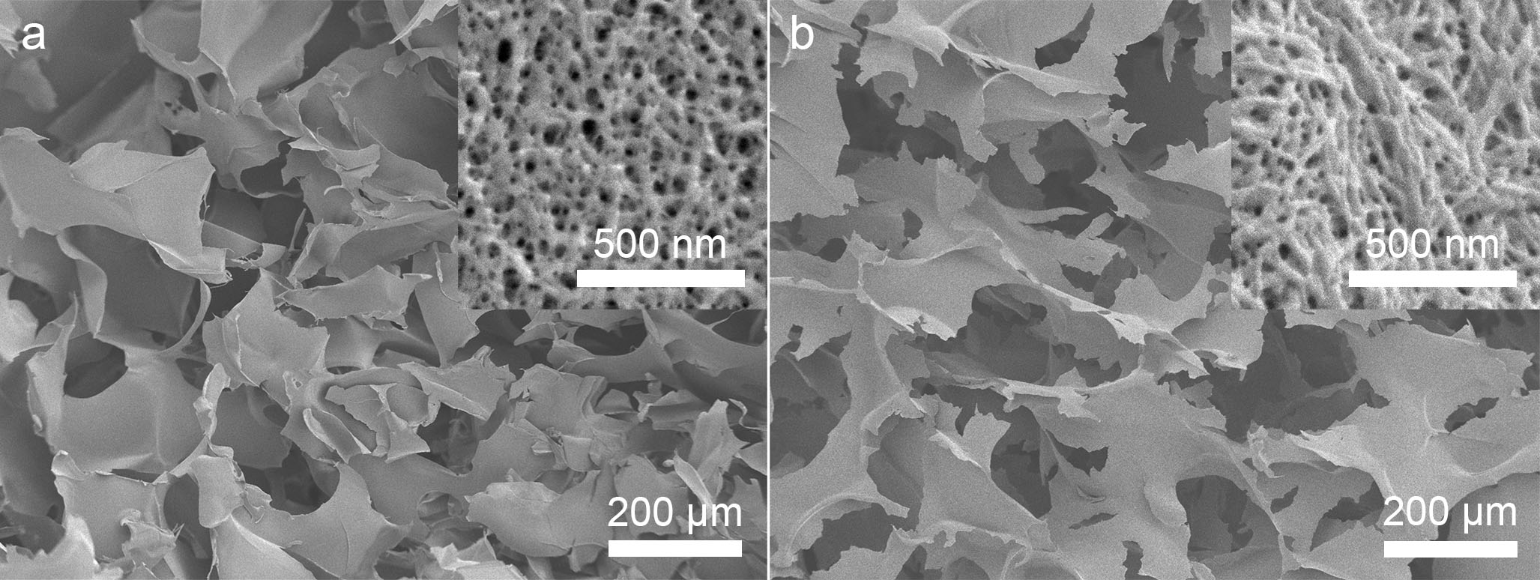
Figure 13: SEM micrographs of cross-sections of (a) S-CNC and (b) P-CNC aerogels. Both types of aerogels have similar morphology with cross-linked CNC sheets (or flakes) separated by macropores. Insets at higher magnification show the similar mesoporous structures of the CNC sheets.
While there were morphological similarities for the two types of aerogels, some mechanical behaviour was similar but some notable differences were also observed. For example, cyclic mechanical testing in wet conditions indicated that P-CNC aerogels have the same flexibility and shape-recovery properties as shown previously for S-CNC aerogels.⁶² However, compression data showed that S-CNC aerogels exhibited higher compressive strength at 90% compression than P-CNC aerogels in both dry and wet conditions (Figure 15). For both types of aerogels, the materials were more easily compressed in water than in air, due to the plasticising effect of water.
Chemical and physical differences between S-CNC and P-CNC aerogels were also quantified: from high resolution nitrogen spectra measured by XPS, S-CNC aerogels show a larger N3 peak, revealing three times more hydrazone bonds (Table 5). Density calculations also indicated that S-CNC aerogels have a lower density, 10 ± 1 mg/cm³, than P-CNC aerogels, 19 ± 2 mg/cm³. In addition, calculated porosity measurements show S-CNC aerogels have a porosity of 99.3 %, while P-CNC aerogels have a porosity of 98.8 %. This is further reinforced through the porosity measurements made from 3D µCT reconstructions, where S-CNC aerogels have a porosity of 89.7 % and P-CNC aerogels having a porosity of 83.9 % (Figure 14). The differences between the two sets of porosity calculations are due to the resolution limitation of µCT imaging. The radiographs analyzed cannot account for pores less than 5 µm, and therefore cannot resolve mesopores for either aerogel. Therefore, the difference between the two porosity calculations is heavily attributed to the porosity provided by the mesopores on CNC sheets.
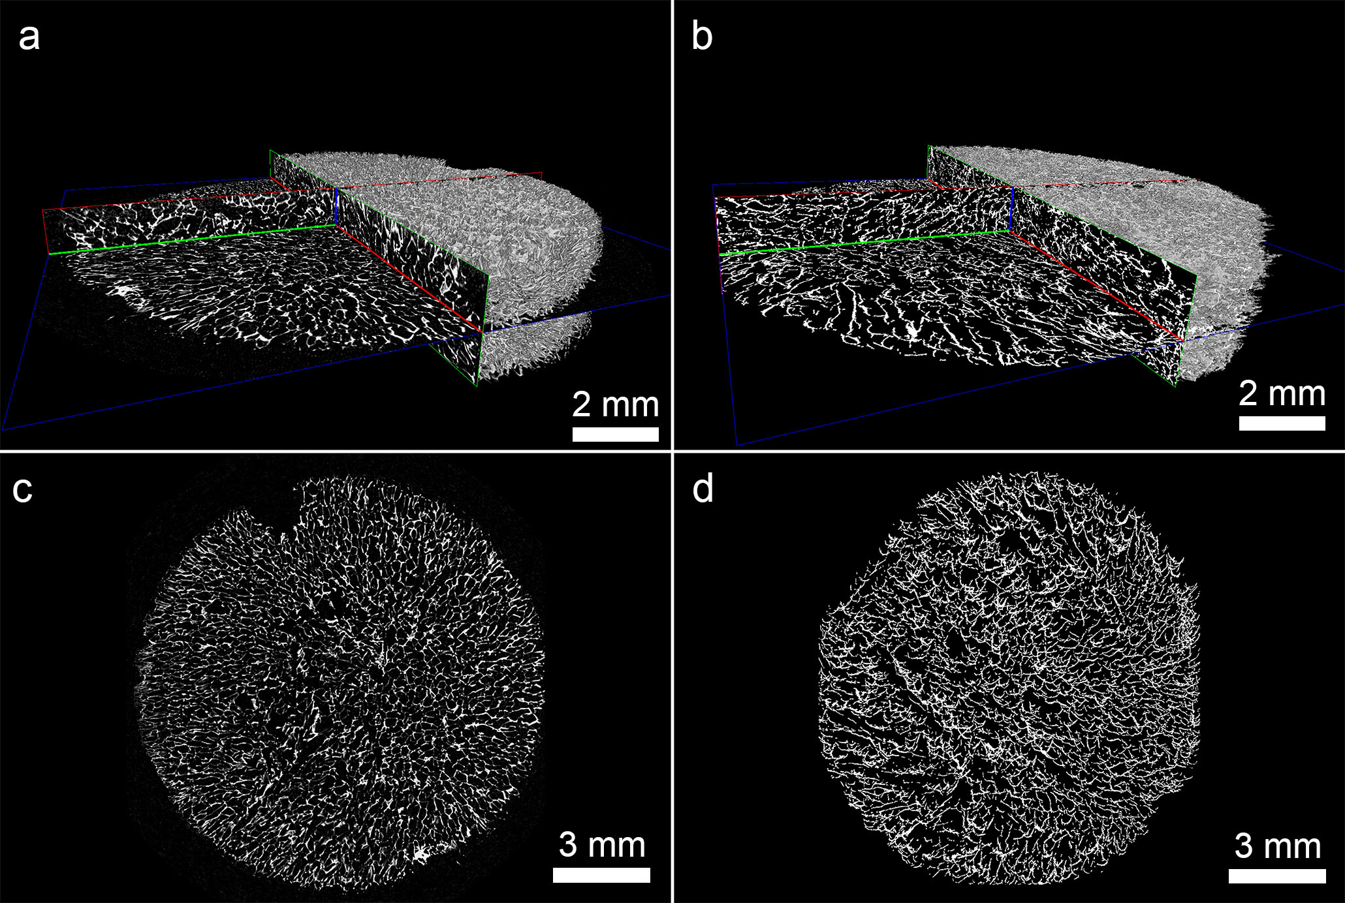
Figure 14: µCT 3D reconstructions of (a,c) S-CNC and (b,d) P-CNC aerogels. (a-b) Orthogonal slices, and a partial volume rendering showing the interconnected pore structure and macropores ranging from 5 µm and larger. (c,d) The macroporous structure through a 2D xy slice through the center of the aerogels.
Table 5: High-resolution nitrogen XPS spectra values for CNC aerogels.
 | Atomic Composition (%)
Type of Aerogel | N1 | N2
S-CNC | 90.1 | 9.9
P-CNC | 96.6 | 3.4

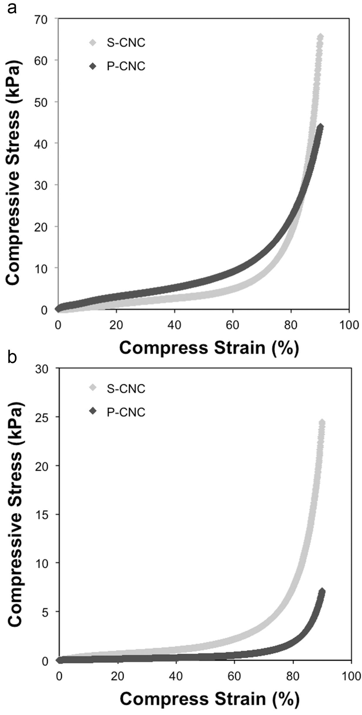
Figure 15: Compressive stress-strain curves for S-CNC (grey) and P-CNC (black) aerogels from 0% to 90% strain in (a) dry conditions, (b) wet conditions, showing that S-CNC aerogels are more resistant to compression than P-CNC aerogels in both dry and wet conditions.

Aerogel Cell Testing
Cells proliferating on S-CNC sheets are shown in Figure 16a and 16b. These images demonstrate characteristics of healthy cell adhesion, as most cells are oblong and elongated (Figure 16a), with Figure 16b showing filopodia extending over the CNC aerogel surface.¹⁹⁶ Cell metabolism on S-CNC aerogels increased between 1 and 3 days while maintaining the same level of cell metabolism between 3 and 7 days (Figure 16c). P-CNC aerogels also showed an increase in cell metabolism over 1, 3, and 7 days (Figure 16c). By 3 days, there was a significant difference (p <0.05) between the aerogels but by 7 days, there was no significant difference with respect to cell metabolism. The ALP activity for S-CNC aerogels showed a similar trend to the S-CNC aerogel cell metabolism (Figure 16d). An increase in ALP activity was noted from 1 to 3 days, with the ALP activity staying statistically the same between 3 and 7 days. While a similar increase in ALP activity occurred between 1 and 3 days for P-CNC aerogels, a sharp increase in ALP activity occurred between 3 and 7 days. A statistically significant difference in ALP activity (p <0.05) at 7 days is noted between the two aerogels.

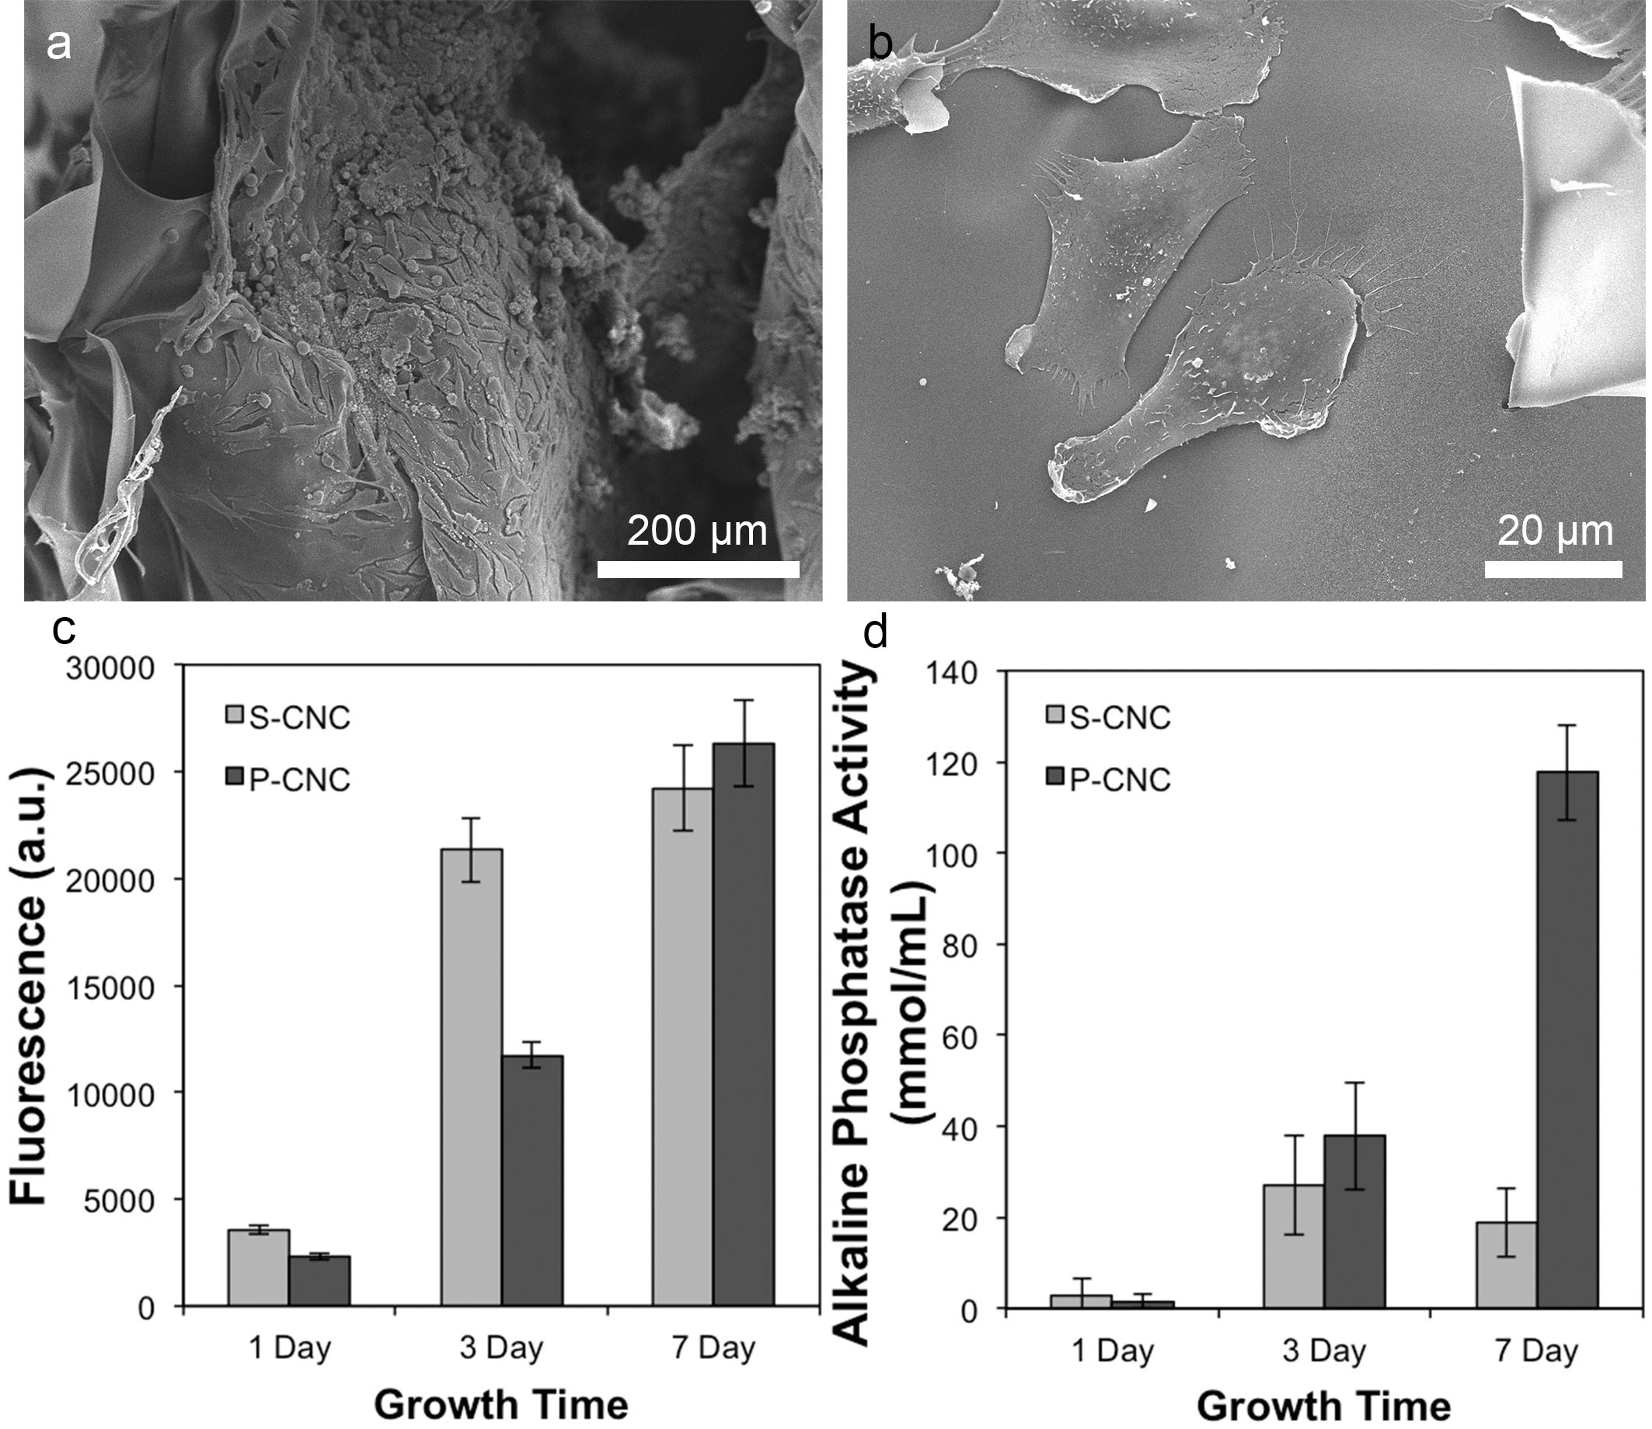
Figure 16: SEM micrographs of an S-CNC aerogel sheet that is (a) confluent with Saos-2 cells, and (b) at higher magnification shows healthy characteristics such as its oblong shape and extending filopodia. (c) Cell metabolism, and (d) alkaline phosphatase activity results comparing S-CNC and P-CNC aerogels for 1, 3, and 7 days.

Simulated Body Fluid Testing
SEM images of S-CNC and P-CNC aerogels after 7 and 14 days in SBF are shown in Figure 17. Figure 17a and 17c show S-CNC and P-CNC aerogels in SBF, respectively, after a pre-treatment with CaCl₂, showing that both S-CNC and P-CNC aerogels nucleated HA, which is apparent by the flaky spherical structures (Figure 17b and 17d).

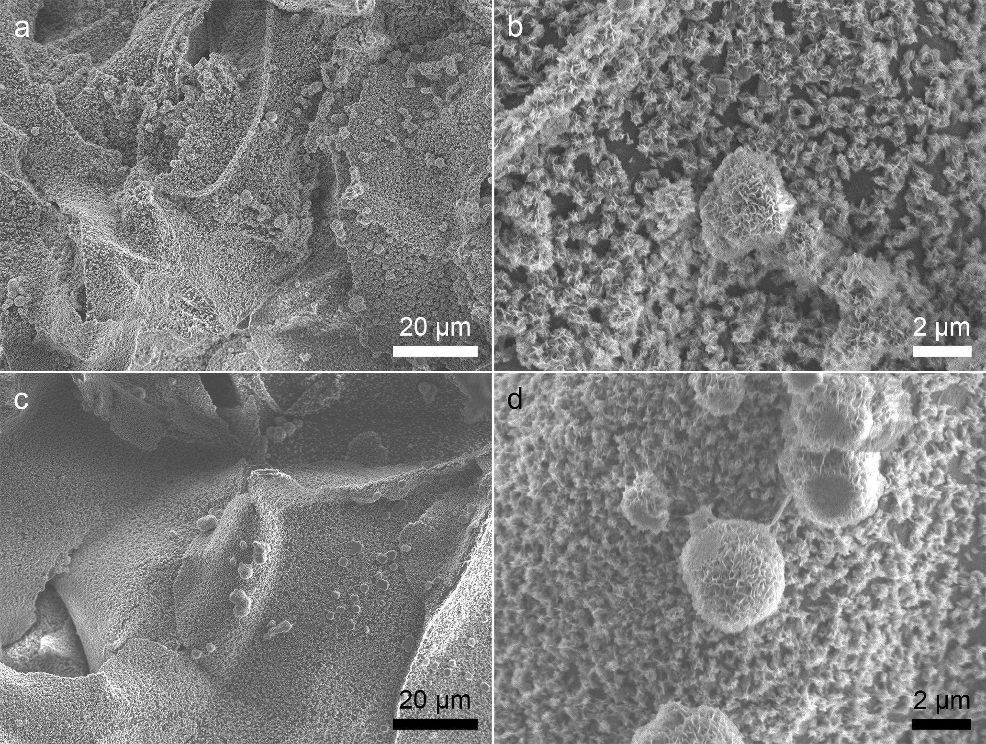
Figure 17: SEM micrographs at low (left) and high (right) magnification of (a-b) S-CNC and (c-d) P-CNC aerogels after pre-treatment with calcium chloride and SBF submersion for 7 days. Characteristic flake-like HA crystals covered the surface of both types of aerogels, and contained Ca and P (EDX results not shown).
It should be noted that aerogel samples not subjected to a CaCl₂ pre-treatment did not grow HA. While preliminary EDX indicated particles contained Ca and P ratios close to the stoichiometric ratio of HA, XRD analysis supports that the crystals shown in SEM images are HA, and provides evidence for an increase in HA growth between 7 and 14 days through a sharpening and increase in peak intensity of characteristic HA peaks, Figure 18.
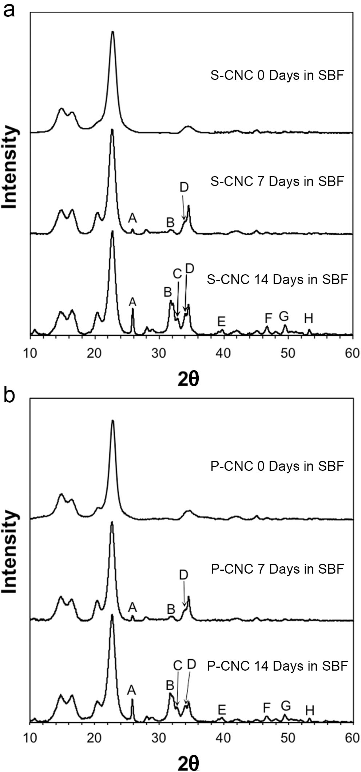
Figure 18: XRD spectra for (a) S-CNC and (b) P-CNC aerogels at 0, 7, and 14 days. At 7 days, both types of aerogels show preliminary HA peaks forming. As submersion time in SBF increases to 14 days, peaks become more defined indicating an increase in the HA layer on CNC sheets. Characteristic HA peaks are marked A = 25.9˚ (002), B = 31.8˚ (211), C = 32.9˚ (300), D = 34.0˚ (202), E = 39.8˚ (310), F = 46.7˚ (222), G = 49.5˚ (213), and H = 53.2˚ (004).¹⁹⁴

Discussion
To the best of our knowledge, CNC aerogels have never been investigated as bone scaffolding materials. Here, both S-CNC and P-CNC aerogels have been shown to possess favorable characteristics of a bone scaffold. The sponge-like properties provide them with the potential advantage of completely filling bone defects.¹⁸⁴ This coupled with its bimodal pore morphology, which allows for an influx of osteogenic cells through macropores and better cell adhesion on mesopores, provides unique properties for bone scaffolding. In addition, the inherent non-toxicity of CNCs²³ has allowed for CNC aerogels to facilitate osteogenic cell growth and differentiation, while the anionic groups on CNC surfaces have provided viable nucleation sites for HA.
S-CNC and P-CNC aerogels are similar in their pore morphology, average mesopore size, and specific surface area. The macropores shown in Figure 13 for both types of aerogels are larger than 50 µm on average, showing the capacity for proteins and cells to enter and interact with the aerogel. The average mesopore size is 11 nm and 6 nm, for S-CNC and P-CNC aerogels respectively, showing that CNC aerogels have a high potential for promoting bone in-growth,¹⁴⁹ cell adhesion,¹³³ and large surface area to enhance cell proliferation. This pore morphology and high porosity also allows the aerogels to quickly and completely fill with whatever liquid environment they are placed in (without collapsing), which is helpful for in vitro and in vivo testing.
S-CNC aerogels have higher compressive strength at 90% compression than P-CNC aerogels in both dry and wet conditions. This is attributed to P-CNCs having fewer cross-links (according to XPS, Table 5), potentially due to P-CNCs being slightly aggregated in suspension (primarily CHO-P-CNCs, Table 4). P-CNC aerogel sheets likely consist of regions of aggregated CHO-P-CNCs that are only held together with cellulose-cellulose bonds, which are less stable in aqueous conditions than hydrazone cross-links. Scaffolds with stronger mechanical properties are preferred for bone tissue growth.^{132,197} This is because scaffolds need to match the load-bearing capabilities that healthy bone withstands during early stages of bone growth.^{132,197} Therefore, S-CNC aerogels have an advantage over P-CNC aerogels as a bone tissue scaffold with regards to mechanical properties.
Both S-CNC and P-CNC aerogels were shown to be viable bone cell scaffolds through cell metabolism and alkaline phosphatase assays (Figure 16). This also shows how the CNC sheets provide a non-toxic environment for cells to remain viable, as cell metabolism was constant between 3 and 7 days for S-CNC aerogels. P-CNC aerogels show a similar trend, as S-CNC and P-CNC aerogel cell metabolism readings were statistically equal at 7 days. However, it should be noted that P-CNC aerogels took longer to become confluent as indicated by the cell metabolism reading at 3 days. This may be due to P-CNC aerogel sheets not being as stiff as S-CNC aerogel sheets, since it has been shown Saos-2 cells favour stiffer environments¹⁹⁸.
ALP activity was shown to be favourable for both S-CNC and P-CNC aerogels and was statistically equal at 1 and 3 days respectively, but is significantly different at 7 days, where P-CNCs were preferable (Figure 16d). This is potentially due to the weaker mechanical properties of P-CNC aerogels. For example, at 7 days, P-CNC aerogels were observed to begin to break down in media. Therefore, as the lysis solution was added to P-CNC aerogels in media, more cells could be lysed, and therefore a stronger ALP activity detected. Since S-CNC aerogels stayed intact due to their highly cross-linked structure, the lysis solution could not penetrate into the aerogel to the same extent as in the P-CNCs. It can be argued that the P-CNC aerogels represent the ALP activity of Saos-2 cells more accurately when compared to S-CNC aerogels, due to their increased degradation after the 7 days. The expression of ALP from both types of CNC aerogels is a promising result for their use as bone tissue scaffolds. Higher ALP readings generally correspond to increased osteoblast cell differentiation^{199,200} and bone minerlization²⁰¹ during osteogenesis.
Due to the different degradation properties between S-CNC and P-CNC aerogels in liquids (over the 7 day period tested), there is potential to tune their bioresorbability in an in vivo environment. It has already been shown that the degradation rate of hydrazone cross-linked gels can be controlled with the amount of hydrazone bonds present.¹⁶² Therefore by tuning the amount of aldehyde and hydrazide content on CNC surfaces, or limiting the amount of hydrazone bonds that can be formed, the degradation rate of CNC aerogels can be tuned.
HA growth occurred on both S-CNC and P-CNC aerogel surfaces that had been pre-treated with 0.1 M CaCl₂. This was expected for P-CNC aerogels as many studies have shown that the phosphorylation of cellulose substrates can facilitate HA growth.^{148,190,191} However, S-CNC aerogels show a similar HA growth after both 7 and 14 days despite not having any phosphate groups. This was attributed to sulfate half-ester groups ionically binding to calcium ions²⁰² during the calcium chloride pre-treatment. These calcium ions ionically bind to phosphate ions in the SBF solution so HA could form.²⁰³ Therefore, this work indicates that the phosphorylation of cellulose substrates is not essential for HA growth in SBF, rather the anionic species on the surface impacts HA growth, as has been similarly reported by Rhee and Tanaka.²⁰² Though previous work has shown SBF submersion tests are not a guarantee of HA growth in in vivo environments,²⁰⁴ many studies have used SBF to produce HA coatings on scaffold surfaces.^{148,205,206} Therefore, even if CNC aerogels cannot grow HA naturally in in vivo environments, this procedure can still be used to coat CNC aerogels with HA to further promote cell adhesion, cell proliferation,²⁰⁷ and cell differentiation.²⁰⁸
Although these in vitro tests have shown that CNC aerogels are a promising bone tissue scaffold, there are limitations to these findings. As mentioned, HA growth in SBF is a promising indicator of osteoconduction in in vivo condition, but not a guarantee.²⁰⁴ This is also true for cellular assays. Therefore, the logical next step for this work is the in vivo testing of CNC aerogels as bone tissue scaffolds in animal models.

Conclusion
This work has demonstrated the feasibility of using S-CNC and P-CNC aerogels as bone scaffolds. S-CNC and P-CNC aerogels exhibited ideal scaffold characteristics, including macropores in the range of 10 - 950 µm to allow cell migration, as well as a unique mesopore morphology, and a large specific surface area to promote cell adhesion and proliferation. Both types of aerogels showed an increase in cell metabolism over a 7 day period. ALP activity on both types of aerogels increased with time indicating a healthy environment for cell differentiation. P-CNC aerogels were found to partially break down at 7 days in the cell assays, indicating that by controlling the amount of hydrazone cross-linking between CNCs we can tune the aerogel bioresorbability.
The application and degradation of cross-linked CNC aerogels in vivo is not expected to have any possible leachates or negative toxic effects due to the fact that both the degradation products from hydrazone cross-links and CNCs with these surface modifications are non-toxic.^{56,162} Additionally, the sponge-like characteristics of these aerogels can allow for pre-loading or impregnation with other biomolecules or drugs to aid in tissue engineering. SBF testing showed that aerogels were capable of growing HA after a CaCl₂ pre-treatment, showing potential for osteoconduction in vivo. S-CNC aerogels also nucleated HA off of the sulfate half-ester groups, with the use of a CaCl₂ pre-treatment, despite the absence of phosphate groups. These findings suggest that CNC aerogels warrant further in vivo investigation as a promising bone scaffolding material.

Acknowledgments
This work was supported by funding to KG and EC from the Natural Sciences and Engineering Research Council of Canada (NSERC) Discovery Grant Program. The authors would like to acknowledge the assistance of Professors T. Hoare, R. Pelton, A. Gurane, and facilities such as the McMaster Automotive Resource Center (MARC), McMaster Biointerfaces Institute, and the University of Waterloo for shared equipment. Electron microscopy was performed at the Canadian Centre for Electron Microscopy, a facility supported by NSERC and other governmental sources. The authors thank Xuan Yang, Oriana Vanderfleet, Andrew Kacheff, James Tedesco, Marcia Reid, Manon Le Gars, Victoria Jarvis, and Dr. Danielle Covelli for training, sample analysis, and expertise.

Conclusions and Future Works

Conclusion
Chemically cross-linked CNC aerogels have been shown to be an attractive material in several applications. This work provided a thorough analysis of chemically cross-linked CNC aerogels by firstly exploring the effect of new aerogel processing techniques, and secondly, by investigating their application as bone tissue scaffolds. The effects of aerogel processing methods were evaluated by comparing the morphologies of two CNC aerogels, one produced by the currently used cryo-templating method, and the other produced by the novel aerogel processing method PGX. CNC aerogels were then evaluated as bone tissue scaffolds by investigating their ability to facilitate cell proliferation, differentiation, and HA nucleation.
In Chapter 3, the comparison of cryo-templating and PGX aerogel processing techniques revealed that an entirely different morphology and characteristics were obtained through the PGX process. PGX aerogels were shown to have a more expanded network of CNCs taking on the form of highly porous mounds, while cryo-templating showed a condensed sheet like morphology separated by large macropores. The PGX process produced aerogels with greater specific surface area, reduced strength, and a wider range of mesopore sizes than cryo-templated aerogels. Both aerogels behaved differently in aqueous environments, with cryo-templated aerogels retaining their shape while PGX aerogels shrank. Through this work demonstrating a scalable manufacturing process that produces CNC aerogel with new morphology and properties has broadened the potential applications of CNC aerogels.
In Chapter 4, cryo-templated CNC aerogels were evaluated as bone tissue scaffolds by testing aerogels made from S-CNCs and P-CNCs in a series of in vitro tests. Both aerogels possessed ideal scaffold characteristics such as macropores to promote vascularization and osteogenic cell migration, mesopores to promote potential bone in-growth and cell adhesion, and shape recovery properties that allow CNC aerogels to conform to complex bone defects. Both aerogels supported osteoblast-like cell proliferation with healthy cell metabolism readings for up to 7 days. Additionally, cells grew across the CNC aerogel surfaces and remained viable after reaching confluency. The ALP assays and SEM images revealed that both aerogels were able facilitate cell differentiation, with ALP activity being more easily probed on P-CNC aerogels due to P-CNC aerogels breaking apart during the cell assay. SBF testing showed that, with a pre-treatment of CaCl₂, both aerogels nucleated HA, which is a promising sign of osteoconductivity in in vivo applications and can be used to coat CNC aerogels in HA prior to use in vivo. This work highlighted for the first time the promising potential CNC aerogels show as bone tissue scaffolds for bone defect healing.

Future Works
While the present work has made considerable strides in showcasing an application of chemically cross-linked CNC aerogels, a deeper understanding of the fundamentals governing the properties of CNC aerogels should be explored in future work. This thesis indicated that the quantity of hydrazone bonds may have a significant impact on the bulk behaviour of resultant aerogels. Therefore, future work will focus on better characterizing the effects of hydrazone bonds on aerogel properties, and further development of biomedical/pharmaceutical applications for CNC aerogels. In particular, the quantity of hydrazone bonds present within cryo-templated CNC aerogels will be varied and the effects on mesopore morphology and mechanical stiffness in both dry and wet environments will be investigated. New surface modifications to CNC surfaces, for new cross-linking chemistries and new post-production cross-linking routes, will also be investigated to evaluate the effect on cryo-templated CNC aerogel morphology, behaviour, and mechanical properties.
For biomedical applications, the in vivo response of CNC aerogels to bone tissue should be explored thoroughly to properly evaluate its ability to stimulate and guide new bone growth. Future work could include pre-clinical evaluation in animal models and investigation of bone growth using similar characterization methods as this work, such as µCT, SEM imaging and other methods, such as light microscopy based histology to probe the growth of bone along the surface and throughout the aerogel volume. Animal studies are often a first step towards clinical development of biomaterials.

References
(1) Du, A.; Zhou, B.; Zhang, Z.; Shen, J. A Special Material or a New State of Matter: A Review and Reconsideration of the Aerogel. Materials (Basel). 2013, 6 (3), 941–968.
(2) Akimov, Y. K. Fields of Application of Aerogels ( Review ). Instruments Exp. Tech. 2003, 46 (3), 287–299.
(3) Kobayashi, Y.; Saito, T.; Isogai, A. Aerogels with 3D Ordered Nanofiber Skeletons of Liquid-Crystalline Nanocellulose Derivatives as Tough and Transparent Insulators. Angew. Chemie 2014, 126 (39), 10394–10397.
(4) Moon, R. J.; Schueneman, G. T.; Simonsen, J. Overview of Cellulose Nanomaterials, Their Capabilities and Applications. Jom 2016, 68 (9), 2383–2394.
(5) Habibi, Y.; Lucia, L. A.; Rojas, O. J. Cellulose Nanocrystals : Chemistry , Self-Assembly , and Applications. Chem. Rev. 2010, 110 (6), 3479–3500.
(6) De France, K. J.; Hoare, T.; Cranston, E. D. Review of Hydrogels and Aerogels Containing Nanocellulose. Chem. Mater. 2017.
(7) Cosgrove, D. J. Growth of the Plant Cell Wall. Nat. Rev. Mol. Cell Biol. 2005, 6 (11), 850–861.
(8) Moon, R. J.; Martini, A.; Nairn, J.; Simonsen, J.; Youngblood, J. Cellulose Nanomaterials Review: Structure, Properties and Nanocomposites. Chem. Soc. Rev. 2011, 40 (7), 3941–3994.
(9) Nishiyama, Y.; Langan, P.; Chanzy, H. Crystal Structure and Hydrogen-Bonding System in Cellulose Iβ from Synchrotron X-Ray and Neutron Fiber Diffraction. J. Am. Chem. Soc. 2002, 124 (31), 9074–9082.
(10) Klemm, D.; Heublein, B.; Fink, H.; Bohn, A. Polymer Science Cellulose : Fascinating Biopolymer and Sustainable Raw Material. Angew. Chemie Int. Ed. 2005, 44 (22), 3358–3393.
(11) Eyley, S.; Thielemans, W. Surface Modification of Cellulose Nanocrystals. Nanoscale 2014, 6 (14), 7764–7779.
(12) Isogai, A.; Saito, T.; Fukuzumi, H. TEMPO-Oxidized Cellulose Nanofibers. Nanoscale 2011, 3 (1), 71–85.
(13) Nickerson, R. F.; Habrle, J. A. Cellulose Intercrystalline Structure. Ind. Eng. Chem. 1947, 39 (11), 1507–1512.
(14) Koshizawa, T. Degradation of Wood Cellulose and Cotton Linters in Phosphoric Acid. Japan Tappi J. 1960, 14 (7), 455–458.
(15) Camarero Espinosa, S.; Kuhnt, T.; Foster, E. J.; Weder, C. Isolation of Thermally Stable Cellulose Nanocrystals by Phosphoric Acid Hydrolysis. Biomacromolecules 2013, 14 (4), 1223–1230.
(16) Sadeghifar, H.; Filpponen, I.; Clarke, S. P.; Brougham, D. F.; Argyropoulos, D. S. Production of Cellulose Nanocrystals Using Hydrobromic Acid and Click Reactions on Their Surface. J. Mater. Sci. 2011, 46 (22), 7344–7355.
(17) Chen, L.; Zhu, J. Y.; Baez, C.; Kitin, P.; Elder, T. Highly Thermal-Stable and Functional Cellulose Nanocrystals and Nanofibrils Produced Using Fully Recyclable Organic Acids. Green Chem. 2016, 18 (13), 3835–3843.
(18) Yu, H.-Y.; Zhang, D.-Z.; Lu, F.-F.; Yao, J. New Approach for Single-Step Extraction of Carboxylated Cellulose Nanocrystals for Their Use as Adsorbents and Flocculants. ACS Sustain. Chem. Eng. 2016, 4 (5), 2632–2643.
(19) Leung, A. C. W.; Hrapovic, S.; Lam, E.; Liu, Y.; Male, K. B.; Mahmoud, K. A.; Luong, J. H. T. Characteristics and Properties of Carboxylated Cellulose Nanocrystals Prepared from a Novel One-Step Procedure. Small 2011, 7 (3), 302–305.
(20) Nishiyama, Y.; Langan, P.; Chanzy, H. Crystal Structure and Hydrogen-Bonding System in Cellulose Iβ from Synchrotron X-Ray and Neutron Fiber Diffraction. J. Am. Chem. Soc. 2002, 124 (31), 9074–9082.
(21) Larsson, P. T.; Hult, E. L.; Wickholm, K.; Pettersson, E.; Iversen, T. CP/MAS 13C-NMR Spectroscopy Applied to Structure and Interaction Studies on Cellulose I. Solid State Nucl. Magn. Reson. 1999, 15 (1), 31–40.
(22) Agarwal, U. P.; Ralph, S. a.; Reiner, R. S.; Baez, C. Probing Crystallinity of Never-Dried Wood Cellulose with Raman Spectroscopy. Cellulose 2016, 23 (1), 125–144.
(23) Roman, M. Toxicity of Cellulose Nanocrystals: A Review. Ind. Biotechnol. 2015, 11 (1), 25–33.
(24) de Figueirêdo, M. C. B.; de Freitas Rosa, M.; Ugaya, C. M. L.; de Souza, M. D. S. M.; da Silva Braid, A. C. C.; de Melo, L. F. L. Life Cycle Assessment of Cellulose Nanowhiskers. J. Clean. Prod. 2012, 35, 130–139.
(25) Jackson, J. K.; Letchford, K.; Wasserman, B. Z.; Ye, L.; Hamad, W. Y.; Burt, H. M. The Use of Nanocrystalline Cellulose for the Binding and Controlled Release of Drugs. Int. J. Nanomedicine 2011, 6, 321–330.
(26) Dong, S.; Hirani, A. A.; Colacino, K. R.; Lee, Y. W.; Roman, M. Cytotoxicity and Cellular Uptake of Cellulose Nanocrystals. Nano Life 2012, 2 (3), 1241006.
(27) Montanari, S.; Roumani, M.; Heux, L.; Vignon, M. R. Topochemistry of Carboxylated Cellulose Nanocrystals Resulting from TEMPO-Mediated Oxidation. Macromolecules 2005, 38 (5), 1665–1671.
(28) Kovacs, T.; Naish, V.; O’Connor, B.; Blaise, C.; Gagné, F.; Hall, L.; Trudeau, V.; Martel, P. An Ecotoxicological Characterization of Nanocrystalline Cellulose (NCC). Nanotoxicology 2010, 4 (3), 255–270.
(29) Drogat, N.; Granet, R.; Le Morvan, C.; Bégaud-Grimaud, G.; Krausz, P.; Sol, V. Chlorin-PEI-Labeled Cellulose Nanocrystals: Synthesis, Characterization and Potential Application in PDT. Bioorg. Med. Chem. Lett. 2012, 22 (11), 3648–3652.
(30) Hervy, M.; Evangelisti, S.; Lettieri, P.; Lee, K. Y. Life Cycle Assessment of Nanocellulose-Reinforced Advanced Fibre Composites. Compos. Sci. Technol. 2015, 118, 154–162.
(31) Ong, K. J.; Shatkin, J. A.; Nelson, K.; Ede, J. D.; Retsina, T. Establishing the Safety of Novel Bio-Based Cellulose Nanomaterials for Commercialization. NanoImpact 2017, 6, 19–29.
(32) Shatkin, J. A.; Kim, B. Cellulose Nanomaterials: Life Cycle Risk Assessment, and Environmental Health and Safety Roadmap. Environ. Sci. Nano 2015, 2 (5), 477–499.
(33) Shatkin, J. A.; Ong, K. J.; Ede, J. D.; Wegner, T. H.; Goergen, M. Toward Cellulose Nanomaterial Commercialization: Knowledge Gap Analysis for Safety Data Sheets according to the Globally Harmonized System. Tappi J. 2016, 15 (9), 425.
(34) Zimmermann, T.; Bordeanu, N.; Strub, E. Properties of Nanofibrillated Cellulose from Different Raw Materials and Its Reinforcement Potential. Carbohydr. Polym. 2010, 79 (4), 1086–1093.
(35) Henriksson, M.; Henriksson, G.; Berglund, L. A.; Lindstro, T. An Environmentally Friendly Method for Enzyme-Assisted Preparation of Microfibrillated Cellulose (MFC) Nanofibers. Eur. Polym. J. 2007, 43 (8), 3434–3441.
(36) Wågberg, L.; Decher, G.; Norgren, M.; Lindström, T.; Ankerfors, M.; Axnäs, K. The Build-up of Polyelectrolyte Multilayers of Microfibrillated Cellulose and Cationic Polyelectrolytes. Langmuir 2008, 24 (3), 784–795.
(37) Pääkkö, M.; Ankerfors, M.; Kosonen, H.; Nykänen, A.; Ahola, S.; Österberg, M.; Ruokolainen, J.; Laine, J.; Larsson, P. T.; Ikkala, O.; et al. Enzymatic Hydrolysis Combined with Mechanical Shearing and High-Pressure Homogenization for Nanoscale Cellulose Fibrils and Strong Gels. Biomacromolecules 2007, 8 (6), 1934–1941.
(38) Dufresn, A. Nanocellulose: From Nature to High Performance Tailored Materials; 2013.
(39) Cavka, A.; Guo, X.; Tang, S.; Winestrand, S.; Jönsson, L. J.; Hong, F. Production of Bacterial Cellulose and Enzyme from Waste Fiber Sludge. Biotechnol. Biofuels 2013, 6 (1), 25.
(40) Delmer, D. P.; Amor, Y. Cellulose Biosynthesis. Plant Cell 1995, 7 (7), 987–1000.
(41) Jr, R. M. B.; Jr, R. M. B. The Biosynthesis of Cellulose. J. Macromol. Sci. Part A Pure Appl. Chem. 1996, 33 (10), 1345–1373.
(42) Mohite, B. V.; Patil., S. V. A Novel Biomaterial : Bacterial Cellulose and Its New Era Applications. Biotechnol. Appl. Biochem. 2014, 61 (2), 101–110.
(43) Czaja, W. K.; Young, D. J.; Kawecki, M.; Brown, R. M. The Future Prospects of Microbial Cellulose in Biomedical Applications. Biomacromolecules 2007, 8 (1), 1–12.
(44) Martínez-sanz, M.; Lopez-rubio, A.; Lagaron, J. M. Optimization of the Nanofabrication by Acid Hydrolysis of Bacterial Cellulose Nanowhiskers. Carbohydr. Polym. 2011, 85 (1), 228–236.
(45) Habibi, Y. Key Advances in the Chemical Modification of Nanocelluloses. Chem. Soc. Rev. 2014, 43 (5), 1519–1542.
(46) Way, A. E.; Hsu, L.; Shanmuganathan, K.; Weder, C.; Rowan, S. J. pH-Responsive Cellulose Nanocrystal Gels and Nanocomposites. ACS Macro Lett. 2012, 1 (8), 1001–1006.
(47) Lin, N.; Huang, J.; Chang, P. R.; Feng, J.; Yu, J. Surface Acetylation of Cellulose Nanocrystal and Its Reinforcing Function in Poly (Lactic Acid). Carbohydr. Polym. 2011, 83 (4), 1834–1842.
(48) Hong, L.; Wang, Y. L.; Jia, S. R.; Huang, Y.; Gao, C.; Wan, Y. Z. Hydroxyapatite / Bacterial Cellulose Composites Synthesized via a Biomimetic Route. Mater. Lett. 2006, 60 (13), 1710–1713.
(49) Bossa, N.; Carpenter, A. W.; Kumar, N.; de Lannoy, C. F.; Wiesner, M. Cellulose Nanocrystal Zero-Valent Iron Nanocomposites for Groundwater Remediation. Enviromental Sci. Nano 2017, 4 (6), 1294–1303.
(50) Sun, B.; Hou, Q.; Liu, Z.; Ni, Y. Sodium Periodate Oxidation of Cellulose Nanocrystal and Its Application as a Paper Wet Strength Additive. Cellulose 2015, 22 (2), 1135–1146.
(51) Azzam, F.; Galliot, M.; Putaux, J. L.; Heux, L.; Jean, B. Surface Peeling of Cellulose Nanocrystals Resulting from Periodate Oxidation and Reductive Amination with Water-Soluble Polymers. Cellulose 2015, 22 (6), 3701–3714.
(52) Larsson, P. A.; Berglund, L. A.; Wågberg, L. Ductile All-Cellulose Nanocomposite Films Fabricated from Core − Shell Structured Cellulose Nano Fibrils. Biomacromolecules 2014, 15 (6), 2218–2223.
(53) Yang, H.; Tejado, A.; Alam, N.; Antal, M.; van de Ven, T. G. Films Prepared from Electrosterically Stabilized Nanocrystalline Cellulose. Langmuir 2012, 28 (20), 7834–7842.
(54) Vanderfleet, O. M.; Osorio, D. A.; Cranston, E. D. Optimization of Cellulose Nanocrystal Length and Surface Charge Density through Phosphoric Acid Hydrolysis. Philisophical Trans. A 2017.
(55) Hemraz, U. D.; Boluk, Y.; Sunasee, R. Amine-Decorated Nanocrystalline Cellulose Surfaces: Synthesis, Characterization, and Surface Properties. Can. J. Chem. 2013, 91 (10), 974–981.
(56) Yang, X.; Bakaic, E.; Hoare, T.; Cranston, E. D. Injectable Polysaccharide Hydrogels Reinforced with Cellulose Nanocrystals: Morphology, Rheology, Degradation, and Cytotoxicity. Biomacromolecules 2013, 14 (12), 4447–4455.
(57) Abitbol, T.; Palermo, A.; Moran-Mirabal, J. M.; Cranston, E. D. Fluorescent Labeling and Characterization of Cellulose Nanocrystals with Varying Charge Contents. Biomacromolecules 2013, 14 (9), 3278–3284.
(58) Chen, L.; Lai, C.; Marchewka, R.; Berry, R. M.; Tam, K. C. Use of CdS Quantum Dot-Functionalized Cellulose Nanocrystal Films for Anti-Counterfeiting Applications. Nanoscale 2016, 8 (27), 13288–13296.
(59) Mahmoud, K. A.; Male, K. B.; Hrapovic, S.; Luong, J. H. Cellulose Nanocrystal/gold Nanoparticle Composite as a Matrix for Enzyme Immobilization. ACS Appl. Mater. Interfaces 2009, 1 (7), 1383–1386.
(60) Parinaz, S.; Richard, A.; Tam, K. C. Surface Modification of Cellulose Nanocrystal with Chitosan Oligosaccharide for Drug Delivery Applications. Cellulose 2013, 20 (4), 1747–1764.
(61) Grabarek, Z.; Gergely, J. Zero-Length Crosslinking Procedure with the Use of Active Esters. Anal. Biochem. 1990, 185 (1), 131–135.
(62) Yang, X.; Cranston, E. D. Chemically Cross-Linked Cellulose Nanocrystal Aerogels with Shape Recovery and Superabsorbent Properties. Chem. Mater. 2014, 26 (20), 6016–6025.
(63) Abitbol, T.; Marway, H. S.; Kedzior, S. A.; Yang, X.; Franey, A.; Gray, D. G.; Cranston, E. D. Hybrid Fluorescent Nanoparticles from Quantum Dots Coupled to Cellulose Nanocrystals. Cellulose 2017, 24 (3), 1287–1293.
(64) Incani, V.; Danumah, C.; Boluk, Y. Nanocomposites of Nanocrystalline Cellulose for Enzyme Immobilization. Cellulose 2013, 20 (1), 191–200.
(65) Ossipov, D. A.; Piskounova, S.; Varghese, O. P.; Hilborn, J. Functionalization of Hyaluronic Acid with Chemoselective Groups via a Disulfide-Based Protection Strategy for in Situ Formation of Mechanically Stable Hydrogels. Biomacromolecules 2010, 11 (9), 2247–2254.
(66) Pieper, J. S.; Hafmans, T.; Veerkamp, J. H.; Van Kuppevelt, T. H. Development of Tailor-Made Collagen-Glycosaminoglycan Matrices: EDC/NHS Crosslinking, and Ultrastructural Aspects. Biomaterials 2000, 21 (6), 581–593.
(67) Patenaude, M.; Smeets, N. M. B.; Hoare, T. Designing Injectable , Covalently Cross-Linked Hydrogels for Biomedical Applications. Macromol. Rapid Commun. 2014, 35 (6), 598–617.
(68) Hrubesh, L. W. Aerogel Applications. J. Non. Cryst. Solids 1998, 225, 335–342.
(69) Soleimani Dorcheh, A.; Abbasi, M. H. Silica Aerogel; Synthesis, Properties and Characterization. J. Mater. Process. Technol. 2008, 199 (1), 10–26.
(70) Schmidt, M.; Schwertfeger, F. Applications for Silica Aerogel Products. J. Non. Cryst. Solids 1998, 225, 364–368.
(71) Oh, K. W.; Kim, D. K.; Kim, S. H. Ultra-Porous Flexible PET/Aerogel Blanket for Sound Absorption and Thermal Insulation. Fibers Polym. 2009, 10 (5), 731–737.
(72) Tao, Y.; Endo, M.; Kaneko, K. A Review of Synthesis and Nanopore Structures of Organic Polymer Aerogels and Carbon Aerogels. Recent Patents Chem. Eng. 2008, 1 (3), 192–200.
(73) Zou, J.; Liu, J.; Karakoti, A. S.; Kumar, A.; Joung, D.; Li, Q.; Khondaker, S. I.; Seal, S.; Zhai, L. Ultralight Multiwalled Carbon Nanotube Aerogel. ACS Nano 2010, 4 (12), 7293–7302.
(74) Gui, X.; Wei, J.; Wang, K.; Cao, A.; Zhu, H.; Jia, Y.; Shu, Q.; Wu, D. Carbon Nanotube Sponges. Advaned Mater. 2010, 22 (5), 617–621.
(75) Zhu, C.; Han, T. Y.; Duoss, E. B.; Golobic, A. M.; Kuntz, J. D.; Spadaccini, C. M.; Worsley, M. A. Highly Compressible 3D Periodic Graphene Aerogel Microlattices. Nat. Commun. 2015, 6, 6962.
(76) Bandi, S.; Bell, M.; Schiraldi, D. A. Temperature-Responsive Clay Aerogel - Polymer Composites. Macromolecules 2005, 38 (22), 9216–9220.
(77) Sehaqui, H.; Morimune, S.; Nishino, T.; Berglund, L. A. Stretchable and Strong Cellulose Nanopaper Structures Based on Polymer-Coated Nano Fiber Networks: An Alternative to Nonwoven Porous Membranes from Electrospinning. Biomacromolecules 2012, 13 (11), 3661–3667.
(78) Sehaqui, H.; Zhou, Q.; Berglund, L. A. High-Porosity Aerogels of High Specific Surface Area Prepared from Nanofibrillated Cellulose ( NFC ). Compos. Sci. Technol. 2011, 71 (13), 1593–1599.
(79) KISTLER, S. S. Coherent Expanded Aerogels and Jellies. Nature. 1931, pp 741–741.
(80) Arthur L. Cohen. Critical Point Drying: Principles and Techniques of Scanning Electron Microscopy; 1974.
(81) Ganesan, K.; Dennstedt, A.; Barowski, A.; Ratke, L. Design of Aerogels , Cryogels and Xerogels of Cellulose with Hierarchical Porous Structures. Mater. Des. 2016, 92, 345–355.
(82) Franks, F. Freeze-Drying of Bioproducts: Putting Principles into Practice. Eur. J. Pharm. Biopharm. 1998, 45 (3), 221–229.
(83) Tang, X. C.; Pikal, M. J. Design of Freeze-Drying Processes for Pharmaceuticals: Practical Advice. Pharm. Res. 2004, 21 (2), 191–200.
(84) Blount, D. H. Production of Silica Aerogels, 1990.
(85) Jiménez-Saelices, C.; Seantier, B.; Cathala, B.; Grohens, Y. Spray Freeze-Dried Nanofibrillated Cellulose Aerogels with Thermal Superinsulating Properties. Carbohydr. Polym. 2017, 157, 105–113.
(86) Ilharco, L. M.; Fidalgo, A.; Farinha, J. P. S.; Martinho, J. M. G.; Rosa, M. E. Nanostructured Silica/polymer Subcritical Aerogels. J. Mater. Chem. 2007, 17 (21), 2195–2198.
(87) Temelli, Feral; Seifried, B. Supercritical Fluid Treatment of High Molecular Weight Biopolymers, 2016.
(88) Seifried, B.; Temelli, F. Supercritical Fluid Drying of High Molecular Weight Biopolymers for Particle Formation and Delivery of Bioactives. In 10th International Meeting on Supercritical Fluids; 2012; San Fransisco, USA.
(89) Seifried, B.; Temelli, F. Density of Carbon Dioxide Expanded Ethanol at (313.2, 328.2, and 343.2) K. J. Chem. Eng. Data 2010, 55 (7), 2410–2415.
(90) Seifried, B. Physicochemical Properties and Microencapsulation Process Development for Fish Oil Using Supercritical Carbon Dioxide, 2010.
(91) Seifried, B. PGX Technology: An Enabling Technology for Generating Biopolymer Fibrils, Particles, Aerogels and Nano-Composites; 2016; Essen, Germany.
(92) Jin, H.; Nishiyama, Y.; Wada, M.; Kuga, S. Nanofibrillar Cellulose Aerogels. Colloids Surfaces A Physicochem. Eng. Asp. 2004, 240 (1), 63–67.
(93) Xu, X.; Liu, F.; Jiang, L.; Zhu, J. Y.; Haagenson, D.; Wiesenborn, D. P. Cellulose Nanocrystals vs. Cellulose Nanofibrils: A Comparative Study on Their Microstructures and Effects as Polymer Reinforcing Agents. ACS Appl. Mater. Interfaces 2013, 5 (8), 2999–3009.
(94) Toivonen, M. S.; Kaskela, A.; Rojas, O. J.; Kauppinen, E. I.; Ikkala, O. Ambient-Dried Cellulose Nanofi Bril Aerogel Membranes with High Tensile Strength and Their Use for Aerosol Collection and Templates for Transparent, Flexible Devices. Adv. Funct. Mater. 2015, 25 (42), 6618–6626.
(95) Kettunen, M.; Silvennoinen, R. J.; Houbenov, N.; Nykänen, A.; Ruokolainen, J.; Sainio, J.; Pore, V.; Kemell, M.; Ankerfors, M.; Lindström, T.; et al. Photoswitchable Superabsorbency Based on Nanocellulose Aerogels. Adv. Funct. Mater. 2011, 21 (3), 510–517.
(96) Jiang, F.; Hsieh, Y. Amphiphilic Superabsorbent Cellulose Nanofibril Aerogels. J. Mater. Chem. A 2014, 2 (18), 6337–6342.
(97) Jiang, F.; Hsieh, Y. Super Water Absorbing and Shape Memory Nanocellulose Aerogels from TEMPO-Oxidized Cellulose Nanofibrils via Cyclic Freezing–thawing. J. Mater. Chem. A 2014, 2 (2), 350–359.
(98) Nyström, G.; Marais, A.; Karabulut, E.; Wågberg, L.; Cui, Y.; Hamedi, M. M. Self-Assembled Three-Dimensional and Compressible Interdigitated Thin-Film Supercapacitors and Batteries. Nat. Commun. 2015, 6, 1–8.
(99) Cervin, N. T.; Aulin, C.; Larsson, P. T.; Wågberg, L. Ultra Porous Nanocellulose Aerogels as Separation Medium for Mixtures of Oil/water Liquids. Cellulose 2012, 19 (2), 401–410.
(100) Valo, H.; Arola, S.; Laaksonen, P.; Torkkeli, M.; Peltonen, L.; Linder, M. B.; Serimaa, R.; Kuga, S.; Hirvonen, J.; Laaksonen, T. Drug Release from Nanoparticles Embedded in Four Different Nanofibrillar Cellulose Aerogels. Eur. J. Pharm. Sci. 2013, 50 (1), 69–77.
(101) Wang, X.; Zhang, Y.; Jiang, H.; Song, Y.; Zhou, Z.; Zhao, H. Fabrication and Characterization of Nano-Cellulose Aerogels via Supercritical CO 2 Drying Technology. Mater. Lett. 2016, 183, 179–182.
(102) Buesch, C.; Smith, S. W.; Eschbach, P.; Conley, J. F.; Simonsen, J. The Microstructure of Cellulose Nanocrystal Aerogels as Revealed by Transmission Electron Microscope Tomography. Biomacromolecules 2016, 17 (9), 2956–2962.
(103) Beck, S.; Bouchard, J.; Berry, R. Dispersibility in Water of Dried Nanocrystalline Cellulose. Biomacromolecules 2012, 13 (5), 1486–1494.
(104) Liu, P.; Mai, C.; Zhang, K. Formation of Uniform Multi-Stimuli-Responsive and Multiblock Hydrogels from Dialdehyde Cellulose. ACS Sustain. Chem. Eng. 2017, 5 (6), 5313–5319.
(105) Abraham, E.; Weber, D. E.; Sharon, S.; Lapidot, S.; Shoseyov, O. Multifunctional Cellulosic Scaffolds from Modified Cellulose Nanocrystals. MultifuACS Appl. Mater. interfaces 2017, 9 (3), 210–2015.
(106) Nguyen, B. N.; Cudjoe, E.; Douglas, A.; Scheiman, D.; Mccorkle, L.; Meador, M. A. B.; Rowan, S. J. Polyimide Cellulose Nanocrystal Composite Aerogels. Macromolecules 2016, 49 (5), 1692–1703.
(107) Rosilo, H.; Kontturi, E.; Seitsonen, J.; Kolehmainen, E.; Ikkala, O. Transition to Reinforced State by Percolating Domains of Intercalated Brush-Modified Cellulose Nanocrystals and Poly(butadiene) in Cross-Linked Composites Based on Thiol−ene Click Chemistry. Biomacromolecules 2013, 14 (5), 1547–1554.
(108) Yang, X.; Shi, K.; Zhitomirsky, I.; Cranston, E. D. Cellulose Nanocrystal Aerogels as Universal 3D Lightweight Substrates for Supercapacitor Materials. Adv. Mater. 2015, 27 (40), 6104–6109.
(109) Gao, K.; Shao, Z.; Wang, X.; Zhang, Y.; Wang, W.; Wang, F. Cellulose Nanofibers/multi-Walled Carbon Nanotube Nanohybrid Aerogel for All-Solid-State Flexible Supercapacitors. RSC Adv. 2013, 3 (35), 15058–15064.
(110) Lu, T.; Li, Q.; Chen, W.; Yu, H. Composite Aerogels Based on Dialdehyde Nanocellulose and Collagen for Potential Applications as Wound Dressing and Tissue Engineering Scaffold. Compos. Sci. Technol. 2014, 94, 132–138.
(111) Ahmadi, M.; Madadlou, A.; Saboury, A. A. Whey Protein Aerogel as Blended with Cellulose Crystalline Particles or Loaded with Fish Oil. Food Chem. 2016, 196, 1016–1022.
(112) Meng, Y.; Wang, X.; Wu, Z.; Wang, S.; Young, T. M. Optimization of Cellulose Nanofibrils Carbon Aerogel Fabrication Using Response Surface Methodology. Eur. Polym. J. 2015, 73, 137–148.
(113) Stevens, M. M. Biomaterials for Bone Tissue Engineering. Mater. Today 2008, 11 (5), 18–25.
(114) Reznikov, N.; Shahar, R.; Weiner, S. Bone Hierarchical Structure in Three Dimensions. Acta Biomater. 2014, 10 (9), 3815–3826.
(115) Bonucci, E. The Mineralization of Bone and Its Analogies with Other Hard Tissues. Adv. Top. Cryst. Growth 2013.
(116) Mcnally, E. A.; Schwarcz, H. P.; Botton, G. A.; Arsenault, A. L. A Model for the Ultrastructure of Bone Based on Electron Microscopy of Ion-Milled Sections. PLoS One 2012, 7 (1), 1–12.
(117) Ackerman, L. V.; Spjut, H. J.; Abell, M. R. Bones and Joints. Williams & Wilkins 1976.
(118) Weiner, S.; Wagner, H. D. THE MATERIAL BONE : Structure-Mechanical Function Relations. Annu. Rev. Mater. Sci. 1998, 28 (1), 271–298.
(119) Clarke, B. Normal Bone Anatomy and Physiology. Clin. J. Am. Soc. Nephrol. 2008, 3 (3), 131–139.
(120) Grandfield, K. Bone, Implants, and Their Interfaces. Phys. Today 2015, 4 (68), 40–45.
(121) Kalfas, I. H. Principles of Bone Healing. Neurosurg. Focus 2001, 10 (4), 1–4.
(122) Seely, R.; Stephens, T.; Tate, P. Skeletal System: Bone and Bone Tissue; The McGraw - Hill Companies, 2004.
(123) Kini, U.; Nandeesh, B. N. Physiology of Bone Formation, Remodeling, and Metabolism. Radionucl. Hybrid bone imaging 2012, 29–57.
(124) Mackie, E. J.; Ahmed, Y. A.; Tatarczuch, L.; Chen, K.; Mirams, M. Endochondral Ossification : How Cartilage Is Converted into Bone in the Developing Skeleton. Int. J. Biochem. Cell Biol. 2008, 40 (1), 46–62.
(125) Coxon, J. P.; Oades, G. M.; Colston, K. W.; Kirby, R. S. Advances in the Use of Bisphosphonates in the Prostate Cancer Setting. Prostate Cancer Prostatic Dis. 2004, 7 (2), 99–104.
(126) Burg, K. J. L.; Porter, S.; Kellam, J. F. Biomaterial Developments for Bone Tissue Engineering. Biomaterials 2000, 21 (23), 2347–2359.
(127) Smrke, D.; Primoz, R.; Veselko, M.; Gubina, B. Treatment of Bone Defects — Allogenic Platelet Gel and Autologous Bone Technique. Regen. Med. Tissue Eng. 2013.
(128) Albrektsson, T.; Johansson, C. Osteoinduction, Osteoconduction and Osseointegration. Eur. Spine J. 2001, 10 (SUPPL. 2), 96–101.
(129) Kuzyk, P. R.; Schemitsch, E. H. The Basic Sceince of Peri-Implant Bone Healing. Indian J. Orthop. 2011, 45 (2), 108.
(130) Polo-Corrales, L.; Latorre-Esteves, M.; Ramirez-Vick, J. E. Scaffold Design for Bone Regeneration. J. Nanosci. Nanotechnol. 2014, 14 (1), 15–56.
(131) Sabir, M. I.; Xiaoxue, X.; Li, L. A Review on Biodegradable Polymeric Materials for Bone Tissue Engineering Applications. J. Mater. Sci. 2009, 44 (21), 5713–5724.
(132) Hutmacher, D. W. Scaffolds in Tissue Engineering Bone and Cartilage. Biomaterials 2000, 21 (24), 2529–2543.
(133) Davies, J. E. Understanding Peri-Implant Endosseous Healing. J. Dent. Educ. 2003, 67 (8), 932–949.
(134) Currey, J. The Mechanical Adaptations of Bone; Princeton University Press: New Jersey, 1984.
(135) Kurtz, M. Standard Handbook of Biomedical Engineering & Design; McGraw-Hill: New York, 2003.
(136) Zheng, Y. F.; Gu, X. N.; Witte, F. Biodegradable Metals. Mater. Sci. Eng. R Reports 2014, 77, 1–34.
(137) Uthoff, H. K.; Finnegan, M. The Effects of Metal Plates on Post-Traumatic Remodelling and Bone Mass. Bone Joint J. 1984, 65 (1), 66–71.
(138) Jones, A. C.; Arns, C. H.; Hutmacher, D. W.; Milthorpe, B. K.; Sheppard, A. P.; Knackstedt, M. A. Biomaterials The Correlation of Pore Morphology , Interconnectivity and Physical Properties of 3D Ceramic Scaffolds with Bone Ingrowth. Biomaterials 2009, 30 (7), 1440–1451.
(139) Uchida, A.; Nade, S. M. L.; McCartney, E. R.; Ching, W. The Use of Ceramics for Bone Replacement. A Comparative Study of Three Different Porous Ceramics. Bone Joint J. 1984, 66 (2), 269–275.
(140) Laurencin, C.; Khan, Y.; El-amin, S. F. Bone Graft Substitutes. Expert Rev. Med. Devices 2006, 3 (1), 49–57.
(141) Nair, L. S.; Laurencin, C. T. Biodegradable Polymers as Biomaterials. Prog. Polym. Sci. 2007, 32 (8–9), 762–798.
(142) Wei, G.; Ma, P. X. Structure and Properties of Nano-Hydroxyapatite / Polymer Composite Scaffolds for Bone Tissue Engineering. Biomaterials 2009, 25 (2004), 4749–4757.
(143) Liu, Xi.; Ma, P. X. Polymeric Scaffolds for Bone Tissue Engineering. 2004, 32 (3), 477–486.
(144) Barbosa, M. A.; Granja, P. L.; Barrias, C. C.; Amaral, I. F. Polysaccharides as Scaffolds for Bone Regeneration. ITBM RBM 2005, 26 (3), 212–217.
(145) Jiang, L.; Li, Y.; Wang, X.; Zhang, L.; Wen, J.; Gong, M. Preparation and Properties of Nano-Hydroxyapatite / Chitosan / Carboxymethyl Cellulose Composite Scaffold. 2008, 74, 680–684.
(146) Béduer, A.; Braschler, T.; Peric, O.; Fantner, G. E.; Mosser, S.; Fraering, P. C.; Benchérif, S.; Mooney, D. J.; Renaud, P. A Compressible Scaffold for Minimally Invasive Delivery of Large Intact Neuronal Networks. Adv. Healthc. Mater. 2015, 4 (2), 301–312.
(147) Xing, Q.; Zhao, F.; Chen, S.; Mcnamara, J.; Decoster, M. A.; Lvov, Y. M. Porous Biocompatible Three-Dimensional Scaffolds of Cellulose Microfiber / Gelatin Composites for Cell Culture. Acta Biomater. 2010, 6 (6), 2132–2139.
(148) Wan, Y. Z.; Huang, Y.; Yuan, C. D.; Raman, S.; Zhu, Y.; Jiang, H. J.; He, F.; Gao, C. Biomimetic Synthesis of Hydroxyapatite / Bacterial Cellulose Nanocomposites for Biomedical Applications. Mater. Sci. Eng. C 2007, 27 (4), 855–864.
(149) Zaborowska, M.; Bodin, A.; Bäckdahl, H.; Popp, J.; Goldstein, A.; Gatenholm, P. Microporous Bacterial Cellulose as a Potential Scaffold for Bone Regeneration. Acta Biomater. 2010, 6 (7), 2540–2547.
(150) Rodan, S. B.; Imai, Y.; Thiede, M. A.; Wesolowski, G.; Thompson, D.; Bar-shavit, Z.; Shull, S.; Mann, K.; Rodan, G. A. Characterization of a Human Osteosarcoma Cell Line ( Saos-2 ) with Osteoblastic Properties. Cancer Res. 1987, 47 (18), 4961–4966.
(151) Lu, H. H.; El-amin, S. F.; Scott, K. D.; Laurencin, C. T. Three-Dimensional, Bioactive, Biodegradable, Polymer – Bioactive Glass Composite Scaffolds with Improved Mechanical Properties Support Collagen Synthesis and Mineralization of Human Osteoblast-like Cells in Vitro. J. Biomed. Mater. Res. Part A 2003, 64 (3), 465–474.
(152) Vieira, S.; Vial, S.; Reis, R. L.; Oliveira, J. M. Nanoparticles for Bone Tissue Engineering. Biotechnol. Prog. 2017.
(153) Pautke, C.; Schieker, M.; Tischer, T.; Kolk, A.; Neth, P.; Mutschler, W.; Milz, S. Characterization of Osteosarcoma Cell Lines MG-63 , Saos-2 and U-2 OS in Comparison to Human Osteoblasts. Antocancer Res. 2004, 24 (6), 3743–3748.
(154) Lee, B. E. J.; Ho, S.; Mestres, G.; Karlsson, M.; Koshy, P.; Grandfield, K. Surface & Coatings Technology Dual-Topography Electrical Discharge Machining of Titanium to Improve Biocompatibility. Surf. Coatings Technol. 2016, 296, 149–156.
(155) Kokubo, T.; Takadama, H. How Useful Is SBF in Predicting in Vivo Bone Bioactivity? Biomaterials 2006, 27 (15), 2907–2915.
(156) Tas, A. C. Synthesis of Biomimetic Ca-Hydroxyapatite Powders at 37 C in Synthetic Body Fluids. Biomaterials 2000, 21 (14), 1429–1438.
(157) Nechyporchuk, O.; Belgacem, M. N.; Bras, J. Production of Cellulose Nanofibrils : A Review of Recent Advances. Ind. Crop. Prod. 2016, 93, 2–25.
(158) Beck-Candanedo, S.; Roman, M.; Gray, D. G. Effect of Reaction Conditions on the Properties and Behavior of Wood Cellulose Nanocrystal Suspensions. Biomacromolecules 2005, 6 (2), 1048–1054.
(159) Zhu, H.; Yang, X.; Cranston, E. D.; Zhu, S. Flexible and Porous Nanocellulose Aerogels with High Loadings of Metal – Organic-Framework Particles for Separations Applications. Adv. Mater. 2016, 28 (35), 7652–7657.
(160) Eyley, S.; Thielemans, W. Imidazolium Grafted Cellulose Nanocrystals for Ion Exchange Applications. Chem. Commun. 2011, 14 (47), 4177–4179.
(161) Tingaut, P.; Zimmermann, T.; Sèbe, G. Cellulose Nanocrystals and Microfibrillated Cellulose as Building Blocks for the Design of Hierarchical Functional Materials. J. Mater. Chem. 2012, 22 (38), 20105–20111.
(162) Smeets, N. M. B.; Bakaic, E.; Patenaude, M.; Hoare, T. Injectable and Tunable Poly(ethylene Glycol) Analogue Hydrogels Based on Poly(oligoethylene Glycol Methacrylate). Chem. Commun. 2014, 50 (25), 3306–3309.
(163) Fumagalli, M.; Sanchez, F.; Boisseau, M.; Heux, L. Gas-Phase Esterification of Cellulose Nanocrystal Aerogels for Colloidal Dispersion in Apolar Solvents. Soft Matter 2013, 9 (47), 11309–11317.
(164) Rahbar, K.; Heidari, H.; Rashidi, A. Preparation and Evaluation of Nanocrystalline Cellulose Aerogels from Raw Cotton and Cotton Stalk. Ind. Crop. Prod. 2016, 93, 203–211.
(165) Chau, M.; France, K. J. De; Kopera, B.; Machado, V. R.; Rosenfeldt, S.; Reyes, L.; Chan, K. J. W.; Fo, S.; Cranston, E. D.; Hoare, T.; et al. Composite Hydrogels with Tunable Anisotropic Morphologies and Mechanical Properties. Chem. Mater. 2016, 28 (10), 3406–3415.
(166) Seifried, B.; Temelli, F. Supercritical Fluid Treatment of High Molecular Weight Biopolymers. 2011, pp 1–62.
(167) Beck, S.; Méthot, M.; Bouchard, J. General Procedure for Determining Cellulose Nanocrystal Sulfate Half-Ester Content by Conductometric Titration. Cellulose 2015, 22 (1), 101–116.
(168) Campbell, S. B.; Patenaude, M.; Hoare, T. Injectable Superparamagnets: Highly Elastic and Degradable Poly(N‑isopropylacrylamide)−Superparamagnetic Iron Oxide Nanoparticle (SPION) Composite Hydrogels. Biomacromolecules 2013, 14 (3), 644–653.
(169) Fraschini, C.; Chauve, G.; Bouchard, J. TEMPO-Mediated Surface Oxidation of Cellulose Nanocrystals (CNCs). Cellulose 2017, 1–16.
(170) Bhattacharjee, S. Review Article DLS and Zeta Potential – What They Are and What They Are Not ? J. Control. Release 2016, 235, 337–351.
(171) Reid, M. S.; Villalobos, M.; Cranston, E. D. Benchmarking Cellulose Nanocrystals: From the Laboratory to Industrial Production. Langmuir 2017, 33 (7), 1583–1598.
(172) Lyons, W. J. Crystal Density of Native Cellulose. J. Chem. Phys. 1941, 9 (4), 377–378.
(173) Seligman, A. M.; Wasserhrug, H. L.; Hanker, J. S. A New Staining Method (OTO) for Enhancing Contrast of Lipid Droplets in Osmium-Tetroxide-Fixed Tissue Osmiophilic Thiocarbohydrazide (TCH). J. Cell Biol. 1966, 30 (2), 424–432.
(174) Cherhal, F.; Cousin, F.; Capron, I. Influence of Charge Density and Ionic Strength on the Aggregation Process of Cellulose Nanocrystals in Aqueous Suspension, as Revealed by Small-Angle Neutron Scattering. Langmuir 2015, 31 (20), 5596–5602.
(175) Hirota, M.; Furihata, K.; Saito, T.; Kawada, T.; Isogai, A. Glucose / Glucuronic Acid Alternating Co-Polysaccharides Prepared from TEMPO-Oxidized Native Celluloses by Surface Peeling. Angew. Chemie Int. Ed. 2010, 49 (42), 7670–7672.
(176) Tolonen, L. K.; Bergenstråhle-Wohlert, M.; Sixta, H.; Wohlert, J. Solubility of Cellulose in Supercritical Water Studied by Molecular Dynamics Simulations. J. Phys. Chem. B 2015, 119 (13), 4739–4748.
(177) Heath, L.; Thielemans, W. Cellulose Nanowhisker Aerogels. Green Chem. 2010, 12 (8), 1448–1453.
(178) Dorris, G. M.; Gray, D. G. The Surface Analysis of Paper and Wood Fibers by ESCA (Electron Spectroscopy for Chemical Analysis). II. Surface Composition of Mechanical Pulps. Cellul. Chem. Technol. 1978, 12, 721–734.
(179) Reid, M. S.; Villalobos, M.; Cranston, E. D. Cellulose Nanocrystal Interactions Probed by Thin Film Swelling to Predict Dispersibility. Nanoscale 2016, 8 (24), 12247–12257.
(180) Bose, S.; Roy, M.; Bandyopadhyay, A. Recent Advances in Bone Tissue Engineering Scaffolds. Trends Biotechnol. 2012, 30 (10), 546–554.
(181) O’Brien, F. J. Biomaterials & Scaffolds Every Day Thousands of Surgical Procedures Are Performed to Replace. Mater. Today 2011, 14 (3), 88–95.
(182) Murphy, C. M.; Haugh, M. G.; O’Brien, F. J. The Effect of Mean Pore Size on Cell Attachment , Proliferation and Migration in Collagen – Glycosaminoglycan Scaffolds for Bone Tissue Engineering. Biomaterials 2010, 31 (3), 461–466.
(183) Tuzlakoglu, K.; Bolgen, N.; Salgado, A. J.; Gomes, M. E. Nano- and Micro-Fiber Combined Scaffolds : A New Architecture for Bone Tissue Engineering. J. Mater. Sci. Mater. Med. 2005, 16 (12), 1099–1104.
(184) Asahina, I.; Watanabe, M.; Sakurai, N.; Mori, M.; Enomoto, S. Repair of Bone Defect in Primate Mandible Using a Bone Morphogenetic Protein (BMP)-Hydroxyapatite-Collagen Composite. J. Med. Dent. Sci. 1997, 44, 63–70.
(185) Oryan, A.; Alidadi, S.; Moshiri, A. Current Concerns Regarding Healing of Bone Defects. Hard Tissue 2013, 2 (2), 1–12.
(186) Lam, E.; Male, K. B.; Chong, J. H.; Leung, A. C. W.; Luong, J. H. T. Applications of Functionalized and Nanoparticle-Modified Nanocrystalline Cellulose. Trends Biotechnol. 2012, 30 (5), 283–290.
(187) Lin, N.; Dufresne, A. Nanocellulose in Biomedicine : Current Status and Future Prospect. Eur. Polym. J. 2014, 59, 302–325.
(188) Zhou, C.; Shi, Q.; Guo, W.; Terrell, L.; Qureshi, A. T.; Hayes, D. J.; Wu, Q. Electrospun Bio-Nanocomposite Scaffolds for Bone Tissue Engineering by Cellulose Nanocrystals Reinforcing Maleic Anhydride Grafted PLA. ACS Appl. Mater. interfacs 2013, 5 (9), 3847–3854.
(189) Camarero-Espinosa, S.; Rothen-Rutishauser, B.; Weder, C.; Foster, E. J. Directed Cell Growth in Multi-Zonal Scaffolds for Cartilage Tissue Engineering. Biomaterials 2015, 74, 42–52.
(190) Zimmermann, K. A.; Leblanc, J. M.; Sheets, K. T.; Fox, R. W.; Gatenholm, P. Biomimetic Design of a Bacterial Cellulose / Hydroxyapatite Nanocomposite for Bone Healing Applications. Mater. Sci. Eng. C 2011, 31 (1), 43–49.
(191) Yamaguchi, K.; Prabakaran, M.; Ke, M.; Gang, X.; Chung, I. M.; Um, I. C.; Gopiraman, M.; Kim, I. S. Highly Dispersed Nanoscale Hydroxyapatite on Cellulose Nanofibers for Bone Regeneration. Mater. Lett. 2016, 168, 56–61.
(192) Hubbe, M. A.; Rojas, O. J.; Lucia, L. A.; Sain, M. Cellulosic Nanocomposites: A Review. BioResources 2008, 3 (3), 929–980.
(193) Briggs, A. P. A Colorimetric Method for the Determination of Homogentisic Acid in Urine. J. Biol. Chem. 1922, 51 (2), 453–454.
(194) De Wolff, P. ICDD Grant-in-Aid; 1966.
(195) Nge, T. T.; Sugiyama, J. Surface Functional Group Dependent Apatite Formation on Bacterial Cellulose Microfibrils Network in a Simulated Body Fluid. J. Biomed. Mater. Res. Part A 2007, 81 (1), 124–134.
(196) Kalbacova, M.; Rezek, B.; Baresova, V.; Wolf-brandstetter, C.; Kromka, A. Nanoscale Topography of Nanocrystalline Diamonds Promotes Differentiation of Osteoblasts. Acta Biomater. 2009, 5 (8), 3076–3085.
(197) Woodard, J. R.; Hilldore, A. J.; Lan, S. K.; Park, C. J.; Morgan, A. W.; Eurell, J. A. C.; Clark, S. G.; Wheeler, M. B.; Jamison, R. D.; Johnson, A. J. W. The Mechanical Properties and Osteoconductivity of Hydroxyapatite Bone Scaffolds with Multi-Scale Porosity. Biomaterials 2017, 28 (1), 45–54.
(198) Anselme, K.; Ploux, L.; Ponche, A. Cell/Material Interfaces: Influence of Surface Chemistry and Surface Topography on Cell Adhesion. J. Adhes. Sci. Technol. 2010, 24 (5), 831–852.
(199) Forwood, M. R.; Bennett, M. B.; Blowers, A. R.; Nadorfi, R. L. Modification of the In Vivo Four-Point Loading Model for Studying Mechanically Induced Bone Adaptation. Bone 1998, 23 (3), 307–310.
(200) Aubin, J. E.; Liu, F.; Malaval, L.; Gupta, A. K. Osteoblast and Chondroblast Differentiation. Bone 1995, 17 (2), S77–S83.
(201) Golub, E. E.; Boesze-Battaglia, K. The Role of Alkaline Phosphatase in Mineralization. Curr. Opin. Orthop. 2007, 18 (5), 444–448.
(202) Rhee, S. H.; Tanaka, J. Self-Assembly Phenomenon of Hydroxyapatite Nanocrystals on Chondroitin Sulfate. J. Mater. Sci. Mater. Med. 2002, 13 (6), 597–600.
(203) Kim, C. Y.; Clark, A. E.; Hench, L. L. Early Stages of Calcium-Phosphate Layer Formation in Bioglasses. J. Non. Cryst. Solids 1989, 113 (2–3), 195–202.
(204) Cüneyt Tas, A. Synthesis of Biomimetic Ca-Hydroxyapatite Powders at 37 C in Synthetic Body Fluids. Biomaterials 2000, 21 (14), 1429–1438.
(205) Gu, Y. W.; Khor, K. A.; Cheang, P. In Vitro Studies of Plasma-Sprayed hydroxyapatite/Ti-6Al-4V Composite Coatings in Simulated Body Fluid (SBF). Biomaterials 2003, 24 (9), 1603–1611.
(206) Weng, J.; Liu, Q.; Wolke, J. G. C.; Zhang, X.; De Groot, K. Formation and Characteristics of the Apatite Layer on Plasma-Sprayed Hydroxyapatite Coatings in Simulated Body Fluid. Biomaterials 1997, 18 (15), 1027–1035.
(207) Deligianni, D. D.; Katsala, N. D.; Koutsoukos, P. G.; Missirlis, Y. F. Effect of Surface Roughness of Hydroxyapatite on Human Bone Marrow Cell Adhesion, Proliferation, Differentiation and Detachment Strength. Biomaterials 2000, 22 (1), 87–96.
(208) Budiraharjo, R.; Neoh, K. G.; Kang, E. T. Hydroxyapatite-Coated Carboxymethyl Chitosan Scaffolds for Promoting Osteoblast and Stem Cell Differentiation. J. Colloid Interface Sci. 2012, 366 (1), 224–232.

