How to set up the Linux subsystem and install Twarc on Windows 10

**Introduction**

Twarc requires python to run properly, and the python installation on a Windows machine can be problematic, requiring permissions that users may or may not obviously have available. Windows 10 provides an alternative, however – installation of an Linux subsystem that includes Python. The following directions will tell you how to set up the Linux subsystem, the Pip package manager for Python, and Twarc itself.

NB: If you are using a machine in the Sherman Centre, try the following before you do anything else:

1. Type **Win+R** to open the run dialog box.
2. Type “cmd” to open a command line prompt.
3. Type “bash” to start the Linux subsystem and open a bash script.

If it is the first time you are using the Linux subsystem there may be a slight pause while it sets the system up for your user account. If you get to the command line, you can skip to “**Setting up Twarc**” below. If instead you get an error message, or are using your own Windows 10 machine, follow the directions below to set up the Linux subsystem, install Pip, and install Twarc.

**Setting up the Windows Environment.**

Your machine should use a 64 bit processor, and be on at least OS build 14393.0. If you’re using the machines in the Sherman Centre, they all meet these criteria, but if you’re not you can find out your architecture and build number by selecting **Settings > System > About**. You can find the settings for the machine by either typing **Windows+I** or by selecting the start button and navigating to “Settings” in the menu.

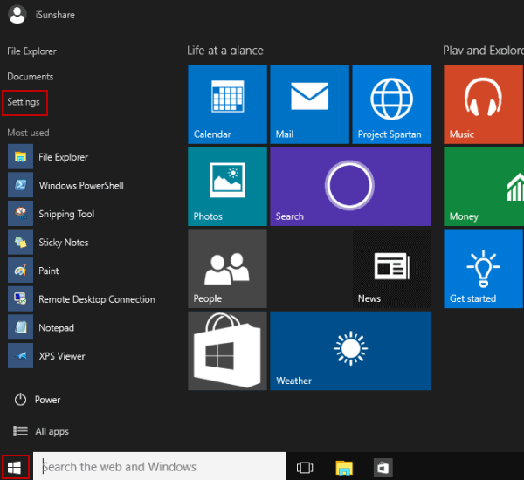

Installing the Linux subsystem requires the use of the program Powershell in Windows. Powershell can be accessed by first typing **Win+R** to access the command prompt, then typing “powershell” to open up Powershell.

Once you have Powershell open, type the following:  
  
Enable-WindowsOptionalFeature -Online -FeatureName Microsoft-Windows-Subsystem-Linux

and hit enter. Restart the machine when it prompts you to do so.

Once the machine is restarted and you are logged in again, you will need to make sure that you are in developer mode before you open a bash script. To do this, you’ll follow the directions above to open your Windows Settings. You’ll then navigate to **Update and Security**, then select **For Developers**. There, you’ll switch the radio button to “Developer Mode.”

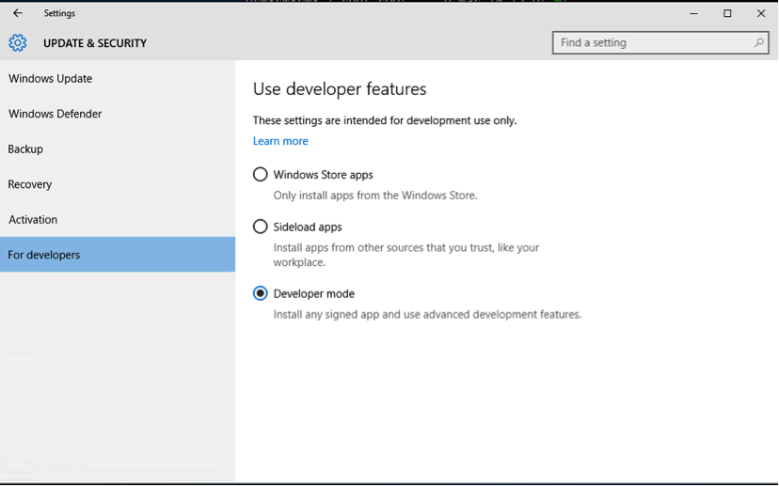

Go ahead and close out the window, then open the run dialog by typing **Win+**R. In the dialog box, type “cmd” and hit return.

You should see a command prompt. Within that command prompt, type “bash” and hit return.

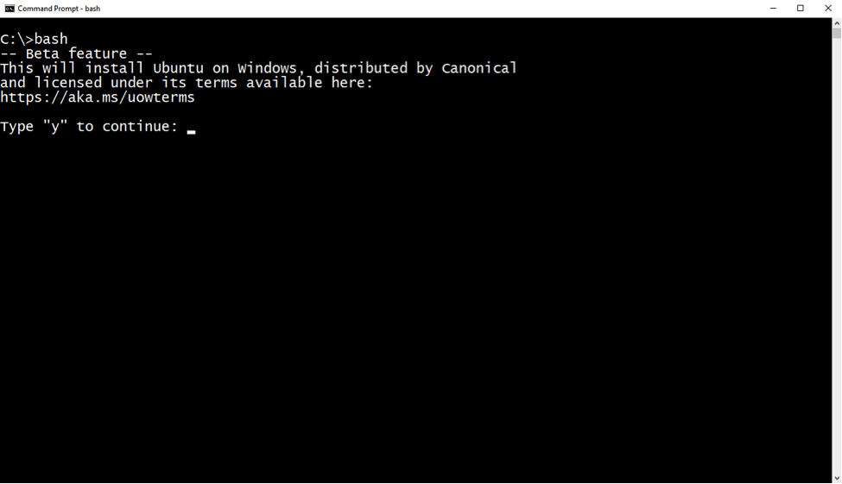

If you are installing on your own machine, you may also see a prompt indicating that you need to enter a Unix username and password. These do not have to be the same username and password as those that you use on your Windows machine.

**Setting up Twarc**

Twarc uses the Pip package manager for python, which is not installed on the version of Linux that is now on your Windows machine. That version of Linux, Ubuntu, uses the Debian architecture, so installing new files is relatively easy. To install the Pip package manager, you’ll type the following in your bash window:

apt-get update

This updates all of the packages available for the Linux installation. Once it has completed updating, type:

sudo apt-get -y install python-pip

This will install the Pip package manager. The “sudo” command, which tells the system to install the package as a superuser, is necessary due to some of the permissions the Windows version of Linux installs with.

Once Pip has finished installing, you will be able to use Pip to install Twarc using the following command:

pip install twarc

Once you have completed installing Twarc you can follow the configuration instructions to be found at https://github.com/DocNow/Twarc