COAGULATION AND REDISPERSION OF CO₂-SWITCHABLE POLYMER LATEXES OF LOW GLASS TRANSITION TEMPERATURES

COAGULATION AND REDISPERSION OF CO₂-SWITCHABLE POLYMER LATEXES OF LOW GLASS TRANSITION TEMPERATURES

By STEVEN DANIEL GARIEPY, B. Eng (Chem.)

A Thesis Submitted to the School of Graduate Studies in Partial Fulfillment of the Requirements for the Degree of Master of Applied Science

McMaster University © Copyright by Steven Daniel Gariepy, July 2015

McMaster University MASTER OF APPLIED SCIENCE (2015) Hamilton, Ontario (Chemical Engineering)

TITLE: Coagulation and Redispersion of CO₂-Switchable Polymer Latexes of Low Glass Transition Temperatures
AUTHOR: Steven Daniel Gariepy, B. Eng (Chem.) (McMaster University)
SUPERVISOR: Professor Shiping Zhu
NUMBER OF PAGES: xv, 65

Lay Abstract
This work examines special type of coagulatable and redispersible latex paint that could potentially reduce the costs in storing and transporting latex paint products. After synthesizing the latex, the nanoscopic polymer particles that make up the latex could be easily coagulated by adding a small amount of sodium hydroxide. Following this, water could be removed and a condensed form of the paint was obtained. The ability to redisperse the particles back into carbonated water was subsequently examined based on the softness of the polymer particles by synthesizing a series of latexes with different fractions of methyl methacrylate (MMA) and butyl acrylate (BA). After synthesis, the latexes that contained higher fractions of MMA were comprised of particles that were less soft than the BA-rich latexes, which made the redispersibility of these particles much easier. Upon coagulation, BA-rich particles fused together upon contact and could not be separated, hence inhibiting their redispersibility. When these same BA-rich latex particles were coagulated at colder temperatures, fusion was inhibited and the redispersibility of particles was greatly improved. Overall, the particles were found to be redispersible if the glass transition temperature of polymer chains within the particles was lower than ambient temperature. Since softer polymer particles are often used for latex paint-based applications, this work provides important and relevant insight in the development of industrially useful CO₂-redispersible products.

Abstract
In this thesis, copolymer latexes comprised of various fractions of methyl methacrylate (MMA) and butyl acrylate (BA) were synthesized through surfactant-free emulsion polymerization. A carbon dioxide responsive comonomer, 2-(diethyl)aminoethyl methacrylate (DEAEMA) was also used with an equimolar amount of hydrochloric acid (HCl) to promote its partitioning into the water phase. Changing the MMA/BA fraction gave control over the resulting glass transition temperature of the particles. Following polymerization, the particles from the resulting latexes could be effectively coagulated be adding a small amount of caustic soda, and could be easily separated from water. After washing the particles with deionized water, CO₂-redispersibility of the latex particles was evaluated as a function of their respective glass transition temperature. It was determined that coagulated particles higher in MMA content could be easily redispersed into carbonated water with the aid of ultrasonication, preparing stable latexes of the same solids content. For latex particles with a glass transition temperature below ambient conditions, coagulation led to the fusion of individual particles, which inhibited their ability to be redispersed. By conducting the coagulation and redispersion cycles at temperatures cold enough for the BA-rich particles to be below their glass transition temperature, these same latex particles could be effectively redispersed. The relationship between the glass transition temperature of the latexes and their CO₂-redispersibility provides guidance from a practical sense for the applicability of CO₂-sensitive amine-functionalized molecules in developing industrially useful CO₂-redispersible latex products.
Acknowledgements
My first “thank you” is directed to my supervisor Dr. Shiping Zhu and to my co-supervisor Dr. Qi Zhang for helping me find my way through this project over the past two years. None of this would have happened without both of your guidance and patience.
A huge thank you is devoted to all of the PolyMac Zhu members who have given countless amounts of advice, help, and most importantly friendship to me throughout the past two years. I am forever grateful for becoming a part of this research group; our group is a very special one, and I have learned so much from all of you.
I would also like to thank the entire faculty and staff of the Chemical Engineering department at McMaster University for all of their help and kindness. Thank you to all of my other peers/colleagues/friends in the department who made the many hours of courses, TA-ing, seminars, conferences, etc. experiences for me not to only enjoy, but to actually look forward to as well.
Thank you to my entire family and friends for supporting me these past two years, as well as throughout my undergrad. In addition, thank you Domenic and your family for all of your support throughout this entire experience, and for making Hamilton a place I now call my home. I certainly would not have made it this far without all of your help, advice, and motivation. Thank you for dealing with my stress-rants (at all hours of the day), and for always bringing me back to ground level again.
Finally; I did it!
Table of Contents

List of Figures ix
List of Tables xi
List of Equations xii
List of Abbreviations xiii
List of Symbols xv
1. Introduction, Background Information and Goals of Research 1
1.1. General Background 1
1.2. Emulsion Polymerization 3
1.2.1. Surfactants 4
1.2.2. Mechanism and Kinetics of Emulsion Polymerization 6
1.2.3. Surfactant-free Emulsion Polymerization 10
1.3. Glass Transition Temperature 12
1.3.1. Methods to Measure Glass Transition Temperature 13
1.3.2. The Fox Equation 14
1.4. Copolymerization 14
1.5. Latex Stability and Zeta-Potential 17
1.6. Film Formation 19
1.7. Switchable Polymer Latexes 21
1.7.1. CO₂-Switchable Functional Groups 22
1.7.2. CO₂-Switchable Surfactants 26
1.7.3. Reactive Switchable Surfactants 28
1.7.4. CO₂-Switchable Initiator 29
1.7.5. Switchable Comonomer Approach 31
1.8. Goals of Research 32
2. Experimental Methods. 34
2.1. Materials. 34
2.2. Surfactant-Free Emulsion Polymerization of BA & MMA. 34
2.3. Characterization. 36
2.4. Destabilization of Particles at Ambient Temperature. 37
2.5. Latex Redispersion at Ambient Temperature. 38
2.6. Coagulation & Redispersion Cycles at 5 °C 38
3. Results and Discussion 40
3.1. Latex Synthesis via Surfactant-Free Emulsion Polymerization 40
3.2. Polymerization using an Acidified System 42
3.3. Controlling the Glass Transition Temperature of Latex Particles 43
3.4. Coagulation of Latex Particles 45
3.5. Fusion of Low T_{g} Latex Particles 47
3.6. Redispersion 49
3.7. Coagulation and Redispersion at Lower Temperature. 52
4. Conclusion 56
4.1. Significant Contributions of Thesis Work 57
4.2. Recommendations for Future Work 58
4.2.1. Using a Pressurized CO₂ Atmosphere for Polymerization 58
4.2.2. Surfactant-free Semi-Batch Polymerization 59
4.2.3. Inhibiting the Fusion of Low T_{g} Particles 60
References 61
Appendix A: Additional Figures 64

List of Figures
Figure 1. The past and predicted global demand for emulsion polymers [metric tons on a dry basis] based on different regions. 3

Figure 2. Examples of the different types of surfactants (a) anionic (sodium dodecyl sulfate, SDS), (b) cationic (cetyltrimethylammonium bromide, CTAB), and (c) non-ionic (nonylphenol ethocylate surfactants). 5

Figure 3. A schematic representation of the three stages of emulsion polymerization and corresponding rate of polymerization during each stage.¹³ 9

Figure 4. A schematic of the steps in emulsion polymerization. 10

Figure 5. A schematic of the possible structures of copolymers containing repeating units of monomer A and monomer B.⁹ 15

Figure 6. A schematic of the four propagation steps that can occur during free-radical copolymerization. 16

Figure 7. A schematic diagram of the double layer that surrounds a colloid within an aqueous medium.³⁰ 18

Figure 8. Schematic representation of latex particles during the three stages of film formation. 20

Figure 9. The aqueous solubility of carbon dioxide over different temperatures at atmospheric pressure. 24

Figure 10. The three types of CO₂-responsive groups based on chemical structure and the reaction between their neutral and ionic states; (a) amidine, (b) amine and (c) carboxyl functional groups. 24

Figure 11. The reversible reaction between the CO₂-responsive initiator VA-061 with CO₂, H₂O, air and heat (Δ). 30

Figure 12. DSC thermograms for dried latex particles at each trial using a heating ramp of 10 °C/min with a temperature range from -20 °C to 150 °C. 44

Figure 13. Images of latex samples from each trial before and after coagulation with NaOH at ambient temperature. 47

Figure 14. SEM images of coagulated latex particles from each trial. 48

Figure 15. Images of latex samples after redispersion using CO₂ and ultrasonication. T1, T2 and T3 could be effectively redispersed; T4 and T5 were not redispersible. 50

Figure 16. Schematic representation of the difference in redispersibility of latex particles with T_{g} higher than and lower than ambient temperature. 52

Figure 17. Images of latex samples from T4 and T5 before coagulation, after coagulation with NaOH at 5 °C, and after redispersion using CO₂ and ultrasonication. 54

Figure 18. Intensity average particle diameter of latexes before (a) and after (b) redipsersion (particles from T4 and T5 were coagulated and redispersed at 5 °C). 64

Figure 19. Additional SEM images of coagulated latex particles. 65

List of Tables
Table 1. Ranges of zeta potential of colloidal dispersions and their corresponding level of stability. 19

Table 2. Experimental formulation that outlines the amount of monomers, comonomer, initiator, acid and water used in the surfactant-free emulsion polymerization trials. 40

Table 3. Results of the surfactant-free emulsion polymerization of MMA and BA with DEAEMA. 41

Table 4. MMA/BA monomer fractions used in experiments, the targeted T_{g} calculated from the fox equation and the measured glass transition temperature from DSC. 45

Table 5. The particle size, polydispersity index and measured zeta potential of latex particles from T1, T2 and T3 before and after redispersion. 50

Table 6. The particle size, polydispersity index and zeta potential of latex particles from T4 and T5 (1) before and (2) after redispersion at 5 °C. 54

List of Equations
Equation 1. The Rate of Polymerization 8

Equation 2. The Fox Equation 14

Equation 3. Reactivity Ratio Equation for Monomer 1 16

Equation 4. Reactivity Ratio Equation for Monomer 2 16

Equation 5. Instantaneous Copolymer Composition 16

Equation 6. Reaction of Carbon Dioxide and Water 23

List of Abbreviations
MMA – Methyl Methacrylate
BA – Butyl Acrylate
DEAEMA – 2-(diethylaminoethyl methacrylate)
HCl – Hydrochloric Acid
CO₂ – Carbon Dioxide Gas
N₂ – Nitrogen Gas
O₂ – Oxygen Gas
H₂CO₃ – Carbonic Acid
Ar – Argon
VOC – Volatile Organic Compound
KPS – Potassium Persulfate
SDS – Sodium Dodecyl Sulfate
CTAB – Cetyltrimethylammonium Bromide
CMC – Critical Micelle Concentration
SFEP – Surfactant-Free Emulsion Polymerization
DSC – Differential Scanning Calorimetry
TMA – Thermal Mechanical Analysis
DMA – Dynamic Mechanical Analysis
DVLO – Derjaguin, Verway, Landau and Overbeek Theory
DMAEMA - 2-(dimethylamino)ethyl methacrylate
LCST – Lower Critical Solution Temperature
PS – Polystyrene
RAFT – Reversible Addition-Fragmentation Chain-Transfer
NaOH – Sodium Hydroxide
VA-061 - 2,2’-azobis(2-(2-imidazolin-2-yl)propane
SEM – Scanning Electron Microscopy
MEHQ – Monomethyl Ether Hydroquinone
V-50 - 2,2’-Azobis(2-methylpropionamidine) dihydrochloride
DLS – Dynamic Light Scattering

List of Symbols
R_{p} – Rate of Polymerization
k_{p} – Propagation Rate Constant
[M] – Monomer Concentration
n – Number of Radicals in a Particle
N_{p} – Number of Polymer Particles
N_{A} – Avogadro’s Constant
T_{g} – Glass Transition Temperature
C_{p} – Heat Capacity
W₁ – Weight Fraction of Monomer 1
W₂ – Weight Fraction of Monomer 2
M₁ – Monomer 1
M₂ – Monomer 2
k_{ij} – Reaction Rate Constant
r₁ – Reactivity Ratio of Monomer 1
r₂ – Reactivity Ratio of Monomer 2
ζ – Zeta Potential
Δ - Heat
Đ – Polydispersity Index
mV – millivolts
ppm – Parts per Million
rpm – Revolutions per Minute

1. Introduction, Background Information and Goals of Research

1.1. General Background
A polymer latex is defined as a dispersion of polymeric materials with a size ranging from tens to hundreds of nanometers that are stabilized within an aqueous medium.¹⁻⁴ Polymer latexes, also known as emulsion polymers, are one of the most important types of products in the polymer industry. Every year, millions of tons of polymer latexes are synthesized and are used for a variety of applications in a number of different industries.⁵ In 2013, the world demand for emulsion polymers was approximated to be 10 million metric tons on a dry basis. This is expected to increase by 4.6% each year over the next few years, reaching a total of 12.6 million metric tons on a dry basis by 2018. The forecasted market value of this will be approximately $36.4 billion US dollars.⁶
Latex polymers can be produced with a variety of different physicochemical properties, and as a result can be used in many different applications. More specifically, they are largely used within the paint and coatings industry as latex paints, and are also used for producing adhesives, within the paper industry, within textiles, as well as various other markets.⁷
The increase in demand for water-based paints and coatings is the main factor that is expected to fuel the increases in latex polymer production. Within the paint and coatings industry, the latex in its dispersed state is used as the end product. When coated to a surface, these tiny polymer particles begin to solidify as they coalesce from the evapouration of water, eventually resulting in a hard film.
Today, products within the paint and coatings industry can be generally classified as being either solvent-based or water-based.⁵ For decades, paints and coatings always relied on the use of solvents in their formulations. The solvents used in these products are a significant source of human-made volatile organic compounds (VOCs), which are known to release toxic chemicals that evapourate and eventually accumulate in the atmosphere. VOCs from solvent-based paint have been proven to have serious negative effects on health and the environment. One example is with the generation of ground-level o-zone when combined with nitrogen oxides. This has been proven to result in damage to vegetation, and long-term problems with respiration, especially within populous regions of Canada.⁷
It is well understood that environmental regulations have grown stricter in recent years and are still continuing to grow, and as such the elimination of formulations that use solvents has become a priority within the paint and coatings industry. Polymer latexes as water-based coatings have offered a promising potential for displacing these solvent-borne formulations, which has led these types of coatings to become dominant over solvent-based coatings.
Within the entire emulsion polymers industry, latex polymers within the paint and coatings industry are expected to experience the most rapid growth into 2016. The acrylics, as the largest emulsion polymer at 40% of the world market, will continue to rapidly grow into 2016. Market advances in North America and Western Europe are expected to grow due to increases in construction activity. The largest consumer will continue to be the Asia/Pacific region, due to the rapid growth within the massive market in China, as well as India’s broadening use of latex paints in rural areas as per capita income increases.⁶ The past, present, and anticipated global demand for emulsion polymers based on region is outlined in in Figure 1.
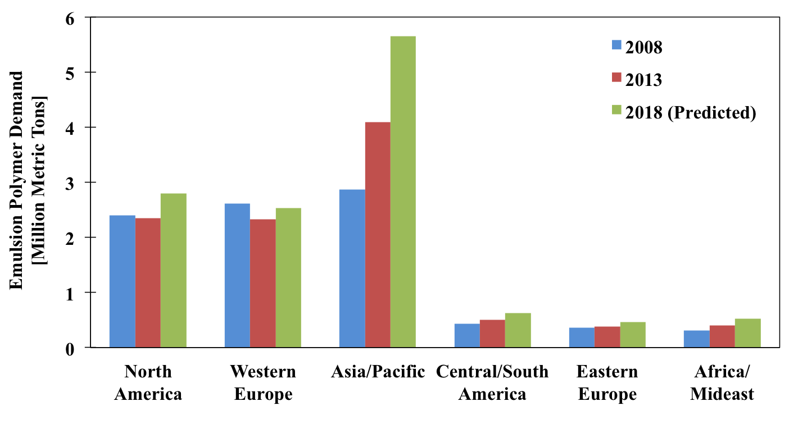
Figure 1. The past and predicted global demand for emulsion polymers [metric tons on a dry basis] based on different regions.

1.2. Emulsion Polymerization
Emulsion polymerization is a widely used method for the production of polymer latex products, and is an important polymerization process on an industrial scale.⁸ This method of polymerization produces approximately 90% of polymer dispersions in industry, and has been used since the 1930’s. It is a preferred method of polymerization compared to other methods from an environmental perspective since the continuous phase is aqueous, and therefore uses less solvent and emits less VOCs. The low viscosity from its water-based operation also provides excellent heat transfer for improved temperature control. High molecular weight polymers can be produced at higher polymerization rates compared to other methods of polymerization, and the final product can also be used as produced without the need for modification.⁹
Emulsion polymerization is based on a free-radical mechanism and it is a heterogeneous polymerization system. Oil-in-water is the most common type of emulsion polymerization, where the monomer (oil-phase) is emulsified within the continuous aqueous phase. The typical ingredients within a conventional emulsion polymerization system are the water-immiscible monomer(s), a water-soluble initiator (such as potassium persulfate, KPS), the dispersion medium (typically water), and lastly the surfactant(s) (also termed as emulsifier).⁸⁻¹⁰

1.2.1. Surfactants
Surfactants are amphiphilic molecules that have a hydrophilic head and a hydrophobic tail. In a form of micelle, the head of the surfactant is generally a polar or ionic functional group that orients itself towards the aqueous (polar) phase, whereas the tail is generally a long alkyl chain, orienting itself to the organic (non-polar) phase. Given this structure, the result is that the surfactant molecules will be situated to the aqueous-organic interface within an emulsion system, lowering the interfacial tension.¹¹ After emulsion polymerization has occurred, the surfactants remain in place and stabilize the latex particles within the aqueous phase thorough either electrostatic or steric repulsion forces.
Typical ionic surfactants can be classified as cationic or anionic, meaning the head group can possess either a positive or a negative charge respectively.⁸ Cationic surfactants include quaternary ammonium salts, whereas anionic surfactants include sodium, potassium and ammonium salts. Ionic surfactants are charged, and therefore provide stabilization to latex particles through electrostatic forces. Non-ionic surfactants do not possess a charge, but have head groups that are polar in nature. Since they are uncharged, they do not provide electrostatic forces to stabilize the particles, but provide stabilization through steric forces instead. Anionic and non-ionic surfactants are the most commonly used surfactants in emulsion polymerization. Surfactants are used for a wide range of applications, including soaps and cleaning products, the petroleum industry, food, pharmaceuticals, coatings, and many others.¹¹ Examples of the different types of surfactants are shown in Figure 2.
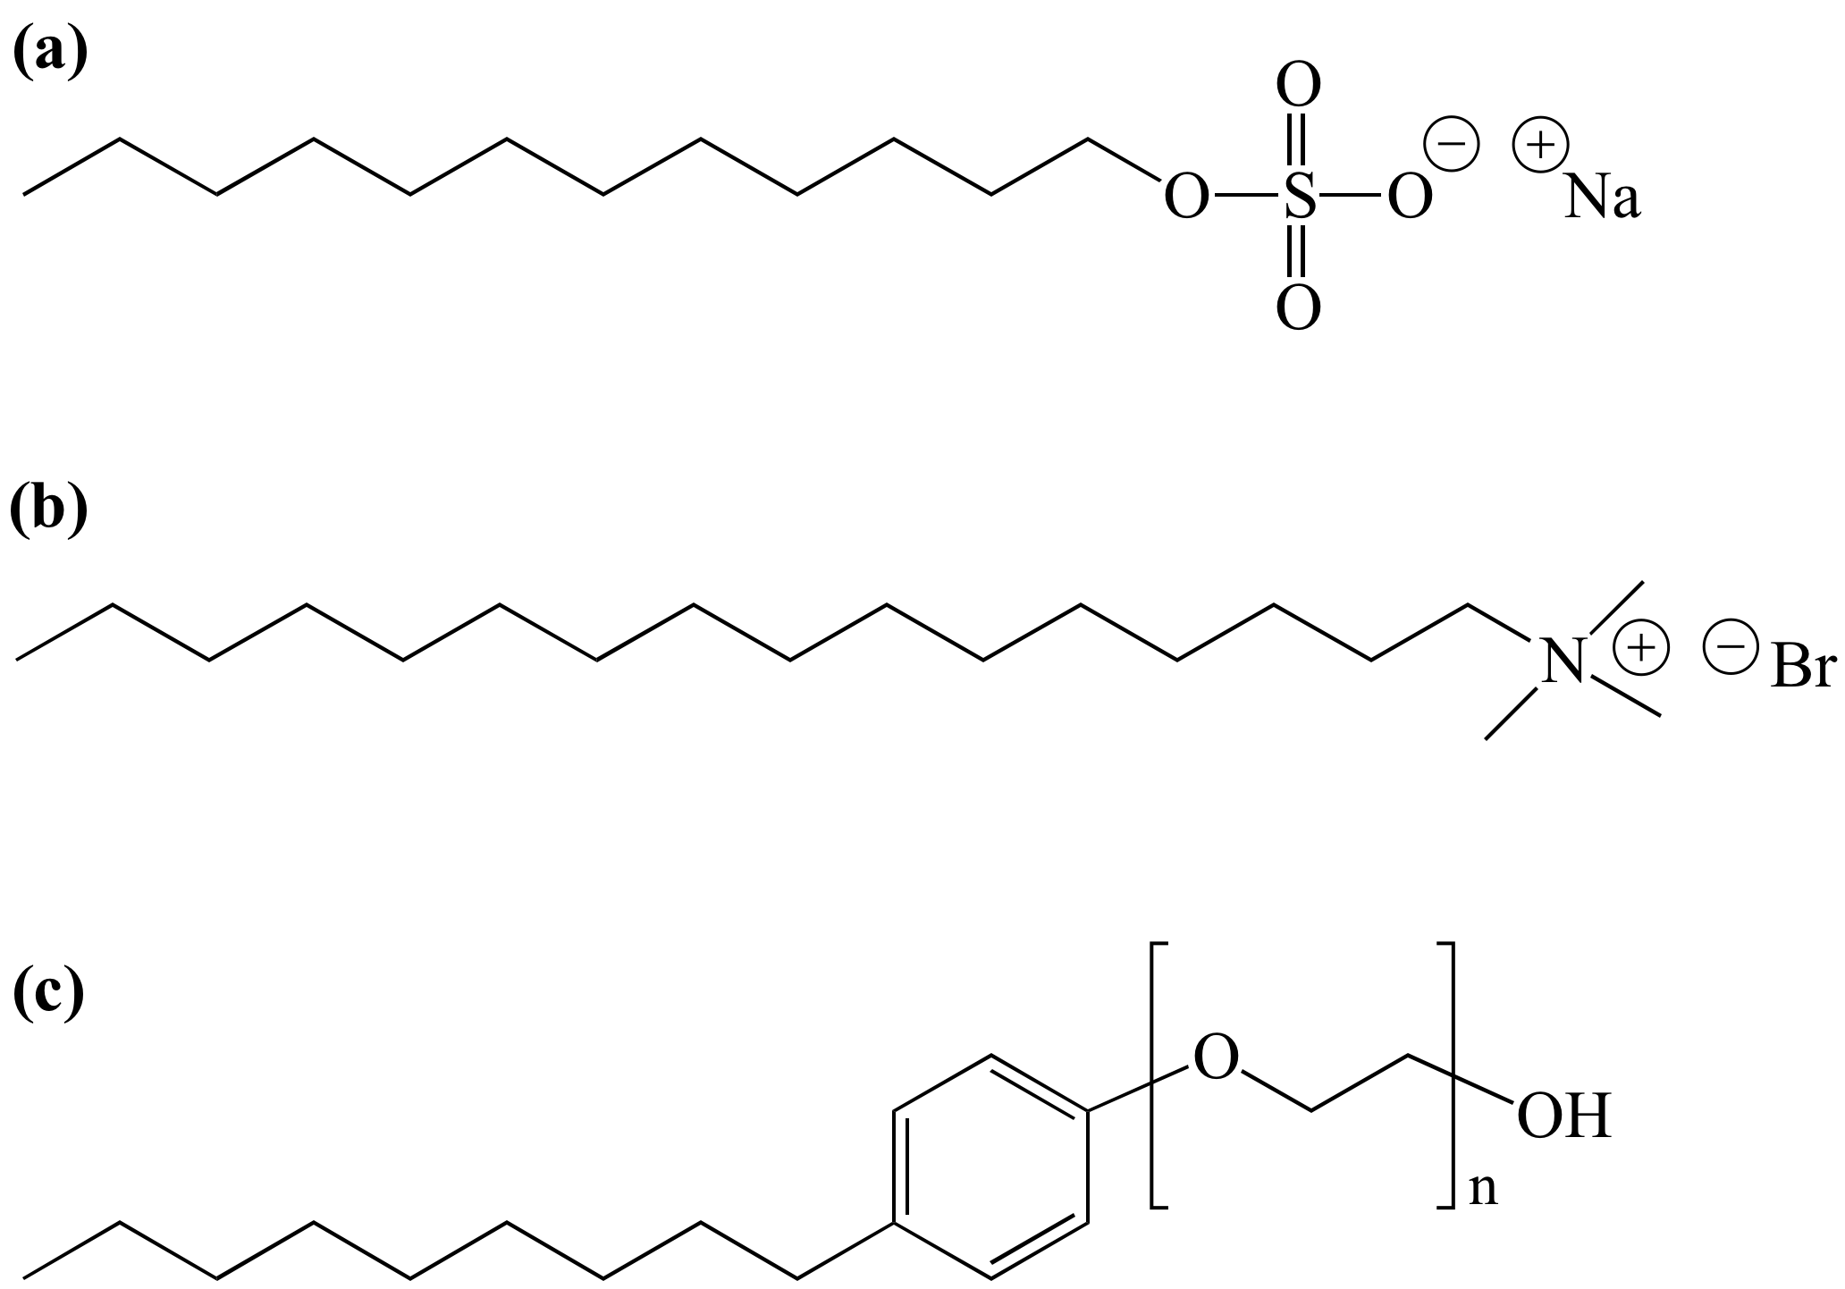
Figure 2. Examples of the different types of surfactants (a) anionic (sodium dodecyl sulfate, SDS), (b) cationic (cetyltrimethylammonium bromide, CTAB), and (c) non-ionic (nonylphenol ethocylate surfactants).

An important characteristic with respect to surfactants in emulsion polymerization is the critical micelle concentration (CMC). In an emulsion polymerization system, the amount of surfactant used is above its CMC, which is a characteristic specific to each surfactant. As mentioned previously, in a monomer-water emulsion the surfactant will orient itself to the aqueous/organic interface. When the interface is completely saturated with surfactant, excess surfactant will solubilize as individual surfactant molecules. The CMC is the surfactant concentration at which the aqueous medium is saturated with dissolved surfactant molecules and excess surfactant will form aggregated structures called micelles within the system. Depending on the surfactant, the micelles are composed from 50 to 100 surfactant molecules, and can form spherical or rod-like structures. These micelles provide the location of where polymerization occurs in a conventional emulsion polymerization system.⁹⁻¹¹

1.2.2. Mechanism and Kinetics of Emulsion Polymerization
At the start of emulsion polymerization, the surfactant is added to emulsify the monomer with agitation into droplets, having diameters of tens of micrometers in the continuous phase. With a surfactant concentration greater than the CMC, micelles will also form in the continuous phase. Some monomer will diffuse into the hydrophobic centers of the micelles. Although the monomer is considered hydrophobic, a small amount will still dissolve in the aqueous phase, which is crucial for emulsion polymerization to be successful.
The mechanism of emulsion polymerization can be divided into three stages; particle nucleation, particle growth, and monomer depletion.¹⁰ Particle nucleation can either occur by homogeneous or micellar nucleation. When the surfactant is above the CMC, micellar nucleation is the sole nucleation mechanism for nucleation of polymer particles. The decomposition of the water-soluble initiator from a raise in the temperature leads to the formation of primary radicals, which react and propagate with the small amount of monomer dissolved in the aqueous phase. As this chains become longer, they become insoluble in water and are captured within the organic (hydrophobic) center of micelles, leading to the formation of a polymer particle. Statistically, these chains are more likely to enter the micelles rather than the monomer droplets, based on the greater surface area that is provided by the micelles. Although the amount of surfactant is much smaller than the amount of monomer, the number of micelles is many orders of magnitude larger than the number of monomer droplets, and thus the total surface area of micelles is much larger than that of monomer droplets. The polymer particle is swollen with monomer, and this monomer continues to propagate with the radical chain. As this reaction progresses, monomer continues to diffuse through the aqueous phase from the monomer droplets into the polymer particle, replacing the depleting monomer. When another radical enters a micelle with a propagating radical chain, the chain is terminated. Another radical can be captured by the now-formed polymer particle, which will again terminate following the subsequent radical that enters, and the polymer particle will continue this on-off growth cycle. Since particle volume is small, radical termination occurs instantaneously within the particle. It is assumed that only 1 radical can occupy a polymer particle at a given time.¹² Some micelles that have not converted into polymer particles will dissolve into the aqueous phase so the surfactant can aid in the stabilization of growing polymer particles. The end of Stage I occurs when all of the micelles disappear from the system, and generally occurs after monomer conversion has reached ~10 %.⁸⁻¹²
In Stage II, there is a constant number of polymer particles and no generation of new particles. The polymer particles continue to grow as the monomer continues to diffuse from the monomer droplets through the aqueous phase. Radicals that are generated within the aqueous phase continue to enter the growing particles. The Smith-Ewart model can be applied for the polymerization kinetics to calculate the rate of polymerization as;

$${\text{R}}_{\text{p}}\text{ = }{\text{k}}_{\text{p}}{\text{[M]}}_{\text{p}}\left({\text{n}{\text{N}}_{\text{p}}}/{{\text{N}}_{\text{A}}}\right)$$ | (1)

where R_{p}, k_{p}, [M]_{p}, n, N_{p}, and N_{A} represent the polymerization rate, the propagation rate constant, the concentration of monomer in the polymer particles, the number of radicals per polymer particle, the number of particles in the system, and Avogadro’s number respectively.⁹ A scheme of the stages of emulsion polymerization and the polymerization rate is shown in Figure 3.

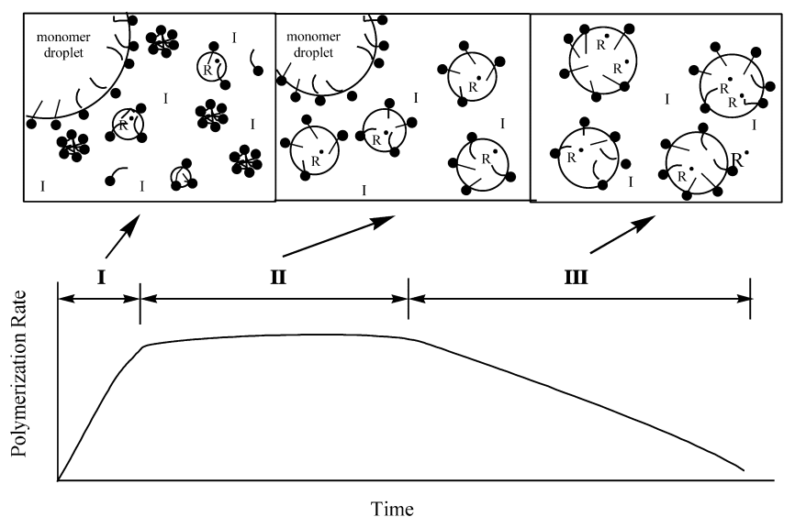
Figure 3. A schematic representation of the three stages of emulsion polymerization and corresponding rate of polymerization during each stage.¹³

The equation is valid if the number of particles is constant, if desorption of radicals from the particle does not occur, and if the bimolecular termination of radicals is instantaneous. Since it is assumed each latex particle can only have either 0 or 1 radicals at a given time, the average is taken as n ~ 0.5, and this is called case II kinetics. Sometimes case II kinetics are violated, such as in the later stages of polymerization at high conversion where n > 0.5 (case III kinetics) or when radicals exit the polymer phase to the water phase (case I kinetics).¹³ The concentration of the monomer continues to diffuse to the growing particles at what is assumed to be a constant rate, therefore the rate of polymerization is assumed to be preserved at steady state until the monomer droplets have depleted, which marks the end of stage II.
At stage III, all of the monomer has diffused into the polymer particles, and thus there are no longer any monomer droplets left in the system. The concentration of monomer within the particles continues to decrease as polymerization causes the conversion to increase, which is also accompanied by a drop in the rate of polymerization.¹⁴ A schematic representing the mechanism of emulsion polymerization is illustrated in Figure 4.
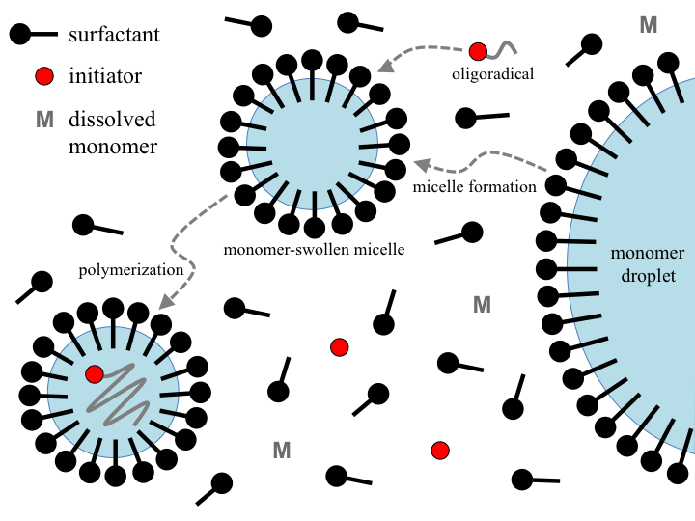
Figure 4. A schematic of the steps in emulsion polymerization.

1.2.3. Surfactant-free Emulsion Polymerization
Surfactant-free emulsion polymerization (SFEP), also known as emulsifier-free emulsion polymerization or soap-free emulsion polymerization, is a type of emulsion technique that is executed without the addition of a surfactant in the formulation. In this type of system, it is generally agreed that the oligomers formed during the initial stages of polymerization act as “in-situ formed” surfactants, aiding in the stabilization of particles during and after polymerization. In conventional emulsion polymerization, the presence of adsorbed surfactant at the particle surface can negatively influence properties such as the surface charge, optical properties or water resistance. This mechanism of polymerization is an industrially important process with respect to the production of materials with good adhesion and water resistance.¹⁵ The typical recipe for SFEP is generally similar to a conventional emulsion polymerization, involving the use of water-insoluble monomer(s), a water-soluble initiator, and an aqueous dispersion medium. Some systems of SFEP also use ionic comonomer(s) in the experimental formulation. After polymerization, stability can be provided solely by the electrostatic charge provided by the initiator’s ionic groups, or an ionic comonomer can also be used to increase the latex stability during and after polymerization.¹⁵
It can be argued that the nucleation mechanism of SFEP is more complex than conventional emulsion polymerization.^{15,16} Without the use of surfactant, no micelles are present within the system initially, so it is disputed that micelle nucleation is not considered as an appropriate mechanism for the generation of polymer particles at the start of the reaction. Given the complexity of the system, resolving the particle nucleation mechanisms continues to be a great challenge to scientists in this area of research.¹⁷
One theory is that is commonly discussed is a coagulative nucleation theory, where nucleation occurs through the precipitation of oligomers/oligoradicals. During the start of SFEP, the decomposition of the water-soluble initiator leads to the generation of hydrophilic radicals, which then react to form oligomer radicals (oligoradicals). When these in-situ formed oligoradicals reach a critical chain length, they become insoluble in the water-phase, and it is postulated that they coagulate together to form the initial polymer particles with very small diameters.¹⁸ These unstable particles continue to coagulate together until the electrostatic charge at the surface is sufficient for particle stabilization. An alternate theory is that after polymerization has been initiated, in-situ surface-active oligomers are formed, which are thought to self-assemble into micelles and may even migrate to stabilize monomer droplets. These micelles then act as the location for particle nucleation, similar to the particle growth of micelle nucleation emulsion polymerization.¹⁷⁻¹⁹

1.3. Glass Transition Temperature
The glass transition temperature (T_{g}) is an important property for polymeric materials, and it is essential to understand when selecting the applications which specific polymeric materials can be used for. The glass transition temperature (T_{g}) is defined as a temperature range within amorphous materials (or within amorphous regions of semi-crystalline materials) where a change in the mobility of polymer chains occurs.⁹ More specifically, the T_{g} is the temperature where an amorphous material transitions from a hard, glassy material to a soft, rubber-like material. When the temperature of a polymer is below the T_{g}, polymer chains are rigid and therefore their mobility is restricted, causing the material to be more brittle or glassy in nature.²⁰ As the temperature rises above T_{g}, the polymer chains gain a higher degree of mobility, becoming more mobile and resulting in a material with more rubber-like properties.

1.3.1. Methods to Measure Glass Transition Temperature
Identifying the T_{g} of polymers is important since it is a very good indicator of a polymer’s physical properties, and is of interest for research and development, quality control, and various other reasons.²¹ There are three general techniques that are used to measure the T_{g}; differential scanning calorimetry (DSC), thermal mechanical analysis (TMA), and dynamic mechanical analysis (DMA). DSC was the only technique used for the purpose of this research, and therefore will be the only method discussed here. DSC is a type of thermal analysis where the difference in the amount of heat required to heat a sample is monitored as a function of temperature. DSC analyzes how a materials heat capacity (C_{p}) changes with temperature, which is the amount of heat required to increase a unit of mass of a material by one degree in temperature. As a sample is heated, the changes in its heat capacity are monitored as changes in the heat flow. The T_{g} obtained from DSC may be influenced from a few different factors, such as the heating rate, and the history of sample heating. DSC is used for a wide range of polymeric materials in a variety of industries, including polymers, food, paper, manufacturing, agriculture, pharmaceuticals and electronics. Although the T_{g} is actually a temperature range, it is common to report a single number for its representation, which is usually determined as the midpoint of the temperature range.²²

1.3.2. The Fox Equation
Two or more different polymers or materials are often combined or blended together into a homogeneous mixture, with the goal of producing a new material with compromised or enhanced properties. When another component is added, the glass transition temperature of the resulting homogeneous mixture will be influenced by the amount of each component and its respective glass transition temperature. The Fox equation is an estimation, which is given by;

$$\frac{\text{1}}{{\text{T}}_{\text{g}}}\text{ = }\frac{{\text{W}}_{\text{1}}}{{\text{T}}_{\text{g,1}}}\text{ + }\frac{{\text{W}}_{\text{2}}}{{\text{T}}_{\text{g,2}}}$$ | (2)

Where W₁ and W₂ represent the weight fraction of component 1 and component 2 respectively, and T_{g,1} and T_{g,2} represent the glass transition temperature of component 1 and component 2 respectively.⁹

1.4. Copolymerization
Copolymerization is a favoured polymerization technique to obtain new polymers with different and desirable properties.²³ Some properties that can be tuned by copolymerization are the glass transition temperature, the polarity or solubility of a material, chemical resistance, as well as various other properties. This is achieved by combining two or more different monomers during polymerization, which results in a polymer with two or more different repeating units within its chain.
The sequencing of monomers within the resulting polymer chain will have a large effect on the resulting properties of the polymer. Some examples of monomer sequencing can be completely random, perfectly alternating, block, or graft copolymers, as shown in Figure 5.
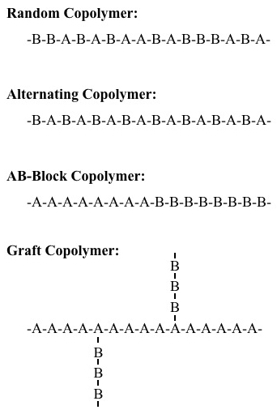
Figure 5. A schematic of the possible structures of copolymers containing repeating units of monomer A and monomer B.⁹

Block copolymers are composed of one block of one monomer type, followed by a block of the other monomer type, whereas graft copolymers involve polymerizing a monomer in the presence of a polymer that has been formed of a different monomer type.
The distribution of monomers in a copolymer is influenced by the reactivity ratio of the monomers (r₁, r₂) as described by the Mayo-Lewis equation. For simplicity, in a binary reaction system (with monomer 1 and monomer 2), there are four reactions that can occur at the end of a reactive chain, and can terminate in either monomer as shown in Figure 6.
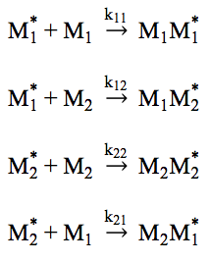
Figure 6. A schematic of the four propagation steps that can occur during free-radical copolymerization.

In this case, M₁ and M₂ represent monomer 1 and monomer 2 respectively, and each reaction has its own reaction rate constant, k_{ij} as seen in Figure 6. This assumes that the reaction rate constant is only influenced by the terminal unit, which is known as the terminal model. The reactivity ratios can be described as;
$${\text{r}}_{\text{1}}\text{ = }\frac{{\text{k}}_{\text{11}}}{{\text{k}}_{\text{12}}}$$ | (3)
$${\text{r}}_{\text{2}}\text{ = }\frac{{\text{k}}_{\text{22}}}{{\text{k}}_{\text{21}}}$$ | (4)
The copolymer equation, which defines the instantaneous composition of the copolymer at any time is then given as;
$$\frac{\text{d}\left[{\text{M}}_{\text{1}}\right]}{\text{d}\left[{\text{M}}_{\text{2}}\right]}\text{ = }\frac{\left[{\text{M}}_{\text{1}}\right]\left({\text{r}}_{\text{1}}\left[{\text{M}}_{\text{1}}\right]\text{ + }\left[{\text{M}}_{\text{2}}\right]\right)}{\left[{\text{M}}_{\text{2}}\right]\left(\left[{\text{M}}_{\text{1}}\right]\text{ + }{\text{r}}_{\text{2}}\left[{\text{M}}_{\text{2}}\right]\right)}$$ | (5)
where the concentration of each monomer is given in square brackets.
The use of copolymerization in emulsion polymerization systems is very common. In addition to the above described kinetics of radical copolymerization, the kinetics is also greatly influenced by the solubility of each monomer in the aqueous phase. Monomers that are less soluble in water will tend to partition into the polymer particles and will become more readily incorporated. The opposite is true for monomers that have a higher affinity for the water phase. The reaction ratios can also be altered in different chemical environments, such as acidic aqueous environments compared to neutral aqueous environments.^{24,25}

1.5. Latex Stability and Zeta-Potential
Latex stability or colloidal stability is a term that refers to the ability of a colloidal dispersion to refrain from aggregation, remaining as individual particles.²⁶ Particles within a colloidal dispersion are always thermodynamically prone to coagulation since it is thermodynamically favourable to reduce the interfacial area between individual colloids in the dispersion medium. With the use of surfactants, the interfacial energy is reduced which is how these molecules can effectively stabilize a system.²⁶
As stated by DVLO theory, the stability of a particle is dependent on its total potential energy function, which is governed by a balance between the attractive (van der Waals) forces and repulsive (either electrostatic or steric) forces at the surface of particles. Particles are continuously experiencing Brownian motion, which is the random motion of individual particles in a fluid, resulting in particle collisions. Maintaining colloidal stability is achieved when the repulsive forces are dominant over the attractive forces. The two major stabilizing forces are the electrostatic forces that arise from ionic agents that exist between particles, and steric forces that prevent particles from coming into too close of contact.^{27,28}
The zeta potential (ζ-potential) is described as a good indication of the interaction between colloidal particles, and its calculated magnitude (often reported in millivolts, mV) is often used to dictate the stability of colloidal systems from a quantitative sense. The majority of colloidal dispersions in water have an electric charge at the surface of colloids.²⁹ Acidic groups on a surface will dissociate to form a negatively charged surface, whereas basic groups will have a positive charge. An electric double layer will exist around each particle, caused by the net charge at the surface of particles affecting ion distribution in the surrounding regions of the interface, and further resulting in counter ions of an increased concentration. The different boundaries are illustrated in Figure 7.

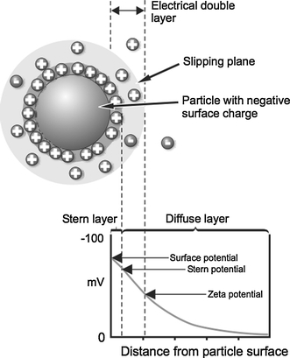
Figure 7. A schematic diagram of the double layer that surrounds a colloid within an aqueous medium.³⁰

When a particle moves in response to an applied electric field, a boundary develops where ions within the boundary also move with the particle, and ions beyond the boundary remain in place within the continuous phase. It is this boundary where the zeta potential is theoretically calculated. The magnitude of the zeta potential and a description of the relative stability of a colloid is outlined in Table 1,

Table 1. Ranges of zeta potential of colloidal dispersions and their corresponding level of stability.
ζ –Potential [mV] | Colloidal Stability
0 to ± 5 | Unstable, rapid coagulation
±10 to ±30 | Slightly Stable
±30 to ±40 | Moderately Stable
±40 to ±50 | Good Stability
greater than ±51 | Excellent Stability

1.6. Film Formation
The phenomenon of latex film formation is important to understand with respect to how products within the paint and coatings industry function at a molecular level. Latex film formation is a process in which the stabilizing forces of individual latex particles are overcome upon evapouration of the continuous aqueous phase, resulting in the transition of a stable colloidal dispersion into a continuous polymer film.
The mechanistic process of film formation can be divided into three stages; 1) coalescence, 2) deformation, and 3) diffusion.³¹⁻³³ In the first stage, the evapouration of water causes the particles to become more concentrated, until they eventually come into contact with one another, leading to particle coalescence and ordering. The second stage begins when enough water has evapourated that all of the particles are completely in contact with neighbouring particles. In the second stage, particles begin to deform if they are soft enough, packing into an ordered structure and coming into irreversible contact with each other. The voids between the spherical particles decrease upon the deformation of the particles. The third and final stage begins involves polymer chain diffusion across the boundaries of the particles. In this stage, soft particles become more homogeneous, and the mechanical properties of the coating improve as neighbouring polymer chains interpenetrate and become entangled with one another across the particle boundaries.³⁴ A schematic of the film formation process is shown in Figure 8.
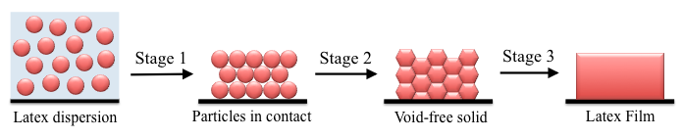
Figure 8. Schematic representation of latex particles during the three stages of film formation.

It is well known that the glass transition temperature plays a crucial role as a parameter within the film formation model. It is most important in the second and third stages, where the deformation of particles and the diffusion of polymer molecules across the boundaries of particles occur. There are many products within the paint and coatings industry which use polymers with glass transition temperatures as low as 10 °C. In this case, these amorphous polymer chains will be soft and rubbery at ambient conditions, and will possess a certain degree of mobility that is optimal for the deformation and diffusion of polymer chains to occur. If the T_{g} of the polymer particles is too high, or if the coating is applied at a temperature too low, the mobility of polymer chains will be hindered at ambient conditions and thus compromise the quality of the coating. As the coating dries, polymer chain deformation and diffusion will not be sufficient for producing a cohesive film, and cracks appear on the surface. On the other hand, if the T_{g} of the particles is too low, the coating can remain too sticky, which can lead to dirt and impurities sticking to the coating. In order to optimize the properties of the coatings, the properties of the polymer chains must also be carefully tuned to achieve a high quality latex coating.³⁴

1.7. Switchable Polymer Latexes
The development of switchable latexes has become of interest in recent years, owing to the disadvantages that current conventional latex products possess. For latex polymers that are desired in the resin state (i.e. non-dispersed state), the deactivation of conventional surfactants is quite difficult, and requires the addition of large amounts of acid, base, or salt depending on the nature of the surfactant. This can have negative effects on the environment, resulting in the generation of wastewater, and is also very energy intensive.
Most latex products are used in their dispersed state after production, and are typically comprised of approximately 45%-60% of water. This amount of water has a large contribution to the storage and transportation costs of these products, since these products are stored and shipped with the water after synthesis. The possibility of destabilizing these latex particles from water could result in a condensed or powdered form of emulsion polymers. After storing and transporting the latex in its condensed form, followed by restabilizing the particles in water when required, the high storage and transportation costs could be eliminated. From a realistic sense, this is impossible for conventional latex paint products. The addition of large amounts of salt, acid or base would be required to destabilize the particles by eliminating the electrostatic forces that the surfactants provide at the surface of latex particles. Once the particles have been aggregated, surfactant molecules would then be washed away, therefore the latex particles could no longer be stabilized within an aqueous system.
The development of coagulatable and redispersible latexes has been proposed through use of switchable functional groups that can change between ionic and neutral states by being prompted using an external trigger. In the ionic state, electrostatic repulsion is supplied at the surface, allowing latex particles to remain stable within an aqueous environment. Removal of the charge to its neutral state facilitates the coagulation of particles, making it possible to separate them from water. Switching back on the ionic charge allows the particles to restabilize themselves within an aqueous environment.

1.7.1. CO₂-Switchable Functional Groups
Many switchable polymers have been previously developed, which can be prompted to switch between ionic and neutral states using light, pH, temperature, magnetic fields, and through the use of carbon dioxide (CO₂).³⁵ For switchable latex systems, CO₂-switchable polymers have grown in interest compared to other switchable polymers since CO₂ is a non-toxic, inexpensive, and abundant gas. CO₂ as a trigger can reach certain requirements other functional groups cannot. For example, pH-sensitive polymers require the repeated addition of acid and bases, which contaminate the system and lead to the accumulation of salts, and eventually depress the switchable activity with these functional groups. Light-responsive groups would not be as useful within switchable latex coatings since light cannot penetrate a large volume of opaque latex paint. Changing temperature to facilitate switching cycles would require energy investments, which is unappealing from an economical perspective.³⁵ It is also too slow because the nature of heat transfer, particularly with a large volume of materials.
Bubbling CO₂ in an aqueous environment leads to the formation of carbonic acid (H₂CO₃), which is outlined by the following reaction equation;

(6)

The reaction between CO₂ and water is an equilibrium reaction. Bubbling argon (Ar), N₂, or simply air can easily remove CO₂ and thus reverse carbonic acid from the system back to CO₂ and water. Carbonic acid is the key component that reacts with CO₂-switchable functional groups. One key point is the solubility of CO₂ in water changes with temperature. CO₂ has a higher solubility at lower temperatures of water, and continues to decrease as the temperature increases, which can be seen in Figure 9.³⁶

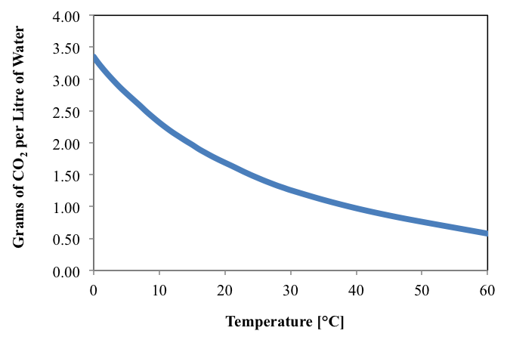
Figure 9. The aqueous solubility of carbon dioxide over different temperatures at atmospheric pressure.

In general, there are three types of CO₂ switchable functional groups based on chemical structure, which are the 1) amidine, 2) amine, and 3) carboxyl groups. An example of the chemical structures of these three groups is shown in Figure 10.
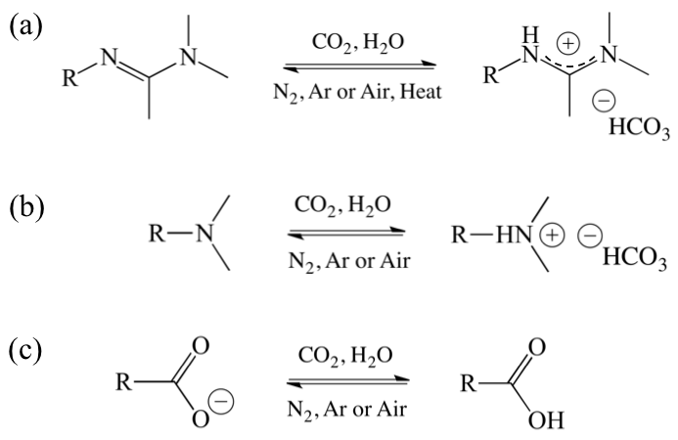
Figure 10. The three types of CO₂-responsive groups based on chemical structure and the reaction between their neutral and ionic states; (a) amidine, (b) amine and (c) carboxyl functional groups.

The amidine group was the first CO₂-sensitive functional group that was reported by Jessop and co-workers in the preparation of CO₂-switchable surfactants.³⁷ Bubbling carbon dioxide in water leads to the formation of carbonic acid, which protonates the sp²-hybridized nitrogen atom, and can be delocalized onto both nitrogen atoms. One drawback of the amidine group is that it can experience partial hydrolysis, and as a result it has limited stability in an aqueous environment. Within CO₂-switchable latexes, usually the amidine group must be synthesized through a series of reactions and purifications, which makes its use much more complex, costly, and time consuming. From an economical perspective, the use of readily available compounds is of more interest.
CO₂-switchable chemistry was later expanded by Zhao and coworkers through the discovery of the amine functional group.³⁸⁻⁴⁰ The amine group within the commercially available monomer 2-(dimethylamino)ethyl methacrylate (DMAEMA) was found to be CO₂/N₂ switchable under ambient conditions. Carbonic acid can effectively protonate the tertiary amine, reverting it to form ionic ammonium bicarbonate, and it is reversible upon the removal of CO₂ by bubbling N₂ or with heat above its lower critical solution temperature (LCST) of approximately 40 °C. This discovery led to the development of several CO₂-switchable polymers in a number of research areas. Later, a similar monomer 2-(diethylamino)ethyl methacrylate (DEAEMA) was found to have better switching properties than DMAEMA. Compared to the amidine functional group, the amine group was found to be advantageous owing to its improved stability over hydrolysis. In addition, the compound is also economically advantageous since it is commercially available, and avoids the requirements of a complex synthesis.⁴⁰
Lastly is the CO₂-switchable functional groups based on carboxyl groups. In this case, the presence of CO₂ dissolved in water can effectively protonate carboxylate anion groups (ionic), forming carboxylic acid (neutral). This differs from the amidine and amine-based groups, since CO₂ is used to facilitate the coagulation of particles instead of the stabilization of particles. This has its proposed advantages in an industrial setting with regards to the polymerization and shelf life of these proposed products. Firstly, a carbonated environment is not required for polymerization of carboxyl-stabilized particles. Secondly, after the coagulation and redispersion cycles, the product would not need to be stored under a carbonated environment.⁴¹

1.7.2. CO₂-Switchable Surfactants
The use of switchable surfactants was the first proposed method to producing coagulatable/redispersible latexes. The development of switchable surfactants were first reported by Jessop, Cunningham and coworkers, which used the cationic surfactants N’-hexadecyl-N,N-dimethylacetamidine and N’dodecyl-N,N-dimethylacetamidine, each equipped with CO₂-switchable amidine functional groups. These two surfactants were the first CO₂-responsive (CO₂/N₂-switchable) structures reported by their group, and were later used to carry out emulsion polymerization of polystyrene (PS) and poly(methyl methacrylate) (PMMA).⁴² Under a carbonated system, these surfactants could successfully stabilize the PS-PMMA latex particles. Bubbling air with some heat neutralized the amidine groups, allowing the particles to aggregate. One drawback was that the duration for destabilization was found to be far too long using these surfactants. In addition, the surfactants desorbed from the surface of latex particles since they were merely adsorbed to the surface of particles through physical interactions, and no redispersibility could be demonstrated after coagulation.
Later, their research group prepared switchable PMMA latexes that were based on aryl amidine and tertiary amine surfactants.⁴³ The results were also compared to previously studied amidine surfactants. After polymerization, these surfactants could stabilize latex particles during and after polymerization within a carbonated system. These surfactants were advantageous over their previous surfactants since destabilization would be achieved much more quickly. In addition, the tertiary amine surfactant was deemed to be more suitable for industrial application since its cost was lower, and its commercial availability eliminated several synthesis steps that were required for the previously used CO₂-switchable surfactants.⁴³
Another method of preparing CO₂-switchable surfactants for use in the emulsion polymerization of PMMA latexes through emulsion was developed by Wang and coworkers. Through reversible addition-fragmentation chain-transfer (RAFT) polymerization, they produced a switchable block copolymer surfactant, poly(2-(dimethylamino)ethyl methacrylate)-block-poly(methyl methacrylate) (PDMAEMA-PMMA).⁴⁴ Under an acidified aqueous environment, the PDMAEMA segment of the block copolymer was ionic, therefore this segment was more hydrophilic whereas the PMMA segment was hydrophobic, which was used as surfactant, helping to provide control over the stability of latex particles during polymerization. The PMMA segment rooted into the particles during polymerization, which provided strong binding of the hydrophilic switchable PDMAEMA segment to the surface of the particles This strong binding was what prevented the desorption of these switchable segments during the coagulation of particles, which allowed the particles to be redispersible. After polymerization, particles were easily destabilized using NaOH, and after washing with deionized water they could be redispersed in a carbonated aqueous system. In addition, they also investigated the coagulated and redispersion performances of the latexes by changing the composition of the block copolymers.⁴⁵

1.7.3. Reactive Switchable Surfactants
The development of reactive switchable surfactants was led from the disadvantages of surfactants that were attached to the surface of particles merely by physical forces. The method of reactive surfactants allows for the covalent attachment of switchable functional groups to the surface of latex particles, which prevent the desorption of these groups and aid in their redispersibility.
The first reactive switchable surfactant was reported by Wang and coworkers using the reactive switchable surfactant, (N-amidino)dodecyl acrylamide, which possesses both a switchable amidine group and a polymerizable vinyl group.⁴⁶ After they synthesized the surfactant, polymerization was carried out in a carbonated aqueous system. For the coagulation of particles, bubbling N₂ as well as providing heat (approximately 60 °C) was required to remove the ionic charge. Redispersibility of the particles was made possible by re-carbonating the system with the aid of ultrasonication.
Another similar method was later developed by Espi and coworkers using a CO₂-responsive carboxyl functionalized reactive surfactant, N-methacryloyl-11-aminoundecanoic acid.⁴¹ This surfactant was used to prepare PS latexes through mini-emulsion polymerization. Mini-emulsion polymerization is a system that differs from traditional emulsion polymerization, since the location of polymerization occurs within the monomer droplets themselves.⁴⁷ High power ultrasound or a high-pressure homogenizer is required to decrease the size of monomer droplets to 50-500 nm in size. An oil-soluble initiator instead of a water-soluble initiator is used, so initiation can occur within the monomer droplets. After the latex was produced, the coagulation of particles could be achieved by bubbling CO₂, protonating the carboxylate anion. Redispersion could be achieved using ultrasonication and heat for latexes with low solid contents. For high solid content latexes, a small amount of sodium hydroxide (NaOH) was required to restabilize the particles. This was the first and only reported work where a switchable polymer latex has used a carboxyl functional group to facilitate the switching cycles.

1.7.4. CO₂-Switchable Initiator
The use of a CO₂-switchable initiator has also been reported as a method to develop coagulatable and redispersible latexes. The initiator has been used on its own as the sole stabilizer of latex particles through surfactant-free emulsion polymerization, and has also been used in conjunction with other methods (CO₂-switchable surfactant, CO₂-switchable comonomer) since the initiator has been shown to aid in switching cycles. The only reported initiator to date has been the commercially available initiator 2,2’-azobis(2-(2-imidazolin-2-yl)propane) (VA-061). It is an azo-based initiator containing two imidazoline groups and is only fully soluble in carbonated water. Carbonic acid reacts with the imidazoline groups, forming a bicarbonate salt as shown in Figure 11.
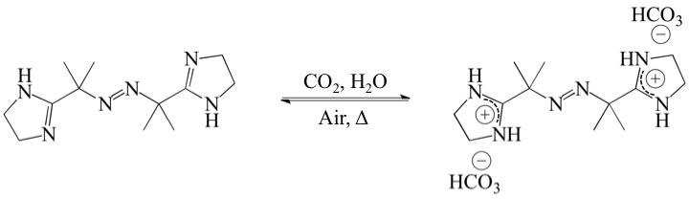
Figure 11. The reversible reaction between the CO₂-responsive initiator VA-061 with CO₂, H₂O, air and heat (Δ).

Jessop, Cunningham and coworkers used their first amidine surfactant, N’dodecyl-N,N-dimethylacetamidine along with VA-061 to prepare CO₂-responsive PS latexes that were reversibly switchable.⁴⁸ This was an improvement to their previous work with this surfactant since the previous latexes could only be destabilized, and restabilization was not possible.
Their group also prepared PS latexes through surfactant-free emulsion polymerization using VA-061 as the sole stabilizer of PS latexes.⁴⁹ The initiator is incorporated to the ends of polymer chains, and therefore provides electrostatic forces that stabilize the particles. Coagulation was achieved by bubbling air along with heat, followed by redispersion by bubbling CO₂ with ultrasonication. The limitation of this was that only latexes with very low solid content could be prepared, which is not practical for use in an industrial setting.

1.7.5. Switchable Comonomer Approach
Another favoured approach for preparing coagulatable/redispersible latexes with the covalent attachment of CO₂-switchable groups to latex particles is through surfactant-free emulsion polymerization using a CO₂-sensitive comonomer in its ionic state. The result is the development of latex particles with switchable ionic groups covalently bound to their surface. Wang and coworkers were the first to use this method to develop switchable PS latexes.⁵⁰ They synthesized an amidine-containing styrene derivative for the comonomer, which was found to successfully stabilize the latex particles during and after polymerization in its water-soluble state. An equimolar amount of HCl was used to dissolve this comonomer in the aqueous phase. After polymerization, the latex could be coagulated with a small amount of NaOH, which neutralized the electrostatic charge provided by the amidine groups. After washing the particles with deionized water, restabilization was possible by bubbling CO₂.
The comonomer approach was later used by Jessop and Cunningham to prepare switchable PS/PMMA latexes through SFEP using the CO₂-sensitive monomer 2-(diethylamino)ethyl methacrylate (DEAEMA) and the CO₂-sensitive initiator VA-061.⁵¹ In a carbonated aqueous system, the polymerization was successfully stabilized using DEAEMA in its water-soluble state. The resulting latex could be easily destabilized by bubbling air, and redispersibility could be achieved by bubbling CO₂ with ultrasonication.

1.8. Goals of Research
The destabilization and restabilization of polymer latexes has been successfully demonstrated by several research groups in the recent years using a variety of different chemicals and methods. The collective impact of the previous developments in this area of research has paved a new path to a sophisticated method of producing emulsion polymers, and has gained a great deal of interest from both academic and industrial perspectives. Although the models reported in the previous researches have been successful, the types of monomers used to produce the resulting latexes have been quite limited. More explicitly, only polymers with very high glass transition temperatures have been used. The most common polymers that have been synthesized are polystyrene (PS) and poly(methyl methacrylate) (PMMA), which the T_{g} of their homopolymers are 95 °C and 105 °C respectively. This has commonly led to the question regarding how the performance of CO₂-switchable latexes would be influenced with the use of a low T_{g} monomer instead. Therefore, instead of exploring other methods or chemicals to create switchable latex systems, it is of more importance and relevance to examine the performance of polymers with lower glass transition temperatures.
In this work, the switchable comonomer approach was adopted using CO₂-responsive DEAEMA as the comonomer to produce switchable latexes through surfactant-free emulsion polymerization. The goal was to prepare a series of CO₂-responsive latexes that had low glass transition temperatures through copolymerization of methyl methacrylate with butyl acrylate (BA). The T_{g} of BA is approximately -54 °C, which is significantly lower than MMA. The copolymerization of MMA and BA can result in a copolymer with a T_{g} between those of MMA and BA. The Fox equation was used to give estimates for designing the resulting glass transition temperatures of the synthesized latexes, and the estimated T_{g}’s were confirmed quantitatively by using a technique such as DSC. After this, the coagulation and redispersion performances of the latexes were examined. The physical characteristics of coagulated particles were further investigated using scanning electron microscopy (SEM). Overall, the goal of this work was to examine the influence that the glass transition temperature had on the coagulation and redispersion of the particles, and to gain further understanding to the applicability of this technology from an industrial perspective.

2. Experimental Methods.

2.1. Materials.
Butyl acrylate (BA, 99 %) and 2-(diethylamino) ethyl methacrylate (DEAEMA, 99 %) were both purchased from Sigma Aldrich, and both contained monomethyl ether hydroquinone (MEHQ, 60 ppm in BA and 1500 ppm in DEAEMA) as an inhibitor. These monomers were both purified by being passed through an inhibitor removal column (also purchased from Sigma-Aldrich) before use. Methyl methacrylate (MMA, 99 %) was purchased from Sigma-Aldrich, which also contained MEHQ (30 ppm) as an inhibitor, and was purified through distillation under vacuum before use. The switchable initiator 2,2’-azobis(2-methylpropionamidine) dihydrochloride (V-50, 97 %) was purchased from Sigma-Aldrich, and was used in experiments without further purification. CO₂ and N₂ (Alphagaz, 99.999%) were used as received. Any other chemicals were analytical-grade reagents, and were also used as received.

2.2. Surfactant-Free Emulsion Polymerization of BA & MMA.
For each of the surfactant-free emulsion polymerization experiments, a 250 mL two-necked flask with a sealed mechanical stirrer was used as the batch reactor. A total of 9.0 mL of deionized water was added to the flask at the beginning of each experiment, along with 0.2779 g (0.015 mol) of DEAEMA. To render DEAEMA soluble in the aqueous phase, approximately 15 mL of HCl with a concentration of 0.1 mol/L (M) (0.015 mol, equimolar to DEAEMA) was added to fully protonate the tertiary amine groups. The pH of the solution was approximated using pH-sensitive paper, and was found to have a pH of approximately 4 prior to polymerization. Once all of the chemicals had been added to the reactor, it was sealed and the stirring speed was set to 500 revolutions per minute (rpm). At this speed, the monomers MMA and BA (total mass of both monomers was 5 g per trial, molar fractions are outlined) were added to the system drop-wise at the same time. It is well known that the presence of oxygen (O₂) in emulsion polymerization systems can slow the rate of polymerization, leading to inconsistencies in batch-to-batch latex production. To fully deoxygenate the system, the reactor was equipped with a needle and was sparged with N₂ for 30 minutes without changing the stirring speed. During that time, 1 mL of water was used to dissolve 0.1356 g (0.0005 mol) of the initiator V-50. This separate mixture was also sparged with N₂ alongside the reaction mixture for 30 minutes to remove any dissolved O₂.
To initiate the polymerization, the aqueous initiator mixture was charged to the reactor through a needle, followed by promptly raising the temperature of the reactor to 70 °C using a previously heated oil bath. N₂ was left to sparge the system for an additional 5 minutes to ensure the reactor was rid of all oxygen. The polymerization was carried out at this temperature for 12 hours. After the first 30 minutes, the stirring speed was slowly reduced to 300 rpm. The pH of the latexes after polymerization was also approximated using pH-sensitive paper, and found to be between pH 5-6.

2.3. Characterization.
The conversion of MMA and BA after polymerization with DEAEMA was determined gravimetrically. After polymerization, the latex was passed through a steel screen (mesh size of 60, sieve size of 0.250 mm) to filter out macro-scale coagulum that formed during polymerization. This coagulum, plus any additional polymer adsorbed to the walls of the reactor, stir bar, and impeller, were all dried and weighed to determine the coagulum percentage with respect to the total monomer initially added to the system. The total mass of the latex after polymerization was weighed for each trial. A 1.0 g sample of this latex was dried from water and any unreacted monomer under vacuum at 60 °C for 24 hours. A small amount of inhibitor (monomethyl ether hydroquinone) was added to the samples prior to drying to prevent further polymerization, which otherwise could result in an over-estimation of the conversion measurements. The dried sample was weighed, and the fraction of its weight over the original sample allowed for the determination of the latex solids content for each trial. From this, the sum of the solids content and the mass of coagulum determined the total mass of polymer produced in the system, allowing for the monomer conversion to be determined.
The particle sizes and zeta potentials of the latexes before and after the coagulation and redispersion cycles were measured using dynamic light scattering (DLS) and zeta potential measurements with a Brookhaven 90Plus particle size analyzer. CO₂-saturated deionized water was used in the measurements of the redispersed latex samples, to ensure the DEAEMA tertiary amine groups were fully protonated.
Scanning electron microscopy (SEM) was used to examine the behaviour of coagulated latex particle samples from each trial using a JEOL JSM-7000F scanning electron microscope. For these tests, particles were dried at ambient temperature (23 °C), and were coated with 5 nm of platinum (Pt). An accelerating voltage of 10 kV (kilovolts) was used to analyze the particles.
Glass transition temperature measurements were performed using differential scanning calorimetry (DSC) on dried latex particles from each trial using a TA Instruments DSC 2910 differential scanning calorimeter. A temperature heating rate of 10 °C/min was used over a temperature range of -20 °C to 150 °C for each test, and the T_{g} was estimated from the resulting DSC thermograms. Two thermal cycles were performed for each sample, and T_{g} values were calculated using the second run.

2.4. Destabilization of Particles at Ambient Temperature.
Destabilization of the latex was achieved by adding base to a sample of the latex, which neutralized the charge at the surface of latex particles that was provided by HCl. This effectively decreased the ionic charge at the surface of particles, causing destabilization and aggregation. A 1.0 M solution of sodium hydroxide (NaOH) at ambient temperature was added drop-wise to 2.0 g of a latex sample until the pH was slightly basic (reaching values of ~ pH 8-9). The destabilized sample was centrifuged for 10 minutes at 3500 rpm in order to separate the aggregated particles from water. After separation, the supernatant liquid from the sample was carefully decanted from the aggregated sample. Approximately 20 mL of neutral deionized water at ambient temperature was used to wash the aggregated particles, and the mixture was held in an ultrasonication bath for 5 minutes to aid in washing the particles. The mixture was centrifuged again, and this cycle was repeated three times until the pH of the washed particles was neutral.

2.5. Latex Redispersion at Ambient Temperature.
For redispersion of the aggregated latex particles, deionized water at ambient temperature was added to the sample to reach the same solids content as the original latex sample. The samples were held under ultrasonication for 10 minutes to help the aggregated latex particles to separate from each other. Following this, the latex samples were sparged with CO₂ for 15 minutes to protonate the tertiary amine groups at the surface of the latex particles. The cycles of ultrasonication and CO₂ sparged were repeated two more times to ensure complete reprotonation of DEAEMA functional groups. The restabilized samples were sealed to prevent the loss of CO₂, and were stored overnight at room temperature before the analysis on redispersed particles was carried out.

2.6. Coagulation & Redispersion Cycles at 5 °C
Destabilization of particles followed by latex redispersion was repeated for latex samples from trials 4 and 5. A 2.0 g sample of each latex was transported to a small vial and cooled to approximately 5 °C in the refrigerator overnight to ensure the temperature of the particles was uniform. Before destabilizing the latex, the NaOH solution, and deionized water used to wash the particles were also cooled to 5 °C. The cooled NaOH solution was added dropwise to increase the pH of the sample to be slightly alkaline (pH~8-9). The washing and centrifugation cycles were repeated as described previously. Ice was packed around the vials within the centrifuge tubes to help prevent the temperature of the sample from rising during centrifugation. The washing cycles were complete after the pH was checked using pH-sensitive paper to ensure the particles were no longer alkaline. CO₂ bubbling and ultrasonication cycles were carried out as described previously, with the aid of an ice bath. The temperature was frequently monitored at 5 °C using a thermometer throughout the destabilization and redispersion experiments. When the latexes were fully redispersed, the vials were sealed with paraffin paper and were stored at room temperature.

3. Results and Discussion

3.1. Latex Synthesis via Surfactant-Free Emulsion Polymerization
Latex synthesis was conducted through surfactant-free emulsion polymerization of MMA and BA with the comomoner DEAEMA in its water-soluble state by adding an equimolar amount of HCl. The polymerization was initiated with the water-soluble initiator V-50. Five formulations were designed based on the estimates of the Fox equation to obtain latex particles with different targeted glass transition temperatures, which is outlined in Table 2.

Table 2. Experimental formulation that outlines the amount of monomers, comonomer, initiator, acid and water used in the surfactant-free emulsion polymerization trials.
Trial | MMA  [g] | BA  [g] | Target T_{g}  [°C] | DEAEMA  [g] | V-50  [g] | HCl  [mol] | H₂O  [mL]
T1 | 5.0 | 0.0 | 105 | 0.2779 | 0.1356 | 0.0015 | 25
T2 | 3.6 | 1.4 | 40 | 0.2779 | 0.1356 | 0.0015 | 25
T3 | 3.3 | 1.7 | 30 | 0.2779 | 0.1356 | 0.0015 | 25
T4 | 3.0 | 2.0 | 20 | 0.2779 | 0.1356 | 0.0015 | 25
T5 | 2.7 | 2.3 | 10 | 0.2779 | 0.1356 | 0.0015 | 25

Using this experimental formulation and the procedures outlined in Section 2.2, the resulting latexes were stable for each trial. After polymerization, the latex was filtered through a mesh screen in order to quantify the amount of coagulum generated within the system. The coagulum on the walls of the reactor, stir bar and impeller were also included in this measurement. All of the coagulum was dried from water and any residual unreacted monomer, and was weighed to determine the coagulum percentage with respect to the total monomer charged to the reactor. All trials contained relatively little coagulum (4~8 wt%). The amount of coagulum was also required to calculate the total conversion of monomer for each trial. Monomer conversion was determined gravimetrically, as described in Section 2.3, and each trial reached quite high conversion values (93~95%). In addition, the particle size and the polydispersity index was measured using dynamic light scattering. The particle sizes were measured to be between 165 nm and 279 nm and were quite monodispersed, which is characteristic in SFEP systems. The zeta potential for each latex sample was also measured, and was found to have moderate-to-good stability with values ranging from 33 mV to 41 mV. The values are summarized in Table 3.

Table 3. Results of the surfactant-free emulsion polymerization of MMA and BA with DEAEMA.
Trial | Conversion [%] | Coagulum [%] | Solid Content [%] | Particle Size [nm] | Đ | ζ-potential  [mV]
T1 | 93.7 ± 0.8 | 6.3 ± 0.6 | 18.3 ± 0.6 | 275 ± 5 | 0.027 ± 0.004 | 37 ± 3
T2 | 92.3 ± 1.2 | 5.7 ± 1.2 | 18.0 ± 0.6 | 182 ± 4 | 0.028 ± 0.004 | 37 ± 6
T3 | 93.7 ± 0.9 | 6.0 ± 1.0 | 18.0 ± 1.0 | 179 ± 13 | 0.020 ± 0.010 | 34 ± 6
T4 | 94.3 ± 0.6 | 6.3 ± 1.5 | 18.3 ± 0.6 | 170 ± 5 | 0.031 ± 0.004 | 37 ± 4
T5 | 94.7 ± 0.7 | 5.6 ± 1.5 | 18.3 ± 0.4 | 166 ± 6 | 0.036 ± 0.003 | 36 ± 4

3.2. Polymerization using an Acidified System
In surfactant-free emulsion polymerization systems, homogeneous nucleation occurs when radicals in the water-phase react with the water-soluble comonomer, producing in-situ oligomers that subsequently form micelles. It was proposed that these oligomers eventually act to stabilize the growing polymer particles, as well as the latex particles after polymerization is complete. In this system, DEAEMA was used as the water-soluble comonomer. As a CO₂-switchable monomer, the protonation of its tertiary amine is crucial to rendering DEAEMA soluble in water.
In this work, an equimolar amount of HCl was added to DEAEMA. The drawback is that an acidified system requires the addition of a strong base to neutralize the acid in order for latex particles to coagulate, which then requires washing and centrifugation cycles. As a CO₂-sensitive monomer, carbonated emulsion polymerization systems have been used in the past to avoid this. The benefit of this is that the resulting latexes can be coagulated simply by the removal of CO₂ by bubbling an inert gas such as N₂ or Ar, and does not require the addition of base. There are however numerous drawbacks to this system.
Firstly, the solubility of CO₂ in water decreases as temperature increases, as shown previously in Figure 9. This means that at the reaction temperature, there will be less carbonic acid within the aqueous phase. A lower amount of carbonic acid could hinder the protonation of DEAEMA, which can be detrimental to the stability of the particles and the amount of coagulum that is formed during polymerization. Secondly, CO₂ must be sparged through the system for the entire duration of the reaction, which can lead to losses in monomer and water by evapouration at such high temperatures since the reaction would no longer be perfectly sealed. Thirdly, a CO₂-responsive initiator must also be used in a carbonated system so that particles can be effectively coagulated, since it has been proven that the initiator end groups also provide electrostatic stability to the surface of particles. From an industrial sense, a pressurized vessel would be more useful to fully saturate the system with CO₂. For the purpose of the experiments in this thesis, it was determined that an acidified system would result in better latex quality, stability, and reproducibility.

3.3. Controlling the Glass Transition Temperature of Latex Particles
An experimental design was executed to produce polymer latexes with different fractions of MMA and BA. The aim of this was to control the resulting glass transition temperature of the particles after polymerization. Using the Fox equation, which estimates the T_{g} of the polymer based on the weight fraction of each monomer and the T_{g} of its homopolymer, five formulations were derived. The relative fractions of MMA and BA were calculated to achieve these five T_{g} values. The amount of total monomer, DEAEMA, initiator, water and HCl remained constant for each experiment.
To confirm the accuracy of the Fox equation, the glass transition temperature was measured using DSC after the latexes were synthesized. A small sample of particles was taken from each sample and was dried under vacuum for 24 hours to ensure all water and any residual unreacted monomer was removed from the polymer chains. It is important to note that the presence of unreacted monomer within the latex particles would result in a T_{g} that is lower than that of the same dried particles. Since each of the trials reached relatively high conversions, it is assumed that any amount of unreacted monomer has a negligible influence on the glass transition temperature of the particles. In other words, it was assumed there was no deviation in the T_{g} of the dried latex particles compared to the latex particles after polymerization. The DSC thermograms for the dried latex particles from each trial are illustrated in Figure 12.

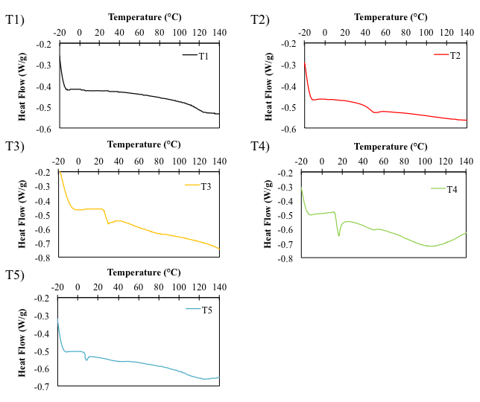
Figure 12. DSC thermograms for dried latex particles at each trial using a heating ramp of 10 °C/min with a temperature range from -20 °C to 150 °C.

The glass transition temperature can be detected as a change in the heat flow. Although the T_{g} is actually a temperature range, the midpoint of the transition’s incline is reported as the T_{g}. The midpoint was determined using the automated T_{g} detection software within the DSC machine. The fractions of each monomer, the targeted T_{g} calculated from the Fox equation, and the measured T_{g} from the transitions recorded in the DSC thermograms are reported in Table 4. It can be seen that the actual T_{g} measured from DSC was close to the predicted value that was calculated using the Fox equation.

Table 4. MMA/BA monomer fractions used in experiments, the targeted T_{g} calculated from the fox equation and the measured glass transition temperature from DSC.
Trial | $$\frac{\left[\text{MMA}\right]}{\left[\text{MMA+BA}\right]}$$ | $$\frac{\left[\text{BA}\right]}{\left[\text{MMA+BA}\right]}$$ | Target T_{g}  [°C] | Measured T_{g}  [°C]
T1 | 1.00 | 0.00 | 105 | 115
T2 | 0.71 | 0.29 | 40 | 45
T3 | 0.66 | 0.34 | 30 | 27
T4 | 0.60 | 0.40 | 20 | 17
T5 | 0.54 | 0.46 | 10 | 7.8

3.4. Coagulation of Latex Particles
The first set of coagulation and redispersion cycles were conducted at ambient temperature, which was measured to be approximately 23 °C throughout the experiments. The destabilization of particles was easily achieved by adding a small amount of NaOH. This led to the deprotonation of the tertiary amine groups of DEAEMA, as well as the amidine groups within the initiator V-50.
Noting the value of ambient temperature and the T_{g} measurements reported in Table 4, it can be seen that the measured T_{g}’s of particles from trials T1, T2 and T3 were higher than 23 °C, whereas those of particles form T4 and T5 were lower than the ambient temperature. When the particles were destabilized, the physical characteristics of the coagulated latexes were observed to be quite different. Coagulated particles from T1, T2 and T3 had a paste-like consistency, and did not have the appearance of large clumps. Contrary to this, the latex samples coagulated for T4 and T5 fused together to form clumps with a rubbery consistency upon the addition of NaOH. These macro-scale clumps of polymer could not be broken apart using ultrasonication, or with physical agitation. Images of the latex samples before and after coagulation are illustrated in Figure 13.

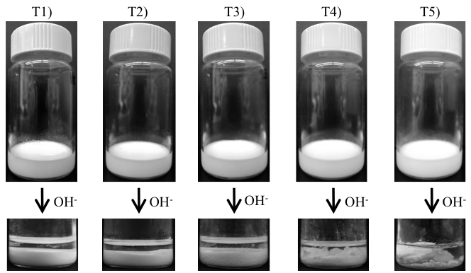
Figure 13. Images of latex samples from each trial before and after coagulation with NaOH at ambient temperature.

3.5. Fusion of Low T_{g} Latex Particles
In order to visualize the behaviour of individual latex particles upon coagulation, SEM was used on a sample of coagulated particles from each trial. The sample of coagulated latex particles was dried at ambient temperature, and the SEM samples were prepared as described in Section 2.3. The SEM images are illustrated in Figure 14.
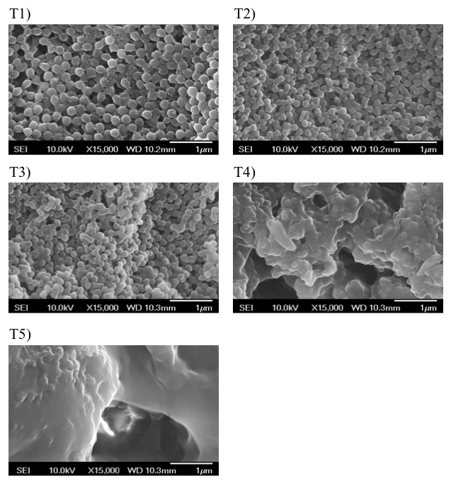
Figure 14. SEM images of coagulated latex particles from each trial.

Higher resolution images can also be found in Figure 19, Appendix A. As seen from Figure 14, particles from T1, T2 and T3 experienced the least degree of fusion during coagulation, which occurred since the T_{g} of these particles was higher than the coagulation temperature. At ambient temperature, the polymer chains in these particles are still above their glass transition temperatures and therefore they are rigid and glassy in nature. This helps the particles to retain their shape in their coagulated state. For particles from T3, the majority of the particles still appear to be individual when examining the particle boundaries, however it was observed that a small degree of fusion might have occurred in some areas. It was proposed that some BA-rich regions might exist within the particles. The resulting T_{g} of these regions would be lower, which would lead to some particles having softer domains. The complete fusion of particles becomes obvious in T4 and especially T5, where there is no longer a distinct boundary between the coagulated particles. Particles from T5 have the lowest T_{g}, and are therefore the softest and exhibit the highest degree of particle fusion.

3.6. Redispersion
The redispersion of latex particles was attempted at ambient temperature (23 °C) for each of the samples through the use of alternating ultrasonication and bubbling CO₂, as described in Section 2.5. Before redispersion, deionized water was used to wash the particles to remove any residual base, and was checked with pH paper to ensure the pH of the particles was neutral. The presence of any excess base in the coagulated particles would prevent their restabilization by bubbling CO₂, since the protonation of the tertiary amine groups would not occur in the presence of excess NaOH. Water was added to reach the same latex solids content prior to coagulation (~17%). Latex particles from T1, T2, and T3 could be effectively redispersed, forming stable latexes. The particles from T4 and T5 that fused together could not be broken apart, either using ultrasonication or by physical force, therefore they could not redisperse to form stable latexes. Images of the latexes after redispersion using CO₂ and ultrasonication are shown in Figure 15.

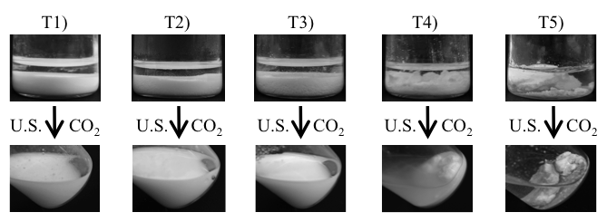
Figure 15. Images of latex samples after redispersion using CO₂ and ultrasonication. T1, T2 and T3 could be effectively redispersed; T4 and T5 were not redispersible.

The particle size, polydispersity and zeta potential after coagulation and redispersion were also measured for T1, T2 and T3. These values are reported in Table 5. The values after redispersion were compared to the previously measured values to examine if coagulation and redispersion had an effect on these parameters.

Table 5. The particle size, polydispersity index and measured zeta potential of latex particles from T1, T2 and T3 before and after redispersion.
Trial | Particle size  [nm] (1) | Đ  (1) | ζ-potential  [mV] (1) | Particle size [nm] (2) | Đ  (2) | ζ-potential  [mV] (2)
T1 | 275 ± 5 | 0.027 ± 0.004 | 37 ± 3 | 278 ± 3 | 0.030 ± 0.003 | 38 ± 2
T2 | 182 ± 4 | 0.028 ± 0.004 | 37 ± 6 | 216 ± 7 | 0.036 ± 0.004 | 32 ± 8
T3 | 179 ± 13 | 0.020 ± 0.010 | 34 ± 6 | 220 ± 9 | 0.062 ± 0.009 | 33 ± 8

From Table 5, it can be seen that the change in the particle size after coagulation and redispersion was the smallest for particles from T1. These particles only experienced a 0.3% increase in size since these particles were the most rigid in their coagulated state. For T2 and T3, the particle sizes increased by about 22% and 26% respectively. The increase in size was thought to be caused by some BA-rich domains in particles, which may have led to a small degree of fusion. This can also be seen in the SEM images in Figure 14. The polydispersity index for T1 also exhibited the smallest change. The polydispersity index of particles from T3 increased the most, which is also attributed to the existence of BA-rich domains. Since the formulation used for T3 involved a greater fraction of the monomer BA, it makes sense that there was a larger change in the particle size and polydispersity index compared to particles from T2. The zeta potential tests also indicated that the redispersed latexes from all trials also had moderate-to-good stability.
After the evaluation of the coagulation and redispersion cycles of these latexes, it was concluded that the T_{g} of the polymer influences the ability of the particles to be redispersed. Polymers with high glass transition temperatures are hard plastics under ambient conditions, which help these particles to retain their shape when they are coagulated, and consequently allow them to be easily redispersed. When the T_{g} is lower than ambient conditions, latex particles are much softer, and thus exhibit deformation, leading to individual particle fusion when the latex is coagulated. As soon as this occurs, particle redispersion will no longer be possible. A schematic of this phenomenon is illustrated in Figure 16.

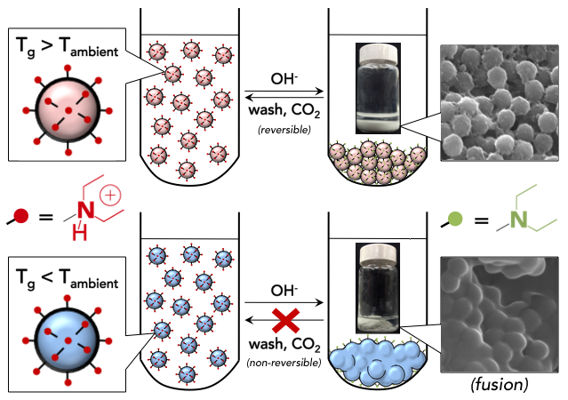
Figure 16. Schematic representation of the difference in redispersibility of latex particles with T_{g} higher than and lower than ambient temperature.

3.7. Coagulation and Redispersion at Lower Temperature.
The destabilization and redispersion was repeated for T4 and T5 at 5 °C to determine if these latexes could be successfully redispersed below their measured glass transition temperatures. The latex samples were cooled to 5 °C, along with the deionized water used for washing/redispersion, and NaOH used for coagulation. When the particles were coagulated, they did not fuse together into a macro-scale rubber-like clump of polymer as was demonstrated previously. Instead, the coagulated particles had a paste-like consistency that was seen with the coagulation of high T_{g} particles. Cooled deionized water was used to wash the particles, and an ice bath was used during coagulation as well as during centrifugation to prevent the temperature of the particles from rising. This was crucial for the successful redispersibility of particles. When the temperature of the particles was not strictly maintained below the T_{g}, the redispersibility was not successful. After washing the particles to a neutral pH at 5 °C, they were ready to be redispersed. Deionized water at 5 °C was added to the particles to reach the same solids content as the initial latex. CO₂ and ultrasound were used to the same degree as described for the previous redispersion experiments, with the use of an ice bath. Under cold temperatures, the particles could be easily redispersed to form stable latexes. Images of the initial latexes before and during coagulation, and after redispersion are illustrated in Figure 17.

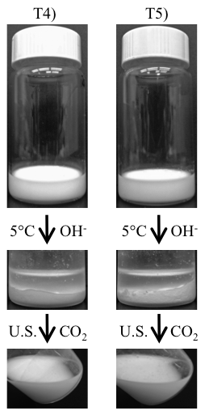
Figure 17. Images of latex samples from T4 and T5 before coagulation, after coagulation with NaOH at 5 °C, and after redispersion using CO₂ and ultrasonication.

Since stable latexes could be achieved, the change in the particle size, polydispersity and zeta potential for the particles from T4 and T5 after coagulation and redispersion could now be measured using DLS. These values are reported in Table 6.

Table 6. The particle size, polydispersity index and zeta potential of latex particles from T4 and T5 (1) before and (2) after redispersion at 5 °C.
Trial | Particle size  [nm] (1) | Đ  (1) | ζ-potential  [mV] (1) | Particle size [nm] (2) | Đ  (2) | ζ-potential  [mV] (2)
T4 | 170 ± 5 | 0.031 ± 0.004 | 37 ± 4 | 222 ± 7 | 0.061 ± 0.004 | 29 ± 4
T5 | 166 ± 6 | 0.036 ± 0.003 | 36 ± 4 | 238 ± 8 | 0.064 ± 0.004 | 33 ± 8
Similar to T2 and T3, the particle size and polydispersity increased after coagulation and redispersion. It was again proposed that low T_{g} regions within the particles still led to a small degree of fusion when particles were coagulated. Similar to the coagulation and redispersion data of T3, the experimental formulation for T5 involves using a higher fraction of BA, which would lead to a larger amount of BA-rich domains in particles. Additional figures for the change in particle size and polydispersity are shown in Figure 18 the Appendix A for all redispersed trials.

4. Conclusion
A series of coagulatable and redispersible latexes based on MMA and BA were produced successfully through surfactant-free emulsion polymerization. Polymerization was initiated using V-50 along with the CO₂-switchable monomer DEAEMA in its ionic state, which was found to effectively stabilize polymer particles during and after polymerization. The resulting particles possessed tertiary amine functional groups at the surface, and had good stability as confirmed by zeta potential measurements. The fraction of MMA and BA used in the experimental formulation was changed as estimated by the Fox equation so that the glass transition temperature of the resulting particles could be systematically designed. The T_{g} predicted from the Fox equation was close to the T_{g} measured by DSC for all trials. All of the latexes could be easily coagulated using a small amount of NaOH, however the ability to redisperse the particles was dependent on the fraction of MMA and BA. With a monomer formulation up to 34 wt% BA (66 wt% MMA), the resulting latex particles had glass transition temperatures above ambient temperature, and were redispersible using CO₂ and ultrasonication after being washed. Monomer formulations using a BA weight fraction of 40 wt% or greater (with 60 wt% MMA or less) resulted in latex particles with T_{g} lower than ambient temperature. These particles deformed and fused together upon coagulation with NaOH, as confirmed by SEM. These fused particles could not be broken apart by ultrasonication or by physical agitation, which prevented particle redispersion. When these same latexes were coagulated at 5 °C (at a temperature below their measured T_{g}), redispersion with CO₂ and ultrasonication was possible without a substantial increase in the particle size.

4.1. Significant Contributions of Thesis Work
The relationship between the glass transition temperature of switchable latex particles and their redispersibility is a crucial concept to explore for the industrialization of CO₂-switchable emulsion polymer technology. The majority of previous research relevant to this area has explicitly stated that this technology would be useful within the paint and coatings industry, which is notably the largest market within the emulsion polymer industry. However, without examining the types of polymers that are similar to those used in the paint and coatings industry, its actual applicability as a latex coating in industry has remained an unanswered question for years.
The glass transition temperature is an important polymer property that dictates what applications polymeric materials can be useful for. For polymers in the paint and coatings industry, it is well understood that the T_{g} plays an important role within the phenomenon of film formation of the coating, and is therefore a critical parameter for these types of products. The work outlined in this thesis is the first to systematically explore the relationship between the glass transition temperature as a parameter and what influence it has within these types of switchable latexes.
For years, the polymers within switchable latexes have been limited to high T_{g} polymers such as PS and PMMA, as the model in systems for proof of the concept, which have limited applicability within the paint and coatings industry. It should be emphasized that most paint and coating polymers are easily deformed soft elastomers, rather than hard brittle plastics. By using a low T_{g} monomer such as butyl acrylate in the experimental formulation, the types of polymers examined within this project present a significant improvement in the applicability of this technology for use in the emulsion polymer industry. Systematically controlling the T_{g} and examining the resulting influence on the switchability of the latex particles has also outlined how ambient temperature is an important parameter within this system. Overall, the conclusions generated from this research have provided a mechanistic insight and practical guidance to the applicability of using amine-containing CO₂-sensitive molecules to prepare emulsion polymer products on an industrially relevant level.

4.2. Recommendations for Future Work
The main theme and general motivation of this work has been to translate how this technology can actually function within industry. Examining the glass transition temperature to produce industrially relevant polymers is just the first of many steps to achieving that goal, and there is still much work that needs to be examined before CO₂-switchable latex products can actually be used within the emulsion polymers industry.

4.2.1. Using a Pressurized CO₂ Atmosphere for Polymerization
In this work, an acidified system was deemed to be better than a CO₂-saturated atmosphere since a pressurized vessel was not available for polymerization. This is unrealistic from an industrial sense because coagulating the particles with NaOH, followed by the cycles of washing the particles is time-consuming, costly, and environmentally unappealing. Using a high pressure CO₂ atmosphere to conduct polymerization could eliminate the need for an acidified environment, and the resulting particles could be coagulated simply by bubbling N₂. This would eliminate the need for adding NaOH to facilitate coagulation, thus eliminating the need for washing the particles. Examining the amount of coagulum would be important for these trials, to see if a pressurized CO₂-saturated atmosphere can stabilize particles through SFEP as effectively as an acidified environment.

4.2.2. Surfactant-free Semi-Batch Polymerization
In the coagulation and redispersion trials, it was found that there was some degree of fusion in the particles, even when the measured T_{g} was above the temperature of coagulation. It was proposed that there were some BA-rich regions within these particles that may have resulted in particles having soft domains, which caused the average particle size and polydispersity of the redispersed particles to increase. By conducting the copolymerization in a semi-batch fashion, the composition of the polymer chains and the sequencing of monomers can be more effectively controlled. This could result in particles having a more uniform composition, eliminating the soft domains within these particles. After conducting semi-batch polymerization, the resulting latexes could be compared to those latexes with the same formulation but through batch polymerization, to observe if the increase in particle size and polydispersity could be reduced for these trials. Another idea is to design core-shell structured latexes. Soft core is wrapped by hard shell to prevent deformation and sticking. Such core-shell structures could be achieved via various reactor technologies such as semi-batch feeding or via innovative polymerization chemistries such as controlled radical polymerization.

4.2.3. Inhibiting the Fusion of Low T_{g} Particles
This work has demonstrated strong evidence to how low T_{g} particles exhibit fusion when they are coagulated at temperatures above their T_{g}. More specifically, polymers used for latex products have a T_{g} of approximately 10 °C, which demonstrated the highest degree of fusion. Future work to inhibiting this fusion is crucial for this technology to have an impact on an industrial level. In the experiments, it was found that reducing the coagulation and redispersion temperature below the T_{g} of the particles could aid in their redispersion, however this is not practical in industry since the coagulated particles would need to be shipped and stored at 5 °C, without the temperature of the particles rising above this temperature. Exploring the preparation of these switchable latexes through other polymerization techniques with the use of harder, solid particles such as Pickering emulsion could potentially help to inhibit the fusion of particles in their coagulated state. In addition, embedding solid particles within latex particles during polymerization may effectively help low T_{g} particles retain their shape during coagulation, preventing fusion of particles.

References
(1) Sherrington, D. C. Reactive and Functional Polymers. 1998, pp 90–105.
(2) Blackley, D. C. High polymer latices: their science and technology; Palmerton Publishing Co. Inc.: New York, 1966.
(3) Gilbert, R. G. Emulsion polymerization: a mechanistic approach; Colloid science; Academic Press, 1995.
(4) Fitch, R. M. L. Polymer Colloids: A Comprehensive Introduction; Colloid science; Academic Press, 1997.
(5) Eliseeva, V. I.; Ivanchev, S. S.; Kuchanov, S. I.; Lebedev, A. V. J. Polym. Sci. Polym. Lett. Ed. 1982, 20 (8), 460–461.
(6) Group, T. F. World Emulsion Polymers; 2014.
(7) Urban, D.; Distler, D. Polymer Dispersions and Their Industrial Applications; Wiley-VCH Verlag GmbH & Co. KGaA, 2003.
(8) Chern, C.-S. Principles and Applications of Emulsion Polymerization; 2008.
(9) Fried, J. R. Polymer Science and Technology; American Chemical Society, 2003.
(10) Chern, C. S. Prog. Polym. Sci. 2006, 31 (5), 443–486.
(11) Goddard, E. D. Colloids and Surfaces. 1989, p 347.
(12) M., F. R. In Emulsion Polymers and Emulsion Polymerization; pp 1–29.
(13) Qiu, J.; Charleux, B.; Matyjaszewski, K. Prog. Polym. Sci. 2001, 26 (10), 2083–2134.
(14) Yamak, H. B. Emulsion Polymerization: Effects of Polymerization Variables on the Properties of Vinyl Acetate Based Emulsion Polymers; INTECH Open Access Publisher, 2013.
(15) Wang, Y.-M.; Pan, C. Y. Colloid Polym. Sci. 1999, 277 (7), 658–665.
(16) Mahdavian, A.-R.; Abdollahi, M. Polymer (Guildf). 2004, 45 (10), 3233–3239.
(17) Tauer, K.; Deckwer, R.; Kühn, I.; Schellenberg, C. Colloid Polym. Sci. 1999, 277 (7), 607–626.
(18) Chen, S. A.; Lee, S. T. Macromolecules 1992, 25 (5), 1530–1533.
(19) Chen, S. A.; Lee, S. T. Macromolecules 1991, 24 (11), 3340–3351.
(20) Li, S.-X. Nat. Sci. 2010, 02 (05), 515–518.
(21) Forrest, J. A.; Dalnoki-Veress, K.; Stevens, J. R.; Dutcher, J. R. Phys. Rev. Lett. 1996, 77 (10), 2002–2005.
(22) Keddie, J. L.; Jones, R. A. L.; Cory, R. A. Faraday Discuss. 1994, 98 (0), 219–230.
(23) Brostow, W.; Chiu, R.; Kalogeras, I. M.; Vassilikou-Dova, A. Mater. Lett. 2008, 62 (17-18), 3152–3155.
(24) Emlie, B.; Pichot, C.; Guillot, J. Die Makromol. Chemie 1991, 192 (7), 1629–1647.
(25) Liu, Y.; Haley, J. C.; Deng, K.; Lau, W.; Winnik, M. A. Macromolecules 2007, 40 (17), 6422–6431.
(26) Berg, J. C. An Introduction to Interfaces & Colloids; World Scientific: Singapore, 2010.
(27) Verwey, E. J. W. J. Phys. Colloid Chem. 1947, 51 (3), 631–636.
(28) H., O. R. In Emulsion Polymers and Emulsion Polymerization; pp 31–59.
(29) Van Oss, C. J. In Interfacial Forces in Aqueous Media, Second Edition; CRC Press, 2006; pp 51–69.
(30) Freire, J. M.; Domingues, M. M.; Matos, J.; Melo, M. N.; Veiga, A. S.; Santos, N. C.; Castanho, M. A. R. B. Eur. Biophys. J. 2011, 40 (4), 481–487.
(31) Winnik, M. A. Curr. Opin. Colloid Interface Sci. 1997, 2 (2), 192–199.
(32) Chevalier, Y.; Pichot, C.; Graillat, C.; Joanicot, M.; Wong, K.; Maquet, J.; Lindner, P.; Cabane, B. Colloid Polym. Sci. 1992, 270 (8), 806–821.
(33) Keddie, J. L.; Routh, A. F. Fundamentals of Latex Film Formation: Processes and Properties; Springer, 2010.
(34) Steward, P. A.; Hearn, J.; Wilkinson, M. C. Adv. Colloid Interface Sci. 2000, 86 (3), 195–267.
(35) Lin, S.; Theato, P. Macromol. Rapid Commun. 2013, 34 (14), 1118–1133.
(36) Li, Y.-H.; Tsui, T.-F. J. Geophys. Res. 1971, 76 (18), 4203–4207.
(37) Liu, Y.; Jessop, P. G.; Cunningham, M.; Eckert, C. A.; Liotta, C. L. Science (80-. ). 2006, 313 (5789), 958–960.
(38) Yan, Q.; Zhao, Y. J. Am. Chem. Soc. 2013, 135 (44), 16300–16303.
(39) Han, D.; Tong, X.; Boissière, O.; Zhao, Y. ACS Macro Lett. 2012, 1 (1), 57–61.
(40) Han, D.; Boissiere, O.; Kumar, S.; Tong, X.; Tremblay, L.; Zhao, Y. Macromolecules 2012, 45 (18), 7440–7445.
(41) Fischer, V.; Landfester, K.; Muñoz-Espí, R. ACS Macro Lett. 2012, 1 (12), 1371–1374.
(42) Fowler, C. I.; Muchemu, C. M.; Miller, R. E.; Phan, L.; O’Neill, C.; Jessop, P. G.; Cunningham, M. F. Macromolecules 2011, 44 (8), 2501–2509.
(43) Fowler, C. I.; Jessop, P. G.; Cunningham, M. F. Macromolecules 2012, 45 (7), 2955–2962.
(44) Zhang, Q.; Yu, G.; Wang, W.-J.; Li, B.-G.; Zhu, S. Macromol. Rapid Commun. 2012, 33 (10), 916–921.
(45) Zhang, Q.; Yu, G.; Wang, W.-J.; Yuan, H.; Li, B.-G.; Zhu, S. Macromolecules 2013, 46 (4), 1261–1267.
(46) Zhang, Q.; Yu, G.; Wang, W.-J.; Yuan, H.; Li, B.-G.; Zhu, S. Langmuir 2012, 28 (14), 5940–5946.
(47) Schork, F. J.; Guo, J. Macromol. React. Eng. 2008, 2 (4), 287–303.
(48) Mihara, M.; Jessop, P.; Cunningham, M. Macromolecules 2011, 44 (10), 3688–3693.
(49) Su, X.; Jessop, P. G.; Cunningham, M. F. Am. Chem. Soc. 2012, 45 (2), 666–670.
(50) Zhang, Q.; Wang, W.-J.; Lu, Y.; Li, B.-G.; Zhu, S. Macromolecules 2011, 44 (16), 6539–6545.
(51) Pinaud, J.; Kowal, E.; Cunningham, M.; Jessop, P. ACS Macro Lett. 2012, 1 (9), 1103–1107.

Appendix A: Additional Figures
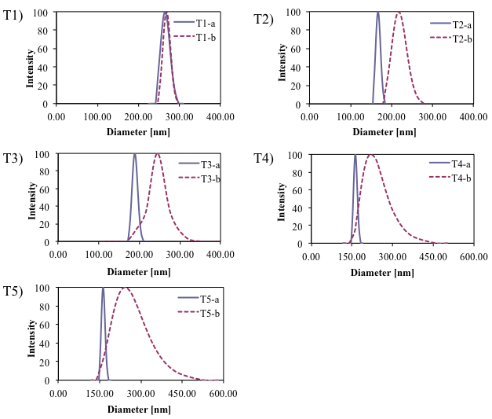
Figure 18. Intensity average particle diameter of latexes before (a) and after (b) redipsersion (particles from T4 and T5 were coagulated and redispersed at 5 °C).
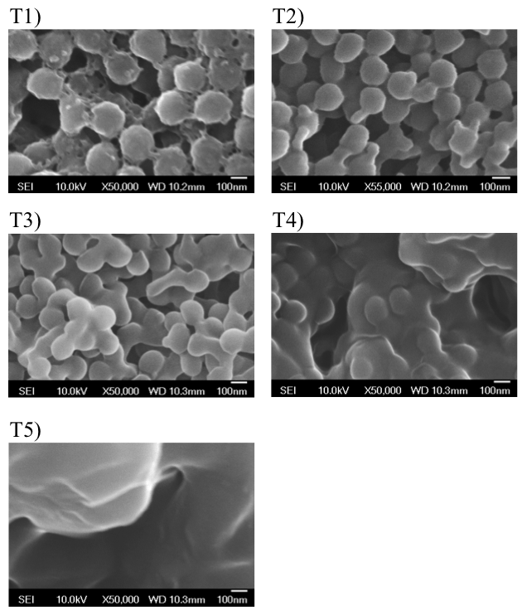
Figure 19. Additional SEM images of coagulated latex particles.

