EMERGENCY MEDICAL SERVICES AND

ST-ELEVATION MYOCARIDAL INFARCATION IN

ARABIAN GULF COUNTRIES

Feasibility of Developing Emergency Medical Services (EMS) Registry and Exploring the benefits of using EMS among Arabian Gulf patients presenting with ST elevation myocardial infarction (STEMI).

Data analysis and interpretation thesis of the RACE III registry (Gulf Registry of Acute Coronary Events: Primary PCI programs).

By

Ayman Al Saleh, MD, ABIM(C), FRCPC

A Thesis

Submitted to the School of Graduate Studies

In Partial Fulfilment of the Requirements

For the Degree

McMaster University

Master of Sciences

© Copyright by Ayman Al Saleh, September 2015

MASTER OF SCIENCE (2015) McMaster University

Health Research Methodology Hamilton, ON

TITLE: Feasibility of Developing Emergency Medical Services (EMS) Registry and Exploring the benefits of using EMS among Arabian Gulf patients presenting with ST elevation myocardial infarction (STEMI). Data analysis and interpretation thesis of the RACE III registry (Gulf Registry of Acute Coronary Events: Primary PCI programs).

AUTHOR: Dr. Ayman M. Al-Saleh

SUPERVISOR: Dr. Koon Teo

COMMITTEE MEMBERS Dr. Lehana Thabane

Dr.Sanjit Jolly

Dr.JD Schwalm

**Abstract**

**Background**

Practice guidelines strongly recommend the activation of emergency medical services (EMS) by patients with symptoms consistent with acute myocardial infarction (AMI). Little is known about the EMS usage by patients with ST elevation myocardial infarction (STEMI) in the Arabian Gulf region. We explored the feasibility of developing an EMS registry and the benefits of EMS use among Arabian Gulf patients presenting with STEMI.

**Objective**

For Arabian Gulf patients presenting with STEMI and enrolled in the Gulf Registry of Acute Coronary Events: Primary PCI programs (RACE III registry), how feasible and suitable the registry data are in terms of data completeness and appropriate recruitment time interval (primary objective). Once the primary outcome is fulfilled, the secondary objective will be explored—namely, whether the use of EMS improves the provision of timely care, defined as door-to-balloon time <90 minutes or door-to-needle time < 30 minutes, or other clinical outcomes.

**Methods**

Analysis and interpretation of the RACE III registry were done by assessing data set completeness and exploring if EMS improved the provision of timely care or other clinical outcomes. We evaluated 574 STEMI patients recruited between May 2013 and May 2014 in six Arabian Gulf countries.

**Results**

For the primary outcome, we found that the study was feasible as only 0.7% of the variables of interest were missing and all patients were recruited over a one-year period. For the secondary outcome, EMS use was associated with better delivery of timely care (EMS used 75.2% vs. EMS not used 49.7%; p<0.001). The adjusted odds ratio for EMS use was 1.81(95%CI: 1.11, 2.96), suggesting that patients using EMS received timely care 1.8 times more than patients who did not use EMS. EMS use was also associated with a lower risk for recurrent MI and hospital death compared to non-EMS use; adjusted OR was 0.29 (95%CI: 0.1, 0.87) for recurrent MI when EMS was used and OR was 0.26 (95%CI: 0.09, 0.81) for hospital deaths when EMS was used.

**Conclusion**

Our study demonstrated the feasibility of the RACE III registry to evaluate EMS use among Arabian Gulf patients presenting with STEMI. EMS use was associated with better timely care and improved clinical outcomes. Caution should be exercised in interpreting these finding due to the low number of study participants and the registry nature of the data.

**Acknowledgments**

I first wish to thank Dr. Koon Teo and Dr. Lehana Thabane, whose vision, guidance and leadership helped foster my interest in the field of study and my development as a clinician scientist. For that I will always be grateful.

I also wish to thank the other members of my thesis committee, Dr. JD Schwalm and Dr.Sanjit Jolly for their constructive advice in the completion of this project.

I wish to thank my parents for their support and advice during the different steps of my academic and personal life.

Finally, my greatest thanks is to my wife Haifa, for her love, support, and motivation, during the long journey to become a successful physician scientist.

**Table of Contents**

**Page**

**Chapter 1 Introduction**………………………………………………….…1

* 1. Introduction.…………………………………………………………..1
  2. Definitions.……………………………………………………………3
  3. Epidemiology of ST elevation myocardial infarction ………………..4
  4. Management of ST elevation myocardial infarction

(Reperfusion therapy).………………………………………………...8

* 1. Reperfusion therapy in practice……………………………………....9
  2. Management of ST elevation myocardial infarction

(Adjunctive Antithrombotic therapy) ……………………………….10

* 1. Arabian gulf countries and STEMI : (Management and

Presentation)………………………………………………………...11

* 1. Arabian Gulf countries and emergency medical services…………...12

**Chapter 2**………………………………………………………………….15

1. Overall aim of the thesis…………………………………………….15
2. GULF RACE III Design and Objectives……………………………15
3. Primary objective of this thesis project……………………………...17
4. Secondary objective of this thesis project…………………………..17

**Chapter 3 Statistical analysis**…………………………………………….18

* 1. Statistical Methodology…………………………………………….18

**Chapter 4 Results**…………………………………………………………21

4.1 Data completeness…………………………………………………...21

4.2 Sociodemographic Information……………………………………...22

4.3 CAD Risk Factors and medical history……………………………...24

4.4 EMS usage and patient’s vital signs upon arrival…………………...25

4.5 In-hospital procedures and medications……………………………..26 4.6 In-hospital major clinical outcomes…………………………………28

4.7 Logistic Regression Analysis………………………………………..29

4.8 Cox Regression Analysis……………………………………………31

**Chapter 5 Implications and Significance**……………………….……….35

5.1 Discussion…………………………………………………………...35

5.2 Limitations…………………………………………………………..39

5.3 Conclusion…………………………………………………………..42

Bibliography………………………………………………………………..43

APPENDIX 1 Adjunctive antithrombotic therapy

Primary PCI………………………………………………...………………48

APPENDIX 2 Adjunctive antithrombotic therapy Fibrinolytics………………………………………………………………...49

APPENDIX 3 Summary Table……………………………………………..50

**List of Tables Page**

Table 1. Sociodemographic information…………………………………...23

Table 2. CAD Risk Factors and medical history…………………………...24

Table 3. Vital signs upon arrival……….…………………………………..25

Table 4. In-hospital procedures: Treatment………………………………..27

Table 5. Oral medications and echo………………………………………..28

Table 6. Major in-hospital outcomes……………………………………….29

Table 7. Impact of EMS use on timely care given (Logistic regression analysis)………………………………………………………………….…30

Table 8. Major in-hospital outcomes: Effect of EMS use………………….31

Table 9. Major in-hospital outcomes: Effect of EMS use (Cox regression analysis)…………………………………………………………………….34

**List of Figures Page**

Figure 1. Heart rate distribution……………………………………………51

Figure 2. Systolic blood pressure distribution……………………………...52

Figure 3. Initial serum creatinine distribution……………………………...53

Figure 4. Peak serum creatinine histogram distribution……………………54

Figure 5. Peak serum creatinine kinase distribution...……………………...55

Figure 6. Time to thrombolytic therapy…………………………………….32

Figure 7. Time to thrombolytic therapy…………………………………….33

**1.1 Introduction**

Cardiovascular disease is predicted to become the leading cause of mortality and morbidity in developing countries, including those in the Arabian Gulf region, by 2020.1 Little is known about the cardiovascular disease profile in the Arabian Gulf region. A medical registry can be deﬁned as a systematic collection of a set of health and demographic data for patients with speciﬁc health characteristics held in a deﬁned database for a predeﬁned purpose.2 Several registries have attempted to quantify the disease burden and address practice patterns in that part of the world. Between 2005 and 2009, the Saudi Project for the Assessment of Coronary Events (SPACE) and the Gulf Registry for Acute Coronary Events (RACE) enrolled more than 8000 acute coronary syndrome (ACS) patients in 65 participating hospitals in 6 countries.3,4 Knowledge from both registries has raised concerns about the population’s coronary artery disease risk profile and identified considerable gaps in the healthcare systems.

Findings from these two registries are summarized here. First, the mean age of presentation is considerably younger (mean age of 56 years) when compared to other registries in North America.5 Second, the coronary artery disease risk factor profile is markedly elevated (diabetics 40%, smokers 35%) when compared to other registries in the world (diabetes 23%, and smokers 27%).6-9 Third, the underutilization of emergency medical services (EMS) has also been noted. Only 20% of the entire ACS population were able to reach hospitals through EMS.10,11 This is considerably lower than north American reported rates of up to 52 %.9 Interestingly, once those patients reach the hospitals, evidence-based therapies were used at guideline acceptable rates.12

Recently, Saudi Arabia has joined an effort led by the European Society of Cardiology “Stent for life,” which is a cross-sectional study to evaluate reperfusion therapy for the ST elevation myocardial infarction (STEMI) population.13 When comparing Saudi Arabia to other European countries, thrombolysis was still the main method of reperfusion in patients with STEMI. With that in mind, prolonged door-to-needle time was still significantly prolonged. In Saudi Arabia, the number of primary PCI centers and procedures per capita were much more limited in number than in other countries in Europe, resulting in prolonged door-to-balloon time. Furthermore, patients who undergo catheterizations are of predominantly low to intermediate risk knowing that higher risk patients derive the most benifit.14

Specifically, major gaps have been identified in the STEMI population from previous ACS registries in the Saudi Arabia/Gulf region.3,4 One third of patients with STEMI presented at more than 12 hours from symptom onset, half received thrombolytic therapy within 30 minutes of hospital arrival, less than one quarter underwent primary PCI, and less than one third of those who received primary PCI did so at fewer than 90 minutes after hospital arrival.

My thesis will address the feasibility of an expanded ACS registry: RACE III registry. This registry will evaluate EMS use and the associated benefits in the Arabian Gulf countries. My role will include: 1) collaborating with the study’s primary investigators; 2) analyzing the study data set; and 3) interpreting the findings pertaining to the potential confounders and benefits of EMS use in the Arabian Gulf countries.

**1.2 Definitions**

According to the STEMI ACC guidelines, STEMI is defined as “a clinical syndrome deﬁned by characteristic symptoms of myocardial ischemia in association with persistent electrocardiographic (ECG) ST elevation and subsequent release of biomarkers of myocardial necrosis”. Furthermore, the diagnostic criteria for ST elevation myocardial infarction are defined as new ST elevation at the J point in at least 2 contiguous leads of ≥ 2 mm (0.2 mV) in men or ≥ 1.5 mm (0.15 mV) in women in leads V 2 –V 3 and/or of ≥ 1 mm (0.1mV) in other contiguous chest leads or the limb leads.

Certain benchmarks are recommended for achieving prompt revascularization during ST elevation myocardial infarction. These benchmarks are advocated for all healthcare systems and have been shown to reduce mortality and morbidity. These benchmarks are defined as follows: door-to-needle time (i.e., the time from hospital arrival to initiation of fibrinolytic therapy) ≤ 30 minutes and door-to-balloon time (i.e., the time from hospital arrival to first balloon inflation in the cardiac catheterization laboratory) ≤ 90 minutes.15

**1.3 Epidemiology of ST elevation myocardial infarction**

In the United States of America, approximately 683,000 patients were discharged with a diagnosis of ACS in 2009 .15 Currently, 25% to 40% of all myocardial infarctions are diagnosed with STEMI.16 Mortality has decreased significantly due to the institution of early reperfusion and evidence-based medical therapy. For example, in-hospital mortality from STEMI has declined from 10 to 5%.17 Furthermore, one-year mortality from STEMI ranges between 7% and 18%.8 Comparable data are much less available in the Gulf States.

Female sex is a strong and independent predictor of failure to receive reperfusion therapy, despite the fact that 30% of STEMI patients are women.18 In the Can Rapid Risk Stratification of Unstable Angina Patients Suppress Adverse Outcomes with Early Implementation of the ACC/AHA Guidelines (Crusade Registry), 18 8578 patients with STEMI from 226 American hospitals participated in a quality improvement initiative from September 2004 to December 2006. The goal for that initiative was to determine factors associated with a lack of reperfusion among patients without a contraindication to reperfusion. It was noted that women had longer door-to-needle and door-to-balloon times. Women were also noted to present later after some symptom onset. One of the strongest factors associated with not attempting reperfusion among the reperfusion-eligible population was female sex (adjusted odds ratio 1.12, 95% CI 1.04–1.21, P = 0.002). Compared with patients receiving attempted reperfusion, adjusted in-hospital mortality rates were higher for eligible patients who did not receive reperfusion (adjusted odds ratio 1.64, 95% CI 1.07–2.50).

Diabetes mellitus is a strong risk factor for the development of atherosclerosis and coronary artery disease. In the NCDR AR-G registry (National Cardiovascular Data Registry), a cohort of 131,980 patients with STEMI and NSTEMI from 250 centers across the US were enrolled from January 2007 to June 2009. The data indicated that 23% of all STEMI patients were diabetics.15 Diabetes was also associated with higher short- and long-term mortality after STEMI.19

Multiple challenges have also been noted among the elderly population. In the Crusade Registry,18 one of the main independent predictors of not receiving reperfusion therapy was old age. Another group of patients presenting with STEMI were patients with chronic kidney disease. These patients were shown to receive less frequent guideline-recommended therapies.20 In the United States of America, the National Registry of myocardial infarction, only 45% of dialysis patients presenting with STEMI received reperfusion therapy while 67% received aspirin on discharge.21

Several independent predictors of early mortality in patients presenting with STEMI have been noted in previous registries, including age, Killip class, time to reperfusion, cardiac arrest, clinical indicators of hemodynamic compromise including tachycardia, hypotension, previous infarction, diabetes mellitus, smoking, and renal dysfunction.22 Several risk scores were developed based upon these risk factors, such as the TIMI risk score and the GRACE risk score.15

In Ontario, the Cardiac Care Network published a report on adult percutaneous coronary interventions in Ontario from October 2008 to September 2011.23 The Cardiac Care Network maintains the cardiac registry for the province of Ontario. In this report, outcomes of patients undergoing PCI procedures in Ontario were examined for the years 2008 to 2011. The total number of PCIs over the period studied was 60,257. Compared to the Massachusetts Data Analysis Center (Mass-DAC) which reported the crude in-hospital mortality rate following STEMI for ﬁscal year 2011 in the shock or STEMI cohort is 5.04% (132 deaths) based on analysis of 2,618 while the range of risk-adjusted rates was 4.65% to 5.68%.24 In Ontario, the crude in-hospital mortality rates following STEMI was 5.2% and the risk-adjusted rate was 4.96%. Furthermore, in Ontario, the mean age was 63, and females accounted for approximately 30% of the patients. STEMI occurred in 30% of patients presenting with ACS. Diabetes was also noted to be present in 30% of patients with STEMI. These statistics demonstrate similarities among the groups of patients presenting with STEMI in North America.23

In a cross-sectional study using aggregated country-level data on the use of reperfusion therapy in patients admitted with STEMI during 2010 or 2011, 37 countries across Europe and Asia were able to provide data from existing national or regional registries.13 Overall, in-hospital mortality for patients presenting with STEMI ranged from 3% in Poland to 10% in Hungary. Meanwhile, in-hospital mortality of patients presenting with STEMI who underwent primary PCI ranged between 2.2% and 6.1%. The variability of primary PCI versus thrombolysis was significant among countries due to the different infrastructure and availability of primary PCI programs. This is clearly demonstrated in the significant variability noted among patients who presented with STEMI and did not receive reperfusion therapy. In the cross-sectional study mentioned, the variability in reperfusion strategy was as great as 526 patients receiving thrombolytics per 1000000 inhabitants in Ukraine versus as low as 19 patients per 1000000 inhabitants in Finland. This variability was also demonstrated in primary PCI which varied ranged from 23 in Saudi Arabia to 884 in the Netherlands primary PCI per 1000000 inhabitants.

**1.4 Management of STEMI (Reperfusion Therapy)**

The main goal in the management of STEMI is to achieve prompt revascularization. Current management strategies are the result of cumulative evidence that first started with the use of aspirin and fibrinolytic therapy. The second International Study of Infarct Survival (ISIS-2) demonstrated a 25% reduction in vascular death with the use of aspirin and streptokinase.25 Furthermore, the Gruppo Italiano per lo Studio della Streptochinasinell’Infarto Miocardico (GISSI) study demonstrated a similar 18% mortality reduction with fibrinolysis.26

Further advances in the management of STEMI included coronary angiography and angioplasty. In the GUSTO IIb trial, angioplasty was directly compared to thrombolytics, demonstrating a 33% reduction in the composite endpoint of death, nonfatal myocardial infarction, and disabling stroke.27 This occurred despite the substantially longer door-to-balloon time as primary angioplasty occurred two hours after randomization. In the seminal trial for primary PCI by Grines et al., 395 patients who presented with STEMI were randomized to primary PCI versus thrombolysis.28 The in-hospital mortality rates for thrombolysis and PCI were 6.5% and 2.6% respectively (P = 0.06). Reinfarction or death occurred in 12% of the patients treated with thrombolysis and 5.1% of those treated with primary PCI (P = 0.02). Furthermore, primary PCI was associated with less intracranial bleeding compared to thrombolysis: 5.1% versus 12 %( P = 0.02). A subsequent meta-analysis conducted by Keeley et al. suggested the superiority of primary angioplasty over thrombolytic in all major adverse vascular events, including death, stroke, and myocardial infarction.29 This led to the preference of primary PCI over thrombolytics in current guidelines.15 Nonetheless, primary PCI is recommended with a door-to-needle time of less than 90 minutes and fibrinolytic therapy with a door-to-needle time of less than 30 minutes.15

**1.5 Reperfusion therapy in practice**

Barriers to achieving reperfusion therapy range from patients’ delay in recognizing cardiac symptoms or seeking medical contact to delays in the transportation or identification and management of STEMI upon first medical contact. Moreover, the unavailability of medical and cardiovascular providers adds to the potential delays in providing appropriate care. It has been acknowledged that longer ischemic times directly correlate with larger infarct sizes and poorer outcomes, which has led to the establishment of programs to enhance the deliverability of reperfusion therapy. These outcomes can be summarized as, first, organizing the administrative support of STEMI care programs and, second, adopting a team-based approach that involves significant collaboration between EMS and first medical contact primary PCI teams. The use of prehospital ECG along with the requirement of a 30-minute response time by the cardiac physician laboratory team are further initiatives to improve care.15

**1.6 Management of STEMI (Adjunctive Antithrombotic Therapy)**

The American College of Cardiology STEMI guidelines recommend several therapies in conjunction with reperfusion therapy.15 In addition to aspirin, the use of a P2Y12 receptor antagonist has a class one recommendation. Furthermore, additional anticoagulation therapy with unfractionated heparin, Bivalirudin, has a class one recommendation from the American College of Cardiology guidelines to support reperfusion with primary PCI. On the other hand, additional anticoagulation therapy with unfractionated heparin, Enoxaparin and Fondaparinux, has a class one recommendation from the American College of Cardiology guidelines to support reperfusion with Fibrinolytic therapy. The use of beta blockers and ACE inhibitors and statins during the first 24 hours of presentation is recommended as an evidence-based therapy in patients with STEMI.

**Please refer APPENDIX 1& 2**

**1.7 Arab gulf countries and STEMI: (Management and Presentation)**

Certain similarities can be drawn from registries in Arab Gulf countries. In a registry involving 7930 patients from 65 hospitals in six countries, it was noted that, among patients who presented with ACS, 45.6% of patients presented with STEMI. Of these, 39.5% were diabetics, 22.3% underwent primary PCI, and 65.7% received thrombolytic therapy. In-hospital mortality was 4.6% while one-year mortality in patients presenting with STEMI was 11.5%. The mean age was 56 years, and 78.8% were men.4

Compared to developed countries, STEMI patients in Arab Gulf countries presented later and their acute management was poor. As 79% of STEMI patients presented within 12 hours of symptom onset, the median time from symptom onset to arrival was 178 minutes. In comparison to 95 % of STEMI patients who presented within 12 hours of symptom onset in the USA, the median time from symptom onset to arrival was 89 minutes.30 This is partly related to the underdevelopment of EMS and the potential underestimation of patients’ symptoms. Furthermore, the lack of universal healthcare systems and traffic congestion in major cities play a significant role in the delay of presentation. On the other hand, among patients who received thrombolytic therapy, only 34% received it within 30 minutes of hospital arrival. The long waiting time for dispensing thrombolytic was directly related to the need to wait for administration’s approval for the cardiology service.4

The high prevalence of STEMI in Arab Gulf countries is probably related to the high prevalence of uncontrolled coronary artery disease risk factors and the occurrence of metabolic syndrome at a younger age.31 A recent study undertaken in 2006 in Saudi Arabia suggests that only 19.9% of Saudis attending primary healthcare clinics had a normal body weight whereas 49.9% were obese.32 In Saudi Arabia, 10.8% of preschool children were estimated to be obese.33 Furthermore, the rate of Kuwaiti obese adolescents exceeded that of the United States of America in 2002 (19.9% versus 15.3%).34,35 The mean body mass index in Saudi Arabia and Kuwait was 30.8 kg/m² and 29 kg/m², respectively.

A higher prevalence of diabetes was also noted (39.5% of patients were diabetics) as compared to the Crusade Registry, where 21.9% of the total 8578 population were diabetics. In the expanded Global Registry of Acute Coronary Events (GRACE) registry,36 26% of 31,982 patients admitted with a presumptive diagnosis of ACS from 2001 to 2007 were diabetics. On the other hand, smoking was also noted to have a significantly high prevalence among Arab Gulf patients presenting with ACS (35.7% were current smokers while 17.2% were former smokers).4 Those factors probably led to the occurrence of STEMI at a much younger age in the Arab Gulf countries (mean age in the Gulf RACE registry was 56 years as compared to 65 years in the GRACE registry)

The adoption of a Western diet and the lack of exercise, combined with oil wealth, led to the introduction of the term *obesogenic urbanization* by Guy et al. Obesogenic urbanization is defined as increasing urbanization and the generation of an obesogenic environment.31 In a short period of time (i.e., within 2 to 3 generations), there has been a society-wide introduction of labour-saving devices, cheap high calorie food, as well as air conditioning, culminating in the removal of all stressors that optimize the population’s biological fitness. This has resulted in the metabolic syndrome being expressed at a younger age.31

**1.8 Arabian Gulf countries and emergency medical services**

The American College of Cardiology and the American Heart Association guidelines recommend that patients with ischemic symptoms should be transported to the hospital by ambulance.15 Little is known about EMS in the Gulf countries. In the ACS registry that took place between 2008 and 2009 and included 5184 patients, only 25% arrived at the hospital via EMS.10 This suggests a significant underuse of EMS in Arab Gulf countries compared to other EMS registries (in The National Registry of Myocardial Infarction [NRMI] 53.4% with STEMI presented through EMS).9

Patients who used EMS were more likely to be men, more often had cardiac arrests on presentation, and more often had left ventricular systolic dysfunction and had STEMI on discharge diagnosis.10 After adjustment, mortality rates were equal among patients who presented through EMS compared to patients who did not.10

The significant underuse of EMS is related to the underdeveloped systems and lack of human and financial resources.10 Furthermore, nationwide public education campaigns about using EMS are currently lacking due to the concern that the system might not be able to accommodate a significant increase of potential calls for EMS. On the other hand, the lack of accurate street address systems and the poor transportation infrastructure in many cities significantly contribute to major delays in the prompt application of emergency medical services in patients suspected of having acute coronary syndromes.

**Chapter 2**

**2.1 Overall aim of the thesis**

The overall aim of this thesis is to assess the feasibility of developing an EMS registry in the Arab gulf countries and explore the benefits of EMS use among patients presenting with STEMI. This is proposed through data analysis and interpretation of the RACE III registry (Gulf Registry of Acute Coronary Events: Primary PCI programs). The following section is a brief summary of GULF RACE III design and objectives.

**2.2 GULF RACE III Design and Objectives**

This is a quality improvement initiative that aims to establish timely acute reperfusion therapy and particularly Primary PCI Programs in order to improve care of STEMI patients in the 6 Arabian Gulf countries (Saudi Arabia, Kuwait, Qatar, Bahrain, UAE, and Oman). The following components were addressed:

1. The current status of EMS services in STEMI care. The objective was to systematically describe the available pre-hospital services as they relate to STEMI care. This will include data on structure of ambulance services (e.g. in some countries such services are under health authorities while in others they are part of the police service), number of STEMI cases as proportion of overall ambulance calls, level of training and services provided by ambulance personnel (e.g. BLS/ACLS, acquisition of ECG, dispensing ASA). Data derived from this component of the program will identify the current state of EMS services in the Gulf (and the expected variability of such services) and serve as a benchmark against which future developments can be measured.

2. Mode of transportation and processes of care in the emergency department (ED). The objective of this component is to study the relationship between mode of transportation and processes of care of patients with STEMI in the ED. What are the clinical features of patients with STEMI who use the EMS (compared with those who do not use EMS)? Is ambulance use associated with shorter door-to-ECG, door-to-needle, and door-to-balloon times? Are these associations modified by any patient or system variable? Delay from symptoms onset to presentation is a major problem in our region and is a significant contributor to shortfall in reperfusion therapy among patients with STEMI. The objective of this component of the study is to understand patient characteristics that are associated with delay and document through a survey or patient interview what may have caused that delay (e.g. denial, lack of awareness about symptoms of ACS, lack of available transportation to a hospital).

RACE III Inclusion Criteria: ≥ 18 y/o, STEMI presenting from the community to the hospital (ED or Cath Lab). Exclusion Criteria: STEMI developed during hospitalization. STEMI transferred from other hospitals. This study forms the basis of this thesis.

**2.3 Primary Objectives of this thesis project**

The primary objective of the thesis is to assess for Arabian Gulf patients presenting with ST elevation myocardial infarction and enrolled in the RACE III registry, how feasible and suitable the registry data are. This be will assessed by evaluating data completeness which is defined as: “availability of ≥ 80% of the key data set variables” 36 and assessing appropriateness of recruitment time, which is defined as “recruitment of a total of 570 patients in on year”.

If data completeness was satisfied further exploration of secondary outcomes will follow.

**2.4 Secondary Objectives of this thesis project**

The secondary objective of the thesis is to assess improvement of timely care provision for Arabian Gulf patients presenting with ST elevation myocardial infarction and using EMS. Timely care is defined as (door to balloon time <90 minutes or door to needle time < 30 minutes). Furthermore, we will explore benefits of EMS use in clinical outcomes. The clinical outcomes of interest are (Death, Stroke, MI, Primary PCI use, Door to device time, Thrombolytic use, Door to needle time, No-reperfusion rates, Killip class, Cardiac arrest, Door to ECG time, Left ventricular function by echocardiography, Use of evidence based medicine therapies in the first 24 hours and on discharge, Cardiac Tamponade, CABG). Further exploration of EMS benefits will be conducted using logistic and Cox regression analysis.

**Chapter 3 Statistical analysis**

**3.1 Statistical Methodology**

The total number of missing data points was counted to describe the data completeness. Patients were grouped into EMS and non-EMS. All the baseline characteristics including sociodemographic, vital sign, and medications were tabulated according into these two groups. Categorical variables were presented as frequencies and percentages. Continuous data were summarized as mean and standard deviation (SD) if data were approximately normally distributed. If data were not approximately normally distributed, median and interquartile ranges (IQR) were calculated. For continuous variables, histograms were examined to check data distribution. Patients with EMS used and not used were compared using chi-squared test or Fisher’s exact test for differences in percentages, normally distributed continuous variables were compared between groups using independent t tests, and non-normally distributed continuous variables were analyzed using

Mann-Whitney U tests.

To examine impact of EMS use on the health care, we analyzed the effect of EMS use on the waiting time (time to treatment) and medical outcomes. If the thrombolytic treatment was given within 30 minutes or the primary PCI was provided with 90 minutes, the patient was considered having timely care provided or else no timely care. The rates of timely care were calculated and compared. Median time to treatment was also calculated and compared. For medical outcomes, event rates were calculated and compared between EMS used and not used.

An odd ratio (OR) represents the odds that an outcome will occur given a particular predictor, compared to the odds of the outcome occurring in the absence of that predictor. Since the outcomes of interest are binary, one possible way to obtain the corresponding odds ratio is to fit a logistic regression.

To fit the logistic regression model for the outcomes, the associations between them and the categorical covariates are assessed using the chi-square test for independence. Only covariates that achieved significance without violating the assumptions of chi-square test are considered for logistic regression. Pearson correlations between numeric outcomes and covariates are calculated and their significances are evaluated. They are also calculated between binary outcomes and numeric covariates. Pearson correlation coefficient between a binary variable and a numeric variable is called point bi-serial correlation coefficient. For each logistic regression model, EMS usage and the covariates that have significance associations and correlations with the outcomes of interest are included in the model. Backward elimination is carried based on Wald test to avoid including unnecessary covariates. Adjusted odds ratio and its 95% confidence interval were calculated.

To describe the difference between the two groups of patients in treatment time in details, survival curve was drawn and Cox regression analysis was performed. Cox regression was also implemented to find the adjusted impact of EMS use on hospital death. In the multiple regression analysis, all the baseline characteristics with p<0.3 in the univariate comparison or clinically important were included in the model.

A two sided P value of less than 5% was considered as statistically significant. All the analyses were performed in SPSS and SAS software package. Analysis will be adjusted for potential covariates which include:

a. Highest Completed Educational Level

b. Country

c. Gender

d. Age

e. Coronary artery disease risk factors

f. Socioeconomic Status: defined as annual income and level of education

h. Markers of illness at presentation (heart rate, blood pressure, heart failure Killip class, cardiac arrest).

A summary that includes all key variables of interest is in Appendix 4

**Chapter 4 Results**

**4.1 Data Completeness**

The total number of missing data points was counted to describe the data completeness. There were 54 variables involved in the analysis, 18 (33.4%) variables had no missing, only one variable had 29 missing, and one had 20 missing all the others 34 (63%) variable have only 4-5 missing. The total number of missing was 211 with a missing rate of 211/ (574*54) =0.7%. As compared to pre specified maximum missing rate of <20%, 0.7% was very trivial.

**4.2 Sociodemographic information**

Table 1 presented the sociodemographic of patients and compared between EMS used and not used. There were no significant differences in all the variables (P>0.05) except for country. A large proportion of patients in the EMS group were from Qatar (76.5%), while only 21.9% patients in the non-EMS group were from Qatar (p<0.001). On the other hand, all patients from Saudi Arabia (KSA) were non-EMS group (p<0.001). This variability among countries is potentially related to the feasibility phase of this registry and different requirement rates among different countries were encountered.

From Table 1, the mean age was 52 years and 34.8% of the patients’ are from Qatar, 24.6% from KSA, 17.1% from United Arab Emirates UAE, 14.1% from Kuwait, 6.6% from Oman and 2.8% from Bahrain. Furthermore, 15.7% of the patients did not receive formal schooling, 31.7% received primary school education, 28.7% attended secondary schools and 23.9% receive post-secondary school education. The majority of the patients; namely, 91.3% of them, have an average annual income less than 60,000$US.About three quarters of the patients do not own a property.

Table 1: Sociodemographic information

|  |  |  |  |  |
| --- | --- | --- | --- | --- |
|  | | **EMS** | |  |
| **Variable** | **Overall**  **(n=574)** | **EMS**  **(n=136)** | **Non- EMS**  **(n=438)** | **P\*** |
| Age (yr.) (Mean ± SD) | 52 ± 10.1 | 51.8 ± 11.8 | 52.6 ± 10.7 | 0.441 |
| Gender | | | | |
| Male | 534 (93.0%) | 128 (94.1%) | 406 (92.7%) | 0.569 |
| Female | 40 (7.0%) | 8 (5.9%) | 32 (7.3%) |  |
| Country | | | | |
| Oman | 38 (6.6%) | 11 (8.1%) | 27 (6.2%) | 0.431 |
| Kuwait | 81(14.1%) | 15 (11.0%) | 66 (15.1%) | 0.237 |
| Qatar | 200 (34.8%) | 104 (76.5%) | 96 (21.9%) | < 0.001 |
| UAE | 98 (17.1%) | 3 (2.2%) | 95 (21.7%) | < 0.001 |
| Bahrain | 16 (2.8%) | 3 (2.2%) | 13 (3.0%) | 0.773 |
| KSA | 141 (24.6%) | 0 (0.0%) | 141 (32.2%) | <0.001 |
| Educational Level | | | | |
| No formal schooling | 90 (15.7%) | 19 (14.0%) | 71 (16.2%) | 0.530 |
| Pr. School | 182 (31.7%) | 44 (32.4%) | 138 (31.5%) | 0.853 |
| Sec. School | 165 (28.7%) | 43 (31.6%) | 122 (27.9%) | 0.397 |
| Diploma | 52 (9.1%) | 13 (9.6%) | 39 (8.9%) | 0.816 |
| University | 76 (13.2%) | 16 (11.8%) | 60 (13.7%) | 0.561 |
| Postgraduate | 9 (1.6%) | 1 (0.7%) | 8 (1.8%) | 0.693 |
| Average annual income | | | | |
| < 12,000 | 353 (61.5%) | 92 (67.6%) | 261 (59.6%) | 0.092 |
| 12,000 - 60,000 | 171 (29.8%) | 36 (26.5%) | 135 (30.8%) | 0.332 |
| > 60,000 | 50 (8.7%) | 8 (5.9%) | 42 (9.6%) | 0.181 |
| Owns a private car | 238 (41.5%) | 57 (41.9%) | 181 (41.3%) | 0.903 |
| Own a property | | | | |
| No property | 434 (75.6%) | 105 (77.2%) | 329 (75.1%) | 0.620 |
| Apartment | 12 (2.1%) | 2 (1.5%) | 10 (2.3%) | 0.741 |
| House | 58 (10.1%) | 15 (11.0%) | 43 (9.8%) | 0.682 |
| Apartment and House | 70 (12.2%) | 14 (10.3%) | 56 (12.8%) | 0.438 |

* All the p-values were from chi-square test or fisher’s exact test except for age for which t-test was used.

**4.3 CAD Risk Factors and medical history**

Table 2 compared CAD risk factors and medical history between EMS used and not used. Patients in the EMS group had a lower DM rate than patients EMS not used, 29.4% vs 45.7% (p=0.001). Chronic renal failure is also lower in patients with EMS used, 0.7% vs 4.8% (p=0.031). Patients with risk factor or chronic diseases tended not to use EMS, except for patients with heart failure, which had a higher rate in EMS used than in EMS not used (4.4% vs 2.5%).

Table 2, Indicates a high prevalence of CAD risk profile among patients presenting with STEMI in the Arab gulf countries. 41.8% of the patients have DM and 50.2% of the patients have HTN. Finally, 58.2% of the patients were smokers.

**Table 2 CAD Risk Factors and medical history**

|  |  |  |  |  |
| --- | --- | --- | --- | --- |
|  | | **EMS** | |  |
| **Variable** | **Overall**  **(n=547)** | **EMS**  **(n=136)** | **Non-EMS**  **(n=438)** | **P** |
| CAD Risk Factors | | | | |
| DM | 240 (41.8%) | 40 (29.4%) | 200 (45.7%) | <0.001 |
| HTN | 288 (50.2%) | 61 (44.9%) | 227 (51.8%) | 0.155 |
| Hypercholesterolemia | 199 (34.7%) | 39 (28.7%) | 160 (36.5%) | 0.093 |
| Smoker | 334 (58.2%) | 80(58.8%) | 254 (58.0%) | 0.864 |
| History | | | | |
| Angina | 69 (12.0%) | 14 (10.3%) | 55 (12.6%) | 0.478 |
| MI | 58 (10.1%) | 11 (8.1%) | 47 (10.7%) | 0.372 |
| Heart failure | 17 (3.0%) | 6 (4.4%) | 11 (2.5%) | 0.254 |
| PCI | 56 (9.8%) | 11 (8.1%) | 45 (10.3%) | 0.453 |
| CABG | 6 (1.0%) | 0 (0.0) | 6 (1.4%) | 0.344 |
| Stroke | 14 (2.4%) | 2 (1.5%) | 12 (2.7%) | 0.536 |
| Chronic Renal failure | 22 (3.8%) | 1 (0.7%) | 21 (4.8%) | 0.031 |

**4.4 EMS usage and patients’ vital signs upon arrival**

Table 3 compared vital sign upon arrival to hospital. Killip class is significantly different between the EMS and non-EMS groups. Patients with Killip class 3-4 were more likely to use EMS as compared to patients in the no CHF, 72.6% vs 87.7% (p<0.001).Peak serum CK is also significantly different (p<0.001), patients who used EMS had a lower median CK level than non-EMS group, 151 vs 798 mmol/L. Regarding the usage of EMS, it is observed that 135 (23.7%) patients did use this service, while 435 (76.3%) patients did not use this service. The difference was significant since P < 0.001.

Table 3 Vital signs upon arrival

|  |  |  |  |  |
| --- | --- | --- | --- | --- |
|  | | **EMS** | |  |
| **Variable** | **Overall**  **(n=570)A** | **EMS**  **(n=135)** | **Non-EMS**  **(n=435)** | **P\*** |
| Status upon arrival | | | | |
| HR bpm, (Mean ± SD) | 81.2 ± 19.7 | 81.2 ± 20.5 | 81.2 ±19.5 | 0.990 |
| SBP mmHg, (Mean ± SD) | 135 ± 28.1 | 131 ± 27.2 | 136 ± 28.2 | 0.059 |
| Cardiac arrest | 37 (6.5) | 10 (7.4) | 27 (6.2) | 0.621 |
| CHF Killip Class | | | | |
| No CHF | 471 (82.6) | 98 (72.6) | 373 (85.7) | <0.001 |
| Rales/Jugular venous dist. | 65 (11.4) | 23 (17.0) | 42 (9.7) | 0.018 |
| Pulmonary edema | 22 (3.9) | 8 (5.9) | 14 (3.2) | 0.154 |
| Cardiogenic shock | 12 (2.1) | 6 (4.4) | 6 (1.4) | 0.041 |
| Blood Investigation | | | | |
| Initial Creatinine (mol/L)  Med. (IQR) | 90 (29.0) | 87.0 (24.0) | 90.0 (29.0) | 0.329 |
| Peak Creatinine (mol/L)  Med. (IQR) | 95.5 (29.0) | 91.0 (23.0) | 97.0 (30) | 0.067 |
| Peak serum CK (mmol/L)  Med. (IQR) | 621.0 (1772.0) | 151.0 (803) | 798.0 (1857) | < 0.001 |

A: There are 4 missing, one for used and 3 for not used.

*: p-values were from t-test for HRbpm and SBP, chi-square test or fisher’s test for Cardiac arrest and CHF killip class, and Mann-Whiteney test for blood investigation parameters.

The histograms of the HR and SBP based on the usage of the EMS, as shown in Figure 1 & 2, indicate that the empirical distributions are close to the normal distribution; therefore, it is possible to compare between the two groups using the t-test. On the other hand, illustrating the initial creatinine, peak creatinine and peak serum CK using histograms, as shown in Figure 3, 4 and 5, indicated that they are not normally distributed; thus, independent-samples Mann-Whitney U Test is used to compare between the distributions of the two groups of interest.

**4.5 In-hospital procedures and medications**

From Table 4, 37.6% of the patients received Thrombolytic therapy while 49.5% underwent primary PCI. The remaining 12.9% patients did not receive either treatment. Timely care, which is defined as a door to needle (thrombolytic therapy) of less than 30 min or doing primary PCI in less than 90min of ER presentation, was provided to 55.6% of the patients. Moreover, 75.2% from the patients who used EMS received timely care, while 49.7% from the patients who did not use EMS received timely care P value <0.001.

**Table 4: In-hospital procedures: Treatment**

|  |  |  |  |  |
| --- | --- | --- | --- | --- |
|  | | **EMS** | |  |
| **Variable** | **Overall**  **(n=574)** | **EMS**  **(n=136)** | **Non- EMS**  **(n=438)** | **P-value** |
| Acute revascularization therapy | | | | |
| Treatment | | | | |
| Thrombolytic therapy | 216 (37.6) | 53 (39) | 163 (37.2) | 0.712 |
| Primary PCI | 284 (49.5) | 60 (44.1) | 224 (51.1) | 0.152 |
| None | 74 (12.9) | 23 (16.9) | 51 (11.6) | 0.109 |
| Reason for not applying treatment A | | | | |
| Late presentation | 50 (73.5) | 13 (65.0) | 37 (77.1) | 0.303 |
| Missed | 3 (4.4) | 0 (0.0) | 3 (6.3) | 0.550 |
| Contraindication | 5 (7.4) | 2 (10.0) | 3 (6.3) | 0.627 |
| Others | 10 (14.7) | 5 (25.0) | 5 (10.4) | 0.145 |

A: there are 6 missing.

|  |  |  |  |  |
| --- | --- | --- | --- | --- |
|  |  | **EMS** | | **P-valueA** |
| **Variable** | **Overall**  **(n=495)** | **Used**  **(n=113)** | **Not Used**  **(n=382)** |
| Timely Care provided | 275 (55.6) | 85 (75.2) | 190 (49.7) | <0 .001 |

A: from chi-square test or Fisher’s exact test

Table 5 compared oral medication and echo between patients with and without EMS. Medications use was similar between the two groups except for ACEI or ARB at 24 hours and statins at discharge. Patients with EMS were given ACEI or ARB less than patients in the non- EMS group, 63.7% vs 74.9% (p=0.011), while statin was given more to EMS patients than to non-EMS patients, 97.8% vs 87.1% (p<0.001). No significant differences was found in echocardiography (echo) use.

**Table 5 Oral medications and echo**

|  |  |  |  |  |
| --- | --- | --- | --- | --- |
|  | | **EMS** | |  |
| **Variable** | **Overall**  **(n=574)** | **EMS**  **(n=136)** | **Non-EMS**  **(n=438)** | **P** |
| Oral medication given in the first 24H of hospital arrivalA | | | | |
| Aspirin | 570 (100) | 135 (100) | 435 (100) | - |
| IIb-IIIa inhibitor | 567 (99.5) | 134 (99.3) | 433 (99.5) | 0.556 |
| Beta-Blockers | 431 (75.7) | 96 (71.1) | 335 (77.2) | 0.150 |
| ACE-I or ARB | 411 (72.2) | 86 (63.7) | 325 (74.9) | 0.011 |
| Statins | 541 (95.1) | 132 (97.8) | 409 (94.2) | 0.097 |
| Aldosterone inhibitor | 32 (5.6) | 8 (5.9) | 24 (5.5) | 0.862 |
| Anticoagulant | 29 (5.2) | 5 (3.9) | 24 (5.6) | 0.429 |
| Oral medication given at dischargeB | | | | |
| Aspirin | 550 (96.7) | 131 (97.0) | 419 (96.5) | 0.781 |
| IIb-IIIa inhibitor | 543 (95.4) | 130 (96.3) | 413 (95.2) | 0.581 |
| Beta-Blockers | 509 (89.5) | 122 (90.4) | 387 (89.2) | 0.692 |
| ACE-I or ARB | 466 (81.9) | 110 (81.5) | 356 (82.0) | 0.886 |
| Statins | 510 (89.6) | 132 (97.8) | 378 (87.1) | < 0.001 |
| Aldosterone inhibitor | 58 (10.2) | 15 (11.1) | 43 (9.9) | 0.687 |
| Anticoagulant | 25 (4.4) | 8 (5.9) | 17 (3.9) | 0.320 |
| Echo is considered | 553 (96.3) | 132 (97.8) | 421 (97.0) | 0.773 |
| Echo option | | | | |
| Normal (EF ≥ 50%) | 185 (32.2) | 37 (28.7) | 148 (35.6) | 0.149 |
| Mild (EF 40 – 50%) | 219 (38.2) | 61 (47.3) | 158 (38.0) | 0.060 |
| Moderate (EF 30- 40%) | 101 (17.6) | 18 (14.0) | 83 (20.0) | 0.126 |
| Severe | 40 (7.0) | 13 (10.1) | 27 (6.5) | 0.172 |

A: there are 4 missing in Aspirin, 20 missing anticoagulant, and

5 missing for others. B: there are 5 missing for all the medication; C: Echo has 5 missing and Echo option has 29 missing.

**4.6 In-hospital major clinical outcomes**

Table 6 presented medical outcome data to show how EMS use could be associated with the clinical outcome. Without adjustment, EMS use was significantly associated with major bleeding. Patients with EMS use had higher bleeding rate as compared to the non-EMS group, 3.7% vs 0.9% (p=0.038)

Table 6: Major in-hospital outcomes

|  |  |  |  |  |
| --- | --- | --- | --- | --- |
|  | | **EMS** | |  |
| **Variable** | **Overall**  **(n=574)** | **EMS**  **(n=136)** | **Non-EMS**  **(n=438)** | **P** |
| Recurrent ischemia | 32 (5.6) | 6 (4.4) | 26 (6) | 0.496 |
| Recurrent MI | 9 (1.6) | 1 (0.7) | 8 (1.8) | 0.693 |
| Atrial Fibrillation/Flutter | 13 (2.3) | 4 (3) | 9 (2.1) | 0.519 |
| Heart Failure | 55 (9.7) | 13 (9.6) | 42 (9.7) | 0.987 |
| Cardiogenic Shock | 34 (6) | 10 (7.4) | 24 (5.5) | 0.422 |
| VT/VF arrest | 32 (5.6) | 9 (6.7) | 23 (5.3) | 0.547 |
| Stroke | 4 (0.7) | 0 (0) | 4 (0.9) | 0.577 |
| Major bleeding | 9 (1.6) | 5 (3.7) | 4 (0.9) | 0.038 |
| Stent thrombosis | 11 (1.9) | 2 (1.5) | 9 (2.1) | 1.000 |
| CABG | 13 (2.3) | 4 (3) | 9 (2.1) | 0.519 |
| Hospital death | 42 (7.4) | 7 (5.2) | 35 (8.1) | 0.264 |

**4.7 Logistic Regression Analysis**

Table 7 shows that timely care provided was significantly different. Patient with EMS used had quicker treatment (timely care), 75.2% vs 49.7% (p<.001). After adjusted for the other variables in a logistic model analysis, it was still very significant with the adjusted odd ratio of 2.28(95% CI: 1.28, 4.08), suggesting the patients with EMS used got timely care 2.28 time patients EMS not used. The median time to obtain treatment was significantly lower in patients used EMS than not use EMS: 20.0 vs 48.0 minutes for Thrombolytic therapy (p<0.001) and 54.0 vs 74 minutes for primary PCI (p=0.003).

**Table 7 Impact of EMS use on timely care given**

**(Logistic regression analysis)**

|  |  |  |  |  |  |  |
| --- | --- | --- | --- | --- | --- | --- |
|  |  | **EMS** | | **P-valueA** | Unadjusted  Odds RatioB  (95% CI) | Adjusted  Odds RatioC  (95% CI) |
| **Variable** | **Overall**  **(n=495)** | **Used**  **(n=113)** | **Not Used**  **(n=382)** |
| Timely Care provided | 275 (55.6) | 85 (75.2) | 190 (49.7) | <0 .001 | 3.07(1.91,4.92) | 2.28(1.28,4.08)** |
|  | | | | | Unadjusted  Hazar RatioD  (95% CI) | Adjusted  Hazard RatioE  (95% CI) |
| Door to needle (Min.) Med. (IQR) (n=216) | 35.0 (47.0) | 20.0 (13.0) | 48.0 (52.0) | <0.001 | 3.76(2.64,5.37) | 2.23(1.43,3.45)** |
| Door to device (Min.) Med. (IQR) (n=284) | 70.0 (69.5) | 54.0 (66.0) | 74.0 (64.0) | 0.003 | 1.48(1.11,1.97) | 1.51(1.07,2.14)* |

A: from chi-square test or Fisher’s exact test; B: from univariate logistic regression; C : from multiple logistic regression; D: from univariate Cox regression; E: from multiple Cox regression. Following variables were controlled in the multiple regression model: gender, income, country, dm, htn, Hypercholestrolemia, smoker hfhistory, hocrfhistory, CHFKillipClass, bb24, aa24, age, SBPmmgH_A, PeakCreatinine, PeakserumCK. A variable was selected for the model if it has a p-value of less than 0.3 or was considered as an important demographic factor, such as age. * P-value <0.05. ** p<0.01.

From table 8, after adjustment for the patient’s sociodemographic and medical characteristics, Recurrent MI and hospital death became significant, suggesting EMS use associated with a lower risk for recurrent MI and hospital death as compared with EMS not use, patients with EMS use had an odds ratio of 0.29 (95%CI: 0.098, 0.867) for recurrent MI, and 0.264 (0.086, 0.814) for hospital death. Major bleeding still kept significant, with the adjusted odds ratio of 7.152 (1.116, 45.83). This is probably because they are more likely to get reperfusion therapy.

**Table 8 Major in-hospital outcomes: Effect of EMS use**

|  |  |  |  |  |  |  |
| --- | --- | --- | --- | --- | --- | --- |
|  | **EMS** | | | **P-valueA** | Unadjusted  Odd RatioB | Adjusted Odd RatioC |
| **Variable** | **Overall**  **(n=569)** | **Used**  **(n=135)** | **Not Used**  **(n=434)** |
| Recurrent ischemia | 32 (5.6) | 6 (4.4) | 26 (6.0) | 0.496 | 0.73 (0.294 ,1.813 ) | 0.29 (0.098 ,0.867 )* |
| Recurrent MI | 9 (1.6) | 1 (0.7) | 8 (1.8) | 0.693 | 0.4 (0.049 ,3.206 ) | 0.06 (0.003 ,1.043 ) |
| Atrial Fibrillation/Flutter | 13 (2.3) | 4 (3.0) | 9 (2.1) | 0.519 | 1.44 (0.437 ,4.758 ) | 1.31 (0.256 ,6.722 ) |
| Heart Failure | 55 (9.7) | 13 (9.6) | 42 (9.7) | 0.987 | 0.99 (0.517 ,1.913 ) | 0.6 (0.228 ,1.580 ) |
| Cardiogenic Shock | 34 (6.0) | 10 (7.4) | 24 (5.5) | 0.422 | 1.37 (0.637 ,2.936 ) | 1.12 (0.278 ,4.486 ) |
| VT/VF arrest | 32 (5.6) | 9 (6.7) | 23 (5.3) | 0.547 | 1.28(0.576 ,2.830 ) | 0.66 (0.216 ,2.032 ) |
| Stroke | 4 (0.7) | 0 (0.0) | 4 (0.9) | 0.577 | 0.61 (0.000,3.586) | Not converge! |
| Major bleeding | 9 (1.6) | 5 (3.7) | 4 (0.9) | 0.038 | 4.14 (1.094 ,15.623 ) | 7.15 (1.116 ,45.831 )* |
| Stent thrombosis | 11 (1.9) | 2 (1.5) | 9 (2.1) | 1.000 | 0.71 (0.152 ,3.328 ) | 0.20 (0.030 ,1.449 ) |
| CABG | 13 (2.3) | 4 (3.0) | 9 (2.1) | 0.519 | 1.44 (0.437 ,4.758 ) | 5.04 (0.963 ,26.334 ) |
| Hospital death | 42 (7.4) | 7 (5.2) | 35 (8.1) | 0.264 | 0.62 (0.270 ,1.438 ) | 0.26 (0.086 ,0.814 )* |

A: from chi-square test or Fisher’s exact test; B: from univariate logistic regression; C : from multiple logistic regression: following variables were controlled in the model: gender, income, country, dm, htn, Hypercholestrolemia, smoker hfhistory, hocrfhistory, CHFKillipClass, bb24, aa24, age, SBPmmgH_A, PeakCreatinine, PeakserumCK. A variable was selected for the model if it has a p-value of less than 0.3 or was considered as an important demographic factor, such as age. * P-value <0.05.

**4.6 Cox Regression Analysis**

From the Cox regression analysis, after adjusted for the other variables, hazard of getting treatment is much higher in patients EMS used than not used with HR of 2.23 (95% CI: 1.43, 3.45) for thrombolytic therapy, and 1.51(1.07,2.14) for primary PCI treatment. (Figures 6 & 7)

**(Figure 6) Treatment rate with time:**

**Time to thrombolytic therapy**

**(Figure 7) Treatment rate with time:**

**Time to primary PCI**



From table 9, Cox regression analysis was also used to find adjusted effect of EMS use on the hospital death. The estimated hazard ratio and its 95% confidence interval are very similar to what obtained from logistic regression analysis.

**Table 9 Major in-hospital outcomes:**

**Effect of EMS use (Cox regression analysis)**

|  |  |  |  |  |  |  |
| --- | --- | --- | --- | --- | --- | --- |
|  |  | **EMS** |  | **P-valueA** | Unadjusted  Hazar RatioB  (95% CI) | Adjusted  Hazard RatioC  (95% CI) |
| **Variable** | **Overall**  **(n=569)** | **Used**  **(n=135)** | **Not Used**  **(n=434)** |
| Hospital death | 42 (7.4) | 7 (5.2) | 35 (8.1) | 0.264 | 0.71(0.32,1.60) | 0.32 (0.11,0.87)* |

A: from chi-square test or Fisher’s exact test; B: from univariate Cox regression; C : from multiple Cox regression: following variables were controlled in the model: gender, income, country, dm, htn, Hypercholestrolemia, smoker hfhistory, hocrfhistory, CHFKillipClass, bb24, aa24, age, SBPmmgH_A, PeakCreatinine, PeakserumCK. A variable was selected for the model if it has a p-value of less than 0.3 or was considered as an important demographic factor, such as age. * P-value <0.05.

**Chapter 5 Implication and Significance**

**5.1 Discussion**

In this study, we identified certain important findings that pertain to the ACS population in the Arab Gulf countries and specifically patients presenting with STEMI. Furthermore, this study is unique in incorporating the use of EMS and their possible impact on clinically relevant outcomes. The first finding in our study is that establishing a registry to evaluate EMS use in patients presenting with STEMI in the Arab Gulf countries is feasible. We mentioned earlier that not a lot of literature exists in this field due to the lack of the research infrastructure. Presenting the feasibility of such a study will serve as a cornerstone to future large registries or trials. As we noted earlier, we found that recruitment times were appropriate and there were no significant missing data in the analysis of completeness we performed (0.7% of the variables of interest were missing).

We also found that the majority of patients presenting with STEMI were of the male sex as only 7% were females, compared to other registries such as the Crusade Registry, where 30% of patients presenting with STEMI were females. This raises certain concerns about symptom recognition and self-education about acute myocardial infarction and its related symptoms in females. Furthermore, this low percentage of female patients presenting with STEMI raises the concern of reporting and diagnostic biases.37,38 Further speculations of the underlying cause of low female percentage would include the possibility of female patients with chest pain in the Arab Gulf countries who were unable to reach the emergency department due to social and cultural context. Another point is the degree of education in Arab Gulf countries, as evident in the rate of patients presenting with ACS and STEMI in the Arab Gulf countries with no formal schooling (15.7%). Interestingly, no statistically significant difference emerged between the degree of education and the use of EMS. This was also found in other parameters of social economic status, such as average annual income and ownership of property or a car. This can also be explained by the fact that EMS use does not require payment by individuals and is supplied by governments.

At the country level, most Gulf countries did not demonstrate any statistically significant difference between the use and non-use of EMS. Only in Qatar and Kuwait was the difference significant. Among the general population in this study, only 141 patients were from Saudi Arabia, and none of them presenting with STEMI used EMS. This is an alarming finding as Saudi Arabia is the largest country with the highest population of the Arab Gulf countries.

Our study demonstrated a high prevalence of CAD risk factors as half of the patients were hypertensive and more than 40% were diabetics. Another alarming finding was the significantly high prevalence of smokers (58.2%) found in our study. Of note, patients who were diabetics or hypertensive presented more frequently without the use of EMS, and the difference was statistically significant. This finding may be explained by poor primary care and risk factor modification as well as the lack of targeted education in symptom recognition, especially in high-risk populations such as patients with diabetes and hypertension. It is expected that these patients would benefit the most from the use of EMS in the case of STEMI. This gives the indication that a significant amount of education and investment in primary healthcare facilities is needed to reach those with the highest risk.

In our study, patients with a history of cardiovascular diseases such as angina, prior myocardial infarction, heart failure, prior percutaneous coronary intervention, or coronary artery bypass grafting or stroke did not demonstrate any statistically significant difference in the use of EMS in the case of STEMI. One would expect patients with prior cardiovascular events or interventions to be more prone to activate EMS. This finding highlights the poor EMS use in both groups and possibly lack of patient education about their condition and symptom recognition upon discharge.

Patients who presented with STEMI and cardiac arrest presented more frequently through EMS than not, although the difference was not statistically significant. This finding is consistent with the clinical sense that the sicker the patient, the greater the need for EMS. This was also found in patients with clinical signs of heart failure, such as rales or elevated jugular vein levels. On the contrary, patients with no heart failure presented more frequently without the aid of emergency medical services. Furthermore, patients with higher levels of CK were noted to present more frequently without the aid of emergency medical services. Those with higher CK levels presented with potentially larger infarct size and higher mortality and morbidity from the event. These groups of patients will potentially have the most benefit from the use of EMS. This highlights the need for investment in the infrastructure of EMS and their deliverability to the population.

Our study also shows that patients who presented through EMS were more likely to receive timely care with shorter door-to-needle and door-to-device times. This is consistent with the guideline recommendation of the use of EMS in patients with STEMI. Ultimately, the high-risk population of individuals with heart failure and cardiac arrest, along with a significantly elevated risk profile such as diabetes and hypertension, were less likely in our study to present through EMS in the case of STEMI while those same populations would infer the highest benefit from receiving timely care. This was also demonstrated in that fact that more patients had late or missed diagnosis of STEMI when not presenting through EMS, although the difference was not statistically significant.

Once the patients with STEMI reached the hospital, they were found to receive evidence-based therapies at appropriate guideline-recommended rates. Furthermore, only ACE inhibitors were used more prevalently in patients who did not present through EMS, which can probably be explained by the more stable clinical profile and higher blood pressure of those patients. Ultimately, patients who did not present through EMS had a higher prevalence of major in-hospital outcomes than patients presenting through EMS, although the difference was not statistically significant.

**4.2 Limitations**

Several limitations can be identified in the analysis that we performed. We begin with the fact that this is a registry type study, in which—like other registries—hospital enrolment was voluntary. As such, it might be unable to fully represent clinical practices in all Arab Gulf countries. Furthermore, potential factors that could affect EMS were not captured, such as type of healthcare system, method of EMS activation, EMS infrastructure, and nationwide education about the use of EMS. No data were collected after discharge for mortality, myocardial infarction, stroke or heart failure, or any other major adverse cardiovascular events. In addition, hospitals participating in registry studies might be more enthusiastic about adherence to guidelines and quality improvement initiatives. However, the wide geographic distribution of several hospitals from different healthcare sectors provides a reasonable overall representation of STEMI and EMS care. Another point would be that mortality might have been underestimated due to events occurring prior to presentation to the emergency department. Although we attempted to compare our data to other STEMI registries, caution should be used when making absolute inferences due to the significant differences in patient age and timing differences between these registries.

Other limitations from registries similar to ours are that the allocation of patients to EMS is not random, allowing for potential differences that could affect outcomes and may lead to biased overestimates of benefits. In other words, selection bias will potentially occur secondary to the inherent nature of registries. Moreover, the ascertainment of outcomes may be incomplete or inaccurate in registries, secondary to the lack of the standardization of follow-ups. Registries are generally considered observational studies leading to further potential bias due to the lack of blinding to intervention allocation. Another potential limitation of our study is that data collection was more passive compared to randomized trials, leading to the possibility of missing data. Although registries are considered more generalizable to real-world practice, entry into registries may not be as strictly monitored compared to randomized trials, which potentially leads to the inclusion of ineligible patients.

From another aspect, feasibility studies are designed to assess the safety of treatment or intervention and recruitment potential and feasibility of a larger trial. Although important clinical information has been discerned from our study, the results obtained are generally hypothesis generating, and emphasis should not be placed on statistical significance, but rather on the feasibility of the study. As commonly noted in feasibility studies, the sample size was small, and it would be erroneous to use results to estimate treatment effect due to the inherent bias resulting from the small sample size.

In our study data, completeness was assessed for all variables of interest, and data completeness was achieved as greater than 80% was available for analysis. Furthermore, timelines for recruitment were followed and did not extend beyond one year. Although no clear sample size calculation was used, the sample size was large enough to give useful information about the use of EMS in Arab Gulf countries and would enhance the likelihood of success of a larger study that assesses the same question. Moreover, the sampling technique was not declared. A more appropriate sampling method would be cluster sampling, which is performed separately in each Gulf country. This is partly because EMS quality is different in each Gulf country. Another limitation noted in the data was the type of hospital; in some Gulf countries, private hospitals provide better health services for patients than public hospitals, which may have affected outcomes.

Another limitation is that we had to explore timely care as binary outcome. It would have been beneficial to explore timely care as a continuous outcome. Continuous outcome analysis requires a smaller sample size as opposed to binary outcomes to achieve a valid analysis. Furthermore analysis of binary outcomes have a lower sensitivity as compared to continuous outcomes.39 But due to the unavailability of that information in the data set that was not performed.

**4.3 Conclusion**

Our study presents a unique opportunity to assess emergency medical services and patients presenting with STEMI in the Arab Gulf countries. Although feasibility was demonstrated in our study, certain cautions should be exercised in interpreting finding from our study due to the pilot nature of this registry.

Nonetheless, patients presenting with STEMI through emergency medical services would benefit from prompt reception of appropriate medical care and potential reduction in in-hospital mortality. The lower use of emergency medical services in Arab Gulf countries requires more investigation into the infrastructure and establishment of STEMI networks. This will be accomplished by initiating knowledge translation programs that target key stakeholders in the health sector in the Arabian Gulf countries. Furthermore, annual meetings and publications of key benchmark data from all centers in the Arab gulf countries will allow further improvident of STMEI patients.

**Bibliography**

1. Yusuf S, Reddy S, Ounpuu S, Anand S. Global burden of cardiovascular diseases: Part II: variations in cardiovascular disease by specific ethnic groups and geographic regions and prevention strategies. Circulation 2001; 104:2855-64.

2. Arts DGT, de Keizer NF, Scheffer GJ: Deﬁning and improving data quality In medical registries: A literature review, case study, and generic framework. J Am Med Inform Assoc 9:600-611, 2002

3. AlHabib KF, Hersi A, AlFaleh H, et al. The Saudi Project for Assessment of Coronary Events (SPACE) registry: design and results of a phase I pilot study. Can J Cardiol 2009; 25:e255-8.

4. Alhabib KF, Sulaiman K, Al-Motarreb A, et al. Baseline characteristics, management practices, and long-term outcomes of Middle Eastern patients in the Second Gulf Registry of Acute Coronary Events (Gulf RACE-2). Ann Saudi Med 2012; 32:9-18.

5. Granger CB, Goldberg RJ, Dabbous O, et al. Predictors of hospital mortality in the global registry of acute coronary events. Arch Intern Med 2003; 163:2345-53.

6. Alnemer KA, Alfaleh HF, Alhabib KF, et al. Impact of diabetes on hospital adverse cardiovascular outcomes in acute coronary syndrome patients: Data from the Saudi project of acute coronary events. J Saudi Heart Assoc 2012; 24:225-31.

7. Xavier D, Pais P, Devereaux PJ, et al. Treatment and outcomes of acute coronary syndromes in India (CREATE): a prospective analysis of registry data. Lancet 2008; 371:1435-42.

8. Roe MT, Messenger JC, Weintraub WS, et al. Treatments, trends, and outcomes of acute myocardial infarction and percutaneous coronary intervention. J Am Coll Cardiol. 2010; 56:254–63.

9. Canto JG, Zalenski RJ, Ornato JP, et al. Use of emergency medical services in acute myocardial infarction and subsequent quality of care: observations from the national registry of myocardial infarction 2. Circulation. 2002; 106(24):3018-3023.

10. Alhabib KF, Alfaleh H, Hersi A, et al. Use of Emergency Medical Services in the Second Gulf Registry of Acute Coronary Events. Angiology. 2014 Sep;65(8):703-9.

11. Saczynski JS, Yarzebski J, Lessard D, et al. Trends in prehospital delay in patients with acute myocardial infarction (from the Worcester Heart Attack Study). Am J Cardiol 2008; 102:1589-94.

12. AlHabib KF, Hersi A, Alsheikh-Ali AA, et al. Prevalence, predictors, and outcomes of conservative medical management in non-ST-segment elevation acute coronary syndromes in Gulf RACE-2. Angiology 2012; 63:109-18.

13. Kristensen SD, Laut KG, Fajadet J, et al. Reperfusion therapy for ST elevation acute myocardial infarction 2010/2011: current status in 37 ESC countries. Eur Heart J 2014; doi:10.1093/eurheartj/eht529

14. Alhabib KF, Jolly SS, Yusuf S, et al. Impact of access to hospitals with catheterization facilities in the second Gulf Registry of Acute Coronary Events (Gulf RACE-2). Coron Artery Dis 2013; 24:412-8.

15. O’Gara et al. 2013 ACCF/AHA Guideline for the Management of ST-Elevation Myocardial Infarction. JACC Vol. 61, No. 4, 2013.

16. Yeh RW, Sidney S, Chandra M, et al. Population trends in the incidence and outcomes of acute myocardial infarction. N Engl J Med. 2010; 362:2155–65.

17. McManus DD, Gore J, Yarzebski J, et al. Recent trends in the incidence, treatment, and outcomes of patients with STEMI and NSTEMI. Am J Med. 2011; 124:40–7

18. Gharacholou SM, Alexander KP, Chen AY, et al. Implications and reasons for the lack of use of reperfusion therapy in patients with ST-segment elevation myocardial infarction: ﬁndings from the CRUSADE initiative. Am Heart J. 2010; 159:757–63.

19. Rasoul S, Ottervanger JP, de Boer M-J, et al. Predictors of 30-day and 1-year mortality after primary percutaneous coronary intervention for ST-elevation myocardial infarction. Coron Artery Dis. 2009; 20:415–21.

20. Reddan DN, Szczech L, Bhapkar MV, et al. Renal function, concomitant medication use and outcomes following acute coronary syndromes. Nephrol Dial Transplant. 2005; 20:2105–12.

21. Berger AK, Duval S, Krumholz HM. Aspirin, beta-blocker, andangiotensin-converting enzyme inhibitor therapy in patients with end stage renal disease and an acute myocardial infarction. J Am Coll Cardiol. 2003; 42:201–8.

22. Van de Werf F, Bax J, Betriu A, et al. Management of acute myocardial infarction in patients presenting with persistent ST-segment elevation: the Task Force on the Management of ST-Segment Elevation Acute Myocardial Infarction of the European Society of Cardiology. Eur Heart J. 2008; 29:2909–45.

23. Report on Adult Percutaneous Coronary Intervention (PCI) in Ontario October 2008 – September. <http://www.ccn.on.ca/ccn_public/uploadfiles/files/Provincial_PCI_Report_FINAL.pdf>

24. Adult Percutaneous Coronary Intervention in the Commonwealth of Massachussetts: Fiscal Year 2011 Report (October 1, 2010 Through September 30,2011). Mass-DAC.

25. ISIS-2 (Second International Study of Infarct Survival) Collaborative Group. Randomised trial of intravenous streptokinase, oral aspirin, both, or neither among 17,187 cases of suspected acute myocardial infarction: ISIS-2. Lancet. 1988; 2:349–60.

26. Effectiveness of intravenous thrombolytic therapy in acute myocardial infarction. Gruppo Italiano per lo Studio della Streptochinasi nell’Infarto Miocardico (GISSI). Lancet 1988; 2:349–60.

27. A clinical trial comparing coronary angioplasty with tissue plasminogen activator for acute myocardial infarction. The global use of strategies to open occluded coronary arteries in acute coronary syndromes (GUSTO IIb) Angioplasty Sub study Investigators. N Engl J Med 1997; 336:1621–8.

28. Grines CL1, Browne KF, Marco J, Rothbaum D, Stone GW, O'Keefe J, Overlie P, Donohue B, Chelliah N, Timmis GC, et al. A comparison of immediate angioplasty with thrombolytic therapy for acute myocardial infarction. The Primary Angioplasty in Myocardial Infarction Study Group. N Engl J Med. 1993 Mar 11;328(10):673-9.

29. Keeley EC, Boura JA, Grines C. Primary angioplasty versus intravenous thrombolytic therapy for acute myocardial infarction: a quantitative review of 23 randomised trials. Lancet 2003;361:13–20.

30. Mathews R1, Peterson ED, Li S, Roe MT, Glickman SW, Wiviott SD, Saucedo JF, Antman EM, Jacobs AK, Wang TY. Use of emergency medical service transport among patients with ST-segment-elevation myocardial infarction: findings from the National Cardiovascular Data Registry Acute Coronary Treatment Intervention Outcomes Network Registry-Get With The Guidelines. Circulation. 2011 Jul 12;124(2):154-63.

31. Guy, G. W., Nunn, A. V.W., Thomas, L. E. and Bell, J. D. (2009) Obesity, diabetes and longevity in the Gulf: is there a Gulf Metabolic Syndrome? International Journal of Diabetes Mellitus, 1 (1). pp. 4354.

32. Al Turki YA. Overweight and obesity among attendees of primary care clinics in a university hospital. Ann Saudi Med 2007;27:459–60.

33. Al-Hazzaa HM, Al-Rasheedi AA. Adiposity and physical activity levels among preschool children in Jeddah, Saudi Arabia. Saudi Med J 2007; 28:766–73.

34. Sorkhou I, Al-Qallaf K, Al-Shamali N, Hajia A, Al-Qallaf B. Childhood obesity in Kuwait – prevalence and trends. Fam Med 2003; 35:463–4.

35. Al-Isa AN. Body mass index, overweight and obesity among Kuwaiti intermediate school adolescents aged 10–14 years. Eur J Clin Nutr 2004; 58:1273–7.

36. Goodman SG, Huang W, Yan AT, Budaj A, Kennelly BM, Gore JM, Fox KA, Goldberg RJ, Anderson FA Jr; Expanded Global Registry of Acute Coronary Events (GRACE2) Investigators. The expanded Global Registry of Acute Coronary Events: baseline characteristics, management practices, and hospital outcomes of patients with acute coronary syndromes. Am Heart J. 2009 Aug; 158(2):193-201.e1-5.

37. WILLIAM R. HOGAN et al. Accuracy of Data in Computer based Patient Records. J Am Med Inform Assoc. 1997;5:342–355.36

38.Meisel ZF, Armstrong K, Mechem CC, Shofer FS, Peacock N, Facenda K, Pollack CV. Influence of sex on the out-of-hospital management of chest pain. [Acad Emerg Med.](http://www.ncbi.nlm.nih.gov/pubmed/20078440) 2010 Jan;17(1):80-7

39. Baneshi MR, Talei AR. Dichotomisation of Continuous Data: Review of Methods, Advantages, and Disadvantages. Iran J Cancer Prev.2011; Vol4, No1, P.26-32.

**Appendix 1 (Figure from ACC/ AHA 2013 STEMI guidelines)**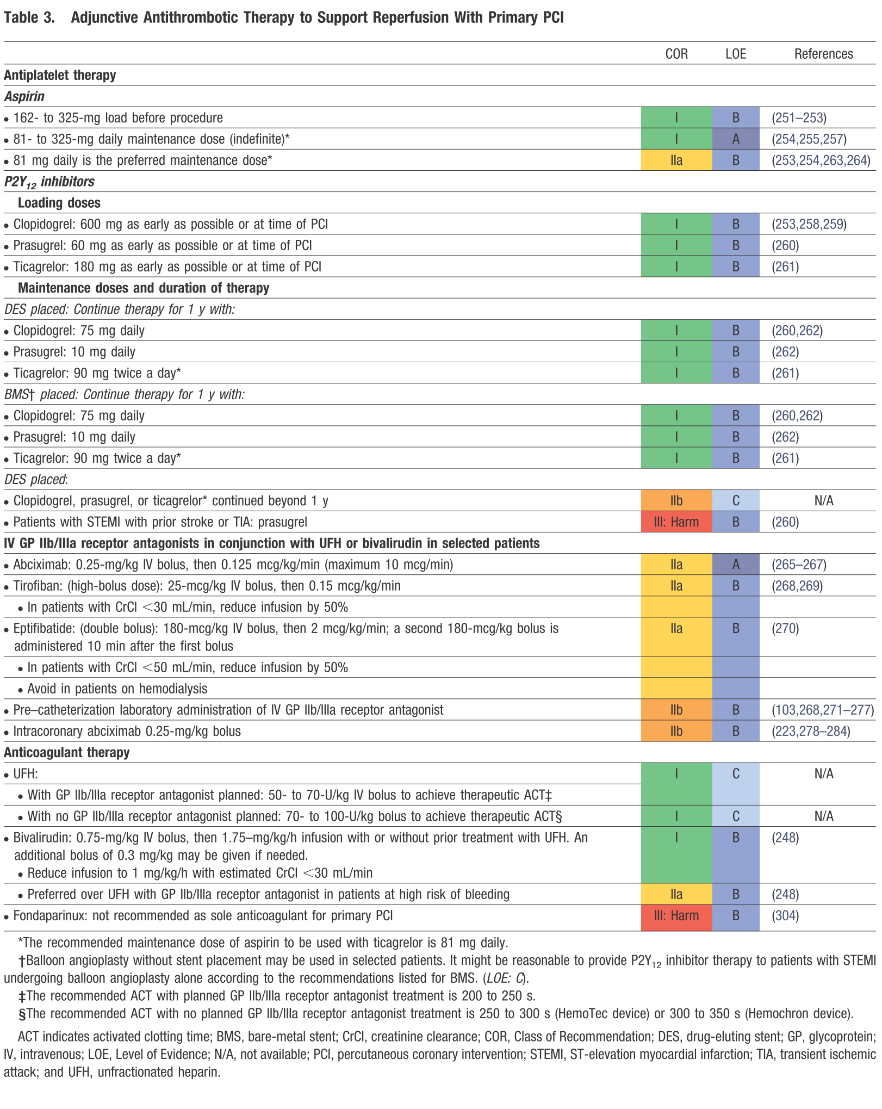

**Appendix 2 (Figure from ACC/ AHA 2013 STEMI guidelines)**

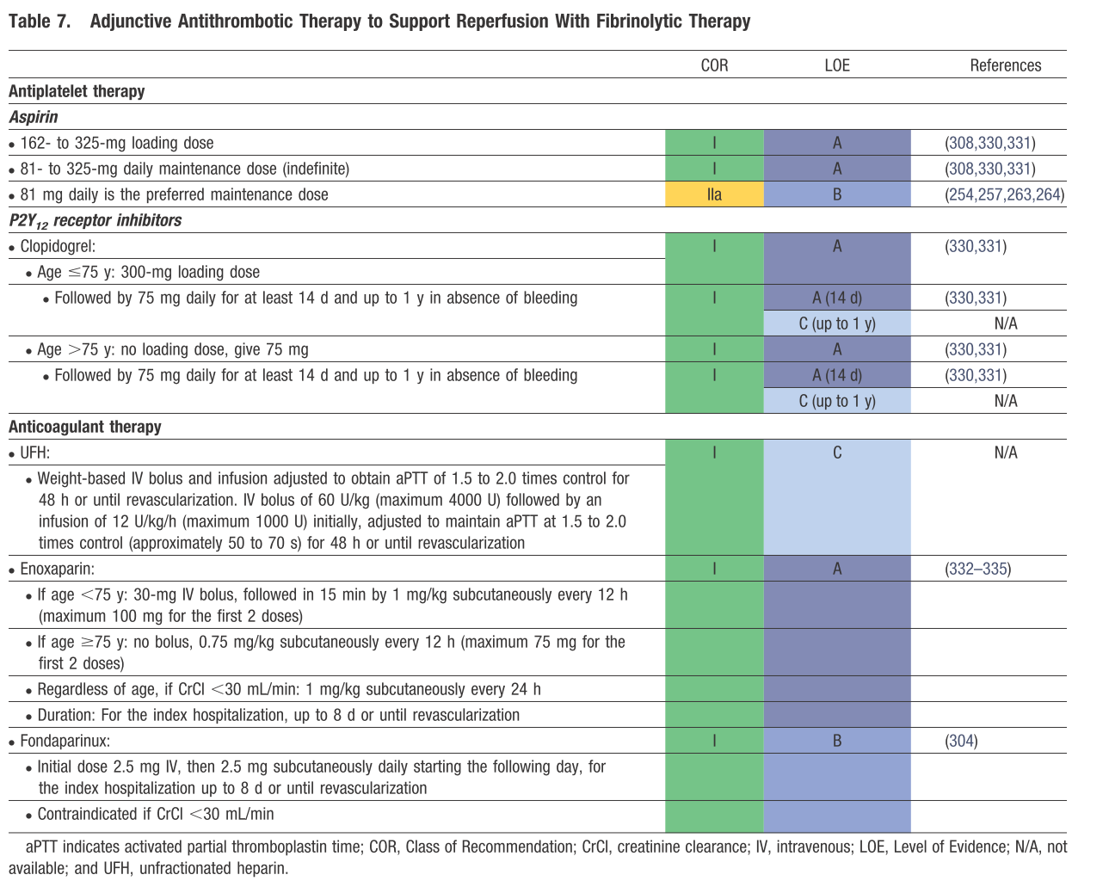

**Appendix 3: Summary Table**

|  |  |  |  |  |
| --- | --- | --- | --- | --- |
| Objectives | Outcomes | Predictor Variables | Hypothesis | Method of Analysis |
| Primary:  For Arabian Gulf patients presenting with ST elevation myocardial infarction and enrolled in the RACE III registry, How feasible and suitable the registry data is from the point of:  **•** Data completeness  • Appropriate recruitment time intervals | How feasible and suitable the registry data is from the point of:   * Data completeness * Appropriate recruitment time intervals | Use of EMS  (Y/N) | Use of EMS will improve providing timely care and other clinical outcomes in the EMS group. | Descriptive analysis:   * Data completeness. Defined as: “availability of ≥ 80% of the data set”. * Appropriate recruitment time intervals. Defined as: “recruitment of a total of 570 patients in on year”. |
| Secondary  For Arabian Gulf patients presenting with ST elevation myocardial infarction:   * Does the use of emergency medical services (EMS) improve providing timely care? Defined as (door to balloon time <90 minutes or door to needle time < 30 minutes). * For Arabian Gulf patients presenting with ST elevation myocardial infarction, does the use of emergency medical services (EMS) improve other clinical outcomes? | * Improve providing timely care? Defined as (door to balloon time <90 minutes or door to needle time < 30 minutes). * Death * Stroke * MI * Primary PCI use * Door to device time * Thrombolytic use * Door to needle time * No reperfusion * Killip class * Cardiac arrest * LV function by Echo * Use of EBM therapies in the first 24 hours and on discharge. * CABG | Multivariable analyses will be based on logistic regression for binary outcomes and linear regression for continuous outcomes.   1. We will use Cox-regression analysis if dates of events are available. 2. Analysis will be adjusted for potential covariates which include :   1.Educatonal Level  2.Country  3.Gender  4.Age  5.CAD risk factors  6.Socioeconomic Status  7.Markers of illness at presentation ( heart rate, blood pressure, Heart failure Killip class, cardiac arrest) |

**Figure 1 Heart rate (HR) histogram distribution**

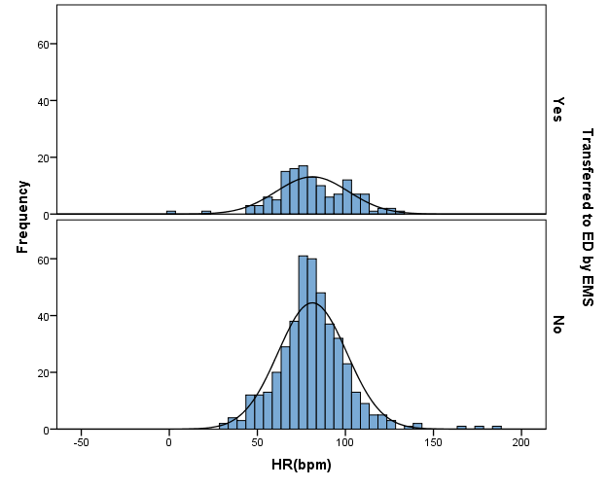

**Figure 2 Systolic blood pressure (SBP) histogram distribution**

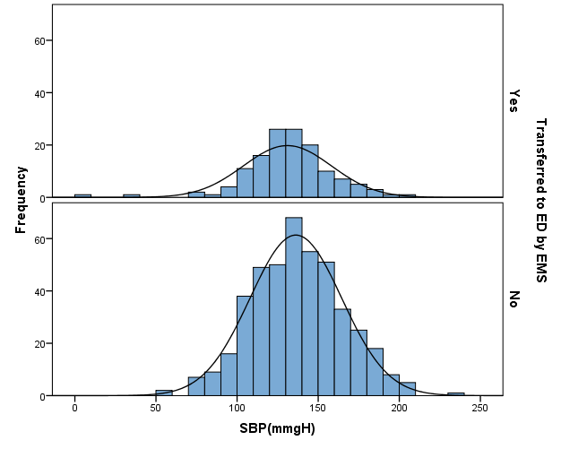

**Figure 3 Initial serum creatinine histogram distribution**

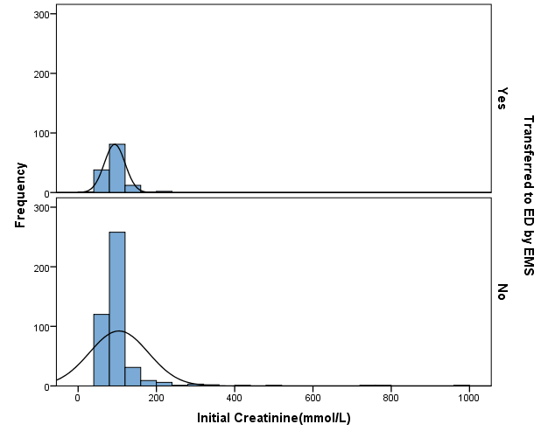

Figure 4 Peak serum creatinine histogram distribution

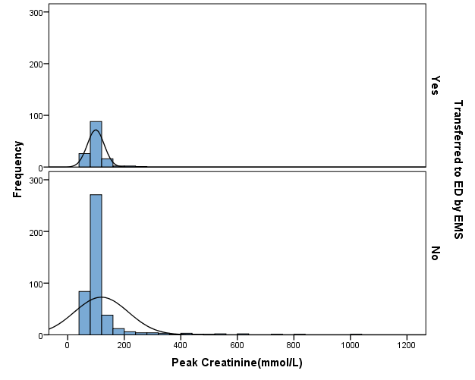

Figure 5 Peak serum creatinine kinase (CK) histogram distribution

