AN INTRODUCTION OF THE ICF TO CHIROPRACTIC INTERNS

THE INTERNATIONAL CLASSIFICATION OF FUNCTIONING, DISABILITY AND HEALTH (ICF) FRAMEWORK: THE IMPACT OF A BRIEF EDUCATIONAL INTERVENTION TO CHIROPRACTIC INTERNS

By JUSTYNE KERSLEY, B.Kin.(Hons), D.C.

A Thesis Submitted to the School of Graduate Studies in Partial Fulfilment of the
Requirements for the Degree of Master of Science

McMaster University
© Copyright by Justyne Kersley, March 2015

MASTER OF SCIENCE (2015) McMaster University
(Rehabilitation Science) Hamilton, Ontario

TITLE: The International Classification of Functioning, Disability and Health (ICF) Framework: The impact of a brief educational intervention to Chiropractic Interns
AUTHOR: Justyne Kersley, B.Kin. (Hons) (McMaster University), D.C. (Canadian Memorial Chiropractic College)
SUPERVISOR: Dr. Peter Rosenbaum
NUMBER OF PAGES: ix, 66

Abstract
Introduction: The World Health Organization (WHO) encourages the use of its International Classification of Functioning, Health and Disability (ICF) framework as a biopsychosocial approach for healthcare professions to understand health and disability. The ICF framework is not currently a component of the curriculum at Canadian Memorial Chiropractic College (CMCC); however its concepts adhere to the college’s program ideals and fit well into a chiropractic model of care.

Purpose: To examine whether a brief educational presentation introducing the ICF to chiropractic interns could result in a detectable change in the interns' clinical thought processes, thus stimulating the incorporation of a wider variety of ICF concepts into the interns’ report-writing including notes on progress and goal setting.

Methods: This study reviewed the clinical report writing style and content of chiropractic clinical interns practicing at one of two Aptus Treatment Centres in Toronto, Ontario. Reports were analyzed prior to and following an educational intervention in which the ICF was introduced to the chiropractic clinical interns with suggestions for applications into practice. Following the intervention a subset of the chiropractic interns was specifically encouraged to incorporate ICF concepts into their report writing. Three participant groups were formed: Group 1 participants attended the presentation and received post-presentation encouragement, Group 2 participants attended the presentations but did not receive direct encouragement to incorporate ICF concepts into their report writing, Group 3 participants were current clinical interns who did not attend the presentations and consented to the evaluation of their clinical reports. After being anonymized to the researchers the pre- and post-intervention reports were reviewed using a standardized evaluation scheme that categorized the use of ICF concepts.
Results: This proof of concept study provided evidence that with a brief introduction to the ICF, chiropractic interns were able to incorporate a greater variety of ICF constructs into their report writing. Detectable changes were noted with Groups 1 and 2. Group 1 demonstrated a decrease in use of references to body function and structure and a marked increase in references to both personal and environmental factors. Group 2 demonstrated a decrease in use of references to body function and structure as well as a notable increase in references to both participation and environmental factors. No detectable changes were noted in the report writing of Group 3 participants who were not exposed to the ICF teaching.

Conclusions: The results of this study indicate that with even short educational presentations chiropractic interns are able to adopt a well-established framework of healthcare concepts into their patient treatment plans as noted in their report writing. This was apparent in both participant groups who attended the presentations and was not dependent on direct encouragement. This knowledge may influence the chiropractic interns’ understanding of health and disability and their interprofessional communication, and affect patient outcomes. These questions should be explored in future prospective controlled studies.

Acknowledgements
I am sincerely grateful for the support and assistance of many people without whom completion of this thesis would not have been possible.

First of all, thank you Dr. Peter Rosenbaum. I am grateful for the support and guidance you have provided throughout this process. Peter, as a thesis supervisor you provided me with much more than educational guidance and often took on the various roles of counsellor, mentor, father-figure, confidant and friend. Thank you for understanding the steps I needed to take in order to complete this process
and for helping me to see the stairs.

Sincerest gratitude is given to my committee members, Sue Baptiste and Joy MacDermid. Thank you for your patience and allowing me the opportunity to work and learn at my own pace while providing me with your expertise, thoughtful insights and helpful feedback. I would also like to thank Liz Dzaman and Marlice Simon for managing my ‘right now’ questions and somehow always having the answers.

Thank you to the McMaster School of Rehabilitation Science for providing me with financial support and particularly for connecting me with some wonderful people. I have an immense appreciation for the support of my colleagues and for the friendships that I have gained throughout my research program. Tram Nguyen, I look forward to the day we sit at Starbucks and actually just talk to each other without looking over our computer screens. You’ve been a wonderful support for me and I know I could not have made it to this point without you. Thanks friend!

Dr. Steven Zylich, as the Aptus Treatment Centre supervisory clinician, your assistance with this project was integral to its success. Thank you for your help in arranging the presentations, encouraging intern participation and assisting with blinding procedures. Dr. Anthony Tibbles, thank you for allowing me the opportunity to work with the CMCC interns and for your help ensuring CMCC processes moved along smoothly.

Finally to my close friends and family, particularly my parents, Lorraine and John, I thank you for providing me with unconditional support, words of encouragement and perspective throughout this process. The journey to completion of this thesis was at times a bumpy road and I could not have made it to the end without a little help from my friends.

Table of Contents

Title Page……………………………………………………………………..…...i
Descriptive note………………………………………………………………......ii
Abstract………………………………………………………………………......iii
Acknowledgements…………………………………………………………….....v
Table of Contents…………...…………………………………….………….......vi
List of figures and tables……………………………………………………......viii
List of abbreviations………………………………………………………….....viii
Declaration of academic achievement…………………………………….……...ix

Chapter One
INTRODUCTION

- Thesis Rationale….……….………………………………………..…….....…1

1.1 Structure of the thesis……….………………………….…………..…….....…3

1.2 Background………………………………….…………….…………….....….4

International Classification of Functioning, Disability and Health
(ICF).……..……………………...……………………………..…………4

"The 'F-words' in Childhood Disability: I swear this is how we should think!" (F-words).……..………………………………..…….…...…..…13

Canadian Memorial Chiropractic College and The Aptus Treatment
Centre………………..………………………………………………...…16

Chapter Two
INTRODUCTION OF THE ICF TO HEALTHCARE PROFESSIONAL STUDENTS

2.0 Study Objectives……………………………………………………….....….19

2.1 Research Design and Methods……………...……………………………......20

Chapter Three
RESULTS

3.0 Results……………………………………………………………………......32

Chapter Four
DISCUSSION AND CONCLUSIONS

- Discussion………………………………..………………………………..…38

Reflection on Results………………………………………………...…...38

Reflection on the Results - Progress…………………....…………...…...38

Reflection on the Results - Goals…………………....…………...……....39

Reflection on the Results by Group..…………………....…………...…...41

Reflection on the Report Structure...………………………………...…...44

Interprofessional Education and Practice…………...………………......47

But that’s just ‘Common Sense’………...……………………………......49

4.1 Strengths and Limitations of this thesis……..…………..……………...……52

4.2 Implications and future research…..………….…………….…..………...….55

4.3 Overall Conclusions…………………...……………………..…...……...…..56

Reference List…………………..……………………………..………………....58

Appendices…………………………………………...………..………………....61

Appendix A. Hamilton Health Sciences/Faculty of Health Sciences Research Ethics Board Student Research Committee Approval……………………………………………………….…...……61

Appendix B. Ethics Board Approval Canadian Memorial Chiropractic College…………………………………………………………………...63

Appendix C. Sample of blinded CMCC ATC clinical case report……………………………………………………………….…….64

Appendix D. Outline of ICF categories and their respective subcategories………………………………………………………..........66

List of Figures and Tables
Figure 1: The World Health Organization’s ICF framework highlighting interactions between its components ……………………………………………11
Figure 2: The World Health Organization’s ICF framework with the ‘F-words’ incorporated…………………………………………………………………...…15
Figure 3: Participant group allocation……………………………………………21

Results Tables
Table 1: Binary Coding Analysis……………………………………...…………32

Table 2: Pre-presentation % use of ICF constructs in Progress section…………34
Post-presentation % use of ICF constructs in Progress section
% Difference use of ICF constructs in Progress section

Table 3: Pre-presentation % use of ICF constructs in Goals section………….…34
Post-presentation % use of ICF constructs in Goals section
% Difference use of ICF constructs in Goals section

List of Abbreviations and Symbols
ATC Aptus Treatment Centre
CMCC Canadian Memorial Chiropractic College
ICD International Classification of Diseases
ICF The International Classification of Functioning, Disability and Health
ICIDH The International Classification of Impairments, Disabilities and Handicaps
WHO World Health Organization

Declaration of Academic Achievement

I, Justyne Kersley, wrote this manuscript with editorial input and guidance from Peter Rosenbaum, Sue Baptiste and Joy MacDermid.

Justyne Kersley developed the overall study design, determined the research question, completed the ethics submissions for the Hamilton Health Sciences/Faculty of Health Sciences Research Ethics Board Student Research Committee and the Canadian Memorial Chiropractic College Research Ethics Board, developed and presented the educational intervention, developed the evaluation schematic, performed the data collection, interpreted the findings, and drafted the manuscript. Peter Rosenbaum assisted in reviewing and editing the ethics applications, refining the research question and study design, development of the evaluation schematic, completed blinding procedures prior to analysis, interpreting the findings, and provided editorial assistance with manuscript preparation. Sue Baptiste and Joy MacDermid assisted in refining the research question and study design, development of the evaluation schematic and provided editorial assistance with the final manuscript preparation.
CHAPTER ONE:
INTRODUCTION

- Thesis Rationale

Health and disability are dynamic multifactorial concepts incorporating biopsychosocial factors. The International Classification of Functioning, Health and Disability (ICF) is the World Health Organization's (WHO) framework for describing and classifying health and disability (WHO 2001). In clinical practice, healthcare providers can use this framework to guide approaches for goal setting, measuring outcomes and determining appropriate interventions. This study, designed as an exploratory proof of concept, set out to review the clinical report-writing style/content of chiropractic clinical interns both prior to and following an educational intervention in which the ICF Framework was introduced with suggestions for applications into practice. Although teaching of the ICF is not a current component of chiropractic education at the Canadian Memorial Chiropractic College (CMCC), the biopsychosocial approach to considering health and disability fits with CMCC’s promotion of patient-centred wellness care (CMCC 2015). Patient-centred care in this definition refers to an approach to healthcare taking into consideration the patient’s needs, values, and perspectives when developing a treatment plan with the clinician (Stewart et al. 2003).

As a biopsychosocial model of care the ICF provides the clinician a framework to guide treatment plans that incorporate a multitude of factors determining an individual’s health. This gives the clinician the opportunity to address patient needs from many viewpoints. The chiropractor is an expert in the field of neuromusculoskeletal healthcare and although considering physical diagnoses in their patients is important, a physical diagnosis provides information about a person’s health but does not solely determine health. “Diagnosis alone does not predict service needs, lengths of hospitalization, level of care or functional outcomes” (WHO 2002, p. 4).
- This study was designed to evaluate whether the introduction of a modern framework for health could lead to changes in the interns’ clinical approach as manifested by changes in the concepts they used in their clinical reports after exposure. It did not evaluate the service they are providing or their chiropractic skill level. Although many studies set out to evaluate the effectiveness of interventions on specific clinical outcomes it is also important to understand the thought process behind the treatment and how this affects the clinical encounter. Rosenbaum and Stewart (2004) state that “the way (healthcare providers) think about health and disease determines to a considerable extent what we do and say in our clinical encounters with patients” (p. 5). This study assessed the approach taken by healthcare professionals’ through the reporting of their patients’ health status and their treatment goals for their patients before and after an introduction to the ICF.

1.1 Structure of the thesis

This thesis is structured in the following manner:

Chapter One (Introduction)
This chapter offers descriptive details about the ICF by discussing its development, with definitions and underlying principles and by presenting the framework. An introduction to the ‘F-words in Childhood Disability’ (the ‘F-words’) will be provided as a way of describing the concepts of the ICF in a relatable and appealing manner. Background information will also be provided about CMCC and the clinical program of the chiropractic interns involved in the study.

Chapter Two (An Introduction of the ICF and the ‘F-words’ to Healthcare Professional Students)
This chapter presents the study objectives, the methodology and processes of an educational intervention in which the ICF and F-words were introduced to a group of CMCC chiropractic interns.

Chapter Three (Results)
This chapter reveals the impact of the educational presentations and presents the study results.

Chapter Four (Discussion and conclusions)
This chapter will summarize the important findings of this thesis, detail the study’s strengths and limitations, and outline implications for rehabilitation as well as areas for future research.

1.2 Background

International Classification of Functioning, Disability and Health (ICF)

The WHO encourages the use of the ICF Framework amongst healthcare professions as an approach to understand and talk about health and disability for all people. As health and disability are multifactorial concepts, the ICF recognizes and includes factors such as environmental concerns and participation in the framework. Developed by the WHO and approved and endorsed for use by the World Health Assembly in 2001, the ICF is considered the international standard to describe a broad approach to health and disability (WHO 2001). The ICF was originally developed to expand on the WHO’s 1980 publication – The International Classification of Impairments, Disabilities and Handicaps (ICIDH) (WHO 1980). The ICIDH was originally published as a multi-purpose classification system to relate to and complement the WHO’s International Classification of Diseases (ICD).

The primary purpose of the ICIDH was to serve as a classification system to code the consequences of diseases and was aimed at analyzing, describing and classifying such consequences, distinguishing between impairments, disabilities and handicaps (Masala 2008). The ICIDH was meant to be applicable in many sectors and although it was criticized for its imperfections (Grimby 2001; Rosenbaum & Stewart 2004; Masala 2008; Hurst 2003) it did present some advantages for enhancing the understanding of health and disability. Primarily, it introduced the idea that knowledge of an individual’s biomedical diagnosis or disease was inadequate to provide a complete definition on the status of their health (Rosenbaum & Stewart 2004). In a healthcare setting it reminded care providers that disease was related to a number of components: biomedical, functional and social. The ICIDH classification system used the labels “impairments,” “disabilities,” and “handicaps.” These labels reflected a negative connotation and created a classification of individuals with disabilities, as opposed to a useful and neutral classification of human functioning (Üstün et al. 2003). ‘Disability’ in this definition was still described as a point where health ended: a stage of being on the other side of wellness. The classification system was also critiqued for the linear approach it took in describing the consequences of diseases (Hurst 2003; Rosenbaum & Stewart 2004; Masala 2008) and thus the model was not widely adopted because of these perceived flaws noted in its original formatting (Rosenbaum & Stewart 2004; Stucki et al. 2002).

This use of negative language and the linearity of the classification system were recognized as strong disadvantages of the ICIDH, initiating the process at the WHO throughout the 1990s to revise and reshape the classification system. A multi-disciplinary team was assembled including healthcare providers and individuals with disabilities gathered from worldwide member groups, and after nearly a decade of alterations and modifications, the WHO published the ICF in 2001 (WHO 2001). The ICF changed the presentation of the WHO’s “consequences of disease”, as had been presented in the ICIDH, to a system of classification of human functioning and disability in the ICF (Grimby 2001; Perenboom & Chorus 2003).

The ICF was developed primarily to expand the classification system previously described in the ICIDH while also presenting a framework for organizing the facets of human functioning and disability that might be affected by a health condition. The ICF adopted a biopsychosocial model of disability, based on the integration of the medical and social models. This perspective was not new to healthcare, having been presented by Engel over 30 years prior (Engel 1977); however, at this time the vision of healthcare was undergoing a great shift and the concept of focussing efforts on individual disabilities was outdated and limiting (Üstün et al. 2003; Cerniauskaite et al. 2011). The emphasis was now being placed on the components of human functioning as a value of health. Human functioning was now highlighted as being associated with, and not merely a consequence of, a health condition (Stucki et al. 2002; Cieza et al. 2009).
One of the main purposes of the newly developed ICF was to provide a conceptual basis for the consequences of health conditions with the establishment of a common language to improve communication. The ICF standardized the language used to describe health and health-related states by incorporating the use of neutral language and terminology (WHO 2001). Establishment of a common language as well as a systematic coding scheme for health information systems allows for data to be shared amongst healthcare service providers, policy makers, research groups and governments.

For the purposes of this thesis the definitions below were used as outlined by the WHO (WHO 2001; WHO 2002).
Impairment: a loss or abnormality in body function or structure (including physical and mental function)
Disability: a disconnect between an individual’s capacity and their environment
Activity (and Activity Limitations): abilities and/or difficulties an individual may have in executing activities in terms of quantity or quality
Participation (and Participation Restrictions): enablers and/or problems an individual may experience in involvement in life situations
Contextual Factors: supports and/or obstacles affecting communication and/or involvement. Environmental factors include physical, social and attitudinal spaces and may be a facilitator for one person and a barrier for another. Personal factors include gender, age, social background, coping styles and other factors that influence how an individual experiences disability.

Foundations of the ICF and important underlying principles
As noted above, one of the criticisms of the ICIDH was its linear design and primary focus as a disability model. In contrast to this, the ICF is structured with an interactive design emphasizing human functioning with a universal focus in which it describes that all persons may and should expect to experience disability at some point in their lives. Together with traditional medical models of care, factors and symptoms are presented and a diagnostic process follows a ‘ruling out’ methodology. Nguyen and Gorter (2014) propose that “the ICF ideas encourage a rule in approach in which we include all relevant elements across several domains of the ICF in contrast to the traditional medical diagnostic process” (p. 760). By incorporating a ‘rule-in’ approach, the ICF highlights that an individual’s overall health status is affected by multiple factors, all of which should be incorporated into the clinical thought process when considering wellness and approaches to treatment.
There are four general principles that structure the development of the ICF and continue to be essential to its application. These principles are: Neutrality, Universality, Parity and etiological neutrality, and Environmental Influence (WHO 2001; WHO 2002).

Neutrality
The terminology used in the ICF is kept neutral to allow for ease of use and direct communication that reflects both positive and negative aspects of health, functioning and disability (WHO 2002).

Universality
The ICF can be used to describe health and functioning of all people and is not meant to be used to label or sort persons with disabilities into separate health categories or distinct social groups. Universality implies that the ICF is applicable to all people and is not dependent on physical, social and cultural state, or specific health status. It is to be expected that anyone and everyone will experience some level of disability in their lifetime. Cerniauskaite et al. highlight that the ICF presents functioning on a continuum; disability is not a complex that applies only to the minority but is relevant to all people as they are at different stages in their lives (Cerniauskaite et al. 2011).

Parity and etiological neutrality
This principle highlights that a health diagnosis alone does not provide enough information to infer participation in activities of daily living or participation within the community (WHO 2002). Knowledge of a single health diagnosis does not define an ability (or disability) or vice versa.

Environmental Influence
A key addition to the ICF as a model of human functioning is that of the influence of the environment. It has been described that viewing disability as an interaction between health condition and environmental factors is the key to how disability can be measured and how interventions to reduce it can be provided and evaluated (Cerniauskaite et al. 2011). Environmental factors may include both physical and social influences as well as interactions between the person and the environment.

ICF Structure
As described above, the ICF is designed as a classification system to measure human health, functioning and disability. It has also been well reported that in addition to its use as a classification system, the framework of interlinked ideas offers a conceptual structure to guide policy, education, research and clinical practice in the understanding of health and disability (Rosenbaum & Stewart 2004; McDougall et al. 2010). It is with use of this framework that this study was developed.

The ICF is structured into the following parts:
ICF Structure

1. Functioning and Disability
a) Body functions and structures
b) Activities
c) Participation
2. Contextual Factors
a) Environmental factors
b) Personal factors
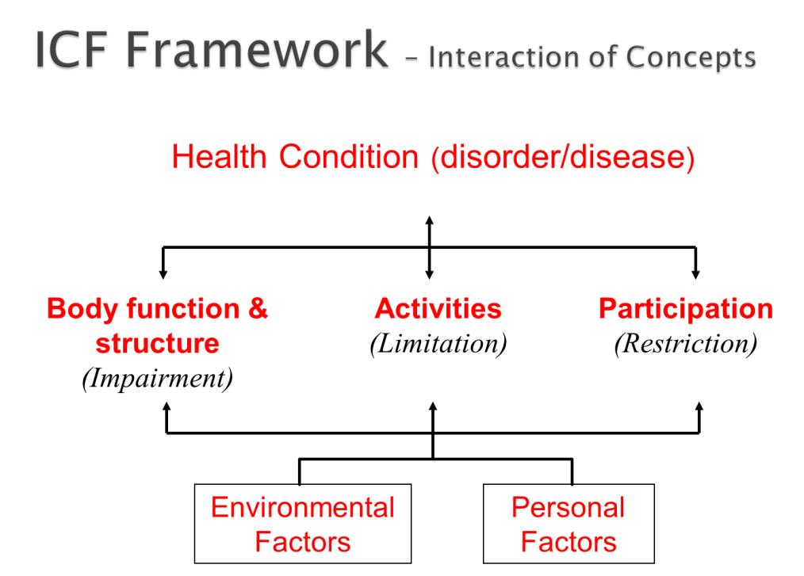

Figure 1: The World Health Organization’s ICF framework highlighting interactions between its components

The ICF Concepts defined (WHO 2001; WHO 2002)

Body Function and Structure describes the physiological and psychological functions of body systems as well as the structural or anatomical parts. This section is classified based on functional ability or impairment and has no specific connection to causality.

Activities are defined as the execution of a task or action by an individual. It is a personal perspective on what can be completed inherently by the person.

Participation is involvement in meaningful life activities ranging from basic to complex while taking into consideration the impact of barriers and facilitators to engagement. Participation reflects a person’s involvement from a societal or community perspective.

Environmental Factors include all aspects of the external world that have an influence on an individual’s level of functioning. These include facilitators that will promote or impact a person’s functionality positively, and barriers that degrade or impact a person’s functionality negatively.

Personal Factors are currently depicted in the framework but are not classified directly in the ICF. In the systematic review published in Disability and Rehabilitation in 2011 Cerniauskaite et al. indicate that future research should consider the development and classification of personal factors (Cerniauskaite et al. 2011). Personal factors commonly reflected include age, gender, culture, education level, etc. Personal factors may be independent of a specific health diagnosis; however, they likely have a direct impact on how or why a person responds to that condition in a specific manner.
"The 'F-words' in Childhood Disability: I swear this is how we should think!" (F-words)

The ‘F-words’ are a set of ideas developed by Rosenbaum and Gorter (2012), designed to create an engaging way for people to understand and incorporate ICF concepts into clinical practice, research and policy with specific emphasis in childhood disability. An introduction to the ICF framework and constructs was the primary goal of the educational presentations offered to the chiropractic interns participating in this study. The ‘F-words’ were incorporated into the presentations as a method of demonstrating how the ICF constructs can be directly applied in clinical reasoning. These concepts are meant to help clinicians to manage clinical cases more effectively by supporting the shift away from the sole use of a traditional biomedical model to one that incorporates the adoption of a biopsychosocial approach. It is proposed that clinicians move away from the idea of “Fixing” and towards an approach incorporating Family, Fun, Fitness, Friends, Function and Future (Rosenbaum & Gorter 2012).

The challenge with fixing is that it implies that something is wrong with the person and is in need of correction. People with disabilities may require a variety of supports but are certainly not broken. The expectation that specific treatment is required to address only a specific biomedical impairment is limiting. Changing the focus to the other descriptive F-words allows for the inclusion of many facets of health into a treatment plan and puts less of an emphasis on the disability.

“Family, Fun, Fitness, Friendship, Function and Future”
(Rosenbaum & Gorter 2012)

Family represents the environment for all children. It is widely supported that incorporating families into the treatment team will help to improve outcomes for children (and families).

Fun is represented within the categories of personal factors and participation. Participation in enjoyable life events may increase for the child by supporting events and creating activities that the child actually enjoys doing.

Fitness supports the components of body function and structure constructs in the ICF. Fitness incorporates an emphasis on health promotion and wellness while including physical, physiological and mental abilities.

Friendship is a component of personal factors and participation where the quality of the friendships is noted as more important than the quantity of connections. The act of both being and having a friend(s) is integral to personal and social development. The cultivation of friendship can develop many important skills, including compassion, compromise and empathy.

Function is described in activities and participation. Function is what we ‘do’, and for children that includes ‘play’. The focus should be placed on the functional achievement of the activity itself with only minor emphasis placed on how well the activity was actually achieved. It is in the ‘doing’ that function is promoted.

Finally the value in considering the future is described. Although this concept is not represented by a specific construct within the ICF structure (which offers a point-in-time cross-sectional view of a person’s status) it is important to consider as a whole as the ICF is designed to be relevant to all persons in various stages of life. It is important to evaluate present factors of health but also to be cognizant of and consider what the future may bring (Rosenbaum & Gorter 2012).

Functions
Fitness

Friendship
Fun

Family
Future

Figure 2: The World Health Organization’s ICF framework with the ‘F-words’ incorporated

Canadian Memorial Chiropractic College (CMCC) and The Aptus Treatment Centres (ATCs)

Chiropractic is a primary contact health care profession. Chiropractors offer expert knowledge in spinal and musculoskeletal health, emphasizing differential diagnosis, patient-centred care and research. The chiropractic program at Canadian Memorial Chiropractic College (CMCC) is a comprehensive, integrative curriculum designed to ensure that graduates of the CMCC Doctor of Chiropractic program meet the requirements of the profession. Applicants are accepted at CMCC after completing a minimum of three years of university education although most students enter the program after having completed a four-year university undergraduate degree. Students at CMCC then undergo a four-year program specializing in the management and treatment of neuromusculoskeletal disorders.

Currently, the ICF is not directly taught at CMCC, although the College's educational program’s ideals adhere to similar concepts. The CMCC program emphasizes a biopsychosocial approach to healthcare and trains chiropractic interns to examine and treat the ‘whole person’ with a patient-centred and evidence-guided curriculum (CMCC 2015). Knowledge of the ICF framework and how its constructs can be applied in practice may provide great benefit to the chiropractic clinical interns as they prepare to begin practice as licensed chiropractors working with other healthcare professionals who have knowledge of the ICF framework.

In the fourth year of study at CMCC students complete two six-month clinical internships under the direction of a licensed chiropractor. The chiropractic interns are provided with a choice of clinics in the Greater Toronto Area (GTA) that provide service to diverse patient populations. Two clinics, run out of The Aptus Treatment Centres (ATCs) – one adult and one children’s day program – allow students the opportunity for a second clinical placement for a nine-month term to work directly with, and provide chiropractic services to, individuals with chronic disabilities and complex special needs. Under the supervision of a licensed chiropractor, the fourth-year chiropractic interns assess clients, develop treatment plans, and implement programs of care on an individual patient basis.

The ATCs (formerly the Muki Baum Treatment Centres) originated in 1979 as an outlet to provide service to individuals with dual diagnoses. The program grew to incorporate multidisciplinary treatment teams and now sees over 180 children and adults through an adult day program, two children’s day programs and eight high-support residential homes (CMCC 2014). The chiropractic program through CMCC was added to the ATC program in 1993 and is available to individuals in both the adult and children’s day programs one day per week. The CMCC interns work with patients to help them meet developmental milestones as well as integrate chiropractic treatment into a care plan that involves multiple facets in an interdisciplinary care team.

The clinical interns are matched with prospective patients at the ATC who require an assessment for new treatment needs or for the continuation of care from the previous (graduating) chiropractic intern. The majority of patients treated at ATC have a medical diagnosis on the Autism spectrum with many having additional medical diagnoses. Treatment plans are intended to address physical, behavioural and functional therapy needs. After the initial assessment, interns write an ‘initial assessment case report’ outlining their findings to set goals and directives for care. At the end of the interns’ placement, or when a patient is ready to be discharged, the interns are also asked to write a progress or discharge report noting changes to the patient’s health status. These reports are made available for review for the next clinical intern who will be treating each individual patient and are kept in the individual’s ATC client file. Patient treatment plans vary according to the individual’s needs, abilities and progress.

CHAPTER TWO:
INTRODUCTION OF THE ICF TO HEALTHCARE PROFESSIONAL STUDENTS

2.0 Study Objectives

This study was designed as an exploratory proof of concept, and set out to review the clinical report-writing style/content of chiropractic clinical interns prior to and following an educational intervention in which the ICF framework was introduced with suggestions for applications into practice. A subset of the chiropractic interns was directed specifically to incorporate ICF concepts into their report writing. The pre- and post-intervention reports were reviewed using a standardized evaluation scheme and the writers’ use of ICF concepts categorized. The findings from this analysis of the reports were then examined to determine if there had been a detectable change in the interns' clinical thought processes; specifically, had the interns incorporated a variety of ICF concepts to their report-writing? This question was then evaluated further to determine if the changes in the interns’ report-writing were related to specific direction to do so, and to determine if the educational intervention alone was enough to promote new ways of thinking among the chiropractic interns.

It was hypothesized that this study would demonstrate that after being introduced to the ICF framework, chiropractic interns would consider a greater number of facets of health when developing plans to treat and educate their patients.

2.1 Research Design and Methods

The intervention in this study was given in the form of an educational presentation offered to a small number of participants to demonstrate its feasibility. It was proposed that if education on the ICF framework demonstrated a development in the thought process of the study participants as indicated by the uptake of the ICF concepts in their reports, it might be of value to CMCC (as well as other healthcare institutions) to consider incorporation of such training into the curriculum.

In March 2014 the chiropractic interns who were actively treating patients out of at least one of the CMCC ATC clinics were invited to attend presentations that provided an introduction to and education on the ICF. The interns were made aware of the presentations through word of mouth from their clinical supervisor. The interns were told by their supervisor that a CMCC graduate and former ATC intern had presentations prepared on a healthcare topic that might be of interest to them. He informed them that attendance at the presentations was not mandatory but that he encouraged all practicing interns to attend. No other forms of advertising were used and the interns were not given any other details about the presentations prior to attending. The presentations were held at the ATC during the interns’ ‘clinical rounds’ time in order to make the presentations accessible to all those wanting to attend.

A total of thirty interns consented to participate in this study. Twenty-one were available to attend the ICF presentations on the dates they were scheduled. Another nine interns agreed to have their reports evaluated for the purposes of this study however they were unable to attend the two presentations. These nine interns then became a third subgroup of participants to act as a control (comparison) group as they also consented and completed pre- and post-reports (based on the same timeline as the other interns) but were not exposed to the intervention directly at any stage.
3 Participant groups
n=30 total

n=21
Exposed to
Presentation

GROUP 3

n=9
Not Exposed to Presentation or Email

GROUP 2
n=10
Exposed to Presentation Email - not Encouraged
GROUP 1
n=11
Exposed to Presentation, Email & ICF Encouraged

Figure 3: Participant group allocation

Participants were shown two one-hour presentations (given on consecutive Tuesdays in March and April 2014) describing the ICF framework and the ‘F-words’. Information was given on the development of the ICF and ‘F-words’, the clinical relevance, and suggestions for applications into practice. These presentations were interactive and discussion-based with a PowerPoint presentation used as a point of reference to keep the group on topic. Participation in whole group discussion amongst the interns was encouraged. A discussion based approach was taken in order to provide the interns the opportunity to engage in their learning while motivating them to develop their own opinions about the topic (Buehl 2014). As noted above the presentations were given during the interns’ clinical rounds time while at their CMCC ATC clinic location. The presentations were prepared and given by the principal student investigator. As the interns were divided between two clinic locations a total of four presentations were given with each group of interns attending two. The PowerPoint presentation acted as a guideline to keep the presentations moving on the same topics for each group and each set of presentations.

At the beginning of the first presentation in each location, the investigator asked the participants if they had knowledge of the ICF prior to starting. The ICF is not currently taught at CMCC, however as professional healthcare students there was a potential that some of the participants may have had prior knowledge of the ICF from their own personal research. Of the twenty-one presentation participants
three indicated, by raising their hands, that they were vaguely familiar with, or had at least heard of, the framework. On further discussion it was determined that these three students were confusing the ICF with the International Classification of Diseases (ICD-10), the WHO’s standard diagnostic tool for epidemiology, health management and clinical purposes including an analysis of the general health situation of population groups. The ICD-10 is used to monitor the incidence and prevalence of diseases and other health problems of countries and populations (WHO 1993). It was then established that none of the clinical chiropractic interns who participated in the study had prior knowledge of the ICF.

The focus of the first presentation was to introduce the ICF to the interns. Background information was given on the framework’s development, its aims and purpose; terms were defined and underlying principles described. The visual framework itself was then presented with each of the constructs further defined. Day One finished with a discussion on usage of the ICF with examples provided to (and received from) the interns.

The second presentation was given to the interns one week following the first. Discussion began with a review of the visual framework itself and uses of the ICF in clinical practice, research and social policy were discussed. The interns were then introduced to another conceptual way of considering constructs of the ICF through introduction of the ‘F-words’ in Childhood Disability. The ‘F-words’ were chosen to be incorporated into these presentations as they present an engaging and easy way for people to appreciate, understand and incorporate the ICF concepts. The ‘F-Words’ encourage modern thinking in childhood disability while highlighting key factors important to childhood development (Rosenbaum & Gorter 2012). Day Two of presentations wrapped up with time allotted for a discussion on the use of the ICF in chiropractic clinical rationale and practice. Patient case examples, as well as clinical applications of the ICF as it relates to individuals treated at the ATCs, were then discussed among the group.

One week following the second presentation the interns were sent an email providing them with links to more information on the ICF framework, the ‘F-Words’ and the World Health Organization. In this email the interns were also all invited to reply with questions if they would like more information. Of the 21 interns who participated in the presentation portion of this study, a randomly selected 11 were also encouraged specifically to take the information they had learned and to incorporate a wider variety of ICF concepts into their final reports at the end of their internship placement. For allocation of the participants, a computer-generated randomization tool was used. This was done to provide another subgroup of interns for evaluation in order to determine whether the interns directly encouraged to use the ICF ideas in their reports were differentially able to use these concepts compared to the interns who were not specifically encouraged.
The chiropractic clinical interns’ consideration and use of ICF constructs were then evaluated through examination of their clinical reports both pre- and post-presentation. Reports written on patients that were currently under treatment at one of the CMCC ATC clinics were provided to the researchers from the ATC supervisory clinician. All personal identifiable details for both the intern and the patient about whom the report was written were blinded prior to evaluation by the ATC supervisory clinician and the principal student investigator’s supervisor. Identifying information of the report status (pre- or post-presentation) was removed and the order of the reports randomized prior to evaluation with use of a computerized random number generator. The ATC supervisory clinician kept information on the participating interns and group allocation, providing this information to the researchers only after the reports had been analysed. These reports were reviewed and coded to determine the number and variability of ICF constructs the chiropractic clinical interns used when evaluating health and disability in their patients. The interns' clinical reports, both pre- and post-intervention, were reviewed blindly post-intervention to determine if a greater number of ICF constructs were incorporated post-intervention, and if this was based on direct suggestion to those encouraged to do so or if the educational intervention itself was enough to encourage more diverse thinking.

Sample and sample size
Participants were recruited from a convenience sample of fourth year chiropractic clinical interns at CMCC treating at one of the two ATC clinic locations. All interns treating patients at an ATC clinic were invited to participate in the study. A total of thirty interns gave consent to participate in this study. Twenty-one interns attended the two presentations and nine interns acted as a ‘control’ (comparison) group as they were unable to attend the presentations but gave consent to their reports being analyzed. All of the interns were in their fourth and final year of the Doctor of Chiropractic program at CMCC and were English speaking with no specifications for age, gender, race or religion. All participants had a minimum of university level education with a good knowledge and understanding of general healthcare concepts and terminology.

Blinding and Confidentiality
Prior to scheduling the presentations and report evaluation, this study was approved by the Hamilton Health Sciences/Faculty of Health Sciences Research Ethics Board Student Research Committee (see Appendix A - REB #14-184-S) and by the CMCC Research Ethics Board (see Appendix B - REB #1403X04).

The chiropractic interns’ clinical reports are handled by their clinical supervisor and follow strict adherence to confidentiality based on CMCC’s policy and procedures. As noted above, the clinical reports evaluated in this study were assessed after all of the interns’ personal details (as well as the patients’ information) were removed by the ATC supervisory clinician and the principal student investigator’s supervisor. A computer generated randomizing tool was used by the student investigator’s supervisor’s assistant to assign new reference numbers to the reports in order to allow for analysis in a completely random order. The reports were then analyzed and coded without knowledge of group allocation or report status (pre- or post-intervention). The ATC supervisory clinician personally kept a record of the interns who attended the presentations and on those who provided access to their reports but did not attend the sessions. This information was blinded to the researchers until after the coding of the reports was completed.

Risk of Bias
In order to minimize the risk of bias a number of procedural steps were taken throughout completion of this study. At the recruitment level, all interns actively treating patients out of the ATC clinics were invited to attend the presentations. The interns were provided with no incentives for participation in this study aside from the potential knowledge they may gain from attending the presentations. All twenty one of the ATC interns who would knowingly be in clinic and available on both dates of the educational intervention chose to attend the presentations. No participants chose to withdraw from the study.
Group allocation for those in attendance was completed at random with the assistance of a random number generator. Data collection and analysis was also completed with the assistance of a random number generator allowing the assessor to be blinded to both group allocation and to the status of the report during the evaluation stage.

Analysis
Analysis of the data was completed using a standardized schematic developed by the researchers and based on the components of the ICF as outlined by the World Health Organization. The researchers were blinded both to the status of the interns (exposed to the intervention and encouraged to use ICF language, simply exposed to the educational intervention, or control) and to the status of the report (pre- or post-intervention).

The Report
At the CMCC ATCs the interns are provided with a standardized report format on which to annotate their individual assessment findings. Please see Appendix C for a sample report.

Headings on the standard report include:

Summary of Treatment and Rehabilitation Program

Start date, last consent date, and date of last communication with parent

Diagnosis:
- Primary file diagnosis:
- Current medications:
- Structural diagnosis:
- Current Treatments
- Progress
- Outcome Assessments
- Goals for next six months
For the purposes of this study two of the report’s sections were used for the analysis: Progress and Goals for the next six months. These were chosen for evaluation as they represent the sections of the report that reflect written feedback on results of intervention and future direction of intervention by the interns. It is in these sections that the interns report the effect of change from goals previously set and propose the best course of action for intended treatment outcomes. The schematic for analysis was developed using the headings outlined in the ICF framework. The general categories were labelled as such:
- Body Function and Structure
- Activities
- Participation
- Environmental Factors
- Personal Factors

The ICF provides both a framework for guidance of treatment and patient care as well as a full classification system. This study did not evaluate the incorporation of the classification system, nor did it intend to do so. Descriptive categories from the classification system were, however, used during the first stage of evaluation of the reports. Subcategories were framed for assessment of the language used by the interns in the Progress and Goals sections of the reports to further expand on the general categories noted above. These subcategories were taken from descriptions provided in the ICF classification system. For example the category Body Function and Structure was further divided into:
- Mental functions/structure
- Sensory structures/functions and pain
- Voice and speech structure/functions
- Functions/structure of the cardiovascular, haematological, immunological and respiratory systems
- Functions/structures of the digestive, metabolic, endocrine systems
- Genitourinary and reproductive structures/functions
- Neuromusculoskeletal and movement-related structures/functions
- Functions of the skin and related structures

Please see Appendix D for a detailed outline of all categories and respective subcategories. The Progress and Goals sections were then reviewed and the language used by the interns was analyzed and coded based on where each statement would fit into one of these subcategories. This was completed for each of the two sections for a total of sixty reports against all of the subcategories for each of the five general categories. The detailed data were collected and subsequently regrouped into placement within the suitable general category. The details were collected within subcategories to allow for a deeper understanding of what the interns specifically referenced; however data were analyzed based on the broader categories to allow for detailed analysis.

A total of thirty participants gave consent to their participation in this study, of which twenty-one attended the group presentations. No personal or demographic data were collected as these were not deemed necessary for the purposes of this study. All participants who attended the presentations had equal levels of chiropractic education, were not familiar with the ICF prior to attending these presentations and were training as chiropractic interns under the same supervisor at a clinic designed to treat individuals with complex developmental needs.

The interns’ clinical case reports were read and the language used was evaluated based on references to health concepts as laid out in the ICF. The reports were assessed and coded in random order and then reassigned after analysis into their respective groups. This study’s primary objective was to determine if chiropractic interns would incorporate a wider variety of health concepts in their report-writing following participation in an educational presentation during which the ICF was introduced to them.

CHAPTER THREE:
RESULTS

3.0 Results
The Progress and Goals sections of the reports were evaluated independently in a total of sixty reports (thirty pre-presentation and thirty post-presentation). Comments that referred to a component of the patient’s health were coded into the appropriate ICF category and analyzed within a binary coding system as well as in a detailed assessment in which each reference was analyzed as an absolute number.
The binary coding analysis in which a value of 1 was given for any reference to an ICF health construct and a value of 0 was given when no references were made by the intern indicates potential changes in the report writing style of the chiropractic interns.
Table 1 - Binary Coding Analysis

Section | Group # | BS&F | Act | Part | Enviro | PF
Progress | 1 | 0 | 0 | -1 | +4 | 0
 | 2 | 0 | 0 | -1 | -1 | +1
 | 3 | 0 | -1 | 0 | 0 | 0
Goal | 1 | +1 | +1 | +1 | +7 | +4
 | 2 | 0 | +2 | +3 | +4 | +1
 | 3 | 0 | +1 | 0 | -1 | -1

Detailed Results Summarized

In a detailed assessment of the use of ICF constructs, each individual reference made by the intern to a health construct was given an equal weighting of 1 and the absolute numbers were examined as a percentage of total references to health constructs in the ICF based on the general categories described above.

The summary tables on the following page outline percentages in the Progress section: pre-presentation, post-presentation and % difference; and in the Goals section: pre-presentation, post-presentation and % difference based on the cumulative number of total references made to health constructs in the ICF. Negative differences (decreases) in reference to a health construct post-presentation are shown as a (- #) in the % difference summary chart and positive changes (increases) are depicted as a (+ #) change.
* indicates a change in results greater than 5%

Group 1 - Attended presentations and received email encouragement to use the ICF
Group 2 – Attended presentations without email encouragement
Group 3 – Did not attend presentations, not emailed

Table 2a - Progress Notes (Pre) %
Group | BS&F | Act |  | Part |  | Enviro | PF
1 | 36 | 18.5 |  | 13.6 |  | 10.9 | 20.9
2 | 29.8 | 21.3 |  | 16.3 |  | 16.4 | 16.2
3 | 31.6 | 23.8 |  | 15.8 |  | 11.9 | 16.8
All groups | 33.6 | 21 |  | 15.2 |  | 13.1 | 18.1
Table 2b - Progress Notes (Post) %
Group | BS&F | Act |  | Part |  | Enviro | PF
1 | 29.9 | 17.7 |  | 13.9 |  | 18.5 | 20.4
2 | 28.9 | 20.5 |  | 15.6 |  | 15.4 | 19.5
3 | 33.1 | 18.9 |  | 15.2 |  | 12 | 18.6
All groups | 30.5 | 19 |  | 14.9 |  | 15.5 | 19.6
Table 2c - % Difference from Pre-Post - Progress
Group | BS&F | Act | Part |  | Enviro |  | PF
1 | -6.1* | -0.8 | +0.3 |  | +7.6* |  | -0.5
2 | -0.9 | -0.8 | -0.7 |  | -1 |  | +3.3
3 | +1.5 | -4.9 | -0.6 |  | +0.1 |  | +1.8
All groups | -3.1 | -2 | -0.3 |  | +2.4 |  | +1.5

Table 3a - Goals (Pre) %
Group |  | BS&F |  | Act |  | Part |  | Enviro |  | PF
1 |  | 67.4 |  | 19.7 |  | 10.4 |  | 2.6 |  | 0
2 |  | 66.2 |  | 18.6 |  | 2.9 |  | 7.8 |  | 4.6
3 |  | 58.2 |  | 29.9 |  | 0.1 |  | 5.3 |  | 5.3
All groups |  | 64.2 |  | 22.4 |  | 4.8 |  | 5.1 |  | 3.1
Table 3b - Goals (Post) %
Group |  | BS&F |  | Act |  | Part |  | Enviro |  | PF
1 |  | 49.7 |  | 18.5 |  | 8.8 |  | 16.3 |  | 6.8
2 |  | 48.5 |  | 22.8 |  | 8.4 |  | 13.4 |  | 6.9
3 |  | 60.8 |  | 30.6 |  | 0.2 |  | 4.3 |  | 2.7
All groups |  | 52.6 |  | 23.6 |  | 6.1 |  | 11.7 |  | 5.6
Table 3c - % Difference from Pre-Post - Goals
Group | BS&F |  | Act |  | Part |  | Enviro |  | PF
1 | -17.7* |  | -1.2 |  | -1.6 |  | +13.7* |  | +6.8*
2 | -17.7* |  | +4.2 |  | +5.5* |  | +5.6* |  | +2.3
3 | +2.6 |  | +0.7 |  | +0.1 |  | -1 |  | -2.6
All groups | -11.6* |  | +1.2 |  | +1.3 |  | +6.6* |  | +2.5
The Progress section of the report is the intern’s evaluation on how the patient has developed since the last full assessment. In this section the intern makes notes on improvements and/or shortfalls the patient has made in achieving the previously set goals. On initial review it is noted that without specific knowledge of the ICF or the specific categories, the interns across all three groups had displayed a variety of references across the health care constructs. Across all three groups progress notations on Body Function and Structure received the most attention at 33.6%. Environmental and Participation factors were reflected on least receiving 13.1% and 15.2% respectively averaged across all three groups.

From pre- to post-intervention report analysis, small changes were noted in the Progress section of the report in Group 1 only. From pre-presentation to post-presentation a decrease in reference to Body Function and Structure constructs (-6.1%) is balanced against an increase in reference to environmental factors (+7.6%).

The biggest differences were noted in the Goals section of the reports. This final section of the report provides the interns an opportunity to evaluate their patients’ overall health status and set goals for future treatment and directives for care. Goals were predominantly set for patients in the Body Function and Structure category at 64.2%. This was noted across all three groups with Participation, Environmental and Personal Factor goals receiving cumulatively only 13% of all goals considered.

From pre- to post-intervention a shift is noted in the report writing style of the interns in the Goals section in both Group 1 and Group 2. Group 1 demonstrated a substantial decrease in use of references to Body Function and Structure constructs (-17.7%) and a marked increase in references to Personal Factors (6.8%) and Environmental Factors (+13.7%) goals. Group 2 demonstrated a substantial decrease in use of references to Body Function and Structure constructs (-17.7%) as well and a notable increase in references to both Participation Factors (5.5%) and Environmental Factors (5.6%) goals.

Although the results from Group 1 and 2 differed there was a notable change in the reports of both groups that was not found in Group 3. A change was noted in both Group 1 and 2 despite the email encouragement that only participants in Group 1 received.

There were no distinct changes in the report writing style of participants in Group 3 based on the same timeline pre- to post-intervention.

There is, however, one interesting finding looking at Group 3 when compared to Groups 1 and 2 in initial review of the Goals section. In the evaluation of the pre-intervention reports for Group 3, Body Function and Structure has a notably lower percentage of focus than is seen in the other two groups; as well, the Activities section was markedly higher in Group 3 pre-intervention as compared to Groups 1 and 2 pre-intervention. In a study with a smaller number of participants one or two outliers in the data analysis may skew a category; however participants in Group 3 appear to have been using a slightly broader variety of ICF constructs in the Goals section of their report writing without having any known introduction to the ICF.

CHAPTER FOUR:
DISCUSSION AND CONCLUSIONS

4.0 Discussion
Reflection on Results
The results of this study demonstrate that even with a brief exposure to the ICF healthcare professional interns are able to understand and adopt its use as evidenced in their report writing. The biggest differences noted to support the finding that the interns were able to learn how to incorporate the ICF constructs in their report writing were found in the Goals section of the reports with smaller changes observed in the Progress section.

Reflection on Results - Progress
As the Progress section is a reflection of the patients’ performance based on previously set goals, the finding that denotes a smaller percentage of difference in this section of the report is not surprising. Interns noting progress changes post-presentation should be writing their progress notes based on achievements from the pre-presentation reports’ goals. This, however, was not directly observed in the analysis of these reports as the variability of constructs used in the post-presentation progress notes do not match the variability of constructs reflected in the goals outlined in the pre-presentation reports. With the incorporation of ICF education into the interns’ training the use of ICF terminology and framework are expected to help to connect components of assessment with classification of outcome measures, evaluation and future goal setting. This will help interns evaluate if the result of a desired intervention has met the previously set goals.

Reflection on Results - Goals
It is in the Goals section of the report that the interns evaluate their patients’ overall health status and set targets to direct future treatment. In the pre-presentation reports a majority of the goals set by the interns related specifically to health constructs focussed in the Body Function and Structure category. On average across all three groups this totaled 64.2% of all goals. Post-presentation goals still focussed on this same category however the percentage decreased to 52.6% across all groups. The goals referenced most commonly by the interns both pre- and post-presentation fit more specifically into the Body Function and Structure sub-categories: Neuromusculoskeletal and movement-related structures/functions, Mental structures/functions and Sensory structures/functions and pain.

The emphasis on treatment goals that affect Body Function and Structure may imply that the interns believe that to improve their patients’ health status they must set goals addressing shortfalls in their patients’ body function and structure as a primary means of improving their health. It might also indicate that the interns believe that it is within this health ‘category’ that they feel they can make the biggest difference as chiropractors. The reasons behind these initial findings were not evaluated directly in this study. A qualitative component to this quantitatively designed study may have provided further insight into this finding.

As a rehabilitation therapy, chiropractic care is understood to address physical deficits and it is thought that interns may have set goals specifically to address shortfalls in their patients’ body function and structure as a direct means to treat ‘physical deficits’. Clinically it is often assumed that an intervention aimed at a body function and structure will have an outcome affecting an individual’s performance or activity (Darrah et al. 2006). McDougall also highlights that despite accepted knowledge that health is a multifactorial concept rehabilitation services tend to focus on physical symptoms (McDougal et al. 2011).

As described above the health of an individual may be affected by a variety of factors. It is well recognized that participation is vital to child health and well-being (Law et al. 2011) and that unfortunately disabled children experience substantially lower levels of participation compared with children without disabilities (Engel-Yeger et al. 2009; Law et al. 2011). Larson and Verna (1999) note that “through participation children gain an understanding of societal expectations and develop competencies needed to function and flourish in their home, school and community environments” (Larson & Verma 1999). The ICF would be a positive addition to chiropractic clinical training as its framework goes well beyond body functions and structures and provides a structure to assess physical symptoms while recognizing the influence of other functional and contextual factors as well.

Reflection on Results by Group
A review of the study objective highlights two main questions. Following an introduction to the ICF could a detectable change be noted in chiropractic interns' clinical thought process; specifically, would the interns be able to incorporate a variety of ICF concepts to their report-writing? This question was then further evaluated to determine if the changes in the interns’ report-writing were related to specific direction to do so, and to determine if the educational intervention alone was enough to promote new ways of thinking among the chiropractic interns. The randomized group allocation was designed with these questions in mind.

The greatest level of difference noted in the interns’ report-writing across all three groups was seen from participants in Group 1. Participants in the group that attended the presentations and received direct email encouragement to incorporate the use of ICF constructs had noticeable changes in the Progress and Goals section of their reports. The difference in the Progress section in the post-presentation reports reveals a decrease of 6.1% in references to Body Function and Structure constructs and an increase of 7.6% for Environmental Factor goals. An even greater difference was detected in the Goals section of the reports for Group 1 with a 17.7% decrease to Body Function and Structure goals and an increase in Environmental Factor goals of 13.7% and in Personal Factor goals of 6.8% post-presentation and email encouragement. Although participant numbers in this study may be too small to determine statistical significance, these results appear to support that an introduction to the ICF can result in a detectable change in chiropractic interns' clinical thought processes as reflected in their report-writing.

Group 2 participants also demonstrated an uptake of the ICF concepts presented as a noticeable change was detected in the Goals section of Group 2’s post-presentation reports. A 17.7% decrease was noted in reference to Body Function and Structure constructs, an increase of 5.5% was noted in goals relating to Participation Factors and an increase of 5.6% was seen in Environmental Factor goals. No detectable change was noted in the Progress section of Group 2’s reports. The participants in Group 2 attended the presentations but did not receive an email that specifically encouraged the use of ICF constructs.

As noted in the Results section, evaluation of Group 3’s reports revealed no detectable change pre- to post-presentation. However evaluation of the reports from Group 3 did indicate an interesting finding. Group 3 participants appear to have been using a slightly broader variety of ICF constructs in the Goals section of their report writing without having any known introduction to the ICF. In the pre-presentation reports Group 3 goals for Body Function and Structure reflected 58.2% of total goals which is notably lower than what was seen in Group 1 and Group 2 with 67.4% and 66.2%, respectively. The Activities section was also markedly higher in Group 3 pre-intervention at 29.9% as compared to Groups 1 (19.7%) and Group 2 (18.6%).

All twenty-one participants in Groups 1 and 2 self-reported that they were unfamiliar with the ICF prior to these educational presentations at onset. This point, however, could not be confirmed with the nine interns who provided consent to evaluate their case reports, having not attended the presentations (Group 3). It is known that these interns had not been directly taught the ICF within their chiropractic education; however prior knowledge of the ICF and other healthcare concepts was not known of the members of Group 3. This may have been simply a factor in this finding, but we do know that the other demographics of Group 3 do not differ from that of Groups 1 and 2. They have equal levels of chiropractic education and are training as chiropractic interns under the same supervisor and in the same clinics. Regardless, this study set out to evaluate if there was a detectable change from pre- to post-intervention and as the numbers do not change significantly from pre-presentation to post-presentation based on the same timeline there is no meaningful change to note in Group 3. Post-intervention evaluation of Group 3’s reports still indicates no difference from that presented in their pre-intervention reports in all five general categories.

Therefore in response to the second question posed, it is probable that the changes noted in the interns’ report-writing were primarily a result of attendance at the presentations. It may be important to note that greater differences were detected in Group 1’s reports, indicating that the email encouragement may not have been necessary for uptake of the ICF constructs but that the encouragement did appear to have an additional affect.

Reflection on the Report Structure
To evaluate the structure of the report itself it is important first to understand and review how treatment models and ideas about health and disability are taught at CMCC. The CMCC curriculum promotes evidence-informed practice along with the use of a biopsychosocial model of care (CMCC 2015). In the first year course Chiropractic Clinical Practice, students are introduced to the theory and application of evidence-informed clinical practice and initially exposed to the skills required for critical appraisal, and application of current health care literature. Students are also introduced to the principles of biomedical, social and biopsychosocial models of care and are presented with the World Health Organization’s definition of health as “a state of complete physical, mental and social well-being and not merely the absence of disease or infirmity” (WHO 1984). In the third year course Integrated Chiropractic Practice, clinical reasoning skills are further encouraged where evidence-based care within a biopsychosocial model is emphasized (CMCC 2015). Although a biopsychosocial model of care is emphasized, neither the ICF nor any other specific framework is directly taught. Ideas about childhood disability are presented to the students in the third year course Chiropractic Practice: Special Populations: Paediatric Patient. According to the CMCC website, students in this course are taught diagnosis and management of birth disorders, child development, the neuromusculoskeletal system, orthopaedics, infectious diseases and common malignancies of the paediatric patient. It is noted that in this course emphasis is placed on prevention and correction of structural problems and on determining which conditions are responsive to chiropractic care (CMCC 2015).

In the fourth year of study CMCC students are practicing clinically as chiropractic interns and utilizing the information taught to them throughout their program of study. This includes not only treating clinic patients but also documenting their assessments and outcomes accurately. At the ATC clinics the interns are provided with a template report format for this documentation. The benefit in having a template report style to follow is in the assistance it provides for ease of transition and for continuation of care for the patient as the interns change over each school year. A good template can provide structure and guidelines while still allowing for individual interpretation and thorough assessment. On the other hand, use of a template can also lead to complacency as the interns may fall into the trap of cutting and pasting previously noted progress assessments and goals from the preceding intern’s outline. The latter approach was noted in a large number of the reports evaluated in this study. As a result, in many of the reports there were inconsistencies between the diagnostic identification and the nature of the intervention and again between the planned intervention and the goals set to be achieved. Non-specific and broad goals were set with very little connection to the earlier identified impairments.

For healthcare professionals it is important that a critical review of interventions and outcomes is completed with each new treatment plan. This is highlighted as a component of CMCC’s curriculum; however, regrettably, this was lacking in a majority of the reports evaluated. If previously set goals are not achieved a few steps can and should be taken. The intervention itself should be evaluated: was it applied appropriately, were the dosage and frequency properly selected, and was it the right intervention to address the noted shortfalls? Second, evaluation of the goal itself is important: was the goal specific enough to note change, are the set goals appropriate for the patient and do they address a specific need? Re-evaluation of the goal also needs to be completed against the chosen treatment: was it achievable with the interventions selected?

Many of the goals simply targeted improvements in broad physical categories such as “increase strength” and “improve posture”. A number of clinical challenges arise when using a treatment model that addresses only physical symptoms, emphasizing ‘fixing’, particularly when treating individuals within this patient population. Potential complications may be seen at both the assessment and intervention level. Interns providing care at the chiropractic clinic within the ATCs are managing a heavy patient load with individuals who present with complex, chronic physical impairments with a variety of developmental challenges to consider. Two individuals may present to one intern for treatment with the same health diagnosis but with completely varied physical abilities. Conversely two individuals may present with entirely different diagnoses but share common functional limitations. Setting goals based purely on physical impairments is limiting to both the patient and to the intern’s health professional knowledge. Goals should be designed to assist each patient in achieving health according to the WHO definition and not merely the absence of disease or fixing of physical impairment. Introducing the ICF to chiropractic interns at a curriculum and/or clinical level may broaden their view on different facets of health while still providing a framework with structure to assist interns to select suitable interventions to guide appropriate treatment plans.

Interprofessional Education and Practice
Incorporating the ICF into the curriculum at CMCC, and within other health professional institutions, will benefit students of rehabilitation disciplines as well as serve the public. The ICF provides a structure to promote interprofessional connections and improved communication (Steiner 2002; Allan 2006; Stephenson & Richardson 2008). One of the noted benefits of the ICF is its use of a unified and neutral language that can act as an interprofessional terminology with which to facilitate the communication of health information across disciplinary and geographic boundaries (WHO 2002). It has been suggested that when properly utilized the ICF framework could promote a common, international language with potential to facilitate communication and support research across disciplines as well as across national boundaries. Interprofessional use of the ICF can stimulate interdisciplinary work, improvements in clinical care, health policy and management (Stucki 2003; Jette 2006).

The ICF framework itself creates a structure that allows health professionals to evaluate the variety of facets that come together to both define and impact health on an individual basis. It may also serve as a structure to highlight the roles of different disciplines, thereby helping health professionals to appreciate where another professional’s skills could benefit their patients, particularly in complex cases. Allan et al. report that “by providing a conceptual framework that is holistic and inclusive, the ICF can create opportunities for professionals to learn about one another’s disciplines” (Allan et al. 2006 p. 242). Furthermore it is imperative that the ICF be a component of the healthcare students’ curriculum, because this is where they are both learning and developing their own theoretical perspectives on how to treat patients and manage future caseloads. By definition, students have limited experience when compared with practicing health professionals and may not as easily recognize the benefits afforded by a biopsychosocial approach. It is for this reason that Allan et al. promote the importance of incorporating instruction of the ICF at a curriculum level, emphasizing the need for current and future healthcare professionals to receive instruction in the conceptual framework and language of the ICF (Allan et al. 2006).

But that’s just ‘Common Sense’
This study was followed a quantitative design; however, in retrospect a proper qualitative component would have provided important additional insight. At the onset of the first presentation the interns were shown a slide that simply stated ‘Determinants of Health’ and were then asked to discuss what they felt fit into this category. The interns entered into discussion, quickly saying: ‘the environment’, ‘access to health care ’, ‘socioeconomic statuses and ‘physical diagnoses’. The next slide presented to the interns presented three statements: ‘Individual characteristics and Behaviours, Physical Environment and Social and Economic Environment’. The group then discussed how each of the statements the interns provided fit within and across these categories.

As the presentation and group discussion continued a slide that asked ‘What do you see?’ was presented and then followed by a short video. The interns were provided with no details but were shown a video of a three-year-old girl at what appears to be a doctor’s office or medical clinic being filmed by her father. When the video ended the interns answered the question ‘What do you see?’ They identified that the young girl in the video appeared to have spasticity in her movements, that she fell frequently, and that she used the wall and/or door handles to help herself get up after each fall. When asked what these observations said about her health, the first response in each presentation was that she appeared to have Cerebral Palsy. The interns were correct about her physical diagnosis and the impairments present, however the presenter then highlighted other visible components in the video: yes she fell frequently but the young girl was able to walk without the use of assistive devices, she was verbal, playful in her responses to her father (who was behind the camera), was dressed in clean well-fitted clothing and appeared to be in a medical office building indicating access to healthcare.

Only moments before the group had discussed multiple determinants of health that were not specifically related to a physical diagnosis, however each response to the video described only that component. On first account nothing was mentioned about the environment in which she appeared, the playful interaction with her father or that she appeared happy and lively. Each of the responses focused on an impairment the girl appeared to have or a ‘disability’ with apparent lack of awareness to her ‘abilities’. This was brought up to the interns who invariably replied ‘but those things are just common sense’. One intern specifically replied that everyone sees those ‘common things’ and that she highlighted the other components as being what she saw as a future healthcare professional.

This concept of accepting the ICF as ‘common sense’ was initiated by the interns following the video and continued to be raised at various points throughout both presentations. The Merriam-Webster dictionary online defines common sense as “sound and prudent judgment based on a simple perception of the situation or facts” and “the ability to think and behave in a reasonable way to make good decisions” (Merriam-Webster 2015). Wikipedia describes common sense as “a basic ability to perceive, understand and judge things which is shared by (common to) nearly all people, and can be reasonably expected of nearly all people without any need for debate” (Wikipedia 2015). Despite being unfamiliar with the ICF prior to attending these presentations, a majority of the interns described feeling comfortable with learning and adopting the ICF framework as they reported feeling that what they were being presented with (i.e. the ICF) was common sense. The question then arises whether, if use of the components of the ICF can reasonably be expected of nearly all people without any need for debate, why is it not ‘common sense’ across all healthcare professionals (and healthcare professional interns) that evaluating health should include an explicit assessment of the patient’s strengths as well as the apparent deficits? When concepts seem familiar and are easily understandable they are often viewed as common sense after they are brought to light. It appears that the information presented to the interns ‘made sense’ but was not ‘common sense’. On first evaluation of the video the interns focused on the physical disabilities and gave an explanation that inferred correcting or fixing these disabilities would lead to improved health. This was also noted in the evaluation of their clinical reports. If this is what the interns as future healthcare professionals saw, what should be expected from the general population? Healthcare professionals need to ensure that the definition of health being translated to their patients includes the emphasis that health resides on a continuum with disability. It is a multifactorial concept and is affected by a variety of constructs beyond physical diagnosis alone. And yes, this should be common sense.

4.1 Strengths and Limitations of this thesis

Strengths
An evidence-informed healthcare concept that supplemented their current educational paradigm was introduced to, and easily accepted by, healthcare professional interns. A relatively rich discussion was raised during the presentations with the interns demonstrating positive uptake of the concepts and expressing interest in learning more.

- This study posed very little to no risk to the participating interns. Every effort was made to ensure that the reports were analyzed anonymously with the researcher being blinded to both the participant group and status (timing) of the report during the analysis.

Many studies examine new treatments or devices, and although this type of research is highly valuable, it is also important for the scientific community that awareness of concepts and frameworks be examined and introduced to healthcare professionals early in their training and career. It is during these early stages of education that theoretical knowledge is being taught and developed that will provide direction into their future healthcare practice. As future healthcare professionals, participation in this study has apparently benefited the clinical interns by informing them about global healthcare concepts that emphasize an internationally recognized multifactorial approach to health and disability.

Limitations
One limitation to this proof-of-concept study is the small sample size used, thereby possibly limiting the direct conclusions that can be taken from the results. All interns practicing at the ATCs were invited to participate, however only a convenience sample of those in attendance on both presentation dates was used. It is also possible that contamination may have occurred between participant groups with discussion on the ICF following the presentations occurring amongst interns in all three groups. In addition, each individual participant’s level of attention during the presentations and/or their interest in the topic may have had an effect on the results.

Another limitation of this study lies in the undetermined value that healthcare professionals (and interns) should be placing on each of the individual constructs the ICF presents. The interns in this study were encouraged to incorporate a wider variety of the ICF concepts into their report writing, however, as health must be defined per the individual, no absolute or correct values for use of each construct can be provided. The role of this study was to introduce the ICF to healthcare professional interns while highlighting the biopsychosocial concepts within it. The constructs that fit into the ICF framework are non-hierarchical with a change of any one component having a potential impact on one’s health, as might a change in another construct. It was hypothesized and confirmed through evaluation of the interns’ reports that despite knowledge that health can be affected by many factors, emphasis in rehabilitation often focusses on health as particularly a component of a physical diagnosis. The results of this study are noted as positive as a discernable change was noted in the use of ICF constructs incorporated into the interns’ report writing; however, the degree of what constitutes ideal cannot be defined.

4.2 Implications and future research

In order to serve the needs of the patient a rehabilitation therapist must be able to assess what the patient’s needs are, determine what factors might be interfering in people being able to achieve those needs, apply an appropriate intervention and evaluate its effectiveness. Although this study evaluated the uptake of the introduction of the ICF to chiropractic clinical interns, this pattern of assessment and treatment is a commonality across rehabilitation disciplines and does not define the professional or the chosen intervention. In 2011 Jelsma and Scott assessed the impact of using the ICF framework as an assessment tool for physiotherapy students treating a pediatric population. Similar to the overall results noted in this study, they found results that supported the use of the ICF framework for clinical assessment and treatment planning (Jelsma & Scott 2011).

With knowledge that an introduction to the ICF can influence the clinical reasoning and report writing of healthcare professional interns, future studies should explore how this is applied directly in clinical practice. How does knowledge of the ICF affect patient care and targeted outcomes? Do patients ultimately benefit from the use of these concepts?

Future research should also include the application of the ICF framework into various levels of curriculum for a variety of healthcare professional disciplines. Application of the ICF framework into clinical practice for different patient population groups should also be studied.

4.3 Overall Conclusions

The results of this study indicate that with short educational presentations chiropractic clinical interns are able not only to learn new healthcare concepts but also to apply them into clinical practice as demonstrated in their report writing style. The proper dosage and frequency of education required on the ICF is yet to be determined, however with even a brief introduction to the topic, chiropractic interns were able to adopt the concepts. This study included a small number of participants and although generalization to all disciplines cannot be assumed the educational intervention emphasized an approach to healthcare that is likely not isolated to chiropractic practice.

It is believed that chiropractic interns, along with students in other healthcare disciplines, will benefit greatly with the incorporation of the ICF framework into education planning and curriculum. In disciplines that emphasize physical rehabilitation encouraging a focus on ‘function’ instead of on ‘fixing’ should promote the uptake of a wider definition of health and provide a comprehensive approach to patient care. In childhood disability many physical impairments cannot be ‘fixed’ according to a traditional biomedical model; however, with use of the ICF framework and an approach that incorporates a biopsychosocial model of care we can improve wellness by managing these conditions and improve health by addressing the many facets that define it.

Reference List

Allan CM, Campbell WN, Guptill CA, Stephenson FF, Campbell KE. (2006). A conceptual model for interprofessional education: the International Classification of Functioning, Disability and Health (ICF). Journal of Interprofessional Care, 20(3):235-45.

Buehl, D. (2014). Classroom Strategies for Interactive Learning (4th ed.) Newark, DE: International Reading Association.

Canadian Memorial Chiropractic College (CMCC). Clinic Page.
(n.d.). Retrieved November, 2014, from http://www.cmcc.ca

Canadian Memorial Chiropractic College (CMCC). Undergraduate Education.
(n.d.). Retrieved January 25, 2015, from http://www.cmcc.ca

Cerniauskaite, M., Quintas, R., Boldt, C., Raggi, A., Cieza, A., Bickenbach, J., & Leonardi, M. (2011). Systematic literature review on ICF from 2001 to 2009: Its use, implementation and operationalisation. Disability and Rehabilitation, 33(4), 281–309.

Cieza A, Hilfiker R, Chatterji S, Kostanjsek N, Ustun BT, Stucki G. (2009). The International Classification of Functioning, Disability, and Health could be used to measure functioning. Journal of Clinical Epidemiology, 62, 899–911.

Darrah J, Loomis J, Manns P, Norton B, May L. (2006). Role of conceptual models in a physical therapy curriculum: application of an integrated model of theory, research, and clinical practice. Physiotherapy Theory and Practice, 22(5)
239–250.

Engel, G.L. (1977). The need for a new medical model: a challenge for biomedicine. Science, 196, 129–136.

Engel-Yeger, B., Jarus, T., Anaby, D. & Law, M. (2009). Differences in patterns of participation between youths with cerebral palsy and CHIEF for Children Parent Version 7 typically developing peers. American Journal of Occupational Therapy, 63, 96–104.

Grimby G, Smedby B. (2001). ICF approved as the successor of ICIDH. Journal of Rehabilitation Medicine, 33, 193–194.

Hurst, R. (2003). The International Disability Rights Movement and the ICF. Disability and Rehabilitation, 25(11–12), 572–576.

Jelsma J & Scott D. (2011). Impact of using the ICF framework as an assessment
tool for students in paediatric physiotherapy: a preliminary study. Physiotherapy,
97: 47-54.

Jette AM. (2006). Toward a common language for function, disability, and health. Physical Therapy, 86, 726–734.
Larson, R. W., Verma, S. (1999). How children and adolescents spend time across the world: work, play, and developmental opportunities. Psychology Bulletin, 125, 701–736.

Law, M., Anaby, D., DeMatteo, C., Hanna, S. (2011). Participation patterns of children with acquired brain injury. Brain Injury, 25, 587–595.

Masala, C., Petretto, D.R. (2008). From Disablement to Enablement: Conceptual models of disability in the 20th century. Disability and Rehabilitation, 30(17), 1233 – 1244.

McDougall J., Wright V., Rosenbaum P. (2010). The ICF model of functioning and disability: incorporating quality of life and human development. Developmental Neurorehabilitation, 13(3), 204–11.

Merriam-Webster. ‘Common Sense’ [Def. 1]. (n.d.). Merriam-Webster Online. In Merriam-Webster. Retrieved January 25, 2015, from http://www.merriam-webster.com/dictionary

Ngyuen, T., Gorter J.W. (2014). Use of the international classification of functioning, disability and health as a framework for transition from paediatric to adult healthcare. Child: care, health and development, 40: 759–761.

Perenboom RJM, Chorus AMJ. (20030. Measuring participation according to the International Classification of Functioning, Disability and Health (ICF). Disability and Rehabilitation, 25, 577 – 587.

Rosenbaum PL, Gorter JW. (2012). The ‘F-Words’ in childhood disability: I swear this is how we should think!. Child: care, health and development, 38, 457–63.

Rosenbaum, P., Stewart, D. (2004). The World Health Organization International Classification of Functioning, Disability, and Health: A Model to Guide Clinical Thinking, Practice and Research in the Field of Cerebral Palsy. Seminars in Pediatric Neurology, 11(1), 5-10.
Steiner WA, Ryser L, Huber E, Uebelhart D, Aeschlimann A, Stucki G. (2002). Use of the ICF model as a clinical problemsolving tool in physical therapy and rehabilitation medicine. Physical Therapy, 82:1098–1107.
Stephenson, R., Richardson, B. (2008). Building an Interprofessional Curriculum Framework for Health: A Paradigm for Health Function. Advances in Health Sciences Education, 13(4), 547-557.
Stewart, M., Belle Brown, J., Weston, W.W., McWhinney, I.R., McWilliam, C.L.,
& Freeman, T.R. (2003). Patient-Centered Medicine Transforming the Clinical Method. (2nd ed). Abingdon: Radcliffe Medical Press.

Stucki G, Ewert T, Cieza A. (2002).Value and application of the ICF in rehabilitation medicine. Disability and Rehabilitation, 24(17), 932–938.
Stucki G, Ewert T, Cieza A. (2003). Value and application of the ICF in rehabilitation medicine. Disability and Rehabilitation, 25, 628 – 634.

Üstün, T. B., Chatterji, S., Bickenbach, J., Kostanjsek, N., & Schneider, M., (2003). The International Classification of Functioning, Disability and Health: A new tool for understanding disability and health. Disability and Rehabilitation, 25, 565-571.

World Health Organization (WHO) (1980) International Classification of Impairments, Disabilities and Handicaps (ICIDH). WHO, Geneva
World Health Organization (WHO) (1984) ‘Definition of Health’. http://www.who.int/about/definition
World Health Organization (1993) The ICD-10 Classification of Mental and Behavioural Disorders: Diagnostic Criteria for Research. WHO, Geneva.
World Health Organization (WHO) (2001) International Classification of Functioning, Disability and Health (ICF). WHO, Geneva
World Health Organization (WHO) (2002) Toward a Common Language for Function, Disability, and Health: ICF. WHO, Geneva
Wikipedia. (n.d.). Common Sense. Retrieved January 2015, from http://www.en.wikipedia.org/wiki/Common_sense

Appendices

Appendix A. Ethics Board Approval Hamilton Health Sciences/McMaster Research Student Research Committee

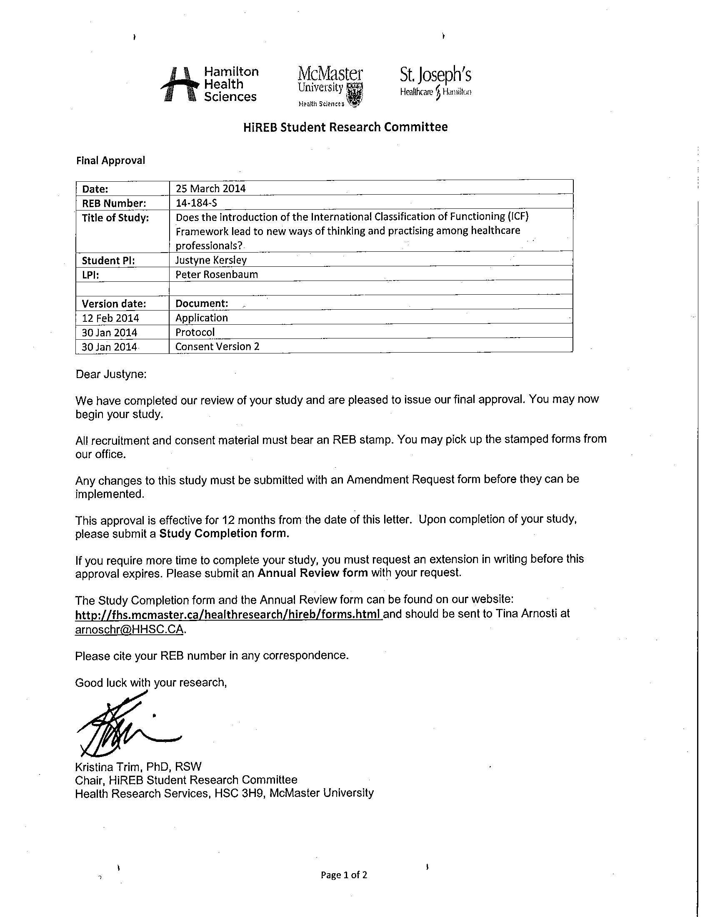

Appendix B. Ethics Board Approval Canadian Memorial Chiropractic College (CMCC)

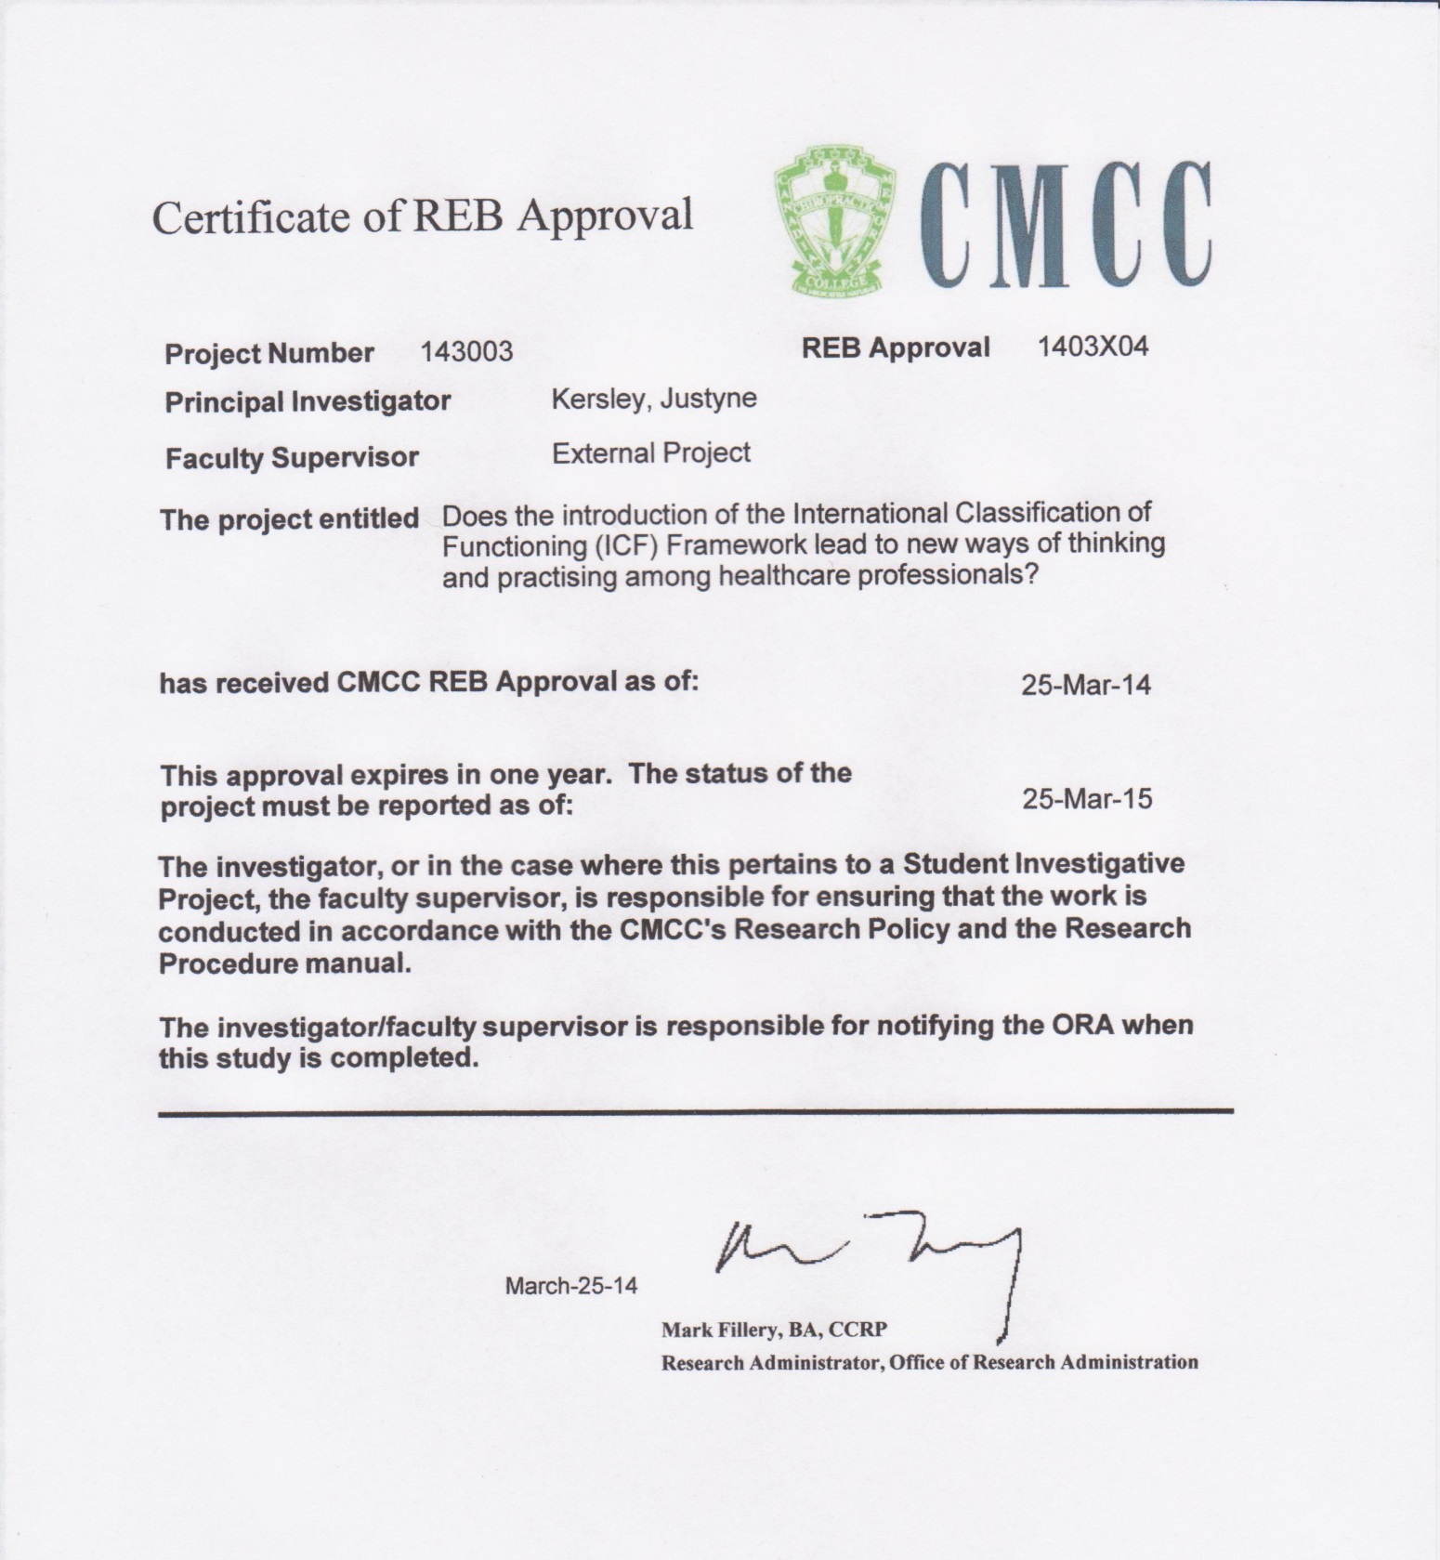

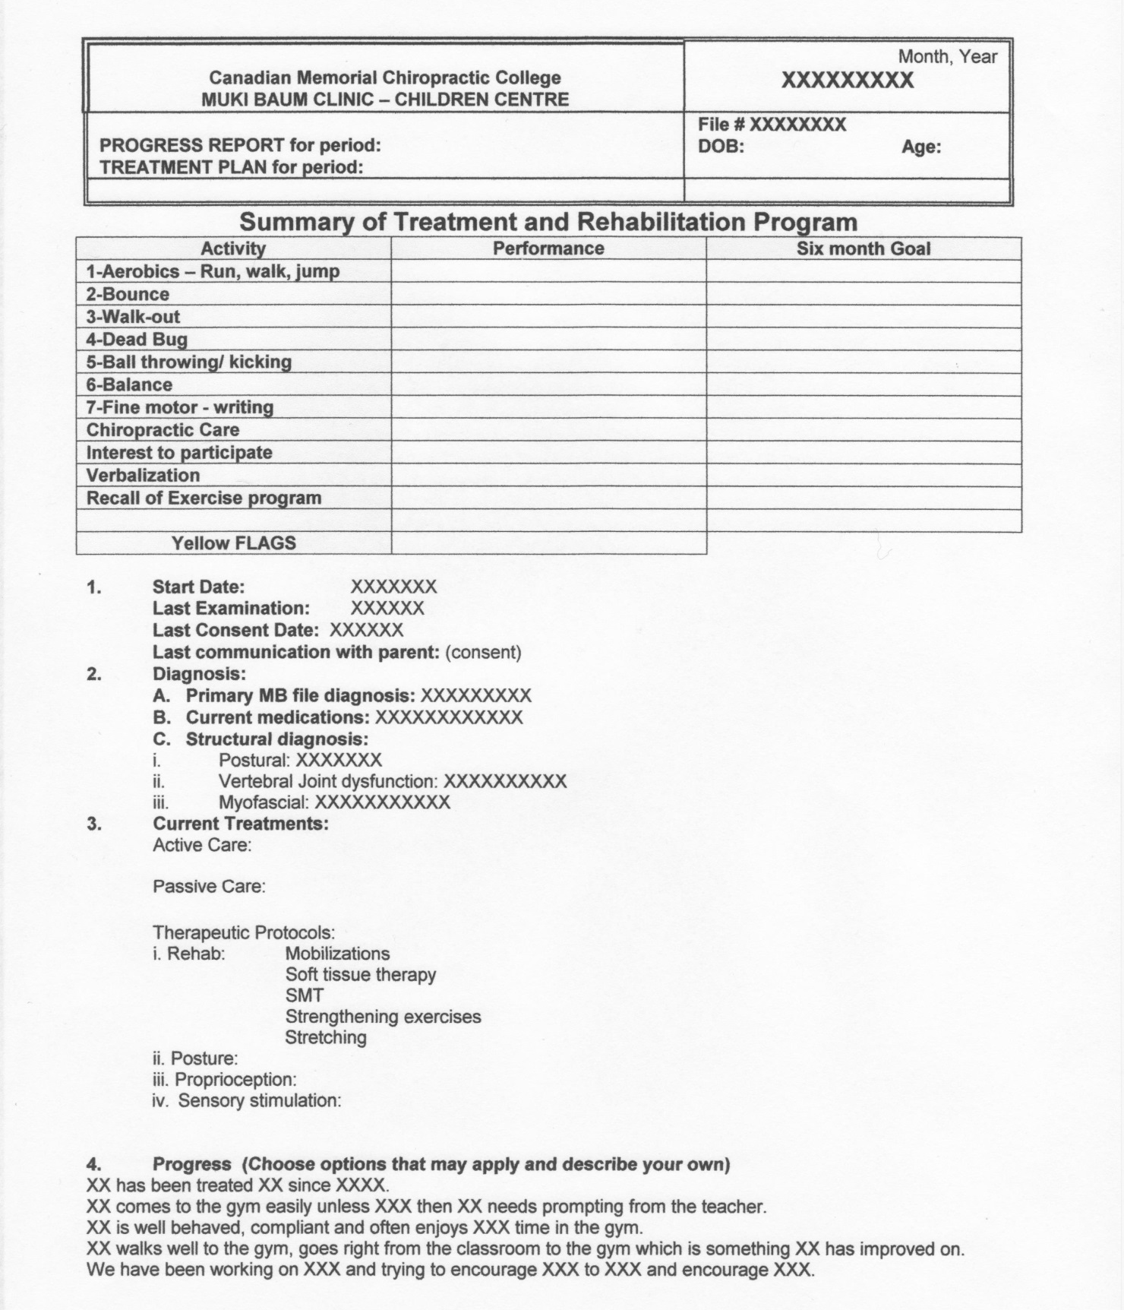
Appendix C. Sample of CMCC ATC clinical case report format

Appendix D. Outline of ICF categories and their respective subcategories
- World Health Organization (WHO) (2001) International Classification of Functioning, Disability and Health (ICF). WHO, Geneva

Body Function & Structures:
- Mental functions /structure
- Sensory structures / functions and pain
- Voice and speech stucture/ functions
- Functions / structure of the cardiovascular, haematological, immunological and respiratory systems
- Functions / structures of the digestive, metabolic, endocrine systems
- Genitourinary and reproductive structures/ functions
- Neuromusculoskeletal and movement-related structures/functions
- Functions of the skin and related structures

Activities:
- Learning and applying knowledge
- General tasks and demands
- Communication
- Mobility
- Self-care
- Domestic life

Participation:
- Interpersonal interactions and relationships
- Major life areas
- Community, social and civic life

Environmental Factors: (total for section)
- Products and technology
- Natural environment and human-made changes to environment
- Support and relationships
- Attitudes
- Services, systems and policies

Personal Factors:
- Examples used - likes, excited, does/does not enjoy, interest in, enthusiastic about

