HANDOVER AMONG MULTIDISCIPLINES IN OBSTETRICS

HANDOVER AMONG MULTIDISCIPLINES IN OBSTETRICS: A MIXED

METHODS STUDY OF CONTENT AND COMMUNICATION PROCESS

By JULIE PACE RN, BScN

A Thesis Submitted to the School of Graduate Studies in Partial Fulfillment of the Requirements for the Degree Master of Science in Health Science Education

McMaster University © Copyright by Julie Pace, June 2015

McMaster University MASTER OF SCIENCE IN HEALTH SCIENCE EDUCATION (2015) Hamilton Ontario

TITLE: Handover Among Multidisciplines in Obstetrics: A Mixed Methods Study of Content and Communication Process AUTHOR: Julie Pace, RN. BScN (McMaster University) SUPERVISOR: Dr. Kelly Dore NUMBER OF PAGES Pages: ix, 92

ii

**ABSTRACT**

**Background:** Communication failures during handover has long been noted as a threat to patient safety.1 Breakdown in communication among health professionals is reported to account for up to 85% of hospital sentinel events.1 Lack of formal structure and training in handover methods 53 as well as modes of communication including nonverbal behaviors 59 have been reported to affect the quality of information exchange in handovers. 59  The objective of this mixed methods study is to conduct a detailed analysis of handover content among physicians and among nurses on a Birthing Unit and to examine communication processes within these groups in order to identify gaps in the process. This may provide a basis for future development of standardized approaches and training efforts.

**Methods**: A convergent, parallel mixed methodology was used. The sample in this study comprises the nurses and medical obstetrical team in a hospital Birthing Unit in Hamilton Ontario. Phase one of the study involved initial observations of handover, performing a Delphi to gain consensus on handover content and creating a handover assessment tool. Phase two involved reliability testing of the tool and in phase three, twenty five paired nurse to nurse compared to medical handovers were video recorded, scored and correlated to participant questionnaires.

**Results:** Gaps in handover content were identified; the nurses achieved a mean score of 10.24 items compared to physicians mean score of 9.02 (correlation 0.582, p <0.01). This showed statistically significant differences in the items mentioned among the two groups

iii

(t = 13.2, p < 0.001). Nonverbal behaviors noted during handover observations revealed inconsistencies in conveying information, within and between the two groups. The findings of this study contribute to a better understanding of handover gaps, has implications to other health team practices and highlights the need for standardized processes, training and policy development.

ix

**ACKNOWLEDGEMENTS**

I would like to acknowledge the brilliance of my thesis committee. To Dr. Kelly Dore, my supervisor, thank you for your passion, leadership and mentorship along this journey. To Dr. Fred Baxter and Dr. Joanna Pierazzo, thank you for allowing me to dig deeper into my research through your different perspectives. I also thank my external reviewer, Dr. Rory McDonagh for your insight and support in my endeavor.

To the nurses, staff obstetricians, and learners of the Birthing Unit, I want you to know that your endless compassion, dedication and expertise in the work you do, does not go unnoticed. It is a privilege to work among the brightest people I know. Thank you for your tolerance in being videotaped. Your contribution to this quality initiative is most appreciated.

To my husband Carl, thank you for your insurmountable patience, love and commitment as I completed graduate studies, while working full time and helping to raise our family.

Most of all, I thank my three beautiful children, Olivia, Luca and Sofia. While you have learned from me that education is a lifelong journey, you have taught me, the most about life and what it’s really all about.

v

Table of Contents

ABSTRACT………………………………………………………………………………iii

ACKOWLEDGEMENTS………………………………………………………………...v

TABLE OF CONTENTS…………………………………………………………………vi

LIST OF TABLES ………………………………………………………………………viii

CHAPTER 1: INTRODUCTION

* 1. Background………………………………………………………………………….1
  2. Thesis rationale………………………………………………………………………3
  3. Objectives……………………………………………………………………………3
  4. The siloed nature of handover……………………………………………………….4
  5. The importance of measurement in handover……………………………………….6
  6. A conceptual framework for measuring handover…………………………………..7
  7. Summary……………………………………………………………………………..9

CHAPTER 2: METHODS

2.1 Mixed methods design………………………………………………………………..10

2.2 Convergent parallel approach………………………………………………………. 12

2.3 Overview of study phases……………………………………………………………13

2.4 Phase One

2.4.1 Observations……………………………………………………………………13

2.4.2 Development of handover tool…………………………………………………14

2.4.3 Delphi…………………………………………………………………………..15

2.5 Phase Two

2.5.1 Inter rater reliability – selection of raters……………………………………….19

2.5.2 Education for raters……………………………………………………………..21

2.6 Phase Three

vi

2.6.1 Sample selection……………………………………………………………………24

2.6.2 Sample Size……………………………………………………………………24

2.6.3 Ethics……………………………………….…………………………………25

2.7 Video Data Collection Procedure…………………………………………………...27

2.8 Questionnaire Data Collection Procedure…………………………………………..29

CHAPTER 3: RESULTS

3.1 Phase One – Delphi…………………………………………………………………..30

3.2 Phase Two - inter rater reliability……………………………………………………32

3.3 Phase three – handover Video observations………………………………………….33

3.3.1 Scores of handover content and process ……………………………………….33

3.3.2 Correlation of handover content and process…………………………………..37

3.3.3 Observed behaviors in handover………………………………………………..38

3.4 Questionnaire Results

3.4.1 Questionnaire Respondent’s Demographics……………………………………44

3.4.2 Agreement of handover distractions……………………………………………46

3.4.3 Agreement of handover quality…………………………………………………47

CHAPTER 4: DISCUSSION

4.1 Phase One – Handover Content and Process………………………………………….50

4.2 Differences in Handover Content……………………………………………………..51

4.3 Phase Three – Handover Observations- Nonverbal behaviors………………………..54

4.4 Observations versus Perceptions………………………………………………………57

4.5 Study strengths and limitations………………………………………………………..60

4.6 Clinical implications and future direction…………………………………………….63

vii

APPENDIX A - Donabedian model for Evaluating Quality………………........................64

APPENDIX B - Normative Model…………………………………………………….....65

APPENDIX C – Combined framework ………………………………………………….66

APPENDIX D – Consent Form Medical Team…………………………………………...67

APPENDIX E – Consent Form Nursing Team …………………………………………..68

APPENDIX F - Study hospital’s Transfer of Accountability Model…………………….69

APPENDIX G – Delphi Results………………………………………………………….70

APPENDIX H – Training for raters………………………………………………………72

APPENDIX I – Handover Questionnaire ………………………………………………..73

APPENDIX J – Chi Squares………………………………………………………………74

APPENDIX K – Frequency tables………………………………………………………...77

REFERENCES …………………………………………………………………………..79

viii

**LIST OF TABLES**

**Table 1** Handover Content Item list used for the Delphi

**Table 2** Additional items added

**Table 3** Pilot Handover Assessment Tool

**Table 4** Frequency/Chi squares of items mentioned between disciplines.

**Table 5** Agreement of handovers across disciplines within patients

**Table 6** Correlation and T Test for the total handover score

**Table 7** Observed nonverbal behaviors

**Table 8**  Most common respondents to questionnaire by profession and rank

**Table 9** Crosstabs Data RN

**Table 10** Crosstabs Data MD

**Table 11** Comparison of MD participant’s perceptions of handover quality to

observed score

**Table 12** Comparison of RN participant’s perceptions of handover quality to observed

score

ix

**CHAPTER 1: INTRODUCTION**

* 1. **Background**

Handover is the transfer of information, responsibility and authority from one provider to the next, during transitions of care across shifts and hospital departments. 1,2,4 This transfer of information can be written or verbal among staff across shifts or across hospital departments and is critically important as it creates a shared understanding of the patient’s condition, thus impacting on care decisions and care planning for the patient.Despite the critical nature of this information sharing, it is not uncommon in some settings, to have independent, siloed handovers occurring; meaning that handover regarding the same patient is occurring simultaneously, independently among different health professional groups. Siloed handovers increase the risk of misinterpretation of information between care providers. This risk, in addition to the complexity of the environment, unit culture, lack of handover structure and human factors are all believed to contribute to misinformation during handovers. 2-4  This is believed to create gaps in understanding and ultimately affect the quality of patient care, treatment decisions and patient outcome. 3

There have been publications citing adverse medical events identified in retrospective adverse-event analyses. 5-7 These studies validate the importance of patient handover as a critical time for patient safety, highlighting the problems that may occur when information is not be transferred accurately or missed altogether.8 – 12 One study found that a significant number of handover incidences involved incomplete handover or no handover at all. 14

When handovers were not accurate, medical residents reported that they encountered high risk clinical situations while on duty for which their handover had incompletely prepared them. 13,14

Given the potential patient harm which might stem from these information gaps, handovers are considered to be a time of high risk . 15, 37 Handovers influence care decisions and are affected by barriers to safe and effective communication. 27- 36 Evaluation of the factors impacting handovers are confounded by the complexity of communication among health care providers. Communication breakdown is influenced by the social, hierarchical culture of the work place, the lack of acceptance of structured handover processes, and the complacency of environmental distractions and interruptions. 27 In fact,literature on handover within critical care areas, medicine and interdepartmental transfers have shown that the communication process is variable, unstructured and error-prone. 20

Many studies have focused on specific areas such as the quality of medical information transfer, standardization of content using tools and checklists, types of media used that could enhance handover, and team function during handover. However, evaluations of any or all of these interventions and its direct association to patient harm are lacking. 15  In fact, these types of associations may be biased due to recall or hindsight biases when reviewing events. 15  Rather, it would better to first understand the information that is and is not being conveyed in handovers as compared to what is perceived as critical.

**1.2 Thesis Rationale**

The siloed approach to handover is the culture of the workplace at the study hospital. The Birthing Unit is a fast paced area with high patient turnover and a variety of disciplines working within it. In order to unravel any gaps in handover practices, it will be necessary to observe handovers within both disciplines who handover information in this clinical context. Therefore, nurses and physicians will be observed to understand any cultural aspects that may influence how handover occurs. It will also be necessary to assess the environment within which handover is given and what the staff perceives as barriers or distractions during handover.

Research has demonstrated that handovers do not often follow a systematic order; they are often informal and are not guided by available documentation.13,16-19 Gaining a better understanding of how content items in handover differ between doctors and nurses or how they are guided in their handover is important in order to best understand how to mitigate information gaps.

**1.3 Objectives**

The thesis will focus specifically on handover in obstetrical contexts; however it is important to consider handover literature in a similar clinical environment to labour and delivery context. Similar environments include the emergency and operating room. Like obstetrics, the emergency room environment has a rapid patient turnover. The handover of operating room staff to recovery room or recovery room staff to intensive care is similar to labour and delivery in that interaction with the patient may be brief before the patient is transferred to another unit. Quick turnovers in cases make patient unfamiliarity an added risk. Any break in the continuity of the information that is transferred is detrimental to safety, and may cause preventable adverse events and mortality. 9, 38-43, 45

In the clinical area of obstetrics at the study hospital, handover of a woman who is admitted for labour or is a scheduled caesarean section, occurs between outgoing and incoming nurses and a separate handover of the same patient by the outgoing and incoming medical team in a different location in the hospital. Since patient care is multi-disciplinary team-based it is important to understand the perspectives and issues within each profession. This interprofessional perspective will allow an analysis of differences that may exist in the content of handovers between the two disciplines. Siloed handovers increases the frequency of patient information exchange and potentially increases the risk of having doctors and nurses not sharing the exact information and may lead to increased error from losing essential information. The other issue is that doctors and nurses may not share the same understanding of the current situation of where the woman is in her care journey. Ultimately, this can affect care planning and thus delay interventions and may lead to increased length of stay. Currently, there is no literature that has made comparisons of handover content between doctors and nurses in a specific clinical setting like obstetrics. Moreover, there are no studies that have explored handover gaps using a mixed methodology with an interprofessional focus on quality improvement.

**1.4** **The siloed nature of handover**

Siloed communication processes add to the complexity of information transfer. In a series of interviews, 44 researchers have attempted to explore health care provider’s experiences with handover. Similar to other studies, these authors found that in both written and verbal handovers, missing and/or unclear communication was a prevailing theme. Health care staff interviews revealed that misunderstandings were common among care providers regarding treatment plan of care. They attributed these misunderstandings to unstandardized handovers that were carried out in silos. The authors suggest that

“future research is needed to look deeper into a more systematic way to calculate the differences and similarities across informants, departments and handover types” (50, p. 446)

Within the study hospital, as mentioned, there is currently a culture of siloed communication. Two senior staff nurses and two senior physicians were asked about separate handovers during an informal interview on the Birthing Unit prior to the study. Three reasons why their handovers occur at different times and locations were conveyed. The first revolves around the desire to create a culture of learning in the physician context. The medical team which has work hour limitations, allots time for teaching at 7:00 am and handover at 7:30 am. Nurses on the other hand, start their shift at 7:00 am when the incoming team arrives. The second reason is policy requirements differ between the two professions. Nurses, at this hospital, are mandated to do a bedside safety checklist during the handover between outgoing and incoming nurse. Physicians, on the other hand, have no such requirement and therefore may have less structure in their handover. Third, there is a culture of belief that two different specialties need to know different things about the patient. For example, it is believed by the nurses interviewed that nurses use more of a story telling format in handover and tend to tell more than just clinical facts. Nurses will likely talk more about family supports, pain and comfort whereas physicians will likely stick to a succinct, clinical detail focus on handover. The physicians interviewed echoed the same thoughts however they believed that some details such as allergies of the patient or isolation risk details are better left with the nursing staff and don’t necessarily need to be repeated. Therefore two different handover times, locations and handover styles, occur. These combined factors potentially increase the risk for miss-matched or inconsistent information among the care providers.

To best understand the quality of the information conveyed, a checklist of critical content for obstetrical handovers must first be developed. Measures of communication processes are needed to understand the current environmental factors surrounding handover, and process of handover. This may provide the basis for the development of standardized approaches and training efforts.

**1.5 The importance of measurement in clinical handover:**

The ultimate goal from a patient safety perspective is to standardize handover methods in a manner that ensures accurate and timely information between members of the multidisciplinary team caring for the patient. The first step is to identify potential communication gaps by exploring what differences exist in the information transferred within the two disciplines. Although handover content is largely unique to each medical specialty, handover strategies driven by patient safety principles can be applied equally to all disciplines. It is worthwhile to explore the uniqueness of an individual specialty such as obstetrics where team engagement during measurement may allow for members to feel empowered and accountable for any process improvements that the study may generate.

**1.6 A conceptual framework for measuring clinical handover**

A literature search was performed to find a conceptual or theoretical framework to underpin this study to understand quality or measurement aspects of handover in different professions. A hybrid framework 50 which is a combination of two existing frameworks was developed and was thought to best suit this study due to the complex nature of handover and factors that impact it. It includes Donabedian’s model 51 for evaluating quality (Appendix A) and a normative model 52 applied to primary healthcare (Appendix B). The Donabedian model is one used to help evaluate quality in healthcare as it relates to structure, process and clinical outcome. The normative model identifies aspects of group function and how it relates to team effectiveness, and organizes those factors to make them useful in evaluating strengths and weaknesses of task-performing teams. This combined framework fits nicely as it helps to underpin the review of handover practices and identification of gaps. Three key areas of evaluation outlined in this framework are; information, responsibility/accountability and systems during handover. These areas of focus take into account policies, practices and evaluation as they relate to the patient, the practitioner, and the hospital. (Appendix C for combined framework.)

This framework will underpin phase one of the study to help assess and answer what information is transferred during handover. This will help set the stage for future research on whether policy regarding information transfer will influence practice in clinical handover or determine whether standardization of methods of information transfer will influence practice in clinical handover.50 This framework will help the primary investigator identify any gaps in the responsibility and accountability aspects of clinical handover and thus identify any process improvements. As research has previously indicated, many health care organizations do not have an adopted systematic approach to handover. 50  Lack of corporate handover methods may result in suboptimal practices of responsibility and accountability in handover. There is some evidence that unclear systems of accountability and responsibility lead to inadequate escalation of patient care concerns, ultimately compromising quality of care. 53

“Research to survey current practice, with different models of handover with the aim of developing effective systems of accountability and responsibility alongside policies to enforce them, is vital” (50, p. 275)

This framework may help inform an effective method of inter-disciplinary team training to influence practice in clinical handover 50 The authors of this combined model propose that evaluation of handovers using this framework may help determine and standardize the competencies required for clinical handover within existing credentialing systems.58 This is relevant to health professionals education and curriculum design since structured handover methods is not a universal requirement at the study hospital nor is it a nursing or medical mandated competency during training,

In addition to the theoretical framework described above, it was felt that quality of information transfer (that can be gleaned from participant questionnaire data) may not only be influenced by cultural practices within a department such as the Birthing Unit but can also be influenced by behaviours of nonverbal communication. Assessment of nonverbal communication will be added to information or “handover content” metrics. Four patterns of nonverbal behavior have been studied and can impact quality of information transfer in handover. 59 Joint focus of attention, poker hand, parallel play and kerbside consultation patterns will be coded when observing the handovers. These theoretical and perspective lenses were used to guide the development of the methodology and interpretation of the outcomes.

**1.7 Summary**

In summary, this thesis sought to understand five study questions: what are specific content items of an obstetrical patient handover is considered by a multidisciplinary team to be important? What areas of content are covered by physician teams versus nurse to nurse in obstetrical handover? Can observed behaviors of communication be measured in either a physician team handover or a nurse to nurse handover? What perceptions do doctors and nurses have about the quality of the handover they give and receive? To what extent do the observations collected elaborate or support the perceptions of the health professionals involved in the handover?

**CHAPTER 2: METHODS**

**2.1 Mixed methods design**

The current mixed methods 23 study will examine similarities and differences in handovers of nurses compared to doctors in obstetrics. It will also examine each discipline’s perspective on the quality of information transfer. The reason for choosing a mixed method approach will be discussed. Mixed methods research has a long history of debate because some believe that combining two methods with different ontological assumptions is not legitimate. 23 That is, the quantitative assumption is that the nature of reality is found through data that is objectively captured, free from interpretations of the participants themselves. 23 Quantitative purists (positivists) believe that the inquiry of social science should be context-free and the observer should be separate from the entities that are the subject of observation. The positivist paradigm supports that there is a singular and universally accepted truth. 22

In the qualitative paradigm, the researcher believes that one cannot separate oneself from what is known and that the investigator and the subjects are linked. The qualitative purists (constructivists or interpretivists) refute positivism because they believe that time or context free generalization about a social science is not practical or realistic and it cannot be reduced to a cause and effect relationship. 21 The observer is integral to the exploration of social phenomena. The qualitative researcher works closely with the subjects to inductively generate theories from the data collected.

Increasingly, mixed methodologists are finding their way into supporting the understanding of health professions education and practice. This may be because reality of any social phenomena within a health discipline can best be studied if combined subjectively through the meanings and understandings developed within the group being studied but allowing the use of quantitative methods that ensure validity, reliability and generalizability. Mixed methods research will allow for a more in-depth exploration of handover, its intricacies and may begin to inform appropriate, specific and relevant strategies for improvement. More importantly, this research may inform health professions’ education in the area of handover.

Some refer to the mixed method researcher as a pragmatist. This definition is felt to suit the principle investigator of this study because a pragmatist is one who uses method and philosophy to make an attempt to fit together insights gained from both quantitative and qualitative measures.20  Neither positivist nor constructivist paradigms fit in the mixed methodology. 24  Rather than being restricted to a particular methodological approach, the pragmatist is at liberty to use a variety of research methods in order to answer the research question. It is important to note that although communication content and processes during handover is being studied both qualitatively and quantitatively, each design will examine the phenomena from different perspectives. The data from each will be triangulated between two sets of results. Triangulation facilitates validation of data through applying different research methods when studying the same phenomenon.

In this study, a convergent parallel mixed methods design is used. Here, both quantitative and qualitative data are collected at the same time, in parallel, are analysed separately then integrated for the final interpretation of the results.23

**2.2 Convergent Parallel Approach**

A convergent parallel approach was best suited for this study. Two other mixed methodologies were considered; explanatory and exploratory sequential mixed methods. Both of these are more time consuming. Because the study participants involve a large number of student and resident learners, each phase of either explanatory or exploratory design would include a totally different set of subjects thereby affecting the validity of the results. In the explanatory sequential design, the qualitative questions narrows the scope of the quantitative questions and a result, a comparison of results will be difficult to make because the results would have been drawn by different subset of medical staff 23  In the exploratory design, the two data sets are not compared in the interpretation because they are typically drawn from different samples.23 This would not fit the purpose of this study since the goal is to make comparisons among a set group of participants. A limit should not be placed on the types or amount of open-ended questions that the learners will be asked after their handovers

The assumption in a convergent parallel approach is that both types of data collection (quantitative and qualitative) will be collected from the same sample of participants and yield different types of information as guided by the perspectives of the participants themselves.23 Both quantitative and qualitative data were collected in parallel, analysed separately, and brought together to broaden the conclusions.

**2.3 Phases of the Study**

The following methods section will be broken down into three phases undertaken in this study. Phase one included three parts; initial observation, developing content items for a handover tool and conducting a Delphi. Phase two of the study involved inter rater reliability testing involving first, selection of raters followed by the education given to the raters. The third phase of the study was data collection. This will be described in four parts; the sample selection, determining sample size, ethics and finally, the data collection methods will be outlined.

**2.4 Phase One**

**2.4.1**  **Initial Observation**

In order to become familiar with the content and communication processes involved in obstetrical handovers at the study hospital, a convenience sample of five handovers among nurses and five handovers among the medical team were observed. The observations were done to get a sense of the locations of handovers, the communication style used, any challenges to information exchange and the typical environment at the time of handover.

Another important reason for being present in these handovers was to overcome the Hawthorne effect where medical or nursing staff may improve their behavior in response to their awareness of being observed. 60 Sitting in on a variety of handovers would allow the staff to get used to the researcher being present. Even though the researcher is well known to the medical and nursing staff, the repeated presence might make the actual recording less intimidating. A few recordings were done with the investigator present to assess audio-visual quality before the actual recordings were done with solely the recording device present.

**2.4.2 Building the handover tool**

To help inform handover content items, a literature review was done to take into account professional practice standards in Obstetrics (specifically around communication/handover), safety guidelines and systematic approaches that all have positive influences on handover quality. Patient safety literature on handovers informed the specific content items that are essential in handover; age of patient, allergies, infectious alerts, reason for admission, plan of care and identification of risk factors. 13,14, 16, 66,67

The handover tool not only included content items, it also included aspects of teamwork, situational awareness, accountability and responsibility. These aspects are supported by professional practice standards. The ALARM course 69 (Advances in Labour and Risk Management) is one example of practice standards published by The Society of Obstetricians and Gynaecologists of Canada (SOGC). The course is rooted in emergency preparedness in obstetrical care and has a focus on communication. The chapter on communication specifically outlines key principles of nonverbal communication, precision in language, the environment in which information exchange occurs and effective listening. These principles align well with patient safety literature and handover, but also align well with the nonverbal behaviors mentioned as part of the conceptual framework of this study. The MOREob Program 70 (Managing Obstetrical Risk Efficiently) is another example of practice standards that are delivered through an educational initiative, deeply rooted in patient safety. Module 2 is dedicated to learning and practicing effective communication strategies. Handover or information exchange is highlighted.

Currently, the study hospital (where the principal investigator will collect the data) has a systematic approach and policy for nurses around handover and information exchange. It is referred to as transfer of accountability 99 (TOA) which nurses follow at each shift transition point. This is a checklist based handover (Appendix F) that follows a consistent format in order to highlight key areas of information to be handed over. This initiative was implemented by the study hospital’s Chief Nursing Officer and Quality Performance and Improvement Team. The patient safety concept of this initiative used only by the nurses at the study hospital, also informed obstetrical handover practices.

**2.4.3**  **The Delphi**

In order to answer the first question: *what content of handover do doctors and nurses believe to be essential,* a Delphi methodology was implemented. This method was developed in 1963 85, 86 and is still used today as a means of converging opinions and achieving consensus among a group of experts within a particular field. 87-89 The Delphi method allows for controlled, anonymous feedback in as many rounds as it takes to reach consensus. Often, consensus is reached by round three or four. 89  Researchers suggested that the number of experts to pol is ten to fifteen if the background of the subjects is homogeneous. 89

The current study hospital has a multidisciplinary panel of twenty professionals (three obstetricians, two family doctors practicing obstetrics, two midwives, nine nurses, one nurse practitioner, one administrator, one manager and one educator ) working on a quality improvement and patient safety initiative in obstetrics, through a three year educational program (MORE ob). It was convenient to solicit this homogeneous group as the panel of experts for application of the Delphi Method. Monthly meetings, in addition to distribution list emails were used as a venue to educate this group to the purpose of this study and the importance of gathering information. The group was initially presented with a list of content items that may be included during an obstetrical handover (see Table 1). For each item on the list, participants indicated whether the item should be incorporated into a handover by scoring it a 1 (strongly disagree) or 5 (strongly agree).

**Table 1.** Handover content Item list used for the Delphi

Please take a few minutes to look at the following list of items that may be included in a handover between care providers for an obstetrical patient. The items listed below are elements of handover that include specific clinical information regarding each patient. Non-technical skills such as communication, teamwork, situational awareness, accountability and responsibility are also included in this list.

Please give a score between 1-5 on each item. 1 (strongly disagree that it be part of handover) and 5 (strongly agree that it should be part of handover). **1 (strongly disagree) 2 (mildly disagree) 3 (neutral) 4 (mildly agree) 5 (strongly agree)**

**Clinical information between outgoing and incoming team/professional:**

Pt. Name/age 1 2 3 4 5

GTPAL 1 2 3 4 5

Care provider (most responsible provider) 1 2 3 4 5

Allergies 1 2 3 4 5

IPAC alerts 1 2 3 4 5

Maternal Hep B status, HIV, VDRL 1 2 3 4 5

Maternal blood group 1 2 3 4 5

**Current status of the following discussed:**

Type of delivery planned 1 2 3 4 5

Time admitted to unit 1 2 3 4 5

Progress 1 2 3 4 5

Plan of care 1 2 3 4 5

Analgesia 1 2 3 4 5

Support in labour 1 2 3 4 5

**Social aspects are discussed:**

SW consult of any kind 1 2 3 4 5

Maternal drug use 1 2 3 4 5

**Anticipated Baby Care:**

GBS screening: prophylaxis 1 2 3 4 5

Hep B 1 2 3 4 5

Maternal fever: plan of care 1 2 3 4 5

**Communication aspects:**

Handover is written 1 2 3 4 5

The person taking on responsibility of the pt. has

time to ask questions 1 2 3 4 5

Three additional items that had not been included in the initial Delphi round (time admitted to unit, support in labour, maternal drug use) were felt important by the expert panel to be included in round two. This was agreed upon by the expert panel because these factors were identified as gaps in local practice and they inform the progress of labour, care interventions (time admitted) and being proactive with any social needs. Since communication processes around teamwork, situational awareness and accountability were discussed in our MOREob Module 2, the panel agreed that these are important elements and should be part of any handover. (Table 2)

**Table 2.**  Additional items

**Teamwork:**

The leader of the team for the oncoming shift is

Identified 1 2 3 4 5

**Situational awareness:**

Concerns about risks to patient are raised 1 2 3 4 5

The outgoing team/professional provides a clear

assessment of the clinical situation in which the

new team will be working 1 2 3 4 5

**Accountability/responsibility:**

Tasks to be completed are clearly assigned to the 1 2 3 4 5

Incoming professional/group

**2.5: Phase Two**

From the Delphi, all content items agreed upon made up the components of the Handover Assessment Tool. This pilot tool would be the template to capture both content and process elements of handover when observing nursing and medical handovers (Table 3). As the participant questionnaire was going to measure participant’s perceptions of distractions, accountability/responsibility, time to ask questions and situational awareness, these elements were added to the handover assessment tool as well.

**Table 3.** Pilot Handover Tool

Please place a number in each box (1=yes, 2= no and 3=unable to decipher) Rater’s name:

|  |  |  |  |  |  |  |  |  |  |  |
| --- | --- | --- | --- | --- | --- | --- | --- | --- | --- | --- |
| Medical handovers | Patient identifier (room #, first or last name) | How many babies woman has or # of pregnancies (“G2”, “primip”, “mulitp” | Allergies mentioned | Infection control alerts mentioned | Mention of Hep B status, HIV, rubella immune, | Group B strep status (mention of antibiotic prophylaxis) | Mention of maternal fever being treated with antibiotics | Any mention of time admitted to unit or when “she came in” | Type of delivery planned (vaginal, c section) | Progress/Plan of care (membrane status, cervix, needs to be checked/reassessed, oxytocin pump to be increased or decreased, consult needed, transfers etc.. |
| Case #1 |  |  |  |  |  |  |  |  |  |  |

|  |  |  |  |  |  |  |  |  |
| --- | --- | --- | --- | --- | --- | --- | --- | --- |
| Any maternal drug use history  Any mention of narcotics used (not including epidural) | Any mention of support person in the room with her ( partner, husband, mom, friend, doula etc) | Pain relief measures (any) including epidural | Social work consult mentioned or social history or social concerns | Distraction pagers | Distraction phones | Distraction people | Receiver of handover has time to ask questions or clarifies any information | Concerns about pt. Risks are raised |

|  |  |  |  |  |
| --- | --- | --- | --- | --- |
| Person handing over gives clear assessment of current clinical presentation or situation | Tasks to be completed ( like blood work or follow up on blood work, reassessment) are clearly outlined to oncoming person or group | Written format used to guide handover (pt. Care notes or systematic tool used) | Handover verbal (from memory) | Any effort made to overcome distractions? |

**2.5.1 Inter rater reliability of the tool: selection of the raters:**

Reliability testing on the tool was done using four raters. Three are clinicians, however they do not have specific obstetrical experience and the fourth rater has relevant experience. This decision was made by the principle investigator in order to learn if anyone with sufficient knowledge could use the tool as an assessment of handover. An obstetrician was not chosen because he or she may have had a bias toward the quality of the recorded handovers videos used for reliability testing. This limitation will be discussed in Chapter 4. In order to remove any potential biases, the raters that were chosen have many years of clinical experience in acute care and they also have experience in education, quality and improvement initiatives. Investigator triangulation is the use of multiple observers or coders. This helps to remove potential biases that can occur in a single rater study 54

The first rater is a Clinical Nurse Specialist in patient education, who works at the study hospital. She has over 25 years experience in nursing. She has extensive experience in developing educational tools and programs for specific medical and surgical patient populations. She develops all of the hospital’s patient education content. She has experience in inter-rater reliability by coaching others in their study investigation processes.

The second rater is a Registered Nurse with over 15 years experience who currently holds a position in the organization’s quality improvement team as a Patient Safety Representative. He provides education and conducts audits throughout the organization on Transfer Of Accountability; the hospital’s model for bedside safety on handover between off going and incoming nursing staff.

The third rater is a Medical Doctor specializing in Family Medicine. He has 15 years experience working in a small, community Emergency Department and is experienced with quick patient turnover and multiple handovers in one shift. He is an active mentor to family medicine residents and is actively involved in many quality improvement initiatives.

The fourth rater is the study investigator who has 19 years of clinical experience including 12 years in education, quality and program development in woman’s and infants’ care. This rater has sufficient knowledge and expertise on best practice standards in obstetrics.

**2.5.2 Education for the raters:**

The tool was shown to each of the raters separately. Approximately 30 minutes of education on obstetrical terminology and the tool itself was given to each of the raters before they watched the handover sample videos. Each column was given a brief explanation so that when they were ready to watch the sample videos, they could rate each item on the tool as a 1 for “yes” it was mentioned during the handover, 2 for “no” it was not mentioned during the handover, and 3 for “can’t decipher” if the content was mentioned or not.

The 25 items were reviewed as follows to determine if they were mentioned during the handover:

1. The patient identifier; name and /or room number at the beginning of the handover.
2. Gravida status: first baby (“primip”) or greater (“multip”).
3. Allergies and Infection prevention alerts.
4. Hep B status, HIV and GBS (group B strep infection) during pregnancy and required treatment with IV antibiotics.
5. Type of delivery; either vaginal or c section or a planned vaginal birth after previous c section (VBAC).
6. The time arrived to unit: what time the woman arrived or how many hours she had been admitted.

7, 8. Her progress and plan of care; cervix status, membranes (ruptured or intact), when she was last checked (cervix), whether or not labour induction or augmentation is occurring or plan for caesarean section.

9. Analgesia; pain control measures during labour (epidural or non-drug method such as a shower, tub, massage etc).

10. Support in labour; who is supporting her in the room (partner, parent, sibling, doula, etc).

11, 12. Social work issues/ consult and maternal drug use.

13. Maternal fever.

The communication processes items are the following:

14. Does the receiver have time to ask questions about the handover?

15. Are any concerns about the patient raised?

16. Does the person handing over give a clear assessment of the current clinical situation (in other words, can the receiver of handover likely visualize where the pt. is in her care plan and be prepared to take over?)

17. Are tasks to be completed highlighted or assigned?

18. Was there a written format to handover (did the giver or receiver use care notes to guide handover?)

19- 23. What were the distractions if any (specific items included: pager off once, more than once, phones rang once, more than once, or people distracted the conversation).

24. Were any attempts made to mitigate the distractions (did anyone repeat what they said due to the distraction, did the conversation continue or were efforts made to bring the group’s attention back into focus).

25. Was the handover verbal or guided by memory?

Before each of the raters was asked to view the videos, a list of definitions and terms was also outlined especially as three of the raters did not practice specifically in the area of obstetrics (Appendix H). A sample of eight nursing handover videos paired with eight medical handover videos on the same patients were used to pilot test the tool. Each nursing and medical handover video was labeled (for example: nurse handover #1 matched with medical handover #1 as it was about the same patient).

Each nursing and medical handover video was scripted by the study investigator. This was done to avoid the rater from having to replay the video numerous times to identify a particular word or acronym used, volume variations or each speaker’s differences in speech tone, pitch or speed. A sample handover video was reviewed with each rater to ensure that any or all definitions, acronyms or abbreviated terms were understood. This education took approximately 30 minutes for each rater. Each rater was then able to view all 16 videos in a private location (their own locked office or the study investigator’s office) without the investigator present. The investigator also independently reviewed the videos. The handover tool was used to score each item for each handover (Table 3)

**2.6: Phase Three**

**2.6.1 Sample selection :**

All observations occurred between October and December 2014 on a Birthing Unit at a single hospital. The participants were the nursing and medical obstetrical staff and trainees of the Birthing Unit. Nursing staff make up a complement of 45 part time and full time nurses. There were approximately 4 nursing students working on the Birthing Unit during this time frame. The medical team consisted of 10 staff Obstetricians/Gynecologists, 10 residents in OBGYN that range from PGY1 to PGY5 and clinical clerks who were in year three of their medical school training.

The principle investigator is the Clinical Nurse Educator of the Woman’s and Infants’ Program and has easy access and daily exposure to the staff of the Birthing Unit. As a MORE ob core team member with a keen interest to perform a Quality Assurance study in patient safety surrounding handovers, it was feasible to recruit participants for this study. This was deemed a Quality Assurance Project by the Research and Ethics Board.

**2.6.2 Determining sample size**

Initially, a convenience sample of 50 paired handovers was thought to be necessary. As this study involves observation of handover content, processes and aspects of nonverbal communication, the idea of sampling data until saturation is reached, was suitable. 61 Saturation originates from Grounded Theory 61 which allows a researcher to stop collecting data when themes or categories are saturated. This means that collecting any further data will no longer reveal new themes or generate new insights to the study topic. 61

**2.6.3**  **Ethics**

Because this study is deemed as a Quality Assurance Project, REB approval was not needed. All participants however were required to sign consent (see Appendix D and E) prior to being recorded. The recordings were only to take place at the team centre or anywhere in the Birthing Unit outside a patient’s room since patients were not consented to be part of the recordings. Any participant could decline to be video-recorded which would result in their data not being included. All recordings were kept confidential and locked in the investigator’s office.

**2.7 Video Data Collection Procedure**

The recordings were done using Panasonic Tough Pad devices. One Tough Pad was used in the resident lounge or classroom where medical handover occurred every morning at 7:30am. Up to five tough Pads were used; each one to record a handover between an off going and incoming nurse at 7:00 am. All participants were asked to start and stop their recordings.

The context within which nursing handovers occur is typically one outgoing nurse will give handover to a receiving incoming nurse. This happens during shift change occurring at 7:00 am and 7:00 pm. The twenty five nurse handovers were recorded at the 7:00 am handover time only. This time was chosen by the principle investigator because the medical team handover included more residents and clerks during the daytime hours and since recording a daytime handover would capture more medical participants, it was feasible to record the nurses during this time as well.

The nurse’s handovers occur mostly at the team centre that is the hub of the unit’s activity. It’s where phones are answered by the unit clerk, patients come to this area to register and where outgoing and incoming nurses congregate as they share handovers. The medical handover on the other hand, is typically a junior resident handover to a team consisting of junior and senior residents, clinical clerks and an OB staff member. This does not happen at the team centre; rather it occurs in either the classroom located on the Mother- Baby Unit one floor above the Birthing Unit or in the resident lounge area.

Twenty five paired handovers were recorded in the same way as previously described using Panasonic tough pads. Only the videos that could be paired were kept. All others were deleted. For example, if a nurse handover was recorded but a corresponding medical handover could not be captured about the same patient, that nursing handover would not be included in the analysis. There were occasions when medical handover was completed before anyone remembered to record it, which resulted in some of the missed handover content. Between October and December 2014, twenty-five paired handovers were recorded. All videos were coded (RN handover #1 which coincided with MD handover #1). It is important to note that each of the 25 patient handovers had 2 videos associated with it.

**2.7.1 Analysis of the videos**

Interpretative description was used when analysing the videos. Interpretive description is a qualitative research methodology where the goal is to generate knowledge relevant for the clinical context of applied health disciplines. 62Because the participant’s handover practices vary and nonverbal behaviours change within the team environment, the goal was to categorize observed behaviours in a way that would be meaningful and relevant to the participants of the study and to handover practices.55  Schwandt 65 writes:

“From an interpretivist point of view, what distinguishes human (social) action from the movement of physical objects is that the former is inherently meaningful. . . .To find meaning in an action or to say one understands what a particular action means requires that one interpret in a particular way what the actors are doing.” (65, p. 191)

As described earlier, when assessing handovers, a combined framework would also include categorization of nonverbal behaviours. After each video was observed and transcribed, the principle investigator made field notes to help describe the physical environment and communication method including non-verbal behaviors. With repeated immersion in the qualitative data, and comparing one video to the next, interpretative themes emerged in both the MD and RN handovers. 56, 57 This method was conducive to the time frame involved in this study.

The study period chosen was two months because the researcher wanted to include participants in the time frame that residents and other learners would be at the study site. This was done with the goal of having some consistency with the sample of participants. There were limitations in being able to spend a large amount of time with the study participants particularly because of the work nature. Participants being post call are not as willing to spend in interviews particularly because of their work hour limitations. The acuity of the unit and scheduled obstetrical procedures require the staff to be on the unit and ready to work. Therefore, interpretive description methods using the videos and watching them numerous times allowed for the investigator to spend as much time as was needed to analyse what was being observed.

**2.8 Questionnaire Data Collection Procedure**

Twenty five paired nursing handovers included a questionnaire by the off going and incoming nurse. Survey responses were easily matched because each nursing handover was done in pairs. Each patient handover among the medical team was occurring between an outgoing resident to an incoming team, consisting of more than 2 individuals. The incoming medical team consists usually of clinical clerk(s), junior and senior residents (both in OB or Family medicine OB) and always an OB staff member. Therefore, in some handover cases, there were a few questionnaires returned. After each handover was recorded, each outgoing and incoming medical or nursing member was asked to fill out a handover questionnaire (Appendix I). The questions paralleled the process elements being collected quantitatively in the handover tool. Specifically, the staff’s perspectives on distractions during the handover, whether there was time to ask clarifying questions, whether the handover painted a clear clinical assessment picture, whether tasks were delegated and whether the handover followed a particular format or was guided by memory. Questions about each practitioner’s rank or year of experience were asked and the amount of sleep the giver or receiver had prior to each handover. See Appendix I for the complete questionnaire. Each possible answer on the questionnaire was converted into a numerical code for ease of analysis.

Four patterns of nonverbal behavior noted to affect handover quality 59 was used to categorize themes noted in the handover videos. These included; joint focus of attention, poker hand, parallel play and kerbside consultation. Each style of nonverbal communication observed, was given a numerical code. Combinations of these NV behaviors were also given numerical codes. A spread sheet of questionnaire answer codes and NV behavior codes was generated.

**CHAPTER 3: RESULTS**

The results will be displayed in sequence corresponding to the phases in which they were completed.

**3.1 Phase One -Delphi results**

The existing literature on a Delphi process does not define when consensus can be deemed to have been reached. 47 A similar study done to generate consensus on handover performance 48 used an 80% cut off value which correlated to a mean score of 4.0 or greater. The items that achieved this level in round one were automatically included in round two. The group received a summary from round one and were asked to rate the same items in round two.

In phase one of the study, a Delphi was completed with 20 multi-disciplinary experts in Obstetrics in two rounds. Fifteen panel experts responded in both rounds. If greater than or equal to twelve respondents out of fifteen rated an item 4.0 or greater (on a 5-point scale), this represented a mean score of 80% and the item was included in round two. (see Appendix G)

Patient name (identifier), gravida status, serology, type of delivery, progress and plan of care and time admitted to unit were all rated15/15 in both rounds. These were unanimously agreed upon by the panel to be very important elements to mention in a handover. Analgesia, Hepatitis B status and maternal fever achieved ratings of 15/15 in round two. Teamwork, situational awareness and accountability aspects of handover were scored 15/15 in round two. All respondents agreed that having time to ask questions, raise concerns, having a good understanding of the clinical situation and understanding tasks to be done or completed, scored 15/15 in round two and thus needed to be included in the Handover Assessment Tool. A discussion with the expert panel after the second round of the Delphi revealed that distractions to handover need to be captured as well. A third round was not needed as consensus was reached. All of the items were then used to create the Handover Assessment Tool. The handover content items included were generated from the results of the Delphi. (See Appendix G for Delphi method and results)

The final 27 item list created after the two– round Delphi and addition of process items to be matched with questionnaire responses was used to generate the Handover Assessment Tool. The final list of Handover Assessment Tool items included: patient identifier, gravida status, allergies, infection control alerts, serology, GBS status, type of delivery, time arrived to unit, progress, plan of care, analgesia, support in labour, social work consult, maternal drug use, maternal fever, receiver has time to ask questions, concerns are raised, tasks are delegated, clear assessment of clinical situation given, a written format is used, whether handover was guided by a particular format, distractions identified (pagers, phone or people), and attempts made to mitigate the distractions. Two additional items were added to the tool based on consensus just prior to data collection which were: handover guided by notes and handover guided by memory. This made up the final list of 29 items. The last two items were added later because it was felt by the study investigator that it would be important to know not only if a written tool or format guides the person’s handover but to what extent is handover guided by memory.

**3.2 Phase Two - Inter rater reliability of the Handover Assessment Tool**

Inter-rater reliability signifies the degree of agreement among raters on a particular measure. In the case of the handover tool, a pilot study was conducted to determine the extent to which scores given by one rater could generalize to scores given by another rater. If there is too much discrepancy among the raters, either the scale is defective or the raters need to be re-trained. The G coefficient calculated is a score between 0.0-1.0, with a score of 1.0 indicating perfect agreement. For inter-rater reliability calculations of any score above 0.9 is an indication of redundancy specifically that no additional information can be gained by having multiple raters. 90

The goal of the pilot testing for the handover tool was to assess if the tool could be used by any single rater, or if more than one rater was necessary to achieve reliable results. This was done by establishing the inter-rater reliability of the tool through Generalizability analysis.

Three independent generalizability analyses were completed. First, in order to generalize from the ratings given by one rater to the ratings given by the other raters on any particular item, across all sixteen videos (nursing and physician team combined) with twenty nine items per video and four raters. Generalizability analysis with UR Genova yielded an absolute error G coeffient of G=0.918. Second, in order to generalize from the ratings given by one rater to the ratings given by the other raters on any particular item, for the eight MD handover videos, the U R Genova yielded G= 0.958. Lastly, in order to generalize from the ratings given by one rater to the ratings given by the other raters on any particular item, for the eight nursing handover videos, the U R Genova yielded G=0.902.

This demonstrated that any of the four raters had agreement overall. Provided that training using the handover video footage with scripted dialogue and a brief tutorial with OB related definitions and terms are used, these results indicate that any rater could reliably rate the handover videos using the handover tool. These results allowed for a single rater to then rate a larger sample of both MD and RN handovers.

**3.3 Phase Three -– Handover Video Observations**

**3.3.1 Scores of Handover content and process items**

To help answer one of the study questions: *What content is covered by both doctors and nurses in handover?:* each handover video was observed three times. The first time it was observed, each handover item was scored as either 1 “yes the item was mentioned or discussed”, or 2 “it was not mentioned or discussed” or a 3 code was used if it “could not be deciphered”. The video recordings were viewed by the investigator twice more to ensure all items were captured. All handovers were reviewed to determine if a content item was “mentioned” (scored as a “1”) or performed “1” or it was “not mentioned or not performed” (scored as a “2”). It is important to mention, that if an item, for example, “allergies” scored a 2 or “no it was not mentioned”, this does not mean that the patient does not have allergies, rather it means that this was not mentioned in the handover. Another example is “concerns about risk factors”; a nurse can say that “there are no risks or concerns for this patient” in her handover and this would score a 1 or “yes” because the element of risk was mentioned in the handover. Whether or not the patient has allergies or risks is not what gets coded. Rather it’s whether this was highlighted in the handover or not that gets coded. Each of the 29 items were analysed looking at the frequency in which each item of the handover was mentioned across discipline or whether the process items were completed or not. Table 4 displays statistically significant or clinically relevant items (Appendix K has the full list of frequencies per item per discipline). Of the twenty nine items scored on the handover tool, statistically significant differences between the two disciplines were noted. Other items that were felt to be clinically relevant with a focus on patient safety, were also noted and will be elaborated on in the discussion.

**Table 4.** Frequency/Chi squares on content items

|  |  |  |  |
| --- | --- | --- | --- |
|  | RN | MD |  |
| Allergies | 40% | 8% | P < 0.01  0.008 = p ( Fishers exact test) |
| Support in labour | 48% | 16% | P < 0.01  0.013 = p (Fishers exact test) |
| Infection Control Alerts | 16% | 0% | p < 0.05  0.05 = p ( Fishers exact test) |
| Using a written format to guide handover | 28% | 20% | p < 0.05  chi squared (0.43) |
| Phones distracting the handovers | 24% | 4% | p < 0.05  chi squared (2) |
| People distracting the handovers | 72% | 48% | *ns*  Chi squared (3) |
| Pagers distracting the handovers | 4% | 16% | *ns*  0.24 = p fishers exact test |
| analgesia | 56% | 36% | *ns*  chi squared (2.01) |

See (Appendix J) for Chi squares for all 29 items

The degree of agreement was measured within handover pairings across disciplines. Table 5 displays the percentage of time there was agreement between the two disciplines for that particular content or process item on the Handover Assessment Tool.

**Table 5.**  Agreement in handovers across disciplines within patients

|  |  |  |
| --- | --- | --- |
| **variable** | **RN/MD pairings where they did the same thing** | **Percent that they did the same thing** |
| Patient identified | 24/25 | 96 |
| Gravida | 20/25 | 80 |
| Allergies | 17/25 | 68 |
| IPAC | 21/25 | 84 |
| serology | 15/25 | 60 |
| GBS | 10/25 | 40 |
| Type of delivery | 14/25 | 56 |
| Time arrived to unit | 21/25 | 84 |
| progress | 22/25 | 88 |
| Plan of care | 19/25 | 76 |
| analgesia | 14/25 | 56 |
| Support in labour | 15/25 | 60 |
| Social work/issues | 22/25 | 88 |
| Mat drug use | 23/25 | 93 |
| Maternal fever | 18/25 | 72 |
| Receiver has time to ask questions | 17/25 | 68 |
| Concerns are raised | 12/25 | 48 |
| Clear assessment given in handover | 18/25 | 72 |
| Tasks are delegated | 17/25 | 68 |

**3.3.2 Correlation of handover content and process items**

The T- Test compares the difference between the average score from the MD group on the handover tool versus the average score from the nursing group on the handover tool . The mean scores were 9.02 and 10.24 respectively. The T- Test calculates the difference between mean scores of the two groups. The positive correlation (table 6) indicates that when nurses mentioned more items in a particular handover case, the doctors mentioned more as well, relative to the other cases the doctors presented. The T- Test indicates that the doctors on average are still reporting fewer items overall as compared to nurses.

**Table 6.** Correlation and T- Test for the total handover score

|  |  |  |  |  |
| --- | --- | --- | --- | --- |
|  | **RN (Mean)** | **MD (Mean)** | **Correlation** | **T- Test** |
| **Checklist** | 10.24 | 9.02 | 0.582  P < 0.01 | t = 13.211  p < 0.001 |

**3.3.3 Observed behaviours in handover**

In many of the medical team handover videos, it was observed that many of the team members were not all engaged with the speaker who has giving the handover. The speaker was often looking at his/her information source such as a note or talking from memory and the other team members were looking either at the giver, at the computer screen, at another person or even, all around the room. There seemed to be lack of joint focus during most of these handovers and it was difficult to get a sense of whether the entire team was really retaining all of the information being handed over to them.

The nurses displayed similar behaviors. All nursing handovers occurred between one outgoing and one incoming nurse. There were also handovers about numerous patients from one outgoing charge nurse to another incoming charge nurse. At times, the nurses looked at each other, or at the chart and other times no eye contact was made and no suggestion that the receiver of handover was processing the information relayed. Four types of NV behaviors 59 were used as a framework to help record behaviors while observing the doctor’s and nurse’s handovers. The four types (joint focus of attention, poker hand, parallel play and kerbside consultation) or a combination of these, were noted during the observation of all handover videos among the medical and nursing team. The following table shows the percentage of time nurses and doctors used one or more of the coded nonverbal behaviours during their handovers.

**Table 7.** Observed Nonverbal behaviors

|  |  |  |  |  |
| --- | --- | --- | --- | --- |
| **Nonverbal behavior of communication** | **RN**  **frequency** | **RN percentage** | **MD**  **frequency** | **MD percentage** |
| Poker Hand | 11/50 | 22 |  |  |
| Parallel play | 24/50 | 48 | 6/93 | 6 |
| Joint focus of attention | 22/50 | 44 | 32/93 | 34 |
| Kerbside consultation | 2/50 | .04 |  |  |
| Joint focus+parallel | 12/50 | 24 |  |  |
| Poker hand and story telling | 11/50 | 22 |  |  |
| Joint focus + poker | 10/50 | 2 |  |  |
| Parallel play + story telling | 8/50 | 16 |  |  |
| loss of focus as handover continues |  |  | 32/93 | 36 |
| Joint focus + kerbside |  |  | 23/93 | 24 |

These four types of NV behaviours or a combination of them were noted during the observation of all handover videos among the medical and nursing team.

The first, “joint focus of attention” means that both incoming and off going professionals coordinate their visual and verbal attention to the same source of information (computer screen or patient chart). Nurses displayed joint focus of attention 44% of the time compared to doctors, who displayed it in 34% of handovers in addition to 36% of the handovers where the joint focus diminished as the handover continued. (see Table 7)

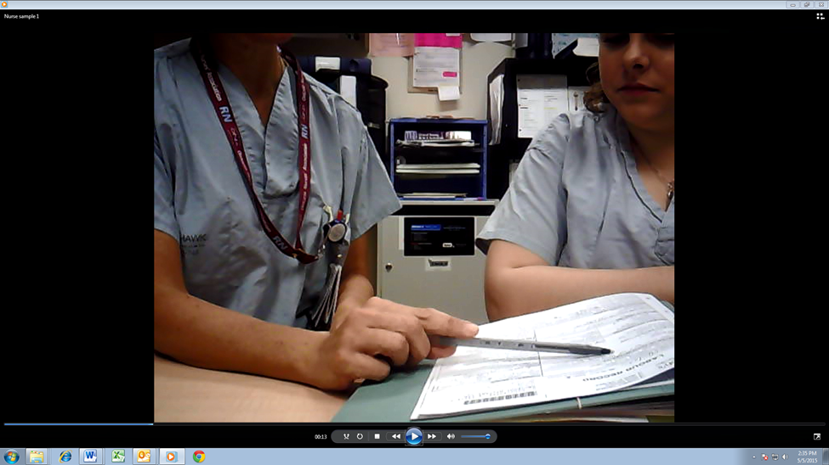

**Figure A –** Joint focus of attention



**Figure B –** Loss of joint focus

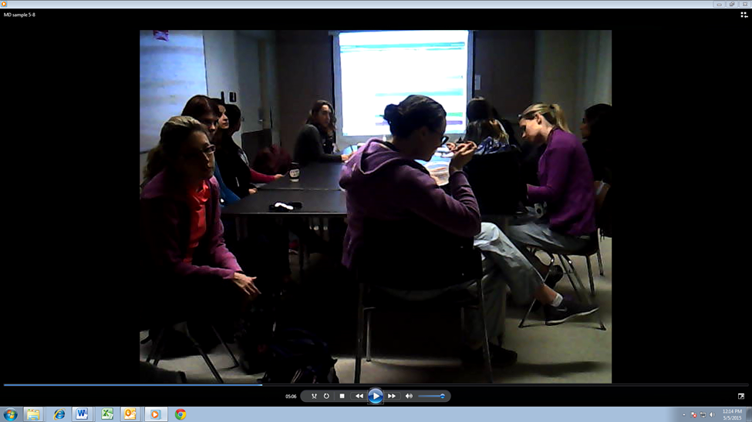

**Figure C**- Loss of joint focus

Figure B and C – Loss of joint focus. Outgoing team member (giver of handover) sits at back of room. Receivers (incoming) are not sure whether to look at the giver or at the information source on the screen. The giver holds details in note format but details are not seen by anyone. One or two receivers are taking notes. Most of the time, the team members who will be assuming care of the patients are not writing down the details, nor are they looking at a consistent information source and there is lack of eye contact between the team members who display body language or facial gestures suggestive of shared understanding.

 Figure D

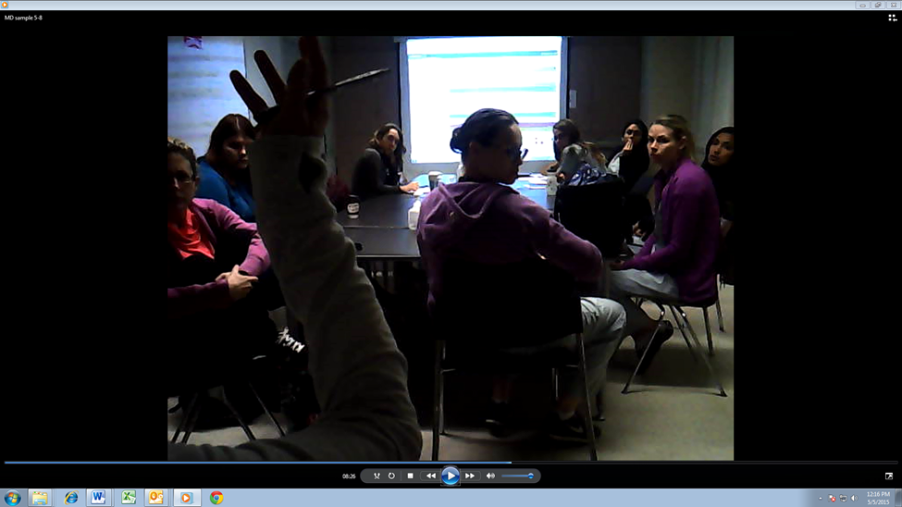 Figure E

In Figure D, loss of joint focus is evident. In the next photo, Figure E, the off going member (giver) uses increased body language and raises her voice when speaking about a concern. It is only at this point that everyone turns to her.

Second, the “poker hand” style of communication is where the giver of handover holds a chart or information source that cannot be seen by the receiver of handover. 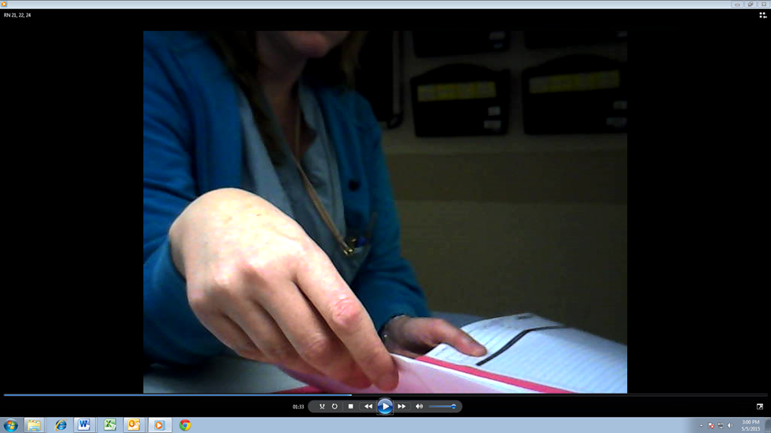

Here the giver of handover is holding the information and the receiver is listening to the details. The receiver is not taking notes at this time, nor can she see any of the details that are in front of the giver. This was observed in 22% of the nursing handovers and none of the MD handovers.

The third style is Parallel Play. Here, the off going and incoming professionals are working in the same space but they do not have a joint focus. Because the giver of handover is looking at a source of information and the receiver is looking elsewhere, it is not possible for the giver to gage whether or not the receiver is processing the information or not. In many of the observed handovers, information was asked to be repeated because the receiver had to clarify a fact. This was seen in 48% of the nursing handovers and 6 % of the MD handovers.

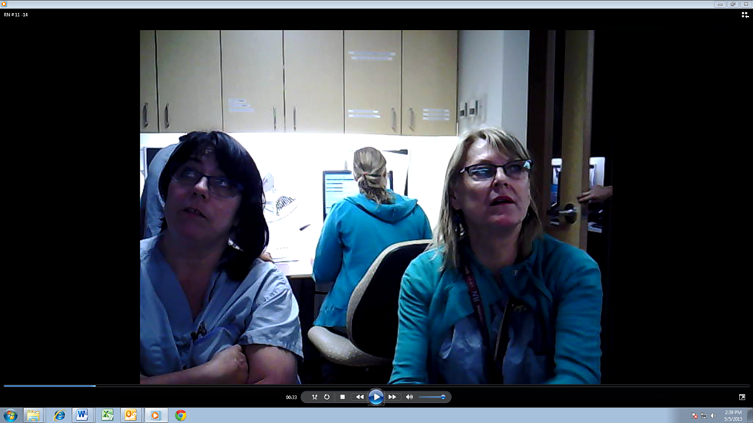 parallel play

Kerbside consultation: Here the giver is standing and the receiver is sitting. Although joint focus is possible in this method, the handover appears hurried and this may prevent receivers from asking clarifying questions. 59 This was the least frequent method of handover (.04% RN vs 24 % MD). In this photo it is the receiver who is standing and appears hurried. The giver is elaborating on details.

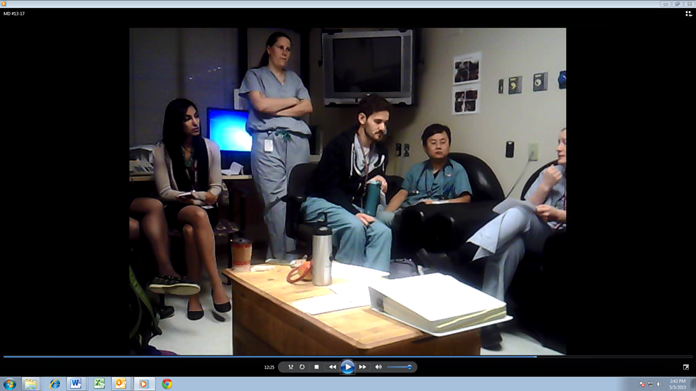

When combining the number of times nurses use joint focus of attention, joint focus with parallel play or poker hand, it was observed that in 40 % of the handovers nurses displayed joint focus attention behaviour. When combining the observations of doctor’s use of joint focus of attention and joint focus with kerbside consultation, it was seen in 64% of the handovers. the roll that nonverbal behaviours have on communication transfer will be discussed in chapter 4.

**3.4 Questionnaire results**

This section will outline demographics about the respondents, and outline correlations between respondent’s perceptions of the quality of the handover compared to observer results.

**3.4.1 Questionnaire respondent’s demographics**

Each RN handover pair had one outgoing or “giver” responder to the questionnaire and one incoming or “receiver” responder. The medical handovers on the other hand were collated differently because each handover case typically had one “giver” response and a few “receiver” responses. This is because each medical handover case involved an outgoing resident handing over to an incoming team. Statistics on the respondents to the questionnaires and their rank are outlined in table 8. It is important to mention here that the people who consistently responded to the medical team questionnaires (for example PGY2) were used to calculate the physician team tables.

**Table 8.**  Most common respondents to questionnaires by profession and rank

Giver of handover – Medical Team

|  |  |  |  |
| --- | --- | --- | --- |
|  | | Frequency | Percent |
| Rank |  |  |  |
|  |  |  |
|  |  |  |
| PGY2 | 22 | 88.0 |
| OB Staff  Total | 3  25 | 12.0  100.00 |
|  |  |  |

Receiver of handover – Medical Team

|  |  |  |  |
| --- | --- | --- | --- |
|  | | Frequency | Percent |
| Rank |  |  |  |
| clerk | 14 | 56.0 |
|  |  |  |
|  |  |  |
| PGY2 | 11 | 44.0 |
| Total | 25 | 100.00 |
|  |  |  |

Giver of handover – Nursing Team

|  |  |  |  |
| --- | --- | --- | --- |
|  | | Frequency | Percent |
| Rank | 0-5 yrs RN | 3 | 12.0 |
| **>10 yrs RN** | 22 | 88.0 |
| Total | 25 | 100.0 |
|  |  |  |  |
|  | |  |  |

Receiver of handover – Nursing Team

|  |  |  |  |
| --- | --- | --- | --- |
|  | | Frequency | Percent |
| Rank | 0-5 yrs RN | 1 | 4.0 |
| **>10 yrs RN** | 24 | 96.0 |
| Total | 25 | 100.0 |
|  |  |  |  |

**3.4.2 Agreement of handover distractions**

One of the study questions was *“ what perceptions do doctors and nurse have about the quality of handover they give and receive?”.* The Handover Assessment Tool captured the types of distractions during handover such as phones, pagers or people who affect quality of information transfer. The participant questionnaire asked each participant to identify distractions during the handover. The next two tables represent what the giver and receiver of handover reported as a perceived distraction compared to the investigator’s observation across all nursing handovers *(Note: this does not indicate the same handover case)*

**Table 9.** Crosstabs Data RN

|  |  |  |  |
| --- | --- | --- | --- |
|  | **Investigator’s Observed score** | **Response Giver** | **Response receiver** |
| **Pagers** | 1 | 2 | 0 |
| **Phones** | 20 | 8 | 9 |
| **Person/people** | 18 | 11 | 5 |

**Table 10.** Crosstabs Data MD

This table represents what the giver and receiver of handover reported as perceived distraction compared to investigator’s observation across all medical handovers *(Note: this does not indicate the same handover case)*

|  |  |  |  |
| --- | --- | --- | --- |
|  | **Investigator’s Observed score** | **Response Giver** | **Response receiver** |
| **Pagers** | 10 | 2 | 2 |
| **Phones** | 4 | 0 | 4 |
| **Person/people** | 12 | 0 | 1 |

**3.4.3 Agreement of handover quality**

This thesis examined each discipline’s perspective on the quality of information transfer; what is observed compared to what is perceived to be critical. Handover distractions (outlined above), time to ask questions, identification of risk and delegation of tasks were the quality aspects that were measured. Three areas of handover quality were assessed on both the Handover Assessment Tool which mirrored questions asked on the questionnaire. See table 11 and 12.

**Table 11:** Comparison of MD participant’s perceptions of handover quality to observed scores

**MD data:**

|  |  |  |  |
| --- | --- | --- | --- |
| **Question asked** | **Responses**  **MD giver** | **Responses MD receiver** | **Observed MD** |
| Do you feel you had time to ask about or clarify any risks or concerns about the patients in this handover? | 100% = yes | 100 % = yes | 56 % |
| Do you feel you received a clear assessment of the patient or clinical situation in order to do your job well today? | 100% = yes | 100 % = yes | 88 % |
| Do you feel that follow up labs/investigations/ or other time sensitive tasks to be completed were clearly outlined or received? | 100% = yes | 100 % = yes | 56% |

**Table 12.** Comparison of RN participant’s perceptions of handover quality to observed handovers

**RN data:**

|  |  |  |  |
| --- | --- | --- | --- |
| **Question asked** | **Responses**  **RN giver** | **Responses RN receiver** | **Observed RN** |
| Do you feel you had time to ask about or clarify any risks or concerns about the patients in this handover? | 84% = yes | 100 %= yes | 56% |
| Do you feel you received a clear assessment of the patient or clinical situation in order to do your job well today? | 100 % = yes | 100 % = yes | 76% |
| Do you feel that follow up labs/investigations/ or other time sensitive tasks to be completed were clearly outlined or received? | 64% = yes | 96% | 48% |

**CHAPTER 4: DISCUSSION**

The following discussion provides an interpretation of the combination of study findings. Communication during an obstetrical patient handover is a complex process with variation in the content and environment where information is exchanged. It is not possible to suggest from this data that these handovers have any associated patient risk or harm. However, the themes that emerged while observing these teams during handover highlighted the variability of communication styles and the environmental factors that can affect handover quality. When placed in the context of patient safety, it became evident where areas for improvement can begin. The use of a combined conceptual framework 50  was helpful when assessing gaps and identifying improvement opportunities in handover practices. The framework helped put into context the need for a more standardized structure, process and policy around handover to ensure accountability and responsibility of information transfer is maintained. The following discussion will outline handover content variation, observations of nonverbal behaviors and the relationship between perception of handover quality and observed reality.

**4.1 Phase One: Handover content and process**

Before the Delphi was done, field observations were completed to get a sense of the environment and process of handover at the study hospital. Nurses and physicians were asked about their perception of the current method of handover. The common response from both disciplines was that there was an assumption that nurses handovers would be more detailed and follow a story format, whereas physician handovers would likely be more succinct and contain only medical details. Doctors and nurses also reported to the principle investigator that each discipline needs to know different things about the patent. The Handover Assessment Tool scores indicate that handover content and process was varied between and within each discipline and that there are significant differences in the details during handover within small specialty teams in obstetrics. The findings of this thesis study add to the body of literature on the quality of information transfer, specifically the differences in handover practices between health care disciplines. In addition, researching these communication issues in specific clinical areas allows for the identification of policy development. Experts have emphasized that standardized handover processes, format and content help improve communication among the team and help to decrease the risk of negative outcomes to patient care. 79  Identifying this gap will help set the stage for handover improvement practices at the study hospital. Given that many health care professionals, including, novice or expert trainees and staff, have not had formal training on handover methods, the medical and nursing staff at the study site may begin to appreciate the need for standardization.

**4.2 Differences in handover content**

The findings from this thesis demonstrate the paucity of similarity in handover content among professional groups. These findings add to the body of literature by underscoring the importance of engaging in research in interprofessional care environments, thus allowing research implications to be understood across disciplines rather than within the context of a specific discipline only. The lack of consistency and overlap in some of the patient details pertaining to handover and their relationship to the existing literature will be discussed here and may provide a basis for team engagement in developing an improved structure, process and policy for obstetrical handover.

Research studies validate the use of checklists, which encourage redundancy of details in a handover. This helps mitigate error and has a significant effect on reducing morbidity and mortality. 81,82  Prior to a caesarean section at the study site, a checklist format is used to brief the team about patient details before the surgery commences. This encourages redundancy of details among the multidisciplinary team with the goal of catching potential errors before they happen. This is a mandated surgical pause that has become a widely accepted practice. Team engagement during the collection of data for this study and sharing broadly the results, may allow for members to feel empowered and accountable for any process improvements that the study may generate.

As seen in section 3 (Table 4), items on the handover tool were analysed between disciplines and areas of statistically significant differences were noted and will be discussed. Allergies were mentioned by nurses 40 % of the time, compared to doctors who only mentioned it 8% (p <0.01). This is a relevant finding and one that can be used to advance the quality of handover in obstetrics. This clinical area is one where a variety of antibiotics are used. The Institute for Safe Medication practice (ISMP) reports that a significant percentage of medical errors in hospitals are directly attributed to medication errors, many of which include prescribing medications to which the patent has allergy .80 It is critical that all team members know the allergies of the patient. It is also critical to know whether there are any infectious risks.

Infection control alerts (or stating that the patient has no isolation requirements) was never mentioned in the doctor’s handover and nurses only mentioned it only 16% of the time (p< 0.05). This is another critical detail in the era of ministry mandated infection control practices and compliancy rates. Hospital compliancy rates are made available through the Canadian Institute for Health Information published reports. 101

Support in labour is another item of handover that was mentioned with little consistency. Support is defined as a woman having constant presence by someone, other than her partner, who will help meet her comfort and emotional needs. Whether the woman had labour support was only mentioned 48% of the time by nurses compared to doctor’s who mentioned it 16% of the time (p<0.01). Although not mentioned, it is possible and perhaps likely that the patient did have some degree of supportive care in her labour. This is clinically relevant and is an area that the study’s Birthing Unit wants to explore further given the evidence to support this practice. A randomized control trial comparing labour outcomes in women who had continuous support by a Doula compared to women who did not have additional support showed that the supported group had significantly shorter labour, greater cervical dilatation at the time of epidural analgesia and babies had higher 1 and 5 minute APGAR scores.83-84  Twenty-two trials involving over 15, 000 women allocated to continuous support were more likely to have a spontaneous vaginal birth (RR 1.08, 95% confidence interval (CI) 1.04 to 1.12) and less likely to have intrapartum analgesia (RR 0.90, 95% CI 0.84 to 0.96). Standardizing the discussion of a woman’s supportive care in labour and pain control measures, may allow both disciplines to keep this momentum thereby creating a positive impact on labour and one that can be measured at the study hospital.

Analgesia used in labour, was only mentioned in handover 56% of the time by nurses and 36% by physicians. This raises the question of whether ongoing monitoring of comfort and pain control measures are maintained throughout transition points in a woman’s care or if this creates any unnecessary delays in establishing comfort. It is evident that mentioning her pain control or comfort is not seen as a priority in any handover. Internal statistics reveal that over sixty percent of women at this hospital receive epidural analgesia. Infusion of narcotics via a pump is considered by ISMP to be a high alert medication practice, one which requires verification of amount infused at each patient transition point. Similarly, women receive oxytocin for labour induction which is run on an infusion pump. The pump rate, which equates to how much oxytocin she is receiving, was mentioned 100 % of the time in the handovers of women whose labor was being induced. Since comfort can have a positive impact on labour progress, it is not clear why less priority is placed on mentioning comfort or narcotic infusion pump rate during the handover. From a safety perspective, it would be worthwhile to standardize infusion pumps as a discussion point in a handover.

**4.3 Handover observations - Nonverbal behaviors**

The way health care providers share time and space is an important aspect to quality of information transfer. Nonverbal behaviours have been studied and found to have a positive impact on the exchange and understanding of information. 59  Using the lens of a combined conceptual framework with the addition of measuring the use of nonverbal behaviours in handover, allowed surveillance of current practice with the aim of developing a system and policy around handover in obstetrics. The four types of NV behaviours (joint focus of attention, poker hand, parallel play and kerbside consultation) or a combination of these, were noted during the observation of all handover videos among the medical and nursing team.

The first “joint focus of attention” means that both incoming and off going professionals coordinate their visual and verbal attention to the same source of information (computer screen or patient chart). Joint focus was only maintained in 44% of the nursing handovers and in 34 % continuously in the medical handovers, but it was observed in other medical handovers initially, then diminished as the handover continued and other distractions occurred. The concept of joint focus has been widely studied and validates that redundancy in the visual field which fosters a mutual understanding of both visual and aural inputs. 73 In clinical communication, mutual eye contact, body posture and voice tone (proxies for joint focus of attention) have been shown to increase care outcomes. 74,75 Another added benefit of joint focus is that it fosters situational awareness which is a framework for how individuals comprehend their environment and react to it. 73 When both incoming and off going practitioners refer to the same patient information source, it fosters attention to the details and makes it easier to come back to the information source if distractions occur. Although at the study hospital most medical team handovers occurred in a room with the information source displayed on a screen in front of the room, it was evident in many cases that the giver of handover carried a sheet containing most of the details that were not visible to anyone else. It was also unclear, in some of the videos, whether the receivers of handover were taking notes or relying on memory. The board that everyone is looking at contains only patient name, weeks’ gestation, method of delivery and progress. These results highlight the importance of evaluating the environment and information sources available to guide a standardized handover.

The second style of nonverbal communication was the poker hand. This was used in 22% of the nursing handovers. This creates potential for error because lab values, vital signs or other detailed information, if not written by the receiver, may be misinterpreted or missed altogether. This suggests that the environment and sources of information used in nursing handover need to be more consistent. Lack of redundancy is shown to decrease visual and aural inputs and increases risk for misunderstanding. 59

The third style is Parallel Play. Here, the off going and incoming professionals are working in the same space but they do not have a joint focus. This was seen in 48% of the nursing handovers and 6 % of the MD handovers. Because the giver of handover is looking at a source of information and the receiver is looking elsewhere, it is not possible for the giver to gage whether or not the receiver is processing the information or not. In many of the observed handovers, information was asked to be repeated because the receiver had to clarify a fact. This finding suggests that the team environment where nurses conduct handover is not conducive to effective listening. Nurses have become complacent to environmental noise and distractions. Nurses perceived phones as a distraction during handover 8.5 times compared to the observed 20 times it actually happened.

The fourth style is kerbside consultation. Here the giver is standing and the receiver is sitting. Although joint focus is possible in this method, the handover appears hurried and this may prevent receivers from asking questions for clarification. 59 This was the least frequent method of handover (.04% RN vrs 24 % MD) however it is a significant result when compared to the perception of medical and nursing staff having time to ask questions. The doctors and nurses who were receiving handover reported that 100 % of the time they felt they had time to ask questions. In fact, it was observed in 56 % of the recordings that there was an actual pause in between handover cases allowing the team to ask or clarify information. Being aware of this nonverbal communication behavior is one that will need to be highlighted for the team. Given these results, and the evidence 50 in communications safety, body language, eye contact and joint focus of attention are important factors to consider when developing training methods and policy of effective handover.

**4.4 Observations versus perceptions**

When analysing distractions, the medical team was more likely to be distracted by pagers and people than phones likely because the handover takes place away from a busy team centre. Staff on the Birthing Unit access the medical team by pager. It was observed on a few occasions that another staff member or a charge nurse would interrupt the medical handover to clarify something or to relay a concern. The differences between the disciplines were not statistically significant. Phones distracting the handover on the other hand were significant. Nurses were more likely to have phones disrupt their handover over doctors (48% versus 4%, p < 0.05). Given that nurse’s handovers occurred at a busy team centre, it was not surprising that 72% of the handovers were disrupted by people. Again, this finding suggests that the team environment where nurses conduct handover is not conducive to effective listening. Nurses have become complacent to environmental noise and distractions. Medical handovers on the other hand were not often interrupted by a loud and busy environment because the team performs handover in a classroom setting, far away from the clinical area.

In the Crosstabs Data for RNs, there is discrepancy between investigator’s observed score and responses given by the participants for distractions. It was observed that phones distracted the nurses handovers significantly more than it did for MDs (p < 0.05) likely because nurses handover occurred in the busy team centre area. During the MD handovers, pagers were observed to be a distraction 10 times compared to the perceived 2 times by givers and receivers. People also distracted the handover 12 times as much as was perceived by the receivers of handover. It is evident from these results that there may be a culture of complacency when it comes to distractions surrounding the handover.

Time to ask questions or clarify any risk factors during a handover was observed and asked of each participant. Interestingly, the medical team “receiver” respondents felt 100 % of the time that they always had time to ask questions during handover. Nurse’s scores were the same. It was observed however, in both groups, that only 56 % of the time there was evidence of clarification of patient details, risks or concerns. The observed handover videos revealed there was rarely any pause between patient handover cases and perhaps this explains why questions were not always asked after the handover. This suggests that receivers of handover may not have had any questions because they were satisfied with the details. But if they did have clarifying questions, it is not evident where or when these were answered. The assumption is that patient details can be clarified on the birthing unit with the nursing staff looking after the patient. This may be time consuming and Unit distractions or acuity may delay acquiring knowledge of the patient.

Participants who felt they received a clear assessment and clinical picture, suggests that they could confidently assume care once they arrive to the unit. Evidence has shown that systematic, concise and accurate handover helps create a shared mental image of the patient at all transfer points so that momentum will be maintained through care planning and interventions. 16 Although 100% of receiving nurses and doctors felt that they received enough information to do their job well, it was actually observed in 88% of the medical and 76% of the nurse’s handovers. This was not a statistically significant finding (p = 0.26). These results indicate that this is a difficult and perhaps invalid measurement because some of the handovers observed were brief and gave very little detail so it was interesting that the doctors and nurses felt they received enough information to give them a clear clinical picture. If, where and when they received enough information to feel satisfied with handover details, could not be measured.

Finally, whether or not the participants felt that follow up labs/investigations/ or other time sensitive tasks to be completed were clearly outlined or received was compared to observed scores. 100% of doctors felt that this was the case but it was actually observed in only 56% of the handovers. In about half of the handovers observed, there was no mention to the incoming team of any labs, tests, or physical assessments that needed to be completed. This may have implications to increasing work for the incoming team who may need to follow up with nurses on the unit regarding the patient’s last cervical check or other time sensitive tasks. The fact that there was no delegation of such tasks does not mean that there weren’t any and this highlights the need for transfer of accountability in handovers outside nursing. Developing a handover model with a system of accountability and responsibility is important to maintain continuity of care. 50 Nurses were only observed delegating time sensitive tasks or outlining the need for her incoming colleague to follow up on a test in 48 % of the handovers. Yet, 96% of the receiving nurses felt that tasks were clearly outlined. The extent of patient information follow up that happens on the unit after handover was not measured.

**4.5**  **Study strengths and limitations**

This study had a few limitations. One of the limitations was the ability to correlate the MD questionnaires to each patient handover. A total of ninety three MD responses were collected from the questionnaires. The PGY 2 most often answered the questionnaire as the giver of handover. The clerk more often than the PGY2 responded with a questionnaire as the receivers of handover. Since medical handovers involved a few patients in any given handover, it was not possible to relate the results of the questionnaire to the quality of handover for each patient talked about rather, it is representative for that particular group of patients being handed over. A total of fifty responses were collected from the nursing questionnaires. Both givers and receivers of handover represented the majority (88% and 96% respectively) of respondents who have greater than 10 years’ experience. No correlations could be made with level of experience and overall quality of handover ratings.

A second limitation involves rater selection for inter rater reliability. It would have been valuable to have a staff Obstetrician rate the handover videos to test for rater- reliability. Although the principle investigator was trying to avoid having a biased assessment of the pilot handover tool, scores between experienced and non-experienced obstetrical care providers may have affected the reliability of the tool.

Third, observing a handover that was captured by using only a video camera is a limitation. The use of a single video camera limits what one can see. Eye contact and sometimes other body language may be missed. Observations made during the handover videos also revealed that only 28% of the nurses used a written format and 16% of MDs used a written format to guide them during the handover. If the camera was moved, it is possible to have missed a paper or other artifact used by the giver of handover. In a few handover cases, the camera was moved by the participants perhaps because they didn’t want to have their faces exposed. This happened with nurses more than it did with doctors. This created more video exclusion and the need to have a discussion with staff before the handover to discuss the importance of leaving the cameras stationed at a fair distance from the participants. This limitation was found in another study 100 evaluating teamwork in the operating room. The study investigators found that it was difficult to gauge eye contact and other nonverbal behaviors when retrospectively observing particular vantage points from the camera. If replicating an observational study of handover, the use of multiple cameras and/or having a live observer would potentially prevent subtle use of language, use of artifacts or nonverbal behaviours to be missed.

One of the strengths of this study was the use of a conceptual framework to help assess and answer what information is transferred during handover. This framework helped identify gaps in the responsibility and accountability aspects of clinical handover. This will help set the stage for creating process improvements and policy regarding information transfer or standardization of methods of information transfer. Future research will be needed at this study hospital to measure how such polices or methods will influence practice in clinical handover in obstetrics.

Another strength is the diversity of information gathered both from the participants perspective as well as observer data. Using a mixed methodology to explore handover content and process between two disciplines and making correlations between observed handover content and health professional’s perceptions of quality was valuable as it allowed the observed data to be further elaborated on with the perceptions of the participants. If only a single methodology was used to analyse handover scores, the discrepancy between perceptions of handover quality and observed reality may have been missed.

Lastly, the use of an interprofessional focus is believed to be a big strength. Many other studies mentioned earlier 5-14 focused on gaps in handover within a specific discipline or from one group of professionals to another during interdepartmental transfers. This thesis however was able to broaden the conclusions by correlating multidisciplinary participant perceptions of handover quality to observed scores within a specific team.

**4.6 Clinical implications and future direction:**

Communication in handover is a complex process that is often variable, unstructured and error-prone. 20 This process, can however, be better understood if studied through the perspectives of all members of the multidisciplinary team. Therefore, a shift in the handover research agenda toward mixed methods approach is necessary. The findings of this study raise questions about whether or not standardization of doctors and nurses handover content in an obstetrical handover reduces the potential for clinical error. The findings show that there are significant differences in the content that is handed over and it also highlights that the environment and the use of nonverbal behaviours can have an impact on information transfer, positive or negative. The findings allowed for the adaption of an existing conceptual framework to measure handover quality, with the addition of observing use of nonverbal behaviours. This demonstrates that it is insufficient to measure only the content in a handover, but rather one needs to consider measurement of how team members share information through the use of body language. Using these perspective and theoretical lens, handover research at the local professional clinical level can be enhanced by measuring handover in the context of the interprofessional team perspective, within a specific environment.

The findings of this study also highlight the need for educators and trainees in health professional education to understand the use of nonverbal behaviors and the impact they have on the quality of information transfer. Although there may be opportunities in clinical training to learn about, practice or enhance effective communication strategies, new graduates face the added complexity of ever-changing teams within a clinical work setting; further impacted by culture, unique dynamics and infrastructure that impacts communication. Learning about and modeling systematic approaches would support further development of communication skills.

Systematic approaches to study handover gaps are vital in order to develop systematic approaches for improvement. The goal mentioned at the beginning of this thesis was to understand what doctors and nurses feel important to mention in their handover. Gaps in practice were identified as originally sought out in the methods. It is clear from this study that there is discrepancy with the content that doctors and nurses cover in handover. It is also evident that doctors and nurses perceive that there is little distraction and that their current handover practices allow for timely exchange of information. They feel satisfied with the quality of information they receive. The observations revealed a different picture; one where complacency to a busy and distracting environment is the norm. What was revealed in this quality assurance project is that the content or “what” is handed over is just as important as the process or “how” is handed over. It is important that handover information is shared effectively from the outgoing crew to the incoming one in a way that is clearly understood or decoded by the recipients – removing assumptions and further investigative work to get the answers that are needed. 48

This research may inform areas outside of obstetrics. Results can potentially generalize to other clinical areas such as general internal medicine or general surgery where nurses and doctors often do not handover at the same time and location. As a start, the study hospital may establish inter-disciplinary team training in clinical handover. This may start simply with changing the layout of the room in which handover is given. Consideration will be given to where the team members should position themselves and what available information needs to be present to foster joint focus of attention.

A second step may be to collaboratively establish a systematic handover format, followed by a policy for the handover process. Since most heath care providers do not receive formal training on handover methods, it will be vital that any systematic process improvements be incorporated in to learner’s orientation to the clinical area. This can be evaluated for sustainability over time. Studies have validated the use of standardised checklists or handover format and its impact on improved quality of information transfer. 16, 92, 93-98 Sustainability can only be ensured if there is ongoing training and policy requirement for handover. If the effectiveness of a standardized handover format is to be studied, it needs to be measured longitudinally to study if practice changes can be maintained.

**Appendix A:** Donabedian model for evaluating quality

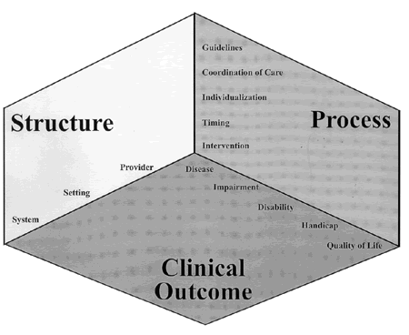

**Appendix B:** Normative Model

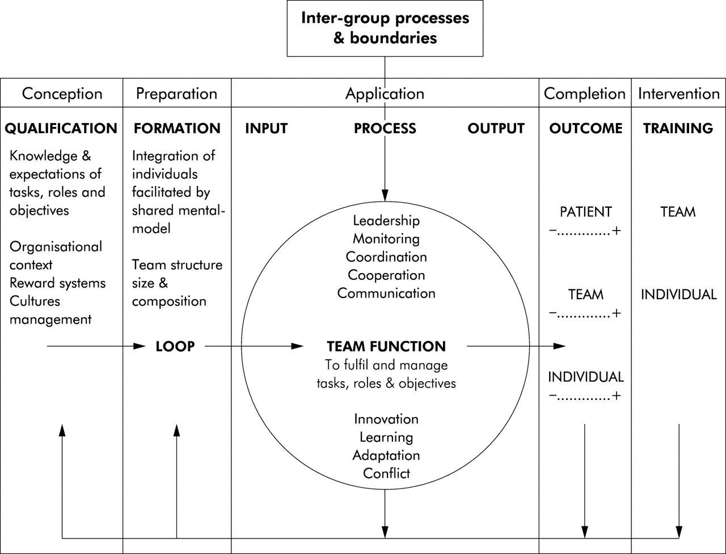

Appendix C: **Combined framework**

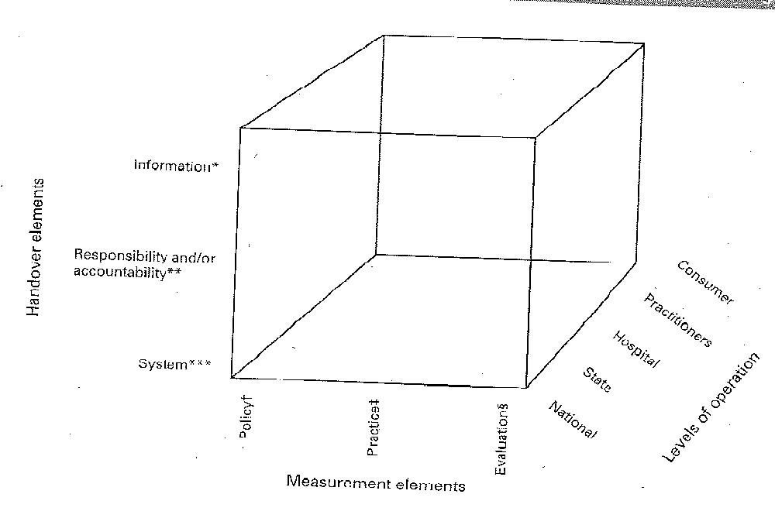

**Appendix D:** Consent for Medical Team Members



**Information and Consent: Handover**

**Project Title: Development and evaluation of a tool to measure and compare handover content between multidisciplinary care providers in obstetrics.**

**Study Investigator**: Julie Pace, Nurse Educator of the Women’s and Infants’ Program St. Joseph’s Healthcare Hamilton.

You are being asked to participate in a research study investigating content and communication processes involved during a handover. The handover you are about to give, will be video recorded with a tablet device. At the end of the handover, you will be asked to fill out a short survey. The recording and survey will be numbered for identification purposes and will be kept confidential. Your name will not be associated with the handover in any analyses, report, or paper that may result from this study.

The handover and survey will not be used as an assessment of your performance and individual results will not be shared with your Clinical Supervisor or Chief of Department of Obstetrics and Gynecology nor appear in your file. All study data will be kept confidential and will be stored in a double -locked environment.

If you decline consent, your handover will not be recorded or used in the analysis.

This study falls under Quality Assurance.

Signature ______________________________

Date_______________________________

Witness______________________________

**Appendix E:** Consent for Nursing Team Members

 **Information and Consent: Handover**

**Project Title: Development and evaluation of a tool to measure and compare handover content between multidisciplinary care providers in obstetrics.**

**Study Investigator**: Julie Pace, Nurse Educator of the Women’s and Infants’ Program St. Joseph’s Healthcare Hamilton.

You are being asked to participate in a research study investigating content and communication processes involved during a handover. The handover you are about to give, will be video recorded with a tablet device. At the end of the handover, you will be asked to fill out a short survey. The recording and survey will be numbered for identification purposes and will be kept confidential. Your name will not be associated with the handover in any analyses, report, or paper that may result from this study.

The handover and survey will not be used as an assessment of your performance and individual results will not be shared with your manager nor appear in your file. All study data will be kept confidential and will be stored in a double -locked environment.

If you decline consent, your handover will not be recorded or used in the analysis.

This study falls under Quality Assurance.

Signature ______________________________

Date_______________________________

Witness______________________________

**Appendix F :** Study Hospital’s Nursing Transfer of Accountability (TOA) format

Critical Elements

Patient Identifiers

Diagnosis and Current Status

Allergies

Code Status

Isolation Requirements

Risks and Concerns

Immediate Goals / Plan of Care

Bedside Safety Check

Patient Identification Band

Allergy Band

Isolation Sign Posted

Tubes and Drains Intact

IV (Solution / Rate / Site / Date)

Restraints

Falls Risk Signage Posted

Oxygen / Suction / Call Bell

Variance

**Appendix G:**  Delphi Results

**Delphi: 20 expert multidisciplines in Obstetrics ( 15 respondents in round one and round 2) All items rated on a 5 point scale 1(strongly disagree) 2 (mildly disagree), 3 (Neutral), 4(mildly agree), 5 (strongly agree) that the item should be included in a handover**

**Clinical information between outgoing and incoming team/professional: 80% mean score ( > 4.0 = include item) > 12 out of 15 say they would include item**

**Round 1 Round 2 (consensus)**

Pt. Name/age 1 2 3 4 5 15/15 I 15/15 I

GTPAL 1 2 3 4 5 15/15 I 15/15 I

Care provider 1 2 3 4 5 5/15 E 7/15 E

Allergies 1 2 3 4 5 14/15 I 14/15 I

IPAC alerts 1 2 3 4 5 13/15 I 13/15 I

serology 1 2 3 4 5 12/15 I 15/15 I

Maternal blood group 1 2 3 4 5 8/15 E 9/15 E

**Current status of the following discussed:**

Type of delivery planned1 2 3 4 5 13/15 I 15/15 I

Time admitted to unit 1 2 3 4 5 -- 12/15 I

Progress 1 2 3 4 5 14/15 I 15/15 I

Plan of care 1 2 3 4 5 14/15 I 15/15 I

Analgesia 1 2 3 4 5 15/15 I 15/15 I

Support in labour 1 2 3 4 5 -- 12/15 I

**Social aspects are discussed:**

SW consult of any kind1 2 3 4 5 15/15 I 14/15 I

Maternal drug use 1 2 3 4 5 -- 14/15 I

**Anticipated Baby Care:**

GBS screening: prophylaxis1 2 3 4 5 13/15 I 15/15 I

Hep B 1 2 3 4 5 13/15 I 15/15 I

Maternal fever: plan of care1 2 3 4 5 15/15 I 15/15 I

**Communication aspects:**

Handover is written 1 2 3 4 5 5/15 E 7/15 E

The person taking on responsibility of the pt has

time to ask questions 1 2 3 4 5 15/15 E 15/15 I

**Teamwork:**

The leader of the team for

the oncoming shift is

Identified 1 2 3 4 5 -- 6/15 E

**Situational awareness:**

Concerns about risks

to patient are raised 1 2 3 4 5 -- 15/15 I

The outgoing team/professional

provides a clear

assessment of the clinical

situation in which the

new team will be working1 2 3 4 5 -- 15/15 I

**Accountability/responsibility:**

Tasks to be completed are

clearly assigned to the

oncoming professional/group 1 2 3 4 5 -- 15/15 I

**Appendix H: Training for the raters:**

Definition legend:

Primip: means primiparous, pregnant for the first time

Multip: mean multiparous, more than one pregnancy

Gravida: means woman is pregnant ( G2 means 2nd pregnancy)

39 and 2 or 37 6/7: this indicated baby’s gestational age. 39 weeks and 2 days or 37 weeks and six days.

T means term (G4, T2 means 4th pregnancy and 2 children born at term)

Ruptured: this means membrane status. If membranes are ruptured this means she ‘broke her water” membranes can be “ARM” (artificially ruptured by doctor) or “Spontaneous” ( woman’s water broke on its own). Membranes can be “bulging”, this means baby is moving down.

Pre eclampsia: a disease of pregnancy with high blood pressure and altered liver and renal status. Feeling unwell, abdominal pain or chest/epigastric pain, visual disturbances.

“bleeds” : indicative of a heavy bleed/post-partum hemorrhage

GBS; group B strep bacteria which require IV antibiotics.

Oxytocin : hormone to kick start labour

“pump running at…” this is oxytocin via IV infusion. It is increased as needed to obtain effective contraction patterns.

Cervix status: unfavorable means its not getting softer and dilating. Favorable means that labour is progressing.

Decels ( decelerations): this is a decrease in fetal heart rate as seen on the fetal monitor strip

Rubella status: part of regular screening for pregnant women.

**Appendix I**

**Handover Questionnaire**

You are being asked to participate in a research study investigating content and communication processes involved during a handover. The handover you are about to give, will be video recorded with a tablet device.

At the end of the handover, please complete this survey. The recording and survey will be numbered for identification purposes and will be kept confidential. Your name **will not** be associated with the handover in any analyses, report, presentation or publication that may result from this study.

1. **I was:** ❒ Giving handover (off going) ❒ Receiving handover (incoming)
2. **My designation is:**

Physician: ❒ Clerk ❒ Intern ❒ PGY1 ❒ PGY2 ❒ PGY3 ❒ PGY4 ❒ PGY5 ❒ OB staff

Registered Nurse: ❒ 0-5 year experience ❒ 5-10 years ❒ 10 or more years

1. **The handover was guided by:**

❒ Patient care notes/ chart

❒ Flow sheet

❒ Memory

❒ Mixed (explain): ___________________________________________

1. **Were there any distractions during this handover?**

❒No distractions

* + Pager went off
  + Telephone call
  + Person/situation interrupted
  + Other: ______________________________________________________

1. **Do you feel you had time to ask about or clarify any risks or concerns about the patients in this handover?**

* Yes
* No: explain:____________________________________________________________

1. **Do you feel you received a clear assessment of each patient/clinical situation in order to do your job well today?**

* Yes

No: explain:________________________________ **Please turn over 🡺**

1. **Do you feel that follow up labs/investigations or other time sensitive tasks to be completed were clearly outlined or received?**

* Yes
* No: explain:____________________________________________________________

1. **How many hours did you sleep prior to this handover? ________________________**

1. **Other comments:**

|  |
| --- |
|  |
|  |
|  |
|  |
|  |

**Thank you for your help.**

**Please put this in the envelope provided and seal it for confidentiality.**

**Appendix J :** Chi Squares for all 29 items





**Appendix K**: Frequency table: percentage of time each discipline mentions each item in handovers

|  |  |  |  |  |  |  |  |  |  |  |  |  |
| --- | --- | --- | --- | --- | --- | --- | --- | --- | --- | --- | --- | --- |
|  | Pt ID | Gavida | allerg | IPAC | Ser | GBS | Type of del | Time | Progr | POC | Analg | support |
| RN % | 96 | 92 | 40 | 16 | 40 | 64 | 56 | 68 | 88 | 92 | 56 | 48 |
| MD % | 100 | 80 | 8 | 0 | 16 | 52 | 60 | 60 | 88 | 84 | 36 | 16 |

|  |  |  |  |  |  |  |  |  |  |  |  |  |  |
| --- | --- | --- | --- | --- | --- | --- | --- | --- | --- | --- | --- | --- | --- |
|  | Social work | Mat drug use | Mat fever | Time to ask | Concerns raised | Clear assess | Tasks assign | Written format | Dis pager >1 | Pager once | Phones >1 | Phones once | peopl |
| RN % | 12 | 4 | 32 | 56 | 24 | 76 | 48 | 28 | 0 | 4 | 16 | 24 | 72 |
| MD % | 8 | 4 | 36 | 56 | 56 | 88 | 56 | 20 | 12 | 12 | 4 | 4 | 48 |

**References**

1. Boat AC, Spaeth JP. Handoff checklists improve the reliability of patient handoffs in the operating room and postanesthesia care unit. Pediatric Anesthesia 2013; 23: 647 – 654.
2. Ong M., Biomed M., Coiera, E. A systematic review of failures in handoff communication during intrahospital transfers. The Joint Commissions Journal on Quality and Patient Safety2011; 37(6):274-284.
3. Gephart, SM. The art of effective handoffs: what is the evidence? Advances in Neonatal Care2012; 12(1):37-39.
4. King H., Hohenhaus, S, Salisbury, M. Team –STEPPS strategies and tool to enhance performance and patient safety. 2007 <http://www.health.state.ny.us/professionals/patients/patient_safety.pdf>
5. Suresh G, Horbar JD, Plesk, P et al. Voluntary anonymous reporting of medical errors for neonatal intensive care. Pediatrics 2004; 113(6):1609.
6. Pronovost, T, Thompson D, Holtzmueller CG et al. Toward learning from patient safety reporting systems. Journal of Critical Care 2006; 21(4):305-315.
7. El-Dawlatly AA, Takrouri, MS, Thalaj A et al. Critical incident reports in adults: an analytical study in a teaching hospital. Middle East J Anesthesiol 2005; 17(6): 1045-54.
8. Australian Commission on Safety and quality in health care. (2010). The OSSIE guide to clinical handover improvement. Sydney Australia.
9. Horowitz LI, Moin T, Krumholz HM, et al. What are covering doctors told about their patients? Analysis of sign out among internal medicine house staff. Qual and Saf in Health Care 2009; 18(4):248-255.
10. Arora V, Johnson J, Lovinger D et al. Communication failures n patient sign-out and suggestions for improvement: a critical incident analysis. Qual and Saf in Health Care 2005; 14(6):401-407.
11. Lamond D, The information content of the nurse change of shift report: a comparative study. Journal of Advanced Nursing 2000; 31(4):794-804.
12. Arora, V, Kao J, Lovinger V et al. Medication discrepancies in resident sign-out and their potential to harm. Journal of General Internal Medicine 2007; 22(12):1751-1755.
13. Borowitz SM, Waggoner-Fountain LA, Bass EJ et al. Adequacy of information transferred at resident sign out (in hospital handover of care): a prospective survey. Quality and Safety in Health Care 2008; 17(1):6-10.
14. Pezzolesi C, Schifano F, Pickles J et al. Clinical handover incident reporting in one UK general hospital. International Journal for Quality in Health Care 2010; 22(5):396-401.
15. Manser T, Foster S. Effective handover communication: an overview of research and improvement efforts. Best Practice and Research Clinical Anaesthesiology 2011; 25:181-191.
16. Catchpole KR, De LaVal MR, McEwan A et al. Patient handover from surgery to intensive care: using formula 1 pit stop and aviation models to improve safety and quality. Pediatric Anesthesia 2007; 17(5):470–478.
17. Horowitz LI, Meredith T, Schuur JD, et al. Dropping the baton: a qualitative analysis of failures during the transition from emergency department to inpatient care. Annals of Emergency Medicine 2009; 53(96):701-710.
18. Meissner A, Hasselhorn H-M, Estrym-Bahar M et al. Nurse’s perception of shift handover in Europe: results from the European nurse’s early exit study. Journal of Advanced Nursing 2007; 57(5):535-542.
19. Smith AF, Pope C, Goodwin D et al. Interprofessional handover and patient safety in anesthesia: observational study of handovers in the recovery room. British Journal of Anesthesia2008; 101(3):332- 337.
20. Raduma-Thomas MA, Flin R, Yule S et al. Doctor’s handovers in hospital: a literature review. *BMJ Quality and Safety* 2011. Published online January 5 doi: 10.1136/bmjqs. 2009.034389.
21. Johnson RB, Onwuegbuzie AJ. Mixed methods research: a research paradigm whose time has come. Qual Saf Health Care2004; 33(7):14-26.
22. Guba EG, Lincoln YS. Fourth generation evaluation. 1989. Newbery Park, CA: Sage
23. Creswell JW, Research Design: Qualitative, quantitative and mixed methods approaches; LA, Sage.
24. Creswell JW, Plano Clark VL. The foundations of mixed methods research. In: *Designing and conducting mixed methods research*. Thousand Oaks, California: Sage; 2011: 19.
25. Dewey J . Reconstruction in philosophy; Boston MA: Beacon Press page 132 In: Johnson RB, Onwuegbuzie AJ. Mixed methods research: a research paradigm whose time has come. 2004 33(7) 14-26.
26. Matthew JW, Thomas TJ, Shultz NH et al. Failure in transition: Learning from incidences to clinical handover in acute care. Journal for Healthcare Quality 2013; 35(3)49-56.
27. Reisenberg,lA, Leitzsch J, Cunningham JM. Nursing handoffs: a systematic review of the literature. Advanced journal of Nursing 2010; 110(4):24-34.

28. Croteau R. JCAHO comments on handoff requirement. *OR Manager* 2005; 21(8):8.

29. Coiera E, When conversation is better that computation. J American Inf Assoc

2000 ;7(3):277-286.

30. Donchin Y et al. A look into the nature and causes of human errors in the intensive care unit. *Qual Saf Health Care* 2003; 12(2):143-147.

31. Coiera EW et al. Communication loads on clinical staff in the emergency department. *Med J Aust* 2002; 176 (9): 415 – 418.

32. Payne S et al. Interaction between nurses during handovers in elderly care. J Adv Nurse 2000; 32(2):277- 85.

33. Dowding D. Examining the effects that manipulating information given in the change of shift report has on nurses’ care planning ability. J Adv Nurs 2001; 33(6):836-46.

34. Danis D et al. Improving patient safety by standardizing handoff communications. Phoenix 2007 NACNS national conference. (National association of Clinical Nurse Specialists) 2007.

35. Earhart A, Mangino RR. Patient handoffs: more than a buzz word changing a culture. 2007 NACNS national conference. (National association of Clinical Nurse Specialists) 2007.

36. Ellis D et al. Back to the bedside, patient safety and handoff report 2007 NACNS national conference. (National association of Clinical Nurse Specialists) 2007.

37. Ross J. Developing a better understanding of handoffs. Journal of Perianesthesia Nursing 2012; 27(5):360 -362.

38. Chien K, Chao M, Turner P. Medical error management and the role of information technology: a new approach to investigating medical handover in acute care settings. Technologies for better health in aging societies IOS Press 2006. Pg 679 -684.

39. Roughton VJ, Severs MP, The junior doctor handover: current practices and future expectations J R Coll Physicians London1996;30:213-214

40. Cheah L, Amott DH, Pollard J et al. Electronic medical handover: towards safer medical care. Med J Aust 2005;183:369-372.

41. Australian safety and quality council in health care. Clinical handover and patient safety. Canberra: Safety and Quality Council, 2005.

42.Kohn LT, Corrogan JM, Donaldson MS, To Err is Human: building a safer health system. National Academy press. Washington 1999.

43. Gaba DM, Howard S, Patient safety: fatigue among clinicians and the safety of patients. N Engl J Med 2002;347- 49.

44. Inger MDS, et al. Factors that impact on the safety of patient handovers: an interview study. N Engl J Med 2012;40: 439 – 448.

45. Horowitz LI, Meredith T, Schuur JD, Shah NR, Kulkarni RG, Jenq GY. Dropping the batton: a qualitative analysis of failures during the transition from emergency department of inpatient care. Ann Emerg Med 2009; 53(6):701-710.

46. Creswell JW, Plano Clark VL. Choosing a mixed methods design. In: *Designing and Conducting Mixed Methods Research.* Thousand Oaks, California: Sage; 2011: 53.

47. Nagpal K, Abboudi M, Fischler L et al. Evaluation of postoperative handover using a tool to assess information transfer and teamwork. Ann Surg 2011;253:831-837.

48. Pezzolesi C, Manser T, Schifano F, et al. Human factors in clinical handover: development and testing of a handover performance tool for doctors’ shift handovers. International Journal for Quality in Health Care2012; (*25*)1:58 – 65.

49. Arora V, Johnson J, A. A model for building a standardized hand-off protocol. Jt Comm J Qual Patient Saf 2006;32*:*646-655.

50. Jeffcott SA, Evans SM, Cameron PA, Chin GS. Ibrahim JE. Improving measurement in clinical handover. Qual Saf Healthcare2009; (18): 272-277.

51. Donabedian A. Evaluating the quality of medical care. Milbank Mem Fund Q 1966; 44: 166-206.

52. Davies GP, Hu W, et al. Developments in Australian general practice 2000-2002. What did these contribute to a well-functioning and comprehensive primary health care system? Aust N Z Health Policy 2006; 3:26.

53. Hillman K, Chen J, Cretikos M. Introduction of the medical emergency team system: a cluster-randomized controlled trial. Lancet 2005; 365:2091-7.

54. Duffy M E, Methodological triangulation: a vehicle for merging quantitative and qualitative research methods. Journal of Nursing Scholarship 1987;19 (3).

55. Thorne S. Conceptualizing findings. In Thorne S. Interpretive Description. Walnut Creek, CA: Left Coast Press; 2008

56. Thorne S. Data analysis on qualitative research. Evid Based Nurs2000; 3:68-70.

57. Thorne S, Darbyshire P. Landmines in the field: a modest proposal for improving the craft of qualitative health research. Qualitative Health Research2005; 15:1105 -1113.

58. Developing a research framework and agenda for clinical handover. Centre for Research Excellence in Patient Safety, Monash University and The Australian Commission for Safety and Quality in Health Care. February 24, 2007.

59. Frankel RM, Flanagan M, Ebright P, Bergman A, O’Brien CM, Franks Z, Allen A, Harris A. Context, culture and (non-verbal) communication affect handover quality. BMJ Qual Saf. 2012; 21:21-27.

60. McCarney R, Warner J, Iliffe S, van Haselen R, Griffin M, Fisher P; Warner; Iliffe; Van Haselen; Griffin; Fisher (2007). ["The Hawthorne Effect: a randomised, controlled trial"](http://www.ncbi.nlm.nih.gov/pmc/articles/PMC1936999). BMC Med Res Methodol **7**: 30.

61. Charmaz K. Constructing Grounded Theory. Thousand Oaks CA; Sage

# 62. Hunt MR, Strengths and Challenges in the Use of Interpretive Description: Reflections Arising From a Study of the Moral Experience of Health Professionals in Humanitarian Work Qual Health Res 2009; 19:1284-1292,

63. Allan G, A critique of using grounded theory as a research method, Electronic Journal of Business Research Methods 2003: 2(1):1-10.

64. Thorne, S. Applied Interpretation: A Review of Interpretive Description The Qualitative Report 2010;15 (6):1624-1628

65. Schwandt, T. A. (2001). Dictionary of qualitative inquiry (2nd ed.). Thousand Oaks, CA: Sage

66. Flin R, Martin L, Goeters, K et al. Development of the NOTECHS (Non-technical skills) system for assessing pilots’ CRM skills Hum Fact Aerospace Saf 2003;3: 95-117.

67. Hatten-Masterson SJ, Griffiths ML. SHARED maternity care: enhancing clinical communication in a private maternity hospital setting. Med J Aust 2009; 190(11): 150 – 151.

68. Kith BT, Cooper JB, Zapol WM et al. Handoffs causing patient harm: a survey of medical and surgical house staff. Jt Comm J Qual Patient Saf*.* 2008; 34(10): 563-570.

69. ALARM. Advances in Labour and Risk Management. 19th ed. SOGC 2013.

70. MOREob. Managing Obstetrical Risk Efficiently. Salus Global 2013.

71. Common Program requirements VI.B. 2011. <http://www.acgme-2010standards.org/pdf/Common_Program_Requirements>

72. The Joint Commission. Improving handoff communications: meeting national patient safety goal 2E. Jt Comm Perspect Patient Saf*.* 2006; 6: 915.

73. Hall, JA, Coats EJ, LeBeau LS. Nonverbal behavior and the vertical dimension of social relations: meta-analysis. Psychology Bull2005;131: 898-924.

74. Hall JA, Roter, DL, Rand CS. Communication of affect between patient and physician. J Health Soc Behav 1981;22:18-30.

75. Roter DL, Hall JA, et al. Slicing it thin: new methods for brief sampling analysis using RIAS-coded medical dialogue. Patient Educ Couns 2011;82:410-19.

76. Irby DM, Ramsey PG, Gillmore GM, Schaad D. Characteristics of effective clinical teachers of ambulatory care medicine. Acad Med 1991; 66: 54-55.

77. Irby DM. Three exemplary models of case based teaching. Acad Med. 1994:69: 947-953.

78. Spafford MM, Schryer CF, Mian M, Lingard L. Look who’s talking: teaching and learning using the genre of medical care presentations. J Bus Tech Commun 2006; 20: 121- 158.

79. Kicken W, van der Klink M, Barach P. Handover training: does one size fil all? the merits of mass customization. BMJ Qual Saf 2012; 21:84-88.

80. Institute for Safe Medication Practice. <https://www.ismp-canada.org/smp0103.htm>

81. Haynes AB, Weiser TG, Berry WR et al. A surgical safety checklist to reduce morbidity and mortality in a global population. N Engl J Med 2009; 360:491-499.

82. de Vries EN, Prins HA, Crolla RM et al. Effect of a comprehensive surgical safety system on patient outcomes. N Engl J Med 2010; 363:1928 – 37.

83. Della A, Campbell MF, Lake MF, Backstrand JR. A randomized control trial of continuous support in labour by a lay doula. JOGNN2006; 456-464.

84. Hodnett ED, Gates S, Hofmey G, Sakala C. Continuous support for women during childbirth. Cochrane Review*.* July 15, 2013.

85. Dalkey NC, Helmer O. An experimental application of the Delphi to the use of experts. Management Science 1963; 9(3):458-467.

86. Dalkey NC. An experimental study of group opinion. Futures 1969;1(5) 408 – 426.

87. Delbecq AL, Van de Ven AH, Gustafson, DH. Group techniques for program planning. 1975. Scott, Foresman and co. Illinois.

88. Young SJ, Jamieson LM. Delivery methodology of the Delphi: a comparison of two approaches. Journ Park Rec Admin 19(1): 42-58.

89. Hsu CC, Sandford BA. The Delphi technique: making sense of consensus. Prac Assess Research Eval 2007; 12 (4).

# 90. Norman GR, Streiner DL. Health Measurement Scales: A practical guide to their development. 2008. Oxford University Press 4th ed.

91. Lyons, MN, Standley TD, Gupta AK. Quality improvement of doctors’ shift change handover in neuro-critical care. Qual Saf Health Care 2010;19: 1-7.

92. Payne CE, Stein JM, Leong T, Dressler DD. Avoiding handover fumbles: a controlled trial of structured handover tool versus traditional handover methods. BMJ Qual Saf 2012;21:925-932.

93. Cornelie S et al. The effect of a checklist on the quality of post-anesthesia patient handover: a randomized controlled trial. Int Journal Qual Health Care 2013;25(2):176-181.

94. Boat A, Spaeth JP. Handoff checklists improve the reliability of patient handoffs in the operating room and postanesthesia care unit*. Pediatric Anesthesia* 2013; 23:647-654.

95. Joy BF et al. Standardized multidisciplinary protocol improves handover of cardiac surgery patients to the intensive care unit. Pediatr Crit Care Med 2011;12(3): 304-308.

96. Basu A, Arora R, Fernandes N. Onsite handover of clinical care: implementing modified CHAPS. Clinical Governance: an International Journal 2011;16(3): 220-230.

97. Starmer AJ et al. I-PASS, a mnemonic to standardize verbal handoffs. Pediatrics. 2012; 129(2): 210 – 204.

98. Flanagan ME, Patterson RM, et al. Evaluation of physician informatics tool to improve patient handoffs. Journal of the American Medical Informatics Association 2009;169(4): 509-515.

99. Alvarado K, Lee R et al. Transfer of accountability; transforming shift handover to enhance patient safety. Healthcare Quarterly 2006; 9:75-79.

# 100. Undre S, Healy AN et al. Observational assessment of surgical teamwork: a feasibility study. World J Surg 2006. 30(10) 1774- 83

101. CIHI. Canadian Institute for health Information. <https://cihi.ca>.