Body mass index and cardiovascular clinical outcomes after acute coronary syndromes

Pablo Manuel Lamelas, MD.

Thesis for the Degree of Master of Science

Health Research Methodology Program

Department of Clinical Epidemiology and Biostatics

McMaster University

Hamilton, Canada

September 2015

MASTER OF SCIENCE McMaster University, Hamilton, Ontario

DEARTMENT Clinical Epidemiology and Biostatics

TITLE: Body mass index and cardiovascular clinical outcomes after acute coronary syndromes

AUTHOR: Pablo Manuel Lamelas, MD

FIRST READER: Jon-David Schwalm, MD, MSc

THESIS COMMITTEE: Salim Yusuf, MBBS, DPhil

Shamir Mehta, MD, MSc

Philip Devereaux, PhD

PAGES: 144

ACKNOWLEDGEMENTS

First, I would like to thank Dr Schwalm for being a wonderful supervisor during all my MSc process. He has done enough effort for being considered my “Canadian big brother” (father may sound like older than he really is!).

My most sincere thanks to Dr Yusuf for providing me this unique learning opportunity. I feel the luckiest fellow in the world by being under his supervision. Also, I want to express my gratitude to Dr Mehta and Dr Deveraux for being part of my committee. Defending my Thesis with such outstanding committee will surely have a profound impact in my future as a researcher. Honestly, my committee was too good to be true.

But nothing of this would happen without the presence of Dr Diaz in my career. He trusted in me from the very beginning when I was at medical school. His passion for research made a boost in my interest for research. And more back in time, I want to express my thanks to Dr Thierer and Dr Botto. All of them were critical for my inspiration in research, and I will always remember them as part of my learning process.

Last but not the least, it would be impossible to achieve this without the support of all my family, Luis, Cecilia, Ceci and Sebastián, and specially my wife Kilmida and my future son Francisco. My career is meaningless without their presence.

ABSTRACT

Obesity, assessed by body mass index (BMI), is considered a major public health problem worldwide. Studies in people without CVD, have shown that BMI between 22.5 to 24.9 kg/m2 is associated with the lowest risk of death in healthy non-smoker populations. However, studies in patients with acute coronary syndrome (ACS) have shown that overweight and obese patients have better survival than those in the normal BMI range. This phenomenon has been called the “obesity paradox”.

This thesis has two main components: a systematic review with meta-analysis of the current literature of BMI and ACS, and an individual patient data meta-analysis from 8 randomized trials whose data base was accessible at the PHRI involving ACS patients. The study-level systematic review (35 studies) and meta-analysis (19 studies) demonstrates that there is a statistically significant adjusted 20% risk lower mortality among overweight and obese participants considered normal weight. Nevertheless, there was moderate to high heterogeneity of pooled estimates that could not be explained in subgroup analyses. Also, the systematic review detected major limitations in the current literature, including missing BMI and covariates data, lost to follow-up, enough number of events in high BMI categories, warranting more research in the area.

The second component, the individual patient data meta-analysis (n = 81,553), confirmed a 20% lower mortality risk in the overweight and type I obesity categories, compared to the normal the BMI range. This lower risk was robust and remained consistent within several sensitivity analyses. Analysis of secondary outcomes suggests that a reduced risk of bleeding, and probably a reduced risk of ischemia and heart failure related deaths, are the responsible mechanisms. Given the limitations of observational research, prospective randomized interventional trials are required to clarify the optimal range of BMI in those with ACS.

ABBREVIATIONS

|  |  |
| --- | --- |
| **Name** | **Abbreviation** |
| Acute coronary syndrome | ACS |
| Acute myocardial infarction | AMI |
| Body mass index | BMI |
| Cardiovascular disease | CVD |
| Confidence interval | CI |
| Coronary heart disease | CHD |
| Hazard ratio | HR |
| Non-ST-segment elevation myocardial infarction | NSTEMI |
| Odds ratio | OR |
| Randomized controlled trial | RCT |
| ST-segment elevation myocardial infarction | STEMI |
| Unstable angina | UA |

TABLE OF CONTENTS

**Chapter 1: Introduction and review of the literature………………………………………….1**

* Cardiovascular disease burden and risk factors
* Obesity definition
* Obesity Epidemiology
* Body mass index and primary cardiovascular prevention
* Body mass index and secondary cardiovascular prevention: “The obesity paradox”
* Literature review
* Rationale
* Research question
* Thesis objectives

**Chapter 2: Systematic review, meta-analysis and limitations of the available evidence…………………………………………………………………………………………………………….18**

* Chapter Introduction
* Systematic review and meta-analysis
  + Methods
  + Results
  + Limitations
  + Conclusions
* Limitations of current evidence
  + Limitations of available observational studies
  + Limitations of systematic reviews and meta-analyses on this topic
* Chapter summary

**Chapter 3: Individual patient data meta-analysis methods…………………………………57**

* Review of individual patient data meta-analysis methodology
  + Introduction
  + Analysis implications
    - One-step analysis
    - Two-step analysis
* Individual patient data meta-analysis methods
  + Population and studies characteristics
  + Exposure considerations
  + Outcomes
  + Statistical analysis
  + Ethical considerations and conflict of interests
* Supplementary Appendix

**Chapter 4: Individual patient data meta-analysis results…………………………………….80**

* Study subjects
* BMI and baseline characteristics
* Clinical outcomes
  + Primary outcome
  + Secondary outcomes
  + Subgroup analysis
  + Sensitivity analysis
* Supplementary Appendix

**Chapter 5: Discussion………………………………………………………………………………………………………….121**

* Main findings
* Findings in the context of previous literature (primary outcome)
* Insights on the obesity paradox mechanisms (secondary outcomes)
* Limitations and threats to validity
  + BMI measurement
  + Residual confounding
  + Selection bias
  + Lead-time bias
  + Reverse causality
* Future directions
* Conclusions

CHAPTER 1: INTRODUCTION AND REVIEW OF THE LITERATURE

**Cardiovascular disease burden and risk factors**

Cardiovascular disease is considered the leading cause of death worldwide.1,2 In 2010, the two leading causes of CV death were ischemic heart disease (13.3%) and stroke (11.1%).1 Also, ischemic heart disease ranked first in disability-adjusted life years (DALYs), with a relative increase 29% from 1990.3 It is estimated that 54% of all DALYs are related to non-communicable conditions and 11.8% of these from cardiovascular diseases.3

The INTERHEART study identified 9 modifiable risk factors (abnormal lipids, smoking, hypertension, diabetes, abdominal obesity, psychosocial factors, consumption of fruits, vegetables, alcohol, and regular physical activity) that explained 90% of first myocardial infarctions.4 The results were consistent in both genders, at all ages and across all geographic regions. As a consequence, the current global approach to cardiovascular prevention is to target all modifiable risk factors.

**Obesity definition**

Obesity is defined as “the condition in which excess fat has accumulated in the body”.5 The World Health Organization defines obesity as a body mass index (BMI) more than 30 kg/m2. Also, individuals are categorized as underweight, normal weight, overweight or obese (Table 1) according to BMI values.

BMI is estimated by dividing weight in kilograms over height in meters (kg/m2). Therefore, BMI is simply a measure of weight adjusted for height and, although it is not a direct measure of adiposity, it is highly correlated with body fat.6,7 This correlation combined with a relatively easy calculation, made BMI a popular tool for obesity assessment worldwide. In addition, major society guidelines currently recommend calculating BMI in general practice.8-11

Other anthropometric measures of adiposity that consider abdominal obesity had been described in the literature, such as waist-to-hip ratio, waist circumference, and waist-to-height ratio. These measures have been shown to be superior to BMI in certain settings and populations.12-14 However, the current approach of the World Health Organization and major society guidelines is to use these additional measures as complement (not as a replacement) of BMI.10,15

**Obesity Epidemiology**

The prevalence of obesity has risen substantially during the last three decades. The 2013 age-standardized global prevalence of BMI ≥ 25 kg/m2 among adults was 36.9% in men and 38% in women, compared to 28.8% in men and 29.8% in women in 1980.16 Developed countries usually rank first in obesity prevalence. A cross-sectional analysis done in the United States between 2011 and 2012 by the National Health and Nutrition Examination Survey concluded that 36% of adults were obese and 34% overweight.17 In 2004, the National Institute for Health and Care Excellence in England found that 66% of the population was overweight or obese.18 However, in developed countries the prevalence of obesity has become more stable during the last 8 years. On the other hand, obesity prevalence seems to be increasing in the developing world and given the large popuations , two-thirds of all obese people in the world live in these countries.16

**Body mass index and primary cardiovascular prevention**

Current national guidelines consider the normal BMI range (18.5 to 24.9 kg/m2) as a target for cardiovascular prevention, including in those who have suffered an acute coronary syndrome (ACS).9,10 These recommendations are supported by studies in individuals without prior CVD, in which individuals who are overweight (BMI 25 to 29.9 kg/m2) or obese (> 30 kg/m2) are at higher risk of myocardial infarction and mortality as compared to patients with a normal BMI range.12,19-22 Moreover, weight reduction among obese patients is associated with improved blood pressure, diabetes and dyslipidemia control, although a reduction in clinical events has yet to be demosntrated.23,24

**Body mass index and secondary cardiovascular prevention: “The obesity paradox”**

On the other hand, excess adipose tissue may be beneficial after coronary heart disease (CHD) is established. This hypothesis is supported by a series of meta-analyses of observational studies including patients with CHD, showing a J- or U-shaped association between BMI and mortality or BMI and cardiovascular mortality. In these studies, a normal BMI was associated with a higher rate of recurrent clinical events compared to those who had a higher BMI.25-28 This phenomenon has been named “the obesity paradox”, given the opposite direction of the effects compared to what would be expected based on the studies of people without CVD. This pattern was also observed in those with other chronic cardiovascular conditions (heart failure, hypertension and peripheral vascular disease), among those with non-cardiovascular chronic conditions (the elderly, chronic renal failure, chronic obstructive pulmonary disease, cancer, rheumatoid arthritis and acquired immune deficiency syndrome) and acutely ill adult patients.29,30

Several mechanisms have been proposed in the literature for explaining this association (Table 2). Some hypothesized mediators deserve to be mentioned. First, increased adiposity might increase the metabolic reserve and counteract the adverse effects of inflammation and cachexia.31 Most severely compromised patients after ACS are likely to develop heart failure, and therefore being at risk of developing cachexia. This mechanism is aligned with previous research among patients with heart failure, in which obese patients consistently have better survival compared to normal weight.32,33 Furthermore, in other conditions related to cachexia, such as lung cancer (a non-obesity related cancer), obese patients have better survival compared to normal weight.34

Second, obesity might be associated with lower rates of bleeding compared with individuals who are under-weight.35,36 Bleeding is associated with increased cardiovascular events and mortality, and this relationship may be causal.37 Obese patients receive relatively lower antiplatelet and anticoagulant doses given their higher body weight (during the ACS admission and after discharge), which may be related to fewer bleeding events. This mechanism is supported by previous reports that reported reduced risk at PCI access site and gastrointestinal bleeding among ACS patients.38,39

Finally, the increased vessel size of obese patients may be related to better outcomes after coronary revascularization. Increased body size, assessed by BMI or body-surface area, is linearly associated with coronary vessel size.40,41 Larger vessel size is related to improved outcomes after primary coronary interventions, such as procedural success rate, reinfarction, restenosis, and mortality.42

On the other hand, many investigators have postulated different biases that may explain this paradox (Table 2). Obese patients are likely to have ACS at a younger age and have lower smoking rates compared to normal weight ACS patients, leading to confounding bias.27 Also, other commonly unmeasured confounders, like cardio-respiratory fitness, may result in residual confounding.43 Other biases different than confounding were also reported. Obese patients are likely to have less severe CAD (likely secondary to a younger age at ACS presentation) which can be related to a lead time bias.44,45 Since patients with severe chronic conditions (including CHD) are likely to have lower BMI, reverse causality was also proposed as a potential mechanism.46 Some of these previously mentioned biases may be addressed by adjusting or exclusion (especially confounding bias), but others may remain even after any effort for controlling them.

**Literature review**

After an initial comprehensive search of articles evaluating the relationship between BMI and mortality after ACS, a systematic review with meta-analysis published on October 2014 including 26 studies (218,532 participants) were identified.27 This review detected lower mortality (compared to normal weight) among overweight (RR 0.70; 95% CI 0.64–0.76) and obese (RR 0.70; 95% CI 0.64–0.76) patients, based on unadjusted estimates. No other systematic review on this topic was identified.

This review detected that obese patients were younger (20/26 studies), that current smoking status was less common in obese or overweight patients (7 studies), and renal disease was less prevalent among obese patients. These three variables are strongly related to poorer outcomes after ACS. Therefore, unadjusted estimates are likely to deviate the estimates in favor of obesity.

The studies included in the systematic review were reviewed, and several limitations were noticed. First, 9 of 26 studies reported only in-hospital mortality, including the two largest cohorts (Diercks et al. with 80,845 and Das et al. with 49,329 participants).44,47 This time frame may be considered short to evaluate the impact of BMI after ACS. Second, missing data on BMI, relevant covariates and follow-up were rarely described or commonly exceeded 10% when these were described. Third, BMI was analyzed as a continuous linear variable in some cohorts, even though the available information has systematically shown a J- or U- shaped pattern between BMI and outcomes in all settings (including primary prevention).19 Finally, other limitations were noticed, such as narrow inclusion criteria, low event rates among the different BMI strata or inclusion of one ethnic group.

**Rationale:**

In summary, there exists a substantial body of evidence showing that increased BMI is related to better outcomes after ACS compared to normal weight patients, called the “obesity paradox”. However, the current systematic review and cohort studies present several limitations as outlined above, and the mechanisms are still unknown.

**Research question:**

Do adult patients post ACS with an increased BMI (overweight, BMI 25 to 29.9 kg/m2 or obese, BMI 30 to 39.9 kg/m2), have a lower mortality and lower risk of other major adverse cardiovascular events compared to patients with a normal BMI (18.5 to 24.9 kg/m2)?

**Thesis Objectives:**

The main objectives of this thesis are to address these limitations doing an updated systematic review with meta-analysis, and an individual patient data meta-analysis of high-quality ACS trials executed by the PHRI.

1. Updated systematic review and meta-analysis: The rationale for doing an updated systematic review and meta-analysis are to:

* Update the recently published systematic review
* Generate a solid review of the available literature
* Perform meta-analysis using adjusted estimates between BMI and all-cause mortality (recent systematic review reported only unadjusted mortality)
* Study the effect of *a priori* study-level subgroups
* Assess the limitations of the current literature in a thorough and systematic fashion to help inform the methods for objective 2.

1. Individual patient data meta-analysis from high-quality ACS randomized trials: Individual patient data meta-analysis has several advantages over study-level meta-analysis, such as:48
2. Homogeneous BMI categorization.
3. Statistical analysis homogenization.
4. BMI analysis as a continuous variable.
5. Allows performing subgroup and sensitivity analysis properly.
6. Avoids the risk patient duplicate sets.
7. Better missing data management.
8. Avoids ecological fallacies, especially important if aggregate data comes from studies that included a certain age, sex or ethnicity.
9. Also allows better adjustment for confounders and evaluation of a range of outcomes (recurrent MI, cause specific mortality and bleeding).

Analyzing data from well-executed trials also may provide advantages over previous cohort studies, such as a lower rate of missing data (especially on BMI and other important prognostic variables), lower loss to follow-up rates and centrally adjudicated events. Statistical precision also is an important advantage, since more than 80,000 participants are available for analysis. As a result, an individual patient data meta-analysis of high-quality randomized trials may improve the understanding of the “obesity paradox” among ACS patients.

**References**:

1. Lozano R, Naghavi M, Foreman K, et al. Global and regional mortality from 235 causes of death for 20 age groups in 1990 and 2010: a systematic analysis for the Global Burden of Disease Study 2010. Lancet 2012;380:2095-128.

2. Lloyd-Jones DM, Leip EP, Larson MG, et al. Prediction of lifetime risk for cardiovascular disease by risk factor burden at 50 years of age. Circulation 2006;113:791-8.

3. Murray CJ, Vos T, Lozano R, et al. Disability-adjusted life years (DALYs) for 291 diseases and injuries in 21 regions, 1990-2010: a systematic analysis for the Global Burden of Disease Study 2010. Lancet 2012;380:2197-223.

4. Yusuf S, Hawken S, Ounpuu S, et al. Effect of potentially modifiable risk factors associated with myocardial infarction in 52 countries (the INTERHEART study): case-control study. Lancet 2004;364:937-52.

5. Concise Medical Dictionary: Oxford University Press; 2010.

6. Gallagher D, Visser M, Sepulveda D, Pierson RN, Harris T, Heymsfield SB. How useful is body mass index for comparison of body fatness across age, sex, and ethnic groups? American journal of epidemiology 1996;143:228-39.

7. Bedogni G, Pietrobelli A, Heymsfield SB, et al. Is body mass index a measure of adiposity in elderly women? Obesity research 2001;9:17-20.

8. WHO. Physical status: the use and interpretation of anthropometry. Report of a WHO Expert Committee. WHO Technical Report Series 854. Geneva: World Health Organization, 1995.

9. Jensen MD, Ryan DH, Apovian CM, et al. 2013 AHA/ACC/TOS guideline for the management of overweight and obesity in adults: a report of the American College of Cardiology/American Heart Association Task Force on Practice Guidelines and The Obesity Society. Journal of the American College of Cardiology 2014;63:2985-3023.

10. Perk J, De Backer G, Gohlke H, et al. European Guidelines on cardiovascular disease prevention in clinical practice (version 2012). The Fifth Joint Task Force of the European Society of Cardiology and Other Societies on Cardiovascular Disease Prevention in Clinical Practice (constituted by representatives of nine societies and by invited experts). European heart journal 2012;33:1635-701.

11. In: Obesity: The Prevention, Identification, Assessment and Management of Overweight and Obesity in Adults and Children NICE guidelines. London; 2006.

12. Yusuf S, Hawken S, Ounpuu S, et al. Obesity and the risk of myocardial infarction in 27,000 participants from 52 countries: a case-control study. Lancet 2005;366:1640-9.

13. Lee CM, Huxley RR, Wildman RP, Woodward M. Indices of abdominal obesity are better discriminators of cardiovascular risk factors than BMI: a meta-analysis. Journal of clinical epidemiology 2008;61:646-53.

14. Zhu S, Wang Z, Heshka S, Heo M, Faith MS, Heymsfield SB. Waist circumference and obesity-associated risk factors among whites in the third National Health and Nutrition Examination Survey: clinical action thresholds. The American journal of clinical nutrition 2002;76:743-9.

15. Waist Circumference and Waist-Hip Ratio. Geneva: World Health Organization; 2008.

16. Ng M, Fleming T, Robinson M, et al. Global, regional, and national prevalence of overweight and obesity in children and adults during 1980-2013: a systematic analysis for the Global Burden of Disease Study 2013. Lancet 2014;384:766-81.

17. Ogden CL, Carroll MD, Kit BK, Flegal KM. Prevalence of childhood and adult obesity in the United States, 2011-2012. Jama 2014;311:806-14.

18. In: Obesity: The Prevention, Identification, Assessment and Management of Overweight and Obesity in Adults and Children. London; 2006.

19. Berrington de Gonzalez A, Hartge P, Cerhan JR, et al. Body mass index and mortality among 1.46 million white adults. The New England journal of medicine 2010;363:2211-9.

20. Whitlock G, Lewington S, Sherliker P, et al. Body mass index and cause-specific mortality in 900 000 adults: collaborative analyses of 57 prospective studies. Lancet 2009;373:1083-96.

21. Hubert HB, Feinleib M, McNamara PM, Castelli WP. Obesity as an independent risk factor for cardiovascular disease: a 26-year follow-up of participants in the Framingham Heart Study. Circulation 1983;67:968-77.

22. Calle EE, Thun MJ, Petrelli JM, Rodriguez C, Heath CW, Jr. Body mass index and mortality in a prospective cohort of U.S. adults. The New England journal of medicine 1999;341:1097-105.

23. Siebenhofer A, Jeitler K, Horvath K, Berghold A, Siering U, Semlitsch T. Long-term effects of weight-reducing drugs in hypertensive patients. The Cochrane database of systematic reviews 2013;3:CD007654.

24. Ricci C, Gaeta M, Rausa E, Asti E, Bandera F, Bonavina L. Long-term effects of bariatric surgery on type II diabetes, hypertension and hyperlipidemia: a meta-analysis and meta-regression study with 5-year follow-up. Obesity surgery 2015;25:397-405.

25. Romero-Corral A, Montori VM, Somers VK, et al. Association of bodyweight with total mortality and with cardiovascular events in coronary artery disease: a systematic review of cohort studies. Lancet 2006;368:666-78.

26. Oreopoulos A, Padwal R, Norris CM, Mullen JC, Pretorius V, Kalantar-Zadeh K. Effect of obesity on short- and long-term mortality postcoronary revascularization: a meta-analysis. Obesity (Silver Spring) 2008;16:442-50.

27. Niedziela J, Hudzik B, Niedziela N, et al. The obesity paradox in acute coronary syndrome: a meta-analysis. European journal of epidemiology 2014;29:801-12.

28. Sharma A, Vallakati A, Einstein AJ, et al. Relationship of body mass index with total mortality, cardiovascular mortality, and myocardial infarction after coronary revascularization: evidence from a meta-analysis. Mayo Clinic proceedings 2014;89:1080-100.

29. Lavie CJ, Milani RV, Ventura HO. Obesity and cardiovascular disease: risk factor, paradox, and impact of weight loss. Journal of the American College of Cardiology 2009;53:1925-32.

30. Oliveros H, Villamor E. Obesity and mortality in critically ill adults: a systematic review and meta-analysis. Obesity (Silver Spring) 2008;16:515-21.

31. Engelman DT, Adams DH, Byrne JG, et al. Impact of body mass index and albumin on morbidity and mortality after cardiac surgery. The Journal of thoracic and cardiovascular surgery 1999;118:866-73.

32. Khalid U, Ather S, Bavishi C, et al. Pre-morbid body mass index and mortality after incident heart failure: the ARIC Study. Journal of the American College of Cardiology 2014;64:2743-9.

33. Sharma A, Lavie CJ, Borer JS, et al. Meta-analysis of the relation of body mass index to all-cause and cardiovascular mortality and hospitalization in patients with chronic heart failure. The American journal of cardiology 2015;115:1428-34.

34. Rivera C, Pecuchet N, Wermert D, et al. [Obesity and lung cancer: incidence and repercussions on epidemiology, pathology and treatments]. Revue de pneumologie clinique 2015;71:37-43.

35. Wiviott SD, Braunwald E, McCabe CH, et al. Prasugrel versus clopidogrel in patients with acute coronary syndromes. The New England journal of medicine 2007;357:2001-15.

36. Mahaffey KW, Tonev ST, Spinler SA, et al. Obesity in patients with non-ST-segment elevation acute coronary syndromes: results from the SYNERGY trial. International journal of cardiology 2010;139:123-33.

37. Yusuf S, Mehta SR, Chrolavicius S, et al. Comparison of fondaparinux and enoxaparin in acute coronary syndromes. The New England journal of medicine 2006;354:1464-76.

38. Mehta L, Devlin W, McCullough PA, et al. Impact of body mass index on outcomes after percutaneous coronary intervention in patients with acute myocardial infarction. The American journal of cardiology 2007;99:906-10.

39. Nikolsky E, Stone GW, Grines CL, et al. Impact of body mass index on outcomes after primary angioplasty in acute myocardial infarction. American heart journal 2006;151:168-75.

40. O'Connor NJ, Morton JR, Birkmeyer JD, Olmstead EM, O'Connor GT. Effect of coronary artery diameter in patients undergoing coronary bypass surgery. Northern New England Cardiovascular Disease Study Group. Circulation 1996;93:652-5.

41. Schunkert H, Harrell L, Palacios IF. Implications of small reference vessel diameter in patients undergoing percutaneous coronary revascularization. Journal of the American College of Cardiology 1999;34:40-8.

42. Brodie BR, Stuckey TD, Hansen C, Kissling G, Muncy D. Influence of vessel size on early and late outcomes after primary angioplasty for acute myocardial infarction. The Journal of invasive cardiology 2000;12:13-9.

43. Banack HR, Kaufman JS. Does selection bias explain the obesity paradox among individuals with cardiovascular disease? Annals of epidemiology 2015;25:342-9.

44. Das SR, Alexander KP, Chen AY, et al. Impact of body weight and extreme obesity on the presentation, treatment, and in-hospital outcomes of 50,149 patients with ST-Segment elevation myocardial infarction results from the NCDR (National Cardiovascular Data Registry). Journal of the American College of Cardiology 2011;58:2642-50.

45. De Schutter A, Lavie CJ, Milani RV. The impact of obesity on risk factors and prevalence and prognosis of coronary heart disease-the obesity paradox. Progress in cardiovascular diseases 2014;56:401-8.

46. Flegal KM, Graubard BI, Williamson DF, Cooper RS. Reverse causation and illness-related weight loss in observational studies of body weight and mortality. American journal of epidemiology 2011;173:1-9.

47. Diercks DB, Roe MT, Mulgund J, et al. The obesity paradox in non-ST-segment elevation acute coronary syndromes: results from the Can Rapid risk stratification of Unstable angina patients Suppress ADverse outcomes with Early implementation of the American College of Cardiology/American Heart Association Guidelines Quality Improvement Initiative. American heart journal 2006;152:140-8.

48. Riley RD, Lambert PC, Abo-Zaid G. Meta-analysis of individual participant data: rationale, conduct, and reporting. BMJ 2010;340:c221.

49. Lauretani F, Russo CR, Bandinelli S, et al. Age-associated changes in skeletal muscles and their effect on mobility: an operational diagnosis of sarcopenia. J Appl Physiol (1985) 2003;95:1851-60.

50. Graziani F, Biasucci LM, Cialdella P, et al. Thromboxane production in morbidly obese subjects. The American journal of cardiology 2011;107:1656-61.

51. Schenkeveld L, Magro M, Oemrawsingh RM, et al. The influence of optimal medical treatment on the 'obesity paradox', body mass index and long-term mortality in patients treated with percutaneous coronary intervention: a prospective cohort study. BMJ open 2012;2:e000535.

Table 1: The international classification of adult underweight, overweight and obesity according to body mass index

|  |  |  |
| --- | --- | --- |
| Classification | BMI (kg/m2) | |
|  | Principal cut-off points | Additional cut-off points |
| Underweight | <18.50 | <18.50 |
| Severe thinness | <16.00 | <16.00 |
| Moderate thinness | 16.00 - 16.99 | 16.00 - 16.99 |
| Mild thinness | 17.00 - 18.49 | 17.00 - 18.49 |
| Normal range | 18.50 - 24.99 | 18.50 - 22.99 |
| 23.00 - 24.99 |
| Overweight | ≥25.00 | ≥25.00 |
| Pre-obese | 25.00 - 29.99 | 25.00 - 27.49 |
| 27.50 - 29.99 |
| Obese | ≥30.00 | ≥30.00 |
| Obese class I | 30.00 - 34.99 | 30.00 - 32.49 |
| 32.50 - 34.99 |
| Obese class II | 35.00 - 39.99 | 35.00 - 37.49 |
| 37.50 - 39.99 |
| Obese class III | ≥40.00 | ≥40.00 |

Notes: Adapted from the World Health Organization 1995, 2009 and 2004 reports.

Table2: Proposed mediators and biases of the obesity paradox

|  |  |
| --- | --- |
| **True mediators** | **Biases** |
| Increased metabolic reserve | **Confounding bias:** |
| Increased coronary vessel size | Younger age |
| Reduced risk of bleeding | Sarcopenia in the normal BMI range49 |
| Reduce thromboxane production50 | Less smoking rates45 |
| Better heart failure prognosis | Better medication adherence51 |
|  |  |
|  | **Other biases:** |
|  | Lead time bias45 |
|  | Reverse causality46 |

CHAPTER 2: SYSTEMATIC REVIEW, META-ANALYSIS AND LIMITATIONS OF THE AVAILABLE EVIDENCE

**Chapter Introduction**

The following chapter describes the methods, results and discussion of the updated “study-level” systematic review and meta-analysis. After that, limitations of meta-analyses and cohort studies of this particular subject are discussed in detail. Finally, the advantages of performing an individual patient data meta-analysis from high-quality studies are detailed on a table.

**Systematic review and meta-analysis**

Methods:

Studies were considered eligible if they described the association between BMI and all-cause mortality after ACS. A systematic search was performed on MEDLINE (Ovid, from 1996 with daily update) and EMBASE (Ovid, from 1996). A sensitive search strategy combining the terms “obesity” AND “acute coronary syndrome” was conducted on April 14th 2015, limited to articles published from the year 2014 (search strategy is attached in the Supplementary Appendix). Other sources were considered for including studies, such as a comprehensive search through Google scholar® and manual reference screening of included studies and reviews. An additional search including a systematic review filter retrieved 43 references, which were manually screened for relevant citations. P.L. performed the title and abstract screening and full-text review individually.

A qualitative assessment was performed in all included articles, and only articles that reported adjusted estimates of BMI categories for all-cause mortality were pooled for meta-analysis. Study quality was assessed using the Newcastle-Ottawa Scale for non-randomized studies in meta-analyses. Results were pooled using the generic inverse variance method. Publication bias was assessed through funnel plot inspection. *A priori* subgroup analysis was performed, including ACS subtype, geographic region, follow-up time, study quality according to the Newcastle Ottawa Scale (defined as at least 3 stars in selection, 2 stars in comparability and at least two stars in outcome) and cohort source (cohort study vs randomized controlled trial based cohort). Endnote® and Review Manager® software were used for reference management and executing the meta-analysis, respectively.

Results

The initial electronic search retrieved 2,206 references, and 1,626 remained after removal of multiple reports from the same study (flowchart is presented in Figure 1). After title, abstract and full-text review 35 articles were added to qualitative and 19 to quantitative synthesis (Table 1). No other systematic review studying the association between BMI and ACS was found.

Included studies were published from 1987 to 2014. Fifteen were an analysis of registries (11 collected data prospectively and 4 retrospectively), 7 retrospective cohorts, 9 analysis of randomized controlled trials data, 3 dedicated prospective cohort studies and one a prospective nationwide survey. Seventeen included acute myocardial infarctions (STEMI/NSTEMI), 9 only STEMI, 3 UA/NSTEMI, and 6 UA/NSTEMI/STEMI. Participant´s follow-up ranged from in-hospital to 96 months.

*Quality of included studies according to the Newcastle Ottawa Scale*: Sample selection was an issue in nearly half of the included studies (17 studies had 2 out of 4 or fewer stars). Only three studies had 4 out of 4 stars in the selection category, and 15 studies had 3 out of 4 stars. Comparability between groups was adequate in most of the studies, which included key variables in the models or performed multiple models (26 studies had two out of two stars). Seven studies did not reported relevant variables for adjustment, such as chronic kidney disease or heart failure, and two studies reported unadjusted estimates only. The outcome category was rated 3 out of 3 stars in only two studies. Most of the studies were rated down secondary for reporting only in-hospital follow-up or considerable loss to follow-up rates (more than 10%).

*BMI measurement and analysis*: Twenty-two studies collected BMI during the admission period, and the remaining recorded BMI through medical records review or after patient discharge. None of the studies provided details of how weight and height were measured. BMI was analyzed as a continuous variable in 7 studies and as quartiles or quintiles in two other studies. Among those studies reporting adjusted estimates, 20 did the analysis through Cox proportional hazards and 13 through multiple logistic regression.

*Qualitative synthesis*: Table 2 summarizes the main findings of each included study. Among studies that analyzed BMI as a continuous variable, two detected association between BMI and mortality. Camprubi et al. detected an OR 0.73 (95% CI 0.59 - 0.91), and Mahaffey et al. a HR 0.86 (95% CI 0.75 - 0.97) for each increase in 5 kg/m2 in patients with less than 30 kg/m2.1,2 The remaining 5 studies that reported BMI as a continuous variable did not find statistical significance regarding BMI and mortality. From 24 studies that included an overweight category, this was considered protective in 10 and not statistical significant in the other 14. From the 28 studies analyzing obesity, 9 found it to be protective and 19 not statistically significant. No included study detected that overweight or obesity was related to an increased risk of mortality compared to normal weight.

*Quantitative synthesis:* 19 studies (144,651 participants) reported BMI in categories, performed multivariable analysis and presented estimates with their confidence intervals. Seven reported adjusted odds ratios and 12 adjusted hazard ratios. No interaction was observed between studies reporting HR or OR (p = 0.32 and p = 0.67 for overweight or obesity vs. normal weight, respectively). The overall HR/OR of all-cause death was 0.82 (95% CI 0.75 - 0.91; p < 0.001; I2 64%) for overweight and 0.81 (95% CI 0.73 - 0.91; p < 0.001; I2 56%) for obese patients (Figure 2A and 2B). Heterogeneity couldn´t be explained by ACS subtype (Figure 3A and 3B), geographic region (Figure 4A and 4B), follow-up time (Figure 5A and 5B), study quality (Figure 6A and 6B) or source of the cohort (Figure 7A and 7B). Funnel plot inspection did not suggest publication bias (Figure 8).

Limitations:

Some limitations deserve to be mentioned. First, our search may have missed relevant citations. The search strategy was planned to cover articles published from 2014, the year that the available systematic review executed the electronic search. This past systematic review may not have included relevant citations since we identified ten relevant studies published before 2014 from other sources. Also, title and abstract review as well as full-text review was not done in duplicate. Second, pooling adjusted estimates may raise the concern of pooled results validity since that studies performed multivariable analysis demonstrated heterogeneity. Third, pooling HR and OR into one estimate may not be statistically correct. However, adjusted all-cause mortality estimates using HR or OR were similar among overweight and obese patients compared to normal weight. Finally, given the lack of enough representativeness of certain geographic regions and inadequate categorization of ACS types (e.g.: all pooled studies included STEMI), we cannot rule out interactions across these subgroups.

Conclusions:

Among patients with ACS, overweight and obese patients (assessed using BMI) were associated with reduced risk of all-cause mortality compared to normal weight. We could not document interactions between the exposure and the effect on all-cause mortality based on ACS presentation, geographic region, follow-up time, and study quality or cohort source.

Compared to the previously published unadjusted estimates meta-analysis (overweight RR 0.70; 95 %CI 0.64–0.76; obese RR 0.70; 95 %CI 0.64–0.76), our pooled results from adjusted estimates appears to be closer to the null, but still highly significant (overweight RR 0.82; 95% CI 0.75 - 0.91; I2 64%; obese RR 0.81; 95% CI 0.73 - 0.91).3 This was an expected result, given that, as previously mentioned in the first Chapter, obese patients tend to have ACS at a younger age, smoke less and have less chronic kidney disease, among other potential confounders.3 However, statistical and methodological heterogeneity, as well as other limitations, prevent us reporting definitive conclusions from this updated meta-analysis.

**Limitations of current evidence**

Limitations of available observational studies: Table 3 summarizes study-level limitations not mentioned in previous tables. The most relevant and common limitations are listed below:

*Missing BMI data*: Baseline BMI availability was poorly reported and missing rates were significant in some studies (from 1% to 50% missing BMI data). Fifteen studies did not report the amount of missing BMI on their full-text. From articles reporting BMI missing data (20), 6 reported less than 5% and 11 less than 10%. Overall, 24/35 studies did not report or had more than 10% missing BMI data. Missing BMI data is unlikely to be at random. More critically ill and less compliant patients are likely to have more missing data on weight and height. Angeras et al. and Bulchoz et al., with 25% and 6% missing data on BMI, respectively, were the only articles that analyzed the risk of those patients with missing BMI values.4,5 Both concluded that those participants with missing BMI had higher mortality risk compared to those with BMI data available (HR 1.65, 95% CI 1.53–1.77; and one year mortality of 14.9% vs. 6.3%; P < 0.001; respectively). As a result, significant missing data on BMI may compromise results interpretation.

*Missing covariates data*: The amount missing co-variate data were not addressed in most of the studies (28/35). Of those articles reporting it (7), 6 had more than 10% missing data. Angeras et al., including 64,436 patients with ACS followed for a mean of 21 months (the largest study with follow-up after discharge), had 30% missing data on relevant variables considered for the primary multivariable analysis.4

*In-hospital mortality*: Nine out of 35 studies reported only in-hospital mortality. This time frame may be considered too short for showing protective effects of increased BMI after ACS. Except two studies that included 80,000 and 50,000 participants respectively, in-hospital analysis had small number of events, limiting the reliability of multivariable analyses. For example, Kosuge et al. included 3,000 patients and reported 2 deaths in the obese category.6 Studies analyzing only in-hospital mortality accounted for 48% (155,318/323,265) of patients across all studies and 12% (16,996/ 144,651) of the pooled estimates in our meta-analysis.

*Lost to follow-up*: Twenty-three (out of 28) studies did not report missing data on vital status during follow-up. Two out of 5 studies had more than 10% lost to follow-up rates. Weinberg et al., which included 10,534 patients with STEMI and were followed for 14 months, reported 35% lost to follow-up. Lost to follow-up is unlikely to be at random and may bias the results, especially with mortality. Lack of reporting may not be necessarily related to high rates of lost to follow-up. Many industry-funded RCTs analysis in our review did not report it, even though these studies usually have high follow-up rates. However, lack or inadequate reporting is known to be related to bias, particularly in those non-RCT based cohorts.7

*BMI analyzed as a continuous linear variable*: Seven studies analyzed BMI only as a continuous variable in their multivariable analysis. Several studies observed a J- or U-shaped pattern between BMI and all-cause mortality, including primary preventions studies.8-10 Thus, linear assessment of this association may not be appropriate.

*Other limitations*: Many other limitations were detected in the studies. First, many studies excluded a significant portion of the original cohorts, mainly for missing data on BMI and other covariates. Wienbergen et al. included just 22% of the original size of the registry.11 Second, many studies had very low event rates in the obese categories. This was mainly due to small sample size, short follow-up period or low prevalence of high BMI among included patients. Third, some RCT-based cohorts had wide exclusion criteria, especially regarding bleeding risk, renal failure, and other comorbidities. Finally, some big registries included mainly Caucasians, particularly those done in the United States. This may limit the validity of these results among other ethnicities in which a same BMI may represent different amounts of body fat.

Limitations of systematic reviews and meta-analyses on this topic:

Beyond limitations of any systematic review and meta-analysis, such as publication bias and analysis of duplicate patient sets, there are some “specific” limitations in this research area:

1. Heterogeneity of BMI reporting: Studies usually report BMI with different cut points or groupings. This complicates the interpretation, and probably biases pooled estimates if the cutpoints were used to emphasize a specific conclusion. Those articles reporting normal BMI as less than 25 kg/m2 (including underweight as normal weight) systematically increase the risk of normal weights, given that underweight patients are known to be at higher risk of all-cause mortality. Something similar occurs when overweight or obese patients are presented in the same group as morbidly obese patients, also known to be at higher mortality risk.
2. Heterogeneity of adjustment methods: Most of the available literature performed multivariable analysis, but two aspects limit pooled estimates. First, the primary method for doing the multivariable analysis. Some studies decided to present their data through multiple logistic regression (which output is OR on a single point in time) or Cox proportional hazards (which output is HR and considers data of those censored before follow-up was completed). A previous analysis of 13 studies comparing results using OR or HR with individual patient data showed that the conclusion of the estimates changed in 4 studies.12 However, this analysis was done on cancer studies with high event rates. If the majority of patients will have the event at the end of follow-up, HR provides the advantage of detecting differences in event rates compared to a single point in time analysis (OR), thus, providing different results. Second, the variables included in the multivariable models changed considerably across studies. Even if the same variables were included, the way that variables were included in the model (continuous or categorical) and cut points were heterogeneous. As a result, pooled analysis has limitations that may bias results.
3. BMI analyzed as a continuous variable: BMI is a continuous variable that is categorized for interpretation and decision-making. Although some cohorts with individual patient data performed continuous analysis for all-cause mortality (usually through restricted cubic splines figures), this is not possible to do with aggregate data in systematic reviews. BMI analysis as a continuous variable is important since it may illustrate better the non-linear relationship with all-cause mortality, providing a better idea where the lowest risk range is located.
4. Subgroup and sensitivity analysis: Given that usually study aggregate data is available, subgroups and sensitivity analysis are limited to study-level characteristics. For example, all the studies in our meta-analysis included STEMI, making it impossible to perform subgroup analysis regarding ACS presentation. One of the major criticisms of articles describing the obesity paradox after ACS is the potential risk of reverse causation. Sensitivity analyses excluding certain subgroups of participants may help to clarify the impact of this particular bias.13 In systematic reviews without individual patient data, sensitivity analysis are limited to study-level characteristics.

**Chapter summary**

This chapter provides a detailed background for justifying further research on the topic. The available literature still has several limitations that cannot be solved by new study-level meta-analysis. Also, several limitations of the available cohort studies threaten the interpretation and validity of results. Combining data quality from well-executed clinical trials with individual patient data may offer new insights into the understanding of the “obesity paradox”. Table 4 presents the limitations of the current evidence along with the potential advantages of the proposed individual patient data meta-analysis.

The next chapter introduces readers to individual patient data meta-analysis and its implications for statistical analysis. Then, the methods of the proposed individual patient data meta-analysis are described.

**References**:

1. Camprubi M, Cabrera S, Sans J, Vidal G, Salvado T, Bardaji A. Body mass index and hospital mortality in patients with acute coronary syndrome receiving care in a university hospital. Journal of obesity 2012;2012:287939.

2. Mahaffey KW, Tonev ST, Spinler SA, et al. Obesity in patients with non-ST-segment elevation acute coronary syndromes: results from the SYNERGY trial. International journal of cardiology 2010;139:123-33.

3. Niedziela J, Hudzik B, Niedziela N, et al. The obesity paradox in acute coronary syndrome: a meta-analysis. European journal of epidemiology 2014;29:801-12.

4. Angeras O, Albertsson P, Karason K, et al. Evidence for obesity paradox in patients with acute coronary syndromes: a report from the Swedish Coronary Angiography and Angioplasty Registry. European heart journal 2013;34:345-53.

5. Bucholz EM, Rathore SS, Reid KJ, et al. Body mass index and mortality in acute myocardial infarction patients. The American journal of medicine 2012;125:796-803.

6. Kosuge M, Kimura K, Kojima S, et al. Impact of body mass index on in-hospital outcomes after percutaneous coronary intervention for ST segment elevation acute myocardial infarction. Circulation journal : official journal of the Japanese Circulation Society 2008;72:521-5.

7. Kirkham JJ, Dwan KM, Altman DG, et al. The impact of outcome reporting bias in randomised controlled trials on a cohort of systematic reviews. BMJ 2010;340:c365.

8. Berrington de Gonzalez A, Hartge P, Cerhan JR, et al. Body mass index and mortality among 1.46 million white adults. The New England journal of medicine 2010;363:2211-9.

9. Hubert HB, Feinleib M, McNamara PM, Castelli WP. Obesity as an independent risk factor for cardiovascular disease: a 26-year follow-up of participants in the Framingham Heart Study. Circulation 1983;67:968-77.

10. Whitlock G, Lewington S, Sherliker P, et al. Body mass index and cause-specific mortality in 900 000 adults: collaborative analyses of 57 prospective studies. Lancet 2009;373:1083-96.

11. Wienbergen H, Gitt AK, Juenger C, et al. Impact of the body mass index on occurrence and outcome of acute ST-elevation myocardial infarction. Clinical research in cardiology : official journal of the German Cardiac Society 2008;97:83-8.

12. Michiels S, Piedbois P, Burdett S, Syz N, Stewart L, Pignon JP. Meta-analysis when only the median survival times are known: a comparison with individual patient data results. International journal of technology assessment in health care 2005;21:119-25.

13. Flegal KM, Graubard BI, Williamson DF, Cooper RS. Reverse causation and illness-related weight loss in observational studies of body weight and mortality. American journal of epidemiology 2011;173:1-9.

14. Hoit BD, Gilpin EA, Maisel AA, Henning H, Carlisle J, Ross J, Jr. Influence of obesity on morbidity and mortality after acute myocardial infarction. American heart journal 1987;114:1334-41.

15. Kaplan RC, Heckbert SR, Furberg CD, Psaty BM. Predictors of subsequent coronary events, stroke, and death among survivors of first hospitalized myocardial infarction. Journal of clinical epidemiology 2002;55:654-64.

16. Ness AR, Gunnell D, Hughes J, Elwood PC, Davey Smith G, Burr ML. Height, body mass index, and survival in men with coronary disease: follow up of the diet and reinfarction trial (DART). Journal of epidemiology and community health 2002;56:218-9.

17. Lopez-Jimenez F, Jacobsen SJ, Reeder GS, Weston SA, Meverden RA, Roger VL. Prevalence and secular trends of excess body weight and impact on outcomes after myocardial infarction in the community. Chest 2004;125:1205-12.

18. Rana JS, Mukamal KJ, Morgan JP, Muller JE, Mittleman MA. Obesity and the risk of death after acute myocardial infarction. American heart journal 2004;147:841-6.

19. Eisenstein EL, McGuire DK, Bhapkar MV, et al. Elevated body mass index and intermediate-term clinical outcomes after acute coronary syndromes. The American journal of medicine 2005;118:981-90.

20. Kennedy LM, Dickstein K, Anker SD, Kristianson K, Willenheimer R. The prognostic importance of body mass index after complicated myocardial infarction. Journal of the American College of Cardiology 2005;45:156-8.

21. Kragelund C, Hassager C, Hildebrandt P, Torp-Pedersen C, Kober L. Impact of obesity on long-term prognosis following acute myocardial infarction. International journal of cardiology 2005;98:123-31.

22. Nigam A, Wright RS, Allison TG, et al. Excess weight at time of presentation of myocardial infarction is associated with lower initial mortality risks but higher long-term risks including recurrent re-infarction and cardiac death. International journal of cardiology 2006;110:153-9.

23. Diercks DB, Roe MT, Mulgund J, et al. The obesity paradox in non-ST-segment elevation acute coronary syndromes: results from the Can Rapid risk stratification of Unstable angina patients Suppress ADverse outcomes with Early implementation of the American College of Cardiology/American Heart Association Guidelines Quality Improvement Initiative. American heart journal 2006;152:140-8.

24. Goldberg RJ, Cui J, Olendzki B, et al. Excess body weight, clinical profile, management practices, and hospital prognosis in men and women after acute myocardial infarction. American heart journal 2006;151:1297-304.

25. Iakobishvili Z, Danicek V, Porter A, Assali AR, Battler A, Hasdai D. Is increased body mass index associated with a cardioprotective effect after ST-segment-elevation myocardial infarction? Acute cardiac care 2006;8:95-8.

26. Nikolsky E, Stone GW, Grines CL, et al. Impact of body mass index on outcomes after primary angioplasty in acute myocardial infarction. American heart journal 2006;151:168-75.

27. Wells B, Gentry M, Ruiz-Arango A, Dias J, Landolfo CK. Relation between body mass index and clinical outcome in acute myocardial infarction. The American journal of cardiology 2006;98:474-7.

28. Buettner HJ, Mueller C, Gick M, et al. The impact of obesity on mortality in UA/non-ST-segment elevation myocardial infarction. European heart journal 2007;28:1694-701.

29. Mehta L, Devlin W, McCullough PA, et al. Impact of body mass index on outcomes after percutaneous coronary intervention in patients with acute myocardial infarction. The American journal of cardiology 2007;99:906-10.

30. Lee SH, Park JS, Kim W, et al. Impact of body mass index and waist-to-hip ratio on clinical outcomes in patients with ST-segment elevation acute myocardial infarction (from the Korean Acute Myocardial Infarction Registry). The American journal of cardiology 2008;102:957-65.

31. Lopez-Jimenez F, Wu CO, Tian X, et al. Weight change after myocardial infarction--the Enhancing Recovery in Coronary Heart Disease patients (ENRICHD) experience. American heart journal 2008;155:478-84.

32. Zeller M, Steg PG, Ravisy J, et al. Relation between body mass index, waist circumference, and death after acute myocardial infarction. Circulation 2008;118:482-90.

33. Aronson D, Nassar M, Goldberg T, Kapeliovich M, Hammerman H, Azzam ZS. The impact of body mass index on clinical outcomes after acute myocardial infarction. International journal of cardiology 2010;145:476-80.

34. Hadi HA, Zubaid M, Al Mahmeed W, et al. The prevalence and outcome of excess body weight among Middle Eastern patients presenting with acute coronary syndrome. Angiology 2010;61:456-64.

35. Shechtera M, Hammermanc H, Boykod V, Hoda H, Behara S, Matetzkya S. The obesity paradox in hospitalized acute coronary syndrome patients in Israel: A national survey CVD Prevention and Control 2010;5:81-7.

36. Das SR, Alexander KP, Chen AY, et al. Impact of body weight and extreme obesity on the presentation, treatment, and in-hospital outcomes of 50,149 patients with ST-Segment elevation myocardial infarction results from the NCDR (National Cardiovascular Data Registry). Journal of the American College of Cardiology 2011;58:2642-50.

37. Timoteo AT, Ramos R, Toste A, Oliveira JA, Ferreira ML, Ferreira RC. Impact of body mass index in the results after primary angioplasty in patients with ST segment elevation acute myocardial infarction. Acute cardiac care 2011;13:123-8.

38. Lazzeri C, Valente S, Chiostri M, et al. Impact of age on the prognostic value of body mass index in ST-Elevation myocardial infarction. Nutrition, metabolism, and cardiovascular diseases : NMCD 2013;23:205-11.

39. Herrmann J, Gersh BJ, Goldfinger JZ, et al. Body mass index and acute and long-term outcomes after acute myocardial infarction (from the Harmonizing Outcomes With Revascularization and Stents in Acute Myocardial Infarction Trial). The American journal of cardiology 2014;114:9-16.

40. Mobeirek AF, Al-Habib K, Al-Faleh H, et al. Absence of obesity paradox in Saudi patients admitted with acute coronary syndromes: insights from SPACE registry. Annals of Saudi medicine 2014;34:38-45.

41. Shehab A, Al-Dabbagh B, AlHabib K, et al. The Obesity Paradox in Patients With Acute Coronary Syndrome: Results From the Gulf RACE-2 Study. Angiology 2014;65:585-9.

42. Witassek F, Schwenkglenks M, Erne P, Radovanovic D. Impact of Body Mass Index on mortality in Swiss hospital patients with ST-elevation myocardial infarction: does an obesity paradox exist? Swiss medical weekly 2014;144:w13986.

Table 1:

|  |  |  |  |  |  |  |  |
| --- | --- | --- | --- | --- | --- | --- | --- |
| First Author | Year | Country or region | Enrolment period | Design | ACS type | N | Follow-up (months) |
| Hoit14 | 1987 | USA | 1979–1983 | Prospective registry | AMI | 1,760 | 12 |
| Kaplan15 | 2002 | USA | 1986–1996 | Retrospective cohort | AMI | 2,677 | 40 |
| Ness16 | 2002 | UK | 1983-1987 | RCT cohort | AMI | 2,033 | NR |
| Lopez-Jimenez17 | 2004 | USA | 1979–1998 | Retrospective cohort | AMI | 2,263 | 68.4 |
| Rana18 | 2004 | USA | 1989–1994 | Prospective registry | AMI | 1,898 | 45.6 |
| Eisenstein19 | 2005 | International | 1997–1999 | RCT cohort | AMI | 15,071 | 12 |
| Kennedy20 | 2005 | Europe | 1998-2002 | RCT cohort | AMI | 5,388 | 33 |
| Kragelund21 | 2005 | Denmark | 1990–1992 | RCT cohort | AMI | 6,168 | 96 |
| Nigam22 | 2005 | USA | 1988-2001 | Retrospective cohort | AMI | 894 | 74 |
| Diercks23 | 2006 | USA | 2001–2003 | Retrospective cohort | UA/NSTEMI | 80,042 | IH |
| Goldberg24 | 2006 | USA | 1997, 1999, 2001, 2003 | Retrospective cohort | AMI | 3,513 | IH |
| Iakobishvili25 | 2006 | Israel | 2002–2003 | Prospective cohort | STEMI | 164 | 1 |
| Nikolsky26 | 2006 | International | 1997–1999 | RCT cohort | AMI | 2,035 | 12 |
| Wells27 | 2006 | USA | 2003–2004 | Retrospective cohort | AMI | 284 | IH |
| Buettner28 | 2007 | Germany | 1996–1999 | Prospective cohort | UA/NSTEMI | 1,676 | 17 |
| Mehta29 | 2007 | International | 1990–1997 | RCT cohort | AMI | 9,406 | 12 |
| Kosuge6 | 2008 | Japan | 2001-2003 | Retrospective registry | STEMI | 3076 | IH |
| Lee30 | 2008 | Korea | 2005-2006 | Retrospective registry | STEMI | 3734 | 6 |
| Lopez-Jimenez31 | 2008 | USA | 1996–2001 | RCT cohort | AMI | 1,676 | 29 |
| Zeller32 | 2008 | France | 2001-2006 | Prospective cohort | AMI | 2229 | 12 |
| Wienbergen11 | 2008 | Germany | 1998–2002 | Prospective registry | STEMI | 10,534 | 14 |
| Aronson33 | 2010 | Israel | 2001–2007 | Prospective registry | AMI | 2,157 | 26 |
| Hadi34 | 2010 | Middle East | 2006–2007 | Prospective registry | ACS | 7,843 | IH |
| Mahaffey2 | 2010 | International | 2001–2003 | RCT cohort | UA/NSTEMI | 9,873 | 1 |
| Shechter35 | 2010 | Israel | 2002, 2004, 2006 | Prospective nationwide survey | ACS | 5,751 | 12 |
| Das36 | 2011 | USA | 2007–2009 | Retrospective cohort | STEMI | 49,329 | IH |
| Timoteo37 | 2011 | Portugal | 2005–2008 | Prospective registry | STEMI | 539 | 12 |
| Bucholz5 | 2012 | USA | 2003–2008 | Retrospective registry | AMI | 6,359 | 12 |
| Camprubi1 | 2012 | Spain | 2009–2010 | Prospective registry | ACS | 824 | IH |
| Lazzeri38 | 2012 | Italy | 2004–2010 | Prospective registry | STEMI | 1,268 | 12 |
| Angeras4 | 2013 | Sweden | 2005-2008 | Retrospective registry | ACS | 64,436 | 21 |
| Herrmann39 | 2014 | International | 2005–2007 | RCT cohort | STEMI | 3,579 | 12 |
| Mobeirek40 | 2014 | Saudi Arabia | 2005-2007 | Prospective registry | ACS | 3469 | IH |
| Shehab41 | 2014 | Arabian Gulf | 2008-2009 | Prospective registry | ACS | 4379 | 1 |
| Witassek42 | 2014 | Switzerland | 2005–2012 | Prospective registry | STEMI | 6,938 | IH |

Notes: General characteristic of included studies. IH: In-hospital, NR: not reported.

Table 2:

|  |  |  |  |  |  |  |
| --- | --- | --- | --- | --- | --- | --- |
| Study | Main findings | S | C | O | Baseline measurement | Follow-up modality |
| Hoit 1987 | Obese patients had reduced mortality compared to normal weight | *** | 0 | ** | Inpatient prospectively | Telephone and death records |
| Kaplan 2002 | MVA , U-shaped pattern with nadir in BMI 26.2-28.6, normal vs overweight HR 1.80 (1.30 - 2.50) | *** | ** | ** | Outpatient medical records | Medical records and death certificates |
| Nes 2002 | MVA, overweight HR 0.69 (0.58 to 0.82) and obese HR 0.79 (0.66 - 0.93) compared to BMI less than 24 | ** | * | * | Outpatient prospectively | NR |
| Lopez-Jimenez 2004 | MVA, overweight HR 0.74 (0.65–0.85) and obese HR 0.75 (0.63–0.88) compared to normal weight | *** | ** | ** | medical records | Medical records and death records |
| Rana 2004 | MVA, overweight HR 0.90 (0.68–1.18) and obese HR 1.23 (0.87–1.74) compared to normal weight | **** | ** | ** | Inpatient prospectively | Death records |
| Eisenstein 2005 | MVA, overweight HR 0.74 (0.60, 0.93) and obese HR 0.68 (0.51, 0.92) compared to normal weight | *** | ** | * | Inpatient prospectively | NR |
| Kennedy 2005 | MVA, overweight OR 0.89 (0.73–1.12) and obese OR 0.92 (0.70–1.23) compared to normal weight | ** | ** | * | NR | NR |
| Kragelund 2005 | MVA, "BMI is inversely related to mortality" | ** | ** | *** | Inpatient prospectively | Death records |
| Nigam 2005 | MVA, overweight HR 0.71 (0.51, 0.97) and obese HR 0.61 (0.42, 0.89) compared to normal weight | *** | ** | ** | Medical record | Medical records and death certificates |
| Diercks 2006 | MVA, “lower death rates among overweight and obesity” | *** | ** | ** | Medical records | Inpatient |
| Goldberg 2006 | MVA, "non-significant reduction in mortality" | *** | * | ** | Medical records | Inpatient |
| Iakobishvili 2006 | "death rates were not statistically significant among BMI groups" | ** | 0 | * | Inpatient prospectively | NR |
| Nikolsky 2006 | MVA, BMI HR 0.95 (0.88-1.03) | ** | ** | ** | Inpatient prospectively | Contact and visits |
| Wells 2006 | MVA, "BMI no does not adversely impact mortality" | ** | * | * | Medical records | NR |
| Buettner 2007 | MVA, BMI >30 kg/m2 HR 0.27 (0.08–0.92) compared to normal weight | *** | ** | * | Inpatient prospectively | Visits |
| Mehta 2007 | MVA, BMI >30 kg/m2 "neutral risk" | ** | ** | * | Inpatient prospectively | NR |
| Kosuge 2008 | MVA, overweight OR 0.79 (0.12–7.56) and obese OR 0.40 (0.43–2.55) compared to normal weight | ** | ** | * | Medical records | NR |
| Lee 2008 | MVA, overweight HR 0.58 (0.30–1.01) and obese HR 0.31 (0.07–1.35) compared to normal weight | ** | ** | ** | Medical records | Telephone or visits |
| Lopez-Jimenez 2008 | MVA, overweight HR 0.96 (0.69-1.35) and obese HR 0.74 (0.51-1.07) compared to normal weight | ** | ** | * | Inpatient prospectively | NR |
| Zeller 2008 | MVA, BMI HR 1.01 (95% CI 0.97-1.06) | **** | ** | *** | Inpatient prospectively | Contact and medical records |
| Wienbergen 2008 | MVA, obese OR 0.50 (0.40–0.79) compared to normal weight | *** | ** | ** | Inpatient prospectively | Treating physician |
| Aronson 2010 | MVA, BMI of 26.5-27.9 was the lowest risk category | *** | ** | * | Inpatient prospectively | NR |
| Hadi 2010 | MVA, BMI OR 0.91 (0.31-1.19) | ** | * | ** | Inpatient prospectively | Inpatient |
| Mahaffey 2010 | MVA, per 5 mg/k2 BMI increase: under BMI 30 HR 0.86 (0.75-0.97) and over BMI 30 1.22 (1.07-1.38) | ** | * | ** | Inpatient prospectively | Telephone or clinic |
| Shechter 2010 | MVA, overweight HR 0.65 (0.54–0.78) and obese HR 0.91 (0.73–1.13) compared to normal weight | *** | ** | ** | Inpatient prospectively | Death records |
| Das 2011 | MVA, BMI 30-34.9 was the lowest risk category, normal BMI OR 1.10 (0.91-1.33) and overweight OR 0.99 (0.87-1-13) | ** | ** | ** | Medical records | Inpatient |
| Timoteo 2011 | MVA, overweight OR 0.37 (0.15-0.95) and obese OR 1.01 (0.31-3.24) compared to normal weight | ** | ** | * | Inpatient prospectively | NR |
| Bucholz 2012 | MVA, overweight HR 0.92 (0.71-1.18) and obese HR 0.77 (0.56-1.06) compared to normal weight | ** | ** | ** | Medical records | Death records |
| Camprubi 2012 | MVA, BMI OR 0.73 (0.59-0.91) | **** | * | ** | Inpatient prospectively | Inpatient |
| Lazzeri 2012 | MVA, overweight HR 1.39 (0.95-2.02) and obese HR 0.60 (0.37-1.69) compared to normal weight | *** | * | * | Inpatient prospectively | Phone |
| Angeras 2013 | MVA, overweight HR 0.63 (0.52–0.76) and obese 0.66 (0.55–0.79) compared to BMI 21-23.5 | *** | ** | ** | Medical records | Death records |
| Herrmann 2014 | MVA, "similar adjusted acute and long-term outcomes" | ** | ** | ** | Inpatient prospectively | Contact and visits |
| Mobeirek 2014 | MVA, overweight OR 1.39 (0.76-2.55) and obese OR 1.25 (0.61-2.54) compared to BMI <25 | *** | ** | ** | Inpatient prospectively | Inpatient |
| Shehab 2014 | MVA, "no assosiation" | ** | ** | ** | Inpatient prospectively | NR |
| Witassek 2014 | MVA, overweight OR 1.05 (0.68–1.62) and obese 0.61 (0.30–1.23) compared to normal weight | *** | ** | ** | Inpatient prospectively | Inpatient |

Notes: Studies main result regarding all-cause mortality, Newcastle Ottawa Scale quality assessment, baseline variables measurements and outcome assessment modality. Estimates are presented with 95% confidence intervals. C: Comparability, MVA: Multivariable analysis, O: Outcome, S: Selection.

Table 3:

|  |  |  |  |  |
| --- | --- | --- | --- | --- |
| Study | LTFU (%) | MD (%) | MBMI (%) | Other potential limitations |
| Angeras 2013 | NR | 30 | 25 | Missing data was related to higher mortality, 10 017 (15.6%) had normal coronary arteries |
| Aronson 2010 | NR | NR | NR |  |
| Bucholz 2012 | NR | 12 | 6 | Wide exclusion criteria |
| Buettner 2007 | NR | NR | NR | Excluded other with other concomitant diseases, 9 deaths among obese patients |
| Camprubi 2012 | IH | NR | 4 | Only 35 deaths |
| Das 2011 | IH | NR | 4 | 85% Caucasians |
| Diercks 2006 | IH | NR | 10 | 80% Caucasians |
| Eisenstein 2005 | NR | NR | 5 | Several covariates excluded for missing values |
| Goldberg 2006 | IH | NR | 19 | Normal BMI category included underweight, didn´t consider smoking or comorbidities for analysis |
| Hadi 2010 | IH | NR | 11 | Normal BMI category included underweight |
| Herrmann 2014 | NR | NR | NR | Important comorbidities not measured (eg.: cancer), excluded high risk of bleeding |
| Hoit 1987 | NR | NR | NR | low BMI and normal BMI together, non-adjusted estimates |
| Iakobishvili 2006 | NR | NR | NR | Excluded prior CVD, normal BMI category included underweight |
| Kaplan 2002 | 9 | 31 | NR | 95% Caucasians, Killip class was missing |
| Kennedy 2005 | NR | NR | NR | Normal BMI 22 to 25 |
| Kosuge 2008 | NR | NR | NR | Only primary PCI patients, 2 deaths in the obese group |
| Kragelund 2005 | 5 | 15 | 8 | Depressed LV function patients, excluded ACE intolerants and uncontrolled diabetes |
| Lazzeri 2012 | 13 | NR | NR | 100% Caucasians, 2 deaths in obese patients |
| Lee 2008 | NR | NR | 39 | Excluded other patients with several conditions, only 40% of the registry was included, only 7 deaths among obese |
| Lopez-Jimenez 2004 | NR | NR | 1 | Single community, suspected missed deaths |
| Lopez-Jimenez 2008 | NR | NR | 7 | Wide exclusion criteria, 33% of the cohort was analyzed |
| Mahaffey 2010 | NR | NR | 3 | Excluded high risk of bleeding |
| Mehta 2007 | NR | NR | NR | Excluded high risk of bleeding |
| Mobeirek 2014 | IH | 32 | 32 | Normal BMI category included underweight |
| Nes 2002 | NR | NR | NR | Normal BMI category included underweight, BMI measured after ACS discharge |
| Nigam 2005 | NR | NR | NR | Single community |
| Nikolsky 2006 | NR | NR | 2 | Broad exclusion criteria, 12 deaths among obese patients |
| Rana 2004 | NR | 8 | 2 | 90% Caucasians |
| Shechter 2010 | NR | NR | NR |  |
| Shehab 2014 | NR | 55 | 50 | Analysis included 45% of the original cohort |
| Timoteo 2011 | NR | NR | NR | Excluded those without reperfusion, single center, 7 deaths in the obese category |
| Wells 2006 | NR | NR | 15 | 24 deaths overall |
| Wienbergen 2008 | 35 | NR | 78 | Analysis included 28% of the original cohort |
| Witassek 2014 | IH | NR | 12 | 22 events in the obese category |
| Zeller 2008 | 0 | NR | NR | No ethnicity and angiographic data |

Notes: Study-level limitations not mentioned in previous tables. IH: in-hospital, LTFU: Lost to follow-up, MBMI: Missing BMI data, MD: Missing data (co-variates), NR: Not reported.

Table 4:

|  |  |  |
| --- | --- | --- |
|  | **Limitations of the current evidence** | **Solution with the proposed analysis** |
| **Existing cohort studies** | Considerable missing BMI data | Less than 1% missing data on BMI |
| Considerable missing covariates data | Less than 1% missing data on important covariates |
| In-hospital mortality only | All participants have post-discharge follow-up, up to 12 months |
| Loss to follow-up | Low rate of loss to follow-up (< 1%) |
| BMI analyzed as a continuous variable | Consideration of the non-linear association in the analysis |
| Small event rate among BMI categories | Enough number of all events of interest on each BMI category |
| Included mainly one ethnic group | Includes ethnic groups from all habited continents |
| **Current meta-analysis** | Heterogeneity of BMI reporting | Patient level BMI value available |
| Heterogeneity of statistical methods | Statistical method homogenization |
| Heterogeneity of variables in multivariable analysis | Multivariable analysis homogenization |
| Impossibility to analyze BMI as a continuous variable | BMI analysis as a continuous variable feasible |
| Subgroup analysis only at study level features | Patient level subgroup feasible |
| Sensitivity analysis only at study level features | Patient level sensitivity analysis feasible |

Notes: Limitations of the current evidence and the proposed advantages of the individual patient data meta-analysis from PHRI RCTs studies.

Figure 1: Flow chart

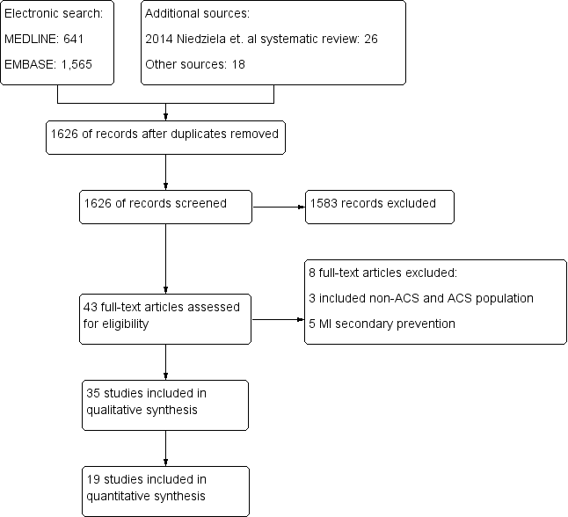

Notes: Flow chart. MI: Myocardial infarction.

Figure 2A: 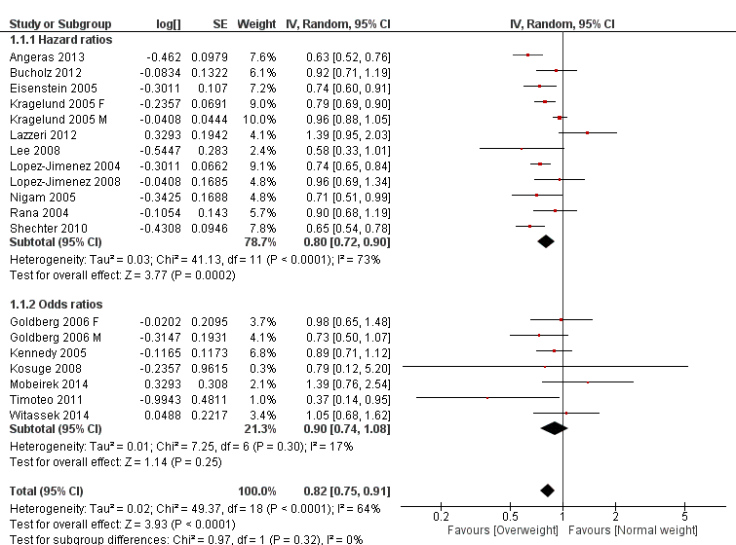

Notes: Overweight vs normal weight for all-cause mortality Forest plot, according to analysis performed (HR or OR).

Figure 2B:

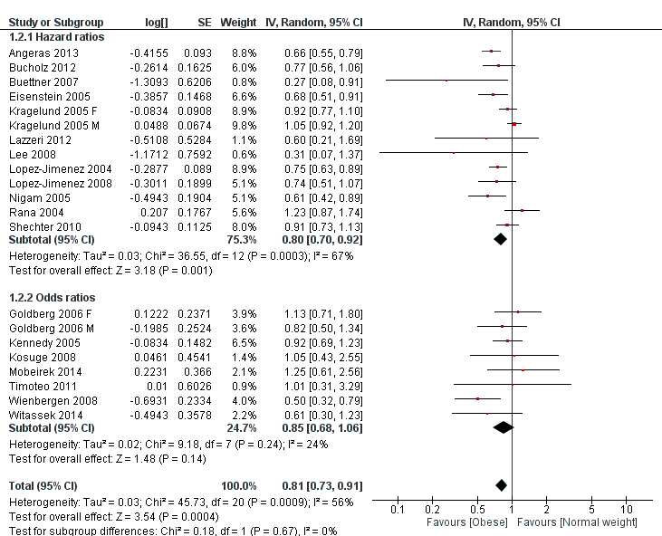

Notes: Obese vs normal weight for all-cause mortality Forest plot, according to analysis performed (HR or OR).

Figure 3A:

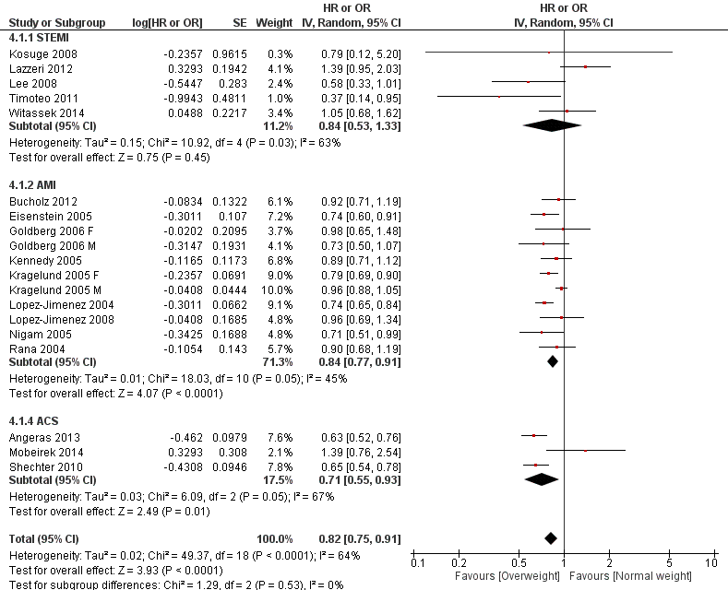

Notes: Overweight vs normal weight for all-cause mortality Forest plot, according to ACS subtype. STEMI: ST-segment elevation myocardial infarction, AMI: Acute myocardial infarction (STEMI or non-STEMI), ACS: Any acute coronary syndrome (STEMI, non-STEMI or unstable angina).

Figure 3B:

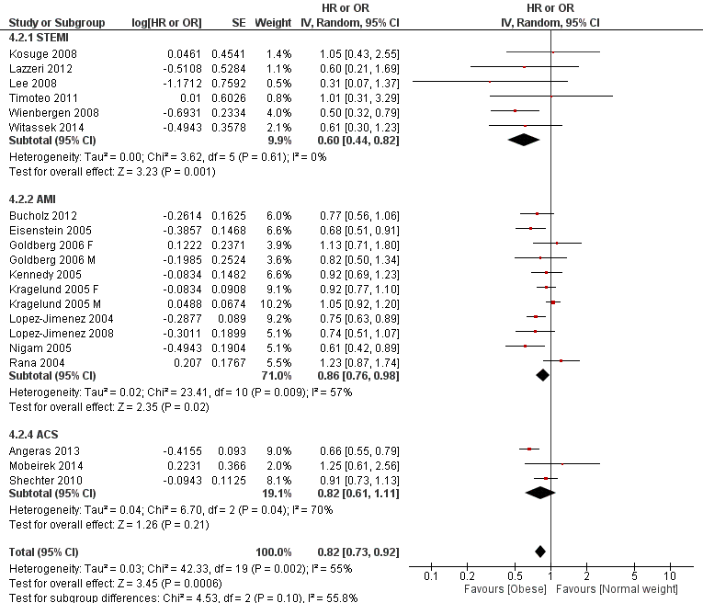

Notes: Obese vs normal weight for all-cause mortality Forest plot, according to ACS subtype. STEMI: ST-segment elevation myocardial infarction, AMI: Acute myocardial infarction (STEMI or non-STEMI), ACS: Any acute coronary syndrome (STEMI, non-STEMI or unstable angina).

Figure 4A:

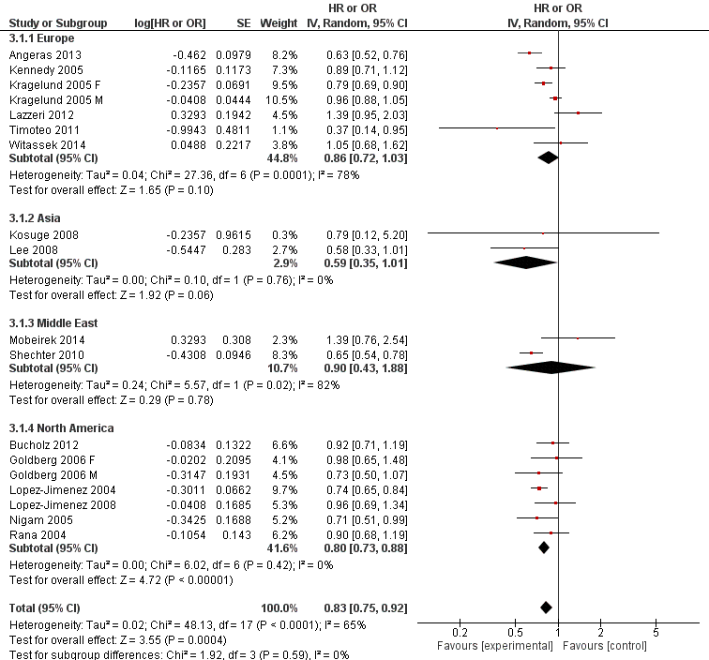

Notes: Overweight vs normal weight for all-cause mortality Forest plot, according to geographic region. One study was excluded for including participants from more than one continent.

Figure 4B:

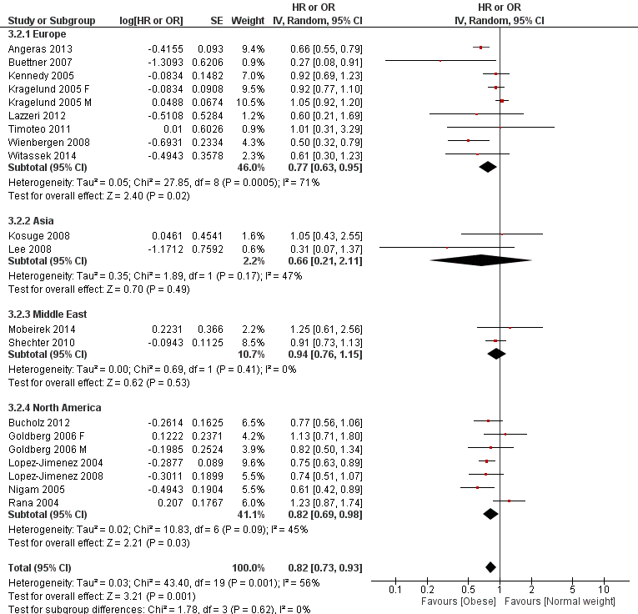

Notes: Obese vs normal weight for all-cause mortality Forest plot, according to geographic region. One study was excluded for including participants from more than one continent.

Figure 5A:

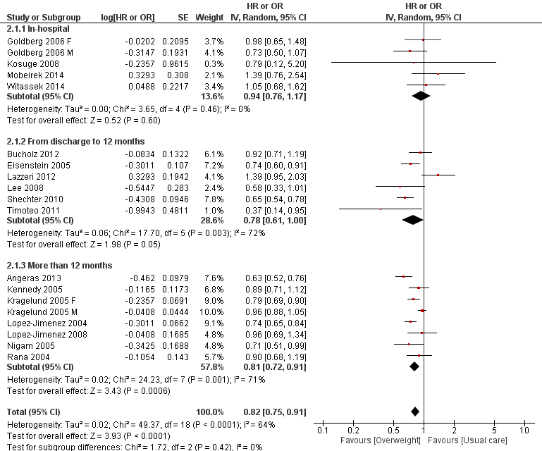

Notes: Overweight vs normal weight for all-cause mortality Forest plot, according to follow-up time. Studies were categorized as in-hospital, discharge to 12 months and more than 12 months.

Figure 5B:

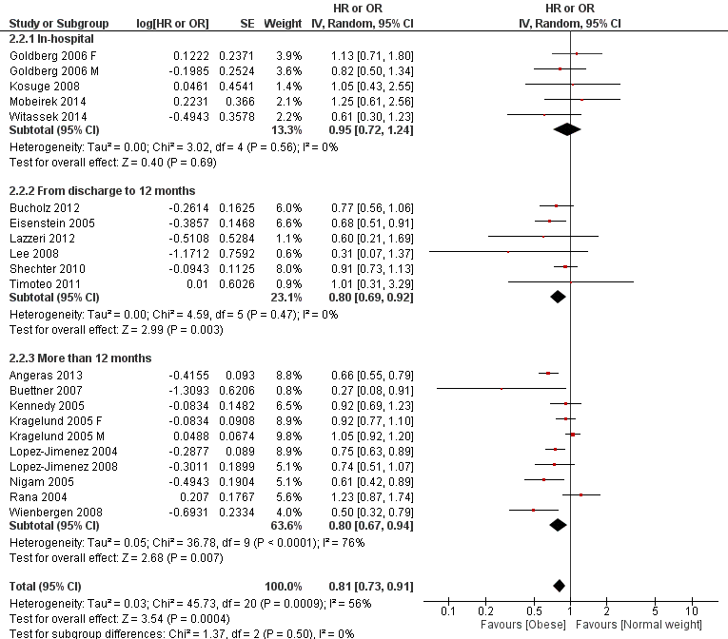

Notes: Obese vs normal weight for all-cause mortality Forest plot, according to follow-up time. Studies were categorized as in-hospital, discharge to 12 months and more than 12 months.

Figure 6A:

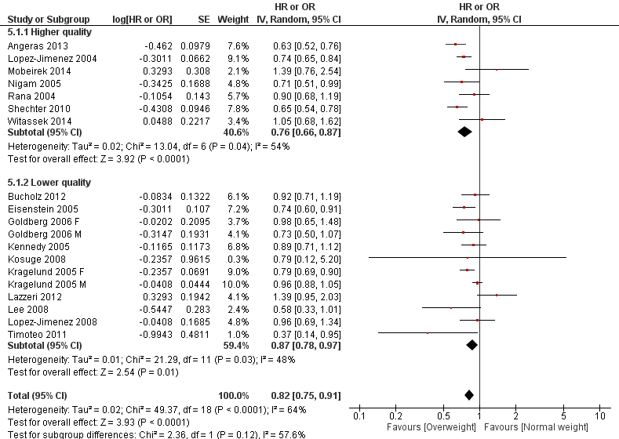

Notes: Overweight vs normal weight for all-cause mortality Forest plot, according to study quality assessed by the Newcastle Ottawa Scale scale. Studies were considered “high quality” if it had at least 3 stars in selection, 2 stars in comparability and at least two stars in outcome.

Figure 6B:

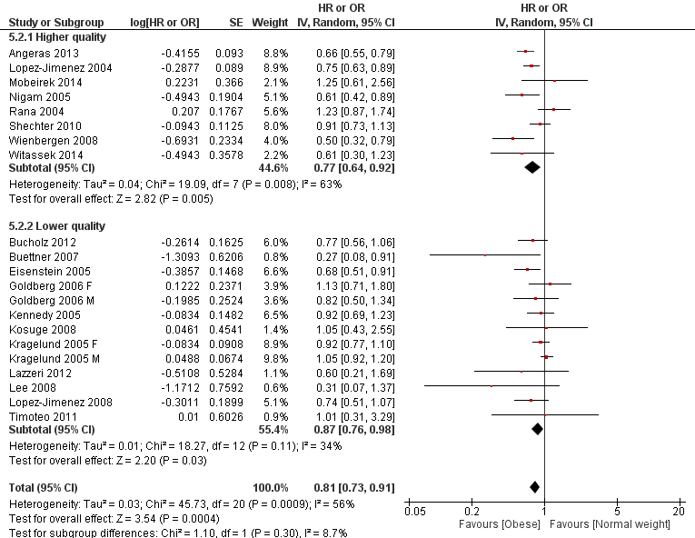

Notes: Obese vs normal weight for all-cause mortality Forest plot, according to study quality assessed by the Newcastle Ottawa Scale scale. Studies were considered “high quality” if it had at least 3 stars in selection, 2 stars in comparability and at least two stars in outcome.

Figure 7A:

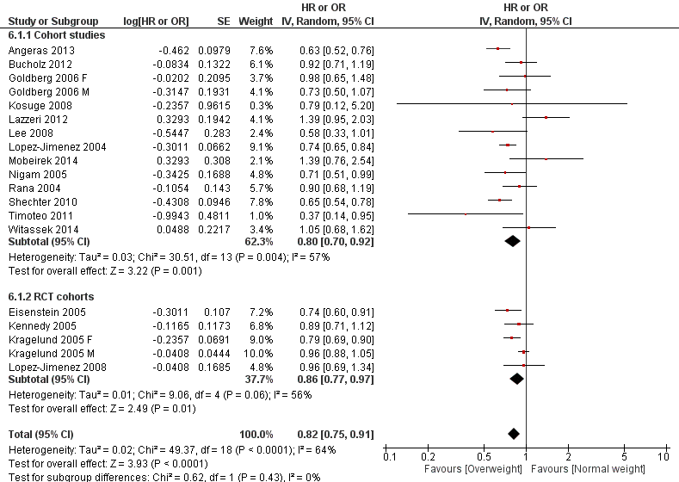

Notes: Overweight vs normal weight for all-cause mortality Forest plot, according to cohort study source (cohort study vs RCT based cohort). RCT: Randomized controlled trial.

Figure 7B:

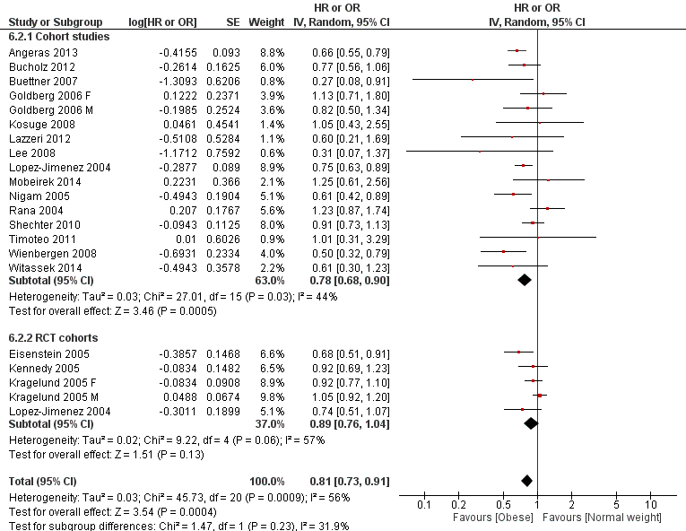

Notes: Obese vs normal weight for all-cause mortality Forest plot, according to cohort study source (cohort study vs RCT based cohort). RCT: Randomized controlled trial.

Figure 8:

A) B)

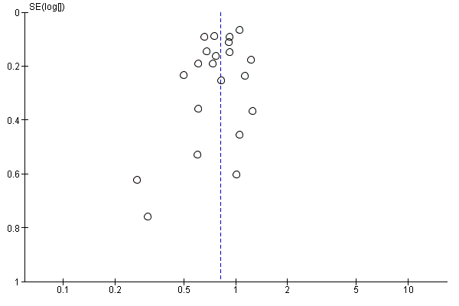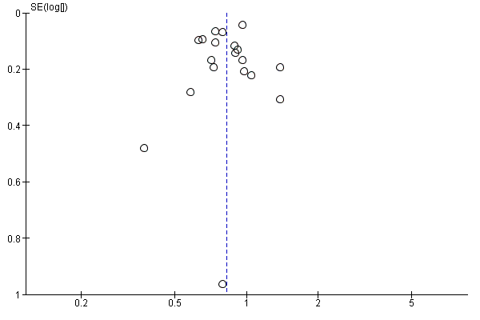

Notes: Funnel plot for the overweight (A) and obese (B) comparisons.

**Ovid MEDLINE search strategy:**

1. body mass index.mp. or BMI or Body Mass Index/

2. obesity.mp. or exp Obesity/ or exp Obesity, Abdominal/

3. (obesity paradox or BMI paradox).mp.

4. body weight.mp. or Body Weight/

5. Adipose Tissue/ or adipos*.mp.

6. (overweight or over weight).mp.

7. 1 to 6

8. Myocardial Infarction/ or Angina, Unstable/ or Acute Coronary Syndrome/ or acute coronary syndrome*.mp.

9. angina.tw.

10. coronary syndrome$.tw.

11. myocardial infarction.tw.

12. (NSTEMI or STEMI).mp.

13. Coronary Thrombosis.mp. or Coronary Thrombosis/

14. acute coronary.tw.

15. 8 to 14

16. 7 and 15

17. limit 16 to last year

Execution date: April 14th 2015

Retrieved results: 641

A similar search strategy was constructed for Ovid EMBASE.

CHAPTER 3: INDIVIDUAL PATIENT DATA META-ANALYSIS METHODS

**Review of individual patient data meta-analysis methodology**

Introduction: Meta-analysis refers to the process of combination and quantitative analysis from similar studies to produce results. Traditionally, the aggregate estimate of effect (eg. relative risk or odds ratio) and their uncertainty (eg. standard errors or confidence intervals) are extracted from the studies and pooled to generate a single estimate. A more powerful analysis can be done when individual patient data are available for analysis, called “individual patient data meta-analysis”. This methodology is becoming popular in the literature. Before the year 2000 there were less than 15 individual patient data meta-analyses published per year and this number has since increased to 15 to 30 between 2000 - 2004 and more than 40 from per year in 2005.1

Individual patient data meta-analysis provides several advantages over aggregate analysis, including: consistent inclusion and exclusion criteria, better missing data management, avoids duplicate patient sets, allows analysis of poorly reported outcomes, standardization of statistical analysis (including testing model assumptions), avoids ecological fallacy, and allows patient-level subgroup and sensitivity analyses.1 As a result, is not surprising that sometimes individual patient meta-analysis arrive at different conclusions compared to aggregate data meta-analysis.2,3 This is even more apparent if patient level characteristics interact with the treatment effect.4 A previous simulation study showed that power raised from 15% to 91% using individual patient meta-analysis when the treatment had interactions with participants baseline risk.5

The individual patient meta-analysis may play a major role in summarizing evidence of prognostic factors, such as BMI and outcomes after ACS. Usually, the quality, methodology and reporting of observational studies are markedly more heterogeneous than studies reporting interventions. Individual patient meta-analysis has been proposed as a potential solution to address this common limitation in epidemiological research.6

Implications for analysis: The main consideration of individual patient data meta-analysis is to contemplate study level cluster effects in the analysis since observations within studies tend to be correlated.1 This is secondary to differences in populations (e.g., inclusion and exclusion criteria, countries involved, etc.) and study execution (definitions, follow-up time, methodology, etc.) among the included studies. Ignoring the clustering effect generates biased estimates with artificially small confidence intervals, especially when the number of clusters or participants are small.7 For simplification purposes, only methodology related to multivariable analysis with binary outcomes is addressed.

There are two approaches for taking into account clustering for individual patient data analysis: one-step and two-step analysis:8

One-step analysis: This approach refers to calculate the estimates using a single analysis from a merged dataset, again using a model that accounts for clustering. If time-to-event is ignored (or not available), multivariable logistic regression adding “study” as a random effect is the preferred approach.9 This can be summarized in the following formula:

$$logit\left(p_{ik}\right)=α_{i}+βx_{ik}.$$

Note that the intercept $α$ is not fixed. The term $α_{i}$ denotes that each cluster $i$ (study) has their own baseline risk, more precisely the risk when $x_{ik}$ equals zero in the $i$ th cluster. This expression is for a fixed-effects meta-analysis given that $β$ is assumed to be equal among studies.

If time-to-event data is available and is considered for analysis, a shared frailty model is a popular approach. Two previous analysis including real-life and simulations examples concluded that the shared frailty model provided the least biased results when analyzing clustered survival data.10,11 This model accounts for a multiplicative factor in the hazard function, in addition to the regressors in the model. The hazard rate of the $j$ th individual in the $i$ th cluster is

$λ_{ij}\left(t\right)=λ_{o}(t)e^{β´Z_{ij}+y_{i}}$,

where $λ_{o}\left(t\right)$ is an arbitrary baseline hazard rate, $Z_{ij}$ is the vector of (fixed-effects) covariates, $β$ is the vector of regression coefficients, and $y_{i}$ is the random effect for cluster $i$. The random components $y_{i},…,y_{s}$ are assumed to be independent and distributed as a normal random variable with mean 0 and an unknown variance .12 Note that without the ${+y}_{i}$ component this function is equivalent to the Cox proportional hazards equation. Then, frailties factors $u_{i},…,u_{s}$, given by $y_{i}=log(u_{i})$, are estimated by the following model:

$λ_{ij}\left(t\right)=λ_{o}(t)u_{i}e^{β´Z_{ij}}$.

Therefore, the frailty factor has a lognormal (or gamma) distribution with a median of 1, and all the participants belonging to the same $i$ th cluster will share the same $u_{i}$. Since $u_{i}$ is applied as a multiplicative coefficient, if $u_{i}$ is > 1 means that the event of interest will happen at a faster rate, and if it is < 1 at a lower rate.

Two-step analysis: This approach refers to calculate study level estimates first and then pool them using fixed or random effects. Since the estimates are calculated separately, it automatically considers the cluster effect of studies. The calculation of study level estimates are done using standard methods used for multivariable analysis in epidemiology (e.g., multivariable logistic regression or Cox proportional hazards). Then, the studies are combined using a generic inverse variance approach with random effects (DerSimonian and Laird method).13

Although some investigators claim that both approaches (one- or two-step) provide similar results, 14,15 others described that they may arrive at different conclusions.16 Apparently, both approaches generate similar results when both the number of clusters and participants are high.17 Otherwise, the one-step approach provides advantages over the two-step, such as using the exact binomial distribution, accounts for within-study correlations, more flexibility in the model selection and avoids continuity corrections.16 From the operational point of view, the one-step approach requires dataset merging (which can be extremely laborious) and requires more statistical expertise. On the other hand, the two-step approach does not require database merging and statistical methods are more standard. For these reasons, Stewart et al. concluded that the one-step approach efforts may outweigh the benefits compared to the two-step approach when summarizing evidence from several large studies.17 However, even if several large studies are available, data merging allows exploring non-linear associations.

In the next section we present the methods of our individual patient data meta-analysis of 81,553 participants from 8 different ACS randomized controlled trials coordinated and lead at the PHRI.

**Individual patient data meta-analysis methods**

**Population and studies characteristics**

The population of interest is adults (> 18 years old) that have suffered an ACS requiring admission to hospital (UA, NSTEMI or STEMI). The PHRI coordinated 9 large-scale ACS randomized trials from 1998 to present. All of them measured weight and height, except CREATE-ECLA (which was excluded from the analysis). Details of the included studies are detailed in Table 1. Two studies started as a sub-study: TIMACS as a sub-study of OASIS 5, sharing a total of 1,633 (54%) participants; and RIVAL as a sub-study of OASIS 7, sharing a total of 3,831(55%) participants. From this point forward, all the participants that shared two studies are considered belonging to the “mother” trial (OASIS5 or OASIS 7). TOTAL is the only ongoing study, which already analyzed and published the 6 months results and is currently finishing the 12-month follow-up. The data from all the studies are stored in a secure server at the PHRI in SAS® format, in which each case report form has a single SAS® file. Data dictionaries and the variables included in it were available in all the studies.

All the included participants had an ACS diagnosis on admission, including UA, NSTEMI and STEMI. In general, those without ST-segment elevation required other high-risk markers, such as increased age, ischemic ECG changes or elevated biomarkers (Table S1). The exclusion criteria varied across studies. The OASIS trials systematically excluded patients at high risk of bleeding. The TOTAL study excluded patients with previous CABG surgery and RIVAL excluded those with prior CABG and a left internal mammary artery graft. The interventions delivered in a random fashion also were different across studies. The OASIS trials randomized interventions related to antiplatelet or anticoagulation therapy while the remaining three studies focused on different interventional cardiology therapeutic and diagnostic strategies. The follow-up duration ranged from 30 days to 12 months.

Patient with implausible weight (< 30 kg or > 250 kg) or height (< 1.25 meters or > 2.40 meters) values were excluded, as well as participants with implausible BMI values (< 10 kg/m2 or > 80 kg/m2). All the studies checked diagnosis at hospital discharge and only participants with discharge diagnosis of UA, NSTEMI or STEMI were included in the analysis.

**Exposure considerations**

The exposure of interest (BMI) was calculated using the Quetelet formula: weight in kilograms divided by height in meters.18 BMI was categorized using the following cut-off points: underweight <18.50, normal range 18.5 - 24.9, overweight 25.0 - 29.9, obese class I 30.0 - 34.9, obese class II 35.00 - 39.9, and obese class III ≥40.0.19

Before variables were abstracted, an analytic framework of the association between BMI and mortality was created after a literature review (Figure 1). Analytic frameworks help to conceptualize theoretical associations between variables and the effect of interest, providing guidance of which ones should be considered for the analysis. Since extracting and merging all the measured variables from all the studies may be unnecessary and time-consuming, a limited set of variables were considered for merging. The first angiogram and a maximum of 3 PCIs were abstracted per patient. Angiographic data included date, access site and coronary anatomy. Access site, treated vessel, treated lesion (with exception of OASIS 4) and procedural success were recorded from each PCI. Creatinine clearance was estimated using the CKD-EPI equation.20,21

Some important variables were not consistently measured in dedicated fields, but they were included in “other conditions” at baseline in text fields. This was the case for previous cancer, previous heart failure and hyperlipidemia in some studies. To get information from text fields, a “find” Excel® procedure using several keywords was utilized. Other categorical and continuous variables with implausible values were imputed missing data. A threshold of 0.2% of missing data in any variable included in primary or secondary multivariable models was imputed using multiple imputation. Missing values pattern were assessed through missing values pattern charts in order to select the imputation method.

**Outcomes**

The primary outcome was all-cause mortality. Secondary outcomes were designated according to the previously mentioned potential mechanisms of the “obesity paradox”, such as reduced heart failure related mortality, improved revascularization outcomes and bleeding risk. As a result, the selected secondary outcomes were: cardiovascular mortality, heart failure hospitalization, heart failure related death, myocardial infarction (or reinfarction in case of STEMI or NSTEMI as index presentation), refractory angina, target vessel revascularization (TVR), target lesion revascularization (TLR), stent thrombosis, stroke, major bleeding, and major or minor bleeding.

With the exceptions of heart failure hospitalization and heart failure related death, all the outcomes were centrally adjudicated by an independent committee as part of the original RCTs (see published protocols for definitions and details). TVR was defined as a PCI of a stented vessel or graft in the first PCI, and TLR as the same vessel or graft segment. Participants with PCI as the first revascularization procedure that received CABG surgery during follow-up, were imputed as a TVR or TLR event. As a result, TVR and TLR secondary outcomes are presented as TVR or CABG and TLR or CABG, respectively. Follow-up was performed by face-to-face visits and telephone contact. Patients were censored the death date or the last follow-up visit date.

**Statistical analysis**

Exploratory analyzes of the association between baseline characteristics and BMI were performed. Continuous variables were presented as mean and standard deviation, and categorical variables as percentages. Continuous variables were analyzed using Student t-test and categorical variables though Chi-square test. Table S2 summarizes the analysis plan. The primary analysis compared BMI in categories with all-cause mortality using a multivariable shared frailty model including study as random effects with gamma distribution. The primary model included the following covariates: age, sex, geographic region, smoking status, previous CVD, previous cancer, heart failure on admission, discharge diagnosis (ACS presentation type) and creatinine clearance. The primary model was reproduced for all secondary outcomes. It is important to mention that diabetes, hypertension and dyslipidemia were not included in the primary multivariable model. The reason is that these risk factors, as it is shown in the analytic framework, may be on the putative causal pathway between the “increased body fat” and cardiovascular disease and mortality association. Adjustment of variables implicated in the putative causal pathway may bias the results.22 Models including these variables are presented as sensitivity analysis.

Subgroup analyses with interaction tests on all-cause mortality were performed using the primary model. The *a priori* variables for subgroup analysis were: Age, sex, diabetes, ethnicity, previous history of CVD, discharge diagnosis, heart failure on admission and chronic kidney disease. Interaction was assessed by including interaction terms in the multivariable model.23

Sensitivity analysis was planned to evaluate the results robustness. First, a two-step individual patient data meta-analysis approach was performed. This was done executing the main model in each trial and then pooling the results using a random effects model. Second, the association between BMI as a continuous variable and all-cause mortality was plotted using restricted cubic spline analysis.24 Third, different models for the primary outcomes were performed, (1) including variables such as diabetes, hypertension and hyperlipidemia, (2) other admission variables such as heart rate, blood pressure, hemoglobin levels, heart failure, intra-aortic balloon pump use and revascularization, (3) discharge medications, and (4) coronary anatomy. Fourth, a restrictive strategy focused on reverse causality was implemented, excluding those patients with previous conditions that can reduce weight and be related with mortality, such as previous CVD (any form of CAD, heart failure, stroke or peripheral vascular disease), previous cancer, and severe renal failure (creatinine clearance < 30 ml/min).

Fifth, a separate analysis in OASIS 4 was done in order to assess the impact of including waist-to-hip ratio in the model. Sixth, three different propensity score approaches were performed (matching, stratification and adjustment) in those BMI categories with significant (p < 0.05) results, compared to normal weight individuals. Matching was done using a greedy approach with no replacement, and with a caliper width of 0.001. Balance was assessed by visual inspection and summary diagnostics provided by the SAS® macro by Hulbert et al.25 Cox-proportional hazards stratified by matched pair were performed to account for the matched nature of the data, and Kaplan-Meier survival curves for each matched cohort were generated. Propensity score statification analysis was performed through Cox-proportional hazards stratified by propensity score quintile. Propensity score adjusted analysis was done including propensity score as a covariate in the Cox-proportional hazards model. Finally, array and rule-out analysis to estimate the degree of unmeasured confounders to change the conclusions was done according to the proposed method by Schneeweiss et. al.26

**Ethical considerations and conflict of interests**

Permission for data access was obtained from the principal investigator of all the closed studies and from the operational committee of the ongoing TOTAL trial. All Participants signed an informed consent in which they agreed to provide their data on anonymous fashion for research purposes. All the files accessed for analyses do not contain any personal identity information. I do not have any conflict of interest related to the Thesis content, as well as all those involved in its preparation and supervision.

**References**:

1. Riley RD, Lambert PC, Abo-Zaid G. Meta-analysis of individual participant data: rationale, conduct, and reporting. BMJ 2010;340:c221.

2. McCormack K, Grant A, Scott N. Value of updating a systematic review in surgery using individual patient data. The British journal of surgery 2004;91:495-9.

3. Jeng GT, Scott JR, Burmeister LF. A comparison of meta-analytic results using literature vs individual patient data. Paternal cell immunization for recurrent miscarriage. Jama 1995;274:830-6.

4. Berlin JA, Santanna J, Schmid CH, Szczech LA, Feldman HI. Individual patient- versus group-level data meta-regressions for the investigation of treatment effect modifiers: ecological bias rears its ugly head. Statistics in medicine 2002;21:371-87.

5. Lambert PC, Sutton AJ, Abrams KR, Jones DR. A comparison of summary patient-level covariates in meta-regression with individual patient data meta-analysis. Journal of clinical epidemiology 2002;55:86-94.

6. Abo-Zaid G, Sauerbrei W, Riley RD. Individual participant data meta-analysis of prognostic factor studies: state of the art? BMC medical research methodology 2012;12:56.

7. Abo-Zaid G, Guo B, Deeks JJ, et al. Individual participant data meta-analyses should not ignore clustering. Journal of clinical epidemiology 2013;66:865-73 e4.

8. Simmonds MC, Higgins JP, Stewart LA, Tierney JF, Clarke MJ, Thompson SG. Meta-analysis of individual patient data from randomized trials: a review of methods used in practice. Clin Trials 2005;2:209-17.

9. Thomas D, Radji S, Benedetti A. Systematic review of methods for individual patient data meta- analysis with binary outcomes. BMC medical research methodology 2014;14:79.

10. Munda M, Legrand C. Adjusting for centre heterogeneity in multicentre clinical trials with a time-to-event outcome. Pharmaceutical statistics 2014;13:145-52.

11. Glidden DV, Vittinghoff E. Modelling clustered survival data from multicentre clinical trials. Statistics in medicine 2004;23:369-88.

12. SAS/STAT(R) 9.3 User's Guide. The PHREG Procedure: The Frailty Model. http://supportsascom/documentation/cdl/en/statug/63962/HTML/default/viewerhtm#statug_phreg_sect036htm Last access July 15 2015.

13. DerSimonian R, Laird N. Meta-analysis in clinical trials. Controlled clinical trials 1986;7:177-88.

14. Riley RD, Lambert PC, Staessen JA, et al. Meta-analysis of continuous outcomes combining individual patient data and aggregate data. Statistics in medicine 2008;27:1870-93.

15. Mathew T, Nordstrom K. On the equivalence of meta-analysis using literature and using individual patient data. Biometrics 1999;55:1221-3.

16. Debray TP, Moons KG, Abo-Zaid GM, Koffijberg H, Riley RD. Individual participant data meta-analysis for a binary outcome: one-stage or two-stage? PloS one 2013;8:e60650.

17. Stewart GB, Altman DG, Askie LM, Duley L, Simmonds MC, Stewart LA. Statistical analysis of individual participant data meta-analyses: a comparison of methods and recommendations for practice. PloS one 2012;7:e46042.

18. Khosla T, Lowe CR. Indices of obesity derived from body weight and height. British journal of preventive & social medicine 1967;21:122-8.

19. WHO. Physical status: the use and interpretation of anthropometry. Report of a WHO Expert Committee. WHO Technical Report Series 854. Geneva: World Health Organization, 1995.

20. Levey AS, Inker LA, Coresh J. GFR estimation: from physiology to public health. American journal of kidney diseases : the official journal of the National Kidney Foundation 2014;63:820-34.

21. Levey AS, Stevens LA, Schmid CH, et al. A new equation to estimate glomerular filtration rate. Annals of internal medicine 2009;150:604-12.

22. Kleinbaum D, Klein M. Logistic Regression: A Self-Learning Text. Springer 2010.

23. Fisher DJ, Copas AJ, Tierney JF, Parmar MK. A critical review of methods for the assessment of patient-level interactions in individual participant data meta-analysis of randomized trials, and guidance for practitioners. Journal of clinical epidemiology 2011;64:949-67.

24. Howe CJ, Cole SR, Westreich DJ, Greenland S, Napravnik S, Eron JJ, Jr. Splines for trend analysis and continuous confounder control. Epidemiology 2011;22:874-5.

25. Hulbert E, Brekke L. A SAS® Macro to Evaluate Balance after Propensity Score Matching. PharmaSUG 2014 - http://wwwpharmasugorg/proceedings/2014/SP/PharmaSUG-2014-SP07pdf Last access Aug 15th 2015 2014.

26. Schneeweiss S. Sensitivity analysis and external adjustment for unmeasured confounders in epidemiologic database studies of therapeutics. Pharmacoepidemiology and drug safety 2006;15:291-303.

27. Yusuf S, Zhao F, Mehta SR, Chrolavicius S, Tognoni G, Fox KK. Effects of clopidogrel in addition to aspirin in patients with acute coronary syndromes without ST-segment elevation. The New England journal of medicine 2001;345:494-502.

28. Yusuf S, Mehta SR, Chrolavicius S, et al. Comparison of fondaparinux and enoxaparin in acute coronary syndromes. The New England journal of medicine 2006;354:1464-76.

29. Yusuf S, Mehta SR, Chrolavicius S, et al. Effects of fondaparinux on mortality and reinfarction in patients with acute ST-segment elevation myocardial infarction: the OASIS-6 randomized trial. Jama 2006;295:1519-30.

30. Mehta SR, Tanguay JF, Eikelboom JW, et al. Double-dose versus standard-dose clopidogrel and high-dose versus low-dose aspirin in individuals undergoing percutaneous coronary intervention for acute coronary syndromes (CURRENT-OASIS 7): a randomised factorial trial. Lancet 2010;376:1233-43.

31. Steg PG, Jolly SS, Mehta SR, et al. Low-dose vs standard-dose unfractionated heparin for percutaneous coronary intervention in acute coronary syndromes treated with fondaparinux: the FUTURA/OASIS-8 randomized trial. Jama 2010;304:1339-49.

32. Mehta SR, Granger CB, Boden WE, et al. Early versus delayed invasive intervention in acute coronary syndromes. The New England journal of medicine 2009;360:2165-75.

33. Jolly SS, Yusuf S, Cairns J, et al. Radial versus femoral access for coronary angiography and intervention in patients with acute coronary syndromes (RIVAL): a randomised, parallel group, multicentre trial. Lancet 2011;377:1409-20.

34. Jolly SS, Cairns JA, Yusuf S, et al. Randomized trial of primary PCI with or without routine manual thrombectomy. The New England journal of medicine 2015;372:1389-98.

Table 1:

|  |  |  |  |  |  |
| --- | --- | --- | --- | --- | --- |
| Study | Patients | Recruitment period | Population | Comparisons | Follow-up (months) |
| OASIS 427 | 12,562 | 1998-2000 | UA/NSTEMI | Clopidogrel vs Placebo | 12 |
| OASIS 528 | 20,078 | 2003-2005 | UA/NSTEMI | Fondaparinux vs Enoxaparin | 3 - 6 |
| OASIS 629 | 12,092 | 2003-2005 | STEMI | Fondaparinux Vs Usual care | 3 - 6 |
| OASIS 730 | 25,086 | 2006-2009 | UA/NSTEMI/STEMI | Clopidogrel and Aspirin doses | 1 |
| OASIS 831 | 2,026 | 2009-2010 | UA/NSTEMI | Heparin low dose vs standard dose | 1 |
| TIMACS32 | 1,398* | 2003-2008 | UA/NSTEMI | Early vs delayed PCI | 6 |
| RIVAL33 | 3,190* | 2008-2010 | UA/NSTEMI/STEMI | Radial vs femoral access | 1 |
| TOTAL34 | 10,732 | 2010-2014 | STEMI | PCI with vs without Routine Manual Thrombectomy | 6 - 12 |

Notes: General characteristics of included studies. PCI: Percutaneous coronary intervention.

* Only participants not included in other trials are presented.

Figure 1: Analytic framework.

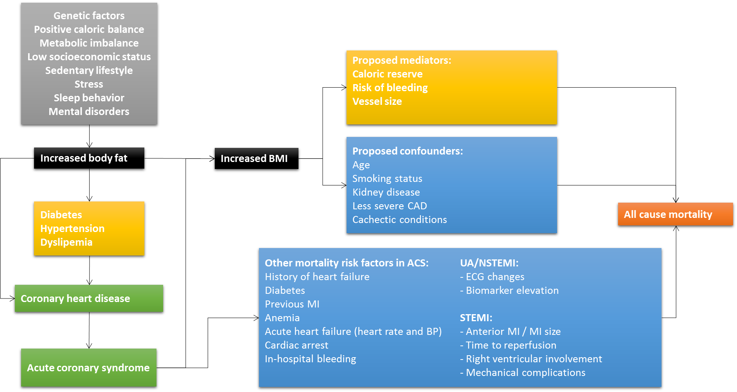

Notes: Grey: determinants of body fat. Black: exposure. Yellow: mediators. Green: Consequences of increased body fat in general primary prevention. Blue: confounders and other risk factors of mortality after ACS. Orange: primary outcome.

**Chapter 3 Supplementary appendix:**

* Table S1: Inclusion and exclusion criteria of the individual studies.
* Table S2: Analysis plan.

Table S1:

|  |  |  |
| --- | --- | --- |
| **Study** | **Inclusion criteria** | **Exclusion criteria** |
| OASIS 4 | Hospitalized within 24 hours after the onset of symptoms and did not have ST-segment elevation, older than 60 years of age with no new electrocardiographic changes but with a history of coronary artery disease were included. After the first 3000 patients the study included only patients who had either ECG changes or an elevation in the serum level of cardiac enzymes. | Contraindications to antithrombotic or antiplatelet therapy, high risk for bleeding or severe heart failure, taking oral anticoagulants, revascularization in the previous three months or had received intravenous glycoprotein IIb/IIIa receptor inhibitors in the previous three days. |
| OASIS 5 | Within 24 hours of symptom onset and at least two of the three following criteria: an age of at least 60 years, an elevated level of biomarkers, or electrocardiographic changes indicative of ischemia. Inclusion criteria were modified and persons under the age of 60 years were required to have both an elevation of biomarkers and ECG changes. | Contraindications to low-molecular-weight heparin, recent hemorrhagic stroke, indications for anticoagulation other than an acute coronary syndrome, or a serum creatinine level of at least 3 mg per deciliter (265 μmol per liter). |
| OASIS 6 | STEMI within 24 hours of symptom onset, then was modified to less than 12 hours. | Contraindications to anticoagulation, high risk of bleeding, receiving oral anticoagulants, or with creatinine levels greater than 265.2 mg/dL (3.0 mmol/L). |
| OASIS 7 | ACS symptoms within 24 hrs with planned coronary angiography within 72 hrs after randomization, plus one of the following : ECG changes or raised biomarkers | Age < 18 years old, increased risk of bleeding or active bleeding, past history of severe systemic bleeding, uncontrolled hypertension, oral anticoagulant use, aspirin or clopidogrel allergies. |
| OASIS 8 | ACS symptoms within 48 hrs, planned coronary angiography and at least 2 of the following criteria: aged 60 years or older, biomarker elevation or ECG changes. | Contraindications to unfractionated heparin or fondaparinux, contraindications for angiography, patients requiring urgent coronary angiography, treatment with other injectable anticoagulants, hemorrhagic stroke within 12 months, indication for anticoagulation other than ACS, pregnancy or breastfeeding, life expectancy less than 6 months, revascularization procedure for the qualifying event already performed, and creatinine clearance less than 20 mL/min. |
| TIMACS | ACS symptoms within 24 hrs and two of the following: an age of 60 years or older, biomarker elevation or electrocardiograph changes | Co-morbidity with life expectancy less than 6 months or less than 21 years of age (plus OASIS 5 criteria in the first 1633). |
| RIVAL | ACS with invasive approach. STEMI or ACS with: biomarker elevation or ECG changes. | Cardiogenic shock, severe peripheral vascular disease precluding a femoral approach, or previous coronary bypass surgery with an internal mammary artery graft. |
| TOTAL | STEMI referred to primary PCI within 12 hrs | Age < 18 years old, thrombolitycs given for index STEMI, previous CABG, life expectancy less than six months due to non-cardiac condition. |

Notes: Inclusion and exclusion criteria of studies included in the individual patient data meta-analysis.

Table S2:

|  |  |  |  |  |  |
| --- | --- | --- | --- | --- | --- |
| Analysis |  | Outcome | BMI | Predictors | Method |
| Primary |  | All-cause mortality | BMI (cat.) | age, sex, geographic region, smoking status, previous CVD, creatinine clearance, previous cancer, admission KK and discharge diagnosis (primary model) | Shared frailty |
| Secondary |  | Cardiovascular mortality | BMI (cat.) | Primary model | Shared frailty |
|  |  | Myocardial infarction | BMI (cat.) | Primary model | Shared frailty |
|  |  | Refractory angina | BMI (cat.) | Primary model | Shared frailty |
|  |  | TVR or CABG | BMI (cat.) | Primary model | Shared frailty |
|  |  | TLR or CABG | BMI (cat.) | Primary model | Shared frailty |
|  |  | Stent thrombosis | BMI (cat.) | Primary model | Shared frailty |
|  |  | Heart failure hospitalization | BMI (cat.) | Primary model | Shared frailty |
|  |  | Heart failure related death | BMI (cat.) | Primary model | Shared frailty |
|  |  | Major bleeding | BMI (cat.) | Primary model, thrombolytic use, anticoagulation at discharge, antiplatelet therapy, admission hemoglobin, heart rate and systolic blood pressure | Shared frailty |
|  |  | Major or Minor bleeding | BMI (cat.) | Primary model, thrombolytic use, anticoagulation at discharge, antiplatelet therapy, admission hemoglobin, heart rate and systolic blood pressure | Shared frailty |
| Subgroups | Age (60 years cutoff) | All-cause mortality | BMI (cat.) | Primary model | Shared frailty with interaction terms and Cox regression |
|  | Sex | All-cause mortality | BMI (cat.) | Primary model | Shared frailty with interaction terms and Cox regression |
|  | Ethnicity | All-cause mortality | BMI (cat.) | Primary model | Shared frailty with interaction terms and Cox regression |
|  | Diabetes | All-cause mortality | BMI (cat.) | Primary model | Shared frailty with interaction terms and Cox regression |
|  | Previous CVD | All-cause mortality | BMI (cat.) | Primary model | Shared frailty with interaction terms and Cox regression |
|  | CKD | All-cause mortality | BMI (cat.) | Primary model | Shared frailty with interaction terms and Cox regression |
|  | ACS presentation | All-cause mortality | BMI (cat.) | Primary model | Shared frailty with interaction terms and Cox regression |
|  | Heart failure on admission | All-cause mortality | BMI (cat.) | Primary model | Shared frailty with interaction terms and Cox regression |
| Sensitivity | Two-step approach | All-cause mortality | BMI (cat.) | Primary model | Cox regression and inverse variance random effects MA |
|  | Continuous BMI | All-cause mortality | BMI (cont.) | Primary model | Restricted cubic splines |
|  | Alternative models | All-cause mortality | BMI (cat.) | Primary model + DBT, HTN and HLP  Primary model + admission variables  Primary model + discharge medications  Primary model + coronary anatomy  Primary model with upper-normal BMI as reference category  Primary model with 30-day landmark analysis | Shared frailty |
|  | Reverse causality | All-cause mortality | BMI (cat.) | Primary model | Shared frailty excluding previous CVD, cancer and CKD |
|  | Propensity score | All-cause mortality | BMI (cat.) | Primary model + 1:1 matching  Primary model + propensity stratification  Primary model + propensity adjustment | Shared frailty |
|  | Array and rule out analysis | All-cause mortality | BMI (cat.) | Primary model | Schneeweiss et. Al |

Footnote: Cat: categorical, Cont: continuous, HLP: Hyperlipidemia.

CHAPTER 4: INDIVIDUAL PATIENT DATA META-ANALYSIS RESULTS

**BMI nomenclature note:**

Underweight: BMI < 18.5 kg/m2.

Normal weight: BMI 18.5 – 24.9 kg/m2.

Overweight: BMI 25 – 29.9 kg/m2.

Type I obesity: BMI 30 – 34.9 kg/m2.

Type II obesity: BMI 35 – 39.9 kg/m2.

Type III obesity or morbid obesity: >= 40 kg/m2.

High BMI categories: BMI >= 25 kg/m2.

Obese categories: BMI >= 30 kg/m2.

**Study subjects**

A total of 88,378 participants from 45 countries were included in the 8 trials (Figure 1). A total of 6,825 (7.7%) were excluded due to: missing or implausible BMI data (825, 0.9%) or presence of a non-ACS diagnosis at discharge and/or normal coronary anatomy at any time during the study (6,064, 6.8%). The remaining 81,553 participants were included in the analysis, of whom 22,657(27.8 %) had unstable angina, 29,046 (35.6 %) NSTEMI and 29,850 (36.6 %) STEMI.

Mean age was 63.4 ± 11.7, 70% were male, and mean BMI was 27.3 kg/m2 ± 4.7 (Table 1). The predominant geographic region was Europe (28.9% from Western and 25% from Eastern Europe), followed by North America (11.2% from Canda and 7.5% from United States). The remaining 27.4% were from Asia (13.4%), Latin America (8.2%), Australia or New Zealand (2.6%), Middle East (2.4%) or South Africa (0.8%). Study-level characteristics are presented in the Table S1 in the Supplementary Appendix.

**BMI and baseline characteristics**

Baseline prevalences among different BMI categories are presented in Table 1, and mean values of BMI across different characteristics are shown in Table S2. There was an inverse association between BMI categories and age. Mean age difference between normal weight and obese patients ranged from -1.12 years in overweight to -6.24 years in morbidly obese participants. However, when BMI is analyzed according to age groups, BMI remained fairly constant (less than half BMI point difference) across participants under 70 years of age: from a mean of 27.96 kg/m2 ± 5.33 in patients with less than 40 years to 27.51 kg/m2 ± 4.62 in adults between 60 and 70 years (Figure S1). The overweight category had the highest percentage of males (73.5%), and mean BMI difference was 0.22 kg/m2 higher in women (p < 0.001). North America had the highest mean BMI values (28.65 ± 6.07 in the United States and 28.18 in Canada ± 5.12), while Asia had the lowest BMI (24.7 ± 3.69). All the other geographic regions had BMI between 27.2 and 27.9 kg/m2.

Risk factors associated with metabolic syndrome increased with BMI, including hypertension, diabetes and dyslipidemia (p < 0.001 for linear trend for all three risk factors). Compared to normal weight individuals, overweight and obese patients had lower prevalence of current smokers and higher proportions of former smokers (p < 0.001), with similar never smokers rates.

Compared to normal weight individuals, overweight, type I, II and III obese individuals were more likely to have a previous percutaneous coronary intervention (9.5% Vs 11.3%, 11.4%, 13.6% and 15.9%, respectively; p < 0.001), coronary artery bypass surgery (5.1% Vs 6.4%, 6.8%, 6.5% and 5.9%, respectively; p < 0.001) and myocardial infarction (19.7% Vs 20.6%, 21.9%, 21.0% and 19.2%, respectively; p < 0.001). Normal and lower weight individuals were more likely to have a past history of stroke (5.33% and 6.25%, respectively; p < 0.001) and peripheral artery disease (6.01% and 5.83%, respectively; p < 0.001) compared to overweight and obese individuals. Cancer history was not associated with BMI categories (p = 0.61) as well as mean BMI (p = 0.54).

Missing data across variables included in primary and secondary models were present in 2.2% of cases. Only admission creatinine (1.3%) and admission hemoglobin (0.9%) exceeded the pre-specified threshold of 0.2% missing data for imputation. Analysis of missing data pattern showed a nonmononote pattern. As a result, a fully conditional specifiation method using all baseline variables was used to impute missing values of admission creatinine and hemoglobin, reducing the missing data to 144 (0.17%) of cases. Patients with missing BMI values (0.9%), excluded from the analysis, had increased risk of mortality compared to participant with BMI data (14.7% vs 5.0%; p < 0.001).

**Clinical outcomes**

Median follow-up time was 171 days (quartiles 25th-75th: 31 - 187 days). Lost to follow-up, defined as participants censored alive with less than 50% of planned follow-up, was 0.6%. A total of 4185 (5.1%) participants died, 3835 (91,6%) of these from cardiovascular causes. A myocardial infarction after the index ACS occurred in 3323 (4.1%), stroke in 841 (1.0 %), refractory ischemia 2277 (2.8%), major bleeding in 2520 (3.1%) and heart failure requiring rehospitalization in 1298 (1.6 %). A coronary angiogram during the index ACS admission was performed in 60,681 (74.4%) patients, and 44,626 (54.7%) received PCI and 5,563 (6.8%) CABG. Revascularization procedures, either PCI or CABG, at any time during the study was performed in 54,516 (66.8%) participants.

Primary outcome: A U-shaped pattern between BMI and all-cause mortality was observed, before and after adjustment with the primary model (Table 2 and Figure 2). Compared to the reference category (BMI range 18.5 – 24.9), overweight (HR 0.81; 95% CI 0.76 - 0.87; p < 0.001) and type I obesity (HR 0.80; 95% CI 0.73 - 0.88; p < 0.001) had significant lower mortality rates in the primary model, while type II obesity was not statistically significant (HR 0.89; 95% CI 0.74 - 1.06; p = 0.17). On the other hand, underweight individuals (BMI < 18.5 kg/m2) had a statistically significant increased risk of death (HR 1.33; 95% CI 1.09 - 1.62; p = 0.005). The lowest mortality was at a BMI of 30.9 kg/m2.

Secondary outcomes: Cardiovascular mortality risk was lower in the overweight (HR 0.82; 95% CI 0.76 - 0.88; p < 0.001) and type I obesity (HR 0.79; 95% CI 0.72 - 0.88; p < 0.001) (Table 3). None of the high BMI categories were associated with non-cardiovascular mortality. Overweight participants had a lower risk of myocardial infarction (HR 0.90; 95% CI 0.84 - 0.98; p = 0.017), and all high BMI categories were associated with lower risk of refractory ischemia. Among patients who received PCI as a first revascularization procedure, there were no association between BMI and target vessel revascularization (or CABG) or target lesion revascularization (or CABG) during follow-up. No association between BMI and stent thrombosis or stroke was found.

Overweight individuals had lower risk of heart failure hospitalizations (HR 0.86; 95% CI 0.75 - 0.98; p = 0.028) and heart failure related death (HR 0.87; 95% CI 0.76 - 0.99; p = 0.047). Major bleeding risk was lower in overweight (HR 0.83; 95% CI 0.75 - 0.91; p < 0.001), type I obesity (HR 0.67; 95% CI 0.60 - 0.76; p < 0.001) and type II obesity (HR 0.75; 95% CI 0.60 - 0.92; p = 0.007), while the risk of major or minor bleeding during the study was significatively lower in all high BMI groups.

Subgroup analysis: A significant interaction between sex, BMI and all-cause mortality was observed (p for interaction = 0.018) (Table S3). In the overweight category, males (HR 0.76; 95% CI 0.70 - 0.84) had a lower risk in all-cause mortality compared to females (HR 0.90; 95% CI 0.81 - 1.01) (p for interaction = 0.02). This association was not significant in the remaining high BMI categories. Compared to males, females had a lower risk in BMI < 30 kg/m2 and similar risk over BMI 30 kg/m2 (Figure 3A). Males and females shared a similar lowest mortality risk BMI category (31.7 vs. 30.5 kg/m2, respectively).

There was no significant interaction between BMI and all-cause mortality and the pre-specified geographic regions (overall interaction p = 0.26). However, Asian countries had markedly higher risk estimates in obese categories compared to non-Asian regions. A post-hoc analysis comparing Asian vs non-Asian countries showed a significant overall interaction (p = 0.046). Participants from Asian countries with BMI > 30 kg/m2 had higher relative risk compared to those from non-Asian countries (interaction p for type I obesity = 0.008). Furthermore, Asian countries had a lower optimal BMI risk value (27.5 vs 31.3 kg/m2 in non-Asian countries) (Figure 3B).

Sensitivity analysis: The two-step approach provided similar estimates to the one-step approach in the overweight (I2 = 0%) and type I obesity (I2 = 0%) categories. However, the two-step estimates of underweight, type II obesity and morbid obese participants varied compared to the one-step approach.

Alternative models provided similar estimates and association pattern compared to the primary model. Adding risk factors associated with increased body fat (diabetes, high cholesterol and hypertension) resulted in comparable estimates. Overweight and type I obesity participants still had a significant reduction in all-cause mortality after including important admission risk factor variables in the multivariate model, such as admission heart rate, systolic blood pressure, hemoglobin levels, heart failure, intra-aortic balloon pump use and revascularization. Models including prognostically important angiographic features, such as left main disease and multi-vessel disease, did not change the estimates or the significance in the overweight and type I obesity categories.

Excluding participants affected by conditions which can potentially reduce weight prior to study enrollment (illness-related weight loss), such as previous CVD, cancer or severe chronic kidney disease (n excluded = 35,782, 43.9%), didn not modify the estimates towards the null nor changed the significance of high BMI categories. The primary model considering the upper-normal BMI (22 – 24.9 kg/m2) as reference category had subtle changes compared to the primary results. 30-day landmark analysis shows similar results between 30-day mortality and > 30-day mortality (Figure 4). In a separate analysis in the OASIS 4 trial, including waist-to-hip ratio did not change the BMI estimates in all-cause mortality (Table 4).

The overweight and type I obesity propensity 1:1 matched cohort included 45,108 and 23,520 participants, respectively. This corresponds to 88.7% matching in ther overweight cohort and 80% in the type I obesity cohort. Baseline characteristics across both matched datasets are presented in Table 5. In both the overweight (HR 0.81; 95% CI 0.74 - 0.88; p < 0.001) and type I obesity (HR 0.85; 95% CI 0.75 - 0.96; p = 0.01) propensity matched cohorts, a significant reduction in all-cause mortality was observed when compared to normal BMI (Figure 5). Stratified propensity score analysis also detected significant reductions in all-cause mortality among overweight (HR 0.82; 95% CI 0.76 - 0.88; p < 0.001) and type I obesity (HR 0.80; 95% CI 0.72 - 0.88; p < 0.001) participants (Figure 6). Multivariate adjustment including propensity score generated similar results: overweight HR 0.83 (95% CI 0.77 – 0.89; p < 0.001) and type I obesity HR 0.81 (95% CI 0.73 – 0.90; p < 0.001).

Overweight array analysis results are presented in Table 6. When assuming a difference in confounder prevalence of 10% among exposure groups, substantial relative risks between the confounder and all-cause mortality are required to turn the “real” relative risk to 1. For example, for a 10% difference in confounder prevalence, the missing confounder should have a relative risk of death around 4.0. When higher differences (20%) in confounder prevalence among exposed groups are assumed, the unmeasured confounder should have a relative risk of death close to 2. Figure 7 presents different combinations between the confounder-exposure risk and confounder-outcome risk to change the exposure-outcome risk estimate to 1, assuming a 20% confounder and 35% exposure prevalence.

Table 1:

|  |  |  |  |  |  |  |  |  |  |  |  |
| --- | --- | --- | --- | --- | --- | --- | --- | --- | --- | --- | --- |
|  |  |  | | Overall | < 18.5 | 18.5 - 24.9 | 25 - 29.9 | 30 - 34.9 | 35 - 39.9 | >= 40 | p value |
| Demographics | | | | n = 81553 | n = 958 | n = 25422 | n = 35613 | n = 14708 | n = 3611 | n = 1233 |  |
|  | Age, years (mean, SD) | | | 63.4 (11.7) | 67.18 (12.4) | 64.66 (12.1) | 63.54 (11.4) | 61.95 (11.1) | 60.24 (11.0) | 58.42 (10.9) | < 0.001 |
|  | Sex, male (n,%) | | | 57140 (70) | 478 (49.7) | 17562 (69.0) | 26196 (73.5) | 9997 (67.9) | 2190 (60.6) | 687 (55.7) | < 0.001 |
|  | Geographic region (n,%) | | |  |  |  |  |  |  |  | < 0.001 |
|  |  | South Africa | | 663 (0.8) | 7 (0.7) | 187 (0.7) | 267 (0.7) | 155 (1.0 | 33 (0.9) | 14 (1.1) |  |
|  |  | Asia | | 10912 (13.3) | 370 (38.6) | 5844 (22.9) | 3898 (10.9) | 692 (4.7) | 85 (2.3) | 23 (1.8) |  |
|  |  | Australia / New Zealand | | 2126 (2.6) | 20 (2.0) | 567 (2.2) | 928 (2.6) | 454 (3.0) | 112 (3.1) | 45 (3.6) |  |
|  |  | Eastern Europe | | 20362 (24.9) | 118 (12.3) | 5351 (21.0) | 9317 (26.1) | 4376 (29.7) | 982 (27.1) | 218 (17.6) |  |
|  |  | Latin America | | 6682 (8.19) | 68 (7.09) | 2041 (8.02) | 3011 (8.45) | 1227 (8.34) | 274 (7.58) | 61 (4.95) |  |
|  |  | Middle East | | 1986 (2.43) | 13 (1.35) | 507 (1.99) | 967 (2.71) | 389 (2.64) | 82 (2.27) | 28 (2.27) |  |
|  |  | North America | | 15240 (18.68) | 151 (15.76) | 3981 (15.65) | 6263 (17.58) | 3195 (21.72) | 1091 (30.21) | 559 (45.37) |  |
|  |  | Western Europe | | 23573 (28.90) | 211 (22.02) | 6944 (27.31) | 10962 (30.78) | 4220 (28.69) | 952 (26.36) | 284 (23.05) |  |
| Past history (n,%) | | |  | |  |  |  |  |  |  |  |
|  |  | Hypertension | | 49160 (60.3) | 472 (49.16) | 13221 (52.00) | 21587 (60.61) | 10199 (69.34) | 2712 (75.08) | 945 (76.60) | < 0.001 |
|  |  | Diabetes | | 18731 (23.0) | 130 (13.54) | 4547 (17.88) | 7982 (22.41) | 4193 (28.50) | 1346 (37.26) | 523 (41.86) | < 0.001 |
|  |  | Dyslipidemia | | 30473 (37.4) | 247 (25.72) | 7908 (31.11) | 13591 (38.16) | 6408 (43.57) | 1709 (47.32) | 595 (48.36) | < 0.001 |

Table 1 cont.:

|  |  |  |  |  |  |  |  |  |  |  |  |  |  |  |  |  |  |  |  |
| --- | --- | --- | --- | --- | --- | --- | --- | --- | --- | --- | --- | --- | --- | --- | --- | --- | --- | --- | --- |
|  |  | | | | | Overall | | < 18.5 | | 18.5 - 24.9 | 25 - 29.9 | | 30 - 34.9 | | 35 - 39.9 | | >= 40 | | p value |
|  | Smoking status | | | | |  | |  | |  |  | |  | |  | |  | | < 0.001 |
|  |  | | | Current | | 26011 (31.9) | | 356 (37.08) | | 9054 (35.65) | 10945 (30.7) | | 4196 (28.56) | | 1053 (29.17) | | 391 (31.82) | |  |
|  |  | | | Former | | 21934 (26.9) | | 161 (16.77) | | 5651 (22.25) | 10119 (28.4) | | 4541 (30.91) | | 1098 (30.42) | | 355 (28.85) | |  |
|  |  | | | Never | | 33561 (41.2) | | 443 (46.14) | | 10691 (42.1) | 14516 (40.7) | | 5953 (40.52) | | 1458 (40.39) | | 485 (39.33) | |  |
|  | Myocardial infarction | | | | | 16738 (20.5) | | 155 (16.14) | | 5002 (19.67) | 7352 (20.6) | | 3223 (21.91) | | 759 (21.01) | | 237 (19.20) | | < 0.001 |
|  | Revascularization | | | | |  | |  | |  |  | |  | |  | |  | |  |
|  |  | | | PCI | | 9023 (11.1) | | 66 (6.87) | | 2416 (9.50) | 4022 (11.2) | | 1827 (12.42) | | 492 (13.62) | | 196 (15.91) | | < 0.001 |
|  |  | | | CABG | | 4938 (6.1) | | 28 (2.91) | | 1300 (5.11) | 2285 (6.4) | | 1011 (6.87) | | 237 (6.56) | | 73 (5.94) | | < 0.001 |
|  | Heart failure | | | | | 2946 (3.6) | | 47 (4.89) | | 909 (3.57) | 1190 (3.3) | | 594 (4.03) | | 136 (3.76) | | 66 (5.45) | | < 0.001 |
|  | Stroke | | | | | 4049 (5.0) | | 60 (6.25) | | 1355 (5.33) | 1734 (4.8) | | 677 (4.60) | | 158 (4.37) | | 63 (5.10) | | 0.003 |
|  | Peripheral artery disease | | | | | 4572 (5.6) | | 56 (5.83) | | 1530 (6.01) | 1965 (5.5) | | 777 (5.28) | | 184 (5.09) | | 53 (4.31) | | 0.004 |
|  | Cancer | | | | | 3225 (4.0) | | 41 (4.27) | | 998 (3.92) | 1402 (3.9) | | 580 (3.94) | | 141 (3.90) | | 61 (4.90) | | 0.611 |
|  | CKD | | | | | 20197 (25.1) | | 281 (29.73) | | 6306 (25.14) | 8675 (24.6) | | 3707 (25.51) | | 928 (25.92) | | 300 (24.63) | | 0.004 |
| ACS admission | | | | |  | |  | |  | | |  | |  | |  | |  | |
|  | Admission KK 2 (n,%) | | | | | 4745 (5.8) | | 79 (8.23) | | 1513 (5.95) | 1946 (5.4) | | 880 (5.98) | | 236 (6.53) | | 88 (7.11) | | < 0.001 |
|  | In-hospital HF (n,%) | | | | | 3952 (4.8) | | 56 (5.83) | | 1354 (5.32) | 1637 (4.5) | | 680 (4.62) | | 171 (4.73) | | 52 (4.22) | | 0.006 |
|  | CrCl, ml/min (mean,SD) | | | | | 75.10 (21.58) | | 72.60 (22.84) | | 75.26 (21.98) | 75.11 (21.2) | | 74.79 (21.44) | | 75.18 (22.06) | | 76.70 (23.09) | | < 0.001 |
|  | Discharge diagnosis | | | | |  | |  | |  |  | |  | |  | |  | | < 0.001 |
|  | |  | UA (n,%) | | | 22657 (27.8) | | 260 (27.08) | | 7096 (27.91) | 9845 (27.6) | | 4189 (28.47) | | 990 (27.40) | | 278 (22.07) | |  |
|  | |  | NSTEMI (n,%) | | | 29046 (35.6) | | 297 (30.93) | | 8411 (33.08) | 12731 (35.7) | | 5632 (38.28) | | 1428 (39.53) | | 541 (43.95) | |  |
|  | |  | STEMI (n,%) | | | 29850 (36.6) | | 403 (41.97) | | 9914 (38.99) | 13034 (36.6) | | 4889 (33.23) | | 1194 (33.05) | | 414 (33.67) | |  |

Table 1 cont.:

|  |  |  |  |  |  |  |  |  |  |  |
| --- | --- | --- | --- | --- | --- | --- | --- | --- | --- | --- |
|  | |  | Overall | < 18.5 | 18.5 - 24.9 | 25 - 29.9 | 30 - 34.9 | 35 - 39.9 | >= 40 | p value |
| Coronary angiogram (n,%) | | | 60681 (74.4) | 628 (65.41) | 18463 (72.62) | 26794 (75.23) | 10984 (74.67) | 2781 (76.99) | 999 (81.08) | < 0.001 |
| Coronary anatomy (n,%) | | |  |  |  |  |  |  |  | < 0.001 |
|  | | 1 VD | 20520 (39.52) | 202 (36.92) | 6226 (39.69) | 9024 (39.40) | 3682 (38.95) | 1023 (41.67) | 363 (41.43) |  |
|  | | 2 VD | 16735 (32.23) | 192 (35.10) | 4932 (31.44) | 7424 (32.42) | 3124 (33.05) | 801 (32.62) | 262 (29.90) |  |
|  | | 3 VD | 13838 (26.65) | 139 (25.41) | 4296 (27.39) | 6126 (26.75) | 2464 (26.07) | 586 (23.86) | 227 (25.91) |  |
|  | | LMD | 6716 (11.41) | 64 (10.44) | 2189 (12.21) | 2975 (11.45) | 1150 (10.80) | 253 (9.29) | 85 (8.79) | < 0.001 |
|  | | LMD or 3-VD | 20554 (35.05) | 203 (33.22) | 6485 (36.28) | 9101 (35.17) | 3614 (34.09) | 839 (30.98) | 312 (32.46) | < 0.001 |
| Revascularization (n,%) | | |  |  |  |  |  |  |  |  |
|  | | PCI | 44626 (54.7) | 450 (46.87) | 13425 (52.80) | 19833 (55.68) | 8087 (54.97) | 2067 (57.22) | 736 (59.71) | < 0.001 |
|  | | CABG | 5563 (6.8) | 37 (3.85) | 1674 (6.58) | 2504 (7.03) | 1016 (6.90) | 253 (7.00) | 79 (6.20) | 0.002 |
| IABP (n,%) | | | 1250 (1.5) | 13 (1.35) | 432 (1.69) | 529 (1.48) | 209 (1.42) | 51 (1.41) | 16 (1.25) | 0.349 |
| Discharge medications | | |  |  |  |  |  |  |  |  |
|  | Betablockers | | 63826 (81.1) | 637 (71.3) | 19157 (78.7) | 28094 (81.5) | 12013 (84.1) | 2929 (83.8) | 996 (83.1) | < 0.001 |
|  | ACEI/ARB | | 56216 (71.4) | 573 (64) | 16587 (68.1) | 24578 (71.2) | 10800 (75.5) | 2743 (78.5) | 935 (77.9) | < 0.001 |
|  | Statins | | 63678 (80.9) | 695 (77.8) | 19417 (79.7) | 27991 (81.2) | 11718 (82) | 2876 (82.3) | 981 (81.8) | < 0.001 |
|  | Diuretics | | 17288 (22.3) | 171 (19.5) | 4666 (19.6) | 7293 (21.4) | 3663 (25.8) | 1084 (31.2) | 411 (34.6) | < 0.001 |
|  | Nitrates | | 26194 (33.2) | 346 (38.7) | 8569 (35.2) | 11339 (32.8) | 4623 (32.3) | 996 (28.5) | 321 (26.7) | < 0.001 |
|  | Aspirin | | 76195 (96.8) | 852 (95.4) | 23510 (96.5) | 33386 (96.8) | 13860 (97) | 3409 (97.6) | 1178 (98.3) | < 0.001 |
|  | DAP | | 56506 (71.8) | 645 (72.1) | 17428 (71.5) | 24698 (71.6) | 10186 (71.2) | 2582 (73.8) | 967 (80.6) | < 0.001 |
|  | Oral anticoagulant | | 2310 (2.9) | 14 (1.5) | 687 (2.8) | 1020 (2.9) | 429 (3) | 117 (3.3) | 43 (3.5) | 0.27 |

Notes: Baseline characteristics and outcomes across BMI categories. CKD defined as creatinine clearance < 60 ml/minute. CV: Cardiovascular, HF: heart failure, IABP: intra-aortic balloon pump, PCI: percutaneous coronary intervention, CABG: coronary bypass surgery, UA: unstable angina, NSTEMI: non-ST segment elevation myocardial infarction, STEMI: ST segment elevation myocardial infarction, CKD: chronic kidney disease, ACS: acute coronary syndrome, LMD: left main coronary artery disease, 3-VD: three vessel coronary artery disease, VD: vessel disease, SD: standard deviation, ClCr: creatinine clearance.

Table 2:

|  |  |  |  |  |  |  |  |
| --- | --- | --- | --- | --- | --- | --- | --- |
|  |  | BMI categories | | | | | |
|  |  | < 18.5 | 18.5 - 24.9 | 25 - 29.9 | 30 - 34.9 | 35 - 39.9 | >= 40 |
|  | All-Cause Death, n(%) | 104/958 (10.86) | 1634/25422 (6.42) | 1644/35613 (4.61) | 608/14708 (4.13) | 142/3611 (3.93) | 53/1233 (4.29) |
| Analysis | |  |  |  |  |  |  |
|  | Univariate | 1.71 (1.40 - 2.08) | 1 | 0.71 (0.68 - 0.78) | 0.66 (0.60 - 0.73) | 0.67 (0.56 - 0.80) | 0.73 (0.55 - 0.97) |
|  | Primary model | 1.33 (1.09 - 1.62) | 1 | 0.81 (0.76 - 0.87) | 0.80 (0.73 - 0.88) | 0.89 (0.74 - 1.06) | 1.03 (0.78 - 1.38) |
|  | Two-step approach | 1.53 (1.10 - 2.13) | 1 | 0.82 (0.76 - 0.88) | 0.81 (0.74 - 0.90) | 0.97 (0.73, 1.27) | 1.17 (0.88 - 1.57) |
|  | Model 1 | 1.37 (1.12 - 1.68) | 1 | 0.80 (0.74 - 0.86) | 0.77 (0.70 - 0.85) | 0.83 (0.70 - 0.99) | 0.96 (0.72 - 1.28) |
|  | Model 2 | 1.29 (1.05 - 1.57) | 1 | 0.87 (0.81 - 0.93) | 0.86 (0.78 - 0.94) | 0.93 (0.78 - 1.11) | 1.11 (0.83 - 1.48) |
|  | Model 3 | 1.35 (0.98 - 1.86) | 1 | 0.78 (0.71 - 0.87) | 0.75 (0.65 - 0.87) | 0.78 (0.59 - 1.02) | 0.93 (0.59 - 1.46) |
|  | Model 2 + 3 | 1.27 (0.93 - 1.75) | 1 | 0.83 (0.74 - 0.92) | 0.81 (0.7 - 0.93) | 0.81 (0.62 - 1.07) | 0.96 (0.61 - 1.51) |
|  | Model 4 | 1.56 (1.15 - 2.13) | 1 | 0.81 (0.73 - 0.90) | 0.83 (0.72 - 0.95) | 0.71 (0.55 - 0.93) | 1.01 (0.67 - 1.53) |
|  | Model 2 + 3 + 4 | 1.17 (0.67 - 2.05) | 1 | 0.80 (0.68 - 0.93) | 0.80 (0.64 - 0.99) | 0.66 (0.43 - 1.01) | 0.75 (0.37 - 1.53) |
|  | Excluding previous CVD, cancer or CKD* | 1.23 (0.89 - 1.69) | 1 | 0.76 (0.68 - 0.86) | 0.78 (0.66 - 0.91) | 0.76 (0.56 - 1.04) | 1.01 (0.62 - 1.64) |
|  | BMI 22 - 24.9 as reference category | 1.36 (1.11 - 1.66) | 1 | 0.83 (0.77 - 0.89) | 0.81 (0.73 - 0.90) | 0.90 (0.75 - 1.07) | 1.06 (0.80 - 1.42) |
|  | 30-day mortality | 1.28 (1.01 - 1.63) | 1 | 0.80 (0.74 - 0.88) | 0.80 (0.71 - 0.91) | 0.90 (0.73 - 1.12) | 0.96 (0.66 - 1.39) |
|  | > 30 days landmark† | 1.42 (0.99 - 2.04) | 1 | 0.82 (0.73 - 0.92) | 0.78 (0.67 - 0.92) | 0.85 (0.63 - 1.14) | 1.20 (0.75 - 1.91) |

Notes: Results from shared frailty models including study as random effects. Data is presented in HR (95% confidence intervals). The primary model includes age, sex, geographic region (Asia, Eastern Europe, Western Europe, Latin America, North America, Middle East, South Africa, Australia/New Zealand), smoking status, discharge diagnosis, previous stroke, previous heart failure, previous coronary revascularization, previous myocardial infarction, previous peripheral vascular disease, previous cancer, Killip & Kimball >= 2 on admission, and creatinine clearance.

1. Primary model plus previous diabetes, hypertension and dyslipidemia.

2. Primary model plus admission variables: heart rate, systolic blood pressure, hemoglobin levels, heart failure, IABP use and revascularization.

3. Primary model plus discharge medications: betablockers, ACEI or ARB, statins, dual-antiplatelet therapy and diuretics.

4. Primary model plus left main and three vessel disease on the first angiogram.

(*) Severe CKD defined as creatinine clearance less than 30 ml/hr.

(†) This landmark analysis excludes death or censored participants during the first 30 days.

ACEI: angiotensin converting enzyme inhibitor, ARB: angiotensin receptor blocker, IABP: intra-aortic balloon pump.

Table 3:

|  |  |  |  |  |  |  |  |  |
| --- | --- | --- | --- | --- | --- | --- | --- | --- |
|  |  |  | BMI categories | | | | | |
|  |  | Overall | < 18.5 | >= 18.5 - 24.9 | 25 - 29.9 | 30 - 34.9 | 35 - 40.9 | >= 40 |
| CV death | n/N (%) | 3835/81553 (4.7) | 91/958  (9.47) | 1503/25422 (5.91) | 1510/35613 (4.23) | 557/14708 (3.78) | 128/3611  (3.54) | 46/1233  (3.73) |
| HR (95% CI) |  | 1.25  (1.01- 1.55) | 1 | 0.82  (0.76 - 0.88) | 0.79  (0.72 - 0.88) | 0.87  (0.72 - 1.04) | 0.97  (0.71 - 1.32) |
| MI | n/N (%) | 3323/81553 (4.1) | 25/958  (2.60) | 1089/25422 (4.28) | 1423/35613 (3.99) | 607/14708 (4.12) | 142/3611  (3.93) | 37/1233  (3.00) |
| HR (95% CI) |  | 0.63  (0.43 - 0.94) | 1 | 0.90  (0.84 - 0.98) | 0.94  (0.84 - 1.04) | 0.96  (0.80 - 1.15) | 0.77  (0.55 - 1.08) |
| Refractory ischemia | n/N (%) | 2277/81553 (2.8) | 20/958  (2.08) | 735/25422 (2.89) | 992/35613 (2.78) | 421/14708 (2.86) | 87/3611  (2.40) | 22/1233  (1.78) |
| HR (95% CI) |  | 0.79  (0.50 - 1.24) | 1 | 0.89  (0.81 - 0.98) | 0.89  (0.78 - 1.00) | 0.77  (0.61 - 0.97) | 0.53  (0.34 - 0.84) |
| TVR or CABG | n/N (%) | 2101/44944 (4.7) | 10/441  (2.27) | 576/13404 (4.30) | 1015/20074 (5.06) | 374/8210  (4.55) | 91/2080  (4.38) | 35/735  (4.76) |
| HR (95% CI) |  | 0.62  (0.33 - 1.17) | 1 | 1.10  (0.99 - 1.22) | 0.98  (0.86 - 1.12) | 0.96  (0.77 - 1.21) | 1.13  (0.80 - 1.6) |
| TLR or CABG | n/N (%) | 1550/42378 (3.7) | 8/424  (1.89) | 428/12704 (3.37) | 751/18850 (3.98) | 277/7723  (3.59) | 64/1974  (3.24) | 22/703  (3.13) |
| HR (95% CI) |  | 0.67  (0.33 - 1.36) | 1 | 1.09  (0.97 - 1.23) | 0.99  (0.84 - 1.15) | 0.91  (0.70 - 1.19) | 0.97  (0.63 - 1.49) |
| Stent thrombosis | n/N (%) | 500/49858 (1.0) | 2/528  (0.38) | 164/14765 (1.11) | 210/21883 (0.96) | 90/9365  (0.96) | 21/2406  (0.87) | 13/911  (1.42) |
| HR (95% CI) |  | 0.30  (0.07 - 1.20) | 1 | 0.93  (0.75 - 1.14) | 1.03  (0.73 - 1.34) | 0.82  (0.51 - 1.32) | 1.44  (0.81 - 2.56) |
| Stroke | n/N (%) | 841/81553 (1.0) | 14/958 (1.45) | 290/25422 (1.14) | 350/35613 (0.98) | 140/14708 (0.95) | 39/3611  (1.07) | 8/1233  (0.64) |
| HR (95% CI) |  | 1.19  (0.69 - 2.04) | 1 | 0.89  (0.76 - 1.04) | 0.90  (0.73 - 1.10) | 1.11  (0.79 - 1.56) | 0.62  (0.29 - 1.33) |

Table 3 cont.:

|  |  |  |  |  |  |  |  |  |
| --- | --- | --- | --- | --- | --- | --- | --- | --- |
|  |  |  | BMI categories | | | | | |
|  |  | Overall | < 18.5 | >= 18.5 - 24.9 | 25 - 29.9 | 30 - 34.9 | 35 - 40.9 | >= 40 |
| HF hospitalization | n/N (%) | 1298/81553 (1.6) | 17/958  (1.77) | 430/25422 (1.69) | 505/35613 (1.41) | 258/14708 (1.75) | 65/3611  (1.79) | 23/1233  (1.86) |
| HR (95% CI) |  | 0.93  (0.57 - 1.51) | 1 | 0.87  (0.75 - 0.98) | 1.09  (0.93 - 1.28) | 1.22  (0.94 - 1.59) | 1.15  (0.73 - 1.79) |
| HF related death | n/N (%) | 1160/81553 (1.42) | 37/958  (3.86) | 440/25422 (1.73) | 462/35613 (1.30) | 178/14708 (1.21) | 29/3611  (0.80) | 14/1233  (1.14) |
| HR (95% CI) |  | 1.6  (1.14 - 2.25) | 1 | 0.87  (0.76 - 0.99) | 0.89  (0.74 - 1.07) | 0.68  (0.47 - 1) | 1.09  (0.63 - 1.87) |
| Major bleeding* | n/N (%) | 2520/81553 (3.1) | 33/958  (3.40) | 926/25425 (3.6) | 1070/35617 (3.00) | 360/14709 (2.4) | 97/3611  (2.70) | 34/1233  (2.80) |
| HR (95% CI) |  | 0.77  (0.51 - 1.15) | 1 | 0.85  (0.77 - 0.94) | 0.65  (0.56 - 0.75) | 0.74  (0.59 - 0.94) | 0.78  (0.53 - 1.14) |
| Major or Minor bleeding* | n/N (%) | 6369/81553 (7.8) | 81/958  (8.45) | 2200/25425 (8.65) | 2715/35617 (7.62) | 1008/14709 (6.85) | 263/3611 (7.28) | 102/1233 (8.27) |
| HR (95% CI) |  | 0.88  (0.69 - 1.12) | 1 | 0.86  (0.81 - 0.92) | 0.73  (0.68 - 0.80) | 0.77  (0.67 - 0.89) | 0.79  (0.64 - 0.97) |

Notes: Secondary outcomes results from shared frailty models including study as random effects. The primary model includes age, sex, geographic region (Asia, Eastern Europe, Western Europe, Latin America, North America, Middle East, South Africa, Australia/New Zealand), smoking status, discharge diagnosis, previous stroke, previous heart failure, previous coronary revascularization, previous myocardial infarction, previous peripheral vascular disease, previous cancer, Killip & Kimball >= 2 on admission, and creatinine clearance.

(*) Bleeding outcomes include anticoagulation on discharge, dual anti-platelet therapy on discharge, heart rate on admission, systolic blood pressure on admission, hemoglobin on admission, and thrombolytic use during the admission in the multivariate model.

HF: heart failure; TVR: target vessel revascularization; TLR: Target lesion revascularization; CABG: Coronary artery bypass surgery.

Table 4:

|  |  |  |  |  |  |  |
| --- | --- | --- | --- | --- | --- | --- |
|  | BMI categories | | | | | |
|  | < 18.5 | >= 18.5 - 24.9 | 25 - 29.9 | 30 - 34.9 | 35 - 40.9 | >= 40 |
| No WHR in the model | 1.85 (1.07 - 3.18) | 1 | 0.81 (0.68 - 0.97) | 0.73 (0.57 - 0.92) | 1.20 (0.81 - 1.75) | 1.43 (0.83 - 2.65) |
| With WHR in the model | 1.91 (1.09 - 3.36) | 1 | 0.80 (0.67 - 0.96) | 0.72 (0.57 - 0.92) | 1.15 (0.78 - 1.71) | 1.49 (0.80 - 2.78) |

Notes: OASIS 4 analysis not including and including WHR in the model. Results are presented in HR (95% CI) from Cox-regression analysis, using the primary model. WHR: waist-to-hip ratio.

Table 5:

|  |  |  |  |  |  |  |  |
| --- | --- | --- | --- | --- | --- | --- | --- |
|  |  |  | Matched cohort 1 | |  | Matched cohort 2 | |
|  |  | BMI category | 18.5 - 24.9 | 25 - 29.9 |  | 18.5 - 24.9 | 30 - 34.9 |
|  |  | Participants (n) | 22554 | 22554 |  | 11760 | 11760 |
|  |  | Mortality (n, %) | 1408 (6.2) | 1154 (5.1) |  | 658 (5.6) | 528 (4.5) |
|  |  | HR (95% CI) | 1 | 0.81 (0.74 - 0.88) |  | 1 | 0.85 (0.75 - 0.96) |
| Age, years (mean, SD) | | | 64.4 (12.1) | 64.5 (11.5) |  | 62.8 (12.1) | 63 (11.2) |
| Sex, male (%) | | | 69.6 | 69.6 |  | 66.9 | 67 |
| Geographic region (%) | | |  |  |  |  |  |
|  | South Africa | | 0.7 | 0.7 |  | 1 | 0.9 |
|  | Asia | | 16.9 | 16.4 |  | 6.5 | 5.8 |
|  | Australia / New Zealand | | 2.4 | 2.5 |  | 2.8 | 2.9 |
|  | Eastern Europe | | 23.1 | 22.8 |  | 28.2 | 28.2 |
|  | Latin America | | 8.4 | 8.8 |  | 8.8 | 8.7 |
|  | Middle East | | 2.1 | 2.2 |  | 2.4 | 2.5 |
|  | North America | | 16.6 | 16.6 |  | 20 | 20.4 |
|  | Western Europe | | 29.3 | 29.9 |  | 30.3 | 30.6 |
| Past history (%) | | |  |  |  |  |  |
|  | Hypertension | | 54.5 | 54 |  | 64.6 | 64.1 |
|  | Diabetes | | 18.6 | 18.3 |  | 23 | 22.8 |
|  | Dyslipidemia | | 33 | 33 |  | 39.5 | 39.8 |
|  | Smoking status | |  |  |  |  |  |
|  |  | Current | 34.5 | 34.6 |  | 30.5 | 30.9 |
|  |  | Former | 23.7 | 23.7 |  | 28 | 28.1 |
|  |  | Never | 41.8 | 41.7 |  | 41.5 | 41 |
|  | Myocardial infarction | | 20 | 20 |  | 21.2 | 21.1 |
|  | Revascularization | |  |  |  |  |  |
|  |  | PCI | 9.9 | 9.8 |  | 11.3 | 11.4 |
|  |  | CABG | 5.5 | 5.5 |  | 6.5 | 6.4 |
|  | Heart failure | | 3.6 | 3.6 |  | 3.9 | 3.9 |
|  | Stroke | | 5.1 | 5.1 |  | 4.7 | 4.6 |
|  | Peripheral artery disease | | 6.1 | 6.2 |  | 5.6 | 5.7 |
|  | Cancer | | 4 | 4.1 |  | 3.9 | 4.1 |

Table 5 cont.:

|  |  |  |  |  |  |  |  |
| --- | --- | --- | --- | --- | --- | --- | --- |
|  |  |  | Matched cohort 1 | |  | Matched cohort 2 | |
|  |  |  | 18.5 - 24.9 | 25 - 29.9 |  | 18.5 - 24.9 | 30 - 34.9 |
| ACS admission | | |  |  |  |  |  |
|  | Admission KK >= 2 (%) | | 5.7 | 6 |  | 5.4 | 6.1 |
|  | Creatinine clearance, ml/min (mean, SD) | | 75.2 (21.9) | 75.1 (21.3) |  | 74.9 (22.1) | 74.7 (21.2) |
|  | Heart rate, bpm (mean, SD) | | 74.8 (16.1) | 74.9 (16) |  | 75.1 (16.1) | 74.9 (15.3) |
|  | SBP, mmHg (mean, SD) | | 133.3 (23.8) | 133.3 (23) |  | 136.9 (24.1) | 136.7 (23.1) |
|  | Hemoglobin, gr/dL (mean, SD) | | 13.7 (1.7) | 13.7 (1.7) |  | 13.9 (1.6) | 13.9 (1.6) |
|  | Discharge diagnosis (%) | |  |  |  |  |  |
|  |  | UA | 28 | 28 |  | 29 | 28.5 |
|  |  | NSTEMI | 34.1 | 34.3 |  | 36.6 | 37 |
|  |  | STEMI | 37.9 | 37.7 |  | 34.4 | 34.5 |
|  | HF during admission (%) | | 5.2 | 5 |  | 4.7 | 4.8 |
|  | IABP (%) | | 1.6 | 1.6 |  | 1.5 | 1.4 |
|  | LM or 3-VD (%) | | 35.8 | 35 |  | 35.3 | 33.8 |

Notes: Propensity score matched cohorts, for the overweight category (matched cohort 1) and type I obesity (matched cohort 2). IABP: intra-aortic balloon pump; LM: left main coronary artery disease, 3-VD: three vessel coronary artery disease, KK: Killip & Kimball.

Table 6:

|  |  |  |  |  |  |
| --- | --- | --- | --- | --- | --- |
| BMI 25 - 29.9 | | | | | |
| ARR | RR**CD** | P**C1** | P**C0** | RR**adjusted** | % Bias |
| 1.23 | 1.50 | 0.15 | 0.10 | 1.20 | 2.38 |
| 1.23 | 2.00 | 0.15 | 0.10 | 1.18 | 4.55 |
| 1.23 | 3.00 | 0.15 | 0.10 | 1.14 | 8.33 |
| 1.23 | 4.00 | 0.15 | 0.10 | 1.10 | 11.54 |
| 1.23 | 5.50 | 0.15 | 0.10 | 1.06 | 15.52 |
| 1.23 | 1.50 | 0.20 | 0.10 | 1.17 | 4.76 |
| 1.23 | 2.00 | 0.20 | 0.10 | 1.13 | 9.09 |
| 1.23 | 3.00 | 0.20 | 0.10 | 1.05 | 16.67 |
| 1.23 | 4.00 | 0.20 | 0.10 | 1.00 | 23.08 |
| 1.23 | 4.50 | 0.20 | 0.10 | 0.98 | 25.93 |
| 1.23 | 5.50 | 0.20 | 0.10 | 0.94 | 31.03 |
| 1.23 | 1.50 | 0.25 | 0.10 | 1.15 | 7.14 |
| 1.23 | 2.50 | 0.25 | 0.10 | 1.03 | 19.57 |
| 1.23 | 3.00 | 0.25 | 0.10 | 0.98 | 25.00 |
| 1.23 | 4.00 | 0.25 | 0.10 | 0.91 | 34.62 |
| 1.23 | 5.00 | 0.25 | 0.10 | 0.86 | 42.86 |
| 1.23 | 1.50 | 0.30 | 0.10 | 1.12 | 9.52 |
| 1.23 | 2.00 | 0.30 | 0.10 | 1.04 | 18.18 |
| 1.23 | 2.50 | 0.30 | 0.10 | 0.98 | 26.09 |
| 1.23 | 3.00 | 0.30 | 0.10 | 0.92 | 33.33 |
| 1.23 | 4.00 | 0.30 | 0.10 | 0.84 | 46.15 |
| 1.23 | 5.00 | 0.30 | 0.10 | 0.78 | 57.14 |

Notes: Array analysis for the overweight category compared to normal weight patients. AAR of 1.23 corresponds to a HR 0.81 in the overweight category. AAR: apparent relative risk, RRCD: relative risk between the confounder and the disease, Pc1: confounder prevalence in the exposed group, PC0: confounder prevalence in the non-exposed group, RRadjusted: adjusted or “real” relative risk.

Figure 1:

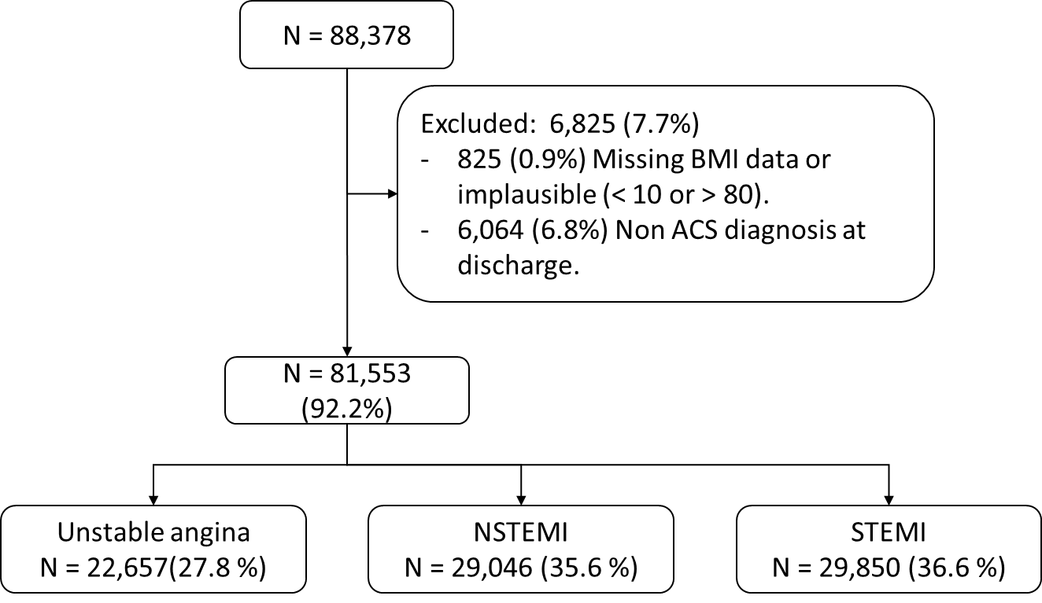

Notes: Study flowchart. Implausible BMI data defined as < 10 or > 80 kg/m2. ACS: acute coronary syndrome. NSTEMI: non-ST segment elevation myocardial infarction, STEMI: ST segment elevation myocardial infarction.

Figure 2:

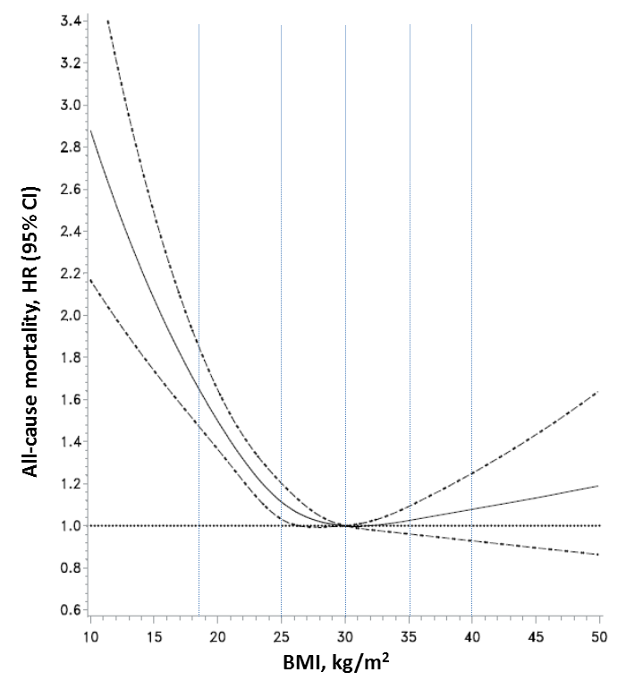

Notes: BMI and all-cause mortality from restricted cubic spline analysis with 4 knots. Data is presented in HR (95% confidence intervals). The multivariate Cox-regression model includes age, sex, geographic region (Asia, Eastern Europe, Western Europe, Latin America, North America, Middle East, South Africa, Australia/New Zealand), smoking status, discharge diagnosis, previous stroke, previous heart failure, previous coronary revascularization, previous myocardial infarction, previous peripheral vascular disease, previous cancer, Killip & Kimball >= 2 on admission, and creatinine clearance. Vertical lines denote BMI categories thresholds. Note that, for this specific plot, hazard ratios are relative to 30 kg/m2, lowest risk BMI value.

Figure 3A and 3B:

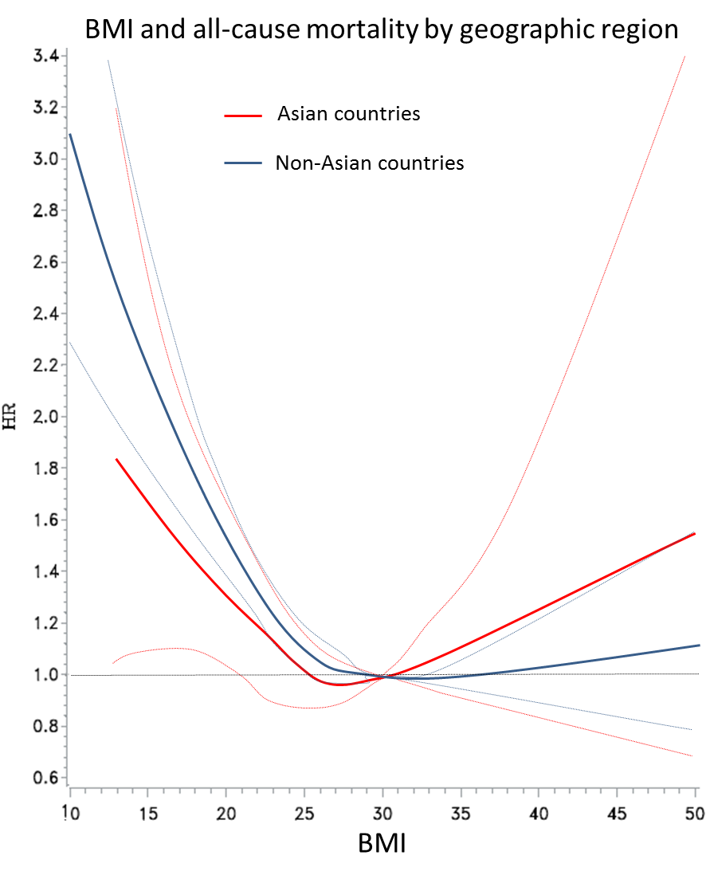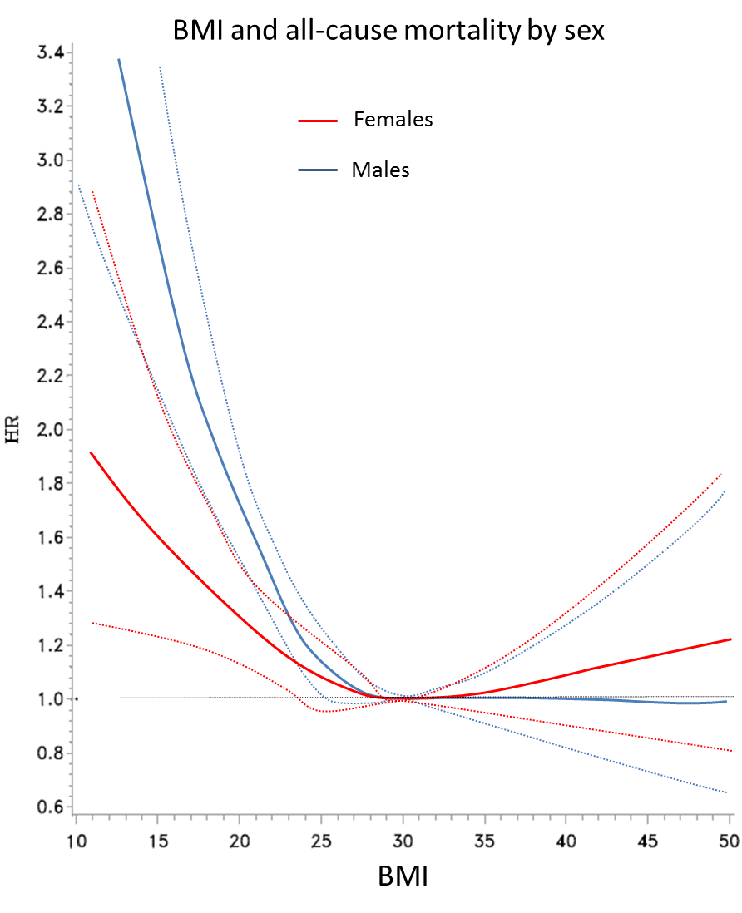 A) B)

Note: BMI and all-cause mortality by sex (A) and geographic region (B). BMI and all-cause mortality from restricted cubic spline analysis with 4 knots. Data is presented in HR (95% confidence intervals), results from the primary model with interaction term. Note that, for this specific plot, hazard ratios are relative to 30 kg/m2, lowest risk BMI value.

Figure 4:

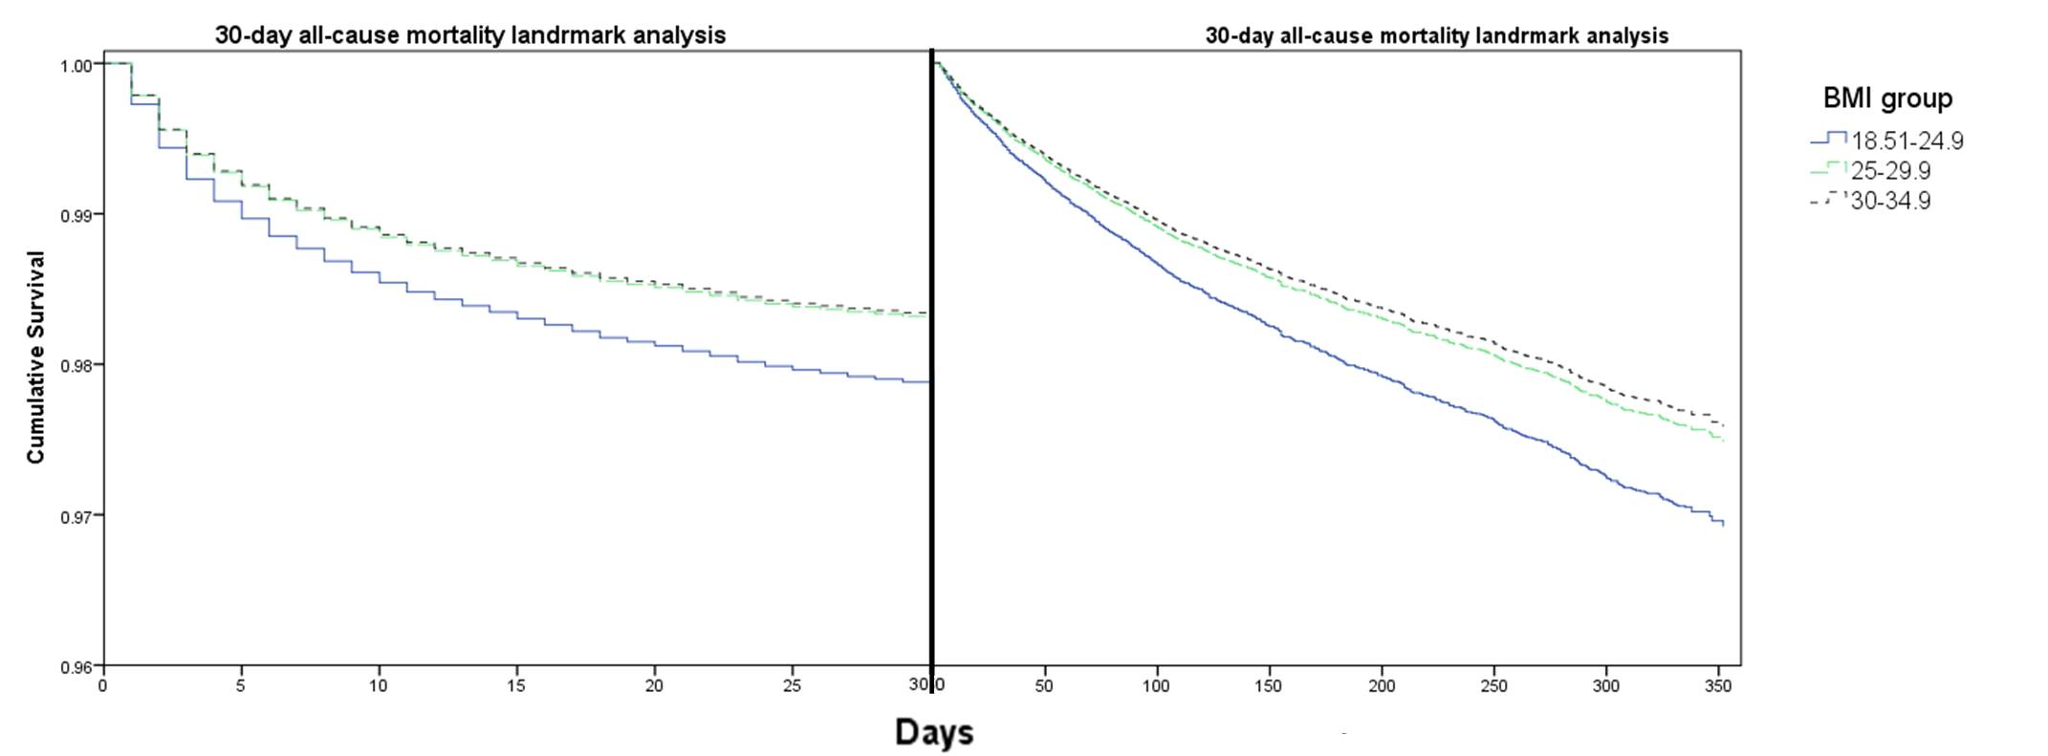

Notes: 30-day all-cause mortality landmark analysis. Survival plot is generated by multivariate analysis using the primary model. X axis is interrupted at the 30-day line, and starting from zero towards the right part of the plot. For ease in visualization, only results from the normal weight, overweight and type I obesity are presented.

Figure 5:

A) B)

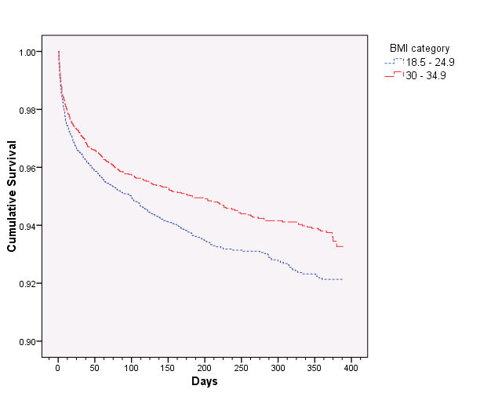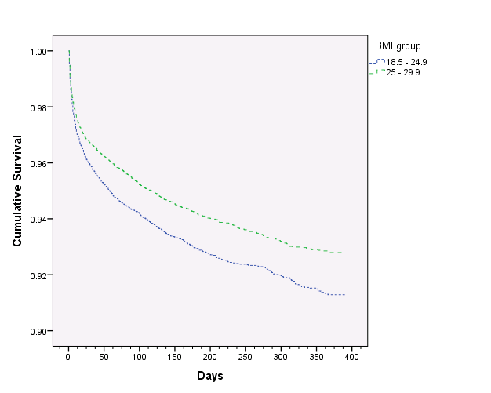

Notes: All-cause mortality according to Kaplan Meier survival analysis among overweight (A) and type I obese (B) participants in propensity score matched cohorts.

Figure 6:

A) B)

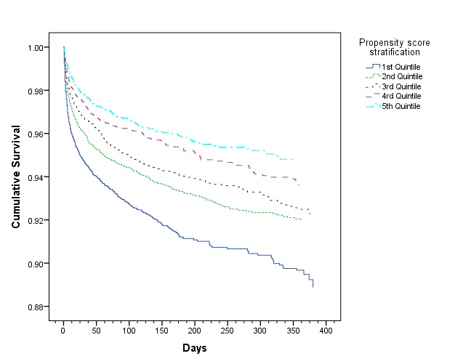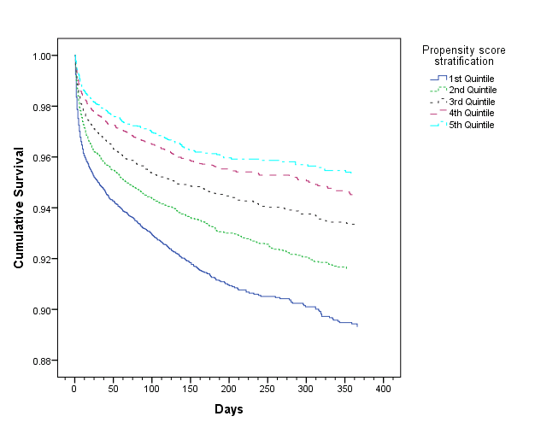

Notes: All-cause mortality according to Kaplan Meier survival analysis among overweight (A) and type I obese (B) participants in stratified propensity score analysis.

Figure 7:

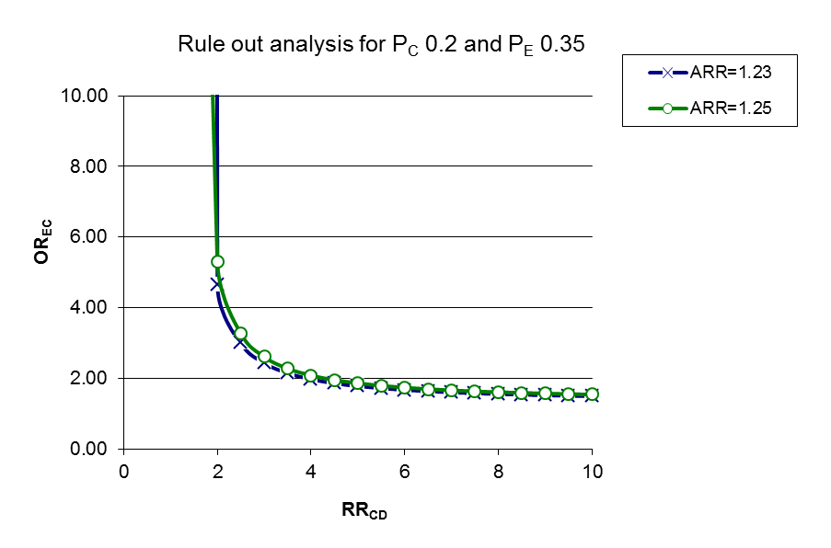

Notes: Rule out analysis. The line with marks, overweight (crosses) and type I obesity (circles), represent the combinations of OREC and the RRCD that would make the exposure-disease RR to 1. All the possible combinations on the lower left side of the graph will not be enough to generate an RR of 1 between the exposure and the disease, and all combinations on the upper right will. AAR of 1.23 corresponds to a HR 0.81 in the overweight category and an ARR of 1.25 to a HR of 0.80 in the type I obesity group. Exposure prevalence of 35% is based on the study prevalence of overweight and type I obesity, while the 20% prevalence of the confounder was selected arbitrarily. AAR: apparent relative risk, RRCD: relative risk between the confounder and the disease, PC: confounder prevalence, PE: exposed group prevalence, OREC: odds ratio between the exposure and the confounder.

Chapter 4 supplementary appendix:

* Table S1: Study-level baseline, admission and follow-up variables.
* Table S2: BMI mean and standard deviation across difference baseline variables.
* Table S3: Subgroup analysis with interaction tests.
* Figure S1: BMI according to age group.

Table S1:

|  |  |  |  |  |  |  |  |  |  |  |
| --- | --- | --- | --- | --- | --- | --- | --- | --- | --- | --- |
| Demographics | | | OASIS 4  (n = 11313) | OASIS 5  (n = 18706) | OASIS 6  (n = 11716) | OASIS 7  (n = 22714) | OASIS 8  (n = 2927) | TIMACS  (n = 1273) | RIVAL  (n = 2811) | TOTAL  (n = 10091) |
|  | Age, years (mean,SD) | | 64.7 (11.1) | 66.8 (10.8) | 61.6 (12.1) | 61.6 (11.6) | 65.8 (11.1) | 65.1 (10.4) | 62.4 (11.7) | 61.1 (11.9) |
|  | Sex, male (n,%) | | 7092 (62.68) | 11827 (63.21) | 8489 (72.40) | 16966 (74.61) | 1962 (67.05) | 872 (68.44) | 2128 (75.67) | 7804 (77.29) |
|  | BMI (mean,SD) | | 27.6 (4.5) | 27.3 (4.5) | 26.5 (4.4) | 27.5 (5.0) | 27.1 (4.51) | 26 (4.8) | 27.8 (4.7) | 27.6 (4.9) |
|  | Geographic region (n,%) | |  |  |  |  |  |  |  |  |
|  |  | South Africa | 283 (2.50) | 189 (1.01) | 123 (1.04) | 68 (0.29) | 0 | 0 | 0 | 0 |
|  |  | Asia | 0 | 1390 (7.43) | 2286 (19.51) | 4970 (21.88) | 654 (22.35) | 762 (59.85) | 279 (9.93) | 571 (5.65) |
|  |  | Australia / New Zealand | 710 (6.27) | 485 (2.59) | 182 (1.55) | 437 (1.92) | 0 | 24 (1.88) | 41 (1.46) | 247 (2.44) |
|  |  | Eastern Europe | 2675 (23.64) | 6457 (34.51) | 4291 (36.62) | 3132 (13.78) | 784 (26.79) | 64 (5.02) | 444 (15.81) | 2515 (24.92) |
|  |  | Latin America | 1210 (10.69) | 1774 (9.48) | 1078 (9.20) | 1982 (8.72) | 118 (4.032) | 135 (10.60) | 25 (0.89) | 360 (3.56) |
|  |  | Middle East | 586 (5.17) | 0 | 0 | 1355 (5.96) | 0 | 0 | 45 (1.60) | 0 |
|  |  | North America | 1960 (17.32) | 2013 (10.76) | 2282 (19.47) | 3993 (17.58) | 109 (3.72) | 237 (18.61) | 1009 (35.94) | 3637 (36.04) |
|  |  | Western Europe | 3889 (34.37) | 6398 (34.20) | 1474 (12.58) | 6776 (29.83) | 1261 (43.09) | 51 (4.00) | 964 (34.34) | 2760 (27.35) |

Table S1 cont.:

|  |  |  |  |  |  |  |  |  |  |  |
| --- | --- | --- | --- | --- | --- | --- | --- | --- | --- | --- |
| Past history (n,%) | | | OASIS 4  (n = 11313) | OASIS 5  (n = 18706) | OASIS 6  (n = 11716) | OASIS 7  (n = 22714) | OASIS 8  (n = 2927) | TIMACS  (n = 1273) | RIVAL  (n = 2811) | TOTAL  (n = 10091) |
|  | Hypertension | | 6673 (58.98) | 12634 (67.52) | 6415 (54.72) | 13799 (60.69) | 2011 (68.7) | 842 (66.1) | 1682 (59.8) | 5104 (50.56) |
|  | Diabetes | | 2644 (23.37) | 4840 (25.86) | 2099 (17.90) | 5477 (24.08) | 841 (28.74) | 319 (25.0) | 635 (22.58) | 1876 (18.58) |
|  | Dyslipidemia | | 5246 (46.39) | 6612 (35.33) | 3843 (32.77) | 9451 (41.57) | 1158 (39.5) | 560 (43.9) | 1195 (42.4) | 2408 (23.85) |
|  | Smoking status | |  |  |  |  |  |  |  |  |
|  |  | Current | 2626 (23.21) | 4223 (22.57) | 4721 (40.32) | 7820 (34.40) | 712 (24.35) | 394 (30.9) | 920 (32.72) | 4595 (45.75) |
|  |  | Former | 4327 (38.25) | 6081 (32.50) | 2097 (17.91) | 5678 (24.98) | 694 (23.73) | 306 (24.0) | 719 (25.57) | 2032 (20.23) |
|  |  | Never | 4359 (38.53) | 8403 (44.91) | 4888 (41.75) | 9232 (40.61) | 1518 (51.9) | 574 (45.0) | 1172 (41.6) | 3415 (34.00) |
|  | Myocardial infarction | | 3787 (33.47) | 4989 (26.66) | 1473 (12.56) | 4236 (18.62) | 613 (20.95) | 217 (17.0) | 502 (17.85) | 921 (9.12) |
|  | Revascularization | |  |  |  |  |  |  |  |  |
|  |  | PCI | 1104 (9.75) | 2229 (11.91) | 350 (2.98) | 3502 (15.40) | 485 (16.57) | 138 (10.8) | 366 (13.01) | 849 (8.41) |
|  |  | CABG | 1325 (11.71) | 1602 (8.56) | 131 (1.11) | 1552 (6.82) | 181 (6.18) | 58 (4.55) | 68 (2.41) | 21 (0.20) |
|  | Heart failure | | 857 (7.57) | 218 (1.16) | 1648 (14.05) | 96 (0.42) | 19 (0.64) | 5 (0.39) | 6 (0.21) | 97 (0.96) |
|  | Stroke | | 473 (4.18) | 1182 (6.31) | 785 (6.69) | 951 (4.18) | 135 (4.61) | 100 (7.84) | 111 (3.94) | 312 (3.09) |
|  | Peripheral artery disease | | 992 (8.76) | 1524 (8.14) | 394 (3.36) | 1129 (4.96) | 180 (6.15) | 60 (4.70) | 67 (2.38) | 226 (2.23) |
|  | Cancer | | 618 (5.46) | 1107 (5.91) | 97 (0.82) | 985 (4.33) | 139 (4.75) | 14 (1.09) | 75 (2.66) | 190 (1.88) |
|  | CKD | | 3301 (29.88) | 6112 (32.79) | 3055 (26.46) | 4801 (21.39) | 722 (24.71) | 277 (22.4) | 478 (17.20) | 1462 (14.69) |

Table S1 cont.:

|  |  |  |  |  |  |  |  |  |  |  |
| --- | --- | --- | --- | --- | --- | --- | --- | --- | --- | --- |
| ACS admission | | | OASIS 4  (n = 11313) | OASIS 5  (n = 18706) | OASIS 6  (n = 11716) | OASIS 7  (n = 22714) | OASIS 8  (n = 2927) | TIMACS  (n = 1273) | RIVAL  (n = 2811) | TOTAL  (n = 10091) |
|  | Admission  KK >= 2 (n,%) | | 277 (2.44) | 1676 (8.96) | 803 (6.84) | 1190 (5.23) | 127 (4.34) | 111 (8.71) | 122 (4.33) | 439 (4.34) |
|  | Heart failure during hosp. (n,%) | | 470 (4.15) | 911 (4.86) | 1173 (10.00) | 648 (2.85) | 41 (1.40) | 40 (3.13) | 58 (2.06) | 611 (6.05) |
|  | Creatinine clearance, ml/min (mean,SD) | | 71.81 (21.39) | 69.72 (20.25) | 74.57 (22.28) | 77.30 (21.42) | 74.97(20.40) | 74.27 (20.27) | 79.84 (20.48) | 83.26 (21.10) |
|  | Discharge diagnosis (n,%) | |  |  |  |  |  |  |  |  |
|  |  | UA | 7745 (68.46) | 7338 (39.22) | 73 (0.62) | 5610 (24.67) | 877 (30.00) | 457 (35.87) | 547 (19.45) | 14 (0.13) |
|  |  | NSTEMI | 3161 (27.94) | 10542 (56.34) | 1291 (11.01) | 9883 (43.46) | 2008 (68.69) | 783 (61.45) | 1376 (48.93) | 12 (0.11) |
|  |  | STEMI | 407 (3.59) | 829 (4.43) | 10358 (88.36) | 7245 (31.86) | 38 (1.30) | 34 (2.66) | 889 (31.61) | 10069 (99.74) |
|  | Coronary angiogram (n,%) | | 4104 (36.27) | 11852 (63.34) | 5161 (44.02) | 22548 (99.1) | 2903 (99.21) | 1216 (95.4) | 2808 (99.8) | 10089 (99.9) |
|  | Revascularization (n,%) | |  |  |  |  |  |  |  |  |
|  |  | PCI | 1660 (14.67) | 6890 (36.82) | 4377 (37.33) | 16993 (74.73) | 2091 (71.46) | 827 (64.91) | 1977 (70.30) | 9811 (97.17) |
|  |  | CABG | 990 (8.75) | 1815 (9.70) | 150 (1.27) | 1718 (7.55) | 209 (7.14) | 152 (11.93) | 326 (11.59) | 203 (2.01) |
|  | IABP (n,%) | | 117 (1.03) | 289 (1.54) | 76 (0.64) | 443 (1.94) | 25 (0.85) | 38 (2.98) | 25 (0.88) | 237 (2.34) |

Table S1 cont.:

|  |  |  |  |  |  |  |  |  |  |
| --- | --- | --- | --- | --- | --- | --- | --- | --- | --- |
| Outcomes &  follow-up (n,%) | | OASIS 4  (n = 11313) | OASIS 5  (n = 18706) | OASIS 6  (n = 11716) | OASIS 7  (n = 22714) | OASIS 8  (n = 2927) | TIMACS  (n = 1273) | RIVAL  (n = 2811) | TOTAL  (n = 10091) |
|  | Follow up time | 323 (199 - 366) | 183 (181 - 183) | 179 (93 - 185) | 31 (31 - 31) | 33 (31 - 36) | 185 (182 - 188) | 33 (32 - 37) | 370 (365 - 387) |
|  | Death | 687 (6.07) | 1176 (6.28) | 1233 (10.51) | 531 (2.33) | 46 (1.57) | 49 (3.84) | 38 (1.35) | 425 (4.20) |
|  | CV death | 599 (5.29) | 1056 (5.64) | 1194 (10.18) | 497 (2.18) | 40 (1.36) | 44 (3.45) | 35 (1.24) | 370 (3.66) |
|  | MI | 718 (6.34) | 1234 (6.59) | 439 (3.74) | 505 (2.2) | 73 (2.49) | 63 (4.94) | 60 (2.13) | 231 (2.28) |
|  | Stroke | 147 (1.29) | 275 (1.46) | 165 (1.40) | 117 (0.51) | 18 (0.61) | 12 (0.94) | 18 (0.64) | 89 (0.88) |
|  | Refractory ischemia | 1073 (9.48) | 465 (2.48) | 62 (0.52) | 102 (0.44) | 42 (1.43) | 31 (2.43) | 7 (0.24) | 495 (4.90) |
|  | Major bleeding | 361 (3.19) | 960 (5.13) | 194 (1.65) | 114 (0.50) | 70 (2.39) | 7 (0.54) | 14 (0.49) | 34 (0.33) |
|  | HF hospitalization | 299 (2.64) | 460 (2.45) | 190 (1.62) | 109 (0.47) | 10 (0.34) | 10 (0.78) | 8 (0.28) | 212 (2.09) |

Notes: Baseline characteristics and outcomes across the included randomized controlled trials. CKD defined as creatinine clearance < 60 ml/minute. CV: Cardiovascular, HF: heart failure, IABP: intra-aortic balloon pump, PCI: percutaneous coronary intervention, CABG: coronary bypass surgery, UA: unstable angina, NSTEMI: non-ST segment elevation myocardial infarction, STEMI: ST segment elevation myocardial infarction, CKD: chronic kidney disease, ACS: acute coronary syndrome, SD: standard deviation.

Table S2:

|  |  |  |  |  |  |  |  |  |  |  |  |  |  |  |  |  |
| --- | --- | --- | --- | --- | --- | --- | --- | --- | --- | --- | --- | --- | --- | --- | --- | --- |
| Demographics (mean,SD) | | |  |  | |  | |  |  | |  | |  | |  | |
|  | Age group |  | | |  | | p < 0.001 | |  | Region | |  | |  | | p < 0.001 |
|  |  | < 40 years | | | 27.96 (5.33) | |  | |  |  | | South Africa | | 27.78 (4.93) | |  |
|  |  | 40 - 50 years | | | 27.96 (5.05) | |  | |  |  | | Asia | | 24.68 (3.69) | |  |
|  |  | 50 - 60 years | | | 27.78 (4.88) | |  | |  |  | | Australia / New Zealand | | 27.95 (4.89) | |  |
|  |  | 60 - 70 years | | | 27.51 (4.62) | |  | |  |  | | Eastern Europe | | 27.79 (4.35) | |  |
|  |  | 70 - 80 years | | | 26.78 (4.30) | |  | |  |  | | Latin America | | 27.24 (4.35) | |  |
|  |  | 80 – 90 years | | | 25.67 (4.08) | |  | |  |  | | Middle East | | 27.73 (4.37) | |  |
|  |  | > 90 years | | | 24.22 (3.69) | |  | |  |  | | North America | | 28.37 (5.56) | |  |
|  | Sex |  | | |  | | p < 0.001 | |  |  | | Western Europe | | 27.38 (4.37) | |  |
|  |  | Male | | | 27.26 (4.41) | |  | |  |  | |  | |  | |  |
|  |  | Female | | | 27.48 (5.26) | |  | |  |  | |  | |  | |  |
|  |  |  | | |  | |  | |  |  | |  | |  | |  |

Table S2 cont.:

|  |  |  |  |  |  |  |  |  |  |
| --- | --- | --- | --- | --- | --- | --- | --- | --- | --- |
| Past history (mean,SD) | |  |  |  |  |  |  |  |  |
|  | Hypertension |  |  | p < 0.001 |  | PCI |  |  | p < 0.001 |
|  |  | No | 26.46 (4.34) |  |  |  | No | 27.24 (4.65) |  |
|  |  | Yes | 27.89 (4.81) |  |  |  | Yes | 27.95 (4.88) |  |
|  | Diabetes |  |  | p < 0.001 |  | CABG |  |  | p < 0.001 |
|  |  | No | 26.98 (4.48) |  |  |  | No | 27.29 (4.69) |  |
|  |  | Yes | 28.46(5.14) |  |  |  | Yes | 27.80 (4.52) |  |
|  | High Cholesterol |  |  | p < 0.001 |  | Heart failure |  |  | p = 0.005 |
|  |  | No | 26.93 (4.57) |  |  |  | No | 27.31 (4.66) |  |
|  |  | Yes | 27.98(4.79) |  |  |  | Yes | 27.56 (5.09) |  |
|  | Smoking status |  |  | p < 0.001 |  | Stroke |  |  | p < 0.001 |
|  |  | Current | 27.87 (4.61) |  |  |  | No | 27.34 (4.68) |  |
|  |  | Former | 26.96 (4.71) |  |  |  | Yes | 27.04 (4.74) |  |
|  |  | Never | 27.24 (4.67) |  |  | PAD |  |  | p < 0.001 |
|  | Myocardial infarction |  |  | p < 0.001 |  |  | No | 27.34 (4.68) |  |
|  |  | No | 27.28 (4.69) |  |  |  | Yes | 27.02 (4.62) |  |
|  |  | Yes | 27.48 (4.63) |  |  | Cancer |  |  | p = 0.54 |
|  |  |  |  |  |  |  | No | 27.32 (4.68) |  |
|  |  |  |  |  |  |  | Yes | 27.37 (4.73) |  |
|  |  |  |  |  |  |  |  |  |  |

Notes: BMI mean and standard deviation across different baseline characteristics. SD: standard deviation, PCI: percutaneous coronary intervention, CABG: coronary bypass surgery.

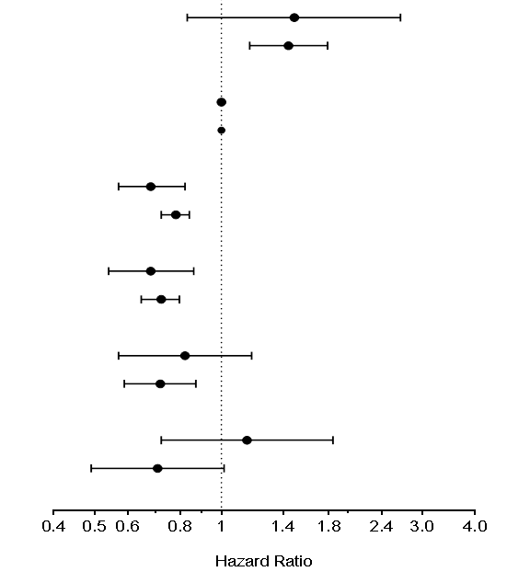Table S3:

|  |  |  |  |  |
| --- | --- | --- | --- | --- |
| BMI category | Age | n/N (%) | HR (95% CI) | Interaction p |
| BMI < 18.5 | Age <= 60 | 12/277 (4.33) | 1.49 (0.83 - 2.66) | 0.92 |
| Age > 60 | 92/680 (13.53) | 1.44 (1.17 - 1.79) |
|  |  |  |  |  |
| BMI >= 18.5 - 24.9 | Age <= 61 | 235/9355 (2.51) | 1 |  |
| Age > 61 | 1387/16034 (8.65) | 1 |  |
|  |  |  |  |  |
| BMI 25 - 29.9 | Age <= 62 | 230/13915 (1.65) | 0.68 (0.57 - 0.82) | 0.19 |
| Age > 62 | 1404/21651 (6.48) | 0.78 (0.72 - 0.84) |
|  |  |  |  |  |
| BMI 30 - 34.9 | Age <= 63 | 113/6550 (1.73) | 0.68 (0.54 - 0.86) | 0.69 |
| Age > 63 | 492/8136 (6.05) | 0.72 (0.65 - 0.80) |
|  |  |  |  |  |
| BMI 35 - 39.4 | Age <= 64 | 33/1797 (1.84) | 0.82 (0.57 - 1.18) | 0.53 |
| Age > 64 | 108/1810 (5.97) | 0.72 (0.59 - 0.87) |
|  |  |  |  |  |
| BMI >= 40 | Age <= 65 | 19/715 (2.66) | 1.15 (0.72 - 1.84) | 0.1 |
| Age > 65 | 30/515 (5.83) | 0.71 (0.49 - 1.02) |

Overall interaction p value = 0.31

|  |  |  |  |  |
| --- | --- | --- | --- | --- |
| Table S3 cont.:  BMI category | Sex | n/N (%) | HR (95% CI) | Interaction p |
| BMI < 18.5 | Males | 52/475 (10.95) | 1.60 (1.21 - 2.11) | 0.12 |
| Females | 52/482 (10.79) | 1.17 (0.88 - 1.55) |
|  |  |  |  |  |
| BMI >= 18.5 - 24.9 | Males | 1015/17545 (5.79) | 1 |  |
| Females | 607/7844 (7.74) | 1 |  |
|  |  |  |  |  |
| BMI 25 - 29.9 | Males | 1013/26153 (3.87) | 0.76 (0.70 - 0.84) | 0.02 |
| Females | 621/9413 (6.60) | 0.90 (0.81 - 1.01) |
|  |  |  |  |  |
| BMI 30 - 34.9 | Males | 342/9981 (3.43) | 0.80 (0.71 - 0.91) | 0.97 |
| Females | 263/4705 (5.59) | 0.80 (0.69 - 0.93) |
|  |  |  |  |  |
| BMI 35 - 39.4 | Males | 62/2190 (2.83) | 0.78 (0.60 - 1.01) | 0.15 |
| Females | 79/1417 (5.58) | 1.00 (0.79 - 1.27) |
|  |  |  |  |  |
| BMI >= 40 | Males | 15/685 (2.19) | 0.73 (0.44 - 1.22) | 0.06 |
| Females | 34/545 (6.24) | 1.29 (0.91 - 1.83) |

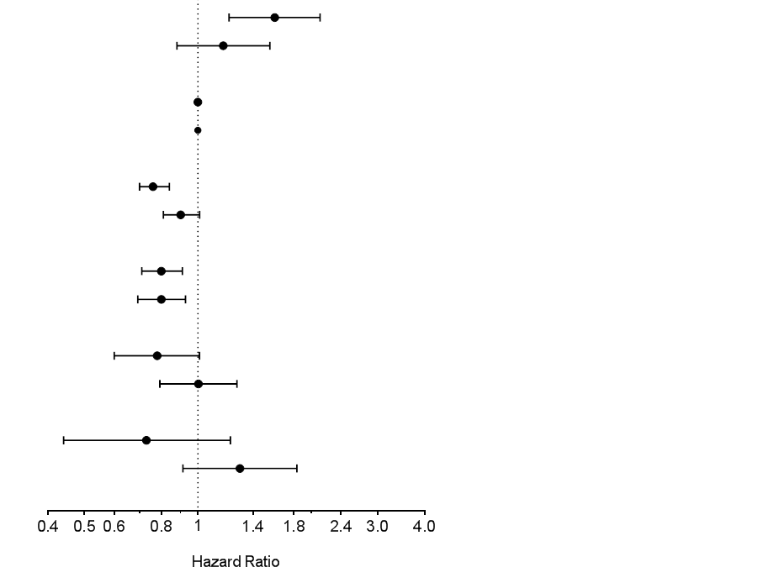

Overall interaction p value = 0.018

|  |  |  |  |  |
| --- | --- | --- | --- | --- |
| Table S3 cont.:  BMI category | Diabetes | n/N (%) | HR (95% CI) | Interaction p |
| BMI < 18.5 | No | 82/828 (9.90) | 1.31 (1.05 - 1.65) | 0.31 |
| Yes | 22/129 (17.05) | 1.68 (1.10 - 2.59) |
|  |  |  |  |  |
| BMI >= 18.5 - 24.9 | No | 1180/20847 (5.66) | 1 |  |
| Yes | 442/4542 (9.73) | 1 |  |
|  |  |  |  |  |
| BMI 25 - 29.9 | No | 1102/27590 (3.99) | 0.81 (0.75 - 0.88) | 0.5 |
| Yes | 532/7976 (6.67) | 0.77 (0.68 - 0.87) |
|  |  |  |  |  |
| BMI 30 - 34.9 | No | 346/10502 (3.29) | 0.75 (0.67 - 0.85) | 0.73 |
| Yes | 259/4183 (6.19) | 0.78 (0.67 - 0.91) |
|  |  |  |  |  |
| BMI 35 - 39.4 | No | 69/2262 (3.05) | 0.82(0.64 - 1.05) | 0.94 |
| Yes | 72/1345 (5.35) | 0.83 (0.64 - 1.07) |
|  |  |  |  |  |
| BMI >= 40 | No | 20/707 (2.83) | 0.89 (0.57 - 1.39) | 0.74 |
| Yes | 29/523 (5.54) | 0.99 (0.67 - 1.44) |

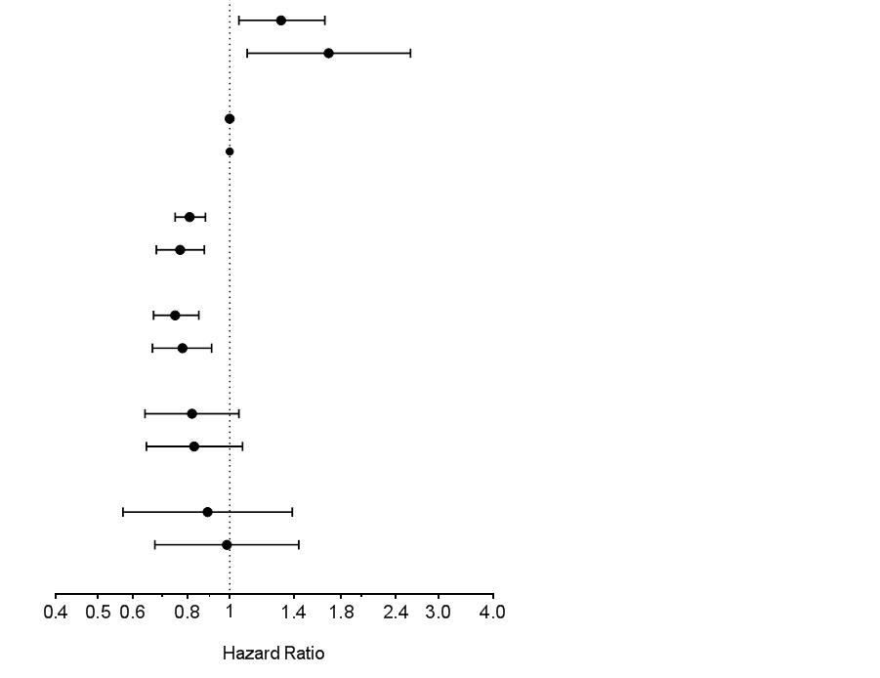

Overall interaction p value = 0.81

|  |  |  |  |  |
| --- | --- | --- | --- | --- |
| Table S3 cont.:  BMI category | Previous CVD | n/N (%) | HR (95% CI) | Interaction p |
| BMI < 18.5 | No | 47/589 (7.98) | 1.29 (0.96 - 1.73) | 0.72 |
| Yes | 57/368 (15.49) | 1.38 (1.06 - 1.81) |
|  |  |  |  |  |
| BMI >= 18.5 - 24.9 | No | 695/15156 (4.59) | 1 |  |
| Yes | 927/10233 (9.06) | 1 |  |
|  |  |  |  |  |
| BMI 25 - 29.9 | No | 631/20812 (3.03) | 0.75 (0.68 - 0.84) | 0.09 |
| Yes | 1003/14754 (6.80) | 0.85 (0.76 - 0.93) |
|  |  |  |  |  |
| BMI 30 - 34.9 | No | 234/8316 (2.81) | 0.79 (0.68 - 0.92) | 0.94 |
| Yes | 371/6370 (5.82) | 0.79 (0.70 - 0.89) |
|  |  |  |  |  |
| BMI 35 - 39.4 | No | 50/2065 (2.42) | 0.76 (0.57 - 1.02) | 0.23 |
| Yes | 91/1542 (5.90) | 0.94 (0.76 - 1.17) |
|  |  |  |  |  |
| BMI >= 40 | No | 20/729 (2.74) | 0.99 (0.63 - 1.55) | 0.87 |
| Yes | 29/501 (5.79) | 1.04 (0.71 - 1.50) |

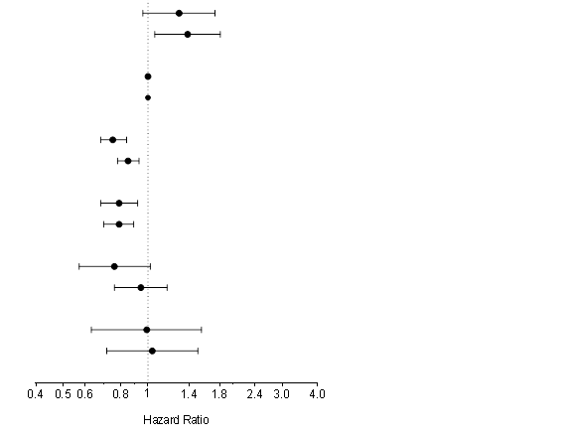

Overall interaction p value = 0.52

|  |  |  |  |  |
| --- | --- | --- | --- | --- |
| Table S3 cont.:  BMI category | Renal disease | n/N (%) | HR (95% CI) | Interaction p |
| BMI < 18.5 | No | 46/662 (6.95) | 1.36 (1.01 - 1.84) | 0.83 |
| Yes | 54/280 (19.29) | 1.31 (0.99 - 1.72) |
|  |  |  |  |  |
| BMI >= 18.5 - 24.9 | No | 765/18754 (4.08) | 1 |  |
| Yes | 825/6294 (13.11) | 1 |  |
|  |  |  |  |  |
| BMI 25 - 29.9 | No | 765/26451 (2.89) | 0.81 (0.73 - 0.90) | 0.7 |
| Yes | 831/8661 (9.59) | 0.83 (0.76 - 0.92) |
|  |  |  |  |  |
| BMI 30 - 34.9 | No | 289/10806 (2.67) | 0.86 (0.75 - 0.99) | 0.24 |
| Yes | 307/3698 (8.30) | 0.77(0.68 - 0.88) |
|  |  |  |  |  |
| BMI 35 - 39.4 | No | 68/2647 (2.57) | 0.97 (0.76 - 1.25) | 0.45 |
| Yes | 71/927 (7.66) | 0.85 (0.67- 1.09) |
|  |  |  |  |  |
| BMI >= 40 | No | 24/919 (2.61) | 1.14 (0.76 - 1.72) | 0.74 |
| Yes | 25/299 (8.36) | 1.04 (0.70 - 1.55) |

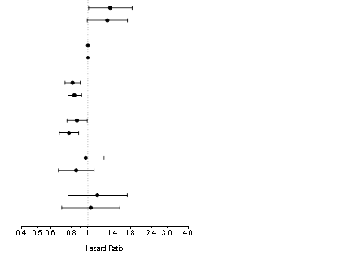

Overall interaction p value = 0.73

|  |  |  |  |  |
| --- | --- | --- | --- | --- |
| Table S3 cont.:  BMI category | HF on admission | n/N (%) | HR (95% CI) | Interaction p |
| BMI < 18.5 | No | 79/878 (9.00) | 1.32 (1.05 - 1.66) | 0.94 |
| Yes | 25/79 (31.65) | 1.35 (0.89 - 2.03) |
|  |  |  |  |  |
| BMI >= 18.5 - 24.9 | No | 1325/23880 (5.55) | 1 |  |
| Yes | 297/1509 (19.68) | 1 |  |
|  |  |  |  |  |
| BMI 25 - 29.9 | No | 1326/33621 (3.94) | 0.80 (0.74 - 0.87) | 0.43 |
| Yes | 308/1945 (15.84) | 0.86 (0.74 - 1.01) |
|  |  |  |  |  |
| BMI 30 - 34.9 | No | 482/13807 (3.49) | 0.79 (0.71 - 0.88) | 0.7 |
| Yes | 123/879 (13.99) | 0.83 (0.67 - 1.02) |
|  |  |  |  |  |
| BMI 35 - 39.4 | No | 113/3371 (3.35) | 0.88 (0.72 - 1.07) | 0.87 |
| Yes | 28/236 (11.86) | 0.91 (0.62 - 1.34) |
|  |  |  |  |  |
| BMI >= 40 | No | 42/1143 (3.67) | 1.21 (0.89 - 1.66) | 0.057 |
| Yes | 7/87 (8.05) | 0.55 (0.26 - 1.17) |

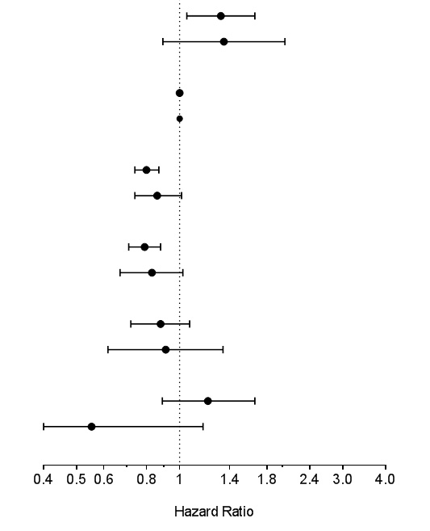

Overall interaction p value = 0.46

|  |  |  |  |  |
| --- | --- | --- | --- | --- |
| Table S3 cont.:  BMI category | ACS diagnosis | n/N (%) | HR (95% CI) | Interaction p |
| BMI < 18.5 | UA | 21/259 (8.11) | 1.54 (0.99 - 2.39) | 0.77 |
| NSTEMI | 29/297 (9.76) | 1.29 (0.88 - 1.88) |
| STEMI | 54/401 (13.47) | 1.28 (0.97 - 1.69) |
|  |  |  |  |  |
| BMI >= 18.5 - 24.9 | UA | 331/7093 (4.67) | 1 |  |
| NSTEMI | 481/8405 (5.72) | 1 |  |
| STEMI | 810/9891 (8.19) | 1 |  |
|  |  |  |  |  |
| BMI 25 - 29.9 | UA | 366/9842 (3.72) | 0.87 (0.75 - 1.01) | 0.62 |
| NSTEMI | 508/12727 (3.99) | 0.80 (0.71 - 0.91) |
| STEMI | 760/12997 (5.85) | 0.80 (0.72 - 0.89) |
|  |  |  |  |  |
| BMI 30 - 34.9 | UA | 132/4188 (3.15) | 0.79 (0.64 - 0.96) | 0.19 |
| NSTEMI | 183/5630 (3.25) | 0.71 (0.60 - 0.85) |
| STEMI | 290/4868 (5.96) | 0.87 (0.76 - 0.99) |
|  |  |  |  |  |
| BMI 35 - 39.4 | UA | 32/990 (3.23) | 0.89 (0.62 - 1.29) | 0.61 |
| NSTEMI | 53/1427 (3.71) | 0.99 (0.74- 1.31) |
| STEMI | 56/1190 (4.71) | 0.81 (0.61 - 1.06) |
|  |  |  |  |  |
| BMI >= 40 | UA | 12/278 (4.32) | 1.57(0.88 - 2.79) | 0.29 |
| NSTEMI | 18/540 (3.33) | 0.97 (0.61 - 1.56) |
| STEMI | 19/412 (4.61) | 0.89 (0.56 - 1.41) |

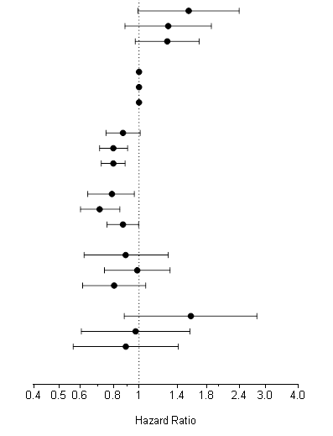

Overall interaction p value = 0.53

|  |  |  |  |  |
| --- | --- | --- | --- | --- |
| Table S3 cont.:  BMI category | Geographic region | n/N (%) | HR (95% CI) | Interaction p |
| BMI < 18.5 | Asia | 332/5840 (5.68) | 1.34 (0.94 - 1.91) | 0.05 |
| Eastern Europe | 405/5349 (7.57) | 1.47 (0.86 - 2.5) |
| Western Europe | 349/6932 (5.03) | 1.26 (0.76 - 2.08) |
| North America | 272/3967 (6.86) | 2.53 (1.70 - 3.76) |
| Latin America | 216/2040 (10.59) | 0.82 (0.37 - 1.85) |
|  |  |  |  |  |
| BMI >= 18.5 - 24.9 | Asia | 155/3893 (3.98) | 1 |  |
| Eastern Europe | 502/9312 (5.39) | 1 |  |
| Western Europe | 384/10955 (3.51) | 1 |  |
| North America | 295/6234 (4.73) | 1 |  |
| Latin America | 210/3011 (6.97) | 1 |  |
|  |  |  |  |  |
| BMI 25 - 29.9 | Asia | 36/692 (5.20) | 0.81 (0.66 - 0.98) | 0.78 |
| Eastern Europe | 217/4376 (4.96) | 0.72 (0.63 - 0.82) |
| Western Europe | 129/4218 (3.06) | 0.74 (0.64 - 0.86) |
| North America | 109/3178 (3.43) | 0.80 (0.67 - 0.94) |
| Latin America | 79/1226 (6.44) | 0.71 (0.59 - 0.86) |
|  |  |  |  |  |
| BMI 30 - 34.9 | Asia | 4/85 (4.71) | 1.12(0.79 - 1.59) | 0.1 |
| Eastern Europe | 42/982 (4.28) | 0.65 (0.55 - 0.77) |
| Western Europe | 31/951 (3.26) | 0.69(0.56 - 0.84) |
| North America | 42/1089 (3.86) | 0.73 (0.58 - 0.91) |
| Latin America | 16/273 (5.86) | 0.69 (0.53 - 0.89) |

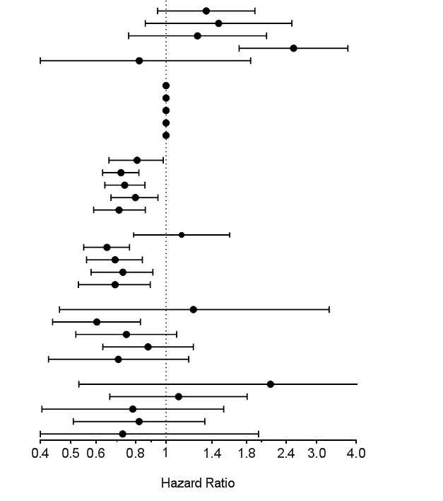

Table S3 cont.:

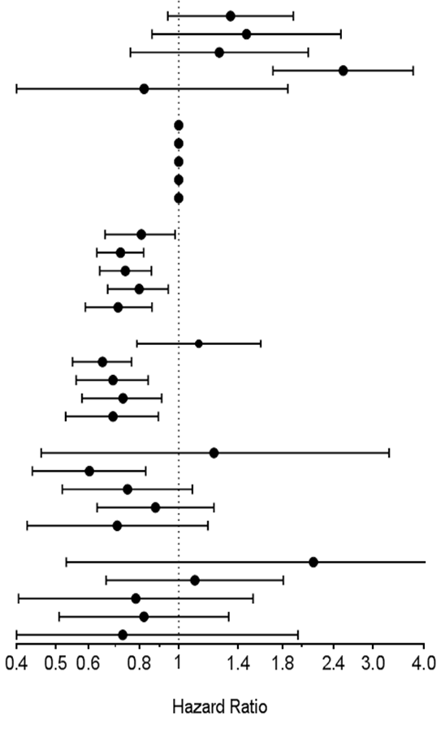

|  |  |  |  |  |
| --- | --- | --- | --- | --- |
| BMI 35 - 39.4 | Asia | 2/23 (8.70) | 1.22 (0.46 - 3.28) | 0.47 |
| Eastern Europe | 16/218 (7.34) | 0.60 (0.44 - 0.83) |
| Western Europe | 9/284 (3.17) | 0.75 (0.52 - 1.08) |
| North America | 18/557 (3.23) | 0.88 (0.63- 1.22) |
| Latin America | 4/61 (6.56) | 0.71 (0.42 - 1.18) |
|  |  |  |  |  |
| BMI >= 40 | Asia | 35/370 (9.46) | 2.14 (0.53 - 8.62) | 0.64 |
| Eastern Europe | 15/118 (12.71) | 1.10 (0.66- 1.81) |
| Western Europe | 17/210 (8.10) | 0.78 (0.40 - 1.52) |
| North America | 28/151 (18.54) | 0.82 (0.51 - 1.33) |
| Latin America | 6/68 (8.82) | 0.73 (0.27 - 1.96) |

Overall interaction p value = 0.26

Notes: Subgroup analysis with interaction tests. Interaction p values were calculated including an interaction term in the multivariate shared frailty model.

Figure S1:



Notes: BMI mean and standard deviation according to age group.

CHAPTER 5: DISCUSSION

**Main findings**

In this large individual patient data meta-analysis, we investigated the association between BMI and all-cause mortality among patients who suffered an ACS. Compared to normal weight individuals, overweight and type I obese participants were associated with a lower risk of all-cause mortality. This association was consistent among all the sensitivity analysis performed, including alternative models, restriction of participants with potential illness-related weight loss, landmark analysis, and propensity score analyzes. This mortality risk reduction was mainly driven by a reduction in cardiovascular mortality, and the association differed according to gender and geographic region.

Overweight participants had a lower risk of developing myocardial infarction during follow-up, and all increased BMI categories experienced lower rates of refractory ischemia. However, there was no improvement of revascularization outcomes among those who received a PCI as a first revascularization strategy, either target vessel or lesion revascularization. Overweight patients also experienced lower heart failure hospitalizations, as well as lower heart failure related death. Finally, bleeding risk was markedly reduced in all high BMI categories.

**Findings in the context of previous literature**

In this individual patient data meta-analysis all-cause mortality results presented herein, are consistent with the overweight (RR 0.82; 95% CI 0.75 - 0.91) and obese (RR 0.81; 95% CI 0.73 - 0.91) pooled estimates from the study-level meta-analysis presented in Chapter 2. However, those study-level estimates are the product of moderate to high heterogeneous study results (I2 = 64% for overweight and I2 = 56% for obese participants). This heterogeneity, exacerbated by its lack of explanation in subgroup analysis, reduces the confidence of the pooled estimate secondary to inconsistency.

In 1987 Hoit et. al published the first study showing that obese patients had a lower mortality than normal BMI in patients with acute myocardial infarction.1 After that, there was a paucity of publications showing increased mortality risk in patients with a BMI of 25 to 40 kg/m2, despite the diversity of populations, follow-up time, study quality and variables for adjustments. In 2002 Kaplan et. al described a U-shaped pattern in the ACS population, in which the lowest mortality risk category was 26.2 to 28.6 kg/m2 range.2 Our present analysis strongly suggests a U-shaped pattern, in which the lowest risk BMI value was 31.3 kg/m2 in non-Asian and 27.5 kg/m2 in Asian countries. Restricted cubic spline analysis showed that under BMI of 26 kg/m2, there was an inverse linear association between BMI and all-cause mortality.

This is the first analysis reporting a gender interaction between the BMI and the all-cause mortality association in the ACS population. A 1.4 million white adults analysis of 19 studies from the National Cancer Institute Cohort Consortium described that there were no differences between males and females death estimates, without providing any estimate or interaction p-value.3 However, in the supplementary appendix they report that females had lower overall adjusted estimates than males in the BMI 18.5 - 19.9 kg/m2 (HR 1.34 [95% CI 1.30-1.38] and HR 1.60 [95% CI 1.51-1.69], respectively) and 20 - 22.4 kg/m2 (HR 1.06 [95% CI 1.04-1.09] and HR 1.18 [95% CI 1.15-1.21], respectively) ranges. A Korean study enrolling 12.8 million adults showed that women had lower all-cause mortality risk estimates in normal weight and underweight individuals.4 Our results are consistent with literature studying healthier cohorts, in which females are associated with a lower risk of mortality in BMI categories under 30 kg/m2. A possible explanation for this interaction is that, for the same BMI value, women have more body fat than men.5 Nevertheless, females shared a similar lower BMI risk with males, and they still had a significant reduction in all-cause mortality in the type I obesity category.

This is also the first report of a geographic region interaction, between Asian and non-Asian countries. Similar to gender, previous reports described that Asians had lower BMI values for the same body fat amount compared to similar white populations.6 This pushed the World Health Organization to consider lower BMI thresholds for obesity categorization in the Asian population.7,8 BMI is supposed to be a tool for estimating excess body fat, but as previously stated, BMI underestimate total body fat in females and Asians. As a consequence, both sex and geographic region effect modifications found in our analysis might be a BMI artifact than a real interaction between body fat and all-cause mortality.

BMI has been questioned for its inaccuracy in estimating body fat.9 Other anthropometric measures, such as waist circumference, waist-to-hip ratio (WHR) or bioelectrical impedance were not consistently measured across the 8 trials included. Some articles included in the systematic review highlighted in Chapter 2, presented waist and hip circumference results. Herrman et. al reported that the BMI-mortality association did not change after considering waist circumference in the analysis.10 Kragelund et. al found a flat RR with reasonable narrow 95% confidence intervals between the first three WHR quartiles, and increased mortality in the highest quartile.11 Lee et. al described an increased WHR was associated with an increased risk of death among Koreans after STEMI.12 If high WHR values are associated with increased mortality, given that high BMI values are more likely to have higher WHR values, this will behave as a negative confounder: accounting for it may actually increase the risk reduction among high BMI categories. This is supported by our analysis from the OASIS 4 study, in which estimates and confidence interval did not materially change when considering waist-to-hip ratio in the model.

**Insights on the obesity paradox mechanisms**

Our study detected a similar degree of lower all-cause mortality and cardiovascular mortality (91.6 % of all deaths) in the overweight and type I obese individuals, with no association with non-cardiovascular mortality. This suggests a lower risk in cardiovascular mortality as the main mechanism in the lower all-cause mortality in these two high BMI categories. None of the studies included in the systematic review analyzed cardiovascular mortality specifically. Results from a systematic review of patients with coronary artery disease, which has shown significant reduction in all-cause mortality in overweight individuals, failed to detect significant reduction in cardiovascular death in the overweight and type I obesity categories.13

Only the overweight category was associated with lower myocardial infarction risk, with a HR of 0.90 (95% CI 0.84 - 0.98). This single estimate is unlikely to be the whole explanation of a 20% reduction in all-cause and cardiovascular mortality in the overweight category. The fact that all high BMI categories were associated with reduced risk of refractory angina is also unlikely to explain an overall reduction in mortality, if MI is the mediator between ischemia and death. However, ischemic events may have other pathways to increase mortality, rather than MI. If obese patients experience less ischemic events, they may be less aggressively treated with antiplatelets and anticoagulants, with a concomitant reduced risk of bleeding, and later risk of death. Also, ischemic events may trigger lethal ventricular arrhythmias, without MI. Although these mechanisms may not be critical in the association between refractory ischemia and cardiovascular mortality in high BMI patients, we cannot reject its contribution in this interesting association.

Previous research hypothesized that high BMI individuals had better outcomes after ACS secondary to better outcomes after PCI. Our results showed no effect of BMI in target vessel or target lesion revascularization, as well as stent thrombosis. However, the literature on these outcomes in post-PCI patients is conflicting. Martin et. al described and increased risk of TVR in high BMI patients with planned PCI, while Schmiegelow et. al concluded that BMI was inversely related to TVR and stent thrombosis.14,15 According to our results, the advantage in mortality among overweight and type I obese participants is unlikely to be a consequence of better PCI-related outcomes.

The obesity paradox was repeatedly described in heart failure patients, even when pre-morbid BMI was available for analysis.16 Our results support this hypothesis in overweight participants, since they had lower heart failure hospitalizations and heart failure related deaths. However, the estimates of lower risk of mortality are not sufficiently large enough to justify a 20% reduction in all-cause mortality in the overweight category. Similar findings were consistent for myocardial infarction.

All high BMI categories were associated with lower risk of bleeding. Despite this strong and consistent association in our results, this was not always the case across the literature. In a report from the SYNERGY study, investigators did not detect an association between BMI and bleeding risk in adjusted analysis.17 On the other hand, Das et. al reported reduced in-hospital bleeding risk among the BMI 25 to 40 kg/m2 range.18 Bleeding events after an acute coronary syndrome has been independently associated with increased mortality risk.19 In the OASIS 5 trial, patients randomized to fondaparinux had lower mortality during follow-up, compared with enoxaparin.20 Participants receiving fondaparinux did not experienced less ischemic events, but they had fewer bleeding events. As a result, reduced mortality risk associated with fondaparinux was hypothesized to be driven by a reduction in bleeding. In our analysis, high BMI categories were associated with reduced risk of bleeding, and this may play a critical factor in determining the mortality reduction in the overweight and type I obesity categories. Some mechanisms were proposed, including, fat tissue compression of access site in PCI procedures and CABG (which can explain short-term bleeding), as well as a relative underdosing of anticoagulants and antiplatelets (which can explain both short- and long-term bleeding).18,21

In summary, our individual patient data meta-analysis supports three potential reasons for explaining the obesity paradox in acute coronary syndromes: (1) reduced ischemic events, (2) improved heart failure survival and (3) reduced risk of bleeding. The fact that the overweight and type I obese participants experienced lower mortality rates, may raise the concern of competing risk bias with secondary outcomes, deviating the estimates towards the null. Patients who died before a first occurrence of the secondary outcome of interest were censored for survival analysis, which may violate the independence assumption of survival analysis (e.g., in the case that patients who died during follow-up were more likely to have an MI or bleeding event than those censored at the end of the study). Moreover, this may be exacerbated if patients experienced a secondary outcome and subsequent sudden death (e.g. MI or or intracranial bleeding presenting as a sudden death). As a result, it is probable that the rates of some secondary outcomes are underestimated.

**Limitations and threats to validity**

BMI measurement: Missing BMI data was infrequent (0.9%), but none of the protocols provided guidelines for height and weight measurement. The lack of BMI measurement standardization may lead to random and systematic errors. Although it may sound counterintuitive, large degrees of random error in a continuous independent variable will induce bias rather than imprecision in regression analysis, a phenomenon called regression dilution bias.22 Since BMI was measured only once during the admission period, we couldn’t estimate the amount of random error and calibrate BMI measurements in a post-hoc fashion. However, this bias deviates estimates towards the null. As a result, this specific bias doesn’t affect the overall interpretation of the main results of our study, in which the null hypothesis was rejected, but may be a flag for a potential underestimation of the real estimate.

On the other hand, systematic errors in height and weight measurement may induce bias in a less predictable way. The most common source of bias in BMI assessment is the self-reported weight and height.23 Typically, this bias has a downward direction, from no difference to a mean difference of -2 kg/m2 between self-reported and measured BMI.23,24 This reduction is quite consistent among different ages, genders, ethnic groups and BMI categories, and it has been stable during the last 10 years.24 The presence of this bias would move the overall real U-shaped pattern towards lower BMI values, and similarly to regression dilution bias, deviating estimates towards the null in the high BMI categories. An exception would be that a sub-group with increased risk of death had an exaggerated downward BMI reporting compared to lower risk participants, which is unlikely.

Residual confounding: The objective of the original randomized trials was not to generate a prospective cohort to evaluate how certain exposures (e.g. BMI) impacts outcomes such as mortality. This raises the concern that important prognostic variables, or potential confounders between the BMI and mortality association, were missed or improperly collected. This was the case for socio-economic status, education, cardiovascular fitness, depression and dementia, which were not dedicatedly measured across the studies. Important prognostic factors, especially previous cancer, were not consistently measured in dedicated fields in all the included trials. These may lead to residual confounding, secondary to unmeasured or improperly measured confounders.

The fact that pooled estimates from the study-level meta-analysis, with very different approaches and populations, coincide with our individual patient data results, reduces the probability that important confounders were missed in the analysis. Propensity score matched analysis produced balanced cohorts, reducing the chance of residual confounding in measured confounders. Array and rule-out analysis had shown that strong unmeasured confounders, with considerable (and probably clinically evident) misbalance between normal weight with overweight and type I obese participants, are needed to make the association disappear. However, if all studies missed the same confounders, because they are unmeasurable or rarely measured, it is probable that all the evidence to date would be limited by the same biased result. This was the case for hormone replacement therapy in postmenopausal women with established coronary artery disease. Several observational trials had shown improved outcomes among those postmenopausal women on hormone replacement therapy, and randomized trials showed no effect or probably harm.25-27 Later, lack of socioeconomic position control in observational studies had been blamed as an explanation of such discrepancy.28

Selection bias: The included multicenter randomized trials followed a convenience sampling approach. This means that participating centers conducted non-systematic screening among eligible participants, and those eligible were approached for consent. Then, only those participants who agreed to participate and provided informed consent were included. Selection bias can occur at several points in this process. First, patients have to meet the inclusion and exclusion criteria. Exclusion criteria varied across studies, excluding participants with a high risk of bleeding, cardiogenic shock, or previous CABG. Second, the patient has to be able to provide informed consent. Critically ill participants cannot provide informed consent by themselves, and getting consent from the family in critical situations may not be always feasible. Third, participants that refuse to participate in research are associated with higher rates of clinical events as compared to consenting patients. As a result, randomized trial populations may not represent the real “all-comers” ACS population, including a “healthier” subset.

However, there are aspects that deserve to be mentioned. First, all observational research that requires personal data needs informed consent from participants, which can affect representativeness if refusal rates are high. For instance, the third generation cohort of the Framingham Heart Study had a refusal rate of 10%.29 Generating a 100% representative sample is always impossible when informed consent is required. Second, regarding baseline risk of participants, the included RCTs had a 3.1% NSTEMI and 5.1% STEMI in-hospital mortality, similar to “all-comers” registries. In the GRACE registry, which included participants from 14 countries in 2005, NSTEMI and STEMI in-hospital mortality were 2.2% and 4.6%, respectively.30 Moreover, in our subgroup analysis we couldn’t find any interaction between BMI and high risk features, such as age over 60, prior diabetes, chronic kidney disease, previous CVD, heart failure on presentation or STEMI diagnosis. The lack of interactions with high-risk features increases the probability that high-risk individuals share the same risk estimate with lower risk individuals, which would be translated into different absolute risk estimates according to baseline risks. Finally, the study-level meta-analysis included observational cohorts (including registries) and analysis from RCT data. There was no interaction between observational cohorts and RCTs results. Furthermore, the observational cohorts and registries pooled estimates for overweight (RR 0.80; 95% CI 0.70 – 0.92) and obesity (RR 0.78; 95% CI 0.68 – 0.90) were very similar to our individual patient data meta-analysis from RCT data. Selection bias is a reality when analyzing randomized trials that used a convenience sampling strategy, but these previously mentioned arguments go in favor of a low impact of this bias.

Lead-time bias: Some authors claimed that one potential explanation of the obesity paradox is related to lead time bias.31 This bias is present when the exposure of interest makes the disease to be diagnosed in an earlier stage, and therefore creating a misleading improved survival.32 This may be a possible explanation in stable coronary artery disease, in which obese patients have more pre-test probability of coronary artery disease compared to the lean, and therefore more likely to be diagnosed in an earlier stage.33 However, lean STEMI, and perhaps lean NSTEMI patients are probably equally diagnosed as the obese.

In epidemiology, a variable that accelerates the appearance of a disease is known as a risk factor.34 In other words, smoking, diabetes, high cholesterol and family history of premature CAD increases the probability of the disease at an earlier age, compared to those without risk factors. Except smoking, in which a paradox was described but refuted in several analyses, there is no paradox described in other factors that accelerate the occurrence of a condition.35 The exception could be that obese participants trigger ACS in an earlier stage compared to other coronary risk factors, which is unlikely. Raw prevalence of left main or three-vessel coronary disease was similar between normal weight, overweight and type I obesity individuals. This small and not age-adjusted difference is unlikely to explain the paradox solely.

Reverse causality: In body-weight studies, the term reverse causation is usually defined as the presence of a condition that makes the patient lose weight and simultaneously increases the risk of mortality. Classic examples are cancer and dementia, which are usually associated with weight loss and increased risk of mortality. The previous literature is not consistent how they refer to reverse causality in body-weight studies, but the term “illness-related weight loss” (IRWL) may fit the concept better.36 Many diseases, such as cancer, dementia, chronic obstructive pulmonary disease, celiac disease, and infective diseases may be considered IRWL conditions. This bias is theoretically difficult to rule out, with adjustment and restriction (exclusion of patients with IRWL conditions, or early mortality) being the most common approaches for analysis.

Although reverse causality is constantly mentioned as a potential explanation of the obesity paradox, there are many points to consider. Frist, IRWL is perhaps an infrequent phenomenon. While it is hard to estimate its precise prevalence, patients with markedly IRWL have decreased short-term survival and are usually excluded from RCTs.37 Previous reports not only showed low prevalence of malignancies among patients with IRWL, but also that benign conditions are more likely to provoke IRWL than malignant ones.38 Second, weight change in undiagnosed cancer is infrequent, and several reports found no association between weight change and later cancer diagnosis.39-42 For example, Rapp et. al couldn’t detect prior weight loss in incident cancer patients among 65,000 adults with yearly weight assessment for 7 years.43 On the other hand, Kritchevsky et. al described only a 1.2 kg weight loss within 6 months of cancer diagnosis.44 Nevertheless, for a height of 1.70 meters, each 2.89 kilograms reduction would be translated into a one point change in BMI. Conversely, patients with conditions that are related to IRWL may also gain weight after diagnosis. In the Atherosclerosis Risk in Communities Study, participants diagnosed with CVD, cancer or self-reported unhealthiness, were equally likely to gain 3 BMI points as they were to lose 3 BMI points within three years prior to enrolment.45 Aligned with previous literature, in our analysis there was no association between BMI and previous cancer. Third, weight loss is not equivalent to low BMI category. For instance, type I obese participants, and probably overweight, have to lose several kilograms to belong to the normal weight category. Assuming that type I obese participants may suffer more frequently from IRWL than overweight and normal weight counterparts, this will likely contaminate more the overweight than the normal BMI category. Finally, several reports from all over the globe concluded that low BMI values, usually under 22.5 kg/m2, were associated with increased mortality risk, even when smokers, participants with comorbidities and deaths during first several years are excluded from analysis.3,4,46-49 Therefore, low BMI seems to have a causal association with mortality that is unlikely to be explained by reverse causation or confounding.

Our sensitivity analysis did not suggest the presence of reverse causality. Excluding participants with previous cancer, CVD or severe CKD did not change the estimates in the overweight and type I obesity categories. Assigning the upper-normal BMI (22 – 24.9 kg/m2) as reference category didn’t change the estimates compared to the primary analysis. Also, similar estimates for short- and long-term follow-up were observed, both in the follow-up subgroup analysis in the study-level meta-analysis and the 30-day landmark analysis in the individual patient data meta-analysis. According to the array analysis, the confounder (in this case an IRWL condition) should be frequent, evidently imbalanced between normal weight, overweight and type I obesity, and highly associated with mortality. Although reverse causality cannot be ruled out, IRWL conditions do not seem to fill all these three criteria.

**Future directions**

The main objective and primary outcome of the individual patient data meta-analysis was to study the association between BMI and mortality while the secondary outcomes were focused in trying to identify possible mechanisms. More in-depth analysis of each secondary outcome can be done, and may help to understand better how BMI impacts mortality. Analysis considering competing risks may change secondary outcomes estimates. Major bleeding was clearly associated with BMI, but significant issues are still unresolved. Is major bleeding reduced in all situations, or only during PCI or CABG procedures? Major bleeding risk is sustained after discharge, suggesting relative under-dosing of long-term antiplatelet therapy?

The results of the study-level meta-analysis and the individual patient data meta-analysis strongly suggest a reduced mortality risk among overweight and type I obesity patients who suffered and ACS. The lack of a single RCT testing weight reduction in post-ACS mortality, or in any other condition in which the paradox was observed, limits the interpretation of our observational data. An RCT showing benefits of weight reduction would probably make all the observational data less relevant, similar to the hormone replacement therapy example. Current major cardiology societies guidelines suggest reducing BMI under 25 kg/m2 in patients who suffered a recent ACS.50 Are we doing more harm than good with this recommendation? The answer to this research question is unanswered, and performing a well-conducted RCT would probably have a profound impact on how overweight and obesity should be managed after an ACS.

**Conclusion**

Among patients with acute coronary syndromes, BMI was non-linearly associated with all-cause mortality, with those with overweight and type I obesity having the lowest risk categories. A reduced risk of bleeding, and probably a reduced ischemic risk and heart failure related death, may be the responsible mechanisms.

This is the largest analysis of the obesity paradox in ACS. Our analysis provides new insights into the understanding of the obesity paradox, including effect modification and potential mechanisms. Given the previous observational literature, the present individual patient data meta-analysis results, there is a need for large RCTs to confirm or refute these unexpected observations and to guide clinical decisions regarding weight loss after ACS.

**References:**

1. Hoit BD, Gilpin EA, Maisel AA, Henning H, Carlisle J, Ross J, Jr. Influence of obesity on morbidity and mortality after acute myocardial infarction. American heart journal 1987;114:1334-41.

2. Kaplan RC, Heckbert SR, Furberg CD, Psaty BM. Predictors of subsequent coronary events, stroke, and death among survivors of first hospitalized myocardial infarction. Journal of clinical epidemiology 2002;55:654-64.

3. Berrington de Gonzalez A, Hartge P, Cerhan JR, et al. Body mass index and mortality among 1.46 million white adults. The New England journal of medicine 2010;363:2211-9.

4. Yi SW, Ohrr H, Shin SA, Yi JJ. Sex-age-specific association of body mass index with all-cause mortality among 12.8 million Korean adults: a prospective cohort study. International journal of epidemiology 2015.

5. Gallagher D, Visser M, Sepulveda D, Pierson RN, Harris T, Heymsfield SB. How useful is body mass index for comparison of body fatness across age, sex, and ethnic groups? American journal of epidemiology 1996;143:228-39.

6. Wang J, Thornton JC, Russell M, Burastero S, Heymsfield S, Pierson RN, Jr. Asians have lower body mass index (BMI) but higher percent body fat than do whites: comparisons of anthropometric measurements. The American journal of clinical nutrition 1994;60:23-8.

7. World Health Organization and International Obesity Task Force. The Asian-Pacific Perspective: Redefining Obesity and Its Treatment. Melbourne, Australia: Health Communications Australia. http://www.wpro.who.int/nutrition/documents/docs/Redefiningobesity.pdf?ua=1 Last access Aug 2015. 2000.

8. Appropriate body mass index for Asian populations and its implications for policy and intervention strategies. Lancet 2004;363:157-63.

9. Romero-Corral A, Somers VK, Sierra-Johnson J, et al. Accuracy of Body Mass Index to Diagnose Obesity In the US Adult Population. International journal of obesity (2005) 2008;32:959-66.

10. Herrmann J, Gersh BJ, Goldfinger JZ, et al. Body mass index and acute and long-term outcomes after acute myocardial infarction (from the Harmonizing Outcomes With Revascularization and Stents in Acute Myocardial Infarction Trial). The American journal of cardiology 2014;114:9-16.

11. Kragelund C, Hassager C, Hildebrandt P, Torp-Pedersen C, Kober L. Impact of obesity on long-term prognosis following acute myocardial infarction. International journal of cardiology 2005;98:123-31.

12. Lee SH, Park JS, Kim W, et al. Impact of body mass index and waist-to-hip ratio on clinical outcomes in patients with ST-segment elevation acute myocardial infarction (from the Korean Acute Myocardial Infarction Registry). The American journal of cardiology 2008;102:957-65.

13. Romero-Corral A, Montori VM, Somers VK, et al. Association of bodyweight with total mortality and with cardiovascular events in coronary artery disease: a systematic review of cohort studies. Lancet 2006;368:666-78.

14. Schmiegelow M, Torp-Pedersen C, Gislason GH, et al. Relation of body mass index to risk of stent thrombosis after percutaneous coronary intervention. The American journal of cardiology 2012;110:1592-7.

15. Martin JL, Jia G, Martin SS, et al. The relationship of obesity to ischemic outcomes following coronary stent placement in contemporary practice. Catheterization and cardiovascular interventions : official journal of the Society for Cardiac Angiography & Interventions 2006;67:563-70.

16. Khalid U, Ather S, Bavishi C, et al. Pre-morbid body mass index and mortality after incident heart failure: the ARIC Study. Journal of the American College of Cardiology 2014;64:2743-9.

17. Mahaffey KW, Tonev ST, Spinler SA, et al. Obesity in patients with non-ST-segment elevation acute coronary syndromes: results from the SYNERGY trial. International journal of cardiology 2010;139:123-33.

18. Das SR, Alexander KP, Chen AY, et al. Impact of body weight and extreme obesity on the presentation, treatment, and in-hospital outcomes of 50,149 patients with ST-Segment elevation myocardial infarction results from the NCDR (National Cardiovascular Data Registry). Journal of the American College of Cardiology 2011;58:2642-50.

19. Eikelboom JW, Mehta SR, Anand SS, Xie C, Fox KA, Yusuf S. Adverse impact of bleeding on prognosis in patients with acute coronary syndromes. Circulation 2006;114:774-82.

20. Yusuf S, Mehta SR, Chrolavicius S, et al. Comparison of fondaparinux and enoxaparin in acute coronary syndromes. The New England journal of medicine 2006;354:1464-76.

21. Niedziela J, Hudzik B, Niedziela N, et al. The obesity paradox in acute coronary syndrome: a meta-analysis. European journal of epidemiology 2014;29:801-12.

22. Hutcheon JA, Chiolero A, Hanley JA. Random measurement error and regression dilution bias. BMJ 2010;340:c2289.

23. Connor Gorber S, Tremblay M, Moher D, Gorber B. A comparison of direct vs. self-report measures for assessing height, weight and body mass index: a systematic review. Obesity reviews : an official journal of the International Association for the Study of Obesity 2007;8:307-26.

24. Hattori A, Sturm R. The obesity epidemic and changes in self-report biases in BMI. Obesity (Silver Spring) 2013;21:856-60.

25. O'Keefe JH, Jr., Kim SC, Hall RR, Cochran VC, Lawhorn SL, McCallister BD. Estrogen replacement therapy after coronary angioplasty in women. Journal of the American College of Cardiology 1997;29:1-5.

26. Henderson BE, Paganini-Hill A, Ross RK. Decreased mortality in users of estrogen replacement therapy. Archives of internal medicine 1991;151:75-8.

27. Hulley S, Grady D, Bush T, et al. Randomized trial of estrogen plus progestin for secondary prevention of coronary heart disease in postmenopausal women. Heart and Estrogen/progestin Replacement Study (HERS) Research Group. Jama 1998;280:605-13.

28. Lawlor DA, Smith GD, Ebrahim S. Socioeconomic position and hormone replacement therapy use: explaining the discrepancy in evidence from observational and randomized controlled trials. American journal of public health 2004;94:2149-54.

29. Splansky GL, Corey D, Yang Q, et al. The Third Generation Cohort of the National Heart, Lung, and Blood Institute's Framingham Heart Study: design, recruitment, and initial examination. American journal of epidemiology 2007;165:1328-35.

30. Fox KA, Steg PG, Eagle KA, et al. Decline in rates of death and heart failure in acute coronary syndromes, 1999-2006. Jama 2007;297:1892-900.

31. De Schutter A, Lavie CJ, Milani RV. The impact of obesity on risk factors and prevalence and prognosis of coronary heart disease-the obesity paradox. Progress in cardiovascular diseases 2014;56:401-8.

32. Hutchison GB, Shapiro S. Lead time gained by diagnostic screening for breast cancer. Journal of the National Cancer Institute 1968;41:665-81.

33. D'Agostino RB, Sr., Vasan RS, Pencina MJ, et al. General cardiovascular risk profile for use in primary care: the Framingham Heart Study. Circulation 2008;117:743-53.

34. Ahrens W, Pigeot I. Handbook of Epidemiology; 2007.

35. Zhang YJ, Iqbal J, van Klaveren D, et al. Smoking is associated with adverse clinical outcomes in patients undergoing revascularization with PCI or CABG: the SYNTAX trial at 5-year follow-up. Journal of the American College of Cardiology 2015;65:1107-15.

36. Flegal KM, Graubard BI, Williamson DF, Cooper RS. Reverse causation and illness-related weight loss in observational studies of body weight and mortality. American journal of epidemiology 2011;173:1-9.

37. Lainscak M, Podbregar M, Anker SD. How does cachexia influence survival in cancer, heart failure and other chronic diseases? Current opinion in supportive and palliative care 2007;1:299-305.

38. Lankisch P, Gerzmann M, Gerzmann JF, Lehnick D. Unintentional weight loss: diagnosis and prognosis. The first prospective follow-up study from a secondary referral centre. Journal of internal medicine 2001;249:41-6.

39. Wilcosky T, Hyde J, Anderson JJ, Bangdiwala S, Duncan B. Obesity and mortality in the Lipid Research Clinics Program Follow-up Study. Journal of clinical epidemiology 1990;43:743-52.

40. Peterson B, Trell E. Premature mortality in middle-aged men: serum cholesterol as risk factor. Klinische Wochenschrift 1983;61:795-801.

41. Rose G, Shipley MJ. Plasma lipids and mortality: a source of error. Lancet 1980;1:523-6.

42. Ma J, Li H, Giovannucci E, et al. Prediagnostic body mass index, plasma C-peptide concentration, and prostate cancer-specific mortality in men with prostate cancer: a long-term survival analysis. The Lancet Oncology 2008;9:1039-47.

43. Rapp K, Klenk J, Ulmer H, et al. Weight change and cancer risk in a cohort of more than 65,000 adults in Austria. Annals of oncology : official journal of the European Society for Medical Oncology / ESMO 2008;19:641-8.

44. Kritchevsky SB, Wilcosky TC, Morris DL, Truong KN, Tyroler HA. Changes in plasma lipid and lipoprotein cholesterol and weight prior to the diagnosis of cancer. Cancer research 1991;51:3198-203.

45. Stevens J, Juhaeri, Cai J. Changes in body mass index prior to baseline among participants who are ill or who die during the early years of follow-up. American journal of epidemiology 2001;153:946-53.

46. Greenberg JA. The obesity paradox in the US population. The American journal of clinical nutrition 2013;97:1195-200.

47. Whitlock G, Lewington S, Sherliker P, et al. Body mass index and cause-specific mortality in 900 000 adults: collaborative analyses of 57 prospective studies. Lancet 2009;373:1083-96.

48. Hozawa A, Okamura T, Oki I, et al. Relationship between BMI and all-cause mortality in Japan: NIPPON DATA80. Obesity (Silver Spring) 2008;16:1714-7.

49. Pednekar MS, Hakama M, Hebert JR, Gupta PC. Association of body mass index with all-cause and cause-specific mortality: findings from a prospective cohort study in Mumbai (Bombay), India. International journal of epidemiology 2008;37:524-35.

50. Steg PG, James SK, Atar D, et al. ESC Guidelines for the management of acute myocardial infarction in patients presenting with ST-segment elevation. European heart journal 2012;33:2569-619.