REGULATORY T CELLS AND OBSTETRIC COMPLICATION:
PERINATAL DEPRESSION AND CARDIOVASCULAR HEALTH

REGULATORY T CELLS AND OBSTETRIC COMPLICATION:
PERINATAL DEPRESSION AND CARDIOVASCULAR HEALTH

By:

LAUREN MICHELLE WRIGHT, H.BA

A Thesis Submitted to the School of Graduate Studies In Partial
Fulfillment of the Requirements for the Degree Master of Science

MASTER OF SCIENCE (2015) MCMASTER UNIVERISTY
(Neuroscience) Hamilton, Ontario, Canada

TITLE: Mood, Inflammation and Cardiovascular Risk in the Perinatal Period
AUTHOR: Lauren Michelle Wright, H.BA. (McMaster University,
Hamilton, Canada)

SUPERVISOR: Meir Steiner, M.D., M.Sc., Ph.D., FRCPC

NO. OF PAGES: xiii, 105

ABSTRACT
Regulatory T cells (TRegs) are stable markers of immune functioning, acting to suppress inflammation. TRegs are important during implantation and early pregnancy where they suppress immune-mediated rejection of the embryo. Given the role of TRegs in the maintenance of pregnancy, their depletion can be associated with obstetric complications. Through the completion of two studies, this thesis seeks to identify the role of TRegs in two forms of perinatal pathology: depression and arterial thickening. The first study examines whether decreased TReg levels during pregnancy are associated with an increase in depressive symptoms, and if this relationship is mediated by maternal stress. We predicted that the TReg-depression relationship would be unique to pregnancy, and not occur in the postpartum. In the second study we assessed if decreased TRegs were inversely correlated with carotid arterial thickness. TReg samples were obtained from women between 24 and 32 weeks gestation (N=16), and at 12 weeks postpartum (N=19). Depression was assessed using the Edinburgh Perinatal Depression Scale (EPDS) and the Mongomery-Asberg Depression Rating Scale (MADRS) , and stress with the Perceived Stress Scale (PSS). TRegs were measured using flow cytometry. In the first study, we showed that lower TRegs were associated with increased levels of depression in pregnancy, and that this association was mediated by perceived stress. In the postpartum period, TRegs were not associated with changes in mood. In the second study, we found no relationship between TRegs and carotid arterial thickness. Our results suggest that TReg changes in pregnancy may be associated with maternal mood in pregnancy, but not in the postpartum period. Despite the fact that we failed to find a correlation between TRegs and carotid arterial thickness during pregnancy, our limited sample size leads us to recommend that the presence of an inverse correlation between these two markers not be ruled out, but suggest that these links be further examined using a larger sample and more precise imaging. Together, these two studies may provide very early insights into the role of TRegs in perinatal mood disorders and cardiovascular health and highlight the need for further research.

ACKNOWLEDGEMENTS
I would first like to thank my supervisor, Dr. Meir Steiner, for his patience, and for enthusiastically supporting my research ideas. I would like to give a special acknowledgment to Dr. Ryan van Lieshout, who was always available to give me academic advice and support, and for instilling the self confidence I required for the completion of this thesis. I would also like to recognize my additional committee members, Dr. Jane Foster and Dr. Deb Sloboda for their valuable and constructive advice throughout my learning journey. My laboratory techniques and skills are completely attributable to Marg Coote, who was very supportive of the new lab endeavors my project led to. I also sincerely appreciate Dr. Jonathan Bramson and Robin Parsons for welcoming me and my research ideas with open arms.
I would like to thank my parents and my sister for their unwavering support during this process, and for always reminding me of my potential. Their steady support has been truly inspiring. My desire to learn deeply was fostered by my grandfather Wright, and I truly thank him for always reminding me to pursue my studies. I can attribute my determination and resilience to my grandmother Wright. It is undeniable that my grandparents have been an integral part of all of my achievements. I express sincere gratitude for my friends (Kristen, Rebecca and Jonathan) for all of their support and kind words during this process. Lastly, I would like to give a special mention to Bill Simpson who has been a friend and mentor to me during both my undergraduate and graduate journey at McMaster, and has had a pivotal role in my career path.

TABLE OF CONTENTS v
ABSTRACT ii
ACKNOWLEDGEMENTS iv
LIST OF FIGURES vii
LIST OF TABLES x
LIST OF ABBREVIATIONS xi
DECLARATION OF ACADEMIC ACHEIVEMENT xii
CHAPTER 1: Background 1
The Immune System 2
Immune System Crosstalk and Stress 10
Choosing an Appropriate Marker of Immune Function 13
The Function of Regulatory T Cells in Pregnancy 14
The Function of Regulatory T Cells in Obstetric Complication 16
CHAPTER 2: Perinatal Depression 21
Introduction and Background Literature of Perinatal Depression 19
Aims and Hypotheses 26
Methods 29
Participants 28
Measures: Depression, TRegs and Stress 32
Statistical Analysis 37
Results : TRegs and Perinatal Depression 38
CHAPTER 3: Cardiovascular Health 56
Introduction and Rationale Based on Pre-eclampsia 56
Aims and Hypotheses 59
Methods 62
Participants 62
Measures: CIMT 63
Statistical Analysis 63
Results : TRegs and CIMT 64
CHAPTER 4: Discussion 69
Limitations and Future Directions 75
REFERENCES 77
Appendix 1 105

LIST OF FIGURES
Figure 1- T Cells and Innate and Adaptive Immunity
Figure 2- Summary of Hypotheses
Figure 3- Study Timeline
Figure 4- Gating Strategy for TRegs
Figure 5- The Distribution of EPDS Scores during Third Trimester Pregnancy
Figure 6- The Distribution of MADRS Scores during Third Trimester Pregnancy
Figure 7- The Distribution of EPDS Scores in Postpartum
Figure 8- The Distribution of MADRS Scores in Postpartum
Figure 9- Plot of Pregnancy EPDS Score and TReg Level
Figure 10- Plot of Pregnancy EPDS Anxiety Sub Score and TReg Level
Figure 11- Plot of Pregnancy EPDS Depression Sub Score and TReg Level
Figure 12- Plot of Postpartum EPDS and TReg Level
Figure 13- Plot of Postpartum MADRS and TReg Level
Figure 14- The Mediation of TRegs and Depression during Pregnancy by Stress

Figure 15- Summary of Hypotheses
Figure 16- Plot of Left CIMT and TReg Quartile in Pregnancy
Figure 17- Plot of Right CIMT and TReg Quartile in Pregnancy

LIST OF TABLES
Table 1- Demographic Characteristics of our Sample
Table 2- Variable Descriptive Statistics
Table 3- Descriptive Statistics for Dependent and Independent Variable

LIST OF ABBREVIATIONS
BCR B Cell Receptor
BMI Body Mass Index
cAMP Cyclic Adenosine Monophosphate
CIMT Carotid Intima Media Thickness
CNS Central Nervous System
CRP C-Reactive Protein
CSC Chronic Subordination Colonization
CVD Cardiovascular Disease
ELISA Enzyme Linked Immunosorbent Assay
EPDS Edinburgh Post/Antenatal Depression Scale
FACs Fluorescence-activated Cell Sorting
GR Glucocorticoid Receptor
HBSS Hank's Balanced Salt Solution
HPA Hypothalamic Pituitary Adrenal
IDO Indoleamine Dioxygenase
IFNα Interferon alpha
IL-10 Interleukin 10
IL-6 Interleukin 6
MADRS Montgomery Asberg Depression Rating Scale
MDD Major Depressive Disorder
NK Natural Killer
PBMC Peripheral Blood Mononuclear Cell
PBS Phosphate Buffer Solution
PSS Perceived Stress Scale
PVN Paraventricular Nucleus
SJHH St. Joseph's Healthcare Hamilton
TNFα Tumor Necrosis Factor alpha
TRegs Regulatory T cells
VEGF Vascular Endothelial Growth Factor

DECLARATION OF ACADEMIC ACHEIVEMENT
This thesis consists of 4 chapters: Chapter 1 provides background information on the immune system with specific attention to regulatory T cells and pregnancy. Chapter 2 examines TRegs in the context of perinatal depression, while Chapter 3 identifies the association between TRegs and carotid arterial thickness during pregnancy. Finally Chapter 4 provides a general discussion and insight into future directions for studying TRegs in obstetric complication . Data collection of clinical and psychometric measures took place between February 2013- May 2014 at the Women’s Health Concerns Clinic at St. Joseph’s Healthcare Hamilton. The study was designed by Dr. Meir Steiner, Dr. Ryan Van Lieshout and Bill Simpson in partnership with the Society for Women's Health Research Cardiovascular Network. I personally oversaw all aspects of the research including study coordination, data collection, data management and statistical analysis. Participant recruitment was carried by Bill Simpson and myself, in collaboration with the St. Joseph's Health Care Hamilton Ultrasound Department. I performed all laboratory analyses under the direction of Marg Coote and in collaboration with Robin Parsons.

CHAPTER 1
The current thesis aims to investigate regulatory T cells as markers of immune function during the perinatal period and their links with depression and cardiovascular disease risk through the presentation of two small sub studies. In the first, TRegs during pregnancy will be measured in association with concurrent depressive symptoms. The second study is comprised of an examination of TRegs in concordance with carotid arterial thickness, based on the literature of pre-eclampsia and immune dysfunction. These two studies together provide insight into the role of TRegs in obstetric complication; highlight the need for further research.
Background
Regulatory T cells (TRegs) originate in the bone marrow, mature in the thymus and are potent suppressors of inflammation. TRegs have recently garnered significant attention in multiple fields of immune mediated pathology, including cardiovascular disease and depression (Barhoumi et al., 2011; Li et al., 2010). Moreover, TRegs have also been implicated in the pathophysiology of normal and abnormal pregnancy. Characterized by the capacity to potently suppress inflammation, TRegs are required for the success of a pregnancy by suppressing immune mediated embryo rejection (Saito et al., 2010). The literature implicating TRegs in obstetric complications is expanding, yet the immune pathogenesis of obstetric disorders, including pre-eclampsia and perinatal depression, is poorly understood (James et al., 2010; Monk and Osborne, 2013).
Partially, this misunderstanding appears to be due at least partly to the ambiguous results of existing studies. Elevations of specific cytokines have inconsistently been reported in pre-eclampsia, and the origin of such elevations is not known (Molvarec et al., 2011; Xie et al., 2011; Lau et al., 2013). Similarly, conflicting cytokine profiles have been reported with perinatal depression (Christian et al., 2009; Blackmore et al., 2014). Cytokines are not invalid markers of immune function, but their transiency and susceptibility to environmental influences may significantly affect their quantification. As the measurement of TRegs becomes more accurate, stable, and convenient, it may be a useful marker for re-evaluating the role of the immune system in pre-eclampsia and other cardiovascular pathologies, as well as perinatal depression, a neuropsychiatric disorder thought to involve immune dysregulation (Cheng and Pickler, 2014). The current thesis will aim to address these important and timely issues via the conduct of two studies.
A brief overview of the major components of the immune system will now be provided with a focus on the role and functioning of regulatory T cells. The significant cross talk that is shared between the immune and stress response systems will be discussed, as both are involved in the development of normal and abnormal pregnancy. Finally, the trajectory and function of TRegs in healthy pregnancies and in the context of obstetric complications will be examined.
The Immune System
The immune system functions to eliminate pathogenic and infectious agents from the body, while protecting and preserving host cells. An effective immune response requires accurate identification and efficient elimination of harmful pathogens. Though simple in concept, an immune response is highly complex. First, a pathogen must first be correctly labeled and identified (Abbas et al., 2012). Pathogens express structural binding sites, called antigens. Foreign antigens are recognized by circulating proteins in the host system, called antibodies. The binding of a host antibody to a foreign antigen, tags that pathogen as an invader and marks it for elimination. This process is called opsonization (Abbas et al., 2012). After opsonization, two subsystems execute an immune response mediated by the innate and adaptive immune systems.
The innate immune system serves as the body's first line of defense, responding to pathogens in a more non-specific manner. The primary product of the innate immune system is inflammation, clinically characterized by edema, redness, pain and warmth. This response requires the functional integration of many types of leukocytes, including phagocytes, mast cells and natural killer cells (Schenten and Medzhitov, 2011). Phagocytes describe a large range of cells, including basophils, neutrophils, macrophages and dendritic cells (Baxt et al., 2013). Though the mechanisms by which they act may differ, all phagocytes actively engulf and degrade tagged pathogens. For example, macrophages expose engulfed pathogens to reactive oxygen species resulting in their death by respiratory burst. On the other hand neutrophils contain intracellular granules, composed of defensins and enzymes that quickly digest the ingested pathogen (West et al., 2011; Kumar et al., 2011; Kumar and Sharma, 2010).
Mast cells function to repair pathogenic tissue damage. Upon activation, a mast cell releases histamine from intracellular granules to activate the endothelium. Endothelial activation results in increased permeability and dilation of blood vessels, which allows other immune cells to more easily access the site of invasion (Zhang et al., 2011). Histamine release is associated with a number of the clinical features of inflammation, including redness, warmth and edema. Lastly, the innate immune system employs natural killer (NK) cells. Unlike mast cells and phagocytes, NK cells work to maintain self-tolerance and efficacy in eliminating the viral infection of host cells (Vivier et al., 2011).
Certain diseases, such as cancer or viruses act by attacking and infiltrating host cells (Pinney et al., 2009). The viral or neoplastic invasion of a host cell alters the surface receptor expression of that particular cell. NK cells actively bind to these altered receptors, initiate apoptosis of the infected host cell, likely through the release of perforin, a cytotoxic molecule (Lu et al., 2014).
The innate immune system functions largely by cyclical communication with small signaling proteins called cytokines. The binding of a cytokine to a cell surface receptor initiates an intracellular signaling cascade that alters cell function to support or suppress inflammation. Therefore, cytokines can be broadly divided into two groups; pro and anti-inflammatory. (Goldstein et al., 2009). Specific pro-inflammatory cytokines, including interleukin (IL)1 and tumor necrosis factor alpha (TNF-α) are stimulated by antibody release. These cytokines activate macrophages and support an inflammatory response by increasing body temperature and vessel permeability. Further, the activation of innate cells, including macrophages, neutrophils, dendritic cells and mast cells, induces the stimulation of other cytokines that support an inflammatory response (e.g., IL-1, TNF-α, IL-4, IL-6, IL-10) (Lacy and Stow, 2011).
The innate immune system is effective for a broad and timely response to pathogen or viral invasion. However its non-specific nature is not sufficient for complete pathogen elimination. Though phagocytes, mast cells, and NK cells have individual purposes, their activation and cytokine secretion serves as a messenger to the adaptive immune system (Iwasaki and Medzhitov, 2010).
The adaptive immune system is the body's second line of defense, providing a complex and specialized response to infection (Sompayrac, 2012). The adaptive immune system is able to provide this type of response based on prior pathogenic exposure and elimination. For this reason, the adaptive immune system is often referred to as the acquired immune system. An adaptive immune response relies on both B lymphocytes and T lymphocytes (Abbas et al., 2012).
B lymphocytes originate and mature in the bone marrow, and are fundamental to pathogen recognition. Every B lymphocyte binds exclusively to a specific antigen through a B cell receptor (BCR). Functional B lymphocytes can generally be subdivided into two groups; effector B cells and memory B cells (Batista et al., 2009). Effector B cells circulate in the body until an initial encounter with a pathogen expressing the antigen to which they exclusively may bind. Through receptor-mediated endocytosis, the antigen is absorbed by the effector B cell, and an antibody specific for that antigen is secreted (Sompayrac, 2012). As discussed, antibodies circulate through the host, identifying and tagging any other pathogens expressing that specific antigen for elimination. Effector B cells are therefore necessary for an immune response to occur (Bao and Cao, 2014). After one exposure to an antigen, some effector B cells differentiate into memory B cells. Memory B cells have a higher binding affinity for their specific antigen based on their past exposure to it (Desjardins and Mazer, 2013). An increased binding affinity will allow for a more efficient production of antigen specific antibodies, and therefore a faster and more effective immune response.
T lymphocytes are more involved in the response to pathogenic invasion than the identification. T lymphocytes mature in the thymus, and express the CD4 and CD8 receptors prior to maturation. After maturation, T lymphocytes are functionally different (Abbas et al., 2012) than they were before. T helper cells (CD4+) are important for regulating inflammation and increasing the efficacy of an immune response. In particular, the primary function of T helper cells is mediating the secretion of cytokines.
T helper cells become activated after encountering activated components of the innate immune system, including macrophages and dendritic cells. An activated T helper cell will secrete the growth factor IL-2, and also express the IL-2 receptor (CD25). The autocrine binding of IL-2 to the CD25 receptor triggers the proliferation of T helper cells into three possible subtypes; effector T cells, memory T cells, and regulatory T cells (Sompayrac, 2012).
Effector T cell proliferation is induced by activated dendritic cells and other antigen presenting cells, and they are classed according to the stimulatory and effector cytokines, and the cells they act upon. T_{h}1cells proliferate in IL-12 rich environments. The primarily product of T_{h}1 cells is the pro-inflammatory cytokine interferon gamma (IFN-γ). IFN-γ secretion supports an immune response by augmenting macrophage activation, and upregulating the transcription of other pro-inflammatory cytokines including tumor necrosis factor alpha (TNF-α) and interleukin (IL)-10. Conversely, T_{h}2 cells expand from and are marked by the secretion of IL-4, which supports an immune response through the upregulation of B cell IG secretion (Ait-Oufella et al., 2014). However, T_{h}2 cells also have anti-inflammatory actions. T_{h}2 cells alter macrophage activation, resulting in the stimulation of anti-inflammatory cytokines (IL-10 and TNF-β). The effector cytokines of T_{h}1 and T_{h}2 cells (IFN-$γ$ and IL-4, respectively), are integral to maintaining a T_{h}1/T_{h}2 balance. AT_{h}1/T_{h}2 balance represents optimal immune system functioning, allowing for appropriate and regulated, inflammatory responses to invasion. Specifically, the secretion of IFN-γ inhibits T_{h}2 cell proliferation, while IL-4 attenuates T_{h}1 responses. As with B cells, some helper T cells adapt after exposure to a specific infection. During a repeated encounter with a specific antigen, memory T cells efficiently shift towards a predominantly T_{h}1 or T_{h}2 profile, based on the prior success of that specific pathogen's elimination (der Haan et al., 2014).
A third subtype of effector T cells, T_{h}17, has recently been identified. T_{h}17 cell proliferation is induced by elevated levels of IL-6. Upon activation, T_{h}17 cells produce IL-17, resulting in potent pro-inflammatory action (Shibui et al., 2012). IL-17 recruits and activates innate neutrophils, increases the secretion of numerous pro-inflammatory cytokines, and directly degrades the cellular matrix of pathogens. Since IL-17 receptors are located in abundance on various cells throughout the body, the secretion of IL-17 elicits powerful effects (Cua and Tato., 2010). Among the immediate pro-inflammatory actions of IL-17, a recent murine study suggested that IL-17 also increases the expansion of T_{h}1 cells, doubling its inflammatory actions (Feng et al., 2011).
In theory, a T_{h}1/T_{h}2/1T_{h}17 balance would be sufficient to regulate an immune response. However, a more potent immune suppressor is required to dampen the immune system after pathogen elimination in order to avoid self tissue destruction. In the body, Regulatory T cells (TRegs) play this role (See Figure 1). Originating in the bone marrow and maturing in the thymus, TRegs are identified by the presence of the CD25 receptor, the transcription factor FOXP3, and by the low expression of the CD127 receptor (Nettenstrom et al., 2013). TRegs can originate from two sites in the body. Natural TRegs refer to those that mature in the thymus, and inducible TRegs refer to those that become functional in the host periphery. Beyond the scope of this thesis, TRegs are involved in self tolerance, as evidenced by their established role in the development of several autoimmune diseases (Jethwa et al., 2014; Miyara et al., 2014; Noack et al., 2014). For the focus of this thesis, natural TRegs and their suppression of inflammation will be discussed. The mechanism by which TRegs suppress inflammation is multifaceted, and not fully understood (Schmidt et al., 2012). Using a murine model of lupus, Lan et al. (2012) suggested that TRegs promote the secretion of the anti-inflammatory cytokines, IL-10 and TNF-β, which reciprocally attenuate the expansion of inflammatory dendritic cells. A separate murine study also implicated the TReg secretion of IL-10 in immunosuppression, demonstrating that IL-10 interrupts the IL-6 induction of T_{h}17 proliferation (Chaudury et al., 2011). However, the human literature has suggested that IL-35, independent of IL-10 and TNF-β, is necessary for TReg action (Sawant et al., 2014). Other work indicates that TRegs participate in suppression through cell-cell contact. Sojka et al. (2012) suggest that TRegs directly transfer large quantities of cyclic adenosine monophosphate (cAMP) to target inflammatory agents, which at high levels have been shown to inhibit T_{h} cell proliferation. Overall, while there is disagreement on the mechanism(s) by which TRegs act, their immune suppressive function is clear. Numerous studies have demonstrated that TReg depletion results in aberrant inflammatory responses, and their deficit have been observed in clinical inflammatory disorders, including Chron's disease, inflammatory bowel disorder, cardiovascular disease, and major depression (Ma et al., 2010; Betelli et al., 2006; Kishimoto, 2010; Ishikawa et al., 2012; Buckner et al., 2010; Hansson and Hermansson, 2011; Li et al., 2010).

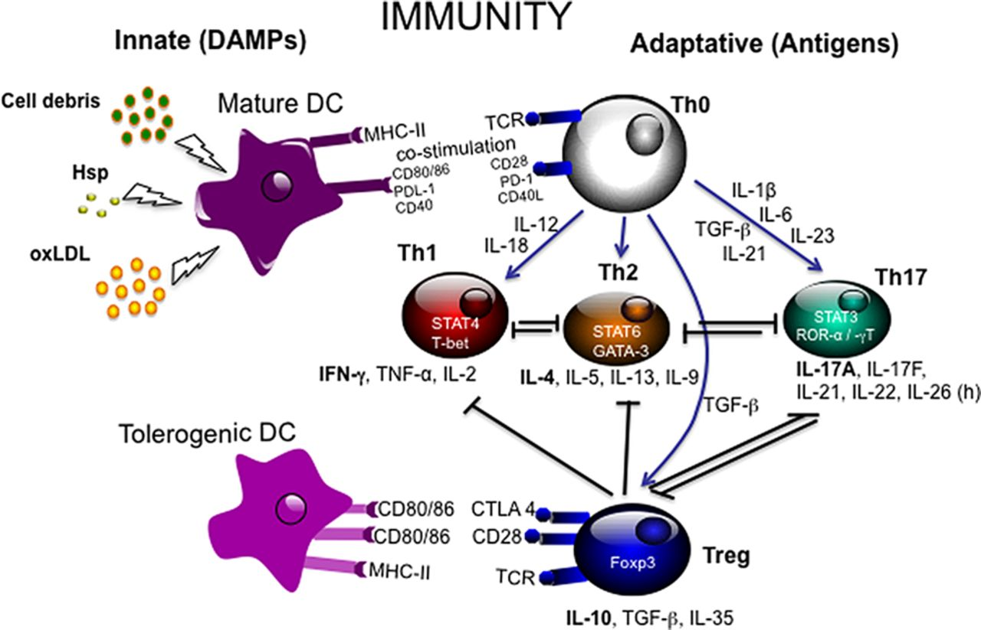
Figure 1
The proliferation of T_{h}0 cells into T_{h}1, T_{h}2, T_{h}17 and indirectly TRegs is dependent on antigen presenting mature dendritic cells. The cytokine environment decides the type of cell proliferation. IL-12 stimulates T_{h}1 cells, IL-4 stimulates T_{h}2 cells, and IL-6 and TNF-β stimulates T_{h}17 cells. TNF-β also functions to promote TReg proliferation, acting as a regulatory mechanism (Ait-Oufella et al., 2014) (Permission obtained)

Immune System Crosstalk and Stress
While the immune system is extraordinarily complex, one of the main tenets of its regulation is homeostasis. T_{h}1 and T_{h}2 responses must be balanced, effector T cells and TRegs must find equilibrium, and the innate immune and adaptive immune systems must communicate to maintain stability. This considered, the immune system also shares bi-directional cross talk with numerous biological systems (Pilon et al., 2013; Demas et al., 2011). Such communication is crucial to daily functioning and healthy immune responses. However, this link also allows any aberrant or abnormal activity within other biological systems to significantly affect immune function. One system that can significantly influence the immune system is the stress response and processing system (Chovatiya and Medzhitov, 2014).
The hypothalamic-pituitary-adrenal (HPA) axis orchestrates the body's physiological responses to acute stressors. In the context of the stress response system, the primary product of the hypothalamus is corticotrophin releasing hormone (CRH). CRH acts on the pituitary gland to stimulate the release of adrenocorticotrophic hormone (ACTH) that acts on the adrenal gland to produce the glucocorticoid, cortisol (O'Keane et al., 2012). Cortisol serves two primary functions; to stimulate gluconeogenesis for stress response and recovery, and to act as an anti-inflammatory immune regulator (Marques et al., 2010). Glucocorticoid receptors (GR) are integral to HPA axis and cortisol homeostasis (Bellavance and Rivest, 2013). Once cortisol is released and binds to a GR, negative feedback signaling communicates with the paraventricular nucleus and the anterior pituitary gland, to inhibit the release of CRH and ACTH, effectively attenuating cortisol secretion. Coinciding with this is immune regulation. The binding of cortisol to GRs activates the transcription of anti-inflammatory cytokines (IL-10, IL-12) and suppresses the transcription of pro-inflammatory cytokines (IL-2, IL-3, IL-4, IL-5, IL-6, IL-13, IL-15, TNF-α) in both the brain and body (Barnes, 2011; Silverman and Sternberg, 2012).
The HPA axis is complex system; both structurally and functionally, and there are many levels on which it may be interrupted. Functionally, there is significant inter-individual variation in the level of stress required to elicit a response. Indeed, the impact of a stressor is dependent on an individual's psychological perception of that stressor (Juster et al., 2010). When an individual has an appropriate stress threshold, and can adapt and cope with stressors, they are in a state called allostasis. However, a reduction in an individual's stress threshold or the chronic accumulation of acute stressors and chronic activation can have deleterious effects on the HPA axis, leaving the body in a state called allostatic load. Allostatic load can affect the two functions of cortisol, stress response and regulation of inflammation, (McEwen, 2003). Of particular relevance to this thesis, the inflammatory effects of allostatic load are further exaggerated when an individual has or exercises poor coping techniques, including cigarette or substance use, poor dietary choices, or poor sleep hygiene (Christian, 2012).
A recent animal model confirmed the link between high stress and aberrant inflammation by identifying different cytokine profiles among mice exposed to high and low levels of chronic stress. Using the chronic social defeat stress paradigm, mice that encountered frequent chronic stress had elevated levels of IL-7 and vascular endothelial growth factor (VEG-F). In contrast, mice that encountered no stress demonstrated increased levels of the anti-inflammatory cytokine IL-10, suggesting that chronic stress exposure significantly interferes with cytokine balance.
Structurally, inflammatory dysfunction may also influence the HPA axis and response to stress. The hippocampus has a strong afferent connection with the hypothalamus, thus the activation of the HPA axis is also regulated by hippocampal function. Veenema et al. (2004) demonstrated that mice genetically selected to have increased sensitivity behavioural models of stress had significantly decreased hippocampal serotinergic (5-HT_{1a)} receptor density. This suggests that serotinergic expression within the hippocampus may influence stress responsivity. Similar hippocampal serotinergic receptor profiles are observed in TReg deficient mice, which also demonstrated depressed and anxious behaviours in the forced swim test and the elevated plus maze test respectively (Kim et al., 2012). Together, these studies infer that depleted TRegs can affect hippocampal feedback to the HPA axis, directly influencing stress processing and behavior.
On a molecular level, chronic stress can result in excess inflammation through GRs. Sensitization of GRs is common with chronic cortisol secretion and can lead to glucocorticoid resistance (Pariante and Lightman, 2008). Schmid and colleagues (2010) induced glucocorticoid resistance in mice using the chronic subordinate colony (CSC) housing paradigm, which is a validated animal model for psychosocial stress. After CSC, increases of TNF-α, and IL-6 were reported, along with decreased TReg populations.
However, the link between stress and inflammation is likely bidirectional. In a murine study immuno-compromised, TReg depleted (anti-CD25 treated) mice exposed to chronic immobilization stress, stress levels positively correlated with and increased production of TNF-α, IL-2, IL-4, IFN-γ, and IL-17. These mice also demonstrated anxious and stressed behaviour, as measured by the forced swim test and the elevated-plus maze test (Kim et al., 2012).
The relationship between the inflammation and stress has been consistently noted in human disease. Chronic stress-related disorders, such major depression have been associated with decreased TReg levels and increased pro-inflammatory cytokines (Li et al., 2010; Dowlati et al., 2010). Individuals with inflammatory disorders, including chronic obstructive pulmonary disease manifest a reduced efficiency in HPA axis activity (Barnes, 2009; Miller et al., 2009; Carvalho et al., 2014). The significant overlap between stress and inflammation therefore must be considered when examining periods of specific immune alteration.
Choosing an Appropriate Marker of Immune Function
Pro-inflammatory cytokines and TRegs are two features of the adaptive immune system that have close links. However, in the context of acute infection, peripheral cytokine levels will deviate and fluctuate with the course of the infection, while TRegs will not be as transient, and their levels remain relatively stable (Pillai and Karandikar, 2007). However, chronic inflammatory disorders, such as hepatitis C or human immunodeficiency virus, may have accompanying decreases in numbers or function of TRegs (Buckner, 2010). The distinction between chronic and acute infection and their impact on immune markers is crucial, as TRegs may reflect an individual's trait or robust immunological profile, while cytokines may be more of a state marker (Rubtsov et al., 2010; Miller et al., 2011).
Aside from the transient nature of cytokines, consistent accuracy in their measurement has been difficult to achieve. Human serum cytokines are typically measured using enzyme-linked immunosorbent assays (ELISA) or multiplex arrays. However, significant intra and inter-kit variability in absolute cytokine values have been reported in the literature using these methods (Breen et al., 2011; Moncunill et al., 2013). Therefore, studies employing serum cytokines alone as markers of inflammation may not be valid or generalizable, due low reliability and reproducibility of quantification methods.
TRegs are typically identified using flow cytometry. Flow cytometry identifies and sorts cells based on the level of fluorescence emitted by the sample. In preparation for flow cytometry, a sample is stained with specific antibodies that will mark receptors or proteins of interest on the cell surface to fluoresce. Early studies in mice suggested that the transcription factor FOXP3 was exclusive to TRegs, and for many years its presence was used to identify TRegs in humans (Chen and Oppenheim, 2011). However, it is now acknowledged that some human effector T cells also express FOXP3 (Gavin et al, 2006). Thus, a new gold standard for the identification of TRegs needed to be established. The presence of FOXP3 in combination with high CD25 fluorescence and low CD127 fluorescence is now used to differentiate TRegs from FOXP3+ effector T cells (Grant et al., 2014). There is now a consensus that the use of these gating strategies accurately identifies TRegs with high intra-assay precision (Demaret et al., 2013). As TRegs are a relatively new and rapidly expanding field of study, most research employs this gold standard, or reports multiple TReg levels based on different identification criteria (ie. FOXP3+, CD25+ FOXP3+, CD127- FOXP3+, etc). This helps to ensure that results are generalizable and are comparable across studies.

The Function of Regulatory T Cells in Pregnancy
TRegs are particularly valuable for studying immune dysfunction during pregnancy based on their stability and function during early pregnancy (Ruocco et al., 2014). The physiological function of TRegs in pregnancy begins prior to implantation. Correlated with estradiol rises, peripheral TReg numbers increase prior to ovulation. It is theorized that the TRegs act to prepare a non-hostile environment in the anticipation of foreign paternal seminal fluid (Arruvito et al., 2007; Robertson et al., 2009). If implantation is successful, the body responds to the embryo as an antigen, and a second wave of TReg recruitment is required. Migrating towards the fetal-maternal interface, TRegs accumulate in decidual tissue and act to suppress an inflammatory rejection of the implantation (Munoz-Suana et al., 2011; Kahn and Baltimore, 2010). It is hypothesized that TReg migration is induced by the participation of multiple proteins and receptors. Mice with genetically reduced expression of the CCR7 homing receptor demonstrate reduced TReg migration to the site of implantation, and an increased rate of implantation failure (Teles et al., 2013). A separate study demonstrated that human trophoblast cells producing human chorionic gonadotropin (hCG) hormone actively facilitate migration of human TRegs along a hormonal gradient (Schumacher et al., 2013).
In the current research literature, there is unanimous agreement that TReg migration occurs shortly after implantation (Tilburgs et al., 2008; Schumacher et al., 2009; Teles et al., 2013). However, the origin of these migrating TRegs is unclear. Some studies suggest that TRegs arriving at the fetal-maternal interface travel directly from the thymus, while others suggest that TReg migration is facilitated by the depletion of peripheral maternal TRegs (Jin et al., 2009; Tillburgs et al., 2008; Steinborn et al., 2008) If this is indeed true, and the maternal periphery becomes TReg deficient as a result, women may become more vulnerable to infection and dysregulated inflammation.
Past implantation, the trajectory of TRegs is less well studied. Both human and murine models provide a consensus that decidual TRegs consistently expand in number throughout pregnancy (Dimova et al., 2011; Zenclussen et al., 2010). However, the direction of the peripheral TReg fluctuation is disputed, enhancing the debate on the origin of migrating TRegs. Several studies suggest that TRegs in the maternal periphery expand in the first trimester, and either remain stable or continue to increase during the second and third trimesters (Heikkinen et al., 2004; Sasaki et al., 2007; Steinborn et al., 2012). However, a study by Mjosberg et al. (2009) suggested that TRegs levels in the maternal periphery are reduced in the second trimester. Given these results, some authors have stated that the reason their more recent findings contradict previous is because of past studies’ improper phenotyping of TRegs, and that a re-evaluation of these studies is required. Subsequent work has suggested similar results, demonstrating that peripheral TRegs levels are reduced in the third trimester, relative to the postpartum (Wegienka et al., 2011; Ernerudh et al., 2011). The latter work supports the theory that upon implantation, TRegs migrate from the maternal periphery
The Function of Regulatory T Cells in Obstetric Complication
The significant role of TRegs in the maintenance and success of pregnancy suggests that their dysregulation may be involved in the pathogenesis of obstetric complications. Indeed, the role of TRegs has been well defined in implantation-related adversities, the most notable of which is spontaneous abortion. In mice prone to spontaneous abortion, Yin et al. (2012) noted that in-vivo expansion of TRegs significantly reduced the rate of fetal resorption mediated pregnancy loss. The function of these administered TRegs was validated by elevations noted in IL-10 and TNF-β. Work examining human pregnancy mirrors these findings as decreased decidual TReg levels have been noted in women prone to unexplained recurring miscarriage (Inada et al., 2013; Mei et al., 2010). Low TReg levels have also been successfully used in the prediction of pregnancy loss in women with a history of spontaneous miscarriage (Winger et al., 2011). This suggests that TReg profiles remain consistent between pregnancies but that they may be involved in pregnancy associated pathology.
The role of TRegs in less direct immune obstetric complications is not well understood, particularly in pathophysiology of pre-eclampsia and perinatal depression. Both disorders can have a detrimental impact on maternal and fetal health, and so understanding their role in the genesis of these disorders is vital.
To date, the role of TRegs has not been examined in perinatal depression. This is despite the fact that major depression has been consistently hypothesized to be an inflammatory disorder (Miller et al., 2009). Recently, an emerging body of work has also highlighted the role of immune related pathology in the development of perinatal depression. However, most of these studies have used cytokines as their marker of peripheral immune functioning (Osborne and Monk, 2013). The role of cytokines in the development of perinatal depression and the questions that this literature leaves unanswered will be addressed in Chapter 2 of the thesis. We propose that TRegs are a more reliable and valid immune marker of perinatal depression because of the crucial role they play in normal pregnancy, their stability, and their interaction with the stress response and processing system. Chapter 2 examines this hypothesis by analyzing the correlation between TRegs and depressive symptoms, at 24-32 gestational weeks, and12 weeks postpartum.
Contrary to the lack of literature examining the role of TRegs in perinatal depression, these immune cells have been more widely studied in pre-eclampsia. Indeed, there are consistent reports of depleted TRegs in women presenting with pre-eclampsia (Toldi et al., 2012; Hsu et al., 2012). However, what is not understood is the mechanism behind these findings, or the role TRegs play in the development of pre-eclampsia. Chapter 3 of this thesis includes a more detailed discussion of current theories relating to the role of TRegs in cardiovascular pathology and in particular, vascular thickness. Additionally, Chapter 3 provides a small analysis of TRegs during the third trimester of pregnancy, in relation to carotid artery thickness.

CHAPTER 2: Perinatal Depression
INTRODUCTION
The perinatal period can be associated with significant changes in mood. On average, 12% of women of childbearing age will suffer from depression. During pregnancy, this number increases to 20% (Lopez-Molina et al., 2014). Characterized by low mood and feelings of guilt, diminished self worth, and sleep disturbance, perinatal depression can be detrimental to both women and their families (Yonkers et al., 2012; Banti et al., 2011). Perinatal depression is not simply a disruption of mental health during pregnancy or the postpartum, but it is associated with an increased risk of other complications of pregnancy, namely impaired fetal growth, preterm birth, and pre-eclampsia (Accortt et al., 2014; Grigoriadis et al., 2013; Kharaghani et al., 2012). Extending past pregnancy, perinatal depression can negatively impact maternal-infant bonding, breastfeeding success and duration, and the offspring's mental and general health across the lifespan (Muzik et al., 2013; Keim et al., 2012; Figueiredo et al., 2013; Murray et al., 2011).
The combination of adverse co-morbidities and the challenges of treating perinatal depression have lead research to focus on identifying risk factors and predictors (e.g., biomarkers) associated with perinatal depression. Traditionally examined risk factors and biomarkers for major depressive disorder (MDD) have been examined within perinatal depression though these have not significantly advanced the prediction, detection, or treatment of this disorder. For example, early research has mapped the monoamine theory of depression onto perinatal depression. Reduced levels of serotonin and dopamine both have shown associations with depressive symptoms during pregnancy and the postpartum period (Field et al., 2006). Success with the use serotonin reuptake inhibitors (SSRIs) to alleviate depressive symptoms during pregnancy has also been reported (Koren and Nordeng, 2012). However, pregnant women often elect to forgo the use of antidepressant medications including SSRIs, and emerging research indicates that their administration during pregnancy may be associated with a small increase in cardiovascular malformations and respiratory distress in offspring (Colvin et al., 2011; Malm et al., 2011; McDonagh et al., 2014).
Though perinatal depression mirrors MDD in some aspects, the unique biological profile of pregnancy must be considered when studying depression in the perinatal period. As previously discussed, pregnancy is immunologically complex. Steroid hormones and immunosuppressive TRegs together compose a delicate environment to support and maintain maternal health and fetal growth (Parker et al., 2011).
Perinatal depression has recently been conceptualized as an inflammatory disorder (Osborne and Monk, 2013). Even though our current knowledge of links between inflammation and perinatal depression is based nearly exclusively on the study of cytokines, the results of this work are ambiguous. Some clinical studies report an inverse correlation between pro-inflammatory cytokines, IL-17 and TNF-α, and depression during the perinatal period (Shelton et al., 2014) while others report that increased levels of IL-6 and TNF-α in the first trimester, are positively correlated with depressive scores during pregnancy, and that CRP levels predict postpartum depression (Haeri et al., 2013; Scrandis et al., 2008). Further, some studies have reported no relationship between pro-inflammatory markers, IL-6 or TNF-α, and depressive scores at any point during pregnancy (Blackmore et al., 2014). Though discouraging, these discrepancies do not discount the role of the immune system in perinatal depression. Instead, they highlight the need for a stable marker of inflammation, and careful consideration of the mechanisms through which inflammation and perinatal depression may be associated.
TRegs are a stable marker of immune function. Their indispensible role in the success of a pregnancy identifies them as a primary candidate in the study perinatal depression. To date, only one study has examined the association between perinatal depression and perinatal TRegs. Krause and colleagues (2014) reported that increased peripheral TRegs in pregnancy and the postpartum were associated with postpartum depression. While these findings could be seen as contradicting theories that posit that perinatal depression is an 'inflammatory' disorder, TReg populations undergo fluctuation primarily during pregnancy and generally return to stable, non-pregnancy levels in the postpartum (Tele et al., 2013). This also leaves open the possibility that TRegs are more closely linked to depression during pregnancy, which this study did not record. Clearly, further research is required to elucidate the role of TRegs in the development of depression during pregnancy.
Given the significant crosstalk present between the immune and stress responses systems, it is possible that the link between perinatal depression and TRegs is influenced or medicated by stress. Early pregnancy and its immune requirements impose significant strain on the HPA axis (Schminkey and Groer, 2014). The migration and subsequent depletion of TRegs from the maternal periphery may be powerfully affected by cortisol secretion, a primary regulator of inflammation. For this reason, early pregnancy has been described as adaptively hypercortisolemic (Michael and Papgeorghiou, 2008). Pregnancy is inherently enriched with acute stressors. The anticipated financial burden of a baby, strained interpersonal relationships, and physiological wear are just a few of the many stressors that an expectant mother endures (Divney et al., 2012; Dunkel Schetter, 2011; Facco et al., 2010). The presence of acute stressors and immune-induced HPA axis hyperactivity could prove detrimental, reducing the body’s immune regulation and stress processing systems. In pregnant mice, HPA axis overactivity has been shown to significantly increase T_{h}1 pro-inflammatory cytokines in the uterus, and is suggestive of a loss of immune regulation and TRegs. The result of this was often fetal loss (Kwak-Kim et al., 2014). HPA axis over activity also accelerates allostatic load. As described by McEwen (2003), sleep disruption, negatively skewed interpretations or attitudes, as well as anxiety are all consequences of stress. Each of these consequences is also a significant risk factor for perinatal depression (Swanson et al., 2011; Mellor et al., 2014; Rifkin-Graboi et al., 2013).
In late pregnancy, murine research suggests that the HPA axis undergoes an immune driven neuronal change that attenuates HPA axis responsiveness. It has been hypothesized that this attenuation is adaptive, functioning to decrease fetal exposure to high levels of glucocorticoids (Brunton and Russell, 2008; Russell and Douglas, 2008). Similar HPA axis attenuations have been reported in human pregnancy and occur around 31 weeks gestation (Entringer et al., 2010). However, if allostatic load during early pregnancy is severe, late pregnancy HPA attenuation may be belated. A recent systematic review reported that psychosocial stress as early as 8-10 weeks gestation predicts depression with an antepartum onset (Lancaster et al., 2010). This suggests that depression may manifest as early pregnancy HPA axis hyperactivity, even prior to clinical presentation.
Stress as a risk factor for depression may be time-specific. A study by Altemus and colleagues (2012) demonstrated that psychosocial stressors were risk factors for the onset of depression during pregnancy, but not in the postpartum period. A previous study similarly found that high levels of stress predicted the antepartum but not postpartum onset of depression (Mora et al, 2009). Together, these studies suggest that antepartum and postpartum depression have different risk factors and developmental origins. Given that pregnancy and not the postpartum period, coincides with extreme TReg shifts, it is possible that TRegs may be associated with antepartum, but not postpartum depression.
To our knowledge, only two studies have explicitly examined the association of stress, immune function and depression in pregnancy. Both reported that women with elevated levels of depressive symptoms also had elevated cytokine levels (IL-6, TNF-α), though no relationship was reported between perceived stress and cytokines. (Christian et al., 2009; Cheng and Pickler, 2014). This lack of association could be true, or it could be attributable to unstable markers of inflammation or error in their measurement.
In light of the paucity of research in this area, a re-evaluation of these studies is merited. We have concretely established that the immune shifts of early pregnancy demand HPA axis overactivity. This, in combination with the abundance of stressors present in pregnancy, increases the risk for the development of antepartum depression. Since stress during pregnancy may also be associated with alterations in immune functioning and in particular inflammation, TRegs may not only be associated with antepartum depressive symptoms but these effects may be mediated by the experience of stress. The current thesis will test these hypotheses, employing TRegs as a marker of immune function (See Figure 2).
In particular, we hypothesize that:
i. CD25+/CD127l-/ FOXP3+ labeled TRegs, in the third trimester of pregnancy, will be inversely related to concurrent antepartum depressive symptoms
ii. The inverse association of CD25+/CD127l-/ FOXP3+ labeled TRegs and depressive symptoms during pregnancy will be mediated by high levels of perceived stress (Figure 2).
iii) CD25+/CD127l-/ FOXP3+ labeled TRegs at 12 weeks postpartum will not be associated with concurrent postpartum depressive symptoms
iv. Peripheral pregnancy and/or postpartum cytokine markers of inflammation
(e.g., TNF-α, IL-6, IL-10 and cRP), will not be associated with depressive
symptoms in pregnancy and/or the postpartum period
In summary, the current study aims to explore TRegs as a suitable biomarker for perinatal depression, and provide additional insights into the pathogenesis of antepartum and postpartum depression.

Pregnancy induced depletion of peripheral CD25+/CD127-/FOXP3+ TRegs
Increased Antepartum Depressive Score

Increased Perceived Stress
A
B
C

Figure 2- Summary of Hypotheses i & ii
A. TRegs migrate to the decidua and are diminished in the maternal periphery, creating a need for HPA axis immune regulation. This, in combination with the abundance of psychosocial and physical stressors natural to pregnancy, reduces stress processing efficiency, resulting in an increased perception and vulnerability to stress. B. Increased maternal stress is a principal risk factor for the occurrence of depression. Reciprocally, the presence of depressive symptoms reduces stress processing efficiency and increases the maternal perception and vulnerability to stressors. C. Reduced TRegs and increased peripheral inflammation likely share direct association. Though not depicted in the current thesis, inflammation may reduce serotinergic activity (see Wright et al.. 2014) (Appendix 1)

METHODS
Participants
Pregnant women between the ages of 18-45 years recruited from the Ultrasound and Diagnostic Imaging Department and the Women’s Health Concerns Clinic at St. Joseph’s Healthcare Hamilton (SJHH) comprised our study sample. To be eligible, they had to be between 24-32 weeks of gestation with a singleton pregnancy.
Women with a current general medical condition(s) that would alter normal levels of inflammation, currently taking psychotropic medications (e.g., antidepressants, antipsychotics, benzodiazepines, mood stabilizers, etc), those currently smoking cigarettes, and women who were unable to understand English and provide consent were not eligible to participate. All subjects gave written and verbal consent to participate in study, as required by the Research Ethics Boards of St. Joseph’s Healthcare Hamilton.
Study Timeline (See Figure 3)
Consented participants were seen for Visit 1 at a gestational age of 24-32 weeks. After verbal and written consent was obtained, participants were taken to the Outpatient Laboratory at SJHH for a fasting blood draw, by a venipuncture nurse or a graduate student trained in phlebotomy. Following this, the clinician-rated MADRS was completed, and participants answered a demographic questionnaire. Pre-pregnancy BMI was assessed, and. participants were sent home with a battery of psychometric measures that included the EPDS and PSS, which they were to complete over the following 24-36 hours.
Approximately 12 weeks after giving birth, participants returned to complete Visit 2 of the study. This visit included an additional blood draw at the SJHH Outpatient Lab, and a repeat of the clinician administered MADRS. Participants also took home a questionnaire package, including the EPDS and PSS. A summary of the visit time line is displayed in Figure 3.

Figure 3 Study Timeline
EPDS: Edinburgh Postpartum/Antenatal Depression Scale; MADRS: Montgomery-Asberg Depression Rating Scale; PSS; Perceived Stress Scale

Regulatory T Cells
In preparation for TReg counts, whole blood was collected via venipuncture at Visit 1 & 2 in heparinized tubes and diluted 1:1 with Delbecco's phosphate buffered saline (PBS) without calcium and magnesium. 20 mLs of blood and 20 mLs of PBS were transferred to a 50 mL sterile conical centrifuge tube. 12 mLs of Ficoll-Hypaque solution was subfused into the blood/PBS mixture and centrifuged at 350 x g for 40 minutes at 20°C.
After initial centrifugation, peripheral blood mononuclear cell (PBMC) plasma layer was collected and transferred into a new tube and washed with Hank's Balanced Salt Solution (HBSS) for 10 minutes at 400 x g at 20°C. The pellet was resuspended in HBSS and the wash was repeated. After the final wash, the PBMCs were re-suspended in 1.5 mL of freezing media (RPMI with 20% fetal calf serum and 10% Dimethyl sulfoxide) and stored at -80°C until assayed.
PBMCs were thawed in a 37°C bath and 200 uL of each sample was placed in a 5mL Polystyrene Round Bottom tube. 1mL of fluorescence activated cell sorter (FACS) Buffer was added to each tube, and tubes were centrifuged at 1500 rpm for 5 minutes at 20°C. 50 uL of diluted antibodies were added to each tube, and tubes were incubated at room temperature for 30 minutes, protected from light. After incubation, 2 mL of diluted BD FACS Lysing Solution was added to each sample, followed by a subsequent incubation for 10 minutes at room temperature, protected from light. Each sample was washed with 2m FACS buffer, followed by centrifugation for 5 minutes at 1500rpm. Supernatant was discarded and pellet was resuspended in 1 mL Fix/Perm Buffer. Samples were incubated for 30 minutes at 4°C, protected from light. Samples were washed twice with 1mL FOXP3 buffer with centrifugation for 5 minutes at 1500 rpm at 20°C in between each wash. Supernatant was discarded, and pellet was resuspended in 50 uL FOXP3 antibody, followed by incubation for 30 minutes at 4°C protected from light. Samples were then washed twice with diluted FOXP3 buffer. After the final wash, supernatant was discarded and pellet was resuspended in 200 uL FACS buffer. Samples were transferred into a 96- well round bottom plate, through a nylon mesh filter paper. Cytometric analysis was performed using the LSR II flow cytometer, with output analysis performed using FlowJo Software (Version 9.7.5). Gating strategies were based on the McMaster Immunology Research Centre protocol (Figure 4). The final TReg number represents the percentage of the parent population (CD4 cells that are CD25hi and CD127lo) which are positive for the FOXP3 transcription factor. The antibodies used for the identification of regulatory T cells were: CD3-Qdot605 from Life Technologies (Burlington, ON); FoxP3-APC and CD127-PerCP Cy5.5 from eBioscience (San Diego, CA); CD4-PacBlue and CD25-PE from BD Biosciences (San Jose, CA)
Inflammatory Markers
Inflammatory markers were also assessed at Visit 1 & 2 in serum. Tumor necrosis factor alpha (TNF-α), interleukin- 6 (IL-6), interleukin- 10 (IL-10) and c-reactive protein (CRP) were quantified from peripheral blood samples by a senior laboratory technician at St. Joseph's Research Laboratory in Hamilton. All samples were assayed in duplicate. TNF-α, IL-6 and IL-10 ELISA assays were performed using kits from R & D Systems (Minnesota, USA) and the CRP ELISA assays were executed using a Ray Biotech kit (Norcross, GA).

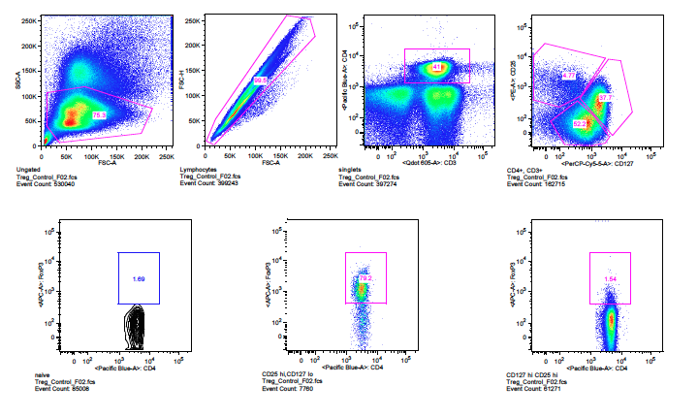
Lymphocytes
Treg Gating Strategy
Singlets
CD3+ CD4+
CD25 hi CD127 lo
Naïve Tcell
Natural Tregs
FoxP3+ CD25 hi CD127 hi

Figure 4 Gating Strategy for TRegs
Regulatory T cells were identified using singlet lymphocytes that were positive for CD3 and CD4, of the high CD25 and low CD127 population, and were positive for transcription factor FOXP3.

Depression
Symptoms of depression were assessed using both the Edinburgh Postpartum/Antenatal Depression Scale (EDPS) and the Montgomery-Asberg Depression Rating Scale (MADRS). The EPDS is a self-report screening tool developed specifically for assessing depression in perinatal women. It shows good specificity and is sensitive to change in depressive symptoms over time (Cox et al., 1987). The EPDS contains validated subscales that are specific to the anxious (questions 4,5,6) and mood features (questions 1,2,7-10) of perinatal depression. Scores on the EPDS can range from 0-30.
The MADRS is a clinician rated scale used to establish the clinical severity of depressive symptoms. The MADRS shows high inter-rater reliability and sensitivity to change in symptoms of depression (Montgomery & Asberg, 1979). Scores on the MADRS can range from 0-60.
Perceived Stress
The Perceived Stress Scale (PSS) is a 14 item self report questionnaire used to identify subjective stress levels over the past month of an individual's life (Cohen et al., 1983). It was administered to measure subjective perception of stress. Scores can range from 0-56.

Statistical Analysis
Clinical outcomes and laboratory assays were analysed using the R statistical analysis program (version 3.0.2 “Frisbee Sailing”, Lucent Technologies). Descriptive statistics, including mean, standard deviation and range were assessed using the "psych" package. Graphical output was generated using the "ggplot2" package. Shapiro-Wilk normality tests were performed for all continuous measures. Data was checked for outliers and inconsistencies and set to boundary limits (outliers) or corrected (inconsistencies). Pearson's R correlations were also employed to validate the stability of TRegs relative to cytokines.
Pearson's R correlation analyses were used to identify any relationship between pregnancy TRegs and pregnancy depression (EPDS and MADRS). Significant correlations elicited the utilization of multiple linear regressions to further assess associations between perinatal TRegs and depressive scores. Gestational age and pre-pregnancy BMI were adjusted for in the linear regression. The assumptions for the linear model were met, as confirmed by the "gvlma" package. Pearson's R correlation tests were performed to identify any association between postpartum TRegs and postpartum depression. Mediation analyses using the "bstats" and "plyr" packages were performed (Baron and Kenny, 1986). We assessed the mediation of effects of perceived stress (PSS) on the association between perinatal TRegs and depression.

RESULTS
Characteristics of the Sample: Demographic Information
Sixteen women provided blood for the measurement of peripheral TRegs during pregnancy, while 19 TReg samples were obtained in the postpartum. The TReg samples obtained in this study were not paired samples, thus no comparison between time points can be made. Of the 16 women who gave a blood sample for TRegs during pregnancy, only 5 also gave a postpartum TReg sample. Women who provided postpartum TRegs were seen during third trimester pregnancy, and their demographic information was collected. Demographics were compared between those with TReg data during pregnancy and the postpartum period and these did not differ significantly (results not shown).
Independent and Dependent Variable Descriptive Statistics
Descriptive statistics for all outcome data are illustrated in Table 2. Shapiro-Wilk normality tests indicated that age (p=0.501) was normally distributed, while gestational age at first visit (p=0.0002) and pre-pregnancy BMI (p=0.002) were not. Each data point of gestational age and pre-pregnancy BMI was transformed by using the BoxTidwell function of the "car" package of R. Repetition of the Shapiro-Wilk normality test on the transformed variables resulted in gestational age (p=0.06) and pre-pregnancy BMI (p=0.713) being normally distributed.

Table 1 Demographic Information (N=16)
Age (mean(sd)) | 31.24 (3.82)
Weeks Gestation (mean(sd)) | 28.16 (2.88)
Average Household Income (%)  - >$9999  - $10, 000-19,999  - $20, 000-29,2999  - $30, 000- 39,999  - $40,000- 49,999  - $50,000- 59,999  - $60,000- 69,999  - $70,000- 79,999  - $80,000- 89,999  - $90,000-99,999  - >$100,000 | 0%  3.1%  0%  6.0%  3.1%  6.0%  9.3%  21.8%  12.5%  18.75%  15.6%
Education Level (%)  - Some high school  - High school completion  - Trade, college or technical school  - Some university  - Bachelor's Degree  - Master's Degree  - Doctoral or Professional Degree | 3.0%  15.1%  39.3%  3.0%`  24.2%  9.0%  6.0%
Utilizing Social Assistance (%) | 21.8%
Percentage of women who have had one or more pregnancies prior to the current | 68.6%

Table 2 Variable Descriptive Statistics
 | Mean (SD) | Range (Min-Max)
Pregnancy % of FOXP3+ CD25+/CD127- TRegs | 61.29 (8.53) | 42.7-73.3
Postpartum % of FOXP3+ CD25+/CD127- TRegs | 75.30 (3.33) | 68.8-83.3
EPDS Pregnancy | 5.38 (3.91) | 0-12
MADRS Pregnancy | 4.32 (4.12) | 0-19
PSS Pregnancy | 18.71 (9.47) | 2-47
EPDS Postpartum | 4.57 (5.75) | 0-23
MADRS Postpartum | 3.38 (6.71) | 0-31
IL-6 Pregnancy | 2.27 (2.76) | 0.14-14.88
IL-10 Pregnancy | 1.27 (0.86) | 0.33-4.71
TNF-α Pregnancy | 12.33 (2.14) | 9.87-22.48
CRP Pregnancy | 6.43(7.92) | 0.78-45.6
IL-6 Postpartum | 2.57(1.29) | 0.46-6.45
IL-10 Postpartum | 1.93 (3.65) | 0.58-18.33
TNF-α Postpartum | 12.53 (1.46) | 10.29-16.09
CRP Postpartum | 5.06 (11.05) | 0.02-56.4

Variable Distributions
Pregnancy EPDS score (p=0.009) and pregnancy MADRS score (p=0.002) were not normally distributed. This was expected however, as the study sample size is small, and the population assessed was comprised of mostly healthy euthymic women. Only 6 cases of mild clinical depression were detected using a cutoff score of 11 on the EPDS. Scoring on the EPDS (Figure 5) and MADRS (Figure 6) scores were skewed toward the low end of the scale, with relatively little variance. Postpartum TRegs (p=0.52) were normally distributed, while postpartum EPDS (p= <0.001; Figure 7) and postpartum MADRS scores (p=<0.001; Figure 10) were not. Similar to the pregnancy depression scoring, this was expected as the majority of the women experienced euthymic mood postpartum, with only 2 cases of mild clinical depression using a cutoff of 11 on the EPDS.

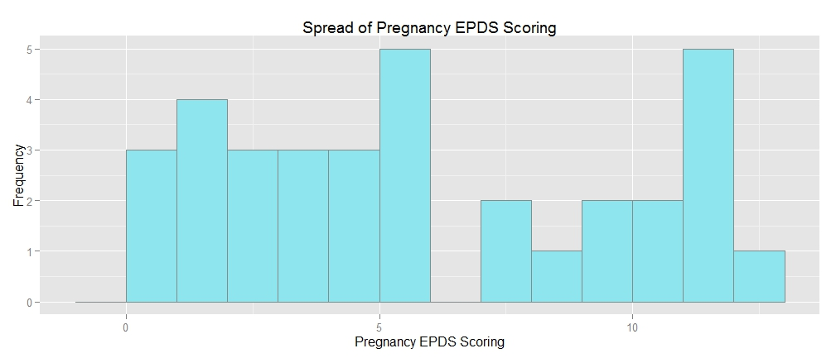

Figure 5
The distribution of EPDS scores in third trimester pregnancy
A Shapiro-Wilk normality test indicated that EPDS scores during pregnancy were not normally distributed. The histogram indicates a bimodal distribution with little variance.

Figure 6
The distribution of MADRS scores in pregnancy
A Shapiro-Wilk normality test indicated that MADRS scores during pregnancy were not normally distributed. The histogram indicates a the distribution is skewed to the left, due to low scores reflective of a healthy population.

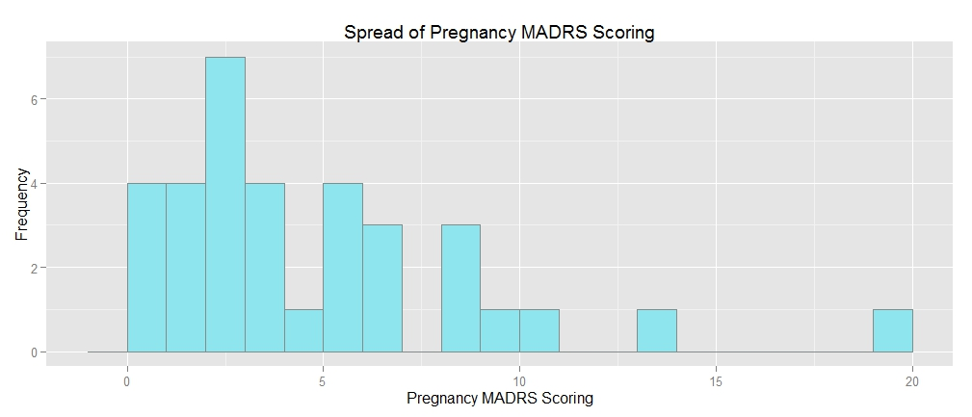

Figure 7
The distribution of EPDS scores in postpartum
A Shapiro-Wilk normality test indicated that EPDS scores at 12 weeks postpartum were not normally distributed. The histogram indicates a the distribution is skewed to the left, due to low scores reflective of a healthy population.

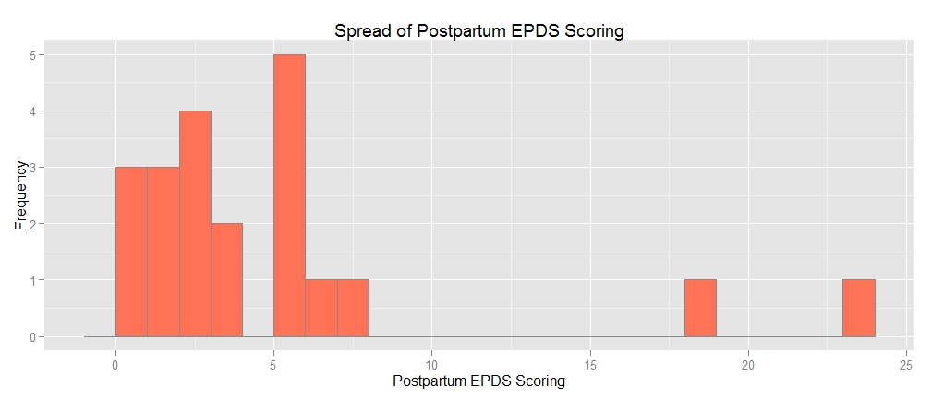
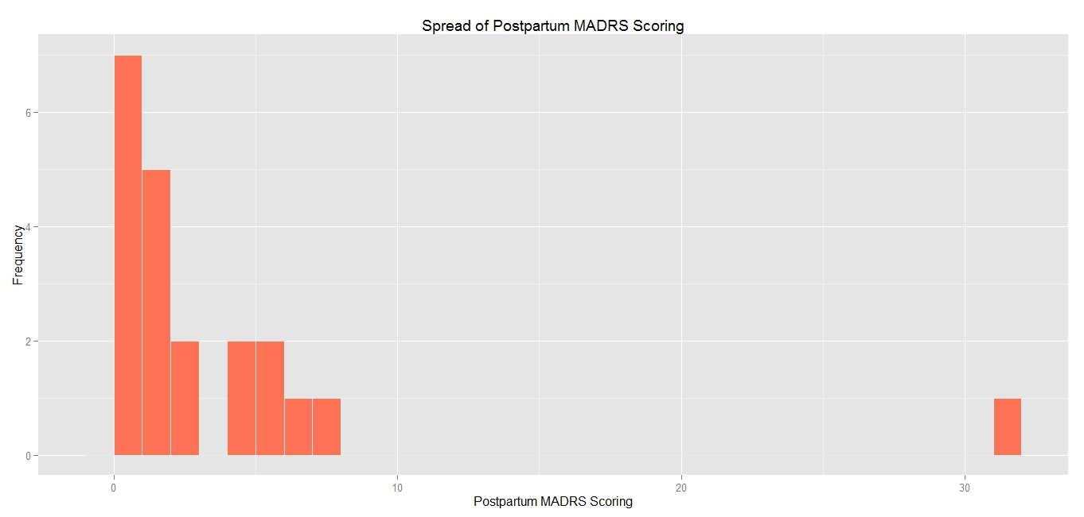

Figure 8
The distribution of MADRS scores in postpartum
A Shapiro-Wilk normality test indicated that MADRS scores at 12 weeks postpartum were not normally distributed. The histogram indicates a the distribution is skewed to the left, due to low scores reflective of a healthy population.

TRegs measured during pregnancy were inversely correlated with antepartum EPDS scores (R= -0.83, p=0.0003), and trended towards an inverse correlation with MADRS scores during pregnancy (R= -0.51, p=0.07), with depressive scoring increasing as TReg levels decreased. Multiple linear regression demonstrated that TRegs during pregnancy significantly predicted the variance of pregnancy EPDS scoring (R²=0.66, β=-0.77, p=0.0003) (Figure 9). A second linear regression indicated that pregnancy TRegs were not associated with pregnancy MADRS scoring (R²=0.03, β=-0.47, p=0.38).
As the EPDS contains a subscale that is sensitive to the anxious symptoms of perinatal depression (general anxiety, panic symptoms, low threshold to stress), and the MADRS does not, a second linear regression was performed to identify if the anxiety subscale of the EPDS was responsible for the observed the relationship between TRegs and the EPDS and the lack of one between TRegs and the MADRS. Pregnancy TRegs are a significant predictor of the anxiety subscale (R²=0.56, β=-0.88, p=0.014) (Figure 10), and less strongly predicted the depression subscale of the EPDS (R²=0.37, β=-0.69, p=0.06) (Figure 11 ).
TRegs collected at 12 weeks postpartum were not found to be correlated with postpartum EPDS (R=-0.09, p=0.69 )(Figure 12) or postpartum MADRS scores (R=-0.16, p=0.49)(Figure 13). To further understand why no association was present between TRegs and EPDS in the postpartum, we examined possible group differences between our postpartum women to identify if there was an unexpected factor that could reduce the strength of these associations. We also identified women who were and women who were not breastfeeding at 12 weeks postpartum. There were no group differences on EPDS (p=0.9)scoring and TRegs (p=0.76) by this grouping.
The relationship between TRegs during pregnancy and pregnancy EPDS scores was partially mediated by perceived stress. As Figure 14 illustrates, the standardized regression coefficient between TRegs and PSS (R²=0.55, p=<0.001)was statistically significant, as was the standardized regression coefficient between pregnancy PSS and pregnancy (R²=0.8, p=<0.001) EPDS. The standardized indirect effect was 0.44.

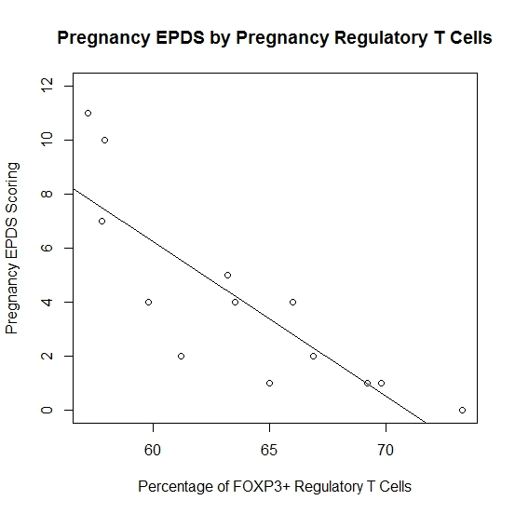
Plots of Pregnancy EPDS Scores and TReg Levels
Figure 9
Regulatory T cells predicting variance of EPDS scores during pregnancy
Linear regression indicated that TRegs during the third were significantly associated with in third trimester EPDS scores (R²=0.66, p=0.0003)

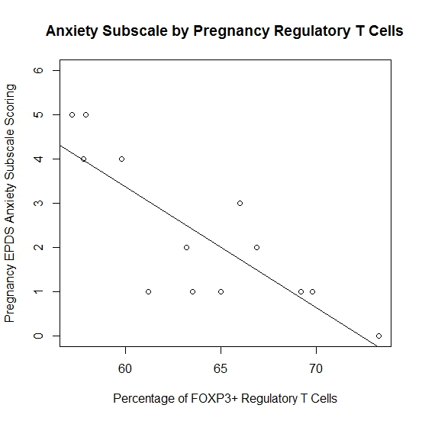
Plot of EPDS Anxiety Sub Scores and TReg Levels
Figure 10
Regulatory T cells predicting variance of EPDS subscales
Linear regression indicated that TRegs during the third trimester were significantly associated with the variance in third trimester anxiety subscale of EPDS scores (R²=0.56, p=0.014)

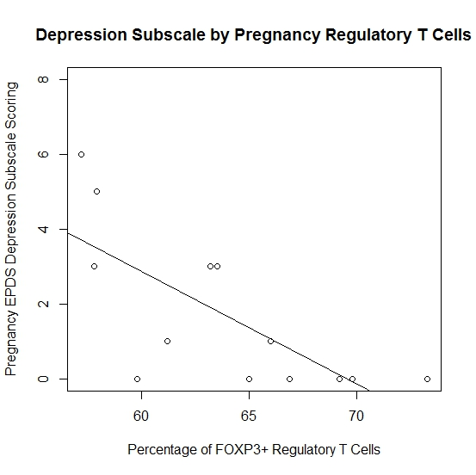
Plot of EPDS Depression Sub Scores and TReg Levels
Figure 11
Regulatory T cells predicting variance of EPDS subscales
Linear regression indicated that TRegs during the third trimester do not significantly predict the variance in third trimester depression subscale of EPDS scores (R²=0.37, p=0.06)

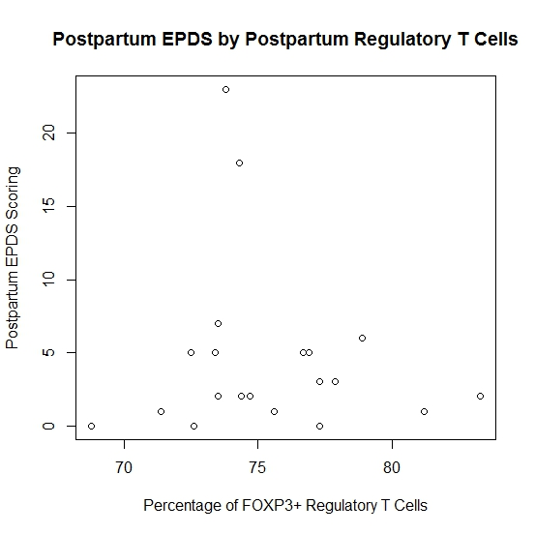
Plot of Postpartum EPDS Scores and TReg Levels
Figure 12
Postpartum Regulatory T cells predicting variance of postpartum EPDS
No association between postpartum TRegs and postpartum EPDS score (R=-0.09, p=0.69 )

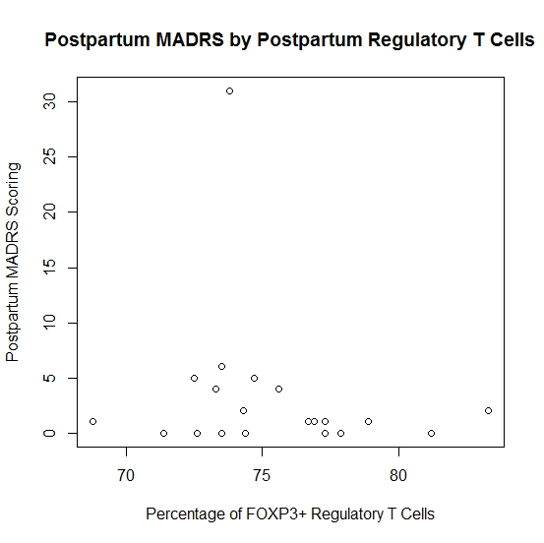
Plot of Postpartum MADRS Scores and TReg Levels
Figure 13
Postpartum Regulatory T cells predicting variance of postpartum MADRS
No association between postpartum TRegs and postpartum MADRS score (R=-0.16, p=0.49 )

R²=0.66, p=<0.001

Peripheral CD25+/CD127-/FOXP3+ TRegs
Antepartum EPDS

Perceived Stress
R²=0.55, p=<0.001

R²=0.8, p=<0.001

Figure 14
The Mediation of TRegs and Depression during Pregnancy by Stress
As predicted in Figure 2, the association between TRegs during pregnancy and antepartum EPDS scores was partially mediated by perceived stress.

Correlations of cytokines and TRegs were also assessed. We found no association with cytokines during pregnancy (n=10; TNF-α R=-0.35 p=0.28; IL-10 R=0.31 p=0.34; IL-6 R=-0.08 p=0.83: CRP R=0.03 p=0.89). Postpartum pro-inflammatory cytokines also did not correlate with postpartum TRegs (n=19; TNF-α R=0.08 p= 0.71; IL-10 R=0.04 p=0.85; IL-6 R=0.22 p=0.32: CRP R=-0.14 p=0.54). Finally, inflammatory cytokines during pregnancy demonstrated no relation to depressive symptoms during pregnancy (n=30; TNF-α R=-0.18 p= 0.33; IL-10 R=0.02 p=0.91; IL-6 R=-0.01 p=0.95: CRP R=-0.02 p=0.90). The lack of association between TRegs and cytokines in our study, in combination with the relationship between depression and TRegs, but not cytokines during pregnancy, supports this claim.
The aim of the first study that comprises this thesis was to investigate the association of perinatal TReg levels and depressive symptoms during this time. We showed that TRegs at 24-32 weeks gestation are significant predictors of EPDS scores and predict with moderate strength, current MADRS scores. The link identified between TRegs and EPDS during pregnancy was partially mediated by perceived maternal stress (PSS). TRegs at 12 weeks postpartum were not related to postpartum maternal mood.

CHAPTER 3: Cardiovascular Health
INTRODUCTION
Pre-eclampsia is a multi organ disease that affects 2-8% of pregnancies (Steegers et al., 2010). Clinically, pre-eclampsia is characterized by a blood pressure above 140 mmHg systolic or 90 mmHg diastolic, with accompanying proteinuria (De Silva et al, 2013). Pre-eclampsia is associated with numerous maternal and fetal morbidities. For example, a recent large scale study linked pre-eclampsia to preterm birth, maternal renal insufficiency, pulmonary edema and hepatic dysfunction. Moreover, the mortality rate in pre-eclamptic women may be as high as 13% (von Dadelszen et al., 2011). The maternal effects of pre-eclampsia can also extend past pregnancy. Women with a pre-eclamptic pregnancy are up to three times more likely to develop cardiovascular disease later in life, an effect that is thought to be mediated by lasting endothelial dysfunction (Powe et al., 2011; Brown et al., 2013). These maternal outcomes alone highlight the need to develop preventive strategies for pre-eclampsia. However, in-utero, pre-eclampsia restricts intrauterine growth and reduces fetal oxygen supply, resulting in fetal hypoxia (Gruslin et al., 2011). Low birth weight is common in women with pre-eclampsia, likely due to the increased prevalence of preterm birth and intrauterine growth restriction.
Due to the poor outcomes associated with pre-eclampsia, numerous attempts have been made to identify risk factors for its development. Pre-existing hypertension, obesity, and smoking, and previous cardiovascular disease have all been identified as risks for pre-eclampsia (Roberts et al., 2011; Wikstrom et al., 2010; Sibai et al., 2011). Despite these findings, the pathophysiology of pre-eclampsia is still not completely understood.
Healthy pregnancy is associated with cardiovascular changes, both locally at the fetal-maternal interface, and in the maternal periphery. The placenta acts as an intersection between the maternal and fetal environments. Throughout pregnancy, the vasculature of the placenta changes with fetal needs. The spiral arteries of the placenta in particular deliver blood from the maternal periphery to the fetus (Nevers et al., 2011). In early pregnancy, spiral arteries are composed of vascular smooth muscle cells, similar to other maternal arteries. From 10 to 20 weeks gestation, the nutritional and oxygen demands of the growing fetus increases, requiring an increased blood flow from the maternal system. To facilitate this, extravillous trophoblast cells slowly migrate from the fetus, to invade the spiral arteries. Trophoblast invasion induces significant remodeling of the spiral arteries, eliminating the smooth muscle cell component and reducing elastin levels in the arterial wall (Harris, 2011). Spiral artery remodeling should be complete by week 20 of gestation, and the result is an artery conducive to high flow and low resistance (Salomon et al., 2014). Incomplete trophoblast invasion results in endothelial damage, accompanied by inflammatory action and the secretion of the angiogenic vascular endothelial growth factor (VEG-F).
It has been hypothesized that pre-eclampsia develops long before its clinical presentation, and incomplete trophoblast invasion and impaired arterial dilation is a candidate mechanism for its early development (Gebb et al., 2011; Lyall et al., 2013). Also consistently reported in pre-eclamptic women, is an unexplained reduction of TRegs (Toldi et al., 2012; Hsu et al., 2012). The role of TRegs in trophoblast invasion should therefore be explored.
An eloquent in vitro study by Du et al. (2014) demonstrated that the treatment of decidual dendritic cells with trophoblast supernatant stimulated TNF-β and TReg proliferation, resulting in IL-10 production. Further, this study identified a reciprocal relationship between TRegs and trophoblasts. TRegs significantly increased the invasive success of trophoblast cells, mediated through IL-10. This study provides evidence that TRegs may significantly promote the success of trophoblast invasion of the spiral arteries, and that this success may also contribute to the immune suppression necessary to pregnancy.
Decreased decidual TRegs can lead to aberrant T_{h}1 responses, of which TNF-α is a product. TNF-α actively promotes the adhesion of lipoproteins to vascular walls, resulting in arterial thickening and increased blood pressure (Zhang et al., 2014). This is demonstrated in pregnant rats, where excessive TNF-α treatment resulted in increased arterial pressure and thickness, and renal alterations producing proteinuria (Cotechini et al., 2014), mimicking the clinical presentation of pre-eclampsia.
TReg depletion may contribute to pre-eclampsia in two ways. First, reduced TRegs may hinder the success of trophoblast invasion, which will cyclically diminish TReg expression. Second, depleted TRegs may contribute to adverse vascular changes, by the inadequate suppression of TNF-α .
Though the literature on pre-eclampsia focuses on arterial changes at the decidual level, the increased risk a pre-eclamptic woman has for later cardiovascular disease suggests that vascular changes may also occur in the periphery. Evidence of peripheral vascular modeling in pre-eclampsia was summarized in a recent meta-analysis by Hausvater et al. (2012) who reported that compared to normotensive pregnancies, women who experienced a pre-eclamptic pregnancy had significantly increased arterial stiffness, indicative of poor vascular dilation. Similar results have been found with arterial thickness. Indeed, women with pre-eclampsia have increased (>0.01mm) carotid intima-media thickness measurements (CIMT) relative to normotensive pregnant women (Stergiotou et al., 2013).
The vascular changes of pregnancy should be considered on a continuum, of which pre-eclampsia is an extreme. The proposed role of TRegs in the pathophysiology of pre-eclampsia suggests that TRegs may be involved in these alterations. Given this, moderate decreases in TRegs may predict vascular changes that lead to subclinical but elevated cardiovascular risk.
In particular, we hypothesize that:
i. . CD25+/CD127l-/ FOXP3+ labeled TRegs, at 24-32 weeks gestation will correlate negatively with maternal carotid intima media thickness (Figure 15)
ii. Peripheral pregnancy cytokine markers of inflammation (e.g., TNF-α, IL-6, IL-10 and cRP), will not be correlated with maternal carotid intima media thickness
The aim of this second study of the thesis is to determine if TReg are associated with vascular changes during pregnancy, and to potentially shed light on their pathogenic role in pre-eclampsia.

Depletion of peripheral CD25+/CD127-/FOXP3+ TRegs
Incomplete remodeling of spiral arteries/endothelial damage
Endothelial changes in maternal carotid vasculature
A
B
C

Figure 15- Summary of Hypotheses
TRegs are depleted from the maternal periphery and migrate to the deciduas in pregnancy.e A. Depleted TRegs peripherally allow for excessive and unregulated T_{h}1 cytokine profiles, particularly TNF-α, which increases adhesion of lipoproteins and monocytes to endothelial walls. B. Depleted TRegs at the decidua may hinder the success of trophoblast invasion. This results in endothelial inflammation of the spiral arteries, and aberrant VEG-F secretion. C. Inflammation and VEG-F at the decidua enter maternal circulation, extending their pro-coagulant effects to the peripheral vasculature. The current study will only measure the direct association between TRegs and peripheral vasculature (i.e., link A.)

METHODS
Participants
The participants for the current study were assessed utilized the same inclusion and exclusion criteria as in Chapter 2.
Visit Timeline
Sixteen consented participants were seen for visit 1 at a gestational age of 24-32 weeks. After verbal and written consent was obtained, participants were taken to the Outpatient Laboratory at SJHH for a fasting blood draw, by a venipuncture nurse or a graduate student trained in phlebotomy. After completion of the blood draw, demographic information was collected, and a requisition for a CIMT ultrasound was made to the Ultrasound and Diagnostic Imaging Department at SJHH. Two to four weeks after the first visit, participants completed the CIMT ultrasound. A video recording of the CIMT ultrasound was sent to the Barbra Streisand Women's Heart Center (Los Angeles, CA) for interpretation and measurement.
Regulatory T Cells
TReg cells were sorted and identified using the methods described in Chapter 2.
Inflammatory Markers
Additional inflammatory markers (e.g., IL-6, TNF-α, IL-10, and cRP) were also measured and identified by the methods presented in Chapter 2.

Carotid-Intima Media Thickness
CIMT was measured by ultrasound and is a non invasive test to detect accelerated atherosclerosis as well as subclinical cardiovascular disease (Simon et al., 2010; Yang & Nambi, 2011). CIMT measures the summative dimensions of the intima and the media layers (mm) of the carotid arterial wall. Epidemiological studies have found that CIMT thickness correlates with CVD risk in women, as well as the progression of atherosclerosis, and future CVD events (Bennett et al., 2013). CIMT was measured using B-mode ultrasound scans and CIMT was estimated as an average over 1 cm segments (25 mm proximal to the bulb) of the posterior (far) wall of the left and right common carotid arteries. The Prosound software developed by Robert Selzer (Jet Propulsion Laboratory, Pasadena) was used to measure CIMT with an automated edge-tracking algorithm (Dwyer et al., 1998). An example of a CIMT measurement still can be found in Figure 6).
Statistical Analysis

Summaries of population characteristics, variable normality, and the checking of data outliers were performed identically to those highlighted in Chapter 2. Pearson's R correlation tests were performed to identify associations between pregnancy TRegs and carotid intima media thickness. Correlation analyses were also employed to identify the associations with inflammatory markers (e.g., IL-6, IL-10, TNF-α, and CRP). Quartiles were calculated using the "pylr" package in R, to create participant groupings. A one way analysis of variance (ANOVA) was employed to assess if there were differences in CIMT by TReg quartiles.
RESULTS
The demographic characteristics of the sample are presented in Table 1. Variable descriptive statistics can be found in Table 3.
There was a positive correlation between left and right CIMT (R=0.50, p=0.005). Although the correlation coefficient at first glance is weaker than expected, studies show that thickening of the right carotid can begin up to 10 years later than the initiation of left carotid thickening (Luo et al., 2011).
No significant correlations were found between pregnancy measures of TRegs and left (R=0.42, p=0.275) or right (R=0.19, p=0.61) CIMT measurements. Our cytokine markers of inflammation were also not associated with left (IL-6: R=0.97, p=0.079; IL-10: R=-0.10, p=0.63; TNF-α: R=-0.12, p=0.55, CRP:-0.13, p=0.52) or right CIMT (IL-6: R=0.25, p=0.23; IL-10: R=-0.20, p=0.34; TNF-α: R=0.08, p=0.70, CRP:-0.32, p=0.12)
The lack of association between TRegs and CIMT on a continuous level merited the analysis of TRegs and CIMT by group. Participants were divided into quartiles according to their TReg values (first =57.87%, second= 63.55%, third = 66.22%, fourth=73.3% FOXP3+ cells), to identify if there were differences in CIMT values by group (Figures 16 and 17). A one way ANOVA identified that there were no differences in left CIMT measurements by quartile (p=0.653) or in right CIMT (p=0.833).

Table 3 Variable Descriptive Statistics
 | Mean (SD) | Range (min-max)
Pregnancy % of FOXP3+ CD25+/CD127- TRegs | 61.29 (8.53) | 42.7-73.3
CIMT Right (mm) | 0.62 (0.07) | 0.48-0.75
CIMT Left (mm) | 0.61 (0.05) | 0.49-0.71
IL-6 Pregnancy | 2.27 (2.76) | 0.14-14.88
IL-10 Pregnancy | 1.27 (0.86) | 0.33-4.71
TNF-α Pregnancy | 12.33 (2.14) | 9.87-22.48
CRP Pregnancy | 6.43(7.92) | 0.78-45.6

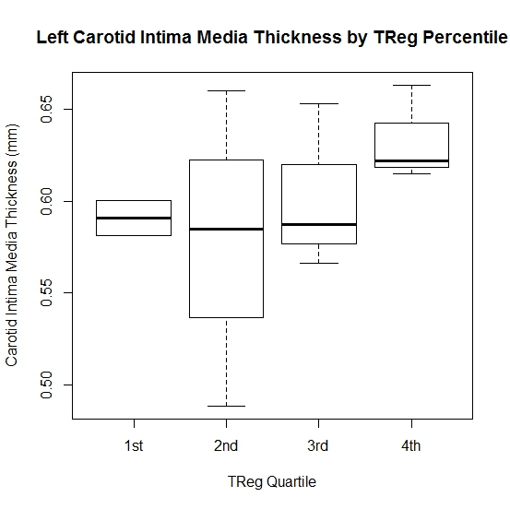
Plot of Left CIMT and TReg Quartile in Pregnancy
Figure 16
Left CIMT by TReg Percentile
A one way ANOVA indicated no significant differences between TReg quartiles in left carotid intima media thickness (p=0.653)

Plot of Right CIMT and TReg Quartile in Pregnancy
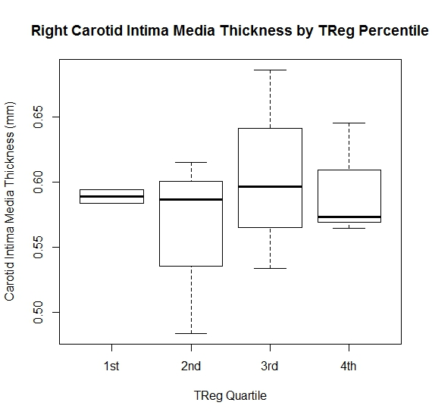
Figure 17
Right CIMT by TReg Percentile
A one way ANOVA indicated no significant differences between TReg quartiles in right carotid intima media thickness (p=0.833)

The aim of this second study of the thesis was to assess associations between TRegs and CIMT in the third trimester of pregnancy. No significant correlations were found between these variables.

CHAPTER 4: Discussion
The aim of the current thesis was to investigate the association between maternal TReg levels during pregnancy and the postpartum period with perinatal depression and cardiovascular risk. In this work, we demonstrated that TRegs measured in the late second/early third trimester were associated with elevated EPDS scores during pregnancy, but did not find significant correlations between postpartum TRegs and postpartum depression. We found no association between TRegs in late second/early third trimester pregnancy and CIMT. These results will be further discussed below.
Though both the EPDS and the MADRS were used to assess depression, the EPDS was the more strongly associated with TRegs during pregnancy. The discrepancy in strength of the association of these scales, both of which measure depression with TRegs may be due to the way they are administered. The EPDS is aself-report scale that subjectively assesses an individual's mood symptoms over the past two weeks. As with all self report measures, it is possible that participant responses may have been adversely affected by transient events, such as poor sleep the previous night, life stress, and personality traits (Cuijpers et al., 2010). The MADRS may be less affected by these factors, as proper clinical interviewing should elucidate depressive symptoms to from such events. However, the EPDS is the gold standard for depression assessment in the perinatal period, as it eliminates the overlap of somatic symptoms that are explained by pregnancy but also common to depression (Hewitt et al., 2010).
Though frequently used in perinatal research, the MADRS has not been validated in pregnancy and there have been numerous reports of false positives with the use of the MADRS during this period (Stewart et al., 2003). In particular, the MADRS contains several items that are sensitive to somatic features of general depression, including a reduction in appetite or changes in sleeping patterns. However, a reduction of appetite and decreased sleep quality and duration can be typical of a healthy pregnancy. As such, an individual answering the MADRS may be reporting these symptoms as a natural result of their pregnancy, but the MADRS score will suggest that the individual is depressed, resulting in false positives.
Though the EPDS and MADRS in pregnancy were moderately correlated with each other, the strength of the correlation was less than expected. There are primary differences between the scales that may explain this. For example, the EPDS contains subscales that are sensitive to both depression and anxiety. It is important to note that the MADRS is not sensitive to symptoms of anxiety either independently, or as a result of depression. When the EPDS anxiety subscale and depressive subscale were independently assessed in relation to TRegs, it was identified that the anxiety symptoms were more strongly associated with TRegs than depressive symptoms, and were a significant contributor to the stronger association seen between the total EPDS score and TRegs. This suggests that anxiety symptoms during pregnancy may actually be more closely related to immune function, and explains why the MADRS did not demonstrate as strong an association with TRegs.
As expected, the association between TRegs and mood did not extend into the postpartum period. The majority of TReg fluctuation in the perinatal period occurs during pregnancy, and stabilizes after delivery (Tele et al., 2013). It is therefore possible that TRegs directly impact depressive symptoms during pregnancy only, as their fluctuation burdens the HPA axis and increases the susceptibility to allostatic load. In the postpartum, TRegs return to non-pregnant levels and resume their immunosuppressive function, reducing HPA axis burden. Krause et al. (2014) did report on whether or not pregnancy TRegs predicted postpartum depression. It is difficult to compare our current findings to this study. In the current study, we assessed TRegs with current mood, and not a temporal prediction (pregnancy to the postpartum).
However, if we had assessed this, we predict our findings would contradict those of the study of Krause and colleagues. Our results indicate that lower pregnancy TRegs are associated with increased depressive scores in pregnancy. Given that depression during pregnancy is an important risk factor for postpartum depression, it is likely that TReg depletion, not elevation in pregnancy would predict a postpartum episode (Faisal-Cury and Menezes, 2012). Unfortunately, Krause et al. did not clearly report depressive symptoms at the time of their pregnancy TReg assessment. Discrepancies between the current thesis and the work of Krause and colleagues (2014) could further be explained by differences in the two samples. The study by Krause et al. measured TRegs at 34 weeks gestation, 3 days postpartum, 7 weeks postpartum, and 24 weeks postpartum. It is likely that by 34 weeks gestation, maternal circulating TRegs are beginning to increase to levels seen outside of pregnancy. The current thesis, in contrast, studied women that were the mean gestational age of 28 weeks, which may be a more representative depiction of ‘pregnancy’ levels of TRegs.
Additionally, the Krause study assessed postpartum depression at multiple time points. However, analysis was conducted by grouping women as depressed or not depressed. It was unclear whether this grouping was based on depression at 3 days postpartum, 7 weeks postpartum or 24 weeks postpartum. The point in time which women were grouped based on depressive symptoms is significant to the study results. Depressive symptoms immediately following delivery (eg. 3 days postpartum) are common and hormonally influenced, also known as postpartum blues. However, depressive symptoms at 7 or 24 weeks postpartum are likely indicative of postpartum depression (O’Hara and Wisner, 2014). If the results of the study were based on women who had mood disruption at 3 days postpartum, this may not accurately represent a 'depressed' population, and may skew the results.
As predicted, the association between TRegs and EPDS during pregnancy was partially mediated by perceived stress. Given the impact of the immunological demands of pregnancy on the HPA axis, this is plausible. To our knowledge, this is the first study to assess depression during pregnancy in relation to stress and TRegs. The sparse literature that has assessed antepartum depression, stress, and cytokines suggest that cytokines are not associated with stress, but these results may not be accurate, due to the transient nature of cytokines. The current study demonstrated that TRegs do not correlate with peripheral cytokines (IL-6, IL-10, TNF-α, CRP). Further, we found that TRegs, but not cytokines, were associated with antepartum depression. It is possible that the former studies found no link between cytokines, stress and depression during pregnancy, because inappropriate immune parameters were measured.
Given the background literature, the mediation of TRegs and depression by stress is logical. The HPA axis functions both as an immunosupressor and participates in mood regulation (Marques et al., 2010; Lamers et al., 2013). Future research should further examine the mediatory effect of stress on TRegs and mood during pregnancy by examining biological correlates of stress, such as cortisol. The aim of this addition would be to identify if the HPA axis activity is elevated with TReg depletion and depression, evidenced by a hypercortisolemic state.
An understanding of the relationship between TRegs, stress and depression during pregnancy is crucial. However, employment of proper stress coping strategies in early pregnancy could significantly reduce contribution of low TRegs to the development of depression. Proper stress coping is a regular component of clinical psychoeducation, and this holistic approach to the prevention of antepartum depression would likely be embraced by expectant mothers (Goodman, 2009).
Regarding cardiovascular health, we found no association between TRegs in late second/early third trimester pregnancy and CIMT. However, the mean age of the women in our study was 31.24 years and atherosclerosis (and consequent thickening of the carotid artery) is a slow and gradual event, averaging at about 7µm/year for young women (Skilton et al., 2010). While CIMT may be a valid marker of cardiovascular disease, in young populations it may be a poor early risk marker. It is likely that our study population was too young for CIMT to provide any substantial cardiovascular risk prediction. There are currently no reference guidelines for CIMT measurements that are stratified by age and sex. However, given the low magnitude of variance we observed for right and left CIMT measurements within our population, we can assume that our pregnant women had good cardiovascular health.
To accurately identify if perinatal TRegs are indeed predictive of atherosclerosis and CIMT increases, further, longitudinal studies with larger samples is required. For example, a longitudinal follow up after pregnancy with progressive CIMT imaging every 2-5 years would be appropriate. Alternatively, an emerging body of research suggests that high resolution ultrasound can image individual layers of the carotid artery. Moreover, it has been suggested that the intima:media ratio is an accurate marker of subclinical atherosclerosis and cardiovascular risk, but total CIMT is not (Akhter et al., 2013). Similar findings have been identified in a depressed population, with the intima:media ration predicting MDD, but not the total CIMT (Bohman et al., 2010). The use of a more sensitive higher frequency ultrasound and the generation of an intima:media ratio for the current study population could have a significant association with TRegs, and should be explored further.
Though this thesis examined perinatal depression and CIMT independently in association with TRegs during pregnancy, the two outcomes may overlap. Arterial thickening and depression are both considered to be inflammatory disorders. Further, women who endure a pre-eclamptic pregnancy not only have an elevated risk for cardiovascular disease in later life, but they are more susceptible to and more often suffer from depression (Delahaije et al., 2013; Powe et al., 2011). Reciprocally, it has been reported that women with pre-existing depressive symptoms are at an increased risk for pre-eclampsia (Thombre et al., 2015). We suggest that TRegs may partially explain the co-morbid occurrence of depression and cardiovascular issues during pregnancy, and further investigation of this with high resolution ultrasound is warranted.
Limitations and Future Directions

The main limitation of the current work is its small sample size. The low variability in depressive scores may also reduce the likelihood of finding significant associations with TRegs during pregnancy (or the postpartum period). As there is great variability between individual TReg profiles, it is possible that the current sample size may have been too small to detect significant differences, increasing the chance of a Type II error. A power analysis indicated that to be statistically powered (80%) to address the research questions under the assumption of a medium effect size, 84 depressed pregnant women would need to complete both pregnancy and postpartum time point assessments.
The current study is observational, thus the use of subjective scales and measures was frequent. Though valuable in clinical research, subjective measures may be influenced by a number of factors, including the diligence of which the scale is completed, and the understanding of the questions. Though the use of such subjective measures is valid, there is a margin of error that must be assumed when using them in clinical research.
The design of the study also allows for no suggestion of directionality of causation. An interesting result of the study was the strong association between perceived stress, EPDS and TRegs during pregnancy. Given the background, the strong association between these variables is biologically plausible; however there are no grounds to establish their temporal relation. A redesign of the study, assessing all three variables prior to pregnancy, in each trimester, and quarterly in the postpartum year could help elucidate their temporal relationship.
Conclusion
Despite its limitations, the current study is novel and identifies the need for further research. To our knowledge, this is one of two studies which examine TRegs with respect to perinatal mood, and the first to examine TRegs and CIMT in a perinatal population. After a thorough analysis of the study results, we suggest that the current study hypotheses with respect to depression are upheld, but that a reassessment of the current research question with a larger sample size, using a higher resolution ultrasound to identify intima:media ratio, and utilizing a less emotionally well-adjusted sample.

References
Abbas, A. K., Lichtman, A. H., & Pillai, S. (2012). Basic Immunology: Functions and Disorders of the Immune System. Elsevier Health Sciences. pp 4-5, 38-49.
Accortt, E. E., Cheadle, A. C., & Schetter, C. D. (2014). Prenatal Depression and Adverse Birth Outcomes: An Updated Systematic Review. Maternal and Child Health Journal. ePub ahead of print doi: 10.1007/s10995-014-1637-2
Ait-Oufella, H., Sage, A. P., Mallat, Z., & Tedgui, A. (2014). Adaptive (T and B Cells) Immunity and Control by Dendritic Cells in Atherosclerosis. Circulation Research, 114(10), 1640-1660.
Akhter, T., Wikström, A. K., Larsson, M., & Naessen, T. (2013). Individual Common Carotid Artery Wall Layer Dimensions, but Not Carotid Intima–Media Thickness, Indicate Increased Cardiovascular Risk in Women With Preeclampsia An Investigation Using Noninvasive High-frequency Ultrasound. Circulation: Cardiovascular Imaging, 6(5), 762-768
Altemus, M., Neeb, C. C., Davis, A., Occhiogrosso, M., Nguyen, T., & Bleiberg, K. L. (2012). Phenotypic differences between pregnancy-onset and postpartum-onset major depressive disorder. The Journal of Clinical Psychiatry, 73(12), e1485-91.
Arruvito, L., Sanz, M., Banham, A. H., & Fainboim, L. (2007). Expansion of CD4+ CD25+ and FOXP3+ regulatory T cells during the follicular phase of the menstrual cycle: implications for human reproduction. The Journal of Immunology, 178(4), 2572-2578.
Bao, Y., & Cao, X. (2014). The immune potential and immunopathology of cytokine-producing B cell subsets: A comprehensive review. Journal of Autoimmunity. 55, 10-23.
Barhoumi, T., Kasal, D. A., Li, M. W., Shbat, L., Laurant, P., Neves, M. F., Paradis, P., & Schiffrin, E. L. (2011). T Regulatory lymphocytes prevent angiotensin ii–induced hypertension and vascular injury. Hypertension, 57(3), 469-476.
Barnes, P. J. (2011). Glucocorticosteroids: current and future directions. British Journal of Pharmacology, 163(1), 29-43.
Baron, R. M., & Kenny, D. A. (1986). The moderator–mediator variable distinction in social psychological research: Conceptual, strategic, and statistical considerations. Journal of personality and social psychology, 51(6), 1173-1179.
Batista, F. D., & Harwood, N. E. (2009). The who, how and where of antigen presentation to B cells. Nature Reviews Immunology, 9(1), 15-27.
Baxt, L. A., Garza-Mayers, A. C., & Goldberg, M. B. (2013). Bacterial subversion of host innate immune pathways. Science, 340(6133), 697-701.
Bellavance, M. A., & Rivest, S. (2014). The HPA–immune axis and the immunomodulatory actions of glucocorticoids in the brain. Frontiers in Immunology, 5. 136. doi:10.3389/fimmu.2014.00136
Bettelli, E., Carrier, Y., Gao, W., Korn, T., Strom, T. B., Oukka, M., Weiner, H., & Kuchroo, V. K. (2006). Reciprocal developmental pathways for the generation of pathogenic effector TH17 and regulatory T cells. Nature, 441(7090), 235-238.
Bilszta, J., Ericksen, J., Buist, A., & Milgrom, J. (2010). Women's experience of postnatal depression-beliefs and attitudes as barriers to care. Australian Journal of Advanced Nursing,, 27(3), 44-47.
Blackmore, E. R., Groth, S. W., Chen, D. G., Gilchrist, M. A., O'Connor, T. G., & Moynihan, J. A. (2014). Depressive symptoms and proinflammatory cytokines across the perinatal period in African American women. Journal of Psychosomatic Obstetrics & Gynecology, 35(1), 8-15.
Blackmore, E. R., Moynihan, J. A., Rubinow, D. R., Pressman, E. K., Gilchrist, M., & O’Connor, T. G. (2011). Psychiatric symptoms and proinflammatory cytokines in pregnancy. Psychosomatic Medicine, 73(8), 656.
Breen, E. C., Reynolds, S. M., Cox, C., Jacobson, L. P., Magpantay, L., Mulder, C. B., Dibben, O., Margolick, J., Bream, J., Sambrano, E., Martinez- Maza, O., Sinclair, E., Borrow, P., Landay, A., Rinaldo, C., & Norris, P. J. (2011). Multisite comparison of high-sensitivity multiplex cytokine assays. Clinical and Vaccine Immunology, 18(8), 1229-1242.
Brown, M. C., Best, K. E., Pearce, M. S., Waugh, J., Robson, S. C., & Bell, R. (2013). Cardiovascular disease risk in women with pre-eclampsia: systematic review and meta-analysis. European Journal of Epidemiology, 28(1), 1-19.
Brunton, P. J., & Russell, J. A. (2008). Attenuated hypothalamo-pituitary-adrenal axis responses to immune challenge during pregnancy: the neurosteroid–opioid connection. The Journal of Physiology, 586(2), 369-375.
Buckner, J. H. (2010). Mechanisms of impaired regulation by CD4+ CD25+ FOXP3+ regulatory T cells in human autoimmune diseases. Nature Reviews Immunology, 10(12), 849-859.
Carvalho, L. A., Bergink, V., Sumaski, L., Wijkhuijs, J., Hoogendijk, W. J., Birkenhager, T. K., & Drexhage, H. A. (2014). Inflammatory activation is associated with a reduced glucocorticoid receptor alpha/beta expression ratio in monocytes of inpatients with melancholic major depressive disorder. Translational Psychiatry, 4(1), e344-351.
Chaudhry, A., Samstein, R. M., Treuting, P., Liang, Y., Pils, M. C., Heinrich, J. M., Jack, R., Wunderlich, F., Bruning, J., Muller, W., & Rudensky, A. Y. (2011). Interleukin-10 signaling in regulatory T cells is required for suppression of Th17 cell-mediated inflammation. Immunity, 34(4), 566-578.
Chen, X., & Oppenheim, J. J. (2011). Resolving the identity myth: Key markers of functional CD4< sup>+</sup> FoxP3< sup>+</sup> regulatory T cells. International Immunopharmacology, 11(10), 1489-1496.
Cheng, C. Y., & Pickler, R. H. (2014). Perinatal Stress, Fatigue, Depressive Symptoms, and Immune Modulation in Late Pregnancy and One Month Postpartum. The Scientific World Journal. eCollection doi:10.1155/2014/652630
Chovatiya, R., & Medzhitov, R. (2014). Stress, Inflammation, and Defense of Homeostasis. Molecular Cell, 54(2), 281-288.
Christian, L. M. (2012). Psychoneuroimmunology in pregnancy: Immune pathways linking stress with maternal health, adverse birth outcomes, and fetal development. Neuroscience & Biobehavioral Reviews, 36(1), 350-361.
Christian, L. M., Franco, A., Glaser, R., & Iams, J. D. (2009). Depressive symptoms are associated with elevated serum proinflammatory cytokines among pregnant women. Brain, Behavior, and Immunity, 23(6), 750-754.
Cohen, Sheldon, Tom Kamarck, and Robin Mermelstein. "A global measure of perceived stress." Journal of health and social behavior (1983): 385-396.
Colvin, L., Slack‐Smith, L., Stanley, F. J., & Bower, C. (2011). Dispensing patterns and pregnancy outcomes for women dispensed selective serotonin reuptake inhibitors in pregnancy. Birth Defects Research Part A: Clinical and Molecular Teratology, 91(3), 142-152.
Corwin, E. J., & Pajer, K. (2008). The psychoneuroimmunology of postpartum depression. Journal of Women's Health, 17(9), 1529-1534.
Corwin, E. J., Guo, Y., Pajer, K., Lowe, N., McCarthy, D., Schmiege, S.,
Corwin, E. J., Johnston, N., & Pugh, L. (2008). Symptoms of postpartum depression associated with elevated levels of interleukin-1 beta during the first month postpartum. Biological Research for Nursing, 10(2), 128-133.
Cotechini, T., Komisarenko, M., Sperou, A., Macdonald-Goodfellow, S., Adams, M. A., & Graham, C. H. (2014). Inflammation in rat pregnancy inhibits spiral artery remodeling leading to fetal growth restriction and features of preeclampsia. The Journal of Experimental Medicine, 211(1), 165-179.
Cox, J. L., Holden, J. M., & Sagovsky, R. (1987). Detection of postnatal depression. Development of the 10-item Edinburgh Postnatal Depression Scale. The British journal of psychiatry, 150(6), 782-786.
Cua, D. J., & Tato, C. M. (2010). Innate IL-17-producing cells: the sentinels of the immune system. Nature Reviews Immunology, 10(7), 479-489.
Delahaije, D. H., Dirksen, C. D., Peeters, L. L., & Smits, L. J. (2013). Anxiety and depression following preeclampsia or hemolysis, elevated liver enzymes, and low platelets syndrome. A systematic review. Acta Obstetricia et Gynecologica Scandinavica, 92(7), 746-761.
Demaret, J., Saison, J., Venet, F., Malcus, C., Poitevin‐Later, F., Lepape, A., Ferry, T., & Monneret, G. (2013). Assessment of a novel flow cytometry technique of one‐step intracellular staining: Example of FOXP3 in clinical samples. Cytometry Part B: Clinical Cytometry, 84(3), 187-193.
Demas, G. E., Adamo, S. A., & French, S. S. (2011). Neuroendocrine‐immune crosstalk in vertebrates and invertebrates: implications for host defence. Functional Ecology, 25(1), 29-39.
den Haan, J. M., Arens, R., & van Zelm, M. C. (2014). The activation of the adaptive immune system: Cross-talk between antigen-presenting cells, T cells and B cells. Immunology Letters. 162(2), 103-112.
Desjardins, M., & Mazer, B. D. (2013). B-cell memory and primary immune deficiencies: interleukin-21 related defects. Current Opinion in Allergy and Clinical immunology, 13(6), 639-645.
Dimova, T., Nagaeva, O., Stenqvist, A. C., Hedlund, M., Kjellberg, L., Strand, M., Dehlin, E., & Mincheva‐Nilsson, L. (2011). Maternal Foxp3 Expressing CD4+ CD25+ and CD4+ CD25− Regulatory T‐Cell Populations are Enriched in Human Early Normal Pregnancy Decidua: A Phenotypic Study of Paired Decidual and Peripheral Blood Samples. American Journal of Reproductive Immunology, 66(s1), 44-56.
Divney, A. A., Sipsma, H., Gordon, D., Niccolai, L., Magriples, U., & Kershaw, T. (2012). Depression during pregnancy among young couples: the effect of personal and partner experiences of stressors and the buffering effects of social relationships. Journal of Pediatric and Adolescent Gynecology, 25(3), 201-207.
Dowlati, Y., Herrmann, N., Swardfager, W., Liu, H., Sham, L., Reim, E. K., & Lanctôt, K. L. (2010). A meta-analysis of cytokines in major depression. Biological Psychiatry, 67(5), 446-457.
Dowlati, Y., Herrmann, N., Swardfager, W., Liu, H., Sham, L., Reim, E. K., & Lanctôt, K. L. (2010). A meta-analysis of cytokines in major depression. Biological Psychiatry, 67(5), 446-457.
Du, M. R., Guo, P. F., Piao, H. L., Wang, S. C., Sun, C., Jin, L. P., & Li, D. J. (2014). Embryonic Trophoblasts Induce Decidual Regulatory T Cell Differentiation and Maternal–Fetal Tolerance through Thymic Stromal Lymphopoietin Instructing Dendritic Cells. The Journal of Immunology, 192(4), 1502-1511.
Entringer, S., Buss, C., Shirtcliff, E. A., Cammack, A. L., Yim, I. S., Chicz-DeMet, A., Sandman, C., & Wadhwa, P. D. (2010). Attenuation of maternal psychophysiological stress responses and the maternal cortisol awakening response over the course of human pregnancy. Stress: The International Journal on the Biology of Stress, 13(3), 258-268.
Ernerudh, J., Berg, G., & Mjösberg, J. (2011). Regulatory T helper cells in pregnancy and their roles in systemic versus local immune tolerance. American Journal of Reproductive Immunology, 66(s1), 31-43.
Facco, F. L., Kramer, J., Ho, K. H., Zee, P. C., & Grobman, W. A. (2010). Sleep disturbances in pregnancy. Obstetrics & Gynecology, 115(1), 77-83.
Faisal-Cury, A., & Menezes, P. R. (2012). Antenatal depression strongly predicts postnatal depression in primary health care. Revista Brasileira de Psiquiatria, 34(4), 446-450.
Feng, T., Qin, H., Wang, L., Benveniste, E. N., Elson, C. O., & Cong, Y. (2011). Th17 cells induce colitis and promote Th1 cell responses through IL-17 induction of innate IL-12 and IL-23 production. The Journal of Immunology, 186(11), 6313-6318.
Field, T., Diego, M., Dieter, J., Hernandez-Reif, M. (2006). Prenatal depression effects on the fetus and the newborn. Infant Behavior and Development, 29(3), 445-55.
Figueiredo, B., Canário, C., & Field, T. (2014). Breastfeeding is negatively affected by prenatal depression and reduces postpartum depression. Psychological Medicine, 44(05), 927-936.
Gavin, M. A., Torgerson, T. R., Houston, E., Ho, W. Y., Stray-Pedersen, A., Ocheltree, E. L., Greenberg, P., Ochs, H., & Rudensky, A. Y. (2006). Single-cell analysis of normal and FOXP3-mutant human T cells: FOXP3 expression without regulatory T cell development. Proceedings of the National Academy of Sciences, 103(17), 6659-6664.
Gebb, J., & Dar, P. E. (2011). Colour Doppler ultrasound of spiral artery blood flow in the prediction of pre-eclampsia and intrauterine growth restriction. Best Practice & Research Clinical Obstetrics & Gynaecology, 25(3), 355-366.
Gold, S. M., Sasidhar, M. V., Lagishetty, V., Spence, R. D., Umeda, E., Ziehn, M. O., ... & Voskuhl, R. R. (2012). Dynamic development of glucocorticoid resistance during autoimmune neuroinflammation. The Journal of Clinical Endocrinology & Metabolism, 97(8), E1402-E1410.
Goodman, J. H. (2009). Women’s attitudes, preferences, and perceived barriers to treatment for perinatal depression. Birth, 36(1), 60-69.
Grant, C. R., Liberal, R., Mieli-Vergani, G., Vergani, D., & Longhi, M. S. (2014). Regulatory T-cells in autoimmune diseases: Challenges, controversies and-yet-unanswered questions. Autoimmunity Reviews. 14(2), 105-116.
Grigoriadis, S., Vonderporten, E. H., Mamisashvili, L., Tomlinson, G., Dennis, C. L., Koren, G., Steiner, M., Mousmanis, P., Cheung, A., Radord, K., Martinovic, J., & Ross, L. E. (2013). The impact of maternal depression during pregnancy on perinatal outcomes: a systematic review and meta-analysis. The Journal of Clinical Psychiatry, 74(4), e321-41.
Gruslin, A., & Lemyre, B. (2011). Pre-eclampsia: fetal assessment and neonatal outcomes. Best Practice & Research Clinical Obstetrics & Gynaecology, 25(4), 491-507.
Haeri, S., Baker, A. M., & Ruano, R. (2013). Do pregnant women with depression have a pro‐inflammatory profile?. Journal of Obstetrics and Gynaecology Research, 39(5), 948-952.
Hansson, G. K., & Hermansson, A. (2011). The immune system in atherosclerosis. Nature Immunology, 12(3), 204-212.
Harris, L. K. (2011). IFPA Gabor Than Award lecture: Transformation of the spiral arteries in human pregnancy: key events in the remodelling timeline. Placenta, 32, S154-S158.
Hausvater, A., Giannone, T., Sandoval, Y. H. G., Doonan, R. J., Antonopoulos, C. N., Matsoukis, I. L., & Daskalopoulou, S. S. (2012). The association between preeclampsia and arterial stiffness. Journal of Hypertension, 30(1), 17-33.
Heikkinen, J., Möttönen, M., Alanen, A., & Lassila, O. (2004). Phenotypic characterization of regulatory T cells in the human decidua. Clinical & Experimental Immunology, 136(2), 373-378.
Hsu, P., Santner-Nanan, B., Dahlstrom, J. E., Fadia, M., Chandra, A., Peek, M., & Nanan, R. (2012). Altered Decidual DC-SIGN< sup>+</sup> Antigen-Presenting Cells and Impaired Regulatory T-Cell Induction in Preeclampsia. The American Journal of Pathology, 181(6), 2149-2160.
Inada, K., Shima, T., Nakashima, A., Aoki, K., Ito, M., & Saito, S. (2013). Characterization of regulatory T cells in decidua of miscarriage cases with abnormal or normal fetal chromosomal content. Journal of Reproductive Immunology, 97(1), 104-111.
Ishikawa, D., Okazawa, A., Corridoni, D., Jia, L. G., Wang, X. M., Guanzon, M., Xin, W., Arseneau, K., & Cominelli, F. (2012). Tregs are dysfunctional in vivo in a spontaneous murine model of Crohn's disease. Mucosal Immunology, 6(2), 267-275.
Iwasaki, A., & Medzhitov, R. (2010). Regulation of adaptive immunity by the innate immune system. Science, 327(5963), 291-295.
Jethwa, H., Adami, A. A., & Maher, J. (2014). Use of gene-modified regulatory T-cells to control autoimmune and alloimmune pathology: is now the right time?. Clinical Immunology, 150(1), 51-63.
Jin, L.-P., Q.-Y. Chen, T. Zhang, P.-F. Guo, and D.-J. Li. 2009. The CD4+ CD25 bright regulatory T cells and CTLA-4 expression in peripheral and decidual lymphocytes are down-regulated in human miscarriage. Clinical. Immunology.133: 402–410.
Joseph Larkin III, C. M. A., Wilson, T. D., & Johnson, H. M. (2013). Regulation of interferon gamma signaling by suppressors of cytokine signaling and regulatory T cells. Frontiers in Immunology, 4, 469-478.
Juster, R. P., McEwen, B. S., & Lupien, S. J. (2010). Allostatic load biomarkers of chronic stress and impact on health and cognition. Neuroscience & Biobehavioral Reviews, 35(1), 2-16.
Kahn, D. A., & Baltimore, D. (2010). Pregnancy induces a fetal antigen-specific maternal T regulatory cell response that contributes to tolerance. Proceedings of the National Academy of Sciences, 107(20), 9299-9304.
Keim, S. A., Daniels, J. L., Siega-Riz, A. M., Dole, N., Herring, A. H., & Scheidt, P. C. (2012). Depressive symptoms during pregnancy and the concentration of fatty acids in breast milk. Journal of Human Lactation, 28(2), 189-195.
Kharaghani, R., Geranmaye, M., Janani, L., Hantooshzade, S., Arbabi, M., Bilandi, R. R., & Bagheri, F. (2012). Preeclampsia and depression: a case–control study in Tehran. Archives of Gynecology and Obstetrics, 286(1), 249-253.
Kim, S. J., Lee, H., Lee, G., Oh, S. J., Shin, M. K., Shim, I., & Bae, H. (2012). CD4+ CD25+ regulatory T cell depletion modulates anxiety and depression-like behaviors in mice. PloS one, 7(7), e42054-e4260.
King, E. M., Holden, N. S., Gong, W., Rider, C. F., & Newton, R. (2009). Inhibition of NF-κB-dependent Transcription by MKP-1 transcription regression by glucocorticoids occuring via p38 MAPK. Journal of Biological Chemistry, 284(39), 26803-26815.
Kishimoto, T. (2010). IL-6: from its discovery to clinical applications. International Immunology, 22(5), 347-352.
Koren, G., & Nordeng, H. (2012). Antidepressant use during pregnancy: the benefit-risk ratio. American Journal of Obstetrics and Gynecology, 207(3), 157-163.
Krause, D., Jobst, A., Kirchberg, F., Kieper, S., Härtl, K., Kästner, R., Myint, A., Muller, N., & Schwarz, M. J. (2014). Prenatal immunologic predictors of postpartum depressive symptoms: a prospective study for potential diagnostic markers. European Archives of Psychiatry and Clinical Neuroscience, 1-10.
Kumar, V., & Sharma, A. (2010). Neutrophils: Cinderella of innate immune system. International Immunopharmacology, 10(11), 1325-1334.
Kwak‐Kim, J., Bao, S., Lee, S. K., Kim, J. W., & Gilman‐Sachs, A. (2014). Immunological Modes of Pregnancy Loss: Inflammation, Immune Effectors, and Stress. American Journal of Reproductive Immunology. 72(2), 129-140.
Lacy, P., & Stow, J. L. (2011). Cytokine release from innate immune cells: association with diverse membrane trafficking pathways. Blood, 118(1), 9-18.
Lamers, F., Vogelzangs, N., Merikangas, K. R., De Jonge, P., Beekman, A. T. F., & Penninx, B. W. J. H. (2013). Evidence for a differential role of HPA-axis function, inflammation and metabolic syndrome in melancholic versus atypical depression. Molecular Psychiatry, 18(6), 692-699.
Lan, Q., Zhou, X., Fan, H., Chen, M., Wang, J., Ryffel, B., ... & Zheng, S. G. (2012). Polyclonal CD4+ Foxp3+ Treg cells induce TGFβ-dependent tolerogenic dendritic cells that suppress the murine lupus-like syndrome. Journal of Molecular Cell Biology. 4(6), 409-419.
Lancaster, C. A., Gold, K. J., Flynn, H. A., Yoo, H., Marcus, S. M., & Davis, M. M. (2010). Risk factors for depressive symptoms during pregnancy: a systematic review. American Journal of Obstetrics and Gynecology, 202(1), 5-14.
Lau, S. Y., Guild, S. J., Barrett, C. J., Chen, Q., McCowan, L., Jordan, V., & Chamley, L. W. (2013). Tumor Necrosis Factor‐Alpha, Interleukin‐6, and Interleukin‐10 Levels are Altered in Preeclampsia: A Systematic Review and Meta‐Analysis. American Journal of Reproductive Immunology, 70(5), 412-427.
Li, Y., Xiao, B., Qiu, W., Yang, L., Hu, B., Tian, X., & Yang, H. (2010). Altered expression of CD4< sup>+</sup> CD25< sup>+</sup> regulatory T cells and its 5-HT< sub> 1a</sub> receptor in patients with major depression disorder. Journal of Affective Disorders, 124(1), 68-75.
Li, Y., Xiao, B., Qiu, W., Yang, L., Hu, B., Tian, X., & Yang, H. (2010). Altered expression of CD4< sup>+</sup> CD25< sup>+</sup> regulatory T cells and its 5-HT< sub> 1a</sub> receptor in patients with major depression disorder. Journal of Affective Disorders, 124(1), 68-75.
Lopez Molina, M. A., Jansen, K., Drews, C., Pinheiro, R., Silva, R., & Souza, L. (2014). Major depressive disorder symptoms in male and female young adults. Psychology, Health & Medicine, 19(2), 136-145
Lu, C. C., Wu, T. S., Hsu, Y. J., Chang, C. J., Lin, C. S., Chia, J. H., Wu., T., Huang, T., Martel, J., Ojcius, D., Young, J., & Lai, H. C. (2014). NK cells kill mycobacteria directly by releasing perforin and granulysin. Journal of Leukocyte Biology, 96(6), 1119-1129.
Luo, X., Yang, Y., Cao, T., & Li, Z. (2011). Differences in left and right carotid intima–media thickness and the associated risk factors. Clinical Radiology, 66(5), 393-398.
Lyall, F., Robson, S. C., & Bulmer, J. N. (2013). Spiral Artery Remodeling and Trophoblast Invasion in Preeclampsia and Fetal Growth Restriction Relationship to Clinical Outcome. Hypertension, 62(6), 1046-1054.
Ma, H. L., Napierata, L., Stedman, N., Benoit, S., Collins, M., Nickerson‐Nutter, C., & Young, D. A. (2010). Tumor necrosis factor α blockade exacerbates murine psoriasis‐like disease by enhancing Th17 function and decreasing expansion of Treg cells. Arthritis & Rheumatism, 62(2), 430-440.
Malm, H., Artama, M., Gissler, M., & Ritvanen, A. (2011). Selective serotonin reuptake inhibitors and risk for major congenital anomalies. Obstetrics & Gynecology, 118(1), 111-120.
Marques, A. H., Silverman, M. N., & Sternberg, E. M. (2010). Evaluation of stress systems by applying noninvasive methodologies: measurements of neuroimmune biomarkers in the sweat, heart rate variability and salivary cortisol. Neuroimmunomodulation, 17(3), 205-208.
McDonagh, M. S., Matthews, A., Phillipi, C., Romm, J., Peterson, K., Thakurta, S., & Guise, J. M. (2014). Depression Drug Treatment Outcomes in Pregnancy and the Postpartum Period: A Systematic Review and Meta-analysis. Obstetrics & Gynecology, 124(3), 526-534.
McEwen, B. S. (2003). Mood disorders and allostatic load. Biological psychiatry, 54(3), 200-207.
Mei, S., Tan, J., Chen, H., Chen, Y., & Zhang, J. (2010). Changes of CD4< sup>+</sup> CD25< sup> high</sup> regulatory T cells and FOXP3 expression in unexplained recurrent spontaneous abortion patients. Fertility and Sterility, 94(6), 2244-2247.
Mellor, R., Chua, S. C., & Boyce, P. (2014). Antenatal depression: an artefact of sleep disturbance?. Archives of Women's Mental health, 1-12.
Miller, A. H., Maletic, V., & Raison, C. L. (2009). Inflammation and its discontents: the role of cytokines in the pathophysiology of major depression. Biological Psychiatry, 65(9), 732-741.
Misri, S., Eng, A. B., Abizadeh, J., Blackwell, E., Spidel, A., & Oberlander, T. F. (2013). Factors impacting decisions to decline or adhere to antidepressant medication in perinatal women with mood and anxiety disorders. Depression and Anxiety, 30(11), 1129-1136.
Miyara, M., Ito, Y., & Sakaguchi, S. (2014). TREG-cell therapies for autoimmune rheumatic diseases. Nature Reviews Rheumatology. 10(1), 543-551.
Mjösberg, J., Berg, G., Jenmalm, M. C., & Ernerudh, J. (2010). FOXP3+ regulatory T cells and T helper 1, T helper 2, and T helper 17 cells in human early pregnancy decidua. Biology of Reproduction, 82(4), 698-705.
Mjösberg, J., Svensson, J., Johansson, E., Hellström, L., Casas, R., Jenmalm, M. C., Boij, R., Matthiesen, L., Jonsson, J., Berg, G., & Ernerudh, J. (2009). Systemic reduction of functionally suppressive CD4dimCD25highFoxp3+ Tregs in human second trimester pregnancy is induced by progesterone and 17β-estradiol. The Journal of Immunology, 183(1), 759-769.
Molvarec, A., Szarka, A., Walentin, S., Beko, G., Karádi, I., Prohászka, Z., & Rigó Jr, J. (2011). Serum leptin levels in relation to circulating cytokines, chemokines, adhesion molecules and angiogenic factors in normal pregnancy and preeclampsia. Reproductive Biological Endocrinology, 9(1), 124-131.
Moncunill, G., Aponte, J. J., Nhabomba, A. J., & Dobaño, C. (2013). Performance of multiplex commercial kits to quantify cytokine and chemokine responses in culture supernatants from Plasmodium falciparum stimulations. PloS one, 8(1), e52587-e52593.
Montgomery, S. A., & Asberg, M (1979). A new depression scale designed to be sensitive to change. The British journal of psychiatry, 134(4), 382-389
Mora, P. A., Bennett, I. M., Elo, I. T., Mathew, L., Coyne, J. C., & Culhane, J. F. (2009). Distinct trajectories of perinatal depressive symptomatology: evidence from growth mixture modeling. American Journal of Epidemiology, 169(1), 24-32.
Munoz‐Suano, A., Hamilton, A. B., & Betz, A. G. (2011). Gimme shelter: the immune system during pregnancy. Immunological Reviews, 241(1), 20-38.
Murray, L., Arteche, A., Fearon, P., Halligan, S., Goodyer, I., & Cooper, P. (2011). Maternal postnatal depression and the development of depression in offspring up to 16 years of age. Journal of the American Academy of Child & Adolescent Psychiatry, 50(5), 460-470.
Muzik, M., Bocknek, E. L., Broderick, A., Richardson, P., Rosenblum, K. L., Thelen, K., & Seng, J. S. (2013). Mother–infant bonding impairment across the first 6 months postpartum: The primacy of psychopathology in women with childhood abuse and neglect histories. Archives of Women's Mental Health, 16(1), 29-38.
Nevers, T., Kalkunte, S., & Sharma, S. (2011). Uterine Regulatory T cells, IL‐10 and Hypertension. American Journal of Reproductive Immunology, 66(s1), 88-92.
Noack, M., & Miossec, P. (2014). Th17 and regulatory T cell balance in autoimmune and inflammatory diseases. Autoimmunity Reviews, 13(6), 668-677.
O’Keane, V., Frodl, T., & Dinan, T. G. (2012). A review of Atypical depression in relation to the course of depression and changes in HPA axis organization. Psychoneuroendocrinology, 37(10), 1589-1599.
O'Hara, M. W., & Wisner, K. L. (2014). Perinatal mental illness: Definition, description and aetiology. Best Practice & Research Clinical Obstetrics & Gynaecology, 28(1), 3-12.
O'Mahen, H. A., & Flynn, H. A. (2008). Preferences and perceived barriers to treatment for depression during the perinatal period. Journal of Women's Health, 17(8), 1301-1309.
Osborne, L. M., & Monk, C. (2013). Perinatal depression—The fourth inflammatory morbidity of pregnancy?: Theory and literature review. Psychoneuroendocrinology, 38(10), 1929-1952.
Pariante, C. M., & Lightman, S. L. (2008). The HPA axis in major depression: classical theories and new developments. Trends in Neurosciences, 31(9), 464-468.
Parker, V. J., Arck, P. C., & Douglas, A. J. (2011). Reciprocal Brain-Body Neuro-Endocrine-Immune Interactions: Role in Maintaining Pregnancy. Advances in Neuroimmune Biology, 2(1), 111-123.
Pillon, N. J., Bilan, P. J., Fink, L. N., & Klip, A. (2013). Cross-talk between skeletal muscle and immune cells: muscle-derived mediators and metabolic implications. American Journal of Physiology-Endocrinology and Metabolism, 304(5), E453-E465.
Pinney, J. W., Dickerson, J. E., Fu, W., Sanders-Beer, B. E., Ptak, R. G., & Robertson, D. L. (2009). HIV-host interactions: a map of viral perturbation of the host system. Aids, 23(5), 549-554.
Powe, C. E., Levine, R. J., & Karumanchi, S. A. (2011). Preeclampsia, a Disease of the Maternal Endothelium The Role of Antiangiogenic Factors and Implications for Later Cardiovascular Disease. Circulation, 123(24), 2856-2869.
Procianoy, R. S., Silveira, R. C., Mussi-Pinhata, M. M., Souza Rugolo, L. M. S., Leone, C. R., de Andrade Lopes, J. M., & De Almeida, M. F. B. (2010). Sepsis and neutropenia in very low birth weight infants delivered of mothers with preeclampsia. The Journal of Pediatrics, 157(3), 434-438.
Quinn, K. H., Lacoursiere, D., Cui, L., Bui, J., & Parast, M. M. (2011). The unique pathophysiology of early-onset severe preeclampsia: role of decidual T regulatory cells. Journal of Reproductive Immunology, 91(1), 76-82.
Rifkin-Graboi, A., Bai, J., Chen, H., Hameed, W. B. R., Sim, L. W., Tint, M. T., Leutshcer-Broekman, B., Chong, Y., Gluckman, P., Fortier, M., & Qiu, A. (2013). Prenatal maternal depression associates with microstructure of right amygdala in neonates at birth. Biological Psychiatry, 74(11), 837-844.
Roberts, J. M., Bodnar, L. M., Patrick, T. E., & Powers, R. W. (2011). The role of obesity in preeclampsia. Pregnancy Hypertension: An International Journal of Women's Cardiovascular Health, 1(1), 6-16.
Robertson, S. A., Guerin, L. R., Moldenhauer, L. M., & Hayball, J. D. (2009). Activating T regulatory cells for tolerance in early pregnancy—the contribution of seminal fluid. Journal of Reproductive Immunology, 83(1), 109-116.
Robertson, S. A., Prins, J. R., Sharkey, D. J., & Moldenhauer, L. M. (2013). Seminal fluid and the generation of regulatory T cells for embryo implantation. American Journal of Reproductive Immunology, 69(4), 315-330.
Rubtsov, Y. P., Niec, R. E., Josefowicz, S., Li, L., Darce, J., Mathis, D., Benoist, C., & Rudensky, A. Y. (2010). Stability of the regulatory T cell lineage in vivo. Science, 329(5999), 1667-1671.
Ruocco, M. G., Chaouat, G., Florez, L., Bensussan, A., & Klatzmann, D. (2014). Regulatory T-cells in pregnancy: historical perspective, state of the art, and burning questions. Frontiers in Immunology, 5, 389. eCollection doi:10.3389/fimmu.2014.00389
Russell, J. A., Douglas, A. J., & Brunton, P. J. (2008). Reduced Hypothalamo‐pituitary‐adrenal Axis Stress Responses in Late Pregnancy. Annals of the New York Academy of Sciences, 1148(1), 428-438.
Saito, S., Nakashima, A., Shima, T., & Ito, M. (2010). REVIEW ARTICLE: Th1/Th2/Th17 and Regulatory T‐Cell Paradigm in Pregnancy. American Journal of Reproductive Immunology, 63(6), 601-610.
Salomon, C., Yee, S. W., Mitchell, M. D., & Rice, G. E. (2014). The Possible Role of Extravillous Trophoblast-Derived Exosomes on the Uterine Spiral Arterial Remodeling under Both Normal and Pathological Conditions. Frontiers in Pharmocology 5,, 175. doi:10.3389/fphar.2014.00175
Sawant, D., Corry, D., & Vignali, D. (2014). The inhibitory cytokine IL-35 in Treg-mediated control of allergic diseases (HYP7P. 285). The Journal of Immunology, 192(S1), 119-128.
Schenten, D., & Medzhitov, R. (2011). 3 The Control of Adaptive Immune Responses by the Innate Immune System. Advances in immunology, 109, 87-93.
Schmidt, A., Oberle, N., & Krammer, P. H. (2012). Molecular mechanisms of treg-mediated T cell suppression. Frontiers in Immunology, 3, 51. eCollection: doi:10.3389/fimmu.2012.00051
Schmidt, D., Reber, S. O., Botteron, C., Barth, T., Peterlik, D., Uschold, N., Mannel, D., & Lechner, A. (2010). Chronic psychosocial stress promotes systemic immune activation and the development of inflammatory Th cell responses. Brain, Behavior, and Immunity, 24(7), 1097-1104.
Schminkey, D. L., & Groer, M. (2014). Imitating a stress response: A new hypothesis about the innate immune system’s role in pregnancy. Medical Hypotheses, 82(6), 721-729
Schumacher, A., Brachwitz, N., Sohr, S., Engeland, K., Langwisch, S., Dolaptchieva, M., Alexander, T., Malfertheiner, S., Costa, S., Zimmerman, G., Nitschke, C., Volk, H., & Zenclussen, A. C. (2009). Human chorionic gonadotropin attracts regulatory T cells into the fetal-maternal interface during early human pregnancy. The Journal of Immunology, 182(9), 5488-5497.
Schumacher, A., Heinze, K., Witte, J., Poloski, E., Linzke, N., Woidacki, K., & Zenclussen, A. C. (2013). Human chorionic gonadotropin as a central regulator of pregnancy immune tolerance. The Journal of Immunology, 190(6), 2650-2658.
Scrandis, D. A., Langenberg, P., Tonelli, L. H., Sheikh, T. M., Manogura, A. C., Alberico, L. A., & Postolache, T. T. (2008). Prepartum depressive symptoms correlate positively with C-reactive protein levels and negatively with tryptophan levels: a preliminary report. International Journal of Child Health and Human Development: IJCHD, 1(2), 167-174.
Shelton, M. M., Schminkey, D. L., & Groer, M. W. (2014). Relationships Among Prenatal Depression, Plasma Cortisol, and Inflammatory Cytokines. Biological research for Nursing, Epub ahead of print: 1099800414543821.
Shibui, A., Shimura, E., Nambu, A., Yamaguchi, S., Leonard, W. J., Okumura, K., ... & Nakae, S. (2012). Th17 cell-derived IL-17 is dispensable for B cell antibody production. Cytokine, 59(1), 108-114.
Shima, T., Sasaki, Y., Itoh, M., Nakashima, A., Ishii, N., Sugamura, K., & Saito, S. (2010). Regulatory T cells are necessary for implantation and maintenance of early pregnancy but not late pregnancy in allogeneic mice. Journal of Reproductive Immunology, 85(2), 121-129.
Sibai, B. M., Koch, M. A., Freire, S., Pinto e Silva, J. L., Rudge, M. V. C., Martins-Costa, S., & Spinnato II, J. A. (2011). The impact of prior preeclampsia on the risk of superimposed preeclampsia and other adverse pregnancy outcomes in patients with chronic hypertension. American Journal of Obstetrics and Gynecology, 204(4), 345-e1.
Silverman, M. N., & Sternberg, E. M. (2012). Glucocorticoid regulation of inflammation and its functional correlates: from HPA axis to glucocorticoid receptor dysfunction. Annals of the New York Academy of Sciences, 1261(1), 55-63.
Sojka, D. K., Huang, Y. H., & Fowell, D. J. (2008). Mechanisms of regulatory T‐cell suppression–a diverse arsenal for a moving target. Immunology, 124(1), 13-22.
Sommershof, A., Aichinger, H., Engler, H., Adenauer, H., Catani, C., Boneberg, E. M., Groettrup, M., & Kolassa, I. T. (2009). Substantial reduction of naive and regulatory T cells following traumatic stress. Brain, Behavior, and Immunity, 23(8), 1117-1124.
Sompayrac, L. (2012). How the immune system works. John Wiley & Sons. pp4-9.
Staff, A. C., Dechend, R., & Redman, C. W. G. (2013). Review: Preeclampsia, acute atherosis of the spiral arteries and future cardiovascular disease: Two new hypotheses. Placenta, 34, S73-S78.
Steinborn, A., G. M. Haensch, K. Mahnke, E. Schmitt, A. Toermer, S. Meuer, and C. Sohn. (2008). Distinct subsets of regulatory T cells during pregnancy: is the imbalance of these subsets involved in the pathogenesis of preeclampsia? Clinical Immunology. 129: 401–412.
Steinborn, A., Schmitt, E., Kisielewicz, A., Rechenberg, S., Seissler, N., Mahnke, K., Schaier, M., Zeier, M., & Sohn, C. (2012). Pregnancy‐associated diseases are characterized by the composition of the systemic regulatory T cell (Treg) pool with distinct subsets of Tregs. Clinical & Experimental Immunology, 167(1), 84-98.
Stergiotou, I., Crispi, F., Valenzuela-Alcaraz, B., Bijnens, B., & Gratacos, E. (2013). Patterns of maternal vascular remodeling and responsiveness in early-versus late-onset preeclampsia. American Journal of Obstetrics and Gynecology, 209(6), 558-e1.
Stewart, A. M., Roy, S., Wong, K., Gaikwad, S., Chung, K. M., & Kalueff, A. V. (2014). Cytokine and endocrine parameters in mouse chronic social defeat: Implications for translational ‘cross-domain’modeling of stress-related brain disorders. Behavioural Brain Research.276(1), 84-91.
Swanson, L. M., Pickett, S. M., Flynn, H., & Armitage, R. (2011). Relationships among depression, anxiety, and insomnia symptoms in perinatal women seeking mental health treatment. Journal of Women's Health, 20(4), 553-558
Teles, A., Schumacher, A., Kühnle, M. C., Linzke, N., Thuere, C., Reichardt, P., Tadokoro, E., Hammerling, G., & Zenclussen, A. C. (2013). Control of uterine microenvironment by Foxp3+ cells facilitates embryo implantation. Frontiers in Immunology, 4(158). eCollection: doi:10.3389/fimmu.2013.00158
Teles, A., Zenclussen, A. C., & Schumacher, A. (2013). Regulatory T cells are baby′ s best friends. American Journal of Reproductive Immunology, 69(4), 331-339.
Thombre, M. K., Talge, N. M., & Holzman, C. (2015). Life Course Depression/Anxiety Symptoms Ascertained During Pregnancy and Pregnancy Hypertensive Disorders. Journal of Women's Health. ePub ahead of print: doi:10.1089/jwh.2014.4902
Tilburgs, T., Roelen, D. L., van der Mast, B. J., de Groot-Swings, G. M., Kleijburg, C., Scherjon, S. A., & Claas, F. H. (2008). Evidence for a selective migration of fetus-specific CD4+ CD25bright regulatory T cells from the peripheral blood to the decidua in human pregnancy. The Journal of Immunology, 180(8), 5737-5745.
Tkachenko, I. V., Jääskeläinen, T., Jääskeläinen, J., Palvimo, J. J., & Voutilainen, R. (2011). Interleukins 1α and 1β as regulators of steroidogenesis in human NCI-H295R adrenocortical cells. Steroids, 76(10), 1103-1115.
Toldi, G., Saito, S., Shima, T., Halmos, A., Veresh, Z., Vásárhelyi, B., Rigo, J., & Molvarec, A. (2012). The Frequency of Peripheral Blood CD4+ CD25high FoxP3+ and CD4+ CD25− FoxP3+ Regulatory T Cells in Normal Pregnancy and Pre‐Eclampsia. American Journal of Reproductive Immunology, 68(2), 175-180.
Tuovinen, S., Räikkönen, K., Kajantie, E., Leskinen, J. T., Henriksson, M., Pesonen, A. K., & Eriksson, J. G. (2012). Hypertensive disorders in pregnancy and intellectual abilities in the offspring in young adulthood: The Helsinki Birth Cohort Study. Annals of Medicine, 44(4), 394-403.
Veenema, A. H., Koolhaas, J. M., & Kloet, E. R. (2004). Basal and Stress‐Induced Differences in HPA Axis, 5‐HT Responsiveness, and Hippocampal Cell Proliferation in Two Mouse Lines. Annals of the New York Academy of Sciences, 1018(1), 255-265.
Vivier, E., Raulet, D. H., Moretta, A., Caligiuri, M. A., Zitvogel, L., Lanier, L. L., Yokoyana, W., & Ugolini, S. (2011). Innate or adaptive immunity? The example of natural killer cells. Science, 331(6013), 44-49.
von Dadelszen, P., Payne, B., Li, J., Ansermino, J. M., Pipkin, F. B., Côté, A. M., Douglas, J., Gruslin, A., Hutcheon, J., Joseph, K., Kyle, P., Lee, T., Loughna, P., Menzies, J., Merialdi, M., Millman, A., Moore, P., Moutquin, J., Ouellet, A., Smith, G., Walker, J., Walley, J., Walters, M., Widmer, M., Lee, S., Russell, J., & Magee, L. A. (2011). Prediction of adverse maternal outcomes in pre-eclampsia: development and validation of the fullPIERS model. The Lancet, 377(9761), 219-227.
Weber, M., Pace, T., & Stafford, B. (2013). Immune dysregulation and glucocorticoid resistance in minority and low income pregnant women. Psychoneuroendocrinology, 38(9), 1786-1796.
Wegienka, G., Havstad, S., Bobbitt, K. R., Woodcroft, K. J., Zoratti, E. M., Ownby, D. R., & Cole Johnson, C. (2011). Within-woman change in regulatory T cells from pregnancy to the postpartum period. Journal of Reproductive Immunology, 88(1), 58-65.
West, A. P., Shadel, G. S., & Ghosh, S. (2011). Mitochondria in innate immune responses. Nature Reviews Immunology, 11(6), 389-402.
Wikström, A. K., Stephansson, O., & Cnattingius, S. (2010). Tobacco use during pregnancy and preeclampsia risk effects of cigarette smoking and snuff. Hypertension, 55(5), 1254-1259.
Winger, E. E., & Reed, J. L. (2011). Low circulating CD4+ CD25+ Foxp3+ T regulatory cell levels predict miscarriage risk in newly pregnant women with a history of failure. American Journal of Reproductive Immunology, 66(4), 320-328.
Wobus, A., Schottmann, B., & Pick, K. H. (2013). Hormone levels during pregnancy–a reference interval study. Experimental and Clinical Endocrinology & Diabetes, 121(03), P107-111.
Xie, C., Yao, M. Z., Liu, J. B., & Xiong, L. K. (2011). A meta-analysis of tumor necrosis factor-alpha, interleukin-6, and interleukin-10 in preeclampsia. Cytokine, 56(3), 550-559.
Yin, Y., Han, X., Shi, Q., Zhao, Y., & He, Y. (2012). Adoptive transfer of CD4< sup>+</sup> CD25< sup>+</sup> regulatory T cells for prevention and treatment of spontaneous abortion. European Journal of Obstetrics & Gynecology and Reproductive Biology, 161(2), 177-181.
Zenclussen, M. L., Thuere, C., Ahmad, N., Wafula, P. O., Fest, S., Teles, A., Leber, A., Casalis P., Bechmann, I., Priller, J., Volk, H., & Zenclussen, A. C. (2010). The Persistence of Paternal Antigens in the Maternal Body is Involved in Regulatory T‐Cell Expansion and Fetal‐Maternal Tolerance in Murine Pregnancy. American Journal of Reproductive Immunology, 63(3), 200-208.
Zhang, J., Alcaide, P., Liu, L., Sun, J., He, A., Luscinskas, F. W., & Shi, G. P. (2011). Regulation of Edothelial Cell Adhesion Molecule Expression by Mast Cells, Macrophages and Neutrophils. Plos One 6(1), e14525-e14535.
Zhang, X., Koldzic, D. N., Izikson, L., Reddy, J., Nazareno, R. F., Sakaguchi, S., ... & Weiner, H. L. (2004). IL‐10 is involved in the suppression of experimental autoimmune encephalomyelitis by CD25+ CD4+ regulatory T cells. International immunology, 16(2), 249-256.
Zhang, Y., Yang, X., Bian, F., Wu, P., Xing, S., Xu, G., & Jin, S. (2014). TNF-α promotes early atherosclerosis by increasing transcytosis of LDL across endothelial cells: crosstalk between NF-κB and PPAR-γ. Journal of Molecular and Cellular Cardiology, 72, 85-94.

APPENDIX 1
Please see attached PDF document

