SOFT-TISSUE LAYER MOTION RESPONSE FROM PRELOAD FORCES

PARASPINAL SOFT-TISSUE LAYER DIFFERENTIAL MOVEMENT FROM SPINAL MANIUPULATIVE THERAPY PRELOAD FORCES

By SHAWN ENGELL B. Kin. (Hons), D.C.

A Thesis Submitted to the School of Graduate Studies in Partial Fulfilment of the Requirements for the Degree of Masters of Science
McMaster University © Copyright by Shawn Engell, December 2014

McMaster University MASTERS OF SCIENCE (2014) Hamilton, Ontario (Rehabilitation Science)

TITLE: Paraspinal Soft-Tissue Layer Differential Movement from Spinal Manipulative Therapy Preload Forces
AUTHOR: Shawn Engell, B.Kin. (Hons) (McMastser University), D.C. (New York Chiropractic College)
FACULTY: Health Science, School of Rehabilitation Science
SUPERVISOR: Dr. John J. Triano
NUMBER OF PAGES: x, 82

Abstract

Introduction: Implicit within spinal manipulative therapy is the assumption that treatment loads are effectively transcribed to actuate consistent mechanisms for expected clinical results. There is conflicting evidence between the mechanistic understandings and the physiologic responses from experimental evidence. Greater clarity on how loads are transferred through tissues to the target sites would be useful in enhancing utilization and efficacy of spinal manipulative procedures.
Purpose: Directly monitor displacement of tissue in strata at sequential depths between the load application site and target articulation in the thoracic spine. Tissue displacement served as a surrogate for evidence of load transmission.
Methods: Ultrasound elastography techniques monitored displacement in sequential strata while electromyographic signals, force, kinematic motions were monitored synchronously. Volunteers were placed prone on a treatment table, while a typical spinal manipulative pre-load maneuver was applied in the thoracic spine.
Results: When applying a therapeutic load to the skin the results demonstrate with increasing depth of tissue there is a sequentially decreasing rank order in the mean cumulative displacement with each layer being significantly greater than the deeper adjacent layer. Superficial loose connective tissue layer (0.34 mm ± 0.15) vs. intermediate muscle layer (0.28 mm ± 0.11), p=0.004. Intermediate muscle layer (0.28 mm ± 0.11) vs. deep muscle layer (0.16 mm ± 0.6), p<0.0001. Filtered myoelectric signals were linearly correlated with tissue strata cumulative displacements,
but the relationship was not strong (-0.23 < r < 0.46). Conversely, Pearson correlation analysis revealed strong and relatively stable correlations (0.74 < r < 0.90) for the association between displacement at the load application site and tissue layers.
Conclusion: The sequential tissue motion demonstrates that some degree of load transfer through layers occurs. Both direct and indirect stimulation of tissues across both depth and breadth is feasible, to an extent consistent with the stimulation of mechanoreceptors.

Acknowledgements

This thesis could have not been possible without the support and assistance of many people. I would like to express my sincerest gratitude to Dr. Jay Triano. It was an incredible honour for me to work alongside a colleague who has given so much to the Chiropractic profession over his clinical and academic career. Very few researchers have dedicated as much to improving our biomechanical understanding of spinal manipulative therapy. His guidance has allowed me to become a better clinician and researcher.
I am equally grateful for the guidance from Drs. Norman MacIntyre, Michael Pierrynowski, and Joy MacDermid. I would like to acknowledge their mentorship, and helpful scholarly assistance. There were difficult times throughout this project and everyone was willing to take personal time to ensure that I was able to complete this project, and for that I am sincerely grateful.
Finally, I would graciously like to dedicate this work to my wife Carissa. Her encouragement was the catalyst that started me down this academic path, and I am grateful for her gentle shove. Without her unconditional support I could not successfully completed this journey. The pursuit of higher learning requires dedication, support and encouragement from so many individuals. For everyone who has joined me on this journey, I am infinitely grateful.
This work was supported in part by a grant from the National Institute of Health, National Center for Complementary and Alternative Medicine, 1R21AT00459-01A1
Table of Contents
Abstract iii
Acknowledgements v
List of Figures viii
List of Tables ix
Declaration of Academic Achievement x
Chapter 1: Introduction 1
Mechanical Characteristics of HVLA Procedures 3
Theoretical Foundations for the use of SMT 7
Functional Movement in a Multiarticular Segmented Linkage 8
The Paradox in the Evidence for SMT 12
Soft-tissue Pathways of Force Transmission 14
Purpose and Hypothesis 16
Chapter 2: Methods 17
Participants 17
Experimentation 18
Experimental Maneuver 22
Verifying Assumptions 23
Experimentation: Verifying the Variation in Application Site Orientation 24
Testing Intra-Rater Reliability 25
Data Capturing System Parameters 26
Ultrasound Data Reduction to Layer Displacement 27
Post Processing 28
Uniaxial Model Development 32
Determination of Layer Displacement and Shearing Strains 35
Data Analysis 37
Chapter 3: Results 37
Participants 38
Uniaxial Modeling 42
Soft Tissue Layers 42
Qualitative Tissue Displacement 43
Myoelectric Activation 48
Chapter 4: Discussion 53
Relevance of Tissue Motion Patterns 54
Checking internal and external validity of results 58
Limitations of the study 60
Future Direction 62
Chapter 5: Conclusion 62
References 64
Appendix A: Summary of Ultrasound Speckle Tracking Techniques 80

List of Figures
Introduction
Figure 1.1 :Stylized wave form describing typical phases of a HVLA SMT 5
Figure 1.2: Mechanobiology model summarizing theoretical foundations . 8
Methods
Figure 2.1A: Schematic diagram of the lateral perspective of instrument set-up 21
Figure 2.1B: Schematic diagram of the posteroanterior view of experimental set-up 21
Figure 2.2 : Set-up and positioning of data capture equipment . 22
Figure 2.3 : Sqeuntial steps in the application of the experimenta maneuver . 23
Figure 2.4 : Standardize Ultrasound B-mode image region of interes . 26
Figure 2.5: Flow diagram outlining processing steps 32
Figure 2.6: Free body diagram for uniaxial model 34
Figure 2.7: Displacement of each kinematic marker and the region of interest 36
Figure 2.8: Stylized representation of relative shear between layers 36
Results
Figure 3.1: Tissue Sliding Recorded From B-mode image 43
Figure 3.2A: Graph of “immediate” tissue sliding response 44
Figure 3.2B: Graph of “lagging” tissue sliding response 44
Figure 3.3: Comparison results for cumulative tissue displacement: bar graph. 47
Figure 3.4A: Graph of EMG pattern 1 with tissue displacement response 51
Figure 3.4B: Graph of EMG pattern 2 with tissue displacement response 51
Figure 3.4C: Graph of EMG pattern 3 with tissue displacement response 52
Appendix A:
Figure 1: Stylized representation of ultrasound speckle tracking techniques 80

List of Tables
Introduction:
Table 1.1: Summary of studies quantifiying HVLA SMT proceedures 6
Table 1.2: Summary of neurophysiological responses to spinal manipulation 12
Results:
Table 3.1: Demographic variables for participants in assumption validation study 39
Table 3.2: Comparison of explanatory variables recorded at proximate and distal site 41
Table 3.3: Comparison of explanatory variables for subgroups of tissue sliding patterns. 45
Table 3.4: Comparison of percentage relative shear between tissue strata 48
Table 3.5: Cross Correlation Coefficients: muscle tension by cumulative displacement 49
Table 3.6: Onset, ending, and enveloped integral myoelectric voltages 50
Table 3.7: Pearson correlation coefficients for cumulative tissue displacement with application site displacement 53

Declaration of Academic Achievement
I, Shawn Engell wrote this manuscript and had editing input from Drs. Jay Triano, Norma MacIntyre, Michael Pierrynowski, and Joy MacDermid. The scholarly work from other researchers is properly referenced within the text.

Chapter 1: Introduction
Spinal related pain syndromes are among the most common injuries affecting the population today, with 70-80 percent of people suffering from spinal related pain in their lifetime (Bronfort et al., 2001; Bronfort el at., 2011). To date there is no agreed upon standard of care. Spinal manipulative therapy (SMT) is one commonly used conservative therapy for both acute and chronic spinal related pain. More than 90 percent of patients who seek out care from a chiropractor will receive SMT as part of their treatment (Pickar, 2002). It involves the skillful application of force directed to targeted joints with the intention to reduce pain by improving movement and function of the musculoskeletal system (Murphy, 2007). A number of clinical trials have demonstrated clinical benefit to these patients. (Bronfort et al., 2011; Evan et al., 2011; Hass et al., 2014; Haas et al., 2010; Bronfort et al., 2001; Hoiris et al., 2004; Santilli et al., 2006; Dagenais et al., 2010). The conclusions drawn from the outcomes of the clinical trials suggest that SMT results in significant reduction in pain and disability.
SMT is a complex bimanual task that requires motor skill development in order to safely and expertly administer a force to the target joint (Triano et al., 2012). SMT methods are often defined by their biomechanical characteristics (i.e. preload force, peak force, impulse amplitude, and time to peak force) which are believed to influence the therapeutic response of SMT (Pickar and Wheeler, 2001; Pickar, 2002; Pickar and Kang, 2006). Differences in the ability to modulate these parameters have been observed in both novice and expert clinicians (Cohen et al., 1995; Descarreaux and Dugas, 2010). Successful skill acquisition for the performance of a spinal manipulation requires sufficient practice with proper feedback (Triano et al., 2012). Novice therapists can rapidly improve their skill at applying impulse forces to a level similar to experts when practicing on devices which provide relevant quantitative knowledge-of-results from procedure application (Descarreux and Dugas, 2010; Triano et al., 2011). Skilled delivery of SMT improves rapidly, but like most other motor skills the ability to perform one procedure does not necessarily translate to success with a separate procedure (Triano, 2001).
Numerous systems of SMT methods exist that ascribe different descriptive terminology and heuristic foundations (Triano, 2005). Common to all of them is the fact that the advocated procedures are all mechanical in nature and are limited to the natural 6 degrees of freedom of any system. They apply loads to the body focusing on a targeted joint or tissue (Triano, 2001). While the descriptions may differ, all of the systems may be characterized by the method of load application. Grouped in this way, the spectrum of procedures may be seen to collapse into categories of manual applied, instrument assisted and combined methods. Frequently referenced manual techniques include mobilization and high velocity low amplitude (HVLA) impulse procedures.
Body segment motions may be initiated with HVLA either manually or assisted by a) hand held instruments (e.g. modified dental impulse hammers), b) cam-operated drop mechanisms under support surfaces and c) hinged treatment tables that permit independently driven motion to body parts. Hand held devices are believed to have an advantage of local application of uniaxial force to a small area of tissue with negligible moments. Peak forces can vary from 41-120N and the force is delivered in 20msec (Keller et al., 2003; Herzog et al., 1993). Cam-drop mechanisms allow the applied force to accumulate to a threshold level before release. On release, the body segment is more rapidly accelerated during a short drop of approximately 0.25 to 0.375 inches accentuating peak impulse loads. Treatment tables with moving support surfaces (e.g. continuous passive motion or flexion-distraction) are controlled by the clinician. Typical rates of motion range from 0.03-0.53 Hz (Triano, 2001). Timing of the HVLA impulse component within the cycle of the table motion can accentuate or decrease the total loads acting through the targeted tissues. (Triano, 2001; Triano, 2005)

Mechanical Characteristics of HVLA Procedures
The HVLA impulse procedure, perhaps the most widely evaluated form of manual treatment from a biomechanical point of view, has been quantitatively characterized by early research (Kawchuk, 1992; Herzog et al., 1993 and Triano and Shultz, 1997). Force-time profiles (see Figure 1.1) provide a convenient means to distinguish manual procedures and study the phenomenologic and clinical effects as functions of change in the applied loads (Kawchuk, 1992; Herzog et al., 1993 and Triano and Shultz, 1997). The majority of studies quantifying SMT have been conducted with respect to HVLA procedures. The applied loads have been described as occurring in a sequence of typical phases. Each procedure begins with a baseline preload force followed by the impulse. Each impulse can be divided into a period of rapid rise in force/moment to a peak magnitude, followed by a return to baseline. The baseline, peak, rate of rise and duration to return to baseline most often are used as quantitative parameters of the procedure. Quantifying the magnitudes of treatment force can be technically challenging and two approaches for measuring the force and moments have been taken. The first is a direct measurement method using force sensing equipment located at the interface between the hand and the body surface over landmarks for the target spinal segment (Herzog et al., 1993). Conversely, an inverse dynamics approach was implemented to determine the loads transmitted through the spinal tissues in the transverse plane passing through the target site during SMT (Triano and Shultz, 1997).
In the context of HVLA, velocity describes the rate-of-rise in force (e.g. 20-140 msec) during impulse load (Herzog et al., 1993, Triano, 2001). Low amplitude refers to a relatively small local displacement of the targeted articulation (e.g. 0.5 – 2.0 mm) during the impulse load application (Cramer et al., 2000; Gal et al., 1997). Bony motions induced with HVLA, while distributed generally in the region, tend to be more localized at the site of application (Triano, 2001).
A review of the various studies quantifying HVLA was reported by Downie et al., (2010) and is replicated in Table 1.1.
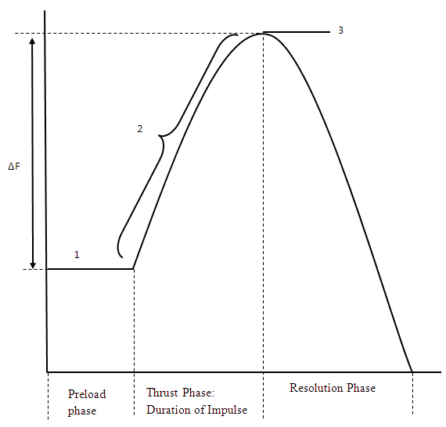
Mobilization methods are generally cyclic in nature. Forces tend to be lower in both amplitude and rate-of-rise in force applied to the body surface over the targeted spinal joint and/or tissue. The lower velocity of force application results in vertebral displacement that is distributed over a spinal region, affecting contiguous articulations in an approximate symmetrical decrease in amplitude for each successive joint above and below the targeted site (Triano, 2001). Motion may be induced manually or through use of treatment tables with moving support surfaces (e.g. continuous passive motion or flexion-distraction) controlled by the clinician. Typical rates of motion range from 0.03-0.53 Hz (Triano, 2001).
Figure 1.1: Stylized wave form describing typical phases of a HVLA spinal manipulation: 1-preload force, 2- rate of rise in force amplitude 3- peak force, ΔF- Impulse amplitude adapted from Downie et al., (2010) and Herzog (2010)

Spinal Region | Year | Author | Mean Preload Force / Mean Peak Force
Cervical Spine | 1992 | Kawchuk | * / 101.7 (± 14.7)
 | 1993 | Kawchuk et al. | 39.5 (± 4.9) / 102.2 (± 46.8)
 |  |  | 24.7 (± 6.5) / 109.8 (± 5.6)
 |  |  | 21.9 (± 5.2) / 40.9 (± 2.8)
 |  |  | 1.9 (± 1.9) / 117.6 (± 6.4)
 |  |  | 29.1 (± 4.3) / 40.5 (± 4.5)
 | 1993 | Herzog et al. | */ 117.6 (± 15.6)
 | 2003 | Van Zoest and Gosslein | 32 (± 10) / 110 (± 12)
Thoracic Spine | 1993 | Conway et al. | 145 (± 54) / 400 (± 118)
 | 1994 | Gal et al. | 69.6 (± 17.4) / 518.5 (± 70)
 | 1999 | Kirstukas and Backman | 310 (± 62) / 1044 (± 186)
 | 2001 | Herzog et al. | 23.8 (± 24.5) / 238.2 (± 45.9)
 | 2003 | Van Zoest et al. | 227 (± 30) / 561 (± 60)
 |  |  | 226 (± 31) / 518 (± 48)
 | 2004 | Forrand et al | 137 (± 58) / 462 (± 194)
 |  |  | 138 (± 63) / 482 (± 130)
 | 2005 | Descarreux et al. | 31 (± 20) / 570 (± 27)
 |  |  | 44 (± 63) / 544 (± 29)
 | 2005 | Descarreux et al. | 59.2 (± 16.2) / 630.9 (± 35)
 |  |  | 176.7 (± 17.3) / 538.4 (± 16.9)
Lumbopelvic | 1997 | Triano and Shultz | */ 495 (± 142.5)
 |  |  | */ 384.7 (± 114.1)
 |  |  | */ 515.5 (± 123.8)
 | 2003 | Van Zoest and Gosslein | 83 (± 15) / 241 (± 57)
 | 2004 | Triano et al. | */ 210.2 (± 106.5)
 |  |  | */ 321.4 (± 112.6)
Table 1.1: Summary of studies quantifying HVLA procedures, adapted from Downie et al. (2010)

Theoretical Foundations for the use of SMT
The preponderance of evidence suggests that patients with spine-related pain frequently benefit from the use of SMT (Brontfort et al., 2001; Brontfort et al., 2011, Dagenais et al., 2010). A number of theoretical explanations for pain reduction and functional restoration have been put forward that draw upon evidence from clinical, biomechanical, and neuromotor control research. Figure 1.2 provides a schematic model of the physiological understanding to date. Implicit within the model is the assumption that loads applied during treatment are effectively transcribed to actuate consistent mechanisms for the expected clinical results. However, there is conflicting evidence between the mechanistic understandings and the physiologic responses from experimental evidence. Greater clarity on how loads are transferred through tissues between the application and target sites would be useful in helping to clarify the appropriate utilization, safety and efficacy of these procedures. A brief review of the foundations for use of SMT, below, provides context for evaluating the assumptions for the role of the loads that are applied during treatment.

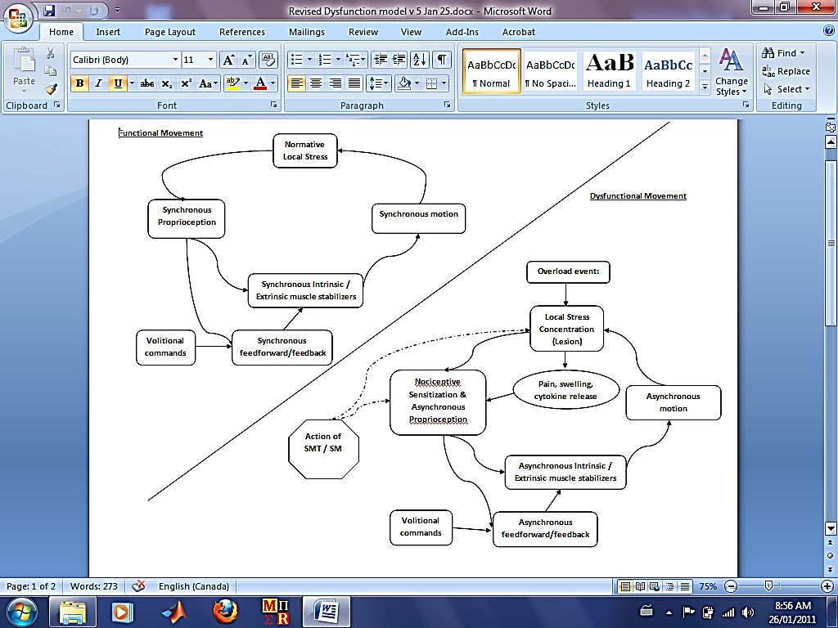
Figure 1.2: Mechanobiology model summarizing theoretical foundations for use of SMT. See the text for a description of the attributed mechanisms and underlying evidence

Functional Movement in a Multiarticular Segmented Linkage
Seminal work beginning with Bergmark (1989) defines the biomechanical and neuromotor control systems for the spine as an interactive communication between the large torso (extrinsic) muscles driving volitional activity and posture with the small spinal (intrinsic) muscles which control vertebral intersegmental spatial configurations. Proprioceptive feedback from the local tissues around the joint structure are integrated with descending central nervous system commands to result in smooth synchronous motion, presumably, with local tissue stress maintained below injury levels (Triano, 2001; Haavik-Taylor and Murphy, 2007; Pickar, 2002). Loss of coordination within these mechanisms, arising from unexpected load, physical fatigue or overload event results in local stress concentration and afferent nociceptive and proprioceptive barrage. An asynchronous coordination of extrinsic and intrinsic muscles enhances abnormal motions.
Evidence underlying the theoretical model is both circumstantial and direct drawing on implications from physiological responses monitored from SMT stimulation. Buckling motion segment behavior associated with painful overload events have been documented (Cholewicki and McGill, 1992). While functional, buckled segments operate with altered centers/axes of rotation (Triano, 2001; Triano, 2005; Bolton and Holland 1998). Pickar (2002) proposed that biomechanical alterations between vertebral segments produces mechanical overload which may alter the signaling properties of receptors within paraspinal tissues. Bolton and Holland (1998) controlled the instantaneous axis of rotation of the cervical spine in cats and demonstrated a profound modification in the proprioceptive barrage to the spinal cord. Henry et al., (2012) induced mechanical compression limited to the facet articulation in rats. The result included sensory changes consistent with extremity hypersensitivity and up-coding of multiple inflammatory cytokines. While local stress concentration has not been independently measured in humans, inflammatory cytokine and chemokine elevations have been observed in patients with musculoskeletal pain commonly treated with SMT (Teodorczky-Injeyan et al., 2011). Furthermore, reductions in pressure pain thresholds and sensitivity to noxious stimuli have been observed in local to regions treated by SMT (Vernon, 2000; Serbley et al., 2013; Bialosky et al., 2014). Motor control in back pain patients is also altered (Marshall and Murphy, 2010). Feed-forward stabilization and motor control is now known be delayed suggesting both spinal cord and central nervous system sensory processing adaptations.
In thinking about how manipulation force application to painful joint areas might affect the neuromotor control cycle, there appear to be two modes. First would be sufficient load transmission to directly affect joint motion and potentially alter local inflammatory response. The works of Nathan and Keller (1994); Gal et al., (1997) in the thoracic spine, Triano and Shultz (1994) in the cervical spine and Lee and Evans (1997); Cramer et al., (2000) in the lumbar spine are examples that demonstrate articular influences. Moreover, Song et al., (2006) in a rat model, has shown reduction in the severity of capsaicin induced inflammation in the spinal segments from instrumented HVLA maneuvers. Desmoulin et al., (2012) suggested that an abnormal mean axis of rotation in a joint is a measure of pathology. Further, their research demonstrated that the abnormal axis of rotation is amenable to SMT, leading to reduced pain and disability (Desmoulin et al., 2012).
Secondly, either through alteration of motion behaviour or direct stimulus of soft tissue proprioceptors, the action of SMT may influence the balance of neuromotor control mechanisms. Colloca et at., (2003) were the first to record EMG from paraspinal muscles and compound action potential from the nerve roots during an instrument assisted HVLA procedure in anesthetized subjects undergoing spinal surgery. Their results indicated an increase in EMG and action potential signaling reaction with increased impulse force. A growing body of evidence supports the idea that injuries alter afferent inputs, which lead to negative neural plastic changes in the sensorimotor areas of the CNS (Haavik-Taylor and Murphy, 2007; 2008; 2012). The works from Murphy’s laboratory (2012 ) have demonstrated restoration of feed-forward control in low back pain patients treated with SMT. Through a series of investigations which involved recording somatosensory evoked potentials Haavik-Taylor and Murphy (2007; 2008; 2010) demonstrated that HVLA procedures alter afferent inputs to the CNS, modulating central sensory processing and enhancing motor output for trained tasks.
Finally, if SMT is a potent influence on neuromotor control and articular behaviour, then systematic physiologic responses should be sensitive to controlled variation of the SMT input characteristics. Pickar and colleagues (2002, 2005, 2006), among others (Sung et al., 2005; Reed et al., 2013; Reed et al., 2014), have focused on this question. In the cat model, Pickar (2002) as summarized in Table 1.2, has shown that the rate and intensity of proprioceptor firing from motion segment tissues stimulated with an HVLA impulse scaled from force-time profiles from human studies. Change in force direction, amplitude and rate-of-rise in force directly alter signaling properties of peripheral mechanoreceptors (Figure 1.2) (Pickar & Wheeler, 2001; Sung et al., 2004; Pickar and Kang, 2006; Reed et al., 2013). Nougarou et al., (2013) used humans to quantify the dose-response of SMT by investigating how increasing peak force magnitudes influenced the EMG response in muscles of the thoracic spine. Both relative vertebral motion and neural responses have been shown to differ based on change in the impulse vector during SMT maneuvers (Colloca et al., 2003; Keller et al., 2003; Keller et al., 2006a; Keller et al., 2006b; Pickar and Wheeler, 2001; Sung et al., 2004; Pickar and Kang, 2006). Further, regulation of circulating inflammatory mediators has been reported to respond to threshold level of force application (Brennan et al., 1992; Brennan et al., 1992; Teodorczky et al., 2006; Teodorczky et al., 2008; Teodorczky et al., 2010).
 | Current Evidence
Neurophysiological Mechanisms | Supports | Does Not Support | Unknown
Alters Group Ia and Group II mechanoreceptor discharge | X
Alters Group III and Group IV mechanoreceptor or chemoreceptor discharge |  |  | X
Alters mechanical environment of the IVF |  |  | X
Alters chemical environment of the IVF |  |  | X
Influences sensory processing in the spinal cord (i.e., central facilitation) | X
Affects neuroendocrine system | X | X
Impacts control of skeletal muscle reflexes (i.e., somatosomatic reflexes) | X |  | X
Impacts control of autonomic reflexes (i.e., somatovisceral reflexes) |  |  | X
IVF=Intervertebral Foramen

Table 1.2: Summary of neurophysiological responses to systematic variations in SMT parameters, adapted from Pickar (2002)

The Paradox in the Evidence for SMT
Taken as whole, the phenomenologic evidence ought to suggest that SMT procedures can be well controlled and impart predictable clinical outcomes by conscious variation of the characteristic parameters. However, the predictability of phenomenological parameters does not translate to predictable clinical outcomes. On the positive side, for example, Cleland et al., (2007) suggests that the rate of loading may be related to rate of recovery. Similarly, Nougarou et al., (2013) have shown enhanced myoelectric responses to increased baseline force amplitudes. Clinical benefits associated with muscle responses, however, have yet to be described. Peak amplitudes of force, proprioceptor firing rates and reflexes may change in animals (Pickar and Wheeler, 2001; Sung et al. 2005; Pickar and Kang, 2006, Reed et al. 2013; Reed et al. 2014). Whereas clinical correlates in humans are unknown. In fact, force amplitudes are reported to vary widely (Table 1.1) in practice without distinct correlation to clinical effect. Indeed, there is question as to whether the force of SMT procedures can be accurately targeted. Triano and Schultz (1997) demonstrated ability to alter load directions and intensity at a target area for the lumbar spine but with no report of clinical relevance. In contrast, Perle and Kawchuk (2005), at least for the thoracic spine, have shown the hand interface applying force at the skin actually slides away from the target segment during force delivery positing a loss of target specificity. Bereznick et al., (2002) examined the transmission of applied force decomposed into orthogonal directions normal to the body surface and parallel to it. They found effective normal transfer of load but little to no transfer in the planes parallel to the body surface. They coined the term of a “frictionless interface” due to tissue sliding. Clinical experience, however, consistently observes that HVLA to the thoracic spine results in apparent displacement of the body as a whole in the direction of the applied load. Such movement would seem to imply load transfer through the “frictionless interface”. Kirstukas and Backman (1999) showed that up to 16% of thoracic HVLA loads dissipated by deformation and tissue absorption. Herzog’s group (2001) found total applied force of 283 N at the body surface imparted only 5 N to a targeted spinal bony landmark. Kawchuk and Perle (2009) investigated vertebral body acceleration in swine cadavers was always most efficiently transmitted when force was directed perpendicular to the body surface and markedly reduced in other directions.
The paradox between phenomenologic observations and with clinical experiences suggests that there is a significant gap in knowledge as to the mechanobiology of load transmission and the tissues effectively stimulated.

Soft-tissue Pathways of Force Transmission
Fascial tissue appears to be an intricate tensional network of connections that is involved in the transmission of force to deeper structures. Two separate layers (superficial and deep) of fascia are present in the body, each with unique histological characteristics that have been suggested to dictate their functional roles (Benjamin, 2009; Stecco et al., 2011). The deep fascia is dense, and composed primarily of collagen fibres; therefore, it has been proposed to have the capacity to effectively transmit force. Furthermore, Nash et al., (2004) identified a network of “skin ligaments” connecting the skin and deep fascia. The presence of these ligaments and histological make-up of the deep fascia provides anatomical support for a potential pathway of force transmission.
Interstitial mechanics have come under recent investigation, showing them to be complex and sometimes counterintuitive. Ultrasound elastography techniques have allowed displacement and lateral strain in muscle strata to be quantified during continuous passive motion of the lumbar spine (Langevin et al., 2011). Langevin et al., (2011) demonstrated that local stretch of paraspinal tissues during passive flexion is not uniformly distributed. Tissue strata move along shear planes between adjacent layers of tissue. Moreover, the strain within tissue layers and their structure may be altered in the presence of chronic spinal pain (Langevin et al., 2009; 2011).
Similar work evaluating the effects of manipulating acupuncture needles across several tissue strata has demonstrated that the biomechanical signal produced by the needle can have an effect on tissue displacement distal (4 cm) to the site of application (Langevin et al., 2001; 2004; 2006). Needle rotation grasps the subcutaneous fascial tissue and twists it around the needle. When depth of the needle was rapidly manipulated up and down the fascial tissue displaces in a similar manner, but with counterintuitive variations depending on distance from the needle that may represent shear wave propagation. Fox et al., (2014) determined that the relative muscle fibre orientation influences tissue displacement during acupuncture needling. Longitudinal tissue displacement was greater when the needle was inserted between the muscles whereas transverse tissue displacement corresponded to the needle being inserted into the muscle belly.
Investigation on the mechanical phenomena of myofascial force transmission further reveals the complexity of load transmission. Fascial tissues are capable of transmitting significant force to adjacent tissues from contracting muscles (Yucesoy et al., 2003; Huijing, 1999; Huijing, 2003; Brown and McGill, 2009; Yucesoy, 2010; Maas and Sandercock, 2010). Two distinct pathways have been identified; the first is intermuscular, where force is transmitted via continuous fascial connections between neighbouring muscles. The second is extra-muscular, where force is transmitted from the epimysium to non-muscular structures (Mass and Sandercock, 2010).
The existence of a pathway that links muscles to neighbouring tissue structures provides a possible pathway for manually applied forces to be transmitted to deeper structures, but these concepts are still evolving. The muscles are unquestionably linked, although the understanding of fascia and its influence on movement remains unclear.

Purpose and Hypothesis
The fates of therapeutic loads causing differing mechanobiological response to SMT may be explained by a better understanding of how loads are transmitted from the surface application site to the target articulation. The purpose of this work was to directly monitor motion of tissue in strata at sequential depths between the SMT load application site and targeted spinal segment in the thoracic spine. Using relative tissue displacement measured by ultrasound elastography as a surrogate for evidence of load transmission we hypothesized that an HVLA preload maneuver applied to the thoracic spine will result in sequential tissue displacement, suggesting differential load transmission between tissue strata. Data of this type will help clarify how therapeutic loads interact with tissues to transfer effects through them. Such understanding will contribute to future work seeking to optimize treatment outcomes for patients receiving SMT procedures in managing their pain and functional impairment.

Chapter 2: Methods
A pre-post test experimental study design was used to evaluate the motion of subcutaneous tissue layers during the application of pre-load spinal manipulation forces manually applied to the thoracic region of healthy volunteers. Ultrasound speckle tracking techniques (Ophir et al., 1991; Konofagu and Ophir, 1998: Langevin et al., 2011) were used to monitor the displacement and shear deformation of the paraspinal soft-tissues during preload as the primary outcomes of the study. A number of biomechanical measures were monitored simultaneously to define the experimental environment. Parameters included forces applied to and transmitted through the thorax, motions of the application hand, torso as a rigid body and the ultrasound sensor. The measures served two purposes. First, they were designed to be input to a uniaxial biomechanical model for estimating the load absorbed by the tissues of the thorax in the primary direction of the applied force. The second purpose was to operate as explanatory variables for hypothesis generation on how loads may be transferred between tissue layers.

Participants
A convenience sample of twenty-four, healthy male volunteers was recruited from the population at the Canadian Memorial Chiropractic College (CMCC). Healthy subjects were selected for this study of mechanical effects on tissues to avoid variations due to pathologic anomaly (Langevin et al., 2011). To control for any potential confounding effects from the presence of variable body fat depth, males with a uniform body type were recruited (Kawchuk et al., 2011). Males with a mesomorphic somatotype were included into the study. Determination of somatotype was based on observation of body morphology on the day of testing. Potential changes in tissue strata due to aging are undefined. To minimize such influence, participants were included if they were between the ages of 23 and 45, a range for males that commonly seek manipulation for low back complaints (Bronfort et al., 2001; Bronfort et al., 2011). A final criterion for inclusion was the ability for each individual to be comfortable lying prone for up to twenty minutes. All participants provided written informed consent that was approved by both the McMaster University Ethics Review Board and the CMCC Research Ethics Review Board.

Experimentation
A series of three experiments were conducted. The primary study was designed to address the main purpose and hypotheses related to relative tissue motions as a result of applied loads. A secondary study was conducted to confirm an underlying assumption of the behavior of the load application site. Finally, consistency of technician identification of tissue layers on ultrasound images was carried out to assess intra-rater reliability.
For the primary study, all participants were scheduled for one session lasting twenty minutes. All testing was conducted in the biomechanics lab at CMCC. Prior to data capture, all participants were screened and anthropometric data were obtained (i.e., age, height, weight, spinal length from inferior angle of the scapula to L5). BMI (Kg/m²) was calculated using the participant’s height and mass. The patient was then instructed to lay prone on a standard treatment table (Leander LT 900, Leander Healthcare Technologies, Lawrence, KA).
The table was modified with an embedded AMTI force plate (Advanced Medical Technology Inc., Model; OR6-7, Watertown, MA) located beneath the thoracic torso support surface. Each subject was positioned with a standard alignment of the L4/L5 motion segment with the cephalic edge of the lower body support. This alignment assured that the thorax was fully supported on its support surface.
Figures 2.1A and 2.1B provide a schematic of the physical instrumentation set-up for the experiment. Additionally, Figure 2.2 provides an illustrative look at the positioning of all data capture equipment. While prone, the participant’s arms were positioned at the side and internally rotated below the elbow. The inferior angle of the scapulae was identified as a consistent landmark between subjects. This landmark was used to identify the location of the intended target, where the experimental maneuver (e.g. the preload site) would be applied. The preload site was located, 2cm lateral-left and 2cm superior to the spinous process at the level of the landmark, a small acrylic block (2cm thick x 4cm wide x 4cm long) was adhered to the skin over the preload site using commercial double-sided tape. The block was machined to hold a mini force transducer (ATI industrial automation, F/T model; mini 45E, Apex, NC) for recording the force and moments of the applied loads. The resting orientation angle of the block with respect to the horizontal was measured with an inclinometer to the nearest degree and was assumed to remain unchanged throughout the load application maneuver. Activity of the underlying muscle, a potential source of internal tissue strata movement, was monitored. Two Ag-AgCl electrodes (Biopac Systems Inc., Goleta, CA), with inter-electrode distance of approximately 4 cm, were applied to the skin overlying the thoracic paraspinal muscles. Placement was arranged to record directly inferior to the preload site, parallel and lateral to the ultrasound sensor monitoring tissue movement. Electrodes were covered with Opcite waterproof tape (Smith and Nephew, Mississauga, ON) before applying ultrasound gel on the skin medial to the electrodes and 2cm lateral to the midline of the spine (Langevin et al., 2009; 2011). A custom clamping apparatus held a 38 mm, 10 MHz linear array ultrasound transducer. The ultrasound image was optimized for clarity and oriented in the peri-sagittal plane while minimizing tissue compression. Two ultrasound sound recording sites were identified. The first site (proximate site), was located directly inferior to the acrylic block at the preload site and 2cm lateral the midline of the spine. The second ultrasound recording region (distal site) was also 2cm lateral to the midline, but 10cm distal to the preload application site. The Optotrak Certus Motion camera (Optotrak Certus System, Northern digital Inc., Waterloo, ON) was positioned 2.5 m to the right of the prone participant. Infrared emitting diode markers were placed in three locations to monitor body segment motions. One tracked the reference corner of the acrylic block, monitoring displacement (mm) of the load application site. A second was placed on the subject’s right acromion process to measure concurrent torso displacement and a third was attached to the USN transducer to ensure relative fixed position during the test maneuver. Finally, a global coordinate reference system was defined by digitizing the corner of the AMTI force plate in the Optotrak calibrated space.

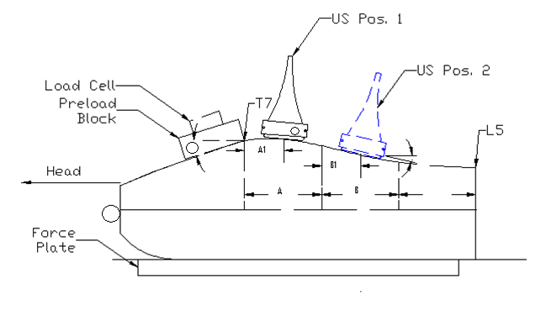

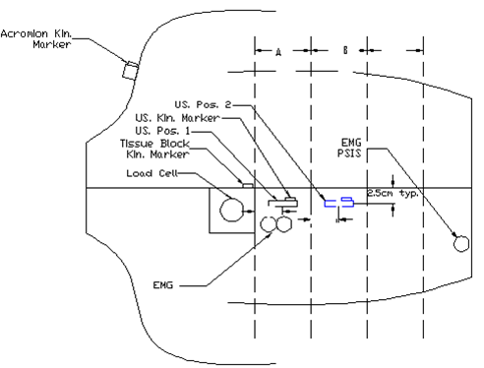
Figure 2.1A: Schematic diagram of the lateral perspective of instrument set-up, identifying the location of biomechanical recording instrumentation (i.e., load cell (applied load), force plate (transmitted load), and displacement (circles: kinematic markers) [US Pos 1= proximate site, US Pos 2= distal site, per text description].

Figure 2.1B: Schematic diagram of the posteroanterior view of experimental set-up, identifying the location of biomechanical recording instrumentation. (US Pos 1=proximate site, US Pos 2= distal site per text description, Kin. Marker= Optotrack™ kinematic recording marker, PSIS= posterior superior iliac spine)

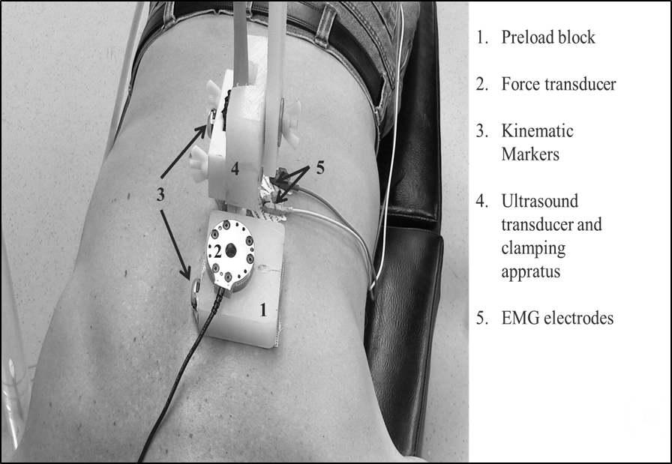

Figure 2.2: Set-up and position of all data capture equipment.

Experimental Maneuver
The experimental maneuver was performed sequentially. An experienced (6 years) and licensed clinician applied force to the patient through mini force transducer and acrylic block unit. The direction of force was intended to be primarily caudo-cephalic and secondarily postero-anterior. The magnitude and rate of force was consistent with typical clinical experience for HVLA preload. The preload phase was modeled because of its known tissue sliding behavior (Bereznick et al., 2002; Kawchuk and Perle, 2009) but absent the highly dynamic elements of the impulse phase. Force was applied and the acrylic block was allowed to displace cephalad until the sense of solid resistance of tissue stretch was met and then released (Figure 2.3). The total time for the experimental maneuver was less than or equal to 10 seconds during which all data were recorded. 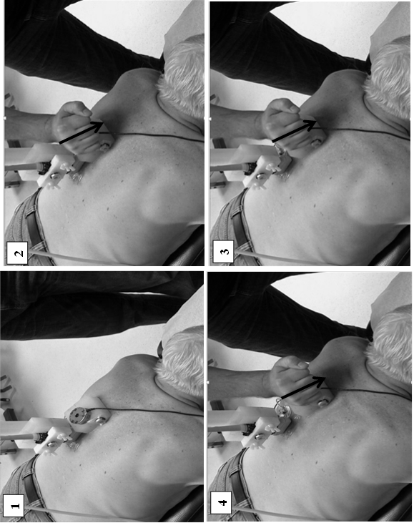
Figure 2.3: Sequence of images demonstrating the experimental preload maneuver; 1) resting state, 2) initial force application, 3) tissue sliding toward end range, 4) full extent of displacement during preload
Verifying Assumptions
The resting angle of the “preload block” and force transducer was assumed to remain unchanged throughout the duration of load application. Tissue displacement in strata at sequential depth was the primary interest for this investigation. The resting orientation of the block was important because it characterized the direction of motion which was parallel to the musculature in the thoracic spine. This resting angle was additionally important for data transformation, so the other kinematic and transmitted load data could be represented at a common reference point, located at the origin of the hand held force transducer. Similar to the primary investigation, a pre-post test experimental design was employed to verify that the resting angle remained unchanged during the application of the preload maneuver

Experimentation: Verifying the Variation in Application Site Orientation
Participant’s (n=10), judged as mesomorphic, were recruited. Anthropometric data (i.e., height and weight) were collected and they were instructed to lay prone on a standard treatment table. While prone, the participant’s arms were positioned at the side. The inferior angle of the scapulae was used as a consistent landmark between subjects, for the identification of where the experimental maneuver (e.g., preload site) would be applied. The load application site was 2cm lateral-left and 2cm superior to the spinous process at the level of the landmark. The same small acrylic block (2cm thick x 4cm wide x 4cm long) used during the primary investigation was adhered to the skin over the preload site using commercial double-sided tape. For verification of the assumption that the block orientation was stable throughout the maneuver, a rigid body outfitted with 4 Optotrack™ infrared emitting diodes (Optotrak Certus System, Northern digital Inc., Waterloo, ON) was adhered to the acrylic block. The orientation angle of the block with respect to the horizontal was recorded by the Optotrack™ data acquisition unit and pre-programmed to report the orientation angle in all three orthogonal planes. The initial resting position of the block was captured at the standardized preload site. Following, force was applied that was consistent with the typical HVLA preload used during the primary investigation. The initial resting angle was recorded, and the block was allowed to displace cephalad until the sense of resistance to tissue stretch was met. The peak difference in the orientation angle across the displacement was computed using a custom design analysis program created using MATLAB (Mathworks, Nattick, MA).

Testing Intra-Rater Reliability
Post-processing of the ultrasound data requires choosing a boundary demarcating the location of distinct behaviour within tissue layers. The B-mode image (Figure 2.4) was used to select tissue layers for analysis by an experienced lab technician trained for this purpose. The criteria for layer selection were the presence of a dense echogenic connective tissue layer or the identification of regions of muscle that appeared to have differential rates of movement. Tissue layers were identified twice on a subsample of 10 participants, 4 to 5 months apart, and distance (mm) from the ultrasound sensor to the boundary were used to create an intra-class correlation coefficient (ICC) to assess reliability.

Loose Connective Tissue
Intermediate Muscle Layer
Deep Muscle Layer
Figure 2.4: Ultrasound B-mode image region of interest (ROI: 1 cm x 3.5 cm), from which individual tissue strata were identified. Outcome measures of tissue displacement and relative shear were calculated from this standardized region

Data Capturing System Parameters
For the kinematic data, the sampling rate was set at 64Hz using a single Certus motion tracking camera (Northern Digital Inc., Waterloo, ON) mounted horizontally on a tripod stand. Displacement was measured in all planes of motion and recorded as millimeters. The applied loads at the clinician’s hand and the transmitted loads sensed by the embedded force plate within the treatment table as well as the myoelectric activity of the paraspinal muscles were sampled at 2048 Hz. An ultrasound image field depth was set at 4cm and focused on the thoracic paraspinal muscles 2cm left of the midline with a 38 mm sound head at 50% sector (i.e. 19 mm visualized field). Ultrasound (Sonix RP) recording of tissue motion was sampled at 51 Hz. An ultrasound cine-loop of B-mode images along with radiofrequency (RF) signals were collected for a 10 second interval. All data capturing instrumentation was interfaced to a 16-channel Optotrak™ digital acquisition unit (ODAU) (Northern Digital Inc., Waterloo, ON) and a time synchronization signal was separately recorded and triggered by the start and stop of ultrasound recording. Optotrak™ kinematic measures have been reported across a breadth of precision (States and Pappas, 2006; Schmidt et al., 2009) based on experimental conditions. Under circumstances comparable to the methods here, States and Pappas (2006) found typical standard deviation of 0.125 mm and differences in measures of a constant length of up to 0.22 mm. The raw data served as input into a custom design analysis program created using MATLAB (Mathworks, Nattick, MA).
Ultrasound Data Reduction to Layer Displacement
Ultrasound elastography techniques estimate axial and lateral tissue displacement from the RF signal and express it in terms of microns (µm) of displacement at each successive frame. The direction of tissue displacement is classically defined relative to the ultrasound beam. Axial displacement refers to movement in the direction of the beam ( i.e. ‘+’ posterior to anterior), while lateral displacement refers to the direction perpendicular to the beam and parallel to the transducer orientation (i.e. ‘+’caudal to cephalic direction). For the purpose of this investigation lateral tissue displacement was
most related to the hypotheses being tested. The Sonix RP ultrasound system recorded radiofrequency and AVI files during the application of the experimental maneuver and triggered start and stop of all data capture for time synchronization. Custom built proprietary software (Courtesy of Elisa Konofagou, Columbia University) processed the RF signals and produced time dependent estimates of displacement for user defined tissue layers. Displacements are estimated using speckle tracking and cross-correlation techniques as validated in previous studies (Ophir et al., 1991; Konofagou and Ophir, 1998; Langevin et al., 2011). A mapping is created by comparing tissue states between successive USN frames over time. A brief review of relevant speckle tracking physics can be found in the Appendix A.
A standardized region of interest (ROI) was established by creating a rectangular window (10 mm wide and 35 mm in length) in which relative tissue layers were tracked during the experimental maneuver. The ROI was placed as close to the transducer-skin interface as possible and immediately beneath the “dead zone” representing interface artifact. Three functional layers of tissue were identified based on the B-mode image movie, observing for relative uniformity in movement within a layer using the differential hyperechoic and hyopechoic reflections from muscle fascicles, fascia and fat. Langevin et al., (2009; 2011) found, for example, reliable landmarks of denser connective tissue having a higher echogenic signal while loose connective tissues has a low echolucent signal. Displacement estimates based on the speckle cross-correlations were represented as an average and located at the center of each ROI layer within each frame. Layer depths and thicknesses were quantified for statistical descriptions of the tissue. Reduced data were saved to file and served as input for time synchronization with kinematic and load data leading to final analysis.

Post Processing
Using custom MATLAB software (Mathworks, Natick, MA) raw kinematic, load, and myoelectric data were processed (Figure 2.5 Flow Chart) and time synchronized with the ultrasound layer displacement data. Because of the different sampling frequencies technically required by the sampling hardware systems, the time synchronized data were alternately extrapolated and decimated as necessary to provide equal length data strings. Error propagation, as potential source of inaccuracy from the extrapolation/interpolation processes had previously been determined in the laboratory by cross-checking values at a fixed time between the original length signal and the adjusted data length signal. A residual analysis technique was implemented to determine the average cut-off frequency for force and kinematic data (Burkhart et al., 2011). Kinematic and force/moment data were digitally filtered using a dual pass, 2nd order, Butterworth filter with a cut-off frequency of 4Hz. Prior to filtering, the raw EMG signal was first full wave rectified. Following, analysis of the EMG signal using FFT/PSD techniques revealed several sources of both low frequency and high frequency noise. Low frequency noise sources generally represent movement artifact such as the swaying of the cables likely induced by the experimental maneuver. Higher frequencies were harmonics of 60 HZ likely induced by clinician contact with the subject. As a result, a dual pass, 2nd order, Butterworth filter with cut-off frequency between 10-400Hz was followed by notch filters to remove these artifacts. The remaining heartbeat artifact was managed with a high pass 2nd order Butterworth filter with a cut off frequency of 250 Hz (Drake and Callaghan, 2008; Potvin and Brown, 2004). Finally, the signal was transformed to provide a surrogate for muscle tension by use of a dual pass, 2nd order Butterworth filter with a 2.5Hz cut-off to create linear envelope tracking force development (Brereton and McGill, 1998). Ultrasound tissue layer displacement data were filtered using a dual pass 2nd order Butterworth filter with a 6Hz cut-off.
Once signal processing and time synchronizations were complete, all kinematic and force data were transformed to be represented in a coordinate reference system at the force application site. Orientation of the reference system was determined based on the manual measurement of the acrylic block orientation in the sagittal plane. Kinematic transformations followed the convention described in Equation 1, whereas, load transformations were carried out similarly through Equation 2. Transformations allowed data to be represented in a common reference system located at the center of the application site and parallel to the underlying tissue strata.

Equation 1: Kinematic transformation: “H[ ]M” = coordinates to locate all body fixed reference systems in reference system fixed in the application site “M” = kinematic markers (i.e. hand, US, and acromion), “H[ ]FP” = Transformation matrix (“θ” = angle at application site). “FP[ ]M” = coordinates to locate all body fixed reference systems in force plate coordinates

1
X_{o}
Y_{o}
Z_{o}
1
X_{i}
Y_{i}
Z_{i}
=
1 0 0 0
P_{x} 1 0 0
P_{y} 0 cosθ sinθ
P_{z} 0 -sinθ cosθ
x
H
M
H
FP
FP
M

Equation 2: Transformation equation between the force plate and common reference system (force application site). “Fx-Mz” represents the transmitted loads sensed at the force plate. “Fbx-Mbz” are the same components represented in the coordinates fixed to the application site.” _{fp}R_{h”} = coordinates of the application site with respect to the force plate. A cross product (e.g. _{fp}R_{h} X n) between application site coordinates and n= [1, 0, 0], o= [0, 1, 0], and a= [0, 0, 1],
x
=
1 0 0
0 cosθ sinθ
0 -sinθ cosθ
_{fp}R_{h} _{fp}R_{h} _{fp}R_{h}
x x x
n o a
1 0 0
0 cosθ sinθ
0 -sinθ cosθ
0 0 0
0 0 0
0 0 0
Mx
My
Mz
Fx
Fy
Fz
Mbx
Mby
Mbz
Fbx
Fby
Fbz
FP

FP
H
H

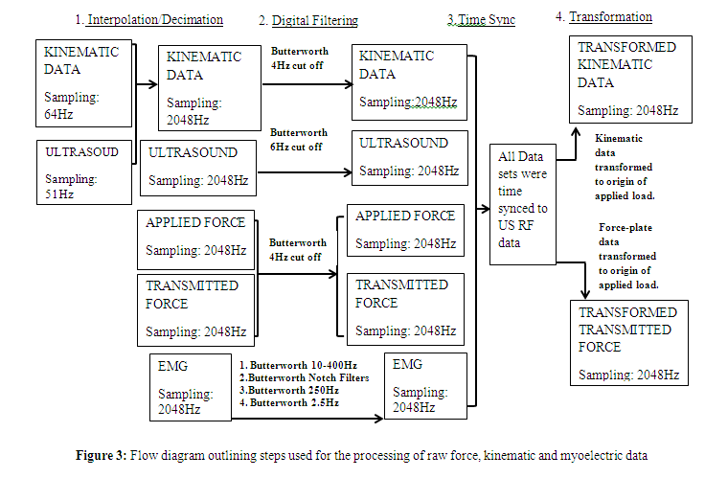
Figure 2.5: Flow diagram outlining steps used for processing raw force, kinematic, and myoelectric data.

Uniaxial Model Development
Direct measurement of force transmission through soft tissues is both technically and ethically challenging. The total loads acting on a tissue is the sum of applied loads, force generated from an accelerating body segment, and any internal muscle tension that may arise (Triano, 2001). Various experimental approaches have been taken to quantify forces acting on spinal tissues.
Biomechanical studies evaluating how loads are transmitted through tissues raise questions as to the ability to control the load parameters past the cutaneous application site (Bereznick et al., 2002; Kawchuk and Perle, 2009). However, the current understanding suggests that approximately 16 percent of the applied load is attenuated by the torso tissues as a whole (Kirstukas and Backman, 1999), but the magnitude of force dissipation in each of the orthogonal direction has not been identified. To better explain load transmission through the thoracic tissues, a uniaxial model was developed to estimate load absorption in the thorax in the primary direction of applied load.
For load transmission through a tissue parallel to an applied load (e.g. preload force), rigid body biomechanics would predict that the transmitted force parallel to the applied load is equal to the sum of the applied force and the force generated from body mass acceleration, as defined by Equation 3 with reference to Figures 2.1A and 2.1B.
Equation 3: F_{y} _{applied} + mass_{torso} X acceleration_{y} = R_{y} _{transmitted}
Clinical observation of whole trunk motion in the direction of the applied load suggests that the torso mass is being accelerated. The work of Kirstukas and Backman (1999) shows a reduction in applied load due to tissue deformation and or elastic absorption by the thorax. Together these factors suggest load attenuation / absorption by the tissues. A free body diagram (Figure 2.6) identifies the sources of inputs into the uniaxial model equation.
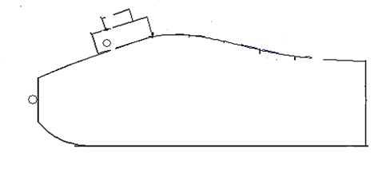
R_{y}
R_{z}
mg
a_{y}
Fe_{y}
Fa_{z}
Fa_{y}
+y
+z

Figure 2.6: Free body diagram identifying sources of inputs into the uniaxial model equation (equation 4), for the estimation of force absorbed in the direction of applied load

Force attenuation through the torso tissues in the direction of applied therapeutic loads can be defined by the uniaxial model as the difference between the transmitted force, the applied force, and the force from the accelerating torso mass. The torso acceleration was, determined by differentiating torso displacement. All force and kinematic values were mathematically transformed (Equations 1 and 2) to the common origin at the effective centre of the hand-held force transducer, and parallel to the underlying tissue. Equation 4 allows for an estimation of the force absorbed in the caudo-cephalic axis (y-axis).
Equation 4: R_{y} _{transmitted} – F_{y applied} – mass _{torso} x acceleration_{y} _{torso} = F_{y} _{absorbed}.

Determination of Layer Displacement and Shearing Strains
Raw lateral tissue displacement was graphed on the same time scale with the displacement data recorded at the application site. A region of interest was manually chosen from these graphs based on the inception of application site and its plateau at maximal displacement (Figure 2.6). Calculations to determine the cumulative lateral displacement and lateral shear between the layers were performed. Peak tissue displacement was calculated as the cumulative total as the integral of the instantaneous displacements corresponding to each ultrasound frame within the region of interest over the time of load application o (Equation 5)
Equation 5: CD = (1/fs) ∫ s_{i} dt, i= 1 to T
where fs = sampling rate (51 Hz), s_{i} = instantaneous displacement at sample “i”. Lateral shear between the tissue layers was calculated using the depth of each tissue layer and the shear equation (Equation 6) adapted from Langevin et al. (2011) (Figure 2.5).
Equation 6: S = ׀ (CD_{j+1} -CD_{j}) ׀ / D
In Equation 6, “S” represents the cumulative shear, “j” gives the strata layer and “D” is the estimated distance between strata centroids based on the ultrasound layer depth measures.
Finally, cross correlation calculations were completed to compare the potentially non-linear filtered EMG activity as a surrogate for tissue tension to the cumulative displacement of the tissue layers. Given the linear nature of the cumulative lateral displacement, Pearson correlation coefficients were calculated to compare the lateral tissue displacement with the displacement recorded at the load application site. 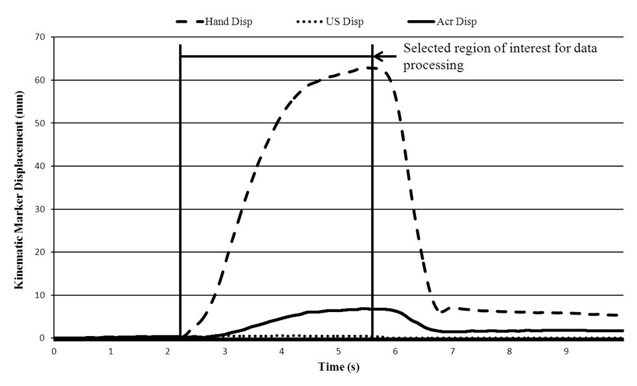
Figure 2.7: Representation of typical chepalad displacement of kinematic markers. The vertical black bars represent the manual selected region of interest, used for further data analysis.
Selected Region of Interest

Direction of Tissue Displacement
- CD_{j}
- CD_{j+1}
D
Superficial Tissue Layer

Intermediate Tissue Layer

Figure 2.8: Stylized representation for calculation of relative shear between layers, adapted from Langevin et al. (2011). CD= cumulative layer displacement, D=Distance between layers.
Intermediate Tissue Layer

Data Analysis

Descriptive statistics (means and standard deviations) were calculated for the entire participant’s demographic data as well as for all the dependent and independent variables. Data were tested for normality using the Anderson-Darling test, and equality of variance (Bartlett’s test). Evaluating myoelectric behavior as surrogate for tension was grouped by common pattern and evaluated by ANOVA. For other data, student t-tests with significance adjusted to α=0.0167 to account for multiple comparisons, were used. For other data failing normality testing, the non-parametric Wilcoxon Sign Rank test with significance set at α=0.05 was utilized.
For the primary hypothesis, the outcomes of tissue strata cumulative displacement and shear between layers were evaluated. All other variables were assessed either in effort to explain mechanism or to confirm underlying experimental assumptions. Tests included consisted of cross-correlation analysis for potentially non-linear data and Pearson correlation for approximately linear data.
Quality control statistical analyses were also used. Intraclass Correlation Coefficients (ICC) was calculated to test the reliability of layer boundary selection. The quality of speckle tracking was assessed by cross-correlation of the USN radiofrequency data between individual frames based on the work of Konofagou and Ophir (1998).
Chapter 3: Results
The primary aim of this work was to evaluate the behaviour of the soft tissue layered strata to determine if differential movement occurs, consistent with applied surface loading, in the plane parallel to the surface. Such displacement, if present, would imply potential load transfer within the soft tissues that might be used in future study to further understand the physiological effects of HVLA procedures.
The dependent variables related to testing of the hypothesis were the differences in cumulative displacement and, secondarily, the shear strain between the three most superficial tissue layers. Two sites were tested, one proximate to the scapular landmark and one approximately 10 cm caudal to it. Results that follow are grouped according to test site. Due to speckle tracking de-correlation between images, tissue displacement and shear data for tissue of the superficial layer at the proximate site
is only available for 21 participants. However, data for all 24 participants is available for the second and third tissue strata. The speckle tracking de-correlation issues were worse for the distal site, and data for the superficial layer is only available for 10 participants

Participants
Twenty-four male volunteers met the inclusion criteria and provided consent to participate. Participant’s age ranged from 23-31 years (25.9 years ± 2.3). Their body mass index extended from 21.8 Kg / m² to 28.9 Kg / m² (25.0 Kg / m² ± 2.0). The spinal length ranged from 30 cm to 35 cm (32.2 cm ± 1.7). The initial angle of the force transducer embedded into the acrylic block was measured to represent the orientation of the surface and subadjacent tissue layers within the global reference frame. The measure served to define kinematic and load transformations to the body fixed reference system located at the load application site. The initial angle varied among the participants, with the mean angle measuring 9.4⁰ ± 4.5⁰. Key to the assumptions of the uniaxial model is the stability of the orientation angle over time during the application of load. With a stable angle, transformations could be made in a planar model rather than requiring a fully tri-axial kinematic representation. Measures of variation of the angle, obtained in an independent sample population (n = 10), demonstrated a normal distribution with angular deviation during the experimental maneuver with average peak change in the angle of 6.9⁰ ± 2.8 allowing for reasonable validation of the assumption for purposes of this report. Table 3.1 provides descriptive comparison of the main group and validation group participants in terms of age and BMI. No differences were noted.
Variable | Study Participants | Validation study Participants | Normal or Non- Normal Distribution (Y/N) | Statistical Test | p
n | 24 | 10
BMI (Kg/m2) | 25 (2.0) | 26 (2.9) | Y/Y | 2-sample t-test | p=0.241
Age (years) | 25 (2.3) | 27 (3.5) | Y/N | Kruskal Walis | p=0.281
Table 3.1: Demographic variables for the participants in the original investigation and the assumption validation investigation.
Table 3.2 provides the descriptive values for the explanatory variables observed during the experimental maneuver. These measures served to document the conditions of the experiment, providing means to cross check for elements of internal and external validity, and some were also intended as input to the uniaxial computational model estimating residual force attenuated by the soft tissue. Characteristics of the experimental maneuver were descriptively different between the proximate and distal ultrasound recording sites. The length of the application site displacement cephalad was 3 mm longer (p = 0.004) and 60 mm / sec² higher (p = 0.001) for the distal site. For peak force magnitude applied during the maneuver, the proximate site measures averaged 80.8 N (30.6) while the distal site experienced a mean of 42.1 N (28.5). The peak transmitted forces measured at the force sensing platform were 91.5 N ± 18.8 and 97.1 N ± 26.6 for the proximate and distal sites, respectively. Peak force measures for the distal site were skewed but with highly significant differences seen between sites only for the applied forces (Applied: W = 296, p = 0.000; Transmitted: W=114, p=0.310). At the distal site, there was a significant difference between applied and transmitted force (W = 290, p = 0.000). Implications of the difference between applied and transmitted forces are presented under the section on the uniaxial model results.
Several other explanatory variables were described. The rate of peak force development, calculated from transmitted loads, was found to be 32.0 N/s ± 8.2 and 37.0 N/s ± 11.6, respectively with a trend to higher rate for the distal site (t ₂₃ = -2.05., p=0.052). As the expected sliding of the surface occurred, the application site displaced a mean of 51.3 mm ± 10.7 mm in the cephalad direction at the proximate site and, similarly, 54.1 mm ± 11.1 mm at the distal site (t ₂₃ =3.21, p=0.004).. Displacement of the torso, as represented by the movement of the acromion marker (See Figures 2.1A and 2.1B in Methods), averaged 8.0 % (4.5 mm ± 1.8) of that at the proximate application site and 9.0% (4.8 mm ± 2.3) for the distal site. Displacements of the ultrasound (USN) transducer, resulting from drag at the interface, were 0.9 mm ± 0.4 and 0.8 mm ± 0.4 for the sites respectively. These displacements were collinear to the movement within the tissues as represented by the RF imaging, suggesting that they are additive to the USN reported internal displacements. Dynamics of the applied load were represented by calculation of site acceleration through numerical differentiation of the displacement data. The acceleration observed at the application sites were 144.7 mm / s² ±(41.7) and 204.1 mm/s ² ± 71.8 (W=17, p=0.001) with the distal site not normally distributed.
Variable | Proximate site | Distal site | Normal Distribution by Site (Y/N) | Statistical Test | p
Application site displacement (mm) | 51.3 (10.7) | 54.1 (11.1) | Y/Y | St | p=0.004
Application site acceleration (mm/s²) | 144.7 (41.7) | 204.1 (71.8) | Y/Y | St | p=0.001
Acromion displacement(mm) | 4.5 (1.8) | 4.8 (2.3) | Y/N | W | p=0.1
Peak Applied Force (N) | 80.8 (30.6) | 42.1 (28.5) | Y/N | W | p = 0.000
Peak Transmitted Force (N) | 91.5 (18.8) | 97.1 (26.6) | Y/N | W | p = 0.310
Rate of transmitted force (N/s) | 32.0 (8.2) | 37.0 (11.6) | Y/Y | St | p = 0.052
Superficial Layer Thickness (mm) | 4.6 (2.7) | 6.1 (2.7) | N/N | W | p = 0.003
Intermediate Layer Thickness (mm) | 4.2 (3.8) | 7.3 (3.0) | N/Y | W | p = 0.002
Deep Layer Thickness (mm) | 9.0 (5.0) | 13.0 (4.0) | N/Y | W | p = 0.003
Superficial Axial Displacement (mm) | 3.5 (1.1) | 3.7 (1.4) | N/N | W | p = 0.010
Intermediate Axial displacement(mm) | 3.6 (1.4) | 3.6 (1.7) | N/N | W | p = 0.025
Deep Axial displacement(mm) | 3.5 (1.5) | 3.6 (1.9) | N/N | W | p = 0.038
Table 3.2: Explanatory variables, measured at the Proximate and Distal sites, evaluated for normality and statistical differences

Uniaxial Modeling
Quality control check of the difference in force magnitudes between the applied and transmitted forces failed to demonstrate the expected dissipation of force by the thorax as seen in the literature (Kirstukas and Backman, 1999). As shown in Table 3.2, the transmitted force measures exceeded the applied force particularly at the distal site. Acceleration magnitudes of the application site were insufficient to imply mass acceleration/deformation of the torso as an explanation. Given the uncertainty on input data, the uniaxial model was not evaluated further.

Soft Tissue Layers
Tissue displacement was recorded based on the caudo-cephalic movement of the identified layers (Figure 3.1) within the standardize region of interest (1 cm x 3.5 cm) in the B-mode image (see Figure 2.4 in Methods). The superficial layer is consistent with the subcutaneous loose connective tissue as described in the thoracolumbar region by Langevin et al., (2011). The intermediate and deep layers represent muscular tissue that is functionally differentiated by their apparent behavior on the sequential B-mode images. The intra-rater reliability for layer identification was excellent, with an ICC › 0.98. Cross-correlation of speckle patterns, as an index of quality control for motion measurements, ranged from an average of 0.747 ± 0.113 for the superficial layer with 0.853 ± 0.100 and 0.894 ± 0.057 for the intermediate and deep layers.

A: t=0
B: t=2

Figure 3.1: Ultrasound image showing movement of tissues in the in response to the applied surface loading. A: resting state of tissue, B: Tissue sliding towards end range. Displacement of tissue is indicated by change is position of dark band.

The average depth of each strata and their thicknesses varied at each ultrasound site (Table 3.2) with the distal site consistently thicker (0.002 < p < 0.003). Within site, the superficial and intermediate layers were approximately the same dimension while the deep layer was on the order of twice as thick.

Qualitative Tissue Displacement
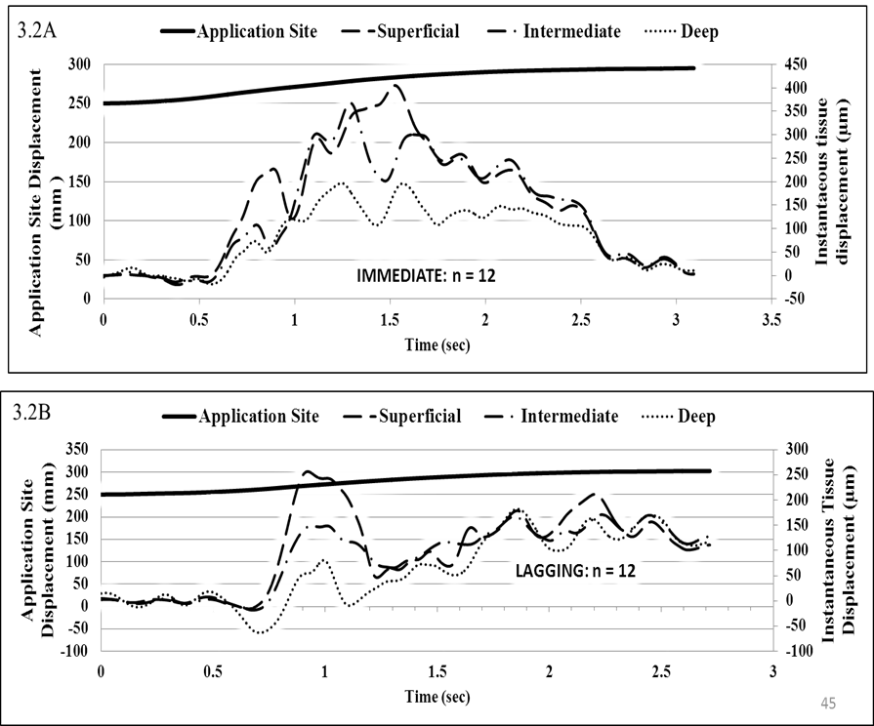
The cephalad displacement of each tissue strata consistently was less than the displacement of the 1 cm ROI width (see Figure 2.4: Methods). Two qualitative behaviours were observed related to how the tissue displacements were initiated. Of the 24 participants, one group (n= 12) demonstrated immediate movement of the 3 strata as a nearly cohesive unit followed by differential rate of movement between layers during the maneuver (Figure 3.2A). The second group (n = 12) showed apparent sequential lags characterized by an initial negative movement followed by sequential reversal between layers (Figure 3.2B). This behavior was consistent for both the proximate and distal sites as apparent on inspection of the B-mode movie files. Quantitative subanalysis examining for any difference in potential explanatory variables (Table 3.3) to account for the lag behaviours yielded no statistical differences.
Figure 3.2: Time-linked application site displacement (mm) is plotted along with strata instantaneous displacements (µM) showing the categorical behavior at the onset of tissue motion. 3.2A, is the “immediate” response while 3.2B shows the “lag” response

Variable | Immediate Onset | Lagging Onset | Normal Distribution (Y/N) | Statistical Test |  | p
n | 12 | 12
BMI (Kg / m²) | 25.3 (2.3) | 24.8 (1.7) | Y |  | St | p=0.55
Application site displacement (mm) | 47.0 (5.6) | 55.5 (13.0) | Y/Y |  | St | p=0.057
Application site acceleration(mm/s2) | 150.5 (46.1) | 136.14 (36.6) | Y/Y |  | St | p=0.409
Peak Applied Force (N) | 83.6 (35.4) | 77.7 (26.3) | Y/Y |  | St | p=0.64
Peak Transmitted Force (N) | 90.2 (16.6) | 92.9 (21.4) | Y/Y |  | St | p=0.753
Rate of transmitted force (N/s) | 33.3 (8.7) | 30.7 (8.3) | Y/Y |  | St | p=0.441
Superficial Layer Thickness (mm) | 4.6 (2.7) | 4.6 (2.9) | N/N |  | KW | p=0.908
Intermediate Layer Thickness (mm) | 4.2 (4.8) | 4.2 (2.3) | N/N |  | KW | p=0.908
Deep Layer Thickness (mm) | 8.8 (5.9) | 8.8 (4.5) | N/N |  | KW | p=0.488
Superficial Axial Displacement (mm) | 3.4 (0.8) | 3.7 (1.4) | N/N |  | KW | p=0.525
Intermediate Axial Displacement (mm) | 3.6 (1.7) | 3.6 (1.7) | N/N |  | KW | p=0.525
Deep Axial Displacement (mm) | 3.4 (1.0) | 3.6 (1.9) | N/N |  | KW | p=1.00
Table 3.3: Subanalysis examining for differences in explanatory variables between the two subcategories of tissue sliding patterns. (St = student’s t-test, KW= Kruskal-Walis)
While the main interest of this work is in the caudo-cephalic axis (e.g. lateral ultrasound axis), posteroanterior (e.g. axial ultrasound) tissue layer displacements were evaluated. Compression of deformable tissue adjacent to the proximate site may lead to volumetric changes that might influence the lateral displacement behavior of tissue strata, important to the study hypothesis. Results for axial motion, while skewed in distribution, were relatively uniform in their means (3.4 mm ± 0.8 < d < 3.7 mm ± 1.4) across strata. Stratified by sliding behavior, for the lagging response was greater in the mean for the superficial and deep layers but without significant difference.
Quantitative lateral movement of the three tissue strata, in the form of the mean cumulative displacements over the duration of the experimental maneuver, are shown in Figure 3.2 for available data common to both sites. For the proximate site, superficial layer data were available for 87.5% (21/24) but for the distal site only 10 participants (42%) have useful data in the same layer.
To simplify explanation of tissue response results in the caudo-cephalic direction, it is instructive to first look at the difference in strata displacement between the proximate and distal sites. The tissue behavior is substantively the same. That is, with increasing depth of tissue there is a sequentially decreasing rank order in the mean cumulative displacement with each layer being significantly greater at the proximate site. The difference in means between sites for the superficial layer is 0.19 mm (n = 10, sd = 0.53; t = 3.96, p = 0.003). For the intermediate layers, the difference is 0.09 mm (n = 24, sd = 0.63; t = 3.37, p = 0.003) and for the deep layers it is 0.05 mm (n = 24, sd = 0. 33; t=3.27, p = 0.003). Given the consistency in behavior between sites, the remainder of the exploration of tissue response will focus on the proximate site.
Figure 3.3 describes the relative motions between the layers (Superficial to Intermediate, Intermediate to Deep) for the proximate and distal sites. Values reported in Figure 3.3 for the superficial layer are reported using the mean values based on the common 10 participants where data were available. As observations progress more deeply into the tissue, the amplitude of cumulative displacement decreases significantly. Superficial mean displacement (n=21, proximate site) was highest with 0.34 mm ± 0.15 while the intermediate layer moved an average of 0.28 mm ± 0.10 (t = 3.29, p = 0.004). Contrasts of the intermediate to deep layer were significant (t = 6.15, p = 0.000) with the deep layer displacing 0.16 mm ± 0.06. Coupled with the collinear drag motion at the USN head suggests that the total movement may be higher and may be estimated by summing the two sources of motion (e.g. 1.06 mm < total < 1.24 mm), depending on the strata.
p= 0.004
p= 0.031
Superficial
n=24
n=24
n=24
n=24
n=21

n=10

Figure 3.3: Cumulative displacement of tissue strata from superficial to deep layers for the Proximate and Distal sites
Figure 3.3: Cumulative displacement of tissue strata from superficial to deep layers for proximate and distal sites.
The deformation within the blocks of tissue at different layer depths is quantified by the calculated relative shear expressed in percentage (Table 3.4). While these values provide an estimate lumped at the interface between layers, inspection of the B-mode images suggests this phenomenon is actually distributed along the depth of the tissues, as might be expected. Represented this way, the shear incorporates both any legitimate interstitial or muscle fiber deformation, which is likely negligible for the muscle tissues (Langevin et al. 2011) and the cumulative sliding between them. Shearing action was not normally distributed and was found to be large within all tissue layers at both sites. In the mean, the shear values were consistently lower for the distal site. At the proximate site, the shear trended toward significance for comparison of the superficial/intermediate shear (2.1% ± 2.3) versus the intermediate/deep shear (4.4% ± 3.7).
 | Superficial / Intermediate | Intermediate / Deep | p
Proximate | 2.1 (2.3) | 4.4 (3.73) | p = 0.014
Distal | 1.2 (1.1) | 1.5 (2.1) | p = 0.760
Table 3.4: Relative shear (%) of tissue strata as a function of within layer sliding of elements.

Myoelectric Activation
Displacement and deformation of the tissues from an externally applied load is certainly an expectation. However, the neuromotor control system serves as an actuator and stabilizer capable of active response to external loading and may alter how the tissue layers behave. Observation of the tissue strata alone may not be able to discern the difference between a passive or active source for the tissue motions. Myoelectric responses from muscles in the region of the USN sampling were initially evaluated by site. Correspondence of change in surrogate muscle tension, expressed as the filtered myoelectric activity, with tissue strata motions were evaluated quantitatively by cross-correlations (Table 3.5). Correlation coefficients were essentially the same (0.64 < XCorr < 0.71) irrespective of whether the layer was of passive (i.e. superficial) or active (i.e. muscle) tissue. Lag in the correlations ranged from 0.6 seconds to 1.5 seconds suggesting latencies beyond the range of simple reflex response.
 | Superficial | Intermediate | Deep
Proximate | 0.67 (0.16) | 0.66 (0.17) | 0.65 (0.13)
Distal | 0.64 (0.14) | 0.71 (0.14) | 0.71 (0.13)
Table 3.5: Cross-correlation coefficients for changes in muscle tension (e.g. envelope filtered myoelectric signals) by site and strata cumulative displacements over time.
Table 3.6 shows the initial and end maneuver voltages along with the envelope integrals of total energy for each application site based on signals filtered at 2.5Hz cut-off as surrogate for muscle tension. Filtered myoelectric signals were linearly correlated with tissue strata cumulative displacements for the both application sites. The superficial layer was positively correlated but at lower levels than found with the cross-correlation analysis (Proximate: r = 0.46; Distal r = 0.54). Intermediate and deep layer responses were even less correlated (-0.23 < r < 0.39).
 | Onset (µV) | Ending (µV) | Envelope Integral (mV)
Proximate | 0.20 (0.11) | 0.31 (0.30) | 1.61 (1.31)
Distal | 0.19 (0.11) | 0.28 (0.24) | 1.31 (0.73)
Table 3.6: Myoelectric voltage responses to the experimental maneuver by site. Onset and end in µV and envelope integral in mV.
Consistent between sites, inspection of the myoelectric behavior itself revealed three distinct qualitative behaviour patterns (Figures 3.3A, 3.3B, 3.3C) based on their apparent timing of activation in relation to tissue strata instantaneous motions. In 10 subjects (Figure 3.4A), the myoelectric activity was stable throughout the experimental maneuver with concurrent relative tissue motions. For 6 subjects, there was a ramping of activity that appeared to stiffen the interlayer motions, making them more uniform (Figure 3.4B). Finally, 8 subjects showed bursting patterns of higher amplitude which increase over the duration of the maneuver (Figure 3.4C). This was more associated with early uniform motion within the layers followed by distinct separation in rate as the myoelectric activity grew. One-way ANOVA suggested significance in difference score between initial and final values for the surrogate for tension. However, the distributions held unequal variance (Bartlett’s Chi-square = 20.08 for difference in variance). Kruskal-Wallis testing showed difference at p = 0.0186.

3.4B
3.4A
3.4A
3.4B
3.4B
3.4A
3.4B
3.4B

3.4C
Figure 3.4: Tissue strata instantaneous displacement with stable time-linked raw myoelectric activity with filtered EMG as surrogate for muscle tension. The vertical scale is accurate for myoelectric microvolts. All other behaviours are scaled from their original amplitudes and separated from each other for clarity of representation in timing of behavior.
3.3B
3B
3C
Alternative to muscle activation as an explanation for tissue motions, association between the tissue strata and application site displacements were sought. Given both signals tended to be monotonically increasing, a Pearson product-moment correlation was selected (Table 3.7). Strong and relatively stable correlations (0.74 < r < 0.90) were observed across the strata, irrespective of whether the tissue was passive or capable of active response. Thus, passive input appeared to be associated with passive response.

 | Superficial | Intermediate | Deep
Proximate | 0.89 (0.17) | 0.90 (0.17) | 0.87 (0.16)
Distal | 0.90 (0.09) | 0.82 (0.26) | 0.74 (0.29)

Table 3.7: Pearson correlation of application site displacement with tissue strata cumulative displacement.

Chapter 4: Discussion
The mechanotransduction of force transmitted by tissue into physiologic response is vanishingly small in comparison to the total loads applied during HVLA procedures. At the cellular level, only 30 to 200 pN of force (Triano, 2011) is required to stimulate the mechanoreceptors. Yet, the amount of force applied to tissues observed in this study for HVLA preload maneuvers was as high as 97 N. Peak impulse amplitudes are known to be several multiples higher (See Table 1, Introduction). Where does the rest of the force go and what does it do while it is there? Bereznick et al., (2002) posited that the “frictionless interface” within the loose connective tissue of the superficial layer was responsible for dissipation of forces and was equivalent to a wasted energy unlikely to foster a biomechanical effect. Data from this study clarifies that a load applied non-perpendicular to the surface does result in significantly large displacement directly at the application site. However unlike Bereznick et al., (2002), strata motion responses deep to the application site were monitored. The amplitude of such movement, considering the summed collinear motions of the USN transducer and measured tissue strata, ranges up to 1.24 mm. The observation of sequential tissue motions, coupled with acceleration of the thorax mass measured by displacement of the acromion, demonstrates that some degree of load transfer through subadjacent layers occurs. Such load transfer is passive and reminiscent of the epimuscular force transmission through fascial connections as described by Yucesoy et al., 2003; Huijing, 2003; Yucesoy, 2010; Maas and Sandercock, 2010. Similar to Langevin et al., (2011), the tissue strata motion observed in this study also appears to displace along shear planes between adjacent layers in the direction of applied force. In several investigations Langevin et al., (2001; 2004; 2006) demonstrated that needle rotation can have an effect on tissue displacement up to 4 cm distal to the application site, but they believed that the spatial extent of this mechanical stimulation was greater than 4 cm. The results of this study suggest that tissue strata as distal as 10 cm and as deep as 3.5 cm from the application site displace in response to the applied force. The cumulative tissue displacements measured in this study were small, but comparable in magnitude to those measured by Fox et al., (2014). Furthermore, the decrease in lateral tissue displacement observed at the distal site was qualitatively similar in that tissue proximate to the perturbation was greater than at a distance

Relevance of Tissue Motion Patterns
The three individual tissue strata measured in this investigation include a superficial loose connective tissue layer and two sequentially deeper muscle layers. The loose connective tissue consists of collagen, elastin, and fat in a matrix of fibers that are distributed in various directions. Separating the superficial from the deep layers is a dense band of fibrous connective tissue comprising the lumbodorsal fascia. The band is, itself, divided into layers that independently attach to the abdominal musculature (Langevin et al., 2011), the fibers of which primarily are oriented consistent with the direction of muscle pull. The deeper muscle layers, on the other hand are highly organized bundles encased in epimysium sheaths. The bundles are oriented in the same direction within the muscle region imaged but may differ between muscles. Earlier work (Fox et al., 2014) suggests that load transmission through tissue is highly influenced by fiber direction. With respect to the present data, the direction of load transmission is unlikely to be influenced significantly by the loose organization of the superficial layer, but heavily affected by the muscle fiber orientations. This effect would promote greater motions in the direction of muscle that is parallel to the transmitted force and reduced when perpendicular to it.
There are two realms of relevance for consideration of tissue motions imparted by manual treatment procedures. The first is based on the theoretical assumption that therapeutic loads are effectively transmitted from the surface to deep joint structures that can impart controlled loading directions to them (Breznick et al., 2002; Bergmann and Peterson, 2011) or to disrupt abnormal adhesions within them (Langevin and Sherman, 2007). The second is the consideration of direct effects on the soft tissues themselves with potential mechanotransduction to alter function or structure within the tissues (Burkholder, 2007; Egan et al., 2007; Langevin et al., 2001; 2004; 2006).
The results of this work demonstrate that tissue strata displacement may be driven passively by the mechanical action of an applied load. Correlations of tissue strata motions were high (0.74 < r < 0.90) when made with application site motion and low (-0.23 < r < 0.39) when tissue tension estimated from myoelectric activity was considered. As might be expected, the qualitative patterns of tissue motion are consistent with the logic of progressive muscle stiffening and ultimate independently driven motions depending on the intensity of activation. The mechanisms of motion including the superficial loose connective tissue layer suggests epimuscular force transmission through the influence of the skin-ligaments (Mass and Sandercock, 2010, Yucesory, 2010, Nash et al., 2004) and therefore stiffening of the muscle strata may impact this layer.
While unable to be tested within the limitations of USN elastography through speckle tracking, the evidence presented here leads to the hypothesis that additional loading as during the impulse phase of HVLA is likely to be transmitted through the soft tissues to deeper structures both locally and over a relatively broad region. The region of load distribution is demonstrated by the consistency of motion behavior between the proximate and distal sites, approximately over a distance of 10 cm. Provided the preload maneuver has been executed to reach tension in the passive tissue elements, as obtained in the methods here (see Figure 2.6: Methods) additional load is likely to be passively transmitted and distributed through the soft tissues to diverse deeper structures. This speculation is consistent with the findings of this study and the localized small loading profile of deep target structures by Herzog et al., (2001). Passive relative joint motions in the cervical (Triano and Shultz, 1994) and thoracic spine (Gal et al., 1997) regions as well as preferential lumbar disc loading (Kawchuk et al., 2010) from HVLA type forces have been shown. These studies were unable to resolve the question of the potency of transmitted forces through the strata layer in directions outside of the normal/perpendicular forces. Making this question more complex are the kinematic constraints on individual joint structures imposed by articular geometry and ligamentous attachments unique to each region of the spine. The contribution of the present work is to confirm that such non-normal force loading is feasible. Future investigations will need to evaluate its local and remote effects under impulse load conditions.
Mechanotransduction through the mechanical interaction of tissues has been documented from HVLA type loads in animal and human subjects (Brennan et al. 1992a; Brennan et al., 1992b, Teodorczyk-Injeyan et al., 2006; Teodorczyk-Injeyan et al., 2008, Egan et al., 2007, Langevin et al., 2006). Certainly some of the functional changes arise from muscle and joint proprioceptor activation. Pickar and Wheeler (2001) were among the first to show that muscle spindle firing frequency increased in response to SMT impulses. Building on this work, Sung et al., (2005), Pickar and Kang (2006), and Reed et al., (2013), investigated how various impulse durations delivered under force and thrust amplitude control would affect proprioceptor discharge frequency. Reed et al., (2013) and Pickar (2002) have suggested the capacity of load to paraspinal tissues may be sufficient to directly stimulate receptors. The results presented here provide evidence of direct mechanical sliding comparable in magnitude to the 1 mm thrust amplitudes used by Reed and colleagues (2013).
In parallel work, Langevin and Sherman, (2007) proposed that connective tissue stiffness due to fibrosis is an important pathogenic mechanism of chronic pain. Changes in the structure of the superficial loose connective tissue and thickening of the dense connective layers demonstrating altered sliding behavior have been identified (Langevin et al., 2009; 2011) in patients with chronic pain. The mechanical action of acupuncture needling (Langevin et al., 2005; 2006; 2013) is associated with local passive stretch and induced morphological changes in fibroblasts from loads as small as 4.9 N. They suggested that this mechanotransduction phenomenon can occur from a variety of mechanical stimuli, and may be common to manual therapies that apply external loads to tissues. Data from the current report is consistent with these observations.

Checking internal and external validity of results
Several measures recorded in this investigation provided a means to cross-check elements of internal and external validity. As a whole, the biomechanical measurements defining the experimental environment are comparable to previous investigations of HVLA procedures. For example, the HVLA preload maneuver force amplitudes were approximately mid-range of those reported in the literature (See Table 1.1, Introduction) for the thoracic spine. The displacement occurring at the load application was comparable to the displacement recorded by Bereznick et al., (2002). As expected, it was also the largest of all kinematic measures obtained within the study, the acromion marker moving approximately 10 percent of the application site.
One area of concern is the absence of expected evidence of thorax load dissipation (-16%) shown in the work of Kirstukas and Backman (1999). Their work similarly measured load applied and transmitted through the thorax during preload and HVLA impulse maneuvers. While the preload forces in the data of this report were comparable to Kirstukas and Backman (1999) and others (See Table 1.1, Introduction), the relative differences between applied and transmitted force magnitudes were missing or inverted (e.g. +13%) at the proximate site. Moreover, the relatively consistent transmitted force noted in Table 3.2 of the results section for both the proximate and distal sites coupled with the significant reduction of measured applied loads at the distal site strongly suggests a systematic error in the data recording. A possible explanation may lie in an accelerated thorax mass summing with the applied force to yield higher transmitted loads. Assuming the upper body represents approximately 50% of total body mass (Chaffin and Anderson, 1984) and the measured accelerations, approximately 6 N to 8N of transmitted force are feasible. This is an order of magnitude lower than the difference in force measures at the distal site and cannot be responsible for the observed differences. A more likely explanation lies with the difference in dimensions of the hand-held load cell and the operator’s hand surface that may have allowed load sharing during force application. On reflection, it is likely that the requisite attention to all other aspects of the simultaneous data capture allowed for part of the hand to be relaxed and to come into contact with the skin surface around the load cell. Such a scenario is consistent with the force measurements reported.
Generalizability of the reported results may be limited by the nature of the population sample who participated in this study. Results may vary significantly for populations with BMI outside the range of the sample or with any abnormality of tissue layers such as a) scar formation with injury, b) stiffening and muscle hypertrophy associated with routine exercise, or c) stiffening from significant myoelectric activity, either volitional or reflexic. Kawchuk et al., (2011) demonstrated that even reliable identification of spinal landmarks is effected by the presence of increased body fat. For this reason, the somatotype of the participants was restricted to the mesomorphic type.

Limitations of the study
Key experimental assumptions were formulated prior to the execution of the experimental protocols. One assumption was that the orientation angle at the application site would not change by more than ten degrees over the duration of the preload maneuver. This assumption was important because of the implications on transforming the kinematic and transmitted force data to a common reference point at the applied load. A single marker system was chosen to track the displacement in the axial direction of interest. The single marker, however, was unable to account for orientation changes during the experimental maneuver that could have altered the validity of comparisons to be made. This assumption was reasonably validated on an independent sample
population. A more effective approach that would avoid ambiguities induced by use of separate samples would use multiple kinematic markers affixed to the application site, permitting time synchronized 3D measures of orientation.
Similarly, a single marker was placed on the USN transducer to confirm rigidity of its station overlying the tissues. Skin drag, induced by the experimental maneuver resulted in unexpected motion averaging 0.9 mm at the proximate site and 0.8 mm at the distal site. A more effective rigid fixation for the marker would be preferable. However, given the documented kinematic measure precision of the Optotrak Certus™ (States and Pappas, 2006) under conditions comparable to the methods of the present report, summing of the collinear transducer motions and the elastography reported tissue strata displacements is a reasonable approximation of the total movement.
An additional constraint resulting from data processing was the use of dual pass filtering in determining an estimate of surrogate for force from myoelectric activity which obscured the normal detection of lag due to electromechanical delay. While the lag was not an important issue for purposes of this analysis, more typical analysis (Brereton and McGill 1998) uses a single pass filter which provides a lag estimate.
Participant stature has implications on the potential for altering the interpretation of results as described earlier. Stature, gender and age all may influence the amount and distribution of loose connective tissue in the superficial layer. The control strategy selected for such confounding was to limit the range of participant BMI. This was accomplished through clinical judgment during selection of participants and to record anthropometric characteristics for post-hoc analysis. A more precise method would acquire measure of BMI as a part of the inclusion criteria of the study.
Another source of error within the data arises from excessive RF signal decorrelation. While the mean cross-correlations were well within accepted limits (Konofagou and Ophir, 1998), some data contained intervals of motion too fast for the system and were demonstrated as momentary excessive (r < 0.5) decorrelation. This results in an underestimate of the total motion within the affected layer. Indeed, 14 of the participant’s data for the distal site were sufficiently decorrelated that individual strata data could not be used.
Finally, while inference may be made from the thoracic spine data here, results may not be directly applicable to other spinal regions or to alternate patient postures assumed during procedures.

Future Direction
This investigation provides a mechanistic link between the application of loads to tissues and the reports of the macromechanics and mechanobiology observations of earlier works. The quantitative results provide some guidance for future work to begin interrogating tissues directly for relevant phenomenologic and clinical consequences from loads of these types. While the data leads to natural questions of the influence of peak impulse forces to the same tissues, it falls short of being able to directly answer them. Future studies will need to consider higher force amplitudes under comparable rates of application as well as under high velocity applications. Finally, the effect of distributed load through the tissues versus concentrated load is a question raised by the data here. Very little is currently known of the potency of these biomechanical effects.

Chapter 5: Conclusion
Spinal related pain syndromes continue to be a significant problem which burdens today’s population. While SMT is a commonly used therapy for which there is evidence of clinical benefit, the mechanisms of action remain unclear. The results from this study demonstrate the feasibility of both direct and indirect stimulation of tissues across both depth and breadth. Strata displacements can be driven passively and to an extent consistent with the stimulation of mechanoreceptors within the tissues. Understanding the potency and effects of these displacements along with learning how to therapeutically control relevant ones is a next challenge for the direction of manipulation science.

References
Benjamin, M. (2009). The fascia of the limbs and back – a review. Journal of Anatomy,
214, 1–18.
Bereznick, D.E., Ross, J.K., McGill, S.M. (2002). The frictional properties at the thoracic skin-fascia interface: implications in spine manipulation. Clinical Biomechanics, 17, 297-303.
Bergmann, T.F., Peterson, D.H. (2011). Chiropractic Technique: Principles and Procedures, (3rd Ed.). Mosby Elsevier, St. Louis:
Bergmark A. (1989). Stability of the lumbar spine: A study in mechanical engineering. Acta Orthopaedica Scandinavica Supplementum, 230(60), 1-54.
Bialosky, J.E., George, S.Z., Horn, M.E., Price, D.D., Staud, R., Robinson, M.E. (2014).
Spinal manipulative therapy–specific changes in pain sensitivity in individuals with low back pain (NCT01168999). The Journal of Pain, 15(2), 136-148.
Bolton, P.S., Holland, C.T. (1998). An in vivo method for studying afferent fibre activity from cervical paravertebral tissue during vertebral motion in anaesthetized cats. Journal of Neuroscience Methods, 85(2), 211-218.
Brereton, L.C., McGill, S.M. (1998). Frequency response of spine extensors during rapid isometric contractions: effects of muscle length and tension. Journal of Electromyography and Kinesiology, 8(4), 227-232.

Bronfort, G., Evans R., Nelson, B., Aker, P.D., Goldsmith C.H., Vernon, H. (2001). A
randomized clinical trial of exercise and spinal manipulation for patients with chronic neck pain. Spine, 26(7), 788-799.
Bronfort, G., Maiers, M.J., Evans, R.L., Schulz, C.A., Bracha, Y., Svendsen, K.H.,
Grimm, R.H., Owens, E.F., Garvey, T.A., Transfeldt, E.A. (2011). Supervised exercise, spinal manipulation, and home exercise for chronic low back pain: a randomized clinical trial. The Spine Journal, 11(7), 585-598.
Brennan, P.C., Kokjohn, K., Kaltinger, C.J. Lohr, G.E., Glendening, C., Hondras, M.A., McGregor, M., Triano, J.J. (1991). Enhanced phagocytic cell respiratory burst induced by spinal manipulation: potential role of substance P. Journal of Manipulative and Physiological Therapeutics, 14(7), 399-408.
Brennan PC, Triano JJ, McGregor M et al. (1992). Enhanced neutrophil respiratory burst
as a biological marker for manipulation forces: duration of the effect and association with substance P and tumor necrosis factor. Journal of Manipulative and Physiological Therapeutics, 15(2), 83-89.
Brown S.H., McGill, S.M. (2009), Transmission of muscularly generated force and
stiffness between layers of the rat abdominal wall. Spine, 34(2), E70-75.
Burkhart T.A., Dunning C.E., Andrews D.M. (2011), Determining the Optimal system-specific cut-off frequencies for filtering in-vitro upper extremity impact force and acceleration data by residual analysis. Journal of Biomechanics, 44, 2728-2731
Burkholder, T.J. (2007). Mechanotransduction in skeletal muscle. Frontiers in Bioscience, 12, 174-191.
Chaffin, D.B., Anderson, G. (1984). Occupational Biomechanics. Hoboken, NJ: John Wiley and Sons.
Cholewicki, J., McGill, S.M. (1992). Lumbar posterior ligament involvement during extremely heavy lifts estimated from fluoroscopic measurements. Journal of Biomechanics, 25(1), 17-28.
Cleland, J.A., Glynn, P., Whitman, J.A., Eberhart, S.L., MacDonald, C., Childs, J.D. (2007). Short-term effects of thrust versus nonthrust mobilization/manipulation directed at the thoracic spine in patients with neck pain: A randomized clinical trial. Physical Therapy, 87:431-440.

Cohen E., Triano J.J., McGregor, M., Papakyriakou M. (1995). Biomechanical performance of spinal manipulation therapy by newly trained vs. practicing providers: does experience transfer to unfamiliar procedures?. Journal of Manipulative and Physiological Therapeutics. 18(6), 347-52.
Colloca, C.J., Keller, T.S., Gunzburg, R. (2003). Neuromechanical characterization of in vivo lumbar spinal manipulation. Part II. Neuromuscular response. Journal of Manipulative and Physiological Therapeutics. 26(9), 579-591.
Conway, P.J.W., Herzog, W., Zhang, Y., Hasler, E.M., Ladly, K. (1993). Forces required to cause cavitation during spinal manipulation of the thoracic spine. Clinical Biomechanics, 8(4), 210-214.

Cramer, G.D., Tuck, N.R., Knudsen, T., Fonda, D.S., Schliesser, J.S., Fournier, J.T.,
Patel, P. (2000). Effects of side-posture positioning and side-posture adjusting on the lumbar zygapophysial joints as evaluated by magnetic resonance imaging: A before and after study with randomization. Journal of Manipulative and Physiological Therapeutic, 23(6), 380-394.
Dagenais, S., Gay, R.E., Tricco, A.C., Freeman, M.D., Mayer, J.M. (2010). NASS
Contemporary Concepts in Spine Care: Spinal manipulation therapy for acute low back pain. The Spine Journal, 10(10), 918-940.
Descarreaux, M., Dugas, C., Raymond, J. Normand, M.C. (2005). Kinetic analysis of expertise in spinal manipulative therapy using an instrumented manikin. Journal of Chiropractic Medicine, 4(2), 53-60.
Descarreaux, M., Dugas C. (2010). Learning spinal manipulation skills: assessment of biomechanical parameters in a 5-year longitudinal. Journal of Manipulative and Physiological Therapeutics, 33, 226-230.

Desmoulin, G.T., Szostek, J.S., Khan, A.H., Al-Ameri, O.S., Hunter, C.J., Bogduk
N. (2012). Spinal intervention efficacy on correcting cervical vertebral axes of rotation and the resulting improvements in pain, disability and psychosocial measures. Journal of Musculoskeletal Pain, 20(1), 31-40.
Egan, T.S., Metzler, K.R., Standley, P.R. (2007). Importance of strain direction in regulating human fibroblast proliferation and cytokine secretion: a useful in vitro model for soft-tissue injury and manual medicine treatments. Journal of Manipulative and Physiological Therapeutics,30(8), 584-592.
Evans, R., Bronfort, G., Schulz, C., Maiers, M., Bracha, Y., Svendsen, K., Grimm, R.,
Garvey, T., Transfeldt E. (2012). Supervised exercise with and without spinal
manipulation performs similarly and better than home exercise for chronic neck pain. Spine, 37(11), 903-914.
Forrand, D, Drover, J., Suleman, Z., Symons, B., Herzog, W. (2004). The forces applied by female and male chiropractors during thoracic spinal manipulation. Journal of Manipulative and Physiological Therapeutics, 27(1), 49-56.
Fox J.R., Gray W., Koptiuch C., Badger G.J., Langevin H.M. (2014), Anisotropic tissue
motion induced by acupuncture needling along intermuscular connective tissue planes. The Journal of Alternative and Complementary Medicine, 20(4), 290-294.

Downie, A. S., Vemulpad, S., & Bull, P. W. (2010). Quantifying the high-velocity, low-
amplitude spinal manipulative thrust: A systematic review. Journal of Manipulative and Physiological Therapeutics, 33(7), 542-553.
Drake, J., Callaghan J.P. (2008). Elimination of electrocardiogram contamination from electromyogram signals: An evaluation of currently used removal techniques. Journal of Electromyography and Kinesiology, 16(2), 175-187.
Gál, J., Herzog, W., Kawchuk, G., Conway, P.J., Zhang, Y.T. (1997). Movements of
vertebrae during manipulative thrusts to unembalmed human cadavers. Journal of Manipulative and Physiological Therapeutics, 20(1), 30-40.
Gál, J., Herzog, W., Kawchuk, G., Conway, P.J., Zhang, Y.T. (1994). Biomechanical studies of spinal manipulative therapy (SMT): quantifying the movements of vertebral bodies during SMT. Journal of the Canadian Chiropractic Association, 38, 11-24.
Haas, M., Spegman, A., Peterson, D., Aickin, M., Vavrek, D. (2010). Dose-response and
efficacy of spinal manipulation for chronic cervicogenic headache: A pilot randomized controlled trial. Spine Journal, 10(2), 117-128.
Haas, M., Vavrek, D., Peterson, D., Polissar, N., Neradilek, M.B. (2014). Dose-
response and efficacy of spinal manipulation for care of chronic low back pain: a randomized controlled trial. The Spine Journal, 11, 1106-1116.

Haavik-Taylor, H., Murphy, B. (2007). Cervical spine manipulation alters sensorimotor
integration: A somatosensory evoked potential study. Clinical Neurophysiology, 118, 391–402.
Haavik-Taylor, H., Murphy, B. (2008). Altered sensorimotor integration with cervical spine manipulation. Journal of Manipulative and Physiological Therapeutics, 31,115-126.
Haavik-Taylor, H., Murphy, B. (2010). The effective of spinal manipulation on central integration of dual somatosensory input observed after motor training: a crossover study. Journal of Manipulative and Physiological Therapeutics, 33, 261-272.
Haavik-Taylor, H., Murphy, B. (2012). The role of spinal manipulation in addressing disordered sensorimotor integration and altered motor control. Journal of Electromyography and Kinesiology, 22 (5), 768-776.
Henry, J.L., Yashpal, K., Vernon, H., Kim, J., Im, H.J. (2012). Lumbar facet joint
compressive injury induces lasting changes in local structure, nociceptive scores, and inflammatory mediators in a novel rat model. Pain Research and Treatment, Article ID 127636, 11 pages, doi:10.1155/2012/127636.
Herzog W., Conway P.J., Kawchuk G.N., Zhang Y., Hasler E.M. (1993), Forces Exerted
During Spinal Manipulative Therapy. Spine, 18(9), 1206-1212.
Herzog W., Kats M., Symons B. (2001), The Effective Forces Transmitted by High-
Speed, Low-Amplitude Thoracic Manipulation. Spine, 26(19), 2105-2111.
Herzog W. (2010). The Biomechanics of Spinal Manipulation. Journal of
Bodywork and Movement Therapy, 14(3), 280-286.
Hoiriis, K.T., Pfleger, B., McDuffie, F.C., Cotsonis,G., Elsangak, O., Hinson, R., Verzosa, G.T. (2004). A randomized clinical trial comparing chiropractic adjustments to muscle relaxants for subacute low back pain. Journal of Manipulative and Physiological Therapeutics, 27(6), 388-398.
Huijing, P. A. (1999). Muscular force transmission: A unified, dual or multiple system? A review and some explorative experimental results. Archives of Physiology and Biochemistry, 107(4), 292-311.
Huijing, P.A. (2003). Muscular force transmission necessitates a multilevel integrative
approach to the analysis of function of skeletal muscle. Exercise Sport Science Review, 31(4), 167-75.
Kawchuk, G.N., Herzog, W., Hasler, E.M. (1992). Forces generated during spinal
manipulative therapy of the cervical spine: a pilot study. Journal of Manipulative and Physiological Therapeutics, 15(5),275-8.
Kawchuk, G.N., Herzog, W. (1993). Biomechanical characterization (fingerprinting) of five novel methods of cervical spine manipulation. Journal of Manipulative and Physiological Therapeutics, 16(9), 573-577.

Kawchuk, G.N., Perle, S.M. (2009). The relation between the application angle of spinal
manipulative therapy (SMT) and resultant vertebral accelerations in an in situ porcine model. Manual Therapy, 14: 480-483.
Kawchuk, G.N., Carrasco, A., Beecher G., Goertzen, D., Prasad, N. (2010). Identification of spinal tissues loaded by manual therapy: A robot-based serial dissection technique applied in porcine motion segments. Spine, 35(22), 1983-1990.
Kawchuk, G.N., Prasad, N., Parent, E., Chapman, S., Custodio, M., Manzon, M., Wiebe, A., Dhillion, S. (2011). Spinal depth landmark in relation to body mass index. Manual Therapy, 16(4), 384-387.
Keller, T.S., Colloca, C.J., Gunzburg, R. (2003). Neuromechanical characterization of in vivo lumbar spinal manipulation. Part 1. Vertebral motion. Journal of Manipulative and Physiological Therapeutics, 26, 576-578.
Keller, T.S., Colloca, C.J., Moore, R.J., Gunzburg, R., Harrison D.E. (2006a). Increased
multiaxial lumbar motion responses during multiple-impulse mechanical force manually assisted spinal manipulation, Chiropractic and Osteopathy, 14(6), 8 pages, doi:10.1186/1746-1340-14-6.
Keller, T.S., Colloca, C.J., Moore, R.J., Gunzburg, R., Harrison D.E. (2006b). Three-
dimensional vertebral motion produced by mechanical force spinal manipulation. Journal of Manipulative and Physiological Therapeutics. 29(6), 425-436.

Konofagou, E., Ophir, J. (1998). A new elastography method for estimation and imaging
of lateral displacements, lateral strains, corrected axial strains and Poisson’s ratios in tissues. Ultrasound Med Biol, 24(8), 1183-1199.
Kirstukas, S. J., & Backman, J. A. (1999). Physician-applied contact pressure and table
force response during unilateral thoracic manipulation. Journal of Manipulative and Physiological Therapeutics, 22(5), 269-279.
Langevin, H.M., Churchhill, D.L., Fox, J.R., Badger, G.J., Garra, B.S., Krag, M.H. (2001). Biomechanical response to acupuncture needling in humans. Journal of Applied Physiology, 91(6), 2471-2478.
Langevin, H.M., Konofagou, E.E., Badger, G.J., Churchill, D.L., Fox, J.R., Ophir, J., Garra, B.S. (2004). Tissue displacement during acupuncture using ultrasound elastography techniques. Ultrasound in Medicine and Biology, 30(9), 1173-1183.
Langevin, H.M., Bouffard, N.A., Badger, G.J., Iatridis, J.C., Howe, A.K. (2005) Dynamic fibroblast cytoskeletal response to subcutaneous tissue stretch ex vivo and in vivo. Am. J Physiol Cell Physiol, 288(3), C747–C756.
Langevin, H. M., Bouffard, N. A., Badger, G. J., Churchill, D. L., & Howe, A. K. (2006).
Subcutaneous tissue fibroblast cytoskeletal remodeling induced by acupuncture: Evidence for a mechanotransduction-based mechanism. Journal of Cellular Physiology, 207(3), 767-774.

Langevin, H. M., Storch, K. N., Cipolla, M. J., White, S. L., Buttolph, T. R., & Taatjes,
D. J. (2006). Fibroblast spreading induced by connective tissue stretch involves intracellular redistribution of a- and ß-actin. Histochemistry and Cell Biology, 125(5), 487-495.
Langevin, H. M., & Sherman, K. J. (2007). Pathophysiological model for chronic low
back pain integrating connective tissue and nervous system mechanisms. Medical Hypotheses, 68(1), 74-80.
Langevin H.M., Steven-Tuttle D., Fox J.R., Badger G.J., Bouffard N.A., Krag M.H., Wu
J., Henry S.M. (2009). Ultrasound evidence of altered lumbar connective tissue structure in human subjects with chronic low back pain. BMC Musculoskeletal Disorders, 3(10), 12 pages. doi: 10.1186/1471-2474-10-151 151(10),
Langevin, H.M., Fox J.R., Koptiuch C., Badger G.J., Greenan-Naumann A.C., Bouffard
N.A., Konofagou E.E., Lee W.N., Triano J.J., Henry S.M. (2011), Reduced thoracolumbar fascia shear strain in human chronic low back pain. BMC Musculoskeletal Disorders, 203(12), doi: 10.1186/1471-2474-12-203.
Langevin, H.M., Fujita, T., Bouffard, N.A., Takano, T., Koptiuch, C., Badger, G.J., Nedergaard, M. (2013). Fibroblast cytoskeletal remodeling induced by tissue stretch involves ATP signaling. Journal of Cell Physiology, 228(9),
Lee, R., Evan, J. (1997). An in vivo study of the intervertebral movements produced by posteroanterior mobilization. Clinical Biomechanics, 12(6), 400-408.
Maas, H., Sandercock, T.G. (2010). Force Transmission between Synergistic Skeletal muscles through Connective Tissue Linkages. Journal of Biomedicine and Biotechnology, Article ID 575672, 9 pages, doi:10.1155/2010/575672.
Marshal, P., Murphy, B. (2010). Delayed abdominal muscle onsets and self-report
measures of pain and disability in chronic low back pain. Journal of Electromyography and Kinesiology, 20(5) ,833–839.
Nash, L.G., Phillips, M. N., Nicholson, H., Barnett, R. and Zhang, M. (2004), Skin
ligaments: regional distribution and variation in morphology. Clinical Anatomy, 17(4), 287–293.
Nathan M., Keller, T.S. (1994). Measurement and analysis of the in vivo posteroanterior
impulse response of the human thoracolumbar spine: a feasibility study. Journal of Manipulative and Physiological Therapeutics, 17(7), 431-441.
Nougarou, F., Dugas, C., Deslauriers, C., Pagé, I., Descarreaux, M. (2013).
Physiological responses to spinal manipulation therapy: Investigation of relationship between electromyographic responses and peak force.
Journal of Manipulative and Physiological Therapeutics, 36(9), 557-563.
Ophir, J., Cespedes, I., Ponnekanti, H., Yazdi, Y., Li, X. (1991). Elastography: A quantitative method for imaging the elasticity of biological tissues. Ultrasound Imaging, 13(2), 111-134.
Perle S.M., Kawchuk, G.N. (2005) Pressures generated during spinal manipulation and their association with hand anatomy. Journal of Manipulative and Physiological Therapeutics, 28(4), 265e1-265e7.
Pickar, J. G., & Wheeler, J. D. (2001). Response of muscle proprioceptors to spinal
manipulative-like loads in the anesthetized cat. Journal of Manipulative and Physiological Therapeutics, 24(1), 2-11.
Pickar, J. G. (2002). Neurophysiological effects of spinal manipulation. The Spine
Journal, 2(5), 357-37.
Pickar, J. G., Kang, Y. (2006). Paraspinal muscle spindle responses to the duration of
A spinal manipulation under force control. Journal of Manipulative and Physiological Therapeutics, 29(1), 22-31.
Potvin J.R., Brown S.H. (2004). Less is more: high pass filtering to remove up to 99% of
the surface EMG signal power, improves EMG based biceps brachi muscle force estimates. Journal of Electromyography and Kinesiology, 12(3), 389-399
Reed W.R., Cao D.Y., Long C.R., Kawchuk G.N., Pickar J.G. (2013), Relationship
between biomechanical characteristics of spinal manipulation and neural Responses in an animal model: effect of linear control of thrust displacement versus force, thrust amplitude, thrust duration, and thrust rate. Evidence-Based Complementary and Alternative Medicine. vol. 2013, Article ID 492039, 12 pages, doi:10.1155/2013/492039.
Reed, W. R., Long, C. R., Kawchuk, G. N., & Pickar, J. G. (2014). Neural responses to
the mechanical parameters of a high-velocity, low-amplitude spinal manipulation: Effect of preload parameters. Journal of Manipulative and Physiological Therapeutics, 37(2), 68-78.
Santilli, V., Beghi, E., Finucci, S. (2006). Chiropractic manipulation in the treatment of
acute back pain and sciatica with disc protrusion: a randomized double-blind clinical trial of active and simulated spinal manipulations. The Spine Journal, 6(2), 131-137.
Song, X.J., Gan, Q., Cao, J.U., Wang, Z.B., Rupert, R.L. (2006). Spinal manipulation reduces pain and hyperalgesia after lumber intervertebral foramen inflammation in the rat. Journal of Manipulative and Physiological Therapeutics, 29(1), 5-13.
Serbely, J.Z., Vernon, H., Lee, D., Polgar, M. (2013). Immediate effects of spinal manipulative therapy on regional antinociceptive effects in myofasical tissues in healthy young adults. Journal of Manipulative and Physiological Therapeutics, 36(6), 33-341.
States, R.A., Pappas, E. (2006). Precision and repeatability of the Optotrak 3020 motion measurement system. Journal of Medical Engineering and Technology, 30(1), 11-16.
Stecco C., Macchi V., Porzionato A., Duparc F., De Caro R. (2011), The fascia: the
forgotten structure. Italian Journal of Anatomy and Embryology, 116(3), 127-138.
Sung, P., Kang, Y.M., Pickar, J.G. (2004) Effect of spinal manipulation duration on low threshold mechanoreceptors in the lumbar paraspinal muscle. Spine, 30(1), 115-122.
Teodorczyk-Injeyan, J.A., Triano, J.J., McGregor, Woodhouse, M.L., Injeyan, H.S.
(2011). Elevated production of inflammatory mediators including nociceptive chemokines in patients with neck pain: a cross-sectional evaluation. Journal of Manipulative and Physiological Therapeutics, 34(8), 498-505.
Teodorczyk-Injeyan JA, Injeyan HS, Ruegg R. (2006). Spinal manipulative therapy
reduces inflammatory cytokines but not substance P production in normal subjects. Journal of Manipulative and Physiological Therapeutics, 29(1), 14-21.
Teodorczyk-Injeyan JA, Injeyan HS, Ruegg R, Harris G. (2008). Enhancement of in vitro interleukin-2 production in normal subjects following a single spinal manipulative treatment. Chiropractic and Osteopathy, 16(5), doi: 10.1186/1746-1340-16-5.

Teodorczyk-Injeyan, J.A., McGregor, M., Ruegg, R., Injeyan, H.S. (2010). Interleukin 2- regulated in vitro antibody production following a single spinal manipulative treatment in normal subjects. Chiropractic and Osteopathy, 18(26), doi: 10.1186/1746-1340-18-26.
Triano, J.J., Shultz A.B. (1987). Correlation of objective measures of trunk motion and
muscle function with low back disability ratings. Spine, 12(6 ), 561-566.

Triano, J.J., Shultz A.B. (1994). Motion of the head and thorax during neck manipulation.
Journal of Manipulative and Physiological Therapeutics, 17(9), 573-583.
Triano, J.J., Shultz A.B. (1997). Loads transmitted during lumbosacral spinal
manipulative therapy. Spine, 22(17), 1955-1964.
Triano, J. J. (2001). Biomechanics of spinal manipulative therapy. The Spine Journal,
1(2), 121-130.
Triano, J.J., Bougie, J., Rogers, C., Scaringe, J., Sorrels, K., Skogsbergh, D. (2004). Procedural skills in spinal manipulation do prerequisites matter? Spine Journal, 4(5), 557-563.
Triano, J.J. (2005). Principles and Practices of Chiropractic (3rd ed.). New York; NY: McGraw-Hill, p. 361
Triano, J.J. (2011). The Science and Clinical Application of Manual Therapy (1st Ed.). Edinburgh: Churchill Livingstone, p. 105.
Triano, J.J., Gissler, T., Forgie, M., Milwid, D. (2011). Maturation in rate of high-velocity, low-amplitude force development. Journal of Manipulative and Physiological Therapeutics, 34(3), 173-180.
Triano J.J., Descarreaux, M., Dugas, C. (2012). Biomechanics – Review of approaches for performance training in spinal manipulation. Journal of Electromyography and Kinesiology, 22(5), 732–739.
Van Zoest, G.G., Gosselin, G. (2003). Three-dimensionality of direct contact forces in chiropractic spinal manipulative therapy. Journal of Manipulative and Physiological Therapeutics, 26(9), 549-556.
Vernon, H. (2000). Qualitative review of studies of manipulation-induced hypoalgesia.
Journal of Manipulative and Physiological Therapeutics, 23(2). 134-138.
Yucesoy C.A. (2010). Epimuscular myofasical force transmission implies novel principles for muscular mechanics. Exercise Sport Science Reviews, 38(3), 128-134.
Yucesoy, C. A., Koopman, B. H. F. J. M., Baan, G. C., Grootenboer, H. J., & Huijing, P. (2003). Extramuscular myofascial force transmission: Experiments and finite element modeling. Archives of Physiology and Biochemistry, 111(4), 377-388.

Appendix A: Summary of Ultrasound Speckle Tracking Techniques
t_{i +1}
t_{i}
t = 0

Superficial loose connective tissue layer

Intermediate muscle layer
Deep Muscle Layer
r = 0.99
r = 0.70

Figure 1: Stylized representation of ultrasound speckle tracking techniques used to determine axial and lateral tissue displacement. (1 cm x 3.5 cm). = ultrasound speckles located within standardized region of interest

Ultrasound (USN) elastography has been developed into an effective technology for quantifying tissue displacement responses resulting from either an internal or external mechanical stimulus. USN radiofrequency signals are passed through the tissues and reflect off structural elements (e.g. tissue planes and macromolecules), which act as “scatterers”, producing interference patterns that are commonly termed “speckles”. Speckle tracking is used to infer tissue movement and strain. Displacements are derived from cross correlation of radio frequency (RF) echo arrival times pre- and post-movement. From this analysis estimates of tissue displacement can be calculated. Strong correlations (r ≈ 1.0) infer that the speckles remain invariant between successive frames, implying rigid body displacement. On the other hand, too much movement or strain occurring between individual frames will cause RF decorrelation and underestimate of any displacement. Speckle tracking works best with small strain (< 2%) environments. Thus monitoring the cross-correlation values provides an index of quality of the measurement. Displacement sensitivity is a function of the interrogating RF frequency (40 MHz) and is in expressed in micrometers.

