WRINKLED ELECTRODES FOR ELECTROCHEMICAL DNA DETECTION
Rapid Prototyping Of Wrinkled Nano-/Micro-Structured Electrodes For Electrochemical DNA Detection
By STEPHEN M WOO, B.Sc. (Hons)
A thesis submitted in partial fulfilment of the requirements
for the degree Master of Applied Science

School of Biomedical Engineering

McMaster University © Copyright by Stephen M Woo, August 2014

McMaster University MASTER OF APPLIED SCIENCE (2014) Hamilton, Ontario (Biomedical Engineering)
TITLE: Rapid Prototyping of Wrinkled Nano-/Micro-structured Electrodes for Electrochemical DNA Detection
AUTHOR: Stephen M Woo, B.Sc. (McMaster University)
SUPERVISOR: Dr. Leyla Soleymani
NUMBER OF PAGES: xiv, 86

Abstract

Rapid, point-of-care infectious disease diagnostics have the potential to dramatically improve health care provision in low-income world regions. However, the development of technologies such as electrochemical DNA biosensors is hindered by slow turnaround times from design to working prototype.
In order to facilitate biosensor development, a rapid prototyping method has been applied to the fabrication of wrinkled nano-/micro-structured electrodes in this work. An electrocatalytic DNA hybridization detection scheme is optimized for use with the wrinkled electrodes by adjusting the concentrations of redox agents FiCN and RuHex. Characterization of the electrodes by electrochemical and fluorescence-based methods showed tunability of important detection-related parameters – namely, the density of DNA probe molecules and the hybridization-induced electrocatalytic signal change – by altering parameters of deposition time, molar fraction of DNA probes relative to diluent molecules, and thickness of the wrinkled gold film.

Acknowledgments
Isaac Newton once wrote, “If I have seen further, it is by standing on the shoulders of giants.” His words ring true for the humble Master’s student just as it does for the renowned physicist. I wish to thank all the people who contributed to the work described in this thesis. First and foremost, I extend my sincere gratitude to my thesis supervisor, Professor Leyla Soleymani, for providing me with the scientific knowledge, irreplaceable mentorship, and encouragement in all my endeavours. Throughout our interactions, her insight and direction has proven invaluable in allowing me to achieve new heights.
I would like to express my thanks to the McMaster School of Biomedical Engineering directors and administrative staff for providing a rewarding experience in my Master’s program. I also thank the Biointerfaces Institute, the Centre for Emerging Device Technologies and the Canadian Centre for Electron Microscopy for their facilities and expertise. I would like to acknowledge the Natural Sciences and Engineering Research Council of Canada and McMaster University for their financial support.
I am grateful to my colleagues, Mr. Chris Adams-McGavin, Mr. Barnabas Fung, Ms. Christine Gabardo, Mr. Amin Hosseini, Mr. Aaron Kwong, Mr. Joey Pavlovsky, Ms. Oriana Vanderfleet, Dr. Yin Wei, Ms. Elisabeth Wenzel, Ms. Jie Yang, and Mr. Mike Zamboni, for their assistance and advice with my research, as well as their fellowship and support over the course of my studies.
And lastly, my heartfelt thanks go out to all my friends and family for their support and encouragement through both the successes and the struggles of my academic career.

Table of Contents

Abstract iii
Acknowledgments iv
Table of Contents v
List of Tables ix
List of Figures x
List of Abbreviations and Symbols xiv
1 Introduction 1
1.1 The call for point-of-care infectious disease diagnostics 1
1.2 Biosensors for point-of-care testing 3
1.3 Rapid prototyping for DNA biosensor development 4
1.4 Thesis objective and overview 6
2 Electrochemical DNA Biosensors: Theory and Overview 8
2.1 Properties of DNA 8
2.2 Working principles of DNA biosensors 10
2.3 Principles of electrochemical DNA biosensors 11
2.3.1 Probe immobilization 11
2.3.2 The three-electrode system 12
2.3.3 Direct oxidation of DNA bases 12
2.3.4 Redox indicators 13
2.3.5 Electroanalytical methods 14
2.4 Enhancement of sensitivity 16
2.4.1 PCR preprocessing 16
2.4.2 Synthetic DNA analogues 17
2.4.3 Sandwich assays 18
2.4.4 Electrocatalysis 18
2.4.5 Nanostructured electrode surfaces 19
3 Rapid Prototyping of Nanostructured Electrochemical Biosensors – Literature Review 20
3.1 Rapid prototyping background 20
3.2 Rapid prototyping of electrode-based DNA biosensors 21
3.2.1 Screen-printed electrodes 22
3.2.2 Inkjet printed electrodes 23
3.3 Nanostructuring of electrode surfaces 24
3.3.1 Electrodeposition 24
3.3.2 Nanomaterials 25
3.3.3 Other methods 27
3.4 Wrinkled nano-/micro-structured electrodes 27
3.4.1 Background 27
3.4.2 Device fabrication 29
3.4.3 Rapid prototyping of device design 30
4 Development of Electrocatalytic Detection Scheme for Gold-Disk Macro-Electrodes 32
4.1 Detection method 32
4.1.1 Materials and reagents 32
4.1.2 Probe preparation 34
4.1.3 Electrode preparation 35
4.1.4 Hybridization 35
4.1.5 Electrochemical scans 35
4.2 Detection results 37
4.3 Assessment of limit of detection 39
5 Characterization Methods for Wrinkled Nano-/Micro-Structured Electrodes 40
5.1 Optical measurement 40
5.2 Scanning electron microscopy 40
5.3 Electrochemical characterization 40
5.4 Characterization using the electrocatalytic detection scheme 41
5.4.1 Study of electrocatalytic behaviour 41
5.4.2 Assessment of limit of detection 41
5.5 Characterization of probe density by fluorescence 42
5.5.1 Quantifying probe density 42
5.5.2 Dependence of probe density on deposition time 44
5.5.3 Dependence of probe density on probe molar fraction 48
5.6 Characterization of effect of probe molar fraction on electrochemical signal 50
6 Characterization Results for Wrinkled Nano-/Micro-Structured Electrodes 52
6.1 Optical measurement 52
6.2 Scanning electron microscopy 53
6.3 Electrochemical characterization 54
6.4 Characterization using the electrocatalytic detection scheme 56
6.4.1 Study of electrocatalytic behaviour 56
6.4.2 Assessment of limit of detection 58
6.5 Probe density characterization by fluorescence 60
6.5.1 Dependence of probe density on deposition time 60
6.5.2 Dependence of probe density on probe molar fraction 61
6.6 Characterization of effect of probe molar fraction on electrochemical signal 63
7 Conclusions 70
7.1 Thesis findings and contributions 70
7.2 Future work 70
7.3 Final remarks 71
Reference 72

List of Figures
Figure 1 Structure of a double-stranded DNA chain, composed of the strands of the sequence 5’-ACGT-3’. Adenine (A) and thymine (T) are attracted together by two hydrogen bonds, and guanine (G) and cytosine (C) are attracted together by three hydrogen bonds. The DNA backbone consists of an alternating phosphate (P) and deoxyribose sugar (S) chain. 9
Figure 2 General design of a DNA biosensor. 10
Figure 3 Input waveforms and measured responses of cyclic voltammetry, differential pulse voltammetry, and chronocoulometry. 14
Figure 4 Typical Nyquist plot generated from electrochemical impedance spectroscopy of an electrochemical cell containing a redox reporter. 16
Figure 5 Structure of peptide nucleic acid (PNA). 18
Figure 6 Fabrication of patterned electrodes through masking with vinyl, sputtering with gold and shrinking of the polystyrene substrate. 30
Figure 7 (a) First device design with probe deposition in progress. (b) Second device design. 31
Figure 8 Photograph of wrinkled gold electrochemical devices of 200 nm sputtered gold thickness, before shrinking (left) and after shrinking and applying insulating glue to gold wires (right). 32
Figure 9 Structure of [thiol-C6] modifier. Reprinted with permission from IDT. 34
Figure 10 CV scans in FoCN for bare (dashed line), probe-immobilized (dotted line) and target-hybridized (solid line) electrodes. Hybridization was performed with (a) 1 μM TLZD and (b) 1 μM T4 DNA. Standard error bars are shown. 37
Figure 11 DPV scans for bare (dashed line), probe-immobilized (dotted line) and target-hybridized (solid line) electrodes. Hybridization was performed with (a) 1 μM TLZD and (b) 1 μM T4 DNA. Percent change in the current peak after exposure to TLZD and T4 is depicted in (c). Standard error bars are shown. 38
Figure 12 DPV signal response after hybridization with varying target DNA concentrations for macro-electrode-based detection. 39
Figure 13 Photographs of wrinkled (left) and planar (right) gold fluorescence devices. 45
Figure 14 Fluorescence-based method used for probe density quantitation 46
Figure 15 Probe deposition in progress in a humidity chamber constructed from a petri dish with a wet paper towel. 47
Figure 16 Procedure for electrochemical DNA detection 50
Figure 17 Photographs of wrinkled electrochemical devices on black polystyrene (a) sputtered with 200nm gold prior to shrinking; (b) 200 nm gold, (c) 100 nm gold, (d) 50 nm gold, (e) 20 nm gold after shrinking; and (f) 100 nm gold planar device on clear polystyrene without shrinking. Area measurements were conducted on electrodes in white box. 52
Figure 18 Average measured electrode areas for wrinkled devices of varying thickness and planar devices of 100 nm thickness 53
Figure 19 SEM images of 20, 50, 100, and 200 nm thick sputtered gold surfaces after heat-induced shrinking of polystyrene substrate, and 100 nm thick gold without substrate shrinking 53
Figure 20 Cyclic voltammograms of planar and wrinkled electrodes with a film thickness of 100 nm in dilute H₂SO₄. 54
Figure 21 Electro-active surface area calculated from H₂SO₄ CV. Standard error bars shown. 56
Figure 22 CV (top) and DPV (bottom) scans in varying scan solutions for (a) planar gold-disk macro-electrodes and (b) 200 nm film thickness gold wrinkled electrodes. 57
Figure 23 Average DPV curves for (a) device A and (b) device B after probe immobilization (dotted lines), after hybridization to 1 nM target DNA (dashed lines), and after hybridization to 10 nM target DNA (solid lines). Device A was exposed to TLZD (complementary) DNA and device B was exposed to T4 (noncomplementary) DNA. 58
Figure 24 DPV signal response after hybridization with varying target DNA concentrations for wrinkled-electrode-based detection 59
Figure 25 DNA probe density over time on planar and wrinkled gold thin films of varying thicknesses. Standard error bars shown. 60
Figure 26 DNA probe density versus probe molar fraction on planar and wrinkled gold films of varying thicknesses. Deposition was performed for 4 hours. Total thiol concentration was held at 5 μM. Standard error bars shown. 62
Figure 19 Response of probe DPV current signal to changes in probe molar fraction. Standard error bars shown. 64
Figure 20 Percent change in signal amplitude after hybridization to 1 μM of either complementary (TLZD) or noncomplementary (T4) DNA, versus probe molar fraction in the immobilization buffer for planar electrodes and wrinkled electrodes of 200 nm sputtering thickness. 65
Figure 21 Average electrocatalytic DPV curves of 200nm thickness wrinkled (a) and planar (b) electrode sensors deposited with a probe DNA/total thiol molar fraction of 0.4, before (dotted line) and after (solid line) exposure to 1uM complementary (TLZD, left) and noncomplementary (T4, right) target DNA. SEM images inset depict surface morphology of each of the electrodes. Standard error bars shown. 67
Figure 22 Signal amplitude change of 200nm thickness wrinkled (b) and planar (c) electrode sensors deposited with a probe molar fraction of 0.4, after hybridization with 1uM complementary and noncomplementary DNA for planar electrodes and wrinkled electrodes of sputtering thickness 200nm. 68

List of Abbreviations and Symbols

CC chronocoulometry
CV cyclic voltammetry
DB desorption buffer; 12 mM 2-mercaptoethanol and 0.3 M phosphate buffer
DNA deoxyribonucleic acid
DPV differential pulse voltammetry
dsDNA double-stranded deoxyribonucleic acid
FiCN ferricyanide, [Fe(CN)₆]³⁻
FoCN ferrocyanide, [Fe(CN)₆]⁴⁻
F-PLZD fluorescent, thiolated probe DNA strand
IB immobilization buffer; 1.0 M NaCl and 10 mM phosphate buffer
MCE 2-mercaptoethanol
MCH 6-mercapto-1-hexanol
MTB Mycobacterium tuberculosis
PB phosphate buffer
PG-ED planar gold electrochemical device
PG-FD planar gold fluorescence device
PLZD thiolated probe DNA strand
POC point-of-care
PS polystyrene
RuHex hexaammineruthenium (III) complex, [Ru(NH₃)₆]³⁺
SAM self-assembled monolayer
SDS sodium dodecyl sulfate
SE standard error
SEM scanning electron microscopy
SSC saline sodium citrate
ssDNA single-stranded deoxyribonucleic acid
T4 noncomplementary target strand
TLZD complementary target strand
tris tris(hydroxymethyl)aminomethane
WB wash buffer; 25 mM NaCl and 25 mM phosphate buffer
WG-ED wrinkled gold electrochemical device
WG-FD wrinkled gold fluorescence device

Introduction

The call for point-of-care infectious disease diagnostics
Over the course of the last century, populations living in industrialized countries have witnessed an impressive success story in the reduction of morbidity and mortality due to infectious diseases. Unfortunately, the burden of infectious disease remains a significant public health issue in low-and middle-income countries. In 2004, the World Health Organization (WHO) estimated that infectious diseases account for 30% of the total disease burden in disability-adjusted life years (DALYs) in low- and middle-income countries; a larger fraction than any other disease category [1].
Molecular diagnostic methods have considerable potential to improve infectious disease management in these regions by offering rapid analysis times, strain-level pathogen identification, and effective treatment selection capabilities. For instance, the Cepheid GeneXpert (Sunnyvale, CA, USA) system is a recently developed automated assay capable of simultaneous detection of the bacterium Mycobacterium tuberculosis (MTB) and resistance to rifampin [2]. In the assay, a clinical sample is first transferred into a disposable cartridge and the cartridge is loaded into the instrument. Within the cartridge, the tuberculosis cells are lysed by an ultrasonic horn to release the DNA contents and a semi-nested real-time polymerase chain reaction is performed to amplify a specific region in the rpoB housekeeping gene and interrogate the rifampin-resistance determining region using fluorescently tagged molecular beacons. The GeneXpert system, which can provide readout in less than two hours, has comparable accuracy to cell culturing, the gold standard of MTB diagnosis, which can take several weeks for a definitive readout [3]. The WHO endorsed GeneXpert for rapid and accurate MTB detection in December 2010, and many countries have implemented their first machines in central- and regional-level labs since that time. The system has been especially promoted for use on those living with HIV, for whom diagnosis is particularly difficult due to low numbers of MTB bacilli in the immunosuppressed, and those suspected of having multi-drug-resistant MTB, since rifampin-resistance is a reliable proxy for identifying this strain of the pathogen.
This assay is an important new addition in the arsenal against a disease which claims over 1.4 million lives each year [3]. However, the cost of the instrument ($17,000), each one-time-use cartridge ($19.96 at full price, $9.98 after subsidies) [4], and other running costs; plus the system’s infrastructure requirements of a continuous power supply and air conditioning limits the system’s implementation beyond large laboratories and hospitals. A great majority of commercially-available technologies for molecular diagnostics rely on expensive instrumentation, highly skilled personnel, and basic infrastructure (such as electricity), often unavailable in resource-poor settings [5] [6]. Due to these limitations, it is clear that the need for fast and accurate pathogen detection at the community level has not yet been satisfied for MTB, HIV, malaria, and other diseases commonly found in low-income regions [7] [8].
There is now widespread awareness of the need for new diagnostic tests which are suited to areas where health-care infrastructure is weak, and as a result the development of point-of-care (POC) diagnostic tests has garnered a great deal of attention. Several agencies including the Bill and Melinda Gates Foundation and Grand Challenges Canada have invested millions of dollars in grants for the development of POC diagnostics for global health [8]. Although there is a great diversity of definitions for POC tests [8], the most basic requirements for POC tests are provision of diagnostic information to guide clinical decisions and sample collection to diagnostic readout in the time span of a single clinical encounter. By these criteria, time to readout can range from near-immediate to several hours (while the patient waits).
WHO has outlined that diagnostic tests for limited-resource environments should be ASSURED: affordable, sensitive, specific, user-friendly, rapid and robust, equipment free and deliverable to end-users [7]. Emphasis has been placed on the fact that these are merely guidelines, and the requirements of a particular diagnostic test should be identified on a case-by-case basis [7] [8]. A more recent appraisal has identified the five different target product profiles at various levels of clinical setting, from localized to centralized, where POC tests can be adopted to provide improved care [8]. The five identified clinical settings are homes, communities, clinics, peripheral laboratories, and hospitals; and different requirements are placed on POC tests at each level. Self-testing at home is the most localized level of testing, requiring POC tests with very simple operation and robust design to enable use by lay-person end-users. Community-level testing involves operation by village health workers or paramedics, where testing is performed with the goal of triage and referral to qualified health professionals. At the third target product profile setting, an outpatient clinic or outpost, clinic staff perform tests for the primary purposes of diagnosis and treatment. Peripheral laboratories, the fourth setting, perform a diversity of tests, some of which can provide rapid or immediate diagnostic information to clinicians at a nearby or attached clinic. In-patient hospitals are the most centralized level of clinical setting where POC tests could be applicable. Larger budgets, more robust infrastructure, trained health professionals, and the objectives of diagnosis, treatment, and monitoring shape the requirements for POC tests at this level.

Biosensors for point-of-care testing
Biosensors are diagnostic devices capable of meeting the criteria laid out for POC tests in limited-resource areas. In broad terms, biosensors detect an analyte of interest using: (1) a biological or biologically-derived element which interacts with the analyte, and (2) some form of transducer or detection element which converts this interaction event into an observable signal. Some common analytes are cells, antibodies, enzymes, DNA, RNA, or biological metabolites. Besides applications in health care in low-income regions, POC biosensors also have relevance in healthcare systems with more developed infrastructure, outside the scope of communicable disease diagnosis [9]. One notably successful biosensor application is in self-monitoring of blood glucose by diabetic patients [10]. These biosensors operate through the use of an enzyme, commonly glucose oxidase, glucose-1-dehydrogenase, or a bioengineered derivative thereof, to catalyse the sugar’s oxidation, and then typically monitor one of the reaction’s products or reactants at an electrode. These biosensors’ use of low-cost, disposable test strips and a portable readout device have made the assay extremely accessible to diabetic patients, enabling the technology to mature and establish a developed market in high-income countries. The blood glucose monitor example illustrates the capacity of biosensor devices to fill the need in the POC setting by enabling rapid, low-cost and portable testing.
Deoxyribonucleic acid (DNA) biosensors in particular are well-equipped to bridge the gap between currently available high-precision molecular diagnostics and the diagnostic needs at the POC in limited-resource settings. They take advantage of the highly sequence-specific and robust nature of Watson-Crick base-pairing to which DNA molecular diagnostics owe much of their success, and combine it with rapid and sensitive signal transduction methods. As a result, these biosensors have the potential to be capable of analysing clinical samples for the presence of low levels of pathogen-specific nucleic acid sequences and give a rapid diagnostic readout.

Rapid prototyping for DNA biosensor development
Fluorescence-based optical detection has become extensively popular as a multiplexed means of detecting hybridization between surface-immobilized probes and fluorophore-labelled target analytes, particularly through DNA microarray technology [11]. However, optical detection commonly suffers from the reliance on bulky optical instrumentation requiring precise spatial alignment of components, hampering the technology’s applicability in POC devices where portability and physical robustness are paramount. Electrochemical readout methods have since garnered a great deal of attention for enabling direct transduction of hybridization to an electronic signal without the need of an optical intermediary. Unlike fluorescence-based detection, multiplexed electrochemical detection requires an electronically active substrate to interrogate each array site. Conventional complementary metal-oxide-semiconductor (CMOS) techniques inherited from the semiconductor manufacturing industry have been repurposed to achieve high-density electrode arrays for electrochemical nucleic acid sensing [11] [12].
A number of electrochemical nucleic acid biosensors exist on the market today. One commercialized biosensor system is called the eSensor XT-8, by GenMark Diagnostics, Inc. (Carlsbad, California) [13]. The eSensor functions through a sandwich hybridization assay. In the presence of the target strand, hybridization to a surface-immobilized DNA probe is followed by a labelling step in which a ferrocene-labelled DNA signalling probe binds to the captured target strand. The ferrocene tag is then measured electrochemically. The eSensor system has been validated for a number of tests including hepatitis C virus genotyping.
The CombiMatrix ElectraSense (Irvine, California) is another commercially available system in which arrays of a large number of microelectrodes are used for genotyping and gene-expression analysis [14]. In this system, targets are first labelled with biotin, and after hybridization streptavidin-linked horseradish peroxidase conjugates with the targets. Oxidation of the enzyme’s substrate, tetramethylbenzidine, leads to the current which can be then detected by the ElectraSense Reader.
In spite of recent progress, the translation of these technologies from the research lab to the marketplace still remains a challenge. Part of the difficulty in technology translation stems from the long period of research and development time required for application-specific device and assay optimization. CMOS fabrication is a time-consuming and expensive process, streamlined for large-scale fabrication as is required for the mass production of semiconductor chips. This makes the fabrication method particularly unforgiving toward flaws in design which might not be immediately apparent before the physical device is produced, so extensive planning and simulation is necessitated before production can even be started. Rapid and dynamic prototyping methods that allow a new device to be designed and fabricated in a matter of hours are essential for the process of iterative design, optimization, testing, and validation that is necessary for biosensing assays.
Our research group has recently shown the rapid fabrication of multi-scale electrodes on polymer substrates using benchtop methods of craft-cutting and polymer-induced metallic thin film wrinkling [15]. Through the use of self-adhesive vinyl films as a mask for sputtered gold, thin film electrodes can be patterned onto a polystyrene substrate. Heating pre-stressed polystyrene substrates above their glass transition temperature of 100°C allows the polymer chains to relax, causing the substrate to shrink along transverse dimensions and to grow along its axial dimension. Transformations on the surface of a polystyrene substrate can impart a stress on an overlying gold thin film, causing the film to buckle and form wrinkled structures. The surface texture can be tuned in terms of roughness, peak-valley separation, and wrinkle wavelength simply by varying the thickness of the deposited thin film [15] [16]. This fabrication technique is ideally suited to the development of diagnostic biosensors, for which new designs can be rapidly created and probe densities and arrangements on the wrinkled structures can be accurately tuned to maximize signal response.

Thesis objective and overview
The primary objective of this thesis is to demonstrate a multiplexed DNA detection platform using a rapid prototyping technique. To that end, the following more specific objectives were pursued:
- To design and rapidly fabricate a multiplexed electrode device with a nano-/micro-structured surface,
- To demonstrate and compare a label-free electrocatalytic detection scheme in terms of the limit of detection as it is applied to a gold-disk macro-electrode substrate as well as the novel wrinkled electrode device,
- To adapt and optimize the electrocatalytic scheme for use with the wrinkled electrode device, and
- To investigate the effect of varying gold film thickness, probe deposition time, and probe molar fraction on the device’s performance parameters related to hybridization detection (specifically probe density and hybridization-induced electrocatalytic signal change).
The remainder of the thesis is organized as follows.
Section 2 discusses the physical principles governing electrochemical DNA biosensors to provide necessary background information. An overview of methods employed to enhance sensitivity is also presented.
Section 3 provides a literature review of rapid prototyping techniques relevant to the fabrication of electrochemical biosensors. General background is provided in terms of rapid prototyping as it applies to biosensor and microfluidics research. Rapid electrode fabrication and nanostructuring techniques are discussed. Past research concerning wrinkled nano-/micro-structured electrodes is summarized. Finally the rapid fabrication technique used in this work to create a multiplexed DNA detection platform is detailed.
Section 4 demonstrates the electrocatalytic detection scheme applied to gold-disk macro-electrodes as a validation step prior to its use with wrinkled electrodes. The procedure is explained, and the results of the procedure and the limit of detection for the scheme when used with the macro-electrodes are presented.
Section 5 illustrates the characterization techniques used to study the wrinkled electrodes, and Section 6 discusses the results of that characterization. Optical measurements were used to confirm that shrinking occurred reproducibly. Scanning electron microscopy was employed to study the electrode surface morphology. Electrochemical techniques were employed to measure the electroactive surface area. The sensitivity of the electrocatalytic detection scheme was determined with an experiment to determine the wrinkled electrode sensor’s limit of detection. The behaviour at the wrinkled electrode surface was characterized in terms of response to each redox agent’s individual and combined contribution to the measured current. The electrocatalytic detection scheme was optimized for the wrinkled electrodes through changes to the scan solution’s redox agent concentrations. A fluorescence-based technique was used to characterize the deposition of thiolated probe DNA over time and in different molar fractions with thiolated diluent molecules. The effect of probe molar fraction was also studied in reference to its effect on the electrocatalytic signal of the detection scheme.
Section 7 concludes the thesis with a review of the contributions reported and a discussion of future work.

Electrochemical DNA Biosensors: Theory and Overview
The rationale for biosensor development was revealed in the introduction. This chapter reports on the development of electrochemical biosensors for deoxyribonucleic acid (DNA) detection. The exposition will begin with a summary of necessary background information regarding the properties of DNA, including its structure and function. The general working principles of DNA biosensors will then be discussed, followed by more specific principles involved in the function of electrochemical DNA biosensors. The section will conclude with a brief overview of some of the methods used to improve the sensitivity of electrochemical DNA biosensors.

Properties of DNA
DNA is a polymeric organic molecule, consisting of a chain of monomers known as nucleotides (Figure 1). Each nucleotide contains three covalently bonded parts – a phosphate group, a deoxyribose sugar, and a variable group called a nitrogenous base. Four bases are commonly found in DNA – adenine (A), guanine (G), cytosine (C), and thymine (T). The end of a single-stranded DNA (ssDNA) molecule terminating with a phosphate group is labelled 5’, and the end terminating with a deoxyribose sugar is labelled 3’. It is very stable in a double-stranded DNA (dsDNA) form, where hydrogen bonding between complementary bases (adenine with thymine, guanine with cytosine) holds the two strands together. The process of two complementary strands binding together is known as hybridization.
The sequence of the DNA bases found in an organism encodes information for the synthesis of proteins that have highly specific structure and function, capable of carrying out a vast diversity of biological processes. The molecule’s double-stranded nature allows for the sequence to be copied down generations, where the double strand is separated and each half serves as the template for a new complementary strand.
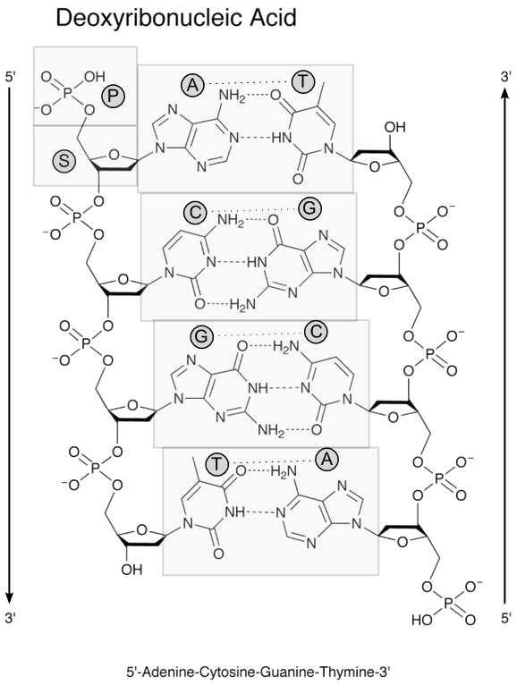
Figure 1 Structure of a double-stranded DNA chain, composed of the strands of the sequence 5’-ACGT-3’. Adenine (A) and thymine (T) are attracted together by two hydrogen bonds, and guanine (G) and cytosine (C) are attracted together by three hydrogen bonds. The DNA backbone consists of an alternating phosphate (P) and deoxyribose sugar (S) chain.
Several properties of DNA make these biological polymers ideal targets for specific detection of pathogens. Firstly, hybridization can be exploited to capture specific target sequences of single stranded DNA from a sample using complementary base sequences as probes. Also, specific DNA sequences can be targeted to discriminate between different species of organisms in a sample. In addition, sequences that encode specific functions such as antimicrobial resistance can be detected to provide additional clinically relevant information.

Working principles of DNA biosensors
The general design of a DNA biosensor provides a platform for hybridization of a target strand with a probe, and for subsequent detection of that hybridization event. Biosensors have the components of a molecular recognition layer, consisting of single-stranded nucleic acid or nucleic acid analogue probe molecules attached to a surface; and a signal transducer, to convert the hybridization event into an appropriate readout (Figure 2).
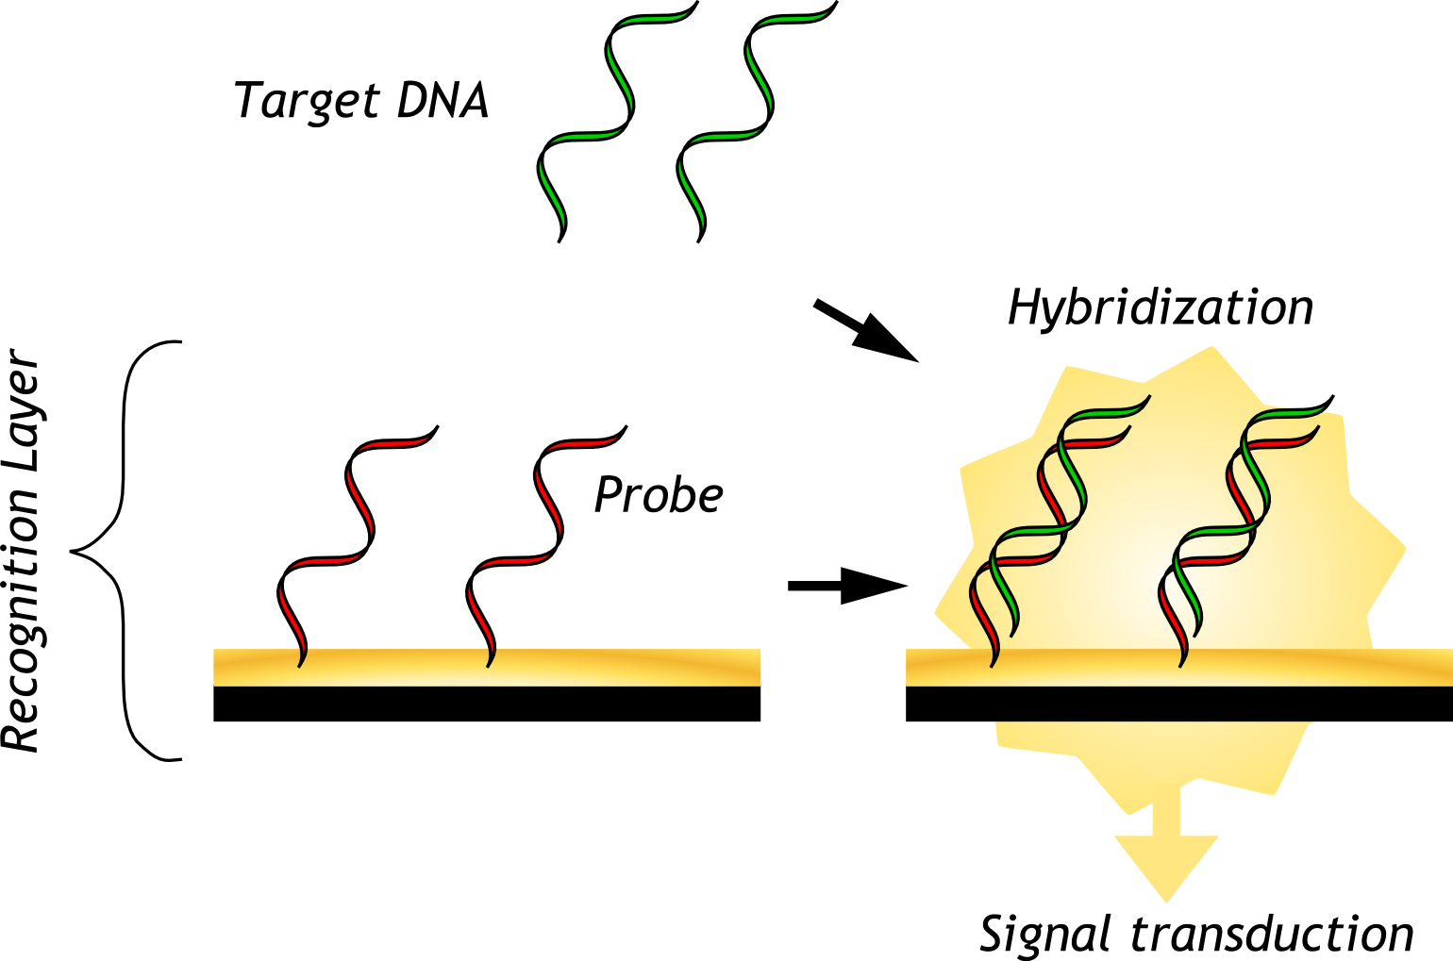
Figure 2 General design of a DNA biosensor.
The method of signal transduction is one crucial way in which biosensors differ from one another. Most signal transduction approaches can be broadly categorized into optical, piezoelectric, electrical, or electrochemical. Other transduction methods have also been explored including those based on photoelectrochemical and magnetoresistive strategies [17] [18].
Extensive progress has been made in the last two decades in the development of electrochemical DNA biosensors [19]. In basic terms, these sensors rely on a change in the redox activity at an electrode surface in response to hybridization of the target with an electrode-immobilized probe. The change in redox activity can result from a number of different mechanisms, which will be detailed further in section 2.3.
Electrochemical modalities of signal transduction have numerous advantages that make them particularly well-suited for point-of-care applications. Both instrumentation and device can be made to be miniaturized and low-cost. Remarkably low limits of detection can be obtained through optimization and various signal amplification strategies [20] [21]. In addition, rapid sample processing is possible when using label-free electrochemical methods. As a result, this readout method has seen particularly expansive development in recent years [22].

Principles of electrochemical DNA biosensors
Electrochemical DNA biosensors use DNA or DNA-analogue probes immobilized on electrode surfaces to capture complementary DNA targets. The hybridization event is detected through some form of electrochemical signal modulated by the presence of target DNA. A number of electroanalytical techniques may be employed to interrogate the electrode surface and measure a signal. The signal is often generated by redox activity of either an added indicator or the nucleic acid bases themselves.

Probe immobilization
Immobilization of DNA or DNA-analogue probes onto a recognition layer is a required preparation step in many DNA biosensors. The way that this is performed varies depending on the surface, the readout method, and other specific considerations of the biosensor. One common method is through the self-assembly of thiol monolayers [22]. For many metals, especially noble metals including gold, thiolated molecules will bond tightly with the surface through a process called chemisorption. Bonds between sulfur and metal atoms lead to the formation of a self-assembled monolayer (SAM) on the metal surface. To exploit this spontaneous process, DNA probe molecules can be functionalized with a thiol group so that they become tethered to the metal surface. Noble metal surfaces are ideal for electrochemical sensing strategies due to their high conductivity and remarkable inertness. In addition, SAM formation is a simple and spontaneous process, making this method of probe immobilization one of the most widely used for electrochemical DNA sensing [20] [23] [24] [25] [26] [27].
Following thiolated probe deposition, a “backfill” is typically performed using another thiolated molecule, or diluent, such as 6-mercapto-1-hexanol (MCH). The function of this diluent is to reduce non-specific adsorption of the probe DNA backbones from the surface of the gold [28]. In addition, this serves to remove weakly bound probes off the surface, as well as to allow properly chemisorbed probes to extend into the solution (rather than lying flat) so that they are in a suitable conformation for hybridization [29].

The three-electrode system
Electroanalytical techniques frequently use a three-electrode system for independent control and measurement of the voltage and current across the sensing surface (Figure 3). The three-electrode setup consists of a working electrode, a counter electrode, and a reference electrode. The recognition layer of the biosensor is paired with the working electrode so that the surface can be interrogated using electrochemical techniques. Current flows between the counter and working electrode. The counter electrode is made of a high surface area, non-reactive substance such as platinum to avoid the generation of unwanted side reactions. The reference electrode has a high input impedance and a stable and well-known electrode potential, and is used to measure the potential of the working electrode.
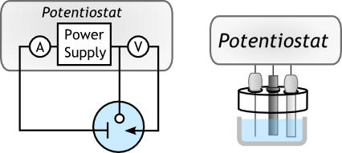
b
a
Figure 3 (a) Electrical connections involved in a three-electrode cell containing (from left) counter, working, and reference electrodes. (b) Schematic representation of a practical three electrode setup (with electrodes in the same order).

Electroanalytical methods
Electrochemical detection of DNA hybridization is performed by applying some form of electrical perturbation to the electrochemical cell and measuring the changes in another electrical property resulting from electrochemical behaviours at the working electrode. For instance, in amperometric and voltammetric techniques a potential is applied over time and the resulting current response is measured. Other electroanalytical methods measure impedance, as in the case of electrochemical impedance spectroscopy (EIS), or potential, as in potentiometry. Common amperometric and voltammetric methods for DNA detection include cyclic voltammetry (CV), differential pulse voltammetry (DPV), and chronocoulommetry (CC) (Figure 4(a)).

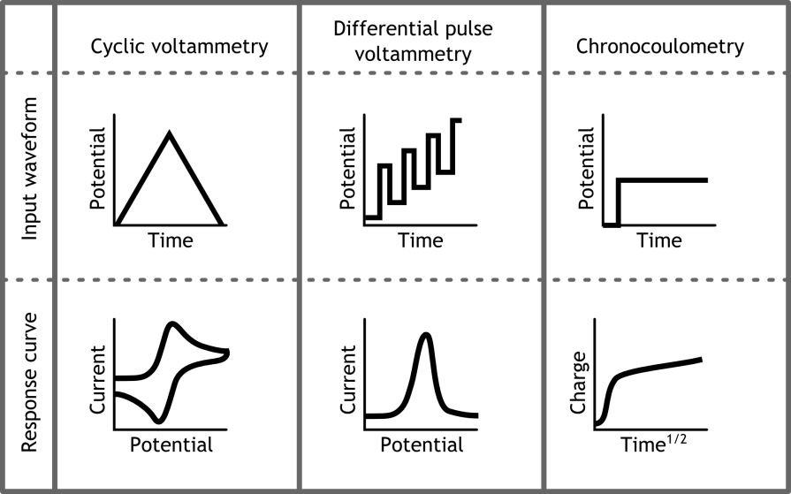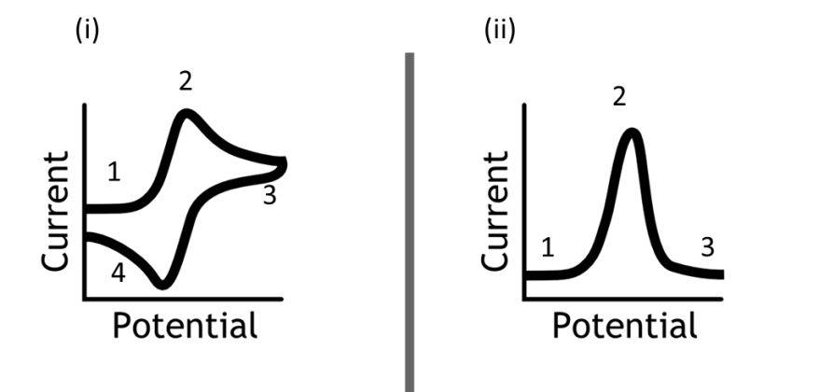
(a)
(b)
Figure 4 (a) Input waveforms and measured responses of cyclic voltammetry, differential pulse voltammetry, and chronocoulometry. (b) enlarged views of typical CV and DPV response curves.
In CV, a potential sweep is applied over a potential window, and current is measured. The resulting cyclic voltammogram displays peaks related to the reduction and/or oxidation of redox species present in the electrochemical cell. In a DNA biosensor using CV for readout, the abundance of redox indicator at the working electrode surface is altered by the presence of hybridized DNA [30]. The altered abundance corresponds to a measurable change in CV signal.
In a typical CV scan, a redox agent is first reduced then oxidized, or vice versa, as the working electrode’s potential changes (Figure 4(b).i). Assuming the convention of more negative potentials displayed to the right, the CV scan starts at a potential more positive than the reduction potential for the redox agent (Figure 4(b).i, 1). Not much current is seen. Then as the potential is swept to higher potentials, reduction begins to occur and electron transfer from the electrode to the reagent occurs. This occurs at an accelerating rate until the reaction becomes limited by the quantity of unreacted redox agent diffusing to the electrode. At this point, a current peak is reached and the limitation of diffusion reduces the observed current (Figure 4(b).i, 2). At the end of the scan window, the potential sweep direction switches. When the direction switches, a rapid change in current occurs and levels off, due to the double-layer capacitance at the electrode (Figure 4(b).i, 3) [79]. Then, as the potential returns to more positive values, redox molecule is oxidized back to its original state, resulting in an oxidative peak (Figure 4(b).i, 4).
The quality of a CV response curve can be affected by the capacitive charging of the electrode’s double layer, which leads to less defined signals and increased background. DPV poses a solution to such effects (Figure 4(b).ii). The DPV scan also exhibits an increase (Figure 4(b).ii, 1), peak (2), and decrease (3) in current in the presence of a redox agent, corresponding to the increasing and decreasing rates of electron transfer at the electrode surface. The technique applies pulses of potential to a stepwise increasing or decreasing baseline. By measuring current toward the end of each potential change, time is provided for capacitive currents to dissipate before the current is sampled. The background current is thereby minimized.
In CC, a single potential step is applied to the electrode and the charge passing through the electrode is measured over time. For electrodes with a planar surface, plotting charge against the square root of time allows for visualization of a linear regime in which charge is mediated by Fickian diffusion of redox species towards the electrode. The charge observed before the start of this linear regime can be attributed to capacitive charging of the electrode’s double-layer and redox of surface-confined species. For DNA detection, the amount of charge transferred in the surface-confined redox reaction is dependent on the amount of target DNA hybridized to the probes.
Electrochemical impedance spectroscopy is a powerful technique involving the measurement of impedance over a range of alternating current frequencies. Plotting the real and imaginary components of the impedance results in a Nyquist plot, from which important parameters such as charge transfer resistance can be obtained (Figure 5). In a DNA biosensor, more negative charges are found at the surface of the electrode after hybridization due to the anionic phosphate groups in the DNA backbone. For EIS, the redox indicator can be selected to be negatively charged, as is the case with ferricyanide ([Fe(CN)₆]³⁻, FiCN) and its reduced form, ferrocyanide ([Fe(CN)₆]⁴⁻, FoCN), so that charge transfer resistance increases in response to the heightened surface negative charge after hybridization [31].
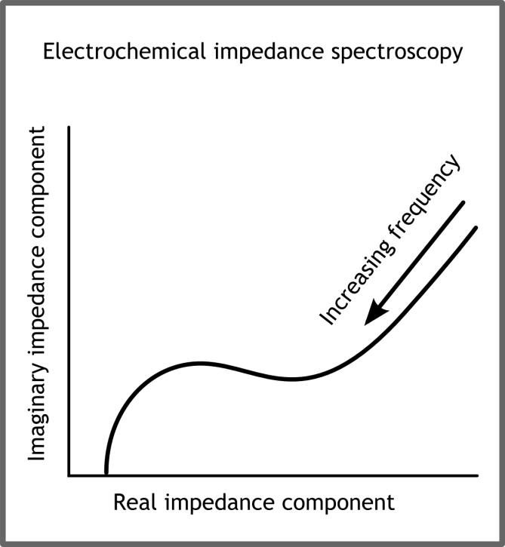
Figure 5 Typical Nyquist plot generated from electrochemical impedance spectroscopy of an electrochemical cell containing a redox reporter.

Direct oxidation of DNA bases
One method of electrochemical signal transduction is through the direct oxidation of DNA bases. The bases adenine and guanine are capable of being oxidized by sufficiently positive potentials. Of the two, guanine requires lesser potentials to be oxidized. Some biosensors exploit this property by applying a potential sufficient to oxidize guanine bases after exposure to the sample has taken place [32]. The oxidation of guanine bases leads to a current signal. To reduce background contribution from the probe strand, the probe’s guanine bases may be replaced with inosine, which will also form a base pair with cytosine but has a well-separated oxidation signal from the guanine response. The electrochemical signal that would be present with oxidation of guanine bases in standard DNA probes is thereby eliminated. Guanine oxidation is also involved in an electrocatalytic signal transduction strategy discussed in Section 2.4.4.
Large voltages are required in order to oxidize DNA bases. This is a significant impediment because high potentials may result in the unwanted redox reactions occurring in some samples. Such side reactions, in combination with the large residual currents associated with large potentials, have impacts on the background signal collected and thus limit the sensitivity of the device. In addition, the number of guanine bases in a target is sequence-dependent, which limits the ease with which new targets could be validated for detection.

Redox indicators
Indicator-based detection relies on the chemical and physical properties of the indicator to react in greater or lesser quantities when the probe has successfully hybridized to the target. An effective indicator would allow for clear differentiation between single- and double-stranded DNA.
Intercalating indicators associate with dsDNA so that it is present in greater abundance at the electrode surface after hybridization. Examples of this type of indicator include methylene blue and ferrocenyl naphthalene diimide [23] [24]. Intercalators take advantage of the phenomenon of pi stacking which allows electrons to tunnel through stacked nitrogenous bases [25]. Since the pi-stacked structure only exists in dsDNA, the tunneling behaviour increases the sensor’s ability to discriminate between dsDNA and ssDNA.
Another class of indicators used are positively charged, so as to electrostatically associate in greater quantities with dsDNA. For instance, cobalt complexes such as Co(bpy)₃³⁺ and Co(phen)₃³⁺ bind electrostatically in the minor groove of the DNA helix [26] [33]. The hexaammineruthenium (III) complex [Ru(NH₃)₆]³⁺ (RuHex) also has a net positive charge, allowing it to bind electrostatically to the anionic DNA backbone [27]. RuHex has been used extensively with many sensing platforms to report hybridization of DNA [34].
Labelling methods are also used to associate redox indicators with target strands. A common strategy for labelling is known as a sandwich assay. In a sandwich assay, the captured target DNA is further hybridized to another DNA or DNA-analogue label which is in many cases covalently attached to the redox molecule [22]. In other cases, the label is attached to a nanoparticle or an enzyme to catalyze reactions which contribute to the current signal [35]. One unfortunate drawback of labelling is that they require extra time for the labelling to take place before measurements can occur.
Depending on the readout method, the number of probes at the surface, and a number of other factors, different biosensors can have varying degrees of sensitivity. Many methods have been employed to enhance the sensitivity of electrochemical DNA biosensors. Some of these will be discussed in the following section.

Enhancement of sensitivity
A great number of methods have been employed to increase the sensitivity of electrochemical DNA biosensors. The use of nucleic acid amplification strategies, synthetic DNA analogues, sandwich assays, and modified electrode surface structures have all been demonstrated to achieve lower detection limits than conventional detection schemes [36].

Nucleic acid amplification
As hybridization assays are inherently limited by the number of copies of target strands, preprocessing steps which amplify the DNA sequence in question has the effect of increasing the readout signal. PCR is the most well-established amplification technique.
The technique of PCR amplification is a cornerstone of molecular biology research which allows for the replication of specific DNA sequences. In PCR, DNA primers which are specific for the region of interest bind to the target strand and allow polymerase enzymes to copy the strand. Heat is applied to denature the two strands and then cooled again so that the process of binding and copying is repeated. Through a PCR preprocessing step, target DNA can be amplified prior to detection, increasing the availability of targets and enhancing the measured signal [37].
PCR is conventionally performed in a specially designed machine known as a thermocycler which allows for precise control over the temperature of loaded samples. New platforms have been developed to enable on-chip PCR amplification, eliminating the need for high-cost instrumentation and minimizing the need for human involvement [38].
Recently, isothermal DNA amplification techniques have gained attention due to the specific advantages they offer. Loop-mediated isothermal amplification (LAMP) and helicase-dependent amplification (HDA) have been applied to real-time electrochemical detection of DNA [39]. Isothermal methods use constant, relatively low reaction temperatures of generally 60–65 °C, and this serves to improve probe stability, reduce platform complexity, and minimize temperature-induced bubble formation and expansion in comparison to PCR.
Amplification-based preprocessing suffers from a number of drawbacks. The step requires unique reagents which add to the complexity of the assay, as well as it fabrication. In addition, the step adds to the total assay time [40].

Synthetic DNA analogues
Synthetic DNA analogues have been successfully applied to DNA biosensing in recent years. Peptide nucleic acid (PNA) is the most extensively investigated of these DNA analogues. PNA substitutes the sugar-phosphate backbone of DNA with a peptide sequence of carboxyl and amino groups (Figure 6). Due to the net neutral charge of the molecule, there is no electrostatic repulsion between it and a target DNA strand. As a result, lower detection limits can be achieved by using PNA as the probe [27]. The neutrality of the molecule also offers the advantage of substantially reducing the background signal in electrochemical detection schemes that rely on the electrostatic association between a redox reporter and the target DNA backbone.
The lack of charge on the molecule unfortunately limits the molecule’s solubility, limiting its potential uses. In addition, synthesis of PNA is an expensive process, which drives up the cost of the finished biosensor.
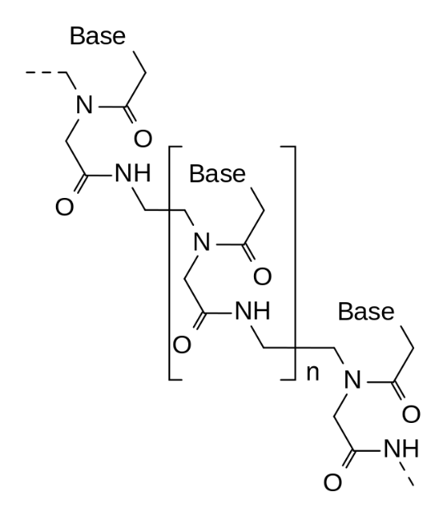
Figure 6 Structure of peptide nucleic acid (PNA).
Another nucleic acid analogue, locked nucleic acid (LNA), has also proven useful for biosensing applications [41]. In LNA, the conformation of the backbone’s sugar motif is restricted by a methylene bridge. LNA has been reported have very high affinity for nucleic acids, particularly RNA, which has encouraged the development of LNA-based biosensors. Out of the many nucleic acid analogues which have been developed, PNA and LNA are the most extensively studied in biosensing applications.

Electrocatalysis
Electrocatalytic signal enhancement has found prominence in literature as a way of achieving greater sensitivity. One such mechanism involves the indirect oxidation of guanine bases at the electrode surface through the action of a redox mediator such as [Ru(bpy)₃]²⁺ [42]. Through this process, the poor electron-transfer kinetics from nucleic acids to most electrode materials is circumvented and a significant oxidation current can be seen by cyclic voltammetry. Although highly sensitive, with detection limits as low as 44 amol/mm², this detection scheme is largely sequence-dependent just like direct oxidation of guanine.
Another electrocatalytic system acts as an enhancement to conventional voltammetry-based DNA detection schemes. In conventional detection schemes, the current signal is typically limited by the number of redox reporters associated with the surface-immobilized DNA. Once redox of all those molecules is complete, no further signal can be measured. In the case of this electrocatalytic system, there is a secondary reporter compound such as [Fe(CN)₆]³⁻ or hemoglobin, present in the bulk solution which reacts with a surface-confined redox reporter such as [Ru(NH₃)₆]³⁺ or methylene blue to replenish its active form [43] [44] [45]. By this mechanism, the same redox reporters at the electrode surface can react repeatedly, thus amplifying the measured current signal.

Nanostructured electrode surfaces
Nanostructured electrodes can significantly enhance the sensitivity of electrochemical biosensors. Nanostructuring length scales of 20 to 50 nm were found to improve detection limits over smooth surfaces by 3 orders of magnitude [46]. Improvement in electrochemical signal has been attributed to two main physical effects. Firstly, increased surface area to volume ratio leads to a greater number of hybridization probes available to capture DNA. Second, nanostructuring allows for more efficient interaction with biomolecules of the same length scale because the three-dimensional geometry reduces the interference of neighbouring probes through steric and electrostatic forces.
A review of rapid nanostructuring techniques for electrodes can be found in Section 3.3.

Conclusions
The present section provided an overview of necessary background information to understand the techniques and principles used for electrochemical DNA sensing in the remainder of the thesis. The relevant properties of DNA, including its structure and function were discussed. The general working principles of DNA biosensors were covered, along with techniques and instrumentation involved in the fabrication and operation of electrochemical DNA biosensors. Finally, some reported methods for sensitivity enhancement were discussed. Short fabrication times are of great value to the development of new biosensing strategies such as the ones reported above. A review of rapid prototyping techniques for electrochemical DNA biosensors is presented in the following section, with a focus on electrode nanostructuring methods.

Rapid Prototyping of Nanostructured Electrochemical DNA Biosensors – Literature Review
As discussed in Section 1.3, the development of POC electrochemical DNA biosensors serves to benefit greatly from rapid prototyping techniques. This section will provide a summary of rapid prototyping techniques relevant to the fabrication of electrochemical biosensors, with particular emphasis on electrode fabrication and nanostructuring.

Rapid prototyping background
Rapid prototyping is a process by which a model of a physical product can be produced quickly and at low cost for the purposes of visualization and/or testing. The process allows for many iterations to be made on a design in quick succession so that problems can be identified early and improvements can be made before having to go through fabrication at larger scales. Rapid fabrication techniques find applications in a diverse range of fields, from surgery; to architecture; to automotive, aerospace, and biomedical engineering [47]. Perhaps the most widely used and well-known group of rapid prototyping techniques is additive manufacturing, whereby successive layers of material are laid down under computer control to create three-dimensional objects of almost any shape. Physical models produced from computed tomography (CT) data and fabricated using additive manufacturing have found utility in craniofacial and maxillofacial surgery, neurosurgery, and orthopedics by allowing surgeons to perform preoperative morphologic assessments and communicate more effectively with families [48]. Customized medical prostheses for facial reconstruction, particularly of the ear and nose, made been made possible through additive manufacturing techniques as well [49].
In 1998, Whitesides et al. [50] introduced a rapid prototyping method using the molding of an elastomeric polymer, poly(dimethylsiloxane) (PDMS), for the fabrication of microfluidic systems. Their work inspired a range of molding, stamping, and bonding techniques for elastomers now known collectively as soft lithography, which allow for the rapid fabrication of micro- to nano-scale three-dimensional structures [51]. The use of PDMS has become standard in microfluidics research due to a number of advantages it offers including low cost, high patterning fidelity, and ease of use [52]. The explosion of progress made in the development of microfluidic analysis systems over the last 16 years owes itself in no small part to the rapid iterative design process that soft lithography makes available [53] [54] [40]. Unfortunately, PDMS is not without its limitations. Propensity for nonspecific biomolecule adsorption, swelling after long-term exposure to water, and difficulty in scaling up for mass production have inhibited the adoption of PDMS outside the realm of academic prototyping [52] [40] [47]. In addition, standard soft lithography techniques require hard masters to act as molds or stamps, which are generally fabricated from silicon by traditional photolithography methods. This master fabrication step adds a level of complexity and time investment to the fabrication process, so iterative design can still be somewhat time-consuming without an alternative master fabrication method.
Paper has recently become a popular substrate for rapid fabrication of microfluidics [55]. By patterning hydrophobic walls of wax in hydrophilic paper with a solid ink printer and melting the wax into the paper to form complete hydrophobic barriers, channels can be created to direct the wicking of solutions through the paper by capillary action. Various functional components such as splitters, timers, valves, and mixers were demonstrated on this platform [56].
In the rapid prototyping of electrochemical DNA biosensors, fabrication of electrode is a crucial step. Performance parameters such as sensitivity, reproducibility, and long-term stability of the detection platform are highly dependent on the properties of the recognition layer, composed of hybridization probe molecules affixed to the electrode surface. While integration into self-contained microfluidic devices is commonly part of the end goal, testing of the actual biosensing modality can be performed without this level of integration simply within a macro-scale electrochemical cell. The following sections of this review will delve into techniques allowing for the rapid fabrication of the biosensing electrodes themselves.

Rapid prototyping of electrodes for electrochemical DNA biosensing
Various methods have been realized to rapidly prototype electrodes on different substrates for biosensing applications. Many of these methods are amenable to integration with rapidly fabricated microfluidic systems. New fabrication methods of electrodes are generally applied to simple analytes such as hydrogen peroxide and uric acid for validation before being applied to DNA sensing due to the additional challenges that DNA detection poses, such as probe immobilization, non-specific adsorption, and sequence specificity. This section will focus on rapid electrode fabrication techniques which have been applied to electrochemical DNA detection.

Screen-printed electrodes
Screen-printing of electrically conductive inks is a well-established method of patterning electrodes onto surfaces. Many commercial sources of screen-printed electrodes (SPEs) exist in different configurations [57]. Substrates such as alumina, ceramics, and polymers such as polystyrene are available to be printed on. The electrode itself is formed from carbon ink/paste or platinum, gold, or other metal paste. The paste is forced through openings in a patterned screen mesh by a squeegee blade, imparting the pattern on the screen onto the substrate. SPEs can be produced quickly and at low cost, making them amenable to rapid prototyping. As such, SPEs have been applied in the literature to sensing of not only DNA, but a wide range of analytes including proteins, organic compounds, heavy metals, nitrites, phosphates, and bacteria [58]. In addition, screen printing can be performed at low cost at very large scales, making this fabrication method particularly well-suited for commercialization [6].
One significant drawback of SPEs is their poor electron transfer kinetics [58]. SPE printing pastes contain mineral binders or insulating polymers to improve adhesion to the substrate. The incorporation of polymers can lead to slower electron transfer at the electrode surface, and variations in ink composition such as size and loading of conductive particles have considerable effects on the sensitivity and reproducibility of electrochemical biosensors. To complicate matters further, the exact paste formulations and compositions are patented by their respective suppliers, or kept as trade secrets [59]. In response to these shortcomings, current SPE research has focused on improving the electroactivity of SPEs, such as through preanodization and integration of an electroactive mediator.
Screen-printed gold electrodes (AuSPEs) have received considerable attention for DNA hybridization biosensors due to the ease with which thiol-functionalized probe DNA can be adsorbed on the gold surface to form self-assembled monolayers, as explained in Section 2.3.1. Wang et al. reported the application of AuSPEs modified with ternary self-assembled monolayers including thiolated DNA probe, MCH, and hexanedithiol constituents for the direct measurement of pM concentrations of target DNA in undiluted biological fluids [6]. Nasciamento et al. attached unmodified DNA probes to AuSPEs through a different technique, through the use of polymers chitosan and poly-L-lysine [60]. Films of chitosan could be prepared by allowing chitosan solution to dry on the electrode surface. Poly-L-lysine films were generated by cyclic voltammetry to induce polymerization. DNA probes were bound to the films by applying them in an acetate buffer solution. Using methylene blue (MB) as the redox indicator, Nasciamento et al. could detect target DNA from bovine papilloma virus as a reduction in the measured DPV peak.
Lu et al. developed SPEs integrated with paper-based microfluidics to produce a folding paper-based electrochemical DNA biosensor [61]. Wax printing was first used to pattern the boundaries of the electrochemical cell. Then screen printing was used to pattern the carbon and Ag/AgCl electrodes. The working electrode was functionalized first with graphene, then gold nanoparticles, and finally with probe DNA. After exposure to the target DNA, a labelling step with reporter probes functionalized with bioconjugates of nanoporous gold, double-stranded DNA, and thionine was performed. Thionine redox was detected by differential pulse voltammetry to detect DNA. Lu et al. demonstrated this biosensor to detect DNA in concentrations as low as 20 aM.

Inkjet printed electrodes
Inkjet printing operates through the use of a piezoelectric or heating component which rapidly vaporizes a droplet of ink and expels it through a nozzle to print upon a substrate. The nozzle scans across the substrate to print the desired pattern of ink. By printing with a conductive ink, inkjet printing can be used as a rapid, cost-efficient, and mask-less method for fabrication of electrochemical biosensors [62].
Fabrication of gold and silver electrodes has been demonstrated by direct inkjet printing of gold nanoparticles on a coated paper substrate followed by a short infrared sintering process [62]. Various other methods have been utilised for the sintering of printed AuNP patterns, including hot plate, and laser methods. A complete electrochemical cell was constructed using inkjet-printed gold and silver as the working, counter, and reference electrodes and a PDMS border to delineate the boundaries of the cell. These cells demonstrated highly reproducible electrochemical behaviour with fast reaction kinetics. More recently, these ink-jet printed gold electrodes were effectively employed to detect DNA hybridization through EIS [63].

Nanostructuring of electrode surfaces
As described in Section 2.4.5, electrode nanostructuring allows for greater probe loading and higher efficiency of probe-target hybridization. Rapid nanostructuring of electrodes has been performed by a number of methods in the literature to enhance DNA detection limits. Some of the publications discussed below performed the technique on electrodes fabricated through methods that would not be considered rapid. Regardless, the nanostructuring step itself could be performed in a short time-span and could potentially be adapted to electrodes fabricated by faster means.

Electrodeposition
Electrodeposition is the most widely-used technique for nanostructuring of electrodes, involving the application of a voltage or current in a cell containing certain metal ions. Though an electrochemical process of nucleation and growth, the ions deposit on the electrode surface and form structures of varying morphology. The morphology can be adjusted by varying parameters of the electrodeposition process, such as time, bath concentration, and applied current or potential [46]. Through careful control of these parameters, electrodes can be programmed to maximize surface area and feature resolution. Electrodeposition is a facile and rapid approach for nanostructuring electrodes through an additive process.
Soleymani et al. [12] fabricated multiple palladium micro-electrodes with varying nanostructured length scales in a single CMOS chip. PNA probes were attached by metal-thiol adsorption. Different electrode morphologies had different log-linear dynamic ranges for DNA detection, and collectively they could cover a dynamic range of six to seven orders of magnitude with a detection limit of 3 aM.
In another study, electrodeposition of gold was performed at high negative potentials to create dendritic nanostructures on gold disk macro-electrodes which yielded an 8.3 times increase in surface area over planar electrodes [21]. Through the use of immobilized DNA probes and MB as the redox indicator, a target DNA concentration as low as 1fM could be detected.
Gold electrodeposition on SPEs has also been demonstrated for DNA sensing. One group produced gold nanostructures of two morphologies (small spherical nanoparticles and larger structures) on the surface of screen-printed carbon electrodes (SPCEs) and functionalized them with DNA probes either through a gold-thiol bond or through streptavidin-biotin cross-linking [64]. The lowest detection limit, 3 pM, was achieved with the biotin-streptavidin electrodes. Another study similarly created electrodeposited gold nanoparticles (AuNPs) on the surface of SPCEs and achieved a detection limit of 15 aM using an enzymatic silver deposition readout method with CC [65].

Nanomaterials
Nanomaterials such as nanoparticles and nanotubes can be functionalized with a range of biomolecules, including DNA probes. Many nanomaterials exhibit high conductivity and their incorporation into other electrode fabrication schemes can be used to increase electrode surface area and rate of charge transfer. Synthesis of some nanomaterials can be a difficult, lengthy, and/or expensive process. However, with the growth of interest in nanomaterials, many of these are available commercially, making their use more amenable to rapid prototyping.
Graphite-based SPEs have been used as substrates for fabrication of chitosan/iron oxide nanoparticle biocomposite films [66]. DNA probes specific to HIV sequences were immobilized to the films through a phosphoramidate reaction between the amine group of chitosan and the phosphate group of the DNA. A detection limit of 50 pM was obtained, and the authors suggested that nanoparticles facilitate electron transfer and thus enhance the current response and the sensitivity of the overall system.
Another group has demonstrated a novel method for attachment of different sequences of DNA probes onto specific electrodes of a SPE array through the electrodeposition of probe-functionalized AuNPs [67]. By applying potential one at a time to different working electrodes, a multiplexed biosensor could be fabricated. Sensitivity was enhanced by the high surface area of nanoparticles.
Carbon nanotubes are one of the most well-known and commonly used materials of nanotechnology, and they have been extensively applied to electrochemical biosensing. In a study by Bonanni et al., multi-walled carbon nanotubes (MWCNTs) with carboxyl-groups were used in a screen-printed electrode [68]. Amino terminated DNA probes were linked to the MWCNTs by carbodiimide chemistry to form amide bonds. Subsequent hybridization and EIS measurement led to a detection limit of 72 pmol.
Graphene is another nanomaterial that has been widely used on electrodes for enhanced sensitivity. For instance, Wang et al. [69] used reduced graphene oxide to modify the surface of glassy carbon electrodes. DNA probes could successfully be anchored on the graphene oxide surface without any chemical modifications. Hybridization to the complementary strand could be detected by EIS down to a concentration of 100 fM.
Polyaniline is a conducting polymer with a number of useful features for biosensor research including high conductivity, low cost, direct and easy deposition on electrode surfaces, high surface area, and tunable properties such as shape and dimensions [68]. It can take on a number of forms including nanospheres, nanorods, and nanotubes. As a result, it has inspired the development of polyaniline-based DNA biosensors. In one publication, nanofibrous polyaniline electrochemically deposited onto ITO-covered glass plates served as a matrix for DNA immobilization [70]. DNA sensing using MB as an indicator showed a sub-femtomolar detection limit after a mere 60 s hybridization time.

Other methods
In one study, nanostructuring was accomplished without incorporation of material, but rather restructuring of the existing electrode surface. A kind of nanoporous gold electrode (NPG) prepared through repetitive square-wave oxidation reduction cycling was shown to have a 9.9 times larger surface area than a planar electrode of equal geometric surface area [71]. Thiolated DNA probes were deposited and the electrode’s capability as a sensor was investigated. When DPV was performed in the presence of MB, a detection limit of 6.7 pM was reported. The authors attributed the sensitivity enhancement to superior conductivity and higher surface area.
The method used to fabricate the wrinkled nano-/micro-structures for this thesis will be discussed in detail in the following section.

Wrinkled nano-/micro-structured electrodes
The nano-/micro-structuring approach which was used in this thesis is unlike any of the methods described in the previous section in that it involves the application of physical stresses on an initially planar surface to achieve its structural features. Below, the progress of research leading up to the fabrication method’s application in this paper is discussed, followed by a detailed description of the fabrication method and the progress of prototypes in the design of the electrochemical devices used in this thesis.

Background
The concept of leveraging rapidly fabricated wrinkled surfaces for a variety of applications has recently become of great research interest. Earlier studies demonstrated wrinkled metal films on PDMS depositing metal on expanded, heated polymer and subsequently allowing the substrate to cool [72]. The compressive stress imparted on the overlying film created wrinkles of wavelengths around 20 to 50 μm.
Wrinkled films on substantially smaller length scales were achieved by Fu et al. [16]. A rapid approach to create metal nanowrinkles of tunable size on a shape memory polymer was reported. A prestressed polystyrene (PS) substrate was first coated by sputtering with specific thicknesses of gold. Heating above the glass transition temperature of PS caused the polymer chains to relax and the substrate surface shrank bi-axially to less than 50% of original dimensions. The shrinking caused the stiffer metal film to buckle and form wrinkles of wavelength around 200 nm to 1 μm.
Even finer wrinkled structures have been achieved by using polyolefin (PO) films [73]. Shrinkage of approximately 95% was observed, and electrodes created by this method showed 647% increased electro-active surface area [74]. Quantitative characterization of wrinkled structures generated by shrunk PO films in terms of wavelength, peak-valley distance, and other physical parameters has yet to appear in literature.
PS shrinking has been used for rapid fabrication of other chip-based systems. Screen-printing of a microfluidic design using dielectric ink onto PS allowed for the creation of high aspect-ratio microfluidic channels after shrinking [75]. Wrinkling on the printed features was not observed, likely due to differences in the material properties of ink and metal films. High aspect-ratio channels could also be produced by scribing into the PS material [76].
Our group has recently shown the rapid fabrication of multi-scale electrodes on polymer substrates using benchtop methods of craft-cutting and polymer-induced metallic thin film wrinkling. Through the use of self-adhesive vinyl films as a mask for sputtered gold, multiplexed thin film electrode arrays can be patterned onto a prestressed PS substrate. Our group has exploited this fabrication method in combination with heat-induced gold film wrinkling to create electrodes of electro-active surface area 477% to 665% greater than that of planar electrodes of equal geometric area [15]. Electro-active surface area was further enhanced through electrodeposition of gold on the wrinkled surfaces.
Wrinkled structures have been applied to detection of ferrocyanide, nicotinamide adenine dinucleotide (NADH), 2-(dibutylamino)-ethanol (DBAE), crystal violet, and rhodamine 6G through electrochemical, electrochemiluminescent, and surface-enhanced Raman scattering modalities [15] [74] [77]. To the author’s knowledge, no publication has yet investigated the utility of wrinkled structures on electrochemical DNA biosensing. The following sections of this thesis will detail the progress made towards this goal.

Device fabrication
The fabrication steps followed to produce wrinkled gold electrochemical devices (WG-EDs) using the vinyl masking and PS shrinking approach are depicted in Figure 7. Sheets of pre-stressed polystyrene (Graphix Shrink Film, Graphix, Maple Heights, Ohio) were cleaned by rinsing in 2-propanol and water, and were dried under a dry nitrogen (Figure 7.i). To produce the patterned masks, adhesive vinyl films (Figure 7.ii) were applied to the PS sheets and flattened using a roller. Patterns designed with Adobe Illustrator [v.16.0.3] CAD modelling software (Adobe Systems, San Jose, Califormia) were then cut into the vinyl film using a Robo Pro CE5000-40-CRP vinyl cutter (Graphtec America Inc., Irvine, California) equipped with a CB09UA supersteel blade (Figure 7.iii). The vinyl cutter was set to force, quality and speed of 10, 1, and 1 respectively. Vinyl was cut with three 5 mm x 5 mm square electrodes per device. The vinyl mask was designed such that each electrode square would have a thin “wire” connection to a contact pad. The cut out vinyl was peeled off using tweezers, exposing the desired pattern on the PS substrate (Figure 7.iv).
The masked PS surface was coated by radio frequency sputtering with a thin film of gold of predefined thickness (20, 50, 100, and 200 nm) from a 99.999% purity gold target (LTS Chemical Inc., Chestnut Ridge, New York) using a Torr Compact Research Coater CRC-600 manual planar magnetron sputtering system (New Windsor, New York) (Figure 7.v). Sputtering was carried out in argon atmosphere at a pressure of 1x10⁻⁵ torr. A 13.56 MHz, 20 W RF power supply was used to provide the RF field, which allowed for a typical gold deposition rate of 0.7 Å/s. The remaining vinyl mask was lifted off to reveal the desired gold pattern on the PS sheet (Figure 7.vi). The devices were rinsed in 2-propanol and water.
To complete the fabrication of wrinkled electrodes, these patterned PS substrates were heated to 160°C on aluminum boats for 3 minutes in a 3511FSQ (664) Isotemp gravity convection oven (Fisher Scientific, Ottawa, Ontario), allowing the pre-stressed polymer chains in the PS to relax. Bi-axial shrinking of the substrate caused the adhered gold film to buckle and wrinkle (Figure 7.vii). Gold squares of original dimensions 5 mm x 5 mm became 2 mm x 2 mm after shrinking. Each electrode’s patterned wire was covered using an insulating, water-insoluble polymer glue (Elmer’s Model and Hobby Cement, Elmer’s Products, Inc, Westerville, OH) to prevent the wire from interfering with electrochemical measurements (Figure 7.viii). Finally, the devices were once again rinsed with 2-propanol and water.
For purposes of comparison, planar gold electrochemical devices (PG-EDs) were fabricated in a similar fashion. The same vinyl pattern was cut at 40% scale in order to create devices of equivalent final geometric area. Gold was sputtered to a thickness of 100 nm. The heating step was omitted from the preparation of the planar devices.
Figure 7 Fabrication of patterned electrodes through masking with vinyl, sputtering with gold and shrinking of the polystyrene substrate.

Rapid prototyping of device design
The first generation device design had a single electrode and incorporated a vinyl mask patterned by craft cutter with a 2 mm x 2 mm window. This mask was placed on a larger sputtered area in order to accurately control the geometric area of the electrode (Figure 8(a)). The second generation device design had three electrodes grouped onto a single substrate to simplify testing electrodes in triplicate. Unfortunately for both devices, small bubbles tended to persist along the edges of the vinyl where it made contact with the electrode surface, which prevented complete and reproducible wetting of the electrode surface.
(a)
(b)
Figure 8 (a) First device design with probe deposition in progress. (b) Second device design.
Devices were redesigned to eliminate the need for the vinyl film. The new design consisted of 3 square electrodes of original dimensions 5 mm x 5 mm which could predictably and reproducibly shrink to 2 mm x 2 mm after heating (Figure 9). In the design, the contact pads were connected by gold so that the initial electrochemical cleaning step of the devices’ application to detection (Section 5.4) could be performed simply on all electrodes at the same time with a single connection. After the cleaning, the connections were severed using a scalpel blade.
The redesign and fabrication process could be performed rapidly and with minimal waste of resources.
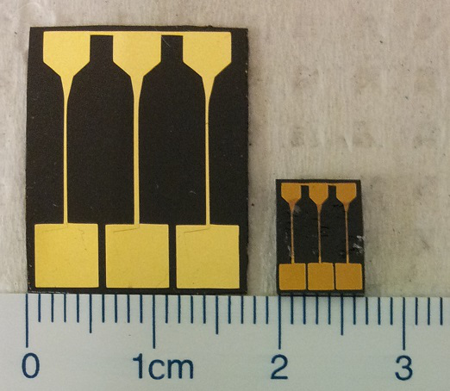
Figure 9 Photograph of wrinkled gold electrochemical devices of 200 nm sputtered gold thickness, before shrinking (left) and after shrinking and applying insulating glue to gold wires (right).

Conclusions
The present section reviewed current methods used to rapidly fabricate electrodes for DNA detection. Rapid methods for nanostructuring the electrode surface were covered. Presented next was a history of research on metallic thin film wrinkling and a detailed description of the fabrication method used to produce the wrinkled nano-/micro-structured electrodes which are the focus of this work. The iterative process used to develop the devices tested in this thesis was presented. The utility of the rapid prototyping process for biosensor development was thereby validated.
The eventual goal in the rapid development of a nanostructured, multiplexed electrochemical DNA detection platform was to demonstrate the sensing capability of these electrodes. Prior to this, the detection scheme had to be demonstrated on a simple planar macro-electrode setup so that any problems with the detection scheme could be identified and corrected.

Development of Electrocatalytic Detection Scheme for Gold-Disk Macro-Electrodes
Before performing electrochemical DNA detection on wrinkled substrates, a detection protocol was first developed and validated using gold-disk macro electrodes as a proxy due to their relative simplicity, ease of preparation, and reusability. The signal transduction strategy was adapted from one reported in literature [43].
In this section, the full detection scheme is detailed and the detection results are discussed. A subsequent test for determination of the limit of detection is explained and the results of that test are presented.

Detection method

Materials and reagents
Potassium chloride (KCl, ≥99.0%), phosphate buffer (PB, 1.0M, pH 7.4), 6-mercapto-1-hexanol (MCH, 99%), 2-mercaptoethanol (MCE, ≥99.0%), hexaammineruthenium(III) chloride (RuHex, 98%), sodium dodecyl sulfate (SDS, ≥99.0%), and saline sodium citrate buffer (SSC), dry blend were purchased from Sigma-Aldrich (St. Louis, Missouri). Potassium ferricyanide (FiCN, 99.0%) was purchased from Anachemia (Rouses Point, NY). Sulfuric acid (H₂SO₄, 98%), 2-propanol (99.5%), methanol (≥99.8%), and sodium chloride (NaCl, ≥99.0%) were purchased from Caledon Laboratories (Georgetown, Ontario). Ethanol was purchased from Commercial Alcohols (Brampton, ON). Immobilized TCEP Disulfide Reducing Resin was purchased from Thermo Scientific (Rockford, Illinois). Tris(hydroxymethyl)aminomethane (tris, ≥99.9%) was purchased from BioShop Canada (Burlington, ON). All other reagents were of analytical grade and were used without further purification. Milli-Q grade ultrapure water (18.2 MΩ·cm) was used to prepare all solutions and for all washing steps.
Synthetic oligonucleotides were purchased from Integrated DNA Technologies (IDT, Coralville, Iowa). The sequences used were as follows: PLZD (thiolated probe strand: 5’-[thiol-C6]-CTG GCC GTC GTG GCC CGC AC-3’), F-PLZD (fluorescent, thiolated probe strand: 5’-[thiol-C6]-CTG GCC GTC GTG GCC CGC AC-[6-FAM]-3’), TLZD (complementary target strand: 5'-GTG CGG GCC ACG ACG GCC AG-3’), and T4 (non-complementary target strand: 5'-TTT TTT TTT TTT TTT TT-3’). The [thiol-C6] modification represents a 5’ hexanethiol and [6-FAM] represents 3’ 6-carboxyfluorescein. All strands underwent standard desalting by IDT, and were stored at a concentration of 1mM in ultrapure water at -20°C.
The [thiol-C6] modifier consists of two six-carbon alkyl chains linked together by a disulfide (Figure 10). One end of the modifier is bonded to the 5’ phosphate of the DNA probe, while the other end terminates in an OH group.
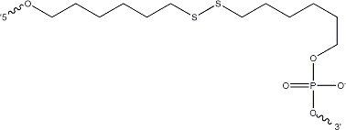
Figure 10 Structure of [thiol-C6] modifier. Reprinted with permission from IDT.
All electrochemical measurements were performed using a CHI 660D electrochemical workstation (CH Instruments, Austin, Texas). Gold disk working electrodes of 2 mm diameter were used as the biosensor surface. A reference electrode of Ag/AgCl (1.0M KCl) and a counter electrode of platinum wire were used.

Probe preparation
Prior to use, the dithiol modifier of PLZD probes needed to be cleaved so that DNA could adsorb to the gold surface via the free thiol group. To achieve this, a 100μl aliquot of TCEP immobilizing slurry was centrifuged and decanted, leaving approximately 50 μl of the gel. A 50 μl solution of 500 μM pH 7.4 PLZD in 25 mM NaCl and 25 mM PB was added to the gel and left to incubate in darkness at room temperature for 1 hour to cleave the disulfide bonds in a reduction reaction. 4 μl of 3 M NaCl was added to the reaction, increasing the ionic strength so that DNA could be released from the slurry into solution. The mixture was then centrifuged in a Nanosep 100K Omega centrifugal device (Pall Corporation, Port Washington, New York) for 1 min at 12,100 x g and the filtrate containing the PLZD was collected. Ultraviolet absorption measurement was conducted to obtain the concentration of PLZD and the probe was diluted to a concentration of 5 μM, adding MgCl₂, PB, and NaCl so that the final concentration of each compound would be 100 mM, 25 mM, and 25 mM, respectively. This PLZD was stored in a tube wrapped with aluminum foil at 4°C.

Electrode preparation
The surfaces of six working electrodes were prepared for modification, starting by polishing with 0.3 μm alumina/water slurry on a polishing cloth. The electrodes were sonicated sequentially in 95% ethanol and deionized water for 5 minutes each. A second polishing was performed in the same manner with 0.05 μm alumina, followed by another round of sonication. The electrodes were then cleaned by cycling between the potentials 0.0 and +1.5 V versus Ag/AgCl in 0.05 M H₂SO₄ solution at a scan rate of 100 mV/s for 30 min until reproducible scans were recorded. The first set of electrochemical scans (“bare scans”) was performed at this point for the purposes of characterization.
SAMs of thiolated probe DNA were created on the electrodes by placing each electrode in a 2 ml centrifuge tube containing 25 μl of the prepared PLZD buffer for 70 minutes in a dark environment. Electrodes were washed in a wash buffer (WB) containing 25 mM NaCl and 25 mM PB, and transferred to 100 μl aqueous solutions of 1 mM MCH for 30 minutes to perform a backfill. Finally, electrodes were soaked in 10 mM tris solution to complete the electrode preparation. At this point, the second set of electrochemical scans was performed (“probe scans”).

Hybridization
After the second set of scans, electrodes were rinsed once again in WB. Three electrodes were exposed to between 1 nM and 1 μM of complementary (TLZD) target DNA, and the other three were exposed to the same concentration of noncomplementary (T4) DNA. Both were suspended in a buffer (pH 7.0) containing adding 25 mM NaCl, 25 mM PB, and 100 mM MgCl₂ for one hour in a dark humidity chamber at 37°C. Finally, the third set of scans was conducted (“target scans”).

Electrochemical scans
Three types of electrochemical scans were recorded: CV in FoCN solution, CC in tris and RuHex solution, and DPV in electrocatalytic solution. CV in FoCN solution was performed to assess the accessibility of the electrode surface to redox-active FoCN molecules. The FoCN solution contained 2 mM FoCN, 25 mM NaCl, and 250 mM PB. The CV scan was performed with two cycles within a potential window from 0.0 V to +0.5 V vs Ag/AgCl, with a scan rate of 100 mV/s. This scan was performed on the bare electrode, after the immobilization of DNA probes, and after hybridization with target DNA. The effectiveness of the cleaning protocol could be evaluated on each bare electrode by observing the peak height and peak-to-peak separation of this CV scan. Following probe deposition and target hybridization, the surface accessibility of the electrodes to FoCN could be evaluated by the results of this scan.
CC was performed after probe immobilization to quantify the probe density following a protocol first reported by Steel et al. [78]. First a baseline was measured in a 10 mM tris buffer (pH 7.4) with a potential step from +0.15 V to -0.35 V and a pulse width of 0.5 s. Then the electrode was transferred to a solution containing 100 μM of RuHex in 10 mM tris for 2 minutes before performing the scan once again in this solution.
DPV measurement was conducted at all three sets of scans, and served as the true quantitative hybridization detection method. This measurement was performed in an electrocatalytic solution containing 2 mM FiCN and 27 μM RuHex, with 25 mM NaCl and 25 mM PB. The following DPV parameters were used: amplitude 50 mV, pulse period 0.2 s, pulse width 50 ms, initial potential +0.1 V, final potential -0.3 V, potential increment 4mV.
This signal transduction scheme has been reported previously in literature [43] and operates as follows. Positively-charged RuHex associates electrostatically with the negatively-charged DNA backbone. As the potential is brought to more negative voltages, the RuHex is reduced, resulting in a corresponding increase in the measured current. This increase in current is enhanced by the presence of FiCN, which acted to replenish the oxidized form of RuHex in an electrocatalytic cycle.
The signal amplitude was calculated as the magnitude of the current peak as defined by the CH Instruments software’s peak-finding algorithm. The percent change in signal amplitude after hybridization was calculated for each electrode using the equation below:
Equation 1 $PCS=\left(\frac{S_{t}}{S_{p}}-1\right)×100\%$
Where PCS is the percent change in signal amplitude, S_{t} is the signal amplitude after hybridization to the target strand, and S_{p} is the signal amplitude after probe immobilization. PCS means and standard errors (SE) were calculated for exposure to both complementary and noncomplementary DNA.

Detection results
Investigating the results of the CV scans in FoCN solution, changes in the properties of the electrode surfaces can be elucidated.
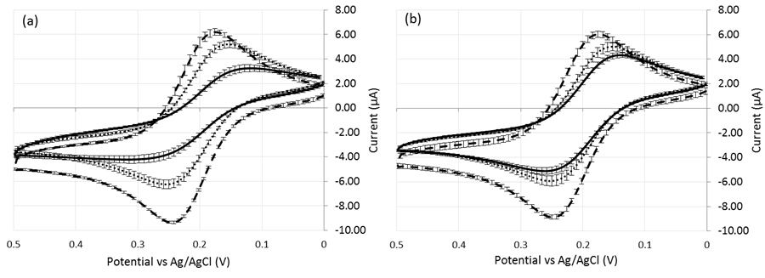
Figure 11 CV scans in FoCN for bare (dashed line), probe-immobilized (dotted line) and target-hybridized (solid line) electrodes. Hybridization was performed with (a) 1 μM TLZD and (b) 1 μM T4 DNA. Standard error bars are shown.
The bare scans displayed well-defined oxidation and reduction peaks of FoCN with a narrow peak-to-peak separation of 66 mV (Figure 11), indicating a highly reversible redox reaction [43]. After probe deposition and MCH backfill, a wider (106 mV) peak separation and reductions in oxidative (-9 µA to -6 µA) and reductive (6 µA to 5 µA) peak amplitudes are seen. This is primarily due to repulsive electrostatic interactions between the anionic FoCN/FiCN redox marker and the polyanionic PLZD probes, leading to less reversibility of the redox exchange. MCH on its own is also understood to increase the peak separation [78], and may have a contribution in this situation. After hybridization to complementary TLZD DNA, a still greater peak separation (194 mV) and further decreased oxidative (-4 µA) and reductive (3 µA) peak amplitudes were observed, indicating that the redox reaction was inhibited further by the presence of hybridized polyanionic target strands. A change is also seen after exposure to non-complementary T4 DNA, but to a lesser extent. This suggests that the strand is adsorbing in a non-specific manner to the surface of the electrode.
A common electrochemical technique for quantifying DNA probe density on planar gold electrodes is to perform chronocoulometric measurements in the presence and absence of dissolved RuHex [29] [78]. In this technique, a potential sufficient to reduce the RuHex is applied and charge is measured over time. RuHex associates electrostatically with surface-confined DNA in a stoichiometrically defined ratio of one RuHex molecule to three DNA bases. When the potential is applied, surface-confined RuHex is rapidly reduced and a diffusion-limited current is established. The observed charge Q as a function of time t after the potential step is the sum of the reduction of RuHex diffusing from bulk solution to the planar electrode, the double-layer charge, and the charge due to reduction of surface-confined RuHex. This is given by the integrated form of the Cottrell equation:
Equation 2 $Q=\frac{2nFAD_{0}^{1/2}C_{0}^{*}}{π^{1/2}}t^{1/2}+Q_{dl}+nFAΓ_{0}$
Where n is the number of electrons per reduced molecule, F is the Faraday constant (C/mol), A is the electrode area (cm²), D₀ is the diffusion coefficient (cm²/s), $C_{0}^{*}$ is the bulk concentration of RuHex (mol/L), $Q_{dl}$is the capacitive charge (C), and $Γ_{0}$ is the amount of surface-confined RuHex reduced (mol/cm²). CC data is plotted as Q versus t^{1/2} (known as an Anson plot), so that the diffusion-limited charge is plotted as linear (Figure 12(a)). A least-squares fit to the linear regime allows for extrapolation to time zero, where Q corresponds to $Q_{dl}+nFAΓ_{0}$. Assuming the absence of RuHex has a negligible effect on $Q_{dl}$, the difference in intercepts between scans performed in the presence and absence of RuHex is taken to be equal to the charge transferred to surface-confined RuHex $nFAΓ_{0}$ (Figure 12(a), inset).
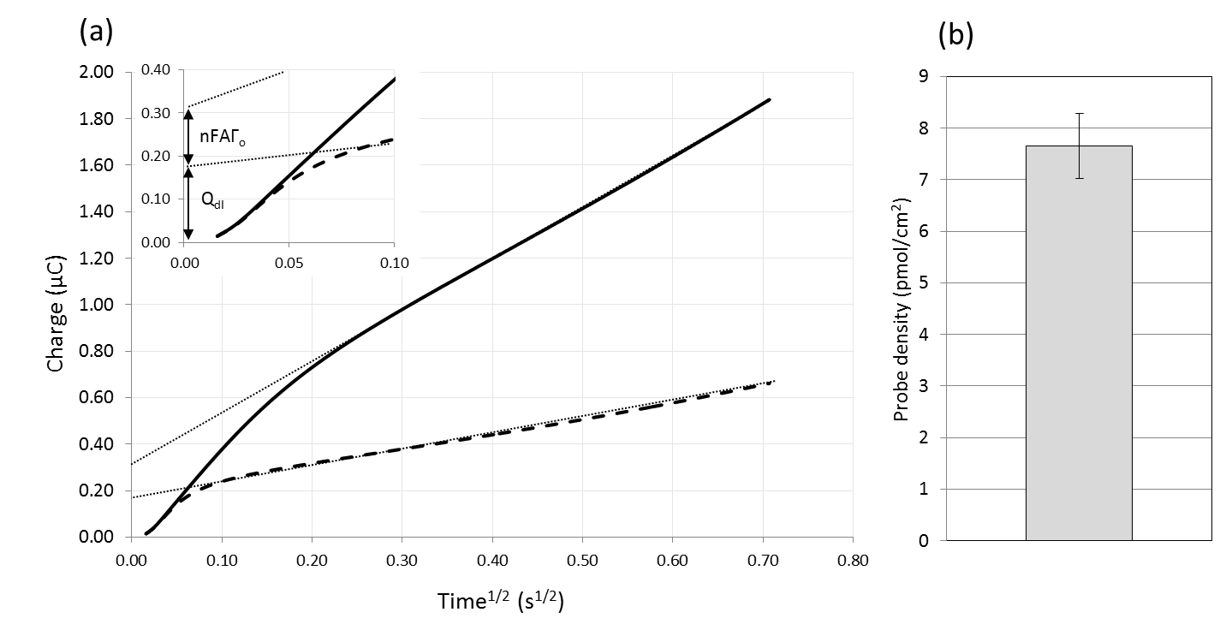
Figure 12 Chronocoulometry data. (a) sample curves from one probe-deposited electrode, scanned in 10 mM tris (dashed line) and in 10 mM tris + 100 µM RuHex. The lines of best fit (dotted lines) are used to determine the intercept at t = 0. (b) Mean probe density for the six electrodes as determined by chronocoulometry.

The DNA probe density can then be determined from the amount of surface-confined RuHex from the following equation:
Equation 3 $Γ_{DNA}=\frac{z}{m}Γ_{0}$
Where $Γ_{DNA}$ is the probe density (moles/cm²), z is the charge per redox molecule, and m is the number of bases in the DNA probe. A mean probe density of 7.65±0.64 pmol/cm² was calculated by this method (Figure 12(b)).
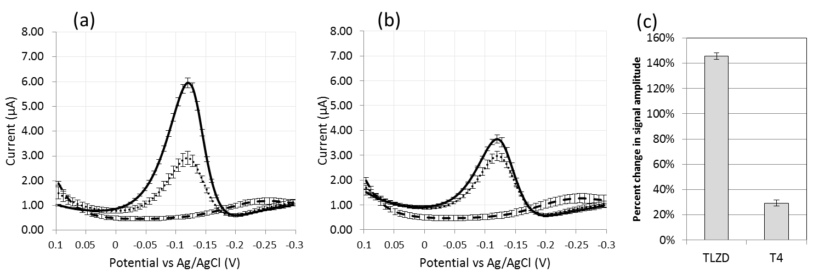
Figure 13 DPV scans for bare (dashed line), probe-immobilized (dotted line) and target-hybridized (solid line) electrodes. Hybridization was performed with (a) 1 μM TLZD and (b) 1 μM T4 DNA. Percent change in the current peak after exposure to TLZD and T4 is depicted in (c). Standard error bars are shown.
Electrochemical signals were measured by DPV with bare, probe, and target scans (Figure 13). The bare scans show negligible redox behaviour in the potential range tested. With the introduction of probe DNA, a clearly defined peak is visible around -0.12 V. An average signal increase of 146% is seen after exposure to TLZD. An increase is also seen after T4 exposure, of 29%.
These results clearly show the efficacy of the presented detection scheme for sensing hybridization events. The significant change in signal seen after exposure to T4 DNA however calls into question the specificity of detection. Adsorption is known to occur between gold surfaces and the polyanionic backbone of DNA [79]. It is possible that defects in the SAM left areas of bare gold exposed to the target DNA solution, leading to the observed increase in signal.
Once the detection scheme had been shown to be effective at detecting complementary DNA at 1 µM concentrations, it was of interest to determine the lowest concentration that could be detected by this same method.

Assessment of limit of detection
The detection scheme was repeated with a modified method in order to determine the lowest detectable concentration of target DNA with macro-electrodes. This limit of detection allowed for later comparison with the wrinkled structured electrodes.

Methods
For this experiment, probe and electrode preparation was performed as previously described in Section 4.1. Following probe scans, sequential steps of hybridization and scans were performed with concentrations of complementary (TLZD) and noncomplementary (T4) target DNA increasing by a factor of 10 with each step, starting from 1 nM up to 1 μM. CV and CC scans were omitted from the protocol. Hybridization to 1 µM of the T4 sequence was used as a control to evaluate background levels. Limit of detection was defined as the lowest concentration at which background-subtracted signal for TLZD target was three times higher than the standard deviation at that concentration.

Results
The DPV scans obtained from two representative electrodes after probe deposition and with each subsequent exposure to TLZD or T4 DNA can be seen in Figure 14 (a, b). Although the experiment was performed with three electrodes for each target sequence, data for only one electrode is shown in each graph for the sake of visual clarity. With higher concentrations of TLZD, higher signal amplitude was observed (Figure 14(a)). Signal amplitude change after hybridization to T4 did not exceed 10% of the original signal (Figure 14(b)). This demonstrates that the assay was specific for the complementary sequence.

Figure 14 DPV response curves at sample macro-electrodes after probe deposition and exposure to varying concentrations of complementary (a) TLZD and (b) T4 DNA. (c) DPV signal response after hybridization with varying TLZD target DNA concentrations for macro-electrode-based detection. Hybridization to 1 µM of the T4 sequence was used as a control to evaluate background levels.
After hybridization to 100 nM concentration TLZD, the percent change in signal amplitude exceeded the background by over three times the standard deviation of the percent change in signal amplitude (Figure 14(c)). Thus, 100 nM was taken as the limit of detection for the detection scheme on macro-electrodes.

Conclusions
This section showed the application of an electrocatalytic DNA detection scheme on a simple, planar macro-electrode platform. The method employed for the detection scheme was described. The electrode’s recognition layer was electrochemically characterized in terms of probe density and accessibility to FoCN for charge transfer. The ability of the detection scheme to distinguish between complementary and noncomplementary target strands was demonstrated. A limit of detection of 100 nM was determined for this detection scheme using the planar macro-electrodes.
Next, the focus is returned to the wrinkled nano-/micro-structured electrodes whose fabrication was detailed in Section 3.4. The techniques used to characterize the electrodes are detailed in the following section.

Characterization Methods for Wrinkled Nano-/Micro-Structured Electrodes
Once wrinkled nano-/micro-structured electrodes had been fabricated, they were characterized and compared with planar electrode surfaces in terms of geometric dimensions (optically), structural morphology (by electron microscopy), electroactive surface area (by CV), and probe deposition behaviour (using a fluorescence-based technique), and sensitivity for DNA detection when used in concert with the detection scheme validated in the above section. Some optimization with regards to the concentrations of redox species had to be performed before the DNA detection characterization could be performed. The aim of this characterization was to compare the wrinkled electrodes’ utility as biosensors in comparison to planar electrodes fabricated in a similar manner.
This section details the procedures used in the characterization and the following section reports the results of that characterization.

Optical measurement
In order to verify the consistency of electrode dimensions, optical measurements were performed. Photographs were taken of the devices against a 2.5 mm x 2.5 mm grid. ImageJ (National Institutes of Health, USA) was used to measure the electrode areas.
Percent difference of wrinkled electrode areas from planar electrode areas was calculated by the following equation:
Equation 4 $\% difference=\frac{\left|A_{w}-A_{p}\right|}{\left|A_{p}\right|}×100\%$

Scanning electron microscopy
After fabrication, devices were characterized by scanning electron microscopy (SEM). SEM images of the planar and wrinkled gold electrodes were obtained using a JEOL JSM-7000S scanning electron microscope with an accelerating voltage of 2 kV, working distance of 6 mm, and low probe current.

Electrochemical characterization
All electrochemical measurements were performed using a CHI 660D electrochemical workstation (CH Instruments, Austin, Texas). A reference electrode of Ag/AgCl (1.0M KCl) and a platinum wire counter electrode were used.
The electro-active surface areas of the wrinkled and planar gold films were quantified using cyclic voltammetry (CV) in a solution of 0.05M H₂SO₄. Devices were first cleaned by rinsing in 2-propanol and water and subsequently performing CV in H₂SO₄. CV was performed with a scan rate of 100 mV/s and a potential range from 0.0 to +1.5 V. The gold oxide reduction peaks of the resulting cyclic voltammograms were integrated to determine the charge and the electrochemically active surface area was calculated (surface area = charge/surface charge density) using the surface charge density of a monolayer of gold, 386 μC/cm² [15]. Each type of electrode was tested in triplicate.

Characterization using the electrocatalytic detection scheme
Once the detection scheme was validated with macro-electrodes (described in Section 4), it was adapted for use with wrinkled nano-/micro-structured electrodes.

Assessment of limit of detection
The limit of detection of the detection scheme was assessed for wrinkled electrodes of 100 nm gold thickness. In this experiment, WG-EDs were prepared as follows. Devices were cleaned by rinsing in 2-propanol and water and subsequently performing CV in H₂SO₄ as described in Section 5.3. Probe deposition was performed at room temperature for 4 hours, and followed with a 1 hour MCH backfill. Probe DPV scans were conducted in the same way as in Section 4.1.5, with a solution containing 2 mM FiCN, 27 μM RuHex, 25 mM NaCl and 25 mM PB. Following this, sequential steps of hybridization and scans were performed with concentrations of target DNA increasing by one order of magnitude at a time. The three electrodes of one WG-ED (“device A”) were used for hybridization with TLZD DNA, while the electrodes of the other device (“device B”) were used with T4 DNA. Data of hybridizations from 10 nM to 1 μM target DNA concentrations are reported.
The signal amplitude was calculated as the peak current of the DPV curve minus the current measured at -0.3 V. The percent change in signal amplitude after hybridization was calculated for exposure to target DNA, just as it was done for macro-electrodes (Equation 1). Hybridization to 1 µM of the T4 sequence was used as a control to evaluate background levels. Limit of detection was once again defined as the lowest concentration at which background-subtracted change in signal amplitude for TLZD target was three times higher than the standard deviation at that concentration.

Study of electrocatalytic behaviour
As reported in Section 6.4.1, this attempt to detect DNA using the detection scheme reported above led to unexpected and poorly understood electrocatalytic DPV scan curves. To address this issue, investigation of the electrocatalytic behaviour of the DPV scans at probe-immobilized wrinkled and macro electrodes was conducted.

Redox agent factorial experiment
In order to clarify the contribution to the observed current made by the redox agents FiCN and RuHex individually and in concert, an experiment was performed with scans containing the agents together and in isolation. For purposes of comparison, the experiment was conducted on both macro-electrodes and WG-EDs. In this experiment, macro-electrodes were prepared as described in Section 4.1.3 and WG-EDs of 200 nm gold thickness were prepared as before by rinsing in 2-propanol and water and subsequently performing CV in H₂SO₄. PLZD was deposited overnight at 4ºC, and MCH backfill was subsequently performed for 1 hour.
A series of scans was employed to study the effect of the redox reporters FiCN and RuHex individually and together in the scan solution. DPV and CV were first performed in 25 mM NaCl and 25 mM PB (wash buffer, WB) containing 50 μM RuHex (“scan A”). The same DPV parameters were used as in Section 4.1.5. CV scans were performed with a single cycle in a potential window from 0 V to -0.35 V, with a scan rate of 100 mV/s. DPV and CV were the repeated in WB with 4 mM FiCN and 50 μM RuHex (“scan B”). Electrodes were then washed thoroughly in WB to remove RuHex that was bound to the DNA and scans were done repeatedly in WB until consecutive scans appeared identical and the last one was recorded (“scan C”). One last set of scans was performed in WB with 4 mM FiCN (“scan D”).

Redox agent concentration optimization
A further study of optimization of the concentration of redox species FiCN and RuHex in the scan solution provided additional characterization information about the electrocatalytic system. It also allowed the identification of the best redox agent concentrations for scans to be performed on wrinkled electrodes. In this experiment, a 200 nm film thickness WG-ED was prepared with probe deposition in the same way as in the previous section, except with a 4 hour PLZD deposition at room temperature. CV and DPV scans were performed using the same parameters as in the previous section in scan solutions containing FiCN at a concentration fixed at 0.5 mM and stepwise increases of RuHex concentration of 0.5 µM, 1 µM, 2 µM, and 4 µM. Then, the electrode was washed thoroughly in WB to remove excess RuHex electrostatically bound to the surface. CV and DPV scans were performed for the same electrode with RuHex concentration fixed at 2 µM and stepwise increases in FiCN concentration of 0.5 mM, 1 mM, 1.5 mM, 2 mM, and 3 mM. Scans were always performed in new aliquots of scan solution.
The scan condition with redox agent concentrations which had exhibited (1) a single, well-defined electrocatalytic peak and (2) the highest signal amplitude (judged as the peak DPV current) relative to background (judged as a DPV current at +1.0 V) was determined as optimal for use with WG-EDs.

Characterization of probe density by fluorescence
One of the critical parameters in achieving high sensitivity for electrochemical DNA biosensors is the density of probes at the electrode surface. To investigate parameters which modulate the probe density at the surface of wrinkled and planar electrodes, a fluorescence-based probe density quantification technique was performed.

Quantifying probe density
Precise control over the density of probes at the electrode surface is critical for optimizing biosensor sensitivity. Past research has shown that optimal probe densities for the greatest hybridization efficiency are significantly below the maximum probe densities achievable through thiol self-assembly [29]. Probe density has been controlled by adjusting deposition time, as well as buffer concentration and molar fraction of probe DNA to thiol diluents in the deposition solution [29] [28] [79]. It has not yet been studied how a wrinkled substrate would affect probe deposition kinetics and dynamics. In order to begin characterizing deposition on wrinkled substrates, an accurate method of probe density quantitation was required.
The technique of CC in a solution of RuHex was employed to quantify probe density for the gold disk macro electrodes in the experiment described previously. However, this method of quantitation cannot be applied to the wrinkled electrode devices because the calculation of surface charge transfer relies on the assumption of a planar electrode surface. The reason for this is that diffusion of RuHex to a planar electrode follows well-defined diffusion behaviour, allowing the reduction of bulk solution RuHex to be modeled mathematically and subtracted from the total observed charge. For complex electrode structures such as wrinkled structures, no method yet exists for subtracting this contribution to the observed charge.
Other options for probe density quantification have been explored in the past. A probe density measurement technique, based on surface plasmon resonance (SPR), is described by Peterson et al. [80]. This technique is unfortunately specific for gold films prepared on SPR prisms and thus was not applicable to the wrinkled substrates.
Huang et al. performed flow-injection quartz crystal microbalance (FI-QCM) and atomic force microscopy (AFM) for this purpose [81]. The FI-QCM technique can only be performed with gold films prepared on quartz crystal surfaces. This method also showed poor agreement with other probe quantitation techniques [81] [82]. The AFM technique counts individual dots in a unit area of gold and extrapolates to the total surface area. This technique relies on assumptions that DNA probes are distributed perfectly randomly over the gold surface; an assumption that would likely prove to be false due to the hills and valleys of the electrode structure. The valleys are less accessible to the bulk solution and require more time for DNA probes to diffuse to those locations. Thus, it is expected that probe densities would be considerably lower in the valleys of the wrinkled structures.
An option for probe density quantitation developed by Demers et al. is through fluorescent labelling of DNA probes, deposition onto the gold surface, desorption of the probes into a buffer, and measurement of fluorescence in that buffer [83]. This technique has been used effectively to systematically map the effects of parameters such as ionic concentration and probe length on probe density [84]. Out of the probe density quantitation methods found in the literature, this one was the best suited for application to wrinkled gold electrodes.

Dependence of probe density on deposition time
Probe deposition kinetics were investigated by observing the probe density after varying lengths of deposition time. This experiment could be broken down into five steps: device fabrication, probe preparation, probe deposition/diluent backfill, probe desorption, and fluorescence measurement.

Device fabrication
This experiment required the fabrication of separate devices from the ones used for electrochemical characterization. Each gold surface needed to be placed in its own separate solution, and WG-EDs and PG-EDs were designed with three electrodes per device. For this experiment, wrinkled gold fluorescence devices (WG-FDs) of varying film thicknesses and planar gold fluorescence devices (PG-FDs) of 100 nm film thickness were developed (Figure 15). Each device had a single 2 mm x 2 mm square of gold. For WG-FDs, as with WG-EDs, vinyl masks were patterned at 2.5 times the final devices dimensions so that after shrinking the desired dimensions would be achieved.
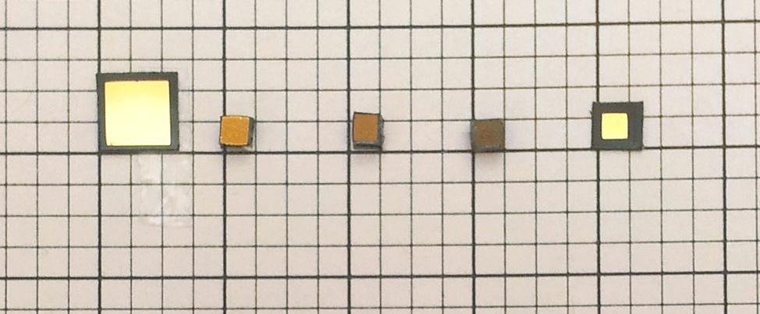
Figure 15 Photographs of wrinkled fluorescent devices on black polystyrene (a) sputtered with 200 nm gold prior to shrinking; (b) 200 nm gold, (c) 100 nm gold, (d) 20 nm gold after shrinking; and (f) 100 nm gold planar device without shrinking.

Probe preparation
Reduction was performed on F-PLZD probes as described in Section 4.1.2, with the following changes. After the reaction was complete, NaCl was not added and the mixture was centrifuged in a Nanosep 100K Omega centrifugal device (Pall Corporation, Port Washington, New York) for 1 min at 12,100 x g and the filtrate was discarded. In this way, the probes remained bound to the surface of the TCEP beads and were retained in the column. Next, 100 μl of pH 7.4 buffer (immobilization buffer, IB) containing 1.0 M NaCl and 10 mM PB was centrifuged through the device for 5 min at 12,100 x g to elute the DNA. Just as before, ultraviolet absorption measurement was conducted to obtain the concentration of PLZD and the probe was diluted to a concentration of 5 μM in IB. This PLZD IB was stored in a tube wrapped with aluminum foil at 4°C.

Probe deposition/diluent backfill
In the following series of steps, fluorescently labelled probes were deposited on fluorescence devices, a backfill was performed, and the probes were desorbed from the surface for measurement of fluorescence intensity (Figure 16).
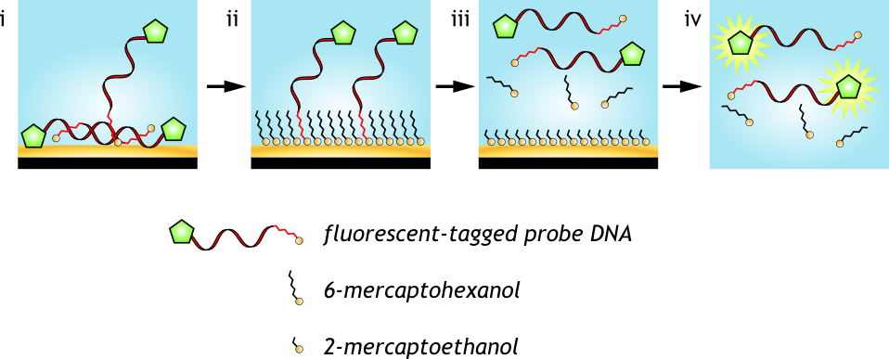
Figure 16 Fluorescence-based method used for probe density quantitation
F-PLZD was deposited onto WG-FDs of 100 nm and 200 nm film thicknesses and PG-FDs. Deposition was performed in a humidity chamber consisting of a petri dish with a wetted paper towel laid on the bottom (Figure 17). Devices were placed on a rectangular plastic sheet. Each device was first wetted by touching a pipette tip containing methanol to the gold surface so that the methanol wicked across the gold surface. 5 μl of F-PLZD were added to each device (Figure 16.i).
Care had to be taken so that evaporation of F-PLZD solutions would be minimized. Evaporation of the droplets occurred in greatest amounts as the humidity in the humidity chamber equilibrated. Thus, re-opening of the chamber was avoided whenever possible. Use of a shallow container reduced the amount of empty space that was required to reach equilibrium.

Figure 17 Probe deposition in progress in a humidity chamber constructed from a petri dish with a wet paper towel.
For each type of device, deposition conditions of 0.25, 0.75, 2, 4, 8, and 18 hours were conducted, with three trials per condition (Figure 17). Start times of deposition were staggered so that they would all finish approximately the same time. When not handling the devices, the humidity chamber was placed in a dark drawer to avoid photobleaching. Once deposition was complete, devices were washed with a buffer of 25 mM NaCl and 25 mM PB and transferred to 100 μl aqueous solutions of 1 mM MCH for 1 hour to perform the backfill (Figure 16.ii).

Probe desorption
After backfill with MCH, each device was rinsed again with 25 mM NaCl and 25 mM PB and transferred to a separate well of a 96-well transparent-bottom microplate. Each well of the microplate that contained a device was filled with 200 μl of pH 7.4, 12 mM MCE in 0.3 M PB (desorption buffer, DB). The MCE competitively exchanged with the MCH and F-PLZD thiols on the surface of the device (Figure 16.iii). Devices were left in the MCE solutions for a minimum of 18 hours before being removed carefully to minimize solution loss.

Fluorescence quantitation
A Tecan Infinite M1000 PRO microplate reader (Tecan Trading AG, Männedorf, Switzerland) was used to measure fluorescence from each well (Figure 16.iv). Excitation and emission wavelengths were set to 494 and 521 nm respectively to match those of 6-carboxyfluorescein. Standard linear calibration curves were prepared with known concentrations of F-PLZD in identical DB solutions. Fluorescence intensities were converted to molar concentrations of the desorbed F-PLZD by interpolation from the standard curve. Finally, the probe density in moles/cm² was obtained by multiplying the measured F-PLZD molar concentration by the volume to obtain the number of moles and dividing by the geometric area of one device.

Dependence of probe density on probe molar fraction
In order to investigate what the presence of MCH in the IB would have on probe density on wrinkled and planar structures, an experiment was carried out wherein relative concentrations of DNA and MCH was varied and probe density was measured. In addition to helping explain the behaviour of probe adsorption to wrinkled structures, this would provide a method to optimize the density of DNA on the surface of the electrode for biosensing applications.
DNA surface density can be controlled by adjusting the deposition time; however, DNA immobilization occurs rapidly and so for lower probe density such as those to maximize hybridization efficiency, short incubation times are required, and there can be significant variation in the densities obtained [29]. Co-immobilization of probe DNA and a diluent thiol allows for an alternate method of probe density tuning and has explored by multiple authors in the past [29] [85] [86] [87] [88] [89]. However, the effect of co-immobilization on the probe density at wrinkled surfaces has not been investigated to date.
This experiment was performed with a very similar procedure as the experiment detailed in Section 5.5.2, with the following changes. Firstly, an additional step was added to the probe preparation in order to remove the MCH cleaved from the thiolated probes from the IB. This additional step was required to ensure that the DNA molar fractions in the deposition solutions were accurate. After the DNA was eluted through the Nanosep 100K Omega column, the eluted DNA solution was spun through a second column; a Nanosep 3K Omega centrifugal device (Pall Corporation, Port Washington, New York) for 15 min at 5,000 x g and the filtrate was discarded. The pores in the column were large enough to pass MCH, but small enough to retain the DNA. 100μl of IB was spun through this second column for 15 min at 5,000 x g to remove any remaining MCH. Finally, retained DNA was collected in 75 μl of IB. Spectroscopic measurements and dilution to 5 μM were performed as before.
To prepare varying molar fractions of probe DNA to total thiols, a stock volume of 5 μM MCH was made in IB. F-PLZD and MCH were then mixed in varying proportions to obtain probe molar fractions of 0.01 (0.05 μM DNA), 0.1 (0.5 μM DNA), 0.2 (1.0 μM DNA), 0.3 (1.5 μM DNA), 0.4 (2.0 μM DNA), and 1.0 (5.0 μM DNA). Deposition was performed as described above. Deposition for all samples was performed for 4 hours, and the subsequent MCH backfill, MCE desorption, and fluorescence measurement steps were performed as previously.

Characterization of effect of probe molar fraction on electrochemical signal
Electrochemical measurements were performed in order to determine the optimal probe molar fraction for generating greatest relative signal changes from the electrocatalytic detection scheme.
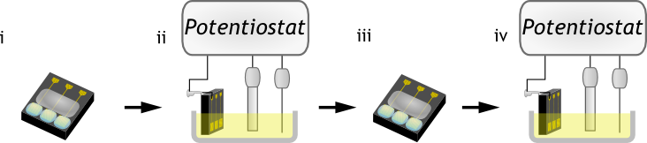
Figure 18 Procedure for electrochemical DNA detection
PLZD DNA probe was reduced by the same method as described in the molar fraction fluorescence in Section 5.5.3. Filtration was performed as in that experiment to remove MCH from the DNA solution. PG-EDs and WG-EDs of 200 nm gold thickness were cleaned by rinsing in 2-propanol and water, and subsequently performing cyclic voltammetry in H₂SO₄ as described in Section 4.1.3. Probe molar fractions of 0.2, 0.4, and 1.0 were then prepared and for each molar fraction, 15 μl were deposited onto a device of each type for 4 hours (Figure 18.i). Probe deposition with PLZD IB was followed by backfill with MCH (one hour). The devices were washed in a buffer (pH 7.0) containing 5X saline-sodium citrate (SSC) and 0.1% sodium dodecyl sulfate (SDS) for one hour in a dark humidity chamber at 37°C. Then, a baseline DPV measurement was taken for each electrode using a 3-electrode system in a scan solution (1 mM FiCN and 2 μM RuHex, with 25 mM NaCl and 25 mM phosphate buffer solution) (Figure 18.ii). This scan was repeated, replacing the scan solution each time, until two consecutive scans showed that the observed signal had stabilized. This process typically required no more than 3 scans.
The devices were subsequently exposed to 1μM of either complementary (TLZD) or noncomplementary (T4) DNA in a buffer (pH 7.0) containing 5X SSC and 0.1% SDS for one hour in a dark humidity chamber at 37°C (Figure 18.iii). DPV scans were repeated and the percent change in signal amplitude was calculated (Figure 18.iv).
The signal amplitude was calculated as the maximum current of the DPV curve minus the current at -0.3 V. The percent change in signal amplitude after hybridization was calculated for exposure to both complementary and noncomplementary DNA, just as it was done for macro electrodes (Equation 1). All error bars in figures are measures of standard error (SE).

Conclusions
The present section described the techniques used to characterize the wrinkled electrodes. Characterization was performed optically, by SEM, by CV, using a fluorescence-based technique and using a DNA detection procedure adapted from the one used on macro-electrodes in the prior section. The following section will describe the results of the procedures described here.

Characterization Results for Wrinkled Nano-/Micro-Structured Electrodes
The aim of characterization was to compare the wrinkled electrodes’ utility as biosensors in comparison to planar electrodes fabricated in a similar manner. In this section, the electrodes’ surface properties can be seen from the results of characterization by optical measurement, SEM, and electrochemical measurement. The electrodes’ probe density after DNA deposition (over varying deposition times and in varying molar fractions of DNA) is observed using fluorescently tagged probes. The electrodes’ sensitivity, in terms of percent change in electrochemical signal amplitude, and specificity for complementary target DNA is also tested in varying molar fractions of DNA. The detection limit of the platform is assessed.

Optical measurement
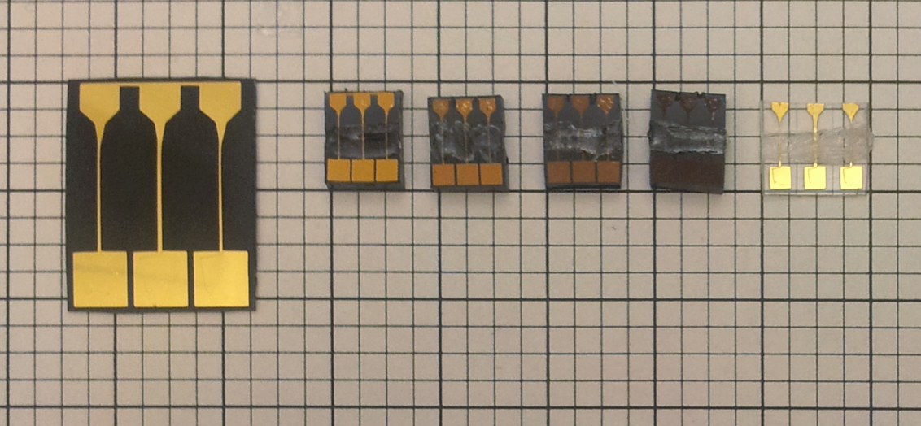

(a) (b) (c) (d) (e) (f)
Figure 19 Photographs of wrinkled electrochemical devices on black polystyrene (a) sputtered with 200 nm gold prior to shrinking; (b) 200 nm gold, (c) 100 nm gold, (d) 50 nm gold, (e) 20 nm gold after shrinking; and (f) 100 nm gold planar device on clear polystyrene without shrinking. Area measurements were conducted on electrodes in white box.
To validate the consistency of electrodes’ areas after shrinking, a photograph was taken for measurement (Figure 19). For each thickness of sputtered gold on wrinkled devices, three electrode areas were measured and compared with the mean planar electrode area. Shrinking occurred reproducibly and accurately for all sputtered thicknesses to match the geometric dimensions of planar, unshrunken electrodes that had been patterned to 40% of the size of wrinkled devices’ masks (Figure 20). The percent difference from planar electrodes for geometric area, calculated according to Equation 4, were 0.8% for 200 nm thickness, 3.7% for 100 nm thickness, 2.6% for 50 nm thickness, and 1.9% for 20 nm thickness wrinkled gold. None of the differences were found to be statistically significant by student’s t-test (p > 0.15).
The shrinking behaviour not only induces wrinkling (Section 6.2), but also allows for smaller feature sizes to be achieved with the craft-cutter patterning method. This is valuable for POC biosensor fabrication where miniaturization of device components allows for more devices to be integrated into a single substrate, reducing the production costs.

Figure 20 Average measured geometric electrode areas for wrinkled devices of varying thickness and planar devices of 100 nm thickness.

Scanning electron microscopy
Results obtained from SEM micrographs obtained using methods described in Section 5.2 are displayed in Figure 21. The size of the resulting wrinkles was found to depend strongly on the film thickness, with thinner films resulting in nanoscale wrinkles and thicker films resulting in microscale wrinkles.
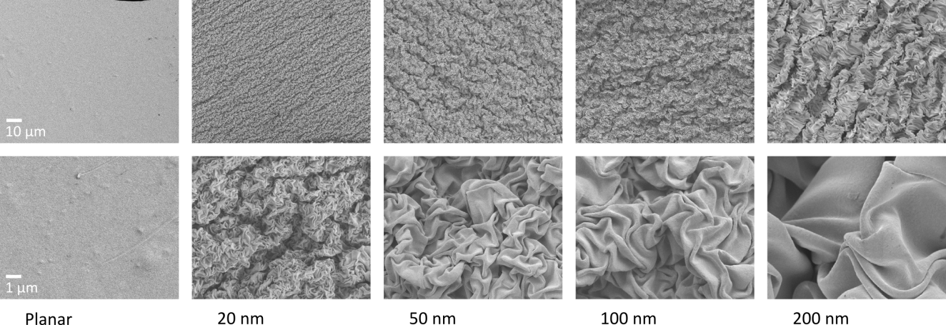
Figure 21 SEM images of 20, 50, 100, and 200 nm thick sputtered gold surfaces after heat-induced shrinking of polystyrene substrate, and 100 nm thick gold without substrate shrinking
In the lower magnification images (Figure 21, top row, rightmost four images), a larger-scale uni-axial ridged pattern can be observed in addition to the nano- to micro-scale bi-axial wrinkling pattern. The uni-axial pattern occurs along the same axis over the entire shrunk gold sample. A phenomenon called secondary wrinkling was reported by Fu et al. for uni-axial shrinking [16]. They found two separate populations of wrinkles with approximate wavelengths of 300 nm and 800 nm for 10 nm thick gold films. Secondary wrinkles were also discussed for bi-axially shrunk PS in Gabardo et al. [15]. No mention was made however on the axial preference of these secondary wrinkles, as observed herein. This phenomenon may reflect axial non-uniformity in the stress of the PS.

Electrochemical characterization

Figure 22 Cyclic voltammograms of planar and wrinkled electrodes with a film thickness of 100 nm in dilute H₂SO₄.
CV curves of PG-EDs and WG-EDs measured in sulfuric acid solutions were performed using methods of Section 5.3 in order to quantify the electro-active surface area. Wrinkled and planar electrode structures displayed a well-defined redox signature associated with the oxidation of gold from +1.0 V to +1.5 V and the subsequent gold oxide reduction peak at +0.8 V (Figure 22).
The surface area of the planar electrode and wrinkled electrodes of 20, 100, and 200 nm thicknesses were measured to be 0.0673±0.0017 cm², 0.4045±0.0051 cm², 0.3692±0.0036 cm², and 0.4094±0.0052 cm² respectively. Given that the electrodes were designed with a geometric area of 0.04 cm², a roughness-induced surface area enhancement (electroactive surface area/geometric area) of 1.682±0.043, 10.11±0.13, 9.350±0.012, and 10.24±0.13 was measured for planar 20 nm, 100 nm, and 200 nm electrodes respectively. The observation that the planar electrode’s roughness-induced surface area enhancement is greater than 1 indicates that the planar surface is not perfectly smooth. Past reports have shown that sputtered gold films have surface roughness which varies greatly depending on the substrate and the sputtering conditions used [90] [91] [88]. The surface roughness observed for the planar electrode falls within that range.
Enhancements in the electro-active surface area of between 5.48 and 6.09 times for WG-EDs were seen, as compared to that of planar electrodes of equal geometric dimensions (Figure 23). This enhancement is lower than theoretically calculated given the geometric area of gold prior to shrinking. With a geometric area of 5 mm x 5 mm prior to shrinking, the theoretical enhancement over the planar 2 mm x 2 mm electrodes would be ${5^{2}}/{2^{2}}=6.25$. Similar behaviour was seen in past literature [15] [74]. The variation in electro-active surface areas seen across film thicknesses may be explained by secondary wrinkling. Adjacent wrinkles pack closely enough that they begin to collide and create voids where the gold surface is inaccessible to the oxidation process.

Figure 23 Electro-active surface area calculated from H₂SO₄ CV. Standard error bars shown.
Surface area enhancement was greatest at low (20 nm) and high (200 nm) film thicknesses. This is inconsistent with past literature [15] which saw a positive relationship between film thickness and surface area enhancement. The discrepancy may be attributable to differences in the method of fabrication for the electrodes. In the previous study, the electrodes’ geometric surface area was controlled using windows of specific dimensions cut out of vinyl masks. In this thesis, tests performed on electrodes prepared by this method were found to have bubbles of air that tended to persist where the gold surface made contact with the vinyl mask (Section 3.4.3). Instead, electrodes were sputtered with specific dimensions planned so that shrinking would lead to the desired final geometric area without any need for masking. By this method, variations in the dimensions of the patterned sputtering masks might have arisen from the limited precision of the craft cutter. This would lead to differences in the sputtered area of the electrodes prior to shrinking, and therefore, differences in electroactive surface area observed between electrodes.
The ease with which these structured surfaces are fabricated makes them attractive for the development of biosensors that exploit the high surface area of the electrodes. In addition, the ability to pattern through masking specific gold film shapes on the macro scale facilitates the creation of complex device designs with multiple electrodes. Fabrication of wrinkled devices was seen to be reproducible in terms of electroactive surface area. For each thickness of gold, the standard error of the surface area was under 3%.
The observed enhancement in electroactive surface area was expected to allow for increases in signal amplitudes and thus higher sensitivity for DNA detection. Thus, the electrocatalytic detection scheme which had been previously validated for macro-electrodes was applied to wrinkled electrodes.

Characterization using the electrocatalytic detection scheme

Assessment of limit of detection
It was of interest to compare the limit of detection of wrinkled electrodes with that of the planar macro-electrodes, which had been established in Section 4.2. The results below illustrate the limit of detection achieved for wrinkled electrodes of 100 nm film thickness. Two WG-EDs were prepared with PLZD probes (as described in Section 5.4.1) so that one could be exposed to the complementary TLZD target strand and the other to noncomplementary T4. DPV scans were performed to measure the current response at the electrodes of the two devices. The results of those scans are presented in Figure 24.
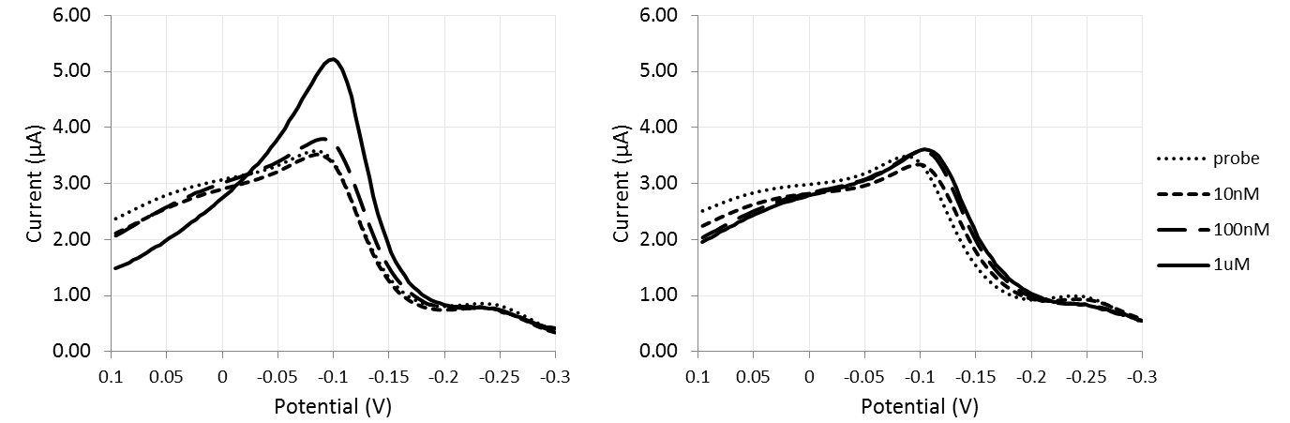
(a)
(b)
Figure 24 DPV curves for a representative electrode of (a) device A and one of (b) device B after probe immobilization, and after hybridization from 10 pM to 1 µM target DNA. Device A was exposed to TLZD (complementary) DNA and device B was exposed to T4 (noncomplementary) DNA.
The shape of DPV scans performed on WG-EDs (Figure 24) was noticeably different from the shape of scans performed on macro-electrodes (Figure 14). The initial current (at E = +0.1 V) was greater than half the height of the signal peak for the probe scans. A substantial decrease in this initial current was observed after hybridization to 1 µM of TLZD. In addition, a second, smaller peak was noticeable around -0.25 V. As expected due to the macro-electrode experiments (Section 4.3.2) at higher concentrations of TLZD target DNA, the electrode exhibited a higher DPV peak (Figure 24(a)). Higher concentrations of T4 target DNA also led to a higher DPV peak, but the difference was less pronounced (Figure 24(b)).
For the electrodes exposed to TLZD, an increase in the peak amplitude relative to the background was first seen of at 100 nM (Figure 25). However, the percent change in measured signal amplitude at 100 nM did not meet the criteria for limit of detection. A greater change in signal amplitude was observed at 1 µM target concentration, and this signal change was greater than the background plus three times the signal standard deviation. Thus, the limit of detection using this detection scheme was found to be 1 µM. This is an order of magnitude higher than the detection limit as seen for the macro-electrodes in Section 4.3.

Figure 25 DPV signal response after hybridization with varying target DNA concentrations for electrocatalytic detection using WG-EDs of 100 nm film thickness.
With a greater surface area for probes at the wrinkled electrode surface, we had expected to see a lower limit of detection than observed for planar electrodes. This was not seen to be the case. One possibility was that the concentrations of the two redox agents, FiCN and RuHex, in the scan solution were not ideal for the novel electrode structure. Since the response seen from the DPV scan appeared to be substantially different from what was seen on macro-electrodes, this possibility needed to be studied in further depth. The results of this study are presented below.

Study of electrocatalytic behaviour

Redox agent factorial experiment
It was found in the limit of detection assessment that the CV and DPV response curves generated from wrinkled electrodes differed in shape from those generated from macro-electrodes. In order to observe the individual contributions of the redox agents FiCN and RuHex to the observed current for wrinkled electrodes and macro-electrodes, an experiment was performed as described in Section 5.4.2.1.
In the CV scans performed on macro-electrodes with only RuHex, a small, broad current peak was observed around -0.3 V (Figure 26(a), Scan A). Similarly, a gentle peak at -0.2 V was observed in the DPV scan (Figure 26(b), Scan A). In the absence of an electrocatalytic agent to replenish the oxidized form of RuHex, the reaction current peaks less than 2 µA were observed for both these scans. This small current is a consequence of the limited concentration of RuHex available in solution. (The result of increasing this concentration will be described in the following section.)
With only FiCN in solution, current peaks for CV and DPV were observed at potentials below -0.25 V (Figure 26(a-b), Scan D). This scan demonstrates the efficient blocking that DNA provides to the direct reduction of FiCN at the electrode surface. FiCN has a reduction potential substantially more positive than the potential windows of either scan in this study [92], but the electrostatic repulsion of the anion by negatively charged DNA strands prevented appreciable reduction to take place until substantially more negative potentials were reached.
When both redox constituents were present, a 5- to 10–fold increase in current signal was observed in comparison to the presence of RuHex alone (Figure 26(a-b), Scan B). The CV scan revealed a characteristic peak in only the negative scan direction indicating that an irreversible reaction had occurred at the electrode [43].
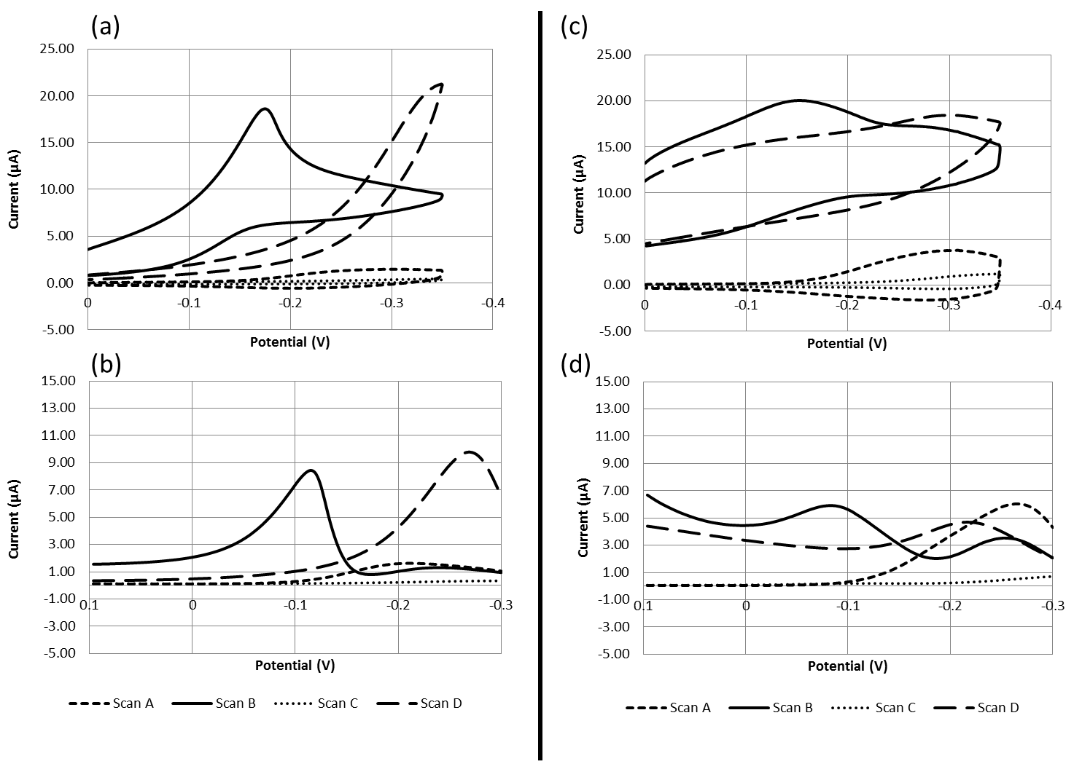
Figure 26 CV (a) and DPV (b) scans in varying scan solutions for planar DNA-modified gold-disk macro-electrodes. CV (c) and DPV (d) scans for 200 nm film thickness DNA modified gold wrinkled electrodes. Scans were performed in 25 mM NaCl and 25 mM PB (wash buffer, WB) containing 50 μM RuHex (“scan A”), WB with 4 mM FiCN and 50 μM RuHex (“scan B”), WB alone (“scan C”), and WB with 4 mM FiCN (“scan D”).
For wrinkled electrodes however, the electrocatalytic behaviour was not as pronounced. In the presence of RuHex alone, substantially higher current peaks were seen in both the CV and DPV curves (Figure 26(c-d), Scan A). This result was to be expected due to the substantial increase in electroactive surface area where charge transfer could occur for wrinkled electrodes.
In the presence of FiCN alone, a high current was seen over the entire CV scan duration (Figure 26(c), Scan D) for the wrinkled electrode. The same was seen for the DPV scan, with a small peak at -0.2 V (Figure 26 (d), Scan D). Both these scans suggested incomplete blocking of the electrode surface by DNA probes which allowed the FiCN to be reduced directly at the electrode surface. This was not ideal behaviour for detection of DNA since the direct reduction leads to high background currents and also depletes the available FiCN for electrocatalytic reduction.
The CV scan performed with both FiCN and RuHex present showed a wide current peak in the negative scan direction (Figure 26 (c), Scan B). DPV showed the presence of two peaks – one at -0.1 V and another at -0.25 V, and high background currents (Figure 26(d), Scan B). The high background currents were understood to be a result of direct reduction of FiCN, as seen in the scans with FiCN alone. The first peak’s potential was around the same range as the electrocatalytic DPV signal observed on macro-electrodes (Figure 26(b), Scan B). The potential of the second peak was in the same range as potentials of peaks observed for scans with RuHex alone as well as FiCN alone.
Beyond the contribution of direct FiCN reduction to the current signal, the reason for the double-peak behaviour seen in the wrinkled electrode DPV scan was not understood. The experiments in the following section are designed to clarify the observations made above.

Redox agent concentration optimization
The concentrations of FiCN and RuHex can modulate the current response seen in electrocatalytic CV and DPV scans of DNA-modified electrodes. By fixing the concentration of one of the redox agents and performing scans at gradually increasing concentrations of the other redox agent, the current contribution of each redox agent could be understood. In addition, this experiment allowed for the determination of concentrations for scan solution components that would result in a clear electrocatalytic peak for WG-EDs. The scan condition with redox agent concentrations which had exhibited (1) a single, well-defined electrocatalytic peak and (2) the highest signal amplitude (judged as the peak DPV current) relative to background (judged as a DPV current at +1.0 V) was sought out for use with WG-EDs. Earlier experiments of a similar design had shown that the concentration of both redox agents needed to be reduced substantially from the concentrations used in the previous experiment (50 μM RuHex and 4 mM FiCN) before background currents were reduced to less than a third of the maximum current and the height of the peak around -0.25 V was no longer visible. Thus, this experiment was performed in a range of FiCN concentrations from 0.5 mM to 3 mM and RuHex concentrations from 0.5 μM to 4 μM. The DPV curves obtained from this experiment can be seen in Figure 27.
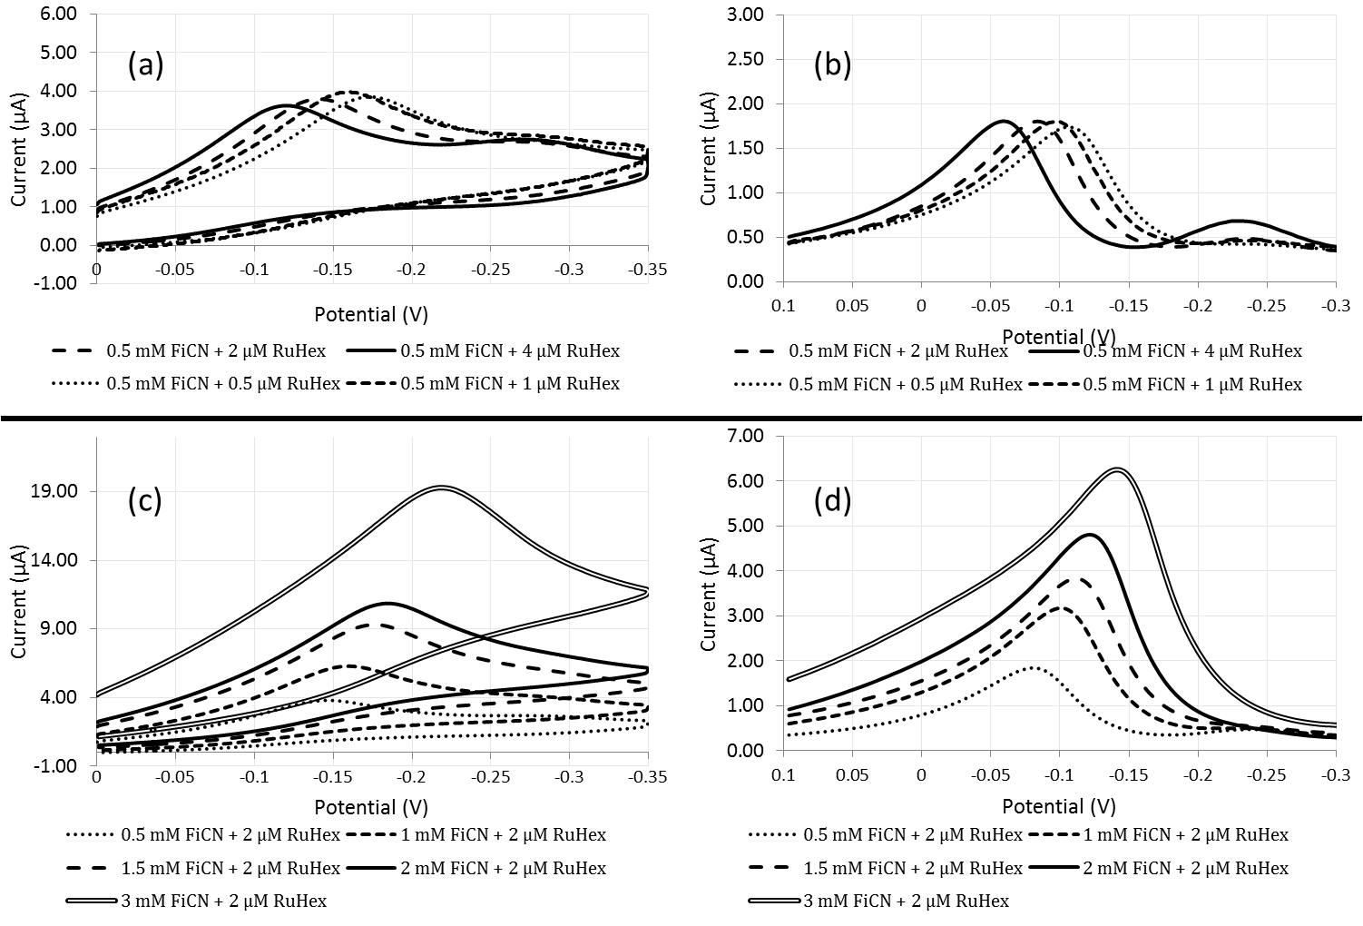
Figure 27 CV (a) and DPV (b) scans for 200 nm film thickness WG-EDs with FiCN concentration fixed at 0.5 mM and RuHex concentrations of 0.5 µM, 1 µM, 2 µM, and 4 µM. CV (c) and DPV (d) scans for the same electrode with RuHex concentration fixed at 2 µM and FiCN concentrations of 0.5 mM, 1 mM, 1.5 mM, 2 mM, and 3 mM.
In conditions of increasing RuHex, a concentration-dependent shift in the electrocatalytic peak was observed to more positive potentials for both CV and DPV curves (Figure 27(a-b)). Within the tested range, there was only a slight (6.07%) difference in amplitudes of the largest and smallest DPV peaks. However, at RuHex concentrations in the upper range tested (2 and 4 µM), a second peak was observed at a more negative potential in both the CV and DPV curves. In reference to the results of the previous section, reduction in the presence of RuHex alone leads to a peak at that same potential (Figure 26, Scan A). Because this peak only became visible at higher RuHex concentrations, it could be deduced that the peak corresponded to the direct reduction of RuHex without replenishment by FiCN.
If the concentration of RuHex was limiting the rate of the electrocatalytic reaction, we would expect to see increases in the peak amplitude with higher concentrations. This is not observed, and thus the conclusion can be drawn that at these concentrations, RuHex is in enough availability not to limit the electrocatalytic reduction of FiCN.
With increasing concentrations of FiCN, increases were seen in the height of the CV and DPV peaks (Figure 27 (c-d)). However, higher current was also observed at +0.1 V, which was labelled as background current. This increased background current was most evident at the FiCN concentration of 3 mM. This background current is attributable to the direct reduction of FiCN at the electrode surface, as seen with the scans performed in FiCN alone (Figure 26, Scan D) in the previous section.
To determine the optimal scan solution to use with subsequent electrochemical tests on WG-EDs, the peak current was divided by the background current to determine the signal to background ratio. The scan condition of 1 mM FiCN and 2 µM RuHex was found to exhibit a signal to background ratio of 5.303, the highest of the conditions tested. Additionally, no direct reduction peak for RuHex was observed in this condition. This scan solution was selected to be used in the final electrochemical experiment described in Section 6.6.
Besides sensitivity, another important performance parameter for biosensors is the device-to-device reproducibility. In a separate experiment (data not shown), between 10 separately prepared electrodes on individual devices, a mean probe DPV signal amplitude of 1.51 μA was found with a standard deviation of 0.19 μA. The coefficient of variation, defined as the standard deviation divided by the mean, was thus 12.6%. Higher reproducibility could be achieved by incorporating a quality control step in which devices with DPV signals above or below prespecified cut-offs would be removed from testing.

Probe density characterization by fluorescence
The high background currents seen in DPV scans in the presence of FiCN in Section 6.4.2.1 pointed to the possibility that probes were not blocking the entire wrinkled gold surface. To test this possibility and to investigate the control of probe density at the surface of wrinkled and planar electrodes, a fluorescence-based probe density quantification technique was performed.

Dependence of probe density on deposition time
Sulfuric acid CV results (Section 6.3) indicated that 100 nm and 200 nm film thickness wrinkled gold electrodes had enhancements in surface area compared to planar electrodes of 5.5 and 6.1 times, respectively. The direct reduction of FiCN at the electrode surface observed in Section 6.4.2.1, however, suggested that the full wrinkled electrode surface had not been covered by the probe molecules. If this was the case, it would be reflected in measured probe density enhancements lower than the enhancements seen in electroactive surface area.
Using the fluorescence technique described in Section 5.5.2, the probe density data presented in Figure 28 was obtained.

Figure 28 DNA probe density over time on planar and wrinkled gold thin films of varying thicknesses. MCH produced from the reduction reaction was not removed from the immobilization buffer prior to probe deposition. Standard error bars shown.
A gradual plateau in probe density was observed for the wrinkled as well as the planar surface morphologies over an 18 hour period (Figure 28). By four hours, the probe density for all electrode structures had reached at least 75% of that attained after 18 hours of deposition. The behaviour can be substantiated by theory. The probe density levels off as the surface binding sites become saturated with thiols. The gradual plateau is consistent with what has been seen in past publications [79] [78] [80] [83]. Some studies have observed a complete leveling off of probe density after a certain length of time [79] [83]. Others report continued increases in probe density, however at a much slower rate, as seen herein [78] [80].
Wrinkled electrodes with gold thicknesses of 100 nm were found to have 2.37 times the probe density of planar electrodes at 4 hours, whereas wrinkled electrodes of gold thicknesses of 200 nm had 2.53 times the probe density. An enhancement in probe density was expected for wrinkled electrodes compared to planar electrodes due to their ability in packing more gold surface area in electrodes of the same footprint. However, the probe density enhancement observed was substantially lower than the 5.5- to 6.1-fold enhancement in surface area measured using electrochemical techniques.
This discrepancy was suspected to be due to the presence of MCH in the immobilization buffer (IB). Due to the dithiol structure of the unreduced DNA probes, reduction leads to the creation of two molecules; the thiolated DNA, and MCH. MCH in the buffer could be adsorbing in greater proportion to the wrinkled surfaces than to the planar surfaces, thus leading to more modest improvements in probe density. This possibility was explored in more depth as reported below.

Dependence of probe density on probe molar fraction
The effect on DNA probe density of MCH in the IB (immobilization buffer) was explored in this study. In order to see if the presence of this thiolated molecule would lead to different behaviours at wrinkled and planar surfaces, IB was prepared with varying proportions of F-PLZD and MCH. Probe density was determined by fluorescence-intensity measurement of the 6-FAM-tagged DNA probe. Figure 29 displays the measured probe density as a function of the molar fraction of F-PLZD in the IB.

Figure 29 DNA probe density versus probe molar fraction on planar and wrinkled gold films of varying thicknesses. Deposition was performed for 4 hours. Total thiol concentration was held at 5 μM. Standard error bars shown.
For planar electrodes, it was observed that as the proportion of DNA in the IB increased, the probe density steeply increased until it reached a maximum and plateaued or decreased as the IB approached 100% DNA content. This behaviour is in good correspondence with past results seen for planar gold electrodes [29] [89]. Keighley et al. [29] observed greater probe densities at 0.5 than 1.0 probe molar fraction and hypothesized that the inclusion of MCH during DNA deposition may prevent non-specific adsorption of DNA, forcing the DNA to stand up from the surface and allowing a greater DNA surface immobilization than when only thiolated DNA is present alone.
A different behaviour was observed for wrinkled electrodes of all sputtered thicknesses, where as probe molar fraction increased, the probe density first rose steeply before levelling off into a linear regime (Figure 29). The broad linear regime is a useful property because it allows for probe density to be tuned to very specific values. Past reports have shown that even small differences in probe density can result in large fluctuations in hybridization efficiency [29]. Better control over probe density would facilitate optimization for maximum sensitivity, and improve reproducibility for large-scale biosensor fabrication.
In comparison to planar probe densities, the hypothetical 5.5- to 6-fold enhancement predicted by electrochemical surface area measurements was not observed at any molar fraction. The greatest improvement seen in mean probe density was at 1.0 molar fraction for 200 nm thickness wrinkled surfaces, where a 4.3-fold increase was observed. One can therefore conclude that there are areas of the gold surface which are electrochemically accessible but not readily accessible by DNA probes.
All wrinkled devices were patterned with the gold of the same footprint, and yet as thickness increases, greater probe densities can be achieved (Figure 29). This behaviour can potentially be explained with reference to the above theory regarding surface accessibility to DNA. With the larger wavelengths of wrinkles observed for thicker films, one can expect the gaps between wrinkles to exist on greater length-scales as well. Larger gaps would correspond to more areas of the surface being accessible to the DNA molecules, and thus higher obtainable probe densities. The ultimate consequence of this is that besides DNA molar fraction, an additional degree of probe density tunability is apparent through control of film thickness. This is particularly beneficial for optimizing probe density for an electrochemical DNA biosensor to maximize the change in signal amplitude after hybridization [29].

Characterization of effect of probe molar fraction on electrochemical signal
It was observed in the experiments reported in Section 6.5.2 that higher molar fractions of probe DNA in the immobilization buffer led to higher probe densities on wrinkled structures (Figure 29). For planar structures this was true at lower molar fractions, but the trend at molar fractions from 0.4 to 1.0 either leveled off or reversed. The relationship between molar fraction and electrocatalytic probe signal was observed next. PG-EDs and WG-EDs were prepared with varying DNA molar fractions (0.2, 0.4, and 1.0). Figure 30 displays the electrocatalytic signals in response to these varied molar fractions of PLZD for wrinkled (200 nm) and planar devices, normalized to the greatest signal observed for each type of device.

Figure 30 Response of probe DPV current signal to changes in probe molar fraction. Standard error bars shown.
It was found that for WG-EDs, the current signal dropped by 49% by decreasing the probe molar fraction from 1.0 to 0.2 (Figure 30). For planar devices, only a decrease of 16% was observed in the same range. Of that 16% decrease, 8% is observed between 1.0 and 0.4 molar fraction and 8% is observed between 0.4 and 0.2. The DPV signal amplitudes were positively correlated with measured probe density, with the exception of planar devices deposited with a 1.0 molar fraction. These devices showed a greater signal in comparison to devices deposited with 0.4 molar fraction, whereas in the fluorescence results a lesser or equal probe density was observed (Figure 29).
The reason why a direct correlation of probe density and current signal was not observed between 0.4 and 1.0 molar fraction could not be determined with certainty. Possibly, the absence of MCH in the IB at 1.0 molar fraction allowed more of the probe DNA molecules to lie flat on the surface of the electrode and provided better electrostatic repulsion of FiCN, despite the probe density being the same or lower than at 0.4 molar fraction. By repelling FiCN and preventing direct reduction at the electrode surface, more FiCN would have been available for contribution to the current at the electrocatalytic peak. This way, a higher electrocatalytic signal might be generated despite the same or lower probe density. On the other hand, the magnitudes of the standard errors for the results of the electrochemical experiment as well as the fluorescence experiment leave open the possibility that the observed discrepancy is not a true reflection of a physical difference, and that with more trials the apparent difference would disappear.
Once the DPV scan was performed after probe deposition, hybridization was performed with either complementary or noncomplementary DNA at a concentration of 1 μM (Figure 31).

Figure 31 Percent change in signal amplitude after hybridization to 1 μM of either complementary (TLZD) or noncomplementary (T4) DNA, versus probe molar fraction in the immobilization buffer for planar electrodes and wrinkled electrodes of 200 nm sputtering thickness.
Following hybridization with 1 μM of either complementary (TLZD) or noncomplementary (T4) DNA, DPV current signals were measured once again and the percent change was plotted against probe molar fraction (Figure 31). At all molar fractions, wrinkled electrodes exhibited greater changes in signal amplitude in response to TLZD than planar electrodes. This could be a result of greater hybridization efficiency exhibited by the wrinkled electrode. The surface textures of nanostructured electrodes have been shown to enhance the efficiency of hybridization [93]. Smaller surface feature size was correlated with larger deflection angle between adjacent probe molecules and higher hybridization efficiency, giving strong evidence to the hypothesis that nanotexturing leads to increased accessibility of the probes on the wrinkled surface. SEM images of wrinkled electrodes with film thicknesses of 200 nm show some folds measuring under 500 nm in width (Figure 21). Thus, probes attached on the smaller features would exhibit non-negligible deflection angles. In addition to the contribution of nanostructuring, accessibility of the probes for hybridization may be enhanced by greater distances and less crowding of the probe molecules. It has been well-documented that excessively high probe densities can inhibit DNA duplex formation through steric and electrostatic interactions with probes [29] [88]. Although an increase in probe density was observed with the wrinkled structures, the increase was lesser than the increase in available surface area. This suggests that the probe molecules are spaced apart so that they do not repel target DNA by electrostatics and hybridization can occur with higher efficiency. Probe crowding also explains why improved signal changes were observed at lower molar fractions for both wrinkled and planar electrodes.
The percent change in signal amplitude could be modulated over a greater range (59%-105%) with WG-EDs compared to PG-EDs (16%-42%) within the range of DNA molar fractions tested (Figure 31). This enhancement in the range of tunability is correlated with the results of the fluorescence experiment (Figure 29) which showed a greater range of probe densities for WG-FDs over the same range of molar fractions. This indicates that the improved control of probe density allows for better control over the change in signal amplitude. The greatest changes in signal were seen with the lowest molar fraction tested (0.2), and even lower molar fractions were seen to show lower probe densities. This suggests that molar fractions in the range of 0 to 0.2 would result in further increases in the observed signal change. Future studies could confirm this prediction.
Lower molar fractions also exhibited greater nonspecific signal response. After exposure to T4 DNA, both wrinkled and planar electrodes were found to exhibit changes in signal amplitude of +12% and -7%, respectively. These signal changes may indicate the propensity of PLZD and T4 DNA to non-specifically adsorb to electrode surfaces that have lower probe densities. The negative charge of the DNA probes would minimize non-specific adsorption through electrostatic repulsion if the probe density was great enough. With lower molar fractions of DNA , the probe density may not be high enough to repel non-specific DNA, leading to a positive change in the signal amplitude after hybridization. Alternatively, nonspecifically adsorbed PLZD molecules may contribute to the redox signals of probe scans but be washed off in the hybridization step, leading to a negative change in signal amplitude. At 0.4 and 1.0 molar fractions of DNA, nonspecific signals were all below 2%. The optimal preparation condition for both WG-EDs and PG-EDs was judged to have the greatest signal-to-noise ratio ($SNR$), defined as:
Equation 5 $SNR= \frac{{PCS}_{c}}{\left|{PCS}_{nc} + {SE}_{PCS noncomp}\right|}$
Where${PCS}_{c}$ is the mean percent change in signal amplitude after complementary exposure, ${PCS}_{nc}$ is the mean percent change in signal amplitude after noncomplementary exposure, and ${SE}_{PCS nc}$ is the standard error in the percent change in signal amplitude after noncomplementary exposure. For both electrode structures the best SNR was observed to be at 0.4 molar fraction, where the greatest signal change was observed to TLZD with minimal response to noncomplementary T4.

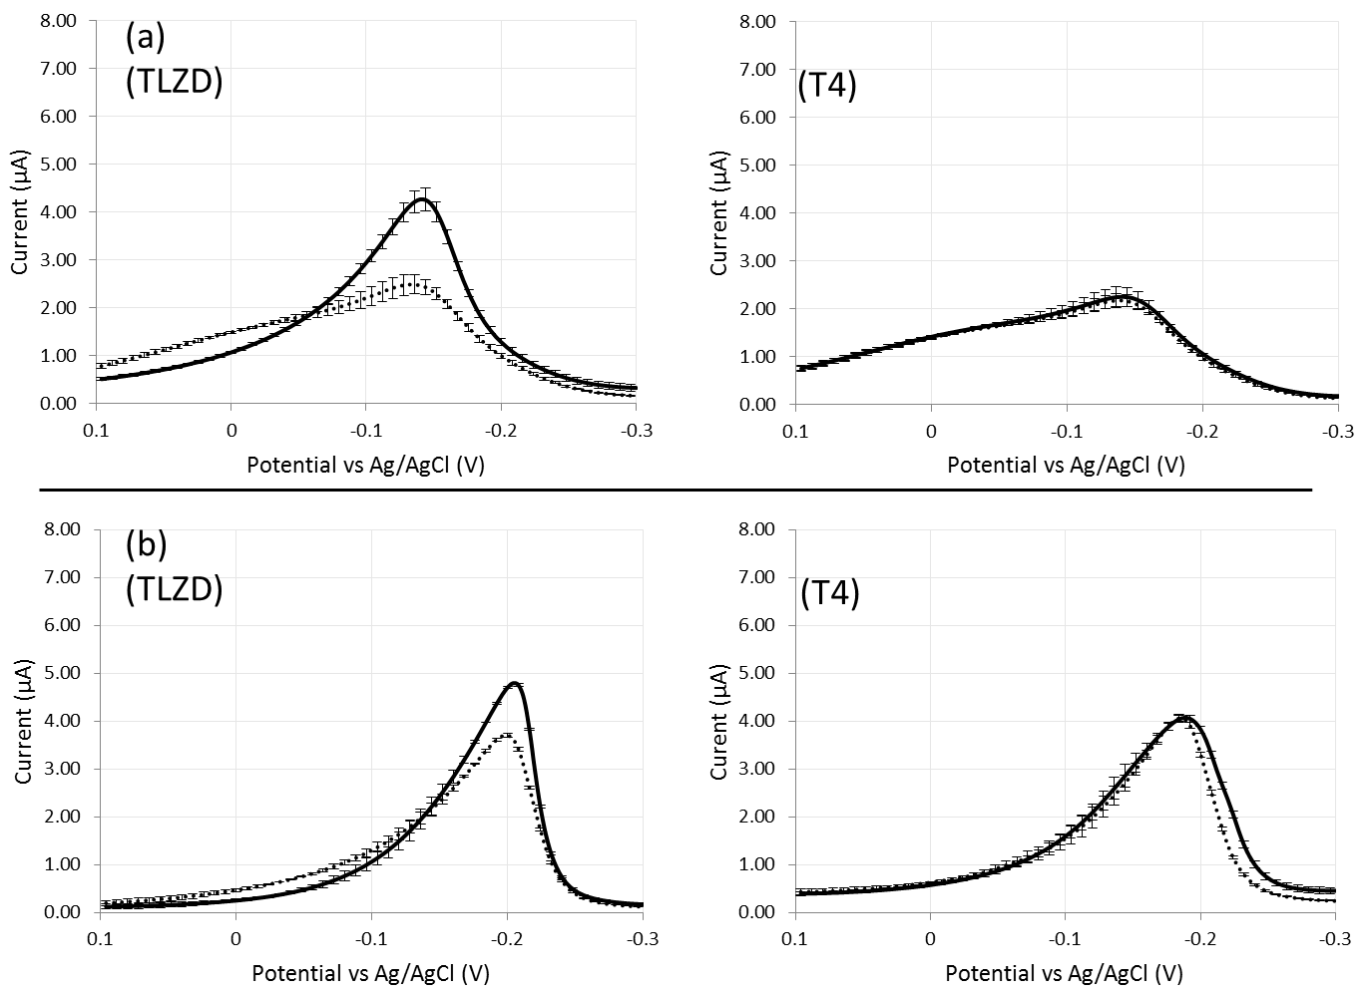
Figure 32 Average electrocatalytic DPV curves of 200 nm thickness wrinkled (a) and planar (b) electrode sensors deposited with a probe DNA/total thiol molar fraction of 0.4, before (dotted line) and after (solid line) exposure to 1 μM complementary (TLZD, left) and noncomplementary (T4, right) target DNA. SEM images inset depict surface morphology of each of the electrodes. Standard error bars shown.
Average DPV curves for 200 nm WG-EDs and PG-EDs deposited with a probe molar fraction at 0.4 can be seen in Figure 32. Nearly two times greater change in signal amplitude was observed after hybridization with the complementary strand for 200 nm wrinkled devices than with planar devices. Exposure to noncomplementary DNA led to less than 2% change in signal amplitude for both PG-EDs and WG-EDs. Analysis shows the substantial difference in the percent change of signal amplitude between wrinkled and planar electrodes (Figure 33).

Figure 33 Signal amplitude change of 200nm thickness wrinkled (b) and planar (c) electrode sensors deposited with a probe molar fraction of 0.4, after hybridization with 1 μM complementary and noncomplementary DNA for planar electrodes and wrinkled electrodes of sputtering thickness 200nm.
The present section demonstrated the electrochemical characterization and electrocatalytic optimization of wrinkled nano-/micro-structured electrodes. It was shown how rapidly fabricated electrodes with tuned surface characteristics were optimized using varying molar fractions of DNA probes to maximize the change in current signal after exposure to complementary DNA. Around 2-fold enhancement was seen in current signal change with wrinkled structures of 200 nm film thickness.

Conclusions

Thesis findings and contributions
This thesis demonstrates a rapid prototyping method for developing an electrochemical biosensing platform with a wrinkled nano-/micro-structured electrode surface. To review, these were the objectives that this work set out to achieve.
- To design and rapidly fabricate a multiplexed electrode device with a nano-/micro-structured surface,
- To demonstrate and compare a label-free electrocatalytic detection scheme in terms of the limit of detection as it is applied to a gold-disk macro-electrode substrate as well as the novel wrinkled electrode device,
- To adapt and optimize the electrocatalytic scheme for use with the wrinkled electrode device, and
- To investigate the effect of varying gold film thickness, probe deposition time, and probe molar fraction on the device’s performance parameters related to hybridization detection (specifically probe density and hybridization-induced electrocatalytic signal change).
Through a combination of sub-millimeter resolution vinyl masking with a computer controlled craft-cutter, and nano to micrometer-scale structuring by heat-induced compressive stresses at a gold thin-film surface, electrochemical devices could be fabricated from design to device in less than one day (Section 3.4.3).
An electrocatalytic DNA hybridization detection scheme was demonstrated with standard macro-electrodes using a previously described method [43] involving the electrocatalytic activity of RuHex species electrostatically associated with DNA (Section 4.2). The limit of detection for this system was found to be 100 nM (Section 4.3.2). A relatively higher limit of detection of 1 µM was seen using 100 nm film thickness wrinkled electrode surfaces without changes to the electrochemical detection scheme (Section 6.4.1).
The shape of the measured electrochemical scans was seen to be substantially different from what was observed with the macro-electrodes, and this difference was explained through a factorial-design experiment which showed the current contributions of non-electrocatalytic reduction of FiCN and RuHex at the electrode surface (Section 6.4.2.1). The electrocatalytic scheme was then improved for use with the rapidly fabricated device through optimization of the concentrations of the two redox agents. Concentration of these redox agents was optimized for the wrinkled electrodes to 1 mM for FiCN and 2 µM for RuHex (Section 6.4.2.2).
Characterization of the wrinkled electrode devices was performed by several means. Through electrochemical methods, the electroactive surface area was shown to be enhanced by between 5.5 to 6.1 times by the wrinkled surfaces of 20, 50, 100, and 200 nm film thickness (Section 6.4). Probe density enhancement of wrinkled electrodes over planar electrodes was found to be 4.3 times by fluorescence.
Probe density on these electrode surfaces was shown to be controlled by the gold film thickness, deposition time, and the molar fraction of probe DNA relative to other diluent molecules. Greater film thicknesses led to higher probe densities (Section 6.5.1). As probe deposition time was increased, probe density rose and plateaued for both wrinkled and planar electrode surfaces. By controlling the molar fraction of DNA in the buffer used for probe deposition, probe densities could be tuned over a wide linear regime with the wrinkled devices, whereas for planar devices, probe density was not linearly correlated with the molar fraction (Section 6.5.2).
The probe molar fraction was also shown to influence sensitivity in terms of hybridization-induced electrocatalytic signal change (Section 6.6). Between molar fractions of 0.2 and 1.0, the signal change was found to vary from 105% to 59% for WG-EDs, compared to 42% to 16% for PG-EDs. Thus, the signal change could be controlled over a wider range through the use of wrinkled electrodes. The signal-to-noise ratio for the electrocatalytic signal was maximal at a molar fraction of 0.4 for both wrinkled and planar electrodes. Comparing wrinkled and planar electrode devices of 200 nm film thickness deposited with 0.4 molar fractions of probe DNA, around 2-fold enhancement was seen in percent change in current signal amplitude.
This fabrication method is ideal for developing biosensing prototypes required for optimizing and validating such systems for their translation from the research lab to the point-of-need.
In conclusion, this fabrication method has shown utility for developing prototypes of electrochemical biosensors. A new device could be fabricated from CAD file with a turnaround time of less than one day, using low-cost substrates, masking methods, and electrode structuring methods. Although improvement in the limit of detection could not be demonstrated, optimization and characterization yielded promising insights, showing that improved control over probe density and change in signal amplitude could be attained relative to planar electrodes. In pursuit of the development of a self-contained total analysis device, the wrinkled electrodes have potential to be integrated with previously-reported microchannels [75] [76] rapidly fabricated with the same substrate.

Future work
In order to realize the ultimate goal of creating a point-of-care DNA biosensor, detection of DNA from cell lysates must be demonstrated. Enhancements in sensitivity are necessary to achieve this. This can be made possible through electrode nanostructuring methods discussed in the literature review. For instance, electrodeposition of gold has been demonstrated on wrinkled electrodes as a valid technique for introducing additional nanoscale texture and enhancing the electro-active surface area [15]. Electrodeposited nanostructures have been shown to be highly effective at improving detection limits [46] [21]. The technique can be implemented using a standard electrochemistry setup, and tuning of the electrodeposited structures is possible by manipulating the electrochemical conditions. Electrostatically neutral PNA probes can be used in place of DNA to enhance sensitivities even further, by eliminating the contribution of the negatively charged DNA probes to the observed electrocatalytic currents and enhancing the affinity of target molecules to the probes. Signal enhancement strategies related to the sequence-specific behaviour of DNA at the electrode surface such as hybridization chain reaction (HCR) could also be used to provide additional negative charges at the electrode surface, which we hypothesize would increase the assay’s sensitivity. [94]. In this strategy, the hybridization of a target with a surface-immobilized hairpin probe or “initiator” leads to a change in the probe’s conformation, resulting in a spontaneous chain of hybridization events with a pair of hairpin sequences with overlapping partial complementarities present in solution.
Integration with microfluidics could confer a number of advantages including the ability to interface with other bioprocessing components such as cell lysis and DNA purification elements. Microfluidic components could be used to introduce sample flow across the electrode surface. This would have the effect of enhancing molecular transport kinetics so that detection could occur more rapidly [95]. Microfluidic channels could be constructed through rapid fabrication techniques such as soft lithography and wax printing as discussed in the literature review. Incorporation of the reference and counter electrodes of the three-electrode system onto the sensing substrate is another important step in the development of a truly integrated detection platform. A three electrode system has already been developed in our lab through bench-top patterning of sputtered silver for the reference electrode and gold for the counter electrode (publication pending).

Final remarks
Rapid, low-cost and portable POC diagnostics have the potential to greatly alleviate the burden of infectious disease in low- and middle-income countries [8]. On the road to their development, rapid and low-cost fabrication methods need to be put in the hands of researchers in order to achieve swift progress. The wrinkled nano- and micro-structured electrodes presented in this thesis have proven themselves to be valuable in the rapid fabrication of an electrochemical DNA biosensor. Through the application of a rapid method for electrode fabrication and structuring on micro to nano length-scales, a rapid prototyping process was made possible by which new device designs could be taken from concept to reality in a period shorter than one day. These electrodes were demonstrated to facilitate simple and precise tuning of probe density for the purposes of optimizing an electrocatalytic DNA detection scheme. For these reasons, continual investigation into the application of the novel structure to DNA biosensing is strongly encouraged.

Reference
[1] P. Pinheiro, C. D. Mathers, and A. Krämer, “The Global Burden of Infectious Diseases,” in Modern Infectious Disease Epidemiology, A. Krämer, M. Kretzschmar, and K. Krickeberg, Eds. Springer New York, 2010, pp. 3–21.
[2] S. D. Lawn, P. Mwaba, M. Bates, A. Piatek, H. Alexander, B. J. Marais, L. E. Cuevas, T. D. McHugh, L. Zijenah, N. Kapata, I. Abubakar, R. McNerney, M. Hoelscher, Z. A. Memish, G. B. Migliori, P. Kim, M. Maeurer, M. Schito, and A. Zumla, “Advances in tuberculosis diagnostics: the Xpert MTB/RIF assay and future prospects for a point-of-care test,” The Lancet Infectious Diseases, vol. 13, no. 4, pp. 349–361, Apr. 2013.
[3] A. S. Piatek, M. V. Cleeff, H. Alexander, W. L. Coggin, M. Rehr, S. V. Kampen, T. M. Shinnick, and Y. Mukadi, “GeneXpert for TB diagnosis: planned and purposeful implementation,” Glob Health Sci Pract, vol. 1, no. 1, pp. 18–23, 2013.
[4] L. Mupfumi, B. Makamure, M. Chirehwa, T. Sagonda, S. Zinyowera, P. Mason, J. Z. Metcalfe, and R. Mutetwa, “Impact of Xpert MTB/RIF on Antiretroviral Therapy-Associated Tuberculosis and Mortality: A Pragmatic Randomized Controlled Trial,” Open Forum Infect Dis, vol. 1, no. 1, p. ofu038, 2014.
[5] G. Carpini, F. Lucarelli, G. Marrazza, and M. Mascini, “Oligonucleotide-modified screen-printed gold electrodes for enzyme-amplified sensing of nucleic acids,” Biosensors and Bioelectronics, vol. 20, no. 2, pp. 167–175, Sep. 2004.
[6] F. Kuralay, S. Campuzano, D. A. Haake, and J. Wang, “Highly sensitive disposable nucleic acid biosensors for direct bioelectronic detection in raw biological samples,” Talanta, vol. 85, no. 3, pp. 1330–1337, Sep. 2011.
[7] P. Yager, G. J. Domingo, and J. Gerdes, “Point-of-Care Diagnostics for Global Health,” Annual Review of Biomedical Engineering, vol. 10, no. 1, pp. 107–144, 2008.
[8] N. P. Pai, C. Vadnais, C. Denkinger, N. Engel, and M. Pai, “Point-of-Care Testing for Infectious Diseases: Diversity, Complexity, and Barriers in Low- And Middle-Income Countries,” PLoS Med, vol. 9, no. 9, p. e1001306, Sep. 2012.
[9] A. P. F. Turner, “Biosensors: sense and sensibility,” Chemical Society Reviews, vol. 42, no. 8, p. 3184, 2013.
[10] E.-H. Yoo and S.-Y. Lee, “Glucose Biosensors: An Overview of Use in Clinical Practice,” Sensors, vol. 10, no. 5, pp. 4558–4576, May 2010.
[11] P. M. Levine, P. Gong, R. Levicky, and K. L. Shepard, “Real-time, multiplexed electrochemical DNA detection using an active complementary metal-oxide-semiconductor biosensor array with integrated sensor electronics,” Biosensors and Bioelectronics, vol. 24, no. 7, pp. 1995–2001, Mar. 2009.
[12] H. M. Jafari, K. Abdelhalim, L. Soleymani, E. H. Sargent, S. O. Kelley, and R. Genov, “Nanostructured CMOS Wireless Ultra-Wideband Label-Free PCR-Free DNA Analysis SoC,” IEEE Journal of Solid-State Circuits, vol. 49, no. 5, pp. 1223–1241, May 2014.
[13] S. S. Sam, H. B. Steinmetz, G. J. Tsongalis, L. J. Tafe, and J. A. Lefferts, “Validation of a solid-phase electrochemical array for genotyping hepatitis C virus,” Experimental and Molecular Pathology, vol. 95, no. 1, pp. 18–22, Aug. 2013.
[14] J. E. N. Dolatabadi, O. Mashinchian, B. Ayoubi, A. A. Jamali, A. Mobed, D. Losic, Y. Omidi, and M. de la Guardia, “Optical and electrochemical DNA nanobiosensors,” TrAC Trends in Analytical Chemistry, vol. 30, no. 3, pp. 459–472, Mar. 2011.
[15] C. M. Gabardo, Y. Zhu, L. Soleymani, and J. M. Moran-Mirabal, “Bench-Top Fabrication of Hierarchically Structured High-Surface-Area Electrodes,” Advanced Functional Materials, vol. 23, no. 24, pp. 3030–3039, 2013.
[16] C.-C. Fu, A. Grimes, M. Long, C. G. L. Ferri, B. D. Rich, S. Ghosh, S. Ghosh, L. P. Lee, A. Gopinathan, and M. Khine, “Tunable Nanowrinkles on Shape Memory Polymer Sheets,” Advanced Materials, vol. 21, no. 44, pp. 4472–4476, 2009.
[17] W.-W. Zhao, J.-J. Xu, and H.-Y. Chen, “Photoelectrochemical DNA Biosensors,” Chem. Rev., Jun. 2014.
[18] J. Schotter, P. B. Kamp, A. Becker, A. Pühler, G. Reiss, and H. Brückl, “Comparison of a prototype magnetoresistive biosensor to standard fluorescent DNA detection,” Biosensors and Bioelectronics, vol. 19, no. 10, pp. 1149–1156, May 2004.
[19] J. Wang, “Electrochemical nucleic acid biosensors,” Analytica Chimica Acta, vol. 469, no. 1, pp. 63–71, Sep. 2002.
[20] C.-Y. Hong, X. Chen, T. Liu, J. Li, H.-H. Yang, J.-H. Chen, and G.-N. Chen, “Ultrasensitive electrochemical detection of cancer-associated circulating microRNA in serum samples based on DNA concatamers,” Biosensors and Bioelectronics, vol. 50, pp. 132–136, Dec. 2013.
[21] F. Li, X. Han, and S. Liu, “Development of an electrochemical DNA biosensor with a high sensitivity of fM by dendritic gold nanostructure modified electrode,” Biosensors and Bioelectronics, vol. 26, no. 5, pp. 2619–2625, Jan. 2011.
[22] A. Sassolas, B. D. Leca-Bouvier, and L. J. Blum, “DNA Biosensors and Microarrays,” Chem. Rev., vol. 108, no. 1, pp. 109–139, Jan. 2008.
[23] Ó. A. Loaiza, S. Campuzano, M. Pedrero, and J. M. Pingarrón, “DNA sensor based on an Escherichia coli lac Z gene probe immobilization at self-assembled monolayers-modified gold electrodes,” Talanta, vol. 73, no. 5, pp. 838–844, Oct. 2007.
[24] S. Sato, M. Tsueda, S. Watanabe, K. Ohtsuka, and S. Takenaka, “Synthesis of a naphthalene diimide derivative having four ferrocene moieties as an electrochemical DNA hybridization indicator,” Nucleic Acids Symp Ser, vol. 52, no. 1, pp. 239–240, 2008.
[25] E. M. Boon, D. M. Ceres, T. G. Drummond, M. G. Hill, and J. K. Barton, “Mutation detection by electrocatalysis at DNA-modified electrodes,” Nature Biotechnology, vol. 18, no. 10, pp. 1096–1100, 2000.
[26] K. M. Millan and S. R. Mikkelsen, “Sequence-selective biosensor for DNA based on electroactive hybridization indicators,” Anal. Chem., vol. 65, no. 17, pp. 2317–2323, Sep. 1993.
[27] M. Steichen, Y. Decrem, E. Godfroid, and C. Buess-Herman, “Electrochemical DNA hybridization detection using peptide nucleic acids and [Ru(NH3)6]3+ on gold electrodes,” Biosensors and Bioelectronics, vol. 22, no. 9–10, pp. 2237–2243, Apr. 2007.
[28] T. Doneux, A. De Rache, E. Triffaux, A. Meunier, M. Steichen, and C. Buess-Herman, “Optimization of the Probe Coverage in DNA Biosensors by a One-Step Coadsorption Procedure,” ChemElectroChem, vol. 1, no. 1, pp. 147–157, 2014.
[29] S. D. Keighley, P. Li, P. Estrela, and P. Migliorato, “Optimization of DNA immobilization on gold electrodes for label-free detection by electrochemical impedance spectroscopy,” Biosensors and Bioelectronics, vol. 23, no. 8, pp. 1291–1297, Mar. 2008.
[30] N. Zhu, Z. Chang, P. He, and Y. Fang, “Electrochemical DNA biosensors based on platinum nanoparticles combined carbon nanotubes,” Analytica Chimica Acta, vol. 545, no. 1, pp. 21–26, Jul. 2005.
[31] H. Peng, C. Soeller, and J. Travas-Sejdic, “Novel Conducting Polymers for DNA Sensing,” Macromolecules, vol. 40, no. 4, pp. 909–914, Feb. 2007.
[32] J. Wang and A.-N. Kawde, “Pencil-based renewable biosensor for label-free electrochemical detection of DNA hybridization,” Analytica Chimica Acta, vol. 431, no. 2, pp. 219–224, Mar. 2001.
[33] S. Liu, J. Liu, X. Han, Y. Cui, and W. Wang, “Electrochemical DNA biosensor fabrication with hollow gold nanospheres modified electrode and its enhancement in DNA immobilization and hybridization,” Biosensors and Bioelectronics, vol. 25, no. 7, pp. 1640–1645, Mar. 2010.
[34] M. Steichen, T. Doneux, and C. Buess-Herman, “On the adsorption of hexaammineruthenium (III) at anionic self-assembled monolayers,” Electrochimica Acta, vol. 53, no. 21, pp. 6202–6208, Sep. 2008.
[35] T. Selvaraju, J. Das, K. Jo, K. Kwon, C.-H. Huh, T. K. Kim, and H. Yang, “Nanocatalyst-Based Assay Using DNA-Conjugated Au Nanoparticles for Electrochemical DNA Detection,” Langmuir, vol. 24, no. 17, pp. 9883–9888, Sep. 2008.
[36] E. G. Hvastkovs and D. A. Buttry, “Recent advances in electrochemical DNA hybridization sensors,” The Analyst, vol. 135, no. 8, p. 1817, 2010.
[37] G. Marrazza, G. Chiti, M. Mascini, and M. Anichini, “Detection of Human Apolipoprotein E Genotypes by DNA Electrochemical Biosensor Coupled with PCR,” Clinical Chemistry, vol. 46, no. 1, pp. 31–37, 2000.
[38] R. H. Liu, J. Yang, R. Lenigk, J. Bonanno, and P. Grodzinski, “Self-Contained, Fully Integrated Biochip for Sample Preparation, Polymerase Chain Reaction Amplification, and DNA Microarray Detection,” Anal. Chem., vol. 76, no. 7, pp. 1824–1831, Apr. 2004.
[39] A. S. Patterson, K. Hsieh, H. T. Soh, and K. W. Plaxco, “Electrochemical real-time nucleic acid amplification: towards point-of-care quantification of pathogens,” Trends in Biotechnology, vol. 31, no. 12, pp. 704–712, Dec. 2013.
[40] S. Choi, M. Goryll, L. Y. M. Sin, P. K. Wong, and J. Chae, “Microfluidic-based biosensors toward point-of-care detection of nucleic acids and proteins,” Microfluid Nanofluid, vol. 10, no. 2, pp. 231–247, Feb. 2011.
[41] C. Briones and M. Moreno, “Applications of peptide nucleic acids (PNAs) and locked nucleic acids (LNAs) in biosensor development,” Anal Bioanal Chem, vol. 402, no. 10, pp. 3071–3089, Apr. 2012.
[42] P. M. Armistead and H. H. Thorp, “Modification of Indium Tin Oxide Electrodes with Nucleic Acids: Detection of Attomole Quantities of Immobilized DNA by Electrocatalysis,” Anal. Chem., vol. 72, no. 16, pp. 3764–3770, Aug. 2000.
[43] M. A. Lapierre, M. O’Keefe, B. J. Taft, and S. O. Kelley, “Electrocatalytic Detection of Pathogenic DNA Sequences and Antibiotic Resistance Markers,” Anal. Chem., vol. 75, no. 22, pp. 6327–6333, Nov. 2003.
[44] A. L. Furst, M. G. Hill, and J. K. Barton, “Electrocatalysis in DNA sensors,” Polyhedron.
[45] C. G. Pheeney, L. F. Guerra, and J. K. Barton, “DNA sensing by electrocatalysis with hemoglobin,” PNAS, vol. 109, no. 29, pp. 11528–11533, 2012.
[46] L. Soleymani, Z. Fang, E. H. Sargent, and S. O. Kelley, “Programming the detection limits of biosensors through controlled nanostructuring,” Nat Nano, vol. 4, no. 12, pp. 844–848, Dec. 2009.
[47] A. Waldbaur, H. Rapp, K. Länge, and B. E. Rapp, “Let there be chip—towards rapid prototyping of microfluidic devices: one-step manufacturing processes,” Analytical Methods, vol. 3, no. 12, p. 2681, 2011.
[48] S. J. Esses, P. Berman, A. I. Bloom, and J. Sosna, “Clinical Applications of Physical 3D Models Derived From MDCT Data and Created by Rapid Prototyping,” American Journal of Roentgenology, vol. 196, no. 6, pp. W683–W688, Jun. 2011.
[49] A. D. Lantada and P. L. Morgado, “Rapid prototyping for biomedical engineering: current capabilities and challenges,” Annu Rev Biomed Eng, vol. 14, pp. 73–96, 2012.
[50] D. C. Duffy, J. C. McDonald, O. J. A. Schueller, and G. M. Whitesides, “Rapid Prototyping of Microfluidic Systems in Poly(dimethylsiloxane),” Anal. Chem., vol. 70, no. 23, pp. 4974–4984, Dec. 1998.
[51] D. Qin, Y. Xia, and G. M. Whitesides, “Soft lithography for micro- and nanoscale patterning,” Nat. Protocols, vol. 5, no. 3, pp. 491–502, Mar. 2010.
[52] H. Sharma, D. Nguyen, A. Chen, V. Lew, and M. Khine, “Unconventional Low-Cost Fabrication and Patterning Techniques for Point of Care Diagnostics,” Ann Biomed Eng, vol. 39, no. 4, pp. 1313–1327, Apr. 2011.
[53] A. Bhattacharyya and C. M. Klapperich, “Design and testing of a disposable microfluidic chemiluminescent immunoassay for disease biomarkers in human serum samples,” Biomed Microdevices, vol. 9, no. 2, pp. 245–251, Apr. 2007.
[54] R. N. Zare and S. Kim, “Microfluidic Platforms for Single-Cell Analysis,” Annual Review of Biomedical Engineering, vol. 12, no. 1, pp. 187–201, Jul. 2010.
[55] E. Carrilho, A. W. Martinez, and G. M. Whitesides, “Understanding Wax Printing: A Simple Micropatterning Process for Paper-Based Microfluidics,” Anal. Chem., vol. 81, no. 16, pp. 7091–7095, Aug. 2009.
[56] J. P. Rolland and D. A. Mourey, “Paper as a novel material platform for devices,” MRS Bulletin, vol. 38, no. 04, pp. 299–305, 2013.
[57] M. Tudorache and C. Bala, “Biosensors based on screen-printing technology, and their applications in environmental and food analysis,” Anal Bioanal Chem, vol. 388, no. 3, pp. 565–578, Jun. 2007.
[58] M. Li, Y.-T. Li, D.-W. Li, and Y.-T. Long, “Recent developments and applications of screen-printed electrodes in environmental assays—A review,” Analytica Chimica Acta, vol. 734, pp. 31–44, Jul. 2012.
[59] A. Hayat and J. L. Marty, “Disposable Screen Printed Electrochemical Sensors: Tools for Environmental Monitoring,” Sensors, vol. 14, no. 6, pp. 10432–10453, Jun. 2014.
[60] G. A. Nascimento, E. V. M. Souza, D. S. Campos-Ferreira, M. S. Arruda, C. H. M. Castelletti, M. S. O. Wanderley, M. H. F. Ekert, D. Bruneska, and J. L. Lima-Filho, “Electrochemical DNA biosensor for bovine papillomavirus detection using polymeric film on screen-printed electrode,” Biosensors and Bioelectronics, vol. 38, no. 1, pp. 61–66, Oct. 2012.
[61] J. Lu, S. Ge, L. Ge, M. Yan, and J. Yu, “Electrochemical DNA sensor based on three-dimensional folding paper device for specific and sensitive point-of-care testing,” Electrochimica Acta, vol. 80, pp. 334–341, Oct. 2012.
[6] L. D. Tran, B. H. Nguyen, N. Van Hieu, H. V. Tran, H. L. Nguyen, and P. X. Nguyen, “Electrochemical detection of short HIV sequences on chitosan/Fe3O4 nanoparticle based screen printed electrodes,” Materials Science and Engineering: C, vol. 31, no. 2, pp. 477–485, Mar. 2011.
[62] A. Määttänen, U. Vanamo, P. Ihalainen, P. Pulkkinen, H. Tenhu, J. Bobacka, and J. Peltonen, “A low-cost paper-based inkjet-printed platform for electrochemical analyses,” Sensors and Actuators B: Chemical, vol. 177, pp. 153–162, Feb. 2013.
[63] P. Ihalainen, F. Pettersson, M. Pesonen, T. Viitala, A. Määttänen, R. Österbacka, and J. Peltonen, “An impedimetric study of DNA hybridization on paper-supported inkjet-printed gold electrodes,” Nanotechnology, vol. 25, no. 9, p. 094009, Mar. 2014.
[64] G. Martínez-Paredes, M. B. González-García, and A. Costa-García, “Genosensor for detection of four pneumoniae bacteria using gold nanostructured screen-printed carbon electrodes as transducers,” Sensors and Actuators B: Chemical, vol. 149, no. 2, pp. 329–335, Aug. 2010.
[65] J. Liu, X. Yuan, Q. Gao, H. Qi, and C. Zhang, “Ultrasensitive DNA detection based on coulometric measurement of enzymatic silver deposition on gold nanoparticle-modified screen-printed carbon electrode,” Sensors and Actuators B: Chemical, vol. 162, no. 1, pp. 384–390, Feb. 2012.
[67] M. Moreno, E. Rincon, J. M. Pérez, V. M. González, A. Domingo, and E. Dominguez, “Selective immobilization of oligonucleotide-modified gold nanoparticles by electrodeposition on screen-printed electrodes,” Biosensors and Bioelectronics, vol. 25, no. 4, pp. 778–783, Dec. 2009.
[68] A. Bonanni, M. J. Esplandiu, and M. del Valle, “Impedimetric genosensors employing COOH-modified carbon nanotube screen-printed electrodes,” Biosensors and Bioelectronics, vol. 24, no. 9, pp. 2885–2891, May 2009.
[69] Z. Wang, J. Zhang, P. Chen, X. Zhou, Y. Yang, S. Wu, L. Niu, Y. Han, L. Wang, P. Chen, F. Boey, Q. Zhang, B. Liedberg, and H. Zhang, “Label-free, electrochemical detection of methicillin-resistant staphylococcus aureus DNA with reduced graphene oxide-modified electrodes,” Biosensors and Bioelectronics, vol. 26, no. 9, pp. 3881–3886, May 2011.
[70] R. Singh, R. Prasad, G. Sumana, K. Arora, S. Sood, R. K. Gupta, and B. D. Malhotra, “STD sensor based on nucleic acid functionalized nanostructured polyaniline,” Biosensors and Bioelectronics, vol. 24, no. 7, pp. 2232–2238, Mar. 2009.
[71] G. Zhong, A. Liu, X. Chen, K. Wang, Z. Lian, Q. Liu, Y. Chen, M. Du, and X. Lin, “Electrochemical biosensor based on nanoporous gold electrode for detection of PML/RARα fusion gene,” Biosensors and Bioelectronics, vol. 26, no. 9, pp. 3812–3817, May 2011.
[72] N. Bowden, S. Brittain, A. G. Evans, J. W. Hutchinson, and G. M. Whitesides, “Spontaneous formation of ordered structures in thin films of metals supported on an elastomeric polymer,” Nature, vol. 393, no. 6681, pp. 146–149, May 1998.
[73] D. Nguyen, D. Taylor, K. Qian, N. Norouzi, J. Rasmussen, S. Botzet, M. Lehmann, K. Halverson, and M. Khine, “Better shrinkage than Shrinky-Dinks,” Lab Chip, vol. 10, no. 12, pp. 1623–1626, Jun. 2010.
[74] J. D. Pegan, A. Y. Ho, M. Bachman, and M. Khine, “Flexible shrink-induced high surface area electrodes for electrochemiluminescent sensing,” Lab on a Chip, vol. 13, no. 21, p. 4205, 2013.
[75] K. Sollier, C. A. Mandon, K. A. Heyries, L. J. Blum, and C. A. Marquette, “‘Print-n-Shrink’ technology for the rapid production of microfluidic chips and protein microarrays,” Lab on a Chip, vol. 9, no. 24, p. 3489, 2009.
[76] C.-S. Chen, D. N. Breslauer, J. I. Luna, A. Grimes, W. Chin, L. P. Lee, and M. Khine, “Shrinky-Dink microfluidics: 3D polystyrene chips,” Lab Chip, vol. 8, no. 4, pp. 622–624, Mar. 2008.
[77] L. Zhang, X. Lang, A. Hirata, and M. Chen, “Wrinkled Nanoporous Gold Films with Ultrahigh Surface-Enhanced Raman Scattering Enhancement,” ACS Nano, vol. 5, no. 6, pp. 4407–4413, Jun. 2011.
[78] A. B. Steel, T. M. Herne, and M. J. Tarlov, “Electrochemical Quantitation of DNA Immobilized on Gold,” Anal. Chem., vol. 70, no. 22, pp. 4670–4677, Nov. 1998.
[79] T. M. Herne and M. J. Tarlov, “Characterization of DNA Probes Immobilized on Gold Surfaces,” J. Am. Chem. Soc., vol. 119, no. 38, pp. 8916–8920, Sep. 1997.
[80] A. W. Peterson, R. J. Heaton, and R. M. Georgiadis, “The effect of surface probe density on DNA hybridization,” Nucl. Acids Res., vol. 29, no. 24, pp. 5163–5168, 2001.
[81] E. Huang, M. Satjapipat, S. Han, and F. Zhou, “Surface Structure and Coverage of an Oligonucleotide Probe Tethered onto a Gold Substrate and Its Hybridization Efficiency for a Polynucleotide Target,” Langmuir, vol. 17, no. 4, pp. 1215–1224, Feb. 2001.
[82] S. Peeters, T. Stakenborg, G. Reekmans, W. Laureyn, L. Lagae, A. Van Aerschot, and M. Van Ranst, “Impact of spacers on the hybridization efficiency of mixed self-assembled DNA/alkanethiol films,” Biosensors and Bioelectronics, vol. 24, no. 1, pp. 72–77, Sep. 2008.
[83] L. M. Demers, C. A. Mirkin, R. C. Mucic, R. A. Reynolds, R. L. Letsinger, R. Elghanian, and G. Viswanadham, “A Fluorescence-Based Method for Determining the Surface Coverage and Hybridization Efficiency of Thiol-Capped Oligonucleotides Bound to Gold Thin Films and Nanoparticles,” Anal. Chem., vol. 72, no. 22, pp. 5535–5541, Nov. 2000.
[84] K. Castelino, B. Kannan, and A. Majumdar, “Characterization of Grafting Density and Binding Efficiency of DNA and Proteins on Gold Surfaces,” Langmuir, vol. 21, no. 5, pp. 1956–1961, Mar. 2005.
[85] C. Boozer, S. Chen, and S. Jiang, “Controlling DNA Orientation on Mixed ssDNA/OEG SAMs,” Langmuir, vol. 22, no. 10, pp. 4694–4698, May 2006.
[86] O. Y. F. Henry, J. G. Perez, J. L. A. Sanchez, and C. K. O’Sullivan, “Electrochemcial characterisation and hybridisation efficiency of co-assembled monolayers of PEGylated ssDNA and mercaptohexanol on planar gold electrodes,” Biosensors and Bioelectronics, vol. 25, no. 5, pp. 978–983, Jan. 2010.
[87] K. B. Cederquist, R. Stoermer Golightly, and C. D. Keating, “Molecular Beacon−Metal Nanowire Interface: Effect of Probe Sequence and Surface Coverage on Sensor Performance,” Langmuir, vol. 24, no. 16, pp. 9162–9171, Aug. 2008.
[88] A. Ferrario, M. Scaramuzza, E. Pasqualotto, A. De Toni, and A. Paccagnella, “Coadsorption optimization of DNA in binary self-assembled monolayer on gold electrode for electrochemical detection of oligonucleotide sequences,” Journal of Electroanalytical Chemistry, vol. 689, pp. 57–62, Jan. 2013.
[89] M. Steichen and C. Buess-Herman, “Electrochemical detection of the immobilization and hybridization of unlabeled linear and hairpin DNA on gold,” Electrochemistry Communications, vol. 7, no. 4, pp. 416–420, Apr. 2005.
[90] C. O’Dwyer, G. Gay, B. Viaris de Lesegno, and J. Weiner, “The Nature of Alkanethiol Self-Assembled Monolayer Adsorption on Sputtered Gold Substrates,” Langmuir, vol. 20, no. 19, pp. 8172–8182, Sep. 2004.
[91] Y. Golan, L. Margulis, and I. Rubinstein, “Vacuum-deposited gold films: I. Factors affecting the film morphology,” Surface Science, vol. 264, no. 3, pp. 312–326, Mar. 1992.
[92] J. E. O’Reilly, “Oxidation-reduction potential of the ferro-ferricyanide system in buffer solutions,” Biochimica et Biophysica Acta (BBA) - Bioenergetics, vol. 292, no. 3, pp. 509–515, Apr. 1973.
[93] X. Bin, E. H. Sargent, and S. O. Kelley, “Nanostructuring of Sensors Determines the Efficiency of Biomolecular Capture,” Anal. Chem., vol. 82, no. 14, pp. 5928–5931, Jul. 2010.
[94] C. Wang, H. Zhou, W. Zhu, H. Li, J. Jiang, G. Shen, and R. Yu, “Ultrasensitive electrochemical DNA detection based on dual amplification of circular strand-displacement polymerase reaction and hybridization chain reaction,” Biosensors and Bioelectronics, vol. 47, pp. 324–328, Sep. 2013.
[95] L. Soleymani, Z. Fang, B. Lam, X. Bin, E. Vasilyeva, A. J. Ross, E. H. Sargent, and S. O. Kelley, “Hierarchical Nanotextured Microelectrodes Overcome the Molecular Transport Barrier To Achieve Rapid, Direct Bacterial Detection,” ACS Nano, vol. 5, no. 4, pp. 3360–3366, Apr. 2011.

