“SOMETHING HAS TO GIVE”: EXPLORING THE NEGOTIATION OF MASCULINITY AND IDENTITY OF GAY MALES IN SPORT

“SOMETHING HAS TO GIVE”: EXPLORING THE NEGOTIATION OF MASCULINITY AND IDENTITY OF GAY MALES IN SPORT

By: Jeffrey J. Black, B.A., B.S.W.

A Thesis

Submitted to the School of Graduate Studies

In Partial Fulfillment of the Requirements

for the Degree

Master of Social Work

McMaster University

MASTER OF SOCIAL WORK McMaster University
(2014) Hamilton, Ontario

TITLE: “Something has to give”: Exploring The Negotiation of Masculinity and Identity of Gay Males in Sport

AUTHOR: Jeffrey J. Black, B.A., B.S.W.

SUPERVISOR: Dr. Chris Sinding

NUMBER OF PAGES: viii; 135

Abstract

The institution of sport has an extensive history of heterosexism, and homophobia, making sport a problematic and unsafe space for gay-identified males. The lack of representation of gay athletes in professional sports highlights the risks associated with openly identifying one’s sexual identity within athletic settings, as gay-identified players often are faced with discrimination and harassment. As a result, gay-identified athletes may choose not to be open about their sexual identity or leave sports altogether as a way to avoid being subjected to discrimination and marginalization within athletics.

Grounded in queer theory, and engaging in phenomenology and arts-informed inquiry, this study seeks to explore the ways in which gay-identified males involved in sport negotiate their identies and masculinities. After each participant was interviewed, he wrote a letter to his past self as a way to share what he had come to learn about his process of coming into his own identity and negotiating masculinity. The study interrogates how gay males experience team-based competitive sports differently than individually-based sports and personal fitness activities. Additionally, it explores the personal process of defining and embracing masculinity. Deconstructing the definition of hegemonic masculinity, this study explores how masculinity can be understood in multiple ways. Changing the heterosexist and homophobic discourse that informs the organization of sport on multiple levels creates more opportunities for gay-identified athletes to be welcomed into the arena of sport and safely access the benefits associated with competitive sports and healthy active living activities. This study brings light to the emotional and psychosocial consequences that stem from homophobia and heterosexism’s dominance in our society. The perpetual discrimination and marginalization faced by those who identify as gay males highlights the need for social work’s involvement in justice-oriented research and practice as a way to bring greater equality and equity into our communities.

Acknowledgements

To ‘acknowledge’ the following people, would be an incredible understatement. It is because of the support, friendship, and love of the following people that I am in the position to complete this thesis.
To Chris Sinding, your overwhelming kindness and wealth of knowledge made it both an honour and a privilege to have you as a supervisor. Your guidance, encouragement, and reassurance throughout the research process made this experience possible. What I have learned from you will carry with me as I continue my pursuits, both in clinical practice and academia.
To Mom, Dad, Greg, and Sarah, for believing in me throughout my entire life, I thank you. Despite the distance between us, your support and love were as strong as ever and I cannot explain how much it meant to know that you were all cheering for me.
To Aunt Linda, you have always supported my academic endeavours and I could not have made it to this point had it not been for your ongoing encouragement, and support. Your dedication to lifelong learning and teaching has been an inspiration to me.
To Aunt Pat, my number one fan. Your unconditional love has been an ongoing encouragement my entire life. Your positive attitude, your encouragement, and your support have motivated me to never hold back.
To Mary Vaccaro, who has literally been by my side throughout the entire MSW program. For all the times you’ve made me laugh and sat across from me at the table when getting our work done, I thank you. Looking back on this long and hard process, I cannot help but to crack a smile knowing how much fun you made this entire experience. I know you will do amazing work upon graduation and I wish you nothing but the best. You have touched so many lives in your work as a social worker so far, and I want you know how you have touched mine as well.
To the authors whose personal experiences were shared alongside the many men who gave up their time and energy to not only share their strengths and successes, but also their personal periods of vulnerability and struggle, I am grateful. Your courage to fight for social justice in times of turmoil is inspiring, and I thank every queer-identified person that has come before me. It is because of their work that I have been able to move forward with my own research and continue to explore the curiousities that I hold as a gay academic and practitioner in the social work community. For that, I give thanks.

“Among other things, you'll find that you're not the first person who was ever confused and frightened and even sickened by human behavior. You're by no means alone on that score, you'll be excited and stimulated to know. Many, many men have been just as troubled morally and spiritually as you are right now. Happily, some of them kept records of their troubles. You'll learn from them—if you want to. Just as someday, if you have something to offer, someone will learn something from you. It's a beautiful reciprocal arrangement. And it isn't education. It's history. It's poetry.” – Mr. Antolini, The Catcher in the Rye, by J.D. Salinger

We have struggled and we have succeeded, but how many of us have ever truly told our story or taken the time to learn that of another? Every story is a gift, a gift in which both the storyteller and the listener have an opportunity to take pause and reflect before moving forward in their lives. So often, our stories, our records of our troubles and triumphs are lost within the chaos of our everyday lives and we forget to reflect on how we became who we are. Through speech, music, art, or letters, we each have a story to offer; while many never know the impact that their story may have on another person, no one can learn from a story that is never told.

Table of Contents

Abstract iii

Acknowledgements iv

Foreword vi

Chapter I: Introduction 1
Orienting the Reader: A Critical Disclaimer 3
Situating my Identity within the Research 5
A Roadmap Without a Compass – My Theoretical Framework 6

Chapter II: Queering Identity Negotiation: An Introduction to the Literature 9
Queering Identity: Unique Experiences within a Unique Community 10
Exploring Masculinity 15
Sports, Athletics, & the Gay Community 26
Literature in Absentia 31

Chapter III: Methodology 36
Methodology: An Infusion of Phenomenology & Arts-Informed Inquiry 37
Integrating Phenomenology & Arts-Informed Methodology 41

Chapter IV: Methods: The Research Process 43
Recruitment 43
Ethics 45
Data Collection: Analysis 46
Contextualizing the Data: An Introduction to the Research Participants 48

Chapter V: Data Analysis 51
Negotiating Masculinity Within Sport 51
Masculinity & Sexuality within Self-Identity 74

Chapter VI: Discussion 78
Summary of the Findings 78
Situating the Findings in Literature and Concepts of Masculinity 81
Reflections on Methodology: Implications on the Research Process 89
Masculinity, Identity, & Sport: Implications for Clinical Social
Work Practice 95
Limitations & Considerations for Future Research 97
Closing Statements 99

Afterword 101

References 103

Appendix I: Xach’s Letter to his Past Self 112

Appendix II: Will’s Letter to his Past Self 113

Appendix III: W.Y’s Letter to his Past Self 116

Appendix IV: Paul’s Letter to his Past Self 117

Appendix V: Dan’s Letter to his Past Self 119

Appendix VI: Recruitment E-Mail 121

Appendix VII: Recruitment Poster 122

Appendix VIII: Letter of Information 123

Appendix IX: Consent Form 127

Appendix X: Interview Guide 131

Appendix XI: Community Supports 133

Appendix XII: ‘Thank You’ Scripts 134

Appendix XIII: McMaster University Research Ethics Board Certificate of
Ethics Clearance 135

Chapter I
Introduction
The institution of sport dates back to ancient times, and has grown to be adopted within some countries as a proud part of their culture. Sport exists as a large and complex institution that offers many opportunities of engagement, both formal and informal, for individuals of all ages. For some, sport is as a fun and recreational activity that can be done with friends, while for others, it becomes a profession and a means to provide for oneself. Despite the way in which people find themselves involved in sport, it continues to exist as an institution where socialization and personal growth occurs.
In the past two years, we have seen an influx of professional athletes coming out and openly identifying themselves as gay with many of them being the first openly gay athlete in their professional league. While this has sparked conversations worldwide regarding the entrenchment of homophobia, heterosexism, and homonegativity within the institution of sport, non-heterosexual and gender non-conforming athletes continue to be disproportionately underrepresented within professional sports. The heterosexism, homophobia, and homonegativity that are entrenched within the institution have made sport a problematic space for gay athletes to become involved (Anderson & McCormack, 2010; Campbell et al., 2011; Steinfeldt & Steinfeldt, 2012; Stoelting, 2011).
As an openly gay male, I continue to explore my own identity and masculinity as I grow as a person and implicate myself within varying institutions. Reflecting on my own experiences in life, I recognize how my surroundings have influenced the way I have negotiated my sense of self, my sexual identity, and my personal embodiment of masculinity. As a social work practitioner and academic, I became intrigued in queer theory’s postmodern approach to understanding identity and the tension that exists when comparing hegemonic masculinity’s attempt to define masculinity. With the patriarchal institution of sport existing as a site of heterosexism, homophobia, and homonegativity, I am intrigued in how gay males who exist within the realm of sport engage in their personal negotiation of identity and masculinity.
Through the oral and written narratives of five gay-identified males involved in varying arenas of sport, this thesis will explore how they have each engaged in their own process of negotiating their identity and masculinity. Exploring the different motivations the participants had for their involvement with sport and how they negotiated ‘safer’ spaces in different areas of sport contributed to this research’s interrogation of identity formation and how masculinity is understood and embodied in a variety of ways.
Social work’s commitment to social justice seeks to understand how communities that face systemic marginalization and discrimination navigate social and institutional oppression. This thesis explores the impact of sport’s oppressive influences on gay-identified males in order to highlight the areas where change is necessary. Involvement in sport can be a special and fulfilling experience, but for some, it can come at the cost of silencing their identity.

Orienting the Reading: A Critical Disclaimer
Given the nature of this paper’s focus, it is imperative that a disclaimer be offered to the reader. With great influence for this study coming from the direction of critical queer theory, it must be recognized that the post-modern understanding of who may identify under the umbrella term of ‘queer’ is ever-evolving (Browne & Nash, 2010; Denzin & Lincoln, 2011). Although there has been some movement away from the pejorative use and understanding of the term ‘queer,’ the term continues to exist in some contested space, based on the reality that folks of different identities, communities, and generations have experienced the term either as a verbal weapon, or as a way to connect with others and strengthen their community (Levy & Johnson, 2011). The reclamation of the term ‘queer’ from its pejorative connotation can be used to reference lesbian, gay, bisexual, trans*, queer, questioning, Two-Spirit, asexual and intersex (LGBT*QQ2SAI) individuals who identify themselves in ways that seeks to troubles society’s generalized approach to understanding sexual and gender identity. Each of the research participants who were a part of this study identified as male, and when referring to their sexual identity, they felt comfortable using ‘queer’ and ‘gay’ to do so.
I offer yet another linguistic caveat regarding the sporadic use of the term ‘homosexuality’ within my writing. I have great appreciation for the progress that queer culture has made in continuing to destigmatize non-heterosexual identities, and understand how problematic the term homosexual continues to be for many members of the population. At times, I will be using the term, but only to reflect the discourse regarding sexuality at the time an article that I will be referencing was written, or when quoting a research participant. Not only will this highlight how the discourse has, and in some cases has not, progressed over time, but it may also illuminate how different authors seek to understand issues regarding LGBT*QQ2SAI folks, as they are influenced by their own identities, life experiences, education, and epistemologies.
Furthermore, the term ‘identity’ will continually be used throughout the paper, but it must be understood that the manner in which this term is used breaks away from the common definition used in contemporary society. Rather, the discourse in which ‘identity’ and ‘identity negotiation’ is used within the queer community is unique as it symbolizes the multidimensionality of our experiences and identities as individuals, and as a vibrant, diverse, yet marginalized community. In the context of this research, ‘identity’ is used to illuminate the way we have come to understand who we are as evolving persons defined by our gender and sexuality, while negotiating and contesting these definitions, but also defined in other terms. Our life experiences, ties to queer sub-communities as well as other communities, and our relationships with those who surround us contribute to the essence of our being as our identities are influenced by our struggles and successes as queer folk. The continual coming out process of gay-identified folk within a heteronormative society is what gives us, as members within the queer community, a unique knowledge through experiencing identity in a manner that cannot be defined by those who live everyday with the privilege associated with heterosexuality.

Situating my Identity within the Research
As a gay-identified cisgender male, it is imperative that I locate myself within the subject matter given that I have, and continue to, negotiate my own identity and masculinity on a daily basis (Finlay, 2002). It is my own knowing and belief that gay men experience life differently than heterosexual males as we have been deserted somewhere in the waters between the binary islands of heterosexuality and what it means to be a “real man” (Phua, 2007, 914). While I operate with much privilege as a cisgender male, my sexual identity places me in a subordinate position beneath my heterosexual counterparts; consequently, I am placed farther away from achieving a powerful social position as I fail to subscribe to the compulsory heterosexuality of hegemonic masculinity (Connell & Messerschmidt, 2005). Developing a greater understanding of how my personal identity and experiences have contributed to my growth process, as I locate my position in society and understand how hegemonic masculinity has influenced my own identity, is a vital step in the research process (Finlay, 2002). While I may share certain experiences with the research participants, I understand that my personal experiences and epistemology are unique to me; it is my hope that the theoretical and methodological approach I use to inform my research process honours the unique experiences, beliefs, and identities of the individuals who are involved in the study.
While I may identify as an “insider” in some regards during the research process, given that I share similar a similar gender and sexual identity as the research participants, and I, too, experience the struggle of negotiating hegemonic masculinity in my own life, I am by no means an expert in the experiences of those who will be partaking in the study (LaSala, 2003). However, my insider status may evoke a different type of relationship with my research participants, as our similar identities may allow for a small sense of community to be fostered among myself and those engaged in the study. Additionally, the potential for similar life experiences may allow myself as a researcher to “communicate a special empathy that… can encourage respondent truth and honesty” (LaSala, 2003, 19). Balancing my own emic and etic positioning within the study can be mediated by following tenets of queer theory which explains that the fluidity of the theory is directed in a large part by the multiplicity of identities held by those whom are the focus of the study (Levy & Johnson, 2011).
A Roadmap Without a Compass – My Theoretical Framework
“Queer theory puts everything out of joint,” explains Plummer (2011), when highlighting the socially constructed meaning of sexuality and gender which exist as unquestioned and taken for granted by the dominant heteronormative discourse within western society (197; Browne & Nash, 2010). Moving in the direction of postmodernism and away from the field of gay and lesbian studies, queer theory seeks to dismantle “the world of normalization and normality,” in its never ending query of the multiple truths that exist for all people (Plummer, 2011, 197). The critical lens encouraged within queer theory rejects the politics that exist as they reinforce binary discourses that force individuals to assume pre-determined identities outlined by the dominant groups and institutions in society (Levy & Johnson, 2011; Ruffolo, 2006). I resonate with queer theory, as its postmodern tenets flow naturally from my own epistemological view of the world, as a gay-identified male, social work practitioner, and member of academia. The guidance it provides, in addition to its freedom to create your own path of inquiry and exploration, supports my quest for broadening my understanding of how I, and others, uniquely experience the world around us.
Queer theory exist in contradistinction to positivist approaches to knowledge gathering and production, as it refutes the idea that a researcher can uncover “a knowable truth” or reality; rather, it values the existence of multiple truths within a world where the intersection of different identities shapes the unique ways we experience daily life on a micro, mezzo, and macro level (Browne & Nash, 2010, 4; Plummer, 2011). “The notion of queer asserts the multiplicity and fluidity of sexual subjects…and seeks to challenge the process which normalise and/or homogenise certain sexual and gender practices, relationships, and subjectivities” (Gorman-Murray, Johnson, & Waitt, 2010, 99).
Given my attempt to interrogate how people who identify as gay men involved in sports and athletics grapple with their negotiations of masculinity and identity, and how this process has occurred over time, the tenets of queer theory truly resonated with how I envisioned going about this research endeavour. By allowing space to explore dominant discourses, intersecting identities, and how our multiple relationships with people and institutions are infected and influenced by heteronormative values, I felt free to embrace the myriad of narratives that I was honoured to be told by the young men with whom I worked with when writing this thesis (Ahmed, 2006; Browne & Nash, 2010; Gorman-Murray, Johnson, & Waitt, 2010; Muñoz, 2010; Levy & Johnson, 2011; Plummer, 2011). While particular theories crystallize a pragmatic way of thinking, queer theory presented itself, and I embraced it, as a roadmap without a compass; it offered me guidance in understanding concepts, relationships, and what are often spoken of as ‘knowable truths,’ and then challenged me to question, query it, and finally, queer it (Heckert, 2010). The freedom for discovery and critical questioning allowed me to be creative with the methodology that would extend from my theoretical framework and into my approach to data analysis. Furthermore, the use of queer theory as a framework extended a freedom to the research participants, as it encouraged research participants to locate themselves and each aspect of their identity in ways that makes sense for them, and gives them space for their identities to change and shift throughout the research process (Levy & Johnson, 2011).
In the literature review that follows, I consider queer theory and ideas about hegemonic masculinity as ways to unearth the existence of a multiplicity of male and ‘masculine’ identities. The theory of hegemonic masculinity was not adopted as a framework in which I conducted my research; rather, it acted as a theory to which I often referred to as a way to understand dominant discourses of masculinity. Rather than using the theory to reinforce my research results, I used it for inspiration to question the ‘norms,’ dominant expectations, and explanations associated with its approach to ‘masculinity.’
In the latter sections of the literature review, I focus specifically on gay men’s experiences in varying arenas of the institution of sport as backdrop for my investigation regarding male athletes negotiation of identity and masculinity within that particular context.
Chapter II
Queering Identity Negotiation: An Introduction to the Literature
Coming to an understanding of who we are as individual persons, members of many (intersecting) communities, and agents that contribute to the functioning of a greater society is a complicated and multidimensional process (Ahmed, 2006; Browne and Nash, 2010). Through personal experiences, interactions with different human and systemic institutions, and in the context of our society, we are moulded in a way that informs our sense of being and sense of self (Browne and Nash, 2010). Both as a graduate student of social work and a member of the queer community, I am fascinated by the way in which we negotiate our identities in regards to the number of personal, social, moral, and even economic factors that influence how we view and conduct our ‘selves.’ We aspire to hold the autonomy to create our own ‘self,’ however, the pressures of the media, our peer groups, family and institutional values, and the influential role of patriarchal and heteronormative ways of existence in greater society often operate as barriers, making it more difficult to shape our own sense of being and journey through life (Browne & Nash, 2010; Moffatt, 2012).
Given that the queer population does not subscribe to the compulsory heterosexuality of the ideal hegemonic male, I decided in my thesis to explore how this population seeks to locate themselves in the patriarchal and heteronormative society we inhabit, and how this process can, at times, be a difficult and taxing experience (Connell & Messerschmidt, 2005).
I chose to focus on the social arena of sport, as a site where hegemonic masculinity is strongly expected and enforced. Engaging with the existing literature regarding masculinity, identity negotiation, and role interactions between queer persons and the institution of sport has been vital to my own growth and understanding of how these ideas have been conceptualized within the academic sphere.
Queering Identity: Unique Experiences within a Unique Community
Coming to an understanding of who we are as individual persons, members of many (intersecting) communities, and agents that contribute to the functioning of a greater society is a complicated and multidimensional process (Ahmed, 2006; Browne and Nash, 2010). Through personal experiences, interactions with different social and systemic institutions, and in the context of our society, we are moulded in a way that informs our sense of being and sense of self (Browne and Nash, 2010; Millington & Wilson, 2010).
Westrate and McLean (2010), who study gay identity development using a cultural-historical lens, highlight how different individuals experience their own queer identity as being unique unto themselves, but also, unique unto their generation. Understanding how different political eras and ever-changing social scripts regarding sexual and gender identities change over time, it is understood that coming out as gay in current times is significantly different than it was for gay men thirty years ago, for example (Westrate & McLean, 2010). Research tells us that the “millennial gay narrative” often focuses on the ‘self’ as an “individualized identity”, whereas older cohorts who came out in earlier decades had a greater focus on ‘community’ (Westrate & McLean, 2010, 235; 234). The younger gay community of adolescents and young adults, commonly seek to understand their identity from an individual perspective, and do so by locating themselves within micro-environments and understanding discrimination, for example, on a personal level (Westrate & McLean, 2010). This differs from older generations of gay men who were, and continue to be, more likely to understand their identities as part of a larger gay community (Westrate & McLean, 2010). While it is imperative that we understand the unique ways in which we each experience our own identities and ways of knowing and understanding our world, we must not forget that our personal journeys are shaped by our greater cultural surroundings (Browne & Nash, 2010; Hammack 2005; Hammack, 2008; Westrate & McLean, 2010). Each story of one’s personal identity is just one narrative within a complex collection of experiences and ways of being, and the culture and environment in which we are surrounded by can subtly, but directly, guide us in how we interpret and narrate our personal stories (Hammack 2005; Hammack, 2008; McAdams & Pals, 2006; Westrate & McLean, 2010).
Queer Identities – Straight Society
The way in which individuals comes to understand their identity and the way in which they define themselves is very much dependent on the context in which they currently inhabit and that of their upbringing (Millington & Wilson, 2010). Based on the heteronormative society in which we operate, our social scripts and initial ways of understanding the world are heavily biased toward what is considered as ‘normal’ by the heterosexual majority and heteronormative institutions, such as government and education (Millington & Wilson, 2010; Paul & Frieden, 2008). “The social influence of this majority group, and the resulting dominant discourse around sexual identity concerns, affect the ways individuals make meaning of, adopt, or struggle with issues of sexual minority identity development” (Paul & Frieden, 2008, 27). While some find pockets in society that are more inclusive and safe, the heteronormative discourse acts as a major barrier for to social inclusion for individuals who do not subscribe to the ‘normal’ sexual identity (Paul & Frieden, 2008; Stevens, 2004). The process of understanding and accepting one’s identity can be a long and difficult process, as it is influenced by factors such as family values, spiritual commitments or affiliations, laws or social policies, and cultural scripts informed and maintained by the hegemonic majority (Paul & Frieden, 2008; Stevens, 2004).
Exploring the masculinity and identity negotiation with men who identify as gay goes beyond looking at their sexual identity, as we must explore what that identity means when they are implicated in certain structures or social situations. For many, coming out is associated with a great deal of risk, and youth and adults fear potential consequences such as losing one’s career, damaging relationships with friends or families, and/or being ostracized from one’s church or community affiliations (Anderson, 2002; Anderson, 2011; Cavalier, 2011; Corrigan & Matthews, 2003; Dankmeijer, 1993; Elling, De Knop, & Knoppers, 2003; Gough, 2007; Orne, 2011; Stevens, 2004). In their formative years of adolescence and young adulthood, queer males face discriminatory microaggressions and acts of physical, sexual, and verbal harassment at rates significantly higher than their heterosexual peers; therefore, it is imperative to understand what this means for queer young adults in terms of entering different spaces and whether or not identity disclosure is a safe option (Blackburn, 2007; Cruz, 2011; Grossman et al., 2009; Toomey, McGuire, Russell, 2012).
Strategic Outness – Strategic Identities
Multiple authors echo why identifying oneself as gay is a heavily negotiated process that is ongoing and extremely strategic (Anderson, 2002; Anderson, 2011; Dankmeijer, 1993; Gough, 2007; Orne, 2011; Stevens, 2004; Paul & Frieden, 2008; Ward & Winstanley, 2005). There is a great deal of stigma that is still attached to non-heterosexual identities, and the effects of that stigma can have implications in all areas of a person’s life; as a result, individuals carefully choose how, when, and to whom they will introduce their queer identity (Anderson, 2002; Anderson, 2011; Dankmeijer, 1993; Gough, 2007; Stevens, 2004; Paul & Frieden, 2008; Ward & Winstanley, 2005). Stevens (2004) highlights how post-secondary students often must learn the unique norms of their school environment as a way to help them figure out “how they fit or do not fit” into the space (186). Many younger queer folk talk about living in “dual worlds,” to talk about their experiences navigating from their assumed heterosexual identity, in which they shared many good memories with friends and families, and their true, queer identity, which has provided them with a certain level of self-acceptance and love, but still proves to be troubling when their true self is not accepted and embraced by others (Paul & Frieden, 2008, 39). The ongoing journey of coming out is both exciting and difficult; for many, they find allies amongst new groups of friends and within their previous social circles, but there is also the potential for previous relationships to be disrupted or discontinued as a result of a lack of understanding and acceptance from a former friend or family member (Anderson, 2011; Corrigan & Matthews, 2003; Paul & Frieden, 2008; Stevens, 2004).
Many males who identify as gay find themselves “[living] both in and out of the closet,” as there is no end to the coming out process given that new connections are always being made (Mosher, 2001, 169). Consequently, gay folk must continue to negotiate whether or not they are in a position to safely come out of the closet (Orne, 2011). While a number of research participants in different studies share how their self-acceptance and self-confidence increased as they became more out and were more open about their gay identity, their testimonies were also riddled with stories of feeling guilty, frustrated, and scared (Anderson, 2002; Anderson, 2011; Corrigan & Matthews, 2003; Paul & Frieden, 2008; Stevens, 2004). When living in the closet, many gay men reported feeling guilty, as if they had been “ly[ing]” to, or “betraying” their loved ones (Stevens, 2004, 193; 194). For those who identify strongly with their family values, the fear of rejection weighed heavily on their shoulders (Paul & Frieden, 2008; Stevens, 2004). Many individuals prolong coming out because they value their friendships with social peers, teammates, and family members to a greater extent than they do their own identity (Anderson, 2002; Anderson, 2007, Cavalier, 2011; Gough, 2007; Paul & Frieden, 2008). Many follow this path until they reach their “boiling point or breaking point,” where not identifying their true self becomes more painful than the risk of coming out to loved ones (Paul & Frieden, 2008, 37).
What complicates one’s queer identity is that it is only one piece of a person’s whole self (Ahmed, 2006; Browne & Nash, 2010; Corrigan & Matthews, 2003). It is not just one’s sexuality with which they identify, but also their gender, religious or spiritual affiliation, culture, and race (Browne & Nash, 2010; Muñoz, 2010; Phua, 2007; Stevens, 2004). Our identities are made up of a number of different, yet equally important, values, group affiliations, beliefs, and identities, and when we find aspects of our identity conflict with another, we must negotiate these identities within ourselves in order to find peace, acceptance, and value as a way to move forward with our lives and flourish in every way possible (Browne & Nash, 2010; Corrigan & Matthews, 2003; Paul & Frieden; Stevens, 2004).
Exploring Masculinity
A Dominant Masculinity Amongst a Multiplicity of Masculinities
The negotiation process of masculinity is not a new phenomenon by any means, however, one can see from the pattern of existing literature on the subject, there has been a resurgence of interest in the “problem, and for some, ‘crisis’ of masculinity” (Renold, 2004, 247). The belief that a “hierarchy of masculinities” exists within society originally grew out of gay men’s experience with violence, prejudice, and oppression from the heterosexual community, and began to be explored within the academic community in the late 1970s (Connell, 1982; Connell, 1983; Connell & Messerschmidt, 2005; Moffatt, 2012; Morin & Garfinkle, 1978).
A significant majority of the journal articles included in this literature review pay homage to the existence of multiple masculinities; while much literature associates masculinity with traits such as heterosexuality, being of middle class, white, athletic, and physically fit, these features do not form the absolute truth of masculinity (Connell, 1992; Connell & Messerschmidt, 2005; Gray et al., 2002; Lanzieri & Hildebrandt, 2011; Millington and Wilson, 2010; Phua, 2007). With the plethora of ideas of what ‘makes up’ masculinity, some visions of masculinity are valued as being ‘more dominant,’ and therefore, are regarded as more ‘normal’ (Hennen, 2005; Phua, 2007; Wilson et al., 2010). From the lack of scholarship that exists on the subject, one can see that understandings of masculinity as a racialized concept, or exploring masculinity without the binds of heteronormative values and assumptions, are very much lacking development and are far behind the academic progressions made in studies of ‘western’ masculinity. This is important to note as the literature review continues; while a postmodern approach to understanding masculinity makes room for multiple understandings and definitions, using race as a lens is underrepresented within the existing research.
Hegemonic Masculinity
Although recent publications regarding masculinity pursue the idea that a multiplicity of masculinities exists in contemporary society, this idea continues to be underrepresented within the greater realm of academic scholarship. Currently, the concept of hegemonic masculinity presents itself as being one of the most dominant concepts used to understand masculinity within academia (Connell & Messerschmidt, 2005). Since its debut in the academic sphere in the early 1980’s, hegemonic masculinity has expanded in its applicability to related research interests including, but not limited to, labour politics, men’s health, the social construction of masculinity (Connell, 1982; Connell, 1983; Renold, 2004).
Since its conceptual birth over three decades ago, hegemonic masculinity has slowly evolved and been manipulated by different researchers and academics in order to manufacture a definition that fits more closely with their particular focus; however, the basic tenets of the concept remain constant. In its most basic form, hegemonic masculinity is understood to be a constant negotiation in which men and women engage as a way to compete with others for a place within a powerful and highly regarded position within the social hierarchy (Connell, 1992; Connell & Messerschmidt, 2005). Therefore, “a specific masculinity is not constituted in isolation, but in relation to other masculinities and to femininities” (Connell, 1992, 745). The most coveted spots, which exist at the top of the hierarchy, are only available to a small proportion of the greater population, as the idealized traits include being male, of middle-class, white, heterosexual in one’s identity and appearance by way of personal behaviours, being physically fit and aesthetically attractive (Anderson, 2002; Connell & Messerschmidt, 2005; Phua, 2007; Lanzieri and Hildebrandt, 2011; Moffatt, 2012; Wilson et al., 2010). However, Moffatt (2012) points out that “men are defined as much by who they are not as who they are”; the male identity is defined by the domination of women and men who are marginalized according to race, sexuality, ethnicity, age, and able-bodiedness (7). Common traits used to describe the hegemonic masculine male in contemporary academia focus on physical traits, with the exception of one’s middle-class socioeconomic status and behavioural traits, which will be explored below. Such physical descriptions include, but are not limited to, being “physically strong, rugged, manly,” athletic, and hairy (Filiault & Drummond, 2008, Phua, 2007, 910; Wilson et al., 2010). Connell & Messerschmidt (2005) highlight that, statistically speaking, hegemonic masculinity is not ‘normal’ as only a small percentage of society is able to enact this coveted identity, but the values surrounding hegemonic masculinity have absolutely been normalized. Hegemonic masculinity “embod[ies] the most honoured way of being a man, it require[s] all other men [and women] to position themselves in relation to it, and it ideologically legitimate[s] the global subordination of women to men,” but also non-heterosexual males to their cisgender, heterosexual, male counterparts (Connell & Messerschmidt, 2005, 832).
It is important to understand why one who “displays [the] quality of heterosexuality” is integral to the idea of masculinity within the gay community (Phua, 2007, 910). Given that masculinity, and the power associated with it, is often derived through the perception of others, if an individual is perceived to be gay, based on stereotypes and assumptions informed through heteronormative values, one’s ‘degree’ of masculinity is immediately reduced and thereby, attributed a lesser amount of social capital as a result (Connell & Messerschmidt, 2005; Higgins, 2006; Lanzieri & Hildebrandt, 2011). The notion of being “straight-acting” and the power and privilege associated with such an identity will be further explored in a latter section of this review of the literature (Bogetić, 2013; Eguchi, 2009, 194). The power of perception is what informs many of the decisions of males who are seeking to achieve a certain ‘degree’ of masculinity, or in other words, hoping to appear as close as they can to the image of the hegemonic male. The social power associated with hegemonic masculinity is given to individuals by society around them by way of social privileges, which includes, but is not limited to, safety from discrimination or prejudice in social spaces, whether these spaces are elementary schools or workplaces (Cavalier, 2011; Gregory, 2010; Lanzieri & Hildebrandt, 2011; Renold, 2004; Yeung, Stombler, & Wharton, 2006).
Fraternities exemplify one space where its members, or “brothers,” pride themselves on reinforcing their own masculinity (Yeung, Stombler, & Wharton, 2006, 7). Fraternities exist as an extension of a larger system, whereby those involved are defined by their difference in gender, informed by the socially constructed and accepted binary of male/female and masculine/feminine. The culture that exists in fraternities includes “homoerotic rituals” which are “merely tools to… reinforce brothers’ heterosexuality” and reproduce hegemonic masculinity within their space (Yeung, Stombler, & Wharton, 2006, 7). Sexual relations with females and engagement with school athletics, for example, are two opportunities for the “brothers” to exude their maleness, whether or not these traits are inherent to their personal being, or if individuals consciously choose to perform such actions in order to appear to follow the status quo of their surroundings and meet the expectations of normalcy from their brothers (Anderson, 2002; Anderson, 2011; Yeung, Stombler, & Wharton, 2006, 7).
‘Gay Masculinity’
When seeking to understand masculinity, there is occasionally a distinction made between ‘heterosexual masculinity,’ and ‘gay masculinity,’ implying that the latter is seen as lesser in the overall hierarchy of masculinity and social power (Anderson, 2011; Cavalier, 2011; Connell, 1992; Connell & Messerschmidt, 2005; Wilson et al., 2010). This does not just consider the sexual identities of the persons involved, but rather, it examines the behaviours and visual appearance of said persons; one’s physical presence and actions, language, and dress are also seen as indicators of both sexuality and masculinity (Connell, 1992; Connell & Messerschmidt, 2005; Lanzieri and Hildebrandt, 2011; Wilson et al., 2010). Much consideration goes into the negotiation of masculinity and the creation and maintenance of a masculine being, and this occurs through a number of conscious and unconscious decisions regarding one’s physical appearance, presentation, choice of partner, and involvement in extra-curricular activities (Eguchi, 2009; Lanzieri & Hildebrandt, 2011; Phua, 2007; Renold, 2004).
Gay Men Enacting Masculinity through Sexuality and Physicality
Masculinity and heterosexuality, as an unchallenged discourse, seem to be inherently connected with each other, and in regards to hegemonic masculinity, heterosexuality is a compulsory character trait that one must hold in order to obtain such a position of power (Wilson et al., 2010). Despite that barrier, it does not stop gay-identified males from engaging in the personal and social negotiation of masculinity, or from navigating pathways that allow them opportunities to access different streams and characteristics associated with hegemonic masculinity (Connell, 1992; Connell & Messerschmidt, 2005; Filiault & Drummond, 2008; Lanzieri & Hildebrandt, 2011; Wilson et al., 2010). The inherent “maleness” of gay men is often called into question and constantly challenged on the basis of their sexual identity; for many, they are targeted by the heteronormative discourse that runs rampant within society at large, that “homosexuality is a negation of masculinity, and homosexual men must be effeminate” (Wilson et al., 2010, 169; Connell, 1992; 736). Among the many strategies used to combat this belief, research has identified one’s own physical body and sexual practices as tools to manage, maintain, and/or construct an image more congruent with that of the hegemonic and heterosexual male.
A recurring theme in existing literature points to how the physical body of gay males is not only a tool to ‘increase’ one’s masculinity, but it is also used as a tool for both gay and heterosexual persons to measure or assess one’s level of masculinity. The physical features of a male, for example, if an individual has a strong, yet lean, build with a muscular and proportionate frame, if one has body and facial hair, and a well endowed penis, they are seen as embodying masculinity to a greater degree. Phua (2007) highlights that racialized queer males are “subordinated within a racialized hegemonic masculinity frame[work]” (911). Physical strength not only contributes to one’s own increase in size, which can be seen as dominating and congruent with the expectation of a male body, but also allows for men to excel in “physically dominating behaviours, like sports” (Wilson et al., 2010, 171). Lanzieri & Hildebrandt (2011), among other authors, stress how “muscularity and athleticism have become powerful aesthetic components that enhance gay men’s ability to connect with other men on a social level” (284). Given that these traits are what are valued in measurements of male ‘attractiveness’ in contemporary western society, gay men who adhere to the same components of social aesthetics valued within the dominant heternormative culture are more likely to be associated with the masculinity held by their heterosexual male peers (Eguchi, 2009; Lanzieri & Hildebrandt, 2011; Wilson et al., 2010).
Masculinity, and the dominant values and societal beliefs surrounding it, are inherently tied to normative gender expectations; therefore, body and facial hair are representative of being male, as western cultural norms understand beauty and femininity as having hairless bodies (Filiault & Drummond, 2008; Phua, 2007). Even if some males naturally have less body hair on their chest, arms, or legs, it is regarded as being a more feminine trait (Phua, 2007). In both queer and heterosexual discourses surrounding masculinity, the idea of actively modifying one’s body hair, such as waxing one’s chest, is seen as an emasculatory action unless it is done under the conditions of increasing one’s performance in a sport, such as swimming (Filiault & Drummond, 2008).
Studies on partner selection within queer male communities report the prevalence of individuals seeking masculine men, often referred to with the short-form ‘masc,’ that adhere to the aforementioned traits, and state that ‘masculine’ or ‘straight-acting’ are often terms used by queer males online to identify themselves (Bogetić, 2013; Eguchi, 2009). These terms are simultaneously used to refer to one’s overall presentation, including one’s demeanour, style of dress, and tone of voice (Bogetić, 2013; Eguchi, 2009). Selecting a partner, whether it be for a longer-term romantic relationship or for a short-term sexual encounter, is a strategic process for many gay males as “masculinity is a prized commodity in mate selection” (Bogetić, 2013; Eguchi, 2009; Phua, 2002; Phua, 2007, 914). Eguchi (2009) discusses the phenomenon of “gay by association,” whereby individuals are assumed to have a gay identity if they are friends with males who are more ‘effeminate’ in their overall demeanour (202). Existing research implies that one’s association with individuals who are representative of the stereotypical male body and masculine traits, can effectively increase their own degree of masculinity (Bogetić, 2013; Eguchi, 2009; Phua, 2002; Phua, 2007). The ideology of masculinity and “straight-acting blurs gay men because they conform to heteronormative masculinity” (Eguchi, 2009, 202). As a result, ‘effeminate’ gay men, and those who are associated with them, are consequenced because their non-normative gender performativity acts as a reinforcement of biased and negative associations made of those who identify as gay or queer (Eguchi, 2009). This also reinforces the notion of patriarchy’s ongoing power within society, highlighting that actions, behaviours, and traits associated with the female identity are seen as less desirable (Bogetić, 2013; Connell, 1992; Connell & Messerschmidt, 2005; Eguchi, 2009).
Phua (2007) extends this idea, highlighting that race is also a factor that is heavily implicated in the process of mate selection. Given that the ideal hegemonic male is white, being involved sexually or romantically with a white partner is often valued in high regard. Phua’s (2007) research brought to light, the struggle of many Asian American men in regards to mate selection, as they actively seek out white partners and some “will not even include someone in their mate consideration if that man is not white, no matter how virile or masculine he is” (915). This internal negotiation stresses the reality of how white males are continually valued as the most dominant and powerful persons in western contemporary culture. Phua (2007) effectively summarizes what came out of his research when he writes, “hegemonic masculinity can be interpreted as a form of racialized masculinity where ownership of hegemonic masculinity belongs solely to the white population” (916).
Going beyond sexual and romantic partnership, sexual practices have also been described as a vehicle that can help one achieve a higher ‘level’ of masculinity, or at least be perceived to be more masculine by others (Phua, 2007; Wilson et al., 2010). A group of gay, bisexual, and questioning adolescent males interviewed by Wilson et al., (2010) discussed how they understood the connection between masculinity and sexual practices, stating “men are expected to be highly sexualized, avoid emotional attachment in sexual relationships” (175). Having multiple sexual partners and “avoid[ing] emotional attachment in sexual relationships” is regarded as traits that reinforce one’s masculinity, and were identified by study participants when asked about the types of messages they received about sexuality and masculinity throughout their childhood and adolescent years (Wilson et al., 2010, 175). According to Gray et al., (2002), who interviewed survivors of prostate cancer, a male’s ability to sexually perform is a vital component of his perception of his own masculinity. Some respondents had lost the ability to engage in sexual intercourse as a result of their treatment, which was a troubling for some as they prided themselves in their ability to satisfy the sexual needs of their partner. Being unable to “perform masculinity” through sex, required them to renegotiate what masculinity truly meant to them, and how they could still feel masculine in light of their physical impairments post-cancer treatment (Gray et al., 2002, 43).
Moreover, it was identified by Wilson et al., (2010) that masculine men were supposed to “be on top” and “dominant” when engaging in sexual intercourse (175). This sentiment was echoed by Phua (2007), whose study also reinforced the notion that the insertive partner in anal intercourse is perceived to be more masculine and masculine-acting in other areas of daily life (Wilson et al., 2010). ‘Top’ and ‘bottom’ are colloquial terms used to identify one’s sexual role in anal sex, where the ‘top’ is the insertive partner and the ‘bottom’ is the receptive partner. The top/bottom identity is often, and incorrectly, understood as a true binary, in that gay males solely fill one of the two roles; in reality, similarly to heterosexual couples, there is much opportunity for fluidity in regards to sexual roles, positions, and opportunities to act in a more dominant or submissive manner. Assumptions regarding the sexual positioning of gay partners reinforce the perception of binary gender roles and is a consequence of heteronormative values. Values and common understandings of heterosexual male/female sexual practices and dynamics are inappropriately ascribed to gay partnerships, resulting in problematic assumptions that one partner must be more masculine and ‘manly’, while the other operates in a role that mirrors that of a stereotypical female in a heterosexual relationship (Phua, 2007).
Although much of the dialogue thus far has understood hegemonic masculinity through examinations of relationships on a personal and community-based level, understanding masculinity as an institutional and cultural entity is vital to a complete and thorough understanding of how individuals and systems are implicated in the overall process of masculinity (Connell, 1992; Connell & Messerschmidt, 2005). Canada’s legal system highlights how historically, and still today, gay males are unable to engage in the same tactics to explore masculinity through sex as their heterosexual counterparts, who continue to operate with power designated by formal institutions. Given that sexual practices are a way in which males, both heterosexual and gay-identified, can access a higher ‘degree’ of masculinity, it is important to note that both historically, and in contemporary society, gay males are further separated from the prestige and power associated with hegemonic masculinity. Not only is this a result of their marginalized identity in a social aspect, but because they are also at a disproportionate risk of criminal charges for engaging in anal intercourse. Although Prime Minister Trudeau’s decriminalization of anal sex between consenting male adults, which occurred in 1967, acted as a large breakthrough for queer rights, unmarried adolescents less than eighteen years of age can still be charged as adults with a violent sexual act and face up to ten years in federal prison for engaging in consensual anal intercourse (Criminal Code, R.S.C. 1985). This highlights how the federal institution of law creates a barrier for gay male adolescents to negotiate their masculinity via sexuality, as they are bound by a higher age of consent than individuals who engage in vaginal intercourse, as the corresponding age of consent is only sixteen years of age (Criminal Code, R.S.C. 1985). This lack of congruency in regards to Canada’s age of consent laws disproportionately affect gay males, placing them at higher risk of legal sanction for engaging in consensual sexual practices.
Sports, Athletics, and the Gay Community
Sports & Athletics as an Institution
When exploring and deconstructing the institution of sport, especially within the context of the western world, it is imperative that we look at its history; as it continues to be in contemporary times, the institution of sport has long excluded particular groups of people based on their gender, ability, race, and socioeconomic status, making sport a problematic space for those who do not identify as members of the dominant group (Anderson, 2002; Anderson & McCormack, 2010; Anderson, 2011; Campbell et al., 2011; Eng, 2008; Gough, 2007; Stoelting, 2011). Sport continues to exist as a powerful institution that fosters socialization on a intra- and interpersonal level, and operates for men in a way that reinforces and reproduces gender role expectations and gender stratification through its existence as a “masculine domain and a patriarchal institution” (Steinfeldt & Steinfeldt, 2012; Stoelting, 2011, 1187). The dominant values, expectations, and norms regarding gender and masculine performativity are crystallized within athletic environments; the socialization that occurs within sport settings is not a static process that remains in that locale, but rather, what is taught then extends into other the areas of life for male athletes (Steinfeldt & Steinfeldt, 2012; Stoelting, 2011). Consequently, the patriarchal values that inform how many male athletes come to understand masculinity, gender, and even sexuality, can influence how male athletes exist in all aspects of their being.
Whether the focus is on sport at a professional level, varsity level, or even within high school leagues, the environment “rejects homosexuality but also venerates hyperheterosexuality,” because the beliefs surrounding gender binaries mirror beliefs surrounding sexuality (Anderson, 2002, 861; Stoelting, 2011). Gay men are devalued within sport, as they are often associated with “softness and effeminacy,” thereby inferring that they are ill-equipped to contribute to a sport team requiring strength, power, and aggressive tendencies, as informed by hegemonic masculinity (Gough, 2007, 157). Not only does this exemplify a level of discrimination in the realm of sexuality, but it reinforces the patriarchal and sexist nature of sport by suggesting that “effeminacy,” or female characteristics, do not have a place within the institution of sport (Gough, 2007, 157). While not a focus of this thesis, the way femininity is problematized within sport has tremendous implications for female-identified athletes within all levels of sport.
Gay Men’s Experiences within Sport: A Mixed Response
Coming out is a difficult and ongoing process for those who do not identify with heterosexuality, and this experience is greatly complicated when individuals operate within the realm of athletics due to the culture of masculinity and heterosexuality which has been highlighted above (Anderson, 2002; Gough, 2007, Stoelting 2011). Existing literature highlights a culture of fear that exists for many gay male athletes in varying levels of athletics (Anderson, 2002; Anderson, 2011, Eng, 2008, Gough, 2007). In addition to the stresses often associated with coming out, many athletes remain closeted, or do not disclose their sexual identity, until after they have left their position on the team; at this time, openly lesbian varsity and professional athletes continue to outnumber openly gay male athletes (Anderson, 2002; Butterworth, 2006; Carless, 2012; Elling, De Knop, & Knoppers, 2003; Eng, 2008; Gough, 2007; Kian & Anderson, 2009). Gough (2007) stresses the reality which exists for many, that the threat of damage being done to one’s athletic career, or future athletic career for younger and aspiring athletes, is a major concern and weighs heavily when athletes are questioning whether or not they may come out to their team and/or to the public. Although some report having very positive experiences with their teammates and coaches at the varsity and high school level, others have shared their experiences of discrimination, harassment, and isolation as a result of their open sexual identity (Anderson, 2002; Eng, 2008; Gough, 2007). Anderson (2002), a former track coach, discusses how some athletes see coming out to teammates as a “difficult and possibly dangerous event” (868). “The fear of violence is justified,” states Anderson (2002), who then shares the story of a former high school athlete he coached who was brutally beaten by a football player who assumed that the heterosexual track star was actually gay (867). Actions like this reinforce why many male athletes who identify as gay choose to hide their identity from the world of sport; “being closeted is therefore not just an individual choice, but often represents a ‘survival’ strategy” (Elling, De Knop, & Knoppers, 2003, 444; Orne, 2011).
Beyond the risk of one’s safety that exists for male athletes who identify as gay, we are urged to consider the social risks associated with coming out while on a team. Many athletes fear that coming out will not only affect the personal relationships with fellow players, but also that the dynamic of the team will be disrupted and have a negative effect on the performance of the team (Anderson, 2002; Anderson, 2011; Gough, 2007). This thought is echoed by Cavalier (2011), who talks about how many gay athletes grapple with a “‘team first’ mentality that encourages athletes to put the success of the team over their own individual needs and identity formation” (627). Consequently, some gay athletes choose to engage in ‘solo’ sports, rather than team sports, as the subcultures that exist within them differ (Anderson, 2002). For example, the dynamics between swimmers who compete individually differ from that of a basketball team. The locker room has repeatedly come up in existing scholarship as a cause for concern for numerous queer athletes. It is identified as a problematic space, as the social environment often places gay male athletes in the midst of dialogues that follow heteronormative patterns of discussing members of the female gender, often in a sexual manner; additionally, they also become implicated in conversations that are congruent with a homophobic discourse that relies on the inclusion of terms deemed offensive to the queer community; “fag” and “that’s gay” are common examples of such speech (Anderson, 2002, 872; Anderson, 2011; Eng, 2008; Gough, 2007). Even athletes who are out to their teammates find themselves implicated in these situations and engage with their heterosexual counterparts in discussions regarding the attractiveness of females to avoid further disrupting the locker room’s dynamic (Anderson, 2002). This form of self-censorship is common for many closeted gay athletes, but also for those who have come out to their teammates, as a way to prevent any potential issues or disruption to the team’s dynamic (Anderson, 2002). This type of isolation and invisibility within sport can cause increased feelings of guilt, loneliness, and anxiety amongst players, which can create great tension when they also have feelings of love and passion for their sport (Anderson, 2002; Eng, 2008; Gough, 2007; Carless, 2012).
Positive testimonies of athletes who have come out in high school or post-secondary settings were also illuminated in the research, and it is evident that homophobia in sports has changed in recent years. Anderson (2002; 2011) highlights the testimonies of multiple athletes who have been embraced by their teammates and have witnessed the homophobic culture of the team shift, as behaviours change and other players become more educated about gay identities. Anderson (2002) made an interesting point, stating that players who are more “valuable” to the team, in terms of winning, were more likely to have positive accounts of acceptance by their peers (861). Moreover, it is speculated that some athletes may “overstate this acceptance because they were treated better than they had expected,” which may still be less than equal respect and understanding offered to players who fit the heterosexual norm of the team (Anderson, 2002; Gough, 2007). Although we must recognize and celebrate the gains that have been made within the realm of athletics, both professional and non-professional, it is imperative that we recognize that homophobia, sexism, and societal norms regarding gender and masculinity continue to be a pervasive force that influences who can access the institution of sport as a ‘safe space,’ rather than an institution that cultivates fear and loneliness for a particular segment of our population.
Literature in Absentia
The information provided above offers quite a substantial view of what has been accomplished within academia and highlights the increase in literature on queer folk, especially in regards to masculinity and gay men. However, despite these contributions to the queer community and the academic community, I believe it is important to bring attention to the areas in which research is lacking, not only in regards to subject matter, but also in terms of the methods and methodologies used to approach and obtain information. Engaging with the material, and at times, the lack thereof, was an opportunity for inspiration, as it motivated me to formulate my own research study and to design an approach that creatively and effectively would help to fill gaps that exist in either the methodological approach to knowledge creation or the knowledge itself (Becker, Bryman, and Ferguson, 2012).
The majority of research that exists regarding identity negotiation and hegemonic masculinity comes from disciplines other than that of social work; rather, sociology, gender, studies, and psychology are responsible for producing much of the in depth and practical research on the subjects (Anderson, 2002; Connell, 1982; Connell & Messerschmidt, 2005; Dankmeijer, 1993; Van Voorhis and Wagner, 2002). While much of the theory that informs our understanding of ‘identity’ within the queer context is rooted in queer theory, academic research involving participants is rarely informed via this model (Browne and Nash, 2010). What exists in its place is critical commentaries and queries written by a single or a collection of authors who are well informed on queer theory, that, while offering deep and intriguing narratives, do not include the plethora of voices which have the potential to share compelling narratives that highlight the diversity of experiences and ways of understanding the world (Browne & Nash, 2010). With that in mind, I must empathize with those whose voices, both historically and in contemporary times, have been silenced by the heteronormative discourse that devalues, stigmatizes, and threatens the queer folk to whom the silenced voices belong. Out of fear for one’s safety from judgment, a lack of understanding from researchers or associated members of academia, harassment, and even violence, many queer-identified folk choose to disengage from research opportunities. Without willing research participants, queer-focused academia becomes limited in the way it can engage in research and explore particular phenomena (Mason, 2012).
Beyond the use of critical commentaries to discuss gay identities and masculinity, linguistic and discourse analyses are often used as a tool to investigate these phenomena, as non-traditional document sources, many of which come from online sites and social media platforms, allow for a degree of anonymity that fails to be possible in qualitative interviews (Bogetić, 2013; Eguchi, 2009; Mason, 2002). While this offers an insight in how language is an important factor in how gay men construct gay masculinity, the depth of this approach to research is sacrificed as honest narratives are unable to be obtained to contextualize the online documents. The number of studies exploring identity and masculinity within sport with heterosexual males exists in contradistinction to those with gay-identified males. Studies interrogating gay identified athletes and sports through a queer lens were often written as authoethnographies or relied on the participation of a limited number of participants (Anderson, 2002; Carless, 2012; Filiault and Drummond, 2008; Cavalier, 2011).
Although I was able to collect a variety of publications relating to my topic of study and toy with them creatively to create links and bonds within the material, I realized the extent to which these subjects were fragmented. Although conversations regarding masculinity, identity, and sport were occurring within (queer) academia, the conversations in literature often seemed out of sync with each other, with particular issues being left out of research.
Much of the research fails to consider the intersection of race and sexuality in the negotiation of hegemonic masculinity, thereby excluding a significant portion of the population from research (Muñoz, 2010; Phua, 2007). Subsequently, such research is then falsely applied to describe the experiences of racialized gay men who experience their sexuality, identity, and the world in a different way than the white, western, dominant class (Ahmed, 2006; Muñoz, 2010; Phua, 2007). Furthermore, very little conversation occurs regarding how one’s human immunodeficiency virus (HIV) status is implicated in their negotiation of hegemonic masculinity. Although Wilson et al., (2010) included HIV in their discussion, the conversation follows a pathways to explore ‘risky’ sexual practices and prevention, rather than what one’s HIV status means in their negotiation of masculinity. The interrogation of time as a part of identity negotiation and masculinity negotiation, especially for gay male young adults, has yet to be explored in great depths, and as a result, I felt it important to include in my own research.
The lack of arts-based methodologies and arts-informed methodologies calls me to question the types of valuable information that we are missing by not accessing these pathways to engage with research (Knowles & Promislow, 2008; Liamputtong & Rumbold, 2008). Although the arts “connection to epistemological issues, at least in the modern day, has not been a strong one,” it cannot be disregarded as a tool that can be used to share one’s own story, or understand that of another person (Eisner, 2008, 3). Arts-based and arts-informed approaches to research can access corners of academia that other, more commonly used, methodologies and methods fail to illuminate. Given the lack of research informed through arts-informed methodology, I hope that my integration of its tenets will help my research fill the existing void within scholarship focusing on negotiations of masculinity and identity for gay-identified male athletes.

Chapter III
Methodology
I was passionate about exploring the process of negotiating masculinity and identity in which young gay-identified males who are involved in athletics engage; however, I knew that exploring such a topic was not enough. Not only did I foresee a feeling of dissatisfaction as a researcher had I taken what some might call a more ‘basic’ approach to data collection, but based on what I knew of the existing literature on the subject, and the lack thereof, I yearned to produce an academic art piece that celebrated and valued different ways of knowing, learning, and expressing one’s story. In qualitative research, having the conversation is important, but one cannot underestimate the impact of how the conversation is facilitated when reflecting on the production of knowledge.
The way in which hegemonic masculinity is explored and presented within academic literature, and how particular forms of masculinity are sensationalized within the public realm, presents itself as one of the most popular understandings of masculinity. Understanding my own positioning on masculinity, both as a gay-identified male and the researcher for this study, my review of the literature on hegemonic masculinity and more detailed articulation of queer theory, included in previous chapters, enabled me to distance myself from the more ‘popular’ definition of masculinity and explore alternative ways of understanding and embodying masculinity within my own life.

Methodology: An Infusion of Phenomenology & Arts-Informed Inquiry
Rather than being directly associated with particular research methodologies and methods, queer theory “borrows, fashions, and retells” existing approaches to research and queers them throughout the process (Browne & Nash, 2010; Plummer, 2011, 203). Its non-prescriptive approach to knowledge production and transfer works in a complementary fashion with an arts-informed methodological approach to research. There are many voices within academia that do not value the space that is taken up within research by the arts, as “the arts are largely forms that generate emotion;” however, when we study the lives of people and community, we must see emotion as knowledge, given that every choice we make evokes some sort of internal feeling, and the collection of our feelings is one way of understanding who we are and what we have experienced (Eisner, 2008, 3; Finlay, 2011).
Phenomenology as a Methodology
The interviews that each participant engaged in were designed with great influence from phenomenology. Phenomenology as a methodology encourages the interrogation of myths, hidden truths, and the close examination of the “deep structures” that are present in how we experience our society (Fook, 2003; Neuman, 1997, 75; Willis, 2008). This approach works in a complementary fashion to queer theory as they both agree that one’s social reality is ever-changing and is “subject to socially created meanings” (Browne & Nash, 2010; Neuman, 1997, 75; Plummer, 2011). Additionally, phenomenology’s tenets support queer theories understanding of the existence of “multiple layers” within the social reality of individual persons (Browne & Nash, 2010; Neuman, 1997, 75; Plummer, 2011). Given that phenomenology seeks to “understand and describe phenomena exactly as they appear in an individual’s consciousness,” it is appropriate given this study’s exploration of identity and masculinity negotiations for queer men involved in sport and athletics (Phillipson, 1972, 122). I must declare that my methodology is not purely aligned with the values of phenomenology, which requires the researcher to bracket oneself from the research process and “lay aside personal assumptions and biases” when exploring how others experience particular phenomena (Paul & Frieden, 2008, 30). All aspects of my identity are vital to how I understand the world and can attempt to hear the narratives of those with whom I will be engaging throughout the research process; by bracketing myself as a researcher, which I see as an impossible task, I am silencing the inspiration from which this project blossomed.
Integrating Phenomenology and Narrative Inquiry into the Research Process
Narrative inquiry allows for narratives to be both a type of knowledge, but also a method of study in itself (Clandinin & Connelly, 2000). Taking a narrative approach and borrowing values from phenomenology brought me to the use of semi-structured interviews as a method of gaining insight in the lived experiences of each of the research participants. The Interview Guide [See Appendix X] was used as a tool to guide the interview process and prompt the participant’s reflection on particular experiences or phenomena. Valuing each participant as an expert in his own life, semi-structured interviews offered a space where participants were able to share their story and discuss how their unique experiences and intersecting identities have shaped their negotiation process of identity and masculinity in relation to sport (Cole & Knowles, 2008; Woo, 2008). The influence from phenomenology on the interview process also allowed for the consideration of individual stories to be “located in a relation to a wider…context of bigger stories, by perceiving connections, to one degree or another, [and] between stories” (Stanley, 2008, 436). In these dialogues, we were able to explore how time was a factor in their narratives, and what it meant for their internal negotiations of identity and masculinity, and how they have or have not shifted over time.
Arts-Informed Inquiry as a Methodology
After each interview was completed, I asked the participants to engage in a letter-writing activity. Letter writing as a research method is linked to arts-informed inquiry, which seeks to enhance our understanding of human experience through creative and non-traditional processes of inquiry and knowledge transfer while simultaneously making academia more accessible to audiences and participants (Cole & Knowles, 2008). It has the ability to enrich the process of knowledge production in a special, unique, and powerful way, not just for the researcher and the participants, but it also actively involves the reader/audience in the research by “provok[ing] emotion, thought,” and could potentially lead to social action (Horsfall & Titchen, 2009; Cole & Knowles, 2008, 62; Schratz & Walker, 2005). This approach allows for participants with a range of epistemologies to come together and contribute to a single research topic and it creates a unique space for individuals to express one’s thoughts, feelings, and experiences while valuing those participating in the study as “knowledge makers” (Cole & Knowles, 2008, 60; Liamputtong & Rumbold, 2008). Similar to the spirit of queer theory, arts-informed methodologies challenges “logical positivism and technical rationality,” as it “creat[es] new understandings of process, spirit, purpose, subjectivities, emotion, responsiveness, and the ethical dimensions of inquiry” (Cole & Knowles, 2008, 59). A creative license is given to the participants and the researcher throughout the research process as a tool of inquiry and knowledge creation.
Letters to Past Selves: A Research Method
Given the inherent fluidity and flexibility in the elements and forms of an arts-informed methodology, the data gathering methods that can be stem from such a methodology are endless (Cole & Knowles, 2008). After each interview, I asked the participants to think about a time in their past when they were heavily involved in their own personal negotiation of identity and masculinity. Given that the study examined how said negotiations have occurred over time, writing the letter to one’s past self allowed each participant to engage in critical self-reflection. This offered an opportunity to consider what they have learned about themselves, social norms regarding gender and sexuality, and values surrounding masculinity in the years between the day they wrote the letter and the age of their past selves to whom the letters were addressed (Morley, 2008). The letters also prompted each of the participants to engage in a unique form of reflection, given that the method was combined with that of an interview. When sharing their oral narratives, the participants were reflecting with the attempt to make sense of their world and past experiences. Writing the letter offered a second opportunity to, not only reflect on their original experiences, but also to reflect and expand on how they tried to make sense of it during their interview.
This method of letter writing was a tool that was integral to the data collection process. Offering participants the multiple avenues to communicate their stories allowed for a collection of narratives to come together vis-à-vis the interviews and the letters. This collection created a special entry point for myself as the researcher to then engage in data analysis. The stories that were shared verbally were enhanced in both a textual and visual manner through the letters the participants wrote to their past selves. Each letter acted as a mode of expression that could not have been replicated within the interview process as the depth of reflection that came through each letter highlighted the unique journeys of identity negotiation that each participant continued to travel.
Integrating Phenomenology & Arts-Informed Inquiry
Arts-informed inquiry can stand alone as its own methodology or be used “as a methodological enhancement,” such as “an arts-informed phenomenological inquiry” (Halifax, 2002; Cole & Knowles, 2008, 60; Rykov, 2006; Thomas, 2004). Fostering the cooperation of these approaches offers research participants complementary avenues of expression (Liamputtong & Rumbold, 2008). Creating space for participants’ personal stories in the research process through semi-structured interviews gives the research participants freedom to express themselves in a way that they may not have been able to had they only relied on the letter writing as a means to express themselves (Cole & Knowles, 2008). Additionally, the fusion of verbal and written narratives can help the readers gain a more thorough understanding of the raw feelings and experiences of the young males involved in the research process (Carter & Little, 2007; Guillemin & Westall, 2008).

Chapter IV
Methods: The Research Process
Recruitment
Focusing on negotiations of identity and masculinity, this study sought to recruit a sample of individuals who self-identified as gay or queer males between the ages of eighteen and twenty-eight. Each male had to have been involved in sports or athletics, or done so in the past, but the requirements outlining what constituted ‘involvement’ were flexible and allowed for those with varying experience to take part. For example, individuals who had involvement with varsity athletics, competitive sport leagues, both private and those connected to school boards, intramural teams, and those whose lifestyle was committed to healthy active living and personal fitness were all invited to participate.
I was seeking to recruit five to eight research participants given the in-depth nature of the study’s approach to data collection via narrative interviews and reflective letter writing; a smaller sample size was ideal given the methodological approach used, as it produced a substantial amount of data in a variety of forms. While I can only assume that there are many males within sport and athletics that would qualify to take part in this study, I can imagine that many of the male athletes who identify as gay did not feel that they were in a place where they felt safe to take part in this study due to the inherent disclosure of one’s sexual identity. Although each participant was guaranteed to be kept anonymous through the use of self-selected pseudonyms, private interviews that took place in a safe space of their choosing, and even the option for phone interviews, the degree of risk and vulnerability associated with sharing one’s story must be respected and understood.
The study was advertised through multiple avenues. One location in which the study was advertised was through an online venue managed by a social group for young folks who identified as queer and gender non-conforming. The Department of Athletics and Recreation at a university also advertised the study in a variety of forms. Posters were made visible throughout the university’s fitness facility, and every male who had purchased a membership to the campus gym was sent an e-mail by a third-party, advertising the study and providing the Letter of Information as an attachment [See Appendix VIII]. Two other third-party recruiters who worked for the Department of Athletics and Recreation sent e-mails containing the same information; one e-mail was sent to all males registered with the school’s Intramural Sport League and the other was sent to all males who were registered as varsity athletes with the university.
A total of five individuals who identified as male and gay, with ages ranging from nineteen to twenty-eight, took part in the study. The interviews process ranged from eighty-five to one hundred forty minutes, with four of the interviews happening face-to-face and the other being held through an online telephone program at the request of the participant to protect his identity. The interviews that occurred in person took place in a public park, the patio of a coffee shop, as well as a conference room and office space on the university’s campus. Each participant was granted the opportunity to choose a location in which they would feel safe and comfortable to conduct the interview and to engage in the letter writing process. Three of the participants who I met with in person wrote their letters immediately after the interview, while the other wrote his afterwards due to scheduling constraints. When writing the letters, I stepped out of the interview room or into another area as to provide the participant space to think and reflect without being under the pressure of my direct supervision. The participant who was interviewed through the online calling program sent in his letter via e-mail after the interview had come to an end.
Throughout the research process, participants were continually asked for their consent to continue with the research, and each individual was reminded of their right to abstain from particular aspects of the process, or to remove themselves as a research participant completely. Each of the young men involved were able to ask questions at any point in during the interview or while writing the letter, and they could skip ahead or return to questions that were previously asked if they chose to do so. The participants were encouraged to discuss any thoughts that they felt were important to them or that they valued as being integral to their story.
Ethics
This study was reviewed by the McMaster University Research Ethics Board (MREB) and received clearance [See Appendix XIII]. The MREB was satisfied with the security measures that were taken to ensure that the integrity of the research was upheld, the rights of the participants were respected, and that every precaution was taken to maintain the confidentiality of the research participants. All files relating to the study were password-protected and the transcription of each interview was completed by myself and then used solely for the purpose of data coding and analysis. Given the risks associated with the study, which were outlined in the Letter of information and Consent Form, each participant was given a Community Supports handout [See Appendix VIII; See Appendix IX; See Appendix XI]. Participants then had the opportunity to choose to access supportive services after the interview, without my knowledge, if they felt it would be helpful. Given the potential for sensitive discussions to emerge during the interview process or the letter writing, it was important to ensure that each of the participants felt supported during, and after, the process. The letter writing activity, in particular, facilitated a unique opportunity for the participants to engage in critical self-reflection, which can be an exciting, but also emotional experience. With this in mind, I checked in with each participant after he completed his letter to debrief on the experience and offer support.
Data Collection: Analysis
The data were obtained through oral narratives in addition to written letters, both of which played a vital part in the data analysis portion of the thesis. Based on the phenomenological influence of my methodological approach to research design, my process of analysis was greatly informed by that of Interpretive Phenomenological Analysis (IPA) (Smith & Osborne, 2008). Phenomenology seeks to garner a contextualized understanding of how research participants experience and understand particular phenomena within their own lives, and the principals of IPA exists to reflect that process (Smith & Osborne, 2008). A double hermeneutic is involved in the IPA process, as the “research participants are attempting to make sense of their world [while] the researcher is trying to make sense of the participants trying to make sense of their world” (Smith & Osborne, 2008, 53). In order to do so effectively, the researcher must engage “in an interpretive relationship with the transcript[s]” (Smith & Osborne, 2008, 66).
Each interview was transcribed verbatim by myself, the researcher, for the purpose of thematically coding the oral narratives. Although I sought out to find similar themes highlighted by each of the participants, I also grappled with each of the transcripts individually in order to understand what were truly experiences that were seen as significant to each participant, whether or not they shared any similarity to the experiences of their fellow participants. It is the meaning of the stories presented that are given greater value in IPA, rather than the frequency in which particular themes arise throughout the research process. (Smith & Osborne, 2008).
Analyzing the letters posed a more difficult task, as they provided both a written narrative of each participant’s feelings and experiences regarding masculinity and identity, but the physical and artistic existence of the letters themselves were sought to be understood differently. The letters were analyzed and coded thematically in addition to seeking out particular experiences of great meaning to each participant, a process very similar to that used to interpret each transcript. The visual presentation of each letter was also taken into account during the analysis. For example, whether or not a letter was hand written or typed on a computer in order to further hide their identity, was significant for some participants as it represented how consciously aware they were about keeping their identity confidential. Two participants actually used their given names when writing the letters, rather than their chosen pseudonyms; the names were removed by myself prior to their inclusion in the thesis. The letters offer more than just a literary narrative of their own experience and an outlet for them to express their feelings; however, the freedom given to each participant to engage with the letter writing process in way that felt natural for them made it difficult to subscribe to one individual pattern for analyzing each letter. Sinner et al., (2006) argue that the integration of arts-informed methods in research “blurs the traditional format of dissertations, performatively, textually, and visually” and can effectively refashion the way in which we come to analyze and understand the process of knowledge production and analysis (1254). The absence of formal criteria for arts-informed data analysis creates space for the researcher and the research participants to engage with the analytical process in original ways that are specifically geared toward the unique focus of the research itself (Rolling, 2010; Sinner et al., 2006).
Contextualizing the Data: An Introduction to the Research Participants
Xack:
Xach, a college student who began his process of ‘coming out’ in grade eight, brought a unique perspective to the research based on his experiences with sport. Having purposely avoided taking part in competitive sports for most of his life, it was not until his final years of high school where he joined his school’s badminton and tennis team. Referring to them as sports that were not “tough” or for the “typical jock,” he saw them as a safe entry point into the institution of sport based on the fact that one can play them as the solo member of a ‘team’, or have a single partner. Since then, Xach has begun to explore Kendo on a casual basis with peers.
Will:
Will, a twenty-six year old, dedicated fifteen years of his life to competitive basketball. Working his way up to higher level leagues, at one point, Will played on three separate basketball teams simultaneously and was also able to compete on his provincial team. Will’s final years in the competitive arena of basketball were dedicated to the varsity team at the university where he completed his undergraduate degree. Leaving high-level competitive basketball has given Will a chance to explore other forms of personal fitness, and while he appreciates the “relief” from the team atmosphere at times, he continues to enjoy participating in a recreational basketball league. Will’s interview was conducted using an online telephone program to maintain the integrity of his anonymity as he has yet to identify himself as gay to peers, family members, or teammates. His personal negotiation of his own identity and heavy involvement with high-level basketball piqued his interest and resulted in his anonymous participation in this study.
W.Y.:
W.Y., a third year university student, had his initial experience with the institution of sport upon his arrival to university. Having not taken part in sports in his youth, W.Y. initially entered the realm of sport through personal fitness activities and became an avid user of his university’s gym. After coming out early in university to some family members and peers, he became involved in his school’s intramural sports league and joined a volleyball team that competed on a weekly basis. W.Y. enjoys the social aspect of his involvement in sport in addition to the health benefits associated with an active lifestyle.
Paul:
Paul, who has been out for almost five years, is a frequent user of his local gym, and has also taken part in intramural athletics in the past. Having completed law school, Paul is no longer affiliated with university athletics, but, for the past three years, has been dedicated to maintaining a healthy lifestyle through personal fitness activities. Valuing the health benefits associated with active living, Paul enjoys the social aspect associated with frequenting his gym and integrating fitness into his overall lifestyle.
Dan:
Entering his final year of university, Dan is an active member of his university’s department of athletics and recreation. Using the gym facilities and taking part in intramural athletics, Dan brought his critical reflection on the institution of sports into the study. Growing up believing that playing sports was not an option, but rather, the norm, Dan played competitive hockey for eleven years until an injury took him off the ice, and competitive soccer for fifteen years. In high school, he briefly was the coxswain on a rowing team before moving over to cross-country running. Dan purposely left the arena competitive sports, although, he takes part in a recreational intramural team organized by his university’s queer student association.

Chapter V
Data Analysis
The verbal narratives and the letters that will be introduced in this chapter were obtained and produced over a period of two months. I engaged with each participant in a semi-structured one-on-one interview focused on his experiences of negotiating identity and masculinity in regards to his connection to sports and athletics. To complement the stories that were shared, each participant wrote a letter to his past self, not only producing a tangible piece of knowledge, but also an expression of himself in a creative way that was not feasible within the interviews. The combination of research methods (the different modes of expression) allowed for the participants to be actively engaged in the knowledge production process and to bring the knowledge to an even deeper level. The interviews and letters were analyzed thematically into the major sections below, and then further explored in subcategories that became apparent during the data analysis.
Negotiating Masculinity and Identity within Sport
Through their narratives in the interviews, each of the participants discussed their past, and current, relationship with the institution of sport and how they experienced and valued it within their own lives. Exploring how each individual understood his relationship to the institution of sport and the activity/activities in which he has been involved, allowed each participant to ground his experiences and further reflect on the implications of these experiences in their negotiation of identity and masculinity.

Motivations for Involvement with Sport: Entry Points
Through the interviews and the letters written by each of the participants, stories were shared that highlighted why each individual initially became involved in sports and healthy active living, in addition to why they have maintained their involvement in such activities. While each of the participants had their own unique entry point into the world of athletics, common themes were seen amongst them as they each recounted multiple positive experiences that guided them through different areas within the realm of sports and athletics. It became obvious through the words of each of the participants, both verbal and written, that sports and/or healthy active living activities such as personal fitness and going to the gym offered multiple positive benefits that satisfied a sense of holistic wellness vis-à-vis physical and social stimulation. As W.Y. said, “Just more than anything, it’s just a way for me to kind of relieve stress and have a little bit of fun during the week.”
W.Y., who “was never too into sports” during his childhood and adolescent years before attending university highlights one of the positive aspects of being involved in sports. Paul and Dan, who had also played on intramural teams, shared a similar sentiment in regards to the social aspect associated with being a part of intramural sports leagues. Not only did this opportunity offer a chance to meet new people, but it created a space for friends to interact during the school year when students are often busy and operating on schedules different than those of their peers.
The notion of sports being an avenue in which individuals can form new social relationships or a space to engage with existing friends is a common discourse, and when speaking with Xach, he recounted what he was told by his guidance counselor upon entering high school and looking to make friends: “My guidance counselor said like, um, the best way to make friends are either sport teams or uh, join the band or performing arts.”
Xach chose not to follow the sports route initially, and instead, joined the school’s performing arts crew. The conversation in the interview focused on his mixed experiences with the crew, where he explained that he “was considered not gay enough for the performance arts.” While he later commented on playing badminton and tennis for the school, which were solo sports, it was not until he produced his letter to his past-self that his true reflection on missing out on the team experience and potential friendships that could have been formed had he joined a team sport early in high school, come to light.
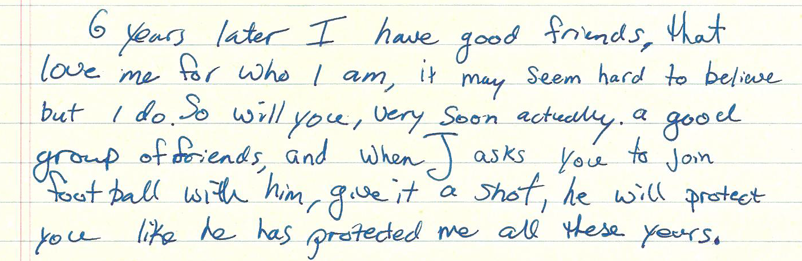
“6 years later I have good friends, that love me for who I am, it may seem hard to believe but I do. So will you, very soon actually. a good group of friends, and when J asks you to join football with him, give it a shot, he will protect you like he has protected me all these years” – Xach’s Letter to his Past-Self [See Appendix I]

Xach’s thoughtful reflection on how things may have been different did come through during the interview, however, having the opportunity to engage in personal reflection through the letter writing process, allowed this sentiment to surface. For Xach, there is a sentiment of loss in regards to the social connections and potential friendships that he missed out on by deciding not to engage in team sports.
In addition to the social aspect that can come along with involvement with sport and active living, a common theme that became quite evident after speaking with each of the research participants was that of a personal and individual nature, and had to do with fitness, health and achievement. Paul was drawn into a lifestyle of healthy active living through his consistent attendance at the gym and has used a trainer in the past, whereas for Dan, his commitment to personal health and well-being has kept him within the sphere of athletics and active living, despite choosing to leave the competitive sport leagues in which he was a member for over fifteen years. For Will, after his athletic career in high-level basketball, he continues to engage in a variety of house league team sports and individual fitness activities as the value of personal health and fitness remain long after his competitive athletic days have ended.
Sports has been such a big part of my life growing up, I would say that I identify quite a great deal with continually being a very active person. I’m not an ‘athlete’ so much anymore, um, but I continue to be athletic. I’m someone who takes great pride in um, keeping active and, and maintain a certain level of fitness of sport skill. – Will

The essence of Will’s statement was shared by the other participants, but was especially stressed in the interviews by Dan and Paul. The notion of “tak[ing] great pride” in maintaining an active lifestyle was a common theme throughout the interviews and illuminates the mental aspect of sport and fitness. Going beyond the physical strength associated with exercising and playing sports, Dan and Paul explained that pushing themselves physically was a testament to their character. By exerting oneself, whether it be in a cross-country race or a rigorous weight-lifting program, the mental strength associated with maintaining a level of devotion to the activity and the perseverance to continue to work hard despite the physical pain and exertion was held in high regard. Will, Dan, Paul, and W.Y. each commented on how their work ethic was an integral part of their overall identity as individuals; however, Paul and Dan highlighted that the feeling of success coming from school or employment could not be compared to the sense of accomplishment from achieving a physical goal. When reflecting upon his time in competitive soccer, hockey, and cross-country running, Dan shared, “It was something about driving your body physically to an extent where you’re dead and you just killed yourself, and you feel great after and I like that.” Paul shared how the “strength of mind” required to achieve such goals was an important aspect of his own embodiment of masculinity. Straying from the popular notion that masculinity is understood solely through physical traits, it was stressed by the majority of the participants that factors such as mental strength, courage, and a firm work ethic play an integral role in their understanding of masculinity. The value placed on these non-physical characteristics illuminates how masculinity extends beyond physicality, and is greatly informed by the personal values by which men choose to live their lives.
Whether it was through “working on yourself,” as described by W.Y., at the gym, or crossing the finish line in a cross-country race, the triumphant feeling of personal satisfaction was presented as an important aspect of the lives of the majority of the participants. The majority of the participants described this as an ongoing motivation to remain involved in a healthy active living and athletic lifestyle within the overarching institution of sport.
Team Sports versus Individual Sports/Personal Fitness Activities: Negotiating Social and Team Dynamics as a Gay Male
Group dynamics can be difficult to navigate in any given scenario, however, the process of understanding team dynamics is further complicated when a male player who identifies as gay is a member of the team. Not only must he assess whether or not the environment is perceived as a safe space to come out as gay, but being in an environment which reinforces the dominant notion of gender-conforming masculinity can be a taxing process for those who are seen as ‘deviating’ from the norm of hegemonic masculinity (Anderson, 2002; Anderson, 2011; Stoelting, 2011). Given the dominant norms regarding gender and masculine performativity within athletic environments, a culture of fear exists for many athletic males who identify as gay (Gough, 2007; Steinfeldt & Steinfeldt, 2012). Choosing whether to engage in team sports, individual sports, or to remain outside of the competitive sphere within sport and focus on personal fitness activities is an ongoing negotiation for many gay males involved in sport, whether or not they are open about their sexuality (Anderson, 2002). The participants echoed much of what came through in the literature as they shared their stories and struggles regarding their negotiation of identity and masculinity in different areas of sport.
As represented in the introductions of each of the research participants, Xach, Will, W.Y., Paul, and Dan have each been active within multiple spheres of the institution of sport. Whether they played competitive hockey and have maintained a steady gym routine, or if they historically played varsity level sport, but continue to play in a community house league, it is clear that each participant has a wealth of experience within the multiple domains of sport in which they have inhabited. When getting to know each of the participants, they briefly explained the different realms of sports in which they have taken part in, either historically or currently; however, it was not until the interview had progressed and the personal narratives developed that I began to see how consciously some of the participants negotiated entering or leaving particular areas of sport. One of the most stressed aspects of this negotiation was whether or not to engage, or maintain one’s engagement, in team sports.
Negotiating Identity and Masculinity in a Team Setting
The oral narratives offered by the participants who have a history of team sport highlighted the complexity of how they found themselves negotiating their identity and understandings of masculinity in the context of team sports. Xach and Dan spoke specifically of how the dynamics of social interaction within the locker room were a unique factor that played a significant role, not only in their negotiation of identity and masculinity, but also in their consideration of participation in team-based athletics. For Xach, the fear of the locker room deterred him from joining team sports in early in highschool.
I was really afraid of joining sports because of the locker room... I always feared that no matter how open [the team] was acting, like they could be running around naked one day, and if I was out, they would be changing with the towel around their waist. I figure they’d go to a similar extreme because it’s not the same anymore. – Xach

When I probed Xach on what he meant when he stated, “because it’s not the same anymore,” he clarified that his gay identity would shatter the general assumption of those in the locker room that everyone identified as heterosexual.
As a result, Xach foresaw the behaviours of the other players changing, with the root of change stemming from their discomfort of Xach’s sexuality. This brings attention to where the burden of responsibility falls in relation to creating and maintaining team dynamics. In Xach’s account, he takes on this responsibility by removing himself from the team’s space as a way to not disrupt the feeling of comfort held by the other players.
Dan explained that he acted completely differently in the locker room with his teammates than he did when at school with his friends. Unlike school, where he was “loud and crazy,” in the locker room he was quiet, reserved, and remained somewhat socially disengaged from his fellow players. Dan even avoided pick-up games of soccer or street hockey, quoting, “I don’t feel like I can play it because I’m, I’m the gay boy. Like, whether or not they know, I feel not masculine enough even to join simple things.” The notion of making others feel uncomfortable by way of one’s own identity and presentation of self was brought up repeatedly by every research participant in relation to familial, peer, and/or professional relationships. W.Y. spoke early on in his interview about the difficult negotiation of balancing the expression of his true identity and the idea that his identity and/or self-expression could make others feel uncomfortable.
…the way I behave in public, you know, it’s just kind of something to think about that other people are uncomfortable…I don’t know what I would do that would make people uncomfortable, but I just know that, you know, just the idea of it does make people uncomfortable, and I think I’m cognizant of that. – W.Y.

Dan also discussed the locker room as a place within team sports that was “uncomfortable.” When reminiscing on his eleven years as a competitive hockey player, Dan commented on the negative atmosphere of the locker room, where the “masculine macho guys kind of rule the roost.” Although Dan was never afraid to be rough and “love[d] to check” in hockey, the overly aggressive tone within the locker room was uncomfortable. When recounting memories of teammates boasting about ‘beating someone up’ or ‘destroying someone’ on the ice, Dan described the experience as a “huge turn off because I like to play because I like to play.” When Dan would leave the change room, he found out that one of the players would make derogatory comments about him being ‘feminine’ and was calling him ‘gay’. In our interview, Dan talked about how he would dismiss the comments made by his teammates and continue to focus on playing hockey, which exemplified a level of inner strength. Upon reading his letter to his past self, a deeper understanding of what those experiences meant to Dan were brought to the surface:
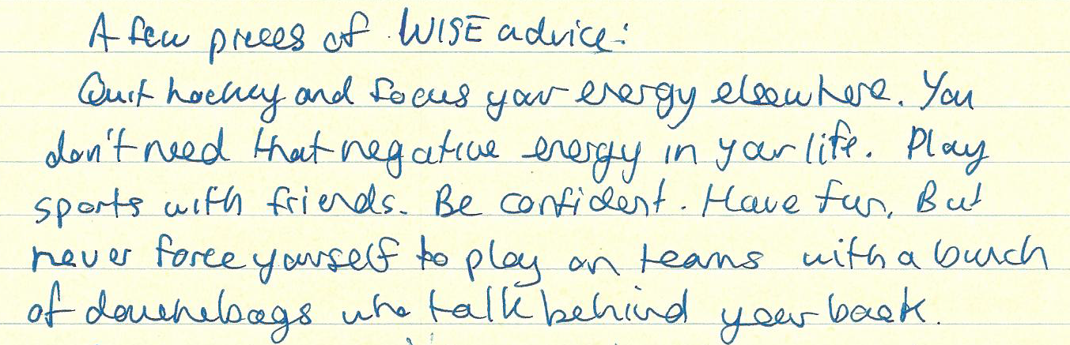
“A few pieces of WISE advice:
Quit hockey and focus your energy elsewhere. You don’t need that negative energy in your life. Play sports with friends. Be confident. Have fun. But never force yourself to play on teams with a bunch of douchebags who talk behind your back.” – Dan’s Letter to his Past Self [See Appendix V]

Dan’s oral narrative spoke much of the positive aspects of his experiences on team sports, including the opportunity to push oneself physically for a sense of personal accomplishment, and while he mentioned many negative aspects associated with team sports, his reflection in his letter to his past self illuminates how he truly looks back on his history. Dan’s advice to himself to “quit hockey,” is not to say that all team sports will offer a negative experience, but instead, highlights his current conviction that bullying and feelings of discomfort within a team atmosphere should not be accepted as a norm or expectation of team dynamics. There is space for positivity and healthy relationships within team sports, and Dan’s advice to his past self to not settle for anything other than respectful relationships amongst team members resonates heavily with many of the written and oral narratives offered by other research participants.
Moving past the locker room, it became evident that gay males in sport must also negotiate team dynamics on the playing field/court itself. It was brought forth that the way in which players present themselves, either by way of a non-heterosexual identity or by not conforming to varying traits of hegemonic masculinity, has major implications for the team dynamics on the playing field/court.
Earlier, Xach described how he feared that his being open about his sexuality would create a level of discomfort within the locker room setting between fellow players; Will extends the notion of this fear as he discussed his negotiation to not come out to his fellow teammates when competing in high-level basketball. Will explained how his choice to not disclose his identity to his teammates was heavily influenced by his understanding of what made an athlete “the most successful” player:
I followed the NBA (National Basketball Association) growing up and through playing so much basketball that, there was always the sense that, you know, the most successful player is the one who won the most, or had the most team success and individual success combined… Like I never felt like I even had the possibility of coming out to my team because it would be too much of a distraction, um, to the team environment, and, um, it would also affect the success we’d have I think… So I decided to put basketball over my orientation, I guess you could say, I prioritized in that manner, to say that I was going to do whatever it took in the team environment to create and foster team success, and if that meant cutting out, or putting up a front, to say, you know, for the time being I was straight, then that’s what it took.
– Will

Will believes that the best athletes sustain a positive team environment – and that coming out, because it disrupts that environment, may compromise the team’s success. The struggle associated with Will’s negotiation of how open he felt he could be about his sexual identity is evident, and he highlights that his decision was not just informed by his own team, but also through the values advertised through the NBA, an influential body within the institution of sport. The stress associated with hiding his sexual identity after years of playing basketball was tremendous and reached its climax when Will seriously considered not returning for his team’s following season of basketball. After engaging in what Will referred to as an “internal discussion” while walking to speak to his coach, he reached the conclusion that his identity as a basketball player was such an integral aspect of his identity as an individual, that he could not follow through with leaving his team or basketball behind. Cavalier (2011) discusses the “team first” mentality, which echoes the negotiation of how someone prioritizes their athletic identity over that of their sexual identity in order to maintain the status quo of the teams dynamic, both on the court and off (627).
Will’s reflection on the value of maintaining a positive team dynamic continued from his oral narrative to his letter to his past self. Deciding whether or not to come out was further complicated by the fact his relationship with his teammates extended beyond the basketball court, as he was close friends with many of the other players. While he wanted to maintain the integrity of the team’s seamless dynamic, he reflected on the toll his delayed ‘outing’ may have on his friendships.
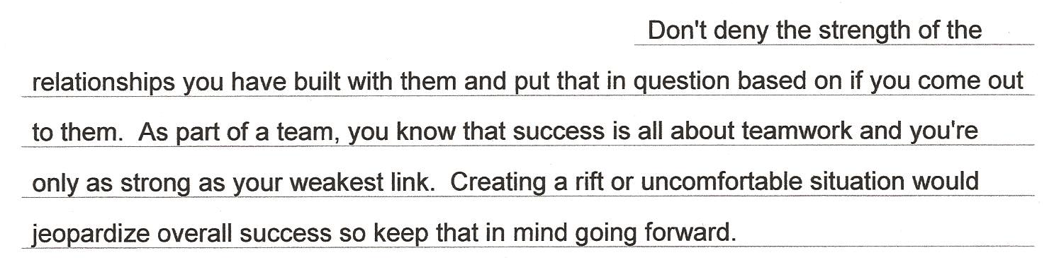
– Will’s Letter to his Past Self [See Appendix II]
The pressure of whether or not to ‘out’ himself to his teammates is crystallized within Will’s conflicting narratives in the letter. While he recognizes “the strength of relationships [he] ha[s] built” with his teammates, he followed up by offering somewhat of a caveat to past self to be aware of the potential consequences associated with disrupting the team dynamic.
While he was not out to his teammates, Dan shared that fellow members of his hockey team would make jokes about him being ‘feminine’ and ‘gay’ when he was out of the locker room. These experiences contributed to how Dan felt he needed to perform, not only in a casual sense in the locker room with his fellow players, but when on the soccer field, hockey rink, or when rowing.
If I prove to everyone that I’m a good player, that doesn’t matter if I’m weird, or later, if I’m gay, it doesn’t matter, like, if I’m feminine or skinny or small. If I like, get goals or am a good player and I work hard, then that’s all that they should care about… I had some indirect goal that I was worth having on the team. – Dan

Dan continued to share how he experienced the pressures he felt from being on a team. Dan grappled with his “feeling [of being] kind of on the outside” of the different competitive sport teams that he was a part of. In his reflection, he shared that while trying to ignore the bullying-like behaviours of some teammates, a part of him still felt like he was “trying to prove himself,” or have his presence and value to the team validated by others. Although Dan saw how this “indirect goal” helped him become an extremely skilled athlete, doing so came at the cost of existing within an environment that valued hegemonic masculine ideals and heterosexuality, two things to which Dan does not conform. After Dan spoke with enthusiasm in regards to his love for pushing himself physically on the ice and enjoying hockey as a sport, the tone of the conversation changed when Dan talked about how he felt isolated on the team.
I really became like, isolated in group. Like, I talked to my, literally talked to myself while playing. I didn’t talk to anyone else, I didn’t want to talk to anyone else…It’s really depressing, geez. And I’m realizing all this stuff! Like, ugh! Like, I hated it! I just cried, like, so many times I knew I had a game. It’d be like traumatizing to have to go to these things because of all these people. And it wasn’t explicitly because they were mean to me, I just didn’t feel comfortable with them. – Dan

Dan’s narrative regarding his general feeling of discomfort with his teammates was not easily articulated; he sometimes stumbled over his words when trying to piece together thoughts, or was only able to say, “I don’t know why. Like, I could never tell you why, it’s it’s so discomforting.” However, as the conversation progressed, Dan was able to verbalize what contributed to his feelings of discomfort with sports teams, specifically the rowing team on which he was the coxswain (or coxy). Dan experienced such strong feelings of discomfort when with his fellow rowers, he left the team.
I was on the rowing team. Oh my God, so uncomfortable! I was the coxy, but I hated being around these guys all the time, like so uncomfortable… It’s like guys being guys and it’s uncomfortable…Maybe it’s because I feel like I was expected to be like them and I wasn’t because I’m supposed to be a guy too, and I’m just not meeting the standards that everyone else is at. – Dan

After having space to reflect upon his own experiences during the interview process, Dan was able to crystallize what contributed to his negative experiences on sport teams. As part of his negotiation of his own identity, he recognized that the way he embodied his own understanding of sexual identity and expression of self was not congruent to the dominant forms of masculinity held by many of the other athletes with whom he was associated. Dan explained how the manner in which the other athletes interacted with each other contributed to the creation of an unsettling environment. Being aware of his own understanding of masculinity and self-expression, he could see the way in which his fellow rowers exuded a “tough” masculine appearance through their social interactions and physical presence. This experience seemed to magnify Dan’s non-conformity to hegemonic masculinity. Dan reflected, “all this, this testosterone or something, I dunno… I just don’t want to be there.” Dan’s reflection on his struggles were reminiscent of my earlier conversation with Will, who talked about the “athletic world,” describing it as a “very exclusive…and harsh atmosphere, so it’s really hard for people to show who they truly are.” As part of his personal negotiation of sexual identity and masculinity, Dan chose to leave rowing, and eventually team sports, and focus his energy on other forms of personal fitness and healthy active living.
An interesting phenomenon that was unique to Will, was that his negotiation of identity and masculinity in relationship to sport was not confined to the locker room or the basketball court. While playing varsity basketball during his undergraduate degree, Will shared a house with many of his teammates. In his letter to this past-self, Will referred to his teammates as his “2nd family,” having spent so much of his university career with them both on the court and at home. While he avoided labeling his teammates at his “social support[s],” but they were the main “social system” with which he identified.
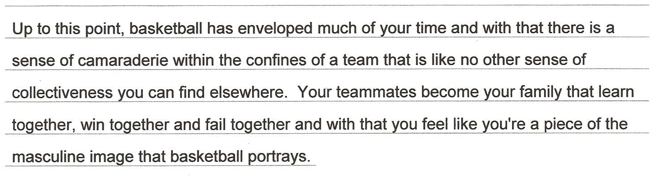
– Will’s Letter to his Past Self [See Appendix II]
The sense of camaraderie that came along with his involvement with his varsity basketball team was an important aspect of Will’s experience in sport. Moreover, being a part of the team contributed to Will’s feeling that he was “a piece of the masculine image that basketball portrays.” However, as Will’s letter continued, it became clear that these positive experiences were only one part of masculinity’s double-edge within sport. Being a part of the “masculine image,” meant that Will monitored his own behaviours and actions as to not deviate from what would be considered ‘normal’ masculinity, which included presenting as heterosexual. Will’s self-surveillance of his own behaviour and self-expression were heavily informed through the constant presence of his teammates, meaning he was constantly working to maintain a façade of heterosexuality and masculinity. The “team atmosphere” carried into other social spheres, such as his student home from his undergraduate degree and social spaces, like bars, downtown. Will relied on the metaphor of a “mask of this masculine figure” to express how he felt both on and off the court with his teammates. When possible, Will chose to remove himself from social spaces and situations that might have made him uncomfortable. At times, Will who prides himself on his strong work ethic and commitment to academics, would use school to avoid uncomfortable situations where he would continue to feel the pressure to wear “a mask and [put] on a bit of a front to fit in.”
I almost used it sometimes as an excuse to avoid social situations that I didn’t want to get into, um, that might make me uncomfortable because of my orientation, so I would choose not to go out with the team at times, saying that I would have school work to do – Will

Having completed his tenure as a varsity athlete, Will reflected on how his social networks have changed and how he has experienced his identity as a gay man and expression of masculinity change over time. His love for basketball continues and he’s left with many “long-term memories,” but upon leaving varsity athletics, Will felt a relief from the pressure to show off the prized traits of hegemonic masculinity as represented in sport: “taller; bigger; stronger; aggressive; shows the least emotion; not showing any weakness.” The “freedom” Will felt upon leaving varsity sport referred not only to the decreased pressure of the team atmosphere, but also to the opportunity to explore other individual sports and personal fitness activities. Moreover, Will was able to build up a network of friends with whom he felt less pressure to conform to a particular image of the hegemonic masculine male.
Negotiating Masculinity and Identity in Individual Sports/Personal Fitness Activities
Opportunities for engagement with the institution of sport are abundant, ranging from recreational leagues, high level competition or professional streams of sport, team-based sports or personal fitness activities. Most of the participants in my study have experiences in both team sports and individual fitness activities, and while some engaged in both forms of activity simultaneously, others purposely gravitated to individual activities after leaving team sports. Each participant had his own reason for getting involved in competitive individual sports, such as cross-country running, or personal fitness activities like biking or weight-lifting; each spoke about how these solo sports and fitness activities offered a unique opportunity to negotiate masculinity and sexual identity in a way that was not an option within team-based athletics.
One of the most prominent themes that stemmed from the participants’ comments on individual sports and personal fitness activities was the notion of offering a refuge from the sometimes, “harsh environments” associated with competitive team sports. Even though some of the participants recounted positive memories associated with their former teams, they could not deny the difficulties associated with the social and team dynamics in team settings. When discussing his past on numerous competitive team sports, Dan shared his difficult decision to leave team sports behind and explore a different athletic outlet.
There’s just too much negative, negativity, and I’ve been there, and I don’t want to be there anymore. It’s kind of sad because I love sports! I like playing them and I like competition, but I’m not going to compromise my comfort for a game. I can play another game. – Dan

Dan’s reflection on his decision to leave team sports represents the multiple factors that he needed to consider. Despite his satisfaction with his decision to leave team environments, which he recognized as being inherently problematic, a sense of loss is maintained in his statement. Over half of Dan’s life was dedicated to competitive team sports – he loved the games and the competition. The final decision came down to whether or not Dan could be truly happy and express himself freely within the arena of team sports. Upon leaving competitive team sports, Dan has found ways to stay fit, such as going to the gym to work out. “I do it because I want to stay in shape,” he explained, saying that building muscle is not always about looking more masculine, but about being happy with himself and being healthy.
Xach, who steered away from team sports in high school, later became involved in badminton and tennis on his school’s team. For him, there was a strong differentiation between badminton and tennis, and other sports, saying that “they’re lesser sports in that they’re either single or pair sports.” Based on the fact that the sports were often not associated with the “tough” or masculine jock stereotype and they were not part of a team, they offered Xach a space within athletics where he felt more “safe.”
Yeah, I would say like, um, I guess there’s sports that are kind of, if they’re individual, I think generally more safe because I guess if you’re on a team, you have to hope that every other person on your team is on your side in that situation, and then, teams look for the weakest link and that’s just something to target and initiate and go after. – Xach

The self-imposed isolation from other players was appealing to Xach, as the risk of bullying from teammates was eliminated. Ideally, as Xach pointed out with a sense of hope, a team would be comprised of individuals that would be supportive, accepting, and protective of their fellow players. However, with each additional player on a team, Xach saw the risk of being singled out based on his sexual identity increase exponentially. Influenced greatly by the heterosexist and homophobic values of sport, Anderson (2002) and Gough (2007) discuss how gay-identified players are often bullied on sports teams. Athletes who are identified as gay are often perceived to be effeminate, lacking in aggression, and are assumed to lack the strength and ability to contribute to a team’s success (Anderson, 2002). These discriminatory stereotypes, which also points to sport’s sexist discourse, are quite pervasive within the world of athletics, as other participants validated these assumptions as commonly held within players of team sports. As a result, Xach gravitated toward tennis and badminton as they allowed him to engage in a safer part of sport, as he would not be implicated in a team setting. Xach believes that a ‘real team’ would be comprised of individuals that were prepared to support each other, both in their actions on the field and off. Supporting a gay-identified player as a team would include challenging homophobic or heterosexist discourse within the locker room and within one’s school environment or sport league.
After years of playing high level competitive basketball, Will felt “a sense of relief” and freedom to explore other forms of fitness activities after graduating from his undergraduate degree. While he continues to play team sports on weekly leagues during the summer, he is no longer on the same training schedule with his basketball team that occupied such a great deal of his time and energy. At one point in his life, Will talked about how being on three different teams simultaneous left very little time for anything or anyone that was not tied to basketball.
I played basketball on high- It’s not a very accepting atmosphere for gay people. It’s um, a lot of harsh words that are said in team environments, and I think that, when I graduated, there was almost a sense of relief from leaving that environment and have the choice to pursue, you know, other athletic, other sports, or other forms of physical exercise. I could express myself in those ways… I got into individual sports; running, um, biking, um, and it’s an opportunity to do what I wanted to do without having um, you know, the distraction of people around me. – Will
Will’s transition into individual sports was not exclusive, as he continues to play in casual basketball leagues during the summer, but after fifteen years of dedication to one high-level sport, Will appreciated the opportunity to “branch out” and become involved in other activities that would still fulfill his dedication to fitness, athleticism, and healthy active living. “I find it helps to balance, to clear my head and get out of the team atmosphere and all the things that come along with that.” Since then, Will has gone on to find a network of friends outside of his athletic world with whom he feels more comfortable. Having more time to socialize with others outside of basketball, Will discussed how it felt to build friendships with those he feels comfortable with, and be able to distance himself from those who do not contribute to a “safe or comfortable” social environment.
Above, Will refers to the idea of being a distraction to other people in a team setting. When talking about personal fitness activities, such as weight lifting at the gym, W.Y. commented on the security associated with being amongst a large number of people at the gym. Here, however, the larger number of people are not team members, but rather other individuals, each working on a fitness project independently. Although surrounded by others, the gym offered a sense of “anonymity,” letting W.Y. “go in, do [his] own thing, and leave.” Yet even in this anonymous space, W.Y. explained that “at first, I was uncomfortable cus I’m not that big.” The perception of the gym being a masculine and heteronormative space was shared with other participants, contributing to some feelings of anxiety or anticipation prior to their first few visits.
I think it’s just kinda the build up before the first time you go to the gym that other people are going to judge you, but just for the first time I was there, and when I actually was there, I wasn’t really worried about it anymore. – W.Y.

W.Y.’s confidence increased as he felt more comfortable in the gym, among a variety and males and females who have all different body types. While it was noted that “there are always gonna be people that are huge and masculine,” and representative of the physical ideals of hegemonic masculinity at the gym, W.Y. shared how he came to realize that “other people don’t care why you’re there.” W.Y. found solace in the anonymity of the gym and being able to focus on himself while those around him focused primarily on themselves.
Dan, although he felt comfortable going to the gym, noticed he often stayed in areas of the gym primarily used by females. It is was difficult for him specify whether his feelings of discomfort in working out in the male-dominated area of the gym stemmed from his sexuality, or that his body type was not congruent with the large and muscular bodies of those who primarily occupy the space. Either way, he dealt with these feelings by scoping out the areas of the gym often inhabited by females.
I’m like, ‘Yeah! That’s my place!’ And even if guys are there, I don’t really care but it’s almost like it’s the girl’s environment so it’s comfortable… I try to avoid the male-dominated areas. I’ll still go and I have been to them and no one’s said anything, no one’s negative, it’s just this looming, like, uncomfortable feeling. – Dan

Dan’s recognition that he has not had a negative experience at the gym, which would inform his avoidance of the male-dominated sections, points to the inherent heteronormativity present within the institution of sport. Balancing his commitment to “being healthy and being in shape,” with values of gender conformity and heterosexuality in sport, has meant that Dan has not only had to navigate his way out of team sports but also through the institution of sport. Gough (2007) and Steinfeldt & Steinfeldt, (2012) refers to sport as a site that reinforces and reproduces gender role expectations and gender stratification.
Paul, whose primary connection to the institution of sport was through personal fitness activities such as weight lifting and maintaining an organized gym routine, spoke differently about his experiences and relationship to the gym than some of the other participants. While many of them reported having a positive relationship to the gym, Paul spoke differently about the social aspect of the gym. W.Y. and Dan enjoyed the “anonymity” of going to the gym to focus solely on themselves and even “pretend that no one else is there,” while Paul valued the social aspect of the gym, whether it be going to the gym with friends or the possibility to meet other males. He saw the gym as a place “to see and be seen,” referring to the opportunity to subtly check out other gym patrons and potentially meet someone new. The gym was also an opportunity to spend time with existing friends, often going to work out with a buddy. “Like, I’d call it a gym date. And not in a romantic way, but like a gym date where you have a gym buddy, uh, and I find it very motivating.” Paul identified himself as a very social person who enjoyed and valued meeting new people.
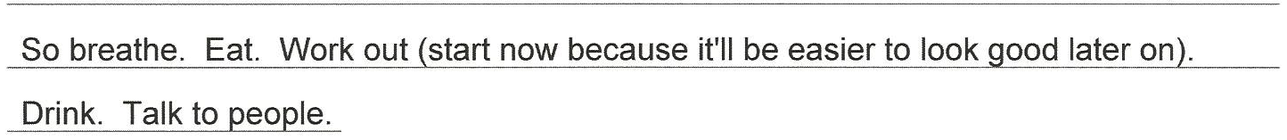
– Paul’s Letter to his Past Self [See Appendix IV]
Paul’s positive relationship with the gym draws attention to the opportunity within personal fitness activities to combine the positive social aspects associated with team sports, such as motivation and support, with the freedom of expression and identity that many of the other participants discussed in relation to individual sports and personal fitness. When asked about what contributed to his positive relationship with the gym as a gay man, Paul stressed two main ideas. Living in a large city, he had the option between attending gyms that were geared toward gay male clientele. Unlike the gyms reference by other participants, Paul guessed that roughly 80% of the other males who frequented his gym identified as gay, which had a positive influence on its general atmosphere. Secondly, “it’s all about gaining that confidence about going to the gym.” Paul felt that the knowledge he gained from using a gym trainer in the past boosted his confidence to navigate his way through all areas of the gym and feel comfortable within the setting and around other people.
Masculinity & Sexuality within Self-Identity
While much of the literature presented in the earlier review highlighted the association of physicality, muscularity, and the strength of males with that hegemonic masculinity, the testimonies of the research participants stressed the notion that strength comes in a variety of forms and is a valued as an integral aspect of identity. The idea of strength in a physical, mental, and emotional sense as being negotiated as part of one’s masculinity was an important discussion that occurred with the majority of the participants and was also reflected upon with their letters to their past selves. When asked to describe what they understood as masculinity, many of the participants gave two-part answers. In the first part they defined masculinity by way of physical characteristics, often in ways that were synonymous to those defined by hegemonic masculinity. They then referred to traits that seemed to be less tangible and more difficult to describe. This difficulty of defining ‘other aspects’ of masculinity has been noted by several other researchers (Anderson, 2002; Filiault & Drummond, 2008; Lanzieri and Hildebrandt, 2011; Wilson et al., 2010). Included in my discussions with participants, some examples they noted were: drive; dedication; and emotional strength.
For example, while Paul explained how his understanding of masculinity included the ideals of physical strength and muscular bodies, he stressed the integral role of discipline and “strength in the mind” as contributing factors of masculinity, as they are the tools that can help someone achieve the body type in which they personally strive to achieve.
It takes a lot of time and energy to look like that! It does take a lot of dedication and strength in the mind. And there’s a lot of value in that too, because it’s about having a goal and then reaching it. Now, you can’t just go to the gym, lift weights or run haphazardly and expect that you will reach your goals… it’s not done randomly and I think that also speaks to masculinity because they have a goal and they, you know, have steps to achieve it, and then they achieved it. – Paul

W.Y. reinforces Paul’s idea that masculinity and fitness goes far beyond the physical aspect and is not confined to solely to one’s physical traits. W.Y. comments on how his understanding of his own masculinity is informed a great deal through feelings of pride, courage, and personal achievement that comes from challenging himself.
When I get an adrenaline rush or when I kind of exhibit bravery in one way or another, or if I just do something new and kind of out of my comfort zone and like, make myself feel proud in a way, I think like, that makes me feel masculine… I identify as a man, so when I do something that makes me feel good or proud, I just kind of, makes me, as a man, feel better about myself in a way. – W.Y.

W.Y. and Paul’s statements illuminate the existence of masculinity as a concept that extends beyond the stereotypical realms of physicality, but rather, is inherently linked to one’s own sense of self. In these quotations, it is not the act of sport which contributes to one’s perception of their own masculine identity, but rather, sport can offer an avenue in which one can set personal goals and push oneself both physically, mentally and emotionally.
Throughout each of the participants’ experiences in different areas of sport, transitions between different arenas of athletics, and interactions with a variety of different individuals, every participant commented on the role of confidence in their life. Many found confidence in themselves to become involved in spaces within sport that are not always perceived as ‘safe’ for those who are gay or for those who do not express themselves in line with society’s expectation of gender conformity (Gough, 2007; Steinfeldt & Steinfeldt, 2012). With that confidence has come an exhilarating sense of freedom to exist according to whatever definition of ‘masculinity’ that they choose to embody.
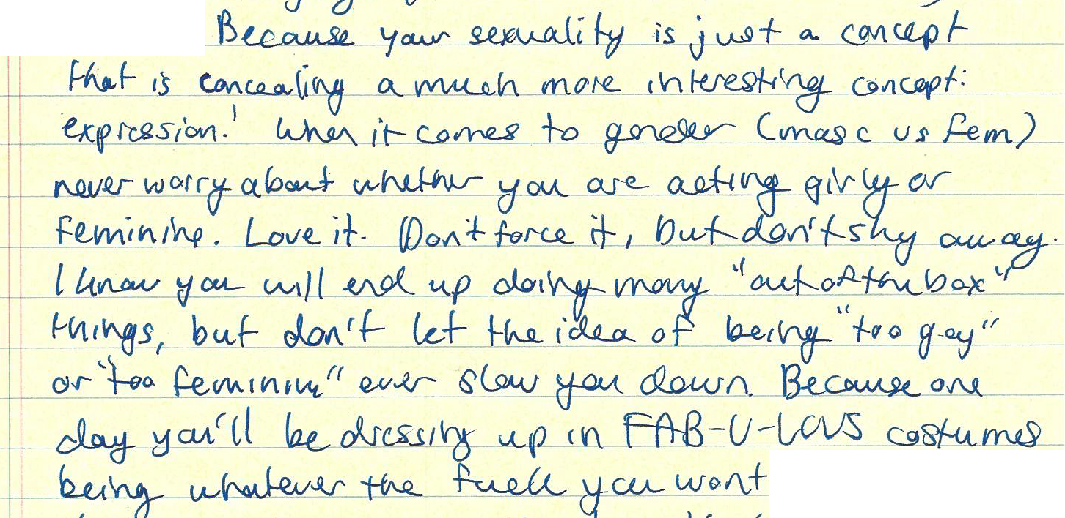
“Because your sexuality is just a concept that is concealing a much more interesting concept: expression! When it comes to gender (masc vs fem) never worry about whether you are acting girly or feminine. Love it. Don’t force it, but don’t shy away. I know you will end up doing many “out of the box” things, but don’t let the idea of being “too gay” or “too feminine” ever slow you down. Because one day you’ll be dressing up in FAB-U-LOUS costumes and being whatever the fuck you want” – Dan’s Letter to his Past Self [See Appendix V]

Dan’s letter encourages his past self to embody his own definition of ‘masculinity,’ and resist society’s oppressive understanding of masculinity and femininity as existing as a binary concept (Levy & Johnson, 2011; Phua, 2007; Ruffolo, 2006). It was clear when listening to Dan share his story that he was confident in himself and comfortable in his identity to express himself, and the conviction with which he spoke about self-expression of identity exudes from his letter to his past self. Given that the letters were to be written to the participants’ past selves at a time where they were heavily involved in their own negotiation of identity and masculinity, the excerpt from Dan’s letter above highlights how he now exists with a sense of self-empowerment and inherently follows his belief in freedom from oppressive constraints on expression.
The unique narratives, both written and oral, offer insight on how each of the research participants have negotiated their own understandings of masculinity and identity within the institution of sport. The mixture of similarities and conflicting narratives between the participants brings attention to the importance of garnering a thorough understanding of each individual’s personal journey of self-exploration and negotiation of identity and masculinity within the institution of sport.

Chapter VI
Discussion
The data produced by the research participants by way of their oral histories and written letters were substantial. The ideas included in the previous chapter were purposively chosen, as they speak directly to the how the research participants negotiated their identity and masculinity in relation to sport. I feel honoured to have had the opportunity to be able to engage with each participant and listen to their narratives, not only in the moment, but multiple times over when transcribing and preparing to code and analyze the data. Doing so allowed me to garner a deeper appreciation for what was being shared and helped me to give more attention to the subtle nuances the came from the interview process. While some major themes subtly came to the surface, others were made obvious early on during the data collection period. The following chapter will offer a deeper summary of the study’s findings, prior to offering a discussion that engages the findings with existing literature. Throughout this chapter, sport’s influence on gay male’s negotiation of masculinity will be interrogated, and the popular notion of hegemonic masculinity will be deconstructed to highlight the true existence of a multiplicity of masculinities.
Summary of the Findings
The purpose of this study was to explore how gay males involved in sport have negotiated their identity and masculinity. Understanding the institution of sport as site of hegemonic masculinity, where gender role expectations and gender stratification is reproduced and reinforced, the space can be quite problematic for those who do not conform to the idealized heterosexual male identity (Anderson & McCormack, 2010; Campbell et al., 2011; Steinfeldt & Steinfeldt, 2012; Stoelting, 2011). Understanding the disproportionate underrepresentation of gay-identified males within sport, I sought to explore how one’s involvement in varying aspects of the institution of sport contribute to one’s personal negotiation of identity and masculinity, and additionally, how this process is experienced over time.
It became clear vis-à-vis the oral and written narratives of the research participants, that their unique experiences within different arenas of the institution of sport have had, and continue to have, a significant impact on their negotiation of identity and masculinity. Many of the participants spoke positively about their reasoning for their initial engagements with sports, fitness, and healthy living, and shared why many of them chose to continue in their athletic pursuits. Although not all of the participants shared the following sentiment, the majority of the participants commented on how their engagement with sports facilitated a social opportunity to meet new people and to spend time with friends. Moreover, three of the participants stressed how their dedication to varying aspects of sports and athletics was an avenue in which they could enjoy the challenge of pushing themselves physically and mentally and also benefit from the health aspects of their activities.
The participants made strong distinctions between the different ways they experienced sport, and in turn, their negotiation of masculinity and identity, through team-based competitive sports, individual sports, and other personal fitness activities. With team sports, came a different social dynamic, as the team played a significant role in the social life of the participants. As a result, individual sports and personal fitness activities were seen as offering a space where a gay male could be more “free” in his identity and embodiment of masculinity, as the pressures and risks related to the ‘team’ did not need to be negotiated. For Dan and Will especially, as they were both heavily involved in team-based competitive sports prior to exploring other, more individual, expressions of athleticism, they emphasized the “relief” they felt upon their entry into personal fitness activities.
Through the written letters and the oral narratives shared by the participants, it was clear that they embodied an understanding of masculinity that was independent from each other’s. Through the similarities and conflicting narratives that surfaced between the narratives of the participants, one can see the importance of understanding the personal nature of one’s negotiation of masculinity and identity. No single definition was agreed upon as being the absolute truth, when it came to the participant’s discussions of the values and traits associated with masculinity. Each participant embodied their own unique approach to masculinity, understanding it as a part of one’s personal self; masculinity was understood as being made up of physical, behavioural, and even value-based traits, that can change and shift as a person grows and changes. While some participants still associate particular physical traits, such as muscle tone and body hair, with masculinity, it became clear that it exists as only one small component of a greater concept. Personal achievement and garnering a sense of personal pride from reaching a goal or pushing oneself out of his comfort zone were identified by some participants as the key aspect to their embodiment of masculinity. Understanding masculinity as something that comes from intangible and immeasurable acts highlights the fluidity of masculinity as a concept; masculinity is an extremely personal negotiation with no particular definition defining how one must live in order to ‘feel masculine.’
Situating the Findings in Literature and Concepts of Masculinity
The participants each had experiences in varying arenas within the institution of sport, with some exclusively dedicating their time to personal fitness activities, while others also took part in team-based competitive sports. As seen in the previous chapter, the dynamics associated with team sports played an integral role in the participants’ negotiation of identity and masculinity and were seriously considered in some of the participants’ decisions of whether or not to involve themselves in team sports. Through the verbal discussions and written narratives surrounding team sports, came out a number of over-arching themes. The idea of ‘risk’ was brought up repeatedly in a variety of fashions when discussing competitive team sports. Dan’s experiences of being called “gay” by his fellow hockey players and being called “feminine” when he would leave the locker room points to the bullying that can occur for those who are seen as not conforming to a heterosexual identity or stereotypically masculine demeanor. Although Dan remained involved in competitive team sports for over fifteen years, the risks associated with team sports prevented Xach from involving himself with any type of sports team as he feared the potential victimization he may face as a result of his sexual identity. It is unfortunate that Xach’s fear of victimization is well-founded and informed. Academic research and the media are riddled with stories of the discrimination and harassment faced by males in sport who are suspected to be gay, causing many athletes to remain in the closet as a “survival strategy” (Anderson, 2002; Elling, De Knop, & Knoppers, 2003, 444; Gough, 2007).
The locker room has repeatedly been brought up in current academic literature as a point of concern for queer athletes; the heteronormative nature of behaviour and use of language makes the locker room a problematic space for those who do not conform to the idealized traits of hegemonic masculinity (Anderson, 2002; Anderson, 2011; Eng, 2008; Gough, 2007). The consequences of this reality, as evidenced by Xach, is that gay males are actively choosing to distance themselves from the institution of sport as a way to protect themselves from bullying and isolation. When Dan shared stories about how his experiences on team sports were “isolating,” he often quickly followed up with a statement reaffirming his enjoyment of the actual sport. The tension experienced between his love for the sport with the negative atmosphere that was associated with said sport, reinforces Gough’s (2007) discussion of the personal costs linked to gay men’s involvement in sport. Dan continually risked facing ridicule during his involvement with team sport, and additionally, was subjected to the risk and reality of feeling isolated, even when surrounded by his teammates.
Anderson (2002) comments on one of the ways in which some gay-identified athletes deal with the risks involved with team sports, offering the thought that players that are seen as more “valuable” to the team’s success (861). Specifically, Anderson (2002) and Gough (2007) infer that a player is less likely to be victimized on a team if they are seen as a valuable member of the team and integral to the team’s overall success. This specific phenomenon was exemplified in Dan’s testimony regarding his “indirect goal to prove that [he] was worth having on the team.” According to Dan, his work ethic and dedication to improving his skill level was motivated by the thought that he needed to “prove” his worth to the team.
The majority of the participants shared how they perceived team-based competitive sports as an environment that involved a greater degree of risk than those of individual sports or personal fitness activities. Many participants stressed the “freedom” and sense of “relief” they felt in their engagement of solo sports or personal fitness activities, given that the pressures associated with the team dynamic were not present. Xach, Will, W.Y., Paul, and Dan each shared how the space they had to negotiate their identity and masculinity when engaging in individually-based fitness/sport activities was a personal process; for the participants who were coming from histories involving team sport participation, they shared a higher degree of control over how they were able to be themselves when doing such activities.
This particular concept, of leaving team-based sports to pursue solo-based activities, is quite absent within existing literature. Despite one author’s recognition that some gay athletes choose individual sports over team sports in order to attempt to bypass particularly heteronormative and masculine environments within sport, there is no inquiry that explores how gay males truly inform their decision to move from the team arena within sport to that of personal activities (Anderson, 2002). Reflecting on the testimonies offered by the participants in the previous chapter, it is clear that the process of navigating one’s space within sport is extremely complicated and involves varying factors, especially for those leaving competitive team sports.
The idea of risk in relation team sports goes beyond that of a social nature, as evidenced by Will’s testimony. Moving from provincial level basketball to that of varsity, Will not only played and practiced with his teammates, but he lived with many of them throughout his undergraduate degree. Being around his teammates almost constantly, meant his negotiation of identity and masculinity did not only occur while on the court. Not only might his coming out risk his personal relationships with his teammates, but Will saw the integrity of the team’s seamless dynamic as being at risk. Cavalier’s (2011) discussion of the “team first” dynamic strongly resonated with Will, who said that coming out would have been “too much of a team distraction,” that risked their performance on the court and their success as a team (627; Anderson, 2002; Anderson, 2011; Gough, 2007). Will’s story extends from the notion of risk to that of ‘responsibility;’ the magnitude of personal responsibility placed on gay athletes in association with the “team first” mentality is not explored within current research. Will’s decision to “put on a mask or front,” and play the role of a heterosexual was informed through, not just the consideration of his own fate, personally and socially, but also by the fate of the team’s success in their efforts to become champions (Anderson, 2011; Cavalier, 2011). This burden of responsibility weighed heavily on Will on and off the court, and informed his decisions to occasionally not take part in social outings with the team. The taxing nature and associated risks of negotiating team dynamics in current literature fails to recognize the fluidity of team dynamics, in that they extend to off-court relations, rather than solely existing on the court and in the locker room.
The idea of responsibility was often brought up by the research participants in conversations regarding the comfort level of their fellow players. With sport being a patriarchal institution that “rejects homosexuality,” participants who had experiences with team sports articulated that being silent about their sexual identity was a strategic decision, and that doing otherwise would create an “uncomfortable” environment for their teammates (Anderson, 2002, 861; Butterworth, 2006; Carless, 2012; Elling, De Knop, & Knoppers, 2003; Eng, 2008; Stoelting, 2011). The burden associated with this responsibility, and how it weighed heavily on some of the participants’ sense of well-being and happiness within their given sports were conversations that extended beyond those that were highlighted in current literature.
The way in which this issue is unexplored within existing literature is quite representative of how many gay-identified athletes are suffering in silence. The idea that these athletes feel responsible to ensure that their teammates feel comfortable points to the reality that many of these gay players do not have someone to whom they can turn for support or assistance. Often times, the captain or coach of a team are supposed to fill the leadership roles, however, if they are implicated in the homophobic, heterosexist, or homonegative discourse occurring within the team, then the gay-identified players are left without resources or support. As evidenced by Will’s testimony, he almost left his varsity basketball team as a result of the stress associated with hiding his identity while being on his team. Will was unable to turn to anyone to discuss the issues associated with hiding his identity or the heteronormative atmosphere amongst the team, meaning that when we he returned to the team for the following season, he continued to face the same stressors.
One of the major benefits of the arts-informed phenomenological methodology that I used to guide the research process was its ability to ensure that the unique experiences of each participant’s negotiation of identity and masculinity could be explored in great depths. As each participant shared their stories and experiences in great detail, I began to notice that conflicting narratives began to emerge in a variety of ways. Not only did narratives conflict between participants, but also within the narratives of participants’ themselves. Moreover, some aspects of their stories contested those presented within existing literature.
The difficulties that were experienced by Dan and Will in regards to their involvement with team sport point to the struggles associated with the heteronormative, sexist, and homophobic environment that exists within the institution of sport (Anderson, 2002; Anderson & McCormack, 2010; Anderson, 2011; Campbell et al., 2011; Eng, 2008; Gough, 2007; Stoelting, 2011). As a result, the institution of sport reinforces and reproduces gender role expectations and gender stratification, having a significant impact on the type of socialization that occurs amongst those that are implicated within the world of athletics (Steinfeldt & Steinfeldt, 2012). Much of this is evidenced through the narratives of the participants, specifically, Will and Dan, both of whom either left competitive team sports completely, or became significantly less involved.
While Dan and Will expressed a sense of “relief” with their decisions, Xach expressed feelings of regret for not joining competitive team sports. Originally, Xach consciously avoided team sports and the locker room setting as a protective measure against bullying. However, upon his reflection, which was facilitated through the letter writing exercise, he feels that joining his school’s football team may have been a positive experience and an opportunity to make new friends. Hearing opposing narratives is fascinating and identifies how one’s relationship with different aspects of sport is truly a personal experience. Xach’s regret highlights one of the consequences of sport’s reputation, and reality, of being a homophobic institution, as Xach is not the only gay youth who missed out on what could have been a positive experience as a result of a rational fear of not being accepted (Anderson & McCormack, 2010; Campbell et al., 2011; Stoelting, 2011).
Continuing to explore the numerous conflicting narratives that came through the data collection process, it became clear that participants lived out their own definitions of masculinity in their own ways. Much of the existing literature relies on the various traits of hegemonic masculinity to guide its approach to understanding masculinity, primarily focusing on the physical traits, such as muscle tone, body hair, and general aesthetics (Anderson, 2002; Connell and Messerschmidt, 2005; Phua, 2007; Lanzieri and Hildebrandt, 2011; Wilson et al., 2010). While some authors offer alternate approaches to understanding masculinity, the conversation often continues to focus on the integral role of one’s physical body as being a major signifier of one’s masculinity (Anderson, 2011; Cavalier, 2011; Connell & Messerschmidt, 2005; Moffatt, 2012). Each of the participants, while noting society’s reliance on physical traits as a way to understand masculinity, extended the conversation about masculinity beyond that which was included in existing literature by focusing on non-physical traits that mark masculinity. Paul and W.Y. stressed their understanding of masculinity as being informed by one’s work ethic; whether applied in the classroom, in a work place, or in the gym, someone with incredible work ethic was understood to be more masculine than a male who is lacking that sense of drive. Other non-physical traits of masculinity that were mentioned included the ability to “show emotion at the appropriate time,” “someone who will own up to a mistake,” “someone who is loyal,” and “someone who has a brain and a heart and a soul.” These types of non-physical traits, which are more closely related to one’s personality and overall value base, are completely left out of the conversations that exist in current literature, but were extremely important to many of the research participants in this study. Understanding masculinity as a personal process and unique aspect of one’s own approach to expressing themselves fails to receive the same attention in the media and in existing literature. By leaving these traits of masculinity out of the conversation, the notion of hegemonic masculinity existing as the idealized form of masculinity continues to be perpetuated. Negotiating masculinity, while understanding physicality as a component, is a complex and subjective experience that goes deeper than the surface of one’s skin. One’s sexual identity is an integral aspect of a person’s overall identity, however, identifying as gay should not disqualify a male from being able to identify as masculine, if they choose to do so. The fluidity of masculinity as a concept is empowering, giving each individual an opportunity to be express themselves and their identity in a way that fits with their complete sense of self.
Through each of their narratives, it became clear that they had each come to understand masculinity in a way that fit with their own way of knowing and existing within the world. For example, one participant enjoys performing in drag and having the opportunity to “fuck with gender,” as he sees the labels of ‘masculinity’ and ‘femininity’ as constraining. Another participant, despite his value of non-physical traits of masculinity, such as a strong work ethic, is quite aware of how his understanding of masculinity is still very much congruent with that of hegemonic masculinity. Some participants debated with themselves during the interview process of whether they truly believed that a muscular and hairy male was masculine, or if that was their automatic assumption based on what they so often see in media. The ways in which each participant approached masculinity were quite detailed, however, this highlights the variety of ways in which one can come to understand and embody masculinity within their own life. With their work rooted in queer theory and not specifically in studies of masculinity, Browne & Nash (2010) would validate the individual and unique approach to understanding masculinity taken by each participant. Despite hegemonic masculinity’s powerful presence within existing literature, this research truly highlights masculinity’s fluid existence within the lives of these five gay men.
Reflections on Methodology: Implications on the Research Process
Having located both myself and my research as existing within the realm of queer theory and postmodern thought, I sought to find a compilation of research methods that would complement each other and allow for the research process to involve a deeper dimension than it would have, had I only interviewed the research participants. While I believed the use of an arts-informed methodology was the key to accessing this deeper dimension of knowledge and reflection, I struggled with finding a method that would truly enhance the research experience for the participants as they reflected upon and shared their experiences of identity negotiation of their masculinity and true self (Barone & Eisner, 2012). After much exploration with different methodologies, arts-related and not, it became clear that the integration of phenomenologically-informed interviews with a creative letter writing exercise would facilitate the unique form of knowledge production that I felt was fitting for this particular study.
Postmodern thought and queer theory would argue in favour of the validity of each person’s unique identity and way of being and it was imperative that I critically engage with a methodology that shared a similar value of personal experience (Browne & Nash, 2010). Using phenomenology to inform my research process was a strategic decision, as it places the greatest value on the how individuals uniquely “understand and describe phenomena” exactly as they are experienced within their own lives (Phillipson, 1972, 122). Being able to delve deeply into the unique experiences of each participant through the interview process created a space where the multiple layers of each individual could be explored and then expand the conversation to make links to larger social and political structures and institutions.
By using a phenomenologically-inspired interview process, it offered the opportunity to delve deeply into the experiences of each research participant. Their oral narratives became more detailed as each interview went on, sometimes even surprising the participants in how deep their reflections became. Many of the participants commented on how the chance to discuss their experiences in the interviews offered them a chance to come to understand their own experiences in ways they never have until that moment, as they were encouraged to critically reflect on their experiences and link them to larger issues surrounding identity, heterosexism, and hegemonic masculinity (Stanley, 2008). Using the tenets of phenomenology to inform the interview design and process was especially appropriate for this research, given the vast differences that exist amongst the participants’ identities, embodiments of masculinity, and past experiences. Phenomenology acknowledges the significance of every story and emphasizes how meaningful each narrative is through its focus on the unique ways in which individuals interpret and experience different phenomena in their own lives (Phillipson, 1972).
A fascinating phenomenon within the interview process itself came to light upon a reflection of the methodology; the phases within the interviews themselves, at times, mimicked the participant’s experiences in sport. When reviewing the transcripts of the interviews, I noticed a pattern in which some of the stories were shared. Initially beginning with tales of some positive memories and experiences within sport, as the interviews continued and the participants delved deeper into critical self-reflection, stories and accounts of some of the difficulties and hardships they faced by way of homophobia, bullying, and isolation began to surface. The honest accounts of their experiences within sports developed as the interviews progressed, sometimes even surprising the participants themselves as they were finally opening up about their feelings from the past and making sense of them through words. The participants often commented on how they felt more “free” to express their true selves and identities at the time of the interview.
This specific process within the interviews can be seen as mirroring some of the participants’ experiences within their involvement in sport. For example, Dan spoke about his early involvement with competitive team sports and many of the positive memories associated with the different teams with which he was a part of in addition to the aspects of sport he was fond of. However, as he progressed over time within hockey and soccer, and then joining other teams, like rowing, he became more aware and more uncomfortable with the overall atmosphere. As time continued, he courageously decided to leave competitive team sports as a way to be more free to enjoy other aspects of healthy living, not only in terms of fitness, but in his own happiness and self-identity.
Combining the semi-structured interviews with the art form of letter writing cohesively brought together two forms of communication, both of which are valuable, but offer different opportunities to express oneself in ways that cannot always be replicated in other communication forms (Barone & Eisner, 2012; Cole & Knowles, 2008; Horsfall & Titchen, 2009). While reflective letter writing is not unknown to qualitative research, its usefulness as a creative approach to data collection remains untouched by many, and letter writing is vastly under-researched as a method, in and of itself, in current scholarship. In the few cases where letter writing has been used as a self-reflexive method for qualitative research, it was the researchers themselves who engaged in the letter writing, and each letter was sent to another individual (Allender & Allender, 2006; Ciuffetelli Parker, 2006; Knowles & Cole, 1994; Pithouse-Morgan et al., 2012).
The letters gave each of the participants a creative outlet to engage in further self-reflection and be immersed in the research process to a greater degree than had they just taken part in the interview. Not only did this opportunity offer space to reflect on their past and current experiences in negotiating identity and masculinity, since the letter writing component took place after the interview, the participants had a second opportunity to reexamine how they orally shared their narratives and the way they attempted to make sense of their history. In the interviews, the participants were engaging in ‘knowledge transfer,’ as they shared their stories for me to work with and bring into the thesis, however, they transitioned into the position of “knowledge makers” through the tangible production of their letters (Cole & Knowles, 2008, 60; Liamputtong & Rumbold, 2008). Many of the participants commented on how much they enjoyed writing the letters, as it was fun, creative, and encouraged them to engage in a type of reflection that they had never experienced.
The narratives produced in the letters differed from those in the interviews; rather than a dialogue occurring between the individual and myself, the researcher, the dialogue witnessed in the letters were more personal in nature, which can be attributed to the fact that the dialogue facilitated by the letter writing was internal and directed to the writer himself. To be privy to these internal dialogues of critical self-reflection and exploration was a special experience; without the integration of arts-informed inquiry, this rare lens into the personal negotiation of identity and masculinity of the research participants would not have been able to be shared.
Highlighting the personal stories of growth, individual experiences of identity transformation, and how each participant has come to learn about himself in his own unique way was integral to the research process. The visual aspect of each letter is representative of the individuality of each participant’s story and their own relationship with their identity and masculinity. For example, we can see Xack refer to an inside joke when he signs off his letter and Will’s decision to type his letter was representative of the lengths he was willing to go to remain unidentified and protected (See Appendix I; See Appendix II). Visually, the texture and style of each letter offers a chance for the reader to become more closely acquainted with the research participants in a manner that could not be replicated had the research only been facilitated via interviews. The visual integration of the physical letters authored by each participant reinforces their integral role as producers of knowledge within the greater research process that led to the creation of this thesis (Cole & Knowles, 2008; Liamputtong & Rumbold, 2008). Their honest words in their letters exist within the thesis unaltered through paraphrasing or even font, adding an additional sense of involvement and ownership over the knowledge discovered through this research project (Liamputtong & Rumbold, 2008).

Masculinity, Identity, & Sport: Implications for Clinical Social Work Practice
Sport’s reputation of being an institution that embodies heterosexism, homophobia, and homonegativity is an unfortunate reality and is extremely problematic for three particular groups of gay males: those who have actively chosen not to enter the realm of sport; those who take part in sport and are dealing with the heterosexist and homophobic nature of the institution; those who have chosen to leave the problematic institution of sport all together (Anderson & McCormack, 2010; Eng, 2008; Gough, 2007; Stoelting, 2011). The unfortunate aspect is that, amongst the issues associated with sports that have been repeatedly mentioned throughout the thesis, sport can offer a number of positive experiences for gay males, but they are missed by many.
Existing literature reminds us of how gay male young adults are disproportionately represented in statistics regarding substance use, issues with mental health, and completed suicides, all of which often associated to the isolation and discrimination they experience during their adolescence and young adult lives (Blackburn & McCready, 2009; Cruz, 2011; Egale, 2013; Pangilinan, 2011). As reported by some of the participants, sport, whether it was through personal fitness or joining an intramural team, played a special role within their daily lives. Whether it was used as a way to reduce stress, have fun with friends, or help maintain a healthy lifestyle, there were benefits that stemmed from their involvement. Through the hostile environment of sport that marginalizes a particular group of people, they then lose out on the opportunity to benefit from a potentially positive outlet in their life that may act as a diversion from certain risky behaviours, such as substance use (Cruz, 2011).
Social work can play a vital role in conjunction with the institution of sport. By creating more accessible avenues for athletes to access social work services, there is the opportunity to assist gay-identified athletes who may be struggling within the team environment or culture of sport. As mentioned by Will, issues that exist off the court often connect to issues on the court, given that one’s identity as an athlete plays such a significant role in their life. For those that are heavily involved in sport, the coach often fills the role of a mentor or support, however, if an athlete is struggling with issues with the team or the coach themselves, having access to social work services with a special understanding of the complexities involved with competitive sports could be effective in addressing specific needs of the athlete.
Social work involvement with sport goes beyond that of micro practice, but would play a vital role in changing the macro-level issues surrounding heterosexism, homophobia, and homonegativity. By understanding the ways these systemic issues manifest themselves within the personal lives of athletes, social work can provide assistance through the provision of education to players, coaches, and the numerous staff who structure the way athletics and recreation is organized in a variety of settings. Social work’s ability to operate with a social justice framework could help change how athletics and recreation are organized and operated within varying institutions. An example of how social work’s involvement in sport can help facilitate effective and positive change is McMaster University’s recent Safety in Sport campaign (McMaster University, 2013). The Department of Athletics and Recreation has made significant changes in its delivery of recreational services and approach to varsity athletics in order to change sports’ reputation of not being a safe space for queer and gender non-conforming athletes (McMaster University, 2013).
While the letters each participant wrote to his past self were originally included in the research design as a method of data collection, through my conversations with the research participants after they had completed their letters and during the data analysis process, it became clear that the letters were also experienced as a therapeutic outlet. McAllister and Wolff (2002) express the multitude of ways that writing can be used as a therapeutic tool, with letter writing being an example of how the process can elicit personal growth and self-discovery. Writing a letter to one’s past self proved to be a complex experience for the participants, however, the therapeutic aspect of the reflection process and the freedom to explore whatever they felt was important to them within the letter was noted by many of the participants. Writing a letter to one’s past self is not just relevant as a research tool, but rather, it can play an integral role in social work practice as a way to promote critical reflection of oneself and one’s past experiences.
Limitations & Considerations for Future Research
The use of phenomenology and arts-informed inquiry as a methodology was vital in my ability to obtain rich and textured narratives from each of the participants (Phillipson, 1972; Liamputtong & Rumbold, 2008; Smith & Osborn, 2008). However, it is important to note that by doing so, I only worked with a sample of five males who identified as gay. Doing so gave me the opportunity to garner a deep understanding of the experiences of each participant in regards to their negotiation of identity and masculinity, however, given the small sample size, it would be inappropriate and inaccurate to make generalized claims based on the knowledge that was generated. In the future, I would consider interrogating the same subject matter using a different methodological approach. Doing so may illicit different conversations and new knowledge that did not surface within this particular study.
The small sample size contributed to a more limited scope into the different arenas within the institution of sport, given that the participants each occupied different spaces within the greater institution. By increasing the sample size and focusing more specifically on one arena, such as varsity sports, a more in depth understanding of the complexities associated with being a part of competitive sports at such a high level would be possible. Given that these athletes often have a long history of sport-involvement prior to their entry into varsity athletics and that it consumes such a significant amount of their time, it would be fascinating to explore how it all is implicated in their negotiation of masculinity and identity. Including gay-identified males who are members of semi- professional and professional sports leagues would provide insight that was not able to have contributed to this particular piece of research, but is vital to academia’s overall interrogation of masculinity and identity as they are also pressured by media and rely on their involvement in sport to financially support themselves. Exploring the non-physical aspects of masculinity within this particular population in future research would uncover the fascinating realities of how masculinity is negotiated within such a large and powerful institution that places such incredible focus on the physical abilities of athletes.
Throughout the research process, each of the participants made subtle references to how their self-confidence and view of self was evolving. Understanding how confidence becomes implicated in the process of identity and masculinity negotiation would extend the findings of this particular study. Future research focusing how this phenomenon is experienced over time would be a vital contribution to academia’s inquiry into how gay males come to embrace their identity and express themselves in the world.
Closing Statements
Every person has a story and no two stories are alike. Through the oral narratives and written letters of each of the young men who participated in this study, it is clear that we each experience the process of coming into our own identity in unique and special ways. No journey is identical and no struggle can be perfectly replicated in the life of another, but as we grow, learn, and experience new things, we are given the opportunity learn about ourselves and how we exist in the world.
The negotiation of masculinity and identity is an extremely personal process in which we, as gay men, are continually engaged, and I am honoured to have been able to listen to each of the stories presented by the participants. Their courage to share their personal experiences of triumphs and struggle as they navigated their way through the complex institution of sport is admirable. While they highlighted the numerous areas within sport that require significant change in order to become a more positive and safe space for gay-identified athletes, their narratives crystallized the ways in which sport have had, and continue to be, an important part of their life.

I believe what Mr. Antolini told Holden Caulfield in The Catcher in the Rye held much truth. Our stories, our histories may one day mean something to someone. If we record our stories, our struggles and successes, those willing to listen may take something from them. However, upon reading each of the letters written to the participant’s past selves, I think Mr. Antolini missed someone, an important member in the audience of our own lives – ourselves.
Though we cannot go back in time, nor can we change the past, we can learn from ourselves and move forward carrying with us the knowledge and wisdom that we have come to teach each ourselves. As Xach, Will, W.Y., Paul, and Dan sign off and say goodbye to their past selves in each of their letters, I can see that Mr. Antolini was right. This thesis and these letters – it’s not just education. It’s history. It’s poetry.

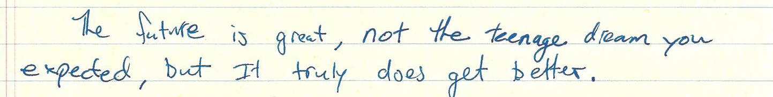
- Xach’s Letter to his Past Self [See Appendix I]

– Will’s Letter to his Past Self [See Appendix II]
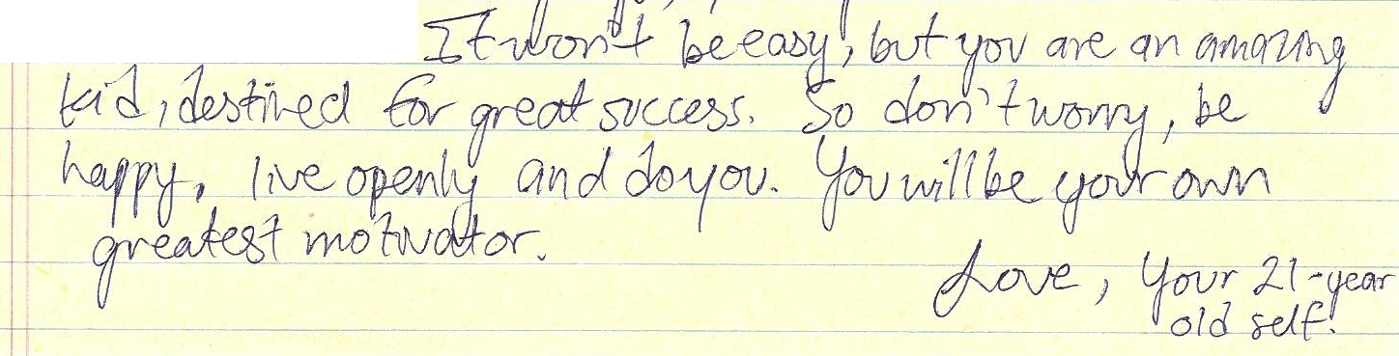
- W.Y.’s Letter to his Past Self [See Appendix III]

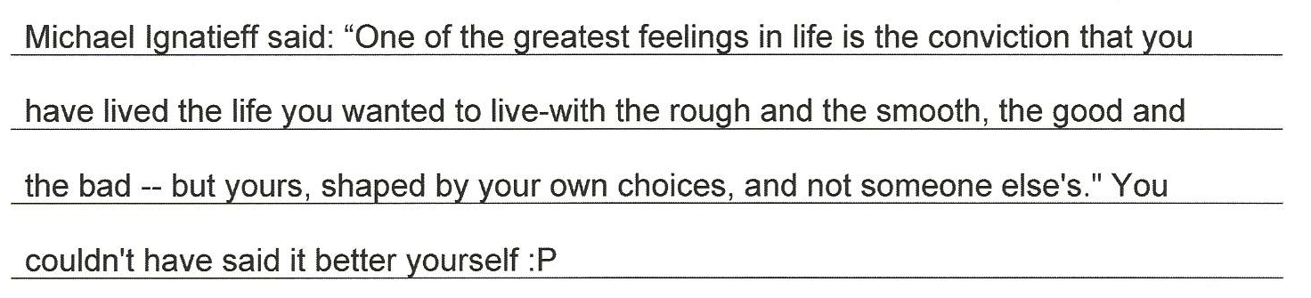
- Paul’s Letter to his Past Self [See Appendix IV]

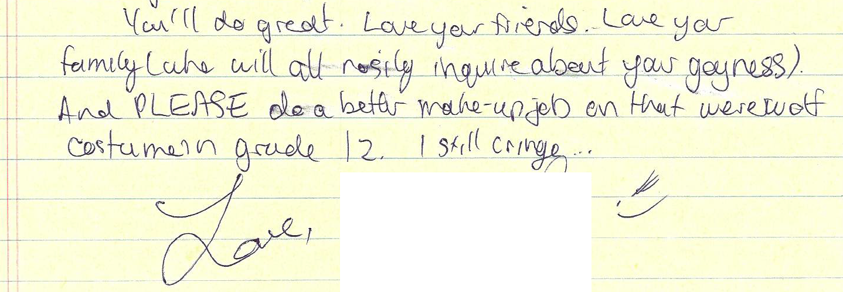
– Dan’s Letter to his Past Self [See Appendix V]

References
Ahmed, S. (2006). Queer Phenomenology: Orientations, Objects, Others. Durham, NC: Duke University Press.

Allender, J., and Allender, D. (2006). How did our early education determine who we are as teachers? In L. M. Fitzgerald, M. L. Heston and D. L. Tidwell (Eds.), Collaboration and community: Pushing boundaries through self-study. Proceedings of the sixth international conference on self-study of teacher education practices, Herstmonceux Castle, East Sussex, England, July 30 - August 3 (14-17). Cedar Falls, IA: University of Northern Iowa.

Anderson, E. (2002). Openly Gay Athletes Contesting Hegemonic Masculinity in a Homophobic Environment. Gender & Society, 16(6), 860-877.

Anderson, E. (2011). Masculinities and Sexualities in Sport and Physical Cultures: Three Decades of Evolving Research. Journal of Homosexuality, 58, 565-578.

Anderson, E., and McCormack, M. (2010). Intersectionality, Critical Race Theory, and American Sporting Oppression: Examining Black and Gay Male Athletes. Journal of Homosexuality, 57, 949-967.

Barone, T., and Eisner, E. (2012). Arts-Based Research. Thousand Oaks, CA: SAGE Publications, Inc.

Becker, S., Bryman, A., and Ferguson, H. (2012). Understanding Research for Social Policy and Social Work: Themes, methods, and approaches (2nd Ed.). Bristol, UK: Policy Press.

Blackburn, M., and McCready, L. (2009). Voices of Queer Youth in Urban Schools: Possibilities and Limitations. Theory Into Practice, 48, 222-230.

Bogetić, K. (2013) Normal straight gays: Lexical collocations and ideologies of masculinity in personal ads of Serbian gay teenagers. Gender and Language, 7(3), 333-367.

Browne, K., and Nash, C. (Eds.). (2010). Queer Methods and Methodologies Intersecting Queer Theories and Social Science Research. Abingdom, UK: Ashgate Publishing.
Butterworth, M. (2006). Pitchers and Catchers Mike Piazza and the Discourse of Gay Identity in the National Pastime. Journal of Sport & Social Issues, 30(2), 138- 157.

Campbell, J., Cothren, D., Rogers, R., Kistler, L., Osowski, A., and Greenauer, N. (2011). Sport Fans’ Impressions of Gay Male Athletes. Journal of Homosexuality, 58, 597-607.

Carless, D. (2012). Negotiating sexuality and masculinity in school sport: an autoethnography. Sport, Education and Society, 17(5), 607-625.

Carter, S., and Little, M. (2007). Justifying Knowledge, Justifying Method, Taking Action: Epistemologies, Methodologies, and Methods in Qualitative Research. Qualitative Health Research, 17(10), 1316-1328.

Cavalier, E. (2011). Men at Sport: Gay Men’s Experiences in the Sport Workplace. Journal of Homosexuality, 58, 626-646.

Ciuffetelli Parker, D. (2006). Literacy narrative relationships: Self-study in collegial letters. In L. M. Fitzgerald, M. L. Heston and D. L. Tidwell (Eds.), Collaboration and community: Pushing boundaries through self-study. Proceedings of the sixth international conference on self-study of teacher education practices, Herstmonceux Castle, East Sussex, England, July 30 - August 3 (198-202). Cedar Falls, IA: University of Northern Iowa.

Clandinin, D.J., and Connelly, F.M. (2000). Narrative Inquiry. San Francisco, CA: Jossey-Bass.

Cohen, T. (2010, April, 17). Hate crimes doubled in Canada. Canwest News Service. Retrieved from: http://www.canada.com/life/Hate+crimes+against+ gays+doubled+Canada/3155968/story.html?__federated=1

Cole, A., and Knowles, J. Arts-Informed Research. In J. Knowles and A. Cole (Eds.). Handbook of the Arts in Qualitative Research (pp. 55-70). Thousand Oaks, CA: SAGE Publications, Inc.

Connell, R.W. (1982). Class, patriarchy, and Sartre’s theory of practice. Theory and Society, 11(3), 5-20.

Connell, R.W. (Ed.). (1983). Which way is up? Essays on sex, class, and culture. Sydney, AU: Allen and Unwin.

Connell, R.W. (1992). A Very Straight Gay: Masculinity, Homosexual Experience, and the Dynamics of Gender. American Sociological Review, 57(6), 735-751.

Connell, R.W., and Messerschmidt, J. (2005). Hegemonic Masculinity Rethinking the Concept. Gender & Society, 19(6), 829-859.

Corrigan, P.W., and Matthews, A.K. (2003). Stigma and disclosure: Implications for coming out of the closet. Journal of Mental Health, 12(3), 235-248.

Criminal Code, R.S.C. 1985, c-C46, s. 159(1-3).

Cruz, C. (2011). LGBTQ street youth talk back: A meditation on resistance and witnessing. International Journal of Qualitative Studies in Education, 24(5), 547-558.

Dankmeijer, P. (1993). Politically Incorrect Identities The Construction of Identities as a Means of Survival: Case of Gay and Lesbian Teachers. Journal of Homosexuality, 24(3/4), 95-105.

Egale. (2013). Media Advisory – Canada’s LGBTQ youth at greater risk of suicide than straight youth. Retrieved from: http://egale.ca/all/ysps recommendation-media-advisory/

Eguchi, S. (2009). Negotiating Hegemonic Masculinity: The Rhetorical Strategy of “Straight-Acting” Among Gay Men. Journal of Intercultural Communication Research, 38(3), 193-209.

Eisner, E. (2008). Art and Knowledge. In J. Knowles and A. Cole (Eds.), Handbook of the Arts in Qualitative Research (3-12). Thousand Oaks, CA: SAGE Publications, Inc.

Elling, A., De Knop, P., and Knoppers, A. (2003). Gay/Lesbian Sport Clubs and Events. International Review for the Sociology of Sport, 38(4), 441-456.

Eng, H. (2008). Doing Sexuality in Sport. Journal of Homosexuality, 54(1/2), 103-123.

Filiault, S., and Drummond, M. (2008). Athletes and Body Image: Interviews with Gay Sportsmen. Qualitative Research in Psychology, 5, 311-333.

Fook, J. (2003). Critical Social Work: The Current Issues. Qualitative Social Work, 2(2), 123-130.

Gorman-Murray, A., Johnson, L., and Waitt, G. (2010). Queer(ing) Communication in Research Relationships: A Conversation about Subjectivities, Methodologies, and Ethics. In K. Browne and C. Nash (Eds.), Queer Methods and Methodologies Intersecting Queer Theories and Social Science Research (97- 113). Abingdom, UK: Ashgate Publishing.

Gough, B. (2007). Coming Out in the Heterosexist World of Sport: A Qualitative Analysis of Web Postings by Gay Athletes. Journal of Gay & Lesbian Psychotherapy, 11(1/2), 153-174.

Gray, R., Fitch, M., Fergus, K., Mykhalovskiy, E., and Church, K. (2002). Hegemonic Masculinity and the Experience of Prostate Cancer: A Narrative Approach. Journal of Aging and Identity, 7(1), 43-62.

Grossman, A., Haney, A., Edwards, P., Alessi, E. Ardon, M., and Jarrett Howell, T (2007). Lesbian, Gay, Bisexual, and Transgender Youth Talk about Experiencing and Coping with School Violence: A Qualitative Study. Journal of LGBT Youth, 6, 24-46.

Guillemin, M., and Westall, C. (2008). Gaining Insight into Women’s Knowing of Postnatal Depression Using Drawings. In P. Liamputtong and J. Rumbold (Eds.), Knowing Differently Arts-Based and Collaborative Research Methods (121- 140). New York: NY: Nova Science Publishers, Inc.

Halifax, N.V.D. (2002). Another form of water: An aesthetic and oblique inquiry into dysbody, solace, and vulnerability. (Unpublished doctoral thesis). University of Toronto, Toronto, ON.

Hammack, P. (2005). The life course development of human sexual orientation: An integrative paradigm. Human Development, 48, 267-290.

Hammack, P. (2008). Narrative and the cultural psychology of identity. Personality and Social Psychology Review, 12, 222-247.
Heckert, J. (2010). Intimacy with Strangers/Intimacy with Self: Queer Experiences of Social Research. In K. Browne and C. Nash (Eds.), Queer Methods and Methodologies Intersecting Queer Theories and Social Science Research (97- 113). Abingdom, UK: Ashgate Publishing.

Hennen, P. (2005). Bear Bodies, Bear Masculinity Recuperation, Resistance, or Retreat? Gender & Society, 19(1), 25-43.

Higgins, D. (2006) Narcissim, the Adonis complex, and the pursuit of the ideal. In C. Kendall and W. Martino (Eds.), Gender outcasts and sexual outlaws: Sexual oppression and gender hierarchies in queer men’s lives (pp. 79-100). New York: NY: Harrington Park Press.

Horsfall, D., and Titchen, A. (2009). Disrupting Edges – Opening Spaces: Pursuing Democracy and Human Flourishing Through Creative Methodologies. International Journal of Social Research Methodology, 12(2), 147-160.

Kian, E., and Anderson, E. (2009). John Amachi: Changing the Way Sport Reporters Examine Gay Athletes. Journal of Homosexuality, 56, 799-818.

Knowles, J., and Cole, A. (1994). We’re just like the beginning teachers we study: Letters and reflections on our first year as beginning professors. Curriculum Inquiry, 24(1), 27-52.

Knowles, J., and Promislow, S. (2008). Using an Arts Methodology to Create a Thesis or Dissertation. In J. Knowles and A. Cole (Eds.), Handbook of the Arts in Qualitative Research (511-526). Thousand Oaks, CA: SAGE Publications, Inc.

Lanzieri, N., and Hildebrandt, T. (2011). Using Hegemonic Masculinity to Explain Male Attraction to Muscular and Athletic Men. Journal of Homosexuality, 58, 275-293.

LaSala, M. (2003). When Interviewing ‘Family’: Maximizing the Insider Advantage in the Qualitative Study of Lesbians and Gay Men. Journal of Gay and Lesbian Social Services, 15(1), 15-30.

Levy, D.L., and Johnson, C.W. (2011). What does the Q mean? Including queer voices in qualitative research. Qualitative Social Work, 11(2), 130-140.

Liamputtong, P., and Rumbold, J. (Eds.). (2008). Knowing Differently Arts-Based and Collaborative Research Methods. New York: NY: Nova Science Publishers, Inc.

Mason, J. (2002). Qualitative Researching (2nd Ed.). London, UK: Sage Publications.

McAdams, D., and Pals, J. (2006). A new Big Five: Fundamental principles for an integrative science of personality. American Psychologist, 61, 204-217.

McAllister, C.H., and Wolff, M.C. (2002). Letters Never Sent: Tending to Unfinished Business. Journal of Poetry Therapy, 15(4), 187-193.

McMaster University. (2013). Building a More Inclusive Sport Community Addressing homophobia in sport through positive space training. Retrieved from: http://www.marauders.ca/news/2011/10/18/
Intramurals_1018115420.aspx

Millington, B., and Wilson, B. (2010). Context Masculinities: Media Consumption, Physical Education, and Youth Identities. American Behavioural Scientist, 53(11), 1669-1688.

Moffatt, K. (Ed.). (2012). Troubled Masculinities Reimagining Urban Men. Toronto, ON: University of Toronto Press.

Morin, S., and Garfinkle, E. (1978). Male homophobia. Journal of Social Issues, 34(1), 29-47.

Morley, C. (2008). Critical Reflection as a Research Methodology. In P. Liamputtong and J. Rumbold (Eds.), Knowing Differently Arts-Based and Collaborative Research Methods (265-280). New York: NY: Nova Science Publishers, Inc.

Mosher, C.M. (2001). The social implications of sexual identity formation and the coming-out process: A review of the Theoretical and Empirical Literature. The Family Journal, 9(2), 164-173

Muñoz, L. (2010). Brown, Queer, and Gendered: Queering the Latina/o ‘Street- Scapes’ in Los Angeles. In K. Browne and C. Nash (Eds.), Queer Methods and Methodologies Intersecting Queer Theories and Social Science Research (55- 68). Abingdom, UK: Ashgate Publishing.

Neuman, W. (1997). Social Research Methods: Qualitative and Quantitative Approaches. Don Mills, ON: Allyn and Bacon.

Orne, J. (2011). ‘You will always have to “out” yourself’: Reconsidering coming out through strategic outness. Sexualities, 14(6), 681-703.

Pangilinan, C. (2011). Addressing LGBT Poverty Through Regulatory Change in the Obama Administration. LGBTQ Policy Journal, 2, 45-59.

Paul, P., and Frieden, G. (2008). The Lived Experience of Gay Identity Development: A Phenomenological Study. Journal of LGBT Issues in Counselling, 2(1), 26-52.

Phillipson, M. (1972). Phenomenological Philosophy and Sociology. In P. Filmer, D. Phillipson, D. Silverman, and D. Walsh (Eds.), New Directions in Sociological Inquiry (119-164). Cambridge, MA: MIT Press.

Phua, V. (2002). Sex and sexuality in men’s personal advertisements. Men and Masculinities, 5, 178-191.

Phua, V. (2007). Contesting and Maintaining hegemonic Masculinities: Gay Asian American Men in Mate Selection. Sex Roles, 57, 909-918.

Pithouse-Morgan, K., Khau, M., Masinga, L., and van de Ruit, C. (2012). Letters to Those Who Dare Feel: Using Reflective Letter-Writing to Explore the Emotionality of Research. International Journal of Qualitative Methods, 11(1), 40-56.

Plummer, K. (2011). Critical Humanism and Queer Theory: Living With the Tensions. In N. Denzin and Y. Lincoln (Eds.), The SAGE Handbook of Qualitative Research (4th ed.) (195- 212). Thousand Oaks, CA: SAGE Publications, Inc.

Renold, E. (2004). ‘Other’ boys: negotiating non-hegemonic masculinities in the primary school. Gender and Education, 16(2), 247-266.

Rolling Jr., J.H. (2010). A Paradigm Analysis of Arts-Based Research and Implications for Education. Studies in Art Education, 51(2), 102-114

Ruffolo, D.V. (2006). Queer(ing) scholarly research: Decentering fixed subjects for implicated subjectivities. Higher Education Perspectives, 2(2): 1-22.

Rykov, M. (2006). Music at a time like this: Music therapy and cancer support groups. (Unpublished doctoral thesis). University of Toronto, Toronto, ON.

Salinger, J.D. (1945). The Catcher in the Rye. New York, NY: Little, Brown and Company.

Schratz, M., and Walker, R. (1995). Research as Social Change New Opportunities for Social Science Research. London, UK: Routlege Publishing.

Sinner, A., Leggo, C., Irwin, R.L., Gouzouasis, P., and Grauer, K. (2006). Arts-Based Educational Research Dissertations: Reviewing the Practices of New Scholars. Canadian Journal of Education, 29(4), 1223-1270.

Smith, J.A., and Osborn, M. (2008). Interpretive Phenomenological Analysis. In J.A. Smith (Ed.), Qualitative Psychology A Practical Guide to Research Methods (2nd ed.) (53-80). Thousand Oaks, CA: SAGE Publications, Inc.

Stanley, L. (2008). Madness to the method? Using a narrative methodology to analyse large-scale complex social phenomena. Qualitative Research, 8(3), 435-447.

Steinfeldt, M., and Steinfeldt, J. (2012). Athletic Identity and Conformity to Masculine Norms Among College Football Players. Journal of Applied Sport Psychology, 24, 115-128.

Stevens, R.A. (2004). Understanding Gay Identity Development Within the College Environment. Journal of College Student Development, 45(2), 185-206.

Stoelting, S. (2011). Disclosure as an Interaction: Why Lesbian Athletes Disclose Their Sexual Identities in Intercollegiate Sport. Journal of Homosexuality, 58, 1187-1210.

Thomas, S. (2004). Of earth and flesh and bones and breath: Landscapes of embodiment and moments of re-enactment. Halifax, NS; Toronto, ON: Backalong Books; Centre for Arts-Informed Research.

Toomey, R., McGuire, J., and Russell, S. (2012). Heteronormativity, school climates, and perceived safety for gender nonconforming peers. Journal of Adolescence, 35, 187-196.

Van Voorhis, R., and Wagner, M. (2002). Among the Missing: Content on Lesbian and Gay People in Social Work Journals. National Association of Social Workers, 47(4), 345-354.

Ward, J., and Winstanley, D. (2005). Coming out at work: performativity and the recognition and renegotiation of identity. The Sociological Review, 53(3), 447- 475.

Westrate, N., and McLean, K. (2010). The rise and fall of gay: A cultural-historical approach to gay identity development. Memory, 18(2), 225-240

Willis, P. (2008). The Work of Portrayal: Expressive Approaches to Educational Research. In P. Liamputtong, and J. Rumbold (Eds.), Knowing Differently Arts- Based and Collaborative Research Methods. New York: NY: Nova Science Publishers, Inc.

Wilson, B., Harper, G., Hidalgo, M., Jamil, O., Torres, R., and Fernandez, M. (2010). Negotiating Dominant Masculinity Ideology: Strategies Used by Gay, Bisexual and Questioning Male Adolescents. American Journal of Community Psychology, 45, 169-185.

Woo, Y.Y.J. (2008). Engaging new audiences: Translating research into popular media. Educational Researcher, 37(6), 321-329.

Yeung, K., Stombler, M., and Wharton, R. (2006). Making Men in Gay Fraternities Resisting and Reproducing Multiple Dimensions of Hegemonic Masculinity. Gender & Society, 20(1), 5-31.

Appendix I

Xach’s Letter to his Past Self

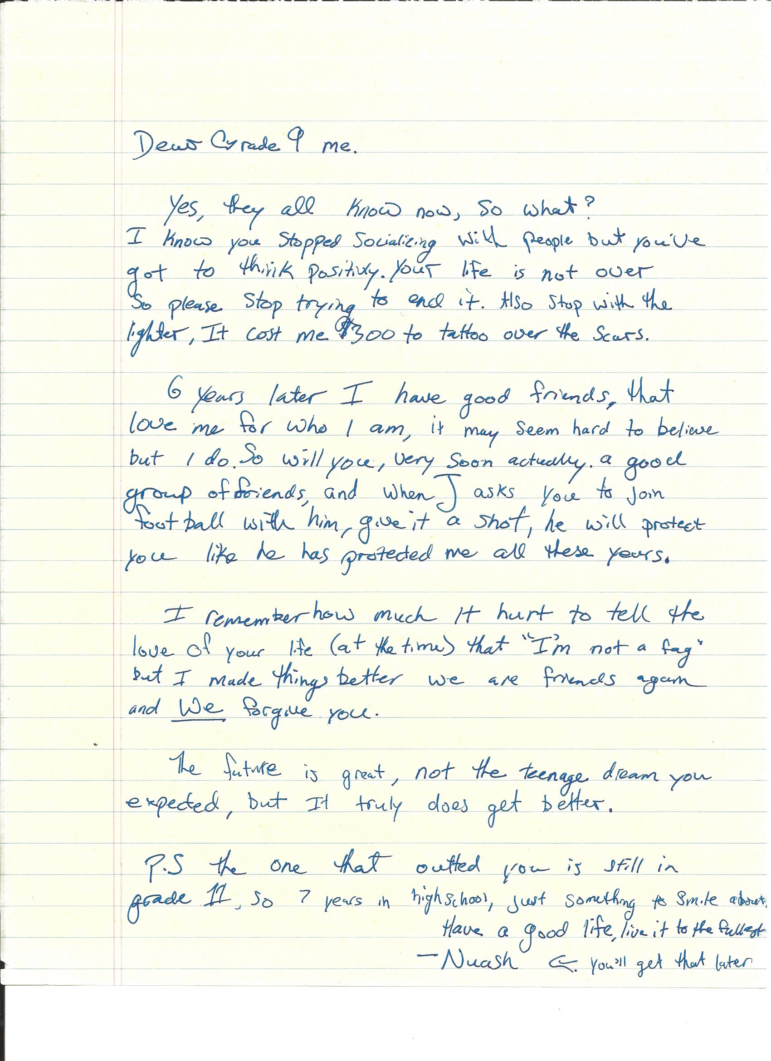

Appendix II

Will’s Letter to his Past Self

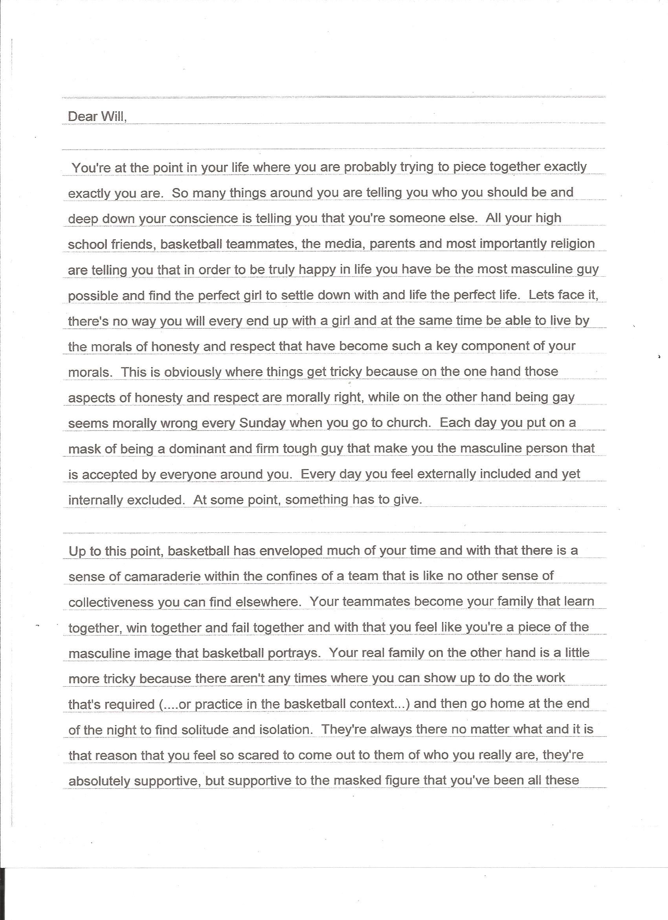

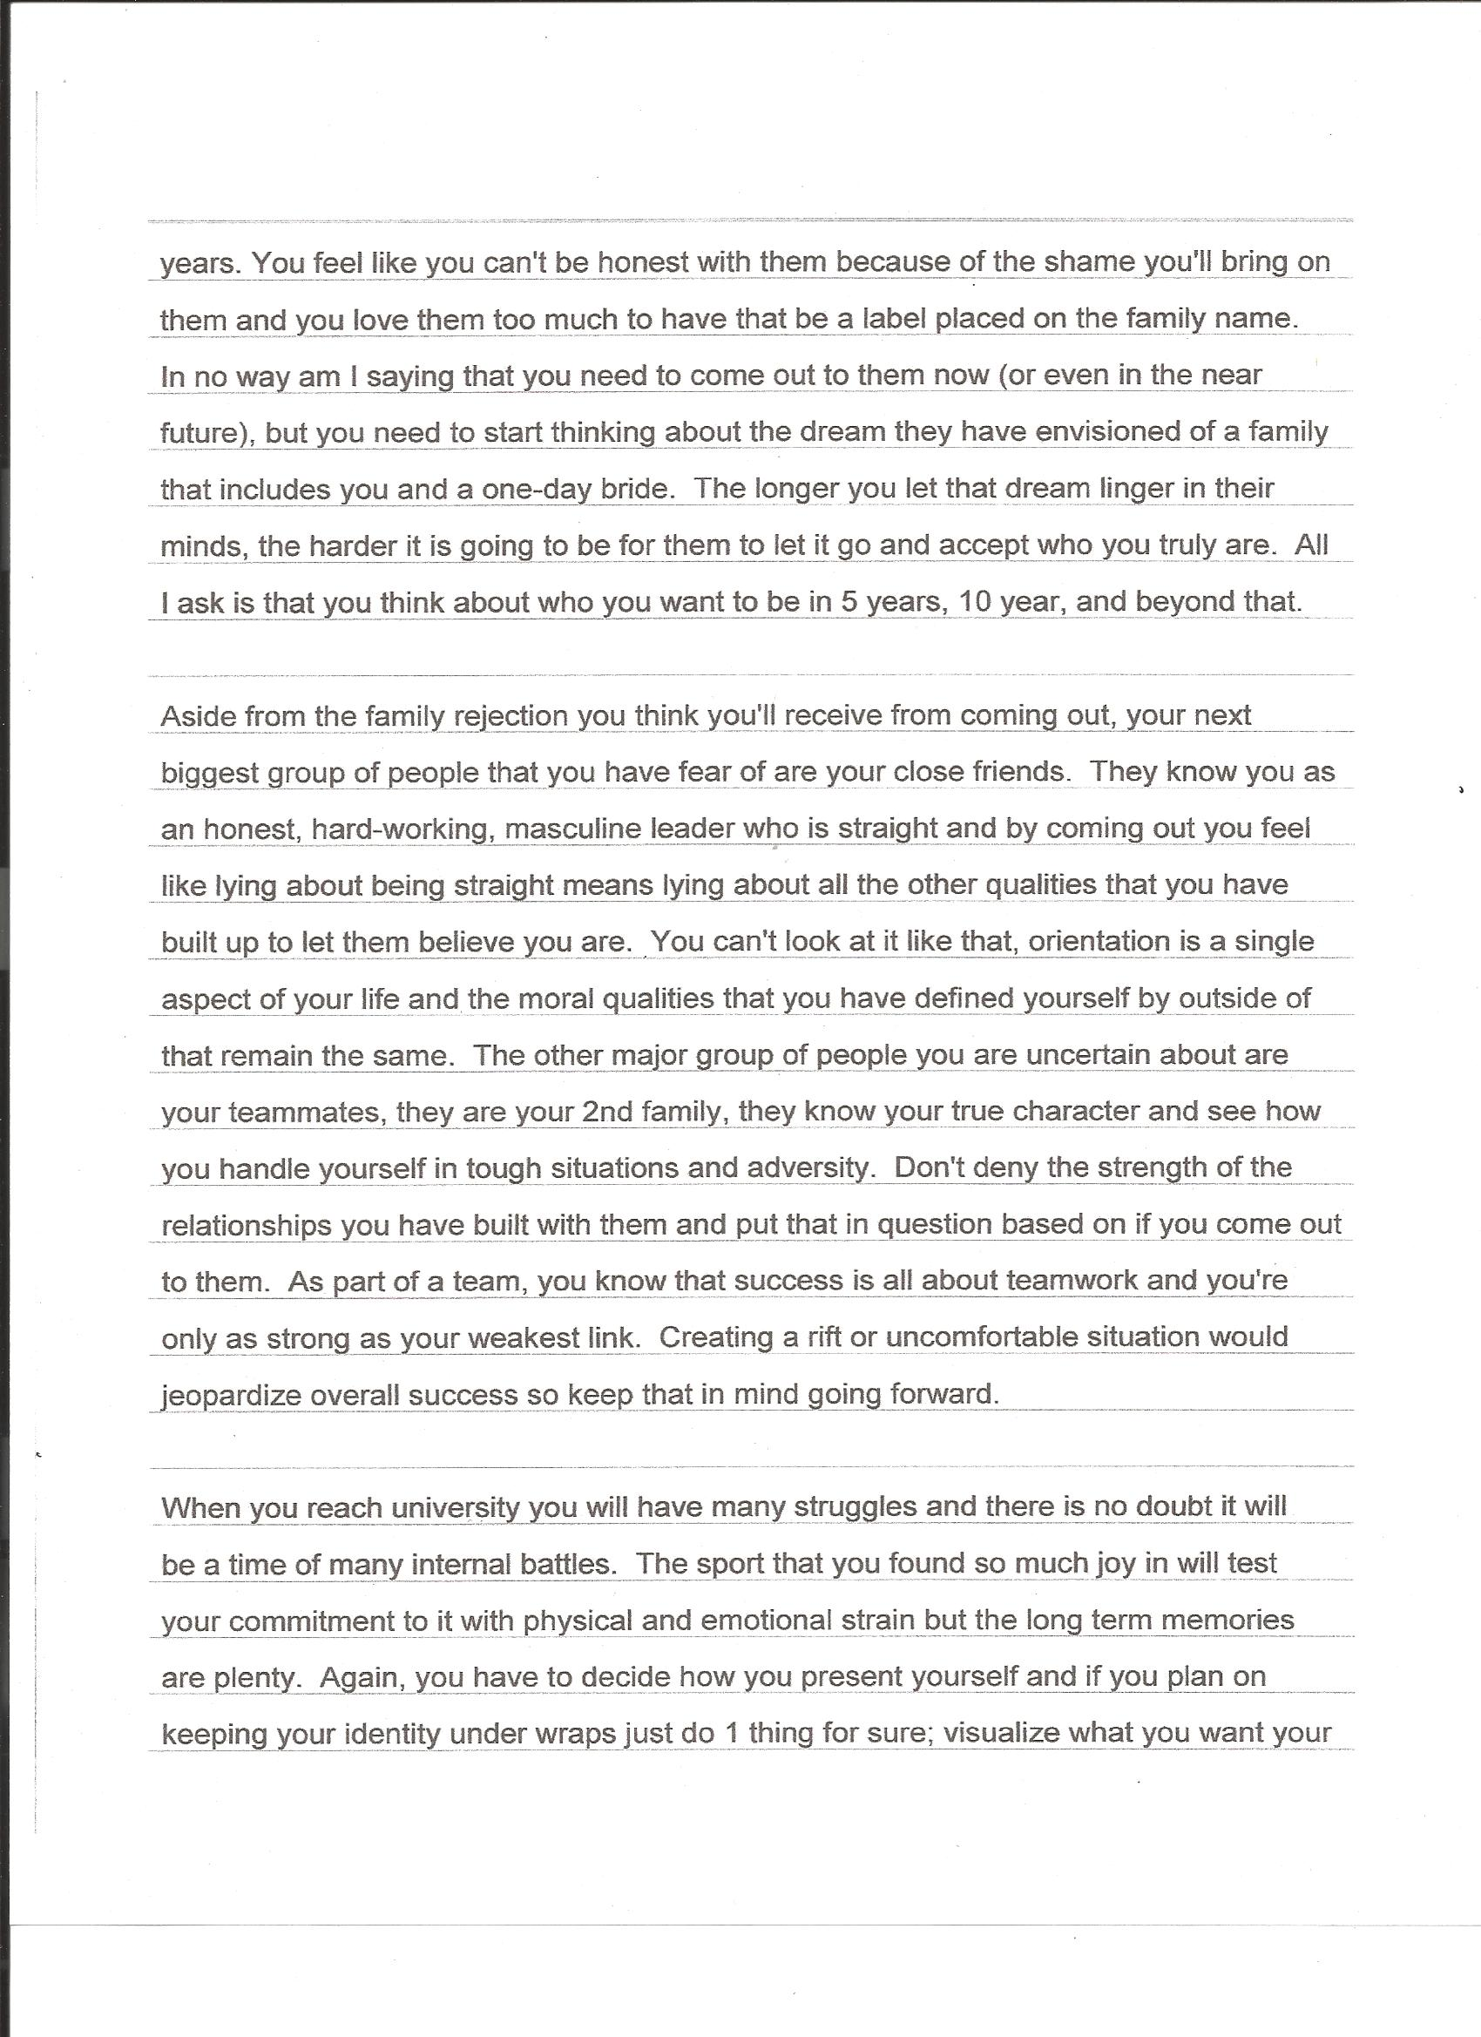

Appendix III

W.Y.’s Letter to his Past Self

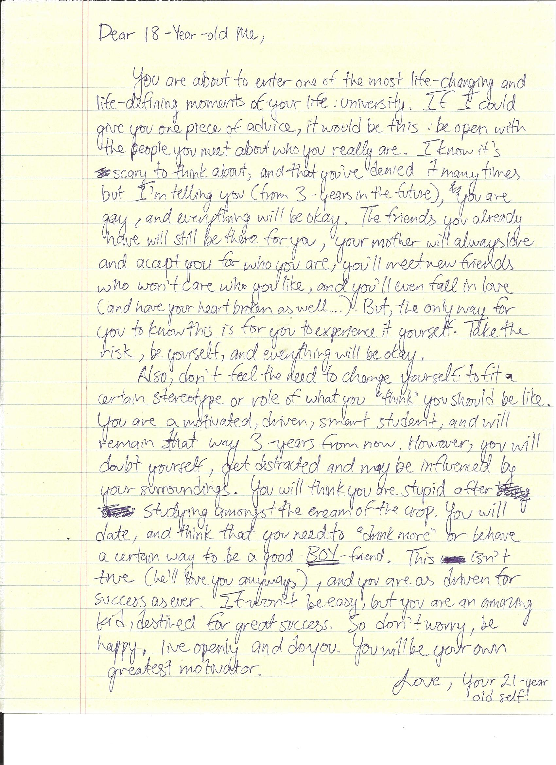

Appendix IV

Paul’s Letter to his Past Self

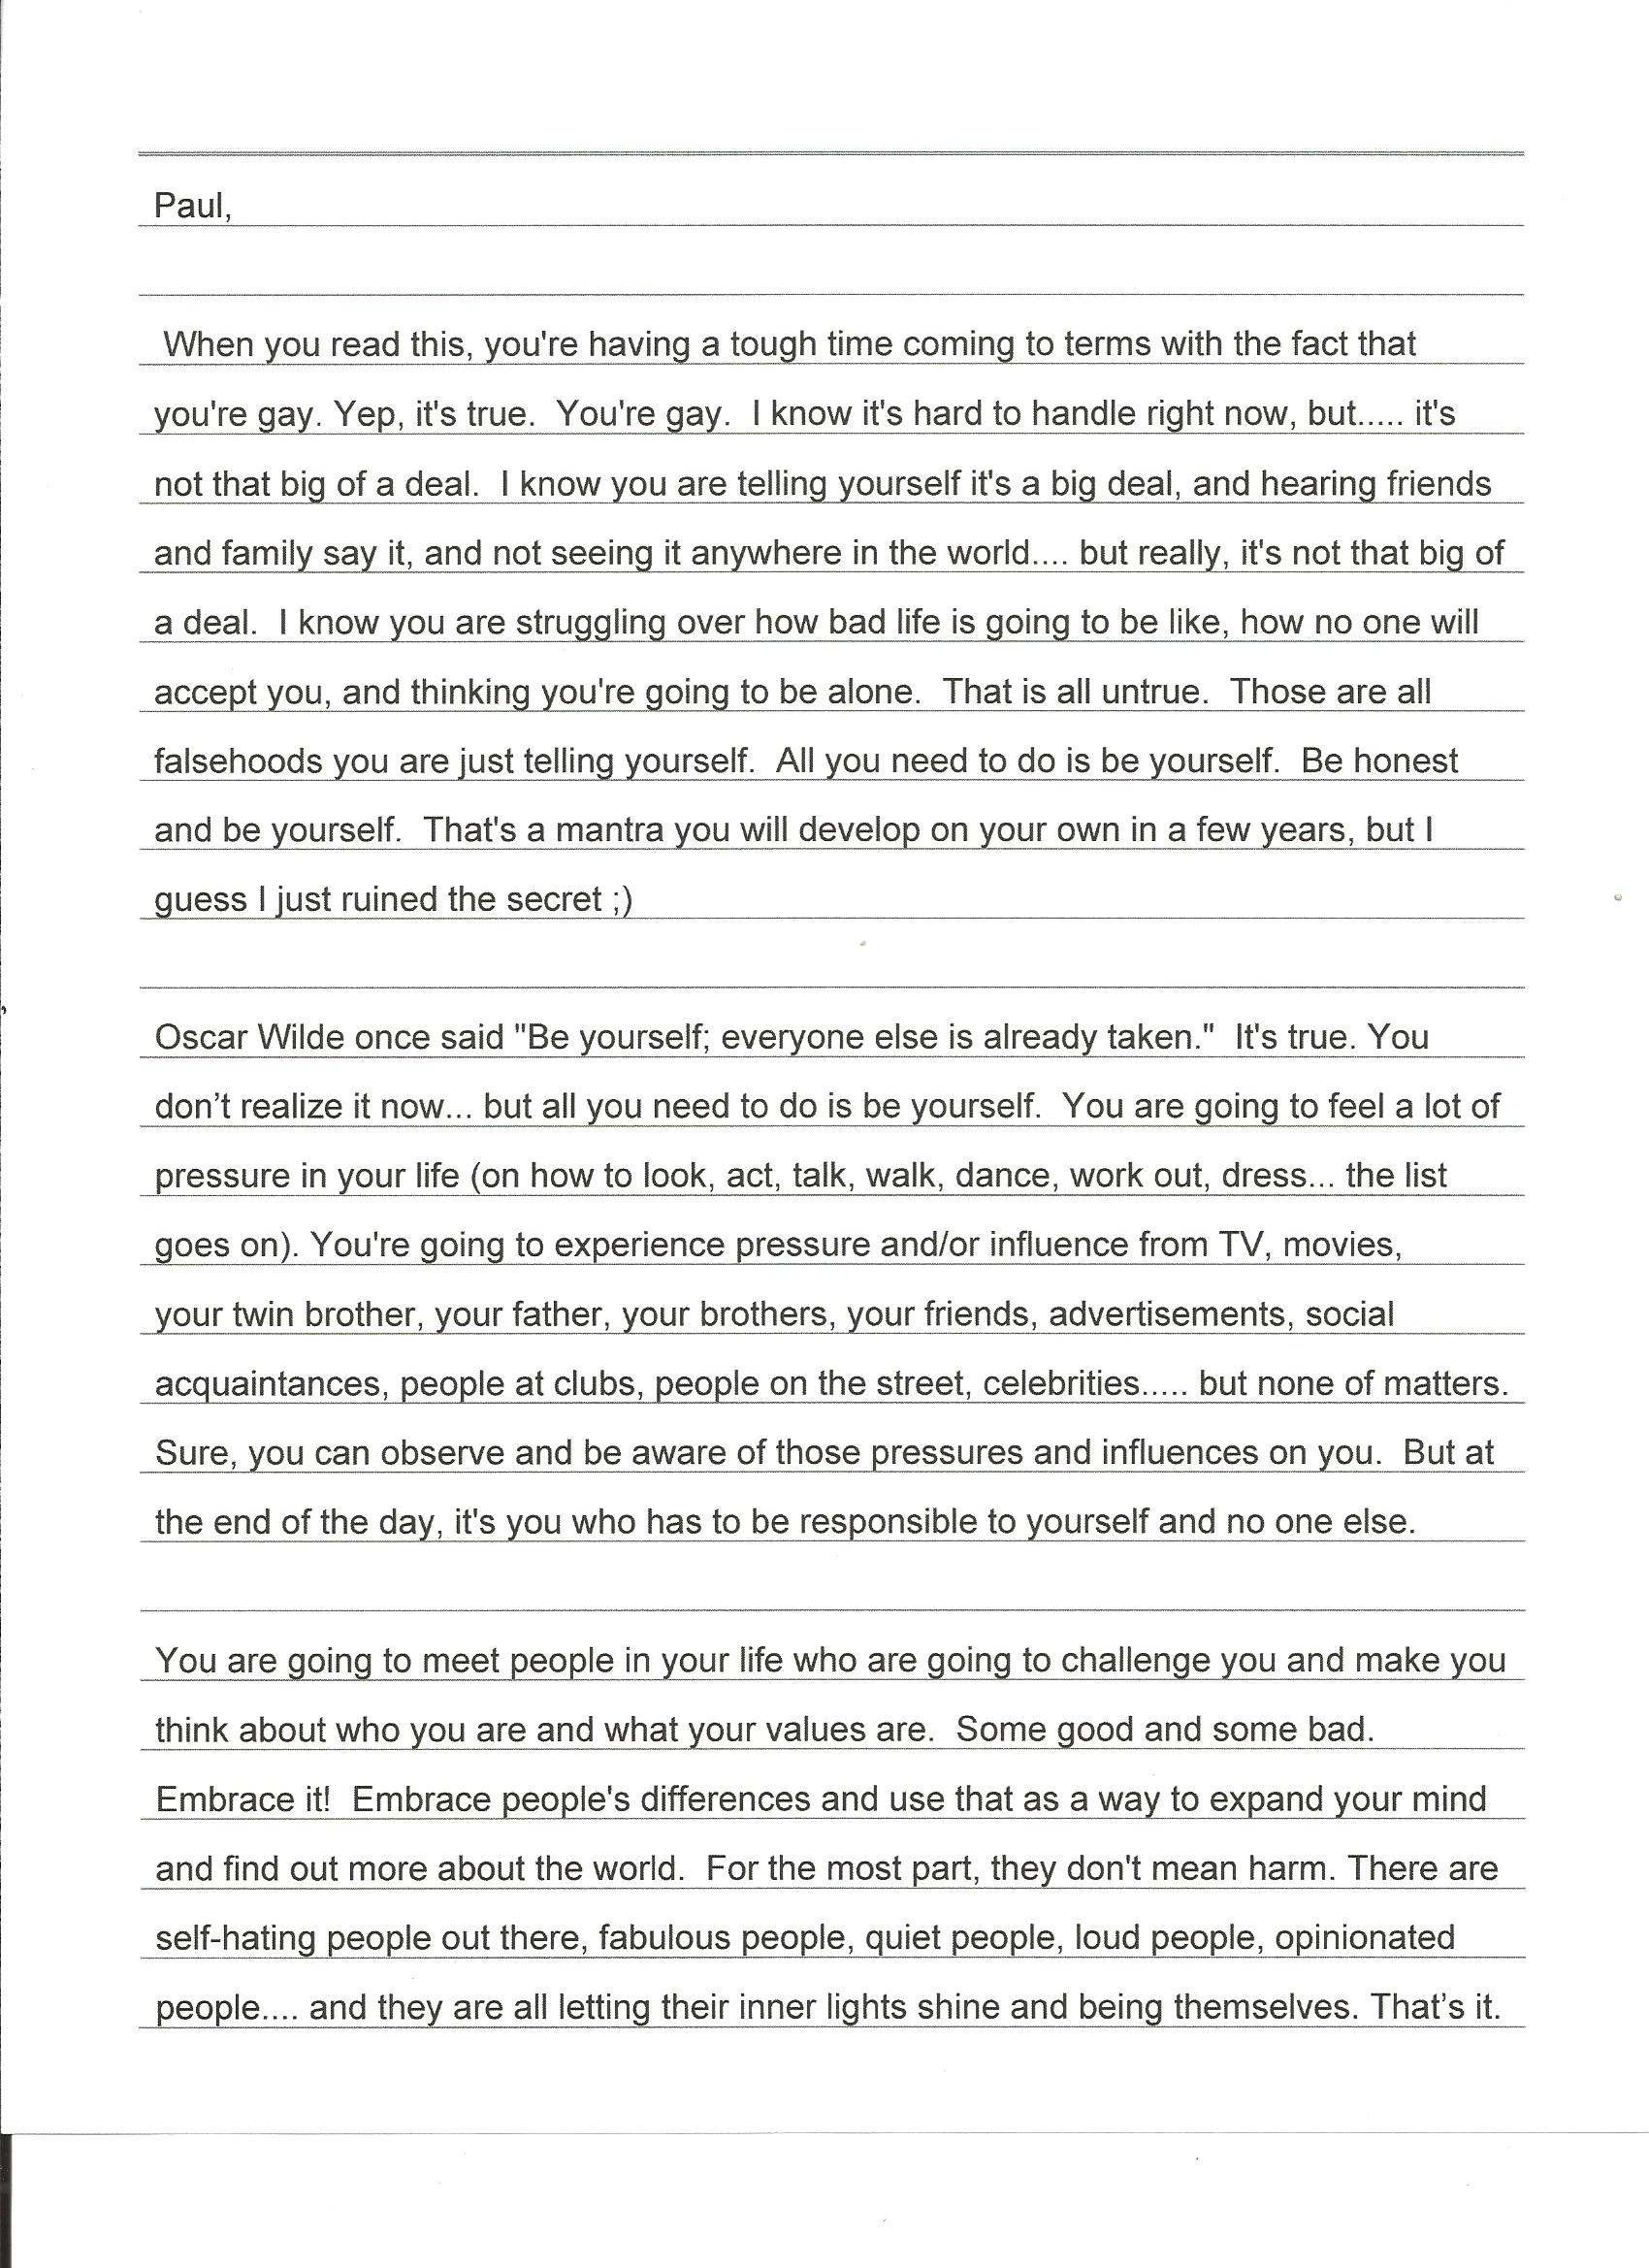

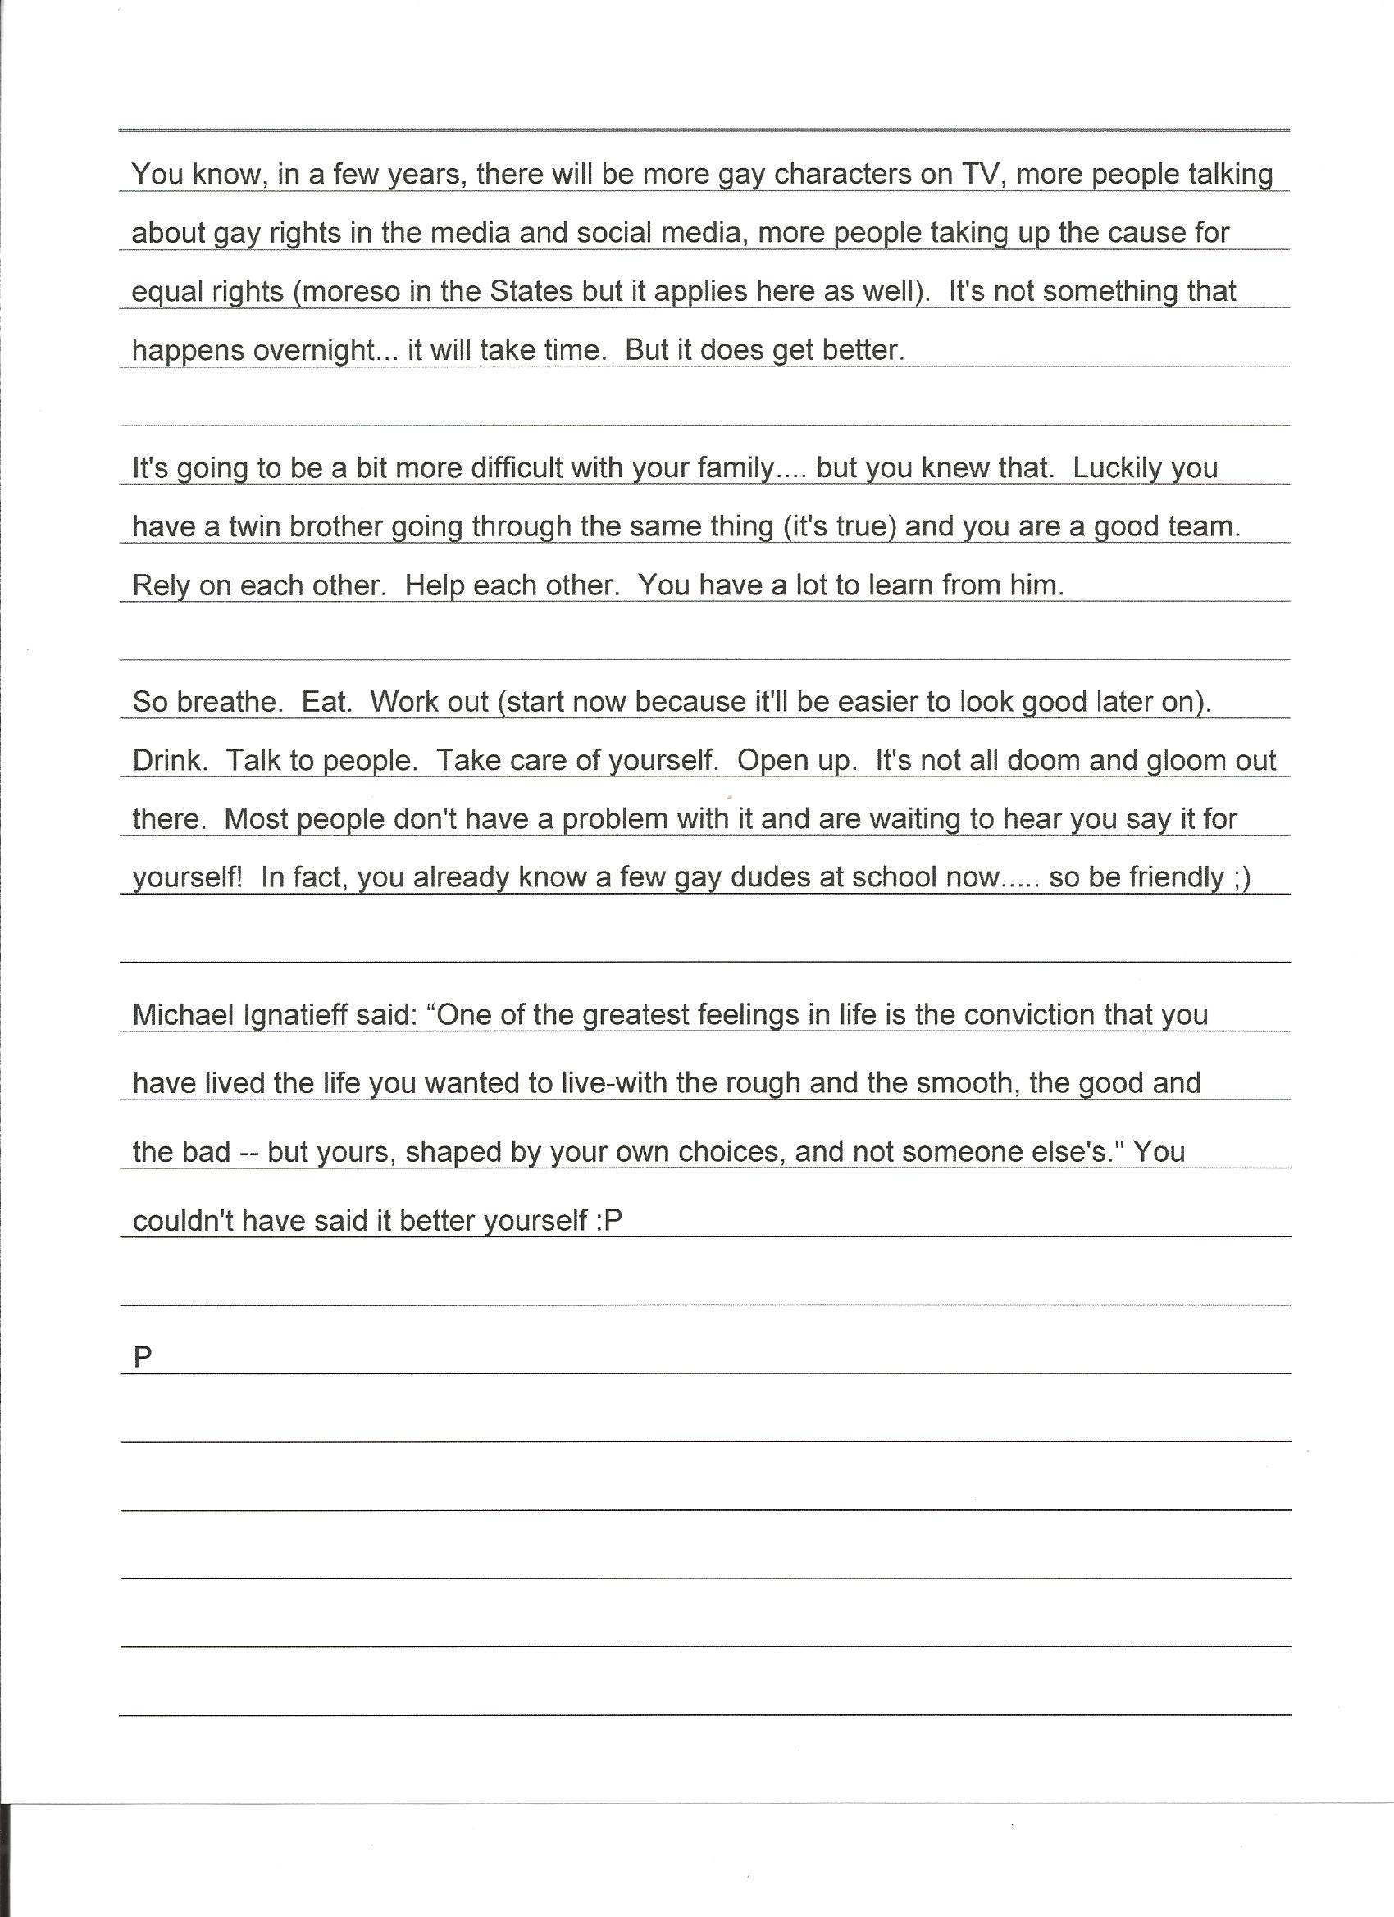

Appendix V

Dan’s Letter to his Past Self

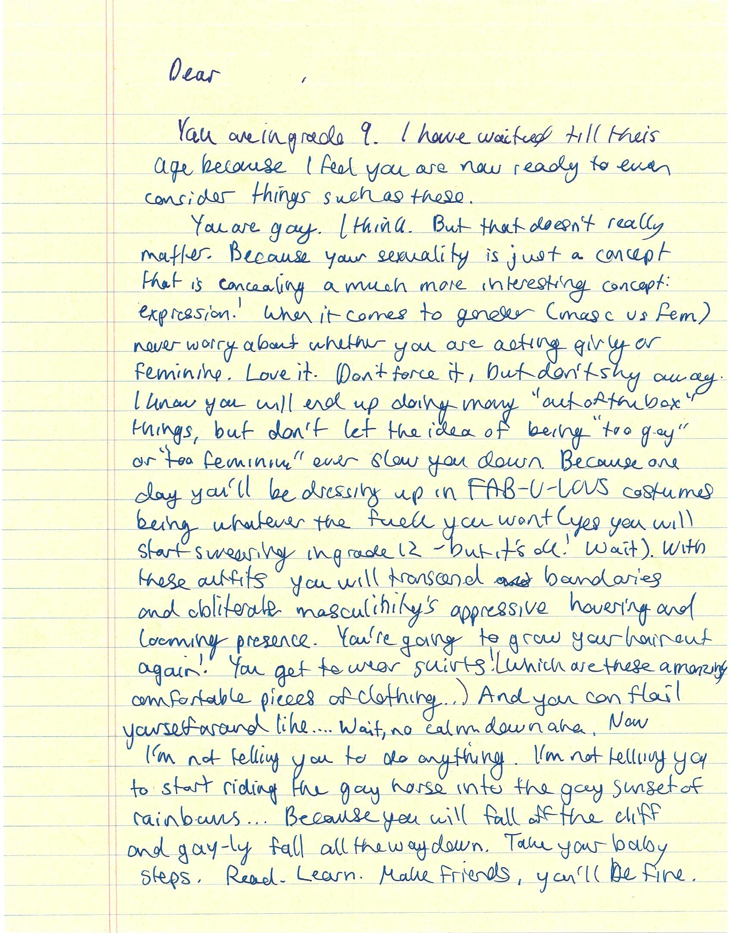

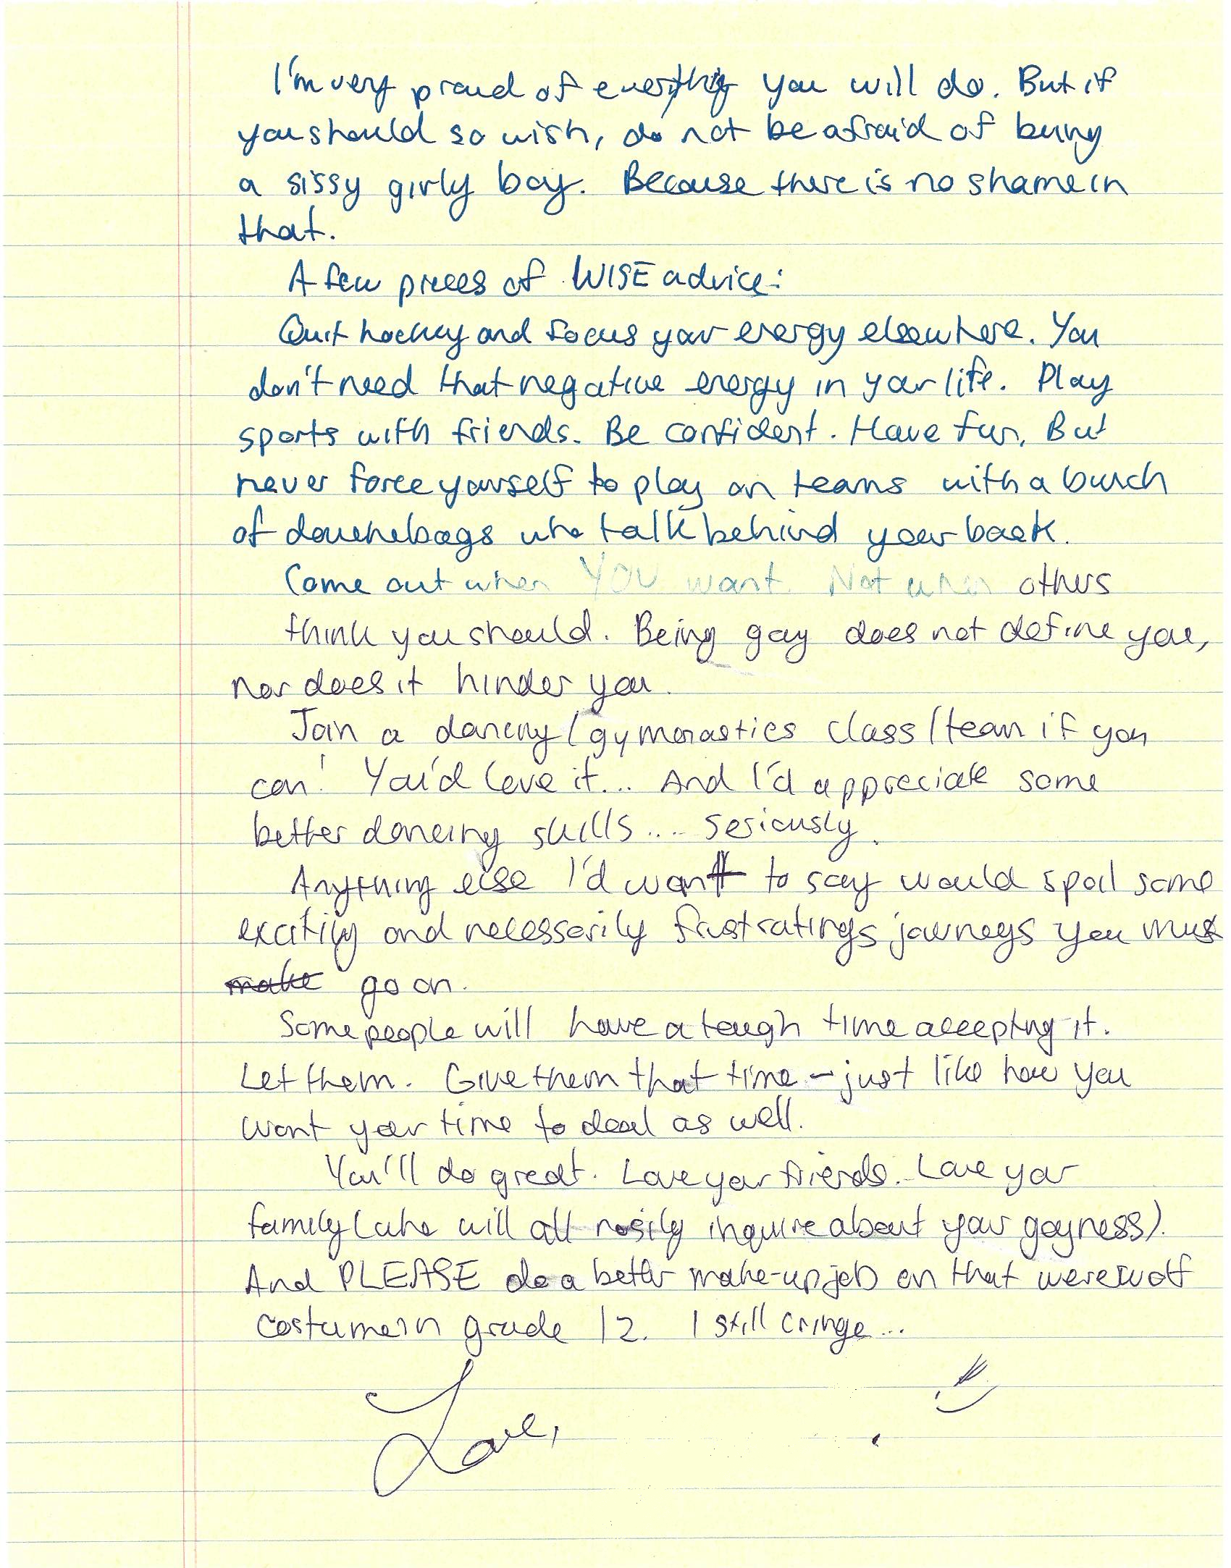

Appendix VI

Recruitment E-Mail
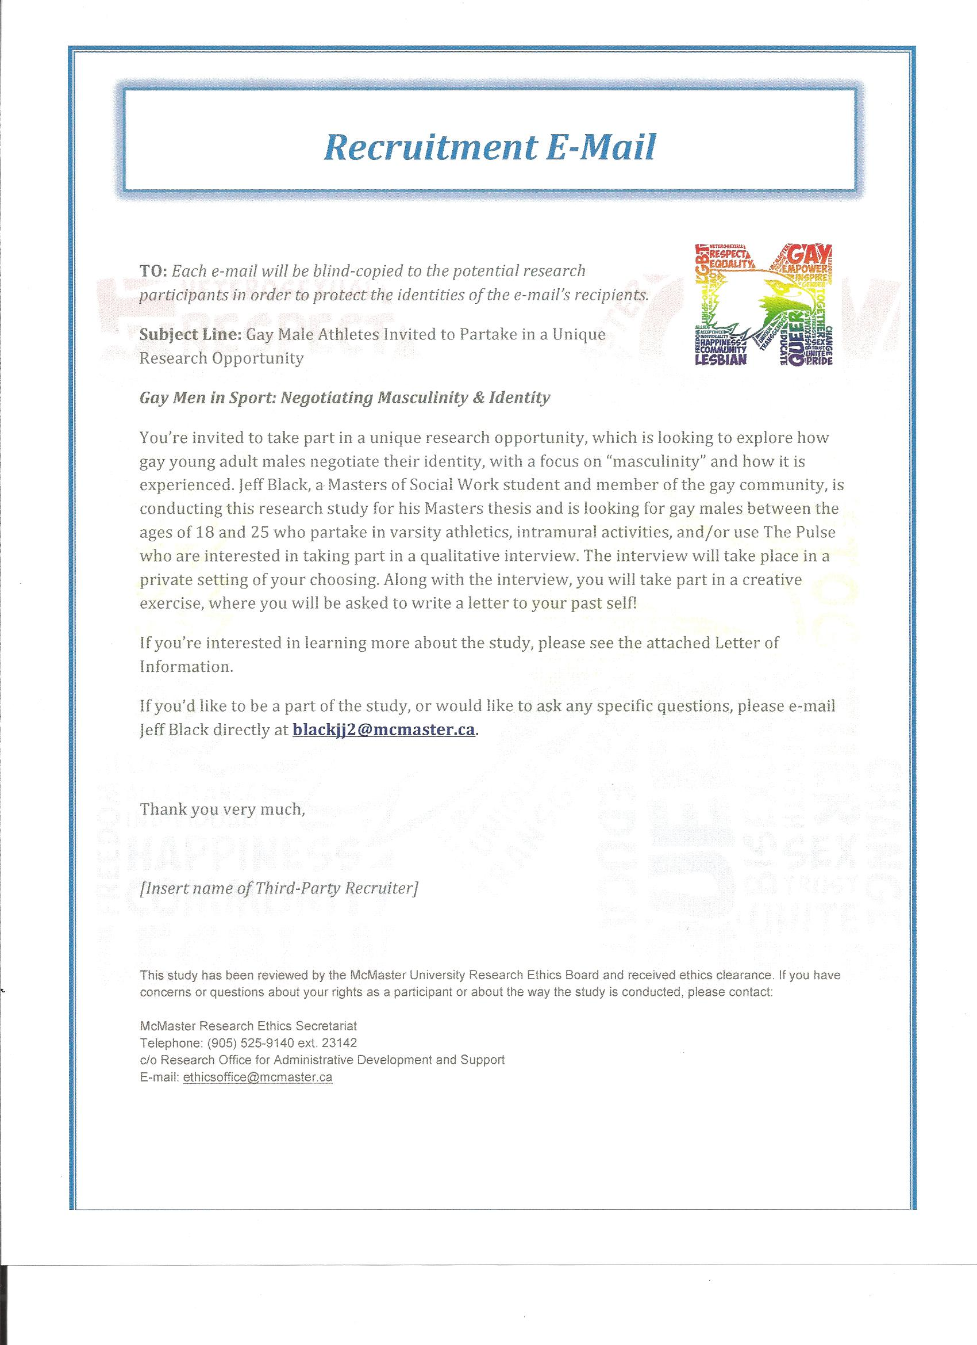

Appendix VII

Recruitment Poster

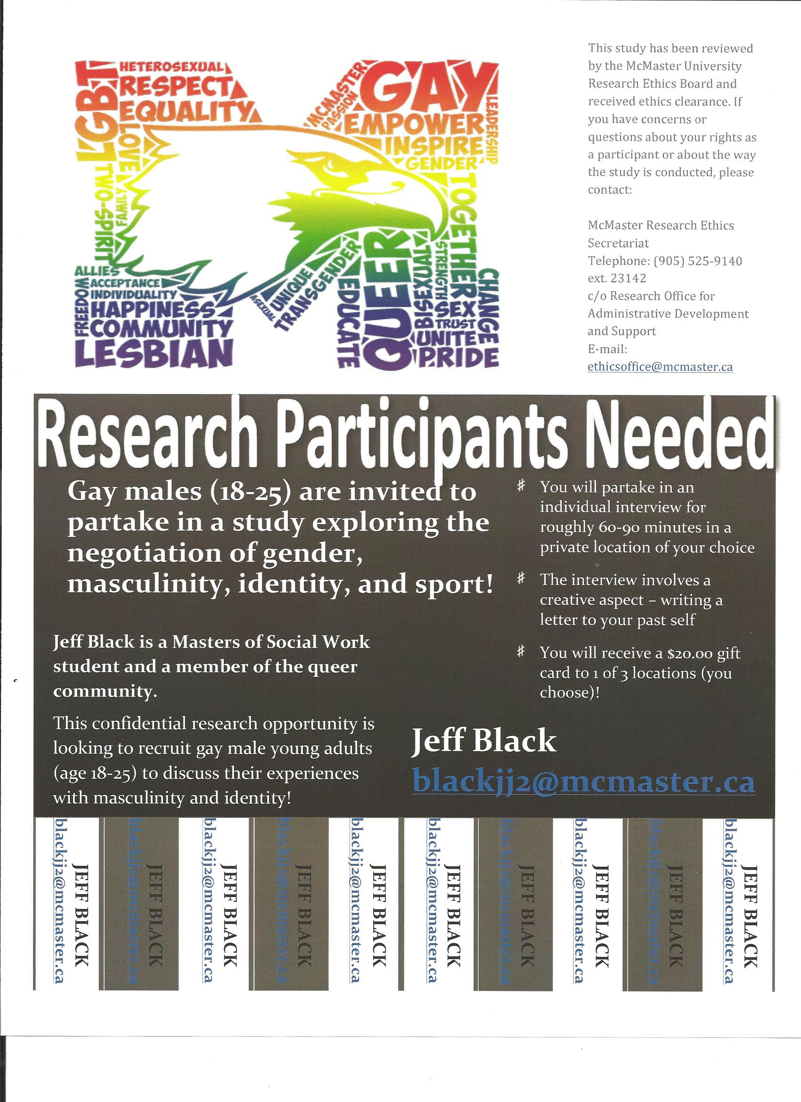

Appendix VIII

Letter of Information
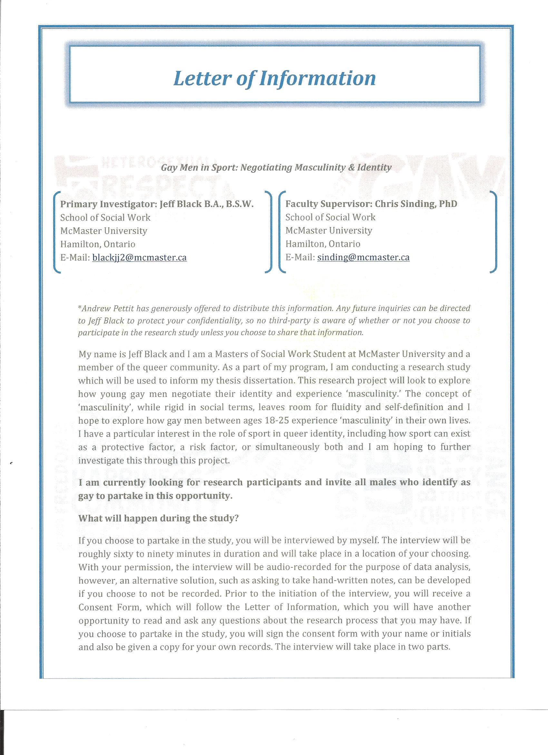

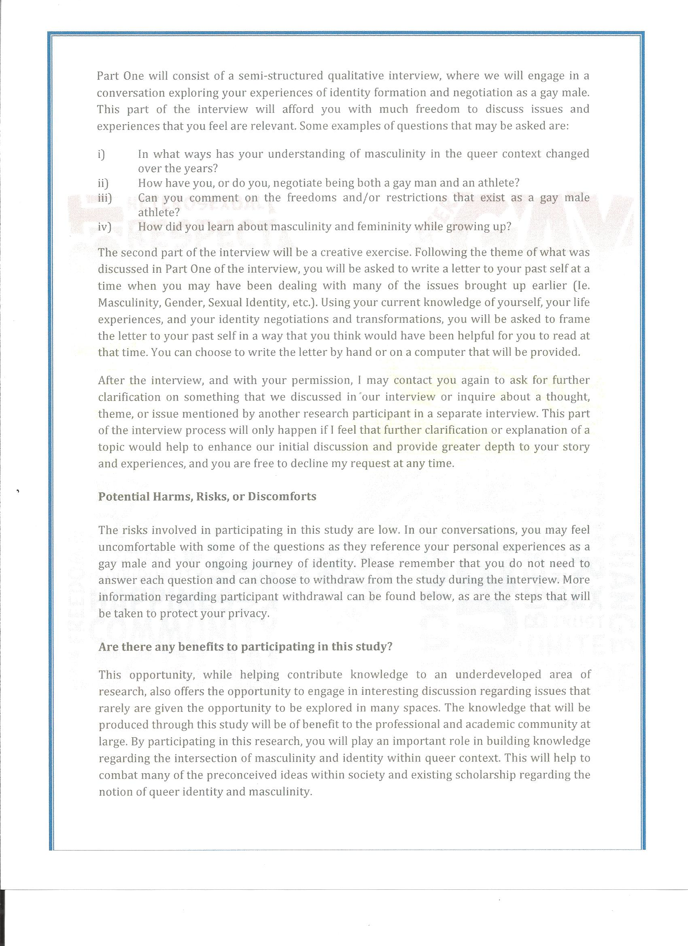

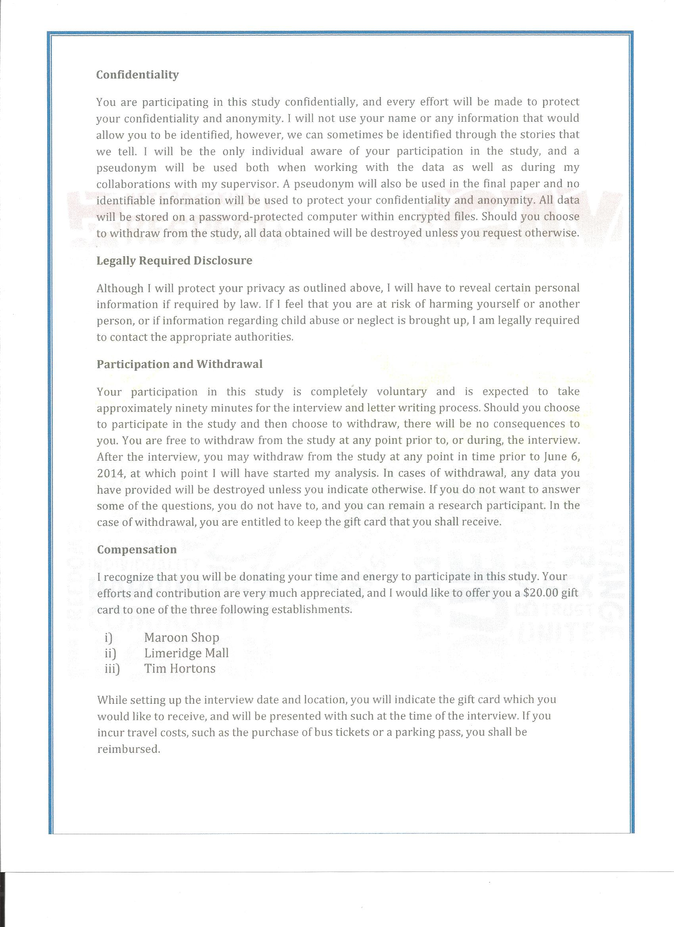

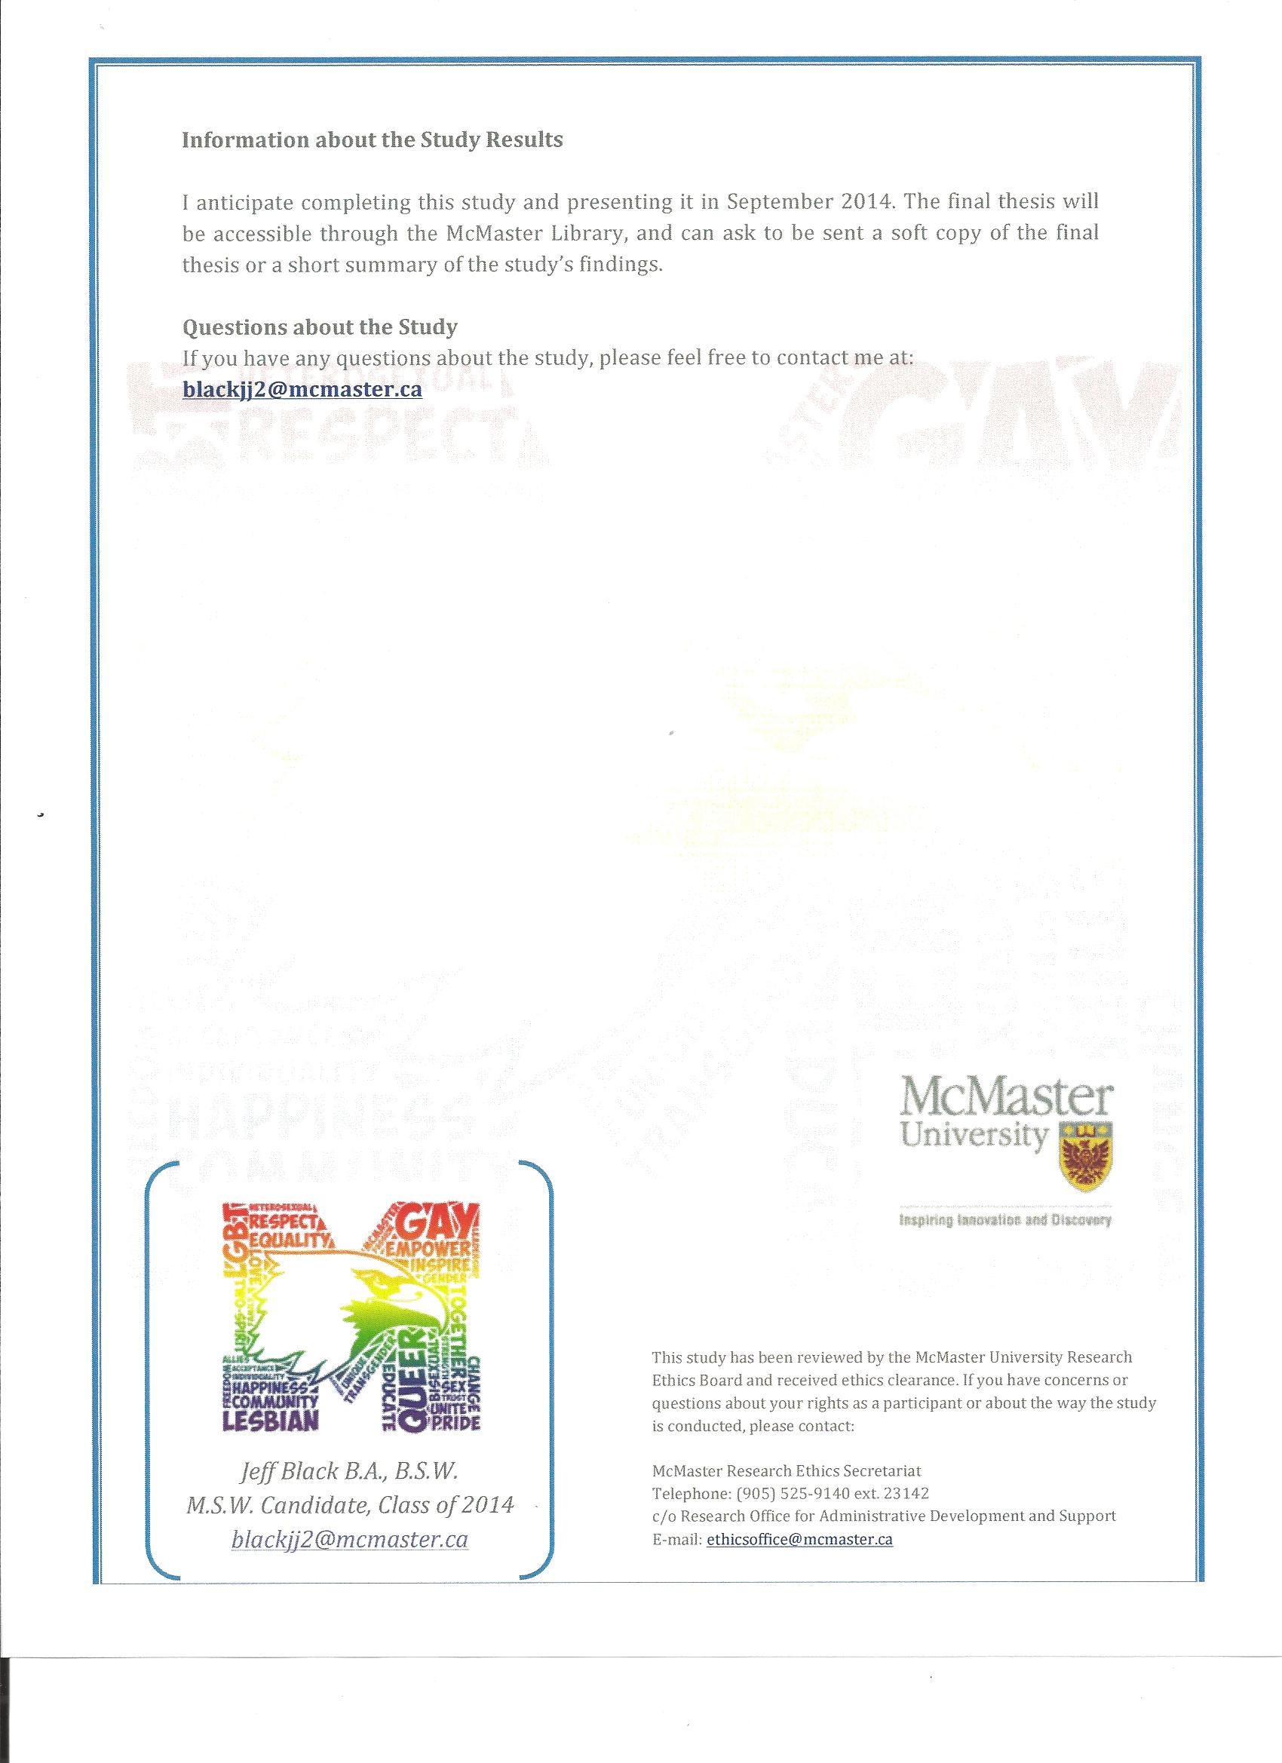

Appendix IX

Consent Form
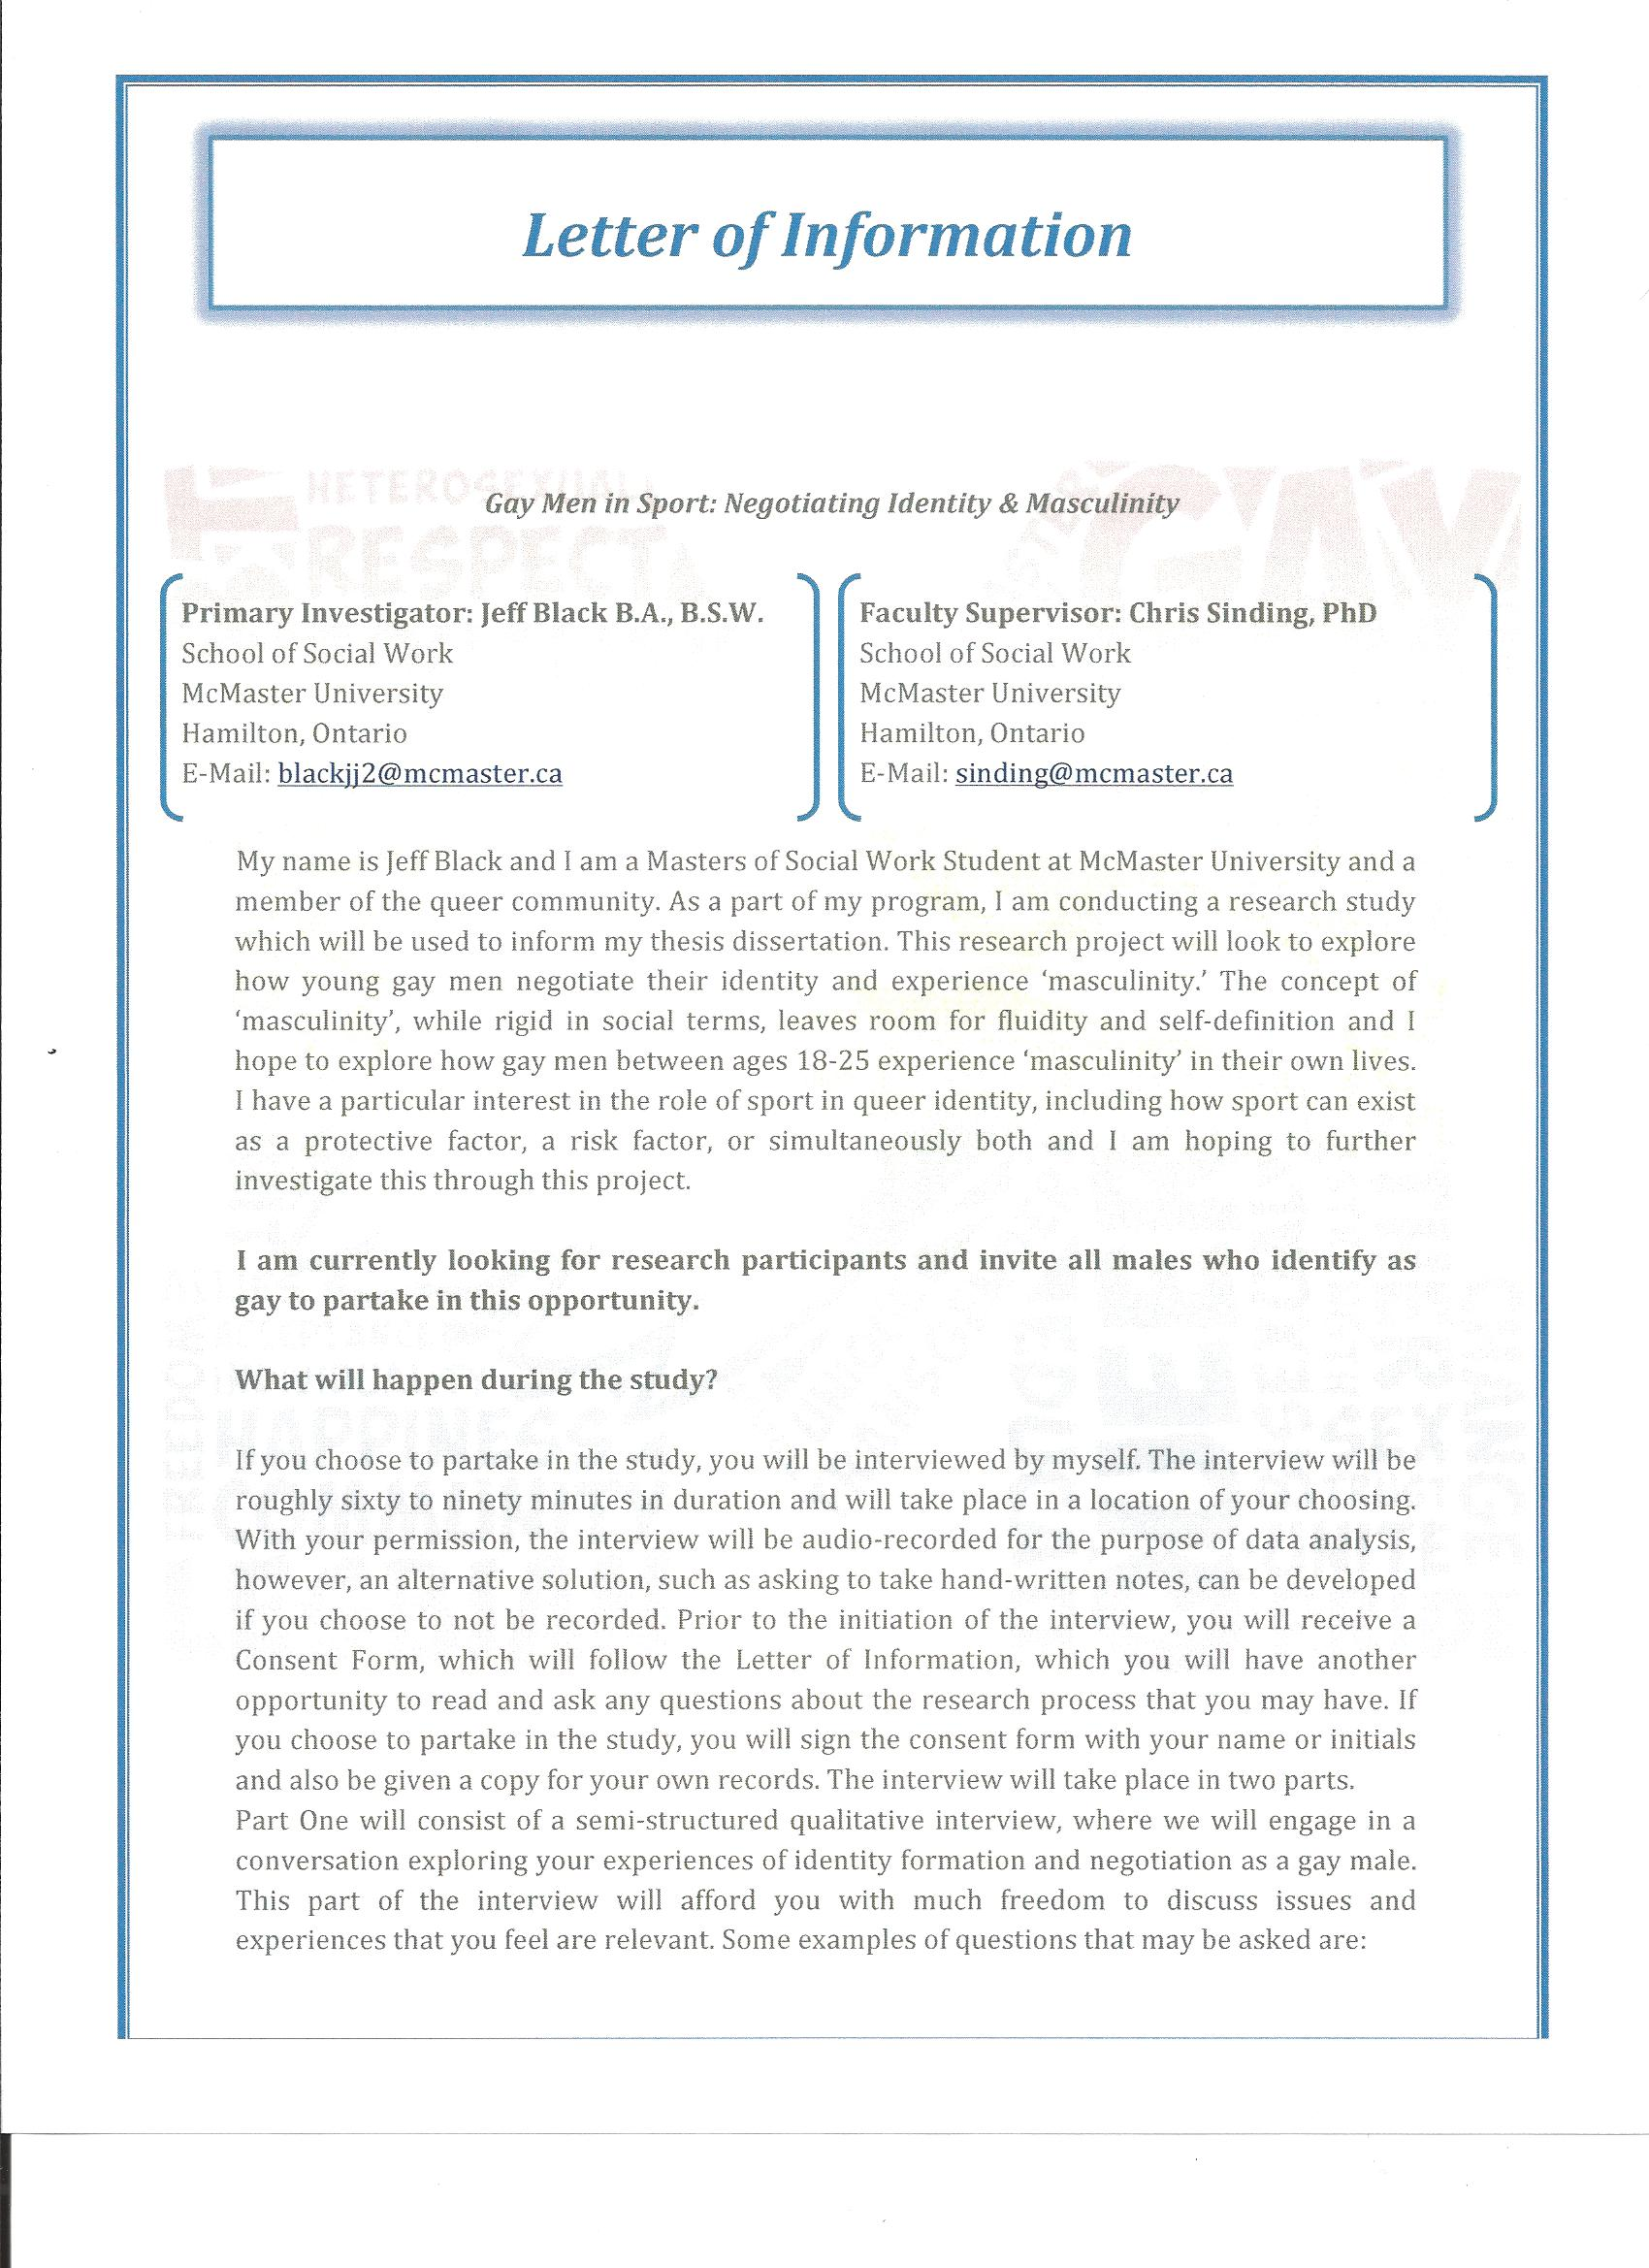

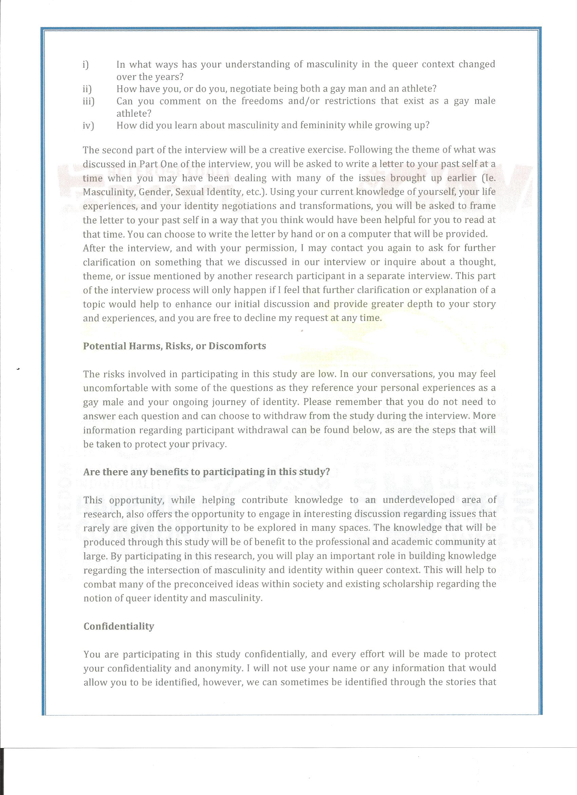

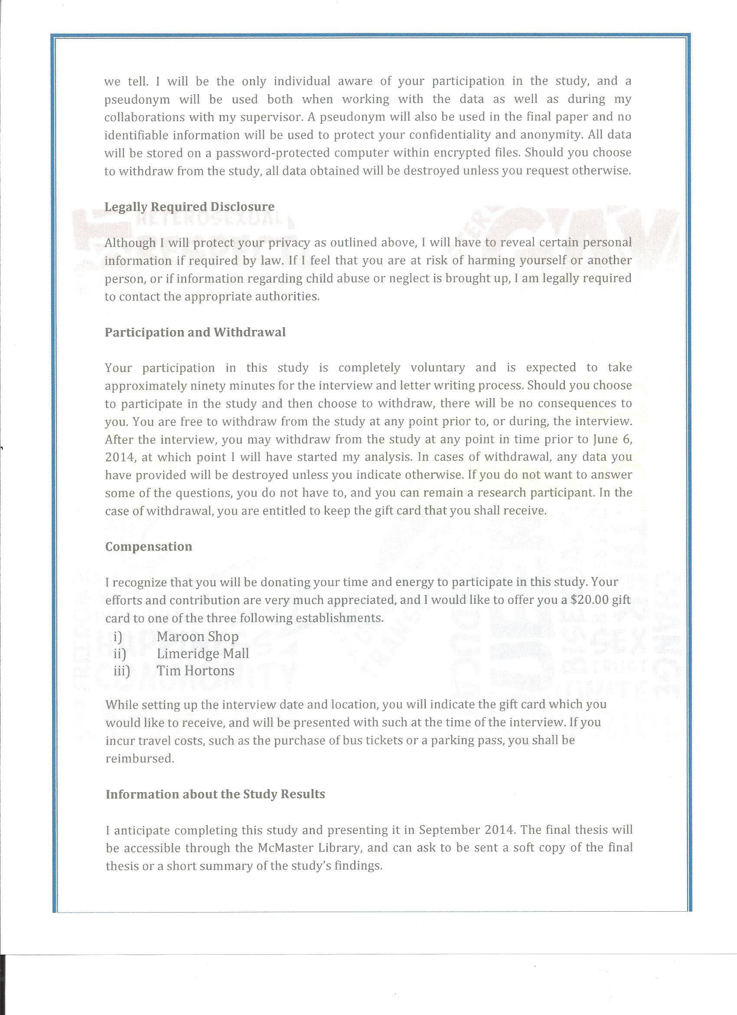

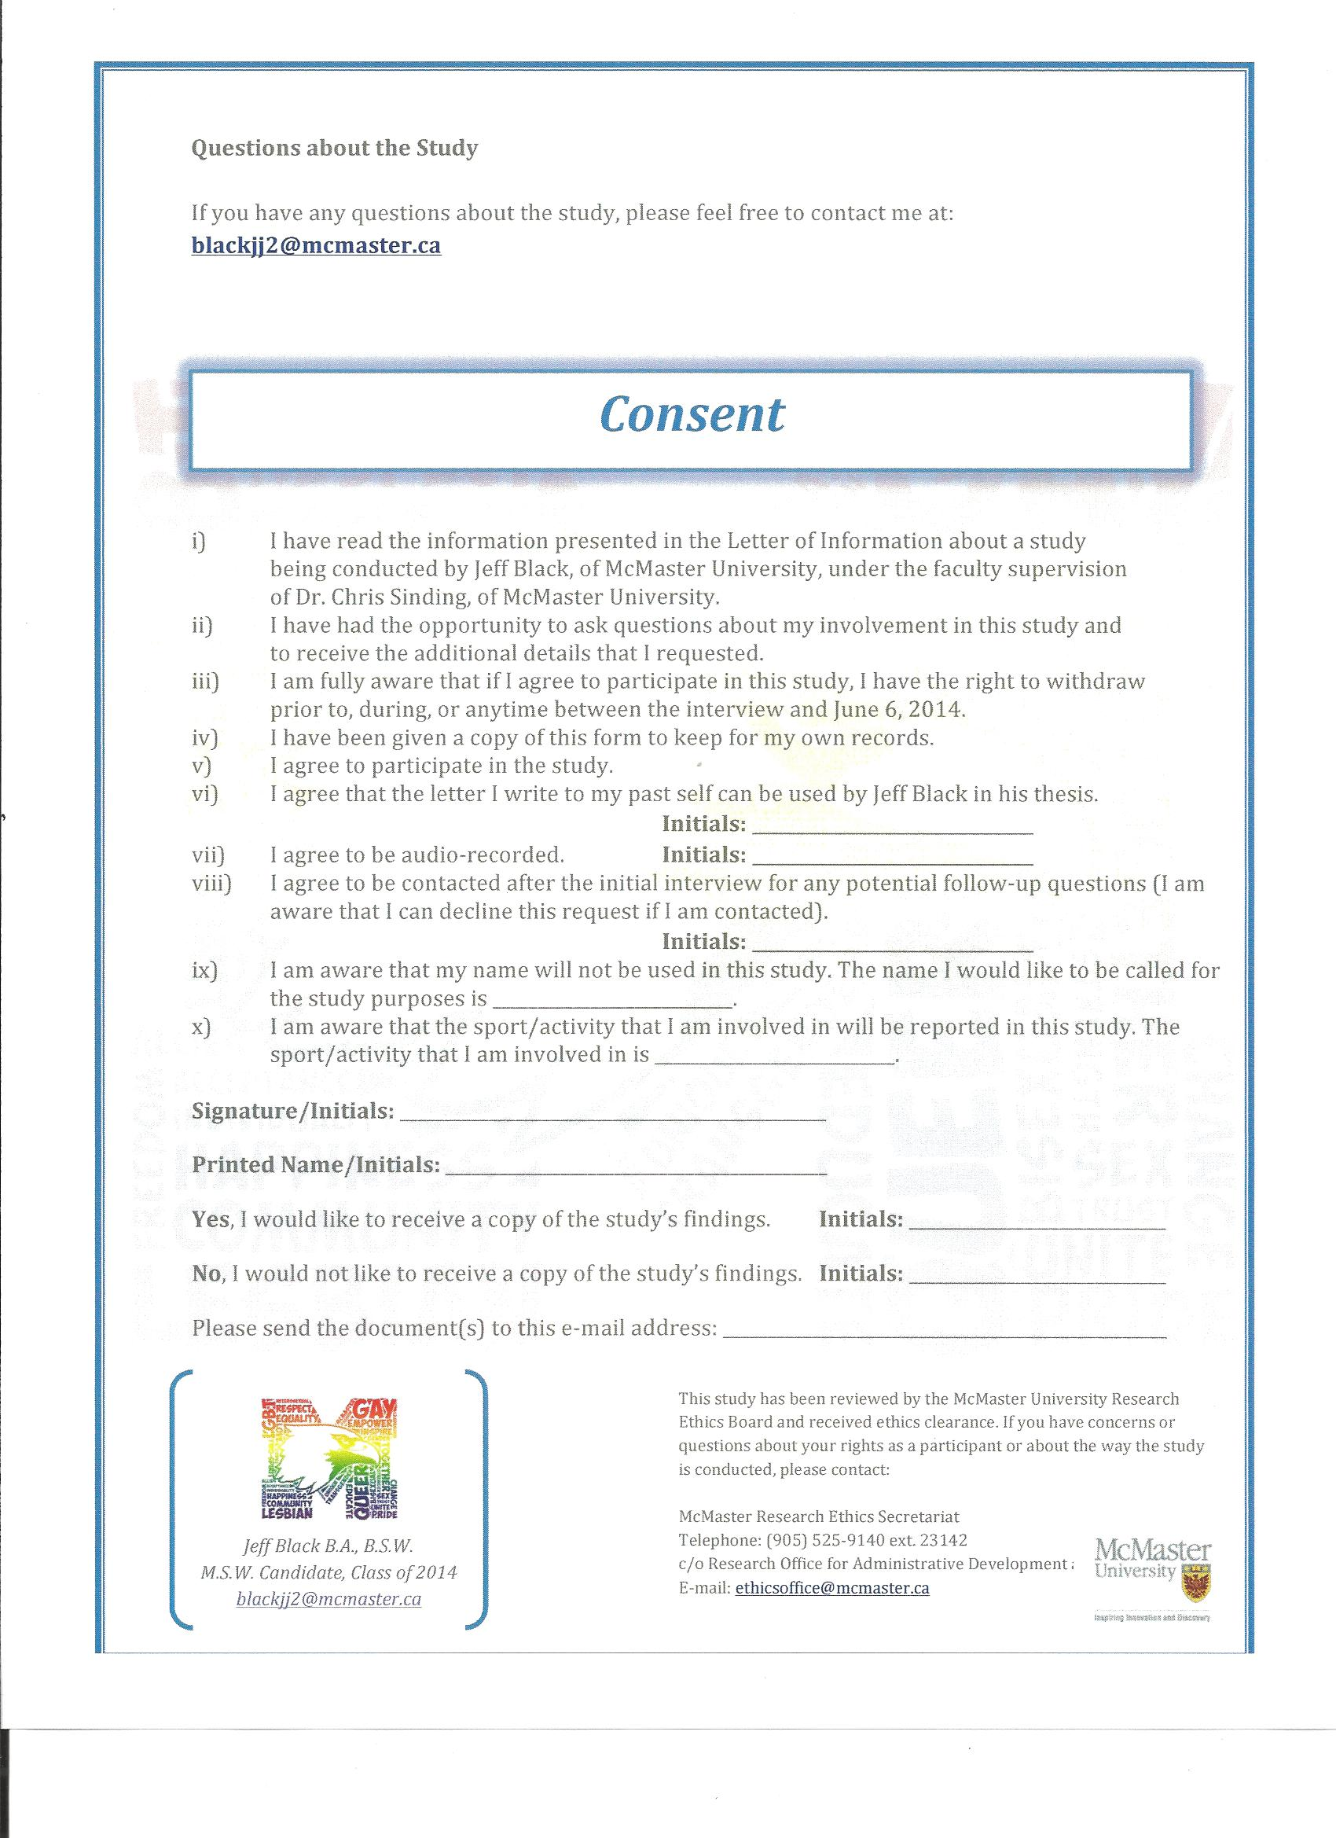

Appendix X

Interview Guide
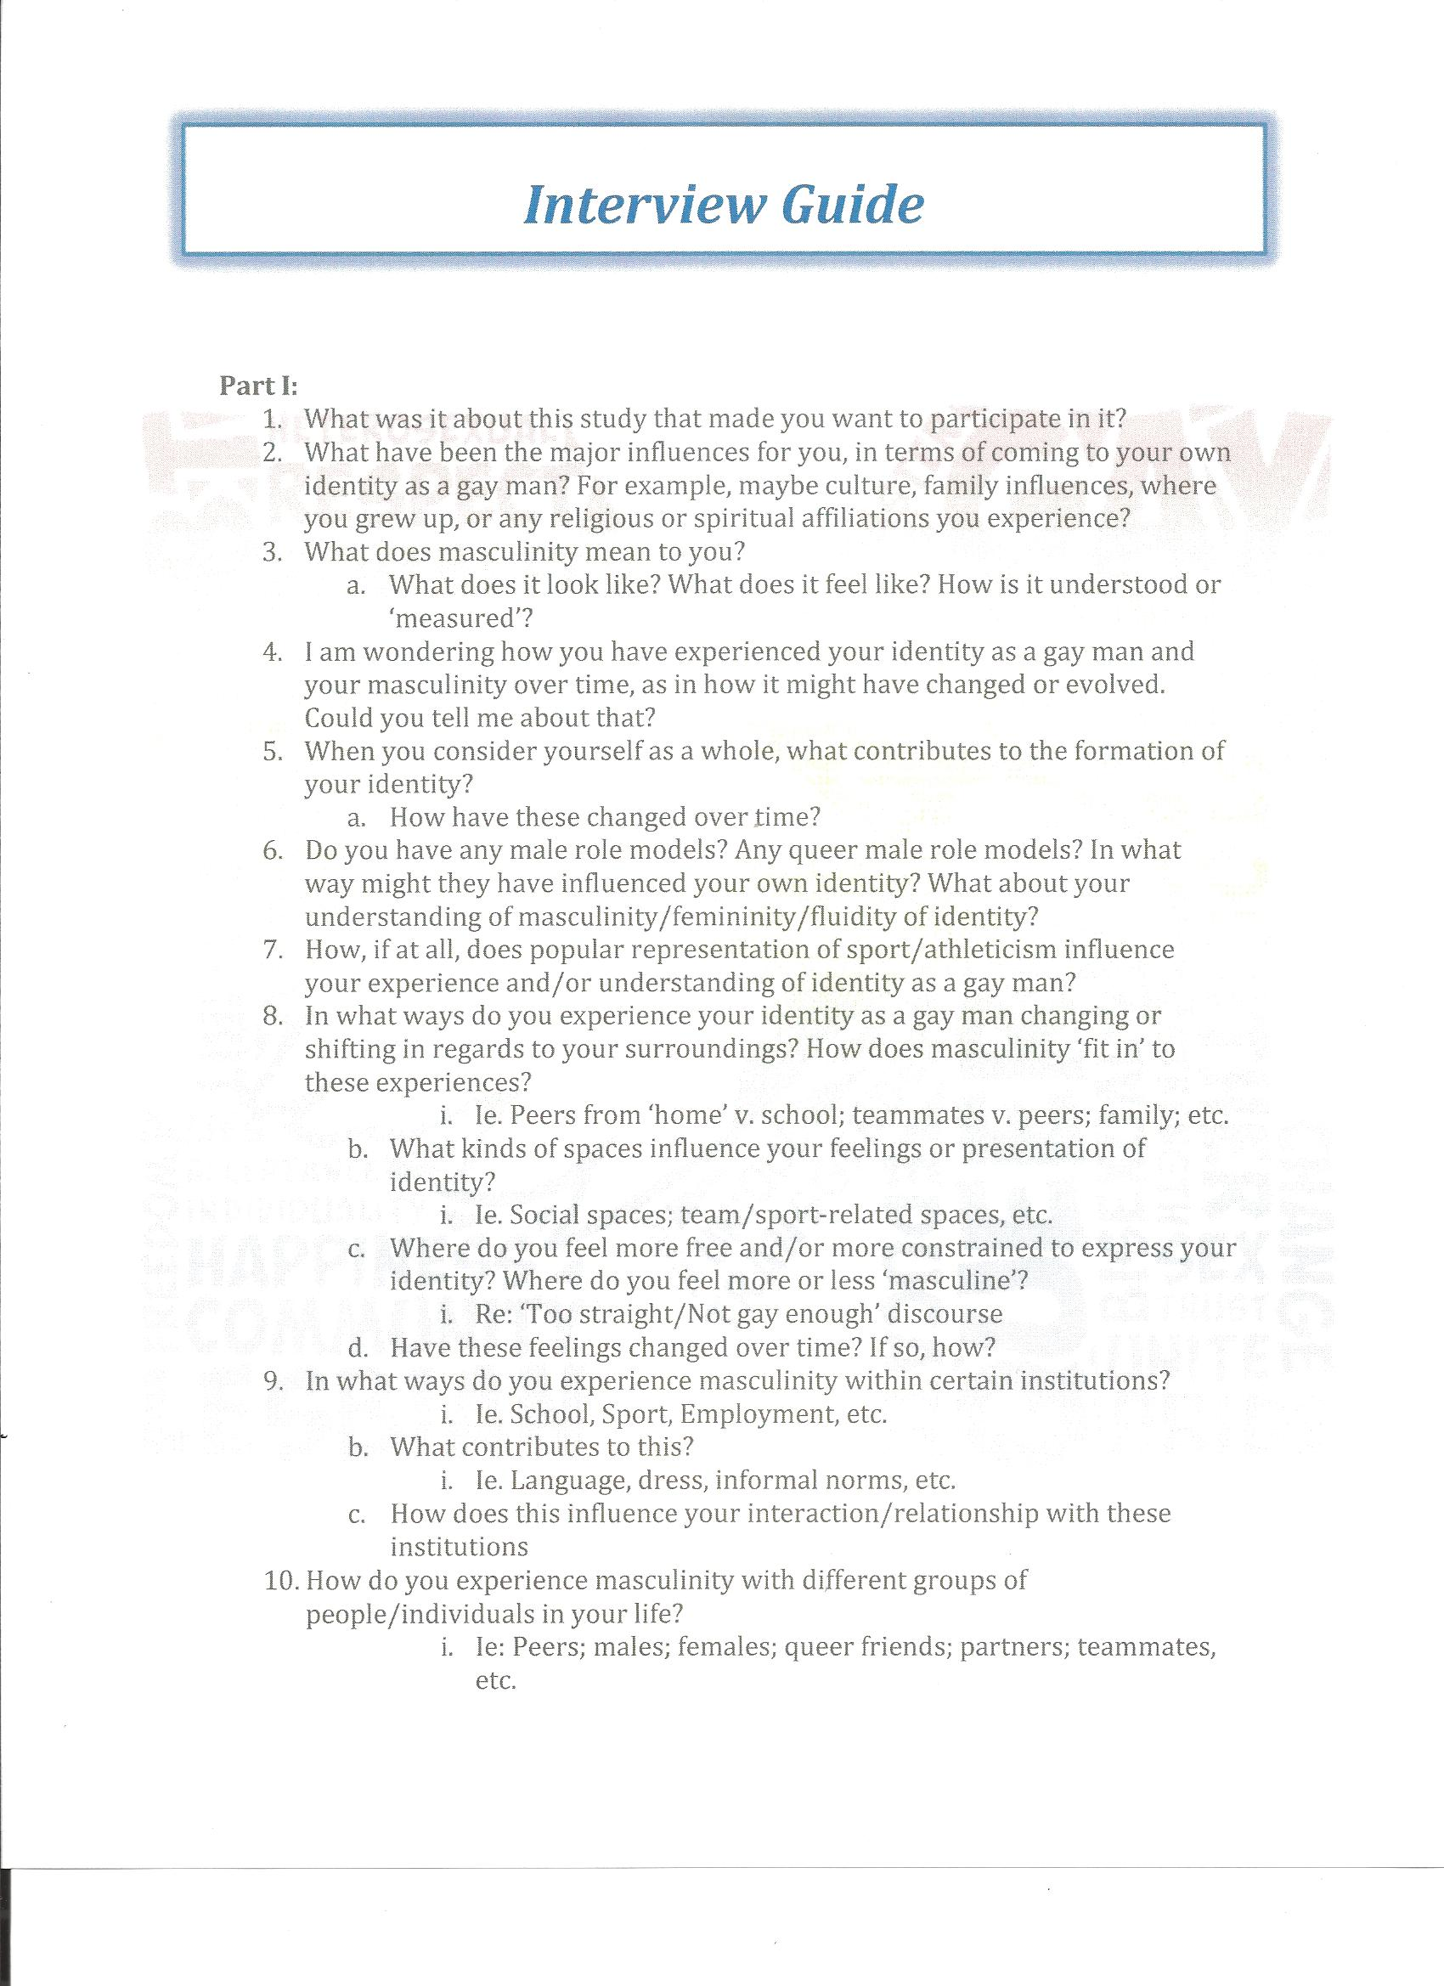

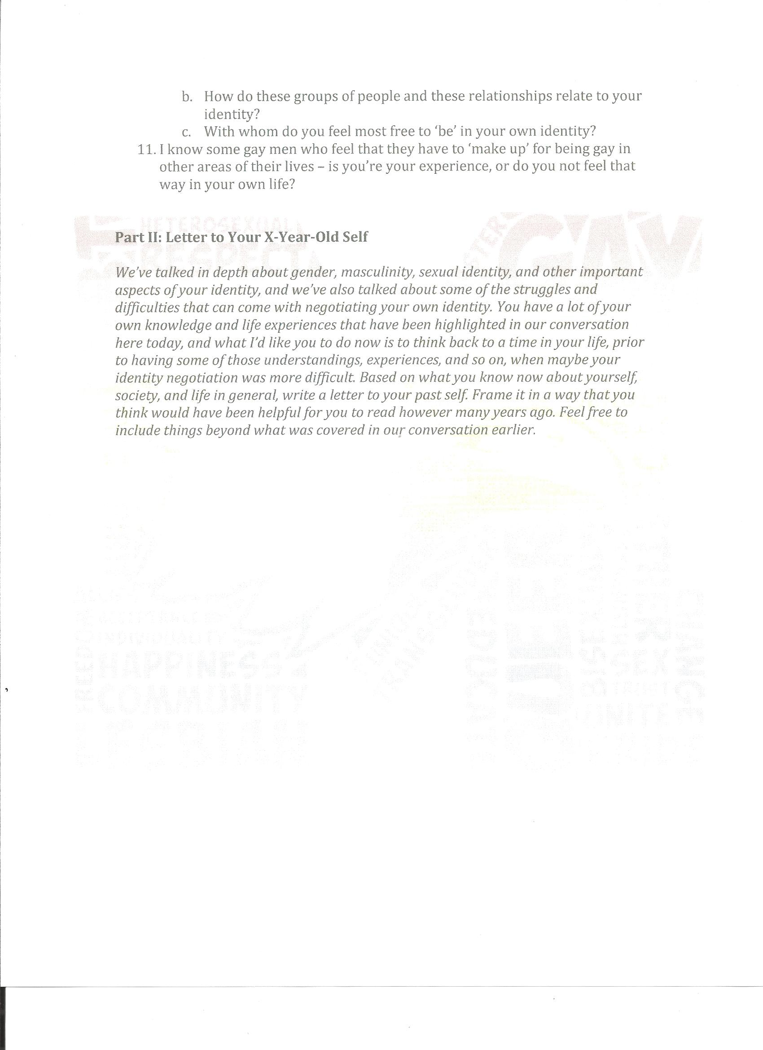

Appendix XI

Community Supports

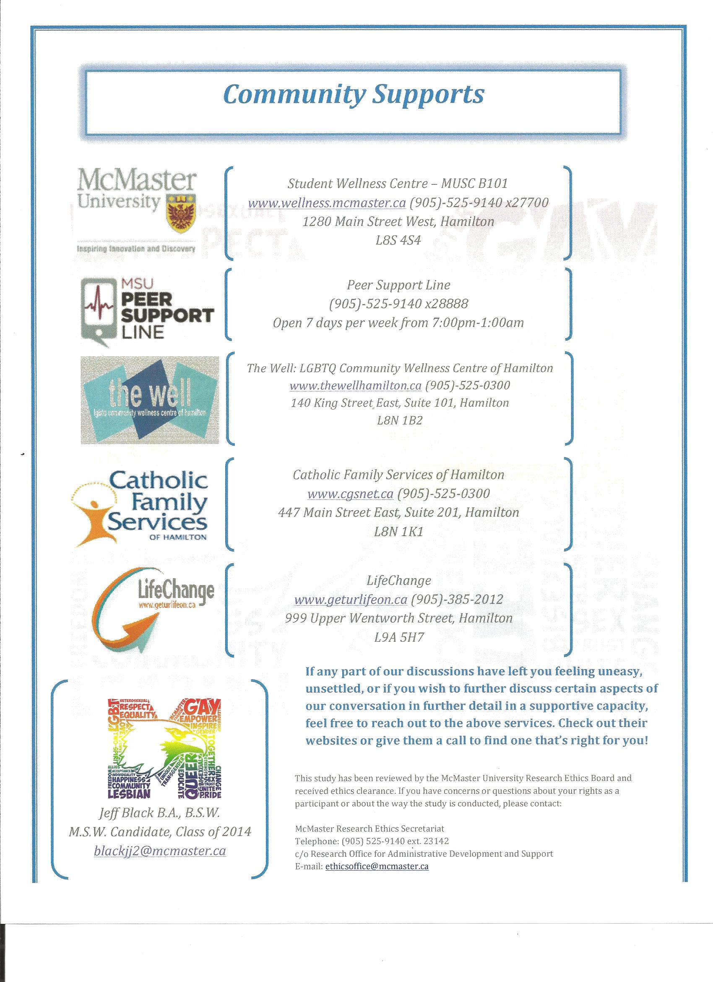

Appendix XII

‘Thank You’ Scripts
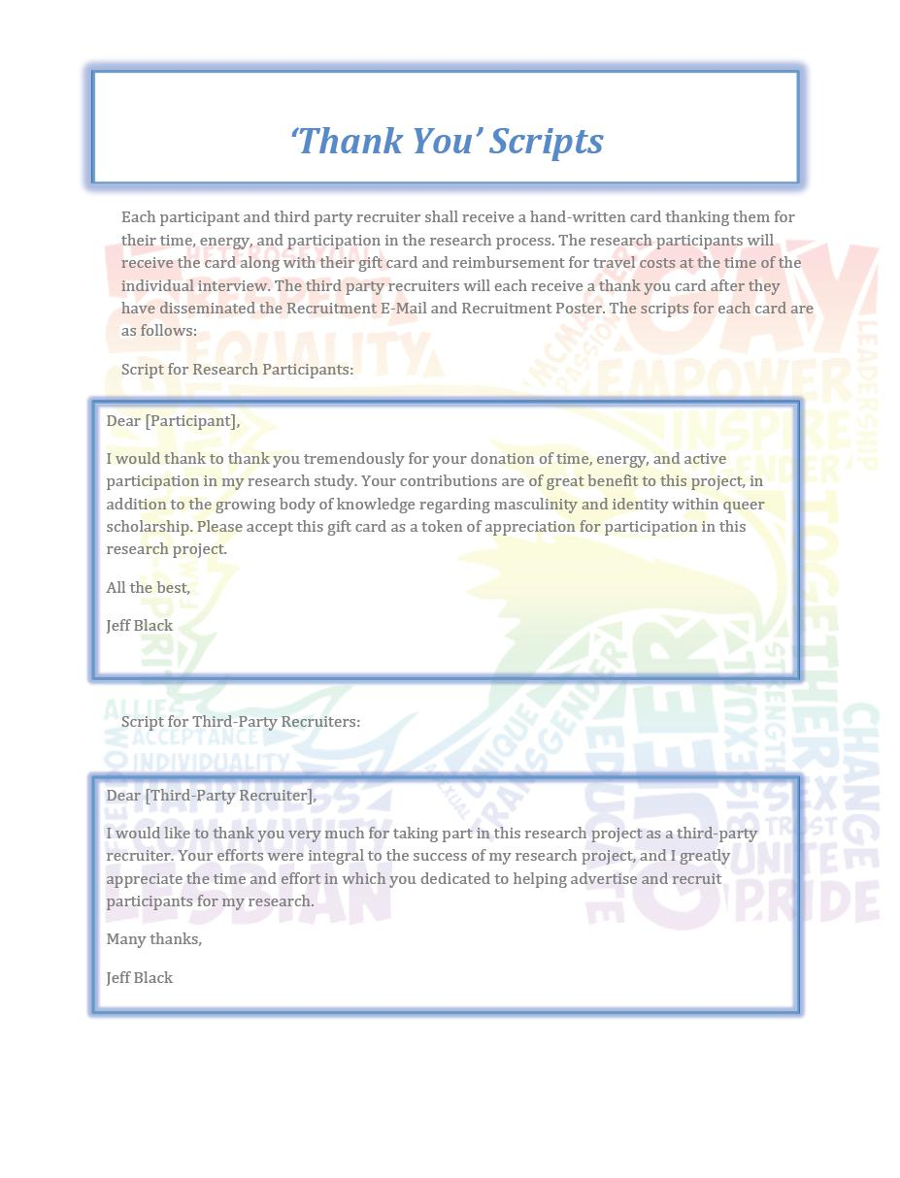

Appendix XIII

McMaster University Research Ethics Board Certificate of Ethics Clearance

