‘UNDER A MAGNIFYING GLASS’:
THE EXPERIENCES OF SOCIAL SERVICE USE FOR MOTHERS LIVING WITH HIV

‘UNDER A MAGNIFYING GLASS’:
THE EXPERIENCES OF SOCIAL SERVICE USE FOR MOTHERS LIVING WITH HIV

By
MARY-ELIZABETH VACCARO, B.A., B.S.W.

A Thesis
Submitted to the School of Graduate Studies
In Partial Fulfillment of the Requirements
for the Degree
Master of Social Work

McMaster University
© Copyright by Mary-Elizabeth Vaccaro, September 2014
MASTER OF SOCIALWORK McMaster University
(2014) Hamilton, Ontario

TITLE: ‘Under a Magnifying Glass’: The Experiences of Social Service Use for
Mothers Living with HIV

AUTHOR: Mary-Elizabeth Vaccaro, B.A., B.S.W. (McMaster University)
SUPERVISOR: Dr. Saara Greene
NUMBER OF PAGES: viii, 143

ABSTRACT
This study explores the subjective experiences of mothers living with HIV from Southeastern Ontario when accessing health and social services. Drawing on principles of feminist participatory action research, 5 MLWH were brought together in order to share their stories of accessing health and social services and to participate in the creation of a collage as part of the storytelling process. Intersectional feminist theory was chosen as a theoretical lens for this project to highlight the ways women’s multiple identities intersect and contribute to HIV-stigma. Emerging from the storytelling and arts based process were stories about the women’s interactions with the criminal justice system, Children’s Aid Societies, social welfare programs and women-specific supports. The key concerns that the women raised in connection to these interactions included having to re-tell their story, concerns about confidentiality and disclosure and experiencing a loss of control as a result of depending on a myriad of health and social services. In addition, the participants identified changes they would like to see within health/social services including more opportunities for peer support and an increase in services available to support the unique psychosocial challenges of MLWH.

ACKNOWLEDGEMENTS
First, I must acknowledge and thank the five incredible women who decided to participate in this project. Thank you for sharing your stories, time and energy with me. Thank you for prompting me to ask new questions and think about things differently. I am so grateful you decided to join me along this journey. I look forward to continuing our work together as we share the findings from this study.
To my thesis supervisor, Dr. Saara Greene, you have been my greatest mentor and support throughout my undergraduate and graduate education at McMaster University. Our many thought provoking and reflective discussions over the past year were invaluable as I worked on this project. Thank you for your time and energy, your encouragement and your willingness to challenge me throughout this process.
To the Interdisciplinary HIV Pregnancy Research Group (IHPREG), thank you for giving me the opportunity to be a part of this exciting area of research during my undergraduate education and sparking my interest in HIV research. Thank you for awarding me the IHPREG Graduate Student Scholarship to assist with this research and my education!
Mom, Dad, and Daniel –Thank you for your love, encouragement and support throughout my life especially during my time in university. I would not have been able to do this without the three of you.
My Nunnie – The countless hours you spent ‘playing school’ with me paid off. Thank you. Jeffrey Black – Thank you for sitting across from me every night for the past few years as we completed our BSW and MSW together. Thanks for your intelligence, humor and kindness I am lucky to have you as a friend.

TABLE OF CONTENTS
Abstract iv.
Acknowledgements v.
Chapter 1: Introducing the Project 1 – 4
Chapter 2: Literature Review 5 - 18
2.1 The State of HIV for Women in Canada 5 – 6
2.2 Women Living with HIV in Canada 7 - 10
2.3 The Intersection of HIV and Mothering for Women 10 – 15
2.4 Social Service and Health Care Use for Mothers Living with HIV 15 – 17
2.5 Identifying Gaps and Unexplored Questions in Existing the Literature 17- 18
Chapter 3: Theoretical Framework, Methodology & Methods 19 - 36
3.1 Intersectional Feminism as a Theoretical Framework 19 - 21
3.2 Integrating Feminist Participatory Action Research and the ‘Arts’ 21 - 26
Chapter 4: Research Methods 27 - 34
4.1 Research Methods 27 - 30
4.2 Recruitment 29-30
4.3 Ethical Considerations 30 - 32
4.4 Data Collection 32
4.5 Participatory and Thematic Data Analysis 33 - 34
Chapter 5: Findings 35-76
5.1 The Women Involved in this Study 35 – 36
5.2 Reflections on Service Use 36 – 47
5.3 Stories of Service Use & Experiences with ‘The System’ 47 - 64
5.4 What Women Want from Health and Social Services 64 – 76
Chapter 6: Discussion 77 - 89
6.1 Strengths & Limitations of the Research 77 - 78
6.2 Health and Social Service Use for Mothers living with HIV 78- 79
6.3 HIV-related Stigma and Discrimination 79 - 82
6.4 Loss of Control 82 -83
6.5 Concerns Around Disclosure and Confidentiality 83 – 85
6.6 What Women Want from Health and Social Services 85 - 89
Chapter 7: Implications for Social Work: Practice, Research & Social Action 90- 101
7.1 Implications for Social Work Practice & Policy 90 - 95
7.2 Implications for Social Action 95 – 96
7.3 Implications for Future Social Work Research 96 - 99
7.4 Plans for Dissemination & Knowledge Transfer and Exchange Activities 99 - 101
Chapter 8: Reflections on the Process and Concluding Statements 102 – 106
8.1 Reflections on the Process 102 – 105
8.2 Concluding Statements 105 – 106
Appendices 107 - 129
Appendix 1: Recruitment Material 107 - 109
Recruitment Flyer 107
Study Information Brochure 108 - 109
Appendix 2: Letter of Information & Consent Form 110 - 115
Appendix 3: Agendas of Our Research Meetings 116 – 117
Appendix 4: Demographic Questionnaire 118 - 119
Appendix 5: Photo Release – Consent Form 120 - 121
Appendix 6: Continued Involvement- Consent Form 122
Appendix 7: Additional Photography of the Collage 123 - 129
References 130 - 143

CHAPTER ONE: Introducing the Project
My experiences as both a social service provider and researcher have prompted me to trouble the current state of the health and social service system and its response to women experiencing marginalization. Over the past few years I have worked as a service provider working within an agency that provides a range of programs and services to socially and economically marginalized women. Through facilitating a drop in program for women experiencing homelessness, I have witnessed some of the profound ways systemic discrimination exists within social services and the impact this has on the women I work with. Oftentimes, women experience challenging and frustrating interactions with social service providers and services when attempting to have their basic needs met. The challenging experiences that women encounter as they attempt to navigate social services can result in further isolation, marginalization and social exclusion. When considering a potential thesis topic I began troubling how social service use is experienced by marginalized women. More specifically, I began to question how women who access a multitude of health and social services perceive their involvement with the ‘system.’
In both my undergraduate and graduate social work education, I have had the opportunity to work as student researcher on projects relating to the experiences of mothers living with HIV (MLWH). As a student researcher, I focused primarily on exploring the experiences that MLWH have with the Children’s AID Society (CAS). These findings suggest that MLWH experience stigma and discrimination within their interactions with the CAS (Greene et al, 2014; O’Brien-Teengs et al, 2012). In addition this study highlighted a profound lack of current knowledge about HIV on the part of service providers (Greene et al, 2014; O’Brien-Teengs et al, 2012). Over the past two years, these findings have deeply troubled me. My involvement in these research projects sparked my curiosity about the other experiences MLWH may be having in their interactions with the multiple health and social services they access. I began to wonder how the intersection of HIV and motherhood complicates experiences of social service use for women who occupy a range of marginalized identities.
As a service provider and researcher, I have considered the many ways the ‘system’ exercises control in virtually all aspects of the lives of marginalized women. For MLWH the intrusion by health and social services is experienced on many fronts by virtue of their unique health needs, laws around HIV-criminalization, the social deprivation caused by poverty and the social surveillance of mothering. When considering how traditional social work and case management has evolved from its original intentions, Margolin (1997) conceptualized an increase of intrusion by all sectors of health care and human services by stating:
“Social workers must go often enough, stay long enough, go despite rebuffs, discourtesy, frank hostility and nonchalant denial of need or wish to use the service” (Margolin, 1997, p. 12).
Mothers living with HIV are uniquely impacted by social and economic determinants including but not limited to poverty (Larkin, 2000, Watkins-Hayes, 2013), homelessness (Aidala et al, 2005; Greene et al, 2010), Children’s Aid Society (CAS involvement (Greene et al, 2014; O’Brien-Teengs et al, 2014), criminalization (Greene et al, 2014; HIV and the Law, 2014) and mental health challenges (Abel et al, 2006; Lekas et al, 2006). These factors coupled with managing a highly stigmatized chronic illness shape the ways MLWH have experienced social work, case management and other social service supports.
As I identified an area of study for my graduate thesis, I knew I wanted to explore the subjective ways MLWH would describe their experiences using social services and interacting with service providers. As I reflected on the unpleasant ways Margolin (1997) describes the institution of ‘social work’, I became troubled by how my own identity as a service provider and researcher through a School of Social Work would impact the way women told their stories about service use. I was conflicted on how elicit these stores in in-depth and authentic ways, despite my experience as an outsider. As I moved away from more traditional research paradigms in designing this project, I began to explore the use of arts-based methods. The use of art throughout this project emerged as a potential way to mediate power imbalances and authentically engage women in telling a story about their experiences of service use.
Since ancient times, ‘art’ has had a profound impact on representing reality, communicating emotion and documenting human life. According to Pablo Picasso, art enables us to see the truth. Women worldwide have always used the arts to uncover or create new knowledge, highlight experience, ask questions or solve problems. For example, here in Canada, quilts have been ‘used for hundreds of years to document family stories’ (Ball, 2008, p. 365) while in Chile women created ‘arpilleras’ (pieces of cloth to tell a story) of the human rights violations occurring during the Pinochet regime, this art was used to alter the way the world viewed this era (Stalker, 2003). Art is an important part of my work as the facilitator of a ‘drop-in program’ for homeless and marginally housed women. I continue to be fascinated by the profound ways art-based activities and the act of creating something has the potential to genuinely engage women who occupy a range different of social identities and lived realities. I decided that my thesis would use art as a way of exploring and documenting the ways MLWH perceive interacting with social services.
‘Under a Magnifying Glass’ is a feminist participatory and action-orientated (FPAR) project that brings five mothers living with HIV from Southeastern Ontario together to use art as a way to discuss experiences with social services. Each time we met women brought photographs, texts, images, objects and words that symbolically represented the stories they told. Over three meetings women worked collaboratively to use the items they had brought to create a collage that visually represented their experiences when accessing health and social services. In addition to sharing stories, women also identified potential local solutions and considered the larger social change needed to improve their experiences with the system. Through using the theoretical lens of intersectional feminism (Crenshaw, 1989), it is my hope this research project will begin to unearth the ways the stigmatization of HIV and the intersecting marginalized identities women occupy impact their experiences of social service use.
What follows is a story about the process, the findings, the meaning and the larger implications of this work. It is my hope that my theoretical and methodological framework positions this project as an alternative to the dominant discourse in existing scholarship on service use for MLWH and a step towards more collaborative research paradigms. Women’s narratives and photographs of their contributions to the collage are interwoven within the findings section of this thesis as I aim to use art as a way of producing knowledge. The action-orientated research paradigm coupled with an arts-based method brought forth discussion on social change and created potential for engaging in future knowledge transfer and exchange (KTE).

CHAPTER TWO: Literature Review
To date, there is a lack of available literature and scholarship focusing on experiences of social service use from the perspective of MLWH. In light of this, my literature review compiles a breadth of scholarship focusing on the psychosocial experiences of MLWH that may lead to accessing social services such as homelessness, poverty, criminalization and child welfare involvement. Throughout my review of the literature, I use an intersectional feminist approach (Crenshaw, 1989) to critically examine the state of HIV in Canada highlighting how women occupying marginalized identities become disproportionately impacted by HIV.
2.1 The State of HIV for women in Canada -
HIV/AIDS remains one of the most serious epidemics worldwide, yet over the passing decades the characteristics of the HIV epidemic have been changing and evolving. In Canada, one of the most salient changes observed has been the increase in the proportion of women impacted by HIV. Epidemiological data would suggest ‘women-identified’ persons are far more impacted by HIV than they were at the beginning of the epidemic (Public Health Agency of Canada, 2012), with Ontario having the largest number of women affected by HIV. Women living in Ontario represent 38.5% of the total number of positive test reports for women in Canada (Public Health Agency of Canada, 2012).
Most recent surveillance data from the Public Health Agency of Canada (2012) suggests that 24% of all persons newly diagnosed annually with HIV were female-identified. CATIE (2013) estimates that 77% of new HIV infections amongst females are attributed to heterosexual sex, while 23% of new HIV infections are attributed to injection drug use. Females aged 30 to 39 had the highest proportion of HIV diagnoses in Canada (36%), followed by females aged 20 to 29 (23%) (Public Health Agency of Canada, 2012).
As there has been an increase in women diagnosed with HIV in Canada, there has been a significant interest in research specifically looking at how to support women living with HIV. Motherhood and pregnancy is also becoming a growing reality for women living with HIV given the proportion of women being diagnosed during their childbearing years. Therefore a growing body of literature exists investigating the unique reproductive health needs for MLWH (Kennedy et al, 2014; Sandelowski, Lambe & Barraso, 2004; Yudin & Loufty, 2011). In addition, many scholars are beginning to consider the psychosocial needs of mothers living with HIV (Greene et al, 2013; Hutchinson & Ingram, 2000; Sandelowski & Barraso, 2003). Advancements in bio-medical spheres have successfully increased the length and quality of the lives of women living with HIV in Canada; improving reproductive options while reducing the rates of vertical transmission significantly (CATIE, 2013). In 2011, there were 203 infants born to MLWH and 3 (1.6%) of these infants were confirmed HIV-positive (CATIE, 2013; Public Health Agency of Canada, 2012). These statistics represent promising childbirth outcomes when compared to the beginning of the HIV epidemic which begin to highlight a shift in the way WLWH experience pregnancy and motherhood (Kennedy et al, 2014; CATIE, 2013).
Despite the epidemiological data on the state of HIV in Canada, it is critical to note that across Canada HIV does not uniformly impact all women. Communities who have faced and continue to face social inequity and marginalization tend to be disproportionately impacted by HIV. Specifically, women from Aboriginal communities, African Caribbean and Black (ACB) women, criminalized women, women living in poverty and women who have histories of injection drug use remain over represented in the population of WLWH in Canada ( Aidala et al, 2005; Bauer et al, 2007; CATIE, 2013; Public Health Agency of Canada, 2012, Spittal et al, 2002).
2.2 Women Living with HIV in Canada
In Canada WLWH occupy many diverse ‘social identities’ and consequentially are subject to experiencing multiple and intersecting sites of oppression and marginalization. As HIV infection disproportionately impacts women from marginalized communities, there is a need to explore the unique social identities of women that remain the most impacted by HIV in Canada. Social determinants that impact the lives of WLWH such as Aboriginal status, precarious Canadian citizenship due to immigration, sponsorship or refugee status, poverty, homelessness, histories of substance use and criminalization have profound impacts on the ways women live with and manage a highly stigmatized chronic illness (Aidala et al, 2005; Ion et al, 2014; Martin et al, 2005; Poulin et al, 2007; Spittal et al, 2002). Exploring and understanding the multiple and fluid identities of WLWH can attempt to contextualize the experiences of WLWH when working with health and social service providers.
A.) Aboriginal Women in Canada
Aboriginal women in Canada represent 23.3% of all positive HIV diagnoses amongst female-identified persons with HIV (Public Health Agency of Canada, 2012), which is an alarming statistic considering Aboriginal people make up only 4% of the overall Canadian population. The overrepresentation of HIV-positive Aboriginal women must be considered within the lager contexts of how colonialism, the profound impacts of intergenerational trauma and the dire social and economic conditions on Canadian reserves have historically and currently impact the lives of Aboriginal women.
In Canada, Aboriginal women are disproportionately overrepresented in many aspects of the social service system, including the legal sector, the child welfare system and experience poverty at a higher prevalence (Beaucage, 2011; Canadian Aboriginal AIDS Network, 2004; O’Brien-Teengs et al, 2012). The disproportionate number of Aboriginal families involved with Children’s Aid Societies (CAS) in Canada is of particular concern, given the ways in which child welfare policy was and in some instances continues, to be used as a mechanism to colonize and assimilate Aboriginal families (O’Brien-Teengs et al, 2012). Despite Aboriginal women being greatly overrepresented in HIV/AIDS statistics there is a startling lack of services that provide women-centered, Aboriginal-specific supports for their psychosocial needs in a way that reflects their identities as an HIV-positive Aboriginal women(Canadian Aboriginal AIDS Network, 2004).
B.) African, Caribbean and Black (ACB) and Immigrant Women
Women who emigrate from countries where HIV is endemic are greatly over-represented in current Canadian HIV statistics. Of the 534 HIV-positive diagnoses in 2012, 312 (58.4%) of the persons diagnosed were born in Africa and the Middle East (Public Health Agency of Canada, 2012). Ethnicity and immigration status are important components to consider when conceptualizing the identity of WLWH and their complex, often multi-layered experiences of stigma (DeSouza, 2004; Kennedy et al, 2014). Research conducted in Ontario has identified young women who are recent immigrants from African countries as disproportionately impacted by HIV; it is estimated that 45% of HIV-positive women in Ontario are from ACB communities (Kennedy et al, 2014; Remis, Swantee & Liu, 2012).
WLWH from ACB communities have shared their stories about the unique challenges they face when navigating Canada’s social service system, Greene et al (2013) found many new immigrant women believe the housing system in Canada is particularly difficult to navigate. Trouble navigating the health and social service sector complicates the experiences of settling in Canada for WLWH who have unique psychosocial needs. The experience of unfamiliarity with the social welfares system is particularly dangerous for immigrant women, who face a heightened vulnerability for experiencing intimate partner violence due to social isolation, language barriers and rigidly defined gender roles (Smith, 2003; Stewart et al, 2006). WLWH who are from immigrant communities require responsive and comprehensive pathways to accessing HIV-related and other social and health care supports in Canada. Moreover, understanding the service use experiences for WLWH from ACB communities requires understanding how systemic racism infiltrates their experiences accessing social services.
C.) Criminalized Women & Women with Histories of Injection Drug Use
Women in Canada who have faced criminalization and subsequent involvement with the prison system are disproportionately impacted by HIV. According to CATIE (2013), 8% of incarcerated women report being HIV-positive compared to 5% of men who are incarcerated. Furthermore, 12% of Aboriginal women who are incarcerated report being HIV-positive compared to only 3% of Aboriginal men (CATIE, 2013). Many women in Canada become involved with the legal system for crimes deeply connected to the living conditions of poverty, such as non-violent thefts and drug related charges (Elizabeth Fry Society, 2013).
Women who have had a history of injection drug use (IDU) face a significantly increased chance of contracting HIV, as epidemiological data estimates that 1 in 10 women who have injected drugs in the past six months are HIV-positive (CATIE, 2013). WLWH who have faced criminalization and/or have histories of IDU may occupy multiple ‘stigmatized’ identities, which can complicate the ways women experience accessing health and social services, as both voluntary and involuntary participants.
Across Canada, WLWH occupy multiple, intersecting social identities which shape their psychosocial experiences and contribute to the ways they experience accessing health and social services. The disproportionate numbers of WLWH from Aboriginal, ACB, and immigrant communities (CATIE, 2013; Public Health Agency of Canada, 2012), and the higher prevalence rates of HIV amongst women with histories of criminalization and/or IDU (CATIE, 2013) begins to shed light on the complex ways ‘HIV’ is linked to larger issues of social and economic injustice and inequalities amongst Canadian women. Understanding the experiences of health and social service utilization for WLWH requires a broader understanding of how women’s multiple identities produce histories and daily lived realities of systemic injustice.
2.3 The Intersection of HIV and Mothering for Women -
Pregnancy and motherhood is a multi-factorial, complex and highly gendered process; an experience that has been conceptualized as both transformative and taxing for women (Aidala et al, 2005; Sandelowski & Barroso, 2003). Women living with HIV, who become pregnant, often report feeling, in many nuanced and textured ways, as ‘other’ when compared to the socially constructed ideals around ‘maternal identity’ (Aidala et al, 2005; Ingram & Hutchinson, 1999; Ion et al, 2011; Kennedy et al, 2014). Despite the social determinants rooted in structural inequalities that positions MLWH on the margins, scholarship would suggest ‘mothering’ also provides women with a sense of joy, strength and purpose and can be a positive experience for WLWH (Ingram & Hutchinson, 1999; Rotherman-Borous et al, 2005; Sandelowski, & Barroso, 2003). These factors contribute to shaping the multifaceted psychosocial experiences and needs of WLWH as they become pregnant, give birth and/or mother.
The ongoing dialogue that exists within contemporary literature tends to focus on the complex social realities for MLWH, particularly in relation to their disproportionate experiences of pervasive social stigma, poverty, lack of housing, violence and other issues impeding ones’ mental well-being (Bauman et al, 2002; Greene et al, 2010; Greene et al, 2013; Hutchinson & Ingram, 1999; Hutchinson & Ingram, 2000; Lekas et al, 2006; Walter, 2011). Very little scholarship focuses on how mothers navigate health and social service systems to respond to these complex psychosocial needs. The intersection of motherhood and HIV, coupled with the multiple other social identities occupied by WLWH often creates situations for women characterized by social injustice leading to social deprivation.
A.) Poverty - Experiences of material deprivation and instances of poverty emerged as a strong theme throughout the literature conceptualizing the social realities for MLWH (Hutchinson & Ingram, 1999; Lichtenstein et al, 2012; Sandelowski & Barroso, 2003). Women and more specifically mothers, are profoundly overrepresented as Ontario’s poorest demographic (Ontario Coalition Against Poverty, 2014). Mothers living with HIV are disproportionately impacted by experiences of poverty (Canadian Aboriginal AIDS Society, 2013; Larkin, 2000; Raphael, 2004). Poverty is often correlated with; a lack of control over one’s life circumstances, a lack of ability to participate in social spheres and a lack of autonomy (Baker Collins et al, 2009; Neysmith et al, 2004). Experiences of living with persistent social stigma may compound the aforementioned symptoms of poverty for MLWH and have profound impacts on the quality of life of themselves and their children. Mothers living in poverty in Canada often interface with multiple social service sectors to meet the most basic needs of themselves and their children through government support programs and food banks. However there is little known about the unique ways MLWH interact with these systems.
B.) Housing Instability & Homelessness - Disproportionate experiences of poverty and social deprivation for this population suggests that there is a need to examine the continuum of housing, transience and homelessness for MLWH and their children (Greene et al, 2013; Ingram & Hutchinson, 1999; Kennedy et al, 2014). WLWH outline poverty, relationship breakdown and abuse as the three most salient factors that contribute to being unstably housed and transient (Greene et al, 2010; Greene et al, 2013). Homelessness uniquely impacts MLWH as they struggle to balance their responsibilities of ‘mothering’ and their responsibilities of ‘managing’ and living with a highly stigmatized chronic illness without adequate housing.
Housing instability is related to a lack of medication adherence for WLWH and a decline in the physical well-being for MLWH (Abel et al, 2006). Greene et al (2010) illuminates that MLWH have fears about coming into contact with Children’s Aid Societies as a result of their housing situation. For MLWH in Canada, housing is a protective factor promoting physical and mental well-being as well as preventing unwanted external intervention from social service agencies in their lives and the lives of their children (Greene et al, 2010; Greene et al, 2013; Ion et al, 2014). ‘Homeless’ is yet another profoundly stigmatizing social identity for MLWH which can lead to the experience of a ‘double burden of stigma’ as their homelessness and HIV statuses intersect (Mill et al, 2010). Further inquiry is needed to uncover the complex ways that MLWH experience homelessness and housing instability, and perceive their interactions with service providers in these contexts.
C.) Child Welfare and Children’s Aid Societies - A growing body of literature on MLWH in Ontario, illuminates the experiences of stigma and discrimination that mothers have had when interacting with Children’ Aid Societies (CAS) (Greene et al, 2010; Greene et al, 2014; Ion et al, 2014; Kennedy et al, 2014, O’Brien-Teengs et al, 2012). An Ontario based research study, entitled The HIV Mothering Study, uncovered MLWH are reporting alarming rates of CAS involvement, finding that 25.7% (18 out of 70) participants disclosed having had historical contact with CAS when interviewed during pregnancy (Ion et al, 2014; O’Brien-Teengs et al, 2012). MLWH from ACB and Aboriginal communities are at heightened risk for interactions with CAS, and these experiences are complicated by histories and daily realities of racism and colonization. Aboriginal mothers who are living with HIV in Ontario are profoundly impacted by CAS involvement as 20% of Canadian children in out-of home care identify as Aboriginal (Beaucage, 2011).
Contemporary scholarship on MLWH experiences with CAS highlight a lack of HIV-related knowledge on behalf of child welfare workers (Greene et al, 2014; O’Brien-Teengs et al, 2012). This lack of knowledge has manifested into stigmatizing and discriminatory practices on behalf of child welfare workers (O’Brien-Teengs et al, 2012). Parental HIV status in and of itself is not an issue warranting concerns about child welfare and subsequent involvement from the CAS. Despite this literature would suggest MLWH often find their HIV status is implicated in broader discussions about child welfare and capacities for mothering in ways perceived as stigmatizing (Greene et al, 2014; Kennedy et al, 2014; O’Brien-Teengs et al, 2012)
D.) Criminal Justice System –The intersection of living with HIV through the era of criminalization, experiencing poverty and coping with substance use, mental health challenges and/or intimate partner violence produces a host of potential ways that MLWH become involved with the criminal justice system. During the past decade, many countries have attempted to respond to the HIV epidemic by using the criminal law to prosecute anyone who puts another person at risk of contracting HIV (HIV and the Law, 2014; Unlocking HIV, 2014). Despite their being no evidence to suggest that criminalizing people living with HIV (PLWH) will assist in managing the HIV epidemic, (De Groot & Ulvin, 2005; HIV and the Law, 2014; Unlocking HIV, 2014) PLWH are facing incarceration and serious criminal charges as a direct result of being accused of not disclosing their HIV status to sexual partners (HIV and the Law, 2014).
Aside from the risk of being criminalized due to non HIV disclosure, other factors impacting the lives of MLWH also position them at increased risk for facing criminal charges. As women who inject drugs are at a higher risk for contracting HIV vis-à-vis needle use, they also face the potential of facing criminalization because of Canadian laws around illicit substances (CATIE, 2013). Moreover, MLWH are disproportionately living in poverty which creates the risk of engagement in criminal activity as a direct means of attempting to alleviate the impacts of poverty on themselves and their children. Women’s crime is often deeply related to experiences of poverty, for example, petty theft, engagement in survival sex work and selling relatively small quantities of illegal substances (Elizabeth Fry Society, 2013).
The United Nations Office on Drugs and Crime (2012) put forth a policy statement calling for a gendered-specific focus in an effort to address the unique needs of WLWH in correctional institutions. A gender-blind approach to service delivery for incarcerated PLWH has had detrimental impacts on the health and well-being for women, more specifically mothers, who are experiencing incarceration and navigating the criminal justice system (De Groot & Ulvin, 2005; United Nations Office on Drugs and Crime, 2012). As MLWH who are incarcerated experience a host of challenges often resulting in the loss of housing, child welfare involvement and psychosocial stress due to navigating the criminal justice system, De Groot & Ulvin (2005) highlights the need for interconnected services addressing the unique needs of MLWH while incarcerated. As conceptualized by De Groot & Ulvin (2005), women specific services would include:
“Clinical medical services, physical and sexual abuse recovery programs, drug treatment
and mental health services, training and skills building workshop to help women become
socio and economically powerful while facilitating their ability to continue to
effectively manage their healthcare needs upon release” (p.3).
The impact of incarceration impacts multiple areas of women’s lives and mothering responsibilities subsequently requiring holistic gender-specific interventions to provide critical support to incarcerated MLWH.
Through reviewing the existing scholarship on the experiences of MLWH it became apparent that while scholars often took up particular aspects of the socio-economic conditions experienced by MLWH, there was a larger trend emerging that needed to be explored. The discussion within the literature focuses on MLWH experiences of pervasive social struggle. Yet there is very little consideration on how MLWH experience using multiple social services and health care providers to remedy these social complexities and meet the basic needs of themselves and their families.
2.4 Social Service and Health Care ‘Use’ for Mothers Living with HIV
Advancements in bio-medicine, specifically highly active anti-retro viral therapies (HAART) has shifted the prognosis of HIV to a ‘manageable chronic illness’ (CATIE, 2013, Public Health Agency of Canada, 2012; Unlocking HIV, 2014). Efforts to manage HIV in Canada require women to access health care services quite frequently for the purposes of monitoring the progression of the illness and the side effects of the medication (CATIE, 2013; Kennedy et al, 2014; Yudin & Loufty, 2011). In addition, MLWH interface with an array of social service agencies to respond to the psychosocial needs that arise from living in poverty, struggling with mental health/substance use and experiencing incarceration. According to CATIE (2013), there are at least twelve health care and human service professionals vital in the circle of care for MLWH. While this highlights that MLWH are accessing a multitude of health and social services in Canada to manage their physical health and psychosocial needs, very little is known about their experiences.
The continuum of care for PLWH has changed significantly as a result of improvements in the medical treatment and overall quality of life for PLWH. AID Service Organizations (ASOs) have evolved from supporting people cope with death and dying to providing case management focused on supporting PLWH in navigating complicated health and social service systems (Cain & Todd, 2009). Research by Stewart et al (2011) would suggest an average of 7 to 8 social services in the continuum of care for PLWH with not a single respondent stating they did not utilize or need any social service agencies. Crook et al (2005) inquired into how often PLWH are accessing health/social services finding that almost half of their respondents identified using services at least once in the past week. While little is known specifically about experiences of MLWH as they navigate multiple social services, a breadth of literature speaks to experiences of stigma in health care and social service institutions.
As motherhood in the context of HIV is often regarded as ‘other’ and in contrast with the preferred maternal identity (Aidala et al, 2005; Sandelowski & Barroso, 2003), there is a need to understand how HIV-related stigma uniquely impacts mothers as they access health/social services for themselves and their children. It is the experience of stigma and discrimination that differentiates the experiences of WLWH from women who are living and managing other, less stigmatized chronic illnesses (Ingram & Hutchinson, 1999; Sandelowski & Barroso, 2003). Experiences of stigma for WLWH consistently emerges as one of the most salient themes within the existing scholarship, with profound impacts on all aspects of MLWH lives (Abel et al, 2006; Ingram & Hutchinson, 2000; Sandelowski & Barroso, 2003).
HIV-related stigma experienced in the context of health/social service use has been considered to be the leading cause of lower rates of health care and social service utilization, oftentimes causing WLWH to go without basic needs to avoid experiencing stigma and discrimination (Abel et al, 2006; Spatial et al, 2005). Existing scholarship would suggest that social workers and human service providers lack knowledge specifically pertaining to HIV-transmission, exposure and prognosis (Chen et al, 2007; Li et al, 2009; Magnus et al, 2013; Oliver & Dykeman, 2005). A lack of knowledge is oftentimes a contributing factor when service providers stigmatize PLWH (Magnus et al, 2012; Oliver & Dykeman, 2005). Li et al (2009) conceptualize that oftentimes HIV-related stigma is unintentional and rooted in misconceptions around HIV exposure and the lived experiences of PLWH.
There is a need within existing literature to more fully understand the ways motherhood, HIV and women’s multiple and fluid identities intersect to impact the experiences that MLWH have when accessing health and social services. Understanding how HIV-related stigma infiltrates MLWH interactions with health and social services is a critical first step in creating more responsive and comprehensive supports for this population.
2.5 Identifying Gaps and Unexplored Questions in Existing Literature
Epidemiological data highlights women of child bearing age are becoming increasingly impacted by HIV in Canada (Public Health Agency of Canada, 2012). The impact of HIV on women in Canada is not uniform, and therefore it is important to trouble which particular groups of women remain disproportionately represented in the HIV epidemic. Public health data would suggest Aboriginal women, women who recently immigrated to Canada, women from ACB communities and women with histories of criminalization and/or IDU are overrepresented in terms of HIV diagnosis. Understanding the psychosocial challenges disproportionately experienced by MLWH including criminalization, CAS involvement, homelessness and poverty highlights the complicated lived realities for this group of mothers.
It is my hope that this research project can fill a gap in contemporary scholarship by analyzing the ways MLWH describe navigating and interacting with health/social services. The ways that HIV, motherhood and other marginalized identities intersect often has profound negative impacts on the social and economic conditions for MLWH in Canada (CATIE, 2013; Canadian Aboriginal AIDS Society, 2014; Greene et al, 2010; Ion et al, 2014; Kennedy et al, 2014). As MLWH attempt to remedy their unique health, social and economic challenges they oftentimes end up navigating ‘the system’ comprised of multiple health and social service agencies. Rather than focus this inquiry on a particular arena of the health/social service sector, a broader lens was chosen in an attempt to consider the subjective experience of ‘service use’ and the identity of a ‘service user’ in a range of settings for MLWH.
CHAPTER THREE: Theoretical Framework & Methodology
The ontological and epistemological beliefs that guide and informed my research process are informed through the lens of intersectional feminism. Grounding my understanding of service use for mothers living with HIV in an intersectional feminist epistemological framework brought forth important recognition that ‘service-use’ exists as a part of a society where women are subjected to multiple layers of oppression and marginalization based on their identity. Throughout designing this research project, I had a commitment to produce knowledge and engage MLWH in a collaborative research project that used alternative and feminist ways of knowing. Moving beyond traditional, androcentric forms of inquiry I used an intersectional feminist theoretical approach to inform this participatory action-orientated research project. In addition, storytelling and arts-based methods were used to collect the data.
3.1 Intersectional Feminism as a Theoretical Framework
In a response to androcentric and male-dominated approaches to inquiry, feminist research was born out of the belief that women learn and express themselves differently than men. Belenky et al (1986) would suggest that feminist ways of knowing tend to place emphasis on the subjective, relational and process-oriented sides of social life. Adapting a feminist lens as a theoretical framework within this project would aid in uncovering the subjective experiences MLWH have interacting with health and social services.
Feminist theory builds upon interpretive and critical social science research by recognizing that women understand and make sense of the world in ways different than men, as a result of gender constructs and division (Neuman, 1997). In an effort to transcend the binary limitations of traditional feminist thought, intersectional feminist scholars would caution researchers to pay attention to the ways that women understand and make sense of the world in inherently different ways based on the intersection of their multiple social identities (Crenshaw, 1989).Understanding the unique ways that gender inequality intersects with race, ableism, heteronormativity and HIV-related stigma is pivotal in attempting to differentiate the experiences of MLWH who access health and social services. Crenshaw (1989) would suggest that an intersectional lens is needed to acknowledge how racism, ability and class impact and differentiate the experience of being a woman. Understanding the experiences of mothers living with HIV through an ‘intersectional’ feminist lens moves analysis beyond the impact of patriarchy and sexism to include how structures such as racism, classism and ableism become implicated.
Feminist research encapsulates a wide range of varying approaches and methods, committing to consciously using a gendered-analysis in ways that focus on how gender-based power and oppression permeate all spheres of social life (Belenky et al, 1986). Women’s voices are captured through feminist methodologies as part of a larger effort amongst feminist scholars to produce research that challenges the male-orientated, positivist perspectives that informs many avenues of social science research (Ackerly & True, 2001). A commitment to the use of feminist theory in research requires pursuing processes that are aimed at facilitating personal and/or societal change for women (Ackerly & True, 2001; Belenky, 1986; Olesen, 2011). Addressing enduring and emergent questions of gendered and other forms of social injustices is integral to the process of feminist researchers who aims to challenge social injustice through their process and analysis (Lykes & Collquillon, 2006).
Feminist scholarship has largely been critiqued for the inability to define the use of ‘feminist theory in research’ in ways that contribute to describing a unified way that feminist theory informs the research process (Lay & Daley, 2007). However, it is the lack of prescriptive approaches embedded in feminist scholarship that creates space for the researcher to use intuition, imagination and personal experience to guide their processes (Acklerly & True, 2001; Neuman, 1997). Feminist qualitative research continues to develop as feminist theorists and social researchers critically examine new foundations, try new approaches to knowledge production, experimental and traditional; and search for unexamined equity issues (Olesen, 2011). Just as there are many forms of feminism, feminist researchers take various approaches to doing to research including participatory or community based research frameworks.
Positioning this inquiry within the realm of feminist qualitative research, I aimed to engage in: “Research that problematizes women’s issues within a framework of social and historical
structures; research that focuses on social justice for women and research that creates knowledge of/for marginalized women” (Olesen, 2005, p. 236). Using the theoretical vantage point of intersectional feminism will be beneficial in an attempt at move away from the positivist paradigm currently characterizing existing literature on the service use patterns for women and mothers living with HIV (Crook et al, 2005; Kuppart et al, 2009; Larkin, 2000).
3.2 Integrating Feminist Participatory Action Research and the ‘Arts’
This project integrates the use of arts-based methodologies in a feminist participatory and action-orientated research framework. Participatory and action-orientated research from a feminist vantage point has potential for researchers engaged in inquiry on instances of health and social injustice impacting marginalized women. In addition, arts-based methodologies are emerging as a powerful tool for qualitative social science researchers who are attempting to engage in inquiry on the subjective aspects of the social experience. Bringing together the use of art and participatory and action-orientated approaches is a useful paradigm for feminist researchers focusing on the experiences and needs of marginalized women.
A. Feminist Participatory Action-Orientated Research - Participatory and action-orientated research (PAR) has garnered attention over the past few decades, and emerged as a way of challenging conventional social science research (Whyte, 1991; Lopes, 2006). Abandoning the traditional notion of the ‘passive participant’ in research projects, PAR advances social science research processes towards adapting more collaborative approaches to knowledge production. By creating space for researchers and persons involved in the research to work collaboratively, research aims to create action or lead to improvements that will benefit the participants directly (Jupp; 2006 Lopes, 2006).
Lopes (2006) articulates PAR as having three major distinctive elements: (1) people-centred, as it is informed by and responds to the needs of people, usually marginalized groups; (2) power, as it disrupts power relations between the researcher and the participants through focusing on the empowerment of marginalized groups; and (3) praxis, as it recognizes the inseparability of theory and practice. PAR has been used extensively to support communities with social justice outcomes related to health inequities. The use of a collaborative approach enables communities to more actively participate in the full spectrum of research (from design, conducting, analysis, interpretation and dissemination), with the goal of influencing change in community health systems, programs or policies (Elliot, 2011; Hockley, 2013; Koch, 2006).
While the ideologies of PAR including, collaboration, dismantling power dynamics and producing action-orientated outcomes had particular usefulness for this project, it is important to reflect on the critique of PAR that has emerged in feminist scholarship. PAR, in its most traditional sense has been critiqued by feminist scholars for its potential to adapt a gender-neutral approach (Lykes & Collquillon, 2006; Ponic, Reid & Frisby, 2010). PAR fails to address and challenge the ways gendered processes impact women, and subsequently is unsuccessful in responding to the barriers women face in relation to ‘knowledge production’ as a result of a lack of recognition for women’s multiple ways of knowing (Belenky et al, 1986). Moving beyond traditional PAR approaches by using a feminist theoretical framework was necessary to challenge the ways patriarchal values are implicated within current health care and social work research and practice (Hankvisky & Christoffersen, 2008 & Ponic, Reid & Frisby, 2010).
Upon reflecting on the contemporary critiques of PAR, Feminist Participatory Action Research (FPAR) was chosen as the methodology for this project. When asking mothers living with HIV to engage in a process of sharing stories about service-use, I sensed the purpose of this research was to begin a dialogue about change. FPAR infuses feminist perspectives with participatory and action-orientated research processes to frame arguments to support demands for change and develop place appropriate change strategies (McCann & Kim, 2003). Feminist perspectives prescribe the intellectual tools required for examining the injustices experienced by women and for confronting the power and privilege of stakeholders when challenging social injustices experienced by women (Reid, 2004). Using FPAR in social science inquiry can be seen as a part of an effort to explicate ways the personal are political, through women’s participation, shared theorizing and social action aimed at addressing social injustices through a gendered-lens (McCann & Kim, 2003; Ponic, Reid & Frisby, 2010).
Both traditional forms of PAR and FPAR use dialogue between participants as a key methodological feature. Ideally dialogue within action or participatory research is aimed at bringing people together, who have faced isolation and/or marginalization, around common problems or needs, in an effort to produce knowledge and enact some ‘change’ (Sohng, 1995; McCann & Kim, 2003, Reid, 2004). Bringing mothers living with HIV together in a group setting to engage in dialogue about their experiences of service-use, was chosen for its congruency with the methodological features of FPAR. Moreover, FPAR extends the research process beyond sitting and talking about shared experiences, to taking action to address the health and social inequities impacting their lives (Reid, 2009; Olesen, 2011; Ponic, Reid & Frisby, 2010).
Ponic, Reid and Frisby (2010) argue that although all humans are inherently theory-builders it is necessary to recognize that we do not all share the specialized language and skills associated with intentionally building and articulating feminist ‘academic’ knowledge. Despite women’s infinite capacities for ‘theory building’ (Ponic, Reid & Frisby, 2010) barriers exist in academia that continue to hinder the representation of marginalized women’s voices, experiences and knowledge in research. While dialogue between marginalized groups about a shared issue of concern is a central tenant of PAR/FPAR methodologies, I troubled the inherent limitations in strictly capturing and showing this story in discursive forms.
Reflecting on the importance of ‘social action’ is critical for any researcher engaged in a FPAR project. I began considering how opportunities to share the knowledge generated through this research project could be a way of beginning a much needed dialogue within community-based and academic spheres about the experiences of service use for MLWH. I started considering how arts-based approaches might be applied to achieve such a vision. Arts-based methods create a unique potential for addressing the inherent power dynamics between the researcher and participants, moving FPAR towards more authentic participation and collaboration. In contrast to traditional forms of research, presented in exclusively written text; the ‘arts’ engages participants imaginations and creativity by ‘revealing what women’s lives are really like and the potential for how they could be’ (Foster, 2007, p.533).
B. The Use of an Arts-Based Methodology
Arts-based inquiry is ‘uniquely positioned as a methodology for radical, ethical and revolutionary research that is futuristic, socially responsible and useful in addressing social inequities’ (Finley, 2008, p.71). Arts-based methodologies can be seen to be aligned with FPAR because it can create processes where oppression is exposed, sites of resistance are targeted and possibilities for transformative praxis are outlined (Finley, 2008). Arts-based methods and methodologies are closely connected to post-modern thought, as they reject attempts at arriving at a concrete set of findings, but rather produce new ideas and generate questions that make our conversations more interesting (Barone & Eisner, 2012). Many diverse and useful methods exist for researchers to draw upon when incorporating ‘art’ into qualitative social science inquiry, including but not limited to the use of visual art, photography, story-telling, drama and forms of new media in the knowledge production processes (Knowles & Cole, 2008).
Although ‘art constitutes one of the oldest forms of knowledge and knowing’ (Clover, 2011, p. 12), it has only recently become integrated as a potential tool within the realm of qualitative social science research. Seeing methodology through an artful eye, ‘reflects a way of being in the world as a researcher, that is paradigmatically different from other ways of thinking about and designing research’ (Knowles & Cole, 2008, p. 1) I have always been fascinated by the ways women, in all parts of the world, have relied on the ‘arts’ throughout history. For many women around the world and locally, historically and currently, art is used as a means of uncovering and creating new knowledge, highlighting experience, posing questions and/or solving the problems impacting their lives (Clover, 2011).
Using arts-based methodologies with women in a FPAR project can draw upon a large spectrum of women’s creative intelligence, developing knowledge through artistically expressive forms, that generates the kind of empathy, curiosity and attention, which renders ‘action’ possible (Clover, 2011; Finley, 2008; Foster, 2007). Creating knowledge and portraying this through art, poses unique potential for knowledge-transfer and exchange activities, dissemination and participatory action-orientated strategizing. Moreover, the tangibility of the ‘art’ invites stakeholders to engage and ‘view’ knowledge through arts-based forms which aligns this approach closely with ‘action-orientated’ approaches (Barone & Eisner, 2012; Clover, 2011; Foster, 2007).
Arts-based methods produce a less tangible and subsequently more interpretive form of knowledge (Clover, 2011). Particularly, the arts are useful for researchers attempting to promote dialogue and explore the nuances of lived experience as arts-based methods will not yield unchallengeable concrete answers about social phenomena (Foster, 2007). By opening up space for experimentation in academic spaces (Cole & Knowles, 2008), arts-based approaches have been used to enhance, deepen and share our understanding of the human condition (Stalker, 2003). Throughout history, artists of all genres have addressed socio-political injustices and engaged public audiences with their messages. Using art as a way to tell a story about the experiences of mothers living with HIV who interact with health and social services holds the potential to yield participation; collaboration and action in ways align with FPAR methodologies.

Chapter Four: Methods & Data Collection
4.1 Research Methods
The research methods used in this project were purposefully chosen for their ability to capture the individual experiences while also highlight the shared collective experience for MLWH who access social services. Story telling through the use of art created space for each woman to share experiences that were most significant to her personally. Collaboratively creating a collective collage facilitated a participatory process where women linked their personal experiences to larger political structures, and identified potential areas for social change.
A.) Arts-informed Story-telling - The underlying premise of many forms of qualitative and narrative inquiry is the view that individuals construct meaning by making sense of their world through telling the stories of their experiences (Bailey & Tilley, 2002; Mishler, 1986). Story-telling as a method in qualitative research helps to capture the nuance of a phenomenon from the perspectives of those persons most implicated (Denzin & Lincoln, 2011). The method of storytelling is an aspect of narrative research that is useful for inquiry into the subjective and emotional aspects of person’s lived experiences. Once the story is told, it enables the narrator and the audience to gain a different perspective on the experience and the story teller (Elliot, 2005; Holloway and Freshwater, 2007).
Story-telling was used as a research method throughout this study. The nature of the group meetings facilitated a space that brought MLWH together to talk about their experiences of service-use by sharing stories. As women told stories, they often brought forth images, text and photographs that symbolically represented their stories about how service-use is experienced and perceived. The use of arts-informed story telling was an attempt to provide women with another way to capture the subjective and emotional aspects of the stories they shared. Oftentimes, these subjective and emotional aspects are indescribable by discursive story-telling (Barone & Eisner, 2011). As women told stories they were not passive story-tellers as they considered potential avenues of social change, advocacy and action to improve their experiences with social services.
Incorporating the use of art differentiates narrative story-telling by engaging women in an alternative process of knowledge production. Through using their stories to create a tangible slice of accessible and relevant knowledge, women participated in the creation of an artistic representation of their stories. The knowledge generated through the art helps to portray their stories in ways that are accessible to larger audiences. By using the method of story-telling in arts-informed ways, the MLWH who participated in this study had the opportunity to uncover and represent the subjective aspects of their experiences.
B.) Collage as a Tool for Action - While the potentials for ‘arts-based methodologies’ are infinite, I became fascinated by a small body of literature focusing on the arts-based method of collage (Davis-Butler & Kisber, 2011; Koestera, 2006; Norris, 2014; Vaughan, 2005). Creating a collage with the women would be used to guide a participatory and action-orientated way of sharing stories as they worked to weave together a larger story about their collective experiences as MLWH who interface with multiple service providers.
The central benefit of collage as an arts-based method is the unique making meaning potential that emerges through the juxtaposition of a multiplicity of photographs, artifacts, words, phrases and stories (Norris, 2014). Contributions to the collage could be symbolic or concrete images related to the phenomena being studied (Norris, 2014). Collaging is differentiated from other arts-based methods, as it serves as both an evocative artistic product and an individual or collective task; it also has inherent analytical function and potential (Norris, 2005; Koestera, 2006).
‘Collective or shared theorizing’ is a central tenant of FPAR methodologies, and focuses on working with women to generate local knowledge, think together about historically entrenched gender inequality and the systems, ideas and policies that reproduce this structure along with identifying potential venues for social change (Frisby, Maguire & Reid, 2009). Collaging brought forth an alternative and unique vehicle for ‘shared theorizing’ by including women’s participation more fully. As we worked together to create the collage, women also engaged in processes of reflecting on and identifying emerging themes, as they became visible in the collage (Norris, 2014). Contributing to collage in a collective setting has the potential for women articulate how the images contributed to the collage are given both subjective meaning and meaning through their relationship to the other images (Robertson, 2000).
The use of collage as a tool for action was chosen for its potential to facilitate exciting and alternative knowledge-transfer and exchange activities that may lead to starting a discussion around service-use for mothers living with HIV. Moreover, the women who participated in this study identified several ways the collage could be used as tool for action and shared with service providers they interact with.
4.2 Recruitment
This project sought to recruit mothers living with HIV living in South Eastern Ontario. The recruitment criteria for MLWH was they had to have one or more child under the age of sixteen years old and they also had to be accessing one or more health/social services.
Mothers living with HIV were recruited through posters disseminated at a peer-led drop-in program supporting women living with HIV. In addition, brochures and posters were made available to clients at the AIDS Network of Hamilton, the AIDS Network of Niagara, and Special Immunology Services offered through Hamilton Health Sciences. The AIDS Network of Niagara also printed information about this study in a monthly newsletter. Five mothers living with HIV decided to participate in this study. Women who were interested in the study contacted me via telephone or email. During this initial contact, the area of this study and the arts-based method was explained to the mothers, women were also asked to give potential times they would be available to meet. Based on the availability of the five women who participated, three meetings were scheduled. Women were then phoned or emailed by the researcher for the purposes of clarifying the time, date and place of our meetings and confirming they would be able to attend these meetings.
4.3 Ethical Considerations
This research project received ethical clearance from McMaster University Research Ethics Board after submitting a formal ethics application.
A. Consent: Following the initial contact with women expressing interest in this study, informed consent was obtained by mailing or emailing women the letter of information and having them sign the informed consent form (Appendix 2). Voluntary participation was ensured through the use of ethical recruitment processes and by transparency around withdrawal procedures. Women were aware of their ability to withdraw from the study at any point prior to August 28th, 2014 when the thesis would become finalized. Women were informed that their decision to withdraw would not impact the honorariums they had received or the social/health care services they access.
B. Confidentiality: Confidentiality was ensured by the researcher through securely holding paper and electronic files, upholding the privacy of the participants’ personal information, and using pseudonyms within this and future publications.
C. Group confidentiality: The collective, participatory and arts-based nature of this project created unique ethical considerations around group confidentiality during the data collection phase. The importance of peers maintaining peers confidentiality as participants in this project was explicit on the informed consent form (Appendix 2) and reiterated and reflected upon each time we met. Women were given a ‘continuing consent’ form (Appendix 4) on our final arts-informed story-telling session, where they could elect how they wished to be involved in the study moving forward. Women who continue their involvement and participate in presentations and KTE activities relating to this project will make choices on how, if at all, they wish to safeguard their anonymity pertaining to their involvement with this project. All women asked to be contacted for future action-orientated strategy using the findings of this project. As some women wished to contribute identifying photographs of themselves and their children to the collage, a Photo Release form (Appendix 6) was used to ensure women had the necessary information to consent to contributing this type of image.
D. Honorarium: Women who participated in this study received a $75 honorarium each time we met, totaling $225 for all three meetings. This was to ensure that women’s participation in this study was accessible by providing funds for childcare and transportation as well as compensating them for their time and energies. The honorarium was made possible by the funding received through the Interdisciplinary HIV Pregnancy Research Group Graduate Scholarship.
Recognizing and negotiating my own power within the research process was integral as I critically reflected on the ethical tensions inherent in this research process. My own identity as an academic researcher, service provider, who has no children and is not living with HIV, positioned me very much as an ‘outsider’ (LaSala, 2003) within this process. Although this tension is unresolvable, it is mediated by my choice of using feminist, participatory and action-orientated processes as well as arts-based methodologies in critically reflexive and action-orientated ways
4.4 Data Collection
All interested participants contacted me and I spoke with them over the telephone prior to meeting as a group. I used this phone conversation to explain the process of arts-informed story-telling and the aims of creating a collage to the women involved. I invited women to bring in anything that could help to tell the story about their experiences of service use, including but not limited to photographs, images, written text and artifacts.
The five participants and I met as a group three times over a two week time period. We met in a private location at an art gallery located in a large city in Southeastern Ontario. Each time we met, we spoke for about two hours in length. These discussions were audio-recorded and I subsequently transcribed each meeting. Each time we met I began by inviting the women to start our conversation by sharing any items they had brought with them to contribute to the collage. The method of arts-informed story-telling allowed for data to be collected vis-à-vis women sharing their stories and through the subsequent discussion that emerged from this story-telling process .The images when contributed to the collage were viewed as data because of their unique ability to capture the subjective meaning of their stories. The images are included in this manuscript throughout the findings section and in Appendix 6.
4.5 Participatory and Thematic Data Analysis
Processes for data analysis used within this project were both thematic and participatory in nature. The women who participated in this project were actively engaged in identifying themes and patterns within the emerging arts-informed stories. Thematic analysis is the process of identifying the themes most significant to the stories women shared (Neuman, 1997). Following our first arts-informed story-telling, I employed a thematic approach to analysis and reviewed the transcript for the purposes of identifying key themes. According to Jackson (2008) following identifying themes, the researcher engaged in traditional thematic analysis is responsible for telling the story of the data by interpreting the meaning and making sense of the patterns that emerged. In an effort to move past traditional thematic analysis, participatory approaches were used throughout the data analysis phase of this project.
Participatory data analysis is consistent with the principles of participatory action research, and can be viewed as an analysis process that incorporates the ideas from participants when analyzing the data (Jackson, 2008). The ways I was able to engage the participants in participatory thematic analysis was limited due to the time constraints of this project. The themes that emerged during our first session and second arts-informed story telling sessions were presented to the women for their input and discussion during the beginning the following meeting for the purposes of member checking (Elliot, 2012). Member checking can be regarded as the process of ensuring that the themes and stories emerging by the participants are accurately captured and depicted by the researcher.
When considering how to analyze a collage made up of letters, photographs, artifacts, poetry and imagery, Rolling (2010), would remind us that there is no one set of criteria for judging arts-based research; Rather, it is in the authenticity and expressiveness of voice and the incisiveness of its social critique uncovered through ‘arts-based’ inquiry that in many ways creates data that transcends the need for analysis because of the space for engaging audiences around subjective interpretation. What follows, is an analysis of the findings generated from this project that weaves together the stories women shared, photographs of the art they used to represent these stories on the collage and considerations put forth by the women on how health care/social services could improve to best meet the needs of MLWH across Southeastern Ontario.

CHAPTER FIVE: Findings
Women met three times to share stories about social services and health care use using an arts-informed approach to story-telling. The data presented here include the reflections of MLWH when considering experiences of health and social service use. Women’s reflected on their experiences of having to re-tell their story, receiving countless referrals and feeling a sense of a loss of control. Stories also about experiences interacting with the criminal justice system, children’s aid societies (CAS), social welfare programs and women-specific agencies. Concluding this section are several recommendations identified by MLWH on ways to improve their experiences of the health and social services they access.
5.1 The Women Involved in this Study:
Gina- Gina identifies a white woman in her earlier thirties. Gina has one son who is twelve years old and who is currently living in her care. Gina lives in a large city in Southern Ontario and her source of income is informal work and the Ontario Disability Support Program. On the demographic questionnaire, Gina identified currently accessing four to six different health/social services.
Tori –Tori identifies as a white woman in her late twenties. Tori has one son who is nine years old and is currently living in her care. Tori lives in a large city in Southern Ontario and her source of income is Ontario Disability Support Program. On the demographic questionnaire, Tori identified currently accessing two to four different health/social services.
Patricia –Patricia identifies as a white woman in her late forties. Patricia has one son, who is six years old. Due to CAS involvement, Patricia does not have custody of her son but has access visits several times a week. Patricia’s source of income is Ontario Disability Support Program and she is currently living in a large city in Southern Ontario. On the demographic questionnaire, Patricia identified currently accessing four to six different health/social services.
Anne –Anne identifies as a white woman in her early fifties. Anne has two daughters ages fourteen and nineteen. Both of her children live at home, in her care. Anne and her daughters live in a large city, in Southern Ontario. Anne’s source of income is Ontario Disability Support Program, she identified on the demographic questionnaire that she is currently accessing two to four different health/social services.
Kayla - Kayla identifies as a white woman in her early thirties. Kayla has one son, who is twelve but because of developmental delays presents significantly younger. Kayla and her son currently are homeless and are residing with her parents temporarily in a large city in Southern Ontario. Kayla’s source of income is Ontario Disability Support Program, she identified on the demographic questionnaire that she is currently accessing six or more different health/social services.
5.2 Reflections on ‘Service-Use’: ‘There’s gotta be a better system put in place’ _{-Anne}
Throughout the dialogue that emerged over our three arts-informed story telling sessions, women identified shared areas of contention with the current state of the social service and health care system. The tensions they experienced were intrinsically related to their identities as mothers living with HIV. During the beginning of our first arts-informed story-telling session, I asked women to write down a word or short stanza to describe their experiences with health and social services. The women each took a few moments to pause and reflect, and then wrote out the word(s) that came to mind.
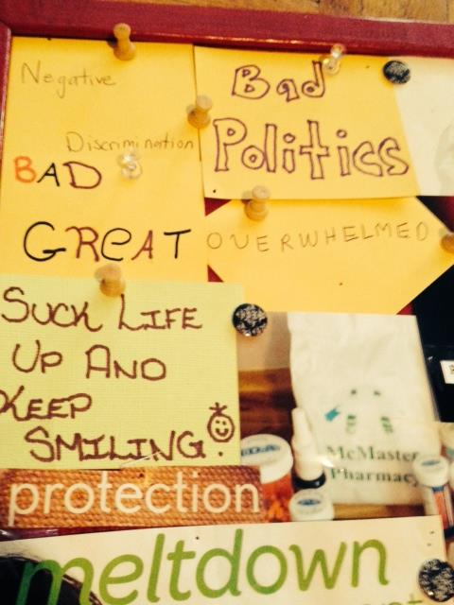
As women shared their reasons for choosing these words, a rich discussion began to emerge encapsulating the largely negative experiences mothers living with HIV are having when attempting to access and navigate health and social services.
A. ‘Re-telling Our Stories’ – Very early on in our first arts-informed story-telling session it became clear that women were troubled by having to re-tell their story to multiple service providers when accessing health/social support. For example, Gina spoke about “having to re-tell her story” at a social service agency that provided HIV-specific supports:
“Many students go in and out of the place… and I find that is a confidentiality breach too because every time I go there, there is another person there and more and more people are finding out my personal information. And it’s like we have to tell our story over again every single time … you know what I mean? And it’s annoying and it, it causes a gap”
For Gina, having to re-tell her story resulted in fears surrounding confidentiality. This concern was echoed by Tori who shared: “We need the old counselors, the ones we had before that know us since we have been there, they have been there for us.” Hence, coupled with fears about too many people knowing their ‘story’ is a desire to have long-term and trusting relationships with service providers.
At the same time, one of the women talked about the normalization of having to constantly disclose her HIV status in order to receive support. As Patricia shared: “It’s uncomfortable but I’m just so used to it, I don’t even think about it anymore,” describing having to re-tell her story as something that was both “uncomfortable” and as something she was “so used to” begins to highlight the complex relationship MLWH have with social service providers. Moreover, it begs to question the ways mothers living with HIV navigate health and social services in a state of continuous and perpetual fear of unwanted disclosure and worries about their confidentiality.
This was highlighted by Gina when she choose to contribute a condom to the collage as a representation of her experience of having to re- tell personal aspects of her story and make “embarrassing requests” to service providers in an attempt to gain necessary resources.
“I brought a condom that I got from [social service agency] and usually … its very anonymous getting condoms but other stuff you ask for ya … it’s kind of embarrassing … I would just rather it be more anonymous and I’ve had to learn to be more open about it … it’s not like I like asking people for stuff”
Gina’s arts-based storytelling process was an experience that resonated deeply for the other women in the group. For example, Kayla stated “you ask one person than another person than another person … and it’s like umm can you leave a message… um can I page someone for you?” illuminating how women are positioned as having to re-tell their story several times when requesting support from service providers.
During our second arts-informed story-telling session, the women shared more stories about their relationships to services and with service providers. Perhaps most compelling was Patricia’s contribution to the collage:
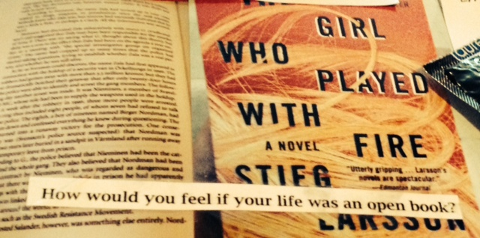
Patricia used this photograph to begin exploring her experiences of having her life be an open-book to so many health care providers’ social service providers.
“How would you feel if your life was an open book? It’s an open-book and a closed-book and interestingly enough it’s the girl who played with fire…”
Throughout our three meetings, women provided more depth and texture to their stories and art, to capture how their experiences as mothers living with HIV are differentiated because of the ways stigma and surveillance become implicated in this process.
B. “Waiting for the referrals, to see if the referrals refer you” - All five women who participated in this study described being referred multiple times to other health care and social service agencies when attempting to seek support around an emerging need for themselves or their children. During our initial arts-informed story-telling session, Anne shared the following word to ground her experiences of health/social service use:
“Overwhelming. I found it overwhelming when I was first diagnosed … you gotta do this, you gotta do that. You’ve got to notify your dentist, your eye doctor about your medication … there is just so much going on … it’s amazing … do this do that … in every week you know. At least when you first get diagnosed it’s a big blur of being at the hospital”
Anne’s story about her overwhelming experiences with health/social services when she was initially diagnosed is particularly important. She begins to contextualize the complex web of service providers’ mothers living with HIV interface with and her concerns were echoed by other women as they reflected on the process of ‘referrals.’
During our first arts-informed story-telling session, Kayla began by reflecting on how she attempts to put supports in place for herself and her son, who is living with a developmental disability:
“They tell me to go out and speak to this person or we’ll make a referral for this and that … and it’s like okay by then it’ll be like I’m broken down somewhere… you know what I mean? Nothing got accomplished”
Kayla shares that while she is attempting to get support, her needs are time sensitive and waiting for multiple referrals to be processed will likely cause her situation to worsen. Moreover, Kayla’s story demonstrates the inability of being able to accomplish anything tangible when interacting with her health/social service supports, which she experiences as problematic. Anne responds to Kayla by articulating that health/social services “are not meeting your needs, they are just giving you referrals.”
Anne share the following image to tell a story about a sense of confusion and powerlessness that characterized her interactions with health/social services immediately following diagnosis:
“I also brought the word ‘meltdown management’ like when I first got diagnosed with HIV … it’s like everything just melted down to just a big confusion and you had to kind of manage it”
Moreover, the idea of ‘melt down management’ was entwined with discussions around ‘service use’, as women specifically discussed the difference in crisis services and support services. Kayla states: “We need someone who understands how our day to day life and is not just there when we are in that crisis mode.” Building upon the idea of readily available crisis supports, but a lack of daily supports for mothers living with HIV, Gina reflects chose to contribute a Band-Aid to the collage as a symbolic representation of service-use.
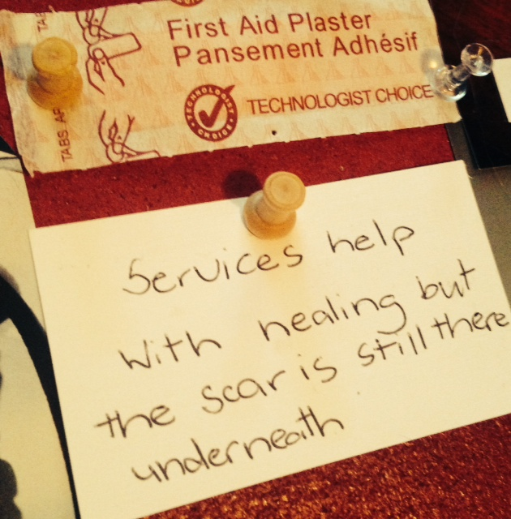
“I brought a band-aid because I just feel like … it’s sorta like okay all the services that we use to cope or you know, that help us keep going, living with HIV is like a band-aid …it’s like it covers up the boo-boo … it covers up the bad and it might help it heal .. but it’s still there when you take the band-aid off”
In many ways, Gina’s story links back to Kayla’s earlier criticism that “nothing getting accomplished” through interactions with service-users. Through using the symbol of a band-aid, Gina sheds light on the ability of services to pacify the complex psychosocial stressors experienced by mothers living with HIV, while simultaneously doing nothing to improve the quality of their daily lives.
As our conversation moved forward, the women who participated in this study began reflecting on the ways they experience powerlessness and a loss of control in their experiences with service providers. The loss of control was deeply connected to the process of referrals and having to re-tell their story multiple times.
C. ‘I’m left in the dark and I’m still waiting’ -Throughout the course of this project, women shared and reflected on instances where navigating health and social services have resulted in a loss of control and personal autonomy over their own life circumstances. During the first arts-informed story-telling session, Anne contributed the following cut out from a magazine to encapsulate her experiences of health and social service use and described it in relation to a loss of control in her relationships with service providers:
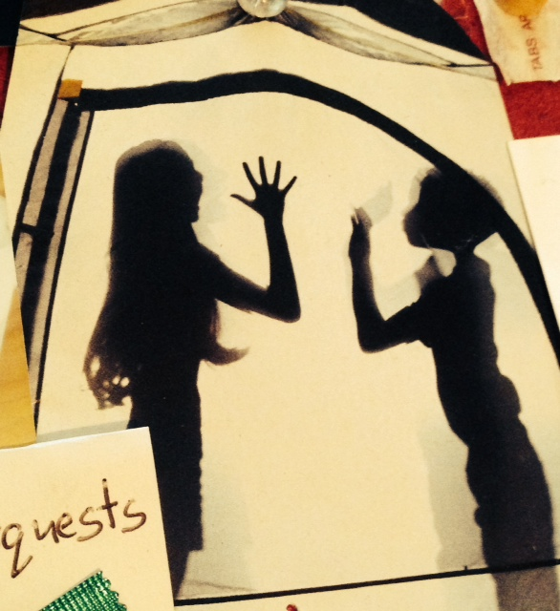
“This is sorta how I feel … like I’m in the dark… there should be like two of me or something… when I first got it they didn’t ask me … they just kinda over-load you with here have a needle, have some blood, pee in this, do this, do that … I feel like a lab-rat”
The sentiment of ‘feeling like a lab-rat’ was echoed by both Gina and Kayla; as Gina stated she ‘says that too’ and Kayla suggested a photo of a lab-rat should be brought in for the collage. The use of the symbolism in this photo represents being in the dark, feeling two people and feeling like a lab rat. This symbolism helps to contextualize the loss of control in interactions with service providers as experienced by Anne.
During our second arts-informed story-telling session, Kayla reflected on how incarceration caused her to lose access to the services and supports she had put in place for herself and her son, who lives with a disability. Kayla explains:
“I was incarcerated, I lost it all, I lost his behavioral therapist … everything. I’m fighting for it all back … ya… so it’s like me doing all the work because professionals and workers and that don’t wanna do anything for me … then they are all on vacation … ya so that’s the way it is … then I have to wait for everyone to get back and by then I’m at my wits end”
While Kayla struggles to manage her own demanding health needs, she subsequently cares for and responds to the complex psychosocial needs of her son, despite receiving little support. Understanding Kayla’s experience requires considering the ways her identity as a MLWH is implicated in the process of caring for her son who has special needs.
On our third day, Kayla shared a poem written by April Vernon, entitled ‘A Special Mom’ that helped articulate her unique experience and struggle as a mother, attempting to negotiate services around her son’s special needs. Kayla shared about how her son’s developmental disability often positions her on the peripheries of service-use subsequently leaving her in the dark about her son’s health and social care.
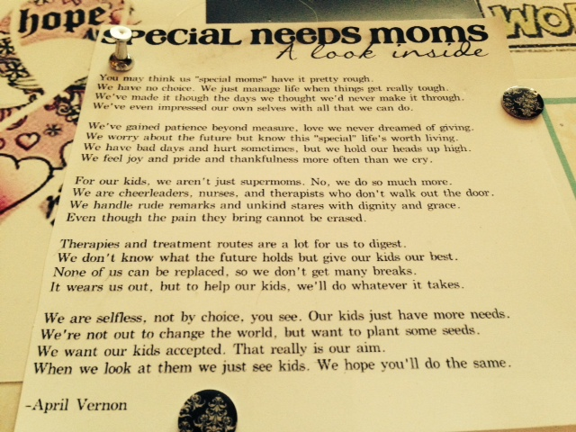
When Kayla read this poem, Anne acknowledged Kayla’s resiliency by sharing “I don’t know how you do it.” Understanding Kayla’s experience as a MLWH, mothering a son with a developmental disability causes her to experience a loss of control in ways intimately connected to her capacities as a mother. Kayla describes tirelessly trying to manage her own health needs and the needs of her child through interacting with a myriad of health and social services.
When I met with Patricia individually, prior to our second arts-informed story-telling session, she shared in many ways, the loss of control and lack of transparency which permeates her relationship with social-service agencies. She uses her experience with the Children’s Aid Society (CAS) as an example:
“They just sent this to me [plan of care] and I got it yesterday and that’s why I’m a little bit livid … like they get you pegged as something and they are just not gonna change their minds about”
In addition to Patricia’s oral story, she contributed a magnifying glass to the collage to symbolically represent the way her life has been examined by this institution.
Patricia’s contribution to the collage is used to represent the ways all aspects of her life, essentially ‘every move’ she makes, is warranted to be investigated by health and social service agencies. Patricia characterizes her experiences with the CAS as both discriminatory and scrutinizing, which further compound the control she has in and over these interactions.
Following our third meeting, I also heard stories about the loss of control that accompanied the ‘left in the dark’ experience. This was demonstrated by Patricia who asked to meet with me to provide the following photographs and stanza as a way of using art to help tell her story about experiencing a loss of control.
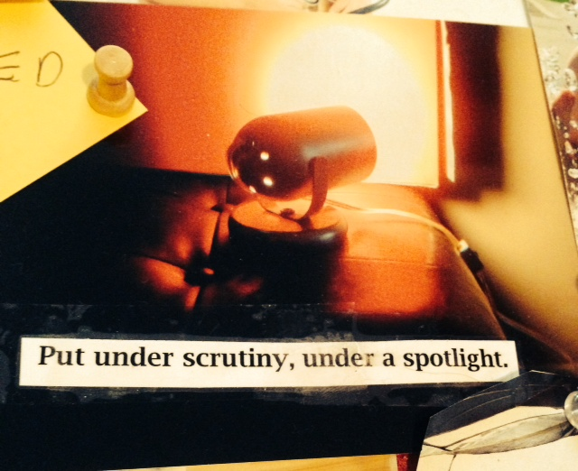
The MLWH who participated in this study spoke in length about their reflections on service use, through using art-informed story telling however, they also spoke about experiences of accessing specific services. While the above subjective themes represent women’s experiences in a range of health and social service sectors, the following section takes a more in-depth look at the significant experiences MLWH have shared about interacting with specific social service agencies.
5.3 Stories Of Service-Use & Experiences with ‘the System’
“Using services is kinda just routine” _{- Patricia}
Over the course of our three meetings, mothers shared arts-informed stories about their subjective experiences of mothering with HIV and experiences of interacting with specific services. Although the mothers identified 36 unique health/social services that they are currently, or have historically accessed for social/health care support their interactions with the criminal ‘justice’ system, children’s aid societies, ODSP/emergency food and housing programs and women-specific and/or HIV-specific services were of particular significance.
A. The Criminal Justice System – During our first arts-informed story telling session, women stories about their experiences with the criminal justice system became a powerful topic of conversation. For example, Kayla shared her story of being criminalized for alleged non-disclosure of her HIV status to sexual partners and described her experiences of being incarcerated and registered as a sex offender:
“My life has been up and down … I just did 16 months incarcerated … for non-disclosure … so it’s like fuck… and now I have to deal with the fact that I’m a registered sex-offender for life … and I lost everything … they literally came and picked me up at Gage Park with my son there … as soon as I got there they threw me in seg because I was on the media … because they didn’t want me in open population so it’s like ya … I must have coloured about 2,000 pictures … there’s nothing you can do … you just sit there by yourself for three weeks”
Kayla’s story helps to crystalize how her identity as an HIV-positive woman put her in a position where she became vilified and subsequently labeled as a ‘sex offender. Kayla’s experience of incarceration and isolation brings forth larger questions of how stigma is embedded and enacted within larger systems and social institutions. Being kept in solitary confinement is an example of how stigma becomes enacted through micro aggressions within institutions.
Tori began exploring the similarities in her story of interacting with the criminal justice system:
“ I was charged with the same stuff you [to Kayla] were … not even five years ago … I spent a month in jail ... I took the probation too … And it wasn’t even true … I told him I was HIV… and we used a condom”
Throughout this discussion, Anne and Gina empathized with Kayla and Tori and yet, because they had never been incarcerated, it was an experience that the women could not completely comprehend. Gina stated: “I can’t imagine … I’ve never been to jail,” others women however, were able to reflect more deeply on the experience of HIV and criminalization as a larger issue impacting all women living with HIV. Anne shared: “It seems like other people who have gotten charged don’t have the same publicity and stuff as you it’s quieter, like they just tried to make an example out of you or something.” Through the empathy and reflection that was portrayed by the MLWH involved, other stories about incarceration began to emerge. For example, Patricia began to share about some of the barriers she faces when incarcerated that prevent her from adhering to anti-retroviral medication:
“I’ve been in jail a few times … and I don’t take my meds when I am in there … I just don’t tell them because, ya, I don’t want it going around … I just tough it out …It just makes it too difficult in there … I’m not sure how I just don’t want to find out … with the guards and everything”
Although Patricia’s charges were not related to her HIV-status, she illuminates the impact of incarceration on her mental and physical health. In an effort to negotiate her safety in this setting, Patricia chose to keep her HIV status private, despite the implications this would have on her medication adherence. This finding is particularly disturbing because non-adherence to medication even for short time periods may have a negative impact on the overall health of People Living With HIV (PLWH) (CATIE, 2013). In response to Patricia’s narrative about incarceration, Anne began to reflect on the struggles of negotiating disclosure in this setting, although she had never faced incarceration: “I can’t imagine … I don’t know what I would do …if I would disclose or not or take my meds or not.”
Stories about criminalization continued to emerge in the second and third meeting in many textured ways. As I met with Patricia in the morning prior to our second meeting, she shared with me a letter that detailed her experiences of stigma inside jail, in relation to her HIV-status.
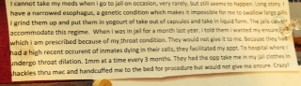
Moreover, a sense of fear was present at the core of Patricia’s story, as she reflected on the perceived stigma and mistreatment she might experience in jail, if her HIV status was known.
With time to reflect on the discussion around ‘criminalization’ after the first meeting, Kayla brought in a DVD entitled Unlocking HIV and asked for it to be photographed and added to the collage during our second meeting. As Kayla shared:
“I did this movie to tell my story … the unlocking HIV project… he had me go to McMaster and speak in front of like sixty-students about criminalization of people with HIV and that, basically I was just like ya they make you feel like a piece of shit actually, they put you all over the media thinking that you’re a fucking sexual predator in life. ”
It was important to Kayla that this be included in the collage because it represented an experience that created space for Kayla to tell her own story from her own perspective. This art-informed story shared by Kayla brought forth shared dialogue about the ways women negotiated their role as mothers as they navigated the criminal justice system. Kayla described how her decision to plead guilty was negotiated as she considered ways in which she could minimize the impact that incarceration would have on her role as a mother:
“It was either take the deal 12 months … 3 years’ probation and registered sex-offender for life or still wait it out for trail… probably woulda been going to trial now so I had to do what was best for my kid … I had to look at both ways.”
Tori echoes Kayla’s decision making process and also chose to plead guilty to her charges of aggravated sexual assault as she explains: “I plead guilty … And it wasn’t even true … I told him I was HIV… and we used a condom… but I only served a month …I had to get out for my kid.” For both Tori and Kayla, pleading guilty was used strategically as a means of moving the process along largely due their roles as mothers in an effort to lessen the impact incarceration would have on their mothering responsibilities
Before our third meeting began, Tori pulled me aside asking if it would be alright if she stepped out an hour early this week to attend a garden opening at her sons elementary school. She started to explain that any parent attending a year end trip required a police check, as she is registered as a sex offender for not disclosing her HIV status she was unable to attend the year end trip. Attending the garden opening at her son’s school was an important opportunity to be involved in her son’s school. This instance, helped to crystalize the many ways that ‘criminalization’ impacts women’s identities as mothers, as mothers who have been criminalized for HIV are excluded from participating in their child’s life in many ways.
Kayla continued to reflect upon the stories she shared during this project related to her experience of being charged with sexual assault as she sent this image via email a few days after our last session. This image provides insight into how Kayla was vilified throughout media-outlets which had a profound impact on her identity as a woman and mother.
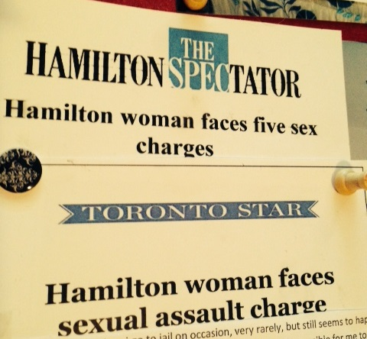
As MLWH explored their experiences of interacting with the criminal justice system, it became apparent that being ‘criminalized’ and subsequently interacting with the criminal justice system had profound impacts on the experience of mothering. Moreover, the stories highlighted by the participants began to shed light on profound instances of institutional stigma that occur in the criminal justice system and in correctional facilities.
B. Children’s Aid Societies: Experiences with the CAS emerged immediately as women wrote a word to reflect their experiences of service-use. Patricia shared the following picture and dialogue related to her experiences of navigating the CAS as an HIV-positive mother.
“I wrote down negative. While I am HIV positive, the experiences are cyclically negative when dealing… not so much the doctors and the health care … there actually pretty good I think at this point but still the Catholic Children’s Aid Societies and those types of institutions are really horrible ... really bad … really discriminatory and awful.”
Understanding the experience that Patricia has had interacting with Children’s Aid Societies clearly emerged as an important story that she would share during the course of this study. However, later on in the meeting, when women were asked if they wished to share any stories about their experiences with social services/health care, Patricia stated:
“I have a really negative story about CCAS but I’m tired today … and it’s just … could I tell it next week? I mean … I could tell it now but it’ll take like 5 or 10 minutes and I’m not in the mood to get into it right now but like I’ll tell it next time… it’s just horrible … really, really bad.”
This began to exemplify the emotional energies involved for Patricia when recounting her experiences with the CAS. Contrary to Patricia’s negative experience, Kayla responded by saying the children’s aid societies are actually one of the few agencies she finds supportive.
“My CAS worker is awesome … actually she’s really good … actually CAS I have no problem with. They have been there for me the whole time I’m open with them and they have never judged me on anything. The worker I have now, she’s amazing, I could call her and talk to her about anything … and tell her anything … It’s been good to have a good bond with her … everyone else though … fuck em’.”
Kayla’s story about the CAS describes this institution as being a non-judgmental, supportive entity in her life. This is very much in contrast with existing literature that focuses on experiences of stigma for HIV positive mothers interacting with child protection services (Greene et al, 2010, Greene et al, 2014; Kennedy et al, 2014; O’Brien-Teengs, et al; 2012). In many ways, throughout this project Kayla’s story provides insight into the positive and supportive role that the CAS has the potential to play in the lives of mothers living with HIV when individual workers choose to act in ways that are kind, supportive and free from stigma.
I met with Patricia in the morning individually prior to our second meeting, she had to send her regrets for the meeting because of child care arrangements but called me that morning to see if I would be willing come to her home to get a written story she had prepared and art she wished to contribute to the collage. It became clear to me that in some way this study was important to her as she wanted to still be able to contribute and share her story, even if she was not able to attend.
Patricia had typed up her story to contribute to the project; she documented and told her story of interacting with a range of service providers. Patricia writes:
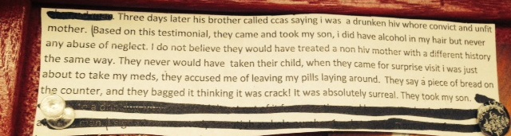
When I met with Patricia that day, she spoke at-length about her experiences with child protective services. As she shared individual instances and a larger story, her experiences were overwhelmed by a profound sense of stigmatization and discrimination. Throughout her interactions with the CAS, Patricia’s HIV-status became uniquely implicated and her ‘health’ became a central focus in the child welfare investigation. Patricia shared about some of the ways she had been treated by the CAS:
“They don’t even want me to have custody … they still think even though I’m kinda non-progressive they still don’t want me to have custody of him in the event of [current care-givers] demise because they think my health would still be an issue … I haven’t proven enough to them to have custody of my son?”
Patricia’s experience demonstrates a lack of knowledge by child welfare workers who continue to involve her health status into her ability to mother; despite HIV being a manageable chronic illness. Throughout Patricia’s story of interacting with the CAS, it became explicit that her identity as a woman living with HIV, was becoming central to arguments about her incapacity to mother. While stigma manifests itself in many interactions that mothers living with HIV have, Patricia’s story highlights how a lack of knowledge on behalf of service providers can have devastating consequences on the lives of mothers living with HIV. Patricia contributed the following excerpt to the collage, in an effort to use the arts to tell her story of interacting with the CAS:
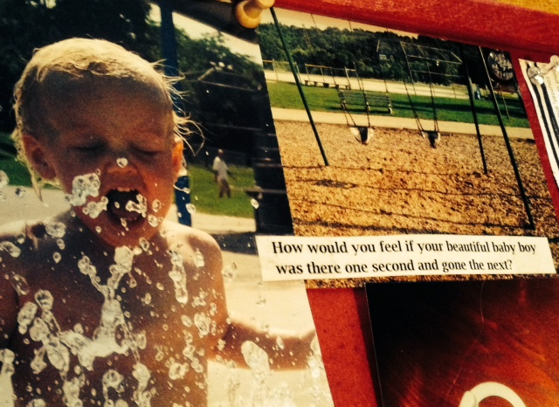
During our second arts-informed story-telling session; women were discussing the multiple ways in which they navigate and coordinate social/health care services for themselves and their children. Kayla began exploring the profound institutional power of the CAS, and the important advocacy role CAS workers can play by supporting mothers to acquire resources and services to support themselves and their children:
“It’s pretty unfortunate that I have to like get my CAS worker to call these people to advocate for me and when my CAS worker calls she obviously gets through and it gets done … I call it’s like I’m leaving 3 or 4 messages and things don’t get done so it’s pretty sad when you have to go out and get someone else to be advocating for you … like just get back to the parent we already have enough struggling … like with our health and everything like that.”
Kayla and Patricia’s stories of service-use are vastly different. Future investigation is needed to understand what categorizes workers as allies, to lessen stigmatizing and discriminatory experience of service-use for mothers living with HIV. While Tori did not speak directly about her experiences with the CAS, she seemed to demonstrate an understanding of how ‘the system’ works, by stating “it is very difficult to switch workers.” Anne shared some reflections on Kayla’s tireless advocacy for her son living with a developmental disability by sharing:
“Ya it’s amazing what that maternal instinct will do … it will take over and you will keep going because you can’t stop because you’ve got a kid …It’s a strong motivation.”
As mothers grappled with the profound impact that the CAS has had on their lives, it was apparent that mothering was central to their lives and an important aspect of their identities. Patricia grappled with how her HIV-status has been misconstrued by child welfare agencies in an effort to position mothers living with HIV as ‘physically and mentally unwell’ while Kayla reflected on the profound positive impact the CAS has had on her experience of mothering.
C. Social Welfare Programs: ODSP, Social Housing & Emergency Food Banks - All of the women who participated in this project relied on the Ontario Disability Support Program (ODSP) for financial assistance. As a result of the current ODSP rates not being congruent with a ‘living wage’, (Ontario Collation Against Poverty, 2014) mothers provided a caveat into the ways they used food banks and subsidized housing to meet the basic needs of themselves and their children. The stories that emerged helped to show how their identities and roles as mothers living with HIV shaped their experiences of poverty.
When invited to share stories and experiences about social services, Kayla spoke in length about her challenges of living on ODSP in relation to her mothering responsibilities. Obstacles put in place by this bureaucratic structure hinder Kayla’s ability to adequately meet the unique needs of her son, whose life is profoundly impacted by his developmental delay.
“ODSP is a joke! Don’t even get me started there. My son is special needs and I am fighting with them to get him glasses. And they won’t provide him with the special frames that he needs … he has had glasses for nine or ten years and been through oh I don’t know 250 pairs? Cause he’s special needs … Well they look at the fact that ‘oh well we are just gonna cover the cheap lenses and frames’ well they break”
At the core of Kayla’s story, is a narrative around the experience of ‘loss of control’ as a mother, which becomes a further complicated and multilayered experience for mothers who are living in poverty and with HIV. Kayla’s experience of a loss of control in her mothering role is experienced simultaneously with other loses of power she experiences that result from her HIV-status, such as a loss of control over her own body, her well-being and her privacy (CATIE, 2013). In contrast to Kayla’s story, Patricia painted her experiences with ODSP as largely supportive:
“They approved it for me [a bus pass]… I still get the food allowance too … and the RDSP you put in $1500 a year and they match it and in ten years you can get the money”
It became visible through our first arts-informed story-telling session that women were receiving and experiencing service-use in different ways, depending on their individual ‘worker.’
Throughout our second arts-informed discussion, it became evident that the use of food banks was a central way that the women provided for themselves and their children given the limited income allotted by ODSP. Tori contributed a photograph of their ‘food bank card’ as it represented a symbol of something that helped to simplify service use, by creating a more accessible and subsequently less stigmatizing process.
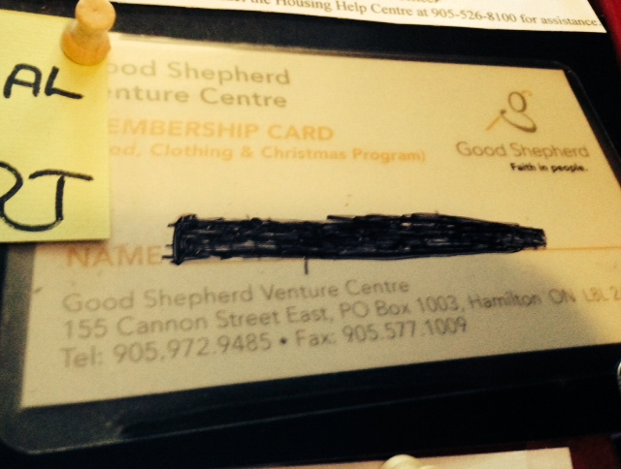
Tori: “See this is the card … see how there is a color in there … there’s a colored sticker and when you go in the shopping area … it’s like a store … it has posts on each thing and it tells you how much you can take based on the size of your family… they do it right on the spot”
Gina: “This is a better process cause before you had to bring your income statement from ODSP, your income statements and proof of your family members, your rent receipt”
Kayla: “You don’t have to wait in a little tiny back room every month”
At this point in our conversation, Gina began exploring her experiences of negotiating HIV disclosure when navigating ‘food banks’ as a means of receiving higher quality food. Her story helped to deepen the original analysis of ‘accessibility’ when obtaining food, and highlighted how HIV differentiates her experiences:
“Listen I know everybody wouldn’t necessarily do this … but I’m open … when I sign up for my food and they ask me ‘do you want frozen meat?’ I’m like ‘is it expired? … because I have HIV and I don’t want to get sick and I know you think best before doesn’t mean it’s not good … but for me it’s not good”
It is vital to remain to explore how Gina’s decision to disclose her HIV status in this setting was used as a means of providing higher quality food for herself and her family.
At the end of our last meeting, Kayla shared she would be going to the subsidized housing office to drop off paper work confirming her homeless status, Kayla discussed the importance of navigating housing services as a step in obtaining permanent housing:
“I am handing in housing forms after this and it’s like now everybody can just be more stressed out because like I had to break it to my parents that I’m leaving … cause they’re not supportive”
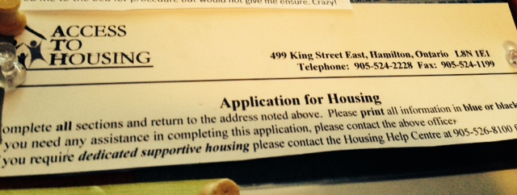
While Kayla faces obstacles in obtaining affordable and safe housing for herself and her son, she tells a larger story about how a lack of housing directly impacts her ability to mother. Kayla began sharing a story about people’s perceptions regarding her incapacities for motherhood because of her inadequate housing situation:
“Unfortunately due to the living situation he’s [son] always in my room … it’s not a living situation where he can feel free and feel comfortable to run amuck … and the computer and the games keep him content … and they’re not with me 24/7 who are they to tell me I’m a fucking piece of shit mother?”
Through Kayla’s narrative and sharing of this image, it became paramount just how important accessible, affordable and safe housing is. Mothers living with HIV in Southern Ontario face increased rates and risks of homelessness (Greene et al, 2010). Access to housing is vital in supporting mothers living with HIV in maintaining their physical and mental health as well as important in optimizing their ability to mother.
Throughout our third meeting, art and conversation tended to move past our discussion of social welfare services such as ODSP, housing and emergency food services. However, it was particularly interesting how women’s involvement with ‘the system’ still became implicated within our process. During our third arts-informed story-telling session, Gina took an important phone call and stepped out of the room for some time. When she returned she shared:
“Sorry I left … it’s just my ODSP called and said I might get canceled because I did not submit my pay stubs for working election day … but I haven’t even got them yet … like they come in the mail four weeks after … so I just had to sort it out but I left messages I just talked to … I have an employment counselor through ODSP because I did a Work Bound program through another agency … so I just called her because she’s the one who reports to them that I’m working … so she’s going to call my worker … so that’s good but it’s just like I shouldn’t have to go through this …”
Gina receiving this phone call during our research process crystalized the very processes women had spent the past three meetings describing in a very real and tangible way. As Gina had to step out of the room to take this call and subsequently place many more phone calls to ensure she would receive her monthly cheque, her frustrations with navigating the system were apparent and were largely echoed by the other women.
Kayla: “See this is exactly what I mean … you don’t need this stress”
Anne: “But you know the problem is you are the one who is being honest about working … you’re being up front so why would they go after you”
Gina’s story explains the complicated process she went through in an effort to work out this discrepancy with ODSP. However, Kayla and Anne empathize with the stress and frustration caused by having a powerful structure like ODSP, “go after you.” This instance helped to illustrate the realities of the lives of mothers living with HIV who interface with multiple service providers in real time.
As the women who participated in this study shared stories of their experiences of interacting with social welfare programs, many ways that MLWH experience and respond to poverty and social deprivation were highlighted. Perhaps most significant to these stories were the ways in which MLWH navigated disclosure in these settings and regarded it as a way to enhance their access to resources.
D. Women-specific Services - Each time we met, women spoke about the important roles that grass-roots, feminist organizations have played, and continue to play in their lives. For the women who told stories and discussed their experiences of accessing women-specific services, it became evident that these instances of service-use were perceived in ways that were beneficial to the women involved. Gina spoke about accessing support groups through a local Women’s Centre and the process of negotiating disclosure in this space. While Gina acknowledged that although her HIV does not define her, it is an important aspect of her lived experience which prompted her decisions around disclosure:
“I’ve met other women … umm it’s not … there not living with HIV but that doesn’t matter to me … like I mean … HIV doesn’t define who I am … I was open with them about my situation and they were accepting”
At the same time, Gina was still was met with the task of negotiating disclosure or risk not telling her ‘whole story.’ Similarly, Patricia spoke about the motive behind accessing women-specific groups at a local Women’s Centre:
“Ya I’ve done a few similar groups at a Women’s Centre so I do, do the groups but not just specifically to deal with HIV … more to make a well-rounded life so to speak.”
Patricia links the importance of taking care of herself in holistic ways as the motivating factor for her decision to seek support from women-specific services and this was echoed by the other women in the group.
As our conversation moved forward, women continued to reflect on the importance of women-specific services and spaces. During our second arts-informed story-telling session it became apparent that women perceived the lack of women-specific, HIV related supports as problematic. Four out of the five women accessed Mary’s Tea Party, the only peer-led, women’s only support for HIV in their area. Women reflected on the benefit of this service and subsequently the need for more women-specific HIV supports. While they acknowledged that the local ASO was attempting to put more opportunities for women-specific programming in place, Gina noted that the turn out for these groups were not successful:
“And everything that they have had that is women-based … because they are trying so hard to reach out to women living with HIV … everything that they have had that is women’s-based I find no one shows up … like a lot of the times I’m the only one that shows up …”
Interestingly enough, despite a shared sense amongst the women that participated in this study on the need for more women-specific supports, Gina discusses the tremendously low turnout at women-specific events. Building upon Gina’s reflections on the lack of services specific for supporting women and mothers living with HIV, Anne begins to share some of her thoughts and reflections:
“It seems like we don’t get to voice our opinions often enough … like the other women who was here [Patricia] she didn’t know about the Tea party so maybe we can do more networking … share information just like this by people getting together …”
Throughout Anne’s story is a sense of wanting to ensure women living with HIV are aware of the services available that might be beneficial to them. Anne’s consideration and reflection on the ‘Tea Party’ demonstrates the importance of creating both women-specific and peer-focused supports for mothers living with HIV.
During our third arts-informed story-telling session, Gina contributed a picture of a disco ball to the collage; she explained the significance of this symbol as something that was given to her during a women’s group, with the intention of reminding her of her beauty and inherent resiliency:
“And then I brought this picture of a disco ball … that I got this disco ball from a women’s group I did at the women’s centre and it is a symbol to remind me … when I feel down about myself that I am beautiful like that disco ball”
Gina shared she regularly accessed this sort of service, and found her experiences to be beneficial. Throughout our time together, the women who participated spoke about their experiences with women-specific services in different ways, often highlighting the beneficial aspects of these services instead of the stigmatizing actions.
Women described experiences with women-specific agencies as non-stigmatizing and supportive while also reflecting on the value of having spaces to connect with other women. As women began discussing what they wanted from the health and social services they accessed, it became evident that more opportunities to connect with women in informal and supportive ways were perceived as an important aspect of health and social service use.
5.4 What Women Want from Health and Social Services - “I want someone to connect with” – Gina
We began our final arts-informed story-telling session in similar to ways to our initial meeting, as I asked women to write down in one word, or a short stanza, what they wanted from health and social services. Women articulated the need for the following aspects of service-use:
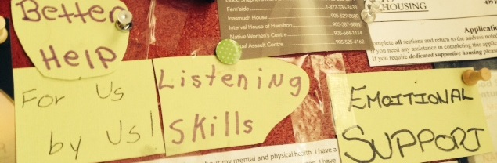
Our conversation around ‘action’ was rooted in unearthing the knowledge necessary to improve the service-use experiences for mothers living with HIV. Women continued to reflect upon their desires of; holistic emotional support including an improvement in listening, understanding and tangible help provided by service providers while enhancing opportunity for peer-based models of support.
A. Peer-Lead & Drop-In Supports - During our initial arts-informed story telling when women first began to grapple with telling a story about their experiences of service-use, Anne brought forth the important role that ‘Mary’s Tea Party’ plays for women living with HIV in her community:
“You see we got lucky because we got Mary’s Tea Party to help … that’s it. And the
woman who runs it, she’s HIV positive so she understands.”
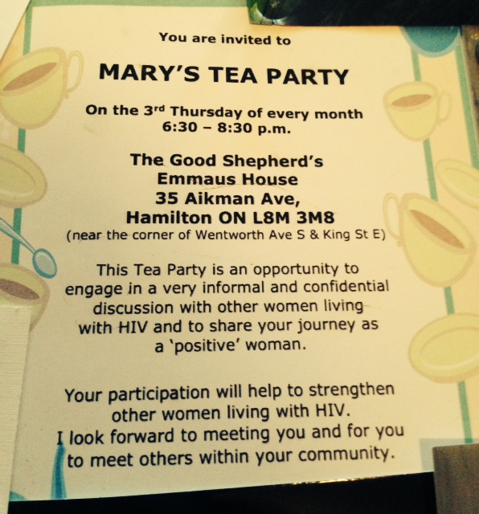
This monthly tea-party serves as an informal drop-in peer support program in Hamilton for women living with HIV, and it emerged as an important part of ‘service-use’ for four out of the five women in the study. Patricia was unaware that this drop-in program was available; however Anne invited her to come by sharing the location and time of the next gathering with her. While Gina conceptualized Mary’s Tea Party as “the only thing going for women living with HIV in the city”, Tori articulates the ability to “go there and say something or say nothing … and you just sit there and hang… do crafts” as something that seems particularly helpful and supportive.
Gina began conceptualizing the importance of peer support while troubling the inherent power imbalances that exist to create barriers in formal hiring processes that disqualify many persons with lived experience:
“I wish you could go in there and say look at me I’ve been through this and I’m standing here and I’m confident, I’m well put together and I might not have the education … but I’ve been through all these things and I am the best candidate for the position”
Throughout Gina’s story, it was evident she was an avid volunteer and activist within her community, yet because she did not have ‘formal education’ her knowledge as a peer was not valued. Kayla echoed Gina’s sentiments about formal employment, “exactly … not cause you got a degree or did all this education … well said there” while Anne articulated the need for “some life experience … if you go to certain types of jobs.” The lack of peer support emerged as an area of contention for women throughout the study, however as our conversation emerged they began to envision models of informal, peer support.
On our second day, Kayla brought the imagery ‘live, laugh, love’ to help tell her experiences of service-use, and when asked the significance of this she simply stated:
“You live life to the fullest, you laugh your ass off when you can and
you love yourself for who you are.”
As our conversation continued on, it became evident that Kayla wanted services that resonated with her philosophies of living a full life, having fun and accepting herself. Kayla spoke about needing a space to connect with other MLWH while problematizing having to rely on the ‘same’ workers:
“It’s good to be with people who are going through the same crap that you are in life … you don’t have to talk to the same worker who you talk to all the time when they don’t do nothing for ya … it’s good to just relate to your peers once in a while.”
When reflecting on Kayla’s needs to connect with peers, Anne deepened the idea of what women want, by incorporating a holistic focus on wellness, by drawing on the knowledge of peers within the community:
“I’m learning Tai –Chi’s… like there all sorts of things that you can teach to other people … they are all things that help with the mind-body connection and stuff.”
Moreover, Anne included the following quote to represent what she wanted from social service providers, whether or not they have similar aspects to their identity as their service-uses.
As Tori, Kayla and Gina all wrote this quote out after Anne shared it with the group; it was evident that the other women resonated with Anne’s arts-informed story.
On our last arts-informed story-telling session, women spent time discussing peer support models in compelling ways directly related to action-orientated processes. Anne raised the question: “It’s too bad we couldn’t set up our own network … like get [peers name] to run it … how could we do it though?” Immediately, conversation emerged that was charged with an excitement and curiosity about how this might be possible. Gina echoed Anne by stating “I agree … so many people have said this to me before too.” Kayla began from a logical positioning, discussing how “we would need funding” and the potential of seeking “government grants.” This helped to move the conversation forward into logistics, Gina discussed the “need [for] a business proposal” while Anne considered another research project she had been a part of and wondered the potential of collaborating to put together a tangible peer-driven support for women living with HIV:
“It was research for peer mentorship, I wonder if you could kinda combine … kinda work with those people …somehow if they give us the info or tell us where to look online”
Women’s for action will be visited in more depth as I move into discussing the implications of this research. The analysis of the data showed in profoundly critical ways how women were incorporating ‘action-orientated’ thought as the root of this research project by way of blending emotional and logical dialogue and processes focused on changing the way they experience and interact with health and social services.
B. Mother-Centred -Women’s identities as ‘mothers’ remained fundamental as our dialogue emerged. Women articulated their own arts-informed stories, and shared the stories of their children in profoundly critical and reflective ways. Throughout our first day, women shared stories about how they experience barriers in accessing health care/social services when they do not have reliable and affordable childcare. Gina troubles this issue by asking:
“Sometimes they offer ‘child care costs’ but the point is what if you have no one who can watch them? Then you can’t go … they don’t have anyone to watch the kids if we need to bring them with us”
While Tori echoed this sentiment by stating “that’s why a lot of people with kids can’t go now” when referring to an HIV-specific social support. Anne further questioned this by arguing how the hours of service delivery exclude mothers who have childcare responsibilities:
“And like mothers … most of them can’t go til after the kids go to school which is like 9 o’clock then were free but by the time you get there at noon it’s like oh I gotta go home … kids coming home … it’s not very client-orientated”
Patricia tells two stories throughout our time together; one about her own experiences of service-use to promote a “well-rounded life” for herself, and another about her experiences of enrolling her son in extra-curricular stating: “I take him to his camp, lessons, his sports stuff he’s involved in a lot of things.” Perhaps most compelling is the absence of a narrative around joint-service use, where women and their children can access supports and programs together, to improve their overall quality of life.
During our second arts-informed story-telling meeting, Tori brought in a photograph of her and her son at a dance for families that was hosted by a social service agency she accessed, sharing:
“It was good one on one time with my son … I don’t get to have much one on one time with them … he’s getting older so he doesn’t like to do a lot of stuff with mommy anymore so we got to actually do something …”
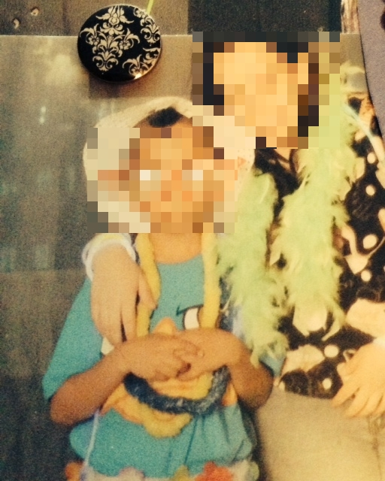
While Gina also brought a photograph from this same dance, she attributed her positive experience to the opportunities for leadership and input by ‘service-users’ when planning and hosting the dance. Understanding the influential role that peers played in planning this dance may attribute the importance of making this event a space where persons had the opportunity to include their children in accessing this event.
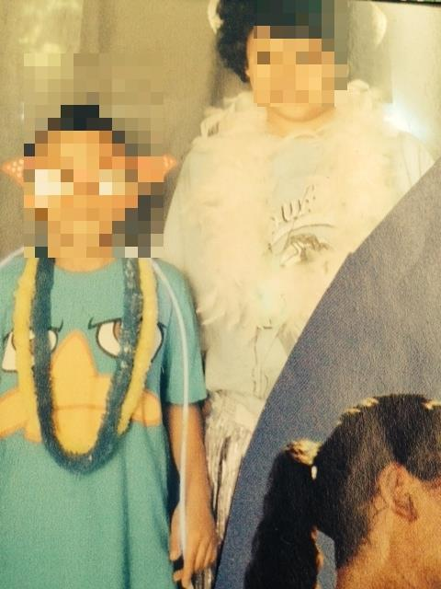
On our final day, Anne brought a powerful image to depict what she described as the “peaceful struggle” of motherhood:
“It’s like your climbing with the kids … it’s like you’re struggling but then it’s peaceful … you know? I want them [the images] to go on together …like sometimes you’re struggling and even though you are struggling it’s just kinda like a peaceful struggle … like sometimes with the kids its wonderful and peaceful and then there’s all the crap that kids cause.”

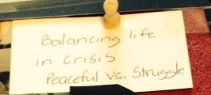
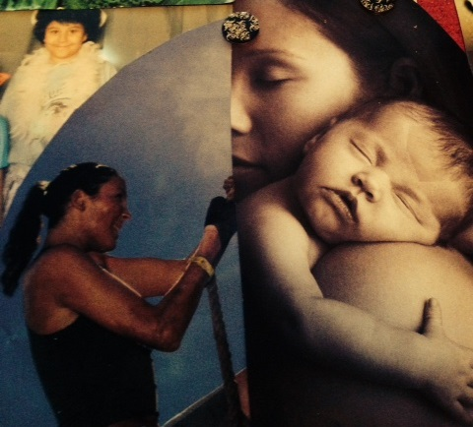
Anne’s contribution to the collage in many ways helped to honor and acknowledge the difficulties inherent in mothering, which prompted Gina to consider how HIV complicates the experience of being a ‘mother:’
“They [service providers] should recognize is that life is difficult enough as a mother living without HIV … imagine that added stress on us … especially when it comes to having them understand why sometimes your sick and sometimes your sad … so it would be helpful if they could understand that we might need a bit of an extra helping hand when it comes to being a parent”
Gina articulates the need for service providers to acknowledge the ways living with HIV may impact the maternal role, and respond by offering an ‘extra heling hand’ from a place of both compassion and knowledge. Kayla built upon the idea of HIV differentiating the maternal role by asking service providers to recognize that: “As a parent we already have enough struggling … like with our health and everything like that … and with my son it takes a lot of patience.”
Anne’s image about this ‘peaceful struggle’ brought forth genuine dialogue amongst the women focusing on the unique struggles of mothering and living with HIV and how service providers may be better equip to provide ‘mother-centered’ supports.
As our dialogue moved forward on our final day to action-orientated processes, Anne continued troubling why social service agencies are not prioritizing childcare as a part of a larger effort to prevent barriers in service-use for women:
“And they have the space to do child care … like they could be doing it very easily …
like if they wanted to do it, if it was important to them … it’d be done.”
Anne raises important questions about health/social services systematic barriers that continue to marginalize mothers that face multiple layers of oppression. Moreover, Gina shared “I even offered to do child minding for some events … so people could actually go and they said it’s a liability.” Tori began troubling the bureaucratic processes at play in health / social service systems by questioning:
“I can’t see it being a liability though I’ve been to place and seen places do it and it’s like they have insurance for people to be there … whatever age and the kids are in one room and parents are in the next room.”
Anne reflected on Tori’s logical argument and replied with: “It’s just a bunch of … they don’t wanna do it.” There was an overwhelming shared sense by the women in this study, that accommodating mothers is not something that is viewed as a priority by service-providers. As women reflected on transformative change they shared a need for accessible childcare, programs and supports that involve children and a need for service-providers to acknowledge the unique challenges experienced by HIV positive mothers.
C. Greater & More Meaningful Involvement - The principle of ‘greater and more meaningful involvement of persons living with HIV/AIDS’ as defined by the United Nations (2004) is a ‘principle that aims to realize the rights and responsibilities of people living with HIV, including their right to self-determination and participation in decision-making processes that affect their lives’ (p. 1). As women articulated what they wanted from health and social services, it was apparent they shared a sense for greater and more meaningful involvement in the health and social services that support them. On the second day, Gina contributed a picture of a camp cabin to the collage and shared the following story:
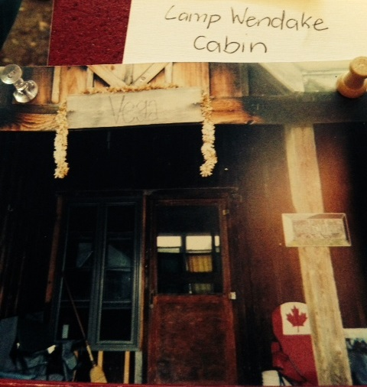
“This is a picture of the Cabin I stayed in… it’s on Lake Huron … it’s beautiful but it’s hard… it is a camp for people living with HIV and the positive leadership training … so these are all agencies from Ontario and I heard a lot of great things happening.”
Gina shared a bit about her experiences at Camp Wendake and described this experience as transformational for her personal growth as well as her ability to act as an advocate for other MLWH. While Anne reflected on Gina’s experience of accessing leadership she stated there was a need for more opportunities for “women to voice their opinions” on the health and social service systems that they utilize. Gina replied to this by sharing her insight on the shallow ways agencies are attempting to engage service users:
“When you say that to them.. they will say well you know … we have quarterly meetings for you to come to so you can voice your opinions well what if that is not the way I want to do that? What if I don’t feel comfortable with that?”
Patricia brought forth a picture of a survey from Catholic Children’s Aid Society (CCAS) that asked her input on the services she had received. When Patricia articulated the meaning behind this image she stated:
“They sent me this and it’s just like really? It’s a survey asking if I am satisfied or unsatisfied … like tick the box. How much do they really care of what I thought? Like really?”

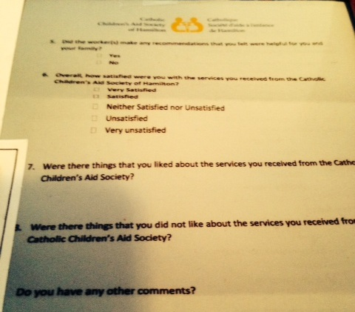
While Patricia alludes to the ways the CCAS tokenized her input on service-delivery by sending a trivial survey, she links this to institutions, such as the CCAS, not truly caring about the perceptions of service-users.
On our final day, as we began to move our conversation forward towards considering the larger social change needed in health care and social service delivery, Kayla echoed the women’s earlier sentiments about the importance of a support group for women living with HIV:
“I wish that like when we had support groups that the social worker who was involved in it would just sit there and shut up and let us talk… We need more groups like this where you can express yourself, vent, feel comfortable and shit”
As Kayla once again reflected on the importance of a group where women felt there was space to feel comfortable and have open dialogue, Tori shared: “We need to be involved.”
As the women concluded our final arts-informed story-telling there was an overwhelming sense that women wanted to be directly and meaningfully included in planning and implementing the health care and social services they access. While Patricia’s arts-informed story using the survey represents a shallow instance of service-user involvement, Gina’s story told through the imagery of the cabin reflects an instance where she had been involved in positive leadership training, which leads to capacity building. Hence, women agreed on a need for greater and more meaningful involvement as well as opportunities for capacity building, leadership.
Throughout the course of this project, women used arts-informed story-telling to capture their subjective experiences with health and social services. The stories shared by the MLWH in this study highlighted some of the unique ways that women find themselves interact with and navigating the criminal justice system, CAS, social welfare and women-specific services. Moreover, the action-orientated focus of this study brought forth several recommendations that MLWH felt could improve the health and social services they utilize. The final collage represents the collective experiences of five MLWH living in Southeastern Ontario as they attempt to navigate multiple health and social services:
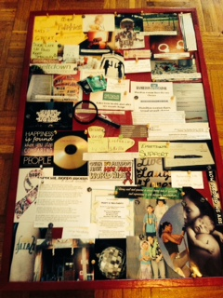

CHAPTER SIX: Discussion
The findings from this study highlight the experiences of mothers living with HIV as they attempt to navigate multiple health and social services. Earlier studies have shown that mothers living with HIV interface with multiple health and social service providers including but not limited to an abundance of health care providers, the criminal justice system, ODSP, child welfare, housing and HIV-specific supports. Mothers who participated in this study shared experiences of interacting with 36 different health and social services, which further highlights MLWH extensive involvement with social services/service providers. What emerged most prominently in this study were women’s experiences of HIV-related stigma and discrimination, a lack of control as experienced through service-use, negotiating confidentiality and disclosure in these interactions and suggestions for what women want from health and social services. What follows is a discussion of the inadequacies of the ‘system’ and the potential ways social services can be transformed to better respond to the needs of MLWH as identified by the women who participated in this study.
6.1 Strengths and Limitations of the Research
This project had many unique strengths and limitations because of the methodological framework and area of inquiry. The stringent timeframe allotted when completing research for a graduate level thesis impacted my ability to fully incorporate ‘participatory and action orientated’ principles throughout project. More time would have allowed for deeper analysis and consideration of the ‘action-orientated’ processes within the manuscript.
A strength of this study was the arts-based approach to inquiry as it facilitated a process whereby women engaged in telling stories about service use, while adopting an active role in the production of knowledge. This was a key aspect of the project as the collage resulted in the development of a tool that could lead to ‘action’ vis-à-vis dissemination efforts. Moreover, the fluid and non-restrictive tenants of arts-based methodologies prompted women to contribute additional art and reflection that emerged after our scheduled time together had concluded.
Although the sample size of five mothers living with HIV from Southeastern Ontario is relatively small compared to other studies, the size of the group resulted in an intimate and safe group setting that was complimentary to the relationship-building processes and arts-informed story-telling method. While this research project does not seek to generalize the experiences of MLWH in relation to service use, it contributes to the existing literature by further understanding the phenomenon of service use for MLWH from a subjective and creative lens.
6.2 Health and Social Service Use for Mothers Living with HIV
In accordance with existing scholarship (Cain & Todd, 2009; Kuppart et al, 2009; Webel et al, 2013) this study suggests that mothers living with HIV are indeed interfacing with a variety of health care and social service agencies in South Eastern Ontario. More specifically, the findings of this study begin to highlight the experiences that mothers living with HIV have had within their interactions with social services and with the service providers whom they interact with. Through arts-informed story-telling, women articulated the ways their identities as mothers living with HIV becomes unnecessarily implicated when seeking social support or interfacing with social services. Perhaps the most salient findings from this study emerged from the unique ways that MLWH described the ways ‘the system’ had failed them and the solutions they provided in an effort to address these concerns.
Earlier studies suggest that as the HIV epidemic continues to shift and evolve there are a greater number of PLWH living in poverty, experiencing unemployment, searching for affordable housing, coping with mental health challenges and navigating the criminal justice system (Cain & Todd, 2009; Merthiew & Davis-Satterla, 2000). Hence, HIV becomes one of the many complex issues present in the lives of PLWH who interface with the social service system. For mothers living with HIV, this becomes further complicated due to the complex internal processes that occur from presenting oneself as a “person in need” when depending upon social services (Watkins-Hayes, 2013, p. 85).
Mothers living with HIV experience several economic and social disadvantages and this study begins to highlight the ways the politics of intersectional stigma (Berger, 2004; Watkins-Hayes, 2013) infiltrate these interactions and shape their experiences when interacting with ‘the system.’ Women in this study articulated how their intersecting identities, HIV status and mothering roles have impacted their experiences of service-use and in addition considered how their unique psychosocial needs and the needs of their children are not reflected in available social/health care services.
6.3 HIV Related Stigma and Discrimination
A breadth of literature exists that speaks specifically to instances of stigma experienced by PLWH when interacting with a myriad of health and social services (Mill et al, 2010; Reidpath & Chan, 2005), however very few studies consider the implications of motherhood on these experiences. Individuals already marginalized in society who develop a stigmatizing condition such as HIV infection, are positioned as at risk for experiencing a layering or double burden of stigma (Duffy, 2005; Mill et al., 2009; Reidpath & Chan, 2005). The mothers who participated in this study experienced marginalization based on an array of intersecting identities including gender, race, culture, socio-economic status and HIV status. Moreover, their roles as mothers uniquely positioned them as ‘service-users’ because of the complex ways their HIV status, multiple other identities and mothering responsibilities intersect and influence experiences of criminalization, child welfare involvement, social welfare dependency and unique psychosocial challenges.
Echoing Greene et al (2014), in the context of the criminalization of HIV, mothers find themselves in a unique position as they come under the surveillance of the criminal justice system. The women in this study shared profound instances of stigma and described how vilifying processes were enacted vis-à-vis media outlets and interactions within correctional facilities. Kayla’s compelling contribution of newspaper headlines to the collage which documents her criminal trial in a local newspaper begins to highlight how her experience became a public affair and was sensationalized largely due to her identity as an HIV-positive woman (Duffy, 2005; Mill et al, 2010). For some mothers, HIV- related stigma within correctional facilities caused them to not disclose their status which resulted in women struggling with adhering to their medication regimes. This was a compelling finding because non-adherence to medication regimes has detrimental impacts to the overall well-being of MLWH (CATIE, 2013).
Mill et al (2010) would conceptualize the stories shared by women within this study regarding the criminal justice system as representative ways ‘stigmatization is used as an institutional and social control mechanism which contributes to further marginalizing PLWH.’ Kayla describes the paradoxical experience of being held in solitary confinement for three weeks as the correctional institutions means of ‘keeping one safe’ and ‘away from HIV-related bullying’. This finding represents a profound lack of institutional knowledge on how to effectively care for and meet the psychosocial needs for someone living with HIV while incarcerated.
HIV-related stigma and discrimination also emerged as a powerful theme within the context of mothers experiences with Children’s Aid Societies (CAS) and child welfare workers; this is a trend that continues to be echoed in a small body of existing literature (Greene et al, 2014; Kennedy et al, 2014; O’Brien-Teengs et al, 2012). Patricia brought the riveting photograph of her son and an empty swing set to show how interactions with CAS have altered her life as a ‘mother’ by taking her son away from her. She used this photograph to share a story about the ways the CAS has implicated her HIV-status into their investigations around child welfare and subsequently developed ‘concerns’ about the ways her physical health would impact her capacity for motherhood.
Considering the ways HIV has evolved into manageable lifelong condition, its impact on overall physical health and day-to-day well-being can be minimal with proper health care patterns (CATIE, 2013; Kennedy et al, 2014). Despite this, HIV remains highly stigmatized even by service providers which can cause adverse experiences for MLWH who interact with ‘the system’ (Ion et al, 2014; Kennedy et al, 2014; Merthiew & Davis-Satterla, 2000). The findings from this study provide further evidence to suggest women’s HIV status is becoming unnecessarily implicated in investigations around child welfare for MLWH in Southeastern Ontario.
Inquiry from an intersectional feminist lens attempts to understand how racism, classism, ableism and gender-identity further compound the experiences of HIV related stigma for MLWH. As the participants from this study all identified as women living in poverty and relying on financial support due to having a ‘disability’; grounding an analysis of HIV-related stigma also requires understanding how the societal constructs around poor, and ‘disabled’ mothers infiltrate their experiences. A breadth of scholarship exist articulating disempowering and negative experiences of service use for mothers living in poverty (Allan, 2004; Baker-Collins et al, 2009) and mothers living with a disability (Grue & Lareum, 2002; Thomas, 1997). Lekas et al (2006) would invite us to question how women’s unique social identities along lines of race, socio-economic status and ability position them as more prone to HIV-related stigma and discrimination. Understanding the plights of MLWH who experience stigma from service providers requires acknowledging how the many aspects of their identity intersect to create space for increased surveillance over their own lives and over their mothering role (Lekas et al, 2006; Sandelowski & Barroso, 2003; Thomas, 1997).
6.4 Loss of Control
Central to many of the experiences that women discussed throughout this study, there was a shared sense that interacting with social services resulted in experiencing a loss of control as they navigated their own life and their roles as mothers. Contemporary scholarship speaks about a ‘loss of control’ for WLWH because of the unique ways HIV impacts one’s body and sense of well-being (Cowdery & Pesa, 2002; Gielen et al, 2001; Sandelowski, Lambe & Barroso, 2004). Very little attention has been paid within existing literature which focuses on how social service use acts as a factor further perpetuating experiences of powerlessness and a lack of control over one’s own life circumstances for MLWH.
The stories women shared throughout this study articulate the use of social services as important as the services they utilize support mothers in meeting the most basic needs of themselves and their children. Understanding social service use as a means of meeting basic needs requires analyzing the tremendous power and control these institutions have over the lives of MLWH. In many instances, the women described their reliance on social service agencies for food, housing, financial resources and access to their children as the reason for their continued engagement despite experiencing instances where they perceived service providers had been controlling and belittling. For example Patricia talks about acting like a ‘pacifist’ in her experiences with the CAS largely due to the fear of having visits with her son revoked, while Gina recounts instances where she felt service providers had overstepped their boundaries and engaged in dialogue that made her feel like she was being spoken to like ‘a child.’ Taylor (2001) documents the control over persons with an HIV-positive diagnosis as a manifestation of paternalistic power in the name of beneficence. Paternalistic power exhibited by service providers in relationships was described by MLWH in detailed ways throughout our arts-informed story-telling sessions.
When considering how MLWH experience a sense of powerlessness in their interactions with service providers, some scholars would suggest considering how stigma is used as a primary way to legitimize social control and surveillance over the lives of MLWH (Mill et al, 2010; Peterson, 2010; Taylor 2001). Experiencing a loss of power and a loss of control occurred simultaneously within instances of HIV-related stigma when interacting with social institutions for many women throughout this study. The stories women shared about interacting with the criminal justice system, CAS and other social service agencies highlight instances where stigma further legitimizes social control.
Peterson (2010) would argue the act of seeking support from social institutions further disenfranchises MLWH who may be negotiating the feelings of powerlessness and the loss of control that often arise following an HIV diagnosis. Understanding the ways MLWH perceive social services and interactions with service providers as controlling and paternalistic is a pivotal finding that emerged from this study. Viewing service use as an extension of social control for MLWH requires further analysis in an attempt to move towards more collaborative and supportive service provision for MLWH.
6.5 Concerns around Confidentiality and Disclosure
The MLWH who participated in this study shared a breadth of concerns regarding how confidentiality and disclosure pertaining to their HIV status complicates their experiences of service use. All of the women who participated described the daunting task of having to re-tell their story to multiple health and social service providers. Women articulated being put in the position where they continually have to re-disclose their HIV status because of a high staff turnover within the agencies they access, receiving multiple referrals to alternative supports and an influx of students on practicums in health and social service settings. Mothers perceived these instances as infringing on their rights to confidentiality while positioning them as at an increased risk of experiencing HIV-related stigma perpetuated by service providers (Mill et al, 2010; Peteson, 2010; Taylor, 2001).
In turn, MLWH who participated in this study conceptualized the sensitive and private information that service providers are privy to as unique because of the risks inherently associated with disclosing HIV. As women interact with multiple social services, more and more people have access to their personal information. Throughout this study, women raised important questions about whether or not their confidentiality is truly being upheld when they are put in a position of continually re-disclosing.
Existing scholarship (Peterson, 2010; Stanley, 1999), considers how women strategically make decisions about disclosing their HIV-status by focusing on maintaining a ‘safe’ social identity and preserving their relationships. Women in this study highlighted the ways they negotiated disclosure in a range of settings including but not limited to, women-specific support group, food-banks, social housing and in correctional facilities. At the same time, some of the women could identify moments where disclosure, even unwanted disclosure, could benefit them in some way.
For example, Gina spoke about disclosing her HIV status when accessing the food bank as she perceived it could lead to gaining access to healthier foods for herself and her family. One participant shared about her experiences of writing what she describes as a ‘passion plea’ when her ODSP had been suspended, explaining the detrimental impacts losing her financial resources and subsidized prescription medication would have on her HIV and subsequent well-being. Other women considered how disclosure of their HIV status in certain instances has led to receiving additional resources from service providers such as bus tickets and honorariums for participating in research. Substantial consideration exists within feminist research that seeks to acknowledge the resourceful activities, strategies and ways mothers living in poverty provide for themselves and their families (Baker-Collins et al, 2009; Jackson & Mannix, 2004; Neysmith et al, 2004). The findings from this study highlight the ways mothers negotiate HIV disclosure by considering the potential benefits of disclosing, oftentimes leading women to making unwanted disclosures as a ‘provisioning tactic’ for themselves and their families (Baker-Collins et al, 2009; Neysmith et al, 2004).
6.6 What Women Want from Health & Social Services
Throughout the arts-informed story-telling process, women shared the many tensions they experience when accessing health and social services. In an effort to respond to the shared areas of contention women had about service use, women also identified potential solutions to help address these tensions including peer support and an increase in ‘mother-centered’ services.
A.) Peer-led Support - The findings that emerged from this study highlighted the important role that peer-based supports have in the health and social service use experiences for MLWH. Many of the women involved in this project shared their experiences of accessing a peer-led drop-in program that focuses on the unique needs of WLWH by providing informal peer support once a month. Women reflected on the usefulness of this support and troubled the limited nature of peer-based supports for MLWH. There is a lack of research and best practice guidelines focusing on providing women-centered and community-based supports for women living with HIV in Ontario (Kwaramba et al, 2014; wHealth Study Team, 2012). In response to this, a peer-case management program was piloted for women living with HIV in South Eastern Ontario. This project yielded tremendously successful outcomes subsequently reinforcing the importance of including peer-based models when developing ‘best practice guidelines’ for WLWH.
Peer-based supports are gaining recognition within existing scholarship as a best practice for engaging hard to reach populations in service use (Albrecht & Peters, 1997; Parrish, Burry, Pabst, 2003). Findings from this project continue to build on ideas in existing literature (Kwaramba et al, 2014; Oosterhoff, 2008; wHealth Study Team, 2012) that suggests peer-based supports are an effective way to support the complex psychosocial needs of MLWH. While mothers in this study struggled with the inherent power dynamics at play in relationships with traditional service providers, they regarded peer-based relationship as more egalitarian and mutual supportive in nature. Moreover, women troubled the absence of PLWH represented as staff in ASO’s and described the lack of lived experience as something which negatively impacted their perceptions of the support they received. Kwaramba et al (2014) discuss the importance of peer involvement at every level, by including peer-consultants on medical teams and including the representation of PLWH as decision-makers and service providers in HIV-specific social supports.
As women began discussing how they considered using the collage as a tool for action-orientated processes, women spent time reflecting on the need for more opportunities for peer-based supports. The women who participated in this study considered how they could form their own peer-based support from for MLWH that was similar but more frequent than the once a month drop-in program they are already attending. While forming or joining a support group can offer opportunities for women to access information, cope with treatment and support one another by drawing on their own lived experience and knowledge (Oosterhoff, 2008), it also provides an important venue to incorporate GIPA/MIPA principles in programming and supports (United Nations, 2004). Although throughout this study women problematized the lack of peer involvement in service use for MLWH, they displayed optimism when regarding their own capacities for leadership and advocating for an increase in peer-based services based on the findings of this study and the collage as a ‘tool.’
B.) Mother-Centred Supports
Contemporary scholarship focusing on the impact that HIV has on families highlighting the need for social services to move past individualistic casework in an effort to respond holistically to the needs of HIV affected families. (Betancourt et al, 2012; Leeper et al, 2012; Ritcher, 2010; Tomilson, 2010). Mothers who participated in this study spoke about the lack of programs and services that are ‘mother-centered.’ Women conceptualized mother-centered supports as social services agencies providing child care, scheduling programs at hours that are accessible to MLWH who have child care responsibilities and including their children by providing opportunities for family events and child-focused supports. Moreover, women troubled the ways social service providers fail to acknowledge the ‘extra strain’ experienced by mothers living with a highly stigmatized chronic illness, which has impacts on both the physical and emotional health of MLWH.
While existing scholarship considers the importance of providing mother-centered support, there is not a consensus on ‘best practice guidelines’ for responding to the complex psychosocial needs of MLWH and their children. The findings generated from this study begin to highlight what ‘mother-centered’ supports might look like for MLWH, although more research is needed to further explore this phenomenon. Mothers discussed the difficulties they experience around disclosing their HIV status to their children, conceptualizing this as a tremendously difficult task for MLWH. While mothers identified they would be open to seeking support around disclosure, they were unable to identify any local services or agencies equipped to support MLWH with this task. While there is a need for more support for MLWH across Ontario, this study begins to highlight some of the things existing services can do in an effort to be more responsive to the needs of MLWH.
Many of the women who participated in this study identified a lack of child care as a barrier preventing them accessing many potentially useful social supports. While family-based supports acknowledge the need for childcare as integral when attempting to retain mothers living with HIV in regular patterns of service use (Betancour et al, 2012; Tomilson, 2010), women in this study troubled the lack of child care offered from local ASO’s. Anne conceptualized the lack of child care offered by ASO’s as further contributing to a “guys club” culture that characterizes many HIV-specific agencies. For the women who participated in this study, not providing child care was experienced as a mechanism of excluding mothers’ involvement and participation in agencies.
In the context of reflecting on positive experiences with social services, Gina and Tori both shared a photograph of their children attending a dance held by a local ASO. Conceptualizing this as a positive experience because of the ‘family-focused’ nature of this event provides further evidence that MLWH benefit from social supports that focus on including the whole family. Ultimately, HIV-positive mothers require supports that recognize their unique responsibilities and identities as mothers and focus on supporting their children (Kwaramba, 2014), now is the time to act and make changes within the social service sector to enhance the experiences of MLWH.
The findings from this study highlight the complex experiences that MLWH have in Southeastern Ontario as they attempt to navigate a myriad of health and social services. In addition to learning more about the specific areas of contention for MLWH who access social services, the women who participated in this project identify potential solutions to change the health and social services they utilize. Through using FPAR and arts-based methods, the findings of this project begin to unearth several implications for social work practice and future research while identifying potential areas for social change.

CHAPTER SEVEN: Implications for Social Work: Practice, Research and Social Action
Findings from this study raise a number of important implications that can be used to inform and enhance social work practice, policy and research in Ontario. As motherhood in the context of HIV is a growing reality for women in Ontario, the stories shared by women in this study brought forth several new contributions to the existing literature on service use for MLWH. In addition, several potential avenues for dissemination and knowledge transfer and exchange (KTE) activities have been made possible because of the creation of the collage.
7.1 Implications for Social Work Practice & Policy
This study found that the social and economic conditions impacting the lives of MLWH result in their use of multiple health and social services; in addition, it also highlights some of the adverse experiences MLWH have when interacting with these services. Through their participation in the arts-based storytelling process, the MLWH shared their stories about how they experienced interfacing with a multitude of different health/social sectors, social workers and other human service professionals. The implications for this study speak specifically to social work practice in an array of settings including, the criminal justice system, children’s aid societies (CAS) and social welfare programs.
There is a need for the criminal justice system, specifically correctional facilities, to enhance their capacities for supporting incarcerated MLWH. The United Nations Office of Drugs and Crime (2012) is calling for correctional facilities to adapt gender-responsive interventions to support WLWH while incarcerated. Stories shared by women in this study would suggest high instances of HIV-related stigma and consequently a lack of specific supports focusing on the unique needs of MLWH while incarcerated. Covington & Bloom (2006) put forth recommendations on how correctional institutions may begin adapting gender-specific supports, including facilitating of visitation between women and their children, peer mentors who exemplify individual strength and growth, residential substance abuse treatment programs and establishing support systems and healthy connections to promote the successful reintegration into community (Covington & Bloom, 2006). The mothers who participated in this study shared stories about profound instances of institutional HIV-related stigma (Mill et al, 2010) when incarcerated. In addition to adapting gender-specific services for women who experience incarceration, correctional facilities in Southeastern Ontario would benefit from establishing guidelines around best practices for supporting WLWH/MLWH while incarcerated.
The findings from this study echo existing literature highlighting experiences of stigma for MLWH when interacting with the CAS (Greene, 2010, 2014; Kennedy et at, 2014; O’Brien-Teengs et al, 2012). Stories shared by one woman who participated in this project highlighted instances where her physical health, or HIV status, was identified as a child protection concern. Child welfare agencies across Canada have not put forth a statement or policy conceptualizing ‘best practice’ when working with families impacted by HIV. The lack of a policy statement creates space for individual workers to act in stigmatizing ways towards families living with HIV. While this stigma may not be intentional, it may be a consequence of a lack of knowledge relating to how HIV has evolved into a chronic manageable illness. A child welfare agency in Leicter, England has a section in their procedures manual explaining how frontline child welfare workers are expected to engage with families impacted by HIV:
“HIV is never in itself a child protection issue. However, there will be a small number of families affected by HIV in which child protection issues arise, as they do in other families where there may be concerns about children. Professionals should maintain collaborative working relationships and refer to existing procedures in order to ensure that the diagnosis of HIV within a family does not prejudice the assessment or outcomes of any child protection/welfare concern.” (Leicester Safeguarding Children’s Board, 2012, Policy 1.6.3)
Canadian child welfare agencies have a lot to learn from the child welfare sector in England, specifically in relation to this progressive policy stance. While adopting a formal policy within child welfare agencies will not eradicate experiences of HIV-related stigma, it is an important starting point to enhancing the experiences of child welfare involvement for families living with HIV.
Greene et al (2014) is currently developing and facilitating a pilot project aimed at educating child welfare workers and social work students in Ontario on the unique needs of HIV-positive parents. Greene and her colleagues are working collaboratively with parents living with HIV in Southeastern Ontario to design and implement these training modules. Through making capacity building opportunities available to child welfare workers and social work students, service provider’s knowledge on the unique needs of MLWH may increase. More opportunities to engage service providers in education, discussion and reflection are essential when attempting to eradicate experiences of stigma for families affected by HIV.
Throughout this study MLWH spoke about their experiences of navigating social welfare programs including emergency food banks, social assistance programs (ODSP) and subsidized housing. Women spoke in-depth about concerns about confidentiality and disclosure of their HIV status when using these social services; yet for social welfare programs, HIV-disclosure was viewed as something that could help women garner additional resources for their families. In addition to unwanted disclosure of their HIV status as a means to garner additional food, financial assistance and priority with housing, women shared many other resourceful ways they provide for themselves and their families. Social services may be wise to incorporate more opportunities for women to come together with the purpose of attempting to alleviate their experiences of poverty by engaging in collective provisioning strategies, such as a community kitchen.
Evidence in existing literature would suggest that best practices for MLWH include programming that places a focus on community building (Abel et al, 2006; Hunter, 2009). It is important that opportunities be explored to support MLWH in meeting their needs vis-à-vis community-based programming, in an effort to lessen their dependency and subsequent unwanted HIV-disclosure within spheres of the social welfare system. MLWH who struggle in meeting their nutritional needs and subsequently access food banks could benefit from the development of community kitchens and gardens, where HIV-positive women could join in for education on healthy foods and more importantly, for communal preparation of nutritious cooking in an informal setting (Hunter, 2009). Opportunities for housing cooperatives, micro-enterprises and accessible community-based childcare represent some approaches in supporting economically marginalized women from a feminist perspective (Hunter, 2009; Green, 2006). These approaches may be useful in supporting MLWH who have had adverse experiences interacting with the traditional social welfare realm but are still required to do so because of their pervasive experiences of poverty.
The findings that emerged from this study brought forth important implications for social work practice that is responsive to the unique needs of mothers. The absence of child care and the timing of groups, programs and services were viewed by MLWH who participated in this study as ways mothers become ‘excluded from social service use’. There is a need to ensure social service agencies serving MLWH make child care readily available as well as incorporate opportunities to involve children in service use, such as the dance offered through a local ASO that the women in this study spoke about.
Social service agencies may consider opportunities to bring MLWH together for the purposes of developing and delivering informal peer-based supports. While service providers should ideally adapt a more passive role in developing these services, their role is to create space for this dialogue to exist within their organizational structures. Throughout this study, women continued to reflect on the importance of peer-based social support groups and peer-led mentorship as useful forms of emotional support. By encouraging MLWH to adapt an active role in the services they utilize, women may be equipped to use their own knowledge garnered through their lived experience to support other MLWH. Social workers practicing in Southeastern Ontario should be exploring opportunities to develop and implement peer-based supports in collaboration with MLWH.
The implications for practice that emerged from this study largely focus on improving HIV-related education for human service professionals and social work students. Many of the stories shared demonstrated service providers stark lack of knowledge on the intersection of HIV and motherhood which lead to stigmatizing practices. Targeting an array of service providers and engaging them in education that acknowledges the multiple identities of MLWH is a pivotal component to enhancing the experiences MLWH have interacting with ‘the system.’ While Greene et al (2014) is developing and implementing an educational module for child welfare workers and social work students in collaboration with parents living with HIV, there is the need to extend this type of education across sectors of the social service field. In schools of social work and CAS agencies across Ontario there has been an increase in education opportunities that specifically focus on the principles of ‘anti-oppressive practice’. Including discussions on HIV-related stigma in schools of social work across Canada and in any AOP education and training targeting service providers is critical in attempting to build HIV related capacity and knowledge in the social service sector.
7.2 Implications for Social Action
While this study brought forth several implications for change at a micro level, it also highlighted areas in service use where change is needed at the macro level. In accordance with the FPAR framework underpinning this project, several areas for potential social action have been identified through this study. An ideological shift in the way services are delivered to MLWH is warranted as the women who participated in this study spoke about the importance of collaborating with service providers and implementing peer-based supports. While the United Nations (2004) put forth a statement encouraging the greater and more meaningful participation of PLWH this principle has yet to be observed by the majority of social service agencies across Southeastern Ontario. The involvement of PLWH in program development and implementation as well as policy-making decisions will improve the relevance, acceptability and effectiveness of programs (United Nations, 2004). The MLWH who participated in this study identified wanting to have a more collaborative role in designing and implementing the services they utilize. However despite the call for GIPA/MIPA in ASO’s across Canada, MLWH still articulate feeling the inherent power imbalances that exist between service providers and service users.
Women in this study spoke at great length about how they may logistically solicit support by mobilizing their existing community connections in an effort to garner the necessary resources to form a peer lead drop-in program for MLWH. Literature would suggest there is a tremendous benefit in being able to attend a support group or social network as it helps to create and maintain friendships, offers peer support and aids in breaking the isolation often felt by MLWH (Greene et al, 2014; Hunter, 2009; Kwaramba et al, 2014; wHealth Study Team, 2012) Any involvement with peer-support or social groups have been found to decrease feelings of isolation and depression amongst MLWH (Abel et al, 2006; Hunter, 2009). While existing literature contextualizes the psychosocial benefits for peer support for MLWH, this study unearths the need for service providers to work collaboratively with MLWH to design and facilitate peer support programs. A project in Southeastern Ontario focuses on a peer case management model and found that WLWH benefited from having an opportunity to connect with a peer for emotional and instrumental support following an HIV diagnosis (Greene et al, 2014; wHealth Study Team, 2012). There is a need for more opportunities of this nature in Southeastern Ontario that include MLWH as collaborative partners throughout processes of program development, implementation and evaluation.
Social workers providing health/social services to MLWH or engaging in academic research on the experiences of MLWH need to move towards more collaborative working relationship. This study highlights the absence of practice guidelines outlining how to best support MLWH in an array of settings. It is imperative that any work moving forward on advancing ‘best practice’ includes the input and wisdom of MLWH by working in collaborative ways to design best practice approaches. In addition, future inquiry should adapt collaborative approaches to knowledge production and knowledge transfer and exchange (KTE) activities that authentically engage the participation of MLWH in accordance with GIPA/MIPA.
Throughout this study, the dominant implication for social action remains the need to adhere to the principles of greater and more meaningful involvement (GIPA/MIPA) for MLWH by considering them as important stakeholders in discussions around the care and support they receive. Moreover, there is a need to value the importance of peer support and begin designing programs that honor the benefits of peer-to-peer relationships for MLWH. Moving forward, this study brought forth a myriad of implications for future social work research specifically relating to areas requiring further inquiry as well as the benefits of collaborative methodological frameworks when conducting research with/for MLWH.
7.3 Implications for Future Social Work Research
A plethora of potential issues emerged from this study that brought forth ideas for transformation in social work research with women living with HIV and highlighted the role that women living with HIV can play in all stages of the research process. Perhaps most importantly however, is the need to begin a dialogue on the unique experiences of MLWH who interact with health and social services. The theoretical and methodological positioning of this study highlights some of the ways researchers can collaborate with women vis-à-vis the use of collaborative and action-orientated processes through knowledge production.
Both the findings emerging from this research study and my experience of doing research with MLWH, suggest that there is a need for increased opportunities to engage in collaborative research with and for MLWH. Key areas of research identified through the findings and by the mothers themselves include the educational needs of service providers, future research into the development and benefit of peer-based supports and a more in-depth analysis on the ways MLWH interact with the criminal justice system, CAS and social welfare programs. Criminal justice system and correctional facilities in particular, as well as the CAS lack a formal policy statement on how to respond to the unique needs of MLWH. There is a need for collaborating with MLWH in research initiatives focused on developing best practice guidelines and educational modules. In addition, analysis into community-based programs to alleviate women’s experiences of poverty, isolation and depression is warranted.
When conceptualizing how to ground future inquiry, intersectional feminism has recently been suggested as a useful framework for health research that attends to issues of social justice (Rogers & Kelly, 2011). Intersectional feminism is the view that women experience oppression in varying configurations and in varying degrees of intensity dependent upon their multiple social identities (Crenshaw, 1989). Mothers living with HIV occupy multiple positions of race, class, gender and sexuality which can create multiple forms of oppression. Understanding their experiences of interacting with health and social services exclusively from the lens of HIV-related stigma would negate the cumulative effects that result from experiencing multiple marginalized identities. Feminist intersectionality is a useful theoretical framework when attempting to understand how oppression impacts women’s “internal sense of self, external material resources and participation in and regard for one’s health” (Rogers & Kelly, 2011, p.399). Using an intersectional feminist framework in future inquiry on the experiences of MLWH can aid researchers in considering the multiple ways social inequalities contribute to disparities and marginalization in social service use and health care for MLWH. Moreover, intersectional feminist research is closely coupled with forms of social action promoting social justice (Rogers & Kelly, 2011).
This study echoes trends within existing literature that suggest MLWH are having adverse experiences with health and social services; however this project is uniquely positioned because of the FPAR framework. Feminist participatory and action-orientated research (FPAR) is a promising, though under-developed, research approach for advancing women’s health and social justice agendas (Reid, 2004). FPAR is theoretically and methodologically positioned by: “processes of uncovering marginalized knowledge, giving priority to this knowledge and enabling the collaborative development of action strategies” (Reid, 2004, p.8). The knowledge garnered through MLWH lived experiences was valued throughout this project; the participatory and action-orientated approach of collage building was used as a method for incorporating their knowledge. Future scholars who aim to study the subjective ways social injustices are experienced by marginalized women may consider using FPAR approaches in an effort to engage participants’ voices more collaboratively and purposefully.
Weaving together feminist principles and participatory and action-orientated methods lead me to incorporating arts-based methodologies. The creation of the collage in this project highlighted how arts-based methods can create space for women to adopt more collaborative roles in producing research. While arts-based methodologies have been critiqued for their limited potential in answering questions or providing definite findings, they have tremendous benefit for evoking thought around a particular phenomenon (Clover, 2011). The combination of FPAR and arts-based methodologies may be useful to feminist researchers who wish to begin a dialogue about a particular health/social injustice issue impacting the lives of marginalized women. Moreover, the use of art in an FPAR project creates a tangible project to use in knowledge transfer and exchange (KTE) activities geared at advocacy and social change which in this case, lead to continued involvement by the participants.
The collaboration of arts-based methods and an FPAR framework proved to be beneficial to this study and emerged as an exceptional way to engage women throughout this project. Feminist researchers may benefit from including the arts as a non-restrictive and fluid way to incorporate women’s ways of knowing throughout the project. Researchers may wish to consider how the use of intersectional feminist theory, a participatory and action orientated framework and arts-based methods can generate ‘data’ that transcend what is possible by traditional research paradigms. Through using this constellation of approaches in critical and reflective ways, the findings from this project represent the beginning of a larger dialogue about health and social service use for MLWH across Southeastern Ontario.
7.4 What’s next? Plans for Dissemination & Knowledge Transfer and Exchange Activities
Reflecting my commitment to feminist participatory action research principles, the findings generated from this study will be used to engage in a process of facilitating discussion and reflection on the unique experiences of service use for MLWH amongst academic and community-based stakeholders. This will be achieved by engaging in various dissemination strategies and plans for knowledge transfer and exchange (KTE) activities.
All of the women who participated in this project stated they wished to be involved in future efforts to share this material. Through women’s continued engagement with this project, there will be opportunities to ensure the women are involved in the strategic planning and development of all knowledge transfer and exchange activities. The participants in this study identified wanting to be a part of efforts to present this material at conferences and within their communities. Moreover, any efforts to transform the collage into a tool for service providers will be done in collaboration with the MLWH involved in this study.
KTE opportunities will be pursued by presenting this material at academic conferences, within community-based settings and to service providers from various social service and health care agencies. Women will be invited to collaborate in designing and presenting this material as well as encouraged to identify potential places this information could be shared. At this particular juncture, many of the HIV related services in the wider Hamilton area have invited us to disseminate our findings within their agencies. The Interdisciplinary HIV Pregnancy Research Group has invited us to present this material at their annual conference in 2015.
Opportunities to use the collage as a tool for engaging service providers in education will be pursued. An online portal that provides an array of training and educational modules for service providers in Hamilton, Ontario may be interested in turning the collage into an interactive resource for service providers to learn more about the service use experiences of MLWH. Potential dissemination of this material could occur vis-à-vis creating an arts-based resource for service providers or showcasing the collage in a venue to help to engage audiences.
Ultimately, the ‘tool’ of the collage is meant to be a creative and engaging way to stimulate a larger discussion within Southeastern Ontario about service use for MLWH. More traditional avenues of dissemination will also be pursued as well, including academic journal publications and presentations at conferences such as the Ontario HIV Treatment Network Conference and the Canadian Association for HIV Research Conference.
The broad scope of this project leads to many implications across all sectors of social work practice as well as larger social change regarding how social services/health care is provided to MLWH. Future research could build upon this study by taking action around a specific localized change in health/social services such as more gender-responsive interventions for incarcerated MLWH. Throughout this study the MLWH identified wanting to be involved in developing and implementing a mother centered peer support program, while this will be explored over the coming months future research is needed to advance the availability of peer-based programs for MLWH.

CHAPTER EIGHT: Reflections on the Process & Concluding Statements
8. 1 Reflections on the Process
“The result of all reflexivity is to produce research that questions its own interpretations and is reflexive about its own knowledge production.” (Pillow, 2003, p. 178)
Engaging in both self-reflexivity by considering and troubling my own identity and power as a researcher; as well as reflecting on the overall research process has been pivotal throughout this project. By bringing MLWH together to share arts-informed stories and create a collage representing their experiences of health and social service use, many instances occurred that caused me to contemplate my own role and the larger processes and purposes of knowledge production.
Very quickly, it became evident that my purpose as the researcher in this project was to be a listener and attempt to hear the meaning in the stories the women shared. Although I had some understanding of the experiences of social service use for MLWH, based on my experience as a service provider and my past research on HIV and CAS (O’Brien-Teengs et al, 2012), I very much adopted a passive role throughout this arts-informed story-telling sessions. Reflecting back on our time together, I may have asked only two or three of the questions that I had originally intended to pose (Appendix 3). The MLWH who participated in this study had a sense of where our conversation needed to go and ultimately unfolded the direction of this research project. I am eternally grateful for their insight in this project and credit this manuscript to the thoughtful and critical ways they engaged with telling their experiences of service use.
Initially, women were asked to come together to for arts-informed story-telling and for the purposes of creating a collaborative collage made up of photographs, images, memos and artifacts. The research was designed with the intention that on our final session, the women would assemble the collage and engage in participatory data analysis. However, as our process evolved it became evident that I had made a paradoxical assumption by using linear and chronological ideas to inform the research design.
The lives of MLWH, as depicted throughout this manuscript, are incredibly complex. Largely due to the lived realities of women’s lives, they contributed items to the collage when they had the time to do such. Some women choose to make additional contributions to the collage after our time together had ended by emailing me images, or asking to meet individually after our third arts-informed story-telling session had concluded. As women who are living with HIV and mothering have multiple, competing responsibilities, it was important I attempted to make their participation in this project as accessible and barrier free as possible.
As any arts-informed research project attempts to be both ‘fluid and non-restrictive’ (Barone & Eisner, 2010) I incorporated all of the additional images and stories into the project. Ultimately, the late submissions to the collage positioned me, in the uncomfortable place of having to alter and assemble the final collage without input from the participants.
To mediate this tension, photographs are inserted in this thesis individually. Ultimately, the analysis of the data places less emphasis on how the collage fits together and more focus on the processes of arts-informed story-telling. While the additional contributions limited the full use of the method of collaging in this project, the images and stories are analyzed in ways most reflective to our process.
Issues of power and identity emerged and required constant reflection throughout this project. My own identity as a sereo-negative woman who does not have children, my professional role as a ‘social service provider’ and my power as an academic researcher were regarded as unresolvable, yet navigable tensions throughout this project. I shared openly about my role as a service provider, explaining that I facilitate an evening drop-program for women experiencing homelessness. In an effort to mediate my power, the framework of FPAR ensured women were involved in ‘action’ orientated efforts using this data. Ensuring that I was not exploiting MLWH by asking them to tell their stories, solely for the purpose of my own academic pursuits was important to me, both personally and politically. Creating the collage and engaging women in action-orientated strategizing positioned this project as both a graduate level thesis and an opportunity for the authentic engagement of MLWH, by inviting them to share their stories in an effort to make change.
Over our three arts-informed story-telling sessions, it became quite obvious that the group of MLWH participating in this study were forming relationships with one another, ultimately strengthening their attachment to the project. When the participants were asked why they continued their engagement with the study, they spoke about the benefits of coming together with other MLWH to share experiences and learn from one another.
Participants spoke about how they might solicit support to begin their own peer-lead program for MLWH based on the findings of this study. While their optimism and engagement was truly admirable, I felt troubled by the ways ‘action orientated’ research may in some ways, overpromise outcomes. Ongoing efforts will be made to mediate this tension by continuing to engage with these women around advocating for improvements in the experiences of MLWH who access social services across Southeastern Ontario. Perhaps these findings will be considered by existing scholars and community organizations in ways that lead to an increase in available peer-led supports. Perhaps the evocative imagery of the collage will cause service providers to reflect on the ways they have treated MLWH who access their agencies. Regardless of the outcomes, I resonate with Clover (2011), who begs us to question the use of art in research:
“Maybe the word ‘art’ should not even be in the title of our work. It’s a misnomer in a
way because it is not about art – it’s about empowerment and community development.”
At the very least, it is my hope that by completing this research project the mothers who participated in this study will continue to voice their opinions and be agents of change in the health care and social services they use.
8.2 Concluding Statement
Contemporary literature would suggest that the unique psychosocial and health needs of MLWH position them as likely using a multitude of different health care and social services. Yet despite this realization, very little attention within contemporary literature has focused on the ways women interpret and make meaning out of their multiple experiences with ‘the system.’ In an effort to begin the dialogue within existing literature on the experiences of service use and of being a ‘service user’ for MLWH, this project focused on investigating any experience MLWH have had and viewed as significant when interacting with ‘the system.’
The findings highlighted stigmatization, service use as further perpetuating a lack of control and unique concerns around disclosure dependent upon the setting. Feminist participatory action principles coupled with an arts-based project elicited the potential to provide a deep understanding of the phenomenon of service use for MLWH, while also identifying potential ways to aspire change within this seemingly broken system.
What distinguishes arts-based research are the multiple creative ways of representing experience and the different forms of expression that can effectively enhance the understanding of the human condition and experience (Clover, 2011). As MLWH engaged in this project they participated in social activism by voicing opinions which may have otherwise felt discounted or silenced due to the inherent power imbalances between service providers and service users (Barone, 2000; Finley & Finley, 1999). Moreover, women participated in a process of making connections between research and lived experience (Garorian, 1999) and making meaning of their lived experience through artistic representation.
This project brought forth insight into the interactions MLWH in Southeastern Ontario have when accessing health and social services. Through focusing on the subjective experiences of MLWH who use social services, many potential areas for transformation were identified throughout the course of this creative inquiry. Furthermore, an abundance of action-orientated strategies have been made possible because of the critical, analytical and thoughtful contributions that women made to this collage by sharing their arts-informed stories.
In closing, this project would not have been possible without the tremendous dedication and critical analysis of the 5 MLWH who participated in this study. By engaging with this process and sharing their stories through both art and oral storytelling, the women brought forth a number of implications for social work praxis, policy and research. Furthermore, in accordance with FPAR several areas for social change were identified, including the need for a more collaborative approach between service providers and service users.
This thesis carries forward the voices of MLWH who experience interacting with multiple health and social services. It is my hope that through collaborative KTE activities, the women who participated in this study and I can use this study and the collage as a tool for beginning an important and necessary discussion, on how the social service sector can become more responsive to the needs of MLWH.

APPENDIX ONE: Recruitment Material - Flyer

Creative Inquiry with HIV positive mothers on experience of service use

Are you over 18? HIV positive?
Do you have a child/children under 16 years old?
Are you interested in participating in an
arts-based research study on the experiences of
HIV positive mothers accessing health &
social services?
If interested, contact Mary at
905-933-9150
or vaccarm@mcmaster.ca
We will meet 3 times as a group for audio-recorded collective discussions and contributing to the arts based project
You will receive $75.00 each time we meet, to compensate you for your time and to assist you with travel and child care related costs.
Your choice to participate, or not to participate, in this study will not impact the services you are receiving through this agency, or other services you use.

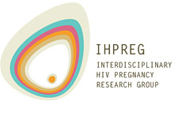 Funded by: Interdisciplinary HIV Pregnancy Research Group
Ethics Approval: McMaster University
APPENDIX ONE: Recruitment Material – Study Information Brochure

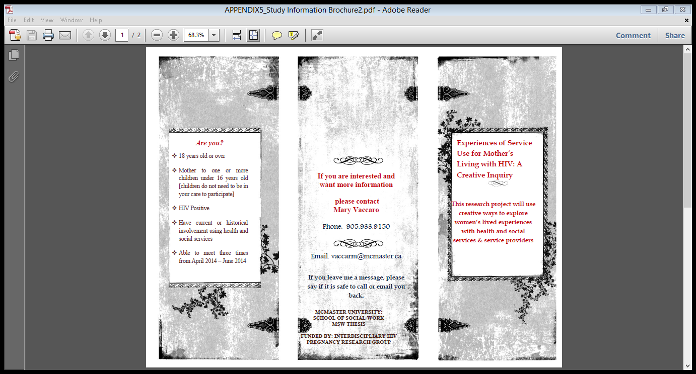

APPENDIX ONE: Recruitment Material – Study Information Brochure

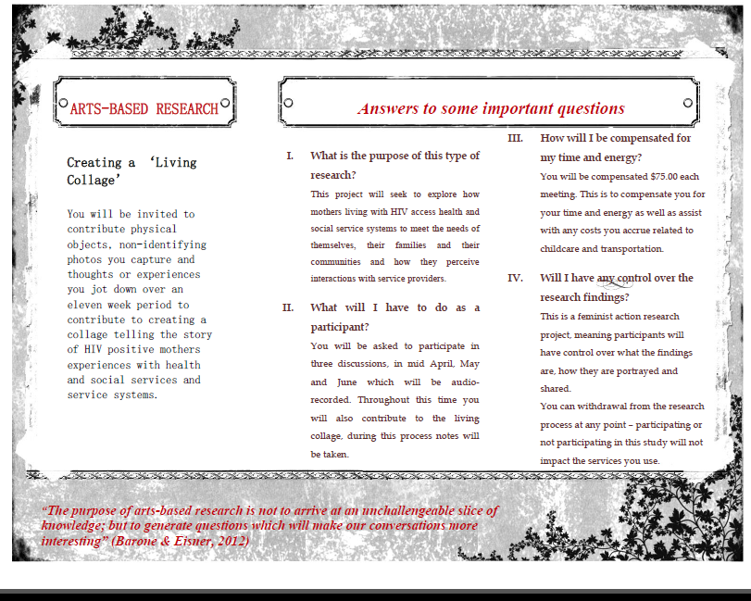

APPENDIX TWO: Letter of Information & Informed Consent Form
DATE: April 2014

LETTER OF INFORMATION / CONSENT

A Creative Inquiry into HIV Positive Mothers Experiences of Service Use

Investigators:

Student Investigator: Mary Vaccaro
School of Social Work
McMaster University
Hamilton, Ontario, Canada
McMaster University

(905) 933-9150
E-mail: vaccarm@mcmaster.ca

Supervisor:
Dr. Saara Greene
School of Social Work
McMaster University
Hamilton, Ontario, Canada
McMaster University

(905) 525-9140 ext. 23782
E-mail: greenes@mcmaster.ca

Research Sponsor: Interdisciplinary HIV Pregnancy Research Group

Purpose of this Research:
This project was developed with the hope of learning more about your personal experiences of accessing and using health and social services.Through sharing stories and experiences, I hope to understand more about the experiences of access and/or barriers for HIV positive mothers in relation to the health and social services they use. This research is important, as there has been very little research done about HIV positive mothers and the ways they experience their interactions with health/social services and service providers.
This project uses an arts-based approach called ‘living collage’ as a tool to help us to be creative in our thought process as we try to notice and reflect on common themes in the stories and experiences shared.
What will happen during the study?
You will be asked to meet as a group, with approximately four to seven other HIV positive mothers and myself, three times over an eleven week time period.
We will meet three times during the last weeks of May and early June. We will pick a date and time during that week to meet, dependent upon your availability.
You will be asked to complete a brief self-administered survey asking you some questions about your identity [age, race, income, age of child(ren) etc.] and some questions about your service use [how often, how many services etc.].

As this project is arts-based, you will be given a disposable camera, a pack of cue cards and a small bag at the first meeting. Over the eleven weeks, you will be asked to take photographs, jot down memos and collect anything (small tokens, objects, paper items etc.) that reflect or symbolize your experiences with using health and social services. It can be anything you want – be creative!
We will have collective discussions each time we meet, for approximately ninety-minutes, for the purpose of learning more about the shared experiences of service and health care use. All three of these discussions will be audio-recorded to ensure that our conversations.
During these collective discussions, you can except to be asked questions such as:
Q1. How do you find accessing health or social services? Is there a particular service that has been helpful? Or unhelpful? What made this service helpful or unhelpful?
Q2: Historically, do you remember a time you accessed services more frequently? What was life like for you at this time? How would you describe your patterns of service use at this time?
Q3: In what ways are your experiences similar to what other women have shared? In what ways are they different?
During the second and the final meeting, you will be asked to share the things you have collected and add them to the living collage. The living collage will be on cork board and items will be easily added, changed and removed by using push pins. The purpose of this is to look for common stories and experiences and consider what these stories mean about social service and health care delivery.
As the collage begins growing and changing, I will be photographing it to include as a visual component of this research. It will be an important part of this study and will help represent our shared thought process. As we contribute to this collage, I will be taking notes to record key themes emerging.

At the end of the study, you will be provided with another informed consent form where you will have the opportunity to select if you wish to receive information about the study, including photos of the collage and/or continue your involvement by contributing to sharing these findings with others.

Are there any risks to doing this study?
The risks involved in participating in this study are related to the group format of our discussion. As it is a group format, other women who are involved in this study will be aware of your contributions t this study. While, I will work to ensure the confidentiality of your information, the other group members will also know your contributions to this project as well. All women who participate will be asked to sign confidentiality agreements, stating they agree to keep the information shared within this study confidential. When we meet as a group, we will revisit this and discuss the importance of this for all group members.

As a participant in this study, you do not need to answer questions that you would prefer not to answer on the demographic/service utilization survey and in collective discussions. You have complete control over how much you disclose to me and to the group. You can stop taking part in the research at any time.
You may feel uncomfortable with the questions being asked in the collective discussions or dislike taking photographs, recording memos and collecting objects for the collage. As participants will be women living with HIV from Hamilton, Niagara and the Greater Toronto Area there is a chance you may know other women in the research group. You may worry about disclosing sensitive information in a group setting.
Photos, objects and memos will be altered to protect your confidentiality and anonymity by covering faces and identifying information. The collection of these objects is not meant to be stressful, you can bring as much or as little as you would like to contribute. As a research group we will discuss an commit to upholding group confidentiality and some basic ground rules to create a safe space for sharing stories.

Are there any potential benefits of this study?
This study has exciting potential benefits because:
- It asks an important and broad question about experiences of service use for mothers living with HIV.
- The arts-based method of collage will add a visual component to the research which may help the community to learn from our findings.
- It will bring together women and mothers with a range of experiences and wisdom to work together and meaningful participate in the research process and purpose

Compensation and Reimbursement: I understand you are a busy woman and therefore will be compensating you $75.00 per meeting for the purposes of assisting you with costs associated with transportation, child care and the time spent participating. If you choose to use the disposable camera that will be provided, as a way to capture moments for the living collage, you will be reimbursed for the money you spent developing the film. Lunch will also be served each time we meet!
Confidentiality: Every effort will be made to guarantee you your confidentiality and privacy as a participant in this research. I will not use require your full name at any point throughout the research. You can use your initials to sign the consent form!
While the data will be collected in a group setting, there will be a discussion and formal agreement about the importance of group members maintaining the group’s confidentiality. Every effort will be made to ensure that your confidentiality is upheld, both by the researcher and by asking group members to keep what is shared by other women themselves. However, due to the group discussion format, you may choose to withhold information that you do not want to discuss in a group.

I will be audio-record the collective discussions, this is so I can type them up and capture everything that is said during time. Once I type it up, I will delete the audio-recording. When I have this information saved on my computer, I will only identify you through your initials and will keep the documents password protected, on my personal computer. Your informed consent forms will be a locked cabinet where only I have access to.
If you include photos of peoples’ it will be asked they consent to this by signing a consent form. You will be asked to blur out the specific names of people to protect their confidentiality unless explicit consent is given. It will be up to the decision of the group what happens to the living collage following the project. It will either be stored for a period of time or dismantled. You will have the opportunity to remove anything you brought for the collage at any time during this process.

b) Legally Required Disclosure
Although what you share in our discussions will be confidentiality, as outlined above, if you share thoughts about harming yourself, someone else or a child I am legally and ethically obliged to disclose this information.

What if I change my mind about being in the study?

You have control over your own involvement in this study. During the study, you will have complete control over what you disclose, if a question is asked you do not want to answer; you do not have to.
If you do decide to take part, you can always change your mind and withdraw, for whatever reason, at any point up until June 11th 2014. After June 11th 2014 we will analyze our data and I will have begun finalizing it for my thesis.
If you decide to withdraw and have contributed objects, photos or memos to the collage I will get make sure you receive these items back. Any data you have provided to the discussions and art will be omitted, unless you indicate otherwise.

How do I find out what was learned in this study and what my work was use for?
This is a ‘feminist action research’ project, which means it focuses on working with women to improve important health and social justice aims. Following the study, you will be asked information about how you want to continue your involvement on this project. You can either choose to end your involvement, receive a summary of the findings and photographs of the collage and/or contribute to continuing efforts around sharing this research with health and community agencies and amongst HIV research communities. .

Questions about the Study

If you have questions or need more information about the study itself, please contact me at:
vaccarm@mcmaster.ca or call me at 905-933-9150

This study has been reviewed by the McMaster University Research Ethics Board and received ethics clearance.
If you have concerns or questions about your rights as a participant or about the way the study is conducted, please contact:
McMaster Research Ethics Secretariat
Telephone: (905) 525-9140 ext. 23142
c/o Research Office for Administrative Development and Support
E-mail: ethicsoffice@mcmaster.ca

CONSENT

- I agree that the collective discussions can be audio recorded so that the reseacher can type them out:
___ Yes
___ No

- I agree that the living collage can be photograpphed and understand the consent process for using photographs of people as well as the processes for maintaining my confidentality
___ Yes
___ No

- I agree that the photographs of the living collage can be shared with health and community agencies, within HIV research circles and in ways that will attempt to benefit mothers living wih HIV
___ Yes
___ No

- If I need to get ahold of you to discuss changes in our meeting times or location, do you have a way I could get in touch with you? (phone, email, home address for mail?)
____________________________________________
____________________________________________
____________________________________________

- I have read the information presented in the information letter about a study being conducted by Mary-Elizabeth Vaccaro, of McMaster University.
- I have had the opportunity to ask questions about my involvement in this study and to receive additional details I requested.
- I agree not to disclose any personal information about Experiences of Service Use for HIV Positive Mothers: an A Creative Inquiry participant that becomes available to me throughout my involvement with this project.
- I agree that an atmosphere of trust based on confidentiality must be created and maintained. I therefore agree that when discussing the study outside of the group I will not identify other participants either by name or by information from which their name/s could be deduced. Any disclosures I make to other people regarding the study will relate only to my own experience, and not to the stories that others choose to share during the sessions.
- I understand that if I encounter an Experiences of Service Use for HIV Positive Mothers: A Creative Inquiry participant, outside of the study workshop and project activities, I will not identify that person as a participant in this study without receiving prior permission to do so

- I understand that if I agree to participate in this study, I may withdraw from the study at any time or up until approximately June 11th 2014.

- I have been given a copy of this form.

- I agree to participate in the study.

You can use your initials here if you wish!!

Signature: ______________________________________

Name of Participant (Printed) ___________________________________

APPENDIX 3: Agenda of Meetings
The collective discussions will rely on an unstructured approach to facilitation, allowing for participants own questions and thought to emerge. The following questions will be used to guide our discussion and keep our reflection focused on the research topic.
Day One:
To begin, we will go around the circle to check in with each other and use a guided check in activity to ground ourselves in the context of the study
Check in: Write down your experiences of service use in one word – share it with the group then add it to the living collage
Q1. How do you find accessing health or social services? Is there a particular service that has been helpful? Or unhelpful? What made this service helpful or unhelpful?
Q2: How do you interact with service providers? Do you have any memories about particular service providers who have been either helpful or unhelpful to you? What types of things did she/he say or do that contributed to your perception to them as either helpful or unhelpful?
Q3: How do you experience the processes of accessing health or social services? How do you become aware of different services? How do you get referred to specific services?
Q4: How do you navigate intake or assessment processes for health and social services? How much of your story do you tell to service providers? How do you make decisions about how much, or what you share?
Check out: Write down one way services could improve – share it with the group then add it to the living collage
Day Two:
To begin, we will go around the circle to check in with each other and use a guided check in activity to ground ourselves in the context of the study. Following the check in, we will have an unstructured discussion where I will ask questions about specific stories shared or other questions to help guide and focus discussions. Participants will be encouraged to continue sharing the items, photos and memos that they brought in to contribute to the collage throughout the discussion.
Check in: We will go around the circle and everyone will be invited to share an item that they brought to contribute to the living collage that holds the most meaning and explain why they choose this item
Q1: Describe your experiences of health and social service use over the past four weeks since we met. What was this process like?
Q2: Can you share a story about an interaction with a health or social service or service provider that you experienced? What was that experience like for you?
Q3: How much of your time and energy did you spend over the past four weeks accessing health or social services? How do you negotiate transportation? What are your arrangements typically for child care? How do you keep track of appointments related to health and social services for yourselves and your families?
Q4: Historically, do you remember a time you accessed services more frequently? What was life like for you at this time? How would you describe your patterns of service use at this time?
Check out: Everyone will be invited to write down and share one theme, or thought that most resonated with them throughout the discussion
Day Three:
To begin, we will go around the circle to check in with each other and use a guided check in activity to ground ourselves in the context of the study
Check in: We will go around the circle and everyone will be invited to share an item that they brought to contribute to the living collage that holds the most meaning and explain why they choose this item
Following the initial check in, all photos/memos/objects women brought with them to our meeting will be added to the collage. Women will either go around the circle until all items are added to the collage or will share items spontaneously.
Q1. In what ways are your experiences similar to what other women have shared? In what ways are they different?
Q2: What has participating in this research been like for you? How do you think the findings could be shared?
Q3: When you look at the collage of experiences, what thoughts, emotions or questions do you have?
Q4: Have your patterns or views of service use changed at all since beginning this project? If so, how?
Check out: Everyone will be invited to write down and share one theme, or thought that most resonated with them throughout the discussion and add this word to the living collage.

Appendix 4: Demographic Questionnaire

Demographic Questionnaire
Demographics:

How do you describe your race and/or ethnic background?
Select all that apply.
- Aboriginal person living in Canada (e.g., First Nations, Métis, and Inuit)
- Indigenous Person from a country outside of Canada
- Black African (e.g., Nigerian, Somali)
- Black Caribbean (e.g., Haitian)
- Black Other (e.g., Black Canadian)
- Caucasian/White
- Chinese or Taiwanese
- Filipino
- Japanese
- Korean
- Latin American (e.g., Chilean, Costa Rican, Mexican)
- South Asian (e.g., Indian, Bangladeshi, Pakistani, Punjabi, and Sri Lankan)
- Southeast Asian (e.g. Cambodian, Laotian, Malaysian, Vietnamese)
- Arab (e.g., Egyptian, Kuwaiti, and Libyan)
- West Asian (e.g. Iraqi, Israeli, Lebanese, Afghani, Iranian)
- Central Asian (e.g., Kazakhstan, Krgyzstan, Tajikistan, Turkmenistan)
- Multiple races / Multiracial / “Mixed”
- Other, please specify: ___________________________
- Don’t know
- Prefer not to answer

If you are Aboriginal, to which Aboriginal group do you belong?
Not applicable
First Nations |  | Métis |  | Inuit
Other  (specify) __________________ |  | Not known |  | Refused

If you are Aboriginal, what Nation do you identify with? _________________________________

Describe the region where you currently live:
Rural (Isolated area of open country with a population ≤ 2,500)
Town (Population 2,500 – 50,000)
Small City (Pop1ulation 50,000 – 500,000)
Large City (Population ≥ 500,000)
Native Reservation (Specify: _____________________________________)
Other (Specify: ____________________________________)
Don’t know/Prefer not to answer

What is your current source(s) of income:
Ontario Disability Support Program
OW
Other form of financial assistance
Employment
Informal work
Partner or family support
No income

Mothering:
How many of your children are currently in your care?

Social Service Use:

Approximately, how many different health / social services are you currently accessing?

0 – 1 |  | 2 – 4
4 – 6 |  | 6 or more

Appendix 5: Photo Release – Consent Form
Photo Release Form

DATE: ______________________________
I, __________________________________, hereby give the Experiences of Service Use for Mothers Living with HIV: A creative Inquiry research team my permission to use any photographs or images of me that ___________________________________________ (Name of Participant, printed clearly) has contributed to the living collage.
I consent to the reproduction of same in any proper manner whatsoever for possible publication and I hereby waive any rights that I may have in such photographs, movie films and video tapes or reproductions of same.
I hereby release McMaster University’s School of Social Work, its employees, agents, and servants from all actions, causes of actions, claims and demands arising out of such consent.
I declare that I am of the age eighteen years.

________________________________ ___________________________
Signature Witness

________________________________ ___________________________
Printed Name Printed Name

********************************************************************

I, _________________________________________, represent that I am the parent or guardian of the minor named above and that I have the legal authority to execute the foregoing consent and release and hereby approve the foregoing and waive any rights in the premises.

________________________________ ___________________________
Signature Witness

________________________________ ___________________________
Printed Name Printed Name

Appendix 6: Continued Involvement- Consent Form
DATE: June, 2014

CONTINUING CONSENT FORM

A Creative Inquiry into HIV Positive Mothers Experiences of Service Use
Thank you so much for contributing to this study! Now that the project is over, I want to know how you want to proceed in terms of receiving information about the stud and continuing your involvement with sharing the information.

Would you like to receive a copy of the findings?
Yes
No
If you choose yes, please share an email address or mailing address where you wish to receive a copy of the study and photos from making the living collage:
_________________________________________________
_________________________________________________
_________________________________________________
Would you like to be contacted within the next six months about opportunities to be involved in sharing the research?
Yes
No
If you choose yes, please share an email address or phone number where you can be contacted:
_________________________________________________
_________________________________________________
Signature: ______________________________________

Name of Participant (Printed) ___________________________________
Date: _____________________________________________
APPENDIX 7: Additional Photography of the Collage
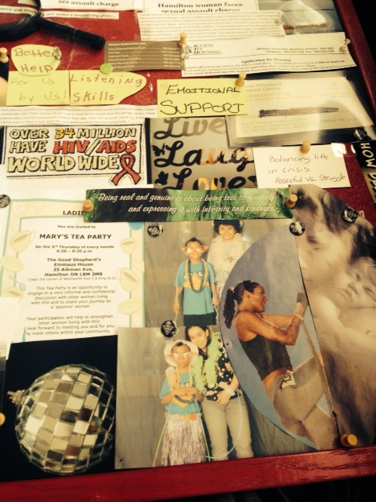

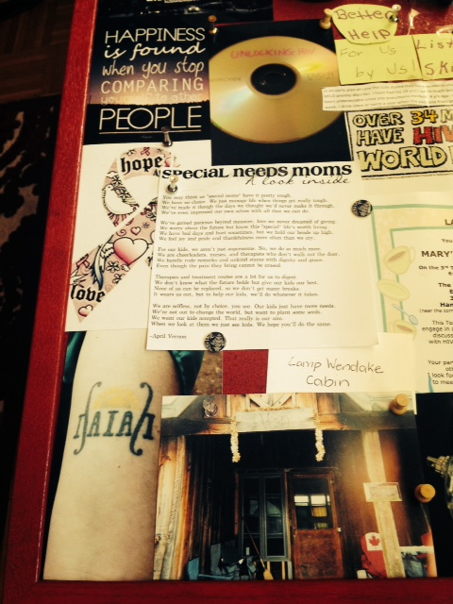
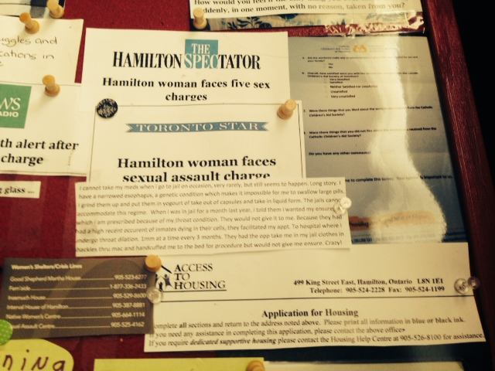

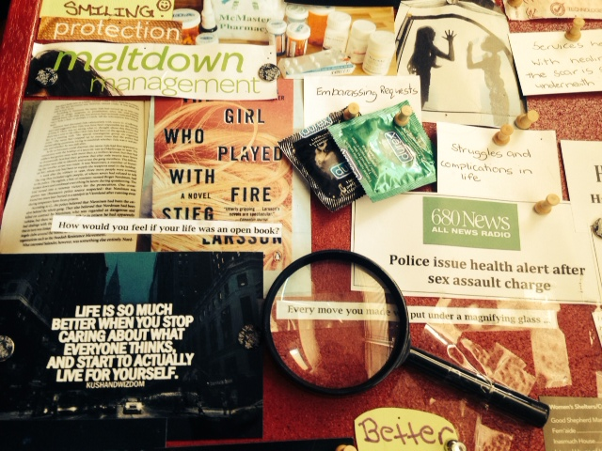

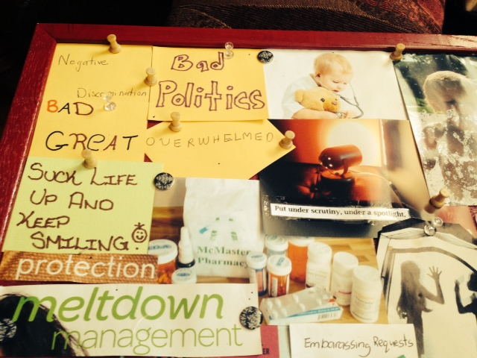

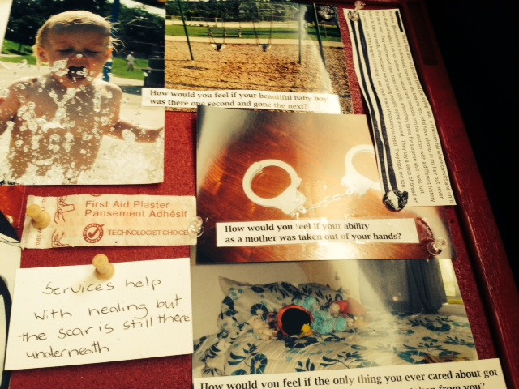

References
Abel, E., Hopson, L., & Delville, C. (2006).Health promotion for women with human
immunodeficiency virus or acquired immunodeficiency syndrome. Journal of the
American Academy of Nurse Practitioners. 18, 534-543.
Ackerly, B., & True, J. (2010). Doing feminist research in political and social sciences.
Palgrave: New York, N.Y.
Aidala, A., Cross, J. E., Stall, R., Harre, D. & Sumartojo, E. (2005) Housing status and HIV risk
behaviors: Implications for prevention and policy. AIDS and Behavior, 9, 251–265.
Albrecht, G.L. & Peters, K.E. (1997). Peer intervention in case management practice. Journal of
Case Management, 6(2), 43-50.

Allan, J. (2004). Mother blaming: a covert practice in therapeutic intervention. Australian Social
Work, 57, 57-70.

Bailey, P., & Tilley, S. (2002). Storytelling and the interpretation of meaning in qualitative
research. Methodological Issues in Nursing Research, 38(6), 574–583

Baker-Collins, S., Neysmith, S., Porter, E., Reisma-Street, M. (2009). Women’s provisioning
work: Counting the cost for women living on low income. Community, Work, & Family,
12(1), 21-37.
Ball, H. K. (2008). Quilts. In J. Knowles & A. Cole (Eds.), Handbook of the arts in qualitative
research (pp. 363–368). Thousand Oaks, CA: SAGE.
Barone, T (2000). Aesthetics, Politics, and Educational Inquiry: Essays and Examples.
Washington, DC.

Barone, T., & Eisner, E. (2012). Arts based research. Sage Publications: Arizona, United States

Bauer, G., Hammond, R., Travers, R. Kaay, M., Hohenadel, K.M., Boyce, M. (2009). ‘I don’t
think this is theoretical; this is our lives’: How erasure impacts health care for transgender
people. Journal Association of Nurses AIDS Care, 20, (5), 348-361.
Belenky, M.F., Clinchy, B.M., Goldberger, N.R., & Tarule, J.M. (1986), Women’s Ways of
Knowing: The Development of Self, Voice, and Mind, Basic Books, New York, NY.
Berger, M. (2004). Workable sisterhood: The political journey of stigmatized women with
HIV/AIDS. Princeton University Press: Princeton, NJ.
Beaucage, J. (2011). The aboriginal advisor’s report on the status of Aboriginal child welfare in
Ontario. Retrieved from
http://www.children.gov.on.ca/htdocs/English/topics/aborignal/reports/child_welfare-
2011.aspx.
Betancourt, T., Fawazi, M., & Burdelin, C. (2012). Children affected by HIV/AIDS: Safe a
model for promoting their security, health and development. Journal of Psychology,
Health and Medicine, 15(3), 53-66.
Brun, C., Rapp, R.C. (2001). Strengths-based case management: Individuals’ perspectives on
strengths and the case manager relationship. Social Work, 46(3), 278-288.

Canadian Aboriginal AIDS Society. (2014). The effects of HIV on Aboriginals in Ontario: Key
issues. Available from http://www.caan.ca/regional-fact-sheets/ontario./

Cain, R., & Todd, S. (2009). HIV/AIDS social services and the changing treatment contexts.
Qualitative Social Work, 8, (2), 249- 265.
CATIE. (2013). Managing your health: A guide for people living with HIV. Retrieved online
from http://www.catie.ca/en/practical-guides/managing-your-health.
CATIE. (2013). The epidemiology of HIV in Canada. Retrieved online from
http://www.catie.ca/en/fact-sheets/epidemiology/epidemiology-hiv-canada.
Chen, H., Phillips, K. A., Kanouse, D. E., Collins, R, L., & Miu, A. (2001). Fertinility desires
and intentions of HIV positive men and women. Family Planning Perspectives, 33, (4),
144.
Clover, D. (2011). Successes and challenges of feminist arts-based participatory methodologies
with homeless/street-involved women in Victoria. Action Research, 9(1), 12-26.
Crenshaw, K. (1989) Demarginalizing the intersection of race and sex: A black feminist critique
of antidiscrimination doctrine, feminist theory and antiracist politics, University of
Chicago Legal Forum, 139, pp. 139–167.

Crook. J., Browne, G., Roberts, J., & Gafni, A. (2005). Impact of support services provided by a
community-based AIDS service organization on persons living with HIV/AIDS. Journal
of the association of nurses in AIDS care, 16, (4), 39-49.
Covington , S., & Bloom, B. (2006). Gender responsive treatment and services in correctional
settings. Women and Therapy, 29(3), 9-33.
Cowdery, J. E., & Pesa, J. A. (2002). Assessing quality of life in women living with HIV
infection. AIDS Care, 14(2), 235–245.

Davis- Butler-Kisber, L. (2008). Collage as inquiry. In A. Cole & G. Knowles, (Eds,) Handbook
of arts in social science research (p. 265-274). Thousand Oak, CA: Sage.
Denzin, N, K. (2005). Emancipatory discourses and the ethics and politics of interpretation. In
N.K. Denzin and Y.S. Lincoln (eds) The Sage handbook of qualitative research.
Thousand Oaks, CA: Sage Publishing.
De Groot, A., & Ulvin, S. (2005). HIV infection among women in prison: Considerations for
Care. Infections Disease Corrections Report, 8, 5-6, 1-4.
De Souza, D. (2004). Motherhood, migration and methodology: Giving voice to the “other.” The
Qualitative Report, 9, 463–482.
Duffy, L. (2005). Suffering, shame and silence: The stigma of HIV/AIDS. Journal of the
Association of Nurses in AIDS Care, 16(1), 13-20.
Eisner, L. (2008). Collage as inquiry. In A. Cole & G. Knowles, (Eds,) Handbook of arts
in social science research (p. 265-274). Thousand Oak, CA: Sage.
Elizabeth Fry Society. (2013). Fact sheet: Criminalized and imprisoned women. Retrieved online
from http://www.caefs.ca/wp-content/uploads/2013/04/Criminalized-and-Imprisoned-
Women.pdf.

Elliott, J. (2005) Using Narrative in Social Research: Qualitative and Quantitative Approaches.
London: Sage.
Elliott, P. W. (2012) Participatory Action Research: Challenges, Complications, and
Opportunities. Saskatoon, SK: Centre for the Study of Co-operatives, University of
Saskatchewan.
Finley S and Finley M (1999) Sp’ange: A research story. Qualitative Inquiry, 5(3), 313–337.
Finley, S. (2008). Art-based inquiry-Performing revolutionary pedagogy. In: Denzin NK and
Lincoln YS (eds) The SAGE Handbook of Qualitative Research, 3rd edn. Los Angeles,
CA: SAGE, pp. 681–694.
Foster, C. (2007). Ways of knowing and showing: Imagination and representation in feminist
participatory social research. Journal of Social Work Practice, (21), 3, 361–376
Frisby, W., Maguire, P., & Reid, C. (2009). The ‘f’ word has everything to do with it: How
feminist theories inform action research. Action Research, 7, (1), 13-29.
Garoian C. (1999). Performing Pedagogy. Albany: State University of New York Press.
Gielen, A., McDonnell, A., Wu, A., et al.(2001). Quality of life among women living with HIV:
the importance of violence social support and self-care behaviors. Social Science
Medicine, 52(2), 315-322.
Green, F. (2006). Developing a feminist Motherline: Reflections on a decade of feminist
parenting. Journal of the Association for Research on Mothering, 8(1/2), 7-20.
Greene, S., Chambers, L., Masinde, K., Mukandoli, C. (2013). Housing as prevention and
support of and for HIV-positive mothers in Canada: the way forward. In: Gahagan J,
editor. Women and HIV prevention in Canada. Toronto: Canadian Scholars Press.
Greene, S., Ion, A., Elston, D., Kwaramba G., Smith, S. and Loutfy, M. (Forthcoming December,
2014). (M)othering with HIV: Resisting and Reconstructing Experiences of Health and
Social Surveillance. Joanne Minaker and Brian Hogaveen (Eds.). Demeter Press, 21.
Greene, S., Tucker, R., Rourke, S.B., Guenter, D., Sobota, M., Monette, L., Koornstra, J., Byers,
S., Ahluwalia, A., Hwang, S., Dunn, J., Watson, J., and White, P. (2010). “Under My
Umbrella”: The Housing Experiences of HIV Positive Parents who Live with and Care
for their Children in Ontario. Archives of Women’s Mental Health, 13(3), 223-232.

Greene, S., O’Brien-Teengs, D., Ion, A., Whitebird, W. (2014). “When you take away parts of
our family you are taking away parts of our heart”: How Positive Aboriginal Women
(PAW) living with HIV talk about their mothering experiences with Child and Family
Services in Ontario. Journal of Public Child Welfare. pp. 37.

Grue, L,. & Lareum, K. (2002). 'Doing motherhood': some experiences of mothers with physical
disabilities. Disability and Society 17(6), 671-683.

Hankivsky O, & Christoffersen A. (2009). Intersectionality and the determinants of health: A
Canadian perspective. Critical Publications in Health, 18, (3), 271-283.

HIV and the Law. (2014). HIV and criminalization. Retrieved online from
http://www.hivandthelaw.com/basic-information.

Hockley, J., Froggratt, K., & Heimerl, K. (2013). Participatory research in palliative care:
Actions and reflections. Oxford University Press: Oxford, United Kingdom.
Holloway, I., & Freshwater, D. (2007). Vulnerable story telling: narrative research in nursing.
Journal of Research in Nursing, 12(6), 703-711.
Hunter, L. (2009). Supporting the mothers: An exploration of maternal health, well-being and
support service needs for HIV positive mothers. Journal of the Association for Research
on Mothering, 11, (1), 263-278.
Hutchinson, S., & Ingram, D. (1999). Defensive mothering in HIV positive mothers. Qualitative
Health Research, 9 (2).
Hutchinson, S., & Ingram, D. (2000). Double binds and the reproductive experiences and
mothering experiences of HIV positive women. Qualitative Health Research, 10 (1).
Ion, A. & the HIV Mothering Study Team (May 15, 2014). Perceived stress and symptoms of
depression in pregnancy and postpartum of mothers living with HIV in Ontario.
Interdisciplinary HIV Pregnancy Research Group Conference: Toronto, ON.
Jackson, D., & Mannix, J. (2004). Giving voice to the burden of blame: A feminist study of
mothers. experiences of mother blaming. International Journal of Nursing Practice, 10,
150-158.
Jackson, S. (2008). A participatory group process to analyze qualitative data. Progress in
Community Health: Research, Education and Action, 2(2), 161-170.
Jarvis, I. (2014). Unlocking HIV. [documentary]. Centre 3: Hamilton, ON.

Kennedy, L., Serghides, L., Raboud, J., Su. D., Blitz, S., Hart, T., Walmsley, S., Angel, J.,
Smaill, F., Ralph, E., Tharro, W., Loutfy, M. (2014). The importance of motherhood in
HIV-positive women of reproduction age in Ontario, Canada. AIDS Care, 26(6), 777-
784.

Koch, T., & Kralik, D. (2006). Participatory action research in health care. Wiley Publishers:
South Australia.

Kostera, M. (2006). The narrative collage as a research method. Storytelling, Self, Society, 2(2),
5-27.

Kuppart, S., Dayton, A., Guschlbauer, A., & Halkitis, P. (2009). Case manager-reported
utilization of support group, substance use and mental health services among HIV-
positive women in New York City. AIDS Care, 21, (7), 874- 880.
Kwaramba, G., Lewis, J., Smith, S., Inoua, H., Greene, S., Benoit, A., & Loufty, M. (2014).
Women living with HIV speak out about their care: Findings from the formative phase of
CHIWOS. Retrieved online from
http://www.actoronto.org/home.nsf/pages/researchdayvideos.

LaSala, M. (2003). When interviewing family: Maximizing the insider advantage in the
qualitative study of lesbian and gay men. Journal of Gay and Lesbian Social Services,
15(1),15-30.

Larkin, J. (2000) Women, poverty and HIV infection, Canadian Woman Studies, 20(3), pp. 134–
139.

Lay, K., & Daley, J. (2007). Critique of feminist theory. Advances in Social Work, 8, (1), 49-61.

Leicester Safeguarding Children’s Board (2012). Child Protection Guidelines. 6.3 Child
Protection and HIV. Retrieved from
http://llrscb.proceduresonline.com/chapters/g_ch_prot_hiv.html
Lekas, H.M., Siegel, K., & Schrimshaw, E.W. (2006). Continuities and discontinuities in the
experiences of felt and enacted stigma among women with HIV/AIDS. Qualitative
Health Research, 16(9), 1165 - 1190.
Leeper, S., Montauge, B., Friedman, J., & Flanigan, T.(2012). Lessons learned from family-
centered models of treatment for children living with HIV: current approaches and future
directions. Journal of International AIDS Society. 13(2), 101-119.

Li, L., Lang, L., Wu, Z., Win, W., Lin, C. (2009). Individual attitudes and perceived social
norms: Reports on HIV/AIDS- related stigma amongst service providers in China.
International Journal of Psychology, 44, (6), 443-450.

Lichtenstein, B., Strudevant, M., & Mujumbar, A. (2012). Psychosocial stressors of families
affected by HIV/AIDS: Implications for social work practice. Journal of HIV/AIDS and
Social Services. 9, 130-152.
Lopes, A. (2006). Participatory action research. In V. Jupp (Ed.) The SAGE Dictionary of Social
Research Methods.
Lykes, B., & Coquillon, E. (2006). Participatory and action research and feminisms: Towards
transformative praxis. In S. Hesse-Biber (Ed.), Handbook of feminist research: Theory
and praxis. Thousand Oaks, CA: SAGE.
Magnus, M., , Herwehe, J., Murtaza-Rossini, M., Reine, P., Cufie, D., Gruber, D., & Kaiser, M.
(2013). Linking and retaining HIV patients in care: The importance of providers attitudes
and beliefs. AIDS Patient Care & STDS, (27), 5, 297-303.
Margolin, L. (1997). Under the cover of kindness: The invention of social work. University Press
of Virginia: Virginia, United States.
Martin, R., & Gold, F., Murphy, W., Remple, V., Bekowitz, J., & Money, D. (2005). Drug use
and risk of blood borne infections: A survey of female prisoners in British Columbia.
Canadian Journal of Public Health, March 96(2), 97-101.
McCann, C., & Kim, S. K. (Eds.). (2003). Feminist theory reader: Local and global
perspectives. New York: Routledge.

Merithew, M., & Davis-Satterla, L. (2000). Protease inhibitors: Changing the way
AIDS case management does business. Qualitative Health Research, 10 (5): 632–45.
Mill, J., Edwards, N., Jackson, R., MacLean, L., & Chaw-Kant, J. (2010). Stigmatization as a
social control mechanism for persons living with HIV and AIDS. Qualitative Health
Research, 20(11), 1469-1483.

Mishler E.G. (1986). Research Interviewing Context and Narrative. Harvard University Press,
London.

Neuman, L. (1997). Social Research Methods: Qualitative and Quantitative Approaches.
Boston: Allyn & Bacon.
Neysmith, S., Reitsma-Street, M. Baker-Collins, S., & Porter, E. (2004). Provisioning: Thinking
about all of women’s work. Canadian Women Studies 23(3/4) 192-198.
Norris, J. (2014). Collage. In L., Given (Ed.) The SAGE Encyclopedia of Qualitative Research
Methods. SAGE: Thousand Oaks, C.A.
O’Brein-Teengs, D., Vaccaro, M., Greene, S., & Ion, A. (November 12, 2012). “I Guess She Just
Needs to Do Her Homework” HIV- Positive Mothers Interactions with Child Protection
Services across Ontario. Ontario HIV Treatment Network Conference, Toronto: ON.
Olesen, V. (2005). Early millennial feminist qualitative research: Challenges and contours. In N.
K. Denzin, & Y. S. Lincoln (Eds.), The Sage handbook of qualitative research (pp. 235-
78). Thousand Oaks, CA: Sage Publications.
Olivier, C., & Dykeman, M. (2005). Challenges to HIV service provision: commonalities
between nurses and social workers. AIDS Care: Psychological and Socio-medical
Aspects of AIDS/HIV, 15 (5), 649-653.
Ontario Collation against Poverty. (2014). Raise the rates. Retrieved online from
http://update.ocap.ca/rtr.
Oosterhoff, P., et al (2008). HIV-positive mothers in Viet Nam: using their status to build
support and access essential services. Reproductive Health Matters, 16(32), 162-170.
Parrish, M., Burry, C., Pabst, M.S. (2003). Providing comprehensive case management services
to urban women with HIV/AIDS and their families. Affilia, 18(3), 302-315.

Peterson, J. (2010). The challenges of seeking and receiving support for women living with HIV.
Health Communication, 25, 470-479.
Pillow, W. (2003). Confession, catharsis or cure? Rethinking the uses of reflexivity as a
methodological power in qualitative research. Qualitative Studies in Education, 16(2),
175-196.
Ponic, P., & Frisby, W. (2010). Unpacking assumptions about inclusion in community-based
health promotion: Perspectives of women living in poverty. Qualitative Health Research
20(11) 1519–1531.

Poulin, C., Alary, M., Lambert, G., Godin, G., Landry, S., Gagnon, H, et al. (2007). Prevalence
of HIV and hepatitis C virus infections among inmates of Quebec provincial prisons.
CMAJ July 31, 177 (3), 252-260.
Public Health Agency of Canada. (2012). Population-specific HIV/AIDS status report: Women.
Government of Canada: Ottawa, ON.
Raphael, D. (2004) Social Determinants of Health: Canadian Perspectives. Toronto, ON:
Canadian Scholars Press.

Reid, C. (2004). Advancing women’s social justice agendas: A feminist action research
framework. International Journal of Qualitative Methods, 3, (3), 2-22.

Reid, C. (2006). Finding the ‘action’ in feminist participatory action research. Action Research,
43, (3), 315-332.
Reidpath, D.D. & Chan, Y. (2005). A method for the quantitative analysis of the layering of
HIV-related stigma. AIDS Care, 17(4), 425-432.
Remis, R. S., Swantee, C., & Liu, J. (2012). HIV/AIDS in Ontario: Preliminary report 2010.
Toronto, ON: Ontario Ministry of Health.
Ritcher, L., Beyrer, C., Kippax, S., & Heidari, S. (2010). Visioning services for children affected
by HIV and AIDS through a family lens. Journal of the International AIDS Society,
13(2), 43-59.

Robertson, B. (2000). Why collage? Retrieved February 8, 2014, from
https://www.collagetown.com/history01.shtml.
Rogers, J., & Kelly, U. (2011). Feminist intersectionality: Bringing social justice to health
disparities research. Journal of Nursing Ethics, 18(3), 397-407.
Rolling, J. (2010). A paradigm analysis of arts-based research and implications for education.
Journal of Issues and Research in Art Education, 51(2). 102-114.

Rotherman-Borous, M., Flannery, D., Rice, E., & Lester, P. (2005). Families living with HIV.
AIDS Care, 17 (8), 979-987
Sandelowski, M., & Barroso, J. (2003). Motherhood in the context of maternal HIV infection.
Research in Nursing and Health, 26, 470–482.

Sandelowski, M., Lambe, C., & Barroso, J. (2004). Stigma in HIV-positive women. Journal of
Nursing Scholarship, 36(2), 122–128.
Smith, E. (2003) Nowhere to Turn?: Responding to Partner Violence Against Immigrant and
Visible Minority Women. Ottawa, ON: Canadian Council on Social Development.

Spittal, P., Craib, K., Wood, E., Lalibetre, M., Li, K., Tyndall, M et al. (2002). Risk factors for
elevated HIV incidence rates among female injection drug users in Vancouver. CMAJ
April, 166 (7), 894-890.

Stalker, J. (2003). Ladies’ work and popular education: Fabricating new approaches. New
Zealand Journal of Adult Education, 31(2), 21–35.
Stanley, L. (1999). Transforming AIDS: The moral management of stigmatized identity.
Anthropology and Medicine, 6(1), 103-120.
Stewart, M. J., Neufeld, A., Harrison, M. J., Spitzer, D., Hughes, K. & Makwarimba, E. (2006)
Immigrant women family caregivers in Canada: implications for policies and
programmes in health and social sectors. Health & Social Care in the Community, 14(4),
329–340.

Stewart, K., Phillips, M., Walker, J., Harvey, S., & Porter, A. (2011). Social services utilization
and need among a community sample of persons living with HIV in the rural south. AIDS
Care, 23, (3), 340- 347.

Taylor, B. (2001). HIV, stigma and health: Integration of theoretical concepts and the lived
experiences of individuals. Journal of Advanced Nursing, 35(5), 792-798.
Thomas, C. (1997). The baby and the bath water: disabled women and motherhood in social
context. Sociology of Health & Illness 19, 622-643.
Tomilnson, M. (2010). Family-centred HIV interventions: lessons from the field of parental
depression. Journal of the International AIDS Society, 13(2), 45-55.
United Nations AIDS. (2004). The Greater Involvement of People Living with HIV.
Retrieved online from http://data.unaids.org/pub/BriefingNote/2007
/jc1299_policy_brief_gipa.pdf.
United Nations Office on Drugs and Crime. (2012). HIV prevention, treatment and care in
prisons and other closed settings: A comprehensive packing of interventions. Retrieved
online from http://www.unodc.org/documents/hiv-
aids/HIV_prisons_advance_copy_july_2012_leaflet_UNODC_ILO_UNDP_Ebook.pdf.
Vaughan, K. (2005). Pieced together: Collage as an artist’s method for interdisciplinary research.
International Journal of Qualitative Methods, 4(1), Retrieved online from
http://www.ualberta.ca/~iiqm/backissues/4_1/html/vaughan.htm.
w-Health Study Team (2012). Strengths-based care management: A manual for HIV-positive
women working as peer case managers. McMaster University, Hamilton: ON.

Walter, E. (2011). The interplay between HIV/AIDS-infected mother’s depression and their
children’s behavioural crises in school. Journal of social work in mental health. 9, 379-
394.
Watkins-Hayes, C. (2013). The micro dynamics of support seeking: The social and economic
utility of institutional ties for HIV-positive women. Journal of the American Academy,
687, 83-101.
Webel, A.(2013). The impact of social context of self-management in women living with HIV.
Social Science & Medicine, 8(7), 147-154.
Whyte, W. F. (1991). Participatory action research. Newbury Park, CA: SAGE.
Wood, A., & Tobias, C. (2004). Barriers to care and unmet needs for HIV-positive women
caring for children: Perception of women and providers. Journal of HIV/AIDS and Social
Services, 3(3), 47-56.
Yudin, M. H., & Loutfy, M. R. (2011). Advocating for assistance with pregnancy planning in
HIV-positive individuals and couples: An idea whose time has come. Journal of
Obstetrics and Gynaecology Canada, 33(3), 269–276.

